PROJECT REPORT
Course: Machine Learning and Pattern Recognition
Project Title: Handwritten Digit Classification Using Logistic Regression and Support Vector Machines with 5-Fold Cross-Validation

Onur Paşahan 20222022398
Mehmet Enes Güneş 20222022410
Bilal Orhanlar 20212022329
Ertuğrul Çakır 20212022070

1. Abstract
In this project, we address the multi-class classification task of handwritten digits using the built-in 'Digits' dataset from the sklearn library. The proposed machine learning workflow consists of exploratory data analysis, data preprocessing (stratified splitting and feature scaling), hyperparameter tuning using 5-fold cross-validation via GridSearchCV, and final evaluation on an unseen test set. Two distinct algorithms are implemented and compared: Logistic Regression and Support Vector Machines (SVM). Experimental results demonstrate that both models achieve high performance, with the optimized SVM model achieving a final test accuracy of %98.33, outperforming the Logistic Regression model which achieved a final test accuracy of %96.11.
2. Introduction & Dataset Description
2.1 Introduction
Optical Character Recognition (OCR) and handwritten digit classification are classic yet vital problems in the fields of computer vision and machine learning. Automating the recognition of handwritten digits has critical real-world applications, such as processing bank checks, sorting postal mail, and digitizing historical documents. This report presents a comparative study of two fundamental machine learning models, evaluating their efficiency, strengths, and limitations on a standard digit dataset.
2.2 Dataset Description
The official Scikit-Learn load_digits() dataset is used in this study. This dataset contains a collection of 8x8 pixel grayscale images of handwritten digits (0 through 9).
- Total Number of Samples: 1797
- Number of Features: 64 (flattened 8x8 matrix where each feature represents pixel intensity ranging from 0 to 16)
- Number of Classes: 10 (digits 0, 1, 2, 3, 4, 5, 6, 7, 8, 9)
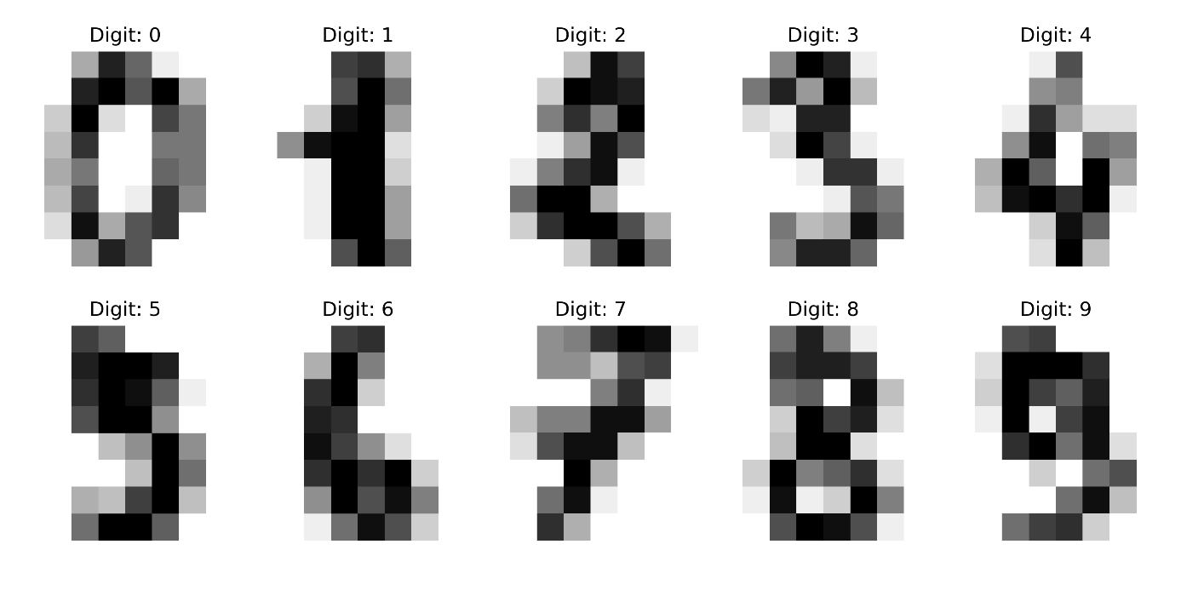
3. Methodology
3.1 Data Preprocessing & Prevention of Data Leakage
To ensure a robust evaluation, the dataset is first split into 80% training (1437 samples) and 20% testing (360 samples) sets. A crucial step implemented here is the use of the stratify=y parameter, which guarantees that the class distribution of digits (0-9) remains identical in both the training and testing partitions, preventing biased training.
Following the split, feature scaling is applied using StandardScaler. To strictly avoid data leakage, the scaler is fitted only on the training data (fit_transform). The test set is subsequently transformed using the parameters learned from the training set (transform). This ensures the model has absolutely no prior information about the test distribution.
3.2 Hyperparameter Tuning with 5-Fold Cross-Validation
Instead of relying on arbitrary parameters, a systematic grid search (GridSearchCV) paired with 5-Fold Cross-Validation is utilized to find the optimal configuration.
- Logistic Regression: Optimized using the regularization strength parameter $C∈\left[0.1,1,10\right]$. The optimization algorithm is configured with max_iter=2000 to guarantee mathematical convergence.
- Support Vector Machines (SVM): Optimized by exploring combinations of the penalty parameter $C∈\left[1,10\right]$, kernel types $∈\left[\text{'rbf'},\text{'linear'}\right]$, and kernel coefficient $γ∈\left[\text{'scale'},0.01\right]$.
4. Experimental Results & Discussion
4.1 Performance Metrics Comparison
After training the models with their best parameters on the full training set, they are evaluated on the 20% unseen test set. The classification metrics are summarized in the table below:
Model | Optimal Hyperparameters | 5-Fold CV Accuracy | Final Test Accuracy
Logistic Regression | C = 0.1 | %96.50 | %96.11
SVM | C = 10, kernel = 'rbf' | %98.80 | %98.33

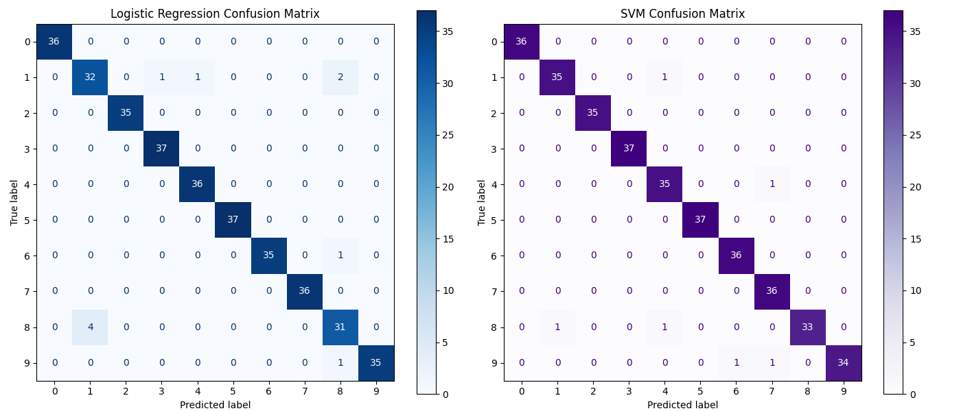

4.2 Discussion
As shown in Figure 2, both models display exceptional classification power. However, analyzing the confusion matrices reveals that SVM misclassifies fewer digits overall. Linear models like Logistic Regression occasionally struggle with digits that share highly similar pixel patterns (such as misclassifying '3' as '8' or '1' as '8'). SVM successfully bypasses this limitation by utilizing the RBF (Radial Basis Function) kernel, which maps the 64-dimensional pixel features into a higher-dimensional space where a non-linear decision boundary can separate the complex patterns effortlessly.
5. Conclusion
In this project, we successfully built, optimized, and evaluated a complete machine learning pipeline for handwritten digit recognition. Through the rigorous use of stratified splitting, proper scaling, and 5-fold cross-validation, we eliminated risks of data leakage and overfitting. While Logistic Regression proved to be a fast and highly competent model, the Support Vector Machine (SVM) emerged as the superior algorithm for this task. The non-linear boundaries provided by the SVM allowed it to capture structural pixel variations more effectively, achieving near-perfect accuracy on unseen data.

