CST2355 – Database Systems Lab Assignment 1

Student Name: *Onur Önel*

Student ID: **041074824**

Student email: onel0001@algonquinlive.com

# Hand-in:

1. The lab assignment will be graded out of a maximum 4 points.
2. This template should be used to submit your lab assignment.
3. Make sure you have enough screenshots to completely document that you have completed all the steps.

# Activities (Steps):

1. Install MS-Office with MS-Access (if necessary)
   1. Use the free MS-Office 365 license that you have been provided by Algonquin.
2. Create a new database using Microsoft’s “Northwind” online database template.
   1. Open MS-Access
   2. Select File > New  
      and search for Northwind

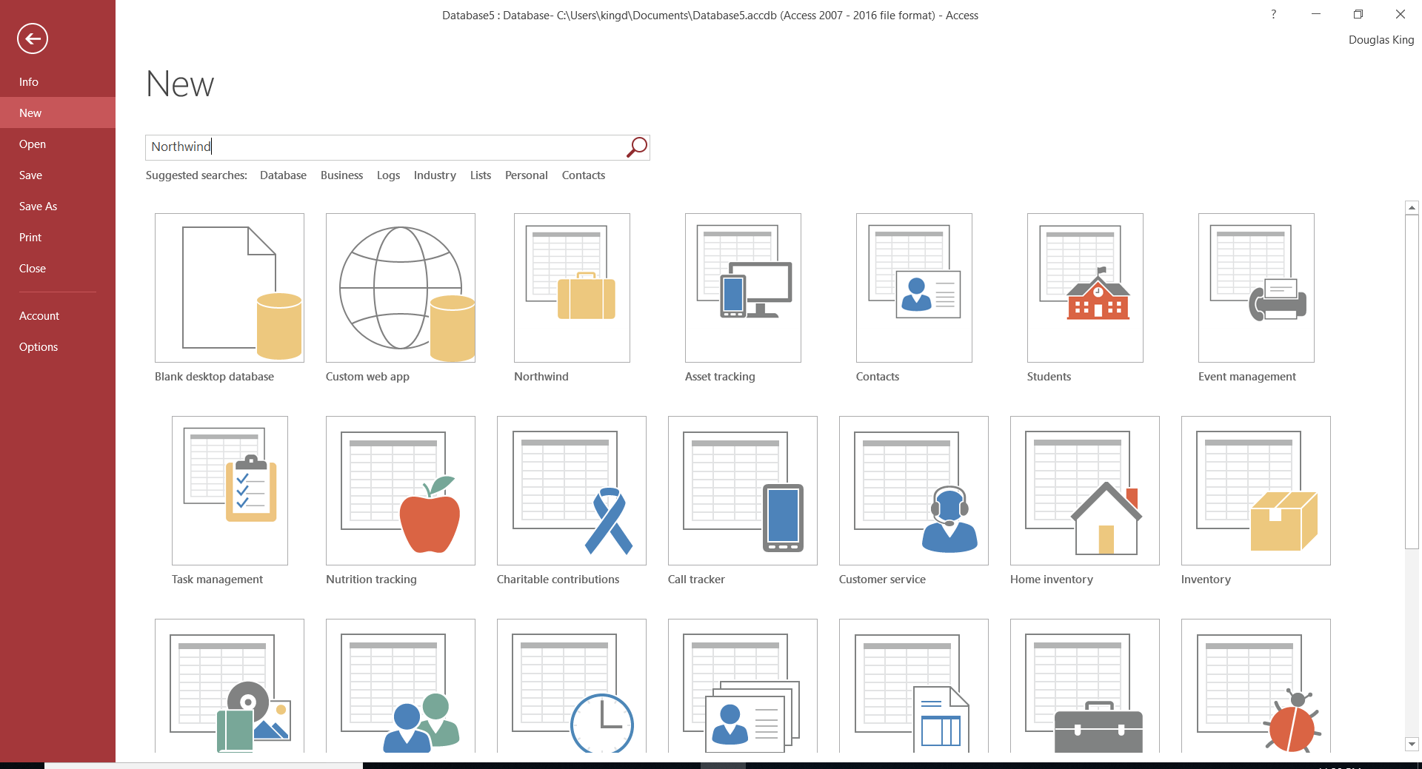

* 1. Once the database is created (it might take a few minutes…) then navigate to find the “Employees” table that is inside the “Supporting Objects” group.
     1. Open the table and see how easy it is to edit the table contents! DONE

1. Investigate the database structure and MS-Access features.
   1. Find two reports, and two forms: Provide a screenshot….

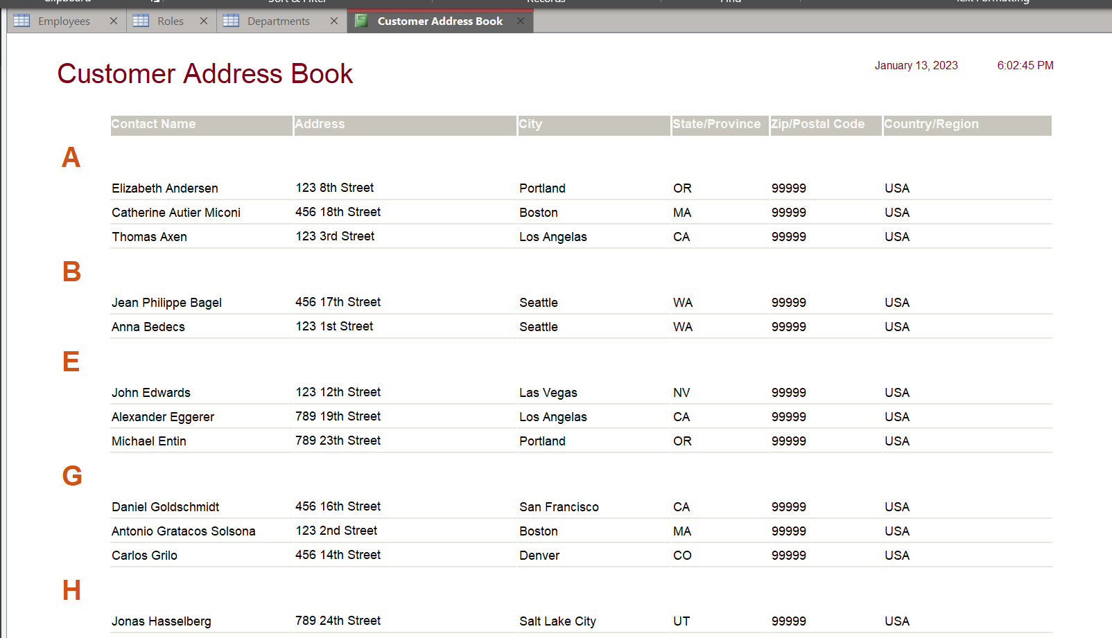

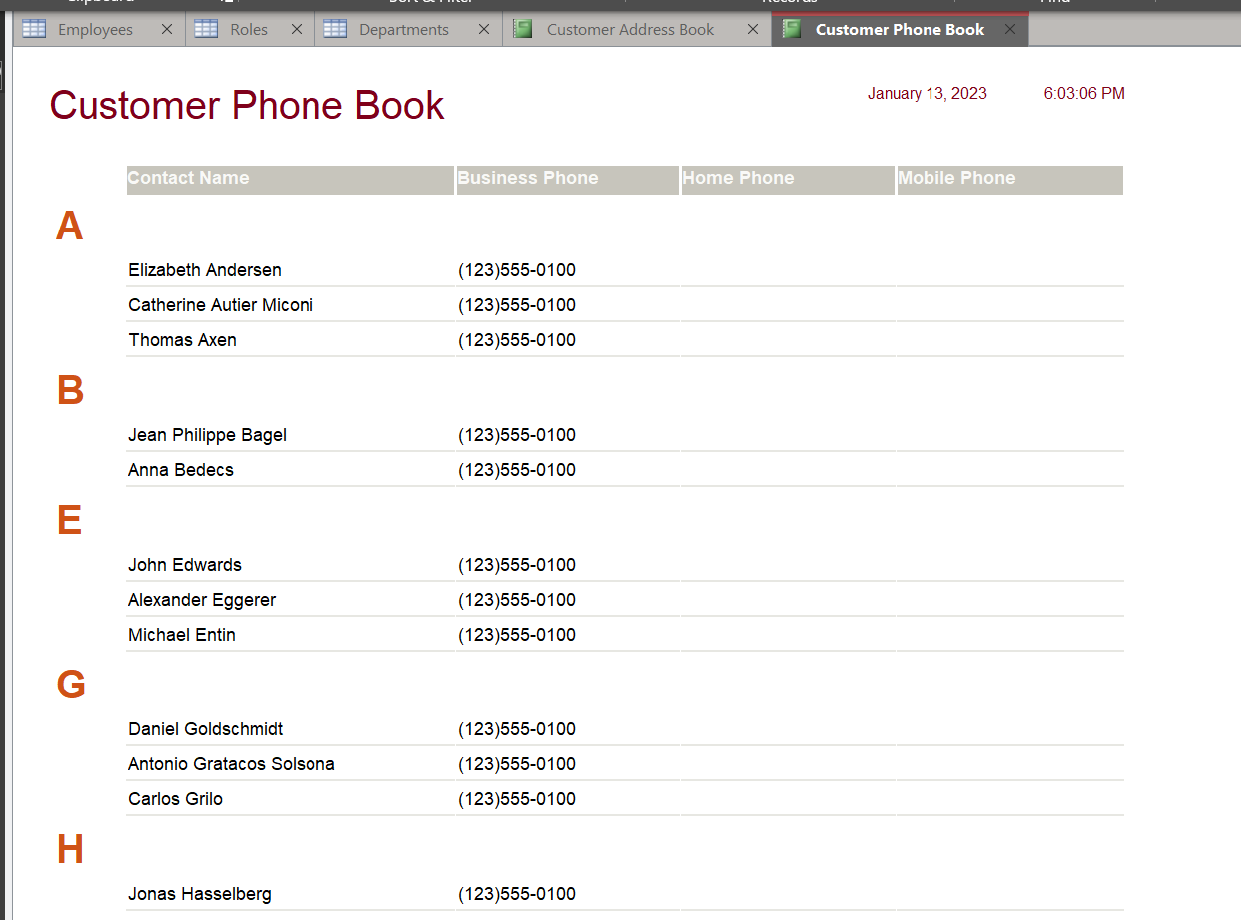

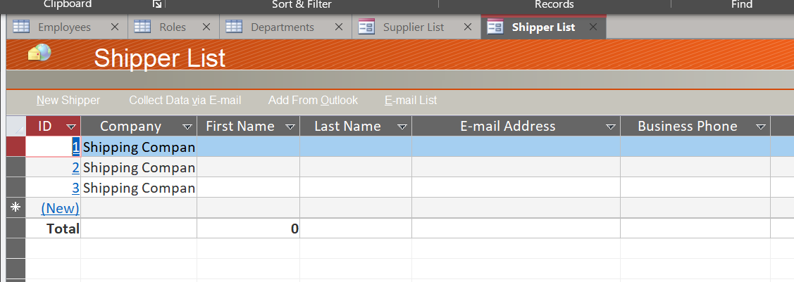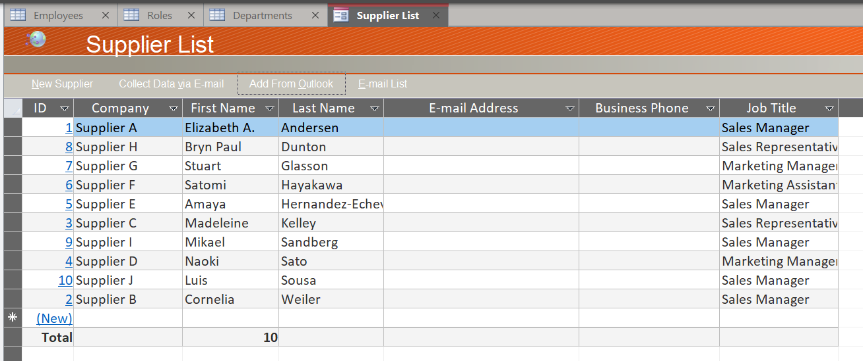

1. Add yourself as to the “Employees” table.
   1. Open the table and add yourself as an employee. DONE
2. Create a new table for “Departments”, with an integer primary key called DepartmentID.
   1. Add fields to have the “Department Name” and the telephone number. DONE
3. Create a new table for “Roles”, with an integer primary key called RoleID.
   1. Add a field to hold the “Role Name”. DONE
4. Move the Departments and Roles table to the “Supporting Objects” Group. DONE
5. Populate the Departments table by inspecting the original employees table and seeing what departments exist (e.g., Sales).
   1. Provide a screenshot of the resulting table. DONE

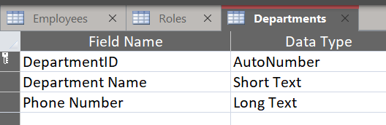 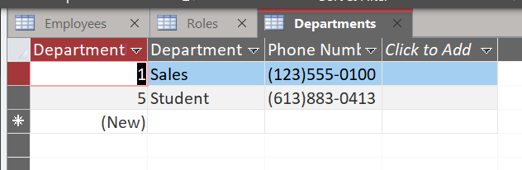

1. Populate the Roles table by inspecting the original employees table and seeing what types of roles exist (e.g., Manager, Clerk).
   1. Provide a screenshot of the resulting table. DONE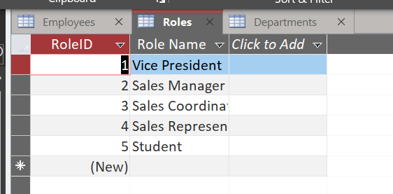

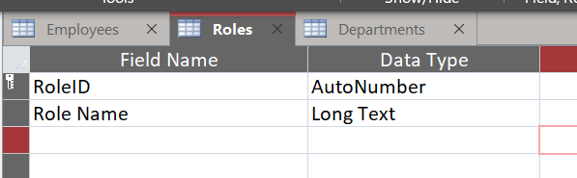

Add a “Department” and a “Role” column to the Employees table.

* 1. Open the Employees table.
  2. Select design view
  3. Create the two new fields: each as a number (to hold the number that corresponds to the RoleID and DepartmentID fields from your new tables.
  4. Populate the Employees table and provide a screenshot. DONE

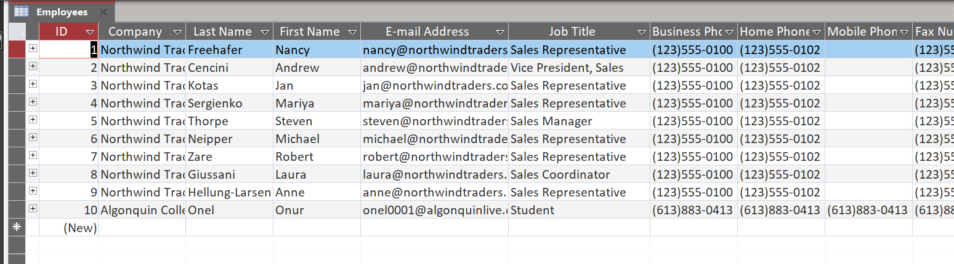

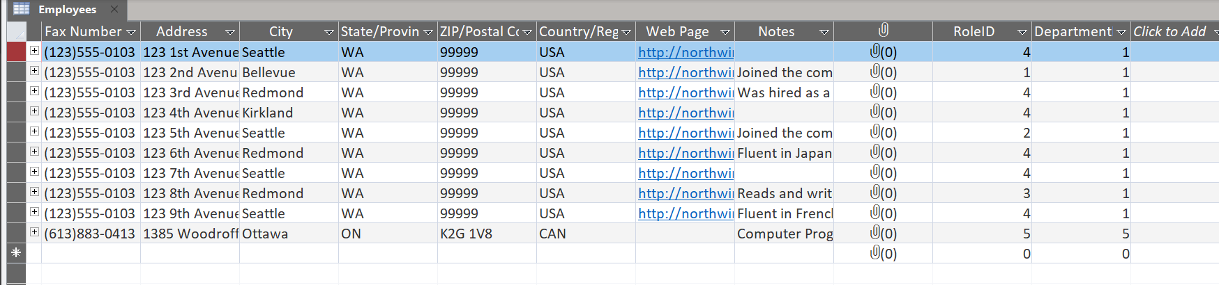

1. Create a form using the form Wizard to show the information for all employees in a particular department using a nested sub-form. The user should be able to select a department from the department table in the main part of the form, and then see the updated list of employees with the associated information in a sub-form. Provide a Screenshot for the form using the department that you associated with your own employee record. DONE

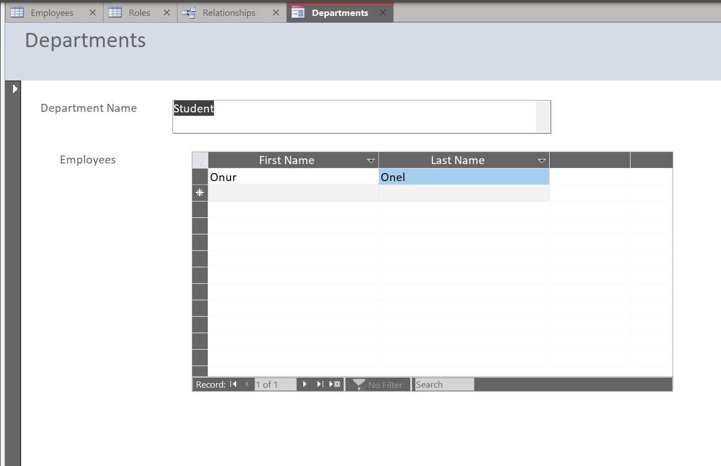

1. Once you have embedded all of your screenshots, submit the file in Brightspace and you’re done!

Thanks 😊