**Lab 2 --- Understanding Oracle’s architecture and key parameter files**

**Purpose:** This lab reinforces your classroom discussions concerning Oracle architecture

**Requirements:** Complete the required tasks and submit the required responses in the **same** word document renamed as ***lab2_****fname_lname* (e.g., ***Lab2_Doug_King***) via Brightspace by the end of the lab and demonstrate your work to the lab professor.

A complete and on-time submission will earn **2 marks**.

**Resources**: <https://docs.oracle.com/cd/B28359_01/server.111/b28318/startup.htm#CNCPT1293>

<https://docs.oracle.com/database/121/CNCPT/startup.htm#CNCPT601>

<https://docs.oracle.com/cd/B28359_01/server.111/b31189/ch12042.htm>

<https://docs.oracle.com/cd/B28359_01/server.111/b28286/statements_6008.htm#SQLRF01308>

**Lab Submission tasks:**

1. **Demo / Problem Solving: During Week 2's lab, you will be required to confirm your Oracle 19c installation is working properly.**
2. **Concepts: Refer to the above noted resources. Copy your answers to your submission document.** 
   1. Without using virtual tables or similar mechanisms, a database instance can be associated with **single** database(s). [How many?]
   2. To start a database instance, configuration parameters must be read. This information is contained in binary format in **server parameter file** and in text format in **initialization parameter file.**
   3. During STARTUP, the instance knows where the data files are located by reading the **control file**.
   4. The main difference between a TRANSACTIONAL SHUTDOWN and an IMMEDIATE SHUTDOWN is, in **a TRANSACTIONAL SHUTDOWN Performs a planned shutdown of an instance while allowing active transactions to complete first**. whereas in an **IMMEDIATE SHUTDOWN Does not wait for current calls to complete or users to disconnect from the database.**
3. **Review the Startup/Shutdown Process (Write the queries and their results):** 
   1. Logon as **SYS as SYSDBA**.
   2. Enter **SHOW PARAMETERS**
      1. From the SHOW PARAMETERS results, determine where the SPFILE file is located. Record this location in your lab file below.

***C:\ORACLE19CINSTALL\WINDOWS.X64_193000_DB_HOME\DATABASE\SPFILEORCL8276.ORA***

* 1. **Create a PFILE:** Enter: ***CREATE PFILE from SPFILE;***
  2. Locate and resulting **PFILE** and in your lab document, specify:
     1. the name of the pfile (show a screenshot of the folder and file on disk)

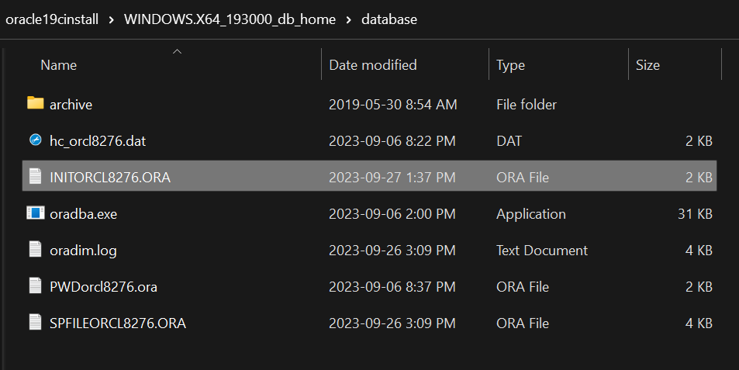

* + 1. Open the file and determine the **oracle_base** name (show a screenshot of the file contents)

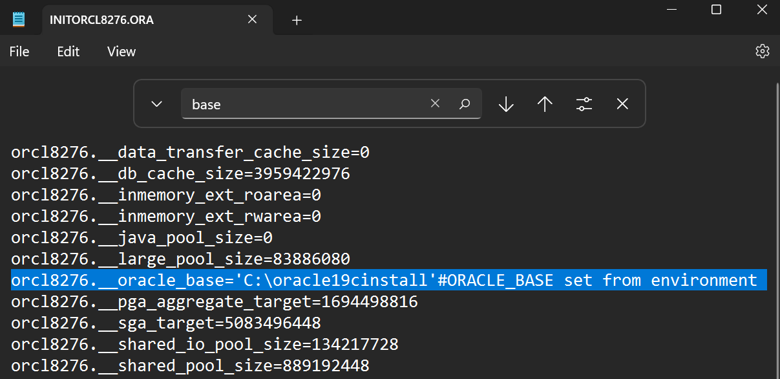

* + 1. the location of the **control_files**

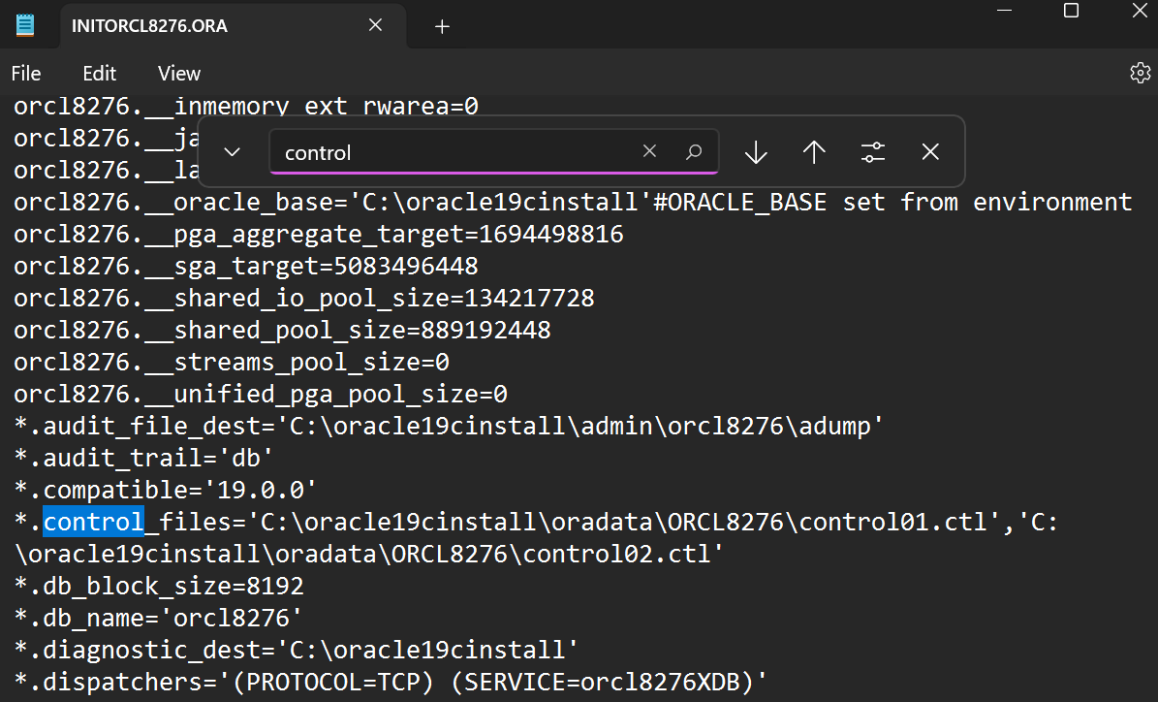

* 1. Enter: **SHUTDOWN**
  2. Enter: **STARTUP**
  3. Indicate, in your lab document, the sequence of objects being started.

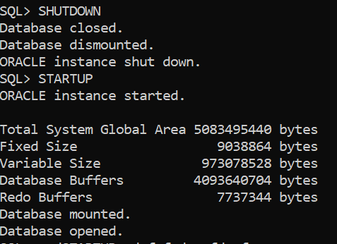

1. **DATA DICTIONARY:** From the SQL prompt, enter **DESC DICT-** this command describes the structure (the columns) of the internal data dictionary.

*Hint:**Throughout the course, when you forget the names of special tables you can return to the dictionary and determine the name.*

In your lab document answer the following questions **(Write the queries and their results)**:

* 1. List the number of rows that are in this table (you may not want to select the rows as there are a lot). ***SQL> SELECT COUNT(*) FROM DICT; Result = 4666***
  2. List the name of the view or table that describes Tablespaces:

***SQL> SELECT TABLE_NAME FROM DICT WHERE TABLE_NAME LIKE '%TABLESPACE%';***

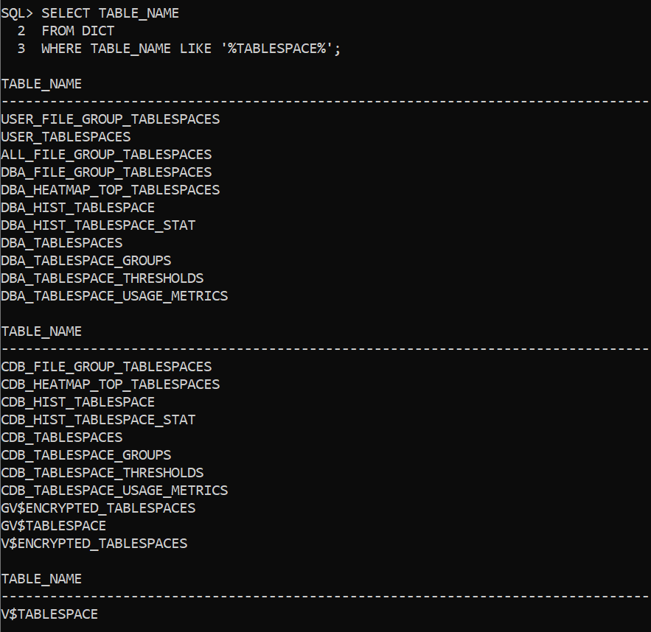

* 1. List the name of the view or table that describes Datafiles:

***SELECT TABLE_NAME, COMMENTS FROM DICT WHERE LOWER(TABLE_NAME) LIKE '%datafile%' OR LOWER(COMMENTS) LIKE '%datafile%';***

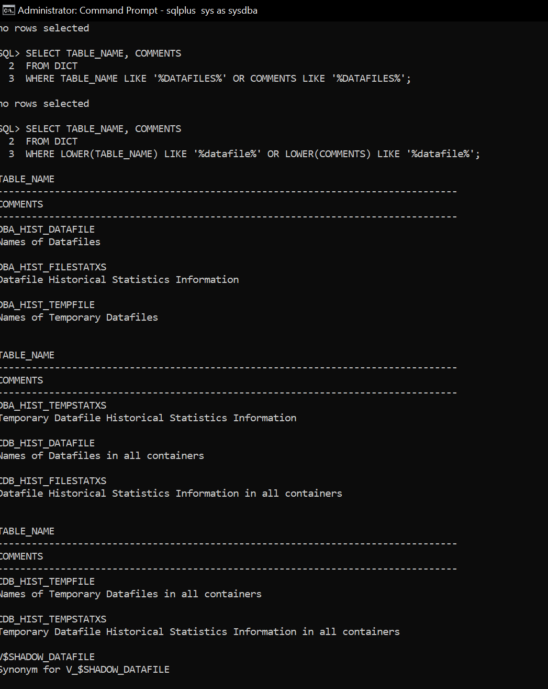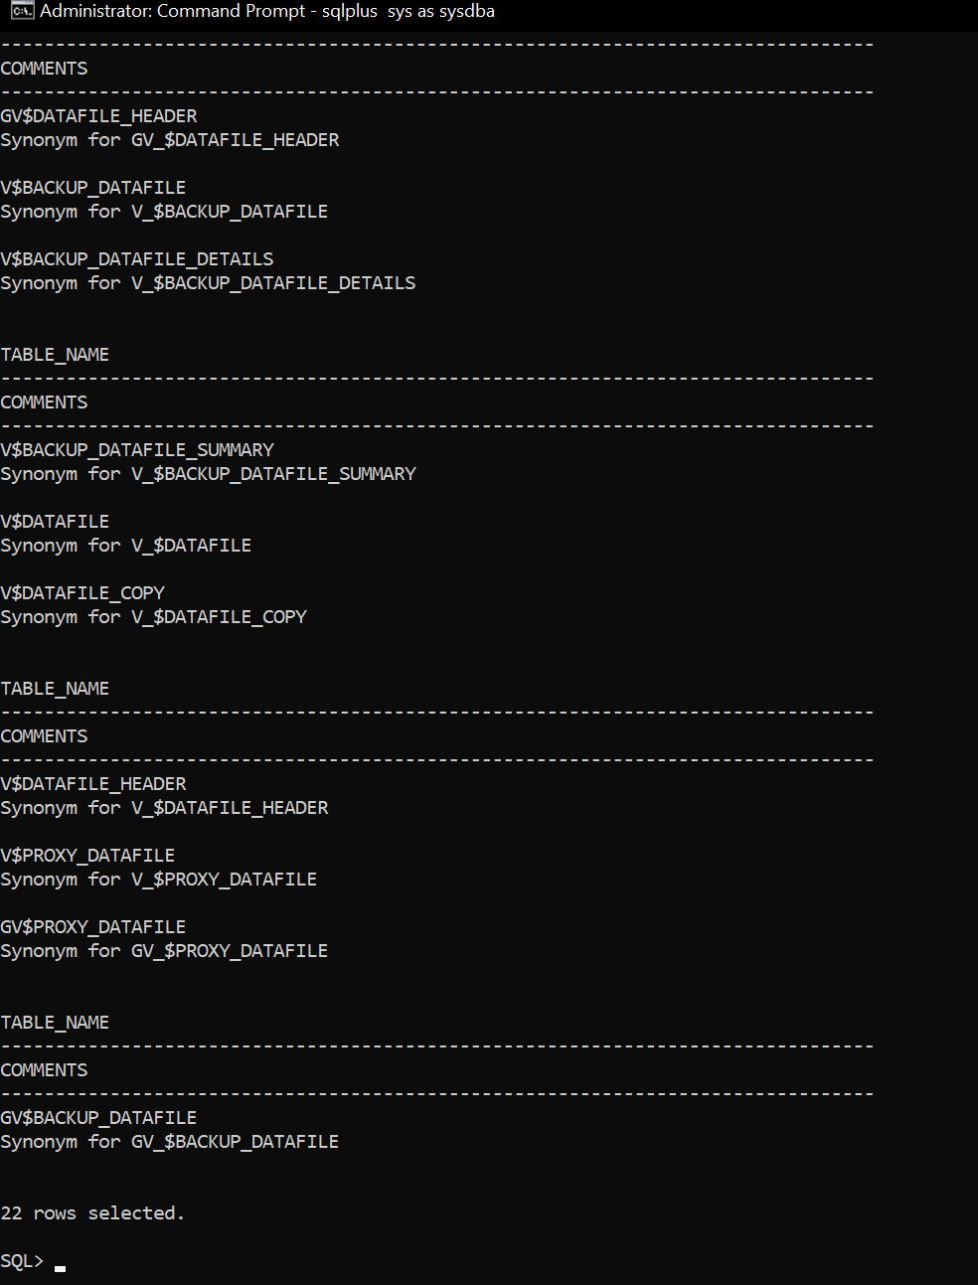

* 1. Write a query that joins the **V_$DATAFILE** and **V_$TABLESPACE** tables, then use the query results to answer the following questions:

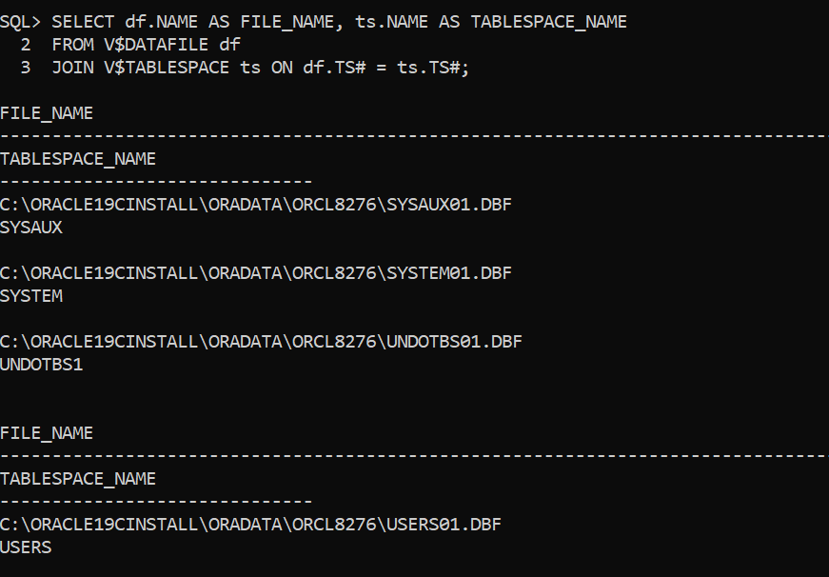

* + 1. What is the location and name of the datafile associated with the SYSTEM tablespace. ***C:\ORACLE19CINSTALL\ORADATA\ORCL8276\SYSTEM01.DBF***
    2. What is the location and name of the datafile associated with the USERS tablespace*.* ***C:\ORACLE19CINSTALL\ORADATA\ORCL8276\USERS01.DBF***

**You're done. Submit your lab.**