Purpose: This lab is the second of two that address the larger theme of NoSQL databases. It focuses on installing and becoming somewhat familiar with the Neo4j graph database.

Graph databases are very appropriate for use in situations where the data *relationships* are more important than the individual attributes. For data that would otherwise be stored in a relational database, it is as if the constraints from foreign-keys are what is being captured. It is more than just the fact that the data is related, it is that the relationships are of interest, and will be queried. The visualization of the data in terms of directed graphs is usually of interest, and the Neo4j browser that we will use in this lab has a built-in visualization engine.

## Requirements:

1. **First Thing**: If you are running Windows 10 Home Edition, you will need to do this step first: (Otherwise: you would have an error after selecting the install location during the Neo4j installation.)
   1. You can check your Operating System Version by typing “About your PC” into the Windows Search bar.
   2. If it is Windows 10 Home do the following:
      1. Add the following items to the Windows Path Environment Variable (System Properties > Advanced > Environment Variables > Path).
         1. %SYSTEMROOT%\System32\WindowsPowerShell\v1.0
         2. %SYSTEMROOT%\System32\wbem
      2. Move the two new components of the path to the top in the path window so that they take precedence in the Path.

There is a very nice white paper available online that outlines “The Top 5 Use Cases of Graph Databases”. Here is the link:

<https://go.neo4j.com/rs/710-RRC-335/images/Neo4j_Top5_UseCases_Graph%20Databases.pdf>

Look at Use Case #3: Master Data Management

What are the main challenges to MDM that a graph database approach can help with?

**Graph databases address key MDM challenges by efficiently managing complex relationships, adapting to dynamic data structures, scaling complex hierarchies, providing real-time performance, simplifying maintenance, integrating multiple data sources, and improving data quality and governance, thereby enhancing overall data management and strategic use of master data.**

1. Navigate to the following site:

[Neo4j Desktop Download | Free Graph Database Download](https://neo4j.com/download/)

And download the current version of Neo4j Desktop. (v 4.4.8 or later)

The relationship between Neo4j Desktop and the other

tools is described at

[Neo4j Graph Platform - Developer Guides](https://neo4j.com/developer/graph-platform/)

and

[Getting Started Guide - Getting Started (neo4j.com)](https://neo4j.com/docs/getting-started/current/)

1. On the download page, click on the download button to initiate the download which includes Neo4j for Developers (the latest default build).
   1. On the next page, fill out the form with your particular information, read the license agreement, and click on “Download Desktop”. The Neo4j installer (approx. 575MB) will download to your laptop.
      1. When the activation key window pops-up, DO NOT CLOSE IT RIGHT AWAY. You will need to copy the key (long string of text) to activate the installation once the download is complete. Take a screenshot of the key pop-up and paste it below. Also, copy the text to a textfile (in Notepad) and save it for later. You can keep this pop-up open until after you have completed the download and installation.
      2. You will be following the instructions as given in the follow-on page “Installation and Launch Guide”. (There is also a link to a video to follow, if you prefer.) The first step is to double-click the Desktop icon for the installer to begin the install. You should get a pop-up similar to the following:

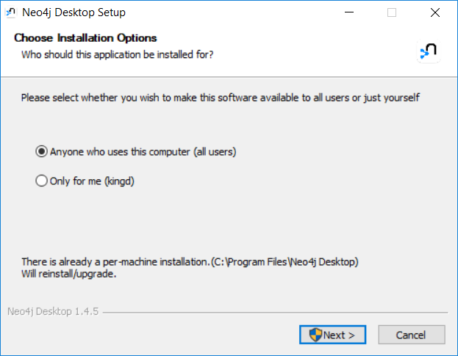

* + 1. Make sure you select “Anyone who uses this computer (all users). Then click Next.
    2. On the next screen, verify the default install location and click Install.

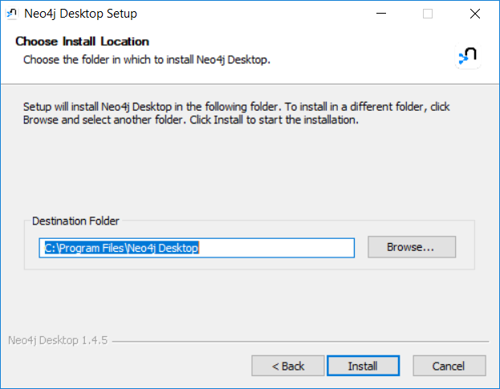

* + 1. On the “Completing Neo4j Desktop Setup” pop-up make sure “Run Neo4j Desktop” is selected, and click “Finish”.
    2. If you get a pop-up from your Firewall, click on “Allow access”
    3. In the (other) pop-up window, Read the License Agreement and click on “I Agree”
    4. If this is your first install:

You may get a pop-up asking for the path where you want to store application data. Make a screen shot that will document your choice & paste below.

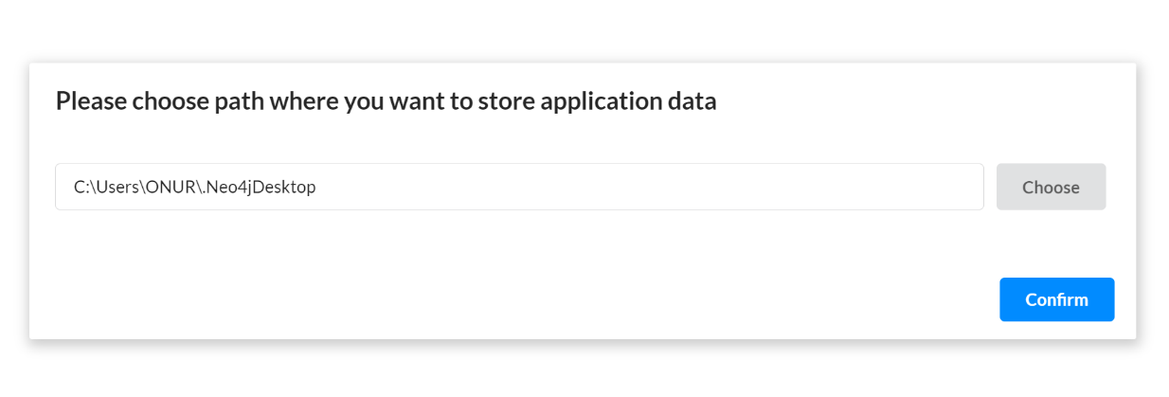

Then, click “Confirm”

On the “Software Registration” pop-up, click on “No thanks! Maybe later. :)” You will be asked again later.

On the “Anonymous Reporting” pop-up, select OK.

1. ***You are now able to create and start a database!.***
   1. In the Neo4j Desktop application, click on the “+New” button to create a new project.
      1. Find the new project in the navigation list on the Left Side of the window. Select the project (if not already selected). Inside the new project, Click “+Add” which will turn give options. Click the one labelled “Local DBMS”.

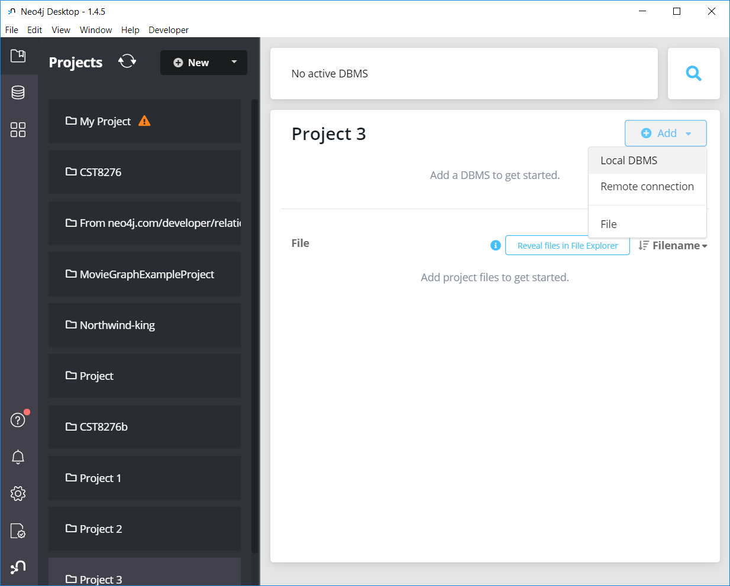

* + 1. Change the suggested Graph Name to: “*yourfirstname*GraphFirstExample”, give a password “myfirstexample” and then click Create.

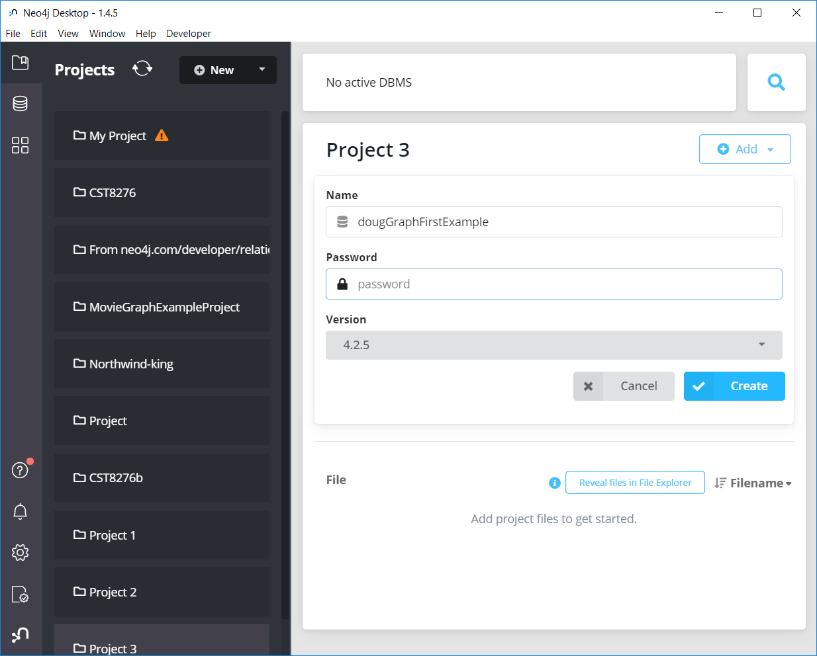

* + 1. Select the newly created Graph DBMS and then click on the Start Button. Once the database (graph) is started, click on the “Open” button and to open it with the Neo4j Browser option.

* 1. The Neo4j Browser will open in a new window, with a command-line near the top (“$” is prompt) and a set of default frames below, showing the output for some commands (e.g., “:play start” and “:server status”

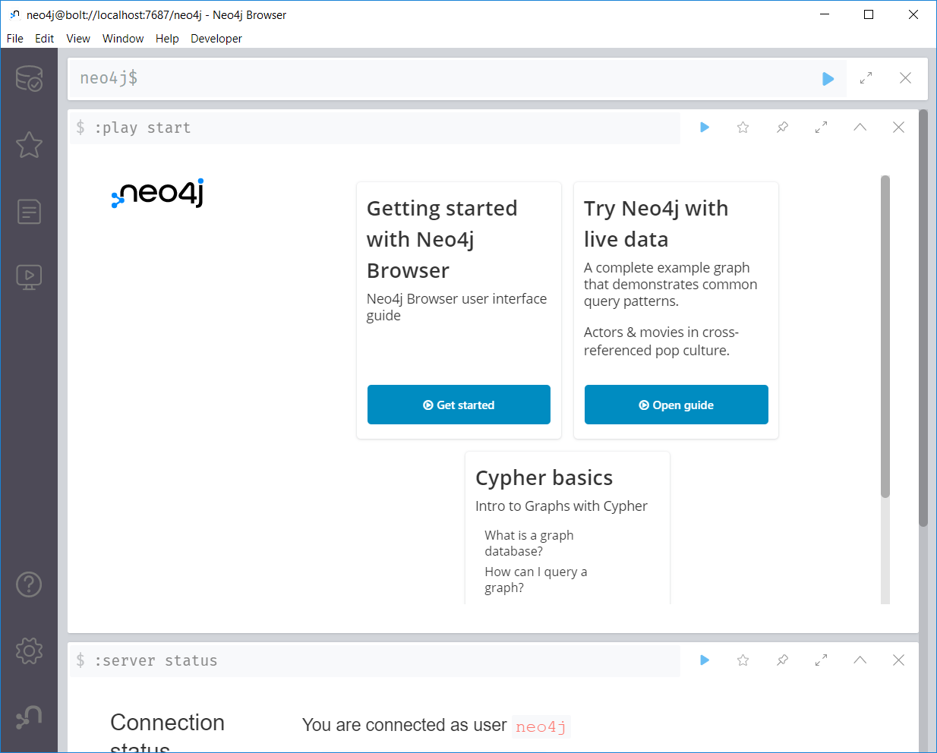

* 1. Click on the “Get Started” button in the :play start output frame.
     1. Read through the Graph Fundamentals material (by clicking “>”)
     2. When you get to “Next steps, read through the Intro and Cypher materials in the Keep Getting started area.

We will now import some data: Make sure you do all steps on each of the screens (you will likely have to scroll down to see some of the commands)

* 1. In the Neo4j Browser, run the command “:play northwind-graph” (Type in the command and click the run button)

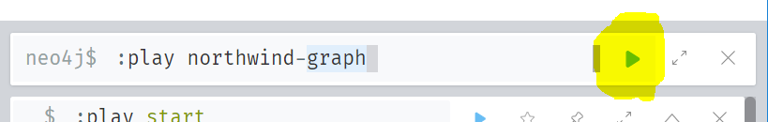

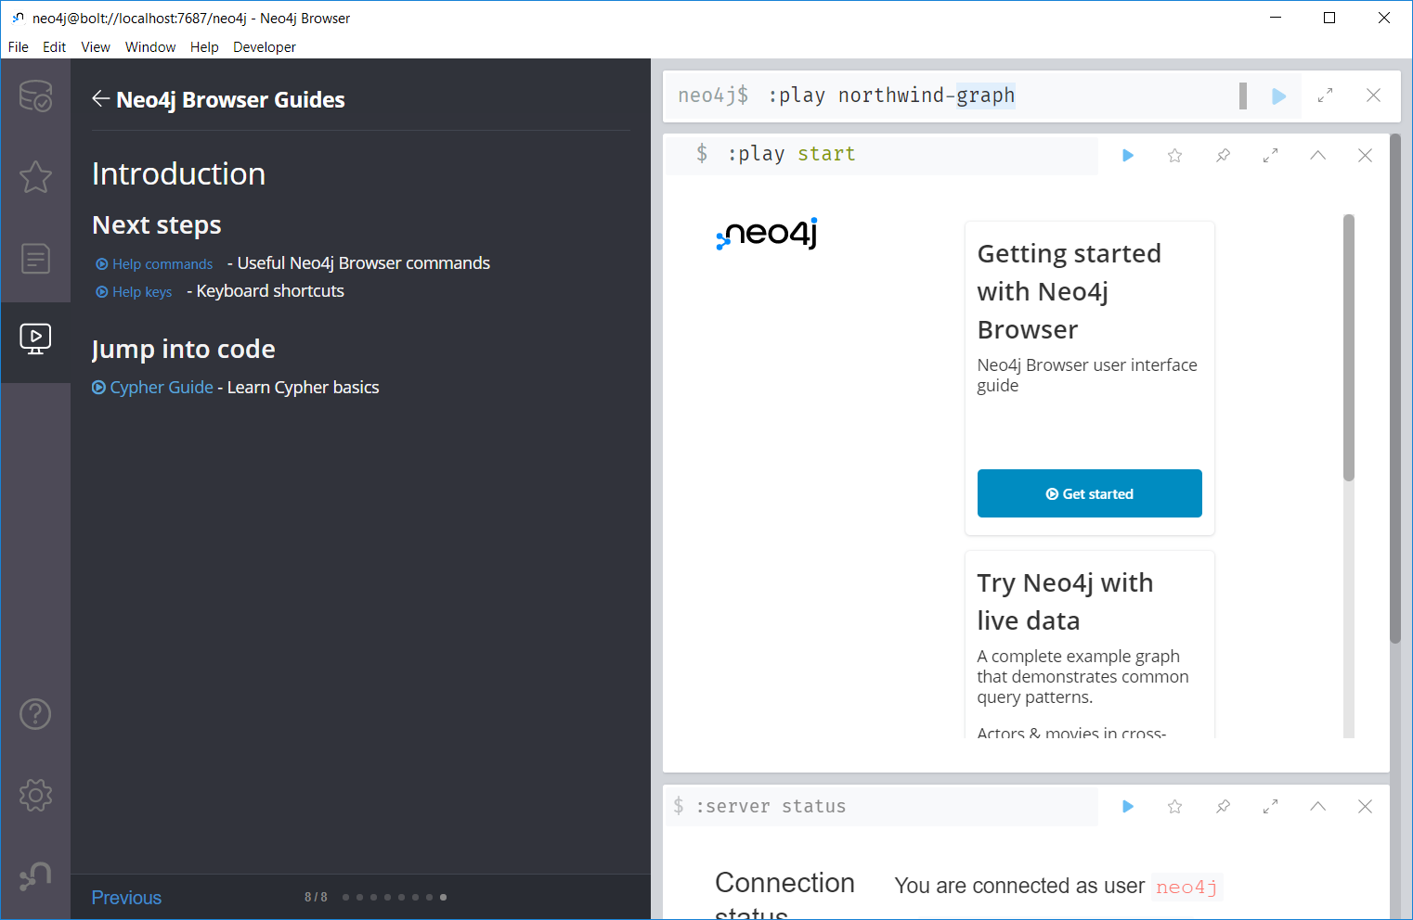

* 1. Then CAREFULLY FOLLOW THE INSTRUCTIONS to load a series of “.CSV” files into the current graph. You need to copy the individual commands into the command window (where you did the :play northwind-graph) and then run them. If you highlight one of the commands – it will get copied into the command window. There should be 7 pages. Run each of the commands in order top-to-bottom in each page before moving to the next page.
     1. Load each of the records from the online CSV files on the first page. Note that the URLs could have been local files. If you receive an error message during the download, you may need to change the http:// portion of the URL to be https:// **(This bug was recently introduced in Aug. 2022).**
     2. There are some commands for creating the three indexes too. Run them.
     3. Then click the “>” button to navigate to the next screen.
     4. Continue running commands on the following screens until you finish screen 3

1. Now comes the magic! You should be on the “Query using patterns” page (screen 4).
   1. Run the first query:

MATCH (s:Supplier)🡪(:Product)🡪(c:Category)  
RETURN s.companyName as Company, collect(distinct c.categoryName) as Categories

1. ***Continue with the Northwind Graph example until you are finished all of importation steps on page 6 and are on page 7 of 7 of the instructions. We will now do some discovery using the Neo4j Browser interface.***
2. Click on the Database Icon near the top left hand side of the main window. 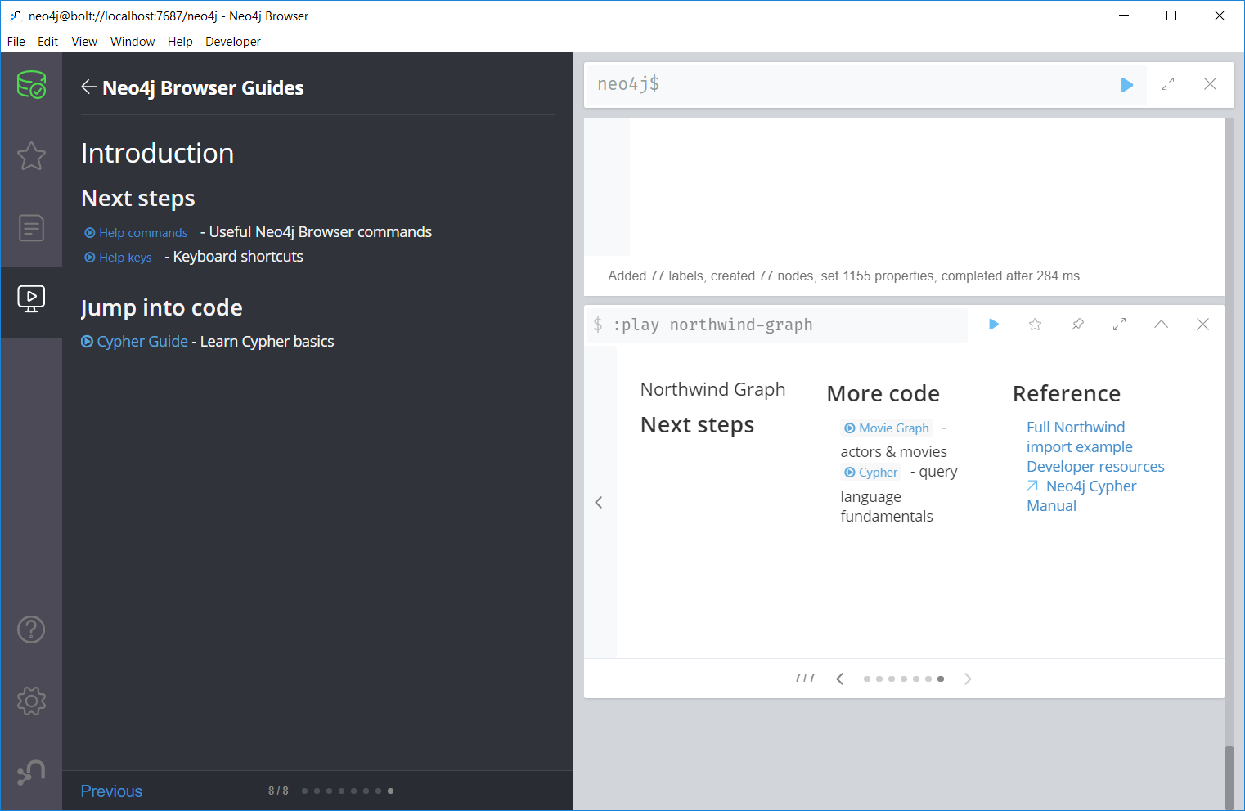

Which after you click will have the browser open with a list of node label types: Customer, Category, Product, Order, Supplier.

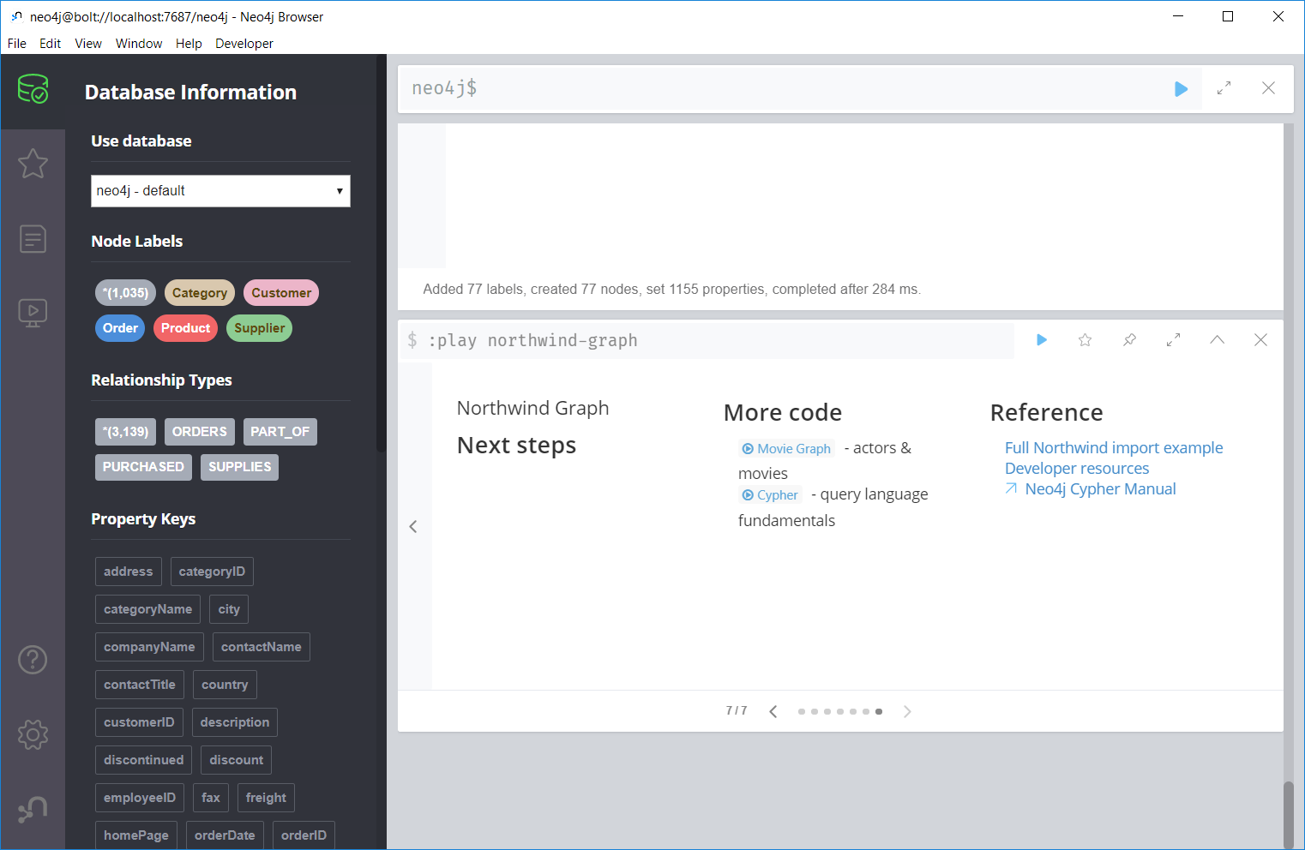

* 1. Click on the “Customer” node label type, and then the “Purchased” relationship type. If you do not see the graph of the database, click on the “Graph” icon in the left hand top area of the result panel. You should see something like this:

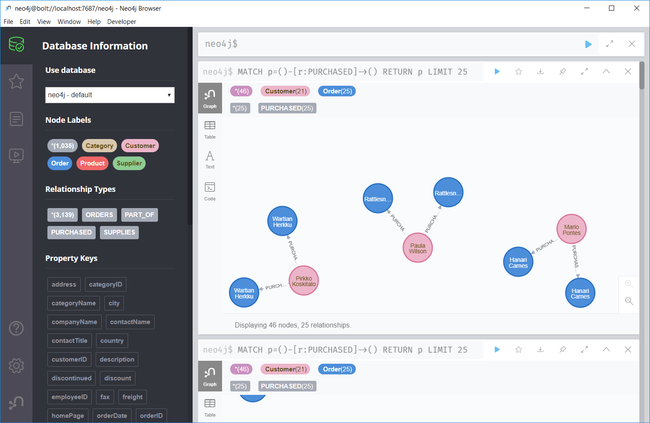

* 1. You will likely need to adjust the display of the node labels by picking which attribute (label, …) to display in the diagram.
  2. Right click on one of the customer nodes. A pop-up ring will appear around the node.

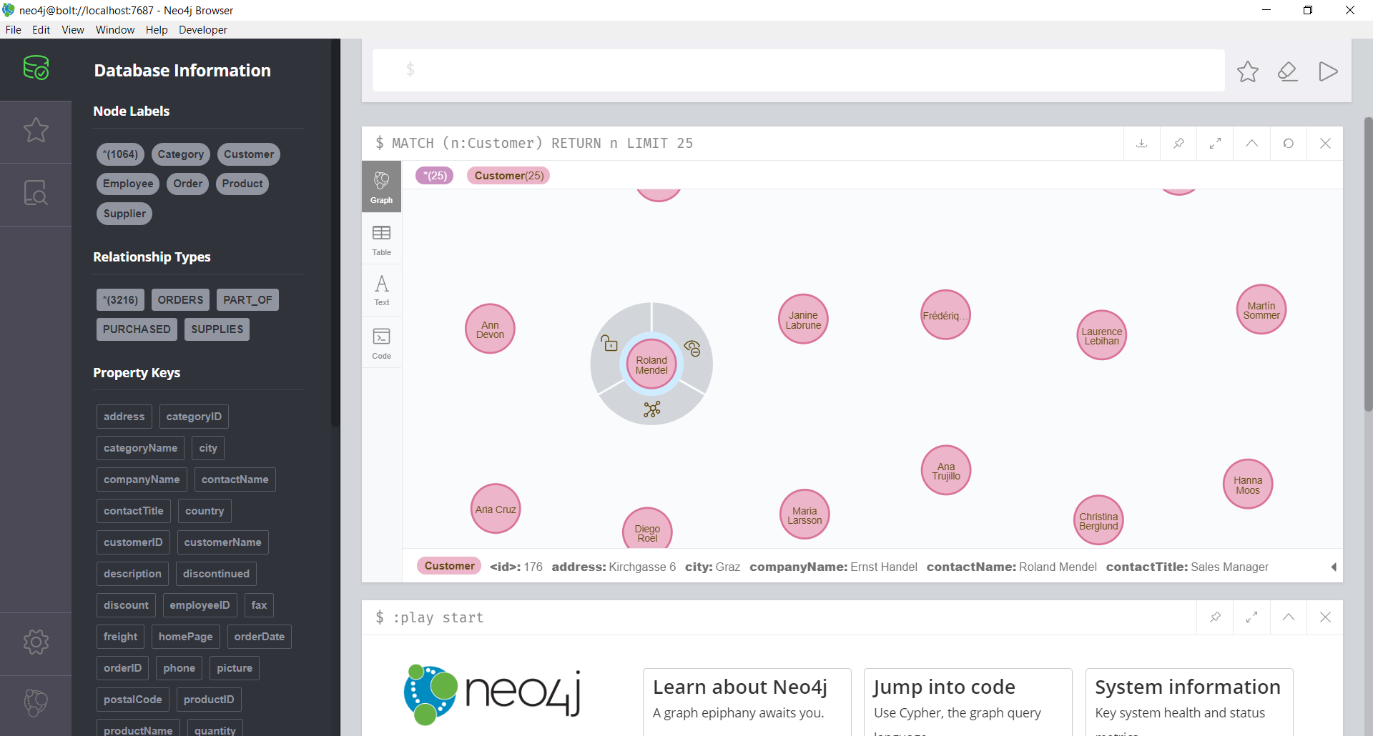

* 1. Now select the graph icon in the bottom part of the pop-up ring; it will load all the relationships for that customer node. For this database, it will show the orders made by that customer. Repeat the process for one of the orders, to find which products were in that order. Then again on one of the products in that order to find a list of other orders containing that product, and continue again on one of the other orders to find other customers who have ordered that same product.

Below is an example showing two potential friends –Paula Wilson and Pascale Cartrain that ordered the same item (Gnocchi di nonna Alice***) If they lived in the same city, it would be interesting.***

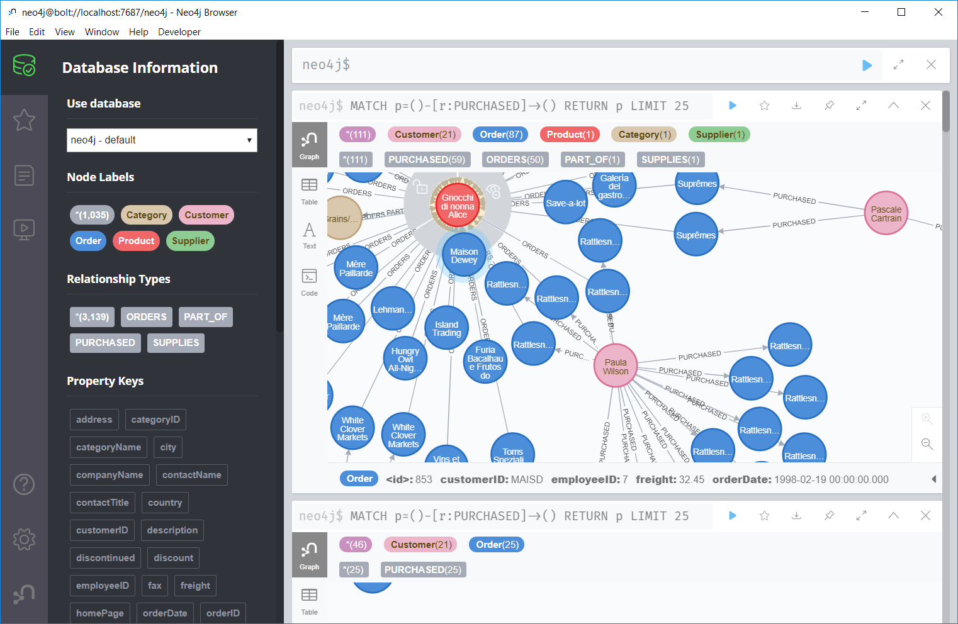

* 1. ***Experiment with the navigation until you can build a screen dump of your relationship map for two other individuals who happened to buy the same product. (It DOES NOT have to be the Gnocchi…)***

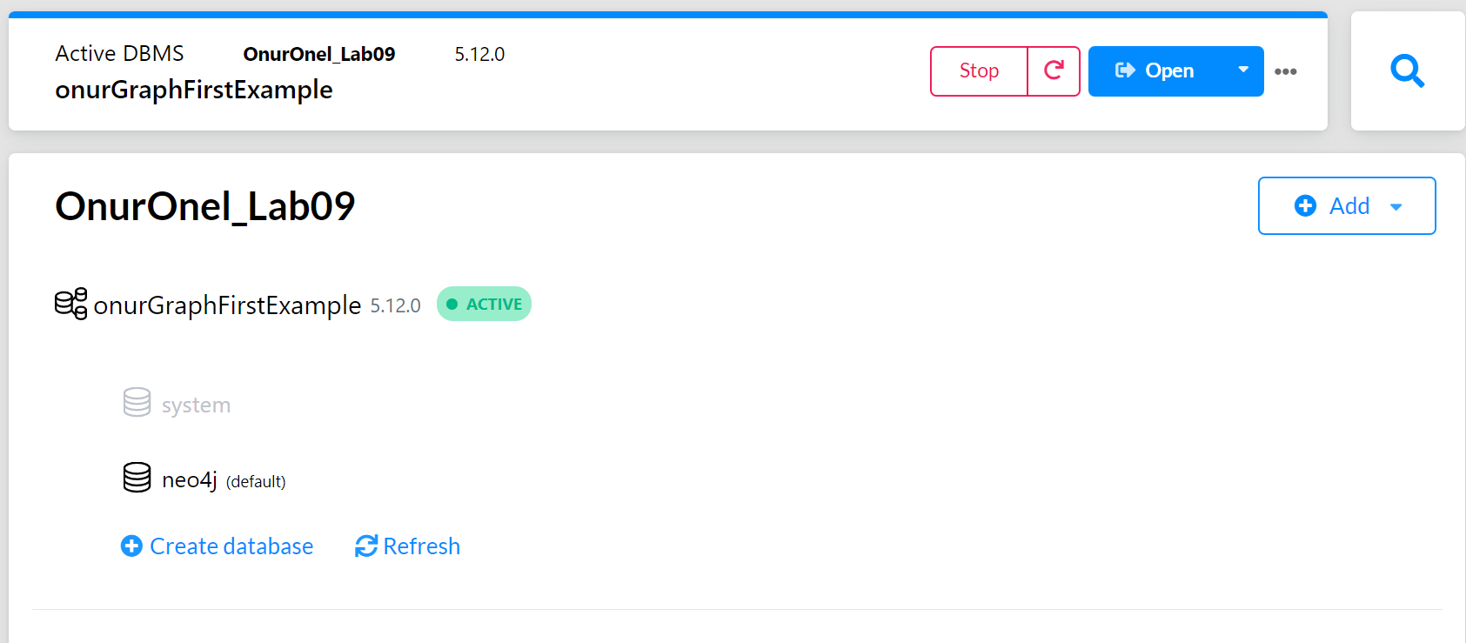

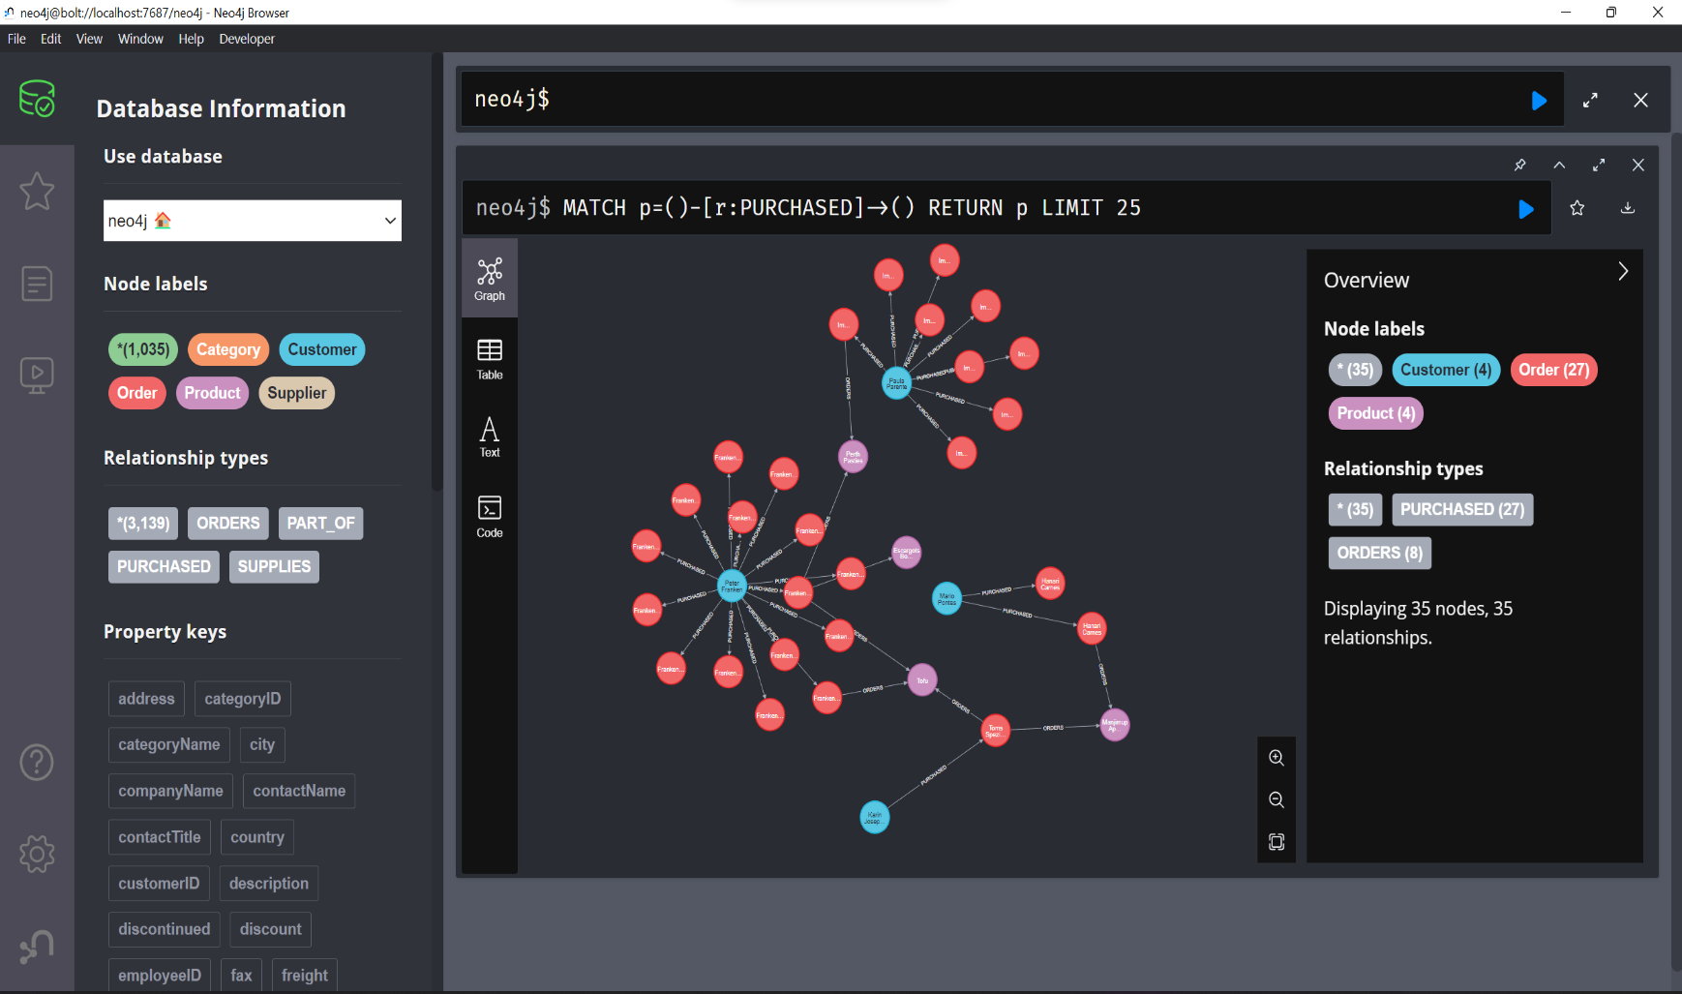

DONE