Lab Section or Time: 031

Student ID#: 041074824

Student Name: Onur Onel

NOTE:

* The test is 90 minutes duration.
* No talking.
* Each student will use their own laptop computer, with Oracle, MongoDB, and Neo4j installed as per the laboratory assignments. Each student has a personalized version of the test, which will be handed out during the lab session. **You must SUBMIT This quiz to record your set of required tasks.**
* There are a sequence of 18 required tasks, with screen shots or short answer responses required to be provided using the **submission document provided on BrightSpace** (under Content > Lab Exam). **You must show your work (using screen shots) for each of the required tasks.**
* Submit your submission document through BrightSpace. This must be done during the allotted time period. **Manage your time carefully.**
* Access to the Internet, including the use of Oracle online documentation, using the Google search engine, and access to online resources, **IS PERMITTED**.
* Collaboration with other students (or anyone else) through any means **IS NOT PERMITTED**.
* Again, to Summarize, you will need to submit the signed ‘**Lab Exam Quiz Paper to your lab professor**’ as well as ‘**Submission Document’** under Assignments in Brightspace.

## Submission for Requirements: (1 point each)

1.

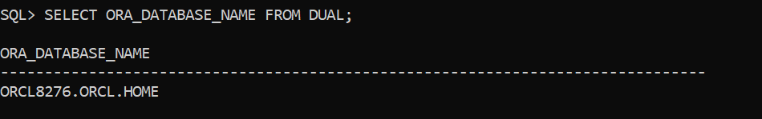

2.

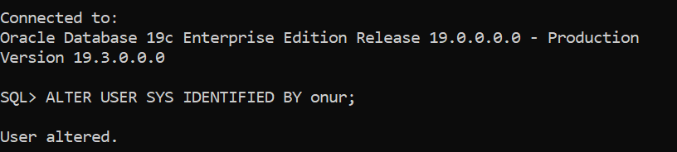

3.

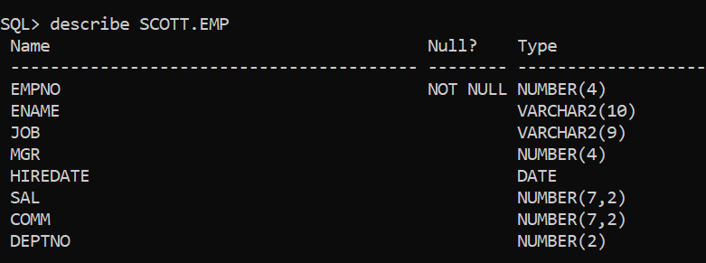

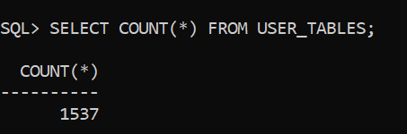

4.

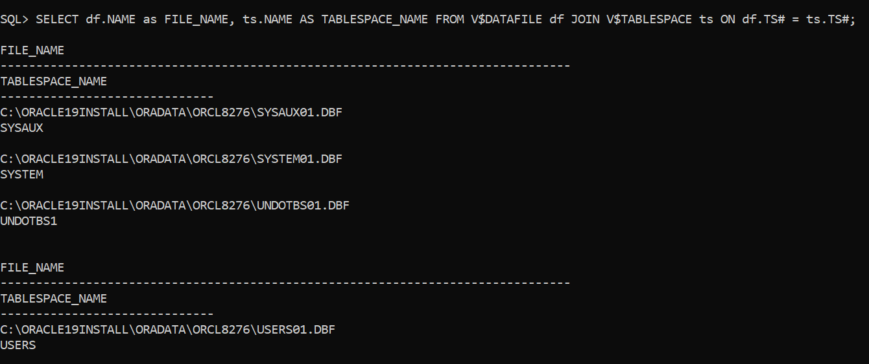

5.

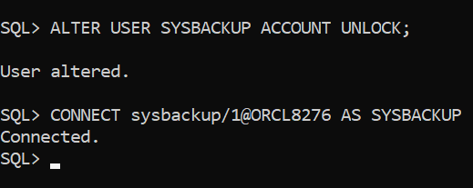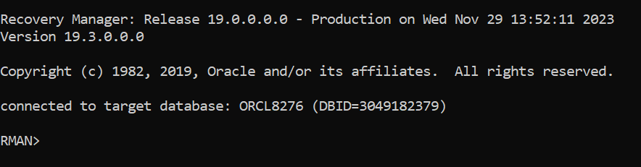

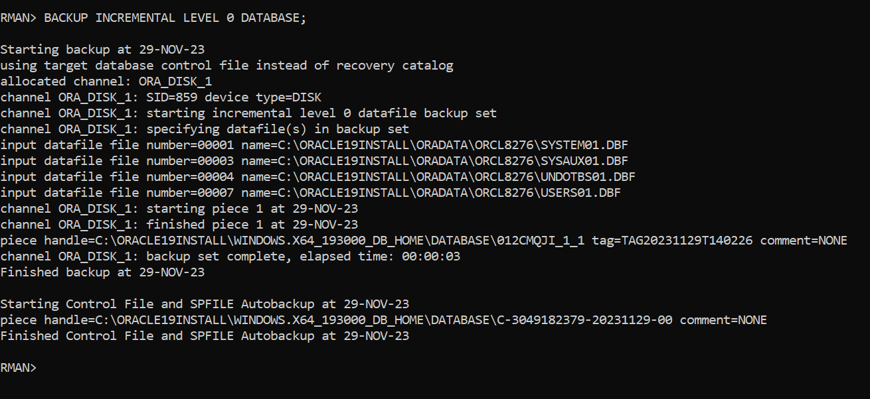

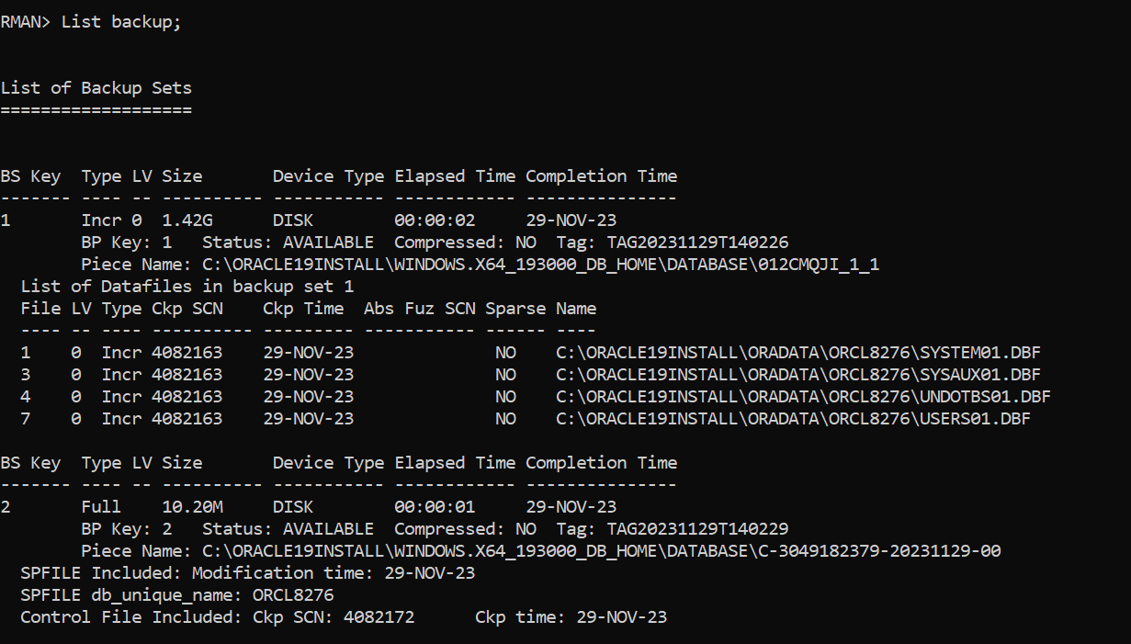

6.

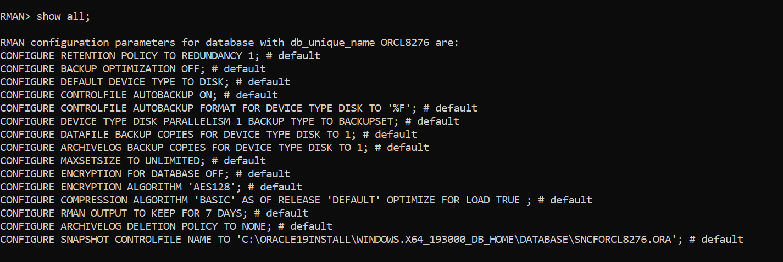

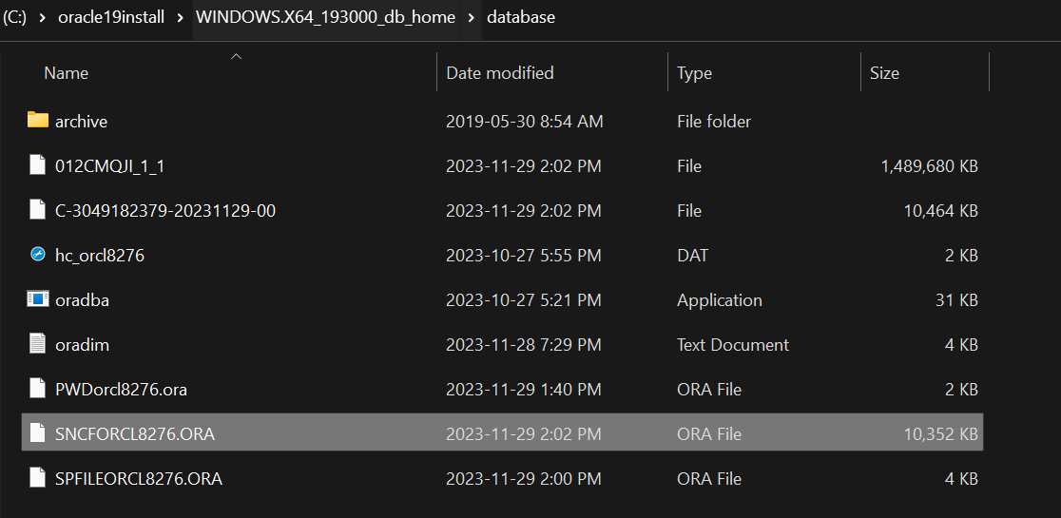

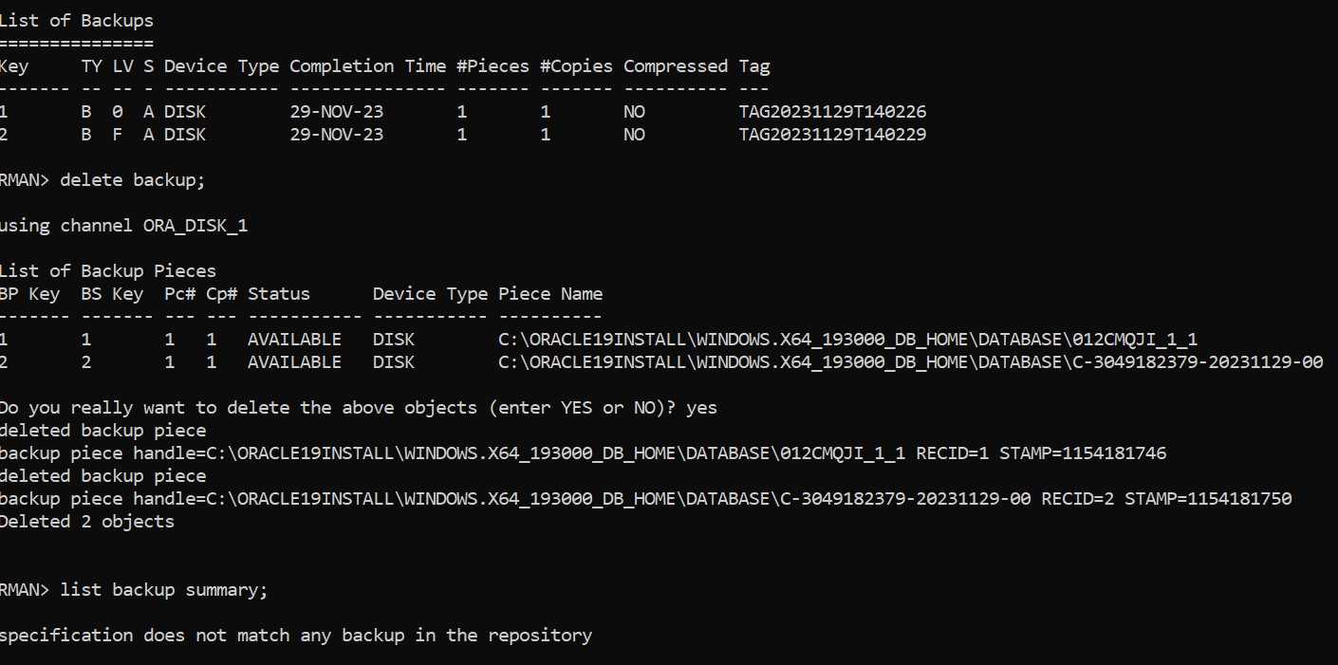

7.

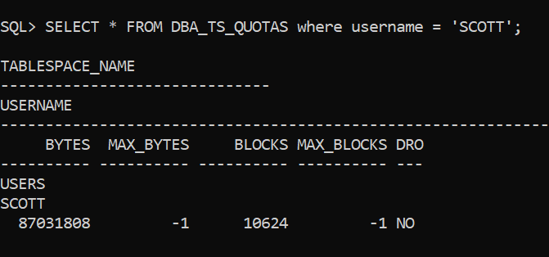

8.

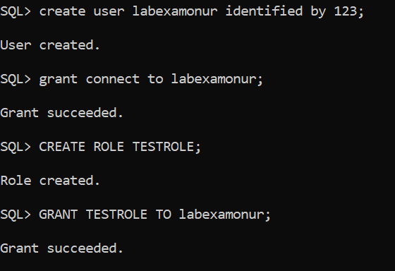

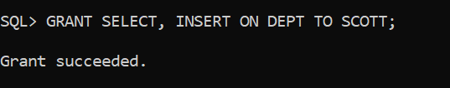

9.

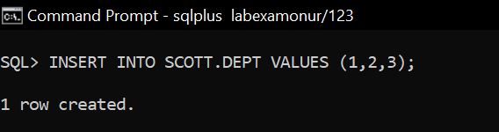

10.

11.

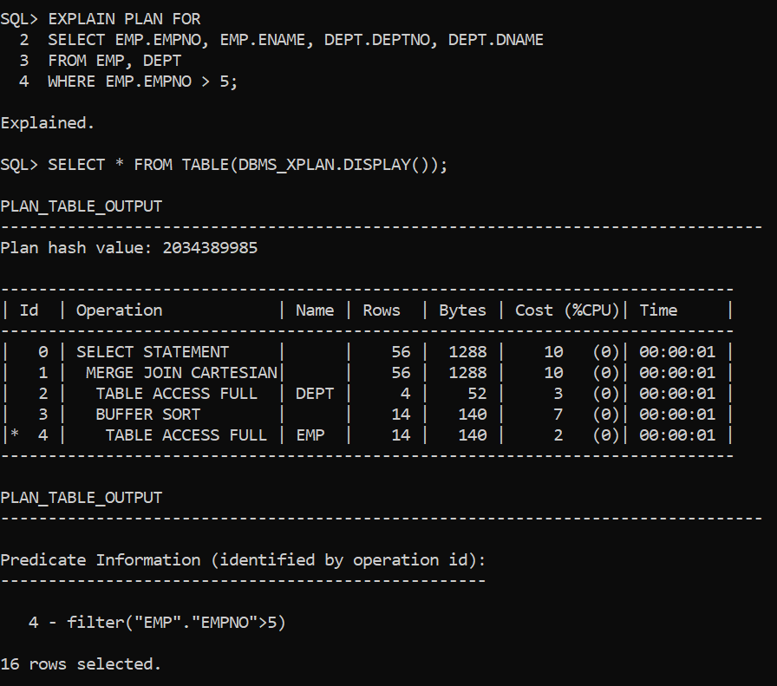

12.

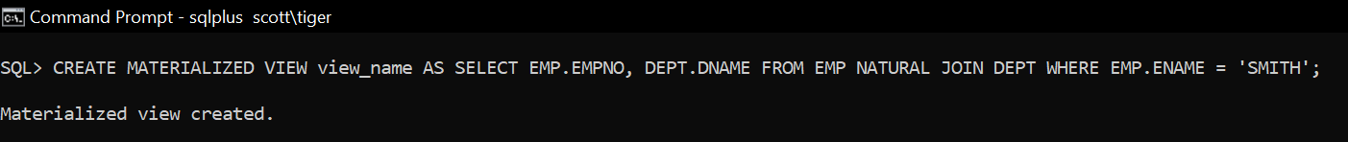

13.

14.

15.

16.

17.

18.

**That’s it! You're done!**