CST2355 – Database Systems Lab Assignment 8

Student Name: Onur Onel

Student ID: 041074824

Student email: onel0001@algonquinlive.com

# Hand-in:

1. The lab assignment will be graded out of a maximum 4 points.
2. This template should be used to submit your lab assignment.
3. Make sure you have enough screenshots to completely document that you have completed all the steps.

**Part A – Data Modeling using SQL Developer**

# Activities (Steps):

1. First thing we need to do is update SQL Developer to the latest version:
   1. Go to: <https://www.oracle.com/tools/downloads/sqldev-downloads.html> and download SQL Developer version 20.4 (or later). (If it is newer than 20.4, your installation/configuration steps may be slightly different.)
   2. When it is downloaded to your PC, extract all the contents of the .zip file.
   3. Then navigate to find ‘sqldeveloper.exe’ and using a right-click menu create a short-cut on your desktop by selecting the ‘Send To’ desktop option.
   4. Run the application.
   5. You will likely be prompted to import your preferences from the previously-installed SQL
   6. developer version: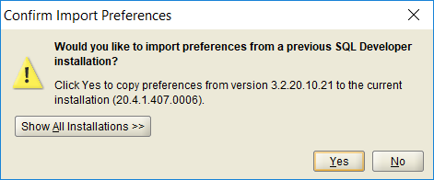
   7. If so, import the preferences.
2. **Select the ‘*yourname*UserConnection*’* from the list of connections**, and then from the File menu, select: Data Modeler, Import, Data Dictionary (see below):

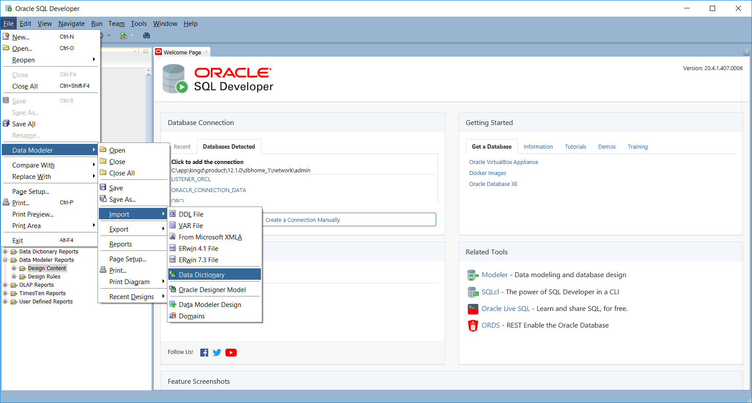

* 1. And click on Next. You will be prompted for your password, and then given a list of schemae from which to select.

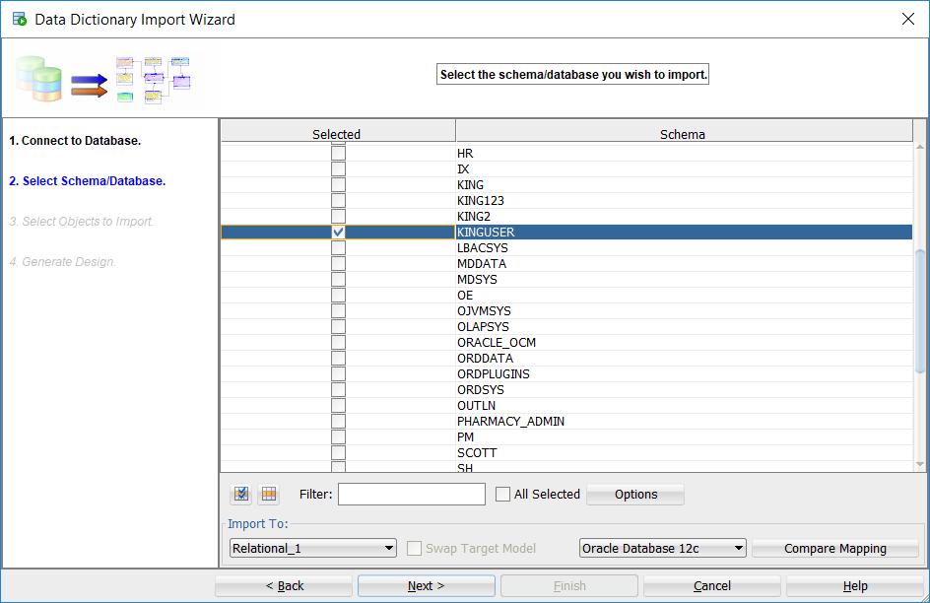

* 1. Select the *yourname*User schema and then click Next.
     1. You will be prompted for what items you would like to import.
        1. Select all of the 11 Tables
        2. Select *yourname*User and MDSYS from Users
        3. Select all of the 4 Roles from the original database
        4. Select CST2355 from Tablespaces
        5. Select both of the 2 Stored Procedures.
  2. Then on the confirmation screen, select ‘Finish’

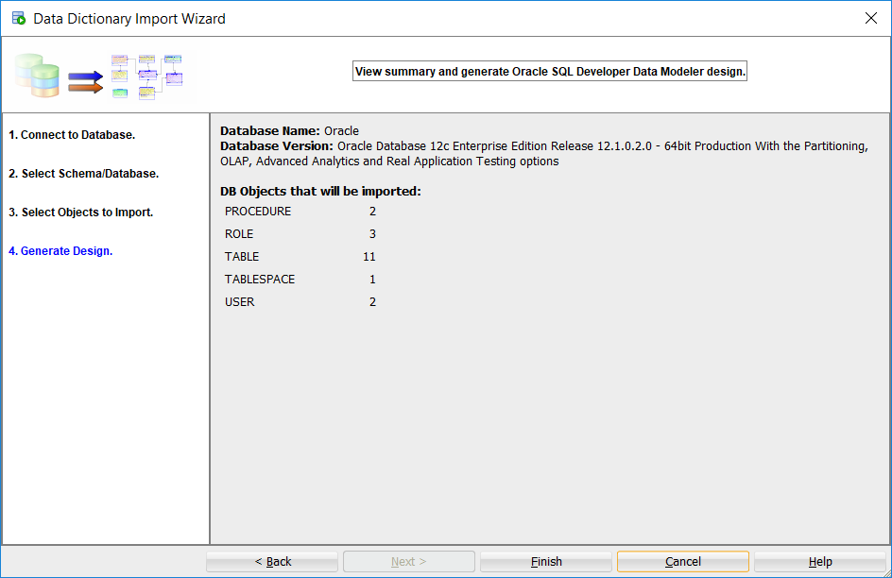

* 1. When completed, you will see the E-R diagram. Here is mine:

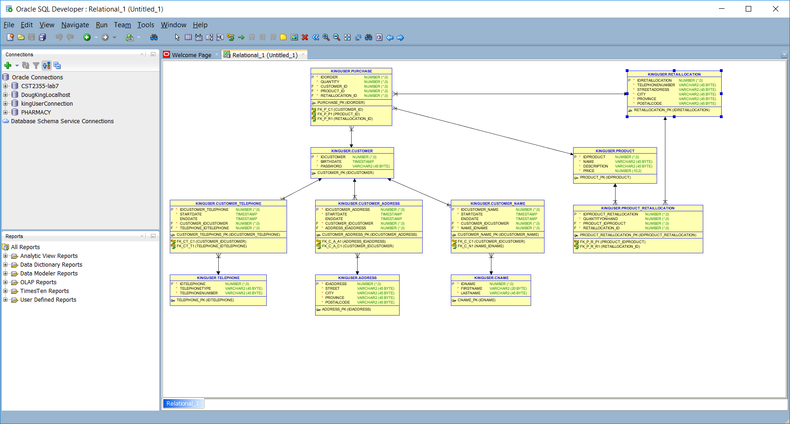

* 1. In SQL Developer, use the menu bar to select the View > Data Modeler > Browser. You will then see a list of designs. Select your new ‘Untitled’ design and save it as *yourname*UserDesign.
     1. Provide a screen shot showing the Data Modeler browser and your newly saved design.

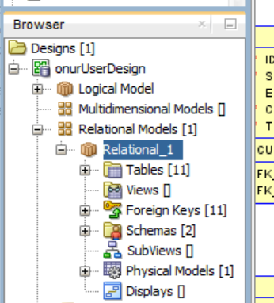

* + 1. Select your relational model in the browser and use the right-click menu to ‘Show” it. Here is mine:

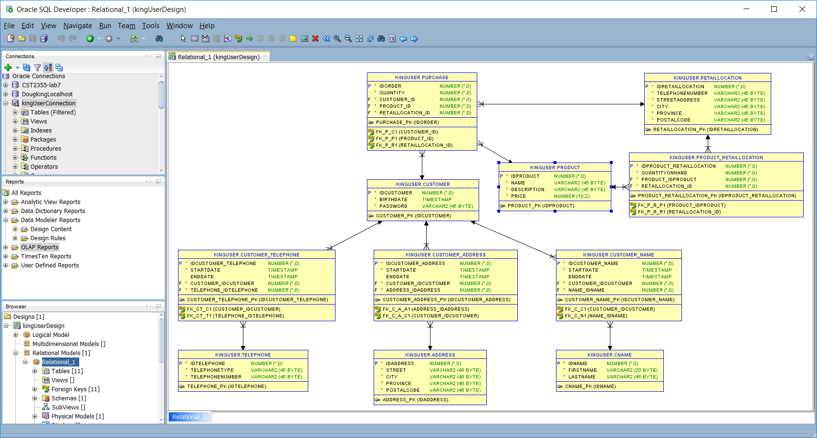

* + 1. Fix the layout of your reverse-engineered diagram so it will all fit on one page with no crossing lines. Provide a screenshot of your relational model here:

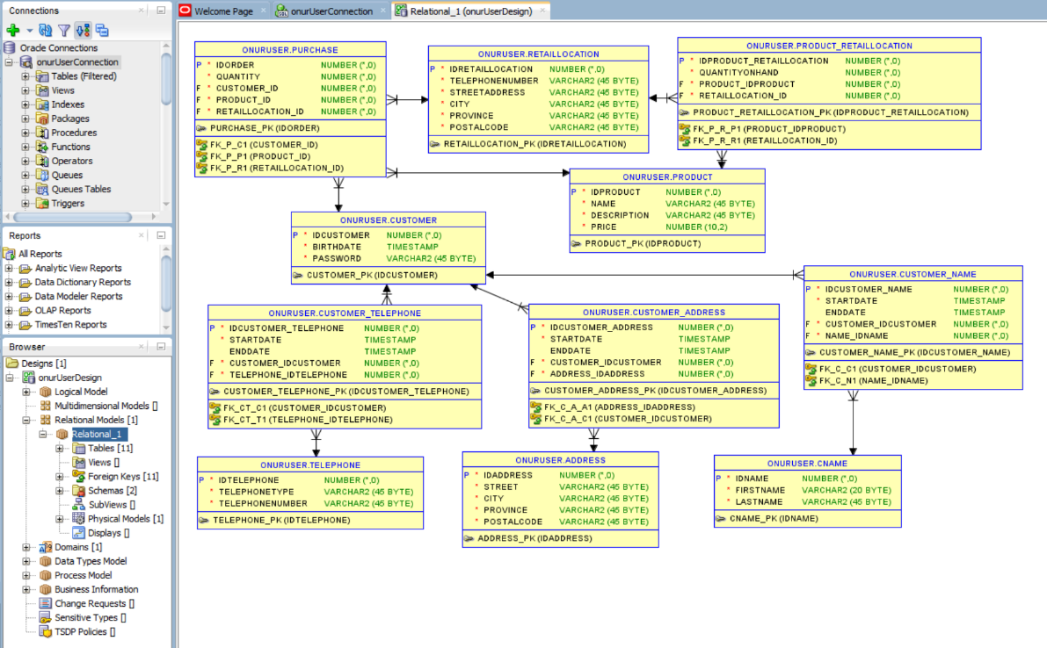

* + 1. Select your relational model and then using the right-click menu, select ‘Engineer to Logical Model’. Provide a screenshot of your logical model here

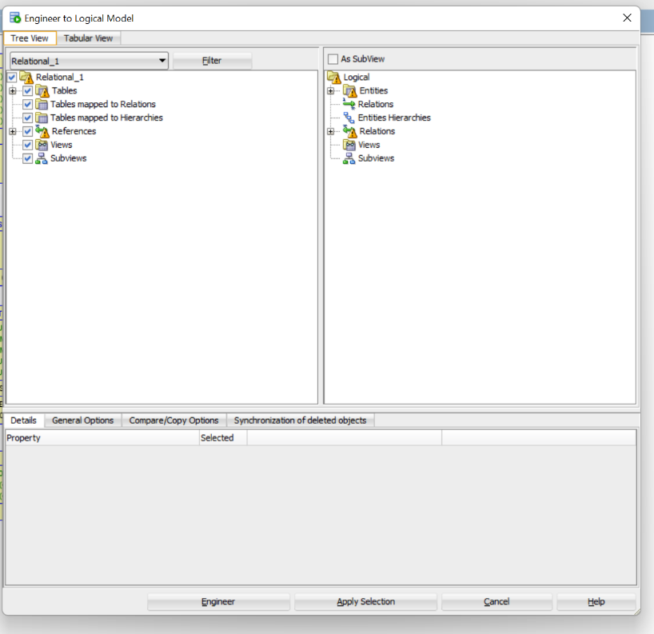

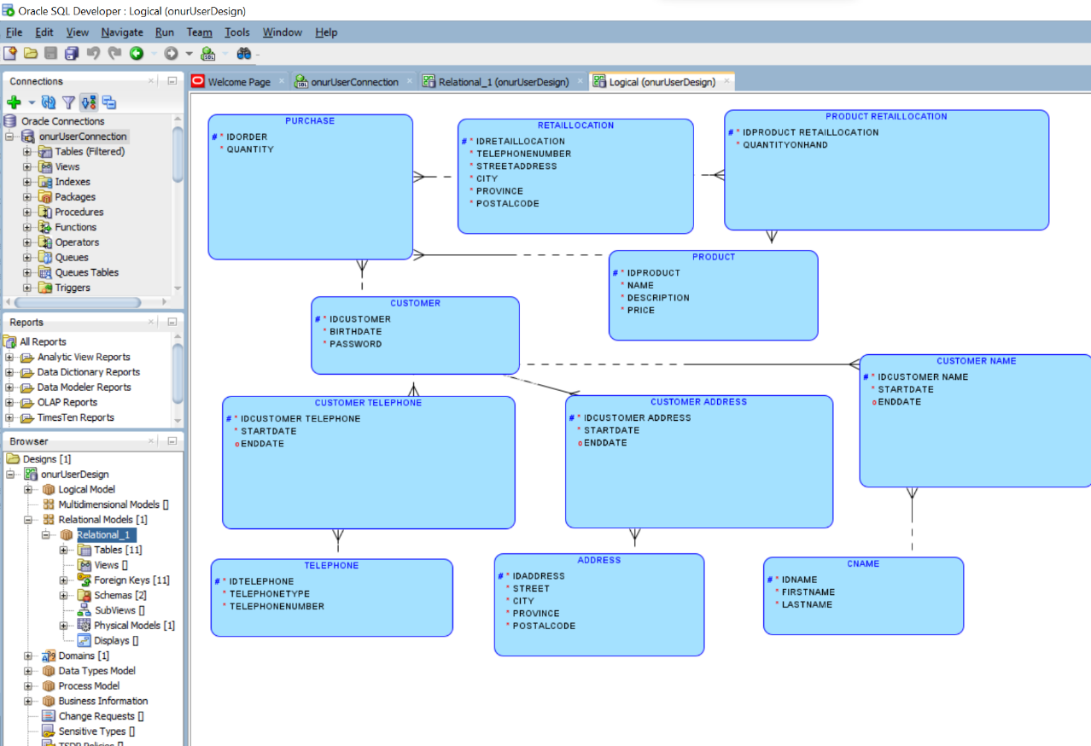

1. **Save your work.**

**Part B – Database Trigger**

**Background**: In this part of the lab, we will create a trigger on **CUSTOMER** table (created in lab7 through lab7-create.sql) script. The objective of the trigger is to check the age of every new customer record being inserted or updated into customer table and if the customer’s age is below 18, then a record will also be inserted into an additional UNDER18_CUSTOMERS table.

1. Connect as *yourname*User (created in lab7) and create a table called ‘UNDER18_CUSTOMERS’ with the following fields: (choose appropriate field types)

IDUNDER18: number for use as a surrogate key

IDCUSTOMER: to identify the customer record just inserted or updated,

OPERATION: a string indicating the type of update (‘Insert’, ‘Update’),

TS: timestamp of insert/update (sysdate),

UPDATED_BY: the database username for the connection making the update.

Provide a screenshot showing the table structure:

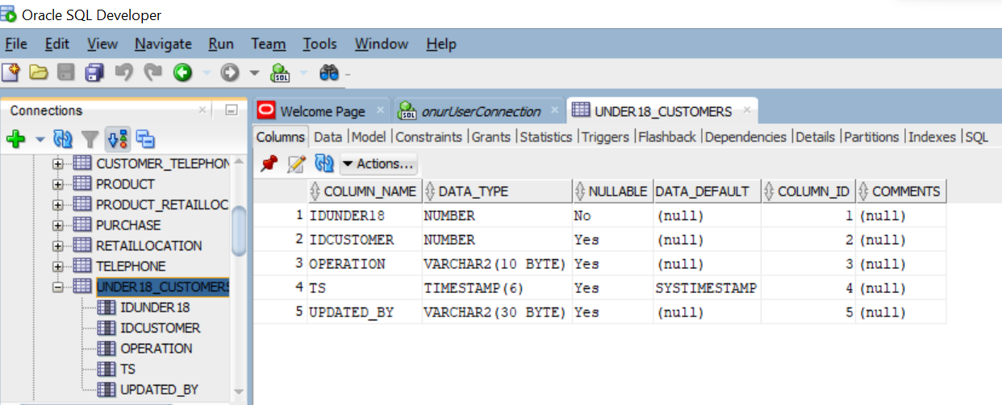

* 1. Create the sequence “UNDER18_SEQ” starting at 1 and incrementing by 1 for use in populating the UNDER18_CUSTOMERS 🡪 IDUNDER18 column. Show your work below.

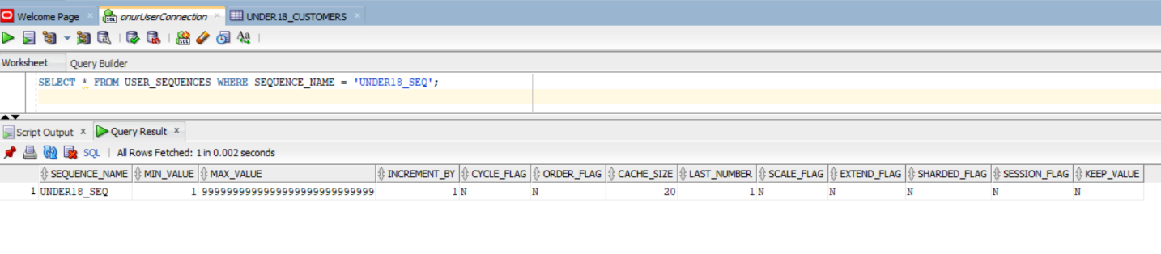

1. Now, you will create a trigger to run after INSERTS and UPDATES on the **customers** table to log customers with birthdates showing that they are not yet 18 years of age. Firstly, review the “Tutorial: Creating a Trigger that Logs Table Changes” example at  
   [https://docs.oracle.com/database/121/TDDDG/tdddg_triggers.htm#TDDDG50000](https://docs.oracle.com/database/121/TDDDG/tdddg_triggers.htm)
   1. Here are the details for your trigger:
      1. Use the function “trunc(months_between(sysdate, birthdate)/12)” to determine the age in years. If they are currently under 18, put an entry in the “UNDER18_CUSTOMERS” table.
      2. Use your “UNDER18_SEQ” sequence to populate the IDUNDER18 field.
      3. Use the customer’s IDCUSTOMER to populate the IDCUSTOMER field.
      4. Use the current sysdate to populate the TS field.
      5. Use the currently connected “USER” (e.g., ‘kingUser’) to populate the UPDATED_BY field.
   2. Provide a screenshot below showing your trigger code:

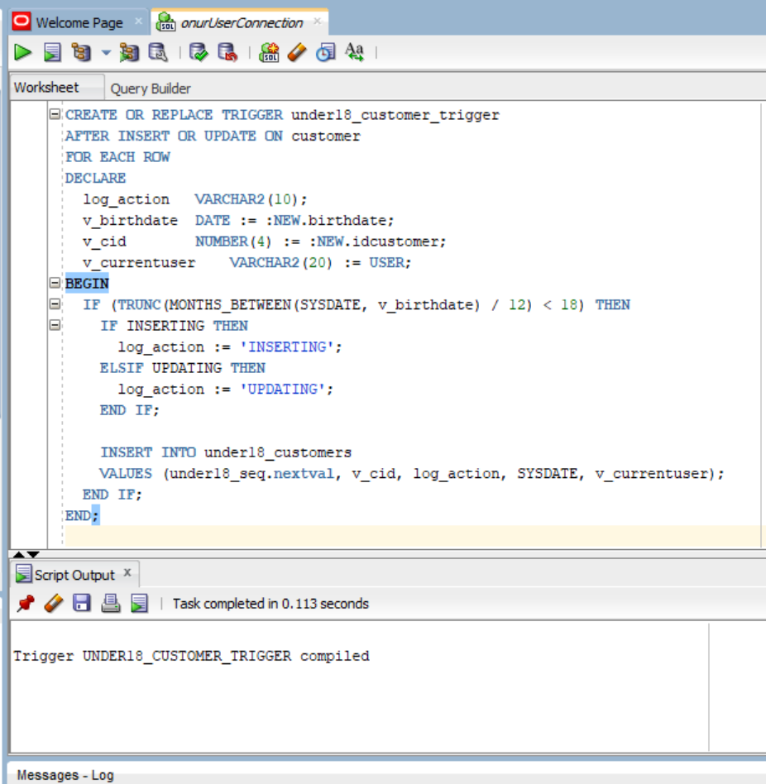

* 1. Testing the Trigger by inserting and updating records in customer table.
     1. Now, insert a new record in the customer table. Ensure that this new customer’s age is below 18. Review the insert statement in ‘Lab7-create’ for sample of insert statement on customer.
     2. Update the password of the new customer record inserted above.
     3. These Insert & Update on customer should have executed the trigger in the background and populated the under18_customers tables. Provide a screenshot of records in the under18_customers table. (There should be atleast two records as a result of above insert and update).

