**Programming Language Research Assignment 3**

Algonquin College

School of Advanced Technology

Computer Programming

Onur Önel

Mazin Abou-Seido

23F_CST8333_360

Submitted November 24, 2023

A technical report submitted to Algonquin College in partial fulfillment of the requirements for a diploma in Computer Programming

**Development Environment Changes**

In Phase 04, the final stage of my project, I've kept the development environment mostly unchanged. The only exception was during Phase 03 when I attempted to use MySQL but faced some compiler issues. I've detailed these issues in my Practical 03 submission and on the discussion board.

For stability in this crucial final phase, I'm continuing with SQLite, specifically version 3.44.1, released on November 22, 2023. My chosen integrated development environment (IDE) is JetBrains CLion, version 2023.2.2, which has been very effective for my project's needs. To ensure my code is reliable and error-free, I've integrated CATCH2 for unit testing. This tool is vital for maintaining high code quality, a key aspect of my project's overall success. With this setup, including SQLite, JetBrains CLion, and CATCH2, I'm well-prepared to efficiently complete the last phase of my project.

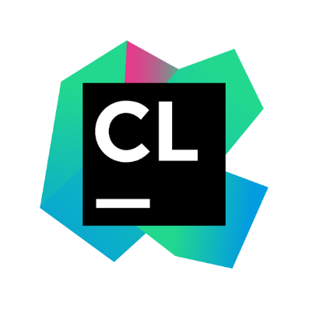



Sqlite Home Page, https://www.sqlite.org/index.html

JetBrains, “Clion: A cross-platform IDE for C and C++ by JetBrains,” JetBrains, https://www.jetbrains.com/clion/

Catchorg, “Catchorg/Catch2: A modern, C++-native, Test Framework for unit-tests,” GitHub, https://github.com/catchorg/Catch2

**Research and Learning Resources**

I downloaded SFML version 2.6.1 from SFML 2.6.1 Download for data visualization purposes, including Horizontal Bar Charts, Vertical Bar Charts, and Pie Charts. Since I'm using the CLion IDE, which defaults to the MinGW compiler, I followed the SFML download page's suggestion to use a specific compiler version. Accordingly, I downloaded GCC 13.1.0 MinGW (SEH) - 64-bit. This version was recommended under 'Here are links to the specific MinGW compiler versions used to build the provided packages.' After downloading, I integrated this new MinGW compiler into CLion, replacing the default MinGW compiler, by adjusting the toolchains section in the IDE settings.

“Download,” Download (SFML), https://www.sfml-dev.org/download.php

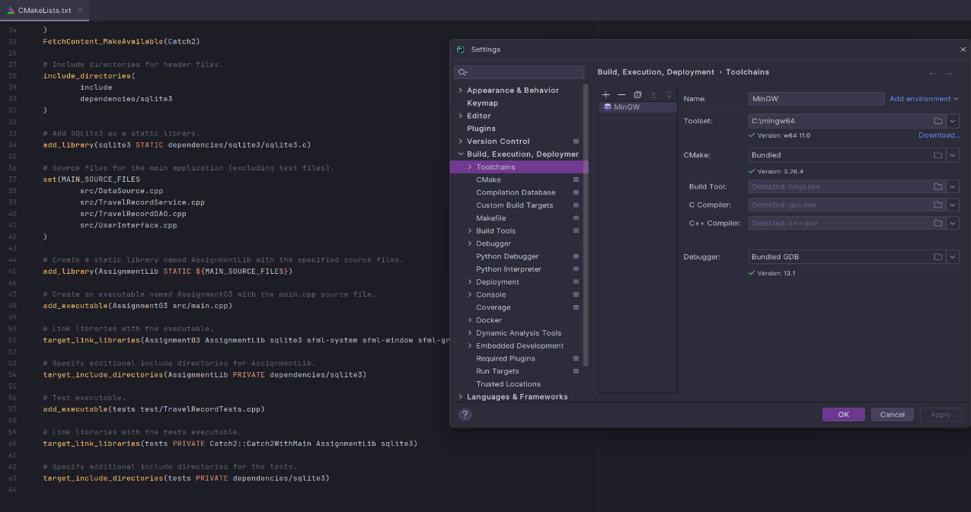

After configuring the compiler through CMakeLists.txt, I successfully displayed a test window using the SFML Library.

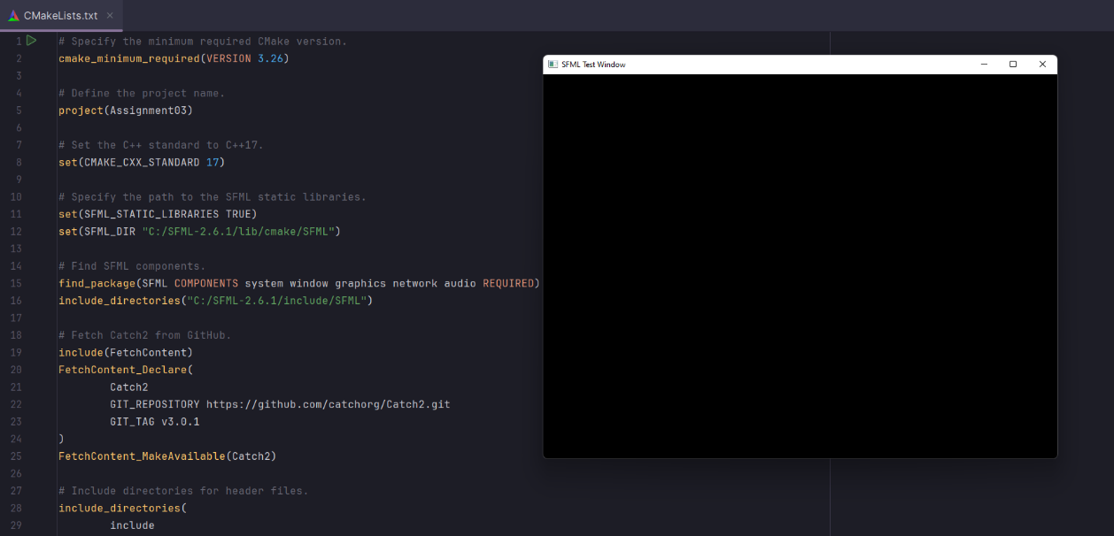

I gained foundational knowledge from the official SFML tutorials available at SFML Tutorials, supplemented by a video titled 'How to get SFML to work with Clion'. For Practical Project 4, my plan is to employ SFML for rendering charts that visually represent data. This will be achieved by processing and analyzing query results obtained from a SQLite3 database. This approach not only leverages SFML's capabilities but also integrates database interaction for comprehensive data visualization.

* “Tutorials for SFML 2.6,” 2.6 Tutorials (SFML / Learn), https://www.sfml-dev.org/tutorials/2.6/
* “How to get SFML to work with Clion,” YouTube, <https://www.youtube.com/watch?v=PInJvpQSRHw&t=2s>

**WBS and Gantt for Practical Project Part 4**

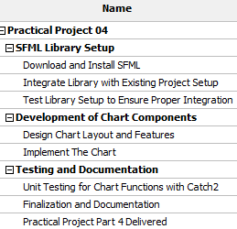

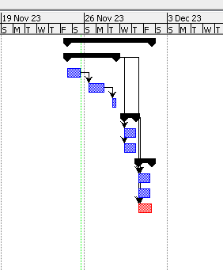

**References**

1. Sqlite Home Page, https://www.sqlite.org/index.html
2. JetBrains, “Clion: A cross-platform IDE for C and C++ by JetBrains,” JetBrains, https://www.jetbrains.com/clion/
3. Catchorg, “Catchorg/Catch2: A modern, C++-native, Test Framework for unit-tests,” GitHub, https://github.com/catchorg/Catch2
4. “Download,” Download (SFML), https://www.sfml-dev.org/download.php
5. “Tutorials for SFML 2.6,” 2.6 Tutorials (SFML / Learn), https://www.sfml-dev.org/tutorials/2.6/
6. “How to get SFML to work with Clion,” YouTube, <https://www.youtube.com/watch?v=PInJvpQSRHw&t=2s>