# IoT Data Collector Application Demo

## Prerequisites

* Cloudera Quickstart VM 5.13 has been downloaded and started up.
* Cloudera VM jdk version is set with 1.8.0_202 before the Apache Spark 2 parcel upgrade
* Apache Spark 2 parcel upgrade has been downloaded and distributed to node.

## Installing and Running

After creating executable jar (mvn clean package), iot_log_collector-1.0-SNAPSHOT-jar-with-dependencies.jar file will be used for data pipelines.

Project have two executable parts. First part is Kafka data ingestion application, the other part is Spark data processing application. Both of them have been written by Java.

#### Kafka Data Ingestion Application Part

In order to run data ingestion application, below command will be used

*java -cp iot_log_collector-1.0-SNAPSHOT-jar-with-dependencies.jar com.company.iot.data.App*

#### Spark Data Processing Application Part

Before the running Spark application (spark-submit), SPARK_KAFKA_VERSION variable should be set as below

*export SPARK_KAFKA_VERSION=0.10*

and

*spark-submit --master local --class com.company.iot.data.streaming.JavaHBaseStreaming iot_log_collector-1.0-SNAPSHOT-jar-with-dependencies.jar*

## Starting

Before the data ingestion and data processing start, Hbase table created.

Create ‘iot’,’rawdata’,’data’

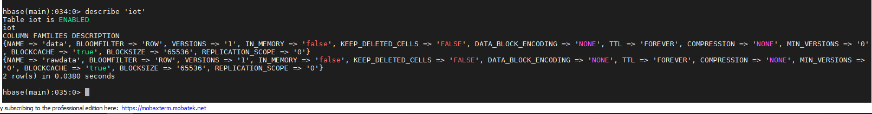

First, Kafka application has been started and then, Spark streaming application has been started. Spark application console output can be seen as below

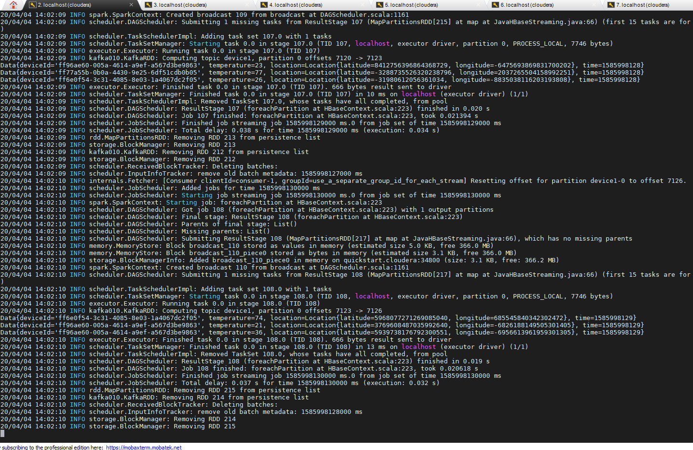

At the same time, data which was inserted into Hbase can be seen as below (After insert into HBase).

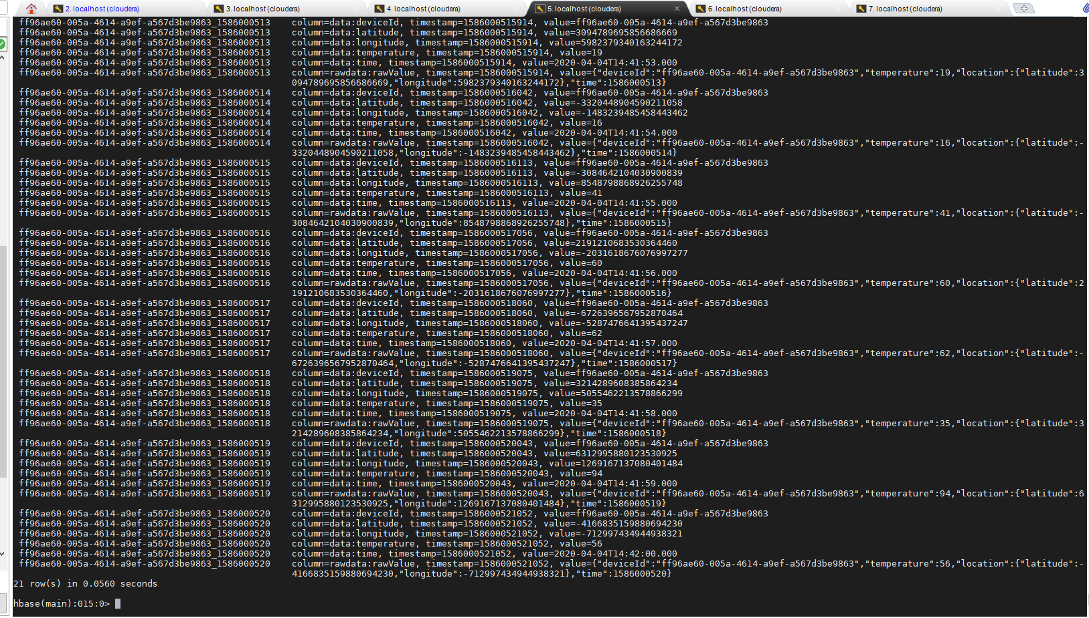

Metastore Table has been created on hive

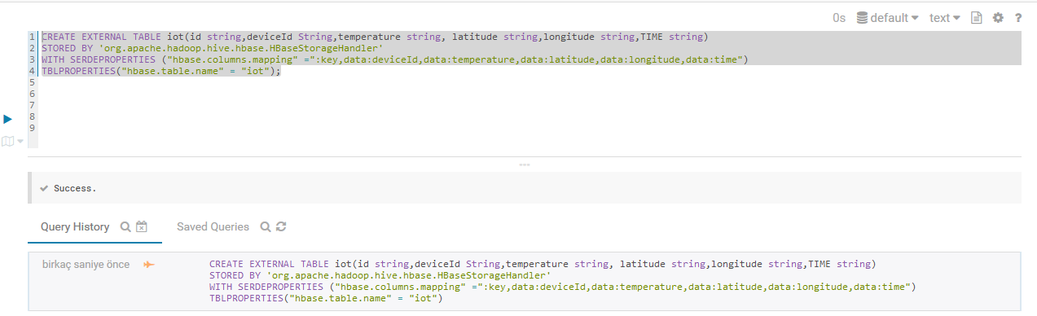

Select test on Impala

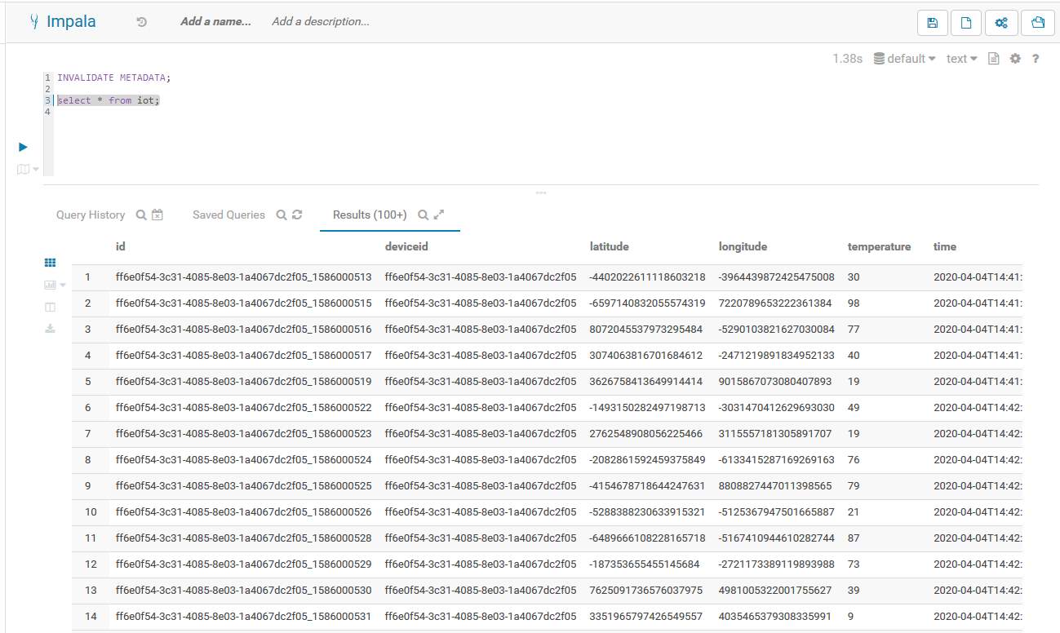

## Expected Data Analysis Queries

1. The maximum temperatures measured for every device

Impala Query:

Select deviceid, max(cast(temperature as int)) from iot group by deviceid;

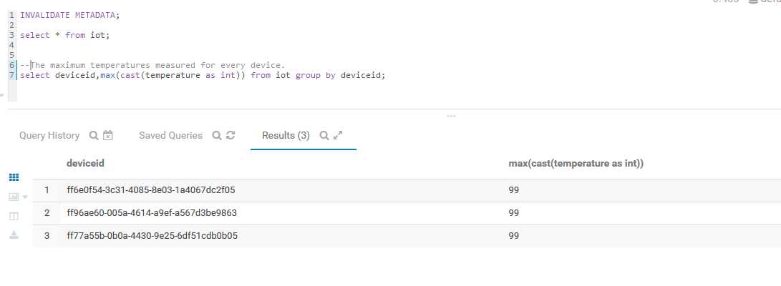

1. The amount of data points aggregated for every device

Impala Query:

Select deviceid, count(*) from iot group by deviceid;

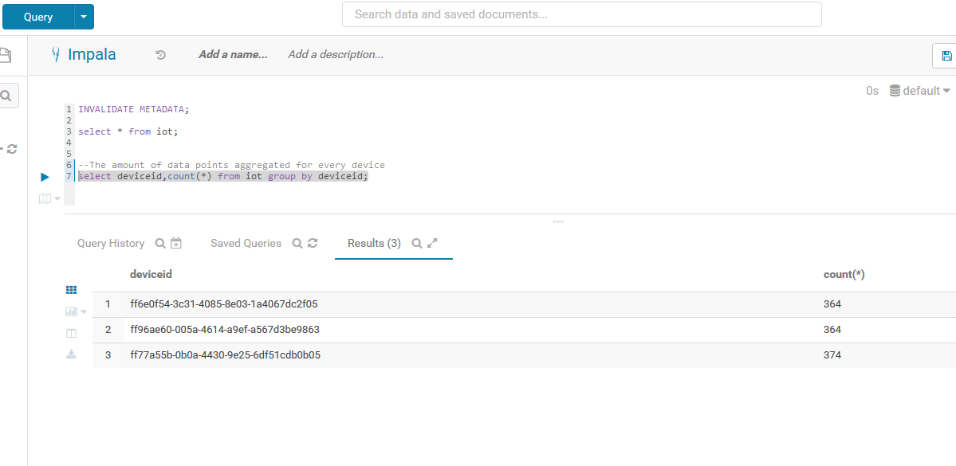

1. The highest temperature measured on a given day for every device

Impala Query:

Select deviceid, from_timestamp(time,’yyyy-MM-dd’) as given_day, max(cast(temperature as int)) from iot group by deviceid,given_day;

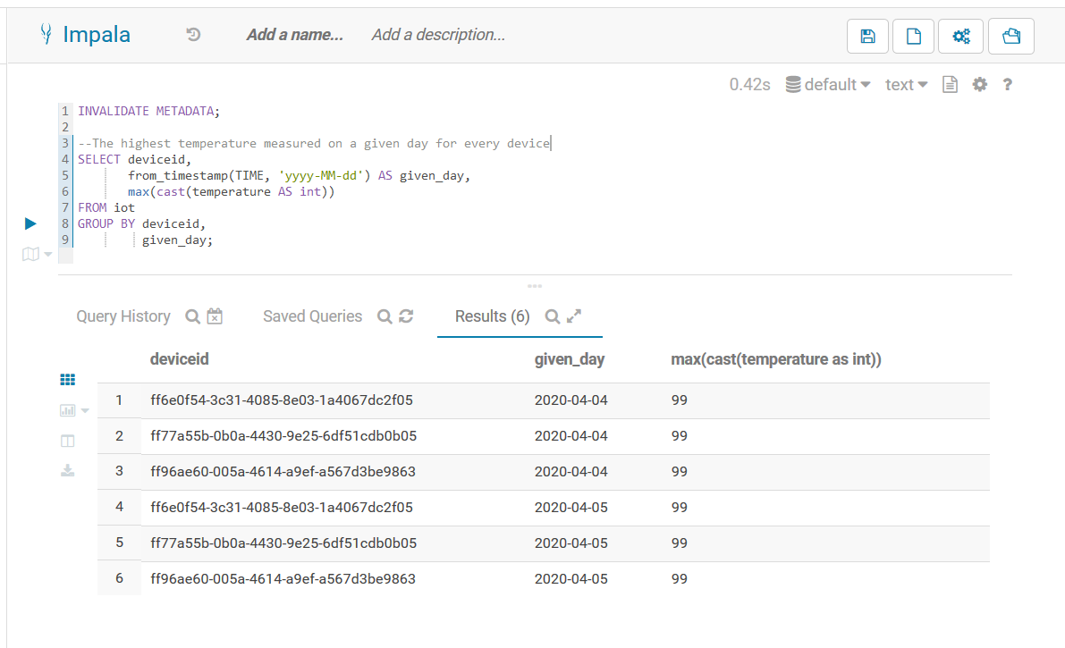

select deviceid,max(cast(temperature as int)) from iot where time like '2020-04-04%' group by deviceid

