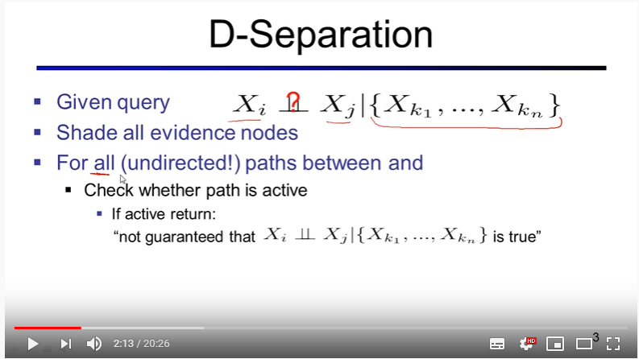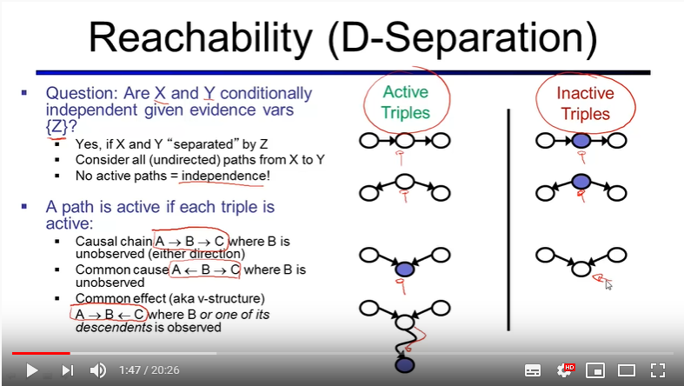

no active paths = independence. Active paths not guaranteed to be true.

Algorithm:

Consider all (undirected) paths from x to y

For all paths:

For every triple:

IF TRIPLE IS INACTIVE

Then all other triples are inactive ( even you found active one before), the path is inactive,

Continue, (go other path);

IF TRIPLE IS ACTIVE

If one triple only, its active

If there are more than one triple, go for other triples.

IF ALL PATHS ARE INACTIVE

Independence

IF EVEN ONE PATH IS ACTIVE:

Not guaranteed to be indepedent

In V structure, the node or any of the descendants.

Active path = not guaranteed to be independent = not guaranteed to be true

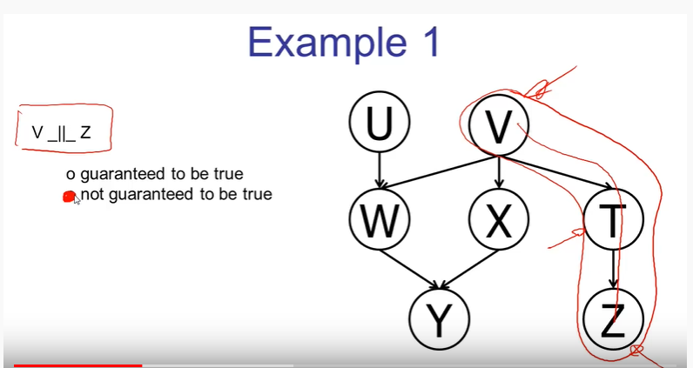

Whether V is independent of Z

There is only one path, and one triple : V -> T -> Z

This triple is active, if triple is active, because there is only one triple the path is active

Not guaranteed to be independent

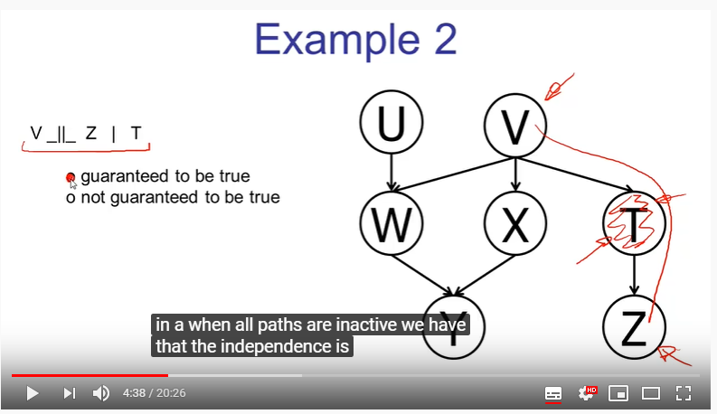

Whether V is independent of Z given T

There is only one path, and one triple : V -> T -> Z

This triple is inactive, if triple is inactive, all other triples are inacitive, that means path is inactive

guaranteed to be independent

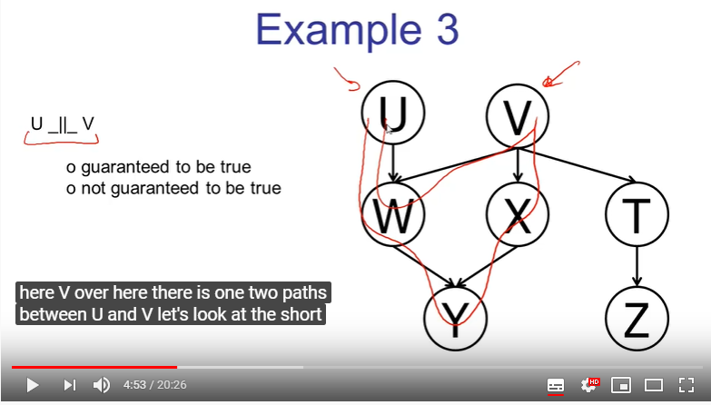

Whether U is independent of V

Two paths:

First Path

U->W->V

One triple which is V structure, W or the descended Y are not observed, that means triple is inactive. If triple is inactive, all other triples are inactive, that means path is inactive

Second Path

U->W->Y-X->V

There are several triples

U->W->Y : casual chain, active triple, triple is active, but we need to continue to look for other variables

W->Y->X : v-structure, inactive triple once a inactive triple found, the path also means inactive

guaranteed to be independent/true

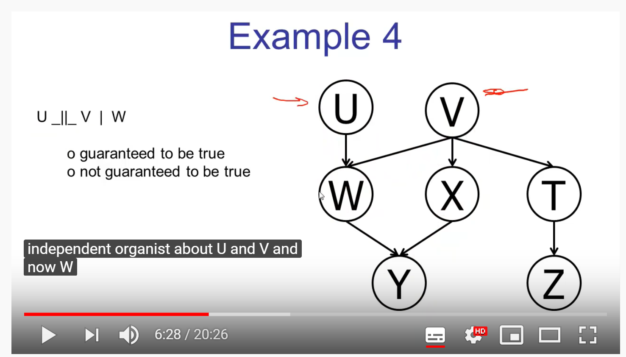

Whether U is independent of V given W

Two paths:

First Path

U->W->V

One triple which is V structure, W observed, that means triple is active. Because this is the only triple that path have, so the path is active

Second Path

U->W->Y-X->V

Because we find an path that is active, we now directly that not guaranteed to be independent

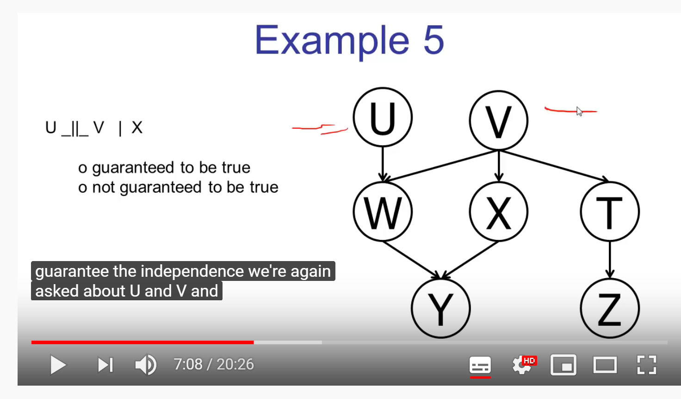

Whether U and V independent given X,

Two paths

Path 1

U-W-V: One triple which is V structure, W or the descended Y are not observed, that means triple is inactive. If triple is inactive, all other triples are inactive, that means path is inactive

Path 2:

U-W-Y : active triple, continue for other triples

W-Y-X : Inactive triple, if one triple is inactive, once we find inactive path then it means all path is inactive

guaranteed to be independent/true

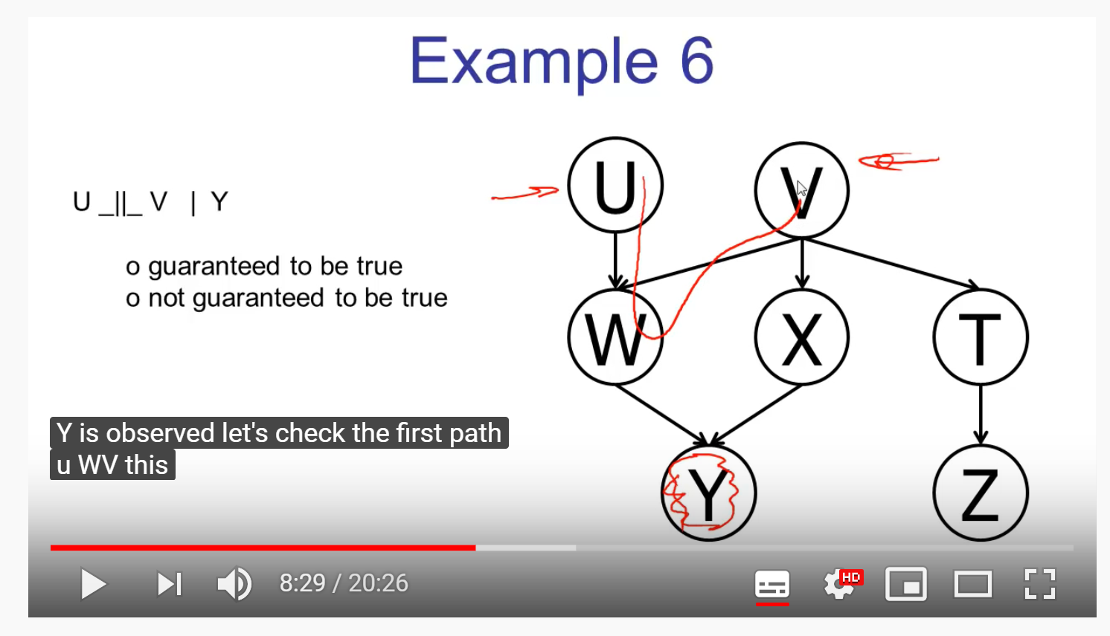

Whether U and V is independent given Y

Two path

Path 1

U-W-V: v structure, W unobserved but descended Y is observed, so its active. Because this is the only triple that path have the path is active.

Because Path 1 is active, no need to check for other paths, its not guaranteed to be independent.

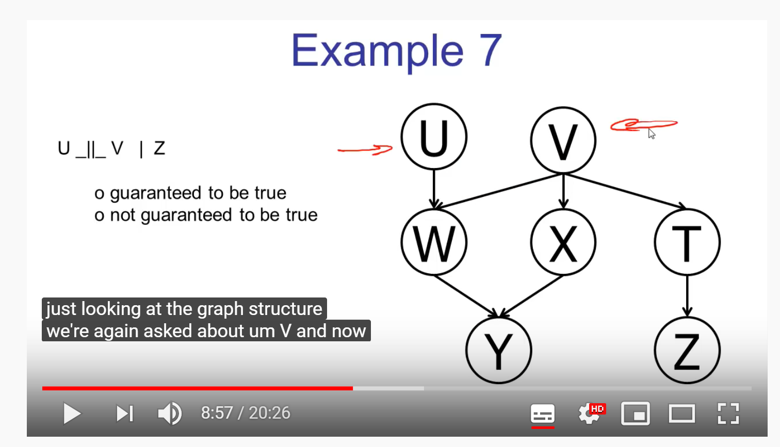

Whether U and V independent given Z

Two Paths

Path 1

U-W-V : Inactive, Path is inactive

Path 2

U-W-Y-X-V:

U-W-Y (Triple) : Active go for other triples

W-Y-X (Triple) : Inactive : All path is inactive

Because both path are İndependent its guaranteed to be true

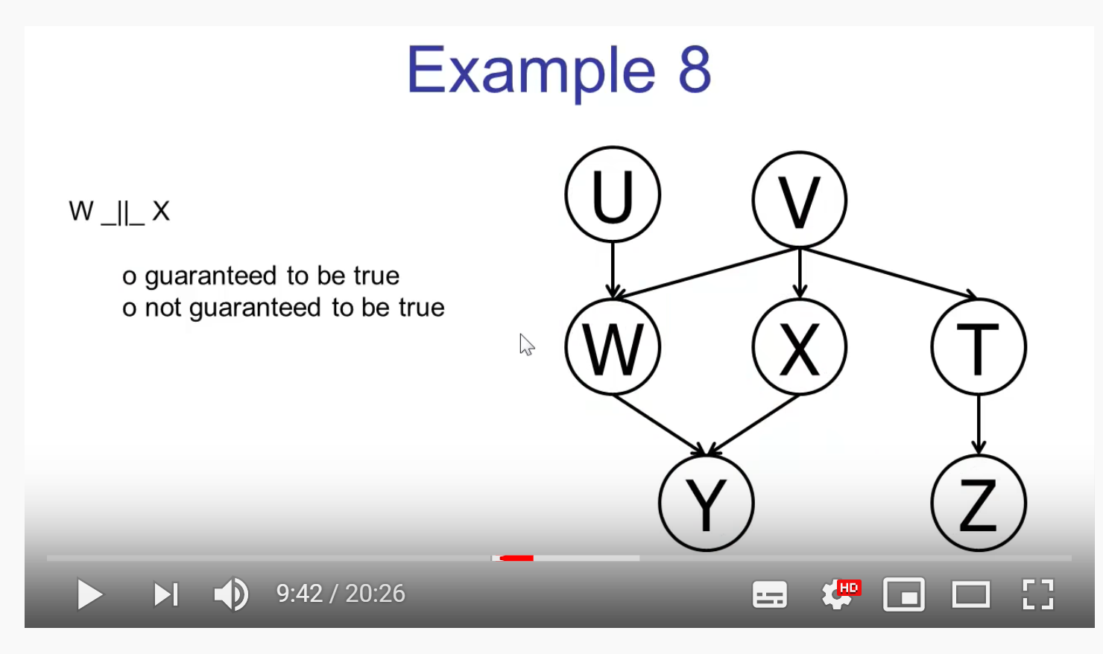

Whether W and X independent

Two Path

Path 1

W-Y-X : Inactive, path is inactive

Path 2

W-V-X : Active, this is the only triple that path is have, so the path is active.

W and X are not guaranteed independent

If you have time to do more please refer : <https://www.youtube.com/watch?v=yDs_q6jKHb0>

If you have time to do more please refer (2) : <https://www.youtube.com/watch?v=i0CGsHhjISU>

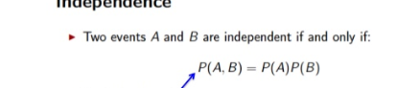





A Bayesian network is directed acyclic graph

A Directed Acyclic Graph (DAG) is a type of graph in which it's impossible to come back to the same node by traversing the edges.

