Appendix
The Appendix will be properly structured as the draft develops. Currently a work in progress for general plots being provided.
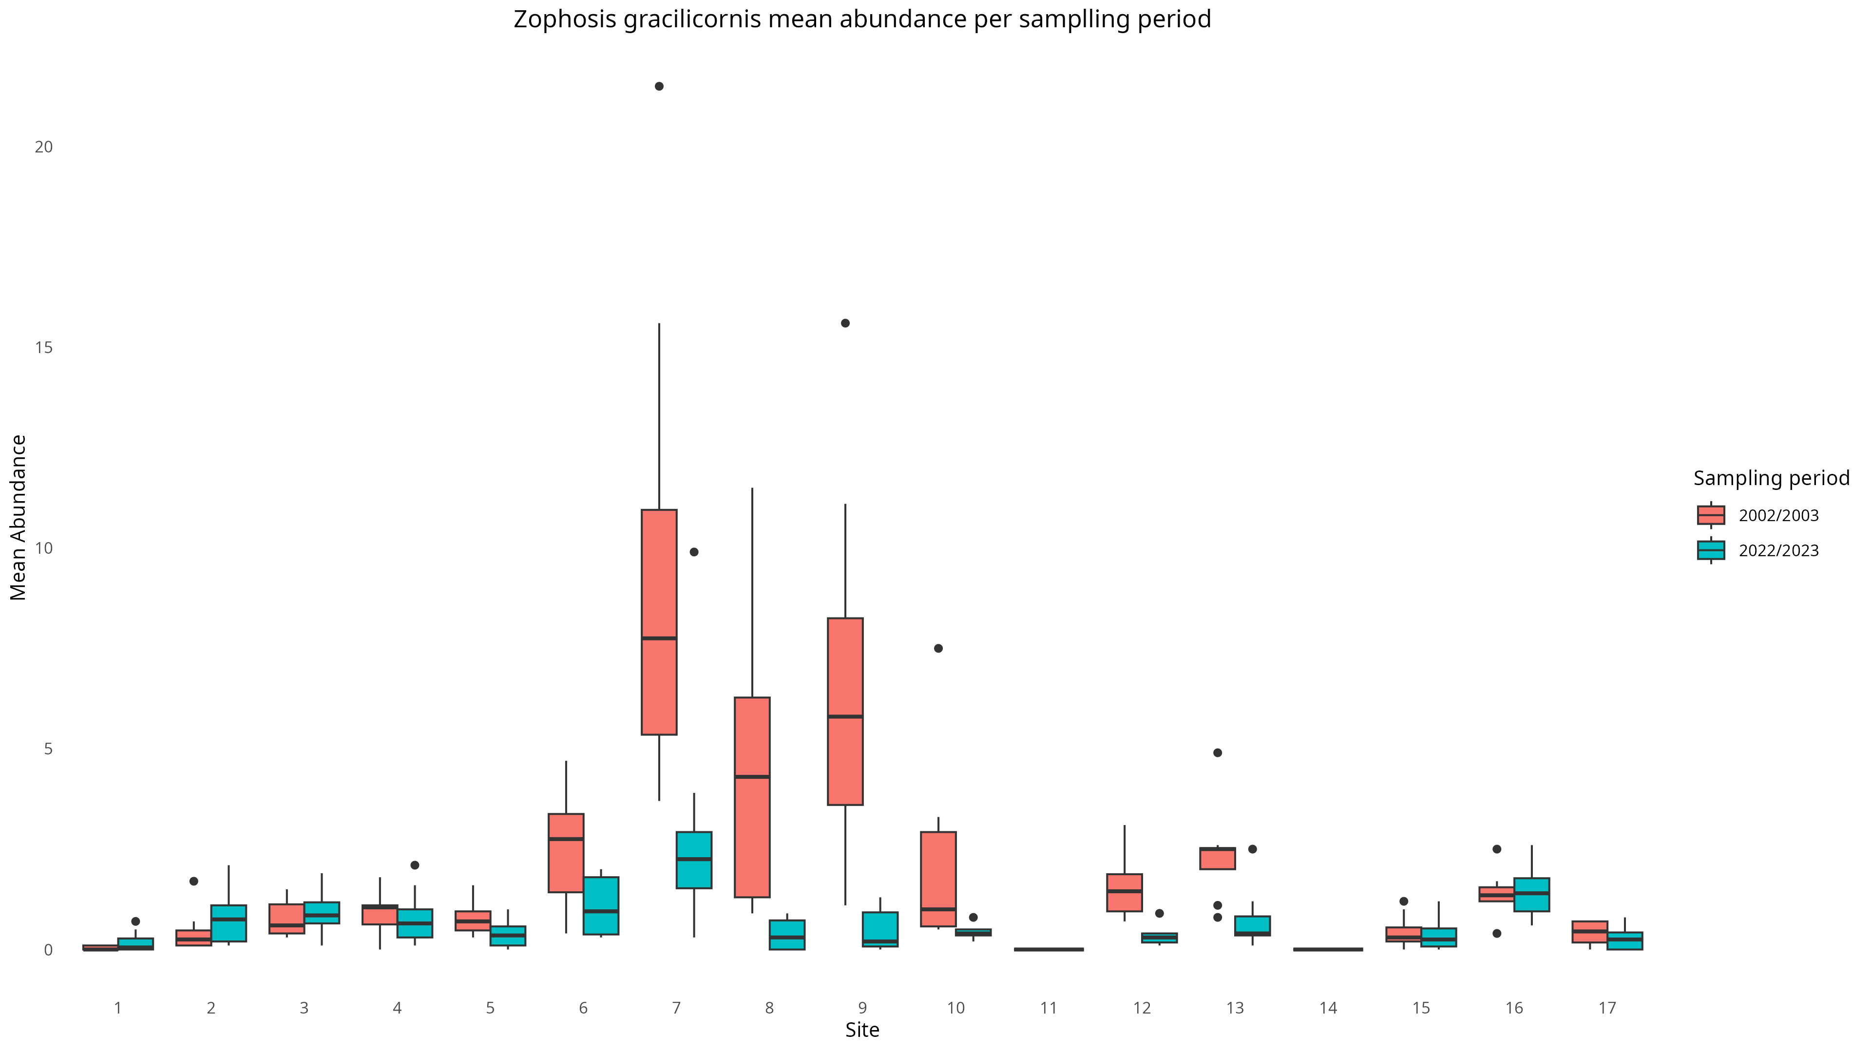
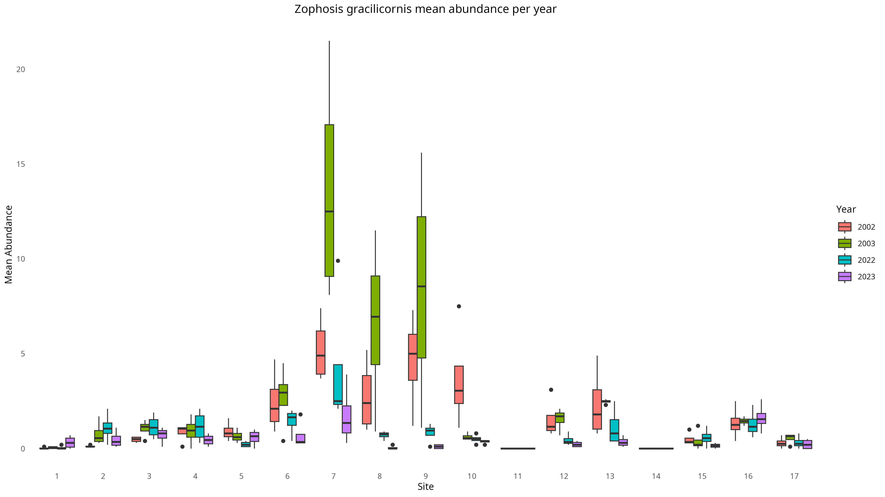
Appendix S2 Boxplots of Zophosis over years and sampling period.

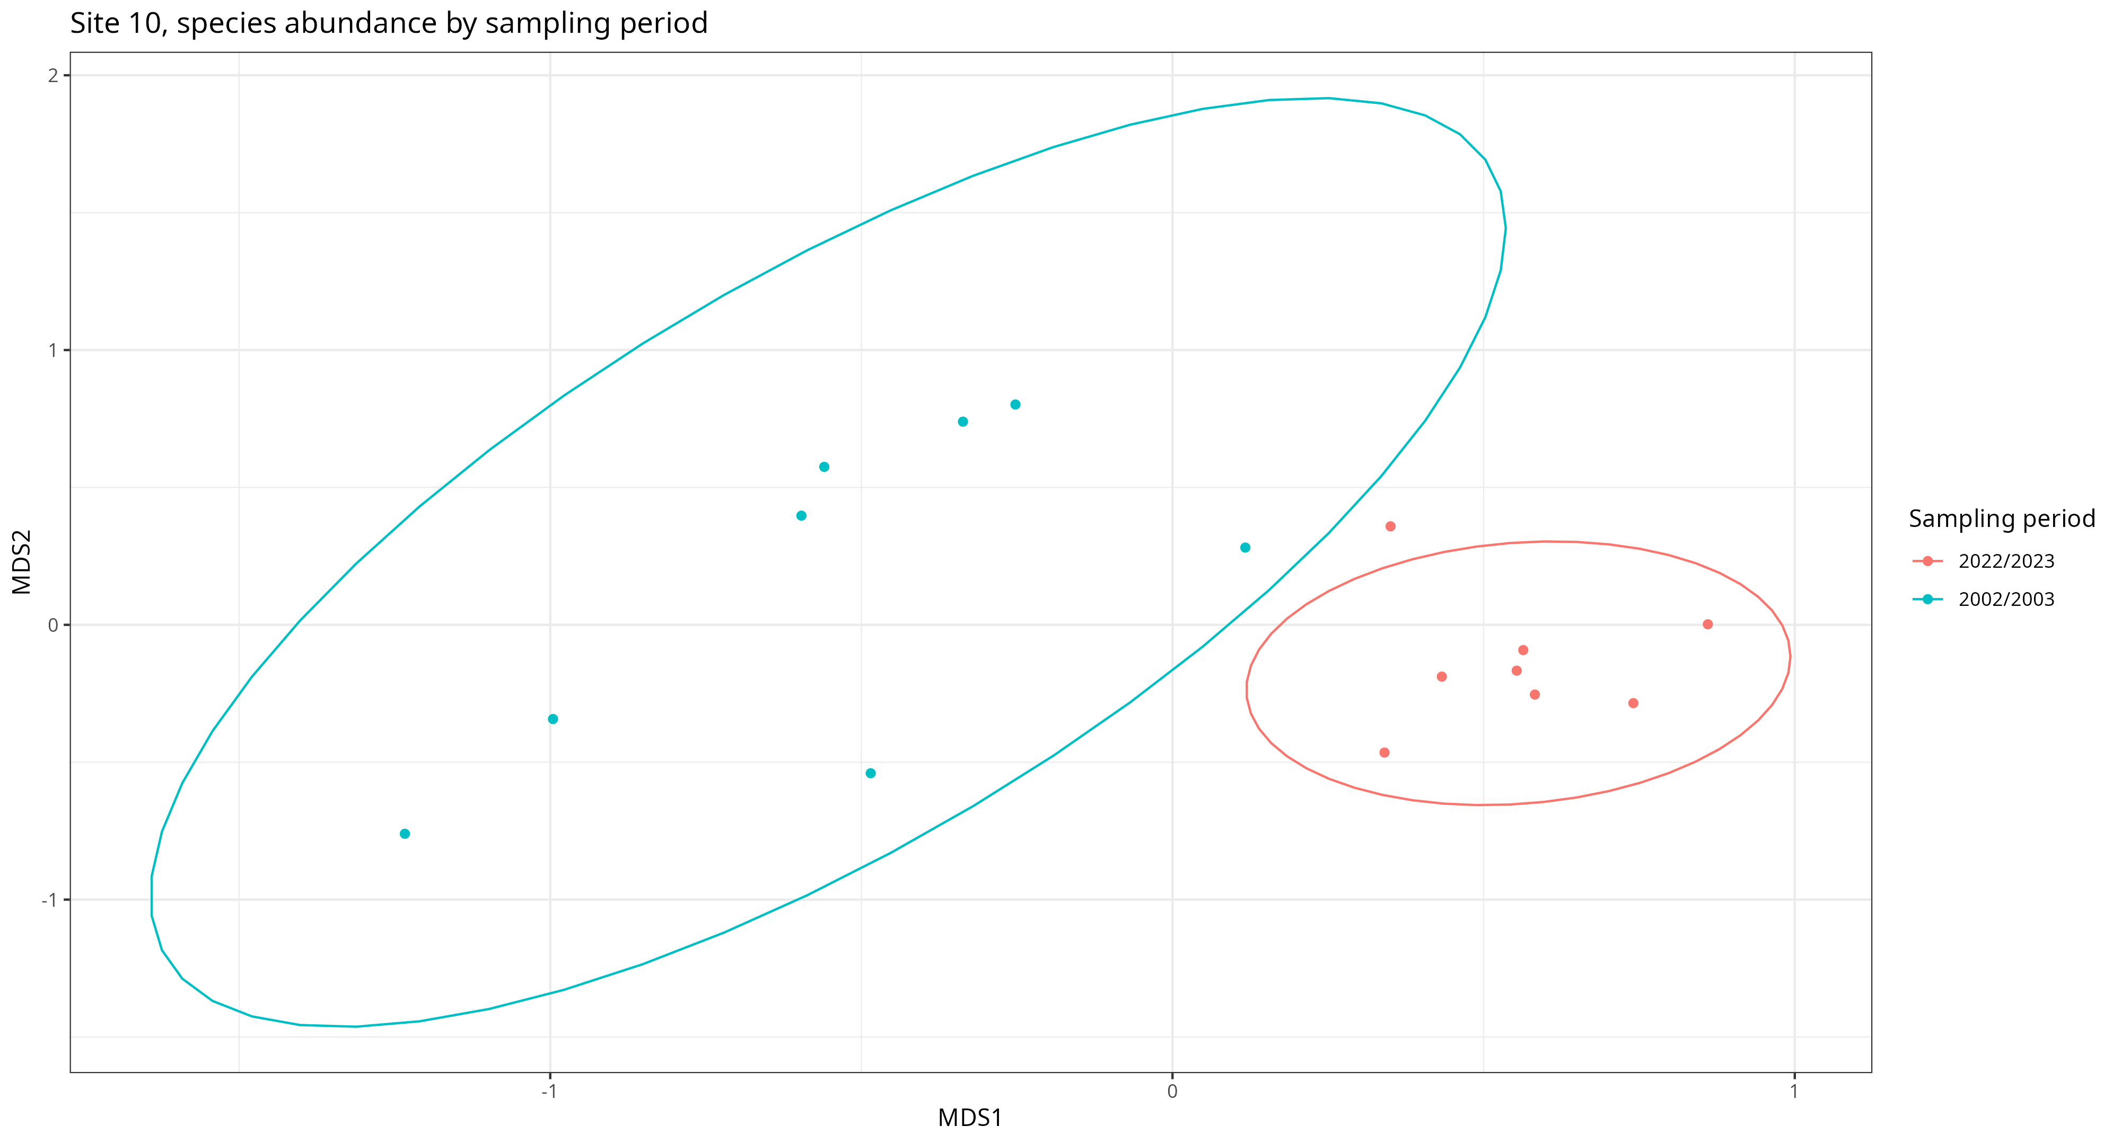
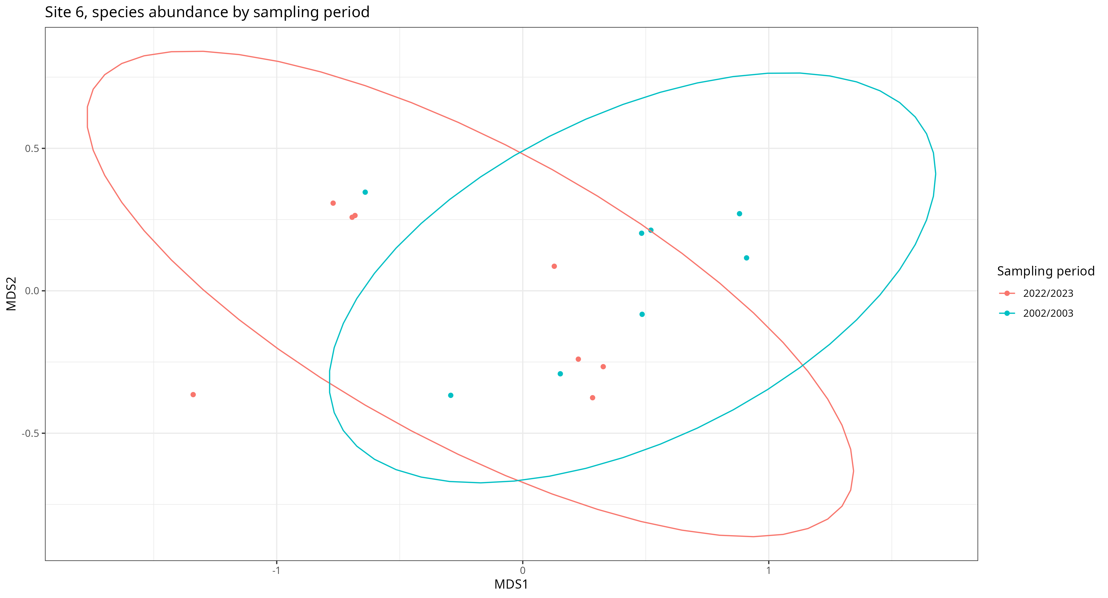
Appendix S3 nMDS of beetle abundance per site

