Integrative taxonomy and biogeography of the ant genus Anoplolepis (Hymenoptera: Formicidae) in southern Africa

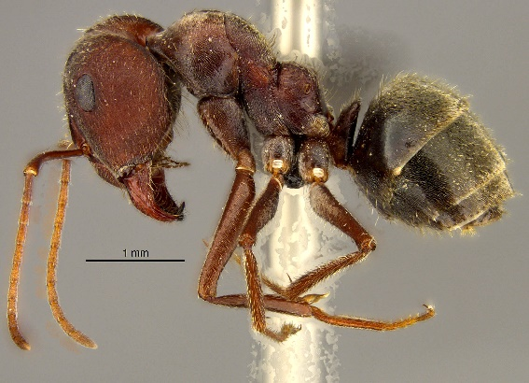

Abusisiwe Ndaba
NDBABU001

Dissertation presented for the degree of Master of Science in the Department of Biological
Sciences, University of Cape Town

February 2022

Supervised by Dr. Charlene Janion-Scheepers
Co-supervisors: Mrs. Nokuthula Mbanyana-Nhleko, Dr. Caswell Munyai, and Dr. Simon van Noort



The copyright of this thesis vests in the author. No quotation from it or information derived from it is to be published without full acknowledgment of the source. The thesis is to be used for private study or noncommercial research purposes only.

Published by the University of Cape Town (UCT) in terms of the non-exclusive license granted to UCT by the author.

DECLARATION
1. I know that plagiarism is wrong. Plagiarism is to use another’s work and pretend that it is one’s own.
2. I have used the South African Journal of Botany referencing style for citation and referencing. Each contribution to, and quotation in, this project from the work(s) of other people has been attributed and has been cited and referenced. Any section taken from an internet source has been referenced to that source.
3. This project is my own work and is in my own words (except where I have attributed it to
others).
4. I have not allowed and will not allow anyone to copy my work with the intention of passing it off as his or her own work.
5. I acknowledge that copying someone else’s assignment or essay, or part of it, is wrong, and declare that this is my own work.
Signature

Abstract
Taxonomy has played an important role in biodiversity assessments. It provides an understanding of biodiversity components, data that are essential for making decisions on conservation and sustainable use and is also a foundation for phylogenetic studies. Although this field of study has played an important role in identifying and describing biodiversity, the issue of cryptic species has posed many taxonomic challenges. In most taxonomic groups, species with subtle differences and high intraspecific variation are often misidentified when morphological data is not supported by other methods, for example, genetic data. The genus Anoplolepis is one of several polymorphic groups of ants. Although this genus is widely distributed in the Afrotropical region, it is understudied. This study aimed to: 1) resolve taxonomic challenges of the ant genus Anoplolepis in southern Africa, including the production of updated identification keys for the species and the description of new species; 2) resolve taxonomic challenges of the ant genus using molecular data; 3) to understand and update the geographical distribution of species within Anoplolepis; 4) verify the existing distributional records for the invasive species, A. gracilipes in South Africa and monitor the main introduction pathways; and 5) to assess the overall changes in ant assemblages of ants collected between harbours and provinces and test the effectiveness of the pitfall trapping and baiting method in sampling ants. Material from various institutions and organisations were used to conduct this study, as well as new material collected. By using a combination of traditional morphological taxonomy and DNA barcoding, a total of 16 species were identified. Of these, 11 species were determined using morphological features and phylogenetic analysis based on molecular data, with the five remaining species being identified using only morphological features. Based on morphological assessment, one species (Anoplolepis sp. nov. 12) was deemed to be new to science. This study showed that the DNA barcoding method (CO1) was not efficient to delimit some of the species in this genus, highlighting the need to prioritize more fine-scale molecular markers, especially when working with polymorphic or cryptic species. Overall, the distribution of species in this genus shows that this genus is widely distributed across southern Africa. The invasive species A. gracilipes was not detected across all the sampled harbours, nor from any of the material housed at the Iziko Museums of South Africa, loaned from other institutions and organisations in South Africa and other countries used for this study. This is a positive outcome for conservation authorities. This species is highly invasive elsewhere in the world, and if introduced outcompetes native fauna and may result in ecosystem collapse. Although A. gracilipes was not detected in the samples from this study, early detection and eradication of this species should be prioritized. This can be done through existing pest monitoring programs at harbours, and thorough biosecurity measures. This study contributed to developing scarce skills such as the taxonomic identification and the descriptions of new species, increasing the barcoding database of ants in South Africa, and the overall revision of this economically and ecologically important ant genus.

Acknowledgements
Firstly, I would like to thank God for giving me the strength and wisdom to complete this research. His endless love, providence carried me through, and most importantly, I thank God for blessing me with a strong and supportive team.

An immense thank you to my supervisors, Dr Charlene Janion-Scheepers, Mrs Nokuthula Mbanyana-Nhleko, Dr Caswell Munyai, and Dr Simon Van Noort. Thank you for the time, energy, opportunities, and valuable input that you have provided and continue to provide me with. I cannot thank you enough for your unlimited supervision and patience, but also for giving me the opportunity to learn to be independent.
To Dr Charlene Janion-Scheepers, thank you for your guidance and support. A lot went into the completion of this thesis, but you carried me through all the challenges. I am grateful to have a supervisor like you, who cared not only about my academics but my social wellbeing as well. Thank you for exposing me to conferences, outreach projects, and other activities that have sharpened my research skills.
To Mrs Nokuthula Mbanyana-Nhleko, thank you for providing me with a continuous source of motivation and drive, and for being invested and involved in my project. You believed in my capabilities from the on go and kept pushing me to do more. Thank you for your guidance, not only in my studies but in life, generally.
To Dr Caswell Munyai, your incredible fascination with insects led me to where I am today. Thank you for believing in me and for your endless support. For your efforts to ensure I keep pursuing my career, regardless of the challenges, I come across, by making all opportunities known to me.
To Dr Simon Van Noort, your expertise in taxonomy was very helpful for carrying out this project, and not forgetting the insightful feedback throughout my thesis. Thank you for the help with using the museum imaging system, sorting out all technical issues, and access to the museum resources.
To Prof Alan Andersen, thank you for helping me with identifications and creating a key. For taking your time to compare my specimens to your ant collection, and not getting tired of replying to endless emails.
Special thanks to Daniela Monsanto who helped me with DNA barcoding and analysis. Your comments and suggestions helped me gain valuable insight into molecular biology.
I would like to thank the Iziko Museums of South Africa (Cape Town, South Africa) for giving me full access to their resources and to work with their ant collection to carry out this project. Thank you to Aisha Mayekiso for making me feel like I am part of the Iziko Museum team. Iimbovane outreach project (Stellenbosch University, South Africa) for loaning me their ant collection and for giving me an opportunity to join their team in outreach projects to add my input as well as learn from them. Afribugs CC (Pretoria, South Africa) and the University of KwaZulu-Natal (Pietermaritzburg campus, South Africa) for loaning me their ant material.
I would like to express my heartfelt gratitude to everyone who helped with fieldwork, Gemma Walker, Gemma Nel, Mj Grobler, Ricardo Guta, Nokubonga Thabethe, and Lindiwe Khoza. The Iziko team, Zikhona Njeza and Mujahid Hector for databasing the material. Lindiwe Khoza and Nokubonga Thabethe for sorting, mounting, and identification. This study would not have been possible without you.
To my family, I can never thank you more than enough for the continuous support and checking up on my wellbeing. Mama, thank you for molding me into the strong woman that I am today, for giving me hope to push against all odds, and for your continuous support. To my siblings, thank you for the long phone calls and continuous motivation to keep pushing. To my partner, thank you for showing me that I am capable of more than I thought I was, for believing in me and my work, and lastly for supporting me throughout. To my friends, all I can say is we went through it together. Thank you for your support and motivation to keep pushing.
An immense thank you to my funders, Foundational Biodiversity Information Programme, this project would have not been possible without your financial support. Lastly, thank you to the University of Cape Town for allowing me to enroll in a master’s degree program.
Table of Contents
Declaration ................................................................................................................................... iii
Abstract......................................................................................................................................... iv
Acknowledgments ........................................................................................................................ vi
Table of content ......................................................................................................................... viii
Chapter 1
Introduction .................................................................................................................................. 1
Background ..……....................................................................................................................... 1
The study genus Anoplolepis .……………………………………............................................................ 3
Invasive species......................................................................................................................... 4
DNA barcoding ………................................................................................................................. 6
Aims and Objectives ….............................................................................................................. 7
References .................................................................................................................................... 9
Chapter 2
Integrative taxonomy and biogeography of the ant genus Anoplolepis (Hymenoptera: Formicidae) in southern Africa
Abstract ....................................................................................................................................... 16
Introduction ................................................................................................................................ 17
Materials and methods ............................................................................................................... 18
1.1 Sample collection ............................................................................................................. 18
1.2 Morphological examination ………………………………….......................................................... 19
1.3 DNA barcoding ................................................................................................................. 20
1.4 Data analysis .................................................................................................................... 21
1.4.1 Phylogenetic analyses ................................................................................................... 21
1.4.2 Species distribution ……………………………………................................................................. 23
Results ......................................................................................................................................... 23
Phylogenetic and species delimitation analysis ……………………………....................................... 23
Morphology ............................................................................................................................ 26
Biogeography ………………………………..………………………………..………........................................... 80
Discussion ................................................................................................................................... 81
Conclusions ................................................................................................................................. 83
References .................................................................................................................................. 84
Chapter 3
Now you see me, now you don’t: verification of the absence of the alien invasive yellow crazy ant Anoplolepis gracilipes at harbours in South Africa.
Abstract ....................................................................................................................................... 88
Introduction ................................................................................................................................ 89
Materials and methods ............................................................................................................... 90
Study area .............................................................................................................................. 90
Ant sampling and species identification ……………………………………………………………………………. 91
Data analysis ……………............................................................................................................. 92
Results ......................................................................................................................................... 93
Discussion.................................................................................................................................... 98
Conclusions ............................................................................................................................... 102
References ................................................................................................................................ 103
Chapter 4
General Discussion and Conclusion …........................................................................................ 107
References ................................................................................................................................ 110
Appendix 1 ................................................................................................................................ 113
Appendix 2 ................................................................................................................................ 118

CHAPTER 1: INTRODUCTION
Integrative taxonomy and biogeography of the ant genus Anoplolepis (Hymenoptera: Formicidae) in southern Africa

Background
Although about 80% of all species on earth are invertebrates, this group receives far less attention compared to vertebrate and plant species (Braby, 2018). Following the development of existing and new methods of estimating global species richness, approximately 1.5 million beetles, 5.5 million other insect groups, and 7 million other terrestrial arthropods exist globally (Stork, 2015). Despite that over one million insect species have been identified, 80% of all insect species remain undescribed (Stork, 2018). This means more attention should be given to less studied taxa, such as most families in the orders Coleoptera, Diptera, and Hymenoptera. This is especially true for parts of the world that have been poorly sampled, including many parts of the Afrotropical region (Stork, 2018). Current extinction rates of species on Earth are 1000 times greater than pre-human levels (De Vos et al., 2015). In addition, many extinctions are predicted to occur among invertebrate groups containing small-sized species, which will disappear with little or no documentation or collection (Woinarski et al., 2019). To reduce the high rate of extinction of undocumented species and promote their conservation, there is a greater need to focus on accelerating the analysis of biodiversity (Smith et al., 2005). Conservation planning needs to focus more on biodiversity data (Smith et al., 2005), which means investing in the accurate identification of species.

Taxonomy has played an important role in classifying, identifying, and naming organisms (Sukumaran and Gopalakrishnan, 2015). It provides an understanding of biodiversity components which are essential for making decisions on conservation and sustainable use, and is also a foundation for phylogenetic studies (Wilson, 2004). This field of study has played an important role in identifying and describing biodiversity (Jinbo et al., 2011). However, many cryptic species are unidentified (Pante et al., 2015). The term cryptic species refers to morphologically indistinguishable taxa using conventional methods and hence their delimitation is a challenge to taxonomists (Wagner et al., 2017). Molecular analysis is a useful additional tool which may reveal that previously unresolved species complex actually consist of several species, supporting the estimate of insect hyper species richness (Stork, 2018). Research shows that tropical regions have a higher number of cryptic species than temperate regions (Bickford, 2007). However, this could be the result of more intensive taxonomic studies in the tropics than temperate regions over the centuries (Stork, 2018).

Uncovering cryptic biodiversity is the initial step to resolving taxonomic disputes (Steiner et al., 2010). It is essential for understanding evolutionary processes and patterns of environmental functioning and nature conservation (Dincǎ et al., 2011). Cryptic species are often misidentified when morphological data is not supported by other methods (Seifert, 2009). Although morphology has traditionally been used to classify organisms, for example ants, delimitation of cryptic species is best achieved using molecular data (Schlick-Steiner et al., 2006; Pante et al., 2015). The misidentification of medically and economically important species negatively impacts conservation (Bickford et al., 2007), especially invasive species that could cause ecosystem collapse if not detected and controlled in time (Gotzek et al., 2012). To circumvent potential misidentifications, the current trend is to employ integrative taxonomy, which uses both morphological data and molecular data to improve the accuracy of species identification (LaPolla, 2004).

Ants are among the most diverse and abundant animals in terrestrial ecosystems (Hölldobler and Wilson, 1990). They are found in almost all terrestrial habitats where they are considered keystone species (Joma and Mackay, 2013) and their morphology is as varied as their habitat preference (Bolton, 1994). Ants play an important role in the ecosystem as they provide a variety of ecosystem services, including pollination, seed dispersal, biological control, nutrient cycling, soil formation and decomposition (Hölldobler and Wilson, 1990; Andersen and Brault, 2010; Cardoso et al., 2011; Del Toro et al., 2012). They are also often used as bioindicators for detecting ecological changes in the environment (Andersen, 1993). Currently, there are more than 16,500 described ant species worldwide, and 2,693 valid species have been described in the Afrotropical regions (http://www.antweb.org). However, data are lacking to estimate the actual number of ant species in Africa (Joma and Mackay, 2013). Only half of the ant genera in Afrotropical region have been revised to modern standards, while southern Africa is a region with poorly studied ant fauna (Robertson, 2000).

The study genus Anoplolepis
The genus Anoplolepis is one of the most diverse genus in the subfamily Formicinae. Species in this genus have 11-segmented antennae, which is the most useful character to differentiate them from other genera. Currently, only nine valid Anoplolepis species are known in the Afrotropical region (Bolton, 2012), with no current revision available for this genus in the Afrotropical region. These ants mainly occur in the arid and semi-arid regions of southern Africa. Anoplolepis are known as epigaeic ants, foraging mainly on the ground or vegetation (Hita Garcia et al., 2013). They feed on various small arthropods such as small isopods, myriapods, molluscs, arachnids and insects (Abbott, 2006), and honeydew, which forms an important part of their diet (Prins, 1982). Some species in the genus Anoplolepis are economically and ecologically important, including Anoplolepis custodiens, common in the Cape Floristic Region of South Africa and considered to be important seed dispersers in the fynbos biome (Wetterer, 2005). Anoplolepis custodiens, a very aggressive species, is considered as extremely dominant over other species (Samways, 1990), and is known to displace many other ant species (Addison and Samways, 2000). Some species in this genus are also known to play a significant role as pollinators of flowers (Prins, 1982).

The activity of ants in the genus Anoplolepis is largely influenced by temperature and relative humidity (Prins, 1982). The worker ants forage out from their nest searching for food (Slingsby, 2017). During cold seasons, the activity of Anoplolepis is reduced and increases in hot seasons with an average temperature of 26˚C (Addison and Samways, 2006). Anoplolepis can withstand extremely high temperatures (Dean, 1992); they showed no mortality at 35˚C (De Bie and Hewitt, 1990) and some species of this genus were found to be active at ambient temperatures greater than 50˚C (Dean, 1992). In cold seasons where their activity is low, they visit trees on warm days to collect honeydew and store it in their crops (Prins, 1982). The stored honeydew is then metabolized to fats in cold weather (Prins, 1982).

Invasive species
Invasive arthropod species are known to have a large negative impact on indigenous fauna ( Mothapo and Wossler, 2011; Morisette et al., 2020). Hymenoptera, particularly ants, are considered the most damaging of all invasive groups given the ecosystem services they provide (Mothapo and Wossler, 2011), thus a number of the world’s worst invasive species are ants (Lowe et al., 2000; Abbott, 2006). This is because alien ants have proven to be very successful in outcompeting native ant species, spreading diseases, and transforming ecosystem structure (Global Invasive Species Database, 2020; Morisette et al., 2020). Considering the potential for expanding distributional ranges of ants at a local, regional and worldwide scale, invasive ants are a concern and a threat to local ecosystems and agricultural and tourism industries in all continental and island ecosystems ( O’Dowd et al., 2003; Abbott, 2006).

Alien invasion refers to the occurrence of species that are not naturally present in a native assemblage, but have been introduced either intentionally or accidentally beyond their geographical range (Blackburn et al., 2011). Although data on how invasions have changed over the years is not available, based on the southern African Plant Invaders Atlas, the number of invasive species has increased drastically (van Wilgen et al., 2020). Biological invasions have negative consequences to both ecological communities and the economy (van Wilgen et al., 2020). The presence of invasive species in an invaded area can alter ecosystem functioning and processes (Dueñas et al., 2018; van Wilgen et al., 2020) through the displacement of native biota and the disruption of ecosystem function in natural ecosystems, which consequently lead to biodiversity collapse (Mothapo and Wossler, 2011). For example, on Christmas Island an invasive ant species, Anoplolepis gracilipes, was found to rapidly eliminate a keystone species, the red land crab, which changed the composition and structure of the forest (Abbott, 2006). Similarly, invasive species can have a significant economic impact in the agricultural and forestry sectors (Mothapo and Wossler, 2011). An estimated amount of US$300 billion per year is spent as a result of invasive species in the United States, British Isles, Australia, South Africa, India and Brazil alone (van Wilgen et al., 2020). The measures taken to prevent losses or enable restoration of ecosystem services in an invaded area can be very costly. Therefore, the decision to implement measures to control invasive species in an invaded area should be taken after assessing returns from the control and if the cost of control is less than the cost of avoiding control measures (van Wilgen et al., 2020). The early detection of invasive species is critical to increasing chances of successful management or eradication (Reed et al., 2016). It is more effective and less costly to control invasive species at their primary stage as they have not reached high densities (Reed et al., 2016). Moreover, the accurate identification of invasive species is crucial, as the misidentification of non-invasive species as invasive species could result in unnecessary misdirected control measures. Conversely, the misidentification of invasive species as non-invasive species could result in missed opportunities for appropriate management action (Morisette et al., 2020), early detection and control.

The genus Anoplolepis has attracted a great deal of attention resulting from the negative impact on both vertebrates and invertebrates by Anoplolepis gracilipes (Hill et al., 2003; Wetterer, 2005; Chen, 2008). Anoplolepis gracilipes is an invasive species that is a major threat to the native ecosystem and global biota and can reach high densities (Abbott et al., 2006). It has been listed as one of the top 100 worst invasive species in the world (Lowe et al., 2000). A recent horizon scan conducted on A. gracilipes in Australia identified the most severe ecological consequences of this species, namely the displacement of native ants and other species, vectors of plant disease, and the increase in other alien species such as scale insects (McGeoch, 2019). Their main introduction pathway is at ports and harbours as stowaways in containers and transportation of bulk materials (McGeoch, 2019). This invasive species has been recorded in South Africa in the Western Cape (Prins, 1982; Slingsby, 2017), which is alarming given the negative impact this species has on other species. Species records are currently known from Table Bay, Gansbaai, and Knysna, and its distribution is thought to be limited by another invasive species, the Linepithema humile (Slingsby, 2017). A single record from Durban harbour has also been documented via a citizen-science platform (http://antsofthecape.blogspot.com/p/ant-catalogue_8.html; https://www.inaturalist.org/; Slingsby, 2017). Although listed on the list of invasive species under legal status 2(b), i.e. species that must be controlled, no risk assessment has been done, nor is the distribution of this species known (van Wilgen and Wilson, 2018). There is no record of this species in the Iziko Museums of South Africa’s Entomology collection, which has one of the biggest Afrotropical Hymenoptera collections in Africa (S. van Noort, pers. comm.). Prevention and early detection of this invasive species are vital, given the high costs associated with eradicating, containment, and control once it has completely established a certain environment (Barbet-Massin et al., 2018). Thus, the correct identification and known distribution of this highly invasive species in South Africa should be investigated.

DNA barcoding
The current study used both molecular and morphological data to re-evaluate taxonomy of Anoplolepis. DNA barcoding is a taxonomic method that uses genetic markers to identify DNA to which organisms belong (Letchuman and Cosmecuticals, 2018). It is a fast and accurate method for species identification and is used to create a library of species that can be difficult to identify in a short period of time (Letchuman and Cosmecuticals, 2018). DNA barcoding has been recognized as one of the most reliable tools available for species identification for systematic research (DeSalle and Goldstein, 2019). Recent studies have found molecular methods to be more powerful than morphology-based identification as it makes it possible to identify cryptic species (Schlick-Steiner et al., 2006; Beheregaray and Caccone, 2007; Seifert, 2009). DNA barcoding has also been used to identify invasive species (Reed et al., 2016). It is a rapid tool and can work with large scale projects, thus, making it possible for the early detection of invasive species (Reed et al., 2016). The use of supplementary sources such as DNA sequences has uncovered a clearer image of the evolutionary history of ants (Ward, 2007). Although DNA barcoding has become the most trusted methodological approach to identifying species, this method has faced criticism if used as the only method to identify organisms (Ng’endo et al., 2013). Integrative taxonomy, which combines molecular and morphological approaches, is used to overcome challenges encountered when only one method is used to identify organisms (Ng’endo et al., 2013).

Barcoding platforms such as the Barcode of Life Data Systems (BOLD) have had the most impact in facilitating collaborations, and have become the most powerful tool used to overcome taxonomic impediments, particularly in entomology (Miller et al., 2016). In southern Africa, the ant fauna is relatively poorly known (Robertson, 2000; Wetterer, 2012; Raven et al., 2020). However, ant data on the Barcode of Life Data (BOLD) system has increased rapidly (www.boldsystems.org). The ant genus Anoplolepis has still been poorly explored, with 681 sequences available representing seven species available on The Barcode of Life Data (BOLD) systems. Only 52 specimens of these, representing three species, are from southern Africa (http://boldsystems.org/index.php/).

In this study, I will also explore the geographical distribution of Anoplolepis species. Accurate knowledge of the geographical distribution of species is vital for many fields, including conservation biology, taxonomy, ecology, and biogeography (Cardoso, 2009). Knowing the geographical distribution of species on Earth is a daunting challenge to taxonomists (Cardoso, 2009). However, the growing loss of biodiversity requires discovering and analysing biodiversity at a more accelerated pace (Smith et al., 2005). Several projects are assembling information on species distribution, for example, Fauna Europea (www.faunaeur.org) and GBIF (www.gbif.org) (Cardoso, 2009). Although many recent projects have contributed to documenting the geographical distribution of invertebrate species, an understanding of the distribution of ant species is still lacking and needs more attention (Guénard et al., 2017), particularly in the Afrotropical regions.

Aims and objectives of this study
Given the large portion of undescribed ant genera in southern Africa, this study aims to assess and revise the taxonomy of species in the genus Anoplolepis using both morphological and molecular data to understand the diversity within this group and provide a means to identify species within this group accurately. I specifically aim to:

- Investigate the morphological characters of species in the genus using available specimens from museum collections to assess species delimitation and enable the production of a species identification key.
- Use DNA barcoding to corroborate the morphological species delimitation and understand the phylogenetic relationships within this genus.
- Verify the existing distributional records for the invasive species, A. gracilipes in southern Africa and monitor the main introduction pathways.
- To document and interpret the geographical distribution of species within the genus Anoplolepis. Such information is needed for identifying areas of high species diversity and endemism (Azuma et al., 2006) and for prioritizing areas for conservation (Faith, 1992).

The resulting data from this study will be used to aid decision making for conserving Anoplolepis species in the future, and to detect new and invasive species.

References
Abbott, K. L., 2006. Spatial dynamics of supercolonies of the invasive yellow crazy ant, Anoplolepis gracilipes, on Christmas Island, Indian Ocean. Diversity and Distributions. 12(1), 101–110. https://doi.org/10.1111/j.1366-9516.2006.00193.x
Addison, P., Samways, M. J., 2000. A survey of ants (Hymenoptera: Formicidae) that torage in vineyards in the Western Cape Province, South Africa. African Entomology 8(2), 251-260.
Addison, P., Samways, M. J., 2006. Surrogate habitats demonstrate the invasion potential of the African pugnacious ant. Biodiversity and Conservation 15(1), 411–428. https://doi.org/10.1007/s10531-005-5399-4.
Andersen, A. N., 1993. Ants as Indicators of Restoration Success at a Uranium Mine in Tropical Australia. In Restoration Ecology 1(3), 156–167. https://doi.org/10.1111/j.1526-100X.1993.tb00022.x
Andersen, A. N., Brault, A., 2010. Exploring a new biodiversity frontier: subterranean ants in northern Australia. Biodiversity and Conservation 19(9), 2741-2750.
Azuma, N., Ogata, K., Kikuchi, T., Higashi, S., 2006. Phylogeography of Asian weaver ants, Oecophylla smaragdina. Ecological Research 21, 121–136.
Barbet-Massin, M., Rome, Q., Villemant, C., Courchamp, F., 2018. Can species distribution models really predict the expansion of invasive species? PLoS ONE 13(3), 1–14. https://doi.org/10.1371/journal.pone.0193085
Beheregaray, L. B., Caccone, A., 2007. Cryptic biodiversity in a changing world. Journal of Biology, 6(4). https://doi.org/10.1186/jbiol60
Bickford, D., Lohman, D. J., Sodhi, N. S., Ng, P. K. L., Meier, R., Winker, K., Ingram, K. K., Das, I., 2007. Cryptic species as a window on diversity and conservation. Trends in Ecology and Evolution 22(3), 148–155. https://doi.org/10.1016/j.tree.2006.11.004
Blackburn, T. M., Pyšek, P., Bacher, S., Carlton, J. T., Duncan, R. P., Jarošík, V., Wilson, J. R. U., Richardson, D. M., 2011. A proposed unified framework for biological invasions. Trends in Ecology and Evolution 26(7), 333–339. https://doi.org/10.1016/j.tree.2011.03.023
Bolton, B., 2012. An online catalog of the ants of the World. http:/www.antcat.com
Bolton, B. Y. B., 1994. A surge. November, 203–209.
Braby, M. F., 2018. Threatened species conservation of invertebrates in Australia: an overview. Austral Entomology 57(2), 173–181. https://doi.org/10.1111/aen.12324
Cardoso, P., 2009. Standardization and optimization of arthropod inventories-the case of Iberian spiders. Biodiversity and Conservation 18(14), 3949–3962. https://doi.org/10.1007/s10531-009-9690-7
Cardoso, P., Erwin, T. L., Borges, P. A., New, T. R., 2011. The seven impediments in invertebrate conservation and how to overcome them. Biological Conservation 144(11), 2647-2655.
CHEN, Y., 2008. Global potential distribution of an invasive species, the yellow crazy ant ( Anoplolepis gracilipes) under climate change . Integrative Zoology 3(3), 166–175. https://doi.org/10.1111/j.1749-4877.2008.00095.x
De Bie, G., Hewitt, P. H., 1990. Thermal responses of the semi-arid zone ants Ocymyrmex weitzeckeri (Emery) and Anoplolepis custodiens (Smith). Journal of the Entomological Society of Southern Africa 53(I), 65–73.
De Vos, J. M., Joppa, L. N., Gittleman, J. L., Stephens, P. R., Pimm, S. L., 2015. Estimating the normal background rate of species extinction. Conservation Biology 29(2), 452–462. https://doi.org/10.1111/cobi.12380
Dean, W. R. J., 1992. Temperatures determining activity patterns of some ant species in the southern Karoo, South Africa. Journal of the Entomological Society of Southern Africa 55(I), 149–156.
Del Toro, I., Ribbons, R. R., Pelini, S. L., 2012. The little things that run the world revisited: A review of ant-mediated ecosystem services and disservices (Hymenoptera: Formicidae). Myrmecological News 17(August), 133–146.
DeSalle, R., Goldstein, P., 2019. Review and Interpretation of Trends in DNA Barcoding. Frontiers in Ecology and Evolution 7(September), 1–11. https://doi.org/10.3389/fevo.2019.00302
Dincǎ, V., Lukhtanov, V. A., Talavera, G., Vila, R., 2011. Unexpected layers of cryptic diversity in wood white Leptidea butterflies. Nature Communications 2(1). https://doi.org/10.1038/ncomms1329
Dueñas, M. A., Ruffhead, H. J., Wakefield, N. H., Roberts, P. D., Hemming, D. J., Diaz-Soltero, H., 2018. The role played by invasive species in interactions with endangered and threatened species in the United States: a systematic review. Biodiversity and Conservation 27(12), 3171–3183. https://doi.org/10.1007/s10531-018-1595-x
Faith, D. P., 1992. Conservation evaluation and phylogenetic diversity. Biological conservation 61(1), 1-10.
GISD, I., 2020. Global invasive species database. http://www.issg.org/database [Accessed 18 July 2020]
Gotzek, D., Brady, S. G., Kallal, R. J., LaPolla, J. S., 2012. The Importance of Using Multiple Approaches for Identifying Emerging Invasive Species: The Case of the Rasberry Crazy Ant in the United States. PLoS ONE 7(9), 1–10. https://doi.org/10.1371/journal.pone.0045314
Guénard, B., Weiser, M. D., Gómez, K., Narula, N., Economo, E. P., 2017. The Global Ant Biodiversity Informatics (GABI) database: Synthesizing data on the geographic distribution of ant species (Hymenoptera: Formicidae). Myrmecological News 24, 83–89.
Hill, M., Holm, K., Vel, T., Shah, N. J., Matyot, P., 2003. Impact of the introduced yellow crazy ant Anoplolepis gracilipes on Bird Island, Seychelles. Biodiversity and Conservation 12(9), 1969–1984. https://doi.org/10.1023/A:1024151630204
Hita Garcia, F. H., Wiesel, E., Fischer, G., 2013. The Ants of Kenya (Hymenoptera: Formicidae)—Faunal Overview, First Species Checklist, Bibliography, Accounts for All Genera, and Discussion on Taxonomy and Zoogeography. Journal of East African Natural History 101(2), 127–222. https://doi.org/10.2982/028.101.0201
Holldobler,B., Wilson, E.O., 1990. The ants. Harvard University Press: Cambridge, MA, USA.
Joma, A. M. A., Mackay, W. P., 2013. A new species of afrotropical ants in the genus Bothroponera (Hymenoptera: Formicidae: Ponerinae). Psyche (London) 2013. https://doi.org/10.1155/2013/917847
Jinbo, U., Kato, T., Ito, M., 2011. Current progress in DNA barcoding and future implications for entomology. Entomological Science 14(2), 107-124.
LaPolla, J. S., 2004. Taxonomic review of the ant genus Pseudolasius (Formicidae: Formicinae) in the Afrotropical region. Journal of the New York Entomological Society 112(2–3), 97–105. https://doi.org/10.1664/0028-7199(2004)112[0097:TROTAG]2.0.CO;2
Letchuman, S., Cosmecuticals, O., 2018. Short Introduction of DNA Barcoding. International Journal of Research 5(4), 673–686.
Lowe, S., Browne, M., Boudlejas, S., 2000. 100 of the world’s worst invasive alien species. Aliens 12, 1-12.
McGeoch, M., 2019. Invasive Insects-Risks and Pathways project Oct 2019. https://scholar.google.com/scholar?hl=en&as_sdt=0%2C5&q=Invasive+Insects-Risks+and+Pathways+project+&btnG=.
Miller, S. E., Hausmann, A., Hallwachs, W., Janzen, D. H., 2016. Advancing taxonomy and bioinventories with DNA barcodes. Philosophical Transactions of the Royal Society B: Biological Sciences 371(1702). https://doi.org/10.1098/rstb.2015.0339
Morisette, J. T., Burgiel, S. W., Gaddis, K. D., 2020. Overview of a Special Issue on Advanced Genetic Analysis of Invasive Arthropod Species. Annals of the Entomological Society of America, X 1–5. https://doi.org/10.1093/aesa/saaa005
Mothapo, N. P., Wossler, T. C., 2011. Behavioural and chemical evidence for multiple colonisation of the Argentine ant. BMC Ecology 11, 1–11.
Ng’endo, R. N., Osiemo, Z. B., Brandl, R., 2013. DNA Barcodes for Species Identification in the Hyperdiverse Ant Genus Pheidole (Formicidae: Myrmicinae) . Journal of Insect Science 13(27), 1–13. https://doi.org/10.1673/031.013.2701
O’Dowd, D. J., Green, P. T., Lake, P. S., 2003. Invasional “meltdown” on an oceanic island. Ecology Letters 6(9), 812–817. https://doi.org/10.1046/j.1461-0248.2003.00512.x
Pante, E., Puillandre, N., Viricel, A., Arnaud‐Haond, S., Aurelle, D., Castelin, M., Samadi, S., 2015. Species are hypotheses: avoid connectivity assessments based on pillars of sand. Molecular Ecology 24(3), 525-544.
Prins, A. J., 1982. Review of Anoplolepis with reference to male genitalia, and notes on Acropyga (Hymenoptera, Formicidae). South African Museum.
Raven, P. H., Gereau, R. E., Phillipson, P. B., Chatelain, C., Jenkins, C. N., Ulloa Ulloa, C., 2020. The distribution of biodiversity richness in the tropics. Science Advances 6(37), eabc6228.
Reed, R. N., Hopken, M. W., Steen, D. A., Falk, B. G., Piaggio, A. J., 2016. Integrating early detection with dna barcoding: Species identification of a nonnative monitor lizard (squamata: Varanidae) carcass in mississippi, U.S.A. Management of Biological Invasions 7(2), 193–197. https://doi.org/10.3391/mbi.2016.7.2.07
Robertson, H. G., 2000. Afrotropical ants (Hymenoptera: Formicidae): Taxonomic progress and estimation of species richness. Journal of Hymenoptera Research 9(1), 71-84.
Samways, M. J., 1990. Species temporal variability: epigaeic ant assemblages and management for abundance and scarcity. Oecologia 84(4), 482-490.
Schlick-Steiner, B. C., Steiner, F. M., Moder, K., Seifert, B., Sanetra, M., Dyreson, E., Christian, E., 2006. A multidisciplinary approach reveals cryptic diversity in Western Palearctic Tetramorium ants (Hymenoptera: Formicidae). Molecular Phylogenetics and Evolution 40(1), 259-273.
Seifert, B., 2009. Cryptic species in ants (Hymenoptera: Formicidae) revisited: we need a change in the alpha-taxonomic approach. Myrmecological News 12(June), 149–166.
Slingsby, P., 2017. Ants of southern Africa: The ant book for all. Slingsby maps.
Smith, M. A., Fisher, B. L., Hebert, P. D. N., 2005. DNA barcoding for effective biodiversity assessment of a hyperdiverse arthropod group: The ants of Madagascar. Philosophical Transactions of the Royal Society B: Biological Sciences 360(1462), 1825–1834. https://doi.org/10.1098/rstb.2005.1714
Steiner, F M, Schlick-Steiner, B. C., Höttinger, H., Nikiforov, A., Moder, K., 2005. Maculinea alcon and M. rebeli (Insecta: Lepidoptera: Lycaenidae) – one or two Alcon Blues? Larval cuticular compounds and egg morphology of East Austrian populations. Bd 165–180. http://www.jstor.org/stable/41767345%0Ahttp://about.jstor.org/terms
Steiner, Florian M., Seifert, B., Moder, K., Schlick-Steiner, B. C., 2010. A multisource solution for a complex problem in biodiversity research: Description of the cryptic ant species Tetramorium alpestre sp.n. (Hymenoptera: Formicidae). Zoologischer Anzeiger 249(3–4), 223–254. https://doi.org/10.1016/j.jcz.2010.09.003
Stork, N. E., 2018. How Many Species of Insects and Other Terrestrial Arthropods Are There on Earth? Annual Review of Entomology 63(1), 31–45. https://doi.org/10.1146/annurev-ento-020117-043348
Stork NE, McBroom J, Gely C, Hamilton AJ., 2015. New approaches narrow global species estimates for beetles, insects, and terrestrial arthropods. PNAS 112, 7519–23
Sukumaran, S., Gopalakrishnan, A., 2015. Integrative taxonomy – Methods and Applications. Summer School on Recent Advances in Marine Biodiversity Conservation and Management 162–163.
van Wilgen, B. W., Wilson, J. R., 2018. The status of biological invasions and their management in South Africa in 2017. Stellenbosch, South Africa: South African National Biodiversity Institute, Kirstenbosch and DST-NRF Centre of Excellence for Invasion Biology.
van Wilgen, B. W., Measey, J., Richardson, D. M., Wilson, J. R., Zengeya, T. A., 2020. Biological invasions in South Africa: an overview. Biological Invasions in South Africa, 1, 3-31.
Wagner, H. C., Arthofer, W., Seifert, B., Muster, C., Steiner, F. M., Schlick-Steiner, B. C., 2017. Light at the end of the tunnel: Integrative taxonomy delimits cryptic species in the Tetramorium caespitum complex (Hymenoptera: Formicidae). Myrmecological News 25(October), 95–129.
Ward, P. S., 2007. Phylogeny, classification, and species-level taxonomy of ants (Hymenoptera: Formicidae). Zootaxa 563(1668), 549–563. https://doi.org/10.11646/zootaxa.1668.1.26
Wetterer, J. K., 2005. Worldwide distribution and potential spread of the long-legged ant, Anoplolepis gracilipes (Hymenoptera: Formicidae). Sociobiology 45(1), 77–97.
Wetterer, J. K., 2012. Worldwide spread of the African big-headed ant, Pheidole megacephala (Hymenoptera: Formicidae). Myrmecological News 17, 51-62.
Wilson, Edward O., 2004. Taxonomy as a fundamental discipline. Philosophical Transactions of the Royal Society B: Biological Sciences 359(1444), 739. https://doi.org/10.1098/rstb.2003.1440
Woinarski, J. C. Z., Braby, M. F., Burbidge, A. A., Coates, D., Garnett, S. T., Fensham, R. J., Legge, S. M., McKenzie, N. L., Silcock, J. L., Murphy, B. P., 2019. Reading the black book: The number, timing, distribution and causes of listed extinctions in Australia. Biological Conservation 239, 108-261. https://doi.org/10.1016/j.biocon.2019.108261

CHAPTER 2
Taxonomy, phylogeny, and biogeography of the ant genus Anoplolepis in southern Africa

Abstract
Taxonomic appraisal of species plays an important role in biodiversity assessments. It provides an understanding of biodiversity components, essential data for making decisions on conservation and sustainable use and is also a foundation for phylogenetic studies. Although this field of study plays an important role in identifying and describing biodiversity, the issue of cryptic species poses many taxonomic challenges. In most taxonomic groups, polymorphic species are often misidentified when morphological data is the only identification method used. Focusing on the genus Anoplolepis, this chapter aims to: 1) resolve taxonomic challenges of the ant genus Anoplolepis in southern Africa based on morphological appraisal, including the production of updated identification keys for the species and the description of new species; 2) resolve taxonomic challenges of the genus using molecular data, and 3) understand and update the geographical distribution of species within Anoplolepis. Sampling was conducted throughout the distribution ranges of the genus Anoplolepis in southern Africa. Specimens were studied from major collections in South Africa. In addition, 155 specimens were sent for DNA barcoding. A total of 16 species were identified from this study. Of these, 11 species were determined using morphological features and phylogenetic analysis based on molecular data, while the five remaining species were identified using only morphological features. Based on morphological assessment one species, Anoplolepis sp. nov. 12, was deemed to be new to science. DNA barcodes (CO1) failed to support species delimitation of five species that were determined as different species using morphological features. This shows that additional fine-scale molecular markers are required to fully disentangle species delimitation within this genus. This study contributed to improving the taxonomic identification and the descriptions of new species, increasing the barcoding database of ants in South Africa, and the overall revision of this economically and ecologically important ant genus.

Introduction
Anoplolepis is one of the most dominant and common ant genera distributed in the Afrotropical region (Hita Garcia et al., 2013). In contrast, fewer species are found in the Malagasy and Oriental regions, while some species have also been introduced to other regions of the world, for example, Christmas Island, and have become invasive (Hita Garcia et al., 2013). Twenty-three species from the genus Anoplolepis are known worldwide (Wetterer, 2005), with nine valid species in the Afrotropical region (Bolton, 2012). However, there is an underestimate of the number of species of Anoplolepis in southern Africa. There has been no revision of this genus in the tropical regions since the work forty years ago by A. J. Prins (Prins, 1982). The last revision of this genus included both alate and worker castes. However, the main focus was on the male and female reproductive castes and was not a complete taxonomic revision.

Anoplolepis are epigaeic ants that forage primarily above the ground (Prins, 1982). They are referred to as pugnacious ants due to their aggressive behaviour and fast zig-zag movements on the ground, which is a behavioural response to disturbance (Prins, 1982). They feed on various small arthropods, e.g. small isopods, myriapods, molluscs, arachnids, and insects (Abbott et al., 2005). Certain species in this genus have been classified as pests, for example, Anoplolepis gracilipes (Abbott et al., 2005), which is also listed under the 100 of the world’s worst invasive alien species (Lowe et al., 2000). However, this genus is not a house pest (Prins, 1982). They are also known for their painful bite, which lasts for as long as the ant bites (Vanderplak, 1960).

Like other ants, the genus Anoplolepis provides important ecosystem services. Some species in this group are economically and ecologically important. For example, Anoplolepis custodiens are common in the fynbos region and are considered as seed dispersers in the fynbos biome (Wettere, 2005). Anoplolepis gracilipes, which has been identified as a pest, has also been used as a biological control agent, for example, A. gracilipes has been used in managing pests on cacao and coconut plantations (Way and Khoo, 1992). Despite the important ecosystem services provided by Anoplolepis, its negative impact on vertebrates and other invertebrates has brought it to the world's attention (Hill et al., 2003). One of the surprising attributes of Anoplolepis gracilipes is the ability to farm and protect sap-sucking scale insects, which has consequently damaged the forest canopy on Christmas Island (Lowe et al., 2000). Anoplolepis gracilipes has eliminated the red land crab, a keystone species, in parts of the island resulting in significant ecosystem disruption in Christmas Island (Abbott et al., 2006). On other islands such as Seychelles, Anoplolepis gracilipes killed bird chicks by nesting on their nests (Abbott et al., 2006).

As mentioned, it has been 40 years since the last taxonomic revision of the genus Anoplolepis in South Africa (Prins, 1982). However, with the substantial improvement in available specimens present in collections and the use of DNA barcoding (Ratnasingham and Hebert, 2007), further revision of this genus in southern Africa is possible. Species in this genus are strongly polymorphic (Doering et al., 2018), making it difficult to identify the workers using morphological characters only. In addition, currently, there are no identification keys to species of the genus Anoplolepis for the Afrotropical region. Therefore, the current study aims to re-evaluate the taxonomy of the South African representatives of Anoplolepis using both morphological and molecular data to provide an updated species key and provide new morphological characters that can be used to diagnose species within this group.

Material and Methods
1.1 Sample collection
Specimens for the study were obtained from the following institutions: Iziko Museums of South Africa (Cape Town, South Africa), University of KwaZulu-Natal (Pietermaritzburg campus, South Africa), Iimbovane Outreach Project (Stellenbosch University, South Africa), and AfriBugs CC (Pretoria, South Africa). In addition, fresh specimens were collected from Limpopo, North West and Mpumalanga (October and November 2020), KwaZulu-Natal, and Western Cape provinces (March to July 2021). Ants were sampled through active collecting methods (sweep nets, vegetation beating, hand collection using baits as attractants to find nests, and excavation of ant nests), and pitfall traps following standardized methods (Parr and Chown, 2001; Ivanov and Keiper, 2010). Ant specimens were stored in 96% ethanol, and voucher specimens were pinned, labeled, and accessioned into the database of Iziko Museums of South Africa (Specify 6 V6.7.01).
1.2 Morphological examination
To analyze species according to their morphological characters, dry-mounted specimens fixed on a pin-holding goniometer that permits rotations around three axes were examined under Leica MZ16A (Wetzlar, Germany). Numerical Morphology-Based Alpha-Taxonomy (NUMOBAT) (Seifert and Galkowski, 2016) was used to examine external morphological characters of the specimen, which included: head width (HW), head length (HL), scape length (SL), eye length (EL), pronotal width (PW), node width (NW), node length (NL) and mesosomal length (ML). The measurements were taken using Leica Application Suite (LAS) V4.9 software. Leica LAS multiple-focus imaging system and Leica Application Suite Software V4.9 were used for acquiring images. Layer photos of the specimens were taken using a Leica M16 stereomicroscope (Wetzlar, Germany) attached to a JVC KY-75U 3-CCD digital camera. In addition, species from this study were digitally compared to an Anoplolepis collection in Australia (A. Andersen, CSIRO, Northern Territory).

Morphological terminology follows Bolton (1980), with the following modifications:
HL (Head Length): the length of the head proper, excluding the mandibles, measured in a full-face view, in a straight line from the anterior-most point of the median clypeal margin to the mid-point of the occipital margin.
HW (Head Width): the maximum width of the head in full-face view, behind the eyes.
HW1 (Head Width 1): the maximum width of the head in full-face view, including the eyes.
EL (Eye Length): the maximum diameter of the eye.
SL (Scape Length): the maximum straight line measurement of the antennal scape excluding the condylar bulb.
PW (Pronotal Width): the maximum width of the pronotum in dorsal view.
NW1 (Petiole node width): the maximum width of the petiole in dorsal view.
NL1 (Petiole node length): the length of the petiole in lateral view.
ML (Mesosoma Length): the length of the mesosoma in lateral view from the anterior-most point of the pronotum to the posterior base of the propodeal lobes.
CI (Cephalic Index): HW divided by HL, x 100.
SI (Scape Index): SL divided by HW, x 100.
EI (Eye Index): EL divided by HW, x 100.

1.3 DNA barcoding
The mitochondrial cytochrome c oxidase subunit I (COI) gene is often used for phylogenetic and phylogeographic studies since it is haploid, uniparentally inherited, and lacks recombination (Avise, 2000), and was therefore used for this study. Moreover, the relatively high mutation rates of mitochondrial genes mean that they are more suitable for tracking shallow/recent evolutionary events in comparison to nuclear gene loci (Yoke et al., 2006).

Specimens sent for DNA barcoding were first imaged in profile view using a Leica LAS multiple-focus imaging system combined with the Leica Application Suite Software V4.9. The middle, right leg of specimens prepared for DNA barcoding were removed and put into a well with 96% ethanol. Where specimens did not have the middle, right leg, the middle, left leg was used. This procedure was done in a sterile environment. Legs were placed in 96-well plates and sent to the Canadian Centre for DNA Barcoding (CCDB), University of Guelph, Canada for DNA barcoding (Ratnasingham and Hebert, 2007).

Mitochondrial DNA (CO1) was extracted from the ethanol-preserved and dry mounted specimens. Where possible, both major and minor workers from the same sample were included for the analysis. DNA was extracted using the Glass Fiber Plates DNA extraction method following the manufacturer's protocol (Ivanova et al., 2006). The mitochondrial COI gene was amplified and sequenced using the following polymerase chain reactions (PCR): 2 µL unquantified template DNA, 10x Buffer, 50 mM MgCl₂, 20 mM dNTPs, 5 pmol of each of the forward and reverse primers LEP-F1, 5′- ATT CAA CCA ATC ATA AAG ATA T -3′ and LEP-R1, 5′- TAA ACT TCT GGA TGT CCA AAA A -3′ (Herbet et al., 2004), 5 U Taq DNA polymerase, and distilled water. Using the MultiGeneTM OptiMax Thermal Cycler (Applied Biosystems), the PCR thermocycler reaction consisted of the initial denaturation step at 94 °C for 1 minute, six cycles at 94 °C for 1 minute, 45 °C for 1 minute and 30 seconds, and 72 °C for 1 minute and 15 seconds, followed 36 cycles at 94 °C for 1 minute, 51 °C for 1 minute and 30 seconds, and 72 °C for 1 minute and 15 seconds, with a final step at 72 °C for 5 minutes. PCR products were visualized using a 1% agarose gel electrophoresis and then sequenced with the forward primer (LEP-F1 primer) using Dye terminator sequencing on an ABI 3730xl automated sequencer (Applied Biosystems, CA, USA).

Specimens included for molecular analysis were collected between 1959 – 2021. In the case of specimens that failed to amplify due to the age of the specimens, an alternative protocol was then followed. Genomic DNA was extracted using the Qiagen DNeasy Blood and Tissue Kit (Qiagen®, Dusseldorf, Germany), following the manufacturer's recommendations with a few modifications. The modifications included specimen homogenization using a pestle, overnight digestion at 37 °C (for no more than 20 hours), gentle inversion rather than vortexing, and a single final elution volume of 70 μl (Moreau, 2014). The mitochondrial COI gene was amplified using the following PCR reaction: 3 µl of unquantified gDNA, 10x PCR reaction buffer (20 mM Tris-HCl of pH 8.0, 100 mM NaCl, 0.1 mM EDTA, 1 mM DTT, stabilizers, and 50% glycerol), 2.5 mM MgCl₂, 0.2 μM dNTPs, 0.75 μM of both the standard forward primer LCO 1490 (5'- GGT CAA CAA ATC ATA AAG ATA TTG G -3') and reverse primer HCO 2198 (5'- TAA ACT TCA GGG TGA CCA AAA AAT CA -3') (Folmer et al., 1994) and 1.5 U Super-Therm Taq DNA polymerase. During the PCR thermocycling reaction, the initial denaturation step was performed at 96 °C for 5 minutes, followed by 45 cycles of denaturation at 96 °C for 30 seconds, annealing at 48 °C for 30 seconds and elongation for 72 °C for 50 seconds, and a final extension step of 72 °C for 10 minutes. Successful amplicons were confirmed on a 1% agarose gel and sequenced with the forward primer using BigDye chemistry on an ABI 3730XL automated sequencer (Applied Biosystems).

1.4 Data analysis
1.4.1 Phylogenetic analysis
DNA sequences were constructed and edited using BioEdit V7.0.5 (Hall, 1999), and aligned using the ClustalW algorithm in Geneious V8.0.5 (Kearse et al., 2012) as it appeared to align better than the Muscle algorithm, which introduced many gaps to the alignment. The Basic Local Alignment Search Tool (BLAST) on the National Center for Biotechnology Information (NCBI) database was used to compare primary biological sequence information of DNA sequences and for species identification. Sequences that were contaminated (did not match the studied genus) and sequences with less than 400 base pairs were removed from the dataset. This was done to increase the accuracy of the phylogenetic tree as bootstrap values were extremely low with the inclusion of sequences with less than 400 base pairs. An outgroup taxon, Camponotus storeatus, was used for the phylogenetic reconstruction, resulting in a dataset that comprised 54 ant sequences and one outgroup taxon. The most likely nucleotide substitution model for the dataset was identified using JModelTest V2.1.9 (Posada, 2008), based on the Akaike Information Criterion (AIC) (Posada and Crandall, 1998). The phylogeny was constructed using Neighbour-Joining method implemented in Mega X (Kumar et al., 2018) by selecting the best substitution model identified by JModelTest, Tamura and Nei parameter (TrN + G). The evolutionary distances were computed using the p-distance method, and 1000 bootstrap replicates were used to assess branch support (Felsenstein, 1985). Additionally, the Maximum Likelihood method was also implemented for comparison, using the TrN + G in Mega X. The phylogenetic tree using the Neighbour-Joining method was selected for downstream analyses over the Maximum Likelihood tree as it yielded better nodal support values. All Trees were visualized in TreeEdit V1.0a1-19 (http://evolve.zoo.ox.ac.uk/software/TreeEdit/main.html).

Clade memberships were used to describe clades and groups used for downstream species delimitation analyses; the larger monophyletic clades for the two big clades (clade A and clade B) were referred to as "clades", while the smaller intraspecific clades/lineages were referred to as "groups" (Appendix 1, Figure A). A barcoding gap analysis was performed in Mega X to compare interspecific (between species clades) and intraspecific (between and within groups for each species) variation between the two big clades, clade A and clade B, to assess overlap between the two measures. The p-distance values between and within groups were calculated using the net between group mean distances, with the inclusion of both transition and transversion nucleotide substitutions (Table 1).

1.4.2 Species distribution
To visualize species richness and distribution of Anoplolepis, all Anoplolepis occurrence records were extracted from the Iziko Museums of South Africa Specify database and overlaid onto biome maps defined by Olson et al. (2001) using QGIS V2.18.3 (QGIS.org, 2022). Additional maps of species distribution were produced with no more than four species on each map for a clear depiction of species distribution (Appendix 1, Figure B-F). The vegetation classification for biomes follows Rutherford and Mucina (2006).

Results
2.1 Phylogenetic and species delimitation analysis
A total of 4, 414 specimens were examined from the collections. From these, a total of 16 species were identified using morphological characters. Of these, 11 species were also recognised with DNA barcoding (Figure 1), while the five remaining species failed to produce DNA sequences. The morphological features show that one species is new to science. Phylogenetic certainty for the positions of Anoplolepis. sp. 2, Anoplolepis sp. 3 to Anoplolepis sp. 5 shows little support that these groups are different species (Figure 1). However, morphological characters indicated that these three species are different from each other (see species descriptions below).

A total of 53 individuals were sequenced, resulting in two clades (clade A with 33 and clade B with 20 specimens). The phylogenetic tree revealed that clade A formed two well-supported smaller clades while clade B formed two smaller clades that had poor nodal support. Based on the morphological characters of these individuals, they were categorised into 16 species, of which only 11 species were determined from the phylogenetic tree. Congruence between morphology and molecular support was found for Anoplolepis sp. 4, Anoplolepis sp. 6, Anoplolepis sp. 7, Anoplolepis sp. 8, Anoplolepis sp. 9, Anoplolepis sp. 10, A. custodiens and A. steingroeveri, however, incongruence was found for Anoplolepis sp. 2, Anoplolepis sp. 3 and Anoplolepis sp. 5.

Pairwise differences between clades A and B were high, while intra-clade distances were an order of magnitude lower. Anoplolepis sp. 6 Anoplolepis sp. 7, Anoplolepis sp. 8, Anoplolepis sp. 9, Anoplolepis sp. 10, and A steingroeveri had high p-distance values when compared to Anoplolepis sp. 2, Anoplolepis sp. 3, Anoplolepis sp. 4, Anoplolepis sp. 5, and A. custodiens which indicated that these are different species (Table 1). When compared to each other, Anoplolepis sp. 9, Anoplolepis sp. 10, and A. steingroeveri had low p-distance values. Anoplolepis sp. 2, Anoplolepis sp. 3, Anoplolepis sp. 4, Anoplolepis sp. 5, and A. custodiens also had low p-distance values when compared to each other.

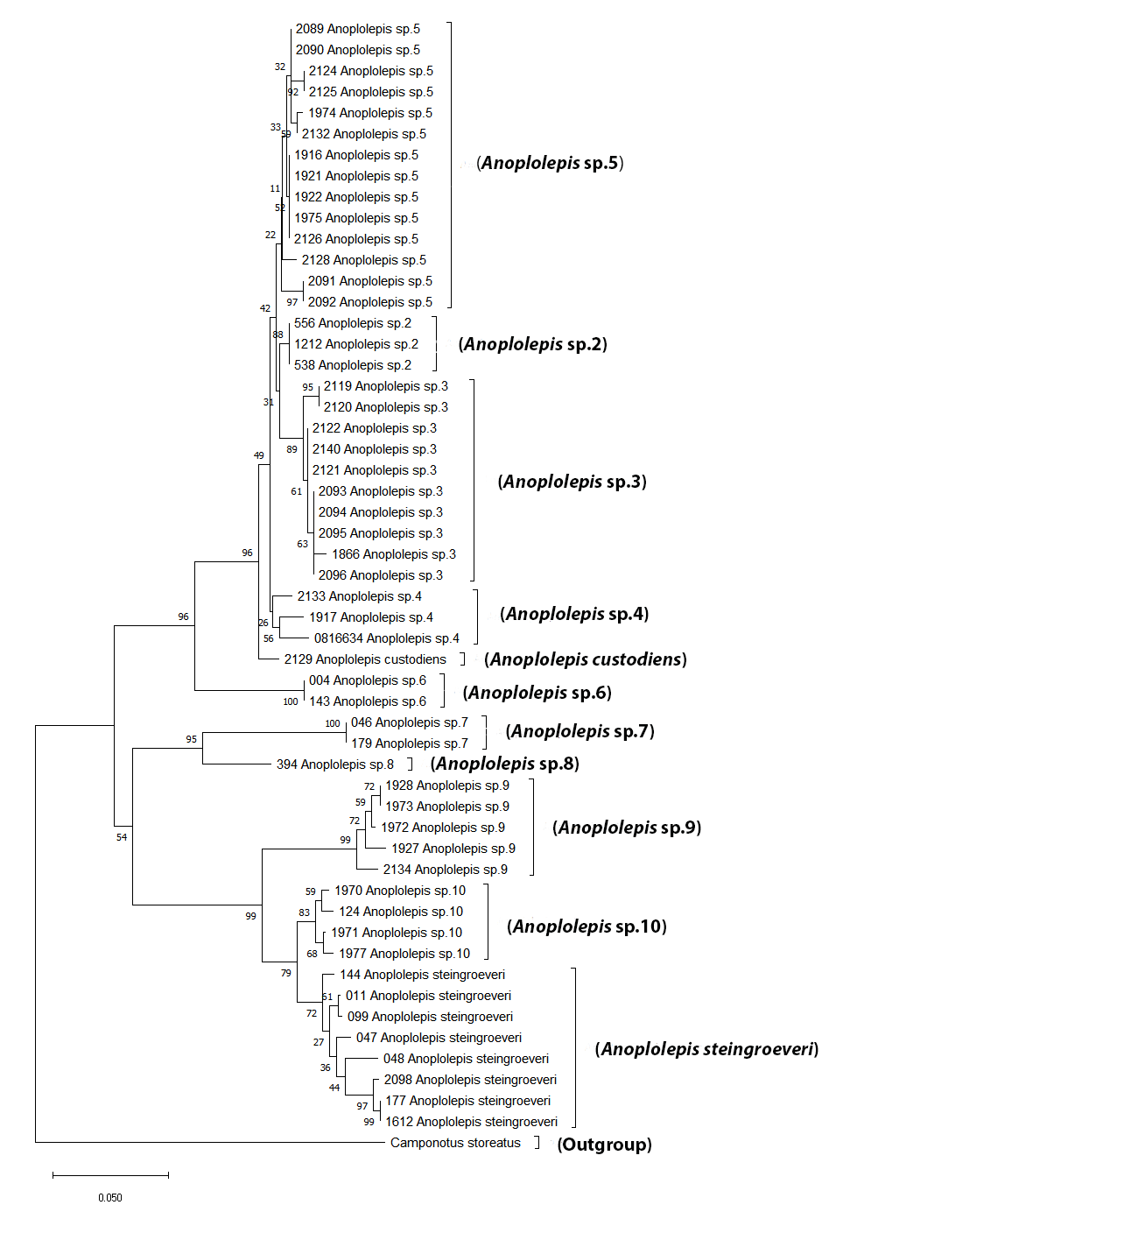
Figure 1: A neighbour-joining phylogenetic tree of 54 Anoplolepis nucleotide sequences (COI) in southern Africa. Bootstrap support values are indicated on nodes.

Table 1: p-distance values of within groups and between groups of barcoded species. P-distance values in red represent the lowest values and green represent the highest values.

2.2 Morphology
Diagnosis of workers within the genus Anoplolepis
Anoplolepis can be distinguished from other genera using the following diagnosis based on Fisher and Bolton (2016): 11-segmented antennae; absence of ocelli (present in some majors); propodeum and petiole lack spines; metanotum on the mesosoma is not differentiated; stout spur present on the metatibia; eyes located well behind the midlength of the head; numerous stout, standing setae present on the dorsum of the head behind the clypeus. Anoplolepis minor workers can be differentiated from a closely related genus Plagiolepis from the lack of ocelli.

Checklist of Anoplolepis species for southern Africa
Anoplolepis carinata (Emery, 1899)
Anoplolepis custodiens (Smith, 1858)
Anoplolepis nuptialis (Santschi, 1916)
Anoplolepis steingroeveri (Forel, 1894)

Key to the identification of southern African species of Anoplolepis (based on workers)
The identification key presented here is based on work by A. Andersen (unpublished data), Prins (1982) and Taylor (2015).

- Body generally stockier without obvious elongation; small species TL (2.3mm – 3.7mm) ……..
….……………………………………………………..................................................................................... 14
Body less stocky with obvious narrow body; workers from small to very big (TL (2.7mm (minors) – 11.1mm (majors)) …..…………………………….……………………………………………..…………… 2

- Chequered pattern of pubescence on metasoma; mesosoma more biconvex due to deeper metanotal groove, with spiracle very prominent, followed by a distinct declivitous face; hind femora with erect setae throughout; metasoma of minors shiny, without pubescence ………. ……………………..………………………………………………………………………………………………………………….. 3
Chequered pattern of pubescence on metasoma absent; Mesosoma not so biconvex, with metanotal spiracle not prominent, metanotum without a distinct declivitous face; erect setae on hind femora, if present, restricted to basal half; metasoma of minors covered with pubescence ..……………………………………………....………………….………………………………………………… 6

- Sides of head hairy; mesosoma more densely hairy (Figure 2A) …….………………......................
…………………………………………………………………………………..……………………………. Anoplolepis sp. 11
Sides of head without setae; mesosoma less densely hairy (Figure 2B) ...…………………………….. ….………………..…………………………………………………………………………………………………………………….. 4
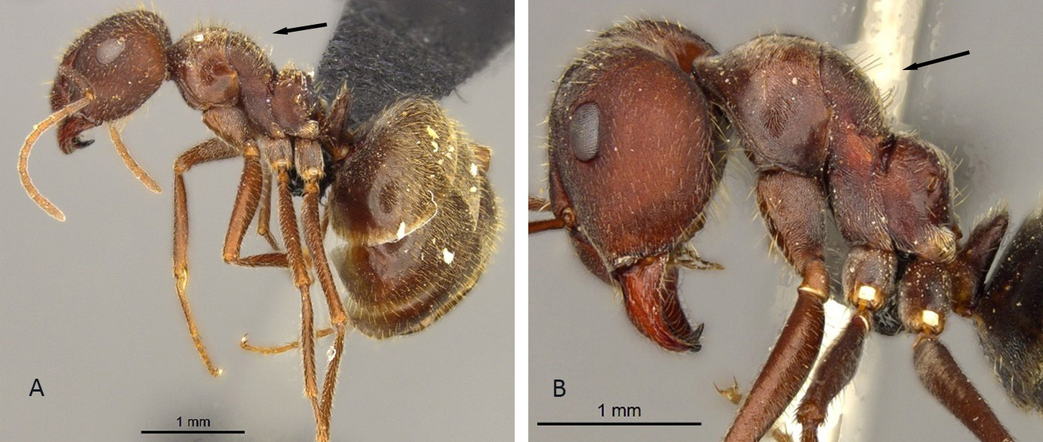
Figure 2: Lateral view of: Anoplolepis sp. 11 (A) showing mesosoma that is densely hairy and, and Anoplolepis sp. 9 (B) showing mesosoma that is less densely hairy.

- Head densely and uniformly punctate in majors, feebly but conspicuously reticulate-punctate in minors; pubescence clearly visible and dense on the head, mesosoma, and metasoma (Figure 3A) .………………………......................................................... Anoplolepis sp. 9
Head not so densely and uniformly punctate in majors, smooth and shiny in minors; pubescence on the head not clearly visible (Figure 3B) …..………………………………………………… 5
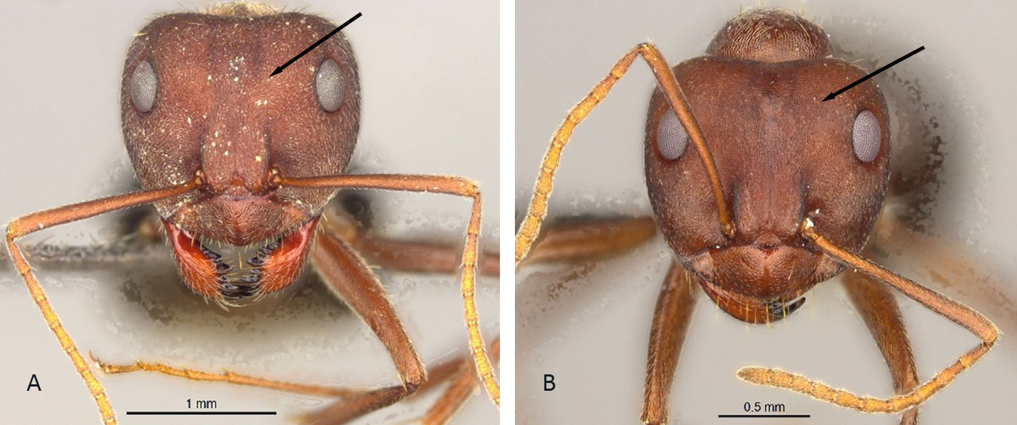
Figure 3: Head in full-face view of: Anoplolepis sp. 9 (A) showing a densely and uniformly punctate head with dense pubescence and, Anoplolepis sp. 10 (B) showing not so densely and uniformly punctate head with less visible pubescence.
- Pubescence less visible on the head and mesosoma, side of mesosoma punctate in majors; head is less heart-shaped as in A. steingroeveri (Figure 4A) …………………………………………….…. ………………………………………………………………………………………………………………. Anoplolepis sp. 10
Pubescence sub-erect and clearly visible on head and mesosoma; side of mesosoma striate in majors; head more heart-shaped (Figure 4B) ………………………………………………………….......... ………………………………………………………................................................. Anoplolepis steingroeveri
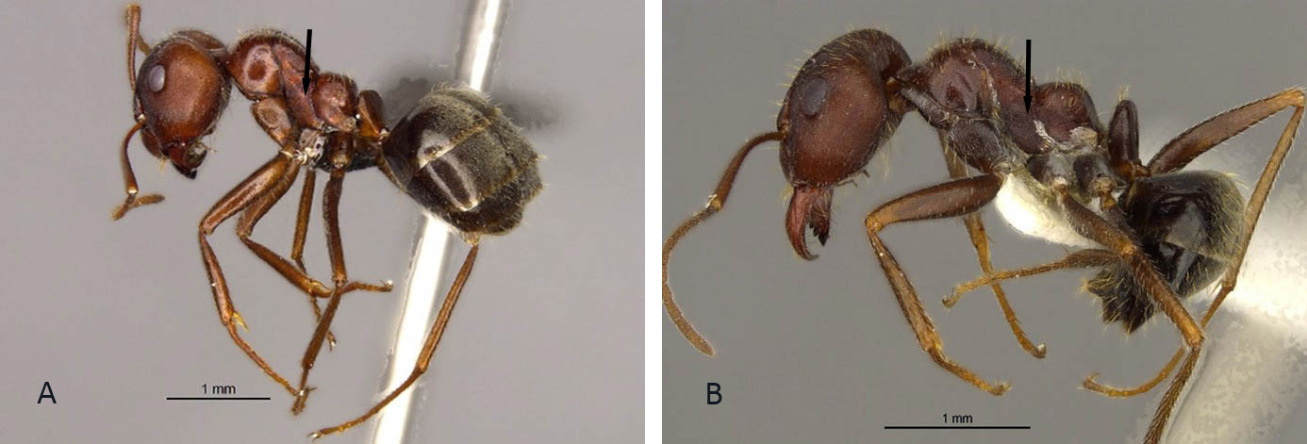
Figure 4: Lateral view of: Anoplolepis sp. 10 (A) showing mesosoma that is punctate and without striation on the sides, and A. steingroeveri (B) showing mesosoma with striation on the sides.

- Scapes exceeding occipital margin by nearly two-thirds their length in minors; setae on mesosoma short (in minors, shorter than maximum diameter of the hind femur) and blunt; hind femur without erect setae (Figure 5A)………………………………………………………………………… 7
Scapes exceeding occipital margin by about half their length in minors); setae on mesosoma longer (in minors, as long or longer than the maximum diameter of the hind femur) and finer; hind femora with erect setae on basal half (Figure 5B)……………………………………………. 13
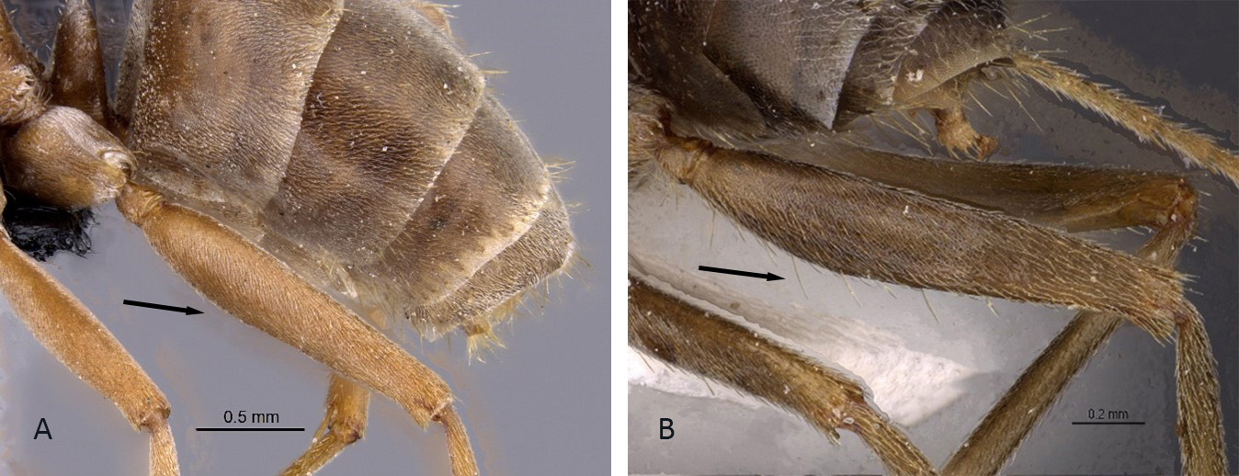
Figure 5: Femur of: A. custodiens (A) showing a hind femur without erect setae, and A. sp. 7 (B) showing a hind femur with erect setae on basal half.

- Setae absent from anterior third of mesonotum …………..…………………………………………………… 8
Setae present on the anterior third of mesonotum .………………..………………………………………. 10

- Mesonotum with single pair of setae only; eyes of normal size (>0.2mm) (Figure 6A) ………. 9
Mesonotum with >2 setae; eyes distinctly smaller (Figure 6B) …………………..………................... ……..……………….………………………………………………………………………………………….. Anoplolepis sp. 1
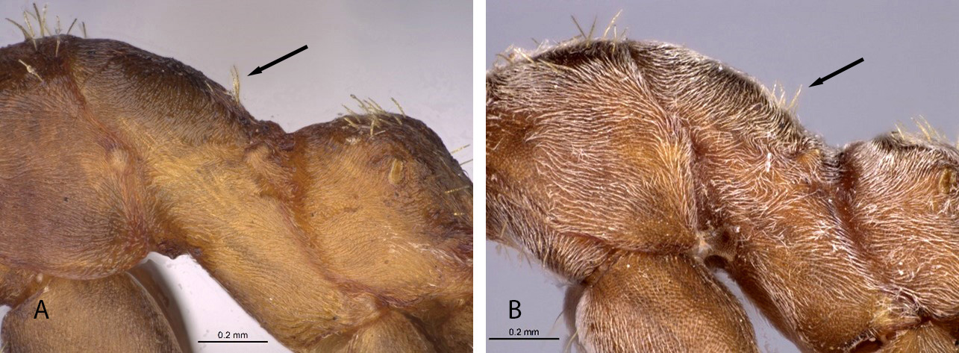
Figure 6: Mesonotum of: Anoplolepis sp. 7 (A) showing a mesonotum with two pairs of setae only, and Anoplolepis sp. 1 (B) showing a mesonotum with more than two setae.

- Head shape more wider than long; eyes of normal size (>0.2mm) ………………………………………..
………..………………………………….…............................................................. Anoplolepis custodiens
Head shape longer than wide, large eyes that protrude more outwardly ..……………..….………...
………..………………………………….…....................................................................... Anoplolepis sp. 6

- Setae on mesosoma uniformly short and blunt (Figure 7A) ..………………………………………………… ……………………………………….………….…………….................................................... Anoplolepis sp. 5
Setae on mesosoma slightly longer and not so blunt (Figure 7B) .…………………………………………. ……………………………………………………….……............................................................................... 11
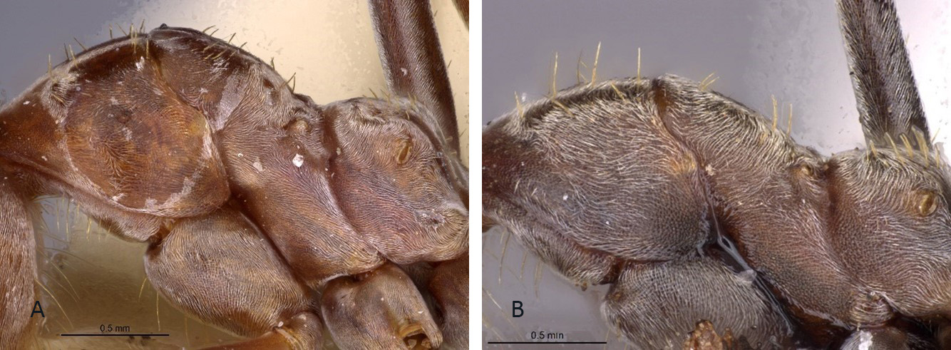
Figure 7: Mesosoma of: Anoplolepis sp. 5 (A) showing a mesonoma with uniformly short and blunt setae, and Anoplolepis sp. 3 (B) showing a mesosoma with slightly longer and not so blunt setae.

- Head shape more wider than long; distinctly small eyes ………………………………………………………. ……………………………………….………………………………………………………………………… Anoplolepis sp. 2
Head shape more longer than wide; eyes of normal size (>0.2mm) ……..………………………………. …………………………………………………………………………………………………………………………………………. 12

- Petiole with a thick erect scale (Figure 8A) ………………………….………………………………………………. ………………………………………………………………………………………………………………….. Anoplolepis sp. 3
Petiole with erect scale, usually with distinct lateral vertical margination (Figure 8B) …………..….. …………………..…………….……………………………………………………………… Anoplolepis sp. 4
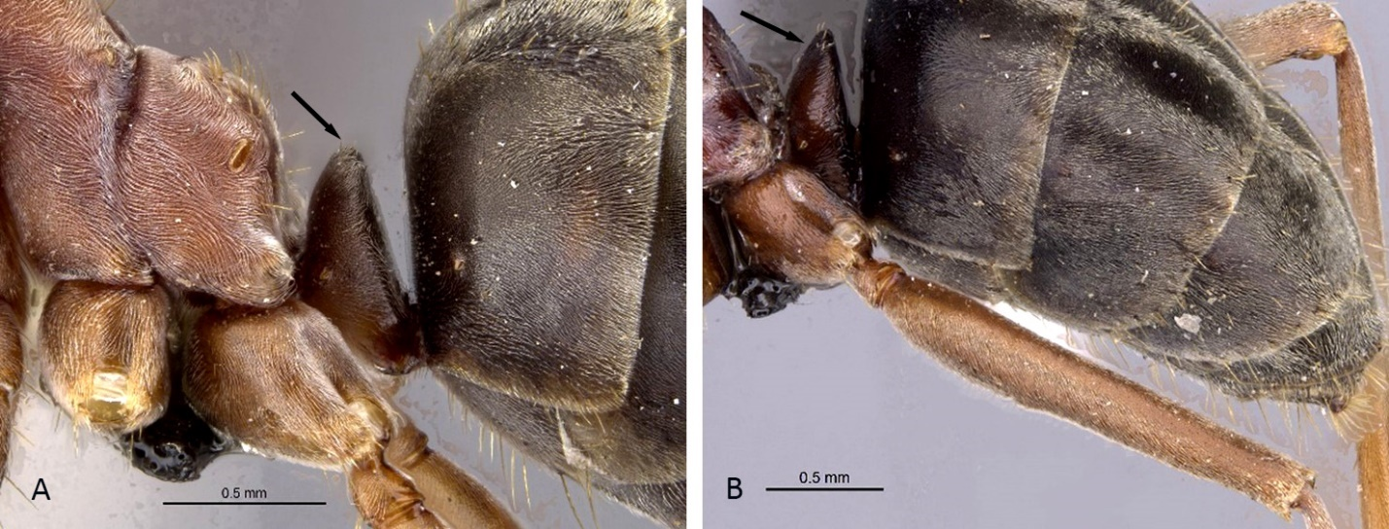
Figure 8: Petiole of: Anoplolepis sp.3 (A) showing a petiole with a thick erect scale, and Anoplolepis sp.4 (B) showing a petiole with an erect scale.

- Eyes of workers normal size (>0.2mm) for both majors and minors; head of minors densely punctate and dull ……….............…………………………………………………………………. Anoplolepis sp. 8
Eyes of workers distinctly smaller for both majors and minors; head of minors rather feebly sculptured and rather shiny ………………………...……………………………………………. Anoplolepis sp. 7

- Propodeum forms an obvious round hump; body has numerous, erect setae; head evenly ovoid; standing setae forming two lines on the frontal carina (Figure 9A) …………………………… ………………….............................................................................................. Anoplolepis carinata
Propodeum does not form an obvious hump; body has no numerous, erect, standing setae (only the metasoma has standing setae); head less ovoid; frontal carinae does not go up and does not have standing setae (Figure 9B) ……………………………..…………. Anoplolepis sp. nov. 12
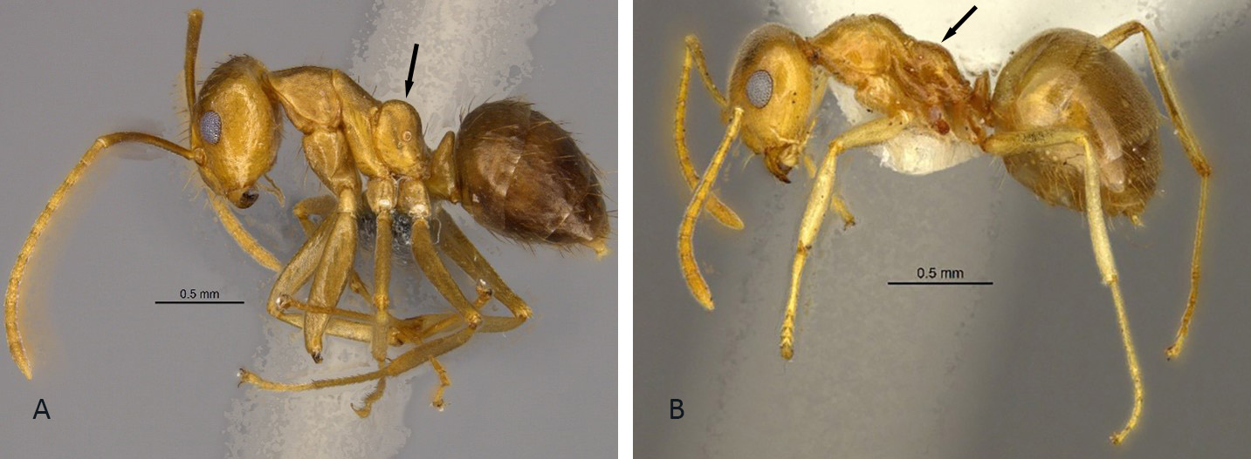
Figure 9: Lateral view of: A. carinata (A) showing a propodeum forming an obvious round hump and body with numerous, erect setae, and Anoplolepis sp. nov. 12 (B) showing a propodeum without an obvious hump and body without erect, standing setae.

Species descriptions
Anoplolepis carinata (Emery, 1899)
(Figures 10A, 10B, 10C)
Measurements (workers)
HW 0.878-0.995, HL 1.073-1.104, SL 1.365-1.463, EL 0.234-0.254, PW 0.605-0.702, NW 0.293-0.332; NL 0.254-0.273; ML 1.346-1.443, CI 85-96, SI 134-174, EI 24-30 (4 specimens measured).

Diagnosis (After Taylor, 2015)
Anoplolepis carinata is the only species in this genus with numerous, erect setae (Figure 10B). Anoplolepis carinata has an evenly ovoid head (Figure 10A), a propodeum that forms an obvious round hump (Figure 10B), and smooth mandibles. Anoplolepis carinata and Anoplolepis sp. nov. 12 are the smallest species within the genus Anoplolepis and are generally stockier (TL 2.3mm – 3.7mm).

Distribution
Anoplolepis carinata was first described from specimens collected in Cameroon. The species was subsequently recorded in neighbouring countries Congo (Appendix 1, Figure E) and the Central African Republic.

Material examined (4 pinned specimens)
Republic of the Congo: Niari: Loucoume Forest, 2.3160S 12.8092E, L. Niemand, 06 November 2020, pitfall trap, CASENT0250095-CASENT0250096; Loucoume Forest, 2.3241S 12.8117E, L. Niemand, 28 June 2013, pitfall trap, CASENT0814955-CASENT0814956.

Type locality Cameroon (Plagiolepis carinata n. sp., Emery, 1899e: 491, worker & queen; in Anoplolepis, Emery, 1925b: 17) collected by Conradt; worker and queen described (see Bolton, 1995). Type locality Cameroon (Plagiolepis carinata n. sp., Emery, 1899e: 491, worker & queen; in Anoplolepis, Emery, 1925b: 17).

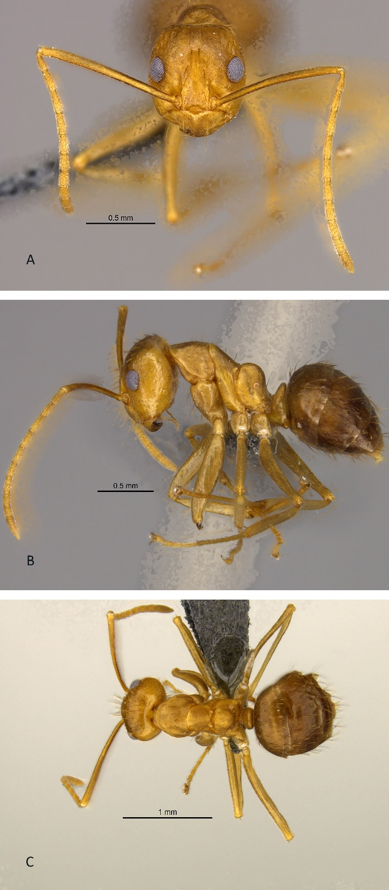
Figure 10: Anoplolepis carinata (worker). A, head in full face view; B, lateral view and C, dorsal view.

Anoplolepis custodiens (Smith, 1858)
(Figures 11A, 11B, 11C)
Measurements (workers)
HW 0.702-2.087, HL 0.858-2.067, SL 0.956-2.340, EL 0.234-0.429, PW 0.488-1.248, NW 0.215-0.644; NL 0.215-0.468; ML 1.293-2.507, CI 82-101, SI 112-178, EI 21-39 (23 specimens measured)

Diagnosis (after Prins, 1982)
Anoplolepis custodiens can be confused with A. steingroeveri (the black pugnacious ant) as both species share the following character: ranges from very yellowish-brown to black and the metasoma that is dark-brown to black. It can be distinguished from A. steingroeveri by the presence of the chequered pattern on the metasoma, more pubescence setae on the metasoma of minors and the metasoma are shinier as opposed to that of A. steingroeveri. The sides of the head from the dorsal view are less convex than A. steingroeveri. Anoplolepis custodiens males and queens can also be confused with those of A. nuptialis. Both species have eight to nine sharp teeth, have a chequered pattern on the metasoma, and wings are more or less the same.

Distribution
Anoplolepis custodiens is the most widespread species in this genus. It occurs in all nine provinces of South Africa and also occurs in Namibia, Botswana, Lesotho, and Mozambique (Appendix 1, Figure B).

Materials examined (338 pinned specimens)
South Africa: Limpopo: Sekhukhune, -24.6984S 30.3566E, P. Hawkes, J. Fisher, B. Reynolds, M. Bain, 13 February 2016, pitfall trap, CASENT0252678; Gauteng: City of Tshwane, 25.7371S 28.2815E, P. Hawkes, M. Clark, 18 March 2005, pitfall trap and wrinkle, CASENT0254088; City of Johannesburg, 26.1689S 28.0021E, P. Hawkes, M. Clark, 15 February 2006, CASENT0254099; Ekurhuleni, 25.9259S 28.2912E, , P. Hawkes, M. Clark, K. Harris, 21 February 2006, hand collected, CASENT0254104 - CASENT0254105; Mpumalanga: Nkangala, 25.7092S 28.9824E, P. Hawkes, M. Clark, 10 March 2005, wrinkle, CASENT0254094; Standerton, 26.8096S 29.2541E, P. Hawkes, J. Fisher, N. Babu, M. Baloi, M. Zulu, 27 November 2008, hand collected, CASENT0256507; Ehlanzeni, 24.9316S 30.3347E, P. Hawkes, J. Fisher, B. Reynolds, M. Bain, 12 February 2016, pitfall trap, CASENT0258443; Barberton, 25.7833S 31.0500E, J.H. Grobler, 29 November 1956, SAM-HYM-C004950; Northern Cape, Postmasburg, 27.8077S 22.9429E, P. Hawkes, J. Fisher, 19 February 2015, pitfall trap; CASENT0255712; Eastern Cape: Cathcart, 32.3167S 27.1333E, J.A. Irish, 16 September 1985, collected from nest, SAM-HYM-C000042; Uitenhage, 33.5667S 25.4167E, J.A. Irish, 26 June 1987, SAM-HYM-C001126; Grahamstown, at old drive-in, 33.3167S 26.5167E, H.G. Robertson, 23 October 1985, HYM-C001126; Komgha, 32.5833S 27.9000E, J.J. Cillie, 21 November 1960, SAM-HYM-C031531; Cradock, 32.1833S 25.6417E, A.J. Prins, 25 May 1987, SAM-HYM-C031527; Port Elizabeth, 33.9181S 25.5701E, J.J. Cillie, 16 November 1960, SAM-HYM-C031304; Humansdorp, 34.0290S 24.7691E, J.J. Cillie, 14 November 1960, SAM-HYM-C031301; Free State: Oranjekrag, 30.6000S 25.5000E, H.G. Robertson, 04 July 1987, turning over rocks, SAM-HYM-C000419; Ooskloof, Jagersfontein, 29.7613S 25.4271E, F. Haniball, 18 December 1963, SAM-HYM-C031535; Tussen Die Riviere, near camp site, CASENT0255712; 8km from Petrusville to Colesburg, 30.0811S 24.6593E, unknown collector, unknown collection date, SAM-HYM-C031440; KwaZulu-Natal: Estcourt, 29.0000S 29.8833E, E. Haviland, 31 December 1894, SAM-HYM-C004981; Durban, 29.7667S 31.0500E, C.N. Barker, 1800, HYM-C004994; Ukulinga Research Farm, 29.6667S 30.4000E, B. Chambers, 31 December 1991, pitfall trap, HYM-C005381; Kokstad 27.4923S 31.7387E, T.C. Munyai, 20 January 2020, HYM-C032186; Durban, Bufflesdraai Conservancy, 29.6319S 30.9683E, T.C. Munyai, 21 October 2018, HYM-C032170; Melmoth, Entonjaneni, 28.5775S 31.3942E, J.H. Grobler, 27 January 1957, SAM-HYM-C031506. North West: Wolwespruit, 28.8737S 27.8813E, R.M. Brits, December 1940, SAM-HYM-C031362. Western Cape: Bredasdorp, 34.5321S 20.0403E, unknown collector, 18 July 1959, SAM-HYM-C031308; Patensie, 33.7428S 24.7101E, A.J. Prins, 22 August 1968, SAM-HYM-C030891; 12km from Swartberg Pass, 33.3466S 21.9280E, N. Mbanyana, 25 October 2005, collected by hand, SAM-HYM-C019037; Patensie, Vredenburg, 33.7331S 24.7068, E. Marais, 06 February 1969, SAM-HYM-C015586.
Lesotho: Maseru, 29.3167S 27.5000E, G. Arnold, 01 December 1912, SAM-HYM-C004992.
Namibia: Sarafri Court Hotel Windhoek, 22.5975S 17.0822E, A. Chapman, September 1998, HYM-C031756.
Botswana: Serowe, 24.8402S 25.5721E, unknown collector, August 1924, SAM-HYM-C031426.
Mozambique: Lipobane Camp (Terebwane), 17.0000S 39.0667E, I.R. Bills, 14 July 1997, collected by hand, SAM-HYM-C013262; Moebase Mine Camp, 17.0500S 38.6667E, I.R. Bills, 12 July 1997, collected by hand, SAM-HYM-C013257.

Type locality South Africa (Formica custodiens, F. Smith, 1858b: 33, worker; Mayr, 1895: 148, male) moved to Anoplolepis by Emery (1925b: 17) Port Natal.

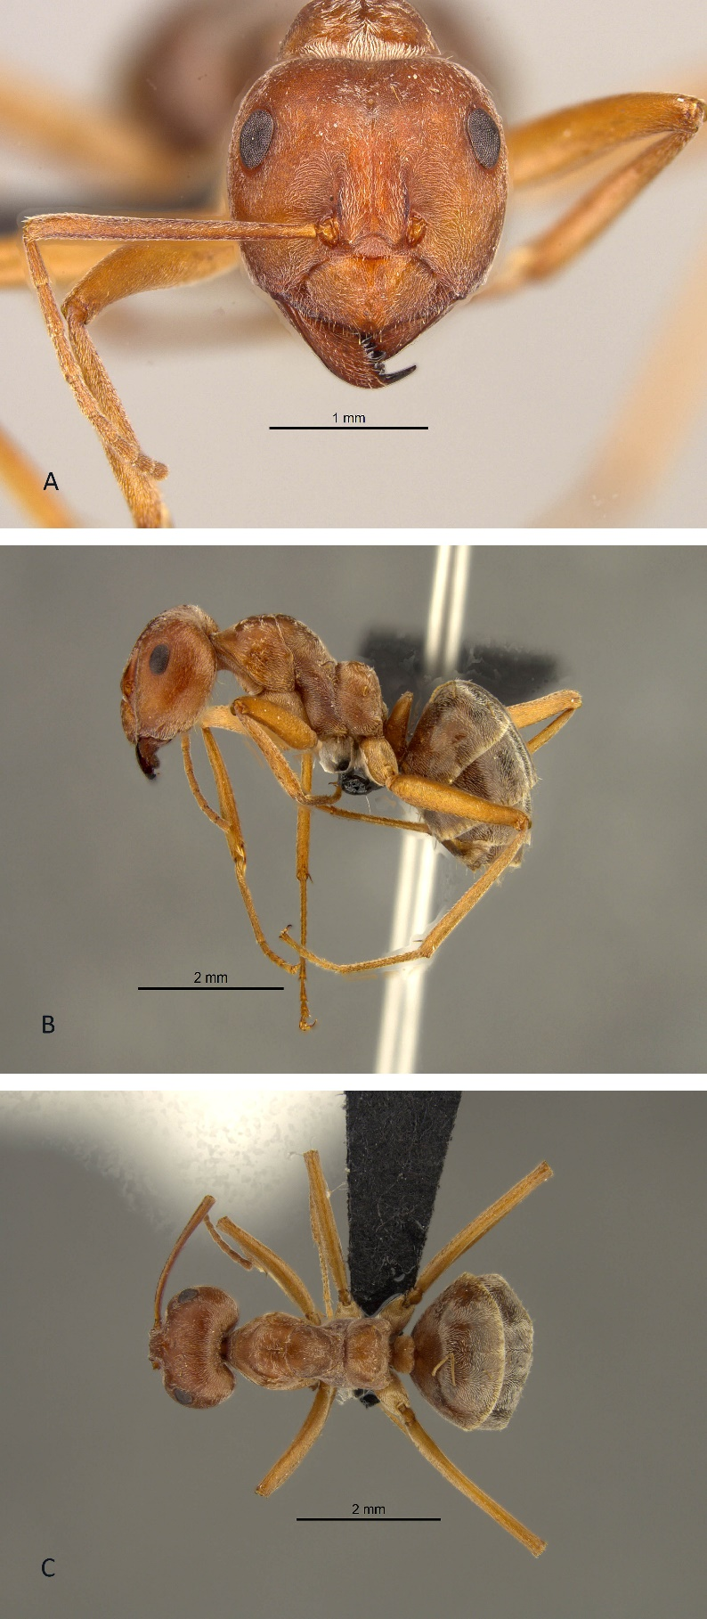
Figure 11: Anoplolepis custodiens (worker). A, head in full face view; B, lateral view and C, dorsal view.
Anoplolepis nuptialis (Santschi, 1916)
(Figures 12A, 12B, 12C)
Measurements (workers)
HW 0.702-0.741, HL 0.780-0.858, SL 0.897-0.956, EL 0.234-0.254, PW 0.410-0.507, NW 0.215-0.234; NL 0.137-0.215; ML 0.783-1.053, CI 84-90, SI 125-132, EI 33-35 (3 specimens measured).

Diagnosis
Anoplolepis nuptialis was first placed in the genus Plagiolepis (Santschi 1917), and later transferred to Anoplolepis by Emery (1925). Anoplolepis nuptialis is distinguished from A. custodiens by its lighter colour, including legs and metasoma. The body is covered with almost silvery pubescence. It has an angular clypeus that is not as acute as in A. custodiens. Ocelli is larger than those of A. custodiens.

Distribution
Only males and queens have been described for this species. Anoplolepis nuptialis occurs in the Fynbos biome (Rutherford and Mucina, 2006) in the Western Cape and Eastern Cape (Appendix 1, Figure D).

Material examined (9 pinned specimens)
South Africa: Eastern Cape: Willowmore, 33.3000S 23.4833E, 01 April 1917, H. Brauns, SAM-HYM-C004971; Western Cape: Bosjiesmansberge, 32.8000S 18.5833E, South African Museum Expendition, 01 February 1940, SAM-HYM-C004972; Albertinia, 34.1250S 21.6250E, A. Roux, 18 May 1987, SAM-HYM-C001706; Worcester, 33.7167S 19.1000E, 01 May 1974, SAM-HYM-C004938.

Type locality South Africa (Plagiolepis (Anoplolepis) nuptialis n. sp., Santschi, 1917b: 289, male; Prins, 1982: 222, queen; in Anoplolepis Emery, 1925b: 18; in Zealleyella, Santschi, 1926a: 14) Cape Province, Willowmore, coll. H Brauns.

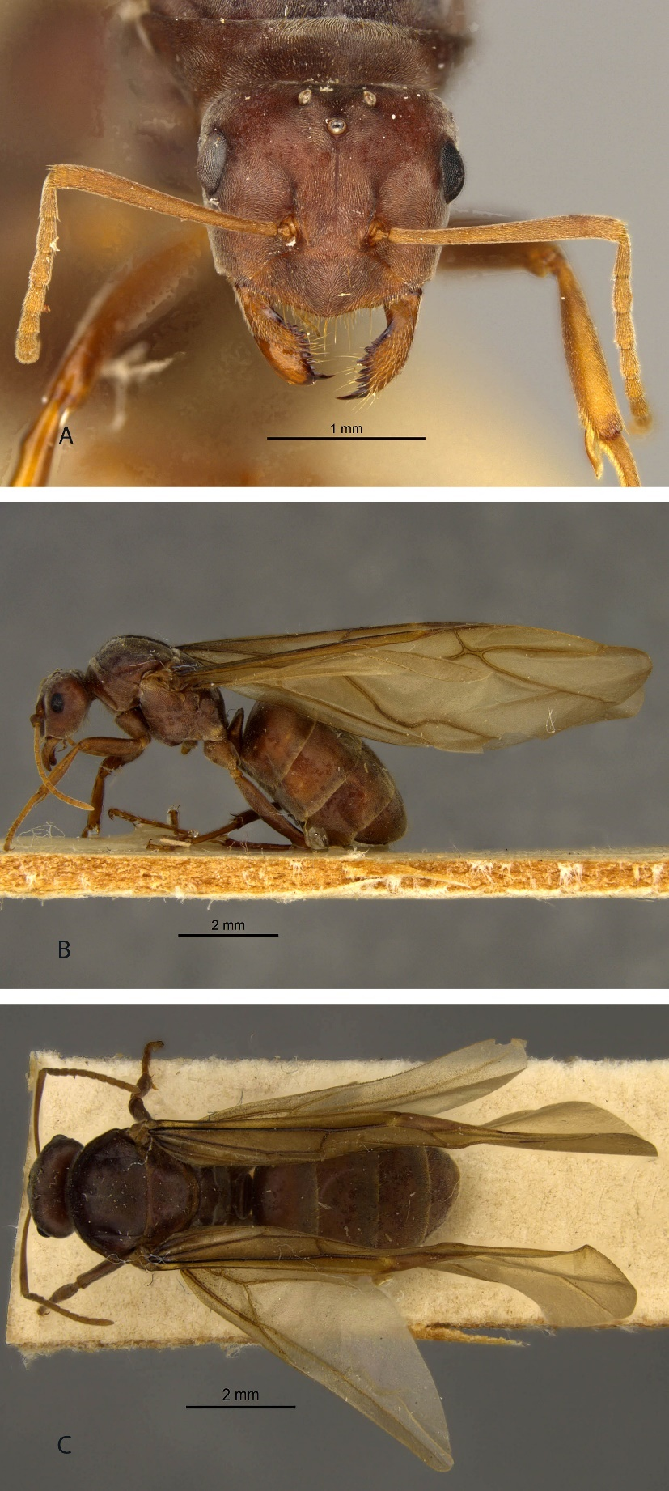
Figure 12: Anoplolepis nuptialis (Queen). A, head in full face view; B, lateral view and C, dorsal view.

Anoplolepis steingroeveri (Forel, 1894)
(Figures 4B, 13A, 13B, 13C)
Measurements (workers)
HW 0.638-2.213, HL 0.702-2.233, SL 0.714-1.892, EL 0.215-0.470, PW 0.410-1.371, NW 0.195-0.744; NL 0.157-0.488; ML 0.823-2.389, CI 74-114, SI 74-150, EI 19-38 (46 specimens measured).

Diagnosis
Anoplolepis steingroeveri specimens vary in colour from reddish-brown to blackish-brown and are sometimes black. This species can be easily distinguished from A. custodiens based on the differential morphological characters listed under A. custodiens.

Material examined
Type locality Namibia (Plagiolepis steingröveri, Forel, 1894b: 72, worker; Arnold, 1922: 590, queen & male; in Zealleyella Santschi, 1926a: 14) subspecies gertrudae (Plagiolepis steingröveri Forel r. gertrudae nov. stirps, Forel, 1900b: 77, worker) from Reunion I.

Distribution
A. steingroeveri is widely distributed across southern Africa (Appendix 1, Figure E). This species occurs in South Africa, Namibia, Botswana, Swaziland, and Zambia.

Materials examined (941 pinned specimens)
South Africa: Eastern Cape: Addo National Park, 33.4830S 25.7548E, A.J. Prins, 25 August 1968, SAM-HYM-C030861; Thursford Farm, 33.2000S 26.3667E, H.G. Robertson, 13 December 1982, SAM-HYM-C000009; Willowmore, 33.3000S 23.4833E, H. Brauns, 01 December 1912, SAM-HYM-C004974 - SAM-HYM-C004977; Western Cape: Brandvlei, 30.5167S 20.4833E, A.J. Prins, 28 May 1986, SAM-HYM-C001760; Montagu, 33.7833S 20.1167E, J.J. Cillie, 22 November 1962, SAM-HYM-C004984; Stanford, 34.4333S 19.4500E, A.J. Prins, 20 March 1972, SAM-HYM-C004985; Silvermine Valley, C.G.C Dickson, 34.0833S 18.4167, 03 April 1945, SAM-HYM-C004986; Seweweekspoort, 33.4000S 21.4000E, K.H Barnard, 01 February 1932, HYM-C006994; Merweville, 32.6667S 21.5167E, H. Zinn, 01 January 1947, SAM-HYM-C007004; Aurora, Piketberg, 32.7000S 18.4833E, A.J. Prins, 07 July 1959, SAM-HYM-C015135; Van Rhynsdorp, Cape, 31.6000S 18.7333E, A.J. Prins, 05 October 1959, SAM-HYM-C015247; Oudtshoorn, 33.5833E 22.2000E, A.J. Prins, 14 May 1960, HYM-C015491; 12 km from Swartberg Pass, 33.3466S 21.9281E, N. Mbanyana, 25 October 2005, collected by hand, SAM-HYM-C019040; Elandsfontein farm, 32.2895S 22.9370E, R. Tourle, 21 April 2001, pitfall trap, SAM-HYM-C021910; Kogelberg Nature Reserve, 34.2500S 19.0833E, C.E. Christian, 16 May 1999, pitfall trap, SAM-HYM-C022867; Kromrivier, Cedarberg, 32.5363S 19.2893E, H. Schanzer, 10 March 2018, pitfall trap, SAM-HYM-C028044; Anysberg Nature Reserve, 33.4744S 20.5440E, S. van Noort, 29 October 2015, yellow pan trap, SAM-HYM-C028790; Gauteng: Bezuidenhoutskraal, 25.1333S 28.7333E, J.J. Nel, 12 December 1957, SAM-HYM-C004979; Alcudia, Rustenburg, 25.6667S 27.2333E, Nel, 28 July 1968, SAM-HYM-C030899; Northern Cape: Britstown, 30.5833S 23.5000E, J.H. Grobler, 14 January 1958, SAM-HYM-C004983; Melton Wold, Victoria West, unknown collector, 31.5167S 22.7833E, 24 June 1939, SAM-HYM-C006990; Tankwa Karoo, 32.6667S 20.3833E, H. Zinn, 01 January 1949, SAM-HYM-C007005; Papkuilsfontein farm, 31.5135S 19.1812E, H.G. Robertson, pitfall trap, 12 October 2000, SAM-HYM-C020716; Narugas, 29.3000S 19.2333E, R. Lightfoot, January 1919, SAM-HYM-C031125; KwaZulu-Natal: Estcourt, 29.0000S 29.8833E, E. Haviland, 31 December 1894, SAM-HYM-C006989; Mfongosi, W.E. Jones, 28.7000S 30.8000E, 01 May 1935, SAM-HYM-C007029; Free State: Vredefort, 27.0000S 27.3667E; unknown collector, 31 December 1902, SAM-HYM-C007002; Limpopo: Leon Taljaard Nature Reserve, Vryburg, 26.9239E 24.6858E, N. Mbanyana, S. van Noort, collected from nest, 05 October 2019, SAM-HYM-C030589.
Namibia: Southwest Africa, Rehoboth, 23.3167S 17.0833E, H.W.B.M. Bell-Marley, 01 November 1938, SAM-HYM-C007009; Aris Farm, 13km South of Windhoek, 22.6931S 17.1064, S. van Noort, collected by hand, 19 April 1999, SAM-HYM-C013311; Sperrgebiet, 27.2215S 16.0798E, I. Wiesel, 01 February 2009, pitfall trap, SAM-HYM-C027686; Mahanene Ovambo, B. Wohlleber, 17.4333S 14.7833E, 05 September 1993, pitfall trap, SAM-HYM-C030107; Kaudom Game Reserve, 19.0667S 20.8000E, E. Marais, 11 January 1991, pitfall trap, SAM-HYM-C030229; Bushmanland, 19.3667S 19.6000E, E. Marais, 07 January 1991, pitfall trap, SAM-HYM-C030230; Etosha Game Park, 18.5167S 15.4000E, E. Griffin, 20 May 1986, pitfall trap, SAM-HYM-C030239.

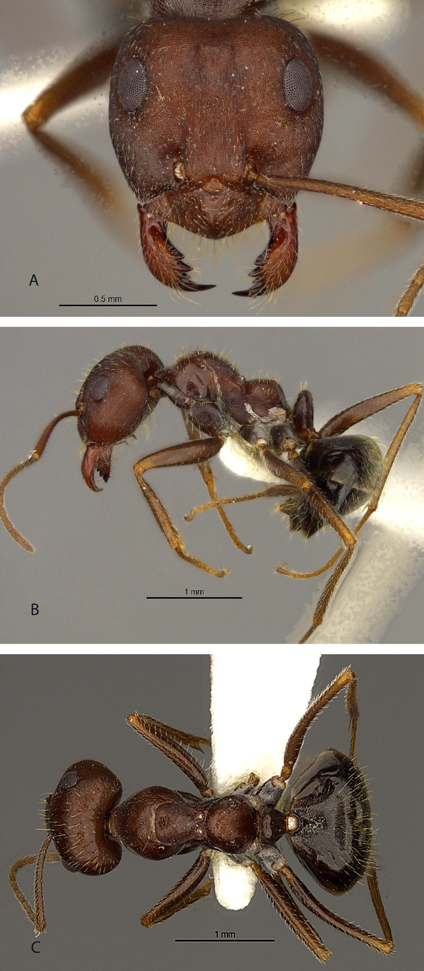
Figure 13: Anoplolepis steingroeveri (worker). A, head in full face view; B, lateral view and C, dorsal view.
Anoplolepis sp. 1
(Figures 14A, 14B, 14C)
Measurements (workers)
HW 0.683-2.311, HL 0.819-2.193, SL 0.897-2.428, EL 0.195-0.509, PW 0.488-1.449, NW 0.215-0.722; NL 0.157-0.509; ML 0.940-3.016, CI 75-109, SI 68-140, EI 24-33 (15 specimens measured).

Diagnosis
Anoplolepis sp. 1 can be distinguished from other species from their absence of setae on the anterior third of the mesonotum and eyes that are distinctly small. This species is similar to Anoplolepis fallax, however, Anoplolepis sp. 1 has less pubescence covering the body than A. fallax.

Distribution
This species occurs in Western Cape, Northern Cape, Eastern Cape, KwaZulu-Natal, and Free State provinces in South Africa. It also occurs outside South Africa, in Mozambique and Zimbabwe (Appendix 1, Figure C).

Materials examined (49 pinned specimens)
South Africa: Northern Cape: Olifantshoek, 27.9426S 22.7362E, A.J. Prins, 07 September 1983, SAM-HYM-C031378; Kamieskroon, 30.2094S 17.9339E, A.J. Prins, 06 October 1959, SAM-HYM-C031453; Port Nolloth, 29.2519S 16.8697E, A.J. Prins, 07 October 1959, SAM-HYM-C031452; Western Cape: Swellendam, 34.0226S 20.4417E, A.J. Prins, 18 July 1959, SAM-HYM-C031307; 19km from Oudtshoorn to De Rust, 34.1831S 22.1461E, A.J. Prins, 20 November 1962, SAM-HYM-C031404; Bredasdorp, Ouplaas, 34.3667S 20.4333E, A.J. Prins, 11 May 1960, SAM-HYM-C031457; Bitterfontein, 31.0371S 18.2648E, A.J. Prins, 05 October 1959, SAM-HYM-C031454; Cape Town, 33.9167S 18.4167E, R.M. Gess, 31 December 1887, SAM-HYM-C005057; Eastern Cape: Cradock, 32.1833333333S 25.6416666666E, A.J. Prins, 25 May 1987, SAM-HYM-C031527; Humansdorp, 34.0290S 24.7691E, A.J. Prins, 15 November 1960, SAM-HYM-C031302; Grahamstown, 33.3042S 26.5328E, A.J. Prins, 18 November 1960, SAM-SAM-HYM-C031246; Oyster Bay, 34.1667S 24.6500E, H.G. Roberston, 29 January 1983, SAM-HYM-C000012; Lusikisiki, 31.4167S 29.5000E, J.D. Mitchell, 08 May 2002, by hand, SAM-HYM-C017935; KwaZulu-Natal: Verulam to Stanger, 28.5775S 31.3942E, unknown collector, 13 February 1962, SAM-HYM-C031281; Cedara, 29.5478S 30.2666E, A.J. Prins, 19 October 1961, SAM-HYM-C031513; Free State: Hillside Farm, Springfontein, 30.1500S 25.7667E, H. Adie, 28 September 1995, SAM-HYM-C008453; Limpopo: Sekhukhune, 24.7777S 30.32246E, Hawkes, Fisher, Reynolds, Bain, 31 December 2017, pitfall trap, CASENT0252845.
Zimbabwe: Communal area, Kanyati, 16.9500S 28.9333E, A.J. Gardiner, 01 March 1996, SAM-HYM-C010926.
Mozambique: Moebase, 16.8000S 38.7167E, I.R. Bills, 13 July 1997, by hand, SAM-HYM-C013269.
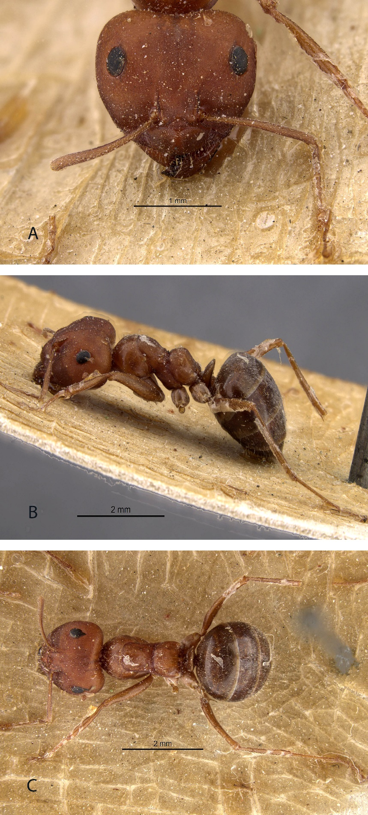
Figure 14: Anoplolepis sp.1 (worker). A, head in full face view; B, lateral view and C, dorsal view.

Anoplolepis sp. 2
(Figures 15A, 15B, 15C)
Measurements (workers)
HW 0.780-2.223, HL 0.917-2.243, SL 0.215-2.340, EL 0.234-0.507, PW 0.429-1.541, NW 0.215-0.761; NL 0.215-0.488; ML 1.097-2.977, CI 85-115, SI 89-144, EI 19-28 (10 specimens measured).

Diagnosis
Anoplolepis sp. 2 is more closely related to Anoplolepis sp.3 and Anoplolepis sp.4. These species have setae that are slightly longer and not so blunt on the mesosoma, which makes them different from Anoplolepis sp. 5. Anoplolepis sp. 2 is different from the other two species from its distinctly small eyes and head that is wider than long.

Distribution
Anoplolepis sp. 2 occurs in South Africa, Botswana, Zambia, and Zimbabwe, mostly in the lowveld areas (Appendix 1, Figure B).

Materials examined (127 pinned specimens)
South Africa: Mpumalanga: Lydenburg, 25.0414S 30.1522E, Hawkes, Fisher, 31 December 2011, collected by hand, CASENT0256099; Ehlanzeni, 24.9662S 30.4019E, Hawkes, Fisher, Reynolds, Bain, 31 December 2017, CASENT0258521; KwaZulu-Natal: Kosi Bay, 26.9000S 32.9000E, B. Braschler, 10 November 2011, FSA1212-42; Reichenau, 29.8007S 29.6092E, H.G. Robertson, R. Tourle, 03 December 2001, pitfall trap, SAM-HYM-C022319; Cottesmere, 29.9221S 29.4273E, .G. Robertson, R. Tourle, 02 December 2001, pitfall trap, HYM-C022320; eMakhosini-Ophathe Heritage Park, 28.4806S 31.1009E, A.J Armstrong, 14 January 2004, SAM-HYM-C027285; Cedara, 29.5478S 30.2665E, unknown collector, March 1920, SAM-HYM-C031425; Western Cape: Kromrivier farm, Cederberg, 32.5334S 19.2851E, Janion-Scheepers, Coetzee, Norris, Barger and Mitchell, 02 April 2019, SAM-HYM-C029290; Kruisrivier Valley, 25.3724S 29.5131E, J. Prins, 01 October 1930, SAM-HYM-C015131; Oudtshoorn, 33.5833S 22.2000E, unknown, 01 May 1910, SAM-HYM-C015132; Limpopo: Zebedelia, 24.3073S 29.2669E, unknown collector, 01 April 1935, SAM-HYM-C015133; Redbank, Letaba Valley, 23.8833S 30.0833E, J.J. Cillie, 25 April 1969, SAM-HYM-C015259; Eastern Cape: Februarie Farm (Kirkwood), 33.5521S 25.0507E, R. Tourle, 10 February 2001, pitfall trap, SAM-HYM-C021269 - SAM-HYM-C021279; Ndawana, 29.9850S 29.4626E, H.G. Robertson, R. Tourle, 08 December 2001, pitfall trap, SAM-HYM-C022317; Uitenhage, 33.7576S 25.3971E, unknown collector, February 1939, SAM-HYM-C031199; Queenstown, 31.8975S 26.8753E, J.J. Cillie, 22 November 1960, SAM-HYM-C031290; East London, Gulu mouth, 33.0111S 27.9100E, A.L. Capener, 26 March 1965, SAM-HYM-C031320; Northern Cape: Edenville, 30.8374S 22.8527E, unknown collector, 04 April 1967, SAM-HYM-C031145; Nietverdiend, 25.0221S 26.1584E, A.J. Prins, January 1941, SAM-HYM-C031185; Free State: Research field, Proefdiertuin, 29.8000S 26.1000E, J. Kelly, January 2005, SAM-HYM-C031435; North West: Rustenburg, 25.6667S 27.2333E, unknown collector, 16 April 1964, SAM-HYM-C031328.
Zambia: southern Province, Wildlives near Kalomo, 17.000S 26.6500E, E. Bruce-Miller, 07 November 1994, SAM-HYM-C008940.
Zimbabwe: Sengwa Wildlife Research Institute, 17.6617S 28.2028E, M. Heath, 15 June 1996, pitfall trap, SAM-HYM-C009703.
Botswana: Serowe, 24.8402S 25.5721E, unknown collector, August 1924, SAM-HYM-C031426.

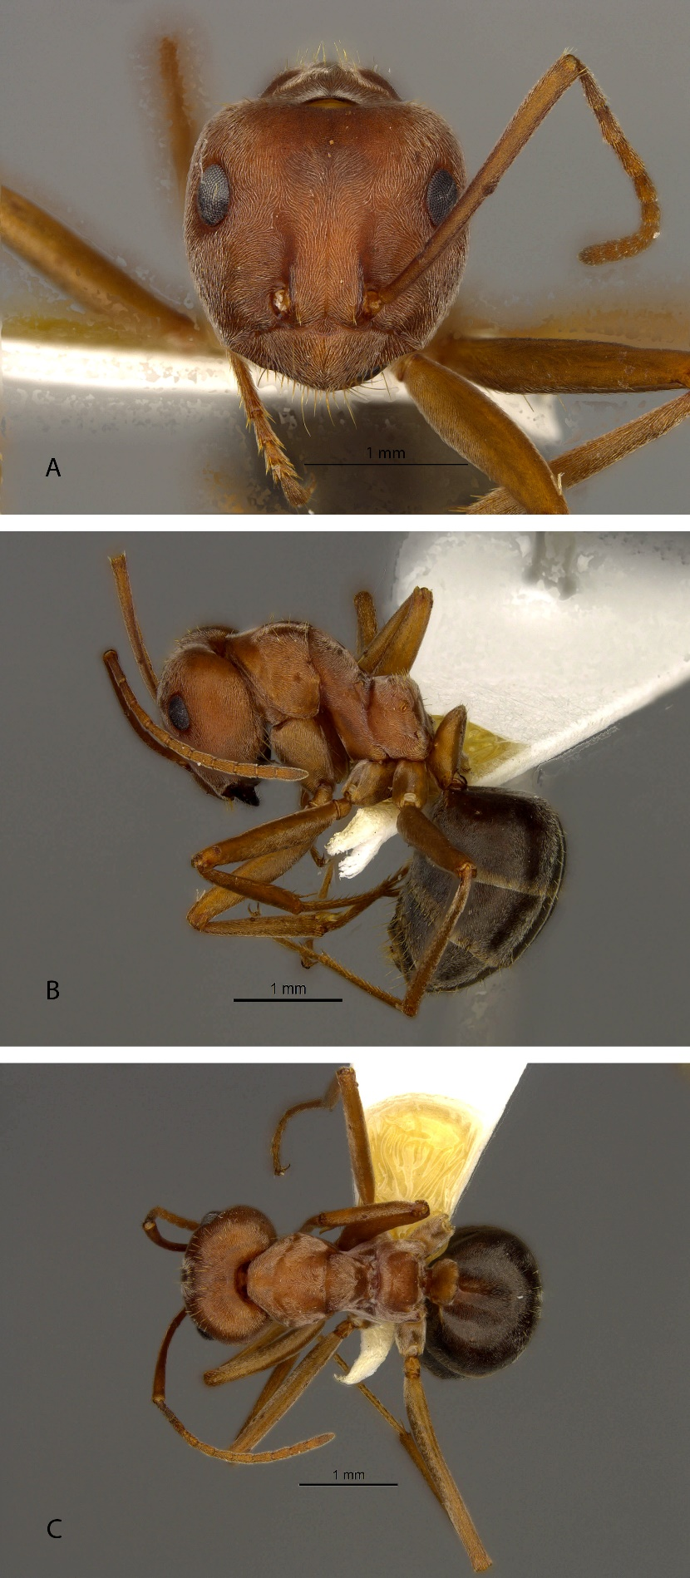
Figure 15: Anoplolepis sp. 2 (worker). A, head in full face view; B, lateral view and C, dorsal view.

Anoplolepis sp. 3
(Figures 16A, 16B, 16C)
Measurements (workers)
HW 0.624-2.272, HL 0.761-2.311, SL 0.878-3.447, EL 0.176-0.548, PW 0.566-1.567, NW 0.176-0.741; NL 0.156-0.548; ML 1.058-3.956, CI 78-105, SI 86-295, EI 19-32 (44 specimens measured)

Diagnosis
Anoplolepis sp. 3 is more closely related to Anoplolepis sp. 4. Both these species mostly occur in the lowveld areas of South Africa. Anoplolepis sp. 3 has a petiole with a thick erect scale (Figure 9A), while Anoplolepis sp. 4 has a petiole with an erect scale, usually with distinct lateral vertical margination (Figure 8B). These two species are similar to A. custodiens.

Distribution
Anoplolepis sp. 3 is widely distributed across South Africa. It also occurs in parts of Lesotho (Appendix 1, Figure B).

Materials examined (467 pinned specimens)
South Africa: Limpopo: Sekhukhune, 24.6992S 30.3606E, P. Hawks, 31 December 2017, pitfall trap, CASENT0252709; Lapellala, 23.8833S 28.3333E, M.H. Villet, collection date unknown, SAM-HYM-C000540; Giyani, 11km west of Letaba River, 23.3333S 30.4833E, H.G Robertson, 18 October 1987, turning over rocks, SAM-HYM-C000603; Tshirolwe, 2km west of N1, H.G. Robertson, 22.9000S 30.0000E, 18 October 1987, SAM-HYM-C000651; Kruger National Park, 24.3750S 31.3750E, A.J. Prins, 17 September 1960, SAM-HYM-C004954; Dendron, 23.3833S 29.3333E, Karney, 06 December 1966, SAM-HYM-C015112; Vaalwater, 24.3000S 28.1000E , A.J. Prins, 22 December 1940, SAM-HYM-C015496; Mpumalanga: Lydenburg, 25.0332S 30.1639E, Hawkes, Fisher, 31 December 2011, pitfall trap, CASENT0256095; Sabie Sand Game Reserve, 24.7667S 31.3667E, J.J. Swart, 17 July 1991, HYM-C006325; KwaZulu-Natal: Weza, near Harding, 30.6000S 29.7500E, H.G. Robertson, 02 December 1986, collected from nest, SAM-HYM-C000206; Mkuze Game Reserve, near Malibali Hide, 27.6500S 32.1833E, H.G. Robertson, 25 February 1988, SAM-HYM-C000998; Karkloof, 29.4000S 30.2833E, S.S. Lu, 01 May 1998, SAM-HYM-C012882; Wahroonga Farm, 29.6000S 30.1167E, S.S. Lu, 21 November 1998, SAM-HYM-C012926; Kokstad, 30.5333S 29.4167, P.S. Ward, 09 February 1999, SAM-HYM-C016485; iGxalingenwa Forest, Creighton, 30.0221S 29.6386E, H. Adie, 30 January 2003, collected from nest, SAM-HYM-C018066; Pongola Nature Reserve, 27.3322S 31.9184E, N. Mbanyana, S. van Noort, 12 April 2018, SAM-HYM-C029368; Northern Cape: Verlatekloof, 32.5333 20.6333E, J.A. Irish, 20 June 1987, SAM-HYM-C001055; Prieska, 29.6667S 22.7333E, unknown collector, 01 October 1887, SAM-HYM-C004966; Kimberley, Modder River, 28.6250S 24.8750E, T.D. Butler, 31 December 1908, SAM-HYM-C004969; Western Cape: Swellendam, Stormvlei, 34.0833S 20.1000E, G. Arnold, 22 August 1900, SAM-HYM-C004970; Romansrivier, 33.4667S 19.2000E, A.A. Bonzaaier, 27 August 1962, SAM-HYM-C015043; Cederberg Wilderness Area, Wupperthal, 32.3459S 19.1389E, A. Botes, 11 October 2002, pitfall trap, SAM-HYM-C024847; Gauteng: Alice Glockner Nature Reserve, Heidelberg, 26.5741S 28.3699E, G. Henning, 11 May 1999, SAM-HYM-C013048; Venterstad, 30.7509S 25.7871E, A.A. Bonzaaier, 18 March 1969, SAM-HYM-C015255; Pretoria East, G.J. Broekhuysen, 33.4341S 25.7699E, 30 April 1940, HYM-C015538; North West: Alcudia, Rustenburg, 25.7500S 27.2667E, J.J. Cillie, 18 March 1970, SAM-HYM-C015479; Pilanesberg National Park, C.L. Parr, 25.2667S 27.1333E, C.L. Parr, 20 October 1998, pitfall trap, SAM-HYM-C016774; Eastern Cape: Mosslands Farm, Grahamstown, 33.4000S 26.4333E, A. Brownes, 01 November 2001, SAM-HYM-C017778; Amanzi, Uitenhage, 33.7167S 30.1635, A.J. Prins, 21 August 1968, SAM-HYM-C030862; Free State: Proefdiertuin, University of the Free State, Bloemfontein, 29.1333S 26.1667E, J. Kelly, 01 March 20014, SAM-HYM-C018325; Kragbron: 3 km W, near Sasolburg, 26.8333S 27.5167, E. Reinecke, 17 May 1995, pitfall trap, SAM-HYM-C010624.
Lesotho: Katse, 29.3609S 28.5253E, H. Geertsema, 21 January 1991, SAM-HYM-C011405.

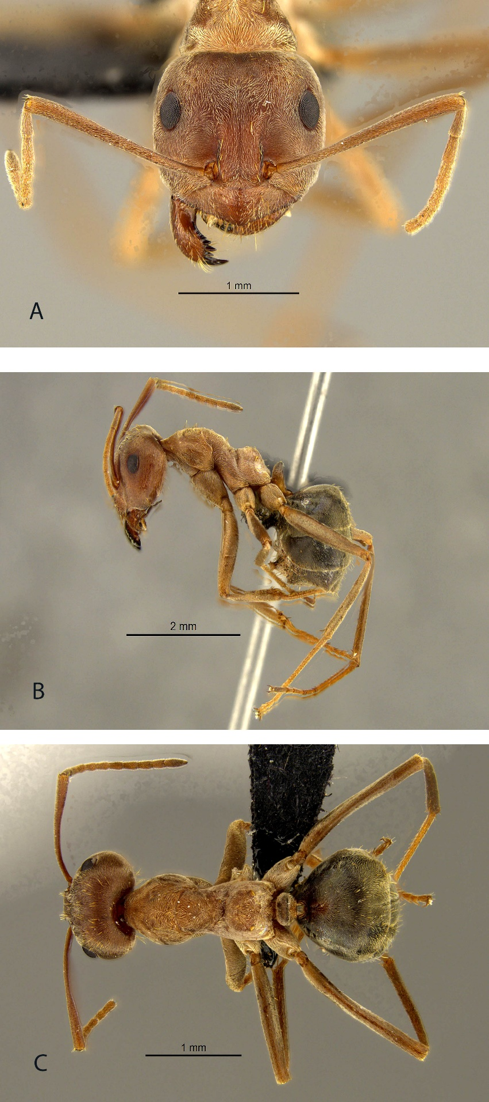
Figure 16: Anoplolepis sp. 3 (worker). A, head in full face view; B, lateral view and C, dorsal view.
Anoplolepis sp. 4
(Figures 17A, 17B, 17C)
Measurements (workers)
HW 0.839-1.970, HL 0.975-2.321, SL 1.268-2.301, EL 0.254-0.744, PW 0.605-1.424, NW 0.254-0.683; NL 0.195-0.507; ML 1.410-2.859, CI 86-97, SI 111-170, EI 22-54 (6 specimens measured).

Diagnosis
Anoplolepis sp. 4 is more similar to Anoplolepis sp. 3 than Anoplolepis sp. 2 based on the morphological characters listed under Anoplolepis sp. 2.

Distribution
Anoplolepis sp. 4 is found in Western Cape, Eastern Cape, KwaZulu-Natal, and Mpumalanga provinces in South Africa, and in Botswana (Appendix 1, Figure B).

Materials examined (31 pinned specimens)
South Africa: Mpumalanga: Ehlanzeni, 25.1495S 30.5636E, Hawkes, Fisher, Reynolds, Bain, 31 December 2017, pitfall trap, CASENT0258899; Premier Mine, Cullinan, 25.6769S 28.5139E, P. Hawks, 10 February 2001, SAM-HYM-C016233; Pietersburg to Paulpietersburg, 28.5775S 31.3942E, J.J. Nel, 25 November 1957, SAM-HYM-C031259; Lothian, Pilgrims Rest, 24.8833S 31.1500E, J.H. Grobler, 19 December 1956, SAM-HYM-C031502; 8km from Barberton to havelock, J.H. Grobler, 25.4333S 31.9333E, 29 November 1956, SAM-HYM-C031505; Western Cape: 16km from Porterville in Kardom pass, 33.0167S 19.0000E, A.J. Prins, 08 January 1962, SAM-HYM-C031268; 22km from Clanwilliam to Calvinia, 32.1975S 18.8967E, unknown collector, 04 January 1962, SAM-HYM-C031277; Riversdale, 34km from Heidelberg to Mosselberg, 34.0317S 21.2486E, A.J. Prins, 19 November 1962, SAM-HYM-C031451; Eastern Cape: Queenstown, 31.8976S 26.8753E, J.J. Cillie, 22 November 1960, SAM-HYM-C031289; East London, 33.0111S 27.9101E, J.J. Cillie, 21 November 1960, SAM-HYM-C031296; Komani, 31.8976S 26.8753E, D.V.V. Webb, 27 September 1960, SAM-HYM-C031481; KwaZulu-Natal: Melmoth, Entonjaneni, 28.5775S 31.3942E, J.H. Grobler, 27 January 1957, SAM-HYM-C031500.
Botswana: Mahalapye, 23.1041S 26.8142E, unknown collector, 01 September 1924, SAM-HYM-C031430.
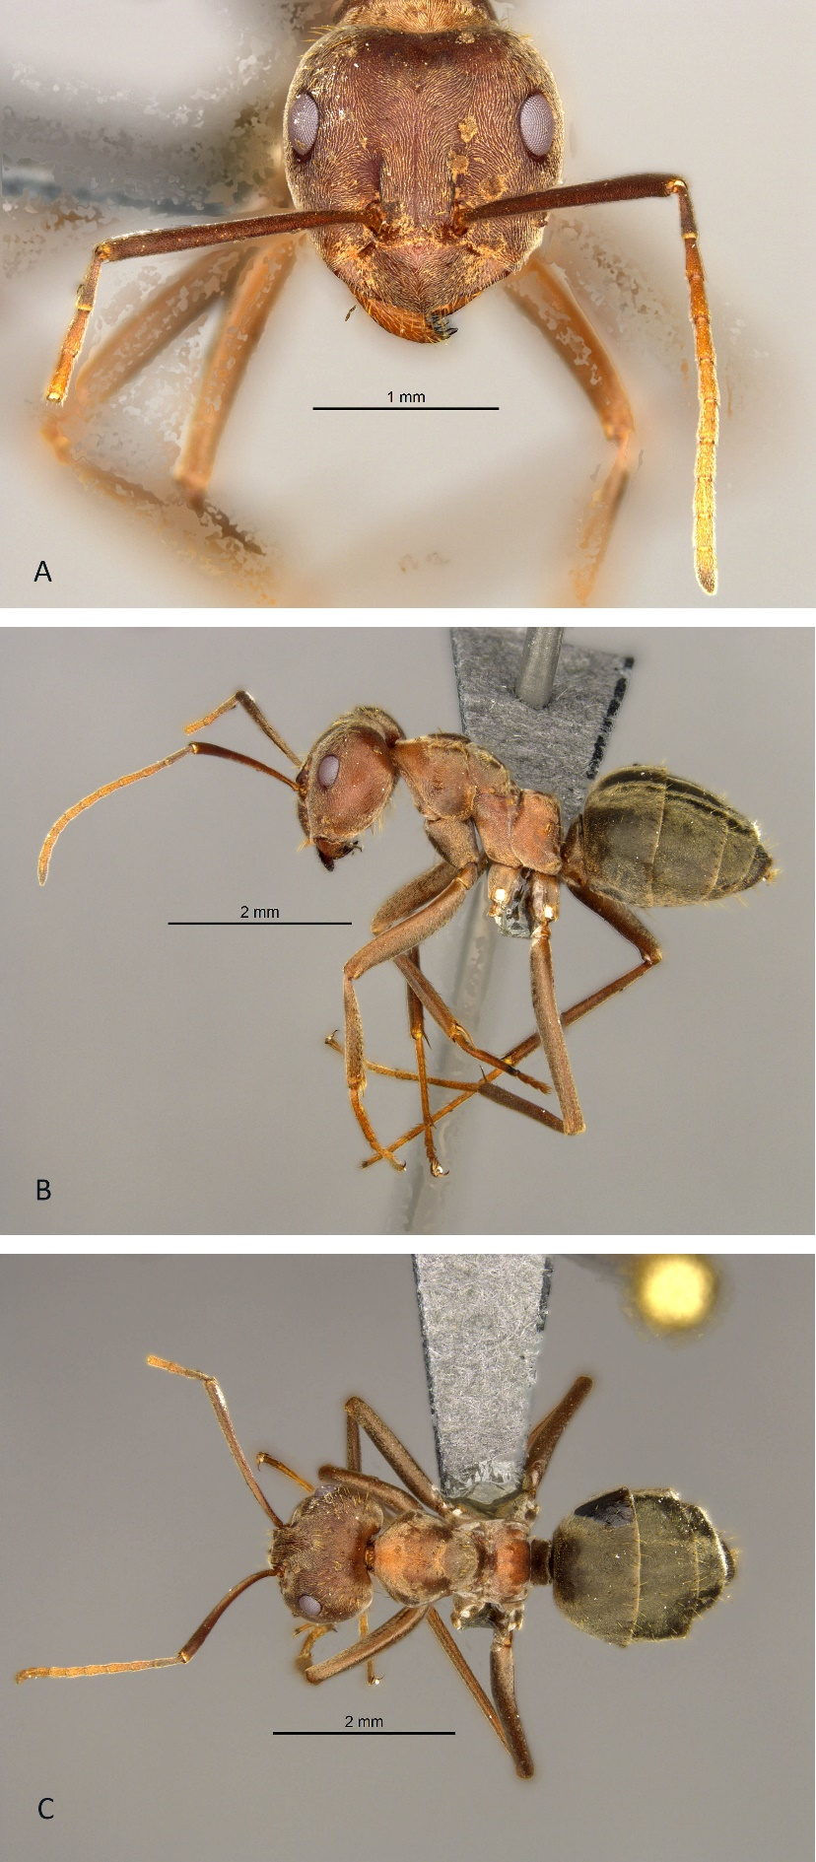
Figure 17: Anoplolepis sp. 4 (worker). A, head in full face view; B, lateral view and C, dorsal view.
Anoplolepis sp. 5
(Figures 18A, 18B, 18C)
Measurements (workers)
HW 0.702-2.2282, HL 0.761-2.301, SL 0.878-2.321, EL 0.195-0.449, PW 0.507-1.443, NW 0.215-0.683; NL 0.195-0.527; ML 0.901-2.742, CI 80-102, SI 87-158, EI 19-61 (13 specimens measured).

Diagnosis
Anoplolepis sp. 5 is different from Anoplolepis sp. 2, Anoplolepis sp. 3, Anoplolepis sp. 4 from its uniformly short and blunt setae on mesosoma (Figure 7A).

Distribution
Anoplolepis sp. 5 is distributed throughout the highveld areas of South Africa. It also occurs in Namibia and Zambia (Appendix 1, Figure A).

Materials examined (451 pinned specimens)
South Africa: Gauteng: Olifantsfontein, 25.9167E 28.2167E, E. van der Westhuizen, 04 February 1995, SAM-HYM-C011978; City of Tshwane, 25.9033S 28.4446E, Hawkes, Clark, du Toit, van der Merwe, 31 December 2009, collected by hand, CASENT0254086; Klipriviersberg, near Mondeor, 26.2833S 28.0167E, H.G. Robertson, 09 May 1987, turning over rocks, SAM-HYM-C000354; Randburg, 26.1500S 28.0333E, L.Y de Jager, 15 April 1987, SAM-HYM-C011977; Alice Glockner Nature Reserve, 26.5739S 28.3699E, T.C. Munyai, 03 March 2019, SAM-HYM-C032192; Mpumalanga: Lydenburg, 25.0332S 30.1640E, Hawkes, Fisher, 31 December 2011, collected by hand, CASENT0255712; Standerton, 26.8096S 29.2541E, Hawkes, Fisher, Babu, Baloi, Zulu, 31 December 2009, collected by hand, CASENT0256505; Belfast, Transvaal, 25.6833S 30.0333E, J.H. Grobler, 21 December 1956, SAM-HYM-C004951; Nelspruit, Dumas, 25.4500S 30.9833E, A.J. Prins, 23 April 1969, SAM-HYM-C015309; Middelburg, 25.7751S 29.4648E, A.J. Prins, 23 November 1960, SAM-HYM-C031530; Free State: Franshoek near Ficksburg, 28.7000S 28.0333E, R.M. Crewe, 03 May 1972, SAM-HYM-C001405; Scotsville, Pietermaritzburg, 29.6167E 30.4000E, R. Potts, 22 March 1969, SAM-HYM-C001414; Bloemfontein, 29.2000S 26.1167E, S. Louw, 01 March 1984, SAM-HYM-C001725; Edenville, 27.5500S 27.6833E, Karney, 22 December 1986, SAM-HYM-C015224; Dunnottar, 26.3458S 28.4308E, M. Berry, August 1940, SAM-HYM-C031364; Proefdiertuin, Research field, 29.1333S 26.1667, J. Kelly, January 2005, SAM-HYM-C031410; KwaZulu-Natal: Durban, Ridgeview, 29.8667S 30.9667E, P. Caldwell, 31 December 1989, SAM-HYM-C001673; Western Cape: Laingsburg, 33.2000S 20.8500E, A.J. Prins, 16 May 1960, SAM-HYM-C011364; Eastern Cape: Fort Beaufort, 32.7833S 26.6333E, unknown collector, 08 July 1944, SAM-HYM-C011999; North West: Brits, 25.3750S 27.6250E, P. van Rensburg, 01 May 1977, SAM-HYM-C012001; Limpopo: Dendron, 23.3833S 29.3333E, Karney, 08 December 1966, SAM-HYM-C015114; Vyeboom village, 23.1477S 30.3850E, T.C. Munyai, 16 November 2020, SAM-HYM-C031659; Leshiba Wildernes Reserve, 22.9835S 29.5586E, T.C. Munyai, 06 November 2020, HYM-C031759; Northern Cape: 50km East of Prieska, 29.5333S 23.6000E, C. Haddad, 22 September 2001, collected by hand, SAM-HYM-C017703.
Zambia: Rhodesia, Lake Kariba, 17.5000S 27.3333E, M. le Roux, 01 April 1944, SAM-HYM-C012002.
Namibia: Khomas, Claratal, 22.7800S 16.7800E, C. Grohmann, 02 May 2005, SAM-HYM-C031784 - SAM-HYM-C031806.

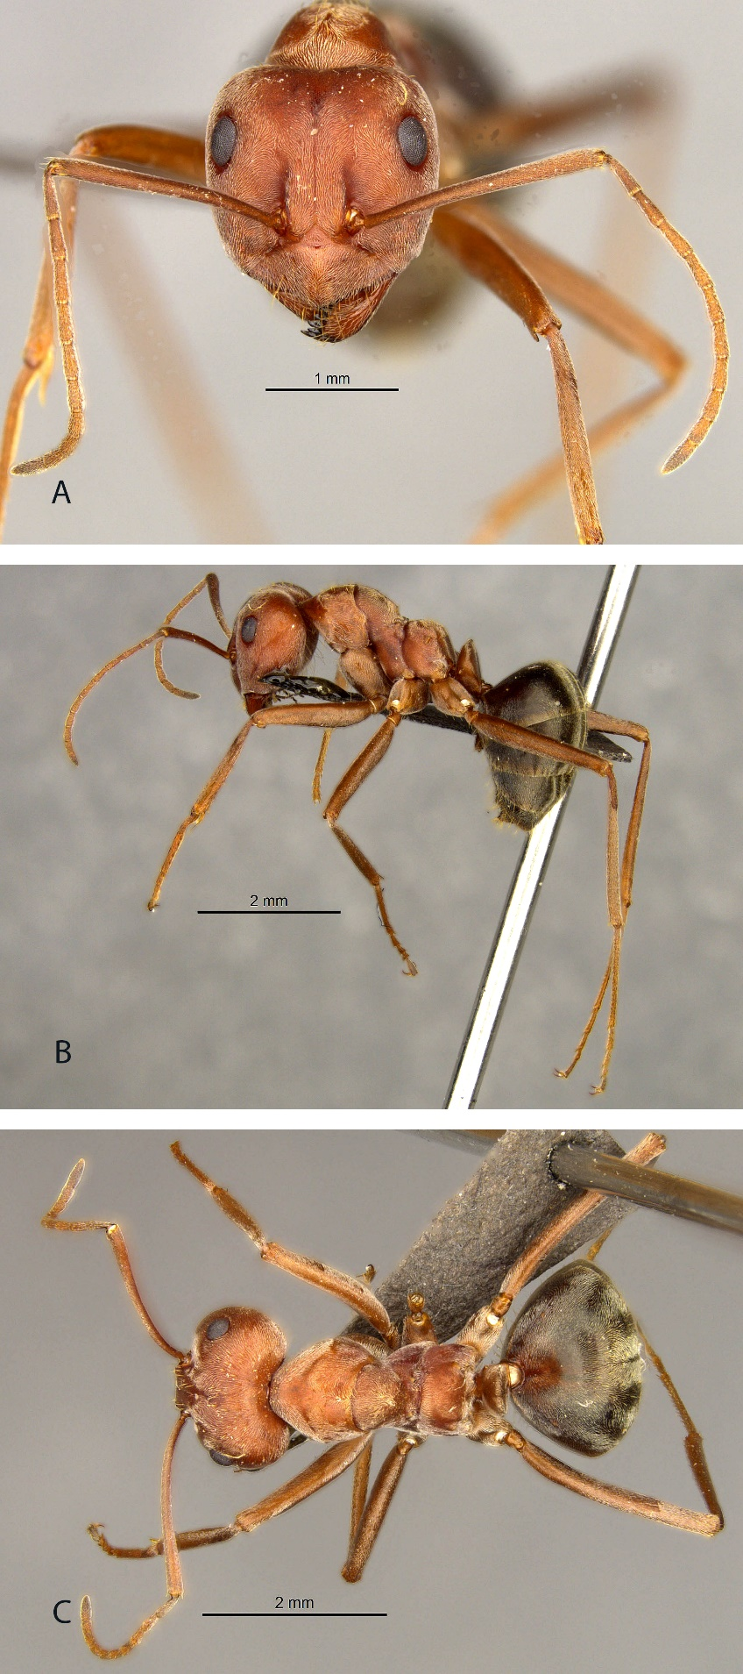
Figure 18: Anoplolepis sp. 5 (worker). A, head in full face view; B, lateral view and C, dorsal view.
Anoplolepis sp. 6
(Figures 19A, 19B, 19C)
Measurements (worker)
HW 1.307, HL 1.541, SL 1.872, EL 0.371, PW 0.975, NW 0.468; NL 0.312; ML 2.126, CI 100, SI 160, EI 32 (only 1 specimen measured due to availability).

Diagnosis
Anoplolepis sp. 6 is the closest to A. custodiens (Figure 1). In Anoplolepis sp. 6, the head is much wider than long, and the eyes are large and protrude more outwardly than in A. custodiens.

Distribution
Anoplolepis sp. 6 occurs only in the in Succulent Karoo and Nama Karoo biomes in the Western Cape province, South Africa (Appendix 1, Figure B).

Material examined (2 pinned specimens)
South Africa: Western Cape: Beaufort West, 32.300000S 22.500000E, du Plessis, Jumbam, Southgate, 16 October 2010, FSA044-11; Karoo National Park, 32.300000S 22.50000E, B. Braschler, 10 March 2011, FSA143-11.
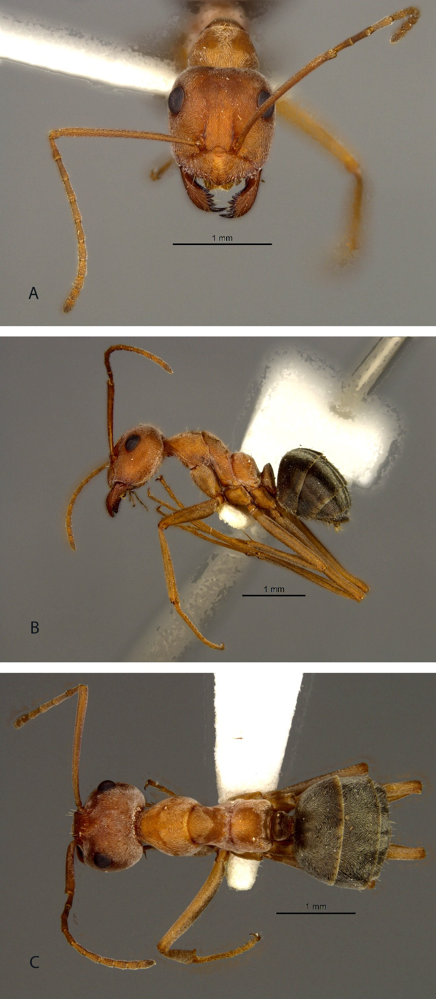
Figure 19: Anoplolepis sp. 6 (worker). A, head in full face view; B, lateral view and C, dorsal view.
Anoplolepis sp. 7
(Figures 20A, 20B, 20C)
Measurements (workers)
HW 0.956-1.892, HL 1.424-1.872, SL 1.424-1.872, EL 0.273-0.371, PW 0.644-1.209, NW 0.293-0.605; NL 0.293-0.351; ML 1.606-2.223, CI 72-111, SI 82-149, EI 18-29 (10 specimens measured).

Diagnosis
Anoplolepis sp. 7 can be distinguished from Anoplolepis sp. 8 by its distinctly small eyes and the head of minors being feebly sculptured and shiny. In Anoplolepis sp. 8, the eyes are of normal size (>0.2mm) and the head of minors are densely punctate and dull. These two species can be referred to as the punctate species group. Anoplolepis sp. 7 and Anoplolepis sp. 8 can be separated from Anoplolepis sp. 2, Anoplolepis sp. 3, Anoplolepis sp. 4, Anoplolepis sp. 5, Anoplolepis sp. 6, and A. custodiens from their hind femora with erect setae on the basal half (Figure 5B).

Distribution
Anoplolepis sp. 7 occurs in the Western Cape, Northern Cape, Eastern Cape, KwaZulu-Natal, and Free State in South Africa (Appendix 1, Figure C).

Materials examined (137 pinned specimens)
South Africa: Northern Cape: Namakwa, 28.0446S 17.0769E, Hawkes, Molenaar, Ungerer, 11 December 2019, pitfall trap, CASENT0818893; Western Cape: Cederberg Wilderness Area, 32.4000S 19.1000E, Braschler, Le Roux, 15 October 2009, FSA045-11; Franschhoek, Braschler, Le Roux, 33.9000S 19.2000E, Braschler, Le Roux, 16 November 2010, FSA046-11; Fernkloof Nature Reserve, Hermanus, 34.4000S 19.2833E, H.G. Robertson, 22 January 1989, SAM-HYM-C001471; Brandfontein Reserve, 34.7667S 19.8667E, H.G. Robertson, 16 October 1992, turning over rocks, SAM-HYM-C006359; Beaufort West, 32.3750S 22.6250E, unknown collector, 01 February 1958, SAM-HYM-C006996; Koeberg, 33.7167S 18.5500E, H.G. Robertson, 04 November 1994, SAM-HYM-C007937; Bonteberg, Cape of Good Hope Nature Reserve, 34.2167S 18.3833E, H.G. Robertson, 30 March 1995, turning over rocks, SAM-HYM-C008176; Constantiaberg, above Donkerboskloof, 34.0333S 18.3917E, H.G. Robertson, 28 August 1995, SAM-HYM-C008231; Jacobsbaai, North of Saldanha Bay, 32.9667S 17.9000E, H.G. Robertson, 27 March 1998, SAM-HYM-C013406; Grootvadersbosch Nature Reserve, 33.9807S 20.8238E, 22 October 2005, collected by hand, SAM-HYM-C018994; 20 km from Ladismith on R62, 33.8310S 20.8823E, N. Mbanyana, 24 October 2005, collected by hand, SAM-HYM-C019016; Kluitjieskraal, Wolseley, 33.4140S 19.2005E, J.H. Grobler, 29 January 1958, SAM-HYM-C031158; Riversdale, 30.9810S 25.6990E, A.J. Prins, 12 May 1960, SAM-HYM-C031159; Simons Town, Cape Point, 34.1919S 18.4397950E, A.A. Boonzaaier, 30 June 1960, SAM-HYM-C031250; Knysna, 34.0729S 23.0436E, J.J. Cillie, 14 November 1960, SAM-HYM-C031287; Wemmershoek, 33.8667S 19.0500E, E.E. Bahlmann, 03 July 1963, SAM-HYM-C031492; Bainskloof, Wellington, 33.5797S 19.1350E, A.J. Prins, 13 January 1960, SAM-HYM-C031544; KwaZulu-Natal: Weza near Harding, 30.6000S 29.7500E, H.G. Robertson, 02 December 1986, turning over rocks, SAM-HYM-C000193; Pongola, 27.3433S 31.6446E, unknown collector, 27 May 1967, SAM-HYM-C031153; Eastern Cape: Oviston, 30.7000S 25.7667E, W.R.J. Dean, 24 November 1988, SAM-HYM-C001503; Steynsburg, 31.3000S 25.8333E, unknown collector, 01 October 1985, SAM-HYM-C007006; Grahamstown, 33.30000S 26.5333E, A.J.F.K. Craig, 11 April 1996, SAM-HYM-C009511; Stormsrivier, 33.9904S 24.0971E, unknown collector, 19 January 1961, SAM-HYM-C031493 Free State: Wolhuterskop Nature Reserve, 3km South of Bethlehem, 28.2747S 28.2825E, J. Heraty, 01 February 1998, SAM-HYM-C011346; Honingkloof, QwaQwa National Park, 28.5333S 28.7333E, D.H. de Swardt, 10 February 1998, SAM-HYM-C011419
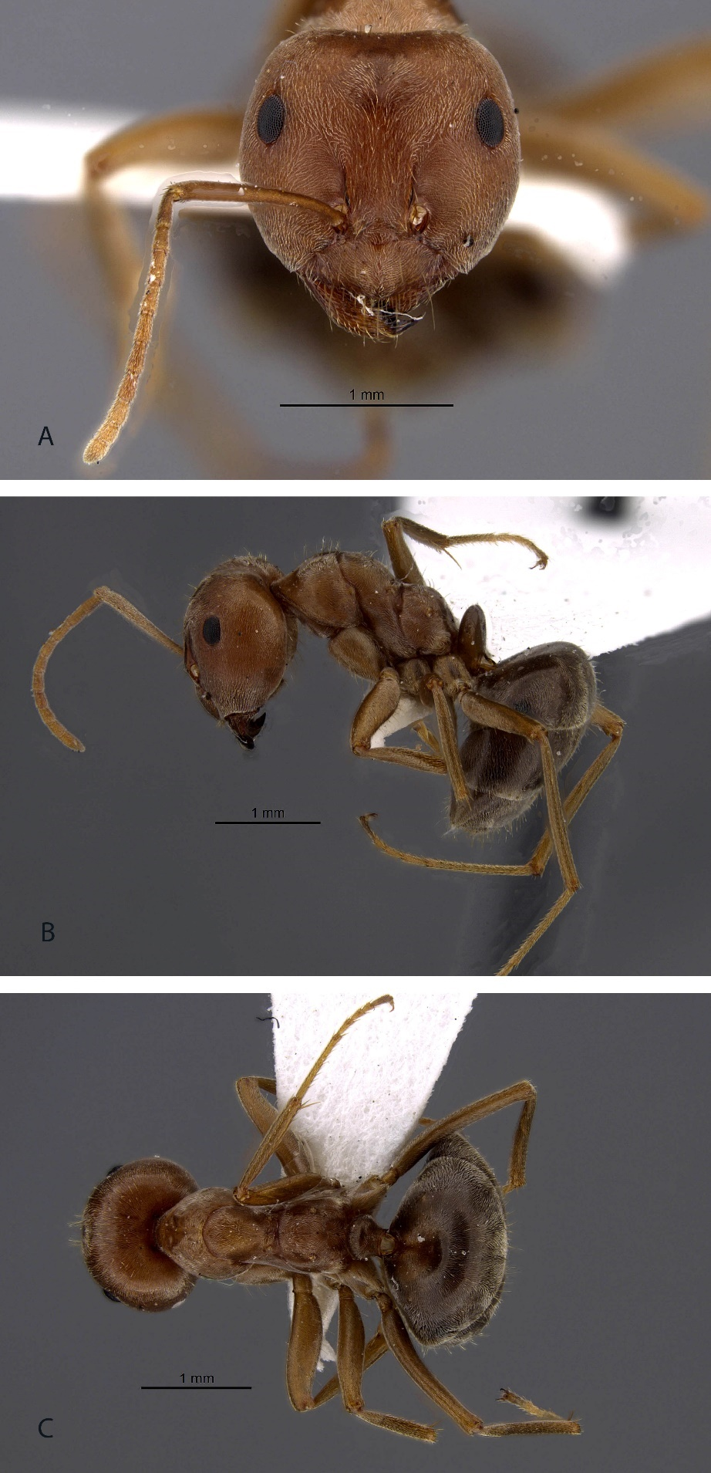
Figure 20: Anoplolepis sp. 7 (worker). A, head in full face view; B, lateral view and C, dorsal view.
Anoplolepis sp. 8
(Figures 21A, 21B, 21C)
Measurements (workers)
HW 0.666-2.272, HL 0.862-2.272, SL 0.862-2.262, EL 0.215-0.509, PW 0.470-1.567, NW 0.273-0.705; NL 0.215-0.449; ML 1.018-4.191, CI 65-167, SI 86-202, EI 16-42 (22 specimens measured).

Diagnosis
Anoplolepis sp. 8 can be referred to as the ‘shiny species’. This species can be separated from Anoplolepis sp. 7 by the characters under Anoplolepis sp. 7.

Distribution
Anoplolepis sp. 8 occurs in Zimbabwe and parts of South Africa including Western Cape, Northern Cape, Eastern Cape, Limpopo, and Gauteng (Appendix 1, Figure C).

Materials examined (126 specimens examined)
South Africa: Eastern Cape: Grahamstown, at old drive-in, 33.3167S 26.51667S, H.G. Robertson, 23 October 1985, collected from nest, SAM-HYM-C000053; Willowmore, 33.3000S 23.4833, E. Marais, 22 June 1987, collected from nest, SAM-HYM-C001109; Coerny, 33.4667S 25.7333E; unknown collector, 01 March 1954, SAM-HYM-C004967; Bathurst, Port Alfred district, 33.5906S 26.89103E, A.J. Prins, 26 May 1960, SAM-HYM-C031245; Western Cape: Cederberg Wilderness, Uitkyk, 32.4135S 19.1147E, N. Mbayanya, P. Ndzunga, T. Wynford, 11 October 2018, SAM-HYM-C028323; Anysberg Nature Reserve, 2km from Vrede, 33.4707S 20.6105E, S. van Noort, 08 January 2015, yellow pantrap, SAM-HYM-C028801; Grootbos Private Nature Reserve, 34.5428S 19.4410E, S. van Noort, 01 February 2019, malaise trap, SAM-HYM-C029745; Table Farm, 33.2500S 26.4333E, H.G. Robertson, 24 April 1983, SAM-HYM-C000493; 122km from Ceres to Sutherland, 31.4833S 19.3500E, A.J. Prins, 28 August 1962, SAM-HYM-C031283; Knysna, 34.0729S 23.0436E, A.J. Prins, 14 November 1960, SAM-HYM-C031288; Great Brak River, George, 33.9667S 22.4500E, A.J. Prins, 07 July 1959, SAM-HYM-C031343; Albertinia, 34.1250S 21.6250E, A.J. Prins, 18 May 1987, SAM-HYM-C001707; Plathuis, near Ladismith, 33.6167S 20.9500E, H.G. Robertson, 08 October 1990, SAM-HYM-C002583; Heidelberg, 34.1000S 20.9667E, A.J. Prins, 19 November 1962, SAM-HYM-C004952; Cape Town, 33.9167S 18.4167E, 31 December 1920, SAM-HYM-C004956; Steenberg Mountains, Cape Peninsula, 34.0833S 18.4333E, C. Pearson, 01 February 1946, SAM-HYM-C004964; Matroosberg, 33.3750S 19.6250E, R.W.E. Tucker, 01 January 1917, SAM-HYM-C004965; Clanwilliam, 32.1500E 18.9500S, J.H. Grobler, 16 January 1958, SAM-HYM-C004982; Fairfield Farm near Napier, 34.4167S 19.7667E, H.G. Robertson, 06 October 1993, collected from termite mounds, SAM-HYM-C007154; Perdeberg Trail, Kogelberg Nature Reserve, 34.2833S 19.0500E, P.S. Ward, 01 February 1999, SAM-HYM-C016474; Grootbrakrivier, 34.0437S 22.2257E, A.J. Prins, 13 May 1960, SAM-HYM-C031242; Northern Cape: Tswalu Kalahari Reserve, 27.2890S 22.4837E, S. van Noort, 23 October 2015, SAM-HYM-C029748; Verlatekloof, 32.5333S 20.6333E, J.A. Irish, 20 June 1987, SAM-HYM-C001055; Prieska, 29.6667S 22.7333E, unknown collector, 01 October 1987, SAM-HYM-C004966; Kimberley, 28.7333S 24.7667E, B. Power, 31 December 1912, SAM-HYM-C004968; Gauteng: Pretoria, 25.7500S 29.1833E, A. Myburgh, 01 February 1961, SAM-HYM-C0011982 - SAM-HYM-C0011990; Limpopo: Nylsvley, Naboomspruit, 24.6667S 28.7167E, C.H. Scholtz, 10 January 1976, SAM-HYM-C011980.
Zimbabwe: Matopos, 20.5833S 28.6667E, unknown collector, 05 November 1944, SAM-HYM-C005341.

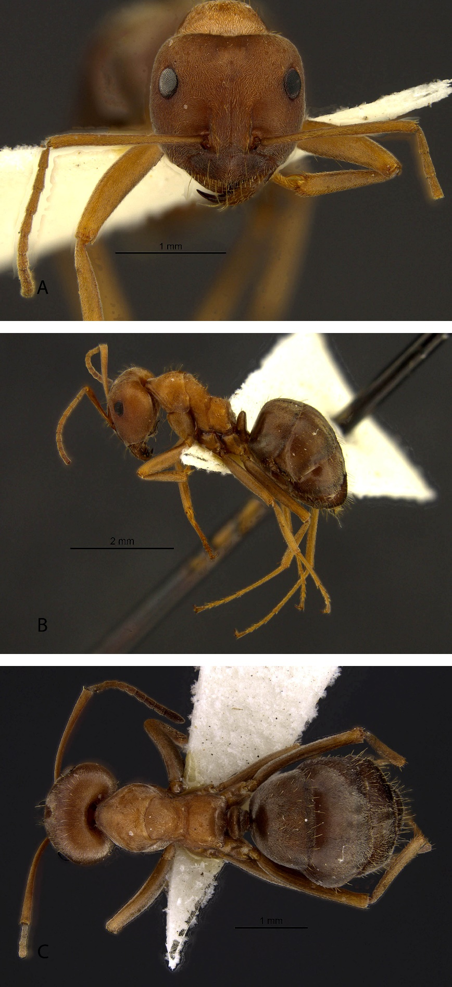
Figure 21: Anoplolepis sp. 8 (worker). A, head in full face view; B, lateral view and C, dorsal view.
Anoplolepis sp. 9
(Figures 2B, 3A, 22A, 22B, 22C)
Measurements (workers)
HW 0.702-2.037, HL 0.878-1.958, SL 0.936-1.979, EL 0.215-0.470, PW 0.507-1.332, NW 0.215-0.744; NL 0.176-0.429; ML 1.053-2.272, CI 40-119, SI 50-137, EI 14-39 (17 specimens measured).

Diagnosis
Anoplolepis sp. 9 is similar to A. steingroveri and Anoplolepis sp. 10. However, the head is densely and uniformly punctate in majors (Figure 22A), feebly but conspicuously reticulate-punctate in minors than that of A. steingroeveri. This species also has much dense pubescence on the body compared to the other two species.

Distribution
Anoplolepis sp. 9 is widely distributed across South Africa except for KwaZulu-Natal, Northwest, and Limpopo. It also occurs in Namibia. In South Africa, this species’ distribution is centered in the Western Cape province (Appendix 1, Figure D).

Materials examined (383 pinned specimens)
Western Cape: De Hoop Nature Reserve, Potberg, 34.4000S 20.5500E, T. Smulian, 08 February 1993, pitfall trap, SAM-HYM-C006578; Le Roux's Farm, 33.6333S 22.1500E, L.L Chaane, 19 October 1998, pitfall trap, SAM-HYM-C017012; 5km from Citrusdal to Clanwilliam, Petersfield, 32.5593S 18.9592E, A.A. Bonzaaier, 08 December 1969, SAM-HYM-C031330; Van Rhynsdorp, 31.4556S 20.3344E, A.J. Prins, 09 October 1959, SAM-HYM-C031339; Springbok, 33.6167S 18.5167E, A.J. Prins, 06 October 1959, SAM-HYM-C031340; Northern Cape: 32km from Petrusville to Luckhoff, 30.0811S 24.6593E, A. Bonzaaier, 25 July 1968, SAM-HYM-C030860; 8km from Upington to Kakamas, 28.4942S 21.1817E, A.A. Bonzaaier, 25 September 1968, SAM-HYM-C031322; Grootderm, 28.3750S 16.6250E, A.A. Bonzaaier, 27 September 1968, SAM-HYM-C031323; Kliprand, Namaqualand, 30.6000E 18.7000E, A.J. Prins, 08 October 1959, SAM-HYM-C031341; Port Nolloth, 29.2519S 16.8697E, A.J. Prins, 07 October 1959, SAM-HYM-C031342; Garies, 30.5622S 17.9891E, A.J. Prins, 06 October 1959, SAM-HYM-C031538; Gauteng: Bezuidenhoutskraal, 25.1333E 28.7333E, J.J. Nel, 12 December 1957, SAM-HYM-C031253; Eastern Cape: Queenstown, 31.8976S 26.8753E, A.J. Prins, 22 November 1960, SAM-HYM-C031291; Humansdorp, 34.0290S 24.7691E, A.J. Prins, 14 November 1960, SAM-HYM-C031300; Mpumalanga: Middelburg, 25.7751S 29.4648E, J.J. Cillie, 23 November 1960, SAM-HYM-C031532; Limpopo: Kruger National Park, 23.8333E 31.5000E, A.J. Prins, 11 September 1960, SAM-HYM-C031534;
Namibia: Otjiwarongo, Waterberg Plateau Park, 20.1667S 17.3333E, M. Pusch, 18 June 1991, pitfall trap, SAM-HYM-C031035; Sangwali, Eastern Caprivi, 18.3000S 23.6833E, E. Marais, 27 November 1991, pitfall trap, SAM-HYM-C031036; Etosha National Park, Ondundo Hills, 19.8500S 15.7167E, E. Griffin, 26 March 1988, SAM-HYM-C031037; Ongombeanavita, 21.5667S 16.5333E, unknown collector, 19 February 1963, pitfall trap, SAM-HYM-C031225; Spitzkoppe, 21.8167S 15.1667E, unknown collector, 19 February 1963, pitfall trap, SAM-HYM-C031226; Karas, Nabaos, 26.3900S 18.0000E, C. Grohmann, 23 February 2005, SAM-HYM-C031755; Hardap, Duruchaus, 23.1300S 16.9000E, C. Grohmann, 07 May 2005, SAM-HYM-C031818.

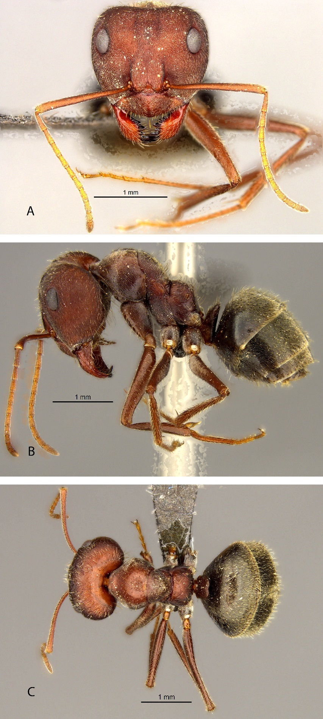
Figure 21: Anoplolepis sp. 9 (worker). A, head in full face view; B, lateral view and C, dorsal view.
Anoplolepis sp. 10
(Figures 3B, 4A, 23A, 23B, 23C)
Measurements (workers)
HW 0.585-2.067, HL 0.741-1.919, SL 0.780-1.677, EL 0.215-0.431, PW 0.429-1.293, NW 0.195-0.744; NL 0.176-0.470; ML 0.862-2.272, CI 41-201, SI 80-141, EI 19-38 (38 specimens measured).

Diagnosis
Anoplolepis sp. 10 is morphologically closest to A. steingroveri. However, Anoplolepis sp. 10 has less visible pubescence on the head and mesosoma (Figure 23A). The sides of the mesosoma are punctate in majors and the head shape is less heart-shaped as in A. steingroeveri.

Distribution
Anoplolepis sp. 10 is widely distributed across five provinces (Eastern Cape, Northern Cape, Free State, Western Cape, and North West) in South Africa and in Namibia, Zambia, and Botswana (Appendix 1, Figure E).

Materials examined (1295 pinned specimens)
South Africa: Eastern Cape: Willowmore, 33.3000S 23.4833E, E. Marais, 22 June 1987, SAM-HYM-C001111; Bakenkraal Farm, near Cradock, 32.1250S 25.6250E, G.G. le Roux, 31 December 1990, SAM-HYM-C001717; Alexandria dunefield, North of Algoa Bay, 33.7000S 25.9333E, G. Castley, 18 October 1991, SAM-HYM-C005625; Cradock, 32.1642S 25.6192E, A.J. Prins, 22 November 1960, SAM-HYM-C031210; Free State: Bloemskraal near Virginia, 28.2444S 26.9750E, R.M. Crewe, 03 April 1972, SAM-HYM-C001406; Northern Cape: Calvinia, 31.4167S 19.7500E, A.J. Prins, 01 May 1986, SAM-HYM-C001785; N1 between Richmond and Hanover, 31.2167S 24.2667E, H.G. Robertson, 01 December 1988, SAM-HYM-C007137; Hopetown Municipal Farm, 29.6333S 24.1500E, B. Chambers, 15 February 1997, SAM-HYM-C010873; Calvinia-Loeriesfontein, 30.919919.4497E, H.G. Robertson, 09 July 1998, collected by hand, SAM-HYM-C013280; Cullinan Farm, 26.3409S 22.6108E, N. Mbanyana, H.G. Robertson, 19 December 2007, pitfall trap, SAM-HYM-C020001 – SAM-HYM-C020007; Dreghorn, 26.8576S 20.7895E, N. Mbanyana, H.G. Robertson, 17 December 2007, pitfall trap, SAM-HYM-C020025; 3km from Britstown to Vosburg, 30.4772S 23.4044E, J.H. Grobler, 14 January 1958, SAM-HYM-C031215; 6km from Port Nolloth to AlexBaai, 29.2519S 16.8696E, A.J. Prins, 20 April 1963, SAM-HYM-C031570; 3km from Middelpos to Sutherland, 31.9058S 20.2286E, A.J. Prins, 24 April 1963, SAM-HYM-C031571; Western Cape: Koppie Alleen, De Hoop Nature Reserve, 34.4792S 20.5125E, H.G. Robertson, 29 April 1993, pitfall trap, SAM-HYM-C006664; Vrede, Anysberg Nature Reserve, 33.4667S 20.5833E, H.G. Robrtson, 27 February 1999, collected by hand, SAM-HYM-C013025; Abrahamskraal, 32.9256S 22.0132E, H.G. Robertson, 12 April 2008, pitfall trap, SAM-HYM-C020277; Josephskraal, 33.0418S 20.7216E, N. Mbanyana, 16 April 2008, pitfall trap, SAM-HYM-C020465; Vergenoeg, 33.2313S 21.4645E, N. Mbanyana, H.G. Robertson, 10 April 2008, pitfall trap, SAM-HYM-C020538; Leipoldtville, 32.2771S 18.52987E, A. Botes, 07 October 2002, pitfall trap, SAM-HYM-C024848; Kromrivier, Cedarberg, 32.5440S 19.2809E, C. Janion-Scheepers, B. W. Coetzee, J. Minnaar, N. Myataza, N. Cordero, P. Mtileni, 03 November 2018, pitfall trap, SAM-HYM-C028413 - SAM-HYM-C028415; Strand, 8km from Gordon's Bay, 34.1069S 18.8275E, A.J Prins, 22 April 1960, SAM-HYM-C031208; Paarl, 33.7621S 18.9357E, J.J. Cillie, 08 December 1961, SAM-HYM-C031211; Kleinmondstrand, 34.3333S 19.0333E, unknown collector, 05 February 1964, SAM-HYM-C031263; Caledon, Stanford, 34.4394S 19.4561E, A.J. Prins, 17 July 1959, SAM-HYM-C031311; Citrusdal, 32.5925S 19.0152E, F. Haniball, 24 February 1969, SAM-HYM-C031326; Van Rhynsdorp, 31.4556S 20.3344E, A.J. Prins, 09 October 1959, SAM-HYM-C031338; Simonstown, 34.1919S 18.4398E, E.D Thomas, 16 June 1959, SAM-HYM-C031368; Clanwilliam, 32.1975S 18.8967E, A.J. Prins, 09 October 1959, SAM-HYM-C031536; George, 33.9667S 22.4500E, A.J. Prins, 19 July 1958, SAM-HYM-C031537; North West: Reivilo, 31.37656S 19.1122E, unknown collector, November 1920, SAM-HYM-C031446; Bitterfontein, 31.0371S 18.2648E, unknown collector, 05 October 1959, SAM-HYM-C031454.
Zambia: southern part of Sesheke, 17.4667S 24.3333E, W. Slobbe, 01 April 1991, SAM-HYM-C005373.
Namibia: Windhoek, Christirina Farm, 23.3333S 18.0000E, C.R. Dickman, 01 April 1992, pitfall trap, SAM-HYM-C006375; Brandberg, Snake Rock, 21.1730S 14.5568E, S. van Noort, 12 April 1999, turning over rocks, SAM-HYM-C013326; Mahanene, Ovambo, 17.4333 14.7833E, B. Wohlleber, 05 September 1993, pitfall trap, SAM-HYM-C030110 – SAM-HYM-C030115; Wolwedans, Maltahohe, 25.1000S 15.9833E, E. Griffin, 12 March 1992, pitfall trap, SAM-HYM-C030200; Khabus, Keetmanshoop, 26.1700S 18.1400E, N.G. Olivier, 14 April 1988, SAM-HYM-C030201; Brukkaros, Namaland, 25.8833S, 17.7667E, E. Marais, 02 April 1995, pitfall trap, SAM-HYM-C030203; Okahandja, 21.9833S 16.9000E, unknown collector, 02 March 1965, SAM-HYM-C031357; Ongombeanavita, 21.5667S 16.5333E, unknown collector, 22 February 1953, collected from nest, SAM-HYM-C031471; Khomas, Claratal, 22.7800S 6.7800E, C. Grohmann, 30 January 2005, SAM-HYM-C031807; Hardap, Duruchaus, 23.1300S 16.9000E, C. Grohmann, 07 May 2005, SAM-HYM-C031818; Erongo, Gobabeb, 23.5300S 15.0500E, C. Grohmann, 11 May 2005, SAM-HYM-C032112.
Botswana: Orapa, 21.3000S 25.5000E, I. Mckay, 20 October 1987, SAM-HYM-C000738.

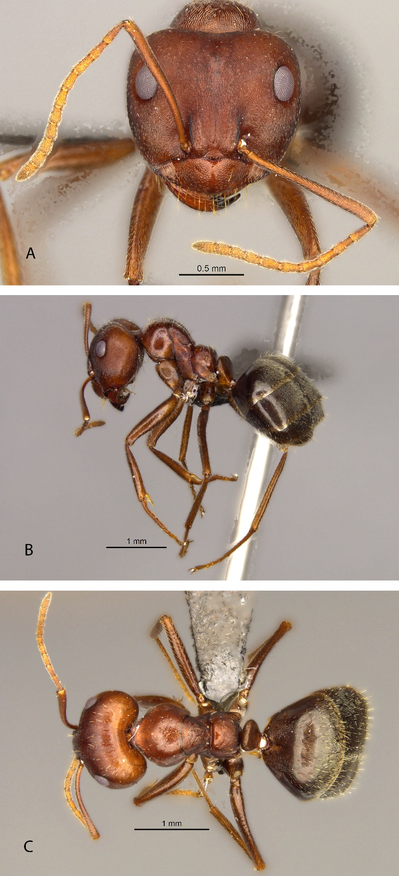
Figure 23: Anoplolepis sp. 10 (worker). A, head in full face view; B, lateral view and C, dorsal view.
Anoplolepis sp. 11
(Figures 2A, 24A, 24B, 24C)
Measurements (workers)
HW 0.761-2.009, HL 0.878-1.872, SL 0.936-1.853, EL 0.234-0.410, PW 0.527-1.268, NW 0.215-0.702; NL 0.195-0.410; ML 1.018-2.154, CI 85-110, SI 82-123, EI 20-31 (6 specimens measured).

Diagnosis
Anoplolepis sp. 11 can be easily distinguished from Anoplolepis sp. 9, Anoplolepis sp. 10 and A. steingroeveri from the densely hairy mesosoma and bearded head (Figure 3A).

Distribution
Anoplolepis sp. 11 is widely distributed across Namibia. This species also occurs in the Succulent Karoo and Nama Karoo biomes of the northern parts of the Northern Cape province in South Africa (Appendix 1, Figure D).

Materials examined (24 pinned specimens)
South Africa: Northern Cape: 1 km from Augrabies falls, 28.6659S 20.4241, A.A. Boonzaaier, 25 September 1968, SAM-HYM-C031324; Onseepkans, 28.7490S 19.30210E, A.A. Boonzaaier, 26 September 1968, SAM-HYM-C031321; Brandvlei 30.5167S 20.4833E, A.J. Prins, 28 May 1986, SAM-HYM-C001762; Springbok, 29.4617S 18.4683E, collector unknown, 05 September 1983, SAM-HYM-C028940.
Namibia: Naukluft Park, Welwitschia Wash, 23.5500S 15.0333E, collector unknown, 30 January 1993, SAM-HYM-C030218 - SAM-HYM-C030225; Navachab 67, Karibib District, 22.0167S 15.7333E, S. Schubert, 01 March 1988, pitfall trap, SAM-HYM-C030226; Orupembe, Kaokoveld, 18.0700S 12.2100E, E. Marais, 23 April 1995, yellow pantrap, SAM-HYM-C030236; Sonnegroet 608, Outjo District, 19.6167S 14.7167E, E. Marais, 20 February 1995, pitfall trap, SAM-HYM-C030250; Sperrgebiet, 27.2215S 16.0798E, B.K. Muramba, 01 February 2009, SAM-HYM-C027686.

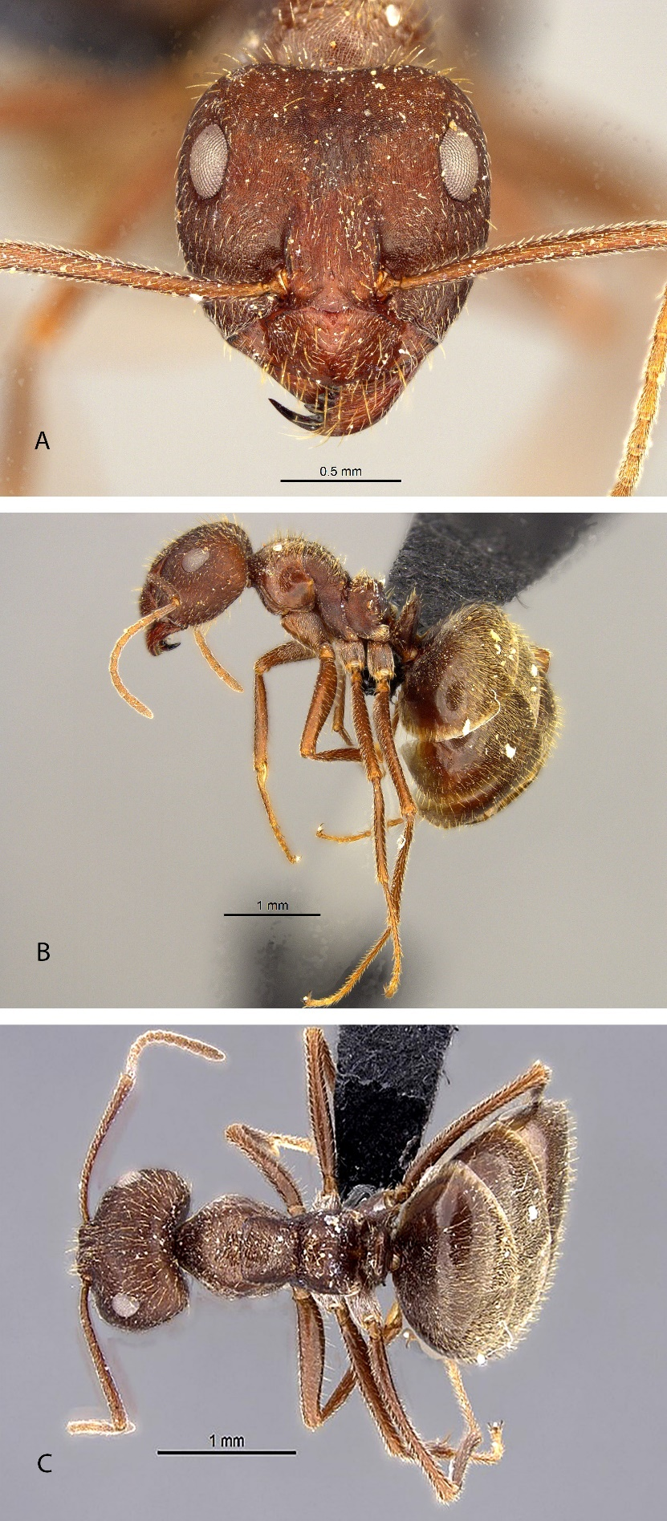
Figure 24: Anoplolepis sp. 11 (worker). A, head in full face view; B, lateral view and C, dorsal view.
Anoplolepis sp. nov. 12
(Figures 25A, 25B, 25C)
Measurements (workers)
HW 0.702-0.741, HL 0.780-0.858, SL 0.897-0.956, EL 0.234-0.254, PW 0.410-0.507, NW 0.215-0.234; NL 0.137-0.215; ML 0.783-1.053, CI 84-90, SI 125-132, EI 33-35 (4 specimens measured).

Description (worker): Head, mesosoma, and metasoma light yellow, shiny, and smooth body (less punctate). Propodeal spiracle round. Pubescence on the metasoma does not form a chequered pattern. Mesosoma has no standing setae but has pubescence that is clearly visible. Propodeum without a huge hump. The eyes protrude to the sides of the head. It has 7 mandibular teeth. Antennal scrobes are absent. Scape exceeds occipital margin by nearly two-thirds of its length.

Diagnosis
Anoplolepis sp. nov. 12 is one of the small species of the genus Anoplolepis (TL 2.3mm – 3.7mm). The species can be distinquished from A. carinata based on the absence of erect setae on the head and mesosoma. Propodeum does not form an obvious hump (Figure 25B), the head is less ovoid with no standing setae, and it has no antennal scrobes (Figure 25A).

Distribution
This species is only known from Western Cape, Cape Flats Nature Reserve (Appendix 1, Figure D) represented by sand fynbos (Rutherford and Mucina, 2006).

Material examined (4 pinned specimens)
South Africa: Western Cape: Cape Flats Nature Reserve, University of the Western Cape, 33.9333S 18.6333E, 01 August 1993, A. Fortuin, pitfall trap, SAM-HYM-C006789.

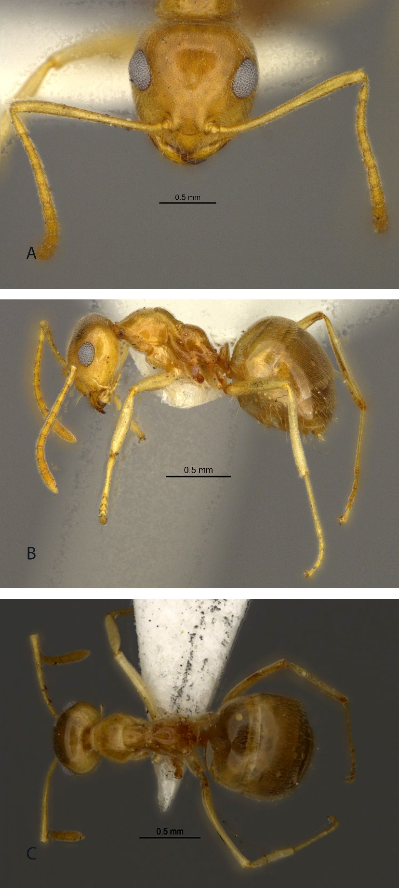

Figure 25: Anoplolepis sp. nov. 12 (worker). A, head in full face view; B, lateral view and C, dorsal view.
2.3 Biogeography
Anoplolepis is widely distributed across southern Africa (Figure 26). The genus has high species richness throughout southern Africa biomes, with Western Cape province hosting the highest species richness in South Africa (Appendix 1, Table 1). The Succulent Karoo, Nama Karoo, Fynbos, Savanna, Grassland, and Afrotemperate Forest biomes (Rutherford and Mucina, 2006) had the highest number of species. Other countries such as Lesotho and Tanzania had the least number of species, although this may be a reflection of insufficient sampling in these regions.

Anoplolepis custodiens is more common in the north-eastern parts, while A. steingroeveri is more common in the western parts of South Africa (Figure 26). Three species had a limited distributional range. Anoplolepis carinata only occurs in Congo, Anoplolepis sp. nov. 12 only occurs in Cape flats, Western Cape, and Anoplolepis sp. 6 only occurs in Western Cape.

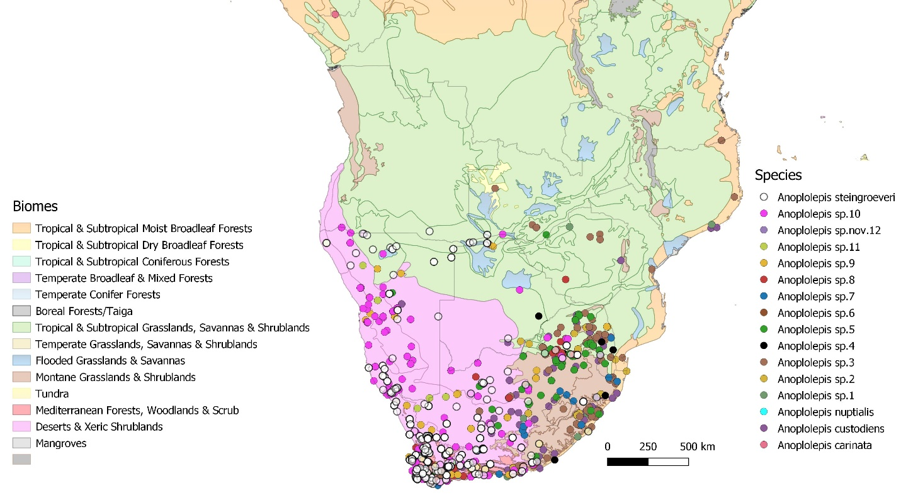
Figure 26: Species richness of Anoplolepis species across the different biomes of southern Africa.

Discussion
This study found a higher Anoplolepis species richness in southern Africa than previously thought. The average divergence value (i.e. p-distance metric) between the two clades (13.29%) was three-fold and one-fold greater than within the small clades (3.62% and 11.9%, respectively), which strongly supports species-level differences. However, the intra-clade divergence values (i.e. within each species) were indicative of the large proportion of variation present within each clade. This is highlighted by the high divergence value seen by groups Anoplolepis sp. 7 for clade A vs. the remaining intra-clade groups and Anoplolepis sp. 7, Anoplolepis sp. 8, Anoplolepis sp. 9, Anoplolepis sp. 10, and A. steingroeveri for clade B. This is likely because these groups each have their own evolutionary trajectory and the time at which they diverged allowed for mutations and thus variation to accumulate with time (Feder et al., 2012).

Phylogenetic certainty for the positions of some groups shows very little support that these groups are different species. However, there is an incongruity between genetics and morphology since the morphological dissimilarities of these specimens suggest species-level differences. A comparison of the p-distance values between Anoplolepis sp. 2, Anoplolepis sp. 3, Anoplolepis sp. 4, Anoplolepis sp. 5, and A. custodiens was low, which generally implies minimal differentiation on a species level. However, morphological differences in characters such as head shape, hair type and length, size of eyes, and petiole shape do indeed reveal distinct differences between them. A comparison of the p-distance values between Anoplolepis sp. 9, Anoplolepis sp.10, and A. steingroeveri, were also low, implying minimal differentiation on a species level. However, the morphological differences in characters such as hair density on the mesosoma, head shape, pubescence, and sculpture on the head do indeed reveal distinct differences between them. The morphological differences of these species could also reflect intra-specific variation. Individuals of the same species can vary in morphological traits, particularly in polymorphic groups. Therefore, scientists need to assess intraspecific variation to avoid losing significant information (Gaudard et al., 2019). The incongruency observed from species delimitation between DNA barcoding and morphological features show that the DNA barcoding method COI was not effective in delimiting species in this genus.

The phylogenetic tree displays some species that show some degree of intra-specific variation. For example, A. steingroeveri shows great variation within the clade (Table 1). This is likely because these groups diverged earlier on in the phylogeny, and thus the older ages of these groups could indicate the accumulation of mutations or variation with time which could be enhanced by environmental stressors (Vrsansky, 2005). Anoplolepis sp. 4 also revealed a great deal of variation between individuals (Table 1). Specimens in this group are found in different geographical regions (South Africa and Tanzania), thus geographical isolation and lack of gene flow could lead to this genetic variation. Within Anoplolepis sp. 5, individuals differ with the length of teeth, with some individuals having long and sharp front teeth while others have short and dull teeth. Some individuals have distinctly rough pubescence on their heads while others do not. Anoplolepis sp. 7 and Anoplolepis sp. 8 do not show much intra-specific morphological variation, however, the position of these individuals on the phylogenetic tree had strong nodal support to present these individuals as two species. The variation within these species can result from cryptic speciation, where species look morphologically indistinguishable and can no longer interbreed, and are, therefore, regarded as different species (Blair et al., 2005).

Anoplolepis has the highest species richness in the Western Cape province of South Africa with 13 species recorded from this region (Appendix 1, Table 1). This region is defined by the Succulent Karoo and Nama Karoo biomes (Rutherford and Mucina, 2006). The geographical distribution results show that A. custodiens is more common in the north-eastern parts, while A. steingroeveri is more common in the western parts of South Africa (Figure 27), data that are consistent with previous results (Prins, 1982). These distributions may also reflect the thermal tolerances of these species (Braschler et al., 2021). Anoplolepis sp. nov. 12 occurred only in the Cape Flats, Western Cape (Appendix 1, Figure E). As the barcoding was not successful for this species, further molecular analysis is needed to verify this species.

Conclusions
This study shows that the genus Anoplolepis has many widely distributed species across southern Africa. Failure of the DNA barcoding method (CO1) to delimit some of the species in this genus which have been identified as different species based on the morphological differences may indicate that more fine-scale molecular markers are required to disentangle this genus fully. More specimens from countries such as Zambia, Angola, Malawi, and Lesotho are required to provide a complete distributional range of species in this genus in southern Africa.

References
Abbott, K. L., 2006. Spatial dynamics of supercolonies of the invasive yellow crazy ant, Anoplolepis gracilipes, on Christmas Island, Indian Ocean. Diversity and Distributions 12(1), 101–110. https://doi.org/10.1111/j.1366-9516.2006.00193.x
Abbott, K. L., Harris, R., Lester, P., 2005. Invasive ant risk assessment: Anoplolepis gracilipes (No. Landcare Research contract report for Biosecurity New Zealand). Wellington, New Zealand.
Avise, J.C., 2000. Phylogeography: The history and formation of species. Harvard University Press, Cambridge, Massachusetts.
Blair, C. P., Abrahamson, W. G., Jackman, J. A., Tyrrell, L., 2005. Cryptic speciation and host‐race formation in a purportedly generalist tumbling flower beetle. Evolution 59(2), 304-316.
Bolton B. 1980. The ant tribe Tetramoriini (Hymenoptera: Formicidae). The genus Tetramorium Mayr in the Ethiopian zoogeographical region. Bulletin of the British Museum (Natural History) Entomology 40: 193‒384. https://doi.org/10.5281/zenodo.26845
Bolton, B., 2012. An online catalog of the ants of the World. http:/www.antcat.com
Braschler, B., Chown, S. L., Duffy, G. A., 2021. Sub-critical limits are viable alternatives to critical thermal limits. Journal of Thermal Biology 101, 103106.
Doering, G. N., Kamath, A., Wright, C. M., Pruitt, J. N., 2018. Evidence for contrasting size-frequency distributions of workers patrolling vegetation vs. the ground in the polymorphic African ant Anoplolepis custodiens. Insectes sociaux 65(4), 663-668.
Emery, C., 1925. Hymenoptera, Family Formicidae. Subfamily Formicinae. In: Wytsman., P. Genera insectorum 183, 1-302.
Feder, J. L., Gejji, R., Yeaman, S., Nosil, P., 2012. Establishment of new mutations under divergence and genome hitchhiking. Philosophical Transactions of the Royal Society B: Biological Sciences 367(1587), 461-474.
Felsenstein, J., 1985. Confidence limits on phylogenies: an approach using the bootstrap. Evolution 39(4), 783-791.
Fisher, B. L., Bolton, B., 2016 Ants of Africa and Madagascar. A guide to the genera. University of California Press.
Folmer O, Black M, Hoeh W, Lutz R, Vrijenhoek R., 1994. DNA primers for amplification of mitochondrial cytochrome c oxidase subunit I from diverse metazoan invertebrates. Molecular Marine Biology and Biotechnology 3, 294-299.
Gaudard, C. A., Robertson, M. P., Bishop, T. R., 2019. Low levels of intraspecific trait variation in a keystone invertebrate group. Oecologia 190(4), 725-735.
Hall, T.A., 1999. BioEdit: a user-friendly biological sequence alignment editor and analysis program for Windows 95/98NT. Nucleic Acids Symposium Series 41, 95-98.
Hill, M., Holm, K., Vel, T., Shah, N. J., Matyot, P., 2003. Impact of the introduced yellow crazy ant Anoplolepis gracilipes on Bird Island, Seychelles. Biodiversity and Conservation 12(9), 1969-1984.
Hita Garcia, F.H., Wiesel, E., Fischer, G., 2013. The ants of Kenya (Hymenoptera; Formicidae)-faunal overview, first species checklist, bibliography, accounts for all genera, and discussion on taxonomy and zoogeography. Journal of East African Natural History 101(2), 127-223.
Ivanov, K., Keiper, J., 2010. Ant (Hymenoptera: Formicidae) diversity and community composition along sharp urban forest edges. Biodiversity and Conservation 19, 3917-3933.
Kearse, M., Moir, R., Wilson, A., Stones-Havas, S., Cheung, M., Sturrock, S., Buxton, S., Cooper, A., Markowitz, S., Duran, C., Thierer, T., Ashton, B., Meintjes, P., 2012. Geneious Basic: An integrated and extendable desktop software platform for the organization and analysis of sequence data. Bioinformatics 28, 1647–9.
Kumar, S., Stecher, G., Li, M., Knyaz, C., Tamura, K., 2018. MEGA X: molecular evolutionary genetics analysis across computing platforms. Molecular Biology and Evolution 35(6), 1547.
Lowe S., Browne M., Boudjelas S., De Poorter M., 2000. 100 of the World’s Worst Invasive Alien Species A selection from the Global Invasive Species Database. Published by The Invasive Species Specialist Group (ISSG) a specialist group of the Species Survival Commission (SSC) of the World Conservation Union (IUCN), 12pp. First published as special lift-out in Aliens 12, December 2000. Updated and reprinted version: November 2004.
Moreau, C. S., 2014. A practical guide to DNA extraction, PCR, and gene-based DNA sequencing in insects. Halteres 5, 32-42.
Olson, D. M., Dinerstein, E., Wikramanayake, E. D., Burgess, N. D., Powell, G. V., Underwood, E. C., Kassem, K. R., 2001. Terrestrial Ecoregions of the World: A New Map of Life on Earth: A new global map of terrestrial ecoregions provides an innovative tool for conserving biodiversity. BioScience 51(11), 933-938.
Parr, C.L., Chown, S.L., 2001. Inventory and bioindicator sampling: testing pitfall and Winkler methods with ants in a South African savanna. Journal of Insect Conservation 5, 27-36.
Posada, D., 2008. jModelTest: phylogenetic model averaging. Molecular Biology and Evolution 25(7), 1253-1256.
Posada, D., Crandall, K. A., 1998. MODELTEST: testing the model of DNA substitution. Bioinformatics (Oxford, England) 14(9), 817-818.
Prins, A. J., 1982. Review of Anoplolepis with reference to male genitalia, and notes on Acropyga (Hymenoptera, Formicidae). South African Museum.
QGIS Geographic Information System. QGIS Association. http://www.qgis.org
Ratnasingham, S., Hebert, P. D., 2007. BOLD: The Barcode of Life Data System (http://www. barcodinglife. org). Molecular Ecology Notes 7(3), 355-364.
Rutherford, M. C., Mucina, L., Powrie, L. W., 2006. Biomes and bioregions of southern Africa. The vegetation of South Africa, Lesotho, and Swaziland 19, 30-51.
Seifert, B., Galkowski, C., 2016. The Westpalaearctic Lasius paralienus complex (Hymenoptera: Formicidae) contains three species. Zootaxa 4132(1), 44-58.
Taylor, 2015. The ants of (sub-Saharan) Africa. http://antsofafrica.org/ [Accessed 02 September 2021]
Vanderplank, F. L., 1960. The bionomics and ecology of the red tree ant, Oecophylla sp., and its relationship to the coconut bug Pseudotheraptus wayi Brown (Coreidae). The Journal of Animal Ecology 15-33.
Vršanský, P., 2005. Mass mutations of insects at the Jurassic/Cretaceous boundary. Geological Carpathica 56(6), 473-781.
Way, M.J. & K.C. Khoo 1992. Role of ants in pest management. Annual Review of Entomology 37, 479-503
Wetterer, J. K., 2005. Worldwide distribution and potential spread of the long-legged ant, Anoplolepis gracilipes (Hymenoptera: Formicidae). Sociobiology 45(1), 77-97.
Yoke, M.M., Morando, M., Avila L.J., Sites., J.W. (JR.)., 2006. Phylogeography and genetic structure in the Cnemidophorus longicauda complex (Squamata, Teiidae). Herpetologica 62, 420–434.

CHAPTER 3
Now you see me, now you don’t: verifying the absence of alien invasive yellow crazy ant Anoplolepis gracilipes at harbours in South Africa.

Abstract
Anoplolepis gracilipes is an invasive species that is a major threat to native ecosystems worldwide. It has been listed as one of the top 100 worst invasive species in the world and is well known for its negative impact on native ants and other animals. Various records of A. gracilipes in South Africa exist. The first published record of A. gracilipes is from Durban harbour and more records for this species are from Gansbaai, Knysna, Table Bay and Kalk Bay. This chapter aimed to verify the current distributional records of A. gracilipes in South Africa and monitor the main introduction pathways. It also aimed to assess the overall changes in ant assemblages of ants collected between harbours in each of the coastal provinces. Since harbours are usually the first detection sites and main introduction pathways of A. gracilipes in other regions, this study was conducted at four harbours in South Africa. Three collection methods were used to sample ants searching for this invasive species, namely pitfall trapping, yellow pan traps and baiting. The invasive species A. gracilipes was not detected from any of the harbours sampled during this study, nor in the material housed at the Iziko Museums of South Africa, and the material loaned from other institutions and organisations in South Africa and other southern African countries were included in this study. This is a positive outcome for conservation authorities as this species is highly invasive and, if introduced, will outcompete native fauna and result in ecosystem collapse. Although A. gracilipes was not detected in the samples from this study, early detection and eradication of this species should be prioritized. This can be done through existing pest monitoring programs at harbours, and standard border control monitoring.

Introduction
Anoplolepis gracilipes is a well-known, widely distributed invasive species and has spread globally through human-mediated pathways (Lee and Yang, 2021). It has been recorded across the pacific tropics, from India to China, Japan, Australia, Chile, Mexico and California. Although the origin of this species is unknown (Wetterer, 2005), ecological niche modelling to reconstruct the ancestral distribution range suggests the origin of A. gracilipes might have been South Asia (Chen, 2008). Based on its current known distribution, A. gracilipes prefers warm and humid areas (Li et al., 2006; Chen, 2008). It is known to thrive in highly disturbed habitats and areas with intermediate human activity. However, this species also inhabits undisturbed areas such as natural forests (Lee and Yang, 2021). The main introduction pathway of A. gracilipes is at ports and harbours as stowaways in containers and from transportation of bulk materials (McGeoch, 2019).

Anoplolepis gracilipes has been listed as one of the 100 worst invasive alien species in the world (Lowe et al., 2000). It is listed under NEMBA category 2b, and under the South African Biodiversity Act, 2004 (Act No.10 of 2004). Species in this category must be controlled as no risk assessment has been done, nor is the distribution of the species known (van Wilgen et al., 2020). Previous studies have investigated the spatial distribution patterns and population structure of A. gracilipes (Chen, 2008). This species has a high density of ground foraging workers and is numerically and behavioral dominant (Lee and Yang, 2021). Its dominance facilitates its success in out-competing native ant species (Dresche et al., 2011). The most severe ecological consequences of A. gracilipes include the displacement of native ants and other species of vertebrates and invertebrates (Chen, 2008; Drescher et al., 2011). This species also alters natural ecosystems' structure, composition, and function (Lee and Yang, 2021). For example, on Christmas Island, A. gracilipes rapidly eliminated keystone species such as the red land crab, which caused major irreversible ecosystem disruption and made way for secondary invasions (Abbott et al., 2006). The red land crab plays an important role in Christmas Island’s Forest ecosystem by facilitating litter breakdown and influencing forest composition by eating leaves and seedlings of rainforest trees (Lowe et al., 2000). Regions predicted to be highly susceptible to A. gracilipes invasion include Asia, Australia, Africa and South America (Chen, 2008). These areas should particularly focus on preventing the introduction of this invasive species.

Various records of A. gracilipes in South Africa exist (Prins, 1990; Mothapo and Wossler, 2015, Slingsby, 2017; https://www.inaturalist.org/observations/1160269). The first published record of A. gracilipes is from Durban harbour (Prins, 1990). Other records for this species are from Gansbaai, Knysna, and Table Bay (Mothapo and Wossler, 2015) and Kalk Bay (Appendix 2, Figure A) (Slingsby, 2017; https://www.inaturalist.org/observations/1160269). It is suggested that this species has expanded its historical distribution into new areas of the Western Cape (Mothapo and Wossler, 2015), which is alarming given the negative impact this species has on other species worldwide. However, no specimens were collected to date from South Africa for taxonomic verification, nor are specimens barcoded from the African continent (www.boldsystems.org). Thus, this chapter aims to verify the existing distributional records for the invasive species, A. gracilipes in South Africa and monitor the main introduction pathways. I also aimed to assess the overall changes in ant assemblages of ants collected between the harbours sampled in the coastal provinces and test the effectiveness of the pitfall trapping and baiting method in sampling ants. This was achieved by sampling ants at different harbours in South Africa, focusing on areas where this species was previously recorded.

Methods and Materials
1.1 Study area
Harbours are usually the first detection site of A. gracilipes in other regions (Suhr et al., 2019). This study was conducted at four different harbours in South Africa, namely: Kalk Bay (34.1293° S, 18.4493° E) and V&A Waterfront (33.9050° S, 18.4204° E) in the Western Cape Province, and Durban (29.8723° S, 31.0249° E) and Richards Bay harbour (28.8000° S, 32.0833° E) in KwaZulu-Natal Province. Sampling sites were chosen based on previously recorded sites (Durban: Prins et al., 1990; Gansbaai, Knysna, and Table Bay: Mothapo and Wossler, 2015; Kalk Bay: Slingsby, 2017; Kalk Bay: https://www.inaturalist.org/observations/1160269). KwaZulu-Natal has dry winter and wet summer seasons, while Western Cape has dry summer and wet winter seasons. The other records of A. gracilipes included Gansbaai and Knysna (Mothapo and Wossler, 2015), but due to logistical constraints these sites could not be sampled. Nevertheless, the four harbours sampled were representative of the major and most confirmed records of this species to date.
At each harbour, at least two sites surrounding the harbour were sampled, including areas where vegetation is found as ants need soil for nesting sites (Underwood and Fisher, 2006). These included: Kalk Bay, two sites (inside harbour and outside harbour); V&A Waterfront (Transnet building and helicopter pad) (Appendix 2, Figure 1); four sites in Durban (Bayhead heritage site, South beach, Royal Natal view park and Umhlanga rocks) and four sites in Richards Bay harbour (Port of Richards Bay, Pelican Island, Palm beach and Alkantstrand beach) (Appendix 2, Figure B). The study sites were characterized by different habitat types: grasslands, mangroves, sand, and rocky shore.

1.2 Ant sampling and species identification
Ants were sampled using standardized pitfall trapping (Parr and Chown, 2001; Ivanov and Keiper, 2010; Munyai and Foord, 2012), yellow pan traps and baiting. Where possible, sampling was done every two weeks for three months between June and September 2021. At each site, 10 pitfall traps were laid out in a sample grid (2 x 5) with 10m spacing between traps. Pitfall traps were half-filled with 100% propylene glycol that neither repel nor attract insects (Munyai and Foord, 2015), and were left open in the field for three days and nights. In areas with concrete where pitfall traps could not be used, yellow pan traps were used with the same layout method as pitfall traps. At each sampling event, the dominant vegetation at the site was recorded.

In addition, the baiting method was implemented across all study sites. Two card papers, one with tuna and one with peanut butter mixed with jam (used as attractants for ants), were laid out in each pitfall and each yellow pan trap across all sites for one hour. These baits were found to be effective in attracting ants (Nyamukondiwa et al., 2014). Ants found at baits were collected and placed in vials containing 96% ethanol. In areas where sites were big, the sites were replicated to cover the whole area of the harbours. At each replicated site, baits were placed across all pitfall traps. Samples were processed and identified in the laboratory using available keys (Fisher and Bolton, 2016) and AntWeb (www.antweb.org). Specimens were stored in 96% ethanol and voucher species pinned. Ants were identified to species level where possible, while the unidentified species were assigned to morphospecies. All specimens were labelled, catalogued and entered into the Iziko Museum of South Africa’s database (Specify 6 V6.7.01). The ant collection at Iziko Museums of South Africa (Cape Town, South Africa), University of KwaZulu-Natal (Pietermaritzburg campus, South Africa), Iimbovane Outreach Project (Stellenbosch University, South Africa), AfriBugs CC (Pretoria, South Africa) and fresh samples collected from Limpopo, North West and Mpumalanga (October and November 2020), KwaZulu-Natal, and Western Cape provinces (March to July 2021) were also examined for specimens of A. gracilipes.

1.3 Data Analysis
To assess if sampling was done to completion, species accumulation curves were made using R V4.1.2 (R Core Team, 2017). Analysis of Variance (ANOVA) was performed in PAST V4.03 to test for a significant difference in the species collected using the two different collection methods (Pitfall trap and Baiting). Multivariate analyses were undertaken using PAST V4.03 (Hammer et al., 2001) to assess the overall changes in ant assemblage between harbours and provinces. The Bray-Curtis similarity index was used to determine the differences in assemblage structure between harbours and provinces. The Simpson’s diversity index (D), Shannon-Wiener Diversity Index (H'), and Evenness (J') were used to determine ant diversity between harbours and provinces. Non-parametric Analysis of Similarity (ANOSIM) with 999 permutations was used to test for any significant differences in ant assemblage composition between provinces (KwaZulu-Natal and Western Cape) and harbours (Durban, Richards Bay, Waterfront and Kalk Bay). Global R values obtained from ANOSIM was used to determine the similarity of assemblages between sites. The closer the significant Global R is to one, the more distinct assemblages are, whereas assemblages with an R-value close to zero indicates that assemblages are barely separable (Parr et al., 2004). Similarity percentage analysis (SIMPER) was used as a measure of dissimilarity index between harbours and provinces. A non-Multidimensional Scaling (nMDS) ordination was performed in PRIMER V6.0 (Clarke and Gorley, 2006) to visualize the patterns of ant assemblages between harbours.

Results
In total, 10 041 specimens were sampled, comprising of 66 species from 27 genera and five subfamilies (Appendix 2, Table 1). Myrmicinae was the most diverse and abundant subfamily with 10 genera, 45 species and 77% of the total abundance, followed by Formicinae with eight genera, 12 species and 18% of the total abundance. Dorylinae was the least diverse with two genera, two species and 0.5% of the total abundance. The most specious genera were Tetramorium (18 species), Pheidole (8 species) and Monomorium (5 species). In KwaZulu-Natal sites, the most abundant genus was Pheidole, while Tetramorium was the most species-rich genus. The most abundant species in the Western Cape harbours were Lepisiota sp.1 and Linepithema sp.1, while Tetramorium was the most species-rich genus. The invasive species A. gracilipes was not detected across any of the sampled harbours, nor in the material housed at the Iziko Museums of South Africa or the loaned material.

The four accumulation curves from various harbours show that the increase in sampling sites resulted in an increased number of species (Figure 1). Most of the accumulation curves reached or nearly reached a horizontal asymptote indicating sufficient sampling, although the Richards Bay curve indicated that more sampling may be needed at this site in the future.
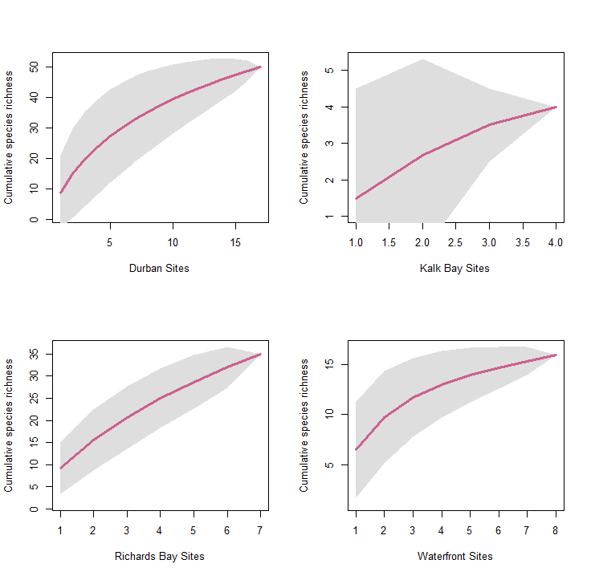
Figure 1: Cummulative species richness of sampling in various sites of the four harbours (Durban, Richards Bay, Kalk Bay, and Waterfront).

The pitfall trapping method was the most effective collecting method, collecting five subfamilies, 27 genera, 66 species and 97% of the total abundance, while baiting resulted in the collection of 3 subfamilies, 13 genera, 19 species and 3% of the total abundance (Table 1). The pitfall trap method recorded a significantly higher number of species than the baiting method (ANOVA, F = 9.443, MS = 141085, df = 1, P_{(0.05)} = 0.003) (Figure 2).
Table 1: Species richness and abundance of subfamilies for ants collected with two collection methods in harbours.
Subfamily | Number of genera | Number of Species | Mean species richness | Total abundance | Mean species abundance
Baiting
Dolichoderinae | 2 | 2 | 10.53 | 110 | 32.45
Formicinae | 5 | 7 | 36.84 | 75 | 22.12
Myrmicinae | 6 | 10 | 52.63 | 154 | 45.43
Pitfall trap
Dolichoderinae | 3 | 3 | 4.55 | 166 | 1.71
Dorylinae | 2 | 2 | 3.03 | 40 | 0.41
Formicinae | 8 | 12 | 18.18 | 1844 | 19.01
Myrmicinae | 10 | 45 | 68.18 | 7634 | 78.68
Ponerinae | 4 | 4 | 6.06 | 18 | 0.19

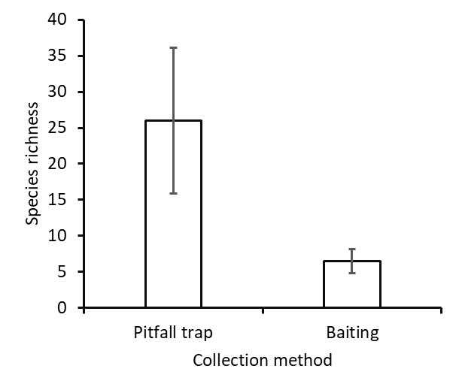
Figure 2: Mean (±SE) total species richness for two sampling methods (pitfall traps and baiting) in Western Cape and KwaZulu-Natal harbours, South Africa.

Analysis of Similarity (ANOSIM) indicated a significant difference (P_{(0.05)} = 0.0001, R = 0.2863) between Western Cape and KwaZulu-Natal provinces. KwaZulu-Natal had the highest species richness with 63 species with a Simpson index of 0.5793 and Shannon-H of 1.609, while the Western Cape had 16 species with a Simpson index of 0.8795 and Shannon-H of 2.319 (Table 2). Pheidole sp.6 (cf. megacephala), Monomorium sp.2 and Lepisiota sp.1 contributed more to the dissimilarity by 38%, 10% and 6%, respectively. All the other species contributed less than 4% to the dissimilarity. SIMPER indicated a dissimilarity index of 97% between the provinces.

A Non-metric Multi-dimensional Scaling (nMDS) ordination shows that the harbours in Western Cape (Waterfront and Kalk Bay) cluster together and harbours in KwaZulu-Natal cluster together (Durban and Richards Bay) (Figure 3). Similarly, Kalk Bay and Waterfront harbours are similar in species composition and different to Durban and Richards Bay harbour (Figure 3). ANOSIM comparison indicated a significant difference (P_{(0.05)} = 0.0001, R = 0.2096) between harbours. A pairwise comparison further indicated that Durban and Richards Bay harbours are similar (Simpson index = 0.5716, Shannon-H = 1.464 and Simpson index = 0.5793, Shannon-H = 1.609, respectively) and different to Kalk Bay and Waterfront harbours (Figure 4). Similarly, Kalk Bay and Waterfront harbours are similar (Simpson index = 0.8638, Shannon-H = 2.22 and Simpson index = 0.5562, Shannon-H = 1.488, respectively) and different to Durban and Richards Bay harbour (Figure3). SIMPER indicated a dissimilarity index of 94% between the harbours.

Table 2: Number of genera, species and biological diversity measured using Simpson’s Diversity index, Shannon-Wiener and Evenness between two provinces and four harbours.
 | Genera | Species | Simpson’s diversity index | Shannon-Wiener Diversity (H’) | Evenness (J’)
Province  Western Cape  KwaZulu-Natal | 9  25 | 16  63 | 0.8795  0.5793 | 2.319  1.609 | 0.5978  0.0793
Harbours
Durban Harbour | 19 | 51 | 0.5716 | 1.464 | 0.0864
Richards Bay | 17 | 34 | 0.6042 | 1.084 | 0.1303
Waterfront | 8 | 16 | 0.5562 | 1.488 | 0.5756
Kalk Bay | 3 | 4 | 0.8638 | 2.22 | 0.739

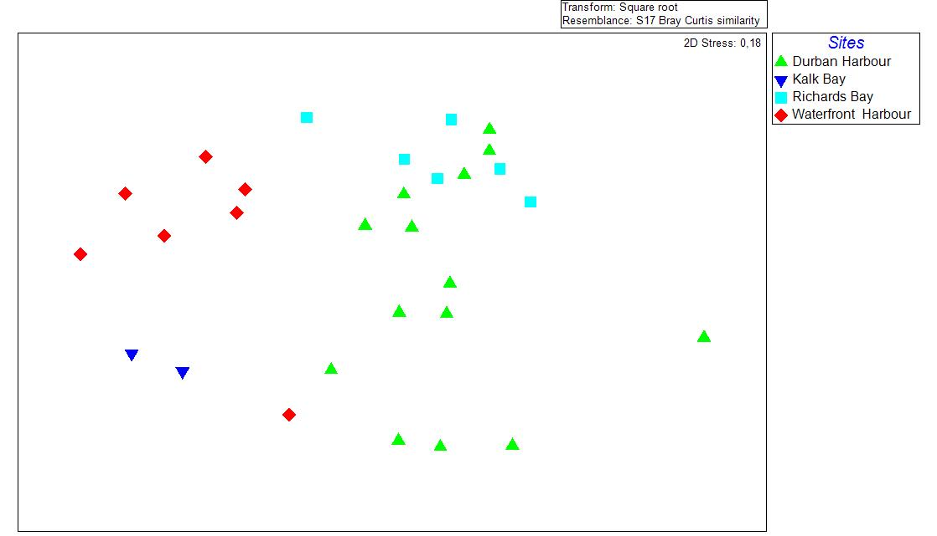
Figure 3: Non-metric Multi-dimensional Scaling (nMDS) ordination between harbours investigated in this study. Red and blue shapes represent Western Cape, Green and mint represent KwaZulu-Natal, p<0.005, R = 0.2096.

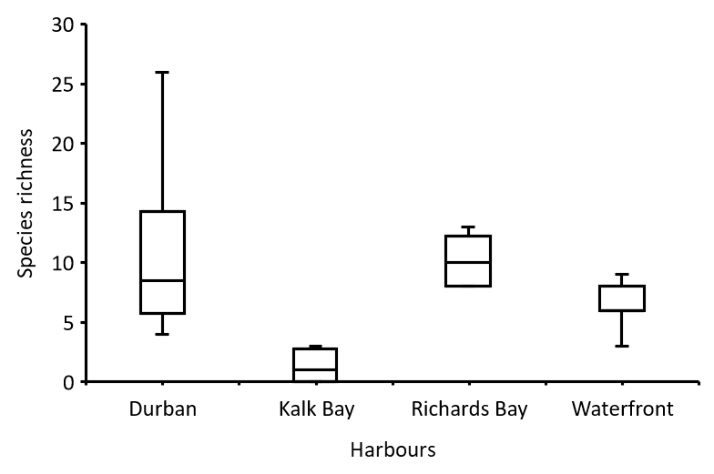
Figure 4: A boxplot showing a pairwise comparison of species richness between the four harbour; Durban and Richards Bay harbours (KwaZulu-Natal) and Kalk Bay and Waterfront harbours (Western Cape), South Africa.

Discussion
In this study, four harbours were sampled in the Western Cape and KwaZulu-Natal provinces in South Africa, including the exact locations where A. gracilipes was previously recorded. However, no specimens of this species were found. Although the species could have been accidentally introduced to South Africa at ports and harbours, no specimens, images or drawings exist of the records of A. gracilipes from South Africa. Therefore, the specimens determined as A. gracilipes could have been misidentified for morphologically similar species, such as species in the genus Leptomyrmex. They are morphologically very similar including characters such as long limbs and a similar-sized, slender body, however, A. gracilipes can be distinguished from this genus by the presence of an acidopore, which is very easily overlooked. The photo of A. gracilipes on iNaturalist is presented by a drawing and not the actual specimen collected (Appendix 2, Figure A). A character like the acidopore is not clearly visible without magnification, thus the identification remains questionable.

The worker description that separates A. gracilipes from other species in the genus Anoplolepis includes their monomorphic and remarkably long and slender yellow-brownish body of 4-5mm with a dark abdomen (Lee and Yang, 2021). The legs and antennae are extremely long, with scapes longer than the body (Taylor, 2015). In Kalk Bay harbour, where A. gracilipes was recorded in 2012 (P. Slingsby, https://www.inaturalist.org/observations/1160269; Appendix 2, Figure A), the alien invasive Linepithema humile (Argentine ant) was found to be the dominant ant species across all areas of the harbour in this study, occurring in almost all pitfall traps (Appendix 2 , Table 1).

Since the detection of A. gracilipes at Kalk Bay in 2012, the site was transformed into a parking area (P. Slingsby, https://www.inaturalist.org/observations/1160269) (Appendix 2, Figure C), and this species was not found again. This could have been a result of A. gracilipes not being able to compete with the abundant L. humile (Argentine ants) present at this site (Slingsby, 2017). Linepithema humile is one of the most widespread ant species in South Africa that has successfully invaded at least six of the nine provinces in South Africa (Mothapo and Wossler, 2015). This species is also listed as one of the world’s 100 worst invaders (Lowe et al., 2000, Nyamukondiwa, 2008). It is well known for its aggressiveness and displacement of native invertebrates and small vertebrates (Lee and Yang, 2021). Several native ant species have been successfully displaced by L. humile leading to a disruption in plant-ant mutualism (Mothapo and Wossler, 2015). Thus, if there was a small population of A. gracilipes present at this site, it could have potentially been displaced by L. humile.

Once alien species are established, their management is costly and is considerably more than the prevention of new invasive species (Reed et al., 2016). The measures taken to prevent losses or enable restoration to restore ecosystem services in an invaded area can be very costly. For example, an estimated US$300 billion per year is spent as a result of invasive species in the United States, British Isles, Australia, South Africa, India and Brazil alone (van Wilgen et al., 2020). In the vineyards in Western Cape, chemical stem barriers were effective in most ant pests (Addison, 2002). However, chemical stem barriers are not effective in controlling species of the genus Anoplolepis (Ueckermann, 1998). Although most chemicals are registered for use in controlling invasive species, the negative impact on other organisms caused by the use of these chemicals far exceeds their cause of action (Walton, 2003). Therefore, the early detection of invasive species is critical to increasing the chances of successful management (Reed et al., 2016).

This is especially prudent given the impact A. gracilipes had on the wine and grape industry in countries in Central America (Hiller and Haelewaters, 2019). The Western Cape wine industry plays a huge role in the country’s economy, with a contribution of about R31 billion to gross domestic product and more than 160 000 employment opportunities, which is 57% and 62% contribution to the country’s total wine industry contribution, respectively (https://www.wosa.co.za/The-Industry/Statistics/World-Statistics/). This is because the wine industry of South Africa is more concentrated in the Western Cape (https://www.wosa.co.za/The-Industry/Statistics/World-Statistics/). However, ants such as L. humile and some species of Anoplolepis are a major problem in vineyards of the Western Cape province (Addison and Samways, 2000). Ants have a mutualistic relationship with aphids (Novgorodova and Ryabinin, 2018). Ants, in particular A. gracilipes, feed on honeydew produced by aphids and other scale insects, thereby protecting them from infestation promoted by a build-up of honeydew and also protecting aphids from predators (Novgorodova and Ryabinin, 2018). Through the consumption of honeydew by ants, the survival of honeydew-producing pests is promoted (Styrsky et al., 2007). This increases the damaging effects on crops through pest outbreaks in agroecosystem (Styrsky et al., 2007). Furthermore, in the Cape Floristic Region, most fynbos plants are dispersed by ants (Nyamukondiwa, 2008). Therefore, the presence of A. gracilipes may also negatively impact fynbos seed dispersal. Despite the absence of this species in this study, prevention of the introduction of A. gracilipes in South Africa should be prioritized. The economic and ecological impacts of this species can be reduced through quarantine programs in susceptible areas (Wetterer, 2005).

Ant assemblage varied among harbours. Durban harbour clustered with Richards Bay harbour while Kalk Bay harbour slightly clustered with Waterfront harbour (Figure 3). The harbours from the two provinces experience different climatic conditions. Durban and Richards Bay harbours in KwaZulu-Natal have dry winters and wet summers, while Kalk Bay and Waterfront harbours in Western Cape have wet winters and dry summers. In the current study, the difference in ant assemblage between the two provinces can be explained by climate differences, particularly rain and temperature. Some species are restricted to a certain area because of different climatic conditions (Braschler et al. 2012). For example, in this study, the species Linepithema humile was found in the Western Cape and not KwaZulu-Natal. According to the known distribution of this Linepithema humile in South Africa, this species does not occur in KwaZulu-Natal (Mothapo and Wossler, 2015).

Species richness and abundance is more in less disturbed areas compared to highly disturbed areas (Botes et al., 2006). Regional variation between sites in this study can be explained by vegetation and the level of disturbance at each harbour. Although all harbours are mostly disturbed, sites in Kalk Bay and Waterfront harbour were found to be highly disturbed with very limited vegetation type that promotes ant diversity. However, sites in Durban and Richards Bay harbour had high species richness, which can be explained by less altered vegetation in certain sites. Ant diversity is known to decrease in altered vegetation with very limited or no shade and litter (Perfecto and Vandermeer, 1996), which may explain the difference in ant diversity across all harbours.

Ants are sensitive to changing climatic conditions such as temperature, water stress, and wing (Porter and Tschinkel, 1993). However, with climate changes, invasive species are thought to handle these warming and drying conditions better than indigenous species as found for other soil-dwelling invertebrates (Janion-Scheepers et al., 2018). The foraging activity of A. gracilipes is largely affected by ambient temperature, with the highest activity levels at 26˚C and 30˚C (Chong and Lee, 2009). This species prefers moist tropical lowlands, however, there is still potential for possible invasion in arid regions, mainly because this species can still thrive in urban and irrigated areas (Wetterer, 2005).

Conclusions
Although A. gracilipes was not detected in the samples from this study, ongoing monitoring is essential to ensure the early detection and eradication of this species. This can easily be accomplished through existing pest monitoring programs at harbours, and through standard border control monitoring. This study showed that pitfall traps are the most efficient way to do this. Additional taxonomic information should be provided to persons at ports of entry. Other global monitoring programs include mesic tropical, subtropical, and warm temperate mainland islands that are most susceptible to being invaded by A. gracilipes (McGeoch, 2019). In addition, the use of citizen science platforms like iNaturalist is a useful research tool for the early detection of severe pests such as A. gracilipes. The current study showed the absence of this invasive species in four major harbours of South Africa. However, sampling should be expanded to other harbours, and take place during different seasons as this study was conducted in one season. For future studies, more sampling should be done along provincial borders, including the Eastern Cape borders and neighbouring countries to South Africa, which were not sampled in this study.

References
Abbott, K. L., 2006. Spatial dynamics of supercolonies of the invasive yellow crazy ant, Anoplolepis gracilipes, on Christmas Island, Indian Ocean. Diversity and Distributions 12(1), 101–110. https://doi.org/10.1111/j.1366-9516.2006.00193.x
Addison, P., Samways, M. J., 2000. A Survey of Ants (Hymenoptera: Formicidae) That Forage in the Western Cape Province, South Africa, African Entomology 8, 251-260.
Botes, A., McGeoch, M. A., Robertson, H. G., Van Niekerk, A., Davids, H. P., Chown, S. L., 2006. Ants, altitude and change in the Northern Cape Floristic Region. Journal of Biogeography 33(1), 71-90.
Braschler, B., Chown, S. L., Gaston, K. J., 2012. The fynbos and succulent karoo biomes do not have exceptional local ant richness. PLoS One 7(3), 31463.
Chen, Y., 2008. Global potential distribution of an invasive species, the yellow crazy ant (Anoplolepis gracilipes) under climate change. Integrative Zoology 3(3), 166-175.
Chong, K. F., Lee, C. Y., 2009. Influences of temperature, relative humidity and light intensity on the foraging activity of field populations of the longlegged ant, Anoplolepis gracilipes (Hymenoptera: Formicidae). Sociobiology, 54(2), 531.
Clarke, K. R., R. N. Gorley., 2006. PRIMER v6: user manual/tutorial. PRIMER-E, Plymouth, United Kingdom.
Drescher, J., Feldhaar, H., Blüthgen, N., 2011. Interspecific aggression and resource monopolization of the invasive ant Anoplolepis gracilipes in Malaysian Borneo. Biotropica 43(1), 93-99.
Fisher, B. L., Bolton, B., 2016. Ants of Africa and Madagascar: a guide to the genera. Berkeley: Univ of California Press.
Hammer, Ø., Harper, D.A.T., Ryan, P. D., 2001. PAST: Paleontological Statistics Software Package for Education and Data Analysis. Palaeontologia Electronica 4(1), 9.

Hiller, T., Haelewaters, D., 2019. A case of silent invasion: Citizen science confirms the presence of Harmonia axyridis (Coleoptera, Coccinellidae) in Central America. PLoS One 14(7), e0220082. https://doi.org/10.1371/journal.pone.0220082.
Ivanov, K., Keiper, J., 2010. Ant (Hymenoptera: Formicidae) diversity and community composition along sharp urban forest edges. Biodiversity and Conservation 19, 3917-3933.
Janion-Scheepers, C., Phillips, L., Sgrò, C. M., Duffy, G. A., Hallas, R., Chown, S. L., 2018. Basal resistance enhances warming tolerance of alien over indigenous species across latitude. Proceedings of the National Academy of Sciences 115(1), 145-150.
Lee, C. Y., Scotty Yang, C. C., 2021. Biology, Ecology, and Management of the Invasive Longlegged Ant, Anoplolepis gracilipes. Annual Review of Entomology 67, 43-63.
Li, H. M., Xiao, H., Peng, H., Han, H. X., Xue, D. Y., 2006. Poten- tial global range expansion of a new invasive species, the erythrina gall wasp, Quadrastichus erythrinae Kim. The Raffles Bulletin of Zoology 54, 229-234.
Lowe S., Browne M., Boudjelas S., De Poorter M., 2000. 100 of the World’s Worst Invasive Alien Species A selection from the Global Invasive Species Database. Published by The Invasive Species Specialist Group (ISSG) a specialist group of the Species Survival Commission (SSC) of the World Conservation Union (IUCN), 12pp.
Macro-Economic Impact of the Wine Industry on the Soth African Economy. https://www.wosa.co.za/The-Industry/Statistics/World-Statistics/ [Accessed 17 January 2022].
McGeoch, M., 2019. Invasive Insects-Risks and Pathways project. https://scholar.google.com/scholar?hl=en&as_sdt=0%2C5&q=Invasive+Insects-Risks+and+Pathways+project+&btnG=.
Mothapo, N., Wossler, T., 2015. Ant invasions feature. Quest 11(2), 27-29.
Munyai, T. C., Foord, S. H., 2012. Ants on a mountain: spatial, environmental and habitat associations along an altitudinal transect in a centre of endemism. Journal of Insect Conservation 16(5), 677-695.
Munyai, T.C., Foord, S.H., 2015. An inventory of epigeal ants of the western Soutpansberg Mountain Range, South Africa. koedoe 57, 1-12.
Novgorodova, T. A., Ryabinin, A. S., 2018. Ant–aphid relations in the south of Western Siberia (Hymenoptera: Formicidae; Hemiptera: Aphididae). Arthropod-Plant Interactions 12(3), 369-376.
Nyamukondiwa, C., 2008. Assessment of toxic baits for the control of ants (Hymenoptera: Formicidae) in South African vineyards (Doctoral dissertation, Stellenbosch: Stellenbosch University).
Nyamukondiwa, C., Addison, P., Shelly, T., 2014. Food preference and foraging activity of ants: Recommendations for field applications of low-toxicity baits. Journal of Insect Science 14(1), 48.
Parr, C.L., Chown, S.L., 2001. Inventory and bioindicator sampling: testing pitfall and Winkler methods with ants in a South African savanna. Journal of Insect Conservation 5, 27-36.
Parr, H., Philo, C., Burns, N., 2004. Social geographies of rural mental health: experiencing inclusions and exclusions. Transactions of the Institute of British Geographers 29(4), 401-419.
Perfecto, I., Vandermeer, J., 1996 Microclimatic changes and the direct loss of ant diversity in a tropical agroecosystem. Oecologia 108, 577–582.
Porter, S. D., Tschinkel, W. R., 1993. Fire ant thermal preferences: behavioral control of growth and metabolism. Behavioral Ecology and Sociobiology 32(5), 321-329.
Prins, A. J., Robertson, H. G., Prins, A., 1990. Pest Ants in Urban and Agricultural. Applied Myrmecology: a world perspective 25. Vander Meer, R. K., 2019. Applied myrmecology: a world perspective. CRC Press.
R Core Team., 2017. R: A Language and Environment for Statistical Computing. R Foundation for Statistical Computing, Vienna, Austria. https://www.R-project.org.
Reed, R. N., Hopken, M. W., Steen, D. A., Falk, B. G., Piaggio, A. J., 2016. Integrating early detection with dna barcoding: Species identification of a nonnative monitor lizard (squamata: Varanidae) carcass in mississippi, U.S.A. Management of Biological Invasions 7(2), 193–197. https://doi.org/10.3391/mbi.2016.7.2.07
Slingsby, P., 2017. Ants of southern Africa: The ant book for all. Slingsby maps, Cape Town.
Styrsky, J. D., M. D. Eubanks., 2007. Ecological consequences of interactions between ants and honeydew producing insects. Proceedings of the Royal Society Biological Science Series 274, 151-164.
Suhr, E. L., O'Dowd, D. J., Suarez, A. V., Cassey, P., Wittmann, T. A., Ross, J. V., Cope, R. C., 2019. Ant interceptions reveal roles of transport and commodity in identifying biosecurity risk pathways into Australia. NeoBiota 53, 1-24.
Taylor, 2015. The ants of (sub-Saharan) Africa. http://antsofafrica.org/ [Accessed 02 September 2021]
Ueckermann, P., 1990. Ant control in vineyards. Wynboer Tegnies 105, 8-9.
Underwood, E. C., Fisher, B. L., 2006. The role of ants in conservation monitoring: if, when, and how. Biological Conservation 132(2), 166-182.
van Wilgen, B. W., Measey, J., Richardson, D. M., Wilson, J. R., Zengeya, T. A., 2020. Biological invasions in South Africa: an overview. Biological Invasions in South Africa, 1, 3-31.
Walton V. M., 2003. Development of and Integrated Pest management System for vine mealybug (Planococcus ficus) (Signoret), in vineyards in the Western Cape Province, South Africa. Dissertation, Stellenbosch University, Private Bag X1, 7602 Matieland (Stellenbosch), South Africa.
Wetterer, J. K., 2005. Worldwide distribution and potential spread of the long-legged ant, Anoplolepis gracilipes (Hymenoptera: Formicidae). Sociobiology 45(1), 77-97.

CHAPTER 4: General discussion and conclusion

Taxonomy plays an important role in recognizing and describing biodiversity (Jinbo et al., 2011). Taxonomists use different methods to identify species, and these include morphological and molecular identification. DNA barcoding is an effective and rapid tool used to identify species (Ratnasingham and Hebert, 2007; Rasool et al., 2020). However, DNA-based method is less effective when used alone. For molecular studies, the use of multigene phylogenies should be encouraged to increase the strength of DNA-based identification (Sharaf et al., 2020). This is particularly so for cryptic species that cannot be delimited using DNA barcoding methods such as CO1. The use of morphology-based methods only is also not accurate for delimiting cryptic species (Seifert, 2009). Therefore, integrative taxonomy that uses a combination of two or more methods increases the accuracy of species identification (Holy, 2013).

In the Afrotropical region, only half of the ant genera have been revised to modern standards. southern Africa is among the regions with the most poorly studied ant fauna (Robertson, 2000).
The genus Anoplolepis has a wide distribution across the Afrotropical region (Hita Garcia et al., 2013). Some of the economically and ecologically important ecosystem services provided by species in this genus include A. custodiens that are common in the fynbos region and are considered as seed dispersers in the fynbos biome (Wetterer, 2005). Anoplolepis custodiens is known for being extremely dominant and out-competing other ant species (Samways, 1990; Addison and Samways, 2000). Another species in this genus, A. gracilipes (crazy yellow ant) is a highly invasive species with efficient fighting capabilities (Desche et al., 2011). Despite the apparent economic and ecological importance of these ants, their taxonomy and biogeography in the Afrotropical region remain largely unresolved.

There are nine valid species of Anoplolepis known in the Afrotropical region (Bolton, 2012). Prins (1982) provided a taxonomic assessment for the South African species of Anoplolepis, based on the queen and male castes only. Species in genus Anoplolepis are highly polymorphic (Doering et al., 2018), making it difficult to classify them to species using morphological characters only. In light of this background, the current study aimed to re-evaluate the taxonomy of the ant genus Anoplolepis for southern Africa, using both morphological and molecular data to provide an updated species identification key. It also documented and interpreted the distribution of ants of the genus Anoplolepis in southern Africa (Chapter 2). In chapter 3, the aim was to verify the presence or distribution of the invasive species, A. gracilipes in South Africa, assess the overall changes in ant assemblages of ants collected between harbours and provinces, and the effectiveness of two collection methods, baiting, and pitfall trap. The current study generated barcodes of 11 Anoplolepis species which were then deposited to the International Barcode of Life Database (BOLD). Specimen data for all of the curated species were digitized on the Iziko Specify6 database for long-term storage and access to international studies. All materials collected for this study were preserved and deposited in the entomology collection of Iziko Museums of South Africa where it is made available for international study.

The results of this study reframe our knowledge on the current number of species of Anoplolepis in southern Africa, highlighting how highly diverse this genus is in this region. The genus showed high species richness in most of the South African biomes. The most profound finding was the distribution of A. custodiens and A. steingroeveri in South Africa. Anoplolepis custodiens was found to be highly distributed in the eastern part of the country, while A. steingroeveri was predominantly distributed in the western part of the country. The western part is characterized by dry summers and wet winters while the eastern part of the country is characterized by dry winters and wet summers (Rutherford and Mucina, 2006). These distributions may also reflect the thermal tolerances of these two species (Braschler et al., 2021).

In most animal groups, the standard barcode region (CO1) has been shown to be highly effective for species identification (Jinbo et al., 2011). However, this is not particularly so for cryptic species with high levels of intraspecific variation. Chapter 2 showed that the CO1 gene was not efficient in disentangling certain species in the genus Anoplolepis. This highlights the need for integrative taxonomic studies where DNA barcoding should be supported by other methods such as morphological, geographical, ethological, and ecological data (Holy, 2013). The level of intraspecific variation found within some species (for example A. steingroeveri) in this genus highlights the need for multiple genes to disentangle this genus accurately. This study showed that the DNA barcoding method (CO1) was not efficient to delimit some of the species in this genus which have been identified as different species based on the morphological differences. This highlighted the need to prioritize more fine-scale molecular markers, especially when working with polymorphic or cryptic species. The age and preservation of specimens used for DNA barcoding should be taken into consideration before their selection. This study also highlights the need for integrative taxonomy as the use of one method cannot be reliable. The distribution of Anoplolepis in southern Africa, particularly South Africa shows a wide distribution. Most of the material used in this study was from South Africa. Therefore, future studies should focus on other southern African countries to provide a complete distributional range of the species in this genus.

In South Africa, there is one published record of A. gracilipes (Prins, 1982). This invasive species has seemingly expanded its distribution with additional (but uncomfirmed) records from Gansbaai, Knysna, and Table Bay (Mothapo and Wossler, 2015) and Kalk Bay (Slingsby, 2017; https://www.inaturalist.org/observations/1160269). Sampling of four major harbours, including those of previous records, found no evidence of the presence of this invasive species in South Africa (Chapter 3). Failure to establish in a new area could include but is not limited to different climatic conditions, limited food resources, and a small population that can be easily wiped out (Tobin, 2018). The record of A. gracilipes in Kalk Bay is an example of invasive species that could have gone extinct due to small population size. However, this highly invasive species has successfully invaded areas outside its natural range (Lester and Tavite, 2004), such as Christmas Island (Wetterer, 2005).

It is important to manage invasion pathways and develop risk assessments for invasive species before and after they inhabit a new area (Hulme et al., 2018). Cooperation from the industry and consumers is also vital as a lack of knowledge from the general public remains an obstacle (Tobin, 2018). Given the introduction pathway of A. gracilipes through shipping containers at ports, risk assessment at harbours is crucial for the control or prevention of this invasive species. This can include regular checks of the presence of this invasive species at the harbours as a cost-effective management strategy, as managing invasive species that have already invaded an area far exceed the costs of monitoring the introduction of invasive species (Tobin, 2018). Agricultural industries are at stake once invasive species have established in an area. This is particularly so in developing countries that cannot afford the costs of impact by invasive species as billions of dollars are spent on control of introduced invasives annually (Paini et al., 2016). Although A. gracilipes was not found in this study, ongoing monitoring of this species is essential for early detection and to prevent the establishment of this invasive in the country. The monitoring of this invasive species can easily be accomplished through existing pest monitoring programs at harbours, and through vigilant border control monitoring. The use of citizen science platforms like iNaturalist is encouraged for the early detection of invasives. In addition, an information leaflet (Appendix 2, Figure D) should be distributed to the public to help monitor any presence of the invasive species in South Africa.

The results from this study will inform South African conservation agencies and aid them in making conservation management decisions for conserving Anoplolepis species and the associated ecological systems in which they exist, while also creating awareness to prevent or detect new invasive ant introductions.

References
Addison, P., Samways, M. J., 2000. A survey of ants (Hymenoptera: Formicidae) that torage in vineyards in the Western Cape Province, South Africa. African Entomology 8(2), 251-260.
Bolton, B., 2012. An online catalog of the ants of the World. http:/www.antcat.com
Braschler, B., Chown, S. L., Duffy, G. A., 2021. Sub-critical limits are viable alternatives to critical thermal limits. Journal of Thermal Biology 101, 103106.
Doering, G. N., Kamath, A., Wright, C. M., Pruitt, J. N., 2018. Evidence for contrasting size-frequency distributions of workers patrolling vegetation vs. the ground in the polymorphic African ant Anoplolepis custodiens. Insectes sociaux 65(4), 663-668.
Drescher, J., Feldhaar, H., Blüthgen, N., 2011. Interspecific aggression and resource monopolization of the invasive ant Anoplolepis gracilipes in Malaysian Borneo. Biotropica 43(1), 93-99.
Hita Garcia, F. H., Wiesel, E., Fischer, G., 2013. The Ants of Kenya (Hymenoptera: Formicidae)—Faunal Overview, First Species Checklist, Bibliography, Accounts for All Genera, and Discussion on Taxonomy and Zoogeography. Journal of East African Natural History 101(2), 127–222. https://doi.org/10.2982/028.101.0201
Hoy, M. A., 2013. Molecular systematics and the evolution of arthropods. In Insect Molecular Genetics. An Introduction to Principles and Applications 521-589.
Hulme, P. E., Brundu, G., Carboni, M., Dehnen‐Schmutz, K., Dullinger, S., Early, R., Essl, F., González-Moreno, P., Groom, q. j., Kueffer, C., Kühn, I., Maurel, N., Novoa, A., Pergl, J., Pyšek, P., Seebens, H., Tanner, R., Touza, J. M., van Kleunen, M., Laura N.H. Verbrugge, L. N., 2018. Integrating invasive species policies across ornamental horticulture supply chains to prevent plant invasions. Journal of applied ecology 55(1), 92-98.
Jinbo, U., Kato, T., Ito, M., 2011. Current progress in DNA barcoding and future implications for entomology. Entomological Science 14(2), 107-124.
Lester, P. J., Tavite, A., 2004. Long-legged ants, Anoplolepis gracilipes (Hymenoptera: Formicidae), have invaded Tokelau, changing composition and dynamics of ant and invertebrate communities. Pacific Science 58(3), 391-401.
Mothapo, N., Wossler, T., 2015. Ant invasions feature. Quest 11(2), 27-29.
Paini, D. R., Sheppard, A. W., Cook, D. C., De Barro, P. J., Worner, S. P., Thomas, M. B., 2016. Global threat to agriculture from invasive species. Proceedings of the National Academy of Sciences 113(27), 7575-7579.
Prins, A. J., 1982. Review of Anoplolepis with reference to male genitalia, and notes on Acropyga (Hymenoptera, Formicidae). South African Museum.
Rasool, K. G., Husain, M., Salman, S., Tufail, M., Sukirno, S., Aldawood, A. S., 2020. DNA barcoding of the fire ant genus Solenopsis Westwood (Hymenoptera: Formicidae) from the Riyadh region, the Kingdom of Saudi Arabia. Saudi journal of biological sciences 27(1), 184-188.
Ratnasingham, S., Hebert, P. D., 2007. BOLD: The Barcode of Life Data System (http://www. barcodinglife. org). Molecular Ecology Notes 7(3), 355-364.
Robertson, H. G., 2000. Afrotropical ants (Hymenoptera: Formicidae): Taxonomic progress and estimation of species richness. Journal of Hymenoptera Research 9(1), 71-84.
Rutherford, M. C., Mucina, L., Powrie, L. W., 2006. Biomes and bioregions of southern Africa. The vegetation of South Africa, Lesotho, and Swaziland 19, 30-51.
Samways, M. J., 1990. Species temporal variability: epigaeic ant assemblages and management for abundance and scarcity. Oecologia 84(4), 482-490.
Seifert, B., 2009. Cryptic species in ants (Hymenoptera: Formicidae) revisited: we need a change in the alpha-taxonomic approach. Myrmecological News 12(June), 149–166.
Sharaf, M. R., Gotzek, D., Guénard, B., Fisher, B. L., Aldawood, A. S., Al Dhafer, H. M., Mohamed, A. A., 2020. Molecular phylogenetic analysis and morphological reassessments of thief ants identify a new potential case of biological invasions. Scientific Reports 10(1), 1-11.
Slingsby, P., 2017. Ants of southern Africa: The ant book for all. Slingsby maps, Cape Town.
Tobin, P. C., 2018. Managing invasive species. F1000Research 7.
Wetterer, J. K., 2005. Worldwide distribution and potential spread of the long-legged ant, Anoplolepis gracilipes (Hymenoptera: Formicidae). Sociobiology 45(1), 77–97.

Appendix 1
Phylogeny

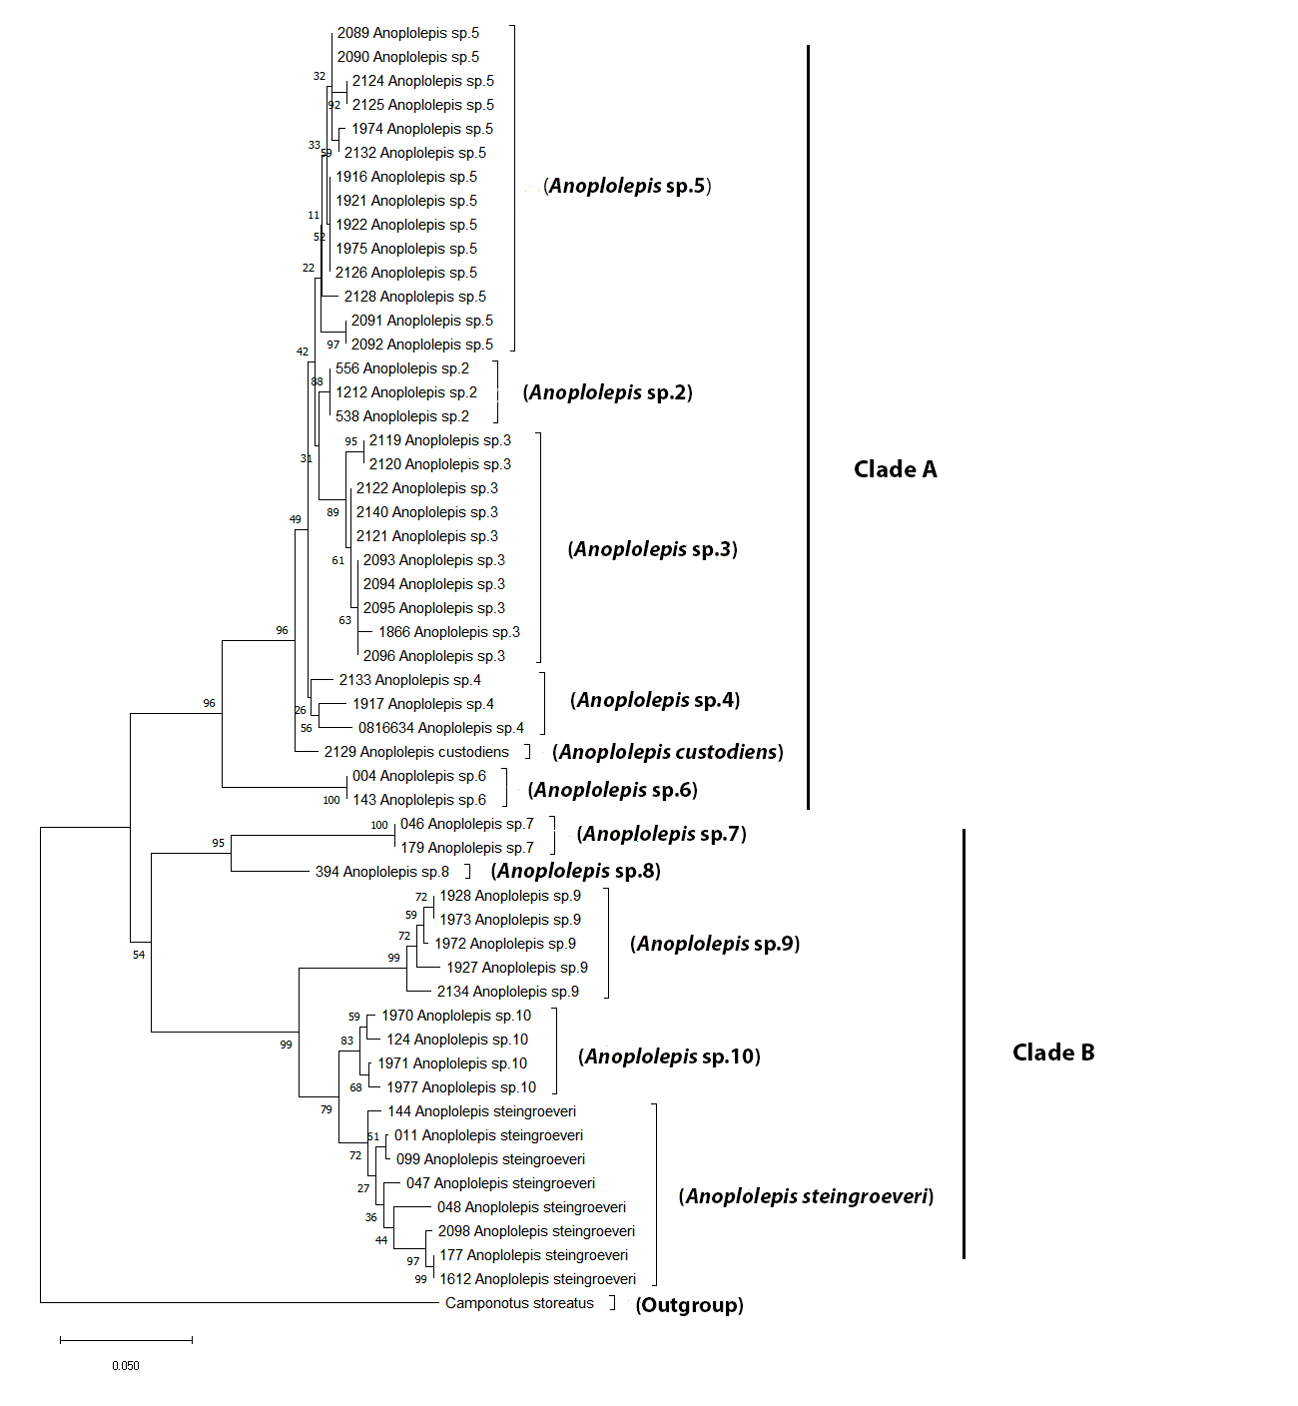
Figure A: Groups used for downstream species delimitation analyses grouped according to clade membership.

Biogeography

Figure B: Map showing the distribution of species Anoplolepis sp. 2, Anoplolepis sp. 3, and Anoplolepis sp. 5 in southern Africa.

Figure C: Map showing the distribution of Anoplolepis sp. 4, Anoplolepis sp. 6, and A. custodiens in southern Africa.

Figure D: Map showing the distribution of Anoplolepis sp. 1, Anoplolepis sp. 7 and Anoplolepis sp. 8 in southern Africa.

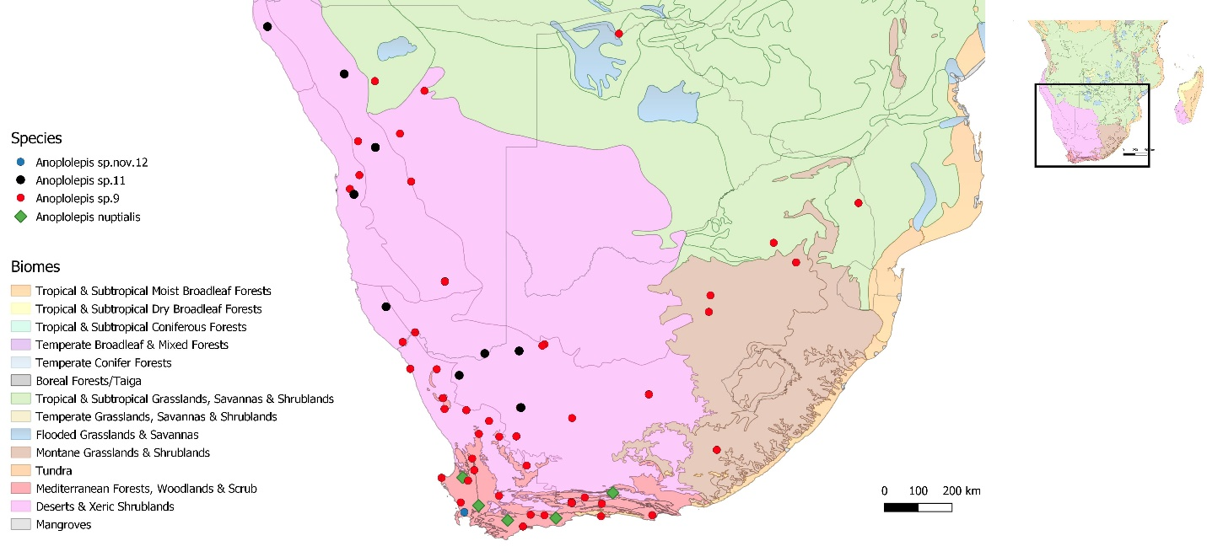
Figure E: Map showing the distribution of species Anoplolepis sp. 9, Anoplolepis sp. 11, Anoplolepis sp. nov. 12 and A. nuptialis in southern Africa.

Figure F: Map showing the distribution of Anoplolepis sp. 10, A. carinata, and A. steingroeveri in southern Africa.

Table 1: Table showing the distribution of Anoplolepis species in different biomes of southern Africa.
Species names | Tropical & Subtropical Moist Broadleaf Forests | Tropical & Subtropical Dry Broadleaf Forests | Tropical & Subtropical Grasslands, Savannas & Shrublands | Flooded Grasslands & Savannas | Montane Grasslands & Shrublands | Mediterranean Forests, Woodlands & Scrub | Deserts & Xeric Shrublands | Mangroves
Anoplolepis sp. 5 | 0 | 0 | 1 | 0 | 1 | 0 | 1 | 1
Anoplolepis sp. 2 | 1 | 0 | 1 | 0 | 1 | 1 | 1 | 1
Anoplolepis sp. 3 | 1 | 1 | 1 | 1 | 1 | 1 | 1 | 0
Anoplolepis sp. 4 | 1 | 0 | 1 | 0 | 1 | 1 | 0 | 0
A. custodiens | 1 | 0 | 1 | 0 | 1 | 1 | 1 | 1
Anoplolepis sp. 6 | 0 | 0 | 0 | 0 | 0 | 0 | 1 | 0
Anoplolepis sp. 7 | 0 | 0 | 1 | 0 | 1 | 1 | 1 | 0
Anoplolepis sp. 8 | 1 | 0 | 1 | 0 | 1 | 1 | 1 | 0
Anoplolepis sp. 1 | 0 | 0 | 1 | 0 | 1 | 1 | 1 | 0
Anoplolepis sp. 9 | 1 | 0 | 1 | 1 | 1 | 1 | 1 | 0
Anoplolepis sp. 10 | 0 | 0 | 1 | 1 | 1 | 1 | 1 | 0
A. steingroeveri | 1 | 0 | 1 | 1 | 1 | 1 | 1 | 0
Anoplolepis sp. 11 | 0 | 0 | 0 | 0 | 0 | 0 | 1 | 0
Anoplolepis sp. nov. 12 | 0 | 0 | 0 | 0 | 0 | 1 | 0 | 0
A. carinata | 1 | 0 | 0 | 0 | 0 | 0 | 0 | 0
A. nuptialis | 0 | 0 | 0 | 0 | 0 | 1 | 1 | 0
Total number of species | 8 | 1 | 11 | 4 | 11 | 12 | 13 | 3

Appendix 2
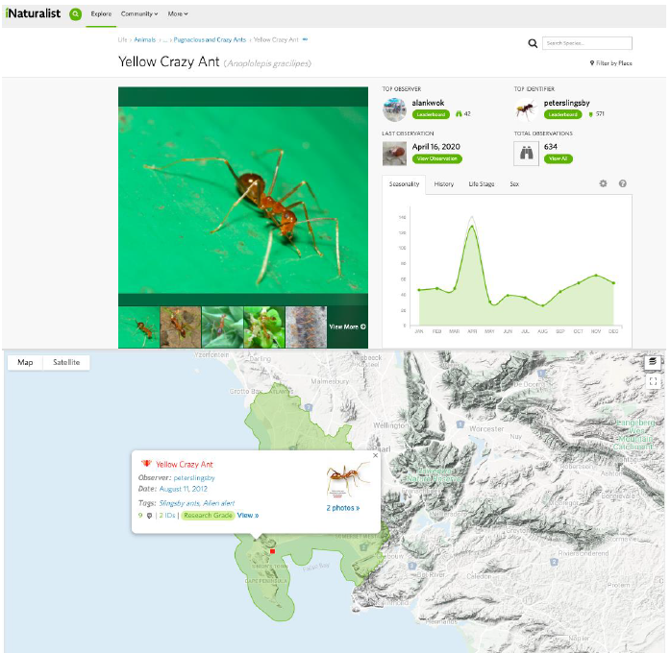
Figure A: Record from https://www.inaturalist.org/observations/1160269, accessed 10 January 2022.

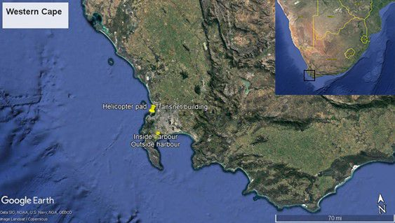
Figure B1: Location of different study sites used for ant sampling in two harbours (Kalk Bay and Waterfront), Western Cape, South Africa.

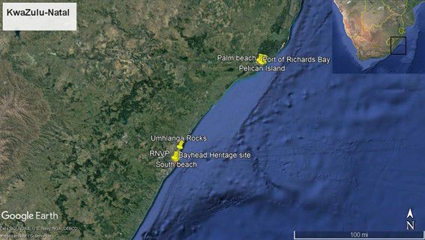
Figure B2: Location of different study sites used for ant sampling in two harbours (Durban and Richards Bay), KwaZulu-Natal, South Africa.
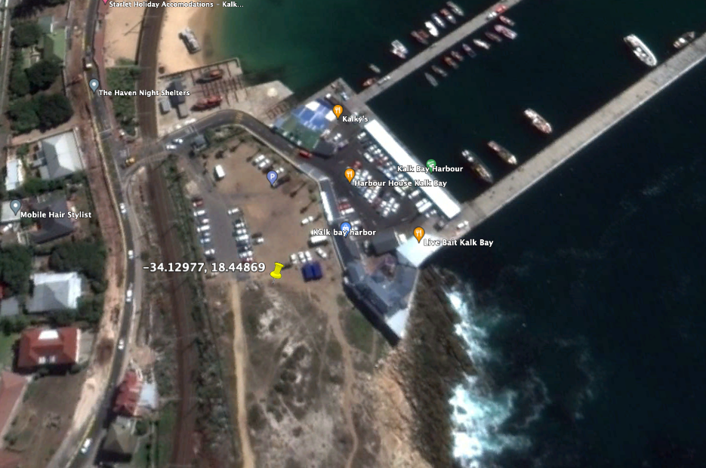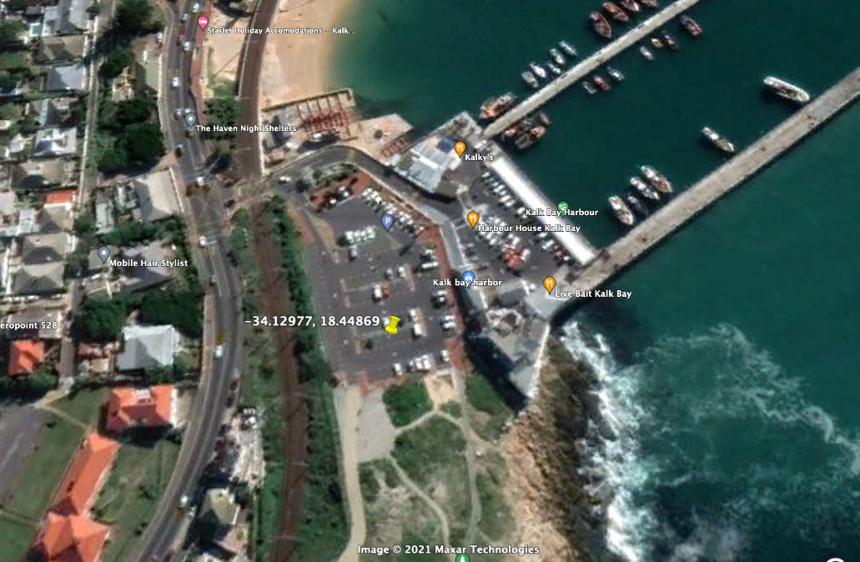
Figure C: Site of the record of A. gracilipes in Kalk Bay site in 2013 (top) and 2021 (bottom) showing parking area construction.

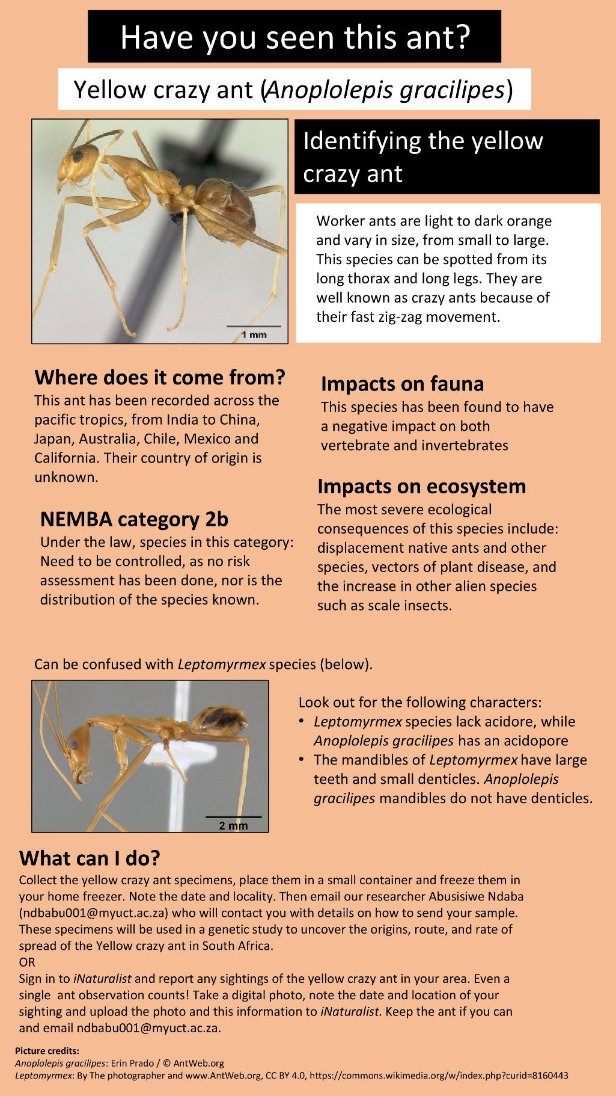
Figure D: A leaflet produced for verifying the existing distributional records for the invasive species, A. gracilipes in south Africa.
Table 1: Mean (±SE) total species richness across harbours in Western Cape and KwaZulu-Natal harbours, South Africa.
Species names | Durban harbour | Kalk Bay | Richards Bay | Waterfront harbour
Aenictus sp.1 | 0.059±0.235 | 0 | 0 | 0
Anochetus sp.1 | 0 | 0 | 0.143±0.331 | 0
Anoplolepis custodiens | 81.941±327.765 | 0 | 0 | 0
Camponotus maculatus | 0.118±0.471 | 0 | 0.143±0.331 | 0
Camponotus sp.1 | 1.118±1.529 | 0.5±0.5 | 0.857±1.059 | 0
Camponotus sp.2 | 0 | 0 | 0.286±0.661 | 0
Cardiocondyla sp.1 | 0.765±2.184 | 0 | 1.571±2.118 | 0.125±0.331
Cardiocondyla sp.2 | 0.059±0.235 | 0 | 0 | 0
Cardiocondyla sp.3 | 0.059±0.235 | 0 | 0 | 0
Crematogaster liengmei | 0 | 0 | 0.143±0.331 | 0
Crematogaster rectinota | 0.294±0.956 | 0 | 0 | 0
Crematogaster sp.1 | 0.118±0.471 | 0 | 0 | 0
Diplomorium sp.01 | 1±2.870 | 0 | 0 | 0
Dorylus helvolus | 0 | 0 | 5.571±12.898 | 0
Hypoponera sp.1 | 0 | 0 | 0.286±0.661 | 0
Lepisiota sp.1 | 0.529±1.144 | 0 | 47±108.807 | 10.125±15.186
Lepisiota spinosior | 0.118±0.471 | 0 | 0 | 0
Leptogenys sp.1 | 0 | 0 | 0.143±0.331 | 0
Linepithema humile | 0 | 25.5±7.5 | 0 | 3±4.330
Mesoponera sp.1 | 0.588±1.751 | 0 | 0.571±1.323 | 0
Messor sp.1 | 0 | 0 | 0 | 0.375±0.484
Monomorium junodi | 0.059±0.235 | 0 | 8.857±18.342 | 0
Monomorium sp.1 | 1.471±4.704 | 0 | 4.286±7.172 | 1±2.645
Monomorium sp.2 | 16.765±23.598 | 0.5±0.5 | 7.429±12.578 | 2.875±4.512
Monomorium sp.3 | 3.353±7.522 | 35±17 | 0 | 0.375±0.696
Monomorium sp.4 | 0.765±2.101 | 0 | 0 | 4.875±5.134
Myrmicaria natalensis | 5.588±17.915 | 0 | 4.571±9.500 | 0
Nylanderia natalensis | 0.176±0.706 | 0 | 0 | 0
Nylanderia sp.1 | 1.529±3.550 | 0 | 0 | 0
Paratrechina sp.1 | 1.706±3.339 | 0 | 0 | 0
Pheidole crassinoda | 0 | 0 | 0.143±0.331 | 0
Pheidole sp.1 | 6.118±13.625 | 0 | 0 | 0
Pheidole sp.2 | 0.588±2.353 | 0 | 0.143±0.331 | 0
Pheidole sp.3 | 0.353±1.412 | 0 | 5±11.571 | 3±3.464
Pheidole sp.4 | 0.588±2.353 | 0 | 6.143±14.221 | 0
Pheidole sp.5 | 1.941±5.525 | 0 | 0 | 0
Pheidole sp.6 (megacephala gp.) | 258.294±604.415 | 0 | 226.714±250.081 | 0.625±0.992
Pheidole sp.7 (megacephala gp.) | 0.059±0.235 | 0 | 0 | 0
Plagiolepis sp.1 | 0.529±1.882 | 0 | 0 | 0
Polyrhachis sp.1 | 0.235±0.941 | 0 | 0 | 0
Solenopsis sp.1 | 0.353±0.681 | 0 | 0.143±0.331 | 0
Solenopsis sp.2 | 0.412±1.647 | 0 | 0 | 0.125±0.331
Strumigenys sp.1 | 0.059±0.235 | 0 | 0 | 0
Tapinolepis sp.1 | 0 | 0 | 0.571±1.321 | 0
Tapinoma sp.1 | 0.353±1.185 | 0 | 1±1.965 | 0
Technomyrmex pallipes | 11±19.369 | 0 | 0.143±0.331 | 0
Tetramorium gabonense | 5.706±10.374 | 0 | 10.714±17.449 | 0
Tetramorium notiale | 0.353±0.836 | 0 | 0 | 0
Tetramorium sericiventre | 2.765±5.504 | 0 | 6.857±7.794 | 6.125±6.918
Tetramorium setigerum | 1.235±4.453 | 1.5±1.5 | 2.429±4.854 | 0.375±0.484
Tetramorium setuliferum | 0 | 0 | 0.143±0.331 | 0
Tetramorium simillimum | 2.176±7.031 | 0 | 1.714±3.606 | 0
Tetramorium sp.1 | 0.294±1.176 | 0 | 1.857±2.913 | 0
Tetramorium sp.10 | 0 | 0 | 0.286±0.661 | 0
Tetramorium sp.11 | 0 | 0 | 0 | 2.25±4.465
Tetramorium sp.12 | 0 | 0 | 2.714±5.243 | 0
Tetramorium sp.13 | 0.706±2.371 | 0 | 0 | 0.5±1.323
Tetramorium sp.2 | 0 | 0 | 0.286±0.661 | 0
Tetramorium sp.3 | 0 | 0 | 0.143±0.331 | 0
Tetramorium sp.4 (squaminode group) | 0.176±0.706 | 0 | 0 | 0
Tetramorium sp.5 (squaminode group) | 1.235±4.941 | 0 | 0 | 0
Tetramorium sp.6 (squaminode group) | 1.235±4.466 | 0 | 0 | 0
Tetramorium sp.7 | 0.059±0.235 | 0 | 0 | 0.125±0.331
Tetramorium sp.8 | 6.118±24.471 | 0 | 0 | 0
Tetramorium sp.9 | 0.059±0.235 | 0 | 0 | 0

