Appendix

Tables
Table S1 Generalised Linear Mixed-Effects model comparing percentage ground cover between the 2002-2003 and 2022-2023 sampling periods. Site used as random effect (DIC: 8817.059)
 | Estimate | Lower 95% Confidence Interval | Upper 95% Confidence Interval | Effective Sample Size | pMCMC
(Intercept) | 42.454 | 39.908 | 44.634 | 1000 | <0.001
periodmodern | -14.728 | -18.141 | -11.712 | 1000 | <0.001
namelitter | -38.415 | -41.725 | -34.972 | 1000 | <0.001
namerock | -23.167 | -26.038 | -19.511 | 896.1 | <0.001
nameveg | -8.251 | -11.494 | -5.225 | 1000 | <0.001
periodmodern:namelitter | 22.141 | 17.769 | 26.988 | 1000 | <0.001
periodmodern:namerock | 12.717 | 8.215 | 17.418 | 1000 | <0.001
periodmodern:nameveg | 23.99 | 18.876 | 28.166 | 917.8 | <0.001
Table S2 Mean abundance (± standard error) of Anthia decemguttata, Stenocara dentata, and Zophosis gracilicornis, at each elevation in October across the four years of the historical comparisons.
Elevation (m a.s.l.) | 2002  (mean ± SE) | 2003  (mean ± SE) | 2022  (mean ± SE) | 2023  (mean ± SE)
Western slope
0 | 0.25 ± 0.25 | 0.5 ± 0.289 | 0.5 ± 0.5 | 3.5 ± 1.55
200 | 2.75 ± 0.854 | 8.5 ± 2.99 | 11 ± 3.89 | 4.75 ± 2.25
300 | 5.25 ± 1.11 | 10.5 ± 2.33 | 13 ± 2.94 | 13.5 ± 4.91
500 | 8.25 ± 2.43 | 9.75 ± 3.33 | 13 ± 4.71 | 5.25 ± 1.8
700 | 10 ± 3.03 | 8.75 ± 2.69 | 3.75 ± 1.6 | 6.5 ± 2.72
900 | 27.25 ± 8.74 | 36.75 ± 9.94 | 19 ± 3.39 | 9.75 ± 3.35
1100 | 62.5 ± 8.45 | 156 ± 32.1 | 71 ± 17.2 | 41.25 ± 9.6
1300 | 44.75 ± 14.4 | 104.25 ± 29.6 | 20.75 ± 3.92 | 7 ± 4.85
1500 | 86.5 ± 20.3 | 117.25 ± 33.8 | 24 ± 6.1 | 11.25 ± 4.75
1700 | 40.5 ± 13.3 | 8.75 ± 1.38 | 23.25 ± 4.35 | 22.25 ± 0.75
1900 | 0 ± 0 | 0 ± 0 | 1.75 ± 1.18 | 0 ± 0
Eastern slope
1700 | 38 ± 2.35 | 24 ± 4.06 | 36.75 ± 6.54 | 22 ± 4.49
1500 | 30 ± 8.26 | 29.5 ± 1.85 | 28.5 ± 8.85 | 10.5 ± 1.26
1300 | 0 ± 0 | 0 ± 0 | 0 ± 0 | 0 ± 0
1100 | 5.25 ± 1.93 | 4.25 ± 2.66 | 9.25 ± 3.97 | 2 ± 0.913
900 | 13.5 ± 4.33 | 14.5 ± 1.04 | 15.5 ± 3.86 | 20.25 ± 4.09
500 | 3.25 ± 1.49 | 7.25 ± 1.11 | 6.25 ± 1.49 | 8.25 ± 2.98

Table S3 Mean abundance (± standard error) of Anthia decemguttata, at each elevation in October across the four years of the historical comparisons.
Elevation (m a.s.l.) | 2002  (mean ± SE) | 2003  (mean ± SE) | 2022  (mean ± SE) | 2023  (mean ± SE)
Western slope
0 | 0 ± 0 | 0 ± 0 | 0 ± 0 | 0 ± 0
200 | 6 ± 0.957 | 3 ± 0.75 | 0 ± 0 | 0 ± 0
300 | 2 ± 0.5 | 0 ± 0 | 0 ± 0 | 15 ± 3.42
500 | 0 ± 0 | 2 ± 0.5 | 5 ± 0.946 | 3 ± 0.479
700 | 4 ± 0.577 | 9 ± 1.11 | 6 ± 0.957 | 3 ± 0.75
900 | 11 ± 0.479 | 39 ± 1.49 | 19 ± 1.55 | 11 ± 1.31
1100 | 27 ± 4.77 | 45 ± 2.29 | 83 ± 6.07 | 71 ± 4.46
1300 | 55 ± 3.54 | 73 ± 3.01 | 33 ± 3.28 | 18 ± 3.23
1500 | 114 ± 4.09 | 98 ± 5.66 | 47 ± 2.95 | 30 ± 2.75
1700 | 0 ± 0 | 0 ± 0 | 15 ± 0.629 | 23 ± 1.18
1900 | 0 ± 0 | 0 ± 0 | 7 ± 1.18 | 0 ± 0
Eastern slope
1700 | 1 ± 0.25 | 1 ± 0.25 | 16 ± 3.03 | 8 ± 2
1500 | 4 ± 0.408 | 0 ± 0 | 16 ± 2.12 | 7 ± 1.03
1300 | 0 ± 0 | 0 ± 0 | 0 ± 0 | 0 ± 0
1100 | 1 ± 0.25 | 1 ± 0.25 | 14 ± 1.55 | 2 ± 0.5
900 | 0 ± 0 | 0 ± 0 | 10 ± 0.289 | 16 ± 1.68
500 | 0 ± 0 | 0 ± 0 | 0 ± 0 | 0 ± 0

Table S4 Mean abundance (± standard error) of Stenocara dentata, at each elevation in October across the four years of the historical comparisons.
Elevation (m a.s.l.) | 2002  (mean ± SE) | 2003  (mean ± SE) | 2022  (mean ± SE) | 2023  (mean ± SE)
Western slope
0 | 0 ± 0 | 0 ± 0 | 0 ± 0 | 1 ± 0.25
200 | 0 ± 0 | 0 ± 0 | 0 ± 0 | 0 ± 0
300 | 0 ± 0 | 0 ± 0 | 6 ± 1.19 | 11 ± 1.18
500 | 0 ± 0 | 0 ± 0 | 0 ± 0 | 0 ± 0
700 | 0 ± 0 | 0 ± 0 | 0 ± 0 | 0 ± 0
900 | 0 ± 0 | 0 ± 0 | 0 ± 0 | 0 ± 0
1100 | 14 ± 1.66 | 33 ± 2.1 | 31 ± 2.39 | 25 ± 1.44
1300 | 14 ± 1.66 | 81 ± 7.79 | 22 ± 2.06 | 8 ± 1.22
1500 | 47 ± 5.31 | 33 ± 1.65 | 16 ± 1.87 | 11 ± 2.1
1700 | 15 ± 2.1 | 10 ± 1.5 | 58 ± 3.93 | 52 ± 1.22
1900 | 0 ± 0 | 0 ± 0 | 0 ± 0 | 0 ± 0
Eastern slope
1700 | 89 ± 4.53 | 33 ± 2.02 | 113 ± 2.32 | 71 ± 2.93
1500 | 23 ± 2.29 | 19 ± 2.29 | 53 ± 4.29 | 21 ± 1.93
1300 | 0 ± 0 | 0 ± 0 | 0 ± 0 | 0 ± 0
1100 | 0 ± 0 | 0 ± 0 | 0 ± 0 | 0 ± 0
900 | 0 ± 0 | 0 ± 0 | 0 ± 0 | 0 ± 0
500 | 1 ± 0.25 | 8 ± 0.913 | 12 ± 1.35 | 24 ± 2.48

Table S5 Mean abundance (± standard error) of Zophosis gracilicornis, at each elevation in October across the four years of the historical comparisons.
Elevation (m a.s.l.) | 2002  (mean ± SE) | 2003  (mean ± SE) | 2022  (mean ± SE) | 2023  (mean ± SE)
Western slope
0 | 0 ± 0 | 0 ± 0 | 0 ± 0 | 1 ± 0.25
200 | 0 ± 0 | 0 ± 0 | 0 ± 0 | 0 ± 0
300 | 0 ± 0 | 0 ± 0 | 6 ± 1.19 | 11 ± 1.18
500 | 0 ± 0 | 0 ± 0 | 0 ± 0 | 0 ± 0
700 | 0 ± 0 | 0 ± 0 | 0 ± 0 | 0 ± 0
900 | 0 ± 0 | 0 ± 0 | 0 ± 0 | 0 ± 0
1100 | 14 ± 1.66 | 33 ± 2.1 | 31 ± 2.39 | 25 ± 1.44
1300 | 14 ± 1.66 | 81 ± 7.79 | 22 ± 2.06 | 8 ± 1.22
1500 | 47 ± 5.31 | 33 ± 1.65 | 16 ± 1.87 | 11 ± 2.1
1700 | 15 ± 2.1 | 10 ± 1.5 | 58 ± 3.93 | 52 ± 1.22
1900 | 0 ± 0 | 0 ± 0 | 0 ± 0 | 0 ± 0
Eastern slope
1700 | 62 ± 5.27 | 62 ± 3.01 | 18 ± 1.55 | 9 ± 0.75
1500 | 93 ± 9.35 | 99 ± 0.629 | 45 ± 4.96 | 14 ± 1.32
1300 | 0 ± 0 | 0 ± 0 | 0 ± 0 | 0 ± 0
1100 | 20 ± 1.68 | 16 ± 2.71 | 23 ± 2.46 | 6 ± 0.645
900 | 54 ± 4.33 | 58 ± 1.04 | 52 ± 3.63 | 65 ± 3.71
500 | 12 ± 1.47 | 21 ± 1.44 | 13 ± 1.7 | 9 ± 1.31

Table S6 Generalised Linear Mixed-Effects model comparing abundance for Anthia decemguttata, Stenocara dentata, and Zophosis gracilicornis between the sampling periods of 2002-2003 and 2022-2023 (Poisson error distribution, log link function). Sites and replicates used as random effects
Random effects:
Groups | Number of obs: | Variance | Std.Dev.
site:replicate | 272 | 2.888 | 1.7
Groups:  site:replicate | 68
Fixed effects: | Estimate | Std. Error | z value | Pr(>|z|)
(Intercept) | 2.40281 | 0.21101 | 11.39 | <2e-16
periodmodern | -0.63808 | 0.02798 | -22.8 | <2e-16

Table S7 Generalised Linear Mixed-Effects model comparing abundance for Anthia decemguttata, Stenocara dentata, and Zophosis gracilicornis between the four years in which sampling occurred in October (2002, 2003, 2022, 2023) (Poisson error distribution, log link function). Sites and replicates used as random effects
Random effects:
Groups | Number of obs: | Variance | Std.Dev.
site:replicate | 272 | 2.888 | 1.7
Groups:  site:replicate | 68
Fixed effects: | Estimate | Std. Error | z value | Pr(>|z|)
(Intercept) | 2.20812 | 0.21193 | 10.419 | 2.00E-16
year2003 | 0.3576 | 0.03343 | 10.697 | 2.00E-16
year2022 | -0.24032 | 0.03865 | -6.218 | 5.05E-10
year2023 | -0.69845 | 0.0445 | -15.697 | 2.00E-16
Table S8 Generalised Linear Mixed-Effects model comparing abundance for Zophosis gracilicornis between the four years in which sampling occurred in October (2002, 2003, 2022, 2023) (Poisson error distribution, log link function). Sites and replicates used as random effects
Random effects:
Groups | Number of obs: | Variance | Std.Dev.
site:replicate | 272 | 2.741 | 1.656
Groups:  site:replicate | 68
Fixed effects: | Estimate | Std. Error | z value | Pr(>|z|)
(Intercept) | 1.89362 | 0.20874 | 9.072 | <2e-16
year2003 | 0.43456 | 0.03882 | 11.194 | <2e-16
year2022 | -0.57988 | 0.05048 | -11.487 | <2e-16
year2023 | -1.21697 | 0.06328 | -19.232 | <2e-16

Table S9 Generalised Linear Mixed-Effects model comparing abundance for Stenocara dentata between the sampling periods of 2002-2003 and 2022-2023 (Poisson error distribution, log link function). Sites and replicates used as random effects
Random effects:
Groups | Number of obs: | Variance | Std.Dev.
site:replicate | 272 | 12.56 | 3.544
Groups:  site:replicate | 68
Fixed effects: | Estimate | Std. Error | z value | Pr(>|z|)
(Intercept) | -2.05907 | 0.65839 | -3.127 | 0.001763
periodmodern | 0.24201 | 0.06518 | 3.713 | 0.000205

Table S10 Generalised Linear Mixed-Effects model comparing abundance for Zophosis gracilicornis between the sampling periods of 2002-2003 and 2022-2023 (Poisson error distribution, log link function). Sites and replicates used as random effects
Random effects:
Groups | Number of obs: | Variance | Std.Dev.
site:replicate | 272 | 2.741 | 1.656
Groups:  site:replicate | 68
Fixed effects: | Estimate | Std. Error | z value | Pr(>|z|)
(Intercept) | 2.13432 | 0.2074 | 10.29 | <2e-16
periodmodern | -1.08923 | 0.03779 | -28.82 | <2e-16

Table S11 Generalised Linear Mixed-Effects model comparing abundance for Zophosis gracilicornis and the effects of environmental variables over time (Poisson error distribution, log link function). Sites and replicates used as random effects
Random effects:
Groups | Number of obs: | Variance | Std.Dev.
site:replicate | 272 | 2.185 | 1.478
Groups:  site:replicate | 68
Fixed effects: | Estimate | Std. Error | z value | Pr(>|z|)
(Intercept) | -2.68E+01 | 2.71E+01 | -0.991 | 3.22E-01
periodmodern | -9.41E+01 | 7.58E+01 | -1.241 | 2.15E-01
`Mg(%)` | 9.46E-03 | 1.86E-02 | 0.509 | 0.61045
Ca | 1.57E-01 | 2.01E-01 | 0.782 | 0.43415
`Ca(%)` | -1.28E-02 | 1.11E-02 | -1.161 | 0.24557
mMax_tair | -1.12E+00 | 3.75E-01 | -2.986 | 0.00282
winddir | 1.35E-01 | 2.91E-02 | 4.626 | 3.72E-06
range_tair | 1.31E+00 | 1.51E-01 | 8.678 | <2.00E-16
`pH(Kcl)` | 7.63E-02 | 1.88E-01 | 0.405 | 0.68535
relhum | 2.11E-01 | 7.20E-02 | 2.934 | 0.00335
swdown | -8.44E-02 | 5.34E-02 | -1.581 | 0.11382
mMax_tground | -6.79E-02 | 3.06E-02 | -2.215 | 0.02675
rock_soil | 3.05E-02 | 1.21E-02 | 2.525 | 0.01155
veg | 2.53E-04 | 3.05E-03 | 0.083 | 0.93377
mMax_precip | 1.97E+01 | 3.87E+00 | 5.097 | 3.45E-07
periodmodern:`Mg(%)` | -3.27E-02 | 1.56E-02 | -2.096 | 0.03604
periodmodern:Ca | -1.56E+00 | 2.57E-01 | -6.071 | 1.27E-09
periodmodern:`Ca(%)` | 6.20E-02 | 1.24E-02 | 5.018 | 5.22E-07
periodmodern:mMax_tair | 1.20E+00 | 4.24E-01 | 2.827 | 0.0047
periodmodern:winddir | -6.32E-02 | 2.49E-02 | -2.536 | 0.01122
periodmodern:range_tair | -1.07E+00 | 1.86E-01 | -5.769 | 8.00E-09
periodmodern:`pH(Kcl)` | 4.77E-01 | 2.32E-01 | 2.056 | 0.03975
periodmodern:relhum | -1.42E-01 | 1.23E-01 | -1.15 | 0.25003
periodmodern:swdown | 4.26E-01 | 2.22E-01 | 1.92 | 0.05484
periodmodern:mMax_tground | 5.15E-03 | 3.11E-02 | 0.166 | 0.86846
periodmodern:rock_soil | -1.33E-01 | 2.42E-02 | -5.505 | 3.69E-08
periodmodern:veg | -2.72E-02 | 6.01E-03 | -4.531 | 5.87E-06
periodmodern:mMax_precip | -1.56E+01 | 1.29E+01 | -1.211 | 0.22587
Table S12 Generalised Linear Mixed-Effects model comparing abundance for Stenocara dentata and the effects of environmental variables over time (Poisson error distribution, log link function). Sites and replicates used as random effects
Random effects:
Groups | Number of obs: | Variance | Std.Dev.
site:replicate | 272 | 7.408 | 2.722
Groups:  site:replicate | 68
Fixed effects: | Estimate | Std. Error | z value | Pr(>|z|)
(Intercept) | -1.32E+02 | 6.07E+01 | -2.182 | 2.91E-02
periodmodern | 1.60E+02 | 3.65E+01 | 4.379 | 1.19E-05
`Mg(%)` | 1.13E-01 | 4.11E-02 | 2.741 | 0.00613
Ca | 1.42E+00 | 4.76E-01 | 2.986 | 0.002825
`Ca(%)` | -6.01E-02 | 3.72E-02 | -1.616 | 0.106195
mMax_tair | -1.97E-01 | 9.79E-01 | -0.201 | 0.840626
winddir | 1.71E-01 | 8.22E-02 | 2.079 | 3.77E-02
range_tair | -4.67E-01 | 6.59E-01 | -0.708 | 0.478654
`pH(Kcl)` | -7.79E-02 | 6.59E-01 | -0.118 | 0.905971
relhum | -4.77E-01 | 2.88E-01 | -1.656 | 0.097687
swdown | 3.96E-01 | 1.26E-01 | 3.157 | 0.001596
rock_soil | 1.15E-01 | 2.20E-02 | 5.238 | 1.62E-07
veg | 2.74E-02 | 8.58E-03 | 3.197 | 0.001391
mMax_precip | 1.07E+02 | 1.96E+01 | 5.438 | 5.38E-08
periodmodern:`Mg(%)` | -9.56E-02 | 3.53E-02 | -2.71E+00 | 0.006798
periodmodern:Ca | -1.71E+00 | 5.19E-01 | -3.294 | 0.000989
periodmodern:`Ca(%)` | 1.49E-01 | 3.78E-02 | 3.94E+00 | 8.33E-05
periodmodern:mMax_tair | 7.46E-01 | 9.20E-01 | 0.81 | 4.18E-01
periodmodern:winddir | -2.33E-01 | 5.90E-02 | -3.959 | 7.52E-05
periodmodern:range_tair | 5.24E-01 | 6.99E-01 | 0.75 | 0.453221
periodmodern:`pH(Kcl)` | 8.04E-01 | 5.90E-01 | 1.36E+00 | 0.173349
periodmodern:relhum | 1.53E-01 | 2.97E-01 | 0.514 | 0.607434
periodmodern:swdown | -4.80E-01 | 3.07E-02 | -15.63 | <2.00E-16
periodmodern:rock_soil | 1.18E-01 | 4.85E-02 | 2.425 | 0.015294
periodmodern:veg | -2.19E-02 | 1.13E-02 | -1.939 | 0.052466
periodmodern:mMax_precip | -4.89E+01 | 4.34E+01 | -1.127 | 2.60E-01

Table S13 Generalised Linear Mixed-Effects model comparing abundance for Anthia decemguttata and the effects of environmental variables over time (Poisson error distribution, log link function). Sites and replicates used as random effects
Random effects:
Groups | Number of obs: | Variance | Std.Dev.
site:replicate | 272 | 4.513 | 2.124
Groups:  site:replicate | 68
Fixed effects: | Estimate | Std. Error | z value | Pr(>|z|)
(Intercept) | 1.04E+02 | 6.34E+01 | 1.632 | 1.03E-01
periodmodern | -3.81E+02 | 2.94E+01 | -12.959 | <2.00E-16
`Mg(%)` | 1.43E-01 | 3.49E-02 | 4.09E+00 | 4.24E-05
Ca | 5.66E-01 | 3.47E-01 | 1.632 | 1.03E-01
`Ca(%)` | -5.33E-02 | 2.42E-02 | -2.203 | 0.027565
mMax_tair | -3.00E+00 | 8.01E-01 | -3.743 | 0.000182
winddir | -2.02E-01 | 8.61E-02 | -2.349 | 0.018837
range_tair | 1.32E+00 | 3.19E-01 | 4.137 | 3.51E-05
`pH(Kcl)` | 7.71E-02 | 4.16E-01 | 1.85E-01 | 0.852915
relhum | 1.97E-01 | 1.56E-01 | 1.26 | 0.207514
swdown | -2.13E-01 | 1.03E-01 | -2.066 | 0.038784
rock_soil | 4.78E-02 | 2.52E-02 | 1.899 | 0.057513
veg | 1.66E-02 | 6.36E-03 | 2.6 | 0.009311
mMax_precip | 6.89E+01 | 1.06E+01 | 6.484 | 8.92E-11
periodmodern:`Mg(%)` | -1.20E-01 | 2.67E-02 | -4.49 | 7.13E-06
periodmodern:Ca | -7.91E-01 | 4.51E-01 | -1.755 | 7.93E-02
periodmodern:`Ca(%)` | 1.09E-01 | 2.32E-02 | 4.673 | 2.97E-06
periodmodern:mMax_tair | 6.68E+00 | 9.42E-01 | 7.09 | 1.34E-12
periodmodern:winddir | -4.73E-02 | 6.68E-02 | -7.08E-01 | 4.79E-01
periodmodern:range_tair | -2.18E-01 | 4.67E-01 | -0.467 | 6.40E-01
periodmodern:`pH(Kcl)` | 7.05E-01 | 5.93E-01 | 1.19E+00 | 0.234377
periodmodern:relhum | -5.97E-01 | 1.81E-01 | -3.306 | 0.000946
periodmodern:swdown | 9.52E-01 | 3.28E-02 | 2.90E+01 | <2.00E-16
periodmodern:rock_soil | -4.44E-02 | 5.61E-02 | -0.791 | 0.428733
periodmodern:veg | -2.78E-02 | 1.02E-02 | -2.727 | 0.006388
periodmodern:mMax_precip | -5.41E-02 | 3.73E+01 | -0.001 | 0.998843

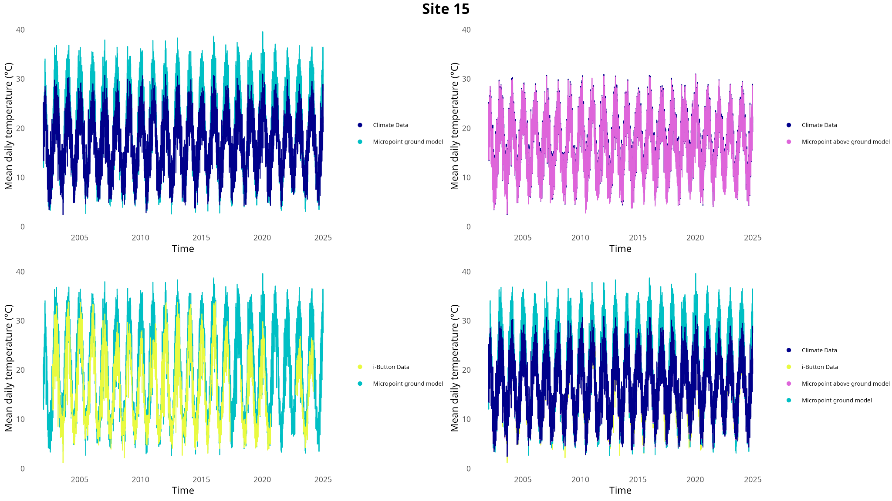
Figures

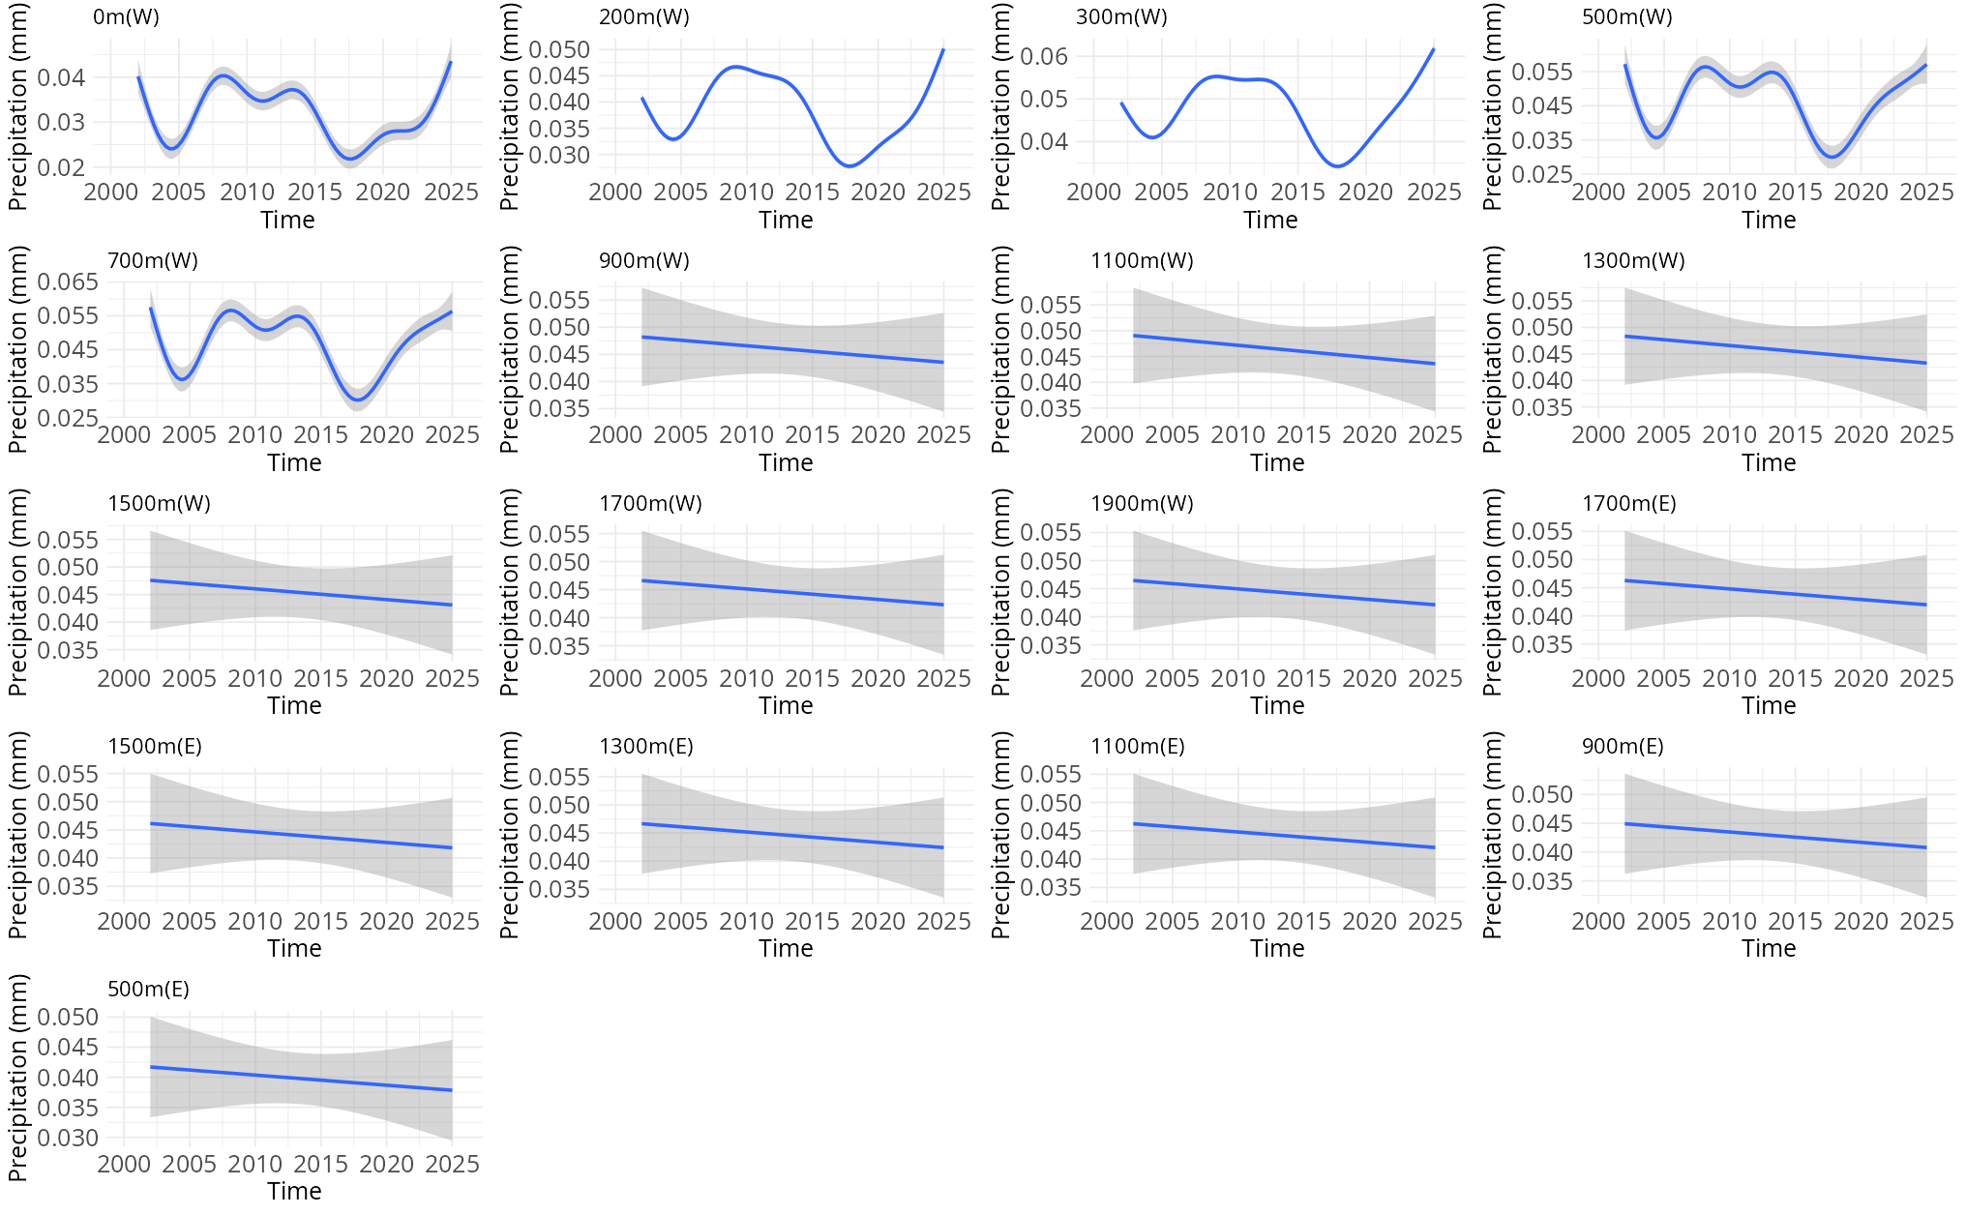
Figure S1 Comparisons between the different sources of temperature data recorded for this study

Figure S2 Trend in baseline precipitation for each site across the entire transect.

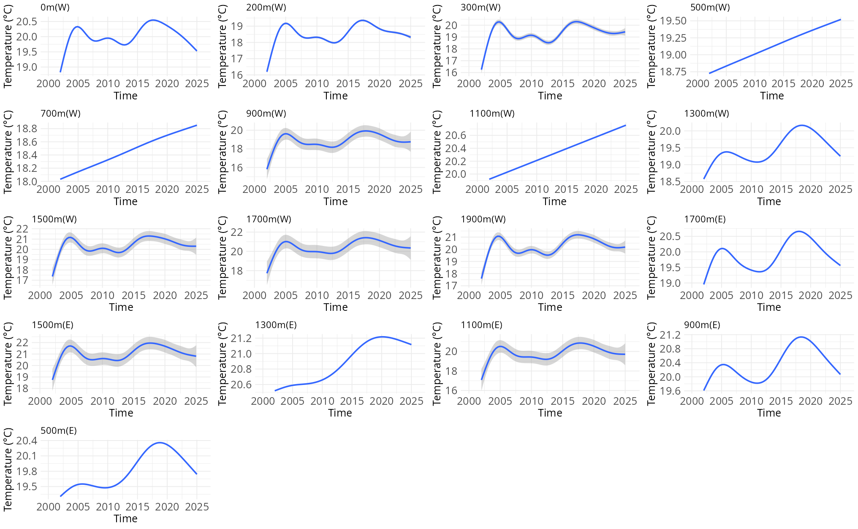
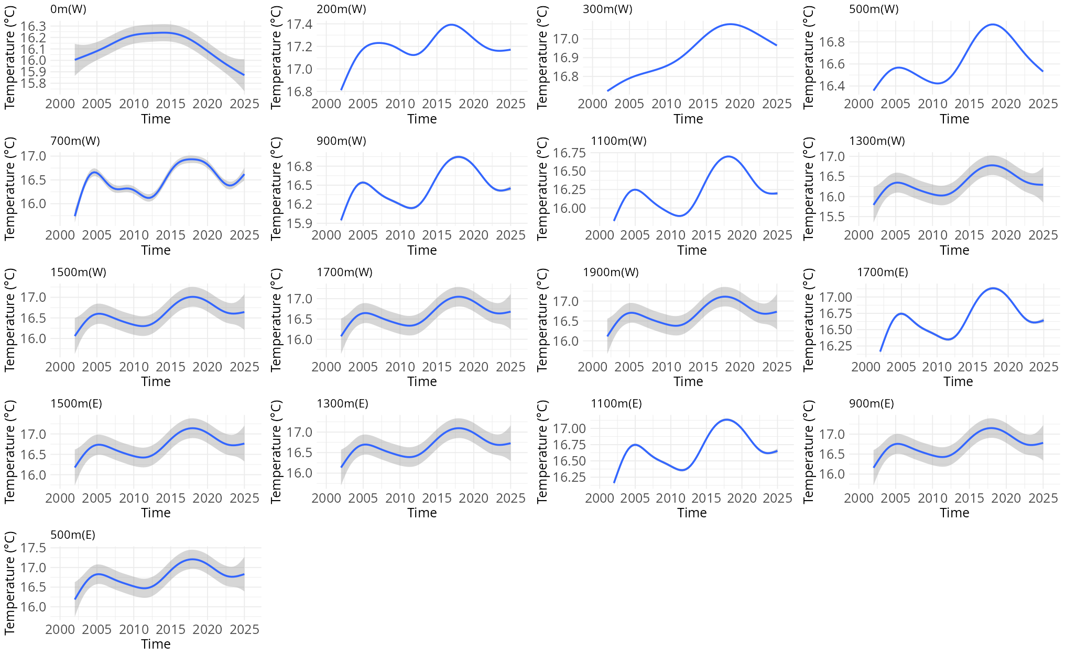Figure S3 Temperature trend over time for (top) ground temperature, and (bottom) air temperature for each site across the transect
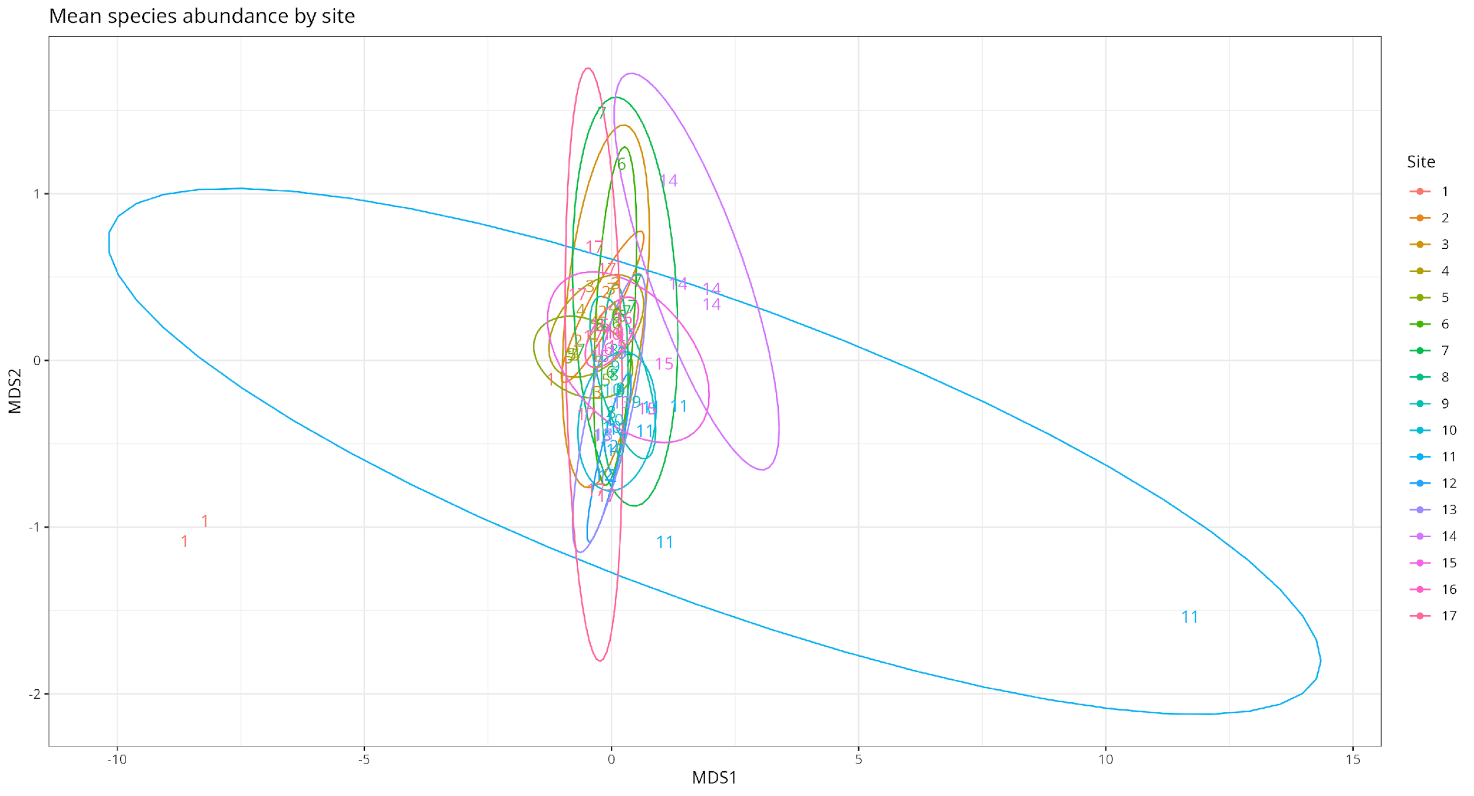
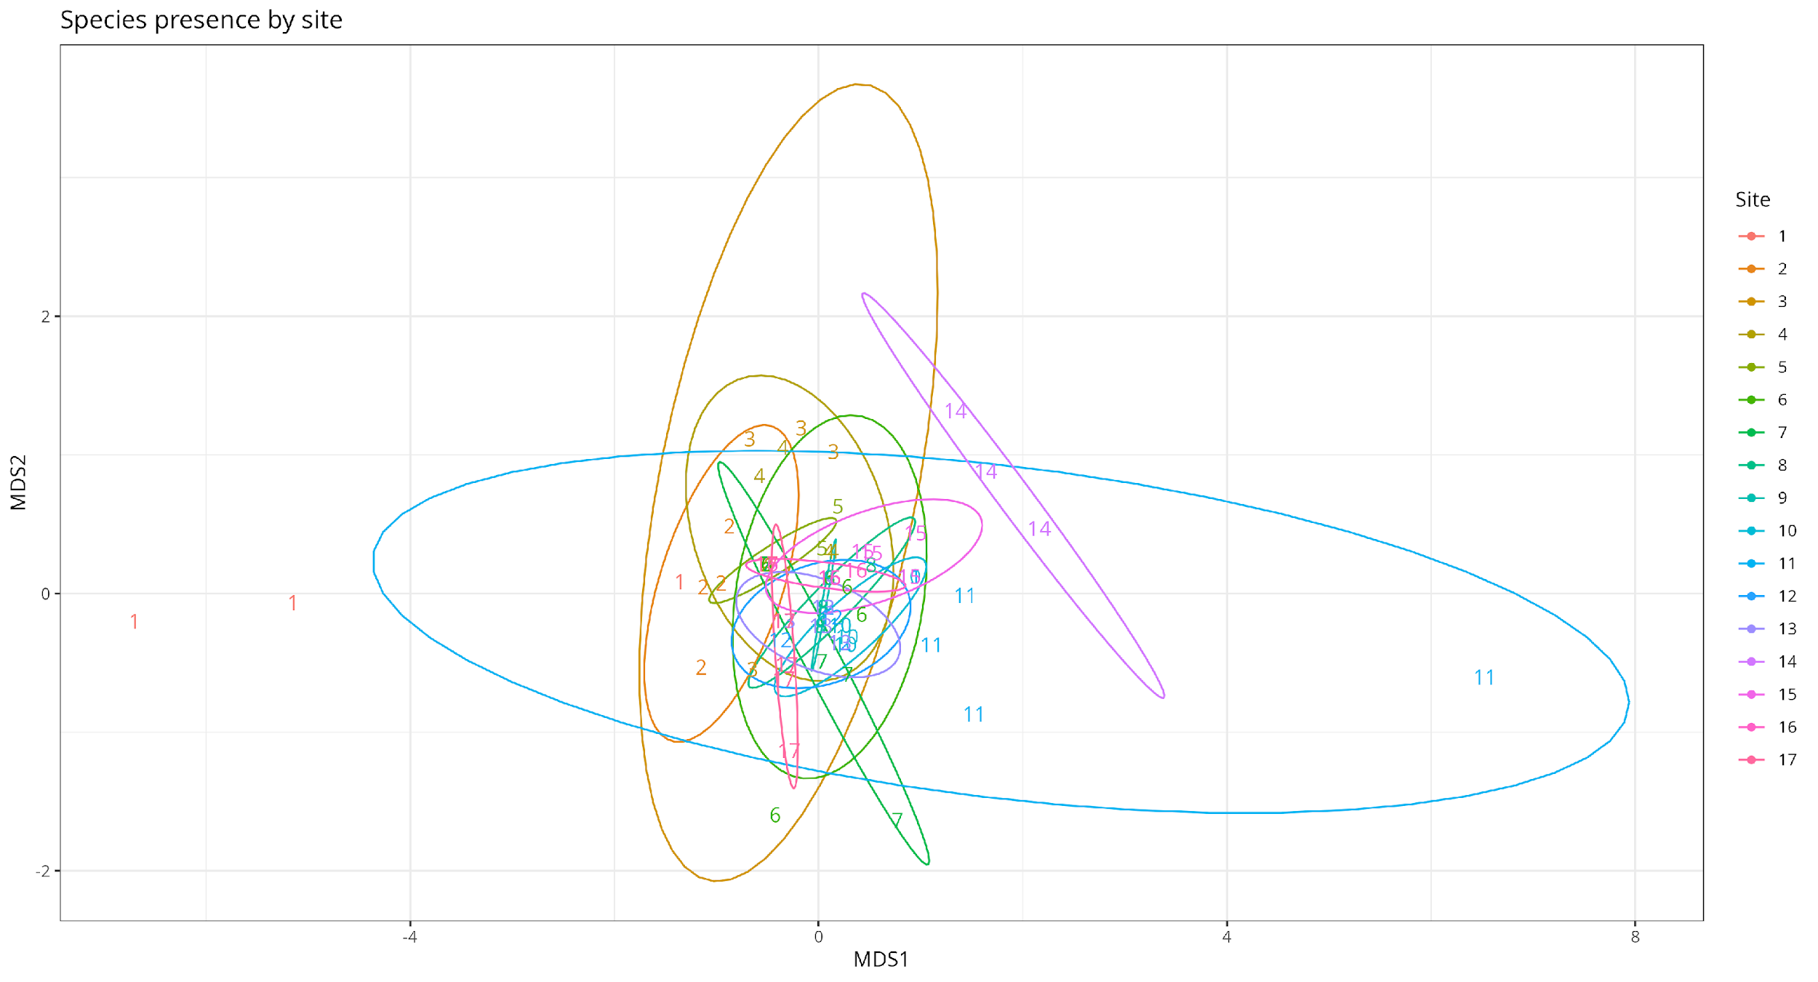
Figure S4 NMDS plot of (a) mean species abundance (stress = 0.1), and (b) species presence (stress = 0.09), compared between the different sites across the altitudinal gradient of the transect.
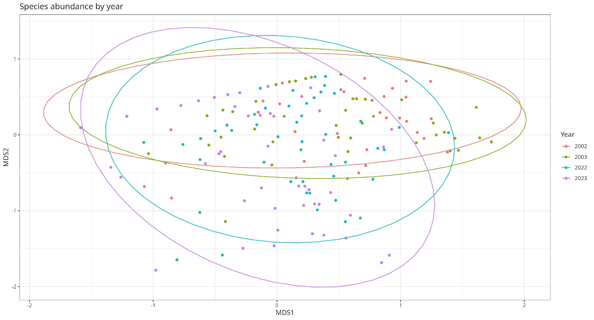
Figure S5 Abundance of the three key species separated by sampling year (stress = 0.16)

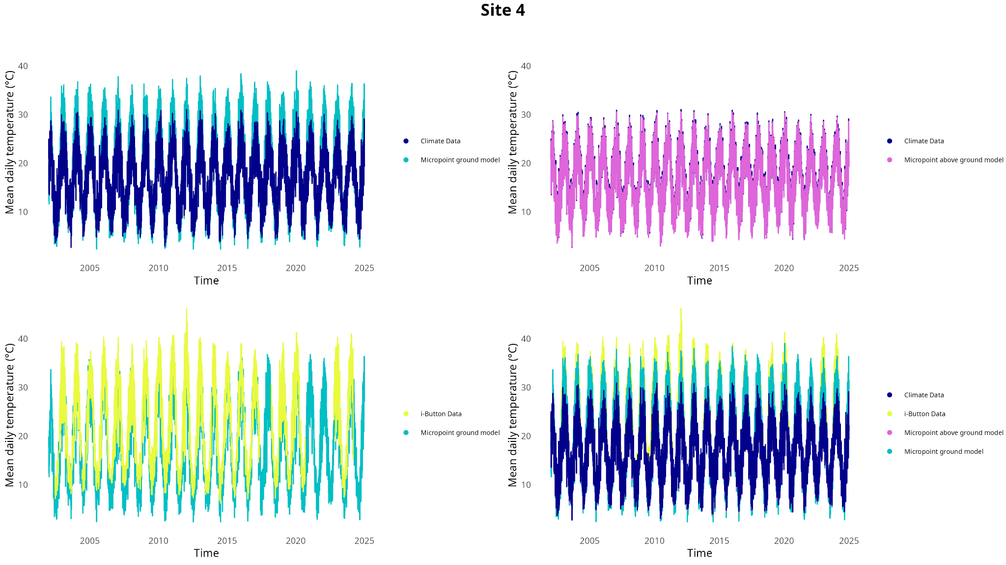
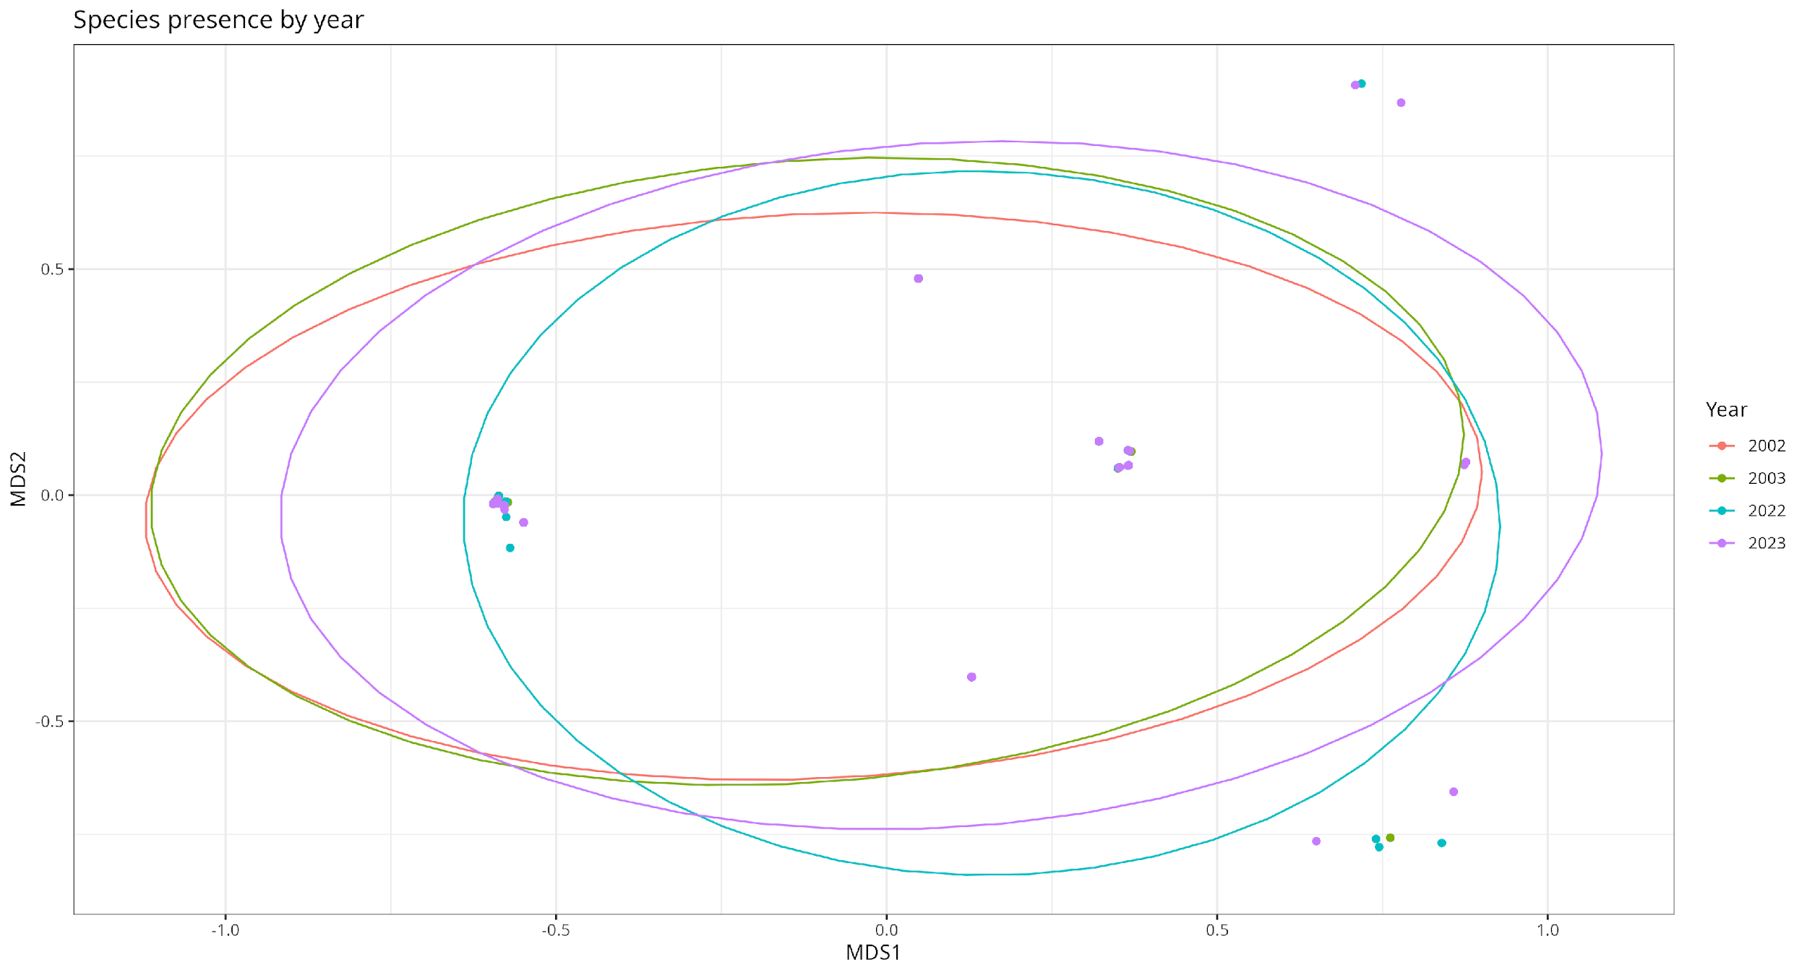
Appendix S6 Presence of the three key species separated by sampling year (stress = 1.7e-05)

