Chapter 2: Data Chapter

Introduction
- Insect assemblages and what affects them.
  - How insect populations and communities have reacted in past studies to changes in various environmental factors and other factors.
- Insect assemblages across altitudinal gradients and how the prior mentioned factors change across such a gradient.
  - Do environmental factors affect insects differently at different altitudes and for what reason.
- Which factors that affect insect assemblages affect beetles specifically to the greatest degree.
  - If possible discuss the biology of beetles specifically that might make them more/less sensitive to certain factors in comparison to other entomofauna.
- Why those factors affect beetles and how might those factors be changing under climate change
- Distinction between baseline climactic changes and protracted short-term climactic phenomena
  - Determine whether any noticed changes in factors like temperature and precipitation should be attributed to a genuine change in the underlying climate of the region, or whether phenomena such as the ENSO might be causing a noticeable change in those factors without necessarily implying a change in the baseline trend.
- The effects of biotic factors compounded with abiotic factors
  - Mention how vegetation is also affected by these environmental changes, and even if the environmental factors might not be affecting the beetles directly, they might be affected by the changes experienced by the vegetation surrounding them. Or higher trophic level beetles might be affected because lower trophic level prey is affected.
- Assessing all of these variables through environmental monitoring, long-term insect assemblage sampling, monitoring across an altitudinal gradient
  - Mention the advantages and knowledge that longitudinal studies bring, and the great diversity that is brought by working across an altitudinal gradient.
- The background of this study emphasising the replication and the foundations that it was built upon. The introduction of the transect and description of the area and the context of the environment
  - More developed in the methods and also Chapter 1, but still can be expanded to some degree here.
- Aims: quantify and qualify environmental changes, assemblage changes, altitudinal range shifts, seasonal comparison, historical comparison, in order to answer the above questions

All figure names are placeholder letters as the order of the figures might change later down the line.

Methods

Site and sampling
The methodology and sampling configurations involved in the design of this study are identical to those used in the historical study that is being repeated after a gap of two decades (Botes et al., 2006).
This study was conducted in the Greater Cederberg Biodiversity Corridor, specifically across an altitudinal transect that spans both aspects (East and West) of the Cederberg mountains. This altitudinal transect comprises the major vegetation types found within the Cederberg Wilderness Area, being Strandveld Succulent Karoo, Mountain Fynbos, and Succulent Karoo, therefore representing almost the full range of vegetation that could be expectedly observed in this region.
A total of 17 different sites were sampled with 200 metre altitudinal intervals between each, ranging from sea level at Lambert’s Bay on the western aspect of the transect (Strandveld Succulent Karoo), to Sneeukop (1926 metres a.s.l.), and finally continuing down the eastern aspect of the mountain and ending near the town of Wupperthal (Lowland Succulent Karoo, 500 metres a.s.l.) (figure B). All of the sites between the two endpoints of the transect were considered to be representatives of Mountain Fynbos vegetation.
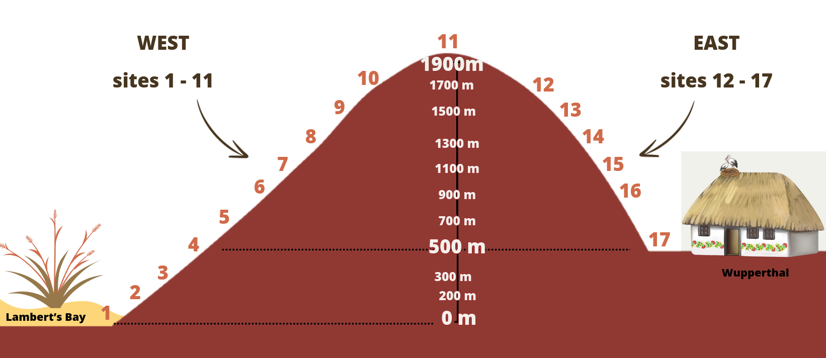
Figure B Diagram representing the study transect.
Pitfall traps were used to sample epigaeic insects across the transect. At each of the 17 sites 4 areas were chosen as replicates, with each replicate being at least 300 metres away from any of the other replicates. At each of these replicates ten pitfall traps were buried in the soil in such a way that the rim of the pitfall trap was level with the ground. The present vegetation was not cleared away when placing the pitfall traps and disturbance of the surrounding areas was kept minimal. Each of the ten pitfall traps were placed in a grid made up of two rows containing five traps, with each trap being at least 10 metres away from any other trap (figure A). GPS coordinates were recorded for every trap for use with spatial analyses later. The traps were half-filled with a 99.9% propylene glycol solution and were left out for five nights before being collected. After collection, the traps were brought to the University of Cape Town where the entomofauna that were captured therein were sorted into different groups (e.g. Hymenoptera, Coleoptera, etc.) with regards to the different studies that were all utilising the same trap samples. This insect sampling was performed in every October and March starting from October 2022 and ending in March 2024. Out of all of these samples, with regards to this study concerning beetles, only the October 2022, March 2023, and October 2023 samples were used.
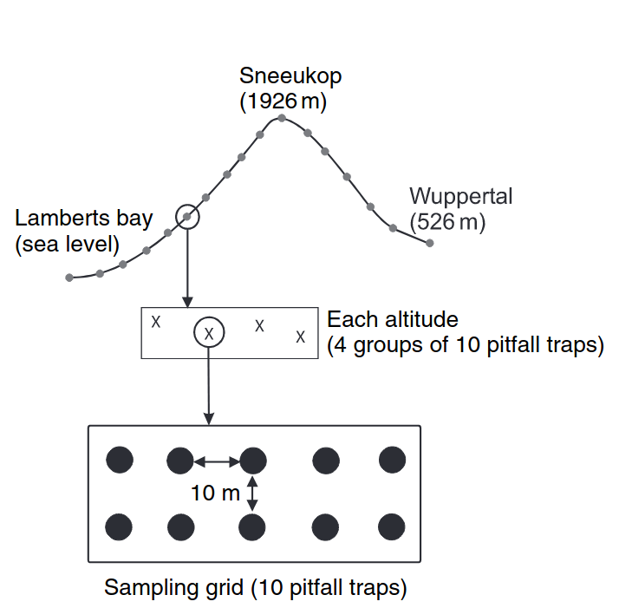
Figure A Pitfall configuration (Botes et al., 2006).

At each sampling replicate a 20cm³ soil sample was collected and were analysed in order to determine and quantify the proportional composition, mineral contents, ionic contents, pH, and conductivity. These samples were collected by first taking 20 sub-samples of soil randomly across the grid of traps, then these sub-samples were mixed together, and the final sample was taken from this mixture. After the soil samples were air-dried in the laboratory for 10 days, they were sent in to be analysed for the mentioned characteristics by BemLab (Pty Ltd.), Strand, South Africa.
Vegetation was sampled in two different ways at each trap in order to determine both horizontal and vertical distribution of the vegetation. The ground cover of vegetation distribution was determined by placing a 1-m² quadrat down with the pitfall roughly at the centre of the square. Following that, the percentage of the ground that was covered by the four classifications of leaf litter, live vegetation, exposed rock, and bare ground were estimated. After estimating the ground cover, a 1.5 metre long rod was placed at each corner of the quadrat. This rod was marked at 25 cm increments and the number of times vegetation made contact with the rod within each height interval was recorded. These counts of contact were used to determine foliage height profiles surrounding each trap.
In the laboratory, each pitfall trap was sorted through in order to identify the specimens. The identifications were performed through assigning the observed beetles to morphospecies (do I need a reference for morphospecies assignment rationale?). Each beetle was either pinned or mounted depending on its size, and they were then labelled and grouped by sample. The beetles were then taken to the Ditsong museum in Pretoria where they were taxonomically identified as far as possible. Only the beetles belonging to the Tenebrionidae, Carabidae, and Cicindelidae families were identified further than family level and used for all future analyses. These are the same three families that were analysed in the historical study involving this transect, and are therefore apt for comparisons (Botes, Mcgeoch and Chown, 2007). Three key beetle species—the carabid Anthia decemguttata (previously Thermophilum decemguttatum), and the tenebrionids Stenocara dentata, and Zophosis gracilicornis—were determined to be the three most abundant and widespread beetle species present across the transect in the current and historical studies. These three species in particular were used for historical comparisons, and for the October 2023 sample these were the only beetle species identified.

Environmental data and climate modelling
The soil temperatures across the transects were measured hourly across various time periods over the 20-year duration of this study using iButton sensors. However these sensors were prone to periodic faults leading to gaps in the microclimate data that were recorded. In addition to these acute faults, the temperature observations were halted for a protracted duration from late 2020 to 2022. Therefore, a mechanistic model was utilised in order to model the microclimate temperatures present within these samples without any gaps.
The “micropoint” model was used to model the ground-level soil temperatures present within the sampling area (Maclean, 2025). This mechanistic model required the input of the meteorological data of the locations to be modelled, as well as defining parameters that correspond to the vegetation, soil, and ground in those areas.
Spatial meteorological data were obtained using the MCERA5 package in R (Klinges et al., 2022), which is based on the ERA5 global climate reanalysis (Hersbach et al., 2020). Using the GPS co-ordinates of each replicate at every altitudinal site across the transect, hourly observations ranging from 2002 to 2024 were extracted for every single sampling replicate. The climate variables of air temperature, relative humidity, atmospheric pressure, shortwave radiation, longwave radiation, diffuse radiation, wind speed, wind direction, and precipitation were used in order to run the microclimate model (Maclean, 2025).
Soil was analysed at each sampling site for their proportional composition of silt, clay, sand, and stone. These compositional measurements were used to group the soil at each site into different categories. After categorising the soil from each site, these classifications were utilised to apply the corresponding pre-set soil parameters for model creation provided by the micropoint package. The parameters necessary for the model were ground reflectance, ground emissivity, soil bulk density, volumetric mineral fraction of soil, volumetric quartz fraction of soil, mass fraction of clay, a Shape parameter for Campbell soil moisture models, matric potential of soil, volumetric water content of soil at saturation, residual water content of soil, a shape parameter of the van Genuchten model, pore size distribution parameter for the soil, and the saturated hydraulic conductivity of the soil (Maclean, 2025). Other required ground parameters of slope and aspect were determined using the NASA SRTM digital elevation model (NASA JPL, 2013).
The vegetation parameters required for the microclimate model were determined using the average vegetation cover and vegetation height that were measured at each pitfall trap, averaged across replicates. These measurements were utilised to generate the required parameters of canopy height, plant area index, leaf inclination angle, canopy clumping, leaf reluctance of shortwave radiation, leaf transmittance of shortwave radiation, the diameter of leaves averaged over both the length and width of leaves, emissivity of vegetation, maximum stomatal conductance, and stomatal sensitivity (Maclean, 2025).
Using all of the required data and generated parameters, the hourly microclimate temperatures at both the soil level and 0.5cm above the ground were calculated using the micropoint model. These modelled temperatures were compared graphically to the empirical temperature observations of both the iButton sensors as well as the meteorological temperature observations. These comparisons showed that the temperatures were matching overall and therefore were sound replacements for the empirical temperature observations and the missing gaps of temperature monitoring contained therein.
The meteorological data were also utilised to extract the hourly precipitation over time per replicate along with the temperature modelling. All of these data were extracted and analysed using R and the “MCERA5” package (Klinges et al., 2022).
Utilising the CapeNature database, a list of historical fires that had occurred within the bounds of the study area were compiled. The extent of each fire and its date were stored using spatial polygons through the “sf” package in R (Pebesma and Bivand, 2023). The fires were were attributed to each pitfall trap using the GPS co-ordinates of the trap. Through cross-referencing the site co-ordinates and the extent of the polygons, a map and database was created which showed the list of all of the fires a particular site had experienced in recorded history, as well as the most recent fire, and consequently the years since the last fire. These fire data were used in conjunction with the other environmental data in order to provide a further explanatory variable to explain the environmental changes that were observed.

Data analyses
All data analyses, except for the calculation of slope and aspect based on GPS co-ordinates, were performed in R. The beetle data was stored in a species abundance for each of the species pertaining to the families of interest that were identified in the contemporary samples. For the October 2022 and March 2023 samples, all of the beetles were compared to each other visually using bar charts and nMDS plots. The abundance and species richness between the two seasons were also compared quantitatively, across the entire transect and on a site-by-site basis. The three key species were used to compare the contemporary beetle samples (October 2022 & 2023, March 2023) to the historical beetle samples (October 2002 & 2003).
Redundancy analysis (RDA) was used to examine the relationships between the beetle sampling and assemblage structure with the environmental variables. RDA was performed to compare the historical beetle data, the modern seasonal assemblage, as well as the October 2022 sampling season by itself. For the modern samples where all of the species from the three families of interest were identified, both the abundances, and the presence-absence data of the beetles were analysed with RDA.
The results of the significant variables obtained from the RDA, as well as prior known explanatory factors that affect beetle abundance and diversity, were used to construct generalised linear models (GLMs) in order to quantify the effects that these various factors may have on the beetle assemblages. Specifically, due to the sampling being repeated on the same locations across a temporal gradient, generalised linear mixed models (GLMMs) were used (Hadfield, 2010).
Whether or not beetle species were shifting in their altitudinal range were analysed. The data were compared both using all of the species compared between the contemporary beetle samples, as well as the three key species compared between the contemporary samples and the historical samples. The Jaccardian similarities of the different sites compared between the modern and historical sampling efforts were computed to show the differences in beetle assemblage composition within each site across the 20-year gap between sampling.
The environmental variables of vegetation ground cover, vegetation height, and soil attributes, were also compared across the various temporal categories corresponding to the different beetle sampling events. They were compared to determine whether the environment surrounding the sampling sites had changed significantly between the different sampling efforts. The changes in environmental conditions combined with the effects that those variables have on beetle assemblage responses as shown in the GLMs will be used to determine whether or not those changes could be driving reasons behind the population changes. The fire data were used to determine whether or not there was a relationship between the recorded fire and the environmental variables present within the sampling sites.
The time-series data for the modelled microclimate temperatures (air and ground) as well as the precipitation observations were analysed using Seasonal-Trend Decomposition with Regression (STR) (Dokumentov and Hyndman, 2022). The STR models separate the changes in the response variable into parts of cycling seasonality (daily, yearly, etc.), and trend over time. This allows for baseline trends in the time-series data to be extracted and determine if there are any potential observable directional changes over time. After determining any potential trends per site, descriptive representatives of the relevant variables can also be incorporated in the interpretation of assemblage changes over time and also utilised in any models.

Results

Environmental variables analysis
The proportional composition of ground cover was observed to have changed significantly between the historical and contemporary sampling events. There has been a general trend where the proportion of the bare ground and exposed rock has decreased, while the proportion of plant litter and live vegetation cover have all proportionally increased (figure Q).
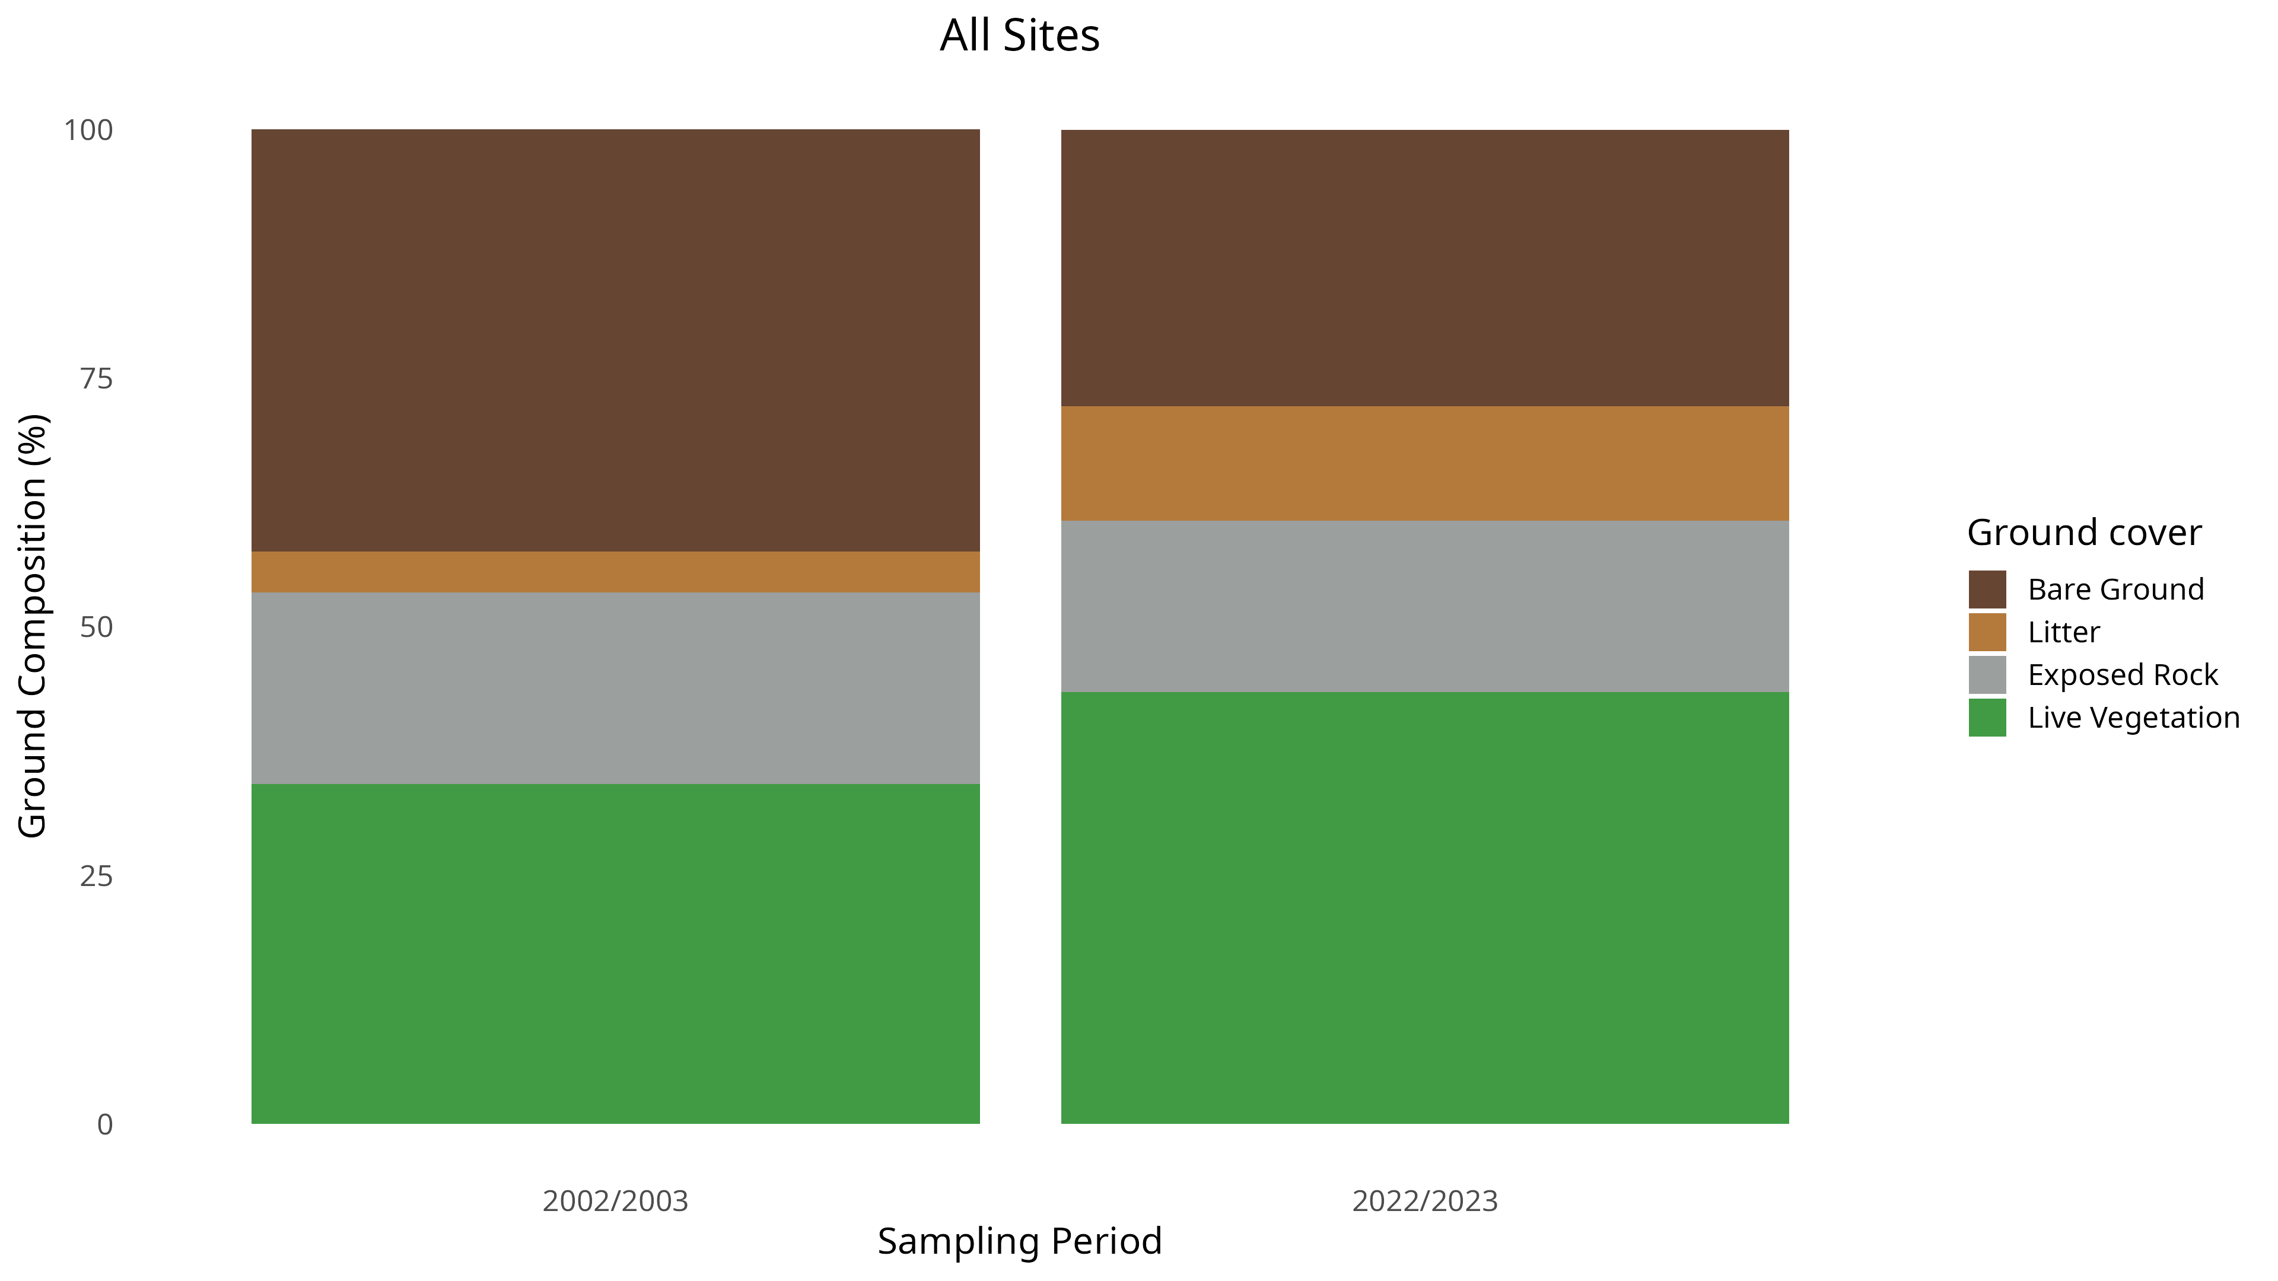
Figure Q Mean proportional composition of the ground cover present across the entire transect, compared between the two different sampling periods.

When these data were analysed with the GLMMs, all of these changes in proportional composition were determined to be significant. Across the time that has passed between the two sampling periods, bare ground has decreased by 35% (43% in 2002–2003, 28% in 2022–2023), plant litter has increased by 183% (4.1% in 2002–2003, 12% in 2022–2023), exposed rock has decreased by 10% (19% in 2002–2003, 17% in 2022–2023), and live vegetation cover has increased by 27% (34% in 2002–2003, 43% in 2022–2023), across the entire transect (table B).
Vegetation height has changed significantly over time across the entire transect, with both the mean vertical complexity of vegetation and the mean maximum vegetation height increasing in the time between the sampling periods (figure R). When analysed with GLMMs these changes were determined to be significant, with mean vertical complexity of vegetation increasing by 28% (8.41 in 2002–2003, 10.7 in 2022–2023), and mean maximum vegetation height increasing by 54% (29 cm in 2002–2003, 58 cm in 2022–2023) (table C). The changes in these vegetation height characteristics were site-specific, and further GLMM analysis including site as an explanatory variable showed in which sites there were significant changes. In every site where there was a significant change, the direction was increasing over time as suggested when considering the transect as a whole (Appendix S8).
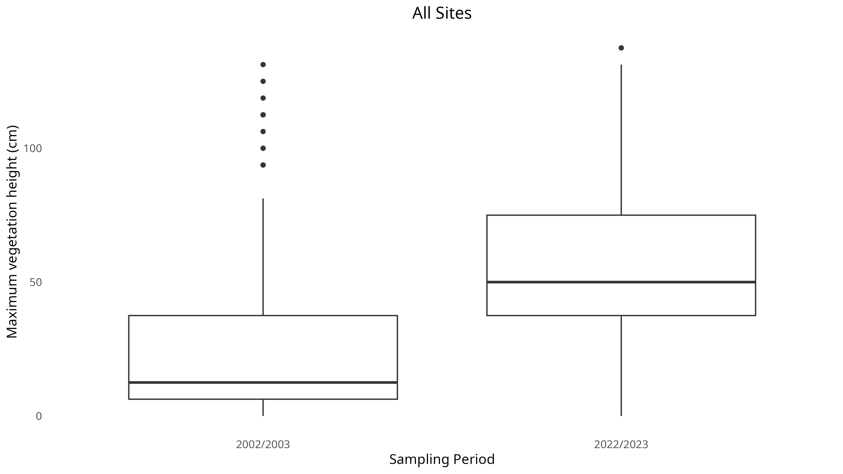
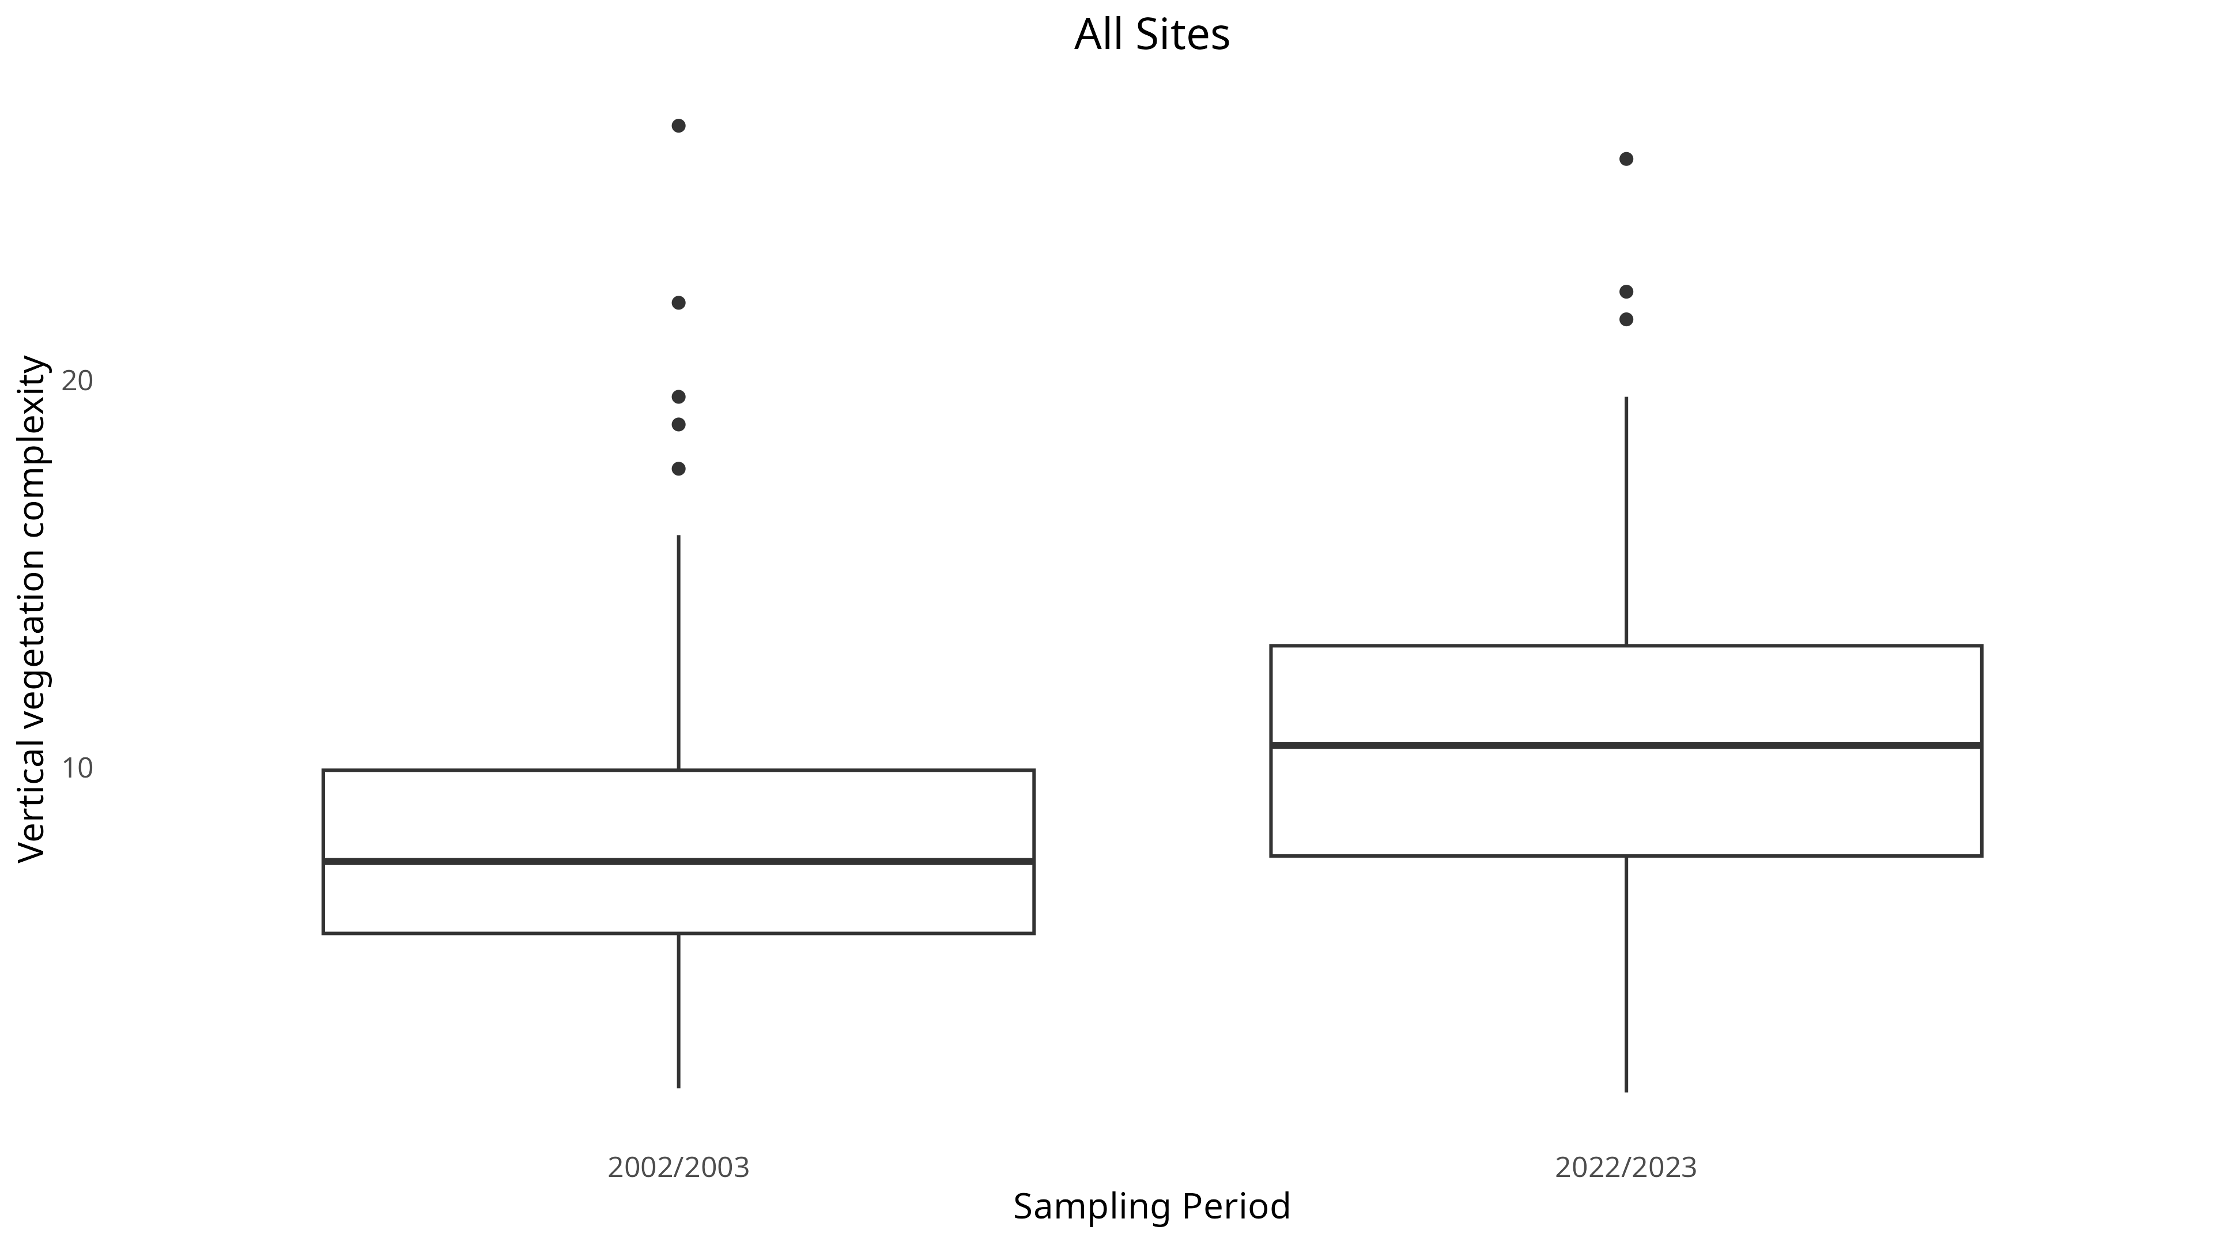
Figure R The (a) vertical vegetation complexity, and (b) mean maximum vegetation height, across the entire transect compared between the different sampling periods.

The fire data was used to show the time since the last fire had occurred in the respective replicate for the study.

Temperature and precipitation seasonal decomposition
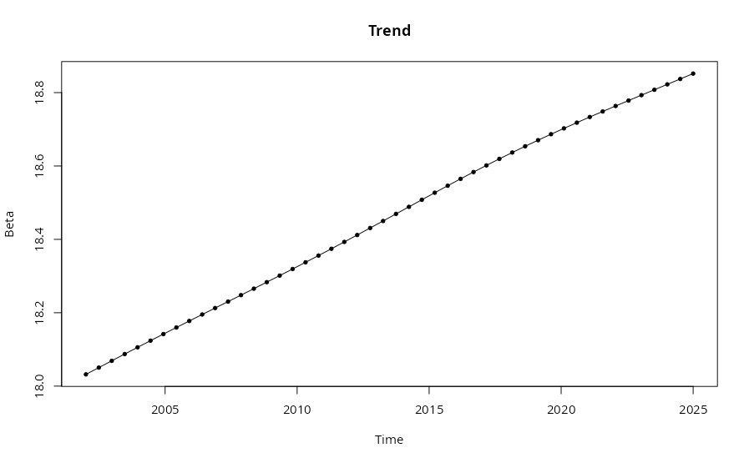
The STR models generated for each individual site were examined to see if their trend components contained any noticeable change over time. Some of the sites exhibited a monotonic temperature trend over time, for example the site at 700 metre altitude on the western slope (figure N). This temperature trend was quantified at an estimated 0.85°C increase in the baseline ground temperature, and a 0.45°C increase in the baseline air temperature over the 23 year period for which temperature was modelled. A total of 8 sites across the transect showed a significant change over time in the baseline temperature present (Appendix S4): "500m(W)", "700m(W)", "1100m(W)", "1300m(W)", "1700m(E)", "1300m(E)", "900m(E)", and "500m(E)".
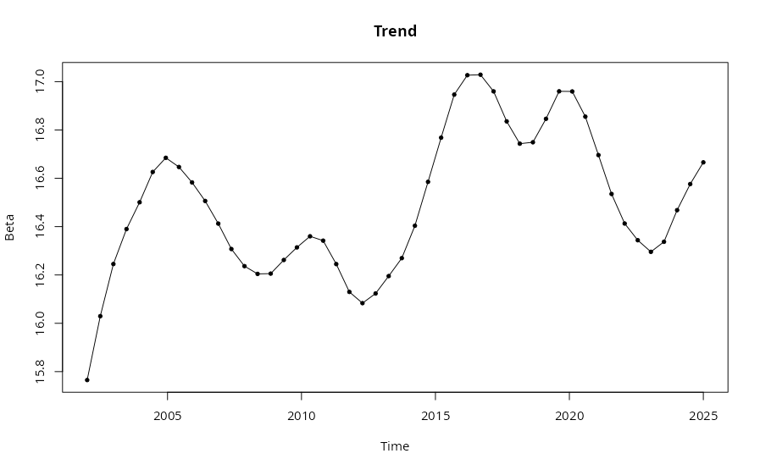
Figure N Temperature trend over time for (a) ground temperature, and (b) air temperature for the site at 700m altitude on the western slope.

There was a consistent change over time, even in sites where the baseline temperature did not display a trend, of the cyclical seasonality of air temperature becoming increasingly more extreme in terms of both local temperature minima and maxima (figure O). This general observation both across the entire transect and within each individual site, with varying degrees of increased extremity in the seasonality (Appendix S5).
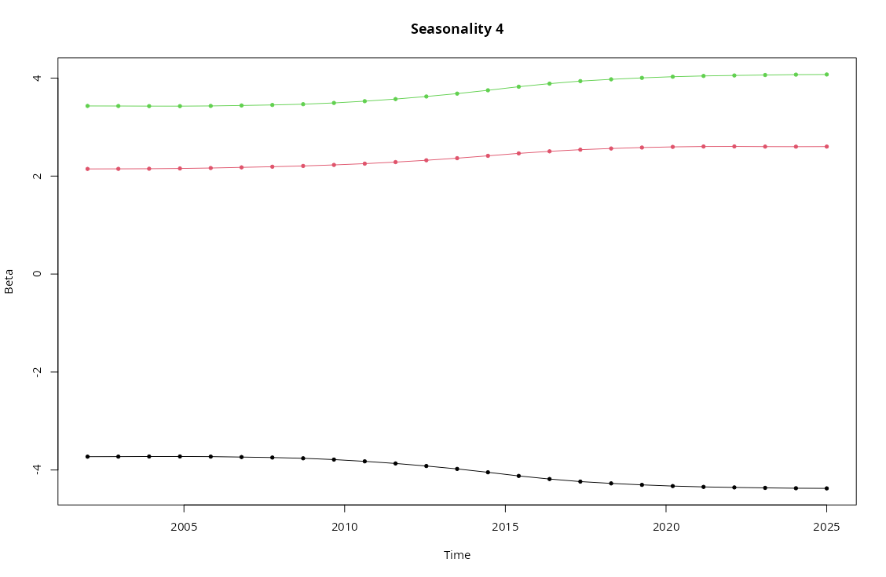
Figure O Seasonality of air temperature for the entire transect, showing the change over years of the coldest time of the day (bottom black line), hottest time of the day (top green line), and the middle of the day (middle red line).

The seasonal decomposition plots for precipitation did not show any monotonic changes in the precipitation trend over time for any particular sites. However there was an overall cyclical trend change where there have been multiple peaks and troughs of baseline precipitation over the years (figure Pa). Most of the variation in precipitation is observed in the first five sites of the transect ("0m(W)", "200m(W)", "300m(W)", "500m(W)", "700m(W)"), with the remaining twelve sites having an almost identical precipitation history across the history of the study (Appendix S6). Despite there not being a monotonic change in the baseline trend, there was a consistent change in the cyclical seasonality of precipitation, exhibiting steady increases in both the minimum and maximum precipitation present within the cycle over the years (figure Pb). The extent of the increasing precipitation seasonality differed by altitudinal site, with some showing a constriction in the seasonality range, however all sites eventually displayed increasing precipitation within their seasonal cycles (Appendix S7).
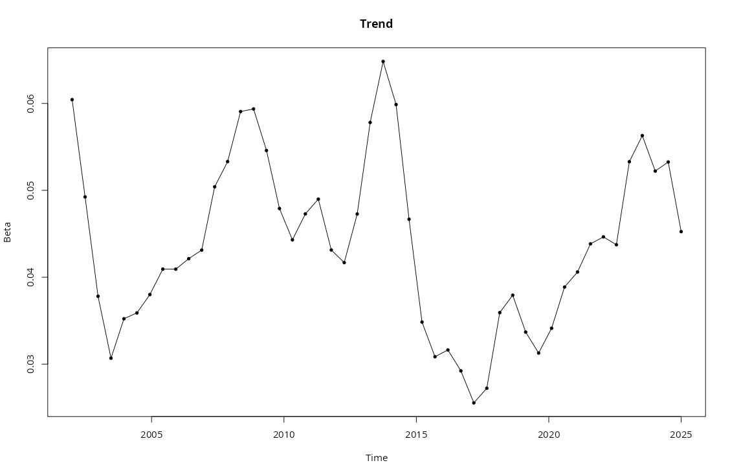
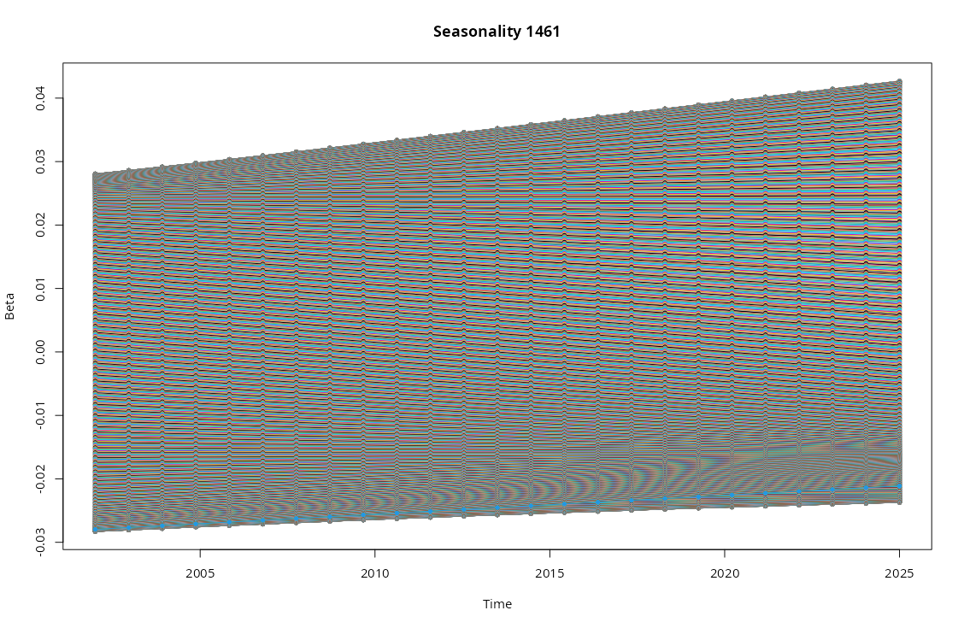
Figure P Trend in (a) baseline precipitation, and (b) seasonal precipitation range over time, for the study transect over time.

Contemporary beetle assemblage and seasonal comparison
In the modern samples that were identified fully (October 2022 and March 2023), there were a total of 42 species collected from the three families that were being studied, with a total of 1633 individual beetles being present in the sample (1589 from October and 44 from March). 34 of the species belonged to the Tenebrionidae, 6 species belonged to Carabidae, and 2 belonged to Cicindelidae. All 42 of the identified species were present in the October sample, however only 5 of these species were present in the March sample (Appendix S1). The highest mean abundance was observed in the Ericaceous Fynbos, with the Succulent Karoo site having the second highest mean abundance, and the Proteoid and Restioid Fynbos sites having similar mean abundances to each other. The lowest mean abundance was observed in the Strandveld and Alpine Fynbos sites. The mean species richness was similar across all of the different vegetation types, with the Proteoid Fynbos sites having the highest richness (table F). For the March 2023 sample specifically, the highest richness and mean abundance were observed in the Succulent Karoo site (figure C).
There were no general trends for species richness and abundance across altitude. However some notable observations were the presence of a very distinct abundance peak situated within the “1100 m (W)” site (table E). Also one specific site, “1300 m (E)”, exhibits a very different assemblage structure and composition when compared to all other sites in the general slope trend across both sides of the transect. This site is very homogeneous and is dominated mostly by one single species (Cicindela lurida), with most of the population of this species being contained within that site. Resulting in a site with relatively high abundance compared to its diversity (figure D).
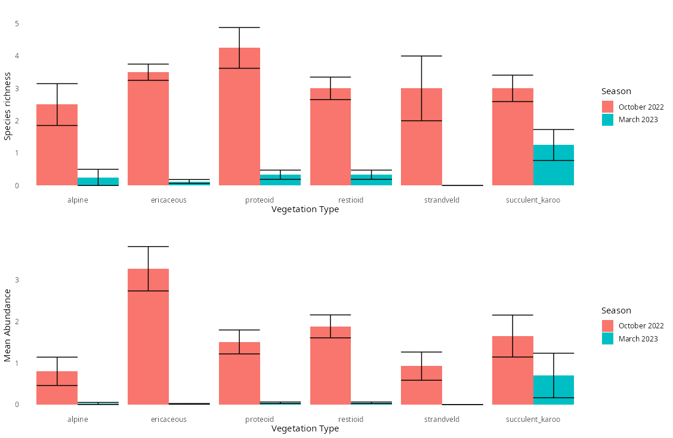
Figure C (a) Species richness, and (b) mean abundance across the different vegetation types present in the transect, separated by season.
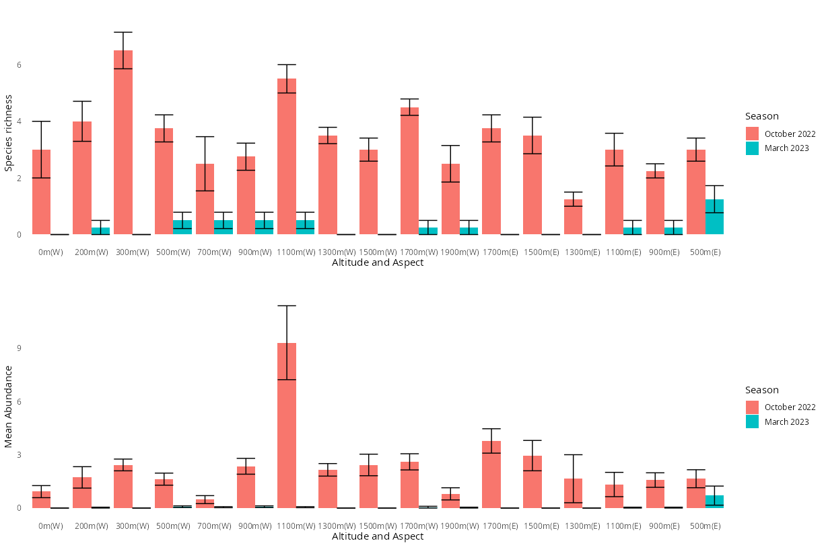
Figure D (a) Species richness, and (b) mean abundance across the altitudinal gradient of the transect, separated by season.

Some of the species shifted in their altitudinal range between seasons, with the range shifts differing between the two aspects of the transect. On the western slope four different species had an upwards contraction of their lower elevation limits, and two of these species also had a downwards contraction of their upper elevation limits (figure Ea). On the eastern slope, three species experienced a downwards contraction of their upper elevation limits, while one species experienced an upwards contraction of its lower elevation limits (figure Eb).
Comparing the abundance between the seasonal samples with an nMDS plot showed that aside from a few outliers, the two samples were still closely related to each other (figure Fa). The comparison of species presence-absence showed that while the October 2022 sample still had many observations that were similar, the different observations for March 2023 didn’t show any signs of significant grouping (figure Fb).
The nMDS plots comparing species abundance and presence between the different altitudinal sites showed that most of the altitudinal sites were similar to each other with only a few notable exceptions (figure G). Site 11 (the summit, 1900m), site 14 (1300m (E)), and site 1 (Lambert’s bay, 0m (W)) were all distinctly different from the general grouping shown by the other sites.
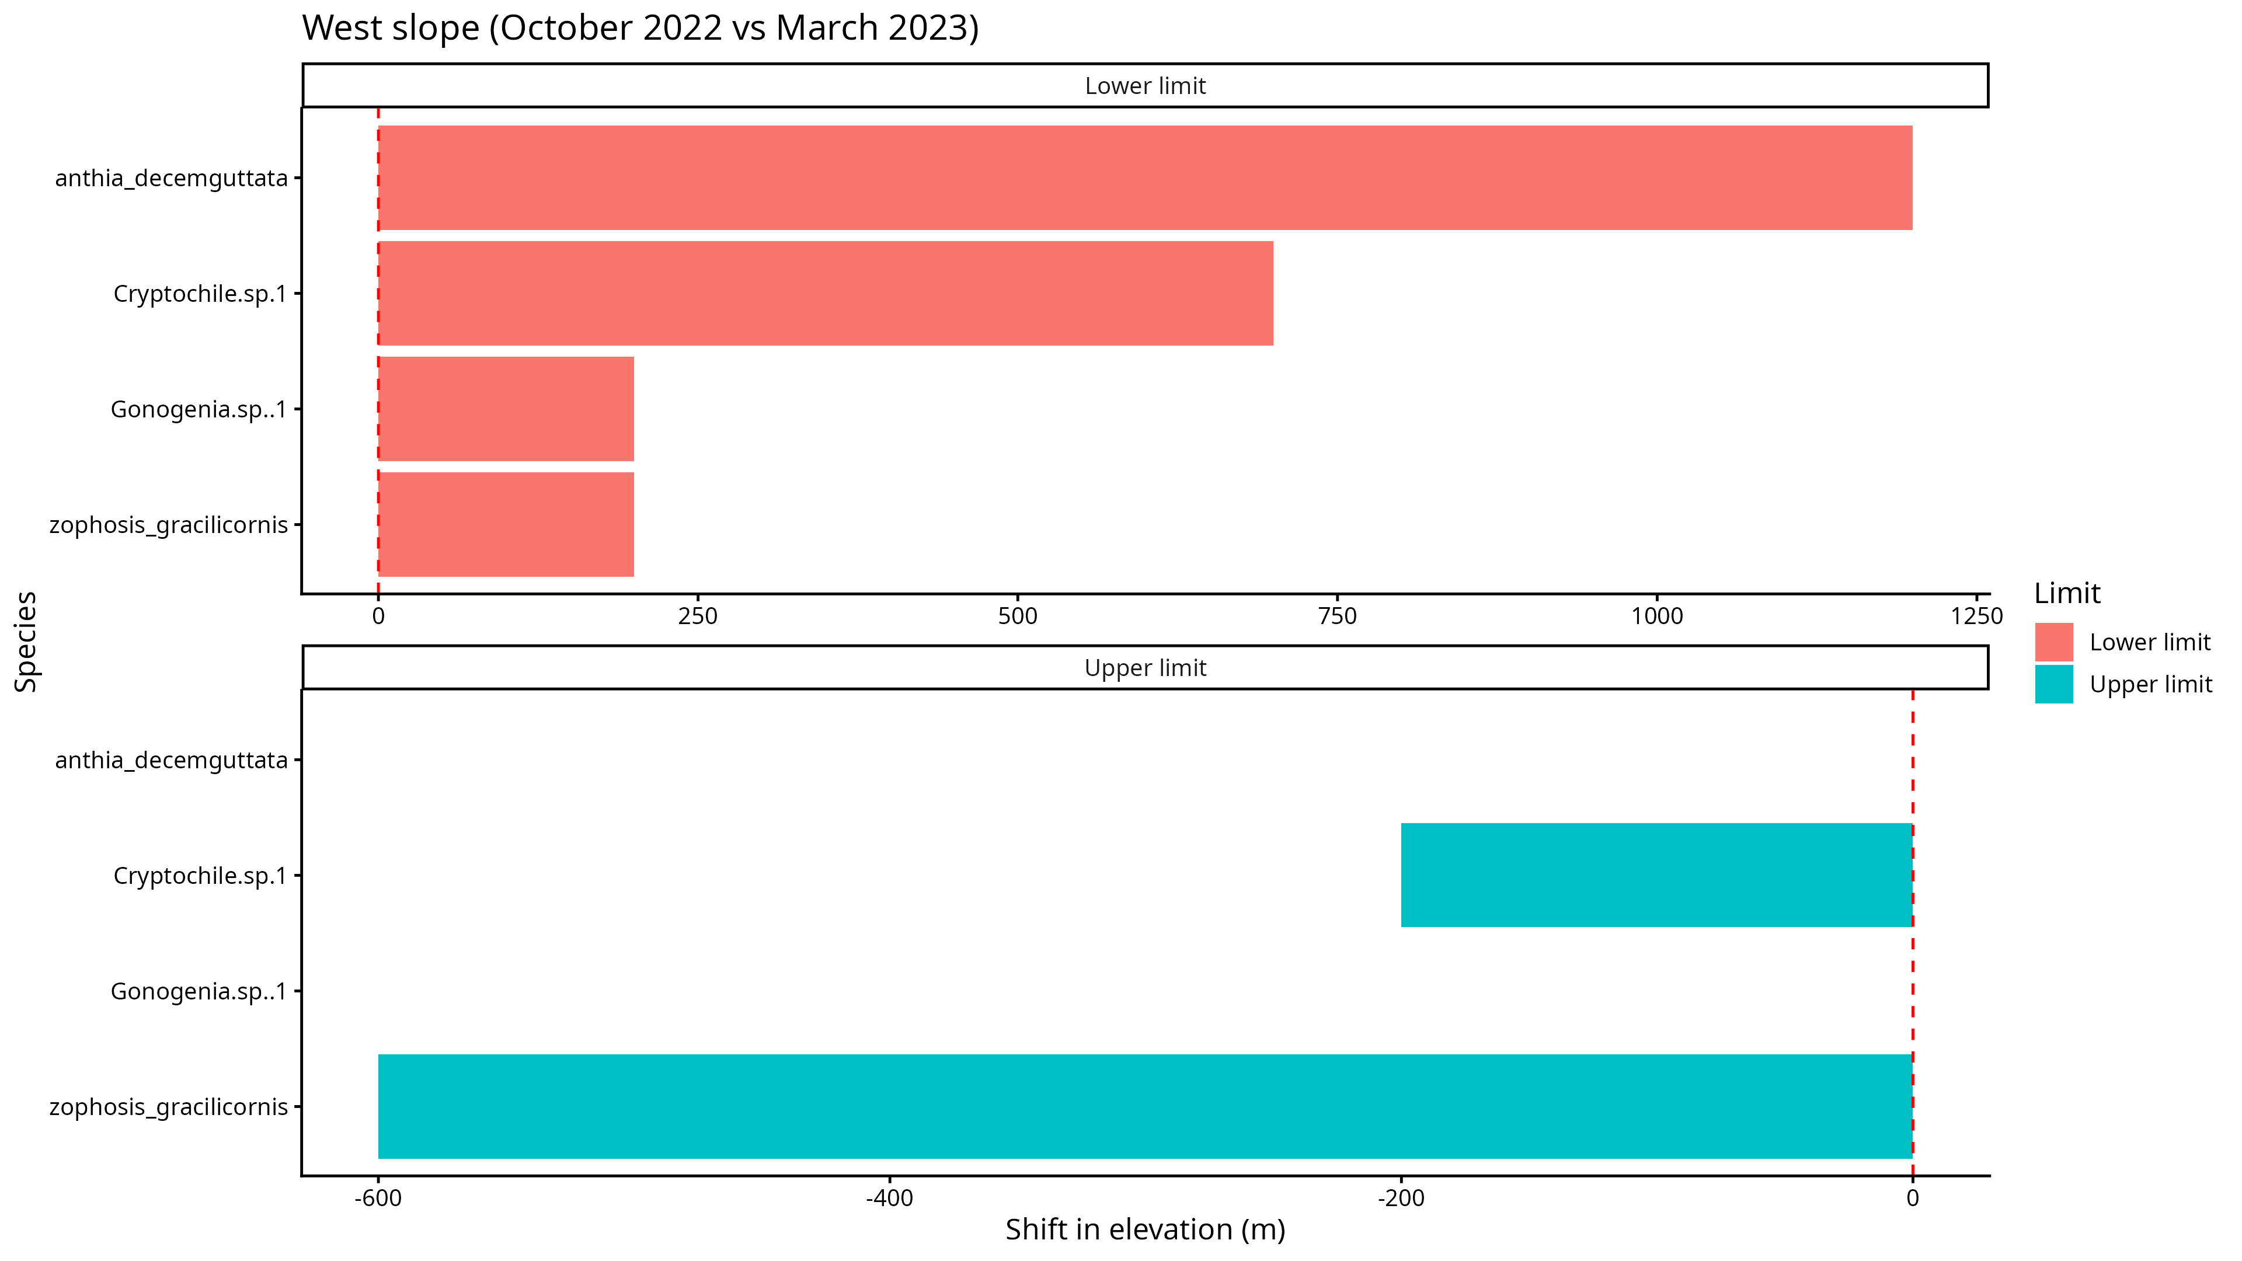
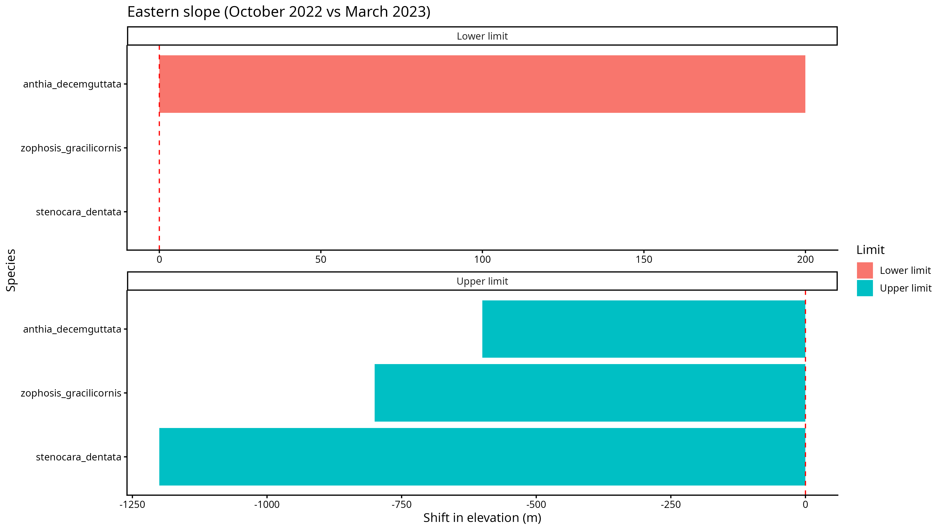
Figure E (a) Western slop, and (b) eastern slope altitudinal range limit shifts for relevant species between October 2022 and March 2023.

Comparing the species abundance and presence between the different categories of vegetation groups in the sites showed that the different subgroups of Mountain Fynbos were all more similar to each other than the other vegetation types. The Proteoid and Restioid sites were the most similar with the Ericaceous sites only differing slightly. The Succulent Karoo site was also similar to the different Fynbos groups but much more closely clustered than the Fynbos sites. The Alpine and Strandveld sites were both very dissimilar to each other and the other groups previously mentioned. The Alpine site was especially very varied within the site itself (Figure H).
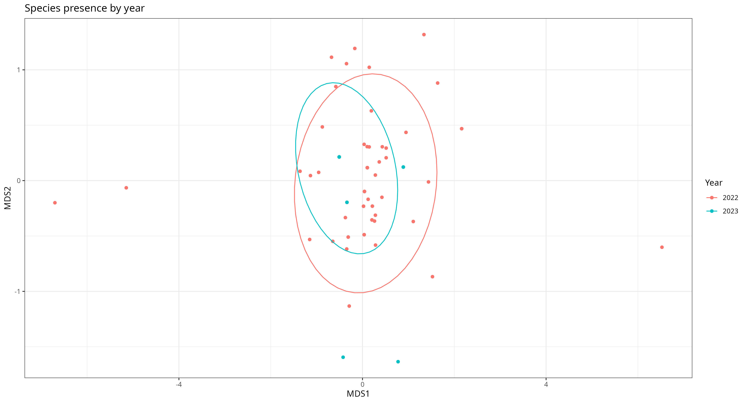
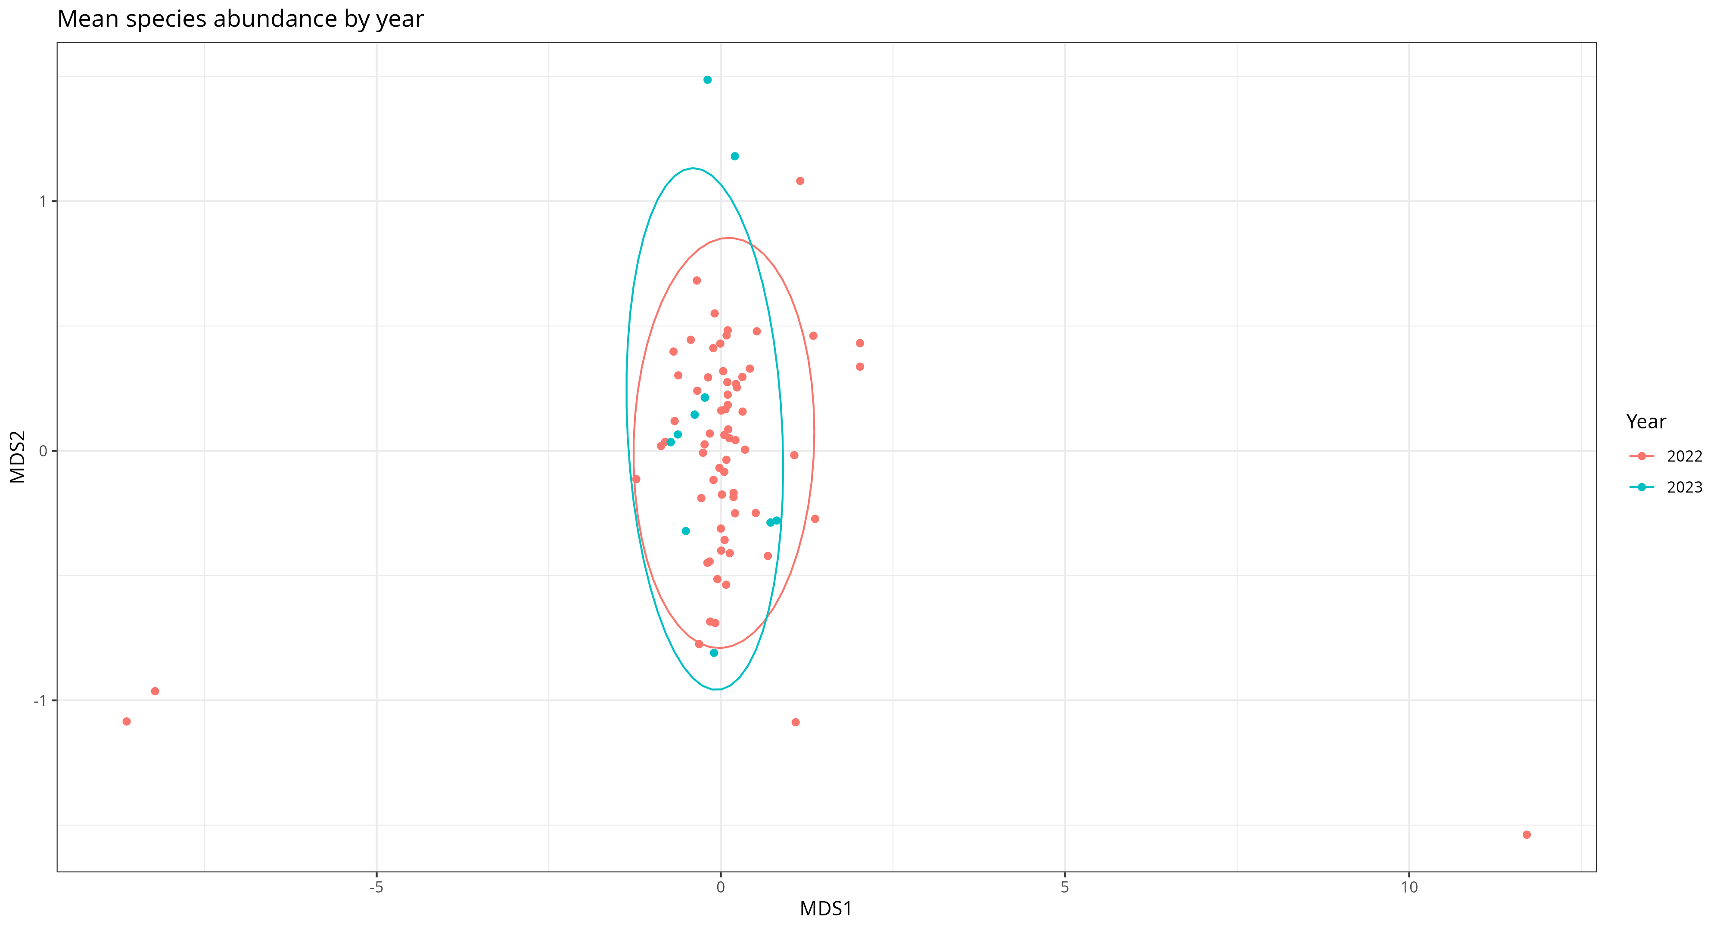
Figure F nMDS plot of (a) mean species abundance, and (b) species presence, compared between the two sampling seasons.
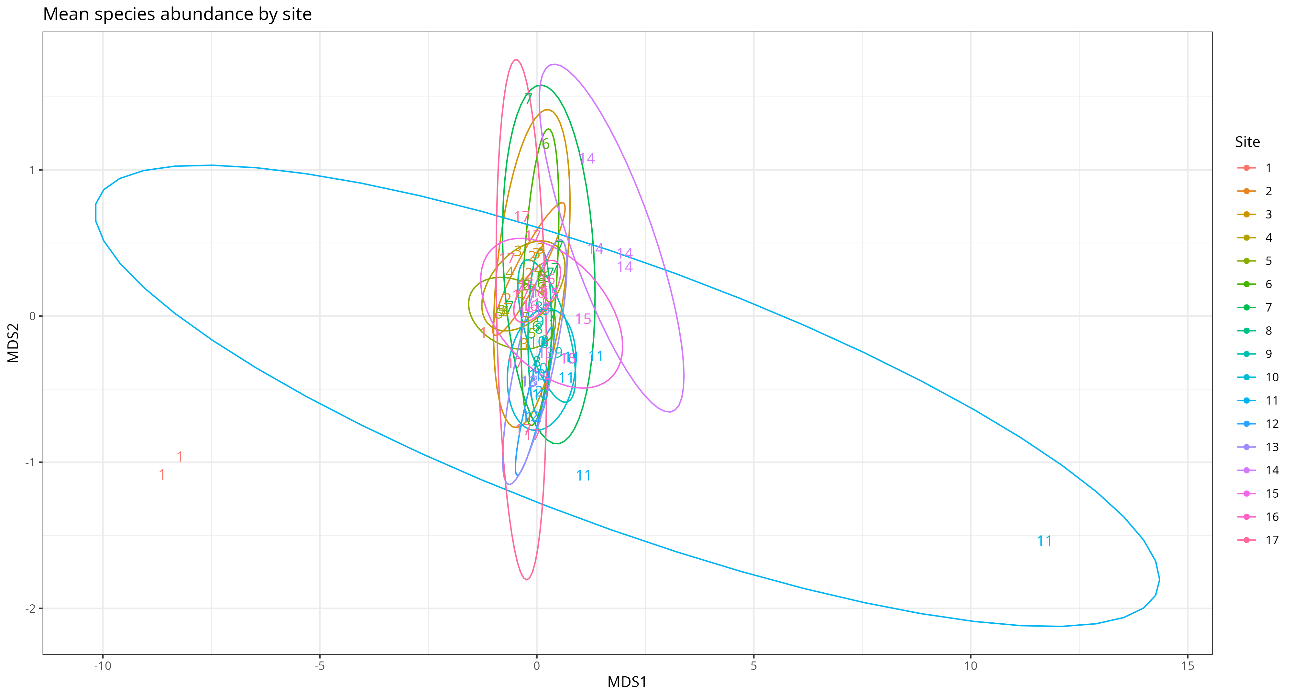
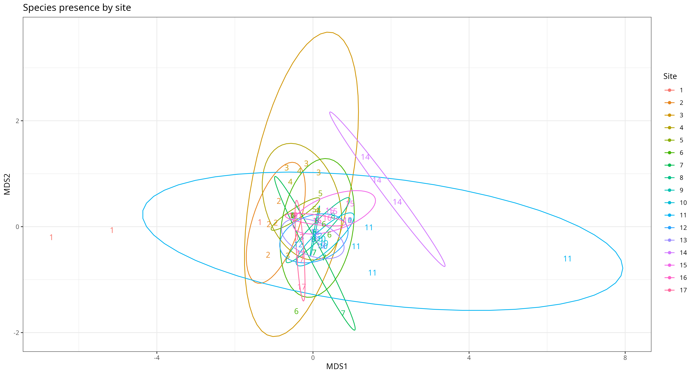
Figure G nMDS plot of (a) mean species abundance, and (b) species presence, compared between the different sites across the altitudinal gradient of the transect.
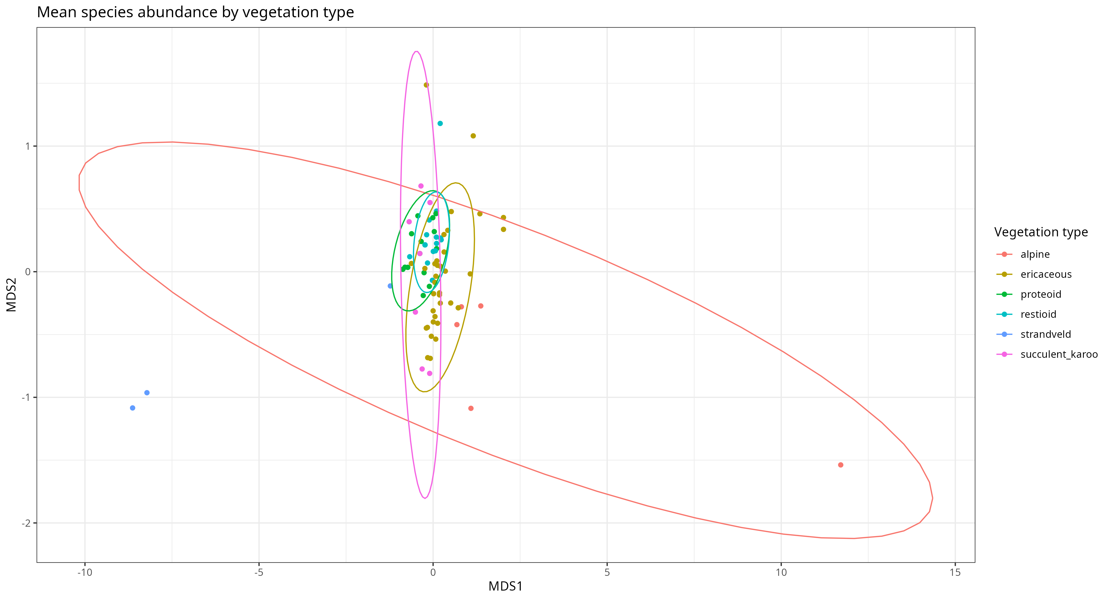
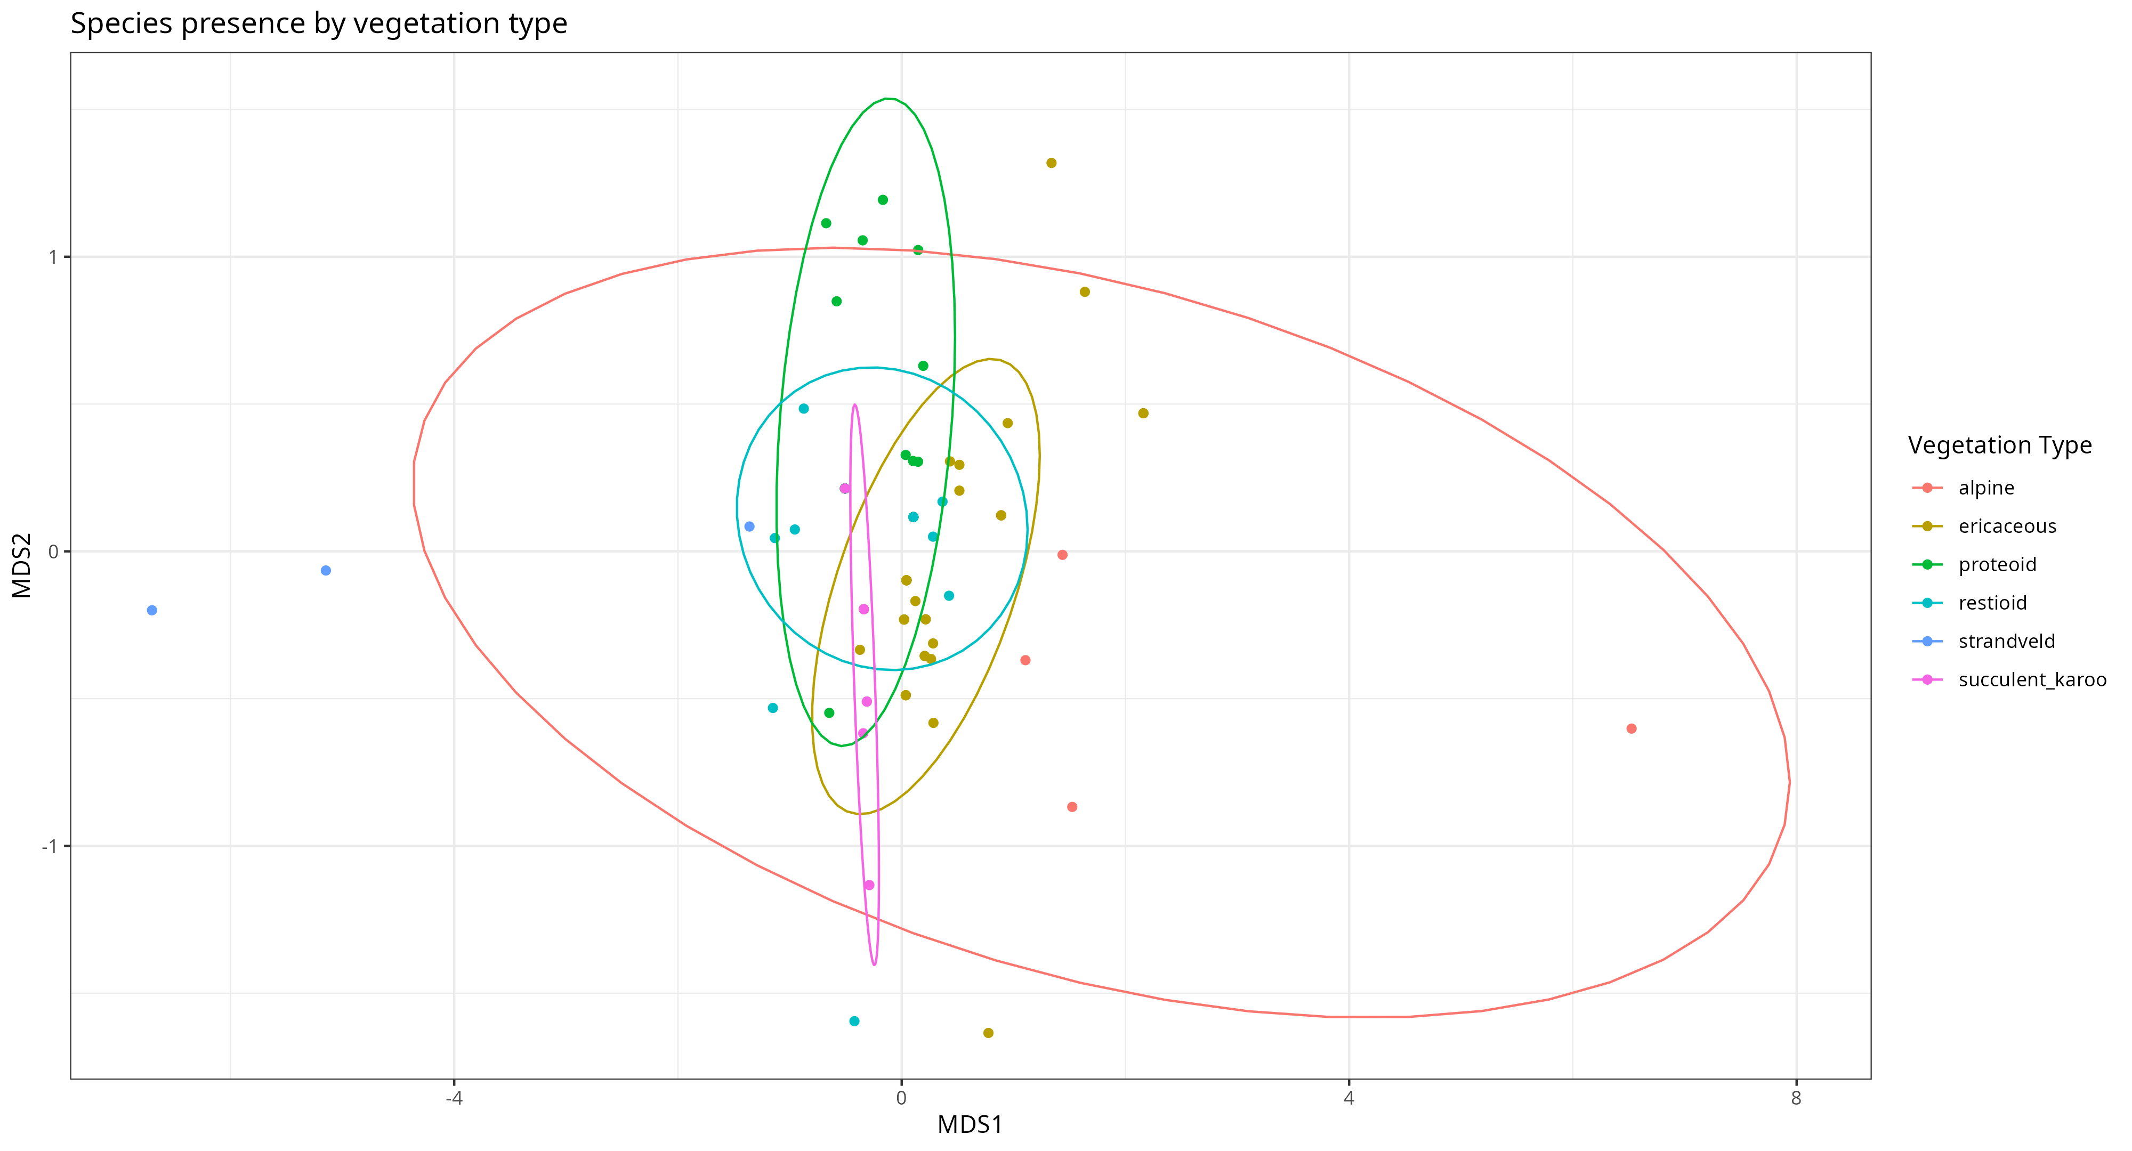
Figure H nMDS plot of (a) mean species abundance, and (b) species presence, compared between the two different vegetation types present across the sites of the transect.

Table F Mean species richness and abundance (± standard error) of all of the beetles identified from the October 2022 sample across the different vegetation types present within the transect.
Vegetation type | Abundance  (mean ± SE) | Species richness  (mean ± SE)
Alpine Fynbos | 8.25 ± 3.45 | 2.5 ± 0.645
Ericaceous Fynbos | 32.875 ± 5.36 | 3.5 ± 0.25
Proteoid Fynbos | 15.5 ± 2.85 | 4.25 ± 0.629
Restioid Fynbos | 19.25 ± 2.81 | 3 ± 0.348
Strandveld | 9.25 ± 3.4 | 3 ± 1
Succulent Karoo | 23.5 ± 8.86 | 3 ± 0.408

Table E Mean species richness and abundance (± standard error) of all of the beetles identified from the October 2022 sample across the elevational gradient.
Elevation (m a.s.l.) | Abundance  (mean ± SE) | Species richness  (mean ± SE)
Western slope
0 | 9.25 ± 3.4 | 3 ± 1
200 | 17.5 ± 5.98 | 4 ± 0.707
300 | 24.25 ± 3.3 | 6.5 ± 0.645
500 | 17 ± 3.39 | 3.75 ± 0.479
700 | 5.25 ± 2.32 | 2.5 ± 0.957
900 | 24.25 ± 4.77 | 2.75 ± 0.479
1100 | 93.5 ± 20.6 | 5.5 ± 0.5
1300 | 21.5 ± 3.52 | 3.5 ± 0.289
1500 | 24.25 ± 6.06 | 3 ± 0.408
1700 | 26.5 ± 4.19 | 4.5 ± 0.289
1900 | 8.25 ± 3.45 | 2.5 ± 0.645
Eastern slope
1700 | 37.75 ± 6.86 | 3.75 ± 0.479
1500 | 29.5 ± 8.53 | 3.5 ± 0.645
1300 | 16.5 ± 13.5 | 1.25 ± 0.25
1100 | 13.5 ± 6.81 | 3 ± 0.577
900 | 16 ± 3.94 | 2.25 ± 0.25
500 | 23.5 ± 8.86 | 3 ± 0.408

Historical beetle population comparisons
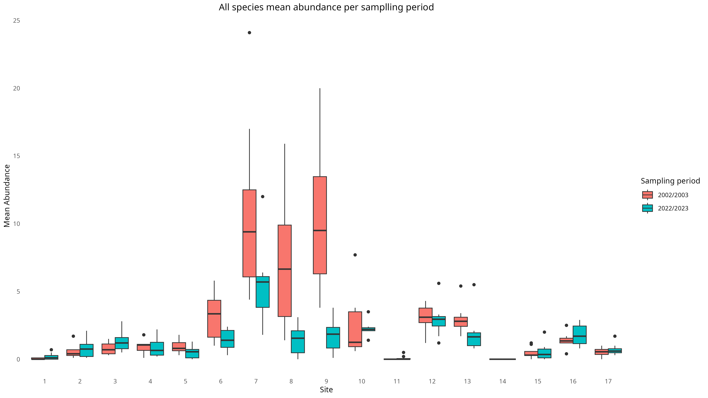
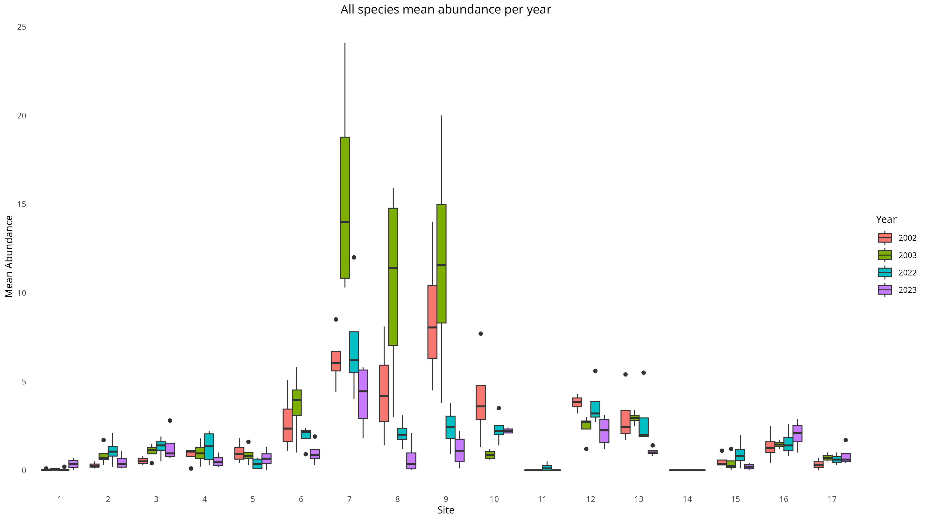
Figure I mean abundance of the three species separated by (a) the sampling period, and (b) the sampling year, across the sites of the altitudinal gradient.

When comparing the contemporary beetle samples (October 2022, October 2023) to the historical samples (October 2002, October 2003), due to how the beetle identifications were not directly comparable to each other as stated previously, only mean abundance of the three key species were utilised in the analyses. Comparing the box plots of abundance and altitudinal site separated by year, it can be observed that in the historical samples the abundance seems generally greater, especially in 2003 (figure I). Additionally, the peaks of abundance for the Anthia and Zophosis within the respective years, have shifted from being at around 1300-1700 m in altitude (on the western slope), to mostly converging at site 7 (1100 m (W)) (Appendix S2).
The nMDS plots of of mean abundance compared between the different sampling years shows that although there is some overlap between the observations from the years of the different sampling periods, there is a clear grouping of the historical samplings when compared to the contemporary ones (figure J). This dissimilarity is not as present when comparing the presences of the species between the years, with a more uniform distribution present in the observations (figure K). These plots therefore indicate that although the abundance of these three species has changed to some degree over time, the distribution of the populations over the transect has not changed as much. Individual sites have different specific relationships with both abundance and presence than when considering the transect as a whole (Appendix S3).
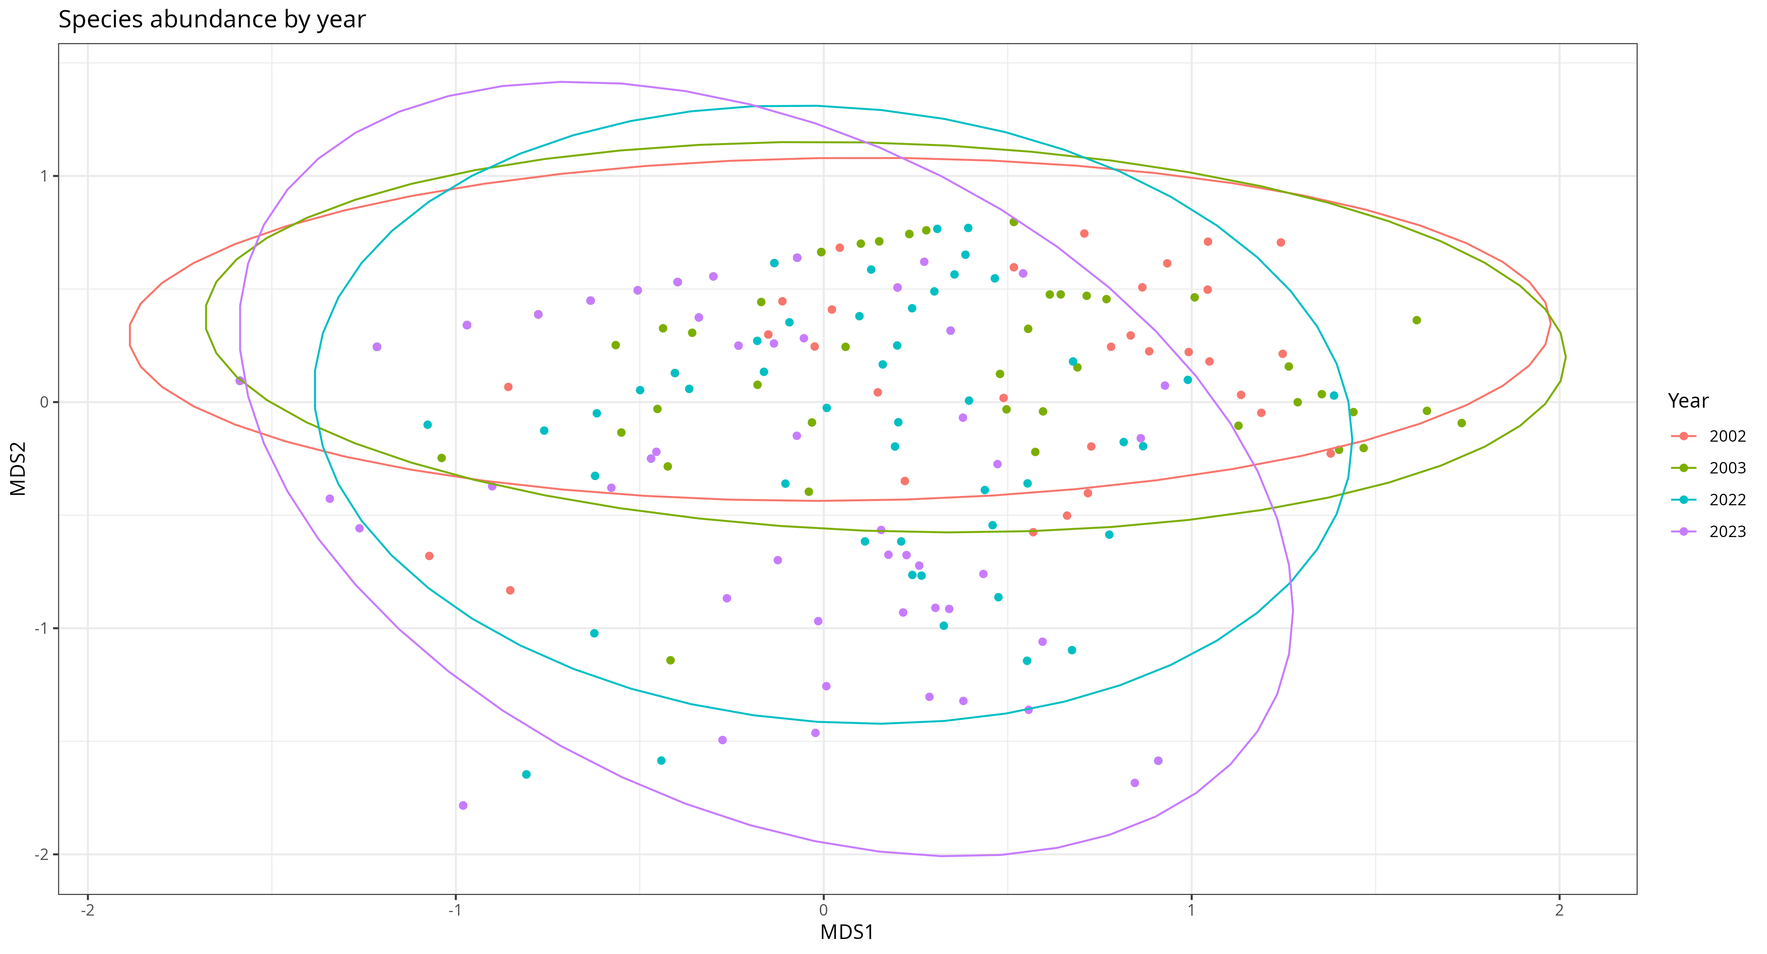
Figure J Abundance of the three key species separated by sampling year
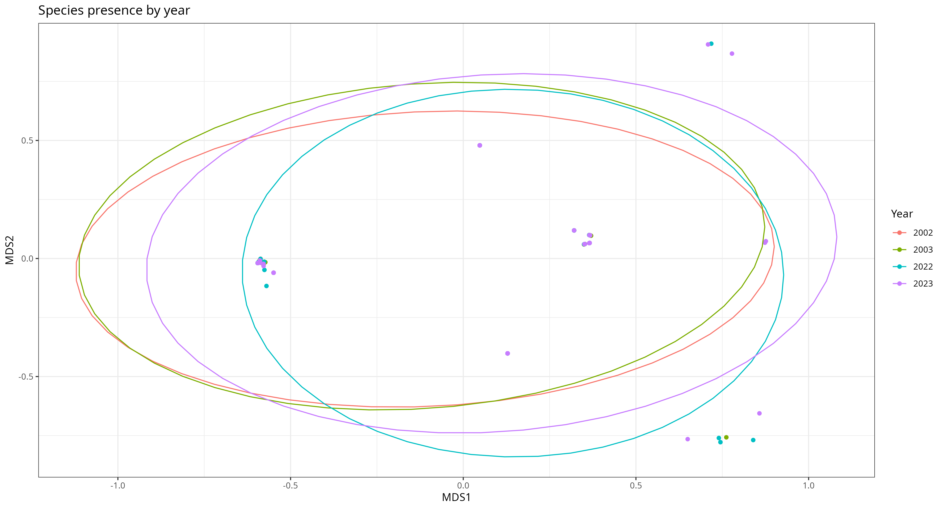
Figure K Presence of the three key species separated by sampling year

A heatmap of the Jaccardian similarities between the different altitudinal sites shows which of the sites are the most similar to each other (figure L). It shows that different “blocks” of sites are similar to each other both due to matching vegetation types, as well as relative altitudinal placement across the gradient of the transect, even on opposing aspects. The two sites at the peak and at 1300 m on the eastern aspect had no recorded observations of any of the key species in every year except for one, and due to multiple rows of zeroes, had to be excluded from the heatmap.
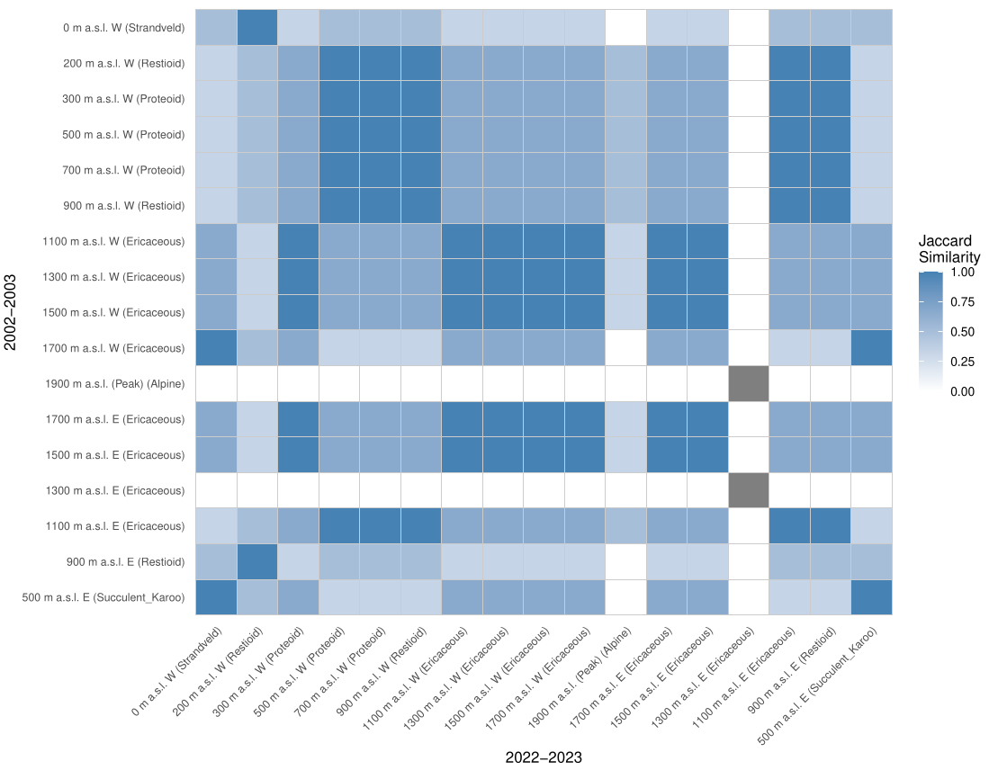
Figure L Heatmap of Jaccardian similarities between different altitudinal sites.

Dendograms of the different sampling periods show how the different sites are related to each other with regards to beetle abundance (figure M). From the clustering of the dendogram branches it can be observed that in both sampling periods, for the most part the sites are separated into two main groups. The first group consisting of the Proteoid and Restioid vegetation sites, and the second group consisting of the mid-high altitude Ericaceous sites. The site at 1300 m on the eastern slope is different from every single other site, along with the peak of the transect.
The GLMMs were used to quantify the difference in abundance between the years and sampling periods. When all of the species and sites are considered together, the only year that shows a significant difference in abundance was 2023 (77% decline in abundance, p: <0.001) (table A). When comparing the entire sampling periods against each other, there is a significant 19% decline in abundance (p: <0.001) between all of species in the historical beetle samples and all of the species in the contemporary beetle samples.

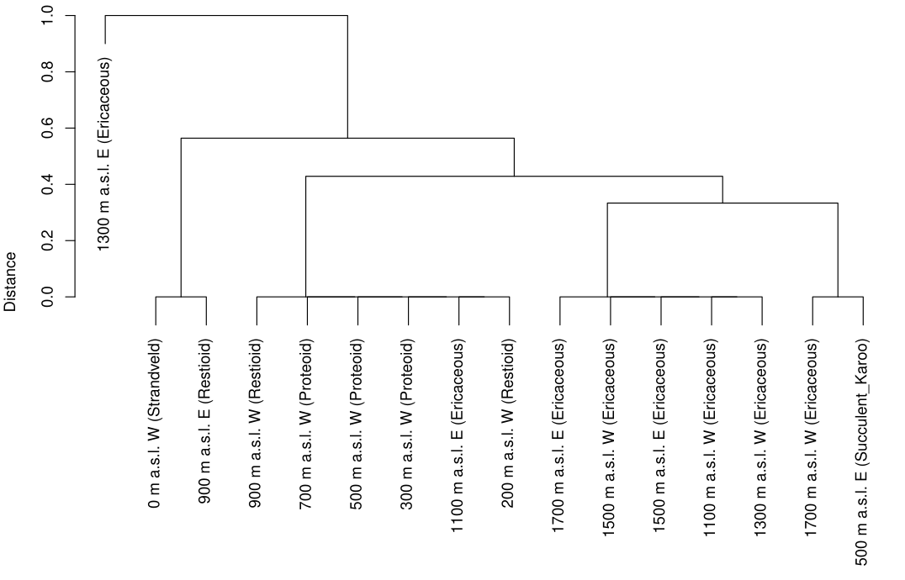
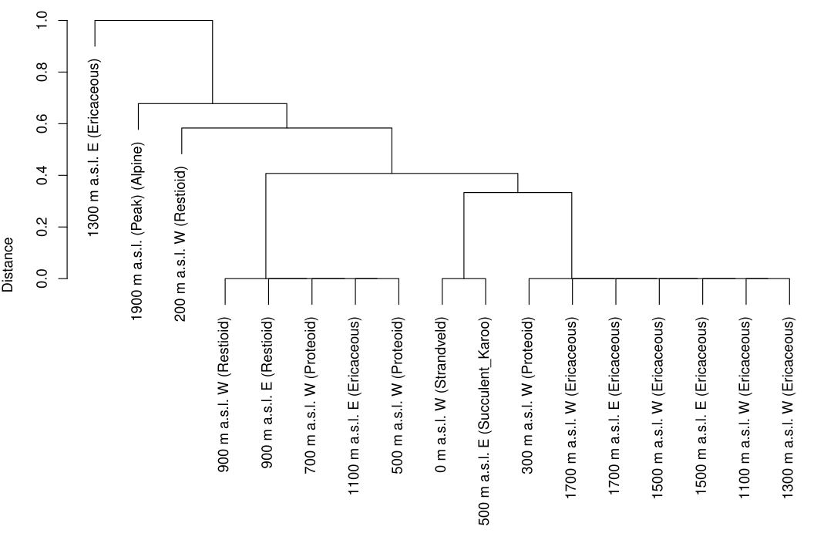
Figure M Dendogram showing the hierarchical clustering of the different sites across the transect in both (a) the 2002-2003 sampling period, and (b) the 2022-2023 sampling period.

When analysing the each individual species by itself, the Stenocara did not show significant changes in abundance between any year or sampling period. The Anthia showed a significant increase in one of the contemporary years compared to the baseline data. The Zophosis showed a significant loss decrease in abundance across all of the contemporary years compared to the baseline data (Appendix S4).

Table D Mean abundance (± standard error) of Anthia decemguttata, Stenocara dentata, and Zophosis gracilicornis, at each elevation in October across the four years of the historical comparisons.
Elevation (m a.s.l.) | 2002  (mean ± SE) | 2003  (mean ± SE) | 2022  (mean ± SE) | 2023  (mean ± SE)
Western slope
0 | 0.25 ± 0.25 | 0.5 ± 0.289 | 0.5 ± 0.5 | 3.5 ± 1.55
200 | 2.75 ± 0.854 | 8.5 ± 2.99 | 11 ± 3.89 | 4.75 ± 2.25
300 | 5.25 ± 1.11 | 10.5 ± 2.33 | 13 ± 2.94 | 13.5 ± 4.91
500 | 8.25 ± 2.43 | 9.75 ± 3.33 | 13 ± 4.71 | 5.25 ± 1.8
700 | 10 ± 3.03 | 8.75 ± 2.69 | 3.75 ± 1.6 | 6.5 ± 2.72
900 | 27.25 ± 8.74 | 36.75 ± 9.94 | 19 ± 3.39 | 9.75 ± 3.35
1100 | 62.5 ± 8.45 | 156 ± 32.1 | 71 ± 17.2 | 41.25 ± 9.6
1300 | 44.75 ± 14.4 | 104.25 ± 29.6 | 20.75 ± 3.92 | 7 ± 4.85
1500 | 86.5 ± 20.3 | 117.25 ± 33.8 | 24 ± 6.1 | 11.25 ± 4.75
1700 | 40.5 ± 13.3 | 8.75 ± 1.38 | 23.25 ± 4.35 | 22.25 ± 0.75
1900 | 0 ± 0 | 0 ± 0 | 1.75 ± 1.18 | 0 ± 0
Eastern slope
1700 | 38 ± 2.35 | 24 ± 4.06 | 36.75 ± 6.54 | 22 ± 4.49
1500 | 30 ± 8.26 | 29.5 ± 1.85 | 28.5 ± 8.85 | 10.5 ± 1.26
1300 | 0 ± 0 | 0 ± 0 | 0 ± 0 | 0 ± 0
1100 | 5.25 ± 1.93 | 4.25 ± 2.66 | 9.25 ± 3.97 | 2 ± 0.913
900 | 13.5 ± 4.33 | 14.5 ± 1.04 | 15.5 ± 3.86 | 20.25 ± 4.09
500 | 3.25 ± 1.49 | 7.25 ± 1.11 | 6.25 ± 1.49 | 8.25 ± 2.98

Synthesis

Redundancy Analysis
For the historical assemblage comparisons, the first two canonical axes together explained 52% of the variance observed when comparing the sample and environment (Axis 1: F = 222.61, P < 0.001; Axis 2: F = 163.71, P < 0.001). A total of nine explanatory factors were selected to significantly explain the beetle abundance variance (R² = 0.62) (table G). Of these variables seven were environmental factors and two were the altitudinal site and the sampling period. The first axis is represented by the environmental gradients of an increase in the mean monthly maximum precipitation, the percentage proportion of calcium in the mineral composition of the soil, and a decrease in the vegetation cover and the free calcium ions in the soil. The second axis is represented by an increase in the mean monthly maximum air temperature, the percentage proportion of magnesium in the soil, and a decrease in the pH of the soil (figure RDA1).
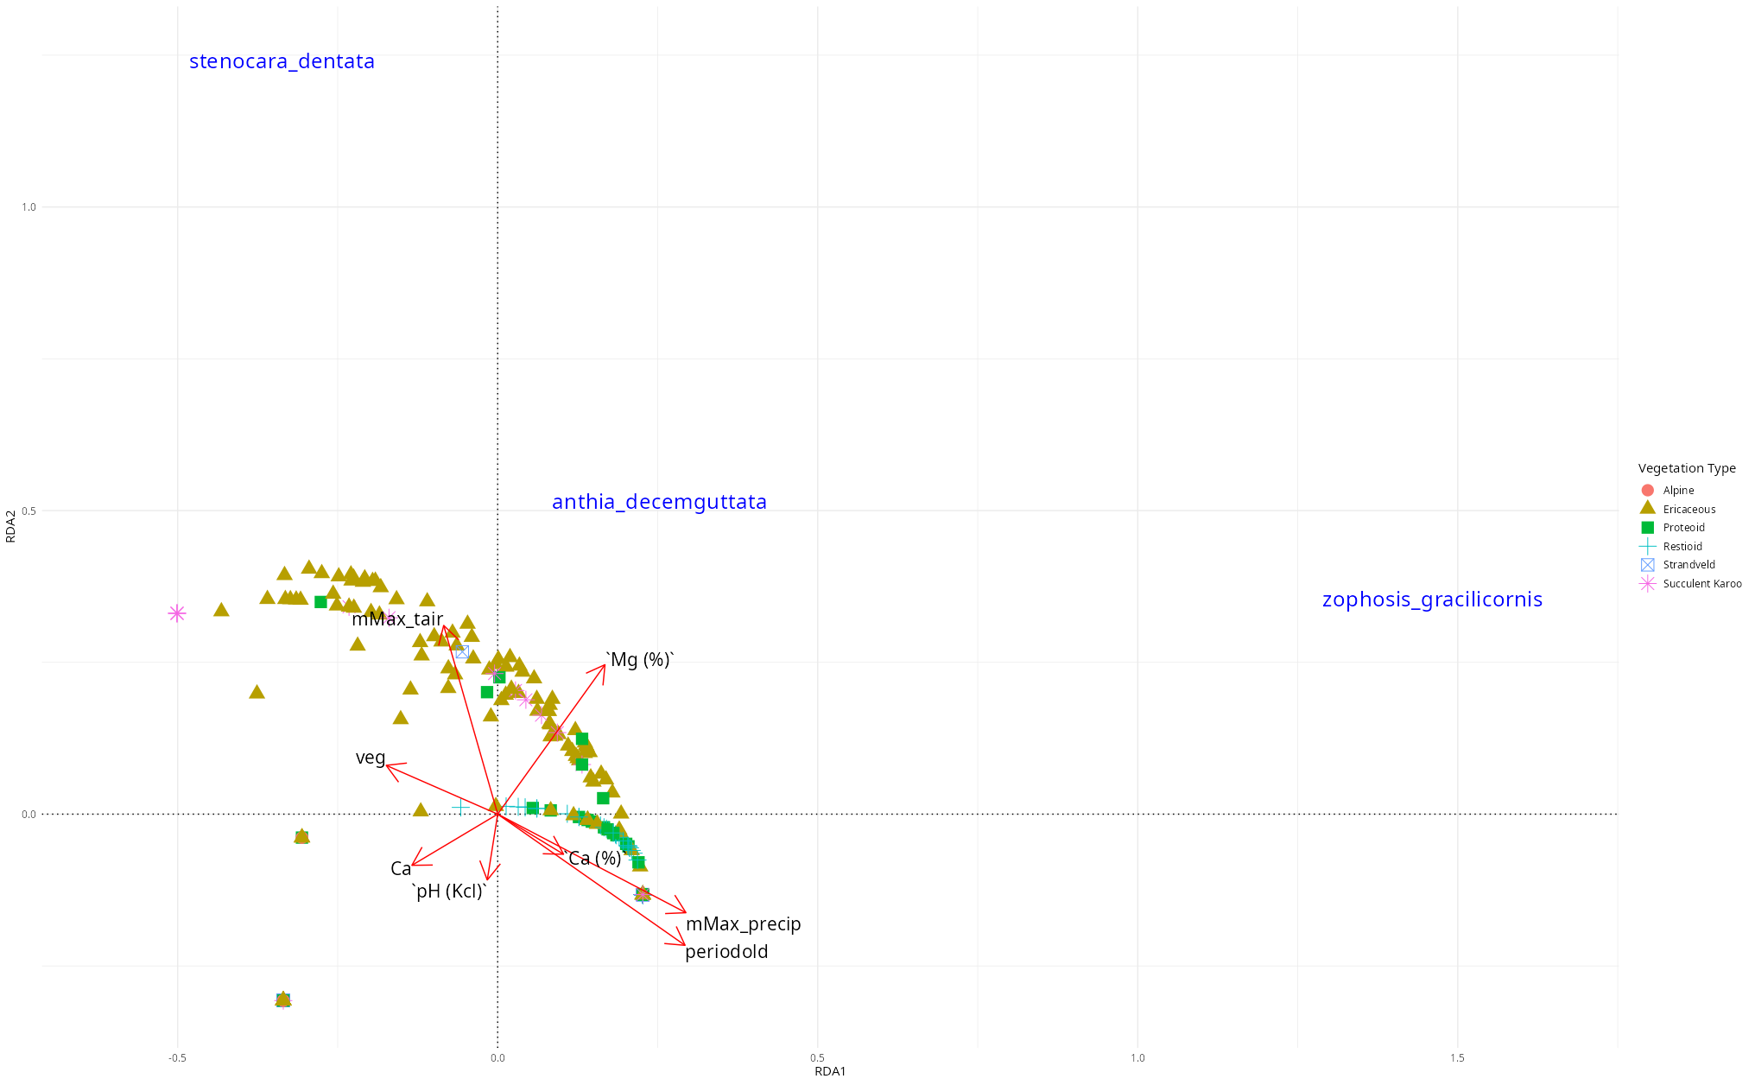
Figure RDA1 Biplot showing the factors that most significantly explained the variance in the beetle abundance across the historical sampling comparisons, with the relevant vegetation type indicated. (mMax_tair: mean monthly maximum air temperature, Mg (%): percentage proportion of magnesium in soil composition, veg: ground vegetation cover, Ca: free calcium ions in soil, Ca (%): percentage proportion of calcium in soil composition, pH (Kcl): pH of the soil, mMax_precip: mean monthly maximum precipitation)

Table A GLMM summary comparing beetle abundance over all (a) years, and (b) periods
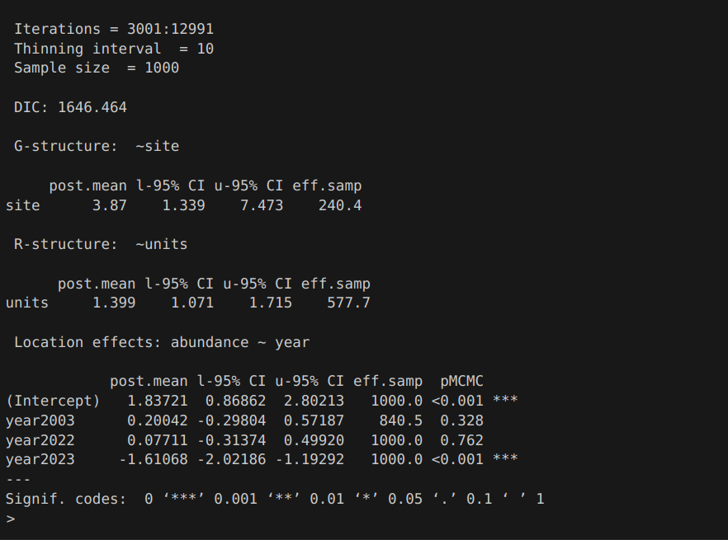
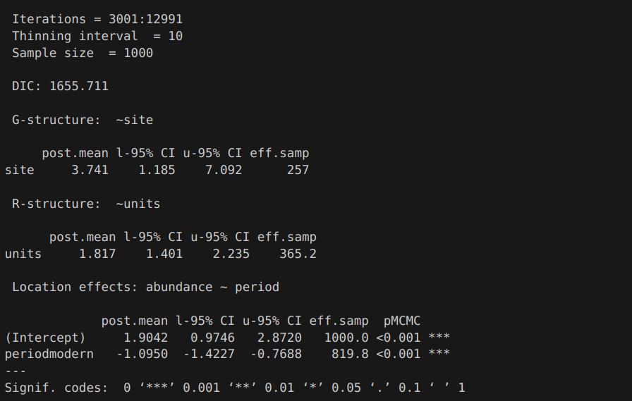
THESE TABLES WILL BE PROPERLY FORMATTED AS TABLES LATER
(b)
(a)

Discussion
- Interpret the seasonal differences between the beetle assemblage in the full identified samples.
  - Discuss the drastic decrease in abundance between the Summer and Winter sampling seasons and provide potential reasons why this reduction was so large (1589 beetles in Summer vs only 44 beetles in Winter).
- With regards to the vegetation types, discuss what the different dominant vegetation types could mean and imply in order to describe the response of the beetles to them.
  - Try to explain why site 14 (1300m E) is so different from every other site around it and why it breaks the pattern of observed beetle communities across the transect.
- The implications of the range shifts for both the seasonal comparison as well as the historical comparison.
  - The range shift of the zophosis is to such a large extent that it could also be influencing the range shift of a predator like the Anthia. Even if that exact example is justifiable, the shift of so much biomass is an important factor to keep in mind with regards to trophic interactions.
- The seasonal decompositions show that the temperature changes are not affecting the transect uniformly. Some sites are strictly increasing, others are fluctuating. This makes it difficult to compare this study to a lot of other studies that did show monotonic temperature changes. However, since the sites with temperature changes can be singled out in this way the individual changes in the beetle populations within sites could be compared to the whether the temperature was changing or not in order to potentially explain the beetle changes.
- In cases with changing temperatures, the extent of the temperature change and the effect it would have on the life that is present within those environments should be discussed. Tying the temperatures back to potential insect decline, either with justification from these beetle data, or from theoretical justification, the degree to which some sites are heating up seems dangerous.
- The vegetation changes in cover and height need to be coupled with the fire data in order to provide reasoning behind the vegetation changes, and then also potentially determine any vegetation changes that occurred without the intervention of fire.
- Further points to be added to this outline as writing develops.

Appendix
The Appendix will be properly structured as the draft develops. Currently a work in progress for general plots being provided.
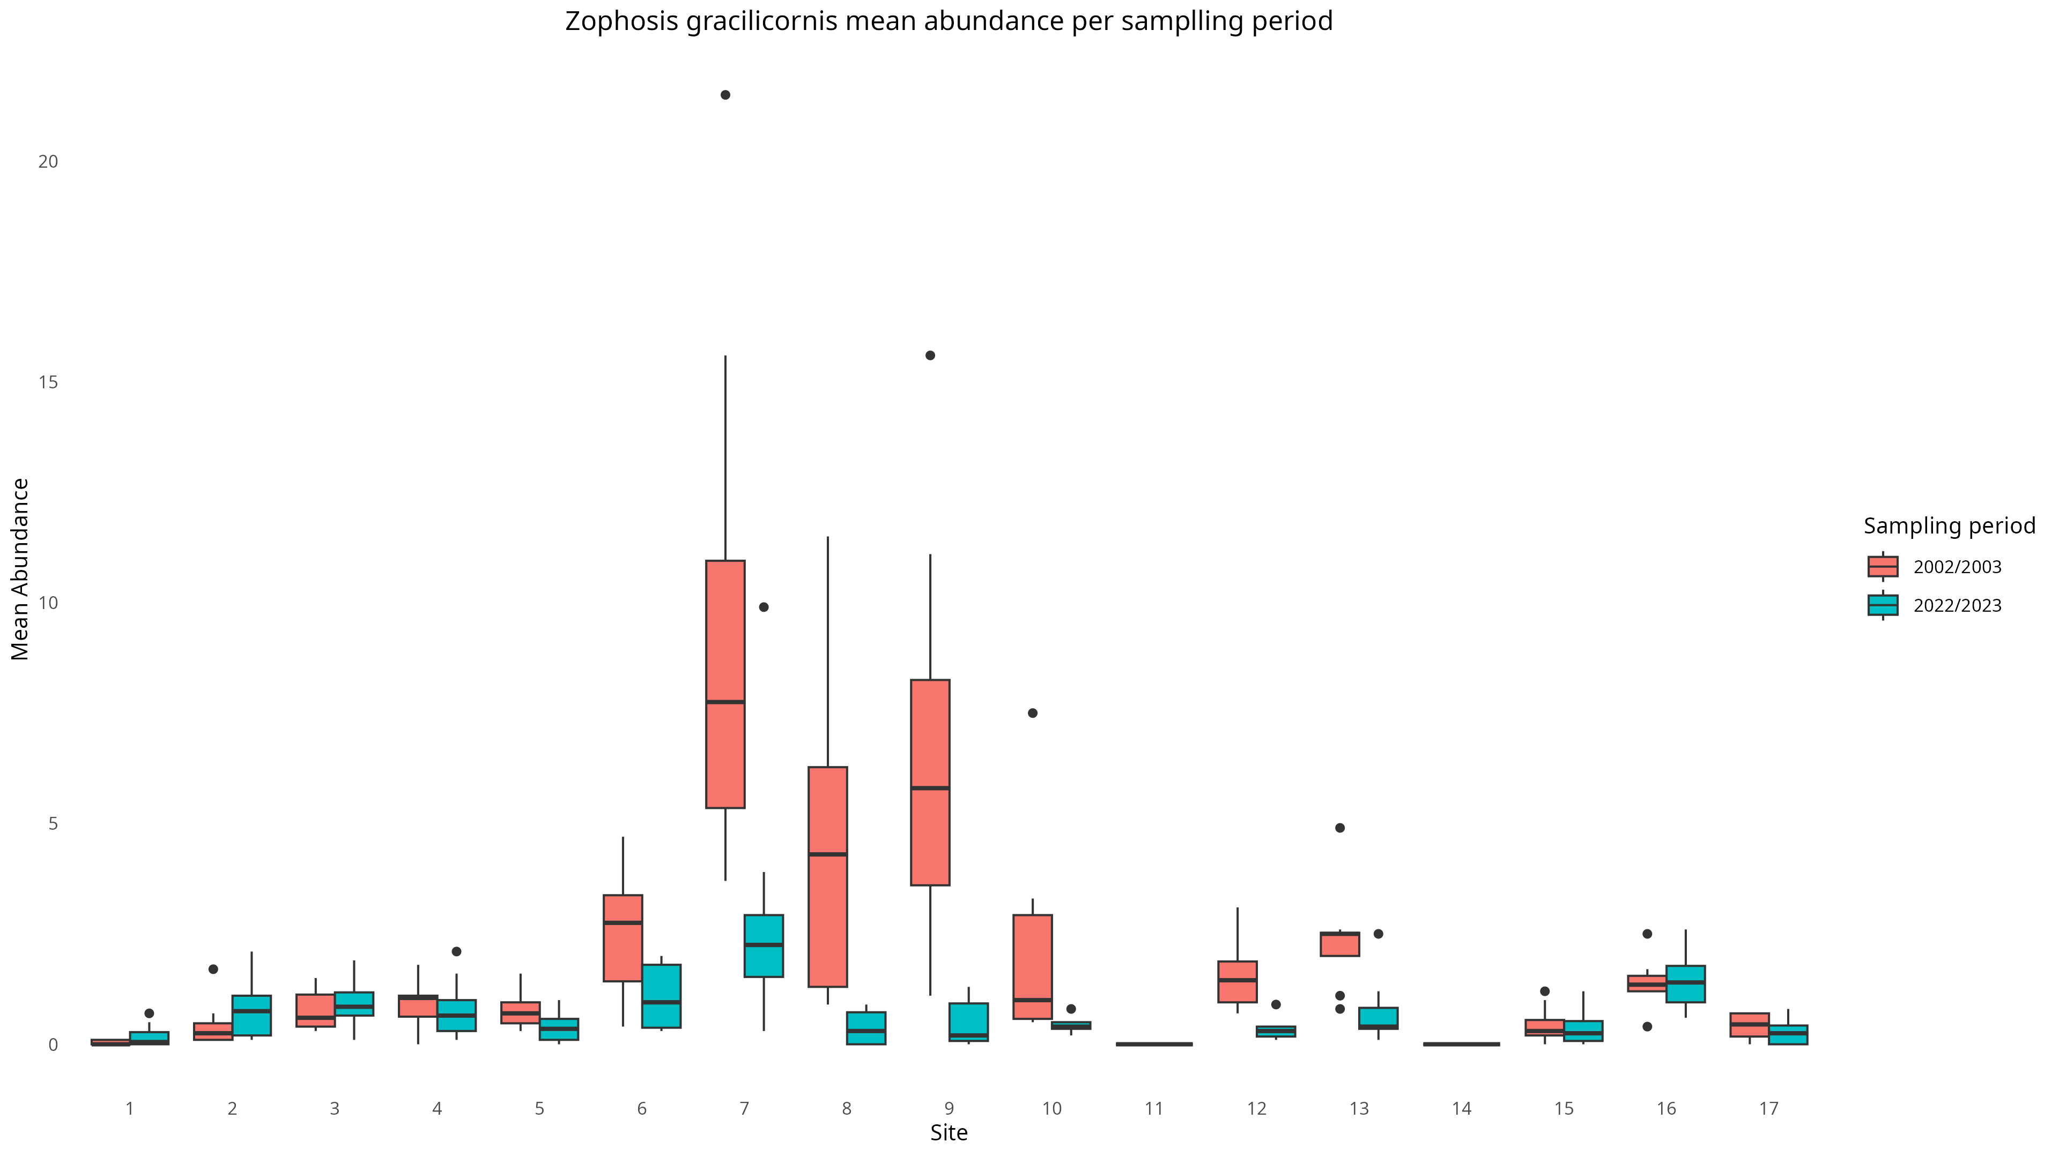
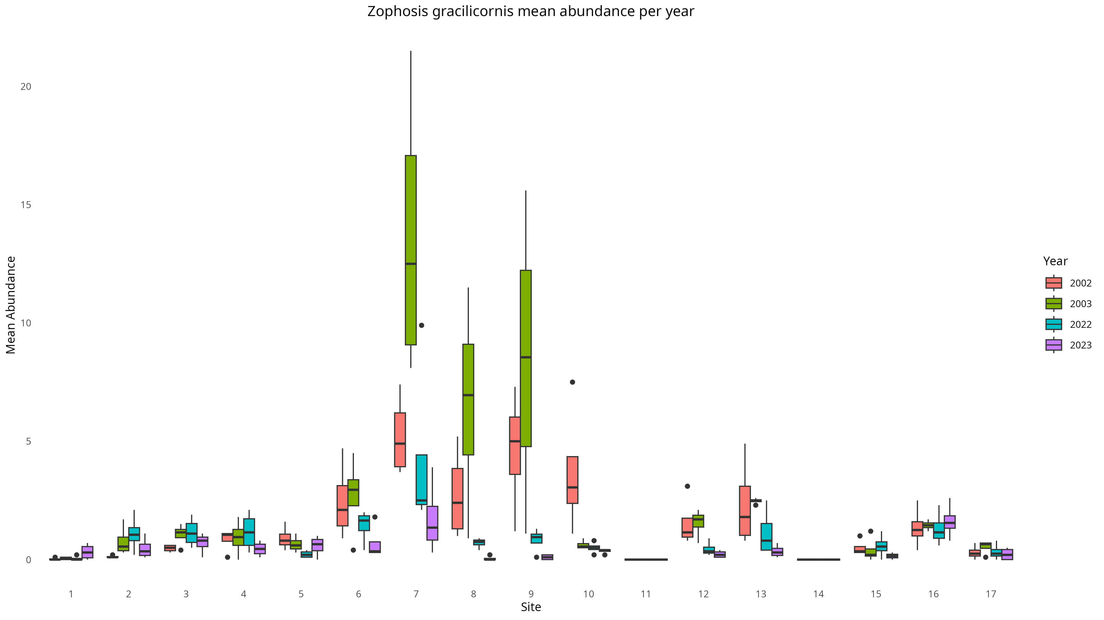
Appendix S2 Boxplots of Zophosis over years and sampling period.

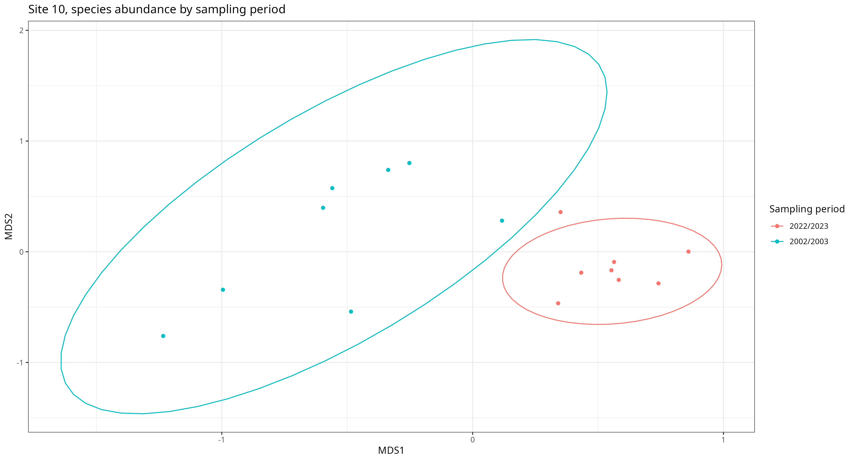
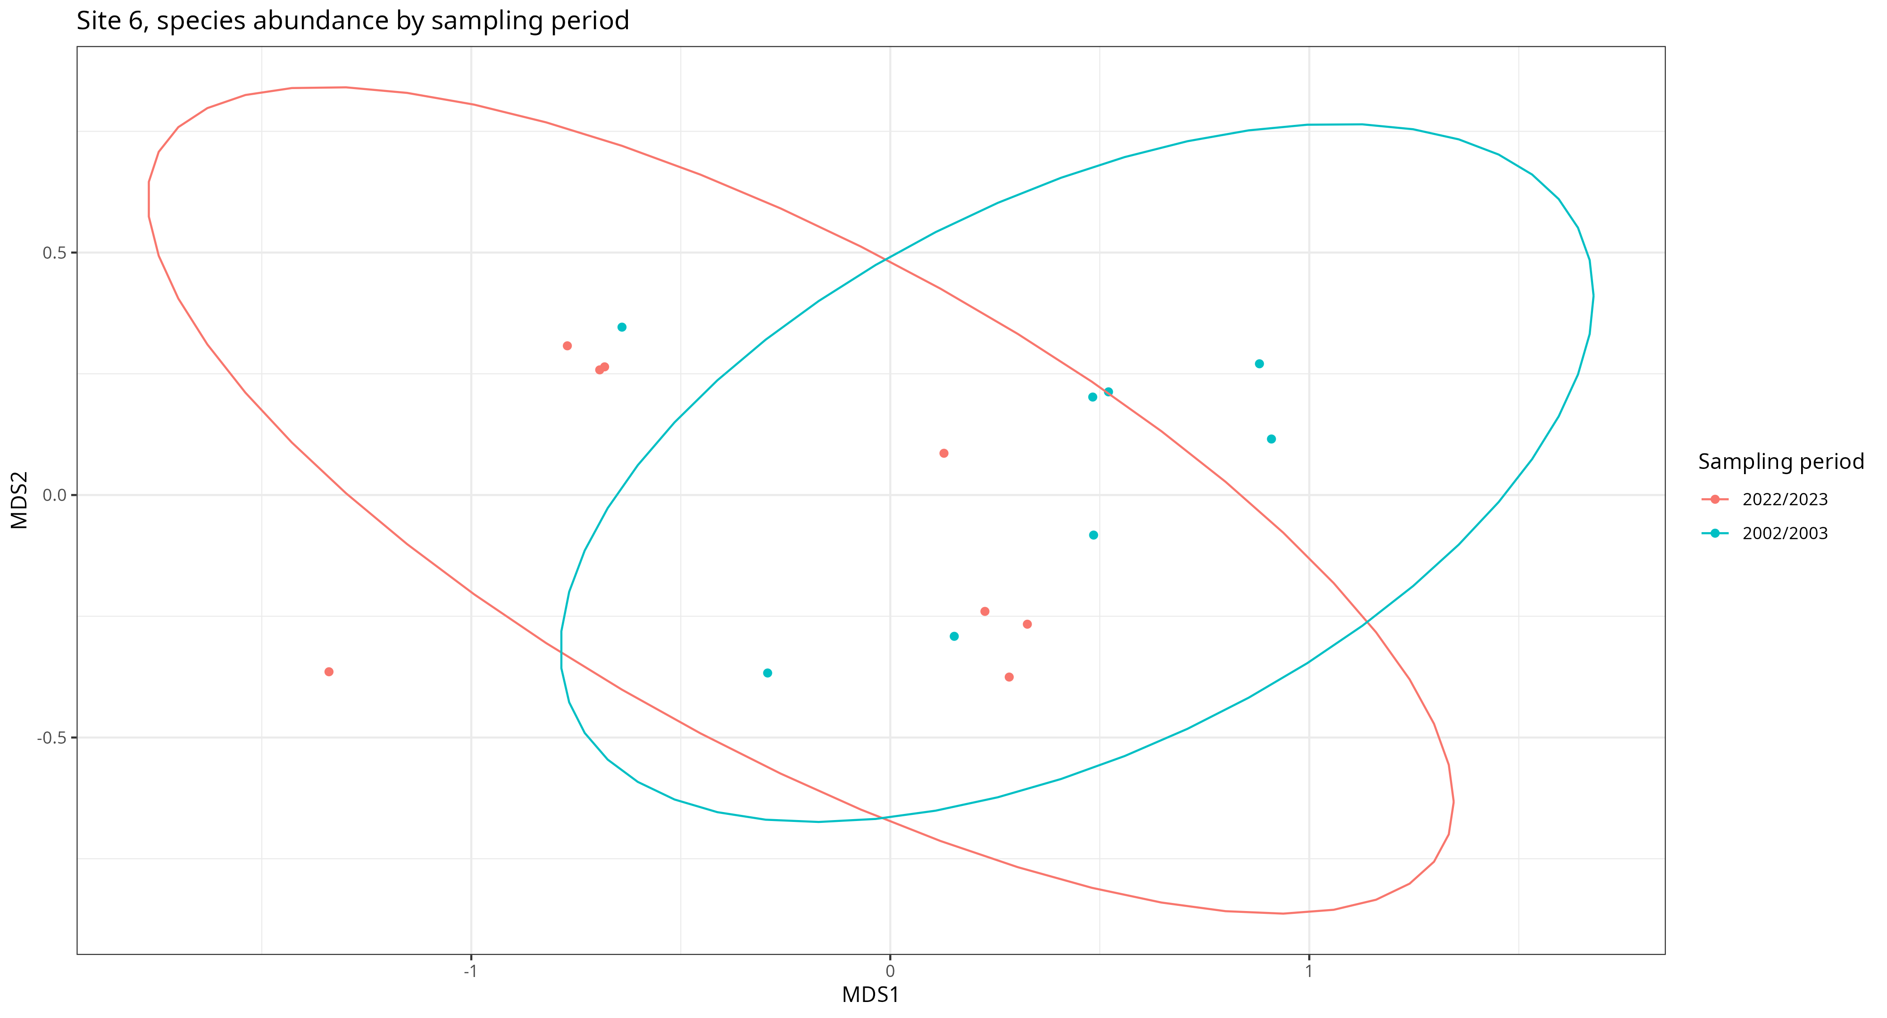
Appendix S3 nMDS of beetle abundance per site

References
Botes, A., Mcgeoch, M.A. and Chown, S.L. (2007) ‘Ground-dwelling beetle assemblages in the northern Cape Floristic Region: Patterns, correlates and implications’, Austral Ecology, 32(2), pp. 210–224. Available at: https://doi.org/10.1111/j.1442-9993.2007.01681.x.
Botes, A., McGeoch, M.A., Robertson, H.G., Niekerk, A., Davids, H.P. and Chown, S.L. (2006) ‘Ants, altitude and change in the northern Cape Floristic Region’, Journal of Biogeography, 33(1), pp. 71–90. Available at: https://doi.org/10.1111/j.1365-2699.2005.01336.x.
Dokumentov, A. and Hyndman, R.J. (2022) ‘STR: Seasonal-Trend Decomposition Using Regression’, INFORMS Journal on Data Science, 1(1), pp. 50–62. Available at: https://doi.org/10.1287/ijds.2021.0004.
Gouws, E.J. (2007) Intraspecific body size variation in insects. Thesis. Stellenbosch : Stellenbosch University. Available at: http://hdl.handle.net/10019.1/50722 (Accessed: 5 April 2023).
Hadfield, J.D. (2010) ‘MCMC Methods for Multi-Response Generalized Linear Mixed Models: The MCMCglmm R Package’, Journal of Statistical Software, 33(2), pp. 1–22.
Hersbach, H., Bell, B., Berrisford, P., Hirahara, S., Horányi, A., Muñoz‐Sabater, J., Nicolas, J., Peubey, C., Radu, R., Schepers, D., Simmons, A., Soci, C., Abdalla, S., Abellan, X., Balsamo, G., Bechtold, P., Biavati, G., Bidlot, J., Bonavita, M., De Chiara, G., Dahlgren, P., Dee, D., Diamantakis, M., Dragani, R., Flemming, J., Forbes, R., Fuentes, M., Geer, A., Haimberger, L., Healy, S., Hogan, R.J., Hólm, E., Janisková, M., Keeley, S., Laloyaux, P., Lopez, P., Lupu, C., Radnoti, G., De Rosnay, P., Rozum, I., Vamborg, F., Villaume, S. and Thépaut, J. (2020) ‘The ERA5 global reanalysis’, Quarterly Journal of the Royal Meteorological Society, 146(730), pp. 1999–2049. Available at: https://doi.org/10.1002/qj.3803.
Klinges, D.H., Duffy, J.P., Kearney, M.R. and Maclean, I.M.D. (2022) ‘mcera5 : Driving microclimate models with ERA5 global gridded climate data’, Methods in Ecology and Evolution, 13(7), pp. 1402–1411. Available at: https://doi.org/10.1111/2041-210X.13877.
Maclean, I. (2025) micropoint: Below or within canopy point microclimate modelling with R. Available at: https://github.com/ilyamaclean/micropoint.
NASA JPL (2013) ‘NASA Shuttle Radar Topography Mission Global 1 arc second’. NASA Land Processes Distributed Active Archive Center. Available at: https://doi.org/10.5067/MEASURES/SRTM/SRTMGL1.003.
Pebesma, E. and Bivand, R. (2023) Spatial Data Science: With Applications in R. 1st edn. New York: Chapman and Hall/CRC. Available at: https://doi.org/10.1201/9780429459016.

