Appendix

Tables
Table S1: Generalised Linear Mixed-Effects model comparing percentage ground cover between the 2002-2003 and 2022-2023 sampling periods. Site used as random effect (DIC: 8817.059).
Parameter | Estimate | Lower 95% Confidence Interval | Upper 95% Confidence Interval | Effective Sample Size | pMCMC
(Intercept) | 42.454 | 39.908 | 44.634 | 1000 | <0.001
periodmodern | -14.728 | -18.141 | -11.712 | 1000 | <0.001
namelitter | -38.415 | -41.725 | -34.972 | 1000 | <0.001
namerock | -23.167 | -26.038 | -19.511 | 896.1 | <0.001
nameveg | -8.251 | -11.494 | -5.225 | 1000 | <0.001
periodmodern:namelitter | 22.141 | 17.769 | 26.988 | 1000 | <0.001
periodmodern:namerock | 12.717 | 8.215 | 17.418 | 1000 | <0.001
periodmodern:nameveg | 23.99 | 18.876 | 28.166 | 917.8 | <0.001
Table S2: Mean abundance (± standard error) of Anthia decemguttata, Stenocara dentata, and Zophosis gracilicornis, at each elevation in October across the four years of the historical comparisons.
Elevation (m a.s.l.) | 2002  (mean ± SE) | 2003  (mean ± SE) | 2022  (mean ± SE) | 2023  (mean ± SE)
Western slope
0 | 0.25 ± 0.25 | 0.5 ± 0.289 | 0.5 ± 0.5 | 3.5 ± 1.55
200 | 2.75 ± 0.854 | 8.5 ± 2.99 | 11 ± 3.89 | 4.75 ± 2.25
300 | 5.25 ± 1.11 | 10.5 ± 2.33 | 13 ± 2.94 | 13.5 ± 4.91
500 | 8.25 ± 2.43 | 9.75 ± 3.33 | 13 ± 4.71 | 5.25 ± 1.8
700 | 10 ± 3.03 | 8.75 ± 2.69 | 3.75 ± 1.6 | 6.5 ± 2.72
900 | 27.25 ± 8.74 | 36.75 ± 9.94 | 19 ± 3.39 | 9.75 ± 3.35
1100 | 62.5 ± 8.45 | 156 ± 32.1 | 71 ± 17.2 | 41.25 ± 9.6
1300 | 44.75 ± 14.4 | 104.25 ± 29.6 | 20.75 ± 3.92 | 7 ± 4.85
1500 | 86.5 ± 20.3 | 117.25 ± 33.8 | 24 ± 6.1 | 11.25 ± 4.75
1700 | 40.5 ± 13.3 | 8.75 ± 1.38 | 23.25 ± 4.35 | 22.25 ± 0.75
1900 | 0 ± 0 | 0 ± 0 | 1.75 ± 1.18 | 0 ± 0
Eastern slope
1700 | 38 ± 2.35 | 24 ± 4.06 | 36.75 ± 6.54 | 22 ± 4.49
1500 | 30 ± 8.26 | 29.5 ± 1.85 | 28.5 ± 8.85 | 10.5 ± 1.26
1300 | 0 ± 0 | 0 ± 0 | 0 ± 0 | 0 ± 0
1100 | 5.25 ± 1.93 | 4.25 ± 2.66 | 9.25 ± 3.97 | 2 ± 0.913
900 | 13.5 ± 4.33 | 14.5 ± 1.04 | 15.5 ± 3.86 | 20.25 ± 4.09
500 | 3.25 ± 1.49 | 7.25 ± 1.11 | 6.25 ± 1.49 | 8.25 ± 2.98

Table S3: Mean abundance (± standard error) of Anthia decemguttata, at each elevation in October across the four years of the historical comparisons.
Elevation (m a.s.l.) | 2002  (mean ± SE) | 2003  (mean ± SE) | 2022  (mean ± SE) | 2023  (mean ± SE)
Western slope
0 | 0 ± 0 | 0 ± 0 | 0 ± 0 | 0 ± 0
200 | 6 ± 0.957 | 3 ± 0.75 | 0 ± 0 | 0 ± 0
300 | 2 ± 0.5 | 0 ± 0 | 0 ± 0 | 15 ± 3.42
500 | 0 ± 0 | 2 ± 0.5 | 5 ± 0.946 | 3 ± 0.479
700 | 4 ± 0.577 | 9 ± 1.11 | 6 ± 0.957 | 3 ± 0.75
900 | 11 ± 0.479 | 39 ± 1.49 | 19 ± 1.55 | 11 ± 1.31
1100 | 27 ± 4.77 | 45 ± 2.29 | 83 ± 6.07 | 71 ± 4.46
1300 | 55 ± 3.54 | 73 ± 3.01 | 33 ± 3.28 | 18 ± 3.23
1500 | 114 ± 4.09 | 98 ± 5.66 | 47 ± 2.95 | 30 ± 2.75
1700 | 0 ± 0 | 0 ± 0 | 15 ± 0.629 | 23 ± 1.18
1900 | 0 ± 0 | 0 ± 0 | 7 ± 1.18 | 0 ± 0
Eastern slope
1700 | 1 ± 0.25 | 1 ± 0.25 | 16 ± 3.03 | 8 ± 2
1500 | 4 ± 0.408 | 0 ± 0 | 16 ± 2.12 | 7 ± 1.03
1300 | 0 ± 0 | 0 ± 0 | 0 ± 0 | 0 ± 0
1100 | 1 ± 0.25 | 1 ± 0.25 | 14 ± 1.55 | 2 ± 0.5
900 | 0 ± 0 | 0 ± 0 | 10 ± 0.289 | 16 ± 1.68
500 | 0 ± 0 | 0 ± 0 | 0 ± 0 | 0 ± 0

Table S4: Mean abundance (± standard error) of Stenocara dentata, at each elevation in October across the four years of the historical comparisons.
Elevation (m a.s.l.) | 2002  (mean ± SE) | 2003  (mean ± SE) | 2022  (mean ± SE) | 2023  (mean ± SE)
Western slope
0 | 0 ± 0 | 0 ± 0 | 0 ± 0 | 1 ± 0.25
200 | 0 ± 0 | 0 ± 0 | 0 ± 0 | 0 ± 0
300 | 0 ± 0 | 0 ± 0 | 6 ± 1.19 | 11 ± 1.18
500 | 0 ± 0 | 0 ± 0 | 0 ± 0 | 0 ± 0
700 | 0 ± 0 | 0 ± 0 | 0 ± 0 | 0 ± 0
900 | 0 ± 0 | 0 ± 0 | 0 ± 0 | 0 ± 0
1100 | 14 ± 1.66 | 33 ± 2.1 | 31 ± 2.39 | 25 ± 1.44
1300 | 14 ± 1.66 | 81 ± 7.79 | 22 ± 2.06 | 8 ± 1.22
1500 | 47 ± 5.31 | 33 ± 1.65 | 16 ± 1.87 | 11 ± 2.1
1700 | 15 ± 2.1 | 10 ± 1.5 | 58 ± 3.93 | 52 ± 1.22
1900 | 0 ± 0 | 0 ± 0 | 0 ± 0 | 0 ± 0
Eastern slope
1700 | 89 ± 4.53 | 33 ± 2.02 | 113 ± 2.32 | 71 ± 2.93
1500 | 23 ± 2.29 | 19 ± 2.29 | 53 ± 4.29 | 21 ± 1.93
1300 | 0 ± 0 | 0 ± 0 | 0 ± 0 | 0 ± 0
1100 | 0 ± 0 | 0 ± 0 | 0 ± 0 | 0 ± 0
900 | 0 ± 0 | 0 ± 0 | 0 ± 0 | 0 ± 0
500 | 1 ± 0.25 | 8 ± 0.913 | 12 ± 1.35 | 24 ± 2.48

Table S5: Mean abundance (± standard error) of Zophosis gracilicornis, at each elevation in October across the four years of the historical comparisons.
Elevation (m a.s.l.) | 2002  (mean ± SE) | 2003  (mean ± SE) | 2022  (mean ± SE) | 2023  (mean ± SE)
Western slope
0 | 0 ± 0 | 0 ± 0 | 0 ± 0 | 1 ± 0.25
200 | 0 ± 0 | 0 ± 0 | 0 ± 0 | 0 ± 0
300 | 0 ± 0 | 0 ± 0 | 6 ± 1.19 | 11 ± 1.18
500 | 0 ± 0 | 0 ± 0 | 0 ± 0 | 0 ± 0
700 | 0 ± 0 | 0 ± 0 | 0 ± 0 | 0 ± 0
900 | 0 ± 0 | 0 ± 0 | 0 ± 0 | 0 ± 0
1100 | 14 ± 1.66 | 33 ± 2.1 | 31 ± 2.39 | 25 ± 1.44
1300 | 14 ± 1.66 | 81 ± 7.79 | 22 ± 2.06 | 8 ± 1.22
1500 | 47 ± 5.31 | 33 ± 1.65 | 16 ± 1.87 | 11 ± 2.1
1700 | 15 ± 2.1 | 10 ± 1.5 | 58 ± 3.93 | 52 ± 1.22
1900 | 0 ± 0 | 0 ± 0 | 0 ± 0 | 0 ± 0
Eastern slope
1700 | 62 ± 5.27 | 62 ± 3.01 | 18 ± 1.55 | 9 ± 0.75
1500 | 93 ± 9.35 | 99 ± 0.629 | 45 ± 4.96 | 14 ± 1.32
1300 | 0 ± 0 | 0 ± 0 | 0 ± 0 | 0 ± 0
1100 | 20 ± 1.68 | 16 ± 2.71 | 23 ± 2.46 | 6 ± 0.645
900 | 54 ± 4.33 | 58 ± 1.04 | 52 ± 3.63 | 65 ± 3.71
500 | 12 ± 1.47 | 21 ± 1.44 | 13 ± 1.7 | 9 ± 1.31

Table S6: Generalised Linear Mixed-Effects model comparing abundance for Anthia decemguttata, Stenocara dentata, and Zophosis gracilicornis between the sampling periods of 2002-2003 and 2022-2023 (Poisson error distribution, log link function). Sites and replicates used as random effects.
Random effects
Groups | Number of obs | Variance | Std.Dev.
site:replicate | 272 | 2.888 | 1.7
Groups:  site:replicate | 68
Fixed effects | Estimate | Std. Error | z value | Pr(>|z|)
(Intercept) | 2.40281 | 0.21101 | 11.39 | <2e-16
periodmodern | -0.63808 | 0.02798 | -22.8 | <2e-16

Table S7: Generalised Linear Mixed-Effects model comparing abundance for Anthia decemguttata, Stenocara dentata, and Zophosis gracilicornis between the four years in which sampling occurred in October (2002, 2003, 2022, 2023) (Poisson error distribution, log link function). Sites and replicates used as random effects.
Random effects
Groups | Number of obs | Variance | Std.Dev.
site:replicate | 272 | 2.888 | 1.7
Groups:  site:replicate | 68
Fixed effects | Estimate | Std. Error | z value | Pr(>|z|)
(Intercept) | 2.20812 | 0.21193 | 10.419 | 2.00E-16
year2003 | 0.3576 | 0.03343 | 10.697 | 2.00E-16
year2022 | -0.24032 | 0.03865 | -6.218 | 5.05E-10
year2023 | -0.69845 | 0.0445 | -15.697 | 2.00E-16
Table S8: Generalised Linear Mixed-Effects model comparing abundance for Zophosis gracilicornis between the four years in which sampling occurred in October (2002, 2003, 2022, 2023) (Poisson error distribution, log link function). Sites and replicates used as random effects.
Random effects
Groups | Number of obs | Variance | Std.Dev.
site:replicate | 272 | 2.741 | 1.656
Groups:  site:replicate | 68
Fixed effects | Estimate | Std. Error | z value | Pr(>|z|)
(Intercept) | 1.89362 | 0.20874 | 9.072 | <2e-16
year2003 | 0.43456 | 0.03882 | 11.194 | <2e-16
year2022 | -0.57988 | 0.05048 | -11.487 | <2e-16
year2023 | -1.21697 | 0.06328 | -19.232 | <2e-16

Table S9: Generalised Linear Mixed-Effects model comparing abundance for Stenocara dentata between the sampling periods of 2002-2003 and 2022-2023 (Poisson error distribution, log link function). Sites and replicates used as random effects.
Random effects
Groups | Number of obs | Variance | Std.Dev.
site:replicate | 272 | 12.56 | 3.544
Groups:  site:replicate | 68
Fixed effects | Estimate | Std. Error | z value | Pr(>|z|)
(Intercept) | -2.05907 | 0.65839 | -3.127 | 0.001763
periodmodern | 0.24201 | 0.06518 | 3.713 | 0.000205

Table S10: Generalised Linear Mixed-Effects model comparing abundance for Zophosis gracilicornis between the sampling periods of 2002-2003 and 2022-2023 (Poisson error distribution, log link function). Sites and replicates used as random effects.
Random effects
Groups | Number of obs | Variance | Std.Dev.
site:replicate | 272 | 2.741 | 1.656
Groups:  site:replicate | 68
Fixed effects | Estimate | Std. Error | z value | Pr(>|z|)
(Intercept) | 2.13432 | 0.2074 | 10.29 | <2e-16
periodmodern | -1.08923 | 0.03779 | -28.82 | <2e-16

Table S11: Generalised Linear Mixed-Effects model comparing abundance for Zophosis gracilicornis and the effects of environmental variables over time (Poisson error distribution, log link function). Sites and replicates used as random effects.
Random effects
Groups | Number of obs | Variance | Std.Dev.
site:replicate | 272 | 2.185 | 1.478
Groups:  site:replicate | 68
Fixed effects | Estimate | Std. Error | z value | Pr(>|z|)
(Intercept) | -2.68E+01 | 2.71E+01 | -0.991 | 3.22E-01
periodmodern | -9.41E+01 | 7.58E+01 | -1.241 | 2.15E-01
`Mg(%)` | 9.46E-03 | 1.86E-02 | 0.509 | 0.61045
Ca | 1.57E-01 | 2.01E-01 | 0.782 | 0.43415
`Ca(%)` | -1.28E-02 | 1.11E-02 | -1.161 | 0.24557
mMax_tair | -1.12E+00 | 3.75E-01 | -2.986 | 0.00282
winddir | 1.35E-01 | 2.91E-02 | 4.626 | 3.72E-06
range_tair | 1.31E+00 | 1.51E-01 | 8.678 | <2.00E-16
`pH(Kcl)` | 7.63E-02 | 1.88E-01 | 0.405 | 0.68535
relhum | 2.11E-01 | 7.20E-02 | 2.934 | 0.00335
swdown | -8.44E-02 | 5.34E-02 | -1.581 | 0.11382
mMax_tground | -6.79E-02 | 3.06E-02 | -2.215 | 0.02675
rock_soil | 3.05E-02 | 1.21E-02 | 2.525 | 0.01155
veg | 2.53E-04 | 3.05E-03 | 0.083 | 0.93377
mMax_precip | 1.97E+01 | 3.87E+00 | 5.097 | 3.45E-07
periodmodern:`Mg(%)` | -3.27E-02 | 1.56E-02 | -2.096 | 0.03604
periodmodern:Ca | -1.56E+00 | 2.57E-01 | -6.071 | 1.27E-09
periodmodern:`Ca(%)` | 6.20E-02 | 1.24E-02 | 5.018 | 5.22E-07
periodmodern:mMax_tair | 1.20E+00 | 4.24E-01 | 2.827 | 0.0047
periodmodern:winddir | -6.32E-02 | 2.49E-02 | -2.536 | 0.01122
periodmodern:range_tair | -1.07E+00 | 1.86E-01 | -5.769 | 8.00E-09
periodmodern:`pH(Kcl)` | 4.77E-01 | 2.32E-01 | 2.056 | 0.03975
periodmodern:relhum | -1.42E-01 | 1.23E-01 | -1.15 | 0.25003
periodmodern:swdown | 4.26E-01 | 2.22E-01 | 1.92 | 0.05484
periodmodern:mMax_tground | 5.15E-03 | 3.11E-02 | 0.166 | 0.86846
periodmodern:rock_soil | -1.33E-01 | 2.42E-02 | -5.505 | 3.69E-08
periodmodern:veg | -2.72E-02 | 6.01E-03 | -4.531 | 5.87E-06
periodmodern:mMax_precip | -1.56E+01 | 1.29E+01 | -1.211 | 0.22587
Table S12: Generalised Linear Mixed-Effects model comparing abundance for Stenocara dentata and the effects of environmental variables over time (Poisson error distribution, log link function). Sites and replicates used as random effects.
Random effects
Groups | Number of obs | Variance | Std.Dev.
site:replicate | 272 | 7.408 | 2.722
Groups:  site:replicate | 68
Fixed effects | Estimate | Std. Error | z value | Pr(>|z|)
(Intercept) | -1.32E+02 | 6.07E+01 | -2.182 | 2.91E-02
periodmodern | 1.60E+02 | 3.65E+01 | 4.379 | 1.19E-05
`Mg(%)` | 1.13E-01 | 4.11E-02 | 2.741 | 0.00613
Ca | 1.42E+00 | 4.76E-01 | 2.986 | 0.002825
`Ca(%)` | -6.01E-02 | 3.72E-02 | -1.616 | 0.106195
mMax_tair | -1.97E-01 | 9.79E-01 | -0.201 | 0.840626
winddir | 1.71E-01 | 8.22E-02 | 2.079 | 3.77E-02
range_tair | -4.67E-01 | 6.59E-01 | -0.708 | 0.478654
`pH(Kcl)` | -7.79E-02 | 6.59E-01 | -0.118 | 0.905971
relhum | -4.77E-01 | 2.88E-01 | -1.656 | 0.097687
swdown | 3.96E-01 | 1.26E-01 | 3.157 | 0.001596
rock_soil | 1.15E-01 | 2.20E-02 | 5.238 | 1.62E-07
veg | 2.74E-02 | 8.58E-03 | 3.197 | 0.001391
mMax_precip | 1.07E+02 | 1.96E+01 | 5.438 | 5.38E-08
periodmodern:`Mg(%)` | -9.56E-02 | 3.53E-02 | -2.71E+00 | 0.006798
periodmodern:Ca | -1.71E+00 | 5.19E-01 | -3.294 | 0.000989
periodmodern:`Ca(%)` | 1.49E-01 | 3.78E-02 | 3.94E+00 | 8.33E-05
periodmodern:mMax_tair | 7.46E-01 | 9.20E-01 | 0.81 | 4.18E-01
periodmodern:winddir | -2.33E-01 | 5.90E-02 | -3.959 | 7.52E-05
periodmodern:range_tair | 5.24E-01 | 6.99E-01 | 0.75 | 0.453221
periodmodern:`pH(Kcl)` | 8.04E-01 | 5.90E-01 | 1.36E+00 | 0.173349
periodmodern:relhum | 1.53E-01 | 2.97E-01 | 0.514 | 0.607434
periodmodern:swdown | -4.80E-01 | 3.07E-02 | -15.63 | <2.00E-16
periodmodern:rock_soil | 1.18E-01 | 4.85E-02 | 2.425 | 0.015294
periodmodern:veg | -2.19E-02 | 1.13E-02 | -1.939 | 0.052466
periodmodern:mMax_precip | -4.89E+01 | 4.34E+01 | -1.127 | 2.60E-01

Table S13: Generalised Linear Mixed-Effects model comparing abundance for Anthia decemguttata and the effects of environmental variables over time (Poisson error distribution, log link function). Sites and replicates used as random effects.
Random effects
Groups | Number of obs | Variance | Std.Dev.
site:replicate | 272 | 4.513 | 2.124
Groups:  site:replicate | 68
Fixed effects | Estimate | Std. Error | z value | Pr(>|z|)
(Intercept) | 1.04E+02 | 6.34E+01 | 1.632 | 1.03E-01
periodmodern | -3.81E+02 | 2.94E+01 | -12.959 | <2.00E-16
`Mg(%)` | 1.43E-01 | 3.49E-02 | 4.09E+00 | 4.24E-05
Ca | 5.66E-01 | 3.47E-01 | 1.632 | 1.03E-01
`Ca(%)` | -5.33E-02 | 2.42E-02 | -2.203 | 0.027565
mMax_tair | -3.00E+00 | 8.01E-01 | -3.743 | 0.000182
winddir | -2.02E-01 | 8.61E-02 | -2.349 | 0.018837
range_tair | 1.32E+00 | 3.19E-01 | 4.137 | 3.51E-05
`pH(Kcl)` | 7.71E-02 | 4.16E-01 | 1.85E-01 | 0.852915
relhum | 1.97E-01 | 1.56E-01 | 1.26 | 0.207514
swdown | -2.13E-01 | 1.03E-01 | -2.066 | 0.038784
rock_soil | 4.78E-02 | 2.52E-02 | 1.899 | 0.057513
veg | 1.66E-02 | 6.36E-03 | 2.6 | 0.009311
mMax_precip | 6.89E+01 | 1.06E+01 | 6.484 | 8.92E-11
periodmodern:`Mg(%)` | -1.20E-01 | 2.67E-02 | -4.49 | 7.13E-06
periodmodern:Ca | -7.91E-01 | 4.51E-01 | -1.755 | 7.93E-02
periodmodern:`Ca(%)` | 1.09E-01 | 2.32E-02 | 4.673 | 2.97E-06
periodmodern:mMax_tair | 6.68E+00 | 9.42E-01 | 7.09 | 1.34E-12
periodmodern:winddir | -4.73E-02 | 6.68E-02 | -7.08E-01 | 4.79E-01
periodmodern:range_tair | -2.18E-01 | 4.67E-01 | -0.467 | 6.40E-01
periodmodern:`pH(Kcl)` | 7.05E-01 | 5.93E-01 | 1.19E+00 | 0.234377
periodmodern:relhum | -5.97E-01 | 1.81E-01 | -3.306 | 0.000946
periodmodern:swdown | 9.52E-01 | 3.28E-02 | 2.90E+01 | <2.00E-16
periodmodern:rock_soil | -4.44E-02 | 5.61E-02 | -0.791 | 0.428733
periodmodern:veg | -2.78E-02 | 1.02E-02 | -2.727 | 0.006388
periodmodern:mMax_precip | -5.41E-02 | 3.73E+01 | -0.001 | 0.998843

Table S14: Abundance of all species identified from Tenebrionidae, Carabidae, and Cicindelidae, in the 2022-2023 sample, separated by year.
Species | Family | Abundance in 2022 | Abundance in 2023
Stenocara dentata | Tenebrionidae | 311 | 24
Zophosis gracilicornis | Tenebrionidae | 607 | 13
Anthia decemguttata | Carabidae | 271 | 4
Cryptochile sp. 1 | Carabidae | 122 | 2
Gonogenia sp. 1 | Tenebrionidae | 23 | 1
Hypomelus sp. 1 | Tenebrionidae | 4 | 0
Stenocara sp. 1 | Tenebrionidae | 6 | 0
Oncotus cedrimontis | Tenebrionidae | 3 | 0
Cryptochile assimilis | Tenebrionidae | 2 | 0
Horatoma sp. 1 | Tenebrionidae | 13 | 0
Cryptochile setipennis | Tenebrionidae | 6 | 0
Cryptochile sp. 2 | Tenebrionidae | 9 | 0
Pachynotelus sp. 1 | Tenebrionidae | 3 | 0
Pachynotelus sp. 2 | Tenebrionidae | 12 | 0
Moluris globulicollis | Tenebrionidae | 16 | 0
Mariazofia sp. 1 | Tenebrionidae | 1 | 0
Ocnodes sp. 1 | Tenebrionidae | 1 | 0
Ocnodes sp. 2 | Tenebrionidae | 2 | 0
Ocnodes sp. 3 | Tenebrionidae | 1 | 0
Ocnodes sp. 4 | Tenebrionidae | 1 | 0
Ocnodes sp. 5 | Tenebrionidae | 1 | 0
Psammodes longicornis | Tenebrionidae | 1 | 0
Somaticus sp. 1 | Tenebrionidae | 1 | 0
Somaticus sp. 2 | Tenebrionidae | 8 | 0
Somaticus sp. 3 | Tenebrionidae | 6 | 0
Physadesmia sp. 1 | Tenebrionidae | 1 | 0
Oxura sp. 1 | Tenebrionidae | 2 | 0
Somaticus sp. 4 | Tenebrionidae | 14 | 0
Somaticus sp. 5 | Tenebrionidae | 1 | 0
Hypomelus sp. 2 | Tenebrionidae | 1 | 0
Ocnodes sp. 6 | Tenebrionidae | 1 | 0
Broomium sp. 1 | Tenebrionidae | 8 | 0
Broomium sp. 2 | Tenebrionidae | 1 | 0
Herpiscius spinolae | Tenebrionidae | 1 | 0
Planostibes sp. 1 | Tenebrionidae | 3 | 0
Blenosia sp. 1 | Tenebrionidae | 1 | 0
Harpalus sp. 1 | Carabidae | 1 | 0
Harpalus sp. 2 | Carabidae | 12 | 0
Hystrichopus sp. 1 | Carabidae | 2 | 0
Scarites rugosus | Carabidae | 16 | 0
Cicindela lurida | Cicindelidae | 76 | 0
Cicindela sp. 1 | Cicindelidae | 17 | 0

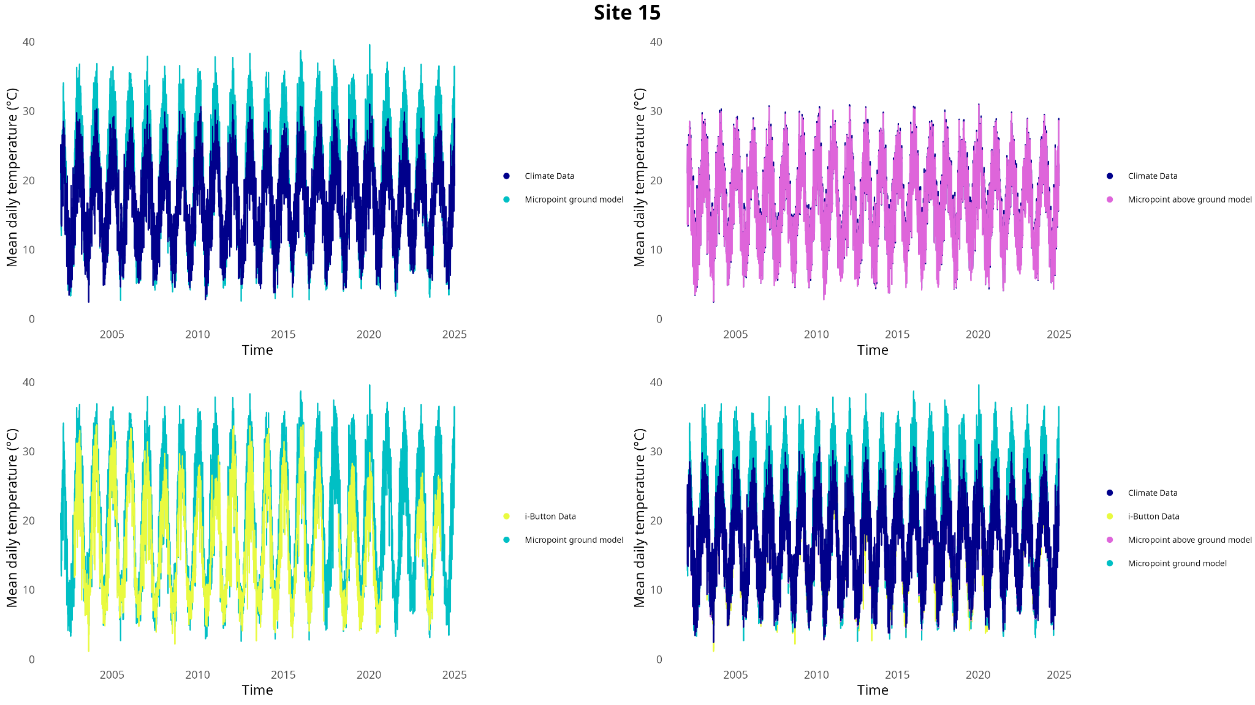
Figures

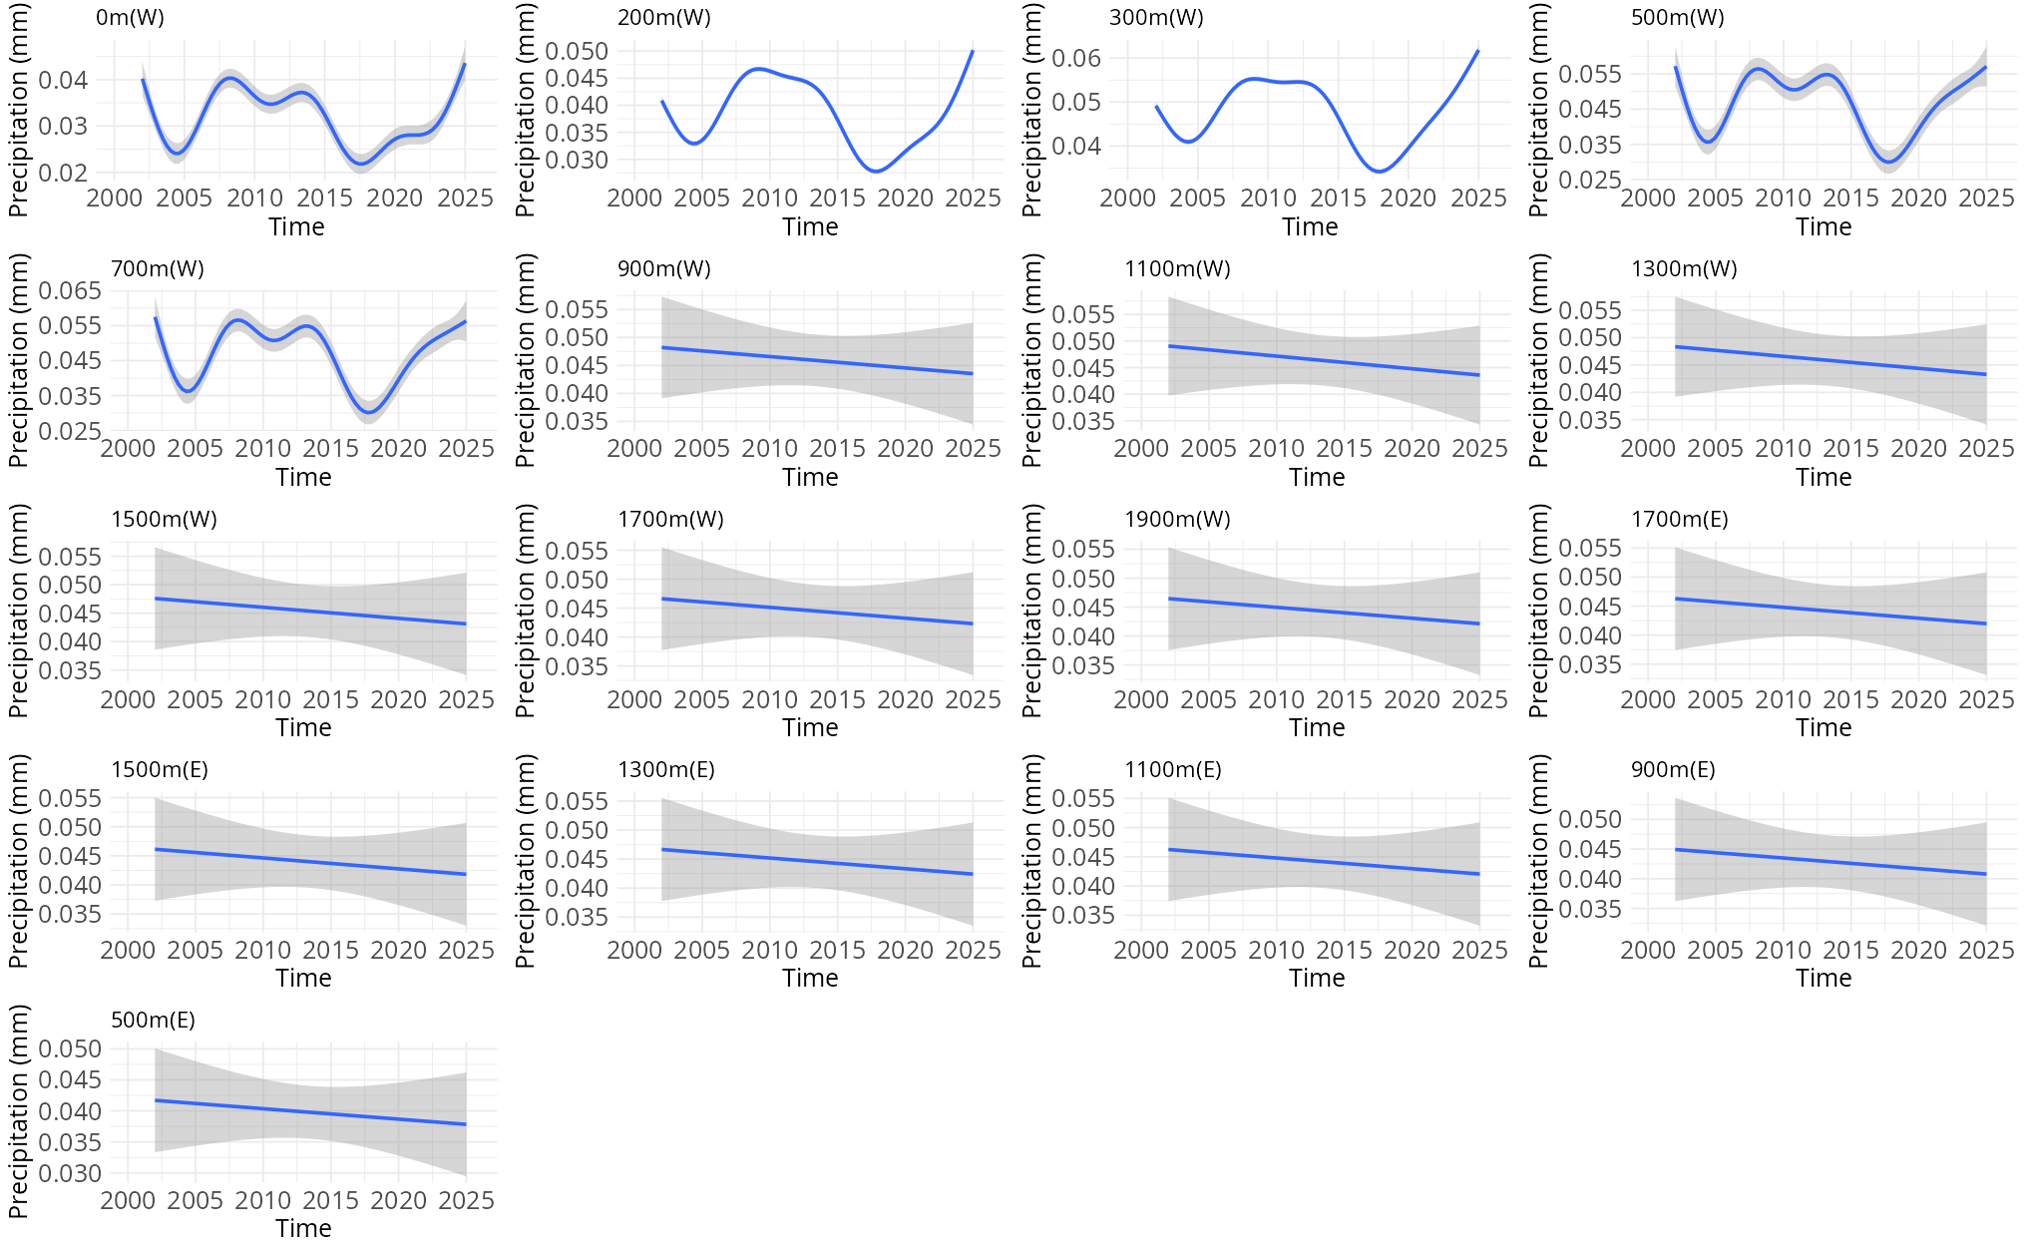
Figure S1: Comparisons between the different sources of temperature data recorded for this study.

Figure S2: Trend in baseline precipitation for each site across the entire transect.

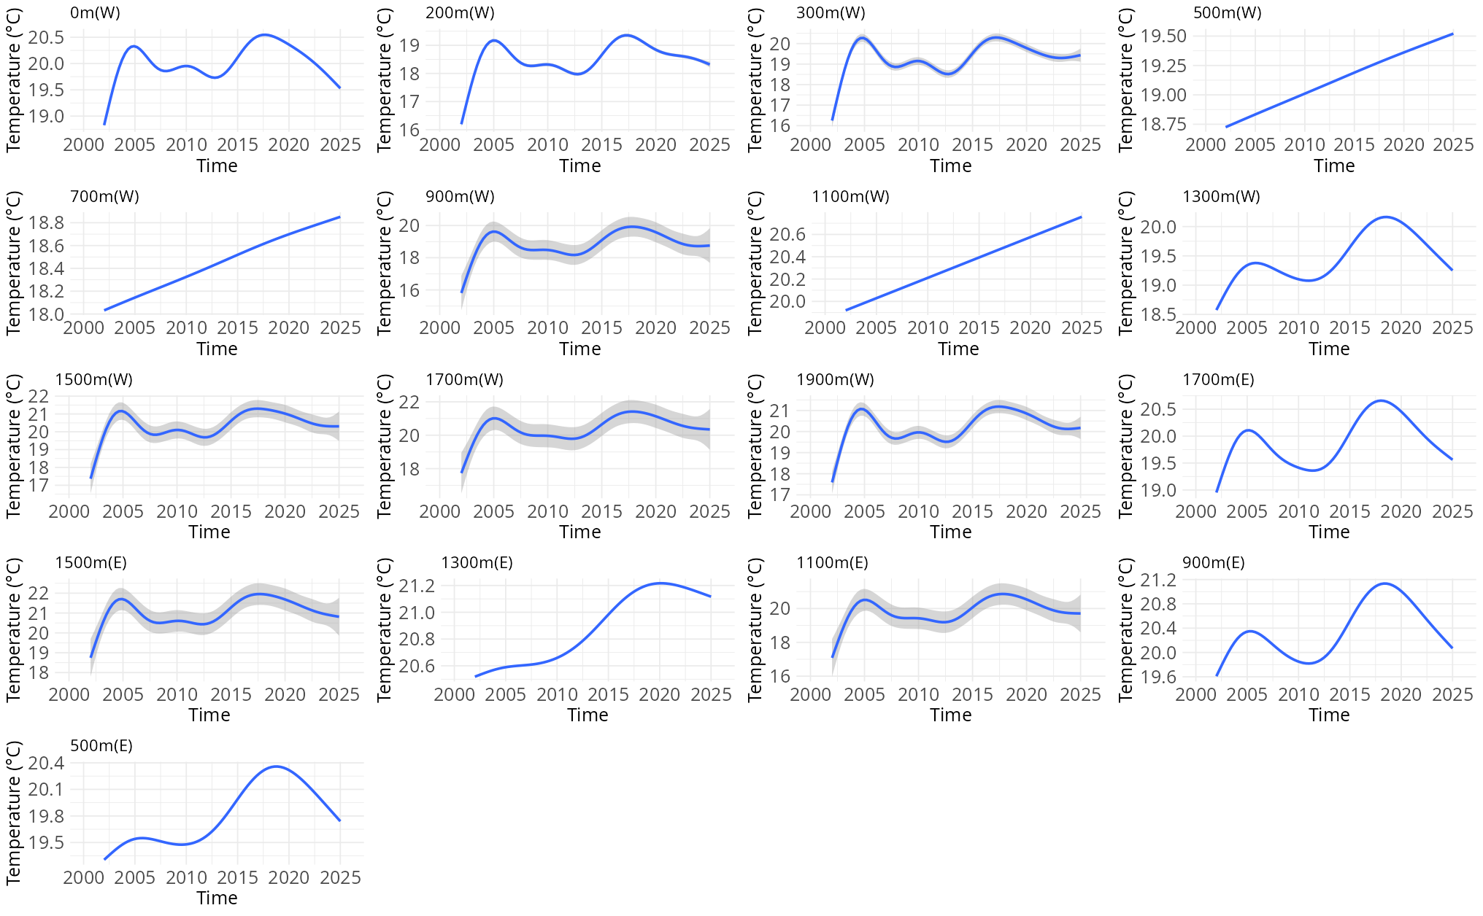
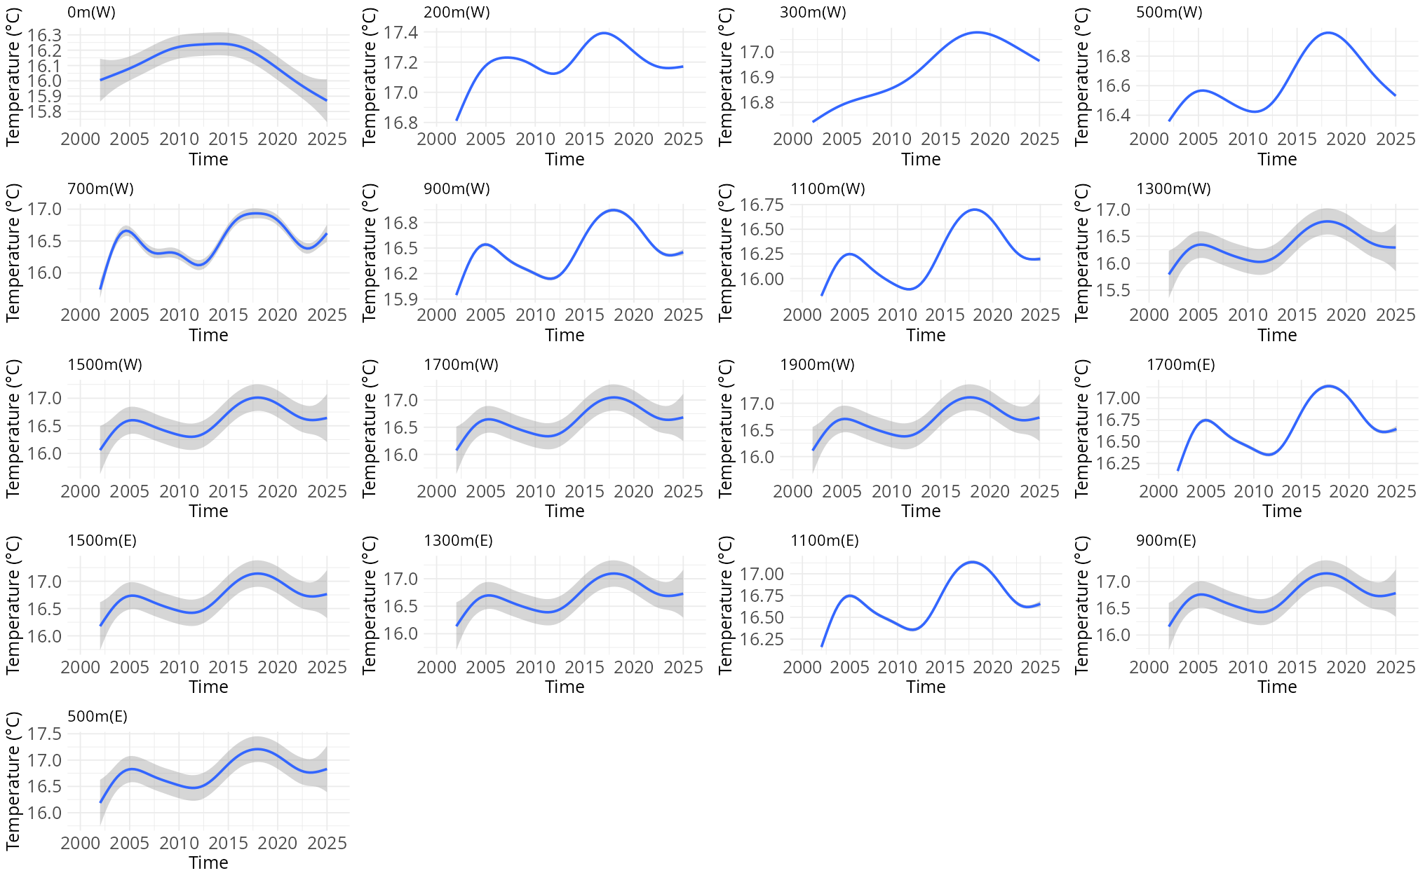Figure S3: Temperature trend over time for (top) ground temperature, and (bottom) air temperature for each site across the transect.
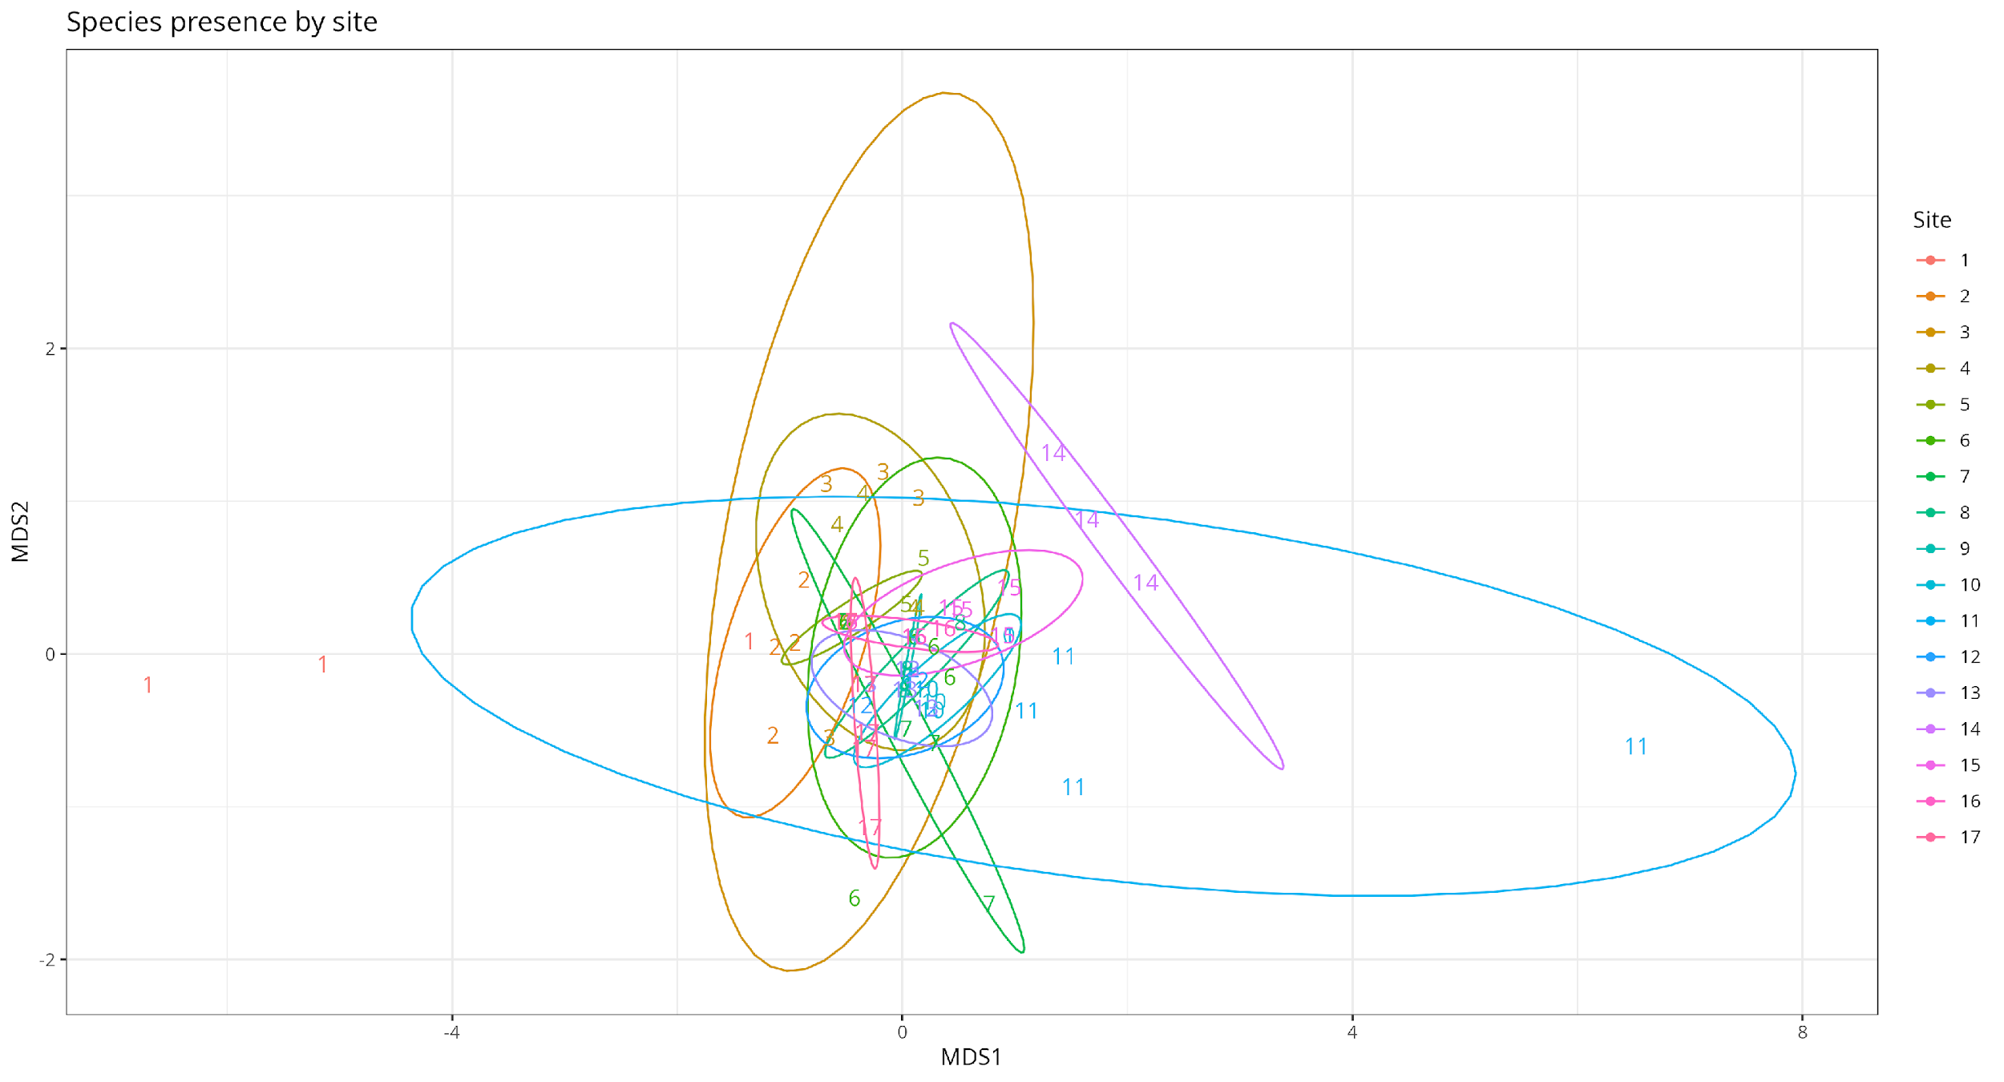
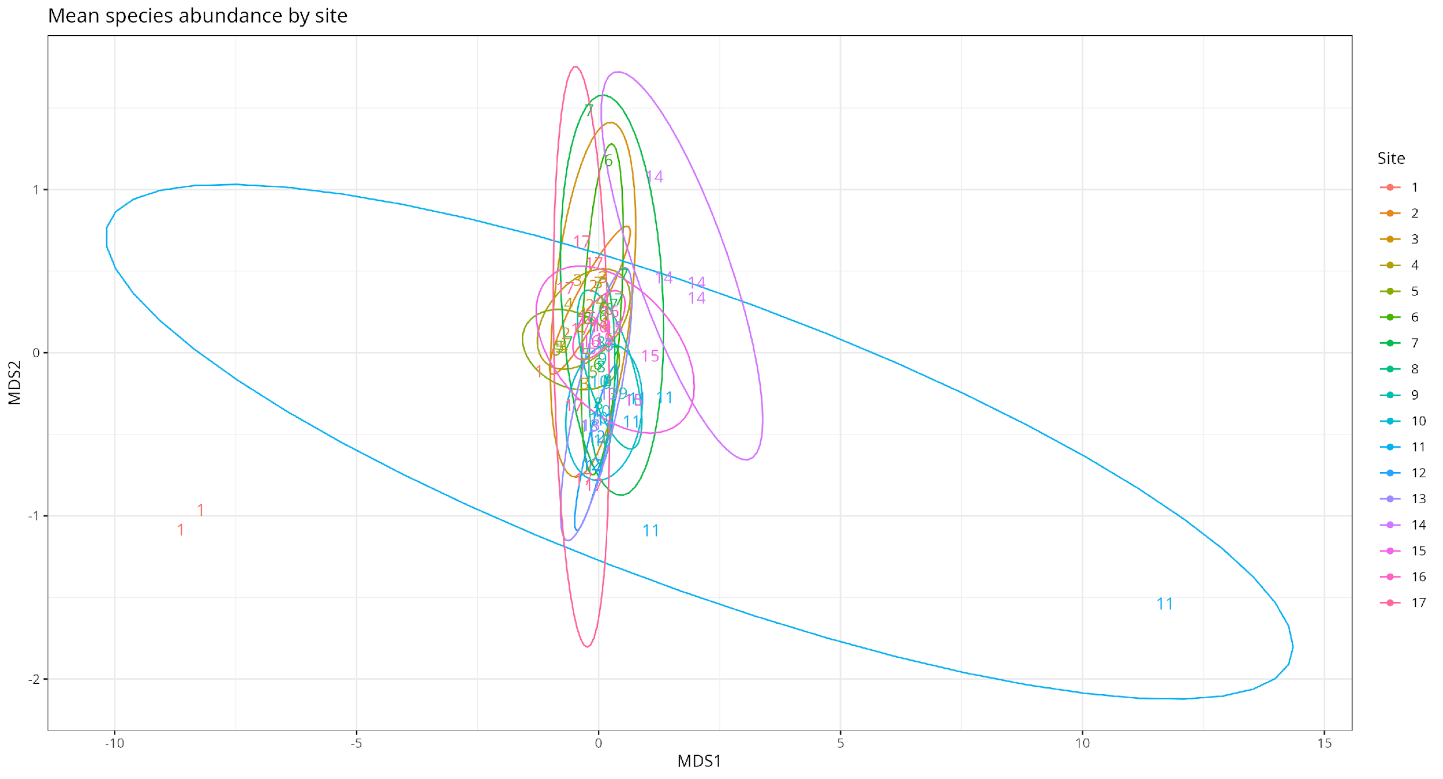
Figure S4: NMDS plot of (a) mean species abundance (stress = 0.1), and (b) species presence (stress = 0.09), compared between the different sites across the altitudinal gradient of the transect.
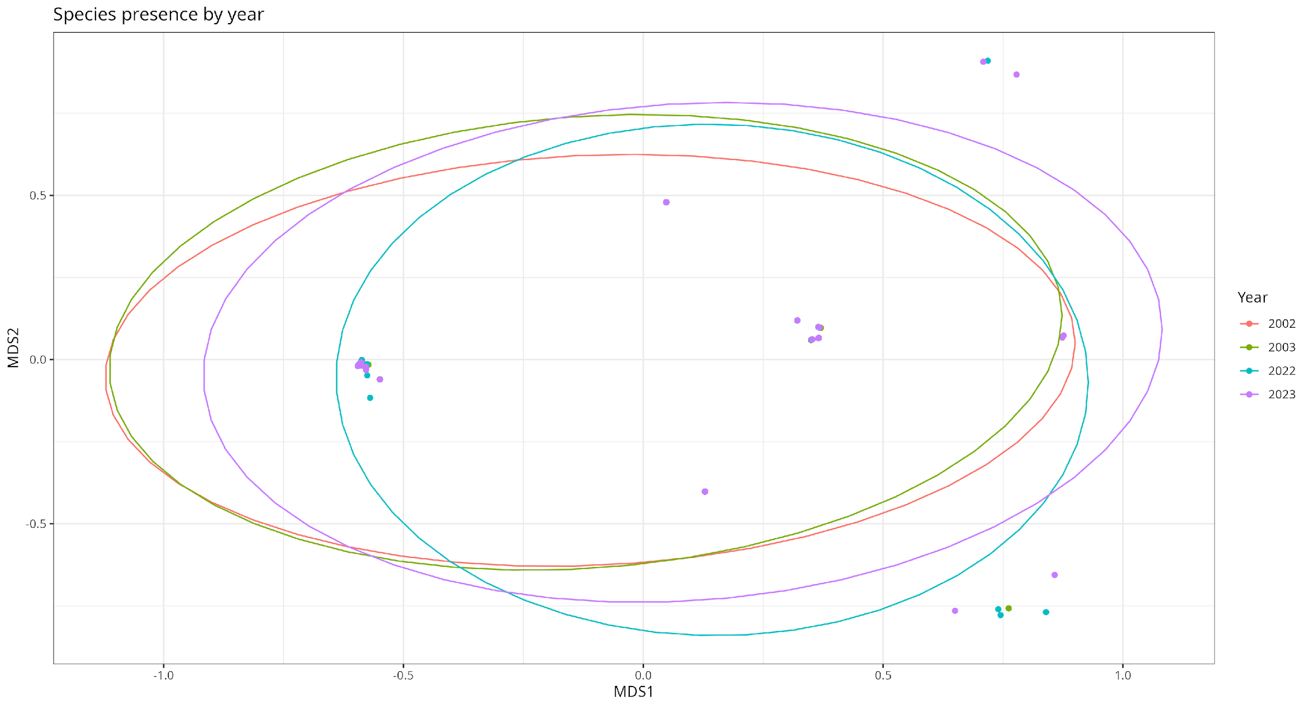
Figure S5: Abundance of the three key species separated by sampling year (stress = 0.16).
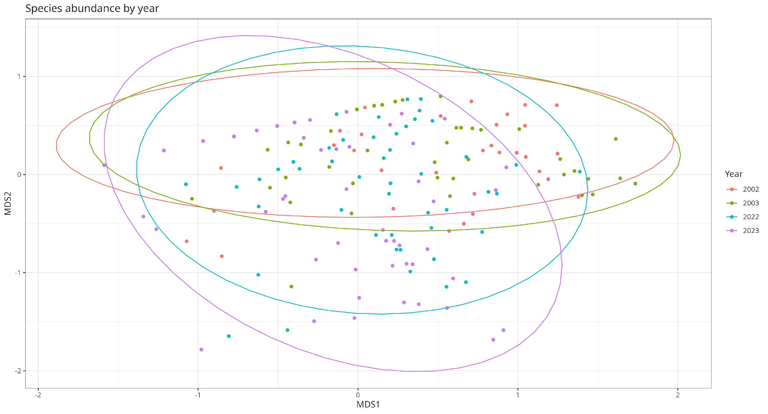
Figure S6: Presence of the three key species separated by sampling year (stress = 1.7e-05).
Figure S7: Sample-based species rarefaction curves of beetle assemblages at (a) sea level to 900m above sea level on the western slope, (b) 1100–1900m above sea level on the western slope, and (c) 1700–500m above sea level on the eastern slope.
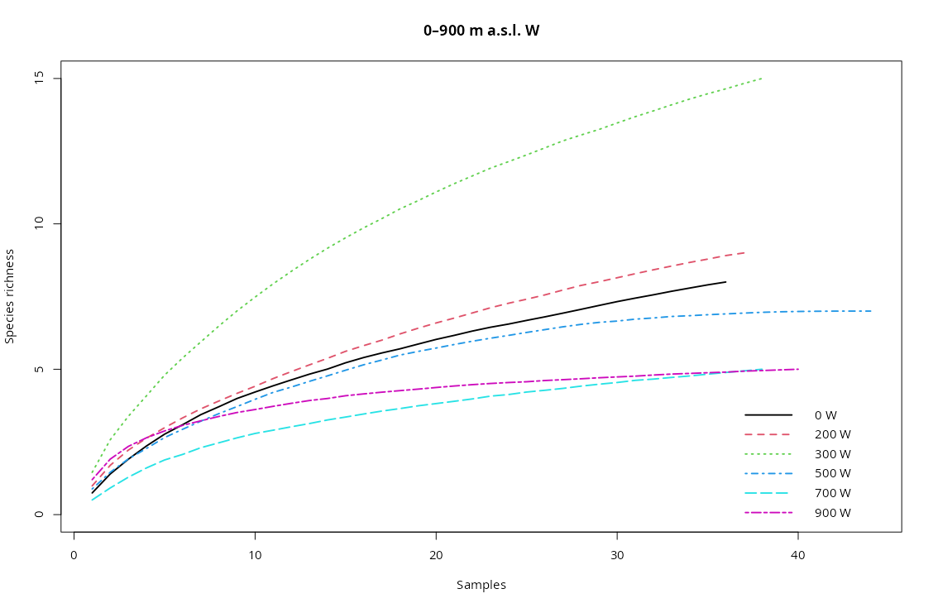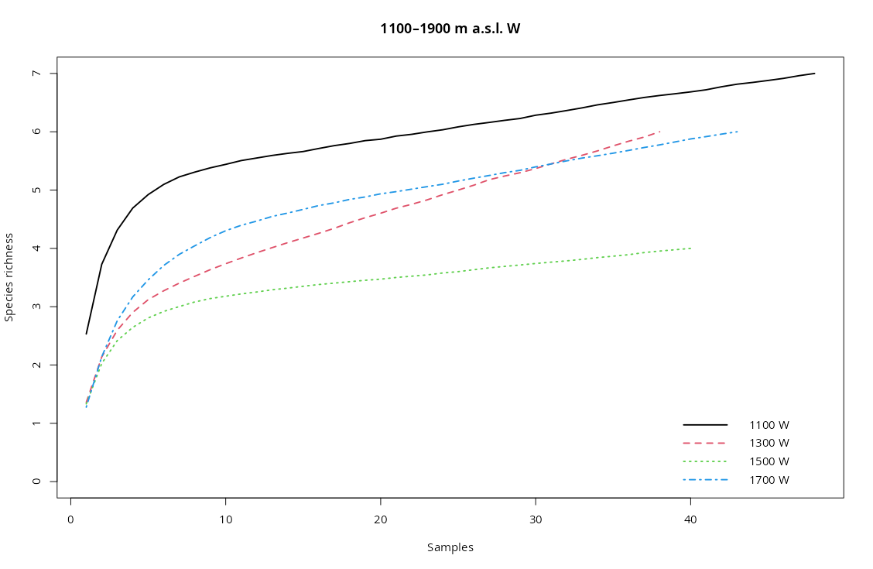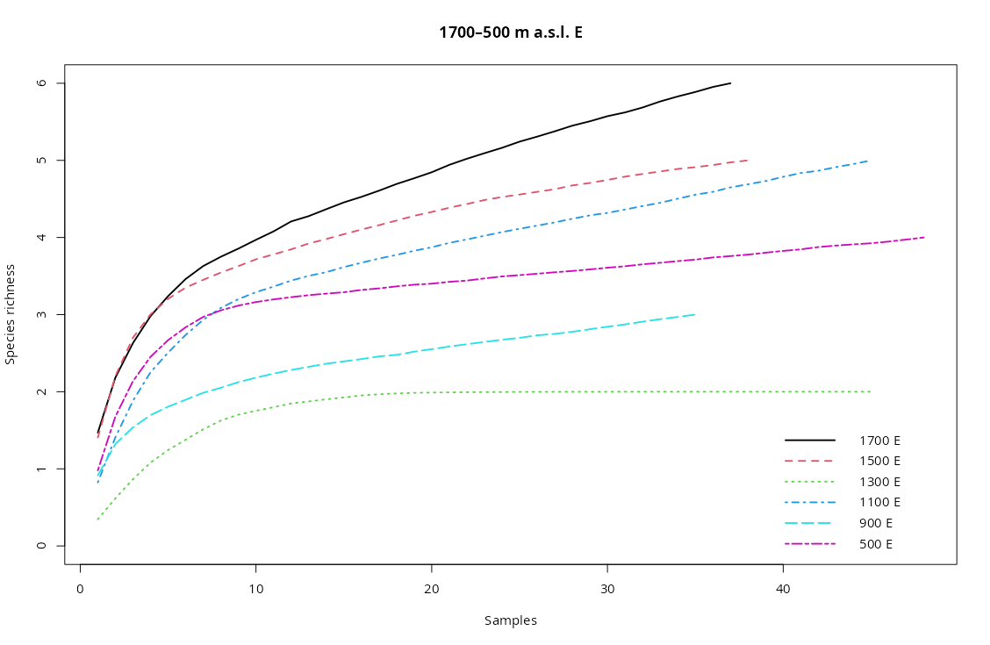
(a)
(c)
(b)
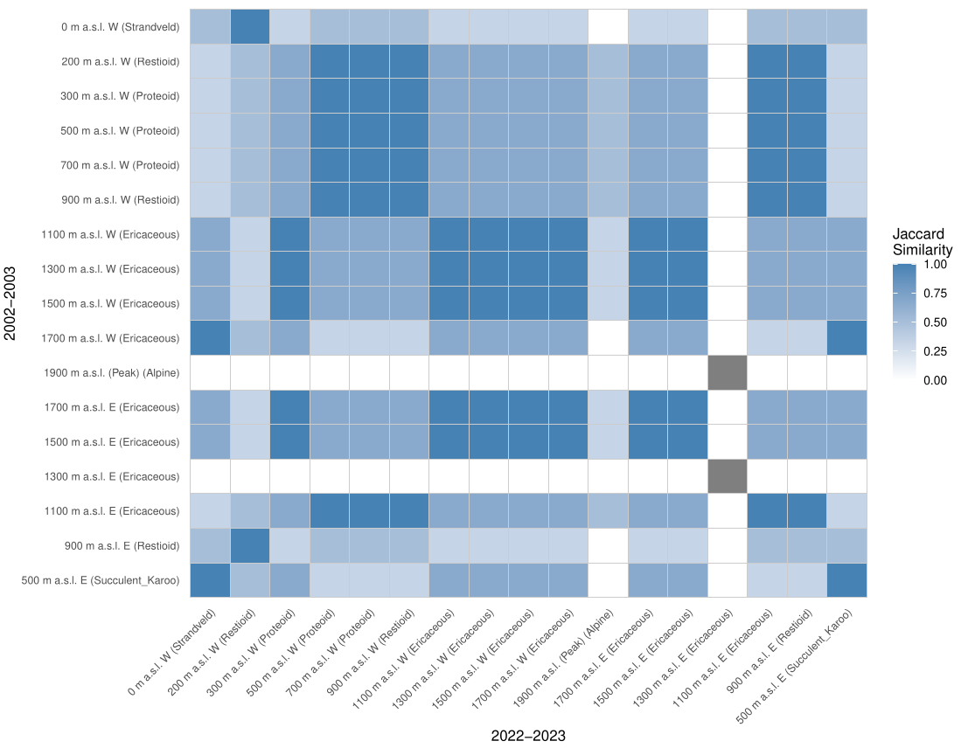
Figure S8: Heatmap of Jaccardian similarities between different altitudinal sites.
Figure S9: Dendrogram showing the hierarchical clustering of the different sites across the transect in both (a) the 2002-2003 sampling period, and (b) the 2022-2023 sampling period.
(b)
(a)
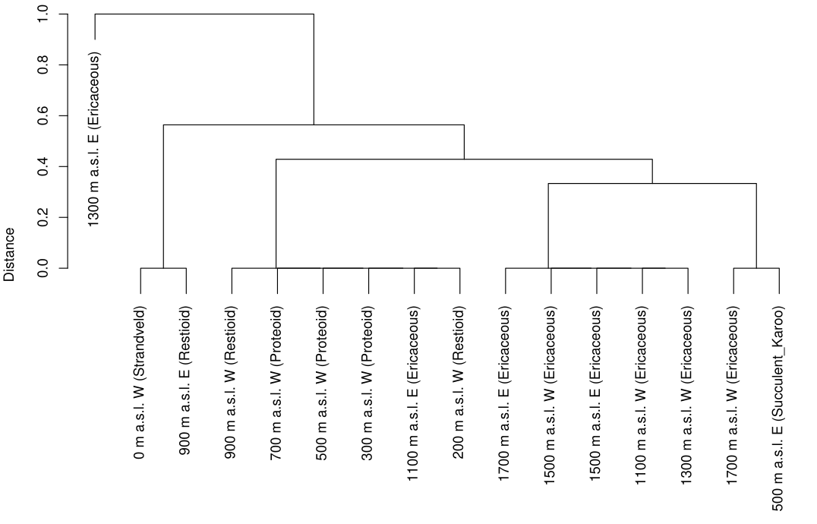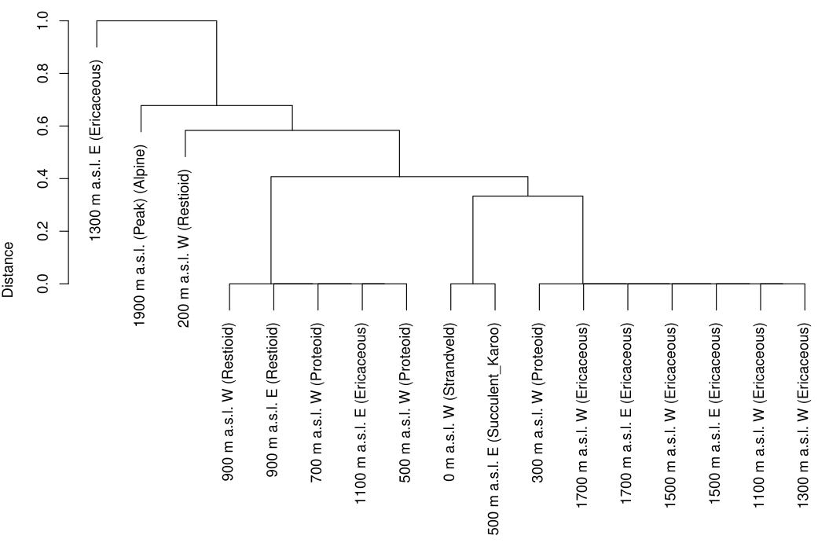
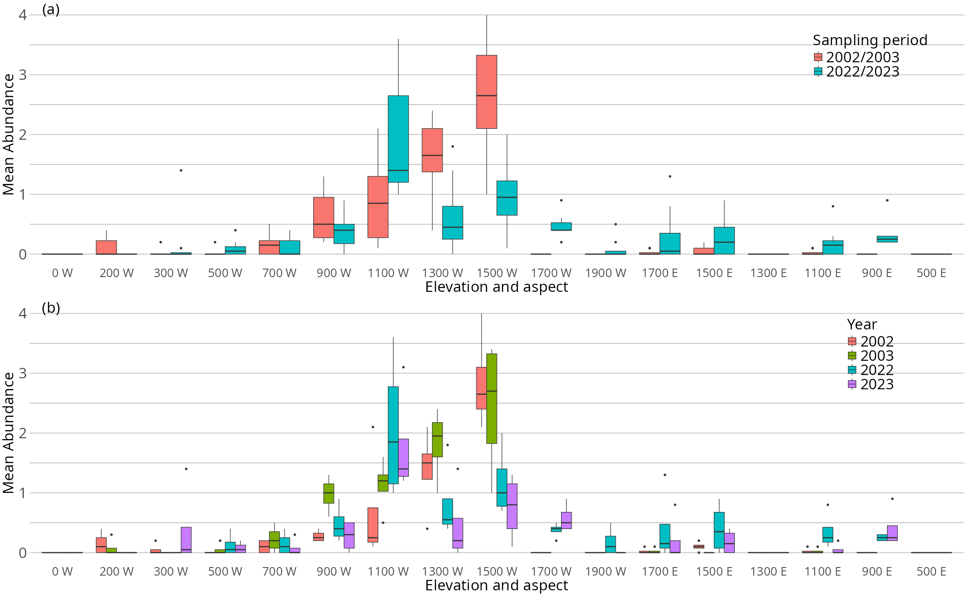
Figure S10: Mean abundance of Anthia decemguttata separated by (a) sampling period, and (b) year, across altitudinal gradient.
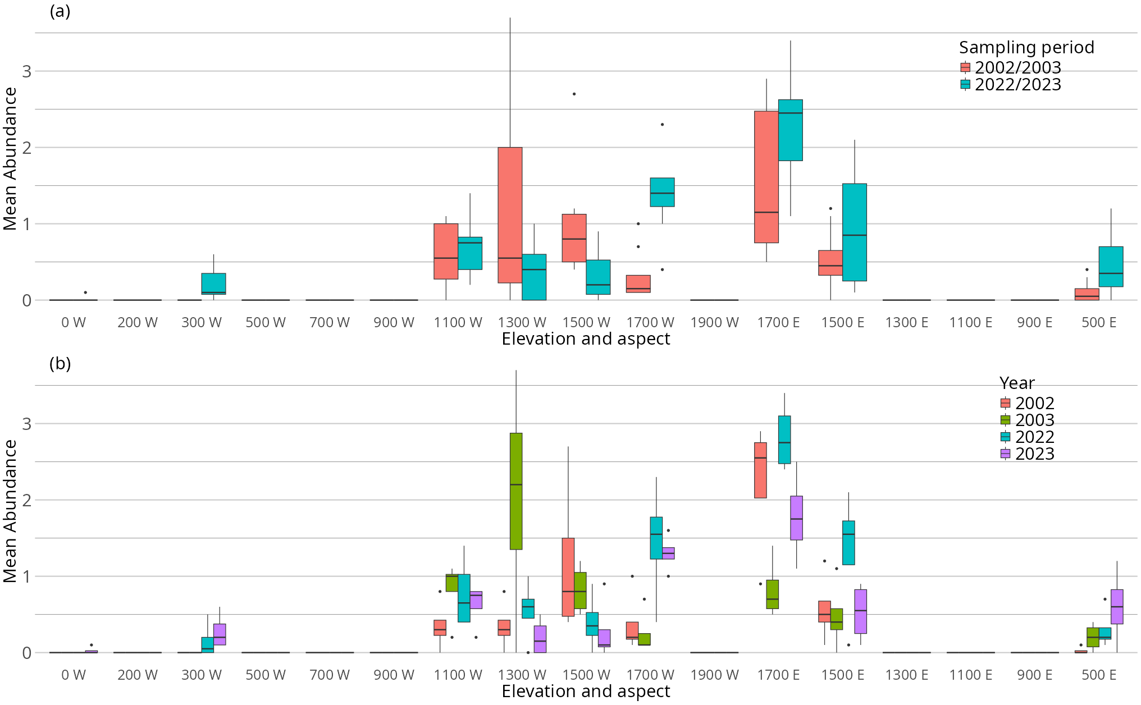
Figure S11: Mean abundance of Stenocara dentata separated by (a) sampling period, and (b) year, across altitudinal gradient.
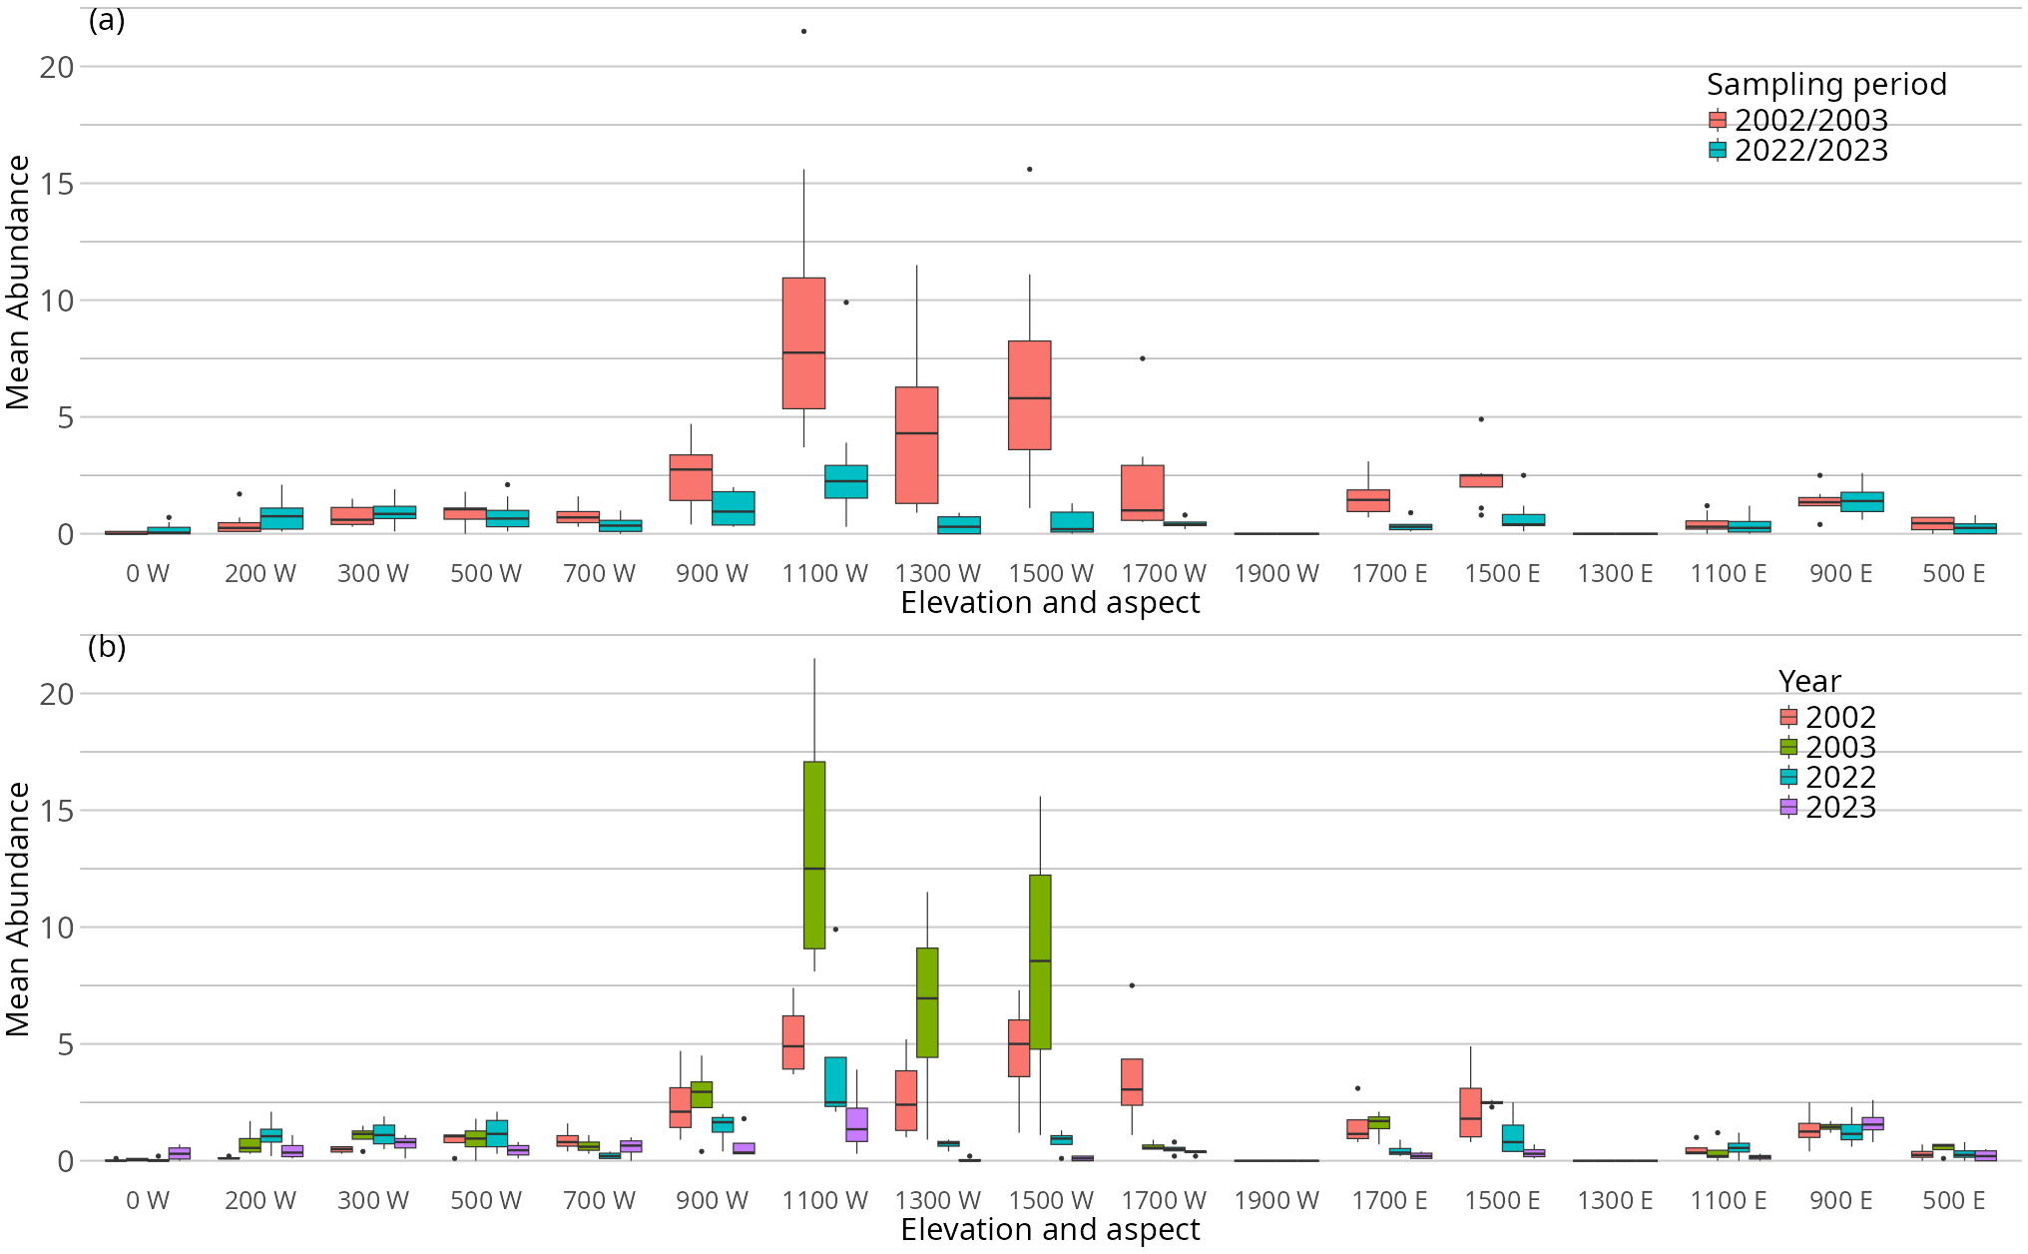
Figure S12: Mean abundance of Zophosis gracilicornis separated by (a) sampling period, and (b) year, across altitudinal gradient.
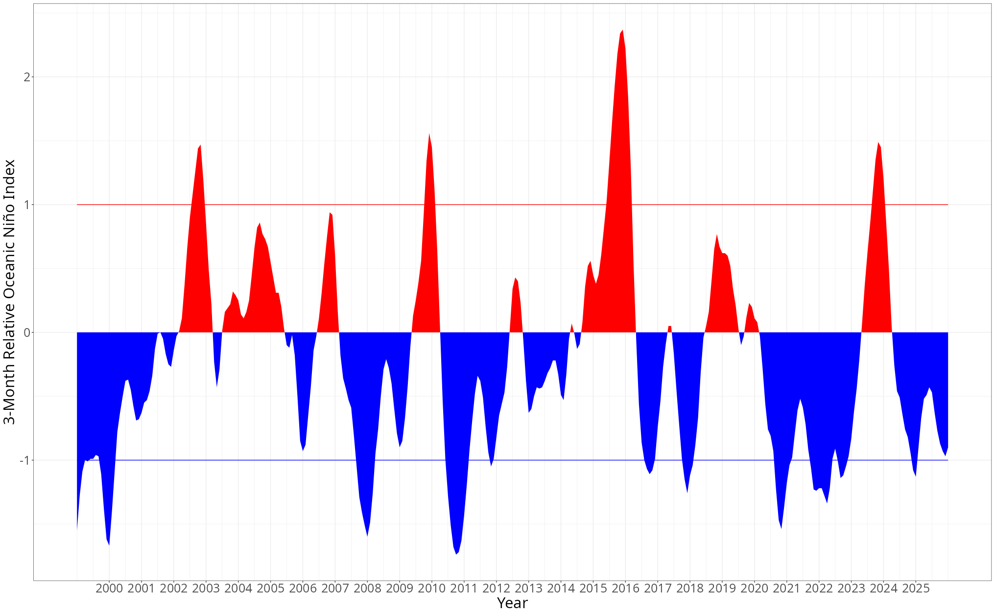
Figure S13: Timeline of El Niño and La Niña events over time. Indices that exceed the red intercept line (y = 1) indicate periods of El Niño, and indices that exceed the blue intercept line (y = -1) indicate periods of La Niña.

