Monad DEX Market Structure
A seven day study of Uniswap v4
Onur Sener | Monad Quantitative Researcher application sample | 13 October 2026
402,062 | 267 | 7,801
Pool Swap events | Active v4 pools | Trading wallet addresses

Scope and purpose
For this application, I present a deliberately focused seven-day study of Monad DEX activity, covering the 3-9 October 2026 UTC period. The study evaluates the quality and concentration of Monad on-chain swap activity, describes liquidity events, and tests whether signed order flow adds any short-horizon information beyond recent returns.
I concentrated the event-level analysis on Uniswap v4, which accounted for 64.72% of the same week's DEX-category volume in the frozen DefiLlama dataset. This produces a manageable research sample for review, while demanding substantive data-engineering and quantitative work.
The objective is to demonstrate a reproducible workflow for
1. extracting blockchain data with ABI decoding,
2. resolving token identities,
3. building structured datasets,
4. calculating market-structure metrics,
5. validating results,
6. and statistical-testing a research hypothesis using Python, SQL, pandas, NumPy.
This report provides a quick first review. You can find the supporting Python/SQL codes, CSV and JSON files, and a detailed methodology under the GitHub repository, whose link is provided in the Monad Quantitative Researcher job application materials, as the answer to the “What experience do you have in HFT or blockchain/crypto space?” question.
The workflow can be extended to longer windows and additional venues upon request.

Principal findings
Activity is concentrated: The five busiest pools account for 72.32% of Monad-chain swaps and 85.95% of estimated USD-equivalent volume.
Wallet address activity is also uneven: Five trading-wallet addresses account for 29.82% of the swap count and 47.15% of volume. 1,127 addresses appear on multiple days inside the sample.
Order flow analysis provides a small improvement in short-term price predictions: My price-prediction model predicts future price changes using recent price movements and pool-specific adjustments.
I then added buying and selling pressure data to see whether predictions improved, by calculating the Mean Squared Error (MSE) for each model. MSE is the average of the squared differences between predicted and actual price changes.
Error reduction (%) = [(Baseline MSE − New Model MSE) / Baseline MSE] × 100

Adding this buying and selling pressure data to my price-prediction model reduced forecasting errors by 1.96% for one-minute predictions and 0.60% for five-minute predictions. However, including additional liquidity measurements beyond 5-minutes did not consistently improve the model's accuracy.
The collected sample uses a specific week’s market-structure and performs an exploratory forecasting exercise. Results are by no means an estimate for persistent ecosystem-wide behavior or demonstrated profitable strategy.
Read pages 3-7 for findings. Page 2 describes validation, page 8 states limitations and reproduction steps. Full methodology, data definitions, and statistical outputs accompany the report.

Data and validation
The study uses events from chain ID 143 (Monad mainnet's unique Chain ID) with the fixed UTC filter 1790985600 <= block_timestamp < 1791590400. The manager address and event signatures are documented in the detailed methodology document.

From raw records to analytical datasets
I used historical pool-creation records (“Initialize” events) to identify each liquidity pool and the tokens traded in it.
Following that, I decoded the raw transaction data and converted token amounts into their actual values using each token's decimal settings.
I arranged all events in chronological order using their block numbers, transaction positions, and event positions. I preserved the original numerical data in its exact form, while using decimal-based calculations for statistical analysis and modeling.
Data lineage
Stage | Observed/reproduced operation
Collection | Goldsky-sourced Monad Uniswap v4 logs in Neon; frozen 7-day export saved in the accompanying reproducibility archive.
Interpretation | Decode Swap and ModifyLiquidity ABI fields;  match Pool IDs to Initialize histories;  attach token contracts and decimal scales.
Quality checks | Validate event/transaction-log uniqueness, pool joins, token scale checks.
Measurement | Build descriptive event/pool/volume tables, observe local liquidity metrics and one-minute signed-flow figures.

Validation item | Verified outcome
Collected manager-event IDs | 409,146 unique records
Observed swap events and pool matching | 402,062 Swaps; 267 of 267 pools matched
Token metadata | 154 ERC-20 contracts plus native MON
Historical decimal checks | 308 of 308 matched
Duplicates and tick-price inconsistencies | Zero in the frozen sample
Independent raw ABI sample | 100 logs; 600 numeric and 200 identity matches
Transaction-origin requests | 301,134 requested transactions; all resolved
Verified swap-origins | 402,062 matches; zero mismatches
Historical sender probe | 51 independently obtained transactions matched

We verified each blockchain address by checking that its transaction details matched the original blockchain records, including transaction IDs, block details, and timestamps.
All verified transactions were successful. We also confirmed that our saved swap and other event records matched the 409,146 events collected in total.

Data quality checks - swap data filters
The 7-day sample data contains 1,163 “hooked” swaps, 352 swaps without matching opposite-amount signs, and 251 swaps reporting zero active liquidity. The source retains these observations but excludes them from trading-volume calculations and forecasting estimates.

Pool activity and trade sizes
A small group of pools accounts for the highest number of executions. The largest MON/USDC pool alone accounts for 32.64% of swaps. Activity peaks on 8 October with 84,165 Swap events.
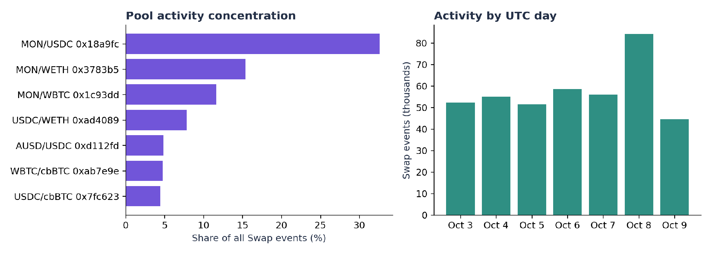
Figure 1. Pool-level Swap counts and daily activity. Counts are decoded Swap events, not users or completed wallet-level trades.

Leading pool | Swap events | Share of all events
MON / USDC (0x18a9fc…) | 131,215 | 32.64%
MON / WETH (0x3783b5…) | 61,852 | 15.38%
MON / WBTC (0x1c93dd…) | 46,820 | 11.65%
USDC / WETH (0xad4089…) | 31,438 | 7.82%
AUSD / USDC (0xd112fd…) | 19,461 | 4.84%

Measure | Swap-count universe | Transaction-volume universe
Included pools | 267 active pools | 189 pools with high volume
Top-five share | 72.32% | 85.95%
Herfindahl–Hirschman Index (HHI) on a 0-10,000 scale | 1,595.8 | 2,107.8
Gini coefficient | 0.9666 | 0.9744

Median trade size in the subset
Out of the 402,062 swaps analyzed, 260,751 involved USDC, USDT0, and AUSD stablecoins as one of the trading pairs. Among these stablecoin swaps, the median trade size was 51.10 units. The largest 10% exceeded 556.38 units, while the largest 1% exceeded 2,190.24 units. These figures represent individual executions within liquidity pools, not necessarily the full size of a trader's order.

The pools with the most trades are not necessarily the ones with the highest trading volumes. This is because a pool that processes many small trades can have more transactions but less total volume, than a pool processing fewer but larger trades. Therefore, examining both the number of trades and their total value gives us a clearer picture of trading activity.
Interpretation: Highly concentrated pool usage does not by itself show weak competition, manipulation, or poor execution quality.

Ecosystem composition
The chart below shows each Monad DEX-venue’s total processed volume throughout the seven-day period. Uniswap v4 represents 64.72% of the entire Monad DEX volume.
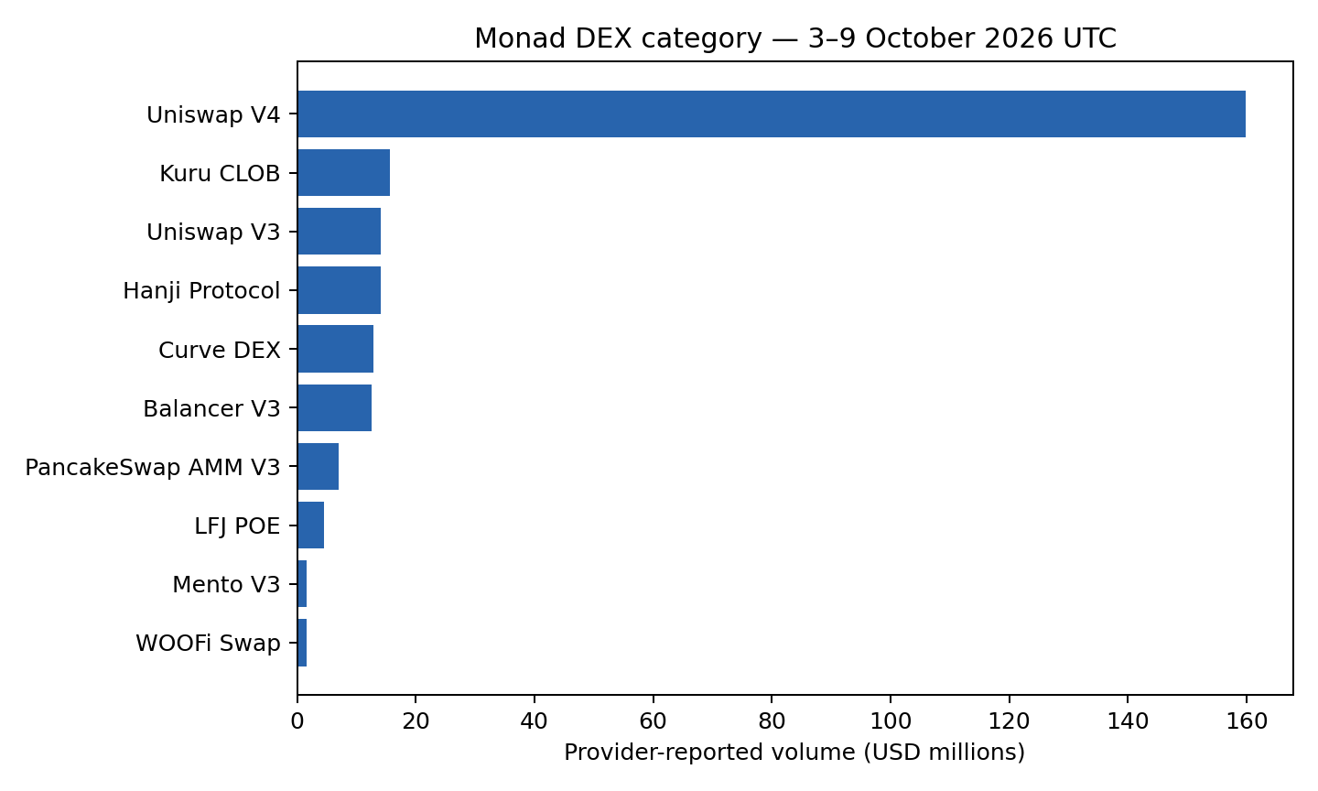
Figure 2. Provider-reported venue aggregates. Event-level decoding in this study is confined to Uniswap v4; other venue totals provide context. Source: DefiLlama
Item | Seven-day figure
Uniswap v4 eligible swap estimate | $157.56m USD-equivalent
Eligible swap coverage | 393,605 / 402,062 = 97.90%
DefiLlama-reported Uniswap v4 volume | $159.88m
DefiLlama-reported Monad Dexs category | $247.03m
Uniswap v4 share of that category | 64.72%

Estimating trading volume in US dollars
I calculated the trading volume in US dollars for the eligible 393,605 swaps (97.90% of all swaps). Together, these trades were worth an estimated $157.56 million.
I assumed that USDC, USDT0, and AUSD are worth exactly $1, so for swaps involving these stablecoins, I directly used their exact amounts. For other major tokens, I used prices recorded on Uniswap v4 within the previous 60 seconds, always using prices from before the swap.
When calculating trading volume, I counted each swap only once.
For example, if someone swapped $100 worth of MON for $100 worth of USDC, I counted it as a $100 trade, not $200. When I could calculate the dollar value of both tokens, I used the average of the two values.
If the two estimated values differed by more than 5%, I excluded that swap from the volume calculation because the price estimate might be unreliable. I also excluded swaps using special contract features ("hooks") or showing unusual token movements.

For the remaining 2.10% of swaps, I couldn't calculate a reliable dollar value. I kept these transactions in our dataset but excluded them from our estimated trading volume.
My $157.56 million Uniswap v4 estimate is 1.45% below DefiLlama's reported $159.88 million for the same week. That difference may come from how trades are priced and counted. Later in this report, I test how our results change when we use different price limits and stablecoin assumptions.

Trading wallets and repeat trading
I matched all 301,134 unique swap transactions with the addresses that originally sent them, which were only 7,801 distinct wallet addresses.
The Swap events themselves showed only 142 different caller addresses. This is because routers and other services can place trades on behalf of many wallets.
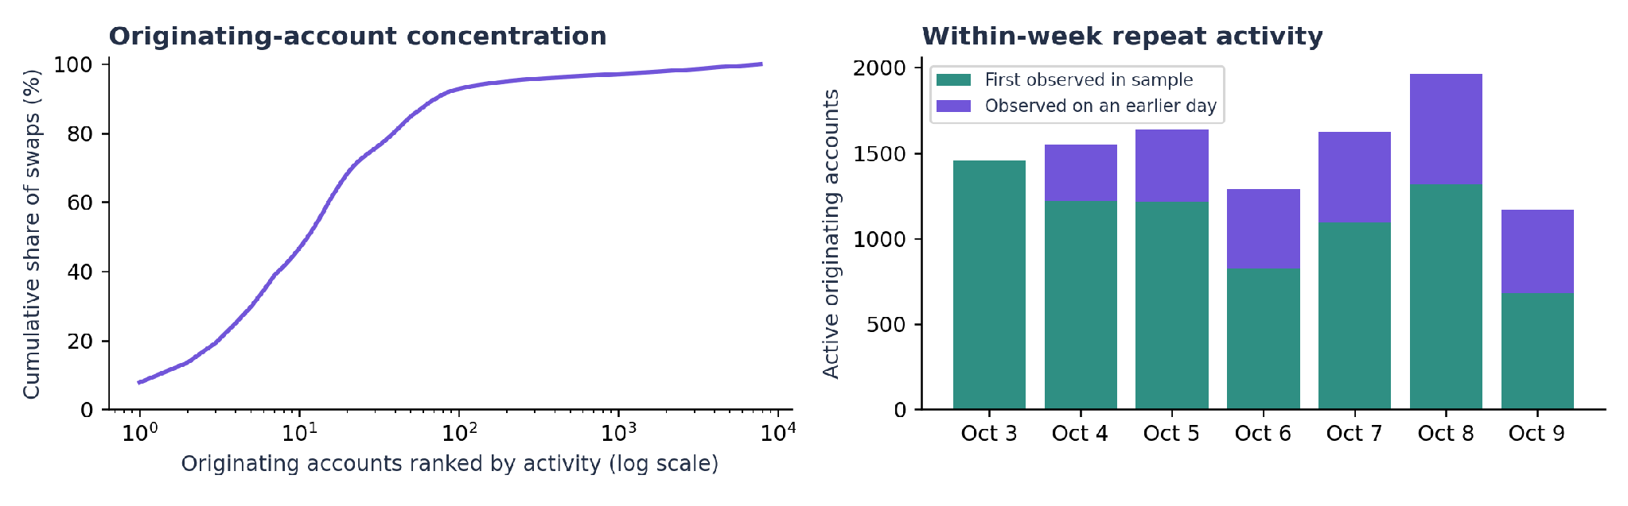
Figure 3. How trading activity is spread across wallet addresses, and how many wallets traded again during the seven-day period. A wallet address does not necessarily represent one single person.
Measure | Result
Share of swaps from five most active blockchain addresses | 29.82%
Share of volume from five highest-volume addresses | 47.15%
Address concentration score (HHI) | 304.7
Addresses active on two or more days | 1,127
Addresses active on all seven days | 178

How often did wallet addresses trade again?
Of the 1,454 addresses we first saw on October 3rd, 492 traded again on a later day (33.84%). I could track these addresses for six more days. Addresses first seen later had less time to return. I could not measure repeat activity for wallets first seen on October 9 as the study ends that day.
"First seen" means the first time we recorded a wallet address during this seven-day study. It does not mean the wallet was newly created or had never traded before. One person may control multiple wallets, and bots or trading services may also be involved.
The results show that a small number of accounts were responsible for a large share of trading, while some accounts traded on multiple days. We cannot tell who owns these addresses, whether they kept trading after the study, or whether any of the volume was artificial.

Liquidity changes and orderflow pressure
I found 6,373 liquidity-change events across 133 pools. Of these, 2,913 added liquidity, 2,551 removed liquidity, and 909 recorded no net liquidity change. I did not reconstruct how much liquidity existed at the start of the week or how liquidity was spread across all price levels.
Each swap event records the liquidity left in its pool immediately after the trade. I used that figure to estimate how much more trading the pool could absorb right around its current price. The formula is in the METHODOLOGY.md file in the GitHub research package.

Can order flows help predict short-term price changes?
I wanted to know if buying and selling activity helps predict a pool's price over the next 1, 5, or 15 minutes.
- I first used recent prices alone.
- Then I added buying/selling pressure.
- Finally, I also added pool liquidity to see if the same buying pressure moves prices more, in pools with less liquidity.
I trained the models on October 3–6 and tested them on October 7–9 using eight pools.
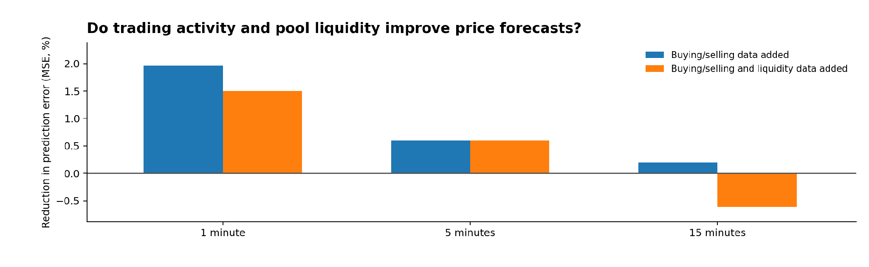
Figure 4. How much each model lowered prediction error compared to forecasts using recent prices alone. Positive = better; negative = worse. These figures are NOT trading profits.
Minutes ahead | Examples for training | Examples for testing | With buying/selling data | With buying/selling and liquidity data
1 min | 8,296 | 7,634 | +1.96% | +1.50%
5 min | 7,781 | 7,193 | +0.60% | +0.60%
15 min | 7,680 | 7,171 | +0.20% | -0.61%

The basic model uses recent prices and allows for differences between pools. Adding buying and selling pressure improved its forecasts slightly. Adding pool liquidity too means checking whether the pool has enough liquidity near its current price to absorb trades, and whether that changes how strongly buying or selling moves the price.
At one minute, buying/selling data lowered mean squared prediction error (MSE) by 1.96% compared to the basic model. Adding liquidity too lowered it by 1.50%. At five minutes, both versions improved MSE by 0.60%. At fifteen minutes, the combined model was 0.61% worse than the basic model.
In short, buying/selling pressure helped a little, but the liquidity data did not consistently improve predictions.
The eight pools included MON, Bitcoin-linked tokens, WETH, and mUSD traded against selected stablecoins. These results measure how well the models predicted later pool prices. I did not test real trading strategies or calculate profits after trading costs.

How does order flow pressure behave under different liquidity levels?
I divided trading into three groups:
- strong buying (more than 75% buying),
- strong selling (more than 75% selling),
- balanced trading (neither side above 75%).
I also grouped the liquidity near each pool’s current price into low, medium, and high levels, using only the October 3–6 training data to set the boundaries.
I then checked the average price change over the following 1, 5 and 15 minutes on October 7–9. The results below show what happened for each combination. A positive number means the price rose on average while a negative number means it fell.
Liquidity | Buy/sell activity | 1 minute | 5 minutes | 15 minutes | 1-min samples
Low | Strong selling | -3.72 bps | -5.38 bps | -7.63 bps | 2,526
Low | Balanced | -1.25 bps | -0.59 bps | +0.06 bps | 1,344
Low | Strong buying | +3.20 bps | +1.95 bps | -1.41 bps | 2,230
Medium | Strong selling | -2.70 bps | -9.58 bps | -14.03 bps | 157
Medium | Balanced | -3.74 bps | -17.65 bps | -56.35 bps | 42
Medium | Strong buying | +0.98 bps | -2.13 bps | -7.33 bps | 198
High | Strong selling | -2.70 bps | -6.11 bps | -11.48 bps | 548
High | Balanced | -0.97 bps | -3.46 bps | -11.28 bps | 120
High | Strong buying | +1.84 bps | +1.20 bps | -4.03 bps | 469
Example: With low liquidity, strong buying was followed by an average 1-minute rise of 3.20 basis points, while strong selling was followed by a fall of 3.72 basis points. (One basis point = 0.01%.)
Important: This does not prove that low liquidity caused a larger price move. About 80% of the test observations fell in the low-liquidity group, and several pools had too few observations in other groups for a fair comparison. The results are preliminary, not a tested trading strategy.
The last column on the table above shows the number of observations for the 1-minute test whereas the 5- and 15-minute tests have slightly different counts. Full counts, results by pool, and the Python test are included in NINE_GROUP_METHODOLOGY.md and results/regime_tests/ in the GitHub research package.

Checking the reliability of results
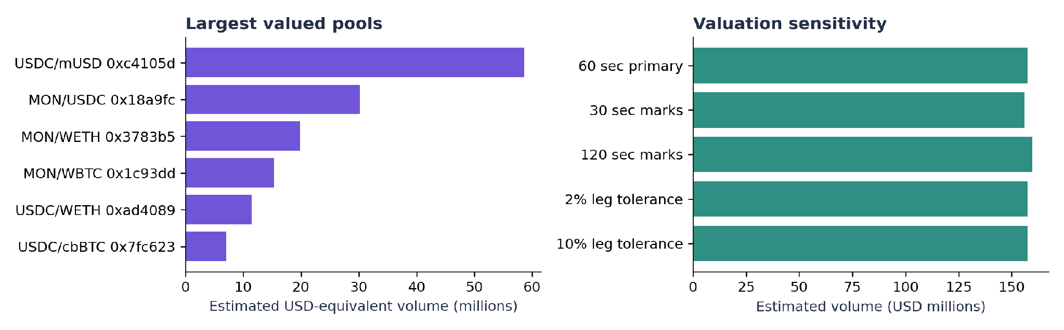
Figure 5. Pools with the highest trading volume, and how our totals change when we allow newer or older token prices. The stablecoin price changes are hypothetical tests, not observed market moves.
Price age limit | Swaps valued | Estimated volume | Share of top five pools
60 sec (main) | 393,605 | $157.56m | 85.95%
30 sec | 388,606 | $155.90m | 86.47%
120 sec | 396,980 | $159.48m | 85.03%

I wanted to see whether using newer or older token prices would significantly change my trading-volume estimates.

When I used token prices recorded within the previous 30 seconds, the estimated trading volume was $155.90 million, with the five largest pools accounting for 86.47% of it.

When I allowed prices from up to 120 seconds earlier, the estimated volume increased to $159.48 million, while the five largest pools accounted for 85.03%.

Both calculations showed the same general result: Most trading volume was concentrated in just a few pools.

How reliable are our price predictions?
I wanted to check whether the small improvements in price predictions were consistent across different pools, or whether the results depended on which pools we tested.
I repeated the statistical checks using 18 four-hour blocks from our three-day testing period. This is a small sample, so the findings are preliminary.
The table below compares the detailed model (recent prices, buy/sell pressure and nearby liquidity) with the basic model (recent price changes, with an adjustment for each pool).
Pools included | 1 minute | 5 minutes | 15 minutes
All eight pools | +1.50% | +0.60% | −0.61%
Busiest MON/USDC pool | −0.12% | +0.19% | −1.37%
Without busiest pool | +3.57% | +1.18% | +0.77%
A positive percentage means that the detailed model made more accurate predictions, while a negative percentage means it performed worse. These are changes in mean squared prediction error, not trading profits.
The busiest MON/USDC pool showed weaker results at one and fifteen minutes. The model also struggled with the relatively stable USDC/mUSD pool. Our separate statistical tests found that the fifteen-minute improvements were particularly uncertain.
Overall, buying/selling pressure offered a small improvement, but adding liquidity did not consistently help. The results changed considerably depending on which pools we included.
For Monad, it is useful to track the busiest pools and compare swap counts, total dollar volume, and wallet addresses separately. Future research could cover more trading days, test models for specific tokens, and rebuild the pools' full liquidity data. These are research suggestions, not proven causes or trading recommendations.

Limitations and how to reproduce the study
Time period: We studied only seven days. Trading behavior may change over weeks, months and under different market conditions. Even with hundreds of thousands of swaps, we do not have hundreds of thousands of independent tests.
Data coverage and wallet identities: We have not checked every event against a second blockchain-data provider. For other DEXs, we used reported total volumes rather than individual trades. One wallet address may represent a person, bot, or service. The short observation period also limits what we can say about how often wallets return.
Prices and liquidity: We assumed USDC, USDT0, and AUSD were worth $1 each. For some other tokens, we used recent prices from Uniswap v4, without fully checking them against independent USD market prices. More historical pool data is needed to calculate total value locked (TVL) and exactly how much could be traded at different prices.
Price predictions: We tested the models on just three days of new data, and accuracy differed across pools. We did not calculate trading fees, gas costs, slippage or actual profits. A small reduction in prediction error does not prove a profitable strategy.

How to check or repeat the research
The GitHub repository includes saved data, Python and SQL code, six charts, supporting CSV and JSON tables, file checksums to confirm the inputs have not changed, and a detailed methodology.
To reproduce the analysis, install the Python packages in requirements.txt, then run python verify_package.py and python run_research.py. Everything runs offline: no Goldsky account, Neon access or paid data subscription is needed.
For a quick overview, start with this report.
For more detail, see METHODOLOGY.md, DATA_DICTIONARY.md, the data-validation results, and the forecast results for each pool. Some larger tables are created when the code runs.

Sources and dates covered
[1] Main swap and wallet datasets. Exported from the Goldsky-to-Neon workflow. The package includes the original numerical values, verified transaction identifiers and saved token information.
[2] Monad official token list. Open source
[3] Monad Uniswap deployment registry. Open source
[4] Uniswap v4 event definitions. Open source
[5] Uniswap v4 pool implementation. Open source
[6] Monad RPC documentation. Open source
[7] DefiLlama API documentation. Open source
The saved daily DefiLlama volume figures and the full data link are listed in METHODOLOGY.md. All DEX comparisons cover October 3–9, 2026 (UTC). This report was prepared on October 13, 2026.
The same methods can be used to study longer time periods and additional DEXs if needed. The data and code already included are enough for someone else to check and reproduce this report.

