1. What is Web 3.0?

Web 3.0 is the third generation of Internet services connecting each other decentralized to bring the best user experiences and personally. Web 3.0 was built from AI, machine learning, Semantic Web, it uses the confidential blockchain system to keep data safe and confidential.

Web 3.0 can change the Internet.

Highlights of Web 3.0:

Semantic Web: The content of the web will be displayed based on effectively analyzing the meaning of words.

Artificial Intelligent (AI): Web 3.0 uses artificial intelligence to provide more accurate results faster through natural language processing where computers and machines will understand information more like humans.

Graphic 3D – Metaverse: Three-dimensional design will be used in websites and services to provide a clear visual image to users. Examples: museum tour guides, computer 3D games, Metaverse - human virtual worlds …

Without middlemen: Data and transactions are shared directly through a decentralized network, eliminating the need for a middleman like Google or tightly controlled payment systems like a bank.

Stop data breaches: You'll be in charge of the data. A hacker cannot manage your data unless he also has complete control over the blockchain network. Big businesses cannot modify or benefit from the sale of your data to third parties.

Data will exist forever: If you ever learn about blockchain, you will realize that no one has the right to view or remove any of your loving games, text messages, or other Web 3.0 data as long as the internet is operational. Similar to this, network services won't be dependent on servers or management firms; instead, they'll keep running as long as there are still users.

Information is transparent and trusted: Thanks to Web 3.0 blockchain technology, which also guarantees the security and privacy of user data and protects identity.

Web3 (also known as Web 3.0) is an idea for a new iteration of the [World Wide Web](https://en.m.wikipedia.org/wiki/World_Wide_Web) which incorporates concepts such as [decentralization](https://en.m.wikipedia.org/wiki/Decentralization), [blockchain technologies](https://en.m.wikipedia.org/wiki/Blockchain), and token-based economics. Some technologists and journalists have contrasted it with [Web 2.0](https://en.m.wikipedia.org/wiki/Web_2.0), wherein they say data and content are centralized in a small group of companies sometimes referred to as "[Big Tech](https://en.m.wikipedia.org/wiki/Big_Tech)".[[5]](https://en.m.wikipedia.org/wiki/Web3#cite_note-:0-5) The term "Web3" was coined in 2014 by [Ethereum](https://en.m.wikipedia.org/wiki/Ethereum) co-founder [Gavin Wood](https://en.m.wikipedia.org/wiki/Gavin_Wood), and the idea gained interest in 2021 from [cryptocurrency](https://en.m.wikipedia.org/wiki/Cryptocurrency) enthusiasts, large technology companies, and [venture capital](https://en.m.wikipedia.org/wiki/Venture_capital) firms. Though the concepts of Web3 were first represented in 2013.

Some[[who?](https://en.m.wikipedia.org/wiki/Wikipedia:Manual_of_Style/Words_to_watch#Unsupported_attributions)] have expressed concerns over the [centralization of wealth](https://en.m.wikipedia.org/wiki/Distribution_of_wealth) to a small group of investors and individuals,[[9]](https://en.m.wikipedia.org/wiki/Web3#cite_note-:9-9) or a loss of privacy due to more expansive data collection.[[10]](https://en.m.wikipedia.org/wiki/Web3#cite_note-:11-10) Others, such as [Elon Musk](https://en.m.wikipedia.org/wiki/Elon_Musk) and [Jack Dorsey](https://en.m.wikipedia.org/wiki/Jack_Dorsey), have argued that Web3 only serves as a [buzzword](https://en.m.wikipedia.org/wiki/Buzzword) or marketing term.

[Web 1.0](https://en.m.wikipedia.org/wiki/Web_1.0) and [Web 2.0](https://en.m.wikipedia.org/wiki/Web_2.0) refer to eras in the [history of the World Wide Web](https://en.m.wikipedia.org/wiki/History_of_the_World_Wide_Web) as it evolved through various technologies and formats. Web 1.0 refers roughly to the period from 1989 to 2004, where most sites consisted of [static pages](https://en.m.wikipedia.org/wiki/Static_web_page), and the vast majority of users were consumers, not producers of content.[[14]](https://en.m.wikipedia.org/wiki/Web3#cite_note-14)[[15]](https://en.m.wikipedia.org/wiki/Web3#cite_note-15) Web 2.0 is based around the idea of "the web as platform" and centers on user-created content uploaded to [forums](https://en.m.wikipedia.org/wiki/Internet_forum), [social media](https://en.m.wikipedia.org/wiki/Social_media) and networking services, [blogs](https://en.m.wikipedia.org/wiki/Blog), and [wikis](https://en.m.wikipedia.org/wiki/Wiki), among other services. Web 2.0 is generally considered to have begun around 2004 and continues to the current day.

In the beginning, there was the internet: the physical infrastructure of wires and servers that lets computers, and the people in front of them, talk to each other. The U.S. government’s ARPANET sent its first message in 1969, but the web as we know it today didn’t emerge until 1991, when HTML and URLs made it possible for users to navigate between static pages. Consider this the read-only web, or Web1.

In the early 2000s, things started to change. For one, the internet was becoming more interactive; it was an era of user-generated content, or the read/write web. Social media was a key feature of Web2 (or Web 2.0, as you may know it), and Facebook, Twitter, and Tumblr came to define the experience of being online. YouTube, Wikipedia, and Google, along with the ability to comment on content, expanded our ability to watch, learn, search, and communicate.

The Web2 era has also been one of centralization. Network effects and economies of scale have led to clear winners, and those companies (many of which are listed above) have produced mind-boggling wealth for themselves and their shareholders by scraping users’ data and selling targeted ads against it. This has allowed services to be offered for “free,” though users initially didn’t understand the implications of that bargain. Web2 also created new ways for regular people to make money, such as through the sharing economy and the [sometimes lucrative](https://www.businessinsider.com/how-much-money-instagram-influencers-earn-examples-2021-6) job of [being an influencer](https://www.cnbc.com/2021/04/30/how-much-money-you-can-make-off-social-media-following-calculator.html).

There’s plenty to critique in the current system: The companies with concentrated or near-monopoly power have often failed to wield it responsibly, consumers who now realize that they are the product are becoming increasingly uncomfortable with ceding control of their personal data, and [it’s possible that](https://techcrunch.com/2019/05/31/targeted-ads-offer-little-extra-value-for-online-publishers-study-suggests/) [the targeted-ad](https://www.wired.com/story/ad-tech-could-be-the-next-internet-bubble/) [economy](https://www.thenation.com/article/culture/qa-tim-hwang-subprime-attention-crisis/)is a fragile bubble that does little to actually boost advertisers. As the web has grown up, centralized, and gone corporate, many have started to wonder whether there’s a better future out there.

Which brings us to Web3. Advocates of this vision are pitching it as a roots-deep update that will correct the problems and perverse incentives of Web2. Worried about privacy? Encrypted wallets protect your online identity. About censorship? A decentralized database stores everything immutably and transparently, preventing moderators from swooping in to delete offending content. Centralization? You get a real vote on decisions made by the networks you spend time on. More than that, you get a stake that’s worth something — you’re not a product, you’re an owner. This is the vision of the read/write/own web.

Web 1.0: Read-Only (1990-2004)

In 1989, at CERN, Geneva, Tim Berners-Lee was busy developing the protocols that would become the World Wide Web. His idea? To create open, decentralized protocols that allowed information-sharing from anywhere on Earth.

The first inception of Berners-Lee's creation, now known as 'Web 1.0', occurred roughly between 1990 to 2004. Web 1.0 was mainly static websites owned by companies, and there was close to zero interaction between users - individuals seldom produced content - leading to it being known as the read-only web.

[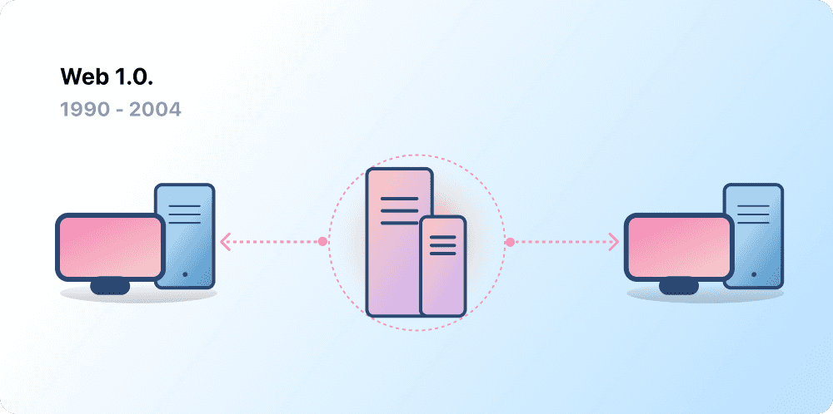](https://ethereum.org/static/aabd6f7a956dd8a7038185b2d03b8459/00d43/web1.png)

Comparison

Web 2.0: Read-Write (2004-now)

The Web 2.0 period began in 2004 with the emergence of social media platforms. Instead of a read-only, the web evolved to be read-write. Instead of companies providing content to users, they also began to provide platforms to share user-generated content and engage in user-to-user interactions. As more people came online, a handful of top companies began to control a disproportionate amount of the traffic and value generated on the web. Web 2.0 also birthed the advertising-driven revenue model. While users could create content, they didn't own it or benefit from its monetization.

[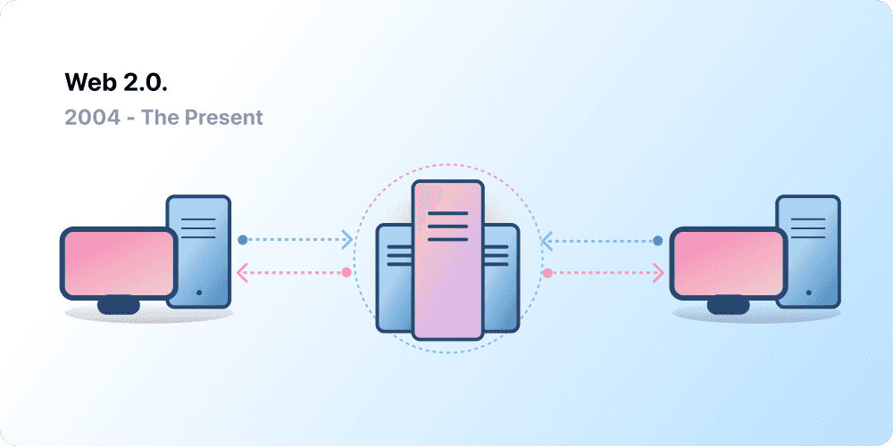(opens in a new tab)↗](https://ethereum.org/static/9f50d47733edad715c3068c4c6a8bc6d/00d43/web2.png)

Web 3.0: Read-Write-Own

The premise of 'Web 3.0' was coined by [Ethereum](https://ethereum.org/en/what-is-ethereum/) co-founder Gavin Wood shortly after Ethereum launched in 2014. Gavin put into words a solution for a problem that many early crypto adopters felt: the Web required too much trust. That is, most of the Web that people know and use today relies on trusting a handful of private companies to act in the public's best interests.

### Evolution of the web

If it comes to pass, Web 3.0 will be the successor to two previous generations of the web.

The first generation, referred to as Web 1.0, was invented in 1989 by Tim Berners-Lee, a British computer scientist who applied the hypertext concepts for linking digital text proposed in 1963 by Ted Nelson, an American information technology pioneer. Besides programming the first browser, Berners-Lee wrote the Hypertext Markup Language ([HTML](https://www.theserverside.com/definition/HTML-Hypertext-Markup-Language)), which tells browsers how to display content, as well as the Hypertext Transfer Protocol ([HTTP](https://www.techtarget.com/whatis/definition/HTTP-Hypertext-Transfer-Protocol)) specifying how web servers transfer files to browsers. He also started designing software for a "Semantic Web" that would link data across web pages, but hardware constraints prevented its implementation.

The public was not much aware of the web until 1993 with the release of Mosaic, the first popular browser, later renamed Netscape Navigator. Similar user-friendly graphical browsers followed, including Microsoft Internet Explorer and, much later, Apple Safari. The first popular search engines -- familiar names like Yahoo! Search, Lycos and AltaVista -- arrived on the scene, but by 2004 Google had put many of them out of business.

Around the turn of the millennium, experts began promoting the idea of an upgraded web that would be more interactive, calling it [Web 2.0](https://www.techtarget.com/whatis/definition/Web-20-or-Web-2). They started referring to the existing web of basic connectivity to mostly static websites as Web 1.0. Berners-Lee fleshed out his Semantic Web concept by co-authoring an article in Scientific American. Publisher Tim O'Reilly helped promote Web 2.0 by starting a conference dedicated to it.

The dream of an interactive web came to fruition several years later with the skyrocketing popularity of social networks like Facebook. The World Wide Web Consortium, the web's standards body, released a Semantic Web standard. Around the same time, two essential Web 3.0 technologies were born: cryptocurrency and blockchain. Prominent journalists and technologists, including Gavin Wood, co-founder of Ethereum, a prominent blockchain platform, began to popularize the terms Web 3.0 and Web 3 to signify a decentralized, semantically aware version of the web.

### Why is Web 3.0 important?

If decentralizing the web's architecture delivers even a portion of the benefits promised by Web 3.0 proponents, it could fundamentally alter how people interact on the web and how companies make money from goods and services.

Web 2.0 giants like Amazon, Google and Facebook parent Meta grew quickly by collecting and centralizing petabytes of customer data and monetizing it in myriad ways. Web 3.0's global peer-to-peer network could be the great leveler that makes it hard for such companies to grow by hoarding data. Individuals will have more control over web content and who can access and profit from their personal data.

[Web 3.0 business](https://www.techtarget.com/whatis/feature/What-does-Web-30-mean-for-your-business) opportunities, by contrast, are likely to center around exploiting this new ability to tailor web products and services to the individual. For example, [Web 3.0 marketing](https://www.techtarget.com/searchcio/tip/5-ways-Web-30-will-impact-digital-marketing) capabilities could help companies strike a better balance between privacy and personalization than is possible with today's web. The downside: They may find Web 3.0's strong privacy protections a barrier to how they already do digital marketing.

The greater transparency provided by immutable blockchain ledgers could improve customer service, as both parties have access to the record of their transactions. Businesses could more easily monitor their supply chains by using decentralized apps to break down data silos and see suppliers' activities. Sharing real-time information among supply chain participants could reduce shortages and speed up deliveries.

Web 3.0 is also important as the infrastructure for the [metaverse](https://www.techtarget.com/whatis/feature/The-metaverse-explained-Everything-you-need-to-know), a proposed 3D virtual world in which digital representations of people, called avatars, interact and conduct business. The metaverse, like Web 3.0, doesn't exist yet, and it will likewise rely on blockchain or a comparable decentralized technology for its data infrastructure and finances, as well as on AI to make it more responsive to the wishes of users.

The metaverse and Web 3.0 are interdependent at the technical and conceptual levels and, therefore, likely to evolve in tandem. The metaverse probably won't come to pass until its Web 3.0 underpinnings are firmly established.