E-Commerce Sales Performance Analysis
Comprehensive Analytical Report
Dataset: Kaggle E-Commerce Dataset | Period: December 2010 – December 2011 | Prepared by: Happy Anwuli
541,909  Raw Records | 397,884  Valid Transactions | 4,338 Customers | 3,665  SKUs | 37  Countries | £8.9M  Total Revenue

1. Executive Summary
This report presents a comprehensive end-to-end analysis of an e-commerce retailer's sales performance over a 13-month period (December 2010 to December 2011). Using 397,884 validated transactions from the Kaggle E-Commerce Retail dataset, the analysis examines revenue trends, customer segmentation, product performance, and retention dynamics.
The business generated £8.9 million in revenue across 4,338 unique customers in 37 countries. Growth was strong throughout 2011, with a pronounced Q4 seasonal peak driven by holiday purchasing behaviour. Three critical strategic challenges emerge from the analysis: heavy geographic concentration (83% of revenue from the UK), low first-month customer retention (~20–25%), and a high proportion of customers who make only a single purchase.

2. Methodology

2.1 Data Source
The dataset is the UCI Machine Learning Repository Online Retail dataset (Kaggle - E-commerce Data.) a widely used benchmark e-commerce dataset containing invoice-level transaction records from a UK-based online gift and homewares retailer.

2.2 Data Preparation
The raw dataset contained 541,909 rows and 8 columns. The following cleaning steps were applied:
- Cancellations removed: Transactions with InvoiceNo prefixed 'C' (representing reversed orders) were excluded.
- Missing CustomerID rows removed: 135,080 rows with no customer identifier were dropped, as they could not be attributed to behavioural analysis.
- Invalid quantities and prices filtered: Zero and negative values for Quantity and UnitPrice were removed.
- Duplicate check: No exact duplicates were found in the cleaned dataset.
After cleaning, 397,884 valid transaction records remained — representing approximately 73% of the raw data.

2.3 Feature Engineering
Feature | Description
Revenue | Quantity × UnitPrice
Year / Month / DayOfWeek | Time decomposition for trend analysis
YearMonth | Period index for monthly aggregations
CohortMonth | First purchase month per customer
CohortIndex | Months elapsed since first purchase
RFM Scores | Recency, Frequency, Monetary quintile scores
Customer Segment | Derived label from composite RFM score

3. Key Findings

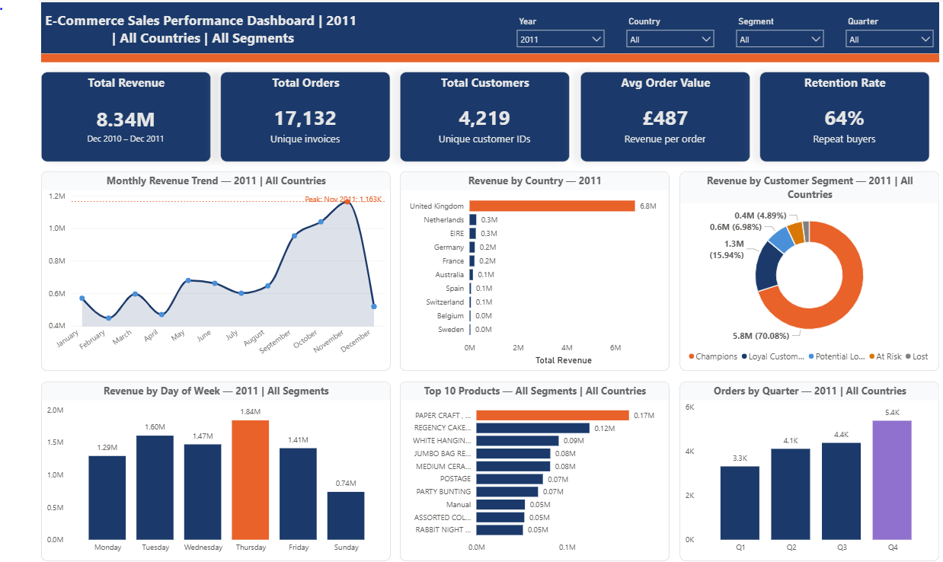

Figure 1: E-Commerce Sales Performance Dashboard — interactive version available via Power BI Service. The dashboard supports dynamic filtering by Year, Country, Customer Segment, and Quarter, with all titles and KPIs updating in real time based on slicer selections. Key highlights include £8.34M total revenue, a November 2011 peak of £1.16M, Champions segment contributing 70% of revenue, and a 64% customer retention rate.

3.1 Revenue Trends
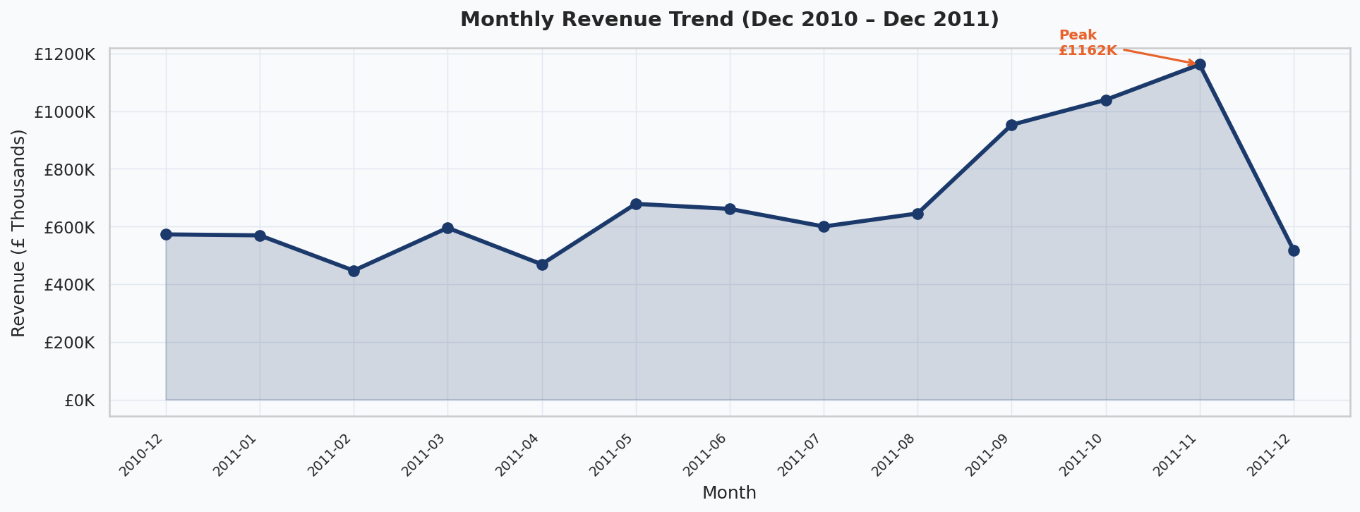
Revenue showed consistent growth across the analysis period, rising from approximately £400K per month in early 2011 to a peak of over £1.2M in November 2011. This sharp Q4 spike — consistent with holiday gifting behaviour — represents both an opportunity and a risk. The business is disproportionately dependent on a narrow 6-8 week window each year.

Order Volume
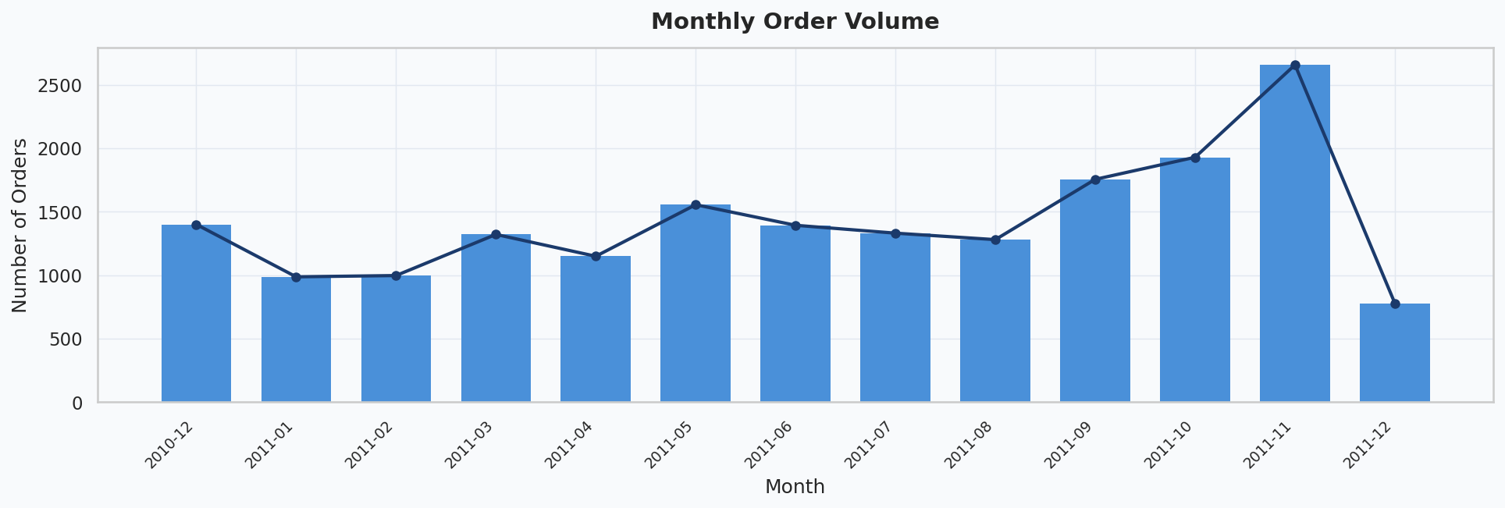
Order volume closely tracks revenue, confirming that growth is being driven by increased transaction frequency rather than just higher order values. December 2011 data is partial (ending 9th December), so the apparent month-on-month decline is a data artefact.

3.2 Geographic Performance
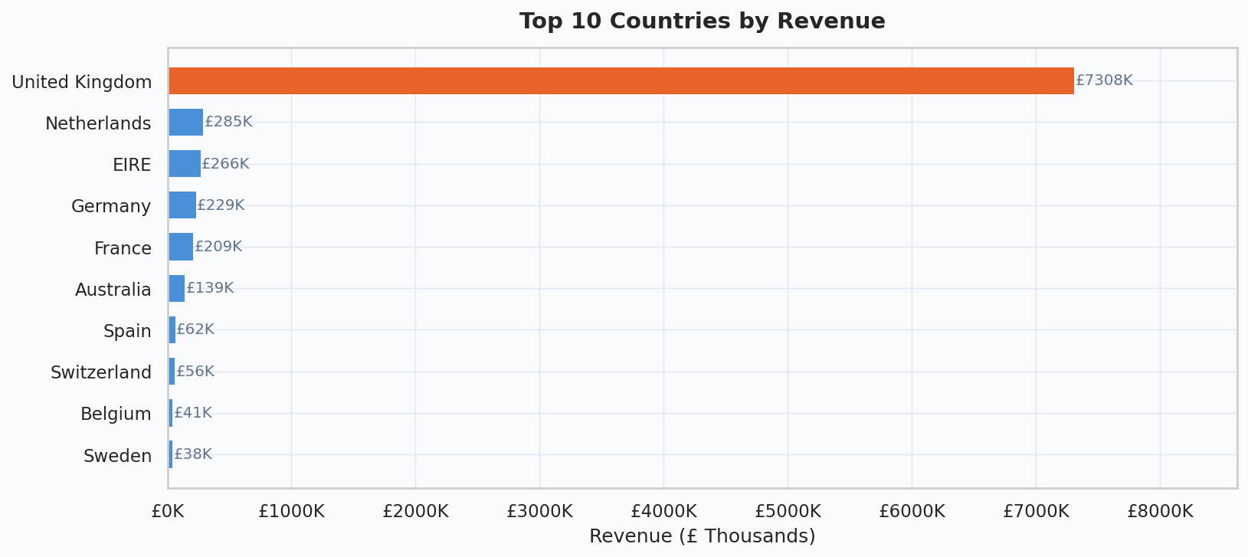
The United Kingdom accounts for 83% of total revenue — a level of geographic concentration that constitutes material strategic risk. The Netherlands, Germany, France, EIRE (Republic of Ireland), and Australia represent the leading international markets, each generating six-figure revenues. Combined, the top five international markets represent a significant expansion opportunity.

3.3 Customer Behaviour

Average Order Value

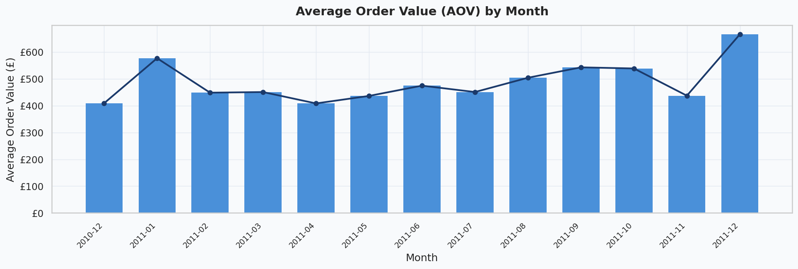
The mean Average Order Value (AOV) across the period was £369, with a median of £230 — indicating a right-skewed distribution driven by a small number of very large orders. AOV elevated materially in Q4, reflecting larger gift-driven basket sizes. This seasonal AOV uplift should be leveraged via targeted upsell and bundle promotions.

Purchase Frequency
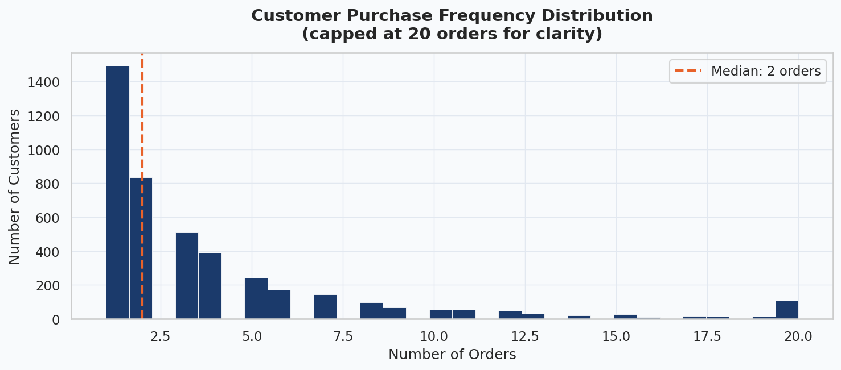
Approximately 35% of customers made only a single purchase. The median customer placed 2 orders, while the most active customer placed 209 orders. This frequency distribution highlights a significant opportunity in first-to-second purchase conversion — moving the modal customer from one-time to repeat buyer.

Customer Lifetime Value

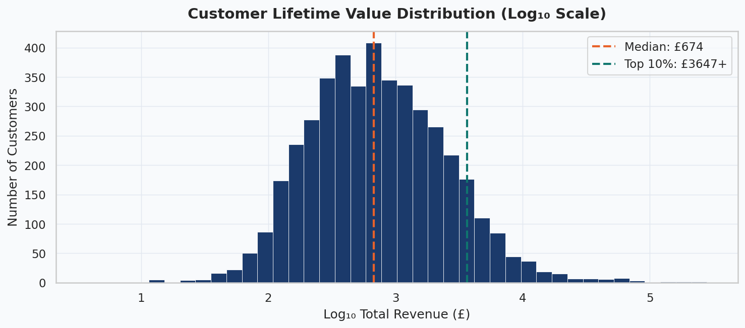
CLV is highly right-skewed. The median customer generated £370 in lifetime revenue, while the top 10% of customers generated £2,800 or more. The top 1% accounted for disproportionate revenue. This Pareto-like distribution underscores the critical importance of identifying, protecting, and growing the highest-value customer tier.

3.4 Product Performance
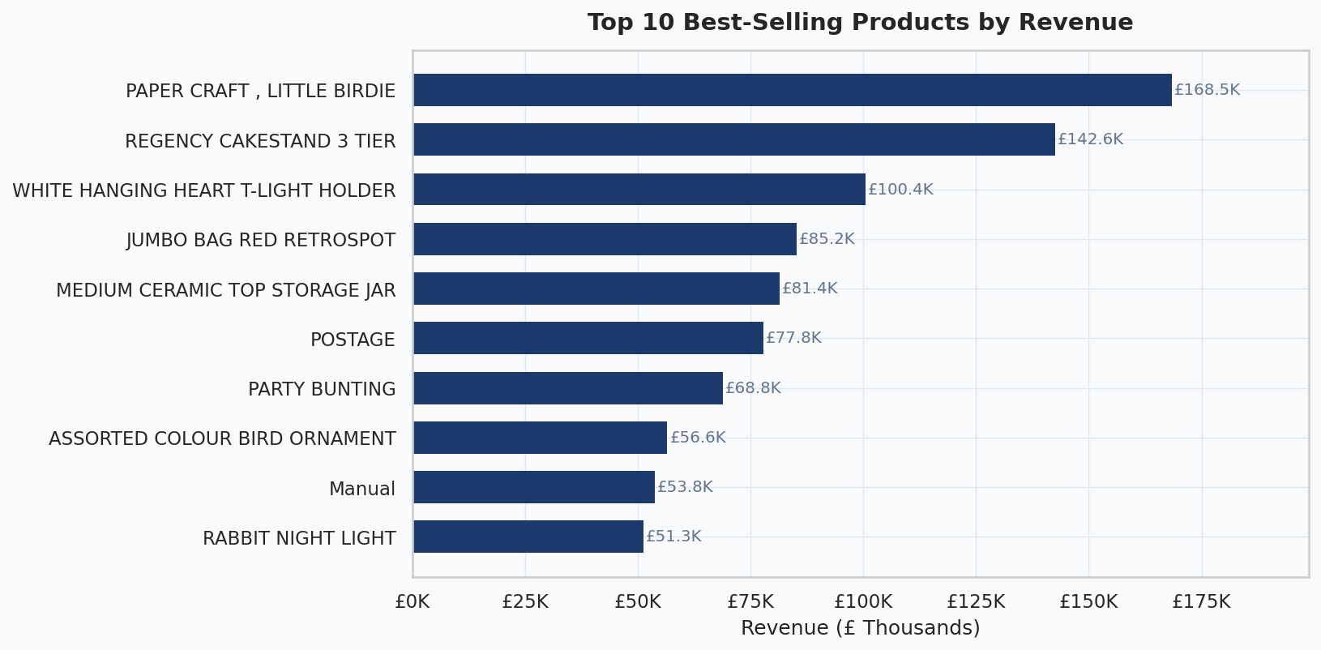
The top 10 products by revenue are concentrated in the decorative homewares and seasonal gifting categories. These products exhibit strong cross-selling potential and should be prioritised in promotional campaigns, search rankings, and inventory planning.
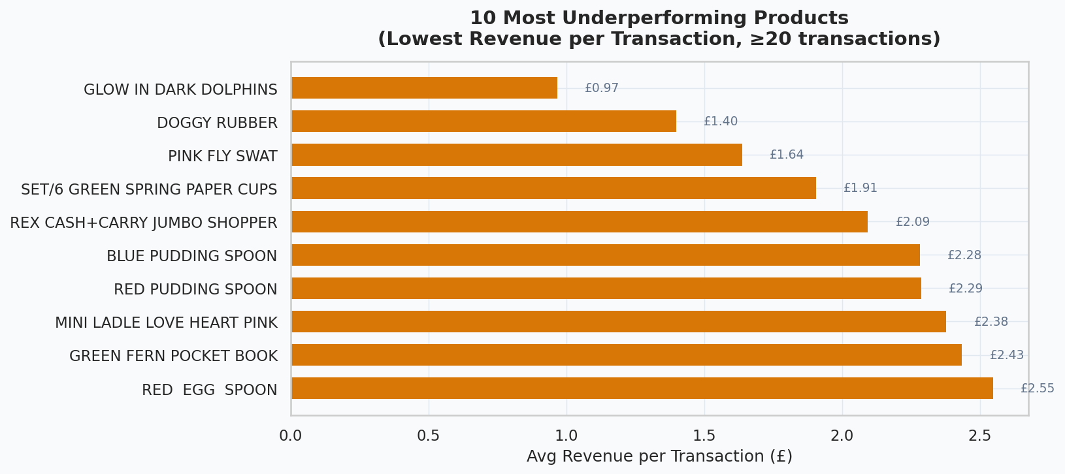
A set of products shows very low average revenue per transaction despite meaningful order frequency. These items may be priced too low, sold in insufficient quantities, or bundled poorly. They represent a pricing and merchandising optimization opportunity.

3.5 Cohort Retention Analysis
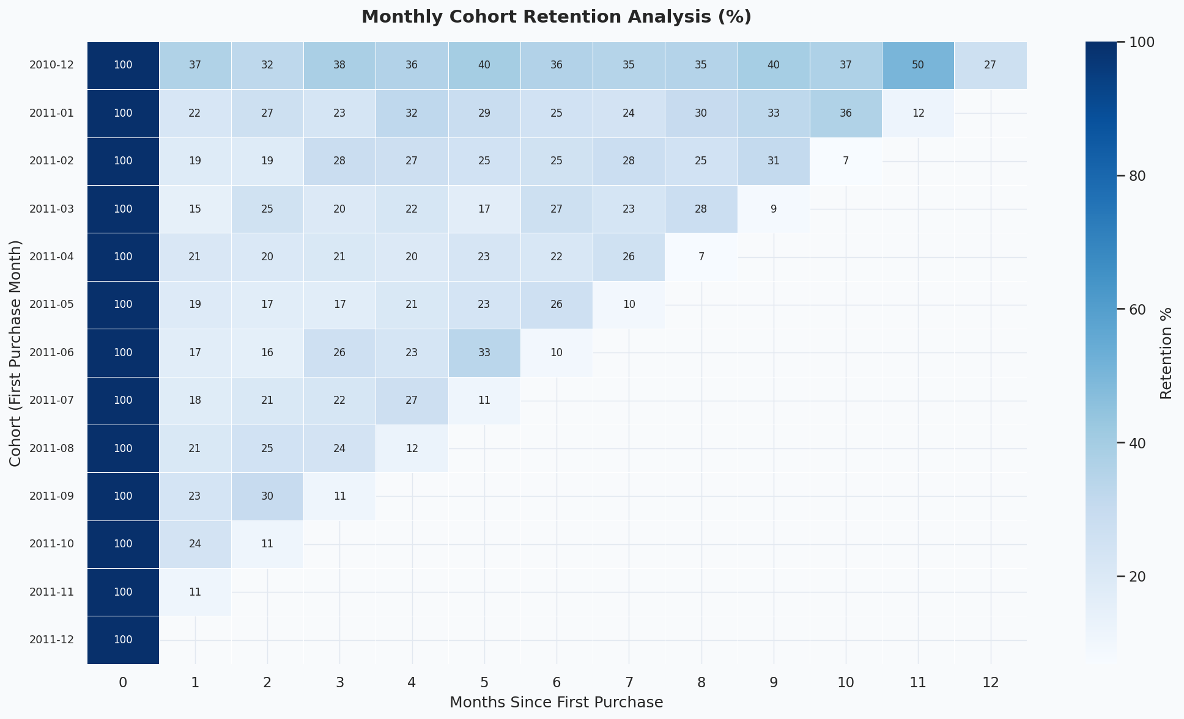
Cohort retention analysis reveals that the first month post-acquisition is the most critical retention window. Average month-1 retention is approximately 20–25%, declining steeply thereafter. The December 2010 cohort — likely composed of holiday shoppers — shows relatively stronger long-term retention, suggesting that seasonal buyers, once retained, may be more loyal than average.

3.6 RFM Segmentation
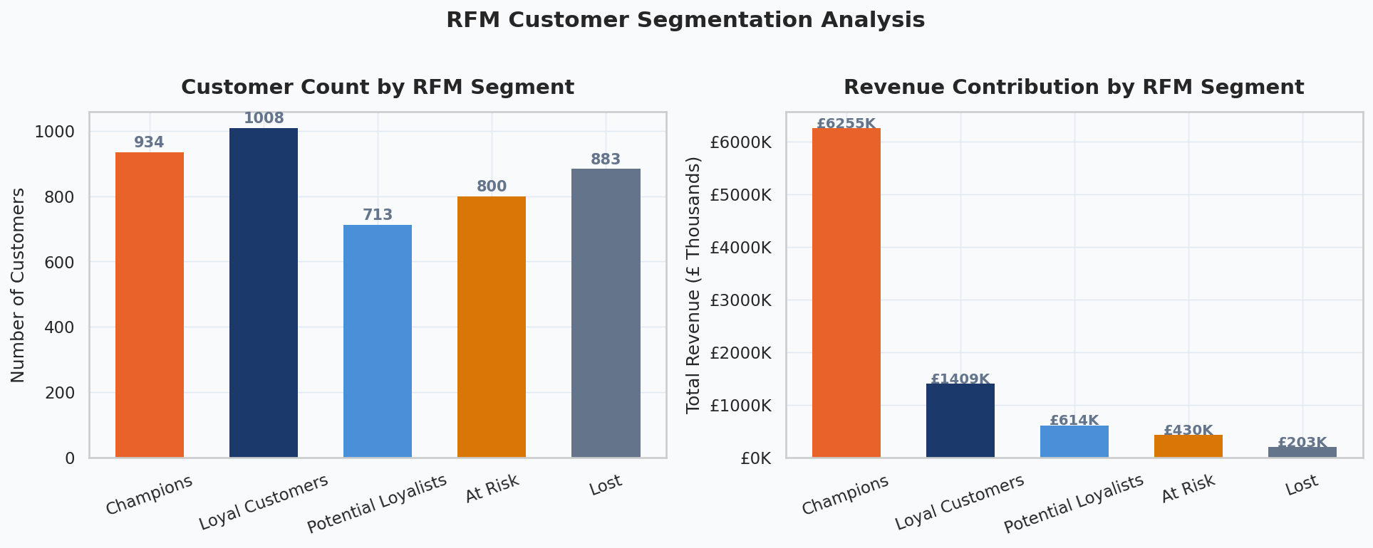

RFM analysis classified customers into five segments based on composite Recency, Frequency, and Monetary scores:
Segment | Customers | Revenue | % of Rev | Strategic Priority
Champions | 934 | £6.25M | 70% | Protect & grow – VIP programme
Loyal Customers | 1,008 | £1.41M | 16% | Deepen engagement – rewards tier
Potential Loyalists | 713 | £614K | 7% | Nurture to loyalty – targeted offers
At Risk | 800 | £430K | 5% | Win-back campaign – urgency messaging
Lost | 883 | £203K | 2% | Re-engagement or suppress

4. Business Recommendations

1. Protect and Grow Champions
Champions (934 customers) generated 70% of total revenue. The business cannot afford to lose these customers to competitors.
- Launch a tiered VIP loyalty programme with exclusive early access, free delivery, and priority support.
- Assign dedicated account management to the top 100 customers by CLV.
- Deliver personalised product recommendations based on purchase history to drive repeat orders.

2. Win Back At-Risk Customers
800 customers show declining engagement, representing £430K in recoverable revenue.
- Deploy a 3-step automated email win-back sequence: 10% discount offer → product spotlight → final 'we miss you' nudge.
- Use RFM recency scores to time outreach before customers transition to the 'Lost' segment.
- Segment win-back messaging by prior purchase category for higher relevance.

3. Convert One-Time Buyers to Repeat Buyers
Approximately 35% of customers make only one purchase. Even converting 20% of these customers to repeat buyers would materially increase revenue.
- Trigger an automated post-purchase email nurture sequence at 14, 30, and 60 days.
- Offer a 10% discount on the second order for all first-time buyers.
- Incorporate social proof (reviews, bestsellers) in the 30-day touchpoint.

4. Capitalize on Q4 Seasonality
Q4 represents the highest-revenue and highest-AOV period. Under-preparing for this window has compounded costs.
- Pre-stock top 10 SKUs by September with 2× normal inventory levels.
- Launch Q4 paid marketing campaigns by late September — before competitor spend peaks.
- Create curated gift bundles at £25, £50, and £75 price points to capture gifting intent.

5. Expand Internationally
83% of revenue from a single country creates fragility. Five international markets show clear demand.
- Build localized product pages and marketing for the Netherlands, Germany, and France.
- Evaluate EU fulfilment partnerships to reduce cross-border shipping costs and delivery times.
- Set a target of reducing UK revenue concentration to <75% within 18 months.

6. Optimize Day-of-Week Campaign Timing
Revenue analysis shows Thursday as the peak trading day.
- Schedule promotional emails and paid digital campaigns on Tuesdays and Thursdays.
- Test weekend flash sales to lift Saturday and Sunday revenue, which currently underperforms weekday levels.

5. Conclusion
This analysis demonstrates that the business is fundamentally healthy — growing, multi-market, and with a clear cohort of highly loyal, high-value customers. However, structural risks require strategic attention: geographic concentration, low first-month retention, and over-reliance on a narrow seasonal window.
The six recommendations above — if implemented with rigor — offer a credible path to 20–30% revenue growth while reducing key-customer and geographic concentration risk. Priority actions are (1) VIP programme for Champions and (2) an automated post-purchase nurture flow for new customers, as these deliver the highest expected return for lowest implementation cost.

