

**SMART-CAFÉ**

**SYSTEM**

**NAME: RICHARD ONYANGO ODHIAMBO**

**ADMISSION NO: COM/046/15**

**COURSE CODE: COM 423**

**COURSE TITLE: PROJECT II**

# **DECLARATION**

I hereby declare that this project is my own work and has never been presented in any other institution of higher learning for the awarding of a degree, diploma or any other certificate

ADM NO. NAME SIGNATURE

COM/046/15 Richard Onyango Odhiambo

PROJECT SUPERVISOR: DR. ERICK ROTICH

DATE …………………… SIGN………………………

# **DEDICATION**

My dedication goes to Almighty God for the wisdom He has acquainted me.

I dedicate this system to the University of Eldoret’s cafeteria to improve services to the whole school during meals.

I dedicate this system to any cafeteria that longs to make their services smart and easy.

# **ACKNOWLEDGMENT**

First and foremost, my great appreciation is to the Almighty God for giving me good health, guidance and protection throughout the project development.

I wish to extend my sincere gratitude to my project supervisor Dr. Eric Rotich, for providing guidance through this project development activity.

To the University of Eldoret for providing a ground and resources for the development of this system.

Last but not least, to my parents and siblings for their full support they provided both spiritually and financially.

Table of Contents

**DECLARATION** 2

**DEDICATION** 3

**ACKNOWLEDGMENT** 4

**ABSTRACT** 7

**CHAPTER ONE** 8

**1.0 Introduction** 8

**2.0 Background Study** 8

**3.0 Problem Statement** 9

**Objectives** 9

**4.0 Scope** 9

**5.0 Justification** 10

**CHAPTER TWO** 11

**2.1 Literature Review** 11

2.1.1. **Introduction** 11

2.1.2 **Restaurant service quality** 11

2.1.3**. Related Works** 13

**CHAPTER THREE** 15

**3.1 METHODOLOGY** 15

3.1.1. **Introduction** 15

3.1.2. **Feasibility study** 15

3.1.3. **Project Management Plan** 16

3.1.4. **Requirement Gathering** 17

3.1.5 **Requirement Analysis** 18

3.1.6**. Requirements Specifications** 19

3.1.7. **Output Specifications** 24

3.1.8. **System Specifications** 24

3.2 **DESIGN** 25

*3.2.1***PROCESS FLOW** 25

3.2.3 **DATA FLOW DIAGRAMS** 27

**3.2.3 FLOWCHARTS** 30

**CHAPTER FOUR** 34

**4.1 RESULTS AND DISCUSSION** 34

**CHAPTER FIVE** 36

**CONCLUSION** 36

**RECOMMENDATION** 36

**APPENDIX** 37

**REFERENCE** 37

# **ABSTRACT**

In most of restaurants across the world, meal ordering is relying on the interaction with waiters to place an order into the kitchen. During the busy hours of the restaurant this coordination is a challenge which finally results to dis-satisfaction of the customer.

Digital multi-touch menu cards in restaurant are replacing traditional services where waiters take order from customer according to their menu requirement.

In traditional restaurant, orders are taken by waiters and they bring the food when it is ready. Later the customer pays the bill to the waiter or the cashier at a reception area. This system relies on large numbers of manpower to handle customer reservation, ordering food, placing order on table, reminding orders of customer and billing. Therefore, how to effectively improve the service quality for customers by using advanced technologies has received much attention in recent years.

Restaurants only provide passive services where waiter can only deal with customer’s order by asking customer’s need and transfer order to kitchen and finally cash counter. In a medium to large and busy restaurant this coordination is a challenge and requires an efficient ordering system. Errors in ordering processes lead to incorrect or out of sequence meal preparation or no consumable and results in added cost to the business.

This project aims to deliver digital meal ordering system wherein orders will be placed digitally through touch screen modules. This order will be communicated through wireless medium to the database available at cash counter laptop. Orders received from different dining tables will be parked in software at cash counter laptop screen.

“SMART CAFÉ: it’s all about getting all of your different Ordering touch pads working together

connected, sharing information, personalizing experiences and speeding processes. In this project Graphical User Interface (GUI) digital touch screen module is used as a food ordering system. Customer can order via this touchscreen device placed on each table in the restaurant. Customers view the menu, price and make an order directly using this touch screen system. Then, their orders are sent to the database in cash counter computer and also viewed on the computer screen at the kitchen for food preparation.

Finally, the billing and WI-FI password details are sent to the user’s mobile phone via an SMS.

# **CHAPTER ONE**

## **1.0 Introduction**

A Café is a kind of business that serves people across the world with ready-made food (Oxford,2008). Visiting a cafe traditionally involves selecting a meal from a paper based menu and being waited on by the café waiters. A busy restaurant or inattentive staff can leave customers waiting to have their orders taken, to refill their drinks or to receive their bill for a longtime. If the restaurant is busy the customer is not served fast enough, where he occupies a table longer than they need

“SMART CAFE” is a web based system which automates day to day activities of a food café. This system provides service facility to a café to handle clients, their orders and helps them find free tables to place their orders. The services that are provided by this system are food ordering management, menu information management, WI-FI passwords management, customer details management and reports generations i.e. Clients Receipts

## **2.0 Background Study**

Cafe is a place that provides services for customers to enjoy the food and drinks available in that premises. Most of the restaurants will do anything to provide the best services for their customers. Different approaches have been used to achieve a whole new level of satisfaction among the customers. A lot of the restaurants come with different ideas and some of them have a

really positive impact on their business.

Waiters always make the same mistake when it comes to taking their customers’ order. Miscommunication is the most common reason why this problem happens. Unsystematic menu implementation in traditional menu system (paper-based system) will make the customers have problem to make up their mind to order what they want to eat in that restaurant. Paper-based menu also has problem caused by restriction of the space needed to show the pictures of all of the food.

As we are living in the era of high-tech devices, ordering food from a café should also be brought to a whole new level. Going through the menu and ordering food from a touchscreen at the comfort of a table will be something common among restaurants and acceptable to the society.

All customers will not have problems with the touchscreen technology as they are used to this technology as it was implemented in the now very common modern smartphones.

Smart-Café system is one of the steps to this evolutionary. The system will include touchscreens which will be available per table. A user upon sitting on the chosen table makes an order via this touchscreen. All orders are seen by the Counter who responds by directing the waiters on standby to deliver to the table. The customer receives a text message via SMS containing the Total Amount spent plus a password to the WI-FI which is system generated hence cannot be guessed or hacked.

The Smart-Café system will revolutionize the café services in the following ways:

* Provide a Responsive Menu interface.
* Allow the administration to easily update the menu.
* Allow a customer make as many purchases as they need.
* Provide the management of the café with feedback from Users.
* Send a message to the Users after making an order.
* Allow the counter to respond to orders on time.

## **3.0 Problem Statement**

Many cafes’ that use the manual servicing of their operations have these common challenges:

Slow services are the most common problem with the manual systems, ranging from slow services by the waiters to the dealing with a huge population of customers making services to lag. Since the waiters are human-beings, they are faced with a limitation of low memory capacity hence a waiter cannot take as many orders at once hence contributing to slow services.

Error arising from waiters. A common error is a waiter delivering food to a customer that did not order. This leads to dissatisfaction to the user. The business hence suffers loss of its potential customers.

Many cafés that offer users with a free WI-FI lack a way of managing the passwords so that not everyone can access the Wi-Fi. Many are times you will notice a password printed and stuck on a wall. This allows everyone including hackers to have access to the system.

Untimely feedback of billing records to the user causing dissatisfaction to the users.

## **Objectives**

* To study the existing manual Café systems
* To investigate the problems with the manual (traditional) Café systems
* To develop an online smart café system
* To implement the developed smart café system

**Research Questions**

* How will the study of the existing system be conducted?
* How to investigate the problems of the existing system?
* How the development of the online smart café system will be carried out?
* How the implementation of the developed system be done?

## **4.0 Scope**

SMART-CAFÉ system is to be used in any restaurant/Café across the world to improve services of the business.

## **5.0 Justification**

* The system will grant customers chance to order food at their comfort zone by doing away with queuing hence increase customer satisfaction.
* The Smart-Café system will reduce paper work service personnel therefore cutting down on cost of a business.
* The Smart-Café system will be available on each Café table increasing the efficiency of the services and improving customer satisfaction
* The Smart-Café system is real time giving feedback immediately a customer orders food.
* It has enhanced security by use of username and passwords hence increasing confidentiality, integrity and accessibility. And also by providing Wi-Fi passwords only to the customers who have made a purchase of at least a food item.

As seen from the above statements the Smart-Café system will greatly improve the Café services.

# **CHAPTER TWO**

## **2.1 Literature Review**

### 2.1.1. **Introduction**

This chapter documents the available relevant literature concerning the problem domain. It contains review of research already undertaken on related topic.

### 2.1.2 **Restaurant service quality**

(Gronross, 1984) and (Berry, 1985) and (Johnston, 1995) defined the

service quality as customer satisfaction, i.e. the degree of fit between customers’ expectations

and perceptions of service. *“Quality is a measurement of various attributes of a product or services as against meeting a specific need at certain place and time*.”

 (Juran, 1989) stated quality as fitness for use. It means that the product meets the customer’s needs and having no defects. (Goetsch,1994) and (Spencer, 1994) defined quality as satisfying or delighting the customer.

(Olsen, 1978), listed seven service attributes which they believe adequately embrace the concept of service quality.

These include: *Security, Consistency, Attitude, Completeness*,*Condition, Availability*,*and Training.*

(Gronroos,1991) identified three dimensions of service quality: the *“technical quality of the outcome”,* the *“functional quality of the encounter”*, and the *“company corporate image”.*

(Lehtinen, 1982) also described service quality in three dimensions: the *“physical quality”*

(of products and/or services), the *“corporate quality” (*the company image) and *“interactive quality” (*interaction between the consumer and the service organization).

(Berry, 1985) list ten determinants of service quality that can be generalized to any type of service. It includes*: Tangibles, Reliability, Responsiveness, Competence, Access, Courtesy, Communication, Credibility, Security, and Understanding*. These ten dimensions were regrouped in the well-known five dimensions in the SERVQUAL model (Berry, 1990) which include

*tangible, reliability, responsiveness, assurance, and empathy.*

SERVQUAL, a model proposed by (Berry, 1988), is widely used to measure service quality (Cao, 2011). The SERVQUAL model is based on the gap between

customers’ expectations and performance perceptions including:

* **Reliability:**

to deliver the promised service to the customer in an accurate manner.

* **Responsiveness:**

the willingness to respond to and resolve customer problems.

* **Assurance:**

the ability to instill confidence and trust in the customer.

* **Empathy:**

the ability to empathize with and understand the customer.

* **Tangibles:**

the appearance of staff, equipment and the physical facilities

**Different types of restaurant systems:**

1.**Manual food ordering system**: Manual Food Ordering System uses waiter to take orders from customers.

This system has the following limitations:

1. Do not take mass order.
2. Does not indicate the famous dishes of a particular restaurant.
3. Nobody shows the current status of delivery.
4. Mismatch in delivery expected time.
5. Outdated data

2.**Waiter paging system**: The Waiter Paging System allows customers to call for a waiter. The pager unit notifies the waiter via a vibrator or buzzer that a request has been received and displays the request.

3.**Touch-Pad Projection System**: The Touch Pad-Projection System also allows customers to send food orders directly to the kitchen. Each table has its own image projector, projecting the menu on the table allowing customers to make an order by touching the table surface instead of a monitor screen. (Apoorva Vengurlekar, 2014)

### 2.1.3**. Related Works**

**E-commerce and E-business**

E-commerce handles many aspects on the internet such as product research, the exchange of business documents over the internet. The definition of e-commerce in its simplest form is buying and selling of goods or services over electronic systems (Referenceforbusiness.com, 2016).

The history of e-commerce is short but is rather impressive, it actually dates back to the 1970s when they sent the first business document over an electronic wire. But as supposed to our definition it started back early in the 1990s, this is when the World Wild Web came into surface and also when the US Government passed a legislation in 1991 to delete the past of credit card information online (Greenstein and Feinman, 2000).

According to Coleman Parkes’ survey (Parkes, 2013), the research shows that the revenue generated by ecommerce is expected to increase by an average of 6% over the next year and that two thirds of business-to business organizations already sell online. In addition, the research also shows that 21-40% of a business contributes resulted to e-commerce and that number is expected to increase fast over up-coming years. Within a few ticks, an exchange or an order can be placed and finished through the internet easily. For example, a managing an account exchange should be possible through the internet inside of couple of minutes, whereas the customary keeping money method might take up to hours.

This proves that e-commerce is beneficial to both consumer and business because payment and documentation can be completed with greater efficiency. To put it plainly, with no real difficulties, E-commerce will definitely continue to establish and develop in the worldwide market and it will become an essential business arrangement for any organization that is hoping to survive and compete in any competition they might face in the ever evolving market.

(Webdesign.vinsign.com, 2016) "Time plays a key part to both the business and consumers”. From a business perspective, with less time spent during every exchange, more exchange can be proficient around the same time. With respect to the buyer, they will spare time during their exchange. To both the shoppers and business, availability is a critical key component for deciding the entire business. From a business point of view; e-commerce gives better network to its potential client clients on the grounds that their site can be gotten to for all intents and purposes from any area through the web.

From a client point of view; e-business is a great deal more advantageous for them as they can browse whole diverse directories of catalogues of lists with no bother. E-business is a blend of business programming keeping in mind the end goal to make some sort of estimations of for its customers and accomplices and the enterprise itself. E-business is a more extensive term than e-commerce; it is regularly taken to mean the coordination of electronic process past buying and offering exercises, for instance; for example; full integration into associations’ enterprise resource or different business instruments to embrace business procedures by keeps an eye on of electronic exchanges end-to-end (Papazoglou, 2006).

**Generic Website Applications**

Web programs are a software application that permits clients to recover information and interface with substance that is situated on site pages inside of the site (Papazoglou and Ribbers, 2006). Advanced sites allow the catch, stockpiling, handling and transmission of sensitive client information for instance, personal details, credit card and other government managed savings information and so forth (Russo, 2016).

This kind of information allows the user to use the service for immediate or recurrent purposes; these actions are done via web applications. Web application features that shape modern websites and deliver communication with prospects and customers;

* Webmail,
* Login pages,
* Support and product request forms
* Shopping basket
* Content Management Systems

Most businesses have numerous of web-based applications which functional size is required to be determined. The following guidelines are derived from the Function Point Analysis. It was first made public by Allan Albrecht of IBM in 1979 (Russo, 2016).

**Intelligent Restaurant**

Intelligent Restaurant is designed to reduce the work load of waiter and to increase the efficiency. In the paper by (Sakari Pieska, 2013) has propose that the customer ‘s application works on an Android tablet. This application is connected to the database and download real-time restaurant ‘s menu. The customer can browse the menu and order it. Using the software, customer can call the waiter by pressing a button. The waiter comes to confirm the order and count the bill. This menu can be displayed in the kitchen ‘s display. When this food items are ready then the kitchen staff can mark them as done. And this food items are visible in the cashier and also in waiter application so that they deliver them to customer.

Another paper (Ching-Su Chang, 2012) has proposed an intelligent e-restaurant for customer-centric service. This system provides an online menu ordering and reservation-making process, and also personal menu recommendation service. With the help of RFID-based membership cards, waiters can immediately identify customers according to their consumption records. The waiter uses a PDA to take orders from the customer and with the use of WLAN order is send to the kitchen. Then chefs prepare the menu and waiter can deliver it to customer. When the customer has finished the meal, the cashier uses RFID based PDA to identify the membership ID to calculate the bill.

Another paper by (Sun Guiling, 2010) has proposed self-service ordering information system based on ZigBee wireless technology. This system uses FFD (Full Function Device) and RFD (Reduced Function Device). FFD is network coordinator that can communicate with other device; RFD is used in star topology network, which can communicate with the FFD.

# **CHAPTER THREE**

## **3.1 METHODOLOGY**

### 3.1.1. **Introduction**

This chapter describes the agile method adopted for development of Smart-Café system.

`Agile method breaks the product or system into small incremental builds. These builds are provided in iterations. Every iteration involves cross functional themes working simultaneously on various areas like: Planning, Requirement analysis, Design, Coding, Unit testing and Acceptance testing.

Planning - performed feasibility study within a period of seven days to determine whether the project is financially and technically feasible to be developed.

### 3.1.2. **Feasibility study**

1. Operational feasibility study

Smart-Café system majorly requires contribution from the owners and staff members of any café or restaurants, there is need for the system by the managements of Cafés and restaurants who are willing to adopt the proposed system.

1. Technical feasibility study

Smart-Café system targets a population that are well adverse with the use of smartphones hence the users will not require elaborate teaching in order to know how to use the system.

The system can be used with anyone with little computer knowledge. The technology used in the System (web-based approach) is available and meets the standards in place and can also be upgraded if need be.

1. Economic feasibility study

The new proposed system cuts down on man power, hard copy menu materials, catering cost and printing cost.

### 3.1.3. **Project Management Plan**

The development of the Smart Café system was divided into manageable modules which were awarded time periods as shown below.

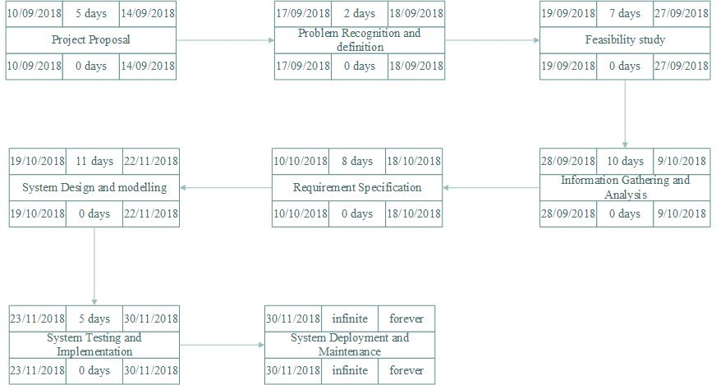

Figure 1:Project Plan Management.

### 3.1.4. **Requirement Gathering**

Observations, interviews and questionnaires were in gathering information from stakeholders for a period of ten days. Also specified are the functional and non-functional requirement in this phase.

**Fact Finding Methods used**

1. **Interviews**

An [interview](https://en.wikipedia.org/wiki/Interview) in qualitative research is a conversation where questions are asked to elicit information. The interviewer is usually a professional or paid researcher, sometimes trained, who poses questions to the interviewee, in an alternating series of usually brief questions and answers (Seidman, 2006).

This was conducted to gather first-hand information from the cafe management staffs, customers and stakeholders.

1. **Observation**

Observation is the active acquisition of information from a primary source. In living beings, observationemploys the senses (Spradley, 2016). Observation was used to asses’ occurrences and flow of business activities within cafés.

1. **Questionnaires**

A questionnaire is a research instrument consisting of a series of questions for the purpose of gathering information from respondents (Richman, 1999). In order to collect data from different cafés, questionnaires were provided. This is to ensure getting of information from stakeholders according to each person’s understanding reducing biasness.

1. **Reviewing of existing documents.**

Existing documents were used to capture step by step data and information on the café management.

### 3.1.5 **Requirement Analysis**

1. Functional Requirements

There are three types of users that interact with the system. User class one is Café administrator, user class two is the Café cashier and user class three is the Café customer. Each of these users have different use of the system thus each have their own requirements.

1. Café administrator functional requirements:

* Administrator Username
* Administrator Password
* Add a cashier plus all their details-assigning them a password.
* Update the menu items.

1. Café cashier functional requirements:

* Cashier username
* Cashier Password
* Respond to customer orders
* Print customer receipts

1. Café customer functional requirements

* Customer username
* Customer table number
* Customer mobile number

1. Non-Functional requirements

Usability: the system provides user friendly GUIs and tool tips to enhance itself

Portability: the system can work on different environments.

Availability: the system is operational at any working day.

Accuracy: the system is optimized to generate accurate report and amount a customer spends.

Secure: the system implements security by use of login function. Only personnel with correct verification details are granted permission to access the system.

### 3.1.6**. Requirements Specifications**

**Input Specifications:**

**Café customer**

1. The customer is required to input their details as follows in order to access the Menu:

* Name
* Table they occupy
* 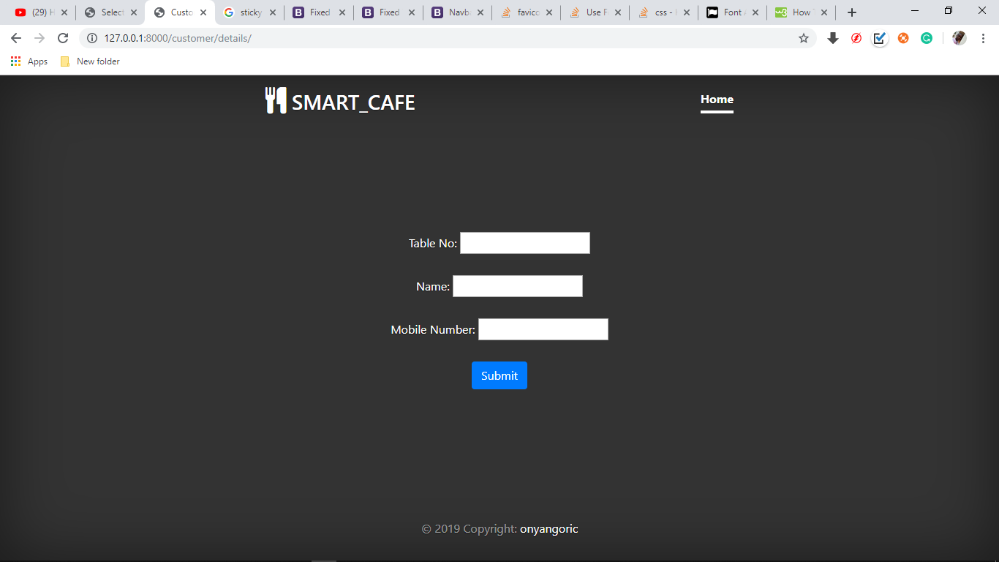Mobile number (MUST BE GIVEN)

Figure 2:Customer details input

1. 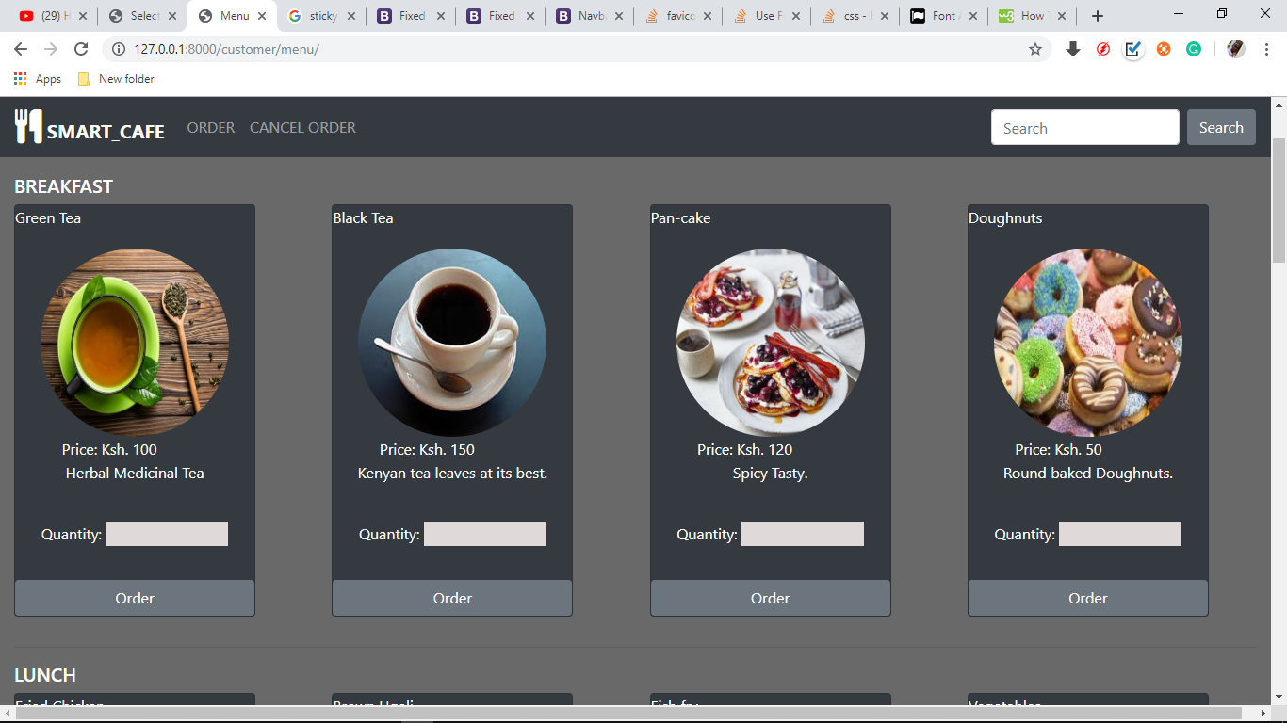The customer is also required to place an order by placing an input in the Quantity input box in the display of a food item and finally clicking Order. The customer can order as many food items as possible.

Figure 3:Food ordering display

1. 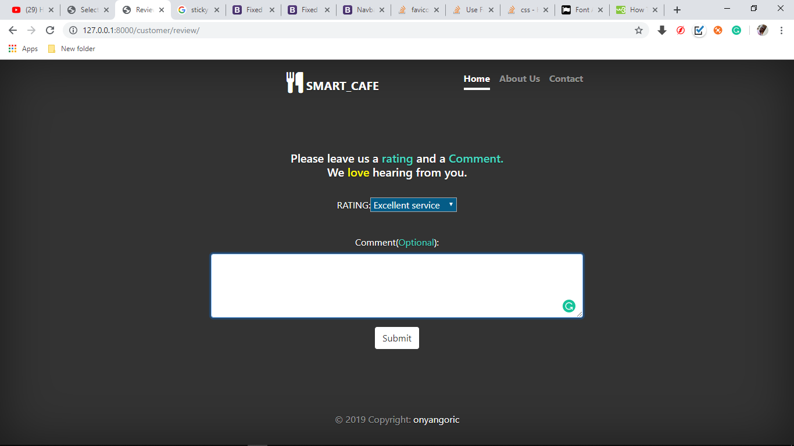The customer is also required to input in their feedbacks to the system in order to receive an SMS providing them with password to Wi-Fi access.

Figure 4:Customer review capture display.

**Café cashier**

1. 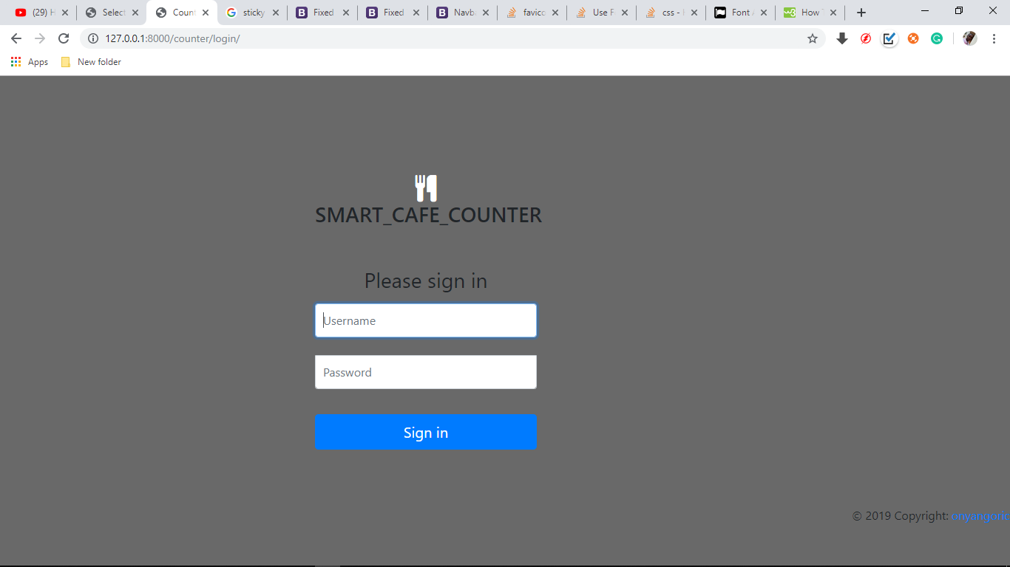The cashier is required to login using the provided Username and password from the administrator.

Figure 5:Cashier Login page

1. 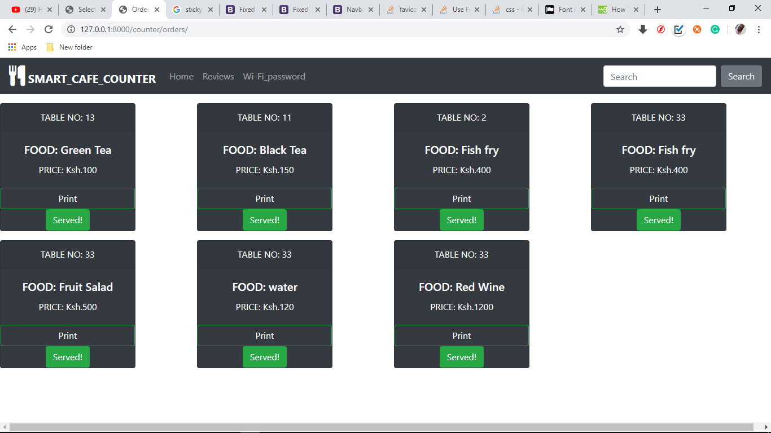The cashier is required to manage all orders. If a table is served, the cashier is required to click on **Served Button** to ensure that all tables receive their orders.

Figure 6:Orders per table.

1. 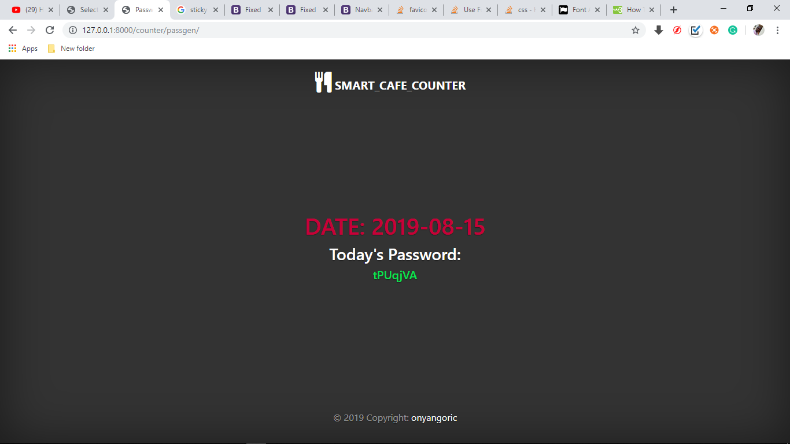The Cashier is required to load the Wi-Fi password page which will automatically load a new password every day. The Cashier should feed in the new password into the Wi- Router each day.

Figure 7:Password generator page.

**Café administrator**

1. 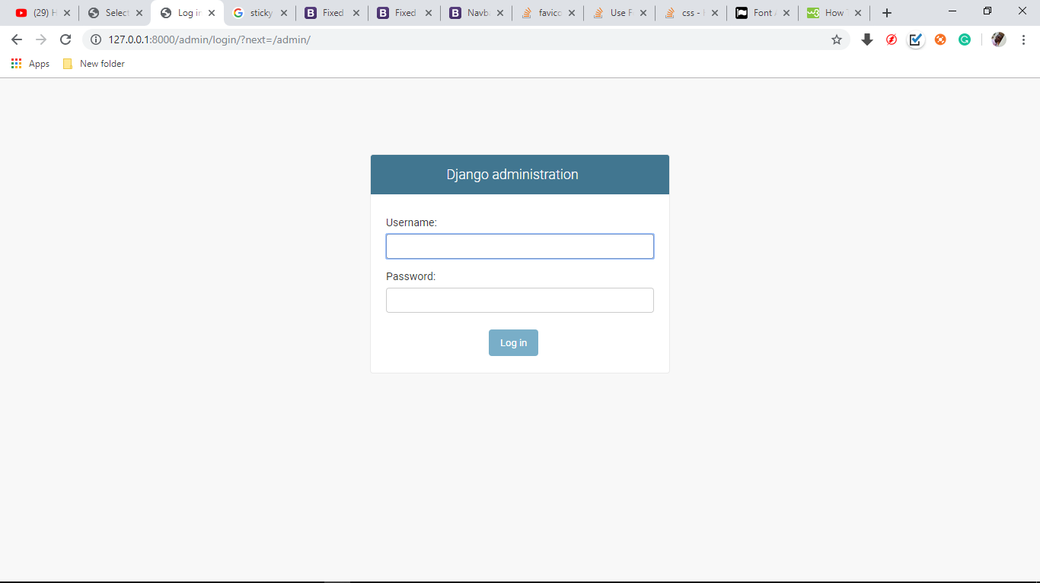The administrator is required to input their username and Password in order to login into the administration site.

Figure 8:Administrator login page.

1. 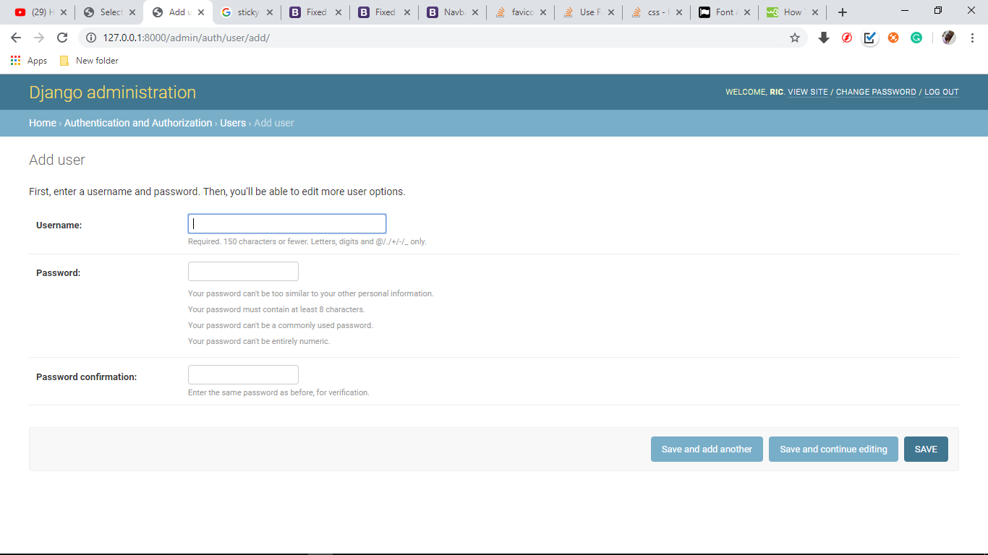The administrator is required to add details of a cashier into the system for them to log in.

Figure 9:Admin adding a Cashier details

1. 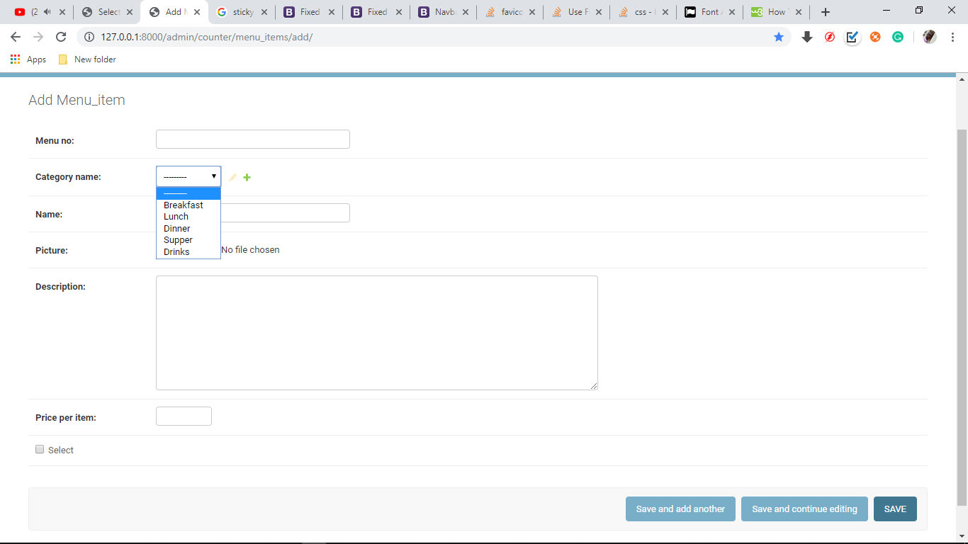The administrator is required to update the food Menu.

Figure 10:Administrator menu editing page.

1. 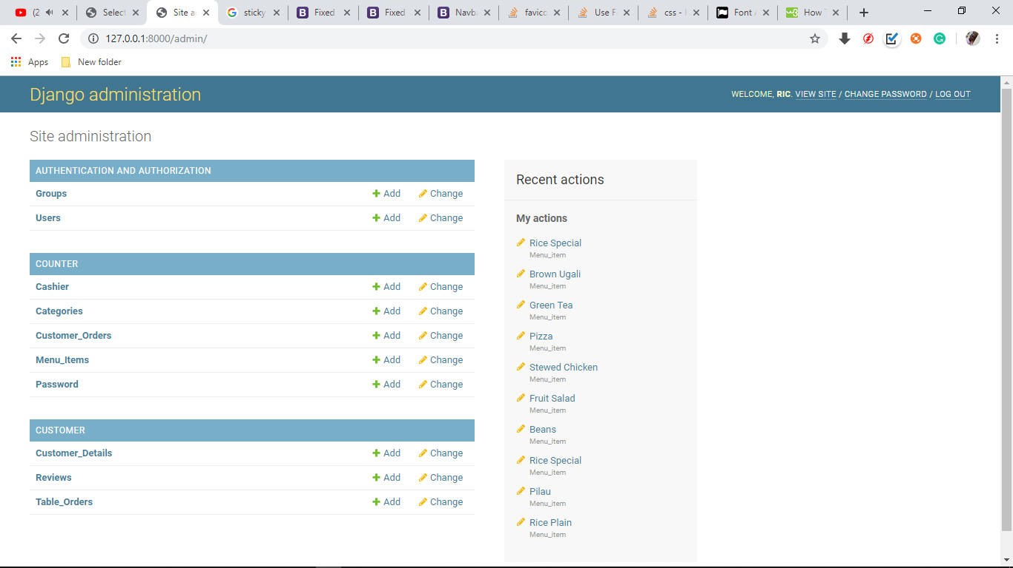The administrator manages all other operations of the system.

### 3.1.7. **Output Specifications**

**Café Customer**

1. The customer must provide a mobile phone number which will be used to convey a Text Message containing the billing amount and the Wi-Fi password.

* The mobile phone should be on in order to receive the message immediately after purchase of food item.

* + 1. System Specifications

Hardware specifications

The hardware specification for the Smart-Café system requires a device with ability to access internet.

The Smart-Café system required a laptop with the following specifications; 500 GB hard disk and a minimum of 2GB RAM.

At the production requirement, the Smart-Café system requires a server disk storage allocation of 1 TB and a mobile phone too.

Software specifications

The Smart-Café system required the following software specifications during development; windows 10 operating system was used in the laptop as an operating system, Xamp server acted as the local server for hosting the system locally while being developed, visual studio, sublime text, notepad ++ was used as a text editor when coding the Smart-Café system.

Django framework is a python framework in for creating web app that was used while developing the Smart-Café system.

The database that was used in developing the app was MySQL database that stores the data in tables.

## 3.2 **DESIGN**

**Design** – Immediately after analysis, was the design of the system into a structure suitable to implement for changing problem domain to solution domain.

### *3.2.1* PROCESS FLOW

FACET 1 – Customer

Sign-Up

The customer after arriving and sitting at a table in the Café, register their details in the order table number, username and mobile number into the touchscreen interface available at each table.

Ordering

Upon signing up into the system, the customer is directed to the menu in order to choose and order for meals.

Review

After a customer has ordered for meals they are informed to give a review of the services in order to receive a Wi-Fi password.

Payment

After the meals, the customer heads to the cashier to pay for meals according to the billing message provided in the *text message* they received.

FACET 2 – Cashier

Sign-In

The cashier signs in using the password and username given to them by the administrator.

Response to Customer Orders

The cashier responds to orders of each table which are displayed on his screen.

Prints the receipt for an order.

Password Update

The cashier opens the Wi-Fi password page which auto generates passwords to the Wi-Fi daily. Hence the Cashier is responsible for daily updating the generated password into the Wi-Fi Router.

FACET 3 – Administrator

Administrator is required to login in to the admin site using Username and password.

The Administrator is responsible for the overview of the whole system.

The administrator creates cashier accounts and assigns them a Username and a Password.

The administrator is also responsible for the update of menu items to be displayed in the Menu list.

### 3.2.3 **DATA FLOW DIAGRAMS**

**Level One Context DFD**

This is a general overview of how the system looks like logically

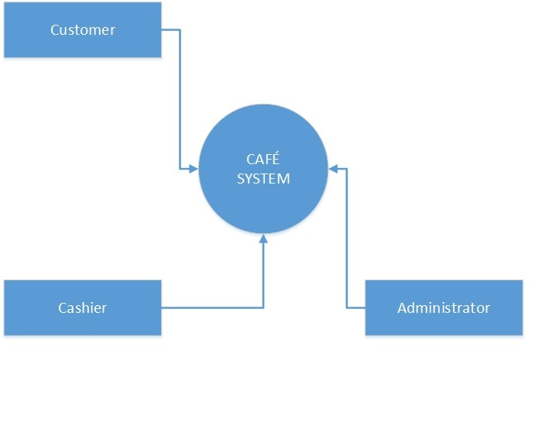Three Users interact with the system as shown in the diagram below.

Figure 11:Level One Context diagram

**Level Two Context DFD**

The diagram below shows how each user of the system interacts with their respective portals and the portals form the major backbone of the system.

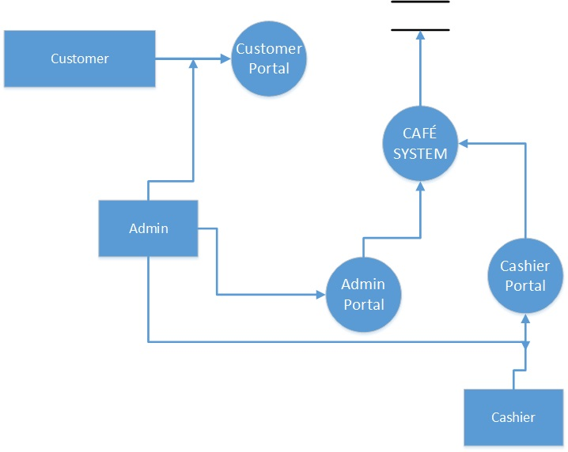

Figure 12:Level Two Context diagram.

**Level Three Context DFD**

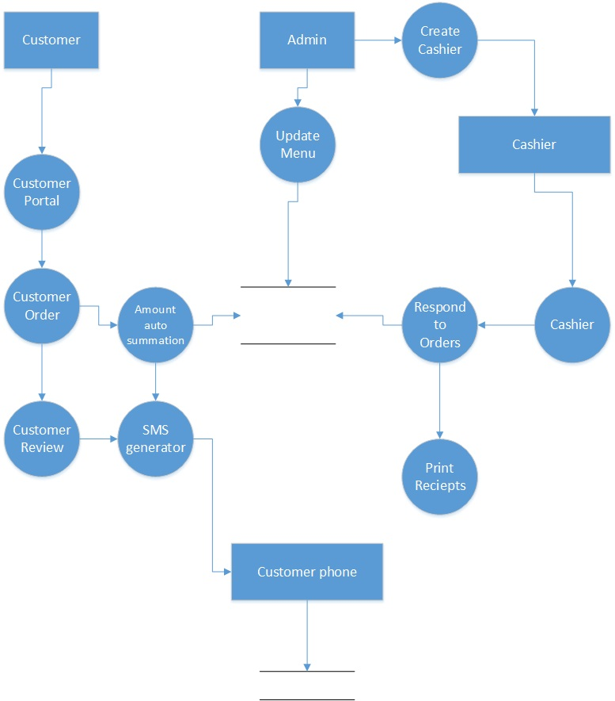This diagram gives a more detailed view of how each module of the system works and how each module interacts with another to form a single functional system.

Figure 13:Level three Context diagram.

### **3.2.3 FLOWCHARTS**

These are diagrammatic representations of the logical flow of events within the system.

**Customer Order Flowchart**

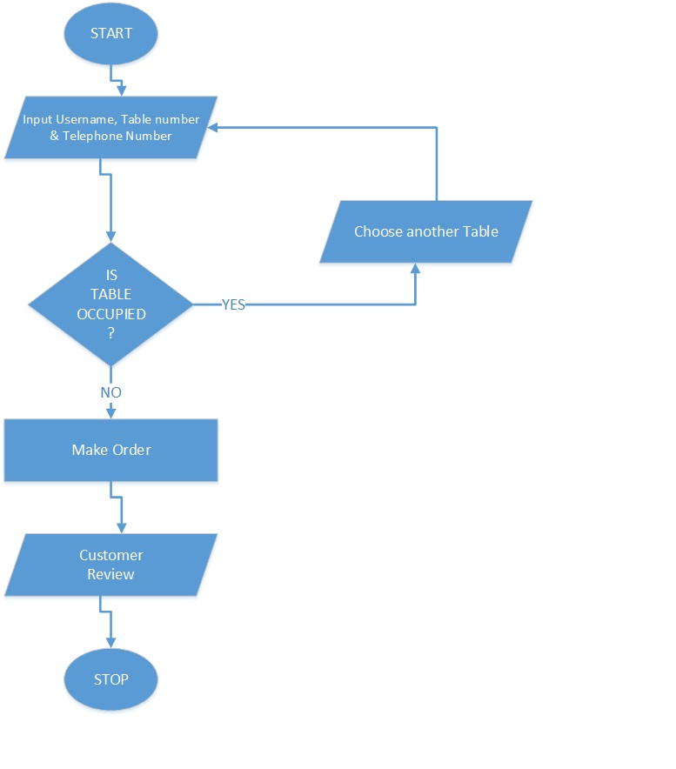Describes the flow that Smart-Café customer goes through in order to make purchase of food.

Figure 14:Customer order flowchart.

**Sending SMS flowchart**

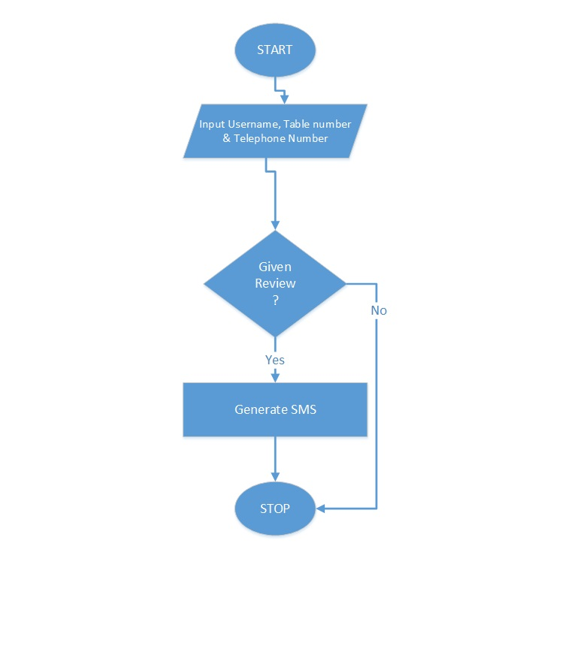For a customer to receive a message containing the Wi-Fi password, they have to give feedback. The flowchart below shows the logical flow to generation of SMS.

Figure 15:SMS generation flowchart.

**System Flowchart**

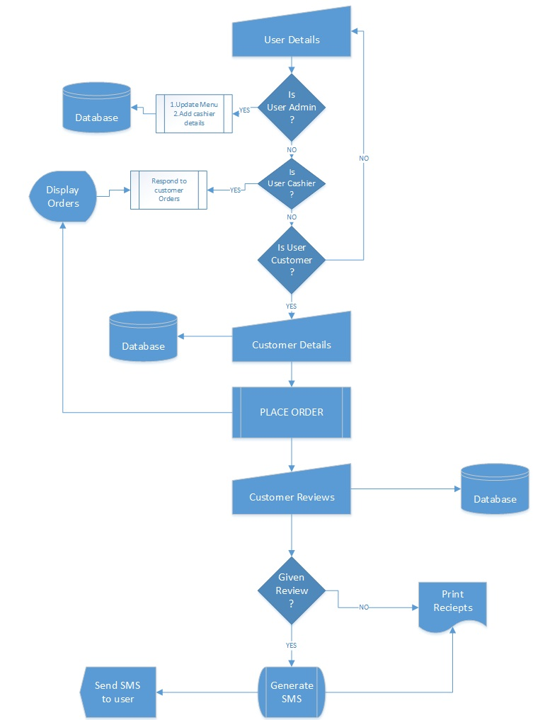This the detailed view of flow of events in the system, containing all the modules that Run in the system.

Figure 16:System flowchart.

**Coding** – Translation of the design in to source code using Html, CSS, Python, JavaScript and other JavaScript libraries programming languages.

**Unit testing** –Testing each module to check if it met the set requirements. Making necessary errors in cases of any errors.

**Acceptance testing** –Involving the stake holders that is the students and staff in testing the product to determine whether they accepted or rejected the system.

# **CHAPTER FOUR**

## **4.1 RESULTS AND DISCUSSION**

**Café Customer**

Upon placing a food order and giving their review, the customers receive a text message on their mobile phones according to the details they gave during sign up. i.e. Mobile Number provided is used to convey a text message containing:

* Password to the Wi-Fi
* Total amount spent
* And a “*Thank You*” message

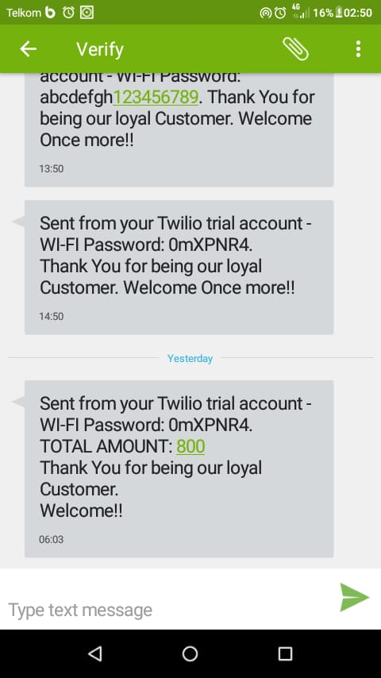

Figure 17:Text message from system.

**Café Cashier**

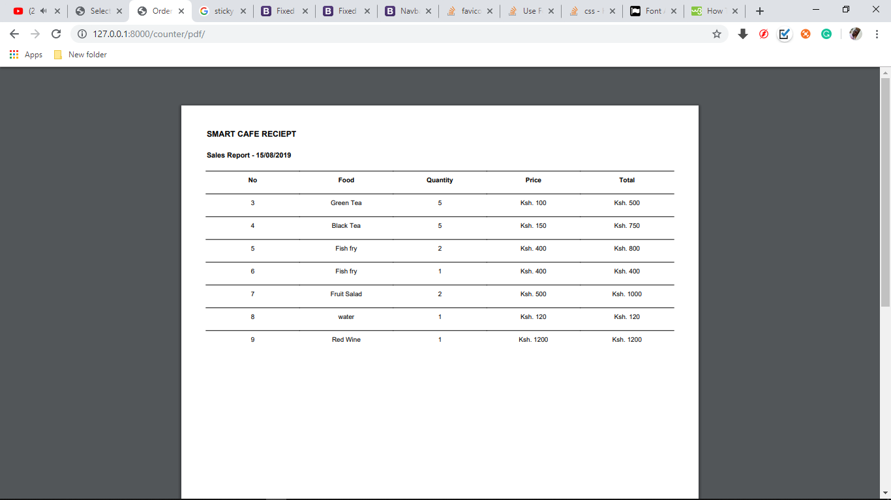The Cashier prints a list of orders which are given to customers to show how purchases are made and amount of each item. The print out can be stored for future reference.

Figure 18: Sales Report.

# **CHAPTER FIVE**

## **CONCLUSION**

In Smart-Café system, Html, CSS, JavaScript and other JavaScript libraries have been used to develop the frontend while the in the backend, Python that is Django framework has been used in conjunction with SQL for the database. The web application Smart-Café system can be adopted for use anywhere in the world.

The system has been tested with use case data which has processes and generated reports.

The system has met the objectives laid out and is fit for use.

## **RECOMMENDATION**

I recommend the system to be adopted by the modern Cafés to improve their services.

This system has room for improvements in payment module. The payments can be made to be online and not manual.

The system can be improved to allow the customers to track their order.

# **APPENDIX**

## **REFERENCE**

1. Sakari Pieska, Markus Liuska, Juhana Jauhiainen, Antti Auno ―Intelligent Restaurant System Smart- menu ‖4th IEEE International Conference on Cognitive Info communications. December 25th, 2013, Budapest, Hungary
2. Tan-Hsu Tan, Ching-Su Chang, and Yung-Fu Chen ―Developing an Intelligent e-Restaurant With a Menu Recommender for Customer-Centric Service‖ IEEE Transactions on systems, man, and cybernetics-part c: Applications and reviews, vol.42,no-5, September 2012.
3. Sun Guiling, SongQingqing ―Design of the Restaurant Self-service Ordering System Based on ZigBee Technology‖ Communications and embedded system lab College of Information Technology and Science, Nankai University Tianjin, China, October 2010.
4. Barsky, J. D., and R. Labagh. 1992. A strategy for customer satisfaction.

*The Cornell Hotel and Restaurant Administration Quarterly* 35 (3): 32 –40.

1. Cao, Y. 2011.*Comparison of customers' perceptions of service quality between different management forms in fast food restaurants.* Master’s thesis. Auburn University.
2. Carrillat, F.A., Jaramillo, F. & Mulki, J.P. 2007. The validity of the SERVQUAL and SERVPERF scales: A meta-analytic view of 17 years of research across five continents.*International Journal of Service Industry Management*, 18(5):472–490
3. Location Based Tracking Application Using Android Mobile Operating System by Apoorva Vengurlekar,Kiran Shukla, Dnyaneshwar J. Dhangar from RajivGandhi Institute of Technology, Mumbai. InternationalJournal of Scientific & Engineering Research, Volume5, Issue 3, March-2014 821 ISSN 2229-5518
4. Allison, B. (1996). Research skills for students. London: Kogan Page, p.17.
5. Bbc.co.uk, (2015). BBC Bitesize - GCSE Computer Science - Programming software and the IDE - Revision 4. [online] Available at: http://www.bbc.co.uk/education/guides/zgmpr82/revision/4 [Accessed 20 Oct. 2015].
6. Bennett, S., McRobb, S. and Farmer, R. (2010). Object-oriented systems analysis and design. Maidenhead,