For Rent

1488 Villa Piña Way #201

2 bed 1.5 bath 900ft2

$1,550 per month

Spanish-style condo in great location

Won’t last! Available June 1

Contact Claire Vasquez @ (double-check cell #)

**ABOUT VILLA PIÑA**

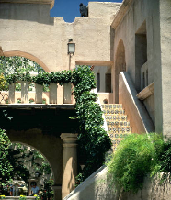

Beautiful grounds

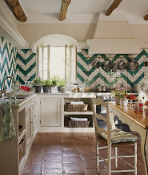

Dine-in kitchen

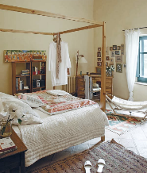

Spacious bedrooms

Private but centrally located, historic Villa Piña is just moments from fine dining, shopping, and public transportation. Enjoy the best of both worlds at Villa Piña—the beauty of nature and the culture of a vibrant neighborhood.

For more information, visit us online:

[*www.villapinacondos.com*](http://www.villapinacondos.com)

For Rent

1502 Villa Piña Way #103

1 bed 1 bath 750ft2

$850 per month

Spanish-style condo in great location

Won’t last! Available August 1st

Contact Juanita Vasquez @ (919-555-7237)

**ABOUT VILLA PIÑA**



Beautiful grounds



Dine-in kitchen



Spacious master

Private but centrally located, historic Villa Piña is just moments from fine dining, shopping, and public transportation. Enjoy the best of both worlds at Villa Piña—the beauty of nature and the culture of a vibrant neighborhood.

For more information, visit us online:

[*www.villapinacondos.com*](http://www.villapinacondos.com)