Shelbyfield Animal Rescue

August Volunteer Update

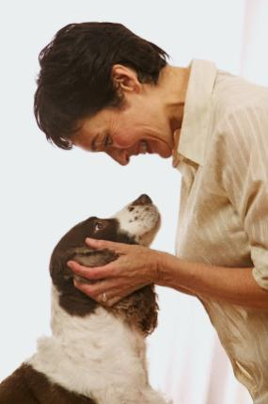A Message from Your Director

It’s been a spectacular month for Shelbyfield Animal Rescue and the animals in our care. Fifteen pets found a new home, including Temple, a longtime resident of the kennel who was later fostered by Raj and Lisa Beharry. Temple was a staff favorite who despite his special needs was always up for a rousing game of keep-away (with the slimiest, grossest tennis ball in the yard).

This was a big month for Arthur too, our lovable yellow lab mix with the submissive smile. Through the generous donation of Dr. Giuliani’s time and resources, Arthur received much-needed hip surgery. He’s recovering nicely in foster care with Joy Ramirez and her two young children, who are teaching Arthur to “speak” while he’s on bed rest.

It’s your hard work and dedication that make it possible for us to help animals in need like Temple and Arthur. To all our volunteers – from kennel staff, to adoption counselors, to office helpers, to those who help with fundraising and special events – thank you for all you do.

– Aurelia & Coco

### Adopted this Month

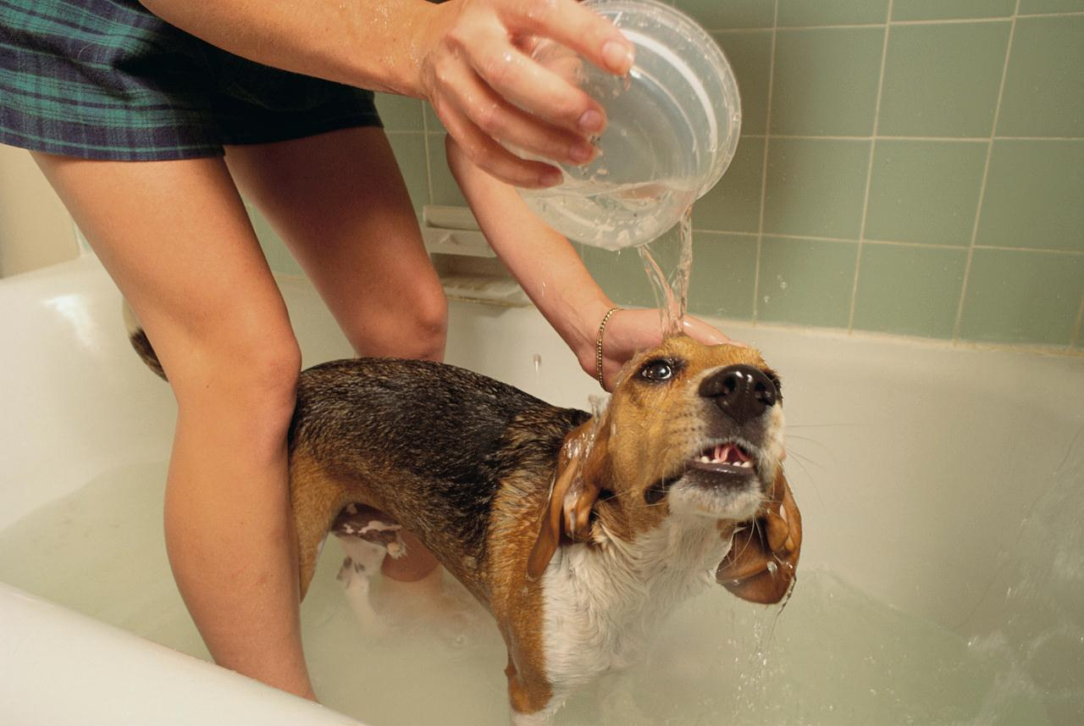Leila gets a much-needed bath

  
Sandy with his new bestie, Ebba

Congratulations to these lucky pets and the Shelbyfield staff and volunteers who helped them find a home!

* **Temple** by the Dia family
* **Leila** by Patrick and Lauren
* **Lucy** by Ileana
* **Sandy** by the Larsson family
* **Chickpea and Garbanzo** by Lee and David
* **Peanut** by Trey
* **Firefly** by Michaela
* **Salvatore** by the Chandra family
* **Hominy** by Chris and Kennisha
* **Cagney and Lacey** by the Crews family
* **Pockets** by the Williams family
* **Oona** by Bebe and Natalie
* **Shadow** by Yolanda

### Featured Pets

These wonderful pets are still looking for their forever homes. Each one has been with Shelbyfield Animal Rescue for six months or more.

|  |  |  |  |  |
| --- | --- | --- | --- | --- |
| Name | Breed | Age | Rescued | Featured because… |
| Irma | Tabby | 12 | Dec | Beautiful senior girl. Still lots of love to give! |
| Arthur | Lab Mix | 1.5 | Jan | Playful, energetic personality. Recent hip surgery, ready for his forever home. |
| Olive | Whippet | 1 | Feb | Very sweet active pup. Needs a home without cats or young children. |
| Jack | Shorthair | 3 | Oct | Lovely cat, brother to Jill. Very bonded, would like to keep together. |
| Jill | Shorthair | 3 | Oct | Cute, playful, affectionate. Seizures easily managed with medication. |

### Updated Adoption Process

We’ve recently implemented the new adoption process. It includes a home visit and the New Pet Pack, a collection of the animal’s records (medical and personal) as well as the standard adoption info and FAQ. We’ve also begun giving pet owners the collar and leash (provided by Shelbyfield Pet Supply) that’s now included in the adoption fee.

### Donations

Shelbyfield Pet Supply  
Barksdale Petsitting   
R.J. and Laurie Dumlao  
Drew family  
Mendoza family  
Shelbyfield Fire Department  
Celia Briggs  
Championship Vinyl Siding  
Angela and Ellen Newton  
Weaver family   
Bark & Bite Bakery  
Tia and Candido Flores   
Spencer, Taylor, and Kylie Gordon  
Donald Hall  
Jenks family  
Kat and Martin O’Neill