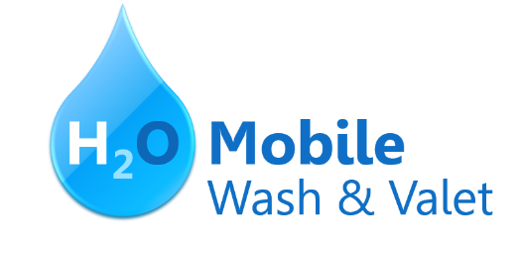

**∙**  H**2O** Signature Wash

*Cars $20 ∙ SUVs $25 and up*

Hand wash and dry vehicle, including tires, rims, wheel wells, and door jambs.

Interior vacuum, dust, and deodorize, plus windows inside & out.

**∙**  Signature Interior

*Cars $40 ∙ SUVs $60 and up ∙ March special! $5 off*

Shampoo carpets, floor mats, seats, and door panels. Clean and protect console, dash, and cup holders.

**∙**  H**2O** Signature Detail

*Cars $60 ∙ SUVs $75 and up ∙ March special! $10 off*

Everything included in the Signature Wash, plus hand wax and buff.

**∙**  Leather Cleaning & Conditioning

*Cars $20 ∙ SUVs $40 and up ∙ March special! $5 off*

Includes seats and door panels.

**∙**  Engine Cleaning

*Cars $35 ∙ SUVs $45*

Clean & shine engine compartment.

**∙**  Paint Correction & Protection

*Call for pricing ∙ March special! 10% off*

*Prices may vary depending on size of vehicle. Heavily soiled vehicles are subject to an additional charge.*

**Schedule your appointment today!**

Contact Hank Odum at 321-555-5400 or hank@H2Omobile.com

Special rates available for weekly/monthly customers

H**2O Mobile Wash & Valet** | Just leave the details to us

H2**O** **Mobile’s**

**UNLIMITED WASH CLUB**

H2**O Signature Detail Plan $84.99/mo**

Includes:

Fragrance

Hand wax

Wax and buff

Hand wash and dry vehicle, including tires, rims, wheel wells, and door jambs

Interior vacuum

Dust

Deodorize

Windows Inside & Out

H2**O Signature Wash Plan $79.99/mo**

Hand wash and dry vehicle, including tires, rims, wheel wells, and door jambs

Interior vacuum

Dust

Deodorize

Windows Inside & Out

For more details, contact Hank Odum at 321-555-5400 or hank@H2Omobile.com

*Prices may vary depending on size of vehicle. Heavily soiled vehicles are subject to an additional charge*

Just leave the details to us

H**2O Mobile Wash & Valet** |

