Design & Simulation of a Multi-Stage Audio AFE for High-Resolution ADCs

1. Abstract

This project implements a precision analogue front-end (AFE) designed to condition low-level differential audio/sensor signals before digitisation by a high-resolution ADC (AD4695 class). The system includes a preamplifier, high-pass filter, low-pass filter, differential ADC driver, and ADC interface, all simulated in LTspice and captured in KiCad using hierarchical design. The goal was to explore real-world analogue design concepts including VMID biasing, differential signalling, filter design, and op-amp selection. 0 ERC was achieved across the entire system.

2. Block Diagram
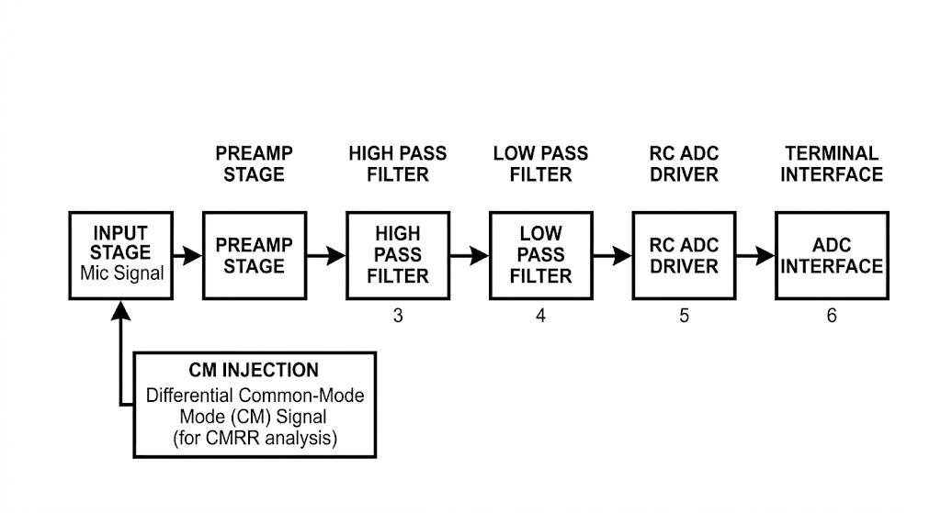

Figure 1 – System Block Diagram

3. Applications

Typically, analogue front ends are used in systems requiring clean, conditioned analogue signals prior to digitisation. Typical applications include:
- Audio acquisition and preamplifiers
- Industrial sensing (strain gauges, accelerometers, pressure sensors)
- Biomedical instrumentation (ECG, EMG, EEG)
- Precision measurement systems and DAQ modules
- Embedded DSP pipelines

This AFE is designed for audio-band acquisition (~15 kHz) and interfaces with AD4695/CS5312-class ADCs, suitable for embedded audio capture and low-noise sensor acquisition.

4. Block-Level Design

4.1 ADA4084-2 Preamp
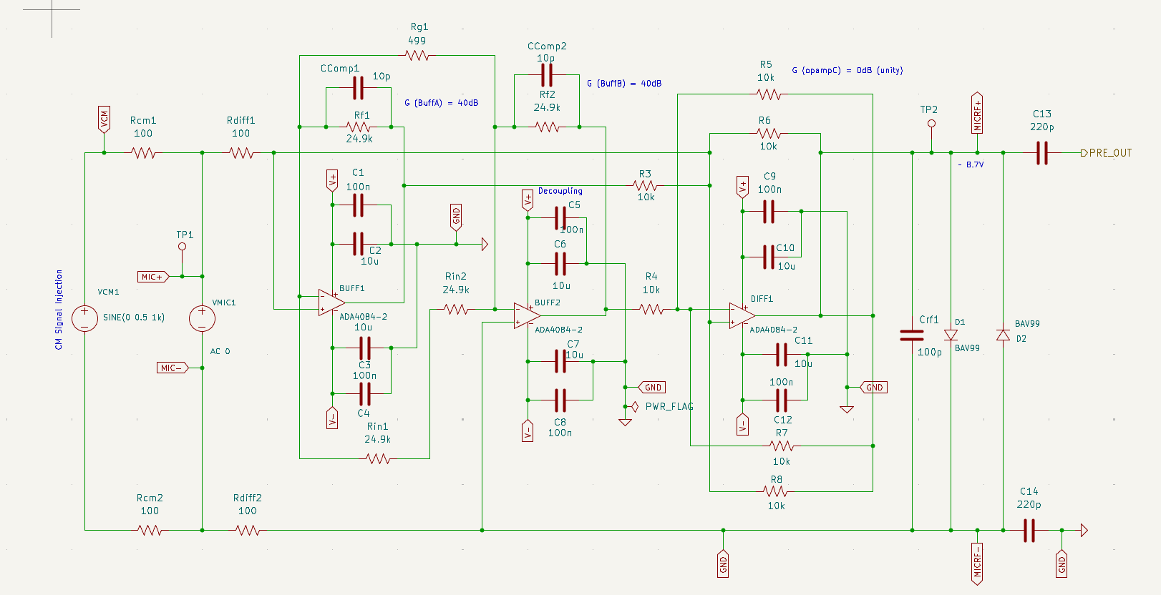
Figure 2 - Differential microphone input with RF/ESD protection and optional common mode injection source used for evaluating CMRR performance.
Provides initial gain, impedance matching, and RF/ESD protection. Implemented using a discrete three-op-amp instrumentation amplifier topology (see glossary) (INA128/INA163 equivalent) using x3 ADA4084 models.

4.2 Power Rails
Generates ±12 V analogue rails and 3.3 V digital rail. Includes decoupling, filtering, and VMID generation.

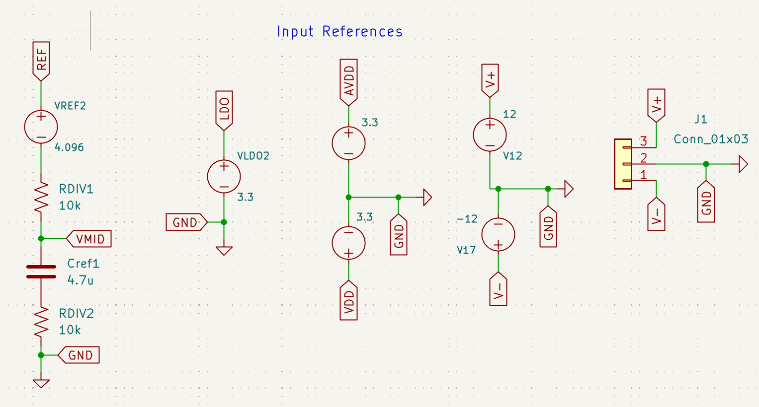
Figure 8 - ±12 V analogue rails, 3.3 V digital rail, and VMID mid rail generator providing stable biasing for AC coupled stages and differential driver common mode control.

4.3 High-Pass Filter

This stage removes DC offset and low-frequency drift from the preamplifier output while preserving signal symmetry. It uses AC-coupling caps biased at VMID to shift the waveform into the ADC’s valid common-mode range. Cut-off Hz is set around 15–20 Hz, ensuring that audio-band content and sensor dynamics remain unaffected while slow baseline wander is eliminated. Both filters employ the Sallen-Key 2nd order topology (see Glossary). See Equations at the end of the report.

The following set the filter cut-off:
- C15
- R9
- R10
- C16
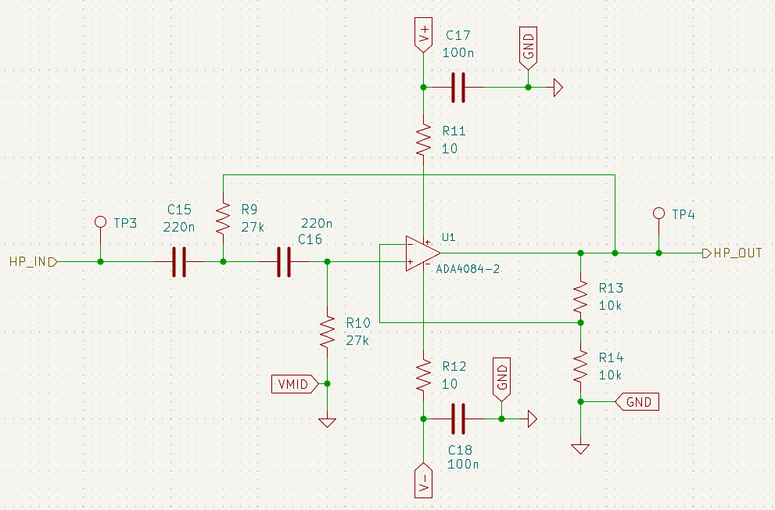

Figure 4 - AC coupled high pass filter biased at VMID to remove DC offset and low frequency drift while maintaining differential symmetry.

4.4 Low-Pass Filter

Following the high pass directly, this defines final analogue bandwidth of the system (~15 kHz). It attenuates high-frequency noise, RF interference, and out-of-band content that could otherwise alias during ADC sampling. Component values were selected to achieve a smooth roll-off and stable Q-factor, ensuring minimal phase distortion within the passband. This stage acts as the primary anti-alias filter, preparing the differential signal for accurate conversion by the ADC driver.

The input is tested at TP5, followed by the below which set the cut-off the filter cut-off:
- R15
- R16
- Equivalent C between C20, C21
- C19
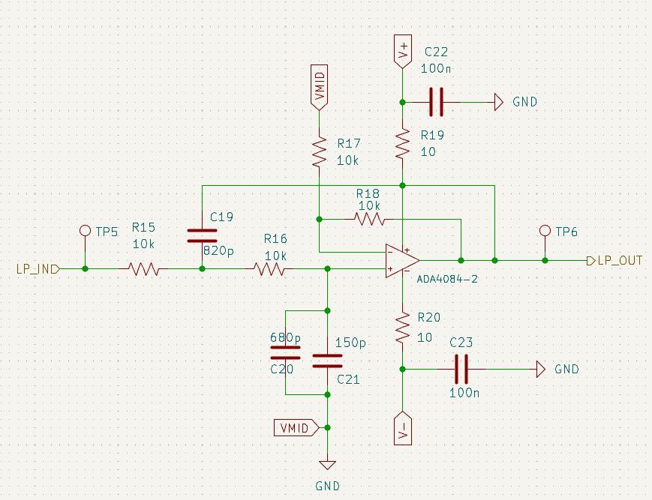

Figure 5 - Second order Sallen Key low pass filter providing anti-aliasing and defining the final analogue -bandwidth (~15 kHz) before ADC sampling.

4.5 ADC Driver

This driver circuit converts the filtered single-ended or pseudo-differential signal into a fully differential output suitable for the AD4695 input structure. Using ADA4084-2 op-amps, it sets the correct differential swing, aligns the common-mode voltage to VMID, and ensures fast settling within the ADC’s acquisition window. The final RC block at the output shapes the transient response and provides impedance matching.

This stage is critical for achieving low distortion, stable common-mode behaviour, and full-scale utilisation of the ADC.
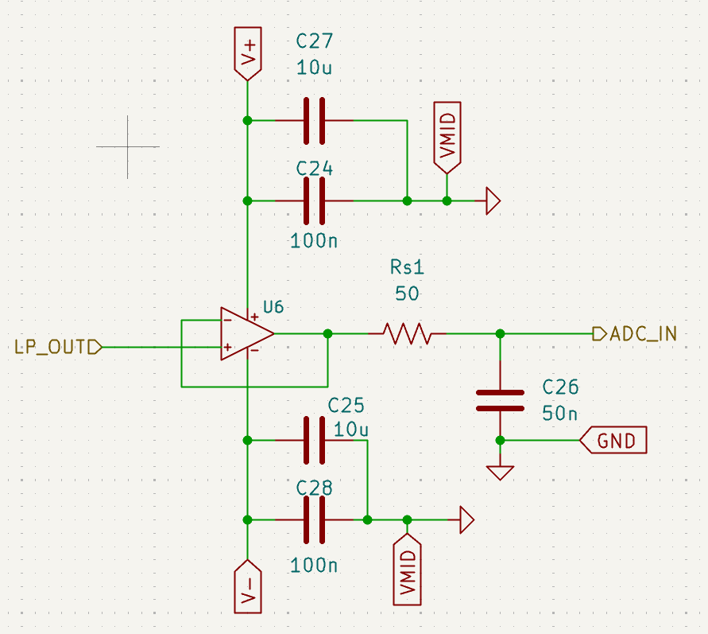

Figure 6 - Differential ADC driver using ADA4084 2 op amps with RC network for settling control, common mode alignment to VMID, and impedance matching to AD4695 input structure.

4.6 ADC Interface

This is the final block, before the audio input is fully digitised. provides the final connection between the analogue signal chain and the AD4695, including reference buffering, decoupling, and a 3.3 V digital supply (datasheet). It ensures that the ADC receives a clean, stable reference voltage and that the differential driver output meets the ADC’s input impedance and common-mode requirements.

This stage also includes terminal pins for SPI or serial data lines, grounding, and local bypass caps placed close to the IC footprint to minimise noise coupling. Together, these elements guarantee reliable sampling and accurate digital conversion.
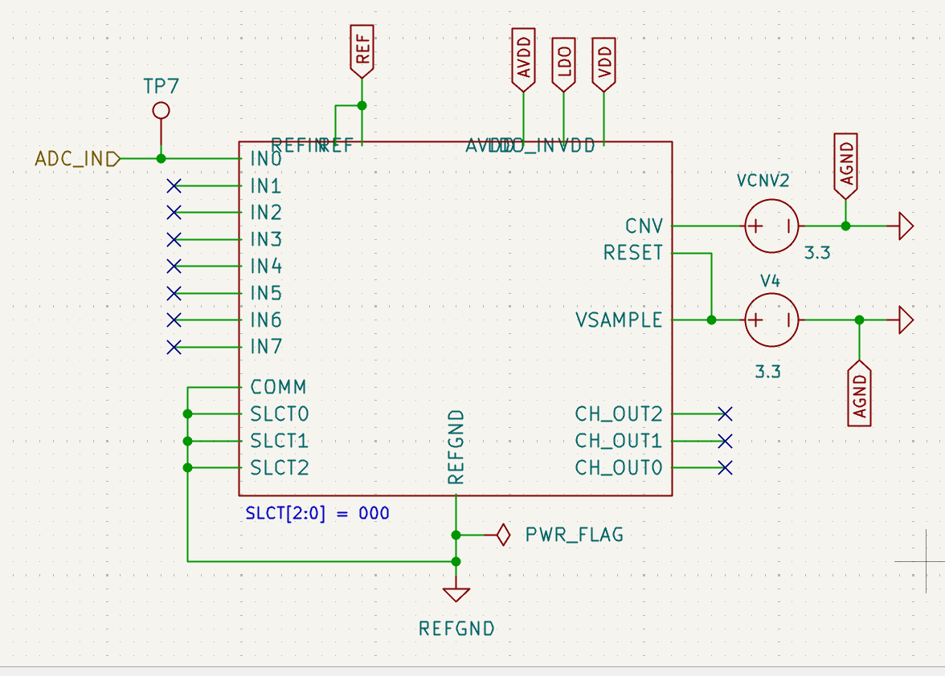

Figure 7 - Terminal interface for AD4695 including reference buffering, decoupling, 3.3 LDO supply, and digital I/O connectivity.

4.7 - Test Points
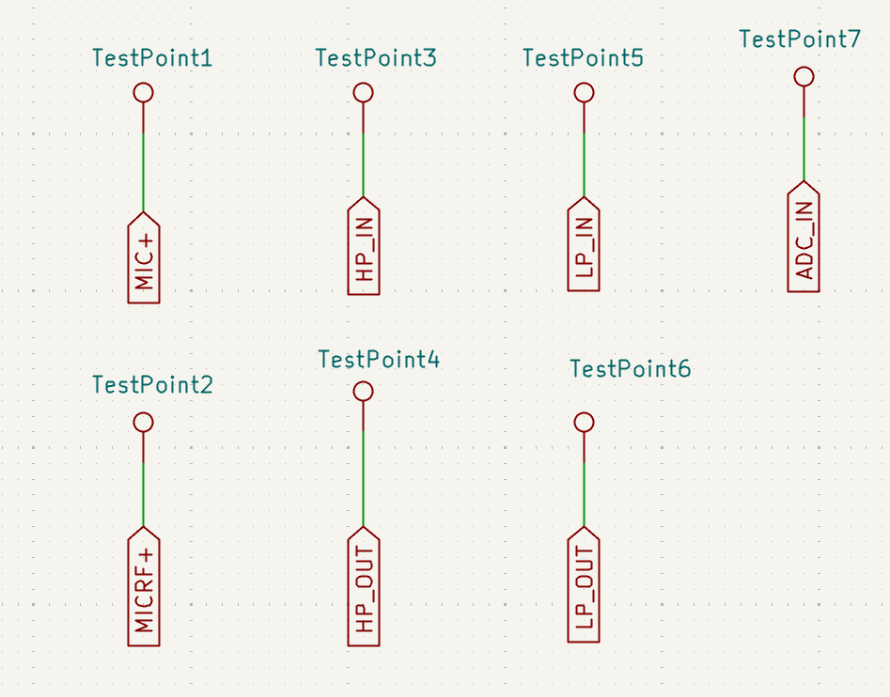

For the PCB, I’ve decided to probe list of 7 below points across the board to ensure functionality.
- TP1 at MIC+ node
- TP2 at MIC_RF+ node
- TP3 at the high pass filter input
- TP4 at the high pass filter output
- TP5 at the low pass filter input
- TP6 at the low pass filter output
- TP7 at the ADC IN0 input


5. Component Choices

Components selected using Octopart, focusing on:
- ADA4084-2 (low noise, high bandwidth)
- AD4695 (high-resolution SAR ADC)
- BAV99 (input protection)
- Precision resistors and film capacitors
- Low-noise 3.3 V LDO

Datasheets and application notes sourced from Analog Devices, TI, and Octopart.

6. PCB Considerations
Although PCB layout was not completed, the following considerations were planned:
- Short, symmetric routing for ADC differential inputs
- VMID kept away from digital switching noise
- Tight feedback loops around op-amps
- Decoupling capacitors placed within 2–3 mm of supply pins
- Single analogue ground plane for low-noise operation
- Reference and ADC driver placed close to ADC package

The snapshot below shows the final ERC run, after multiple runs to correct electrical mistakes, whereby the system achieves 0 ERC. Library errors were ignored, as they have 0 impact on functionality. Therefore, my system is layout ready.
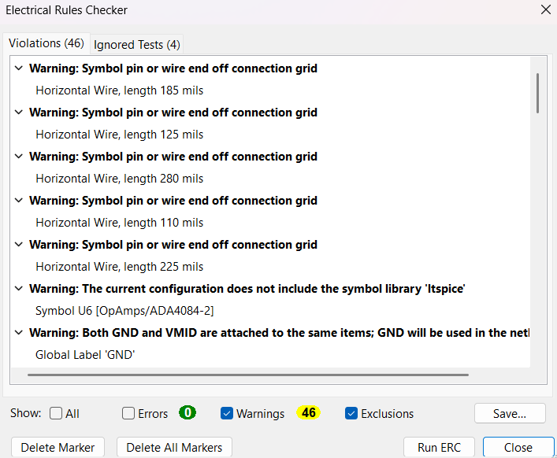

Figure 12 - KiCad ERC report showing zero electrical errors across all hierarchical sheets, confirming correct net connectivity and schematic integrity.

7. Board Design

7.1 Schematic Import & Net Preparation

7.2 Footprint Selection & Justification

7.3 Placement Strategy

7.4 Routing Strategy

7.5 Power, Ground & VMID Strategy

7.6 DRC Validation

7.7 Layout and 3D View

8. Glossary

A
AC coupling: Using capacitors to block DC components while passing AC signals.
Acquisition Window: Time during which the ADC samples the input; driver must settle within this window.
ADC: analogue-to-digital converter, a device that uses sampling/oversampling techniques to digitise a signal into 0s and 1s.
ADC Driver: A stage that allows us to connect an ADC interface without directly loading a conditioned input.
ADC Interface: The ADC itself, including the pinout, connections, and power ports.
AD4695: A high-speed SAR ADC model used in this project from ADI.
AFE: Analog Front-End; full chain of analogue conditioning blocks.
Alias / Aliasing: Distortion caused when sampling frequency is too low.
Amplifier Saturation: An opamp condition where the output smashes into V+/V- rails
Anti-Alias Filter: A low pass filter placed before the ADC to prevent aliasing.

B
Bandwidth: The range of frequencies in which the system operates.
BAV99: A fast switching, silicon diode model used for protection in this system.
Biasing: Setting the DC op point of a circuit.
Bode Plot: Any graph that shows a frequency response, typically logarithmic.

C
Capacitive Reactance: Opposition to AC by a capacitor: $X_{C}=1/\left(2πfC\right)$.
CM Injection: Injecting a common-mode signal to test CMRR.
CMRR: Common-Mode Rejection Ratio; ability to reject common-mode noise.
CM Voltage: Average of the two input voltages.
Cutoff Hz: Frequency at which a filter output drops by –3 dB.

D
DAC: Digital-to-Analog Converter (not used in this project). Inverse of ADC
Decoupling Cap: A capacitor placed near IC supply pins to reduce noise/EMI
Differential Pair: Two complementary signal lines carrying + and -
Differential Signal: Signal represented by difference between + and -
Discrete INA: Instrumentation amplifier built using three op-amps.
Driver Settling: The time required for an ADC driver output to reach final value

E
EMI: Electromagnetic interference; unwanted noise from external EM sources.
ESD: Electrostatic discharge; dangerous HV spikes, often protected by diodes.
ERC: Electrical Rule Checker – KiCad feature
Error Budget: Sum of all noise, distortion, and gain errors.

F
Feedback Loop: Path from output to input of op-amp controlling gain and stability.
Filter Order: Number of reactive components determining roll-off steepness.
Full-Scale Range: Maximum differential voltage the ADC can accept.

G
Gain: Ratio of output to input voltages and power.
Gain-Bandwidth Product: Op-amp parameter defining bandwidth at given gain.
Ground Plane: PCB copper area used for low-noise grounding.

H
High-Pass Filter: A filter that passes high Hz, and attenuates low Hz
Hierarchy (KiCad): Organising schematics into multiple sheets.

I
Impedance: AC equivalent of resistance. Can be capacitive or inductive.
INA: Precision differential amplifier with high CMRR, much higher than an opamp.
Input Bias Current: Small DC current flowing into op-amp inputs.
Input Offset Voltage: Small DC voltage error at op-amp input.

L
LSB: Least Significant Bit of ADC resolution.
Low-Pass Filter (LPF): A filter that low high Hz and attenuates high Hz.
LTspice: Simulation tool used for verifying analogue behaviour.

M
Mic Input: Low-level differential audio signal entering the AFE.
MOSFET: Type of 3-pin, field-effect transistor.

N
Noise Floor: The minimum detectable signal level.
Nyquist Frequency: Half the sampling rate.
O
Octopart: Renesas-owned, component search engine used for selecting parts.
Op-Amp: Operational Amplifier, amplifies the difference between inverting, non-inverting pins.
Oversampling: Sampling a higher rate to reduce noise.

P
PCB: Printed Circuit Board
Preamplifier: An early stage in analogue systems to boost low input signals.
PSRR: Power Supply Rejection Ratio (irrelevant for this project).
PWR_FLAG: A KiCad symbol indicating a net is intentionally powered.

Q
Q-factor: A value that defines the overall performance of opamp

R
Time Constant: (tau) $τ=RC$.
Reference Voltage: Voltage defining ADC full-scale range.
Resistor Divider: Two resistors forming a scaled voltage output. Commonly used in undervoltage lockout, or to turn “on” a chip.

S
Sallen-Key Filter: a 2nd order, active filter topology used to build LPFs, HPFs.
SAR ADC: Successive Approximation Register – type of ADC.
Settling Time: The time required for output to reach final value.
Signal Chain: A sequence of blocks processing the signal.
T
Test Points: Nodes defined on the PCB for probing and power injection.
Thermal Noise: Random noise generated by resistors.

V
Virtual Ground: A ref point treated as 0 V for AC signals.
VMID: Mid-rail bias used for AC-coupled stages.

Z
Zero-Error ERC: When KiCad reports no electrical issues.

9. Appendices

A1 - Key Equations

Input stage & CM injection
Differential & common-mode definition $V_{\text{diff}}=V_{+}-V_{-}$
Common-mode voltage $V_{\text{cm}}=\frac{V_{+}+V_{-}}{2}$
Reconstructing input terminals from $V_{\text{diff}}$ and $V_{\text{cm}}$
$$V_{+}=V_{\text{cm}}+\frac{V_{\text{diff}}}{2}$$
$$V_{-}=V_{\text{cm}}-\frac{V_{\text{diff}}}{2}$$
CMRR $\text{CMRR}=20\log_{10}\left(\frac{A_{\text{diff}}}{A_{\text{cm}}}\right)$

Preamp Equations
Three-opamp INA gain $G_{\text{INA}}=1+\frac{2R}{R_{G}}$
Output differential voltage of INA $V_{\text{out,diff}}=G_{\text{INA}}⋅V_{\text{diff,in}}$
Output common-mode (ideally) $V_{\text{out,cm}}≈V_{\text{cm,in}}$

Filter Equations
Assuming simple RC high-pass or AC-coupling into VMID:
Cut-Off Hz $f_{c,\text{LPF}}≈\frac{1}{2π\sqrt{R_{1}R_{2}C_{1}C_{2}}}$
Cut-Off Hz (simplified)
If $R1=R2{= R}_{\text{HPF}}$ and $C1=C2{= C}_{\text{HPF}}$, the original equation simplified to the below:
$$f_{c,\text{HPF}}=\frac{1}{2πR_{\text{HPF}}C_{\text{HPF}}}$$
The equation is also the same as the cut off Hz formula for a 1st order RC filter.

Q-factor $Q≈\frac{\sqrt{R_{1}R_{2}C_{1}C_{2}}}{R_{1}C_{2}+R_{2}C_{1}}$

RC Driver
Differential output of driver $V_{\text{ADC,diff}}=G_{\text{DRV}}⋅V_{\text{LPF,out,diff}}$
Common-mode at ADC input $V_{\text{ADC,cm}}=\frac{V_{\text{ADC+}}+V_{\text{ADC-}}}{2}=V_{\text{MID}}$
RC time constant for driver network $τ_{\text{DRV}}=R_{\text{DRV}}C_{\text{DRV}}$
Settling behaviour (first-order) $V\left(t\right)=V_{\text{final}}+\left(V_{\text{initial}}-V_{\text{final}}\right)e^{-t/τ_{\text{DRV}}}$
ADC Equations
ADC input range (differential) $V_{\text{ADC,diff,max}}≈2V_{\text{ref}}$
LSB size (for N-bit ADC) $\text{LSB}=\frac{2V_{\text{ref}}}{2^{N}}$

A2 - Software


Software used in this project:
- KiCad
- LTspice
- Octopart
