PaperAudit demonstration manuscript
Synthetic examples for testing a pre-submission checker; not scientific evidence.

1. Introduction
This document references 图 1 and 图 3, while 图 7 has no caption. See references [1, 3].

1.1. Synthetic results
图 1 合成波形（示例）
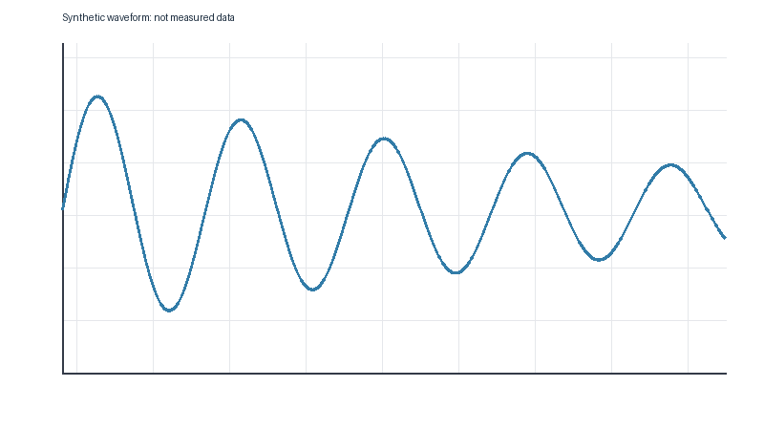
图 3 第二幅图题，仅用于演示缺号检查
表 1 数值示例
Name | Value
Dummy | 1

References
[1] Synthetic reference for demonstration.
[2] Another synthetic reference.

