Fixer Nation
Admin Backend Guide

Step-by-step guide to every admin feature

Fixer Nation Testing Guide

v2.0 — SP-1 through SP-53

August 2026

Introduction
Note: This is a living document — it will be updated with each new sprint release. Screenshots showing a placeholder are from pages that require an active admin login. Replace them by navigating to the URL while signed in and capturing a screenshot.

The Fixer Nation admin backend is accessible at fixernation.org/admin. Access requires the ADMIN or SUPER_ADMIN role. This guide covers every admin section, what it does, and exactly how to navigate and test it.

How to access the admin backend:
1. Open fixernation.org in your browser
2. Click "Log In" in the top navigation and sign in with an ADMIN or SUPER_ADMIN account
3. After sign-in, click your avatar in the top-right corner and select "Admin"
4. Or navigate directly to fixernation.org/admin

Role permissions:
• SUPER_ADMIN — full access to all sections; can promote users to SUPER_ADMIN and manage other admin accounts
• ADMIN — same access as SUPER_ADMIN for all day-to-day functions; cannot promote to SUPER_ADMIN or modify other SUPER_ADMIN accounts
Note: Throughout this guide, "admin" means either ADMIN or SUPER_ADMIN unless otherwise specified.

Part 1: Admin Dashboard
URL: fixernation.org/admin
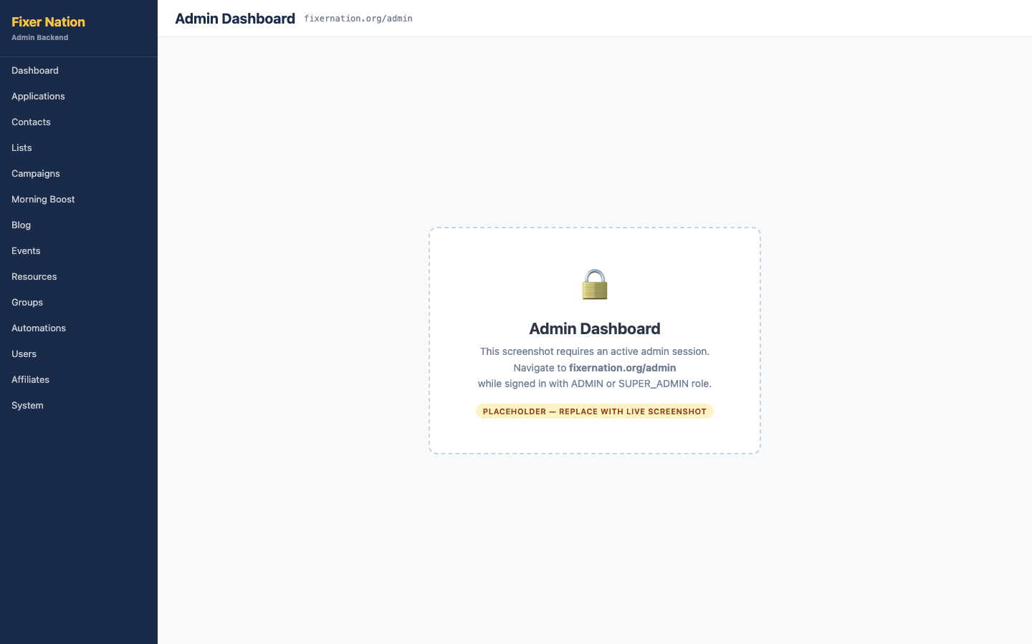
How to get here:
1. Sign in with an ADMIN or SUPER_ADMIN account
2. Click your avatar in the top-right corner and select "Admin"
3. Or navigate directly to fixernation.org/admin

What to verify:
1. Four stat cards at the top show counts for: Total Users, Active Members, Active Products, and New This Week
2. Application funnel grid shows the count of applications in each status: Needs Review, Under Review, Awaiting Applicant, Conditionally Accepted, Accepted, Declined, Expired, and Cancelled
3. Click any status count in the funnel grid — navigates to /admin/applications filtered to that status
4. Conversion rate cards show: Application→Accepted %, Accepted→Paid %, Paid→Active %, and the average days to first review
5. Activation summary shows counts of Active Service Providers and Active Brand Ambassadors
6. Recent sign-ups table shows the 5 most recently registered users with name, email, role, and join date

Part 2: Applications

2.1 Applications List
URL: fixernation.org/admin/applications
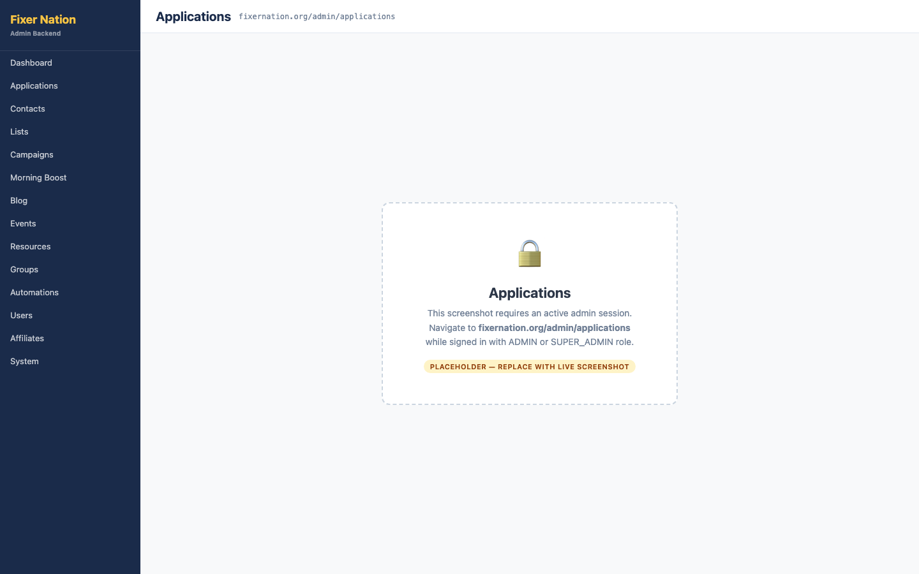
How to get here:
1. Click "Applications" in the admin left navigation sidebar
2. Or navigate directly to fixernation.org/admin/applications

Navigating the list:
1. Five tabs filter applications by status group: Needs Review, In Progress, Accepted, Closed, and All
2. "Needs Review" tab shows an unread count badge — click it to see applications awaiting your attention
3. "Type" dropdown (All Types / Providers / Ambassadors) narrows results within any tab
4. Search box: type a name, email, phone, business name, or service category — results filter in real time
5. Click "Advanced filters" — a panel expands with date range, territory, affiliate status, referral code, and campaign source filters

Actions from the list:
6. Click "Export CSV" — a CSV file downloads with data matching the current filter view
7. Click any application row to expand it inline — contact details, review notes field, and quick action buttons appear
8. Quick actions from the inline expand: Mark Under Review, Request More Info, Conditionally Accept, Accept, and Decline
9. Click "View full application" — opens the full application detail page at /admin/applications/[id]

2.2 Reviewing an Application (Full Workflow)
URL: fixernation.org/admin/applications/[id]
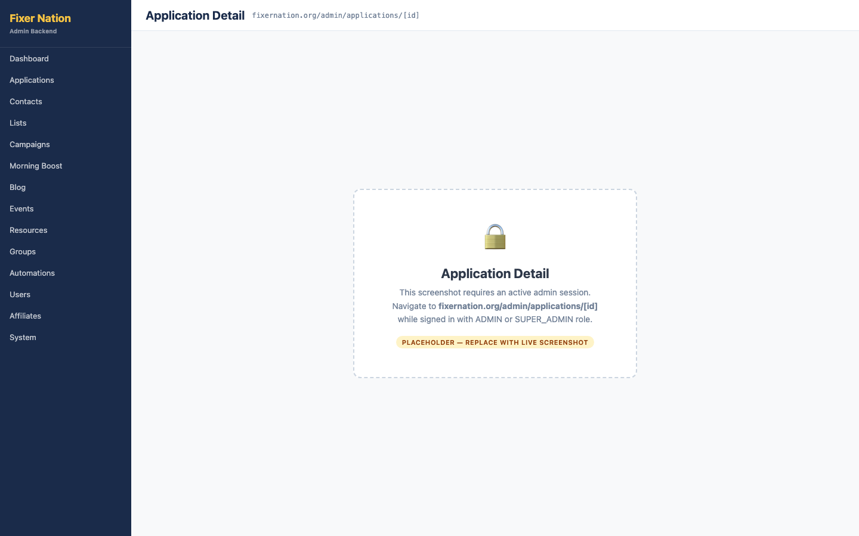
How to get here:
1. From /admin/applications, click "View full application" in the expanded row of any application
2. Or from the admin dashboard, click a status count in the funnel and then open any application

Reviewing the application:
1. Open an application that is in "Needs Review" status
2. Click each collapsible section to expand it: Contact, Business, Services, Your Story, Online Presence, and Agreements — verify all submitted data is displayed correctly
3. Add notes in the "Review notes" textarea at the bottom of the page

Taking action:
4. Click "Mark under review" — status changes to Under Review and an email notification is sent to the applicant
5. Click "Request more info" — an email is sent to the applicant containing your review notes as the request message
6. Click "Conditionally accept" or "Accept" — an email preview dialog appears; review the email and click Confirm to send the acceptance email
7. Click "Decline" — a decline email is sent to the applicant
Note: Acceptance and decline emails are sent using the message templates configured in /admin/message-templates. You can customize these templates before sending.

2.3 Onboarding Checklist
Location on the page:
The onboarding checklist appears below the review section on every application detail page.

What to verify:
1. Provider applications show 12 checklist items; ambassador applications show 14 items
2. Each item has a status dropdown with options: Pending, Passed, Failed, N/A, and Docs Needed
3. Change any status dropdown — the change saves automatically without clicking a Save button
4. Refresh the page — the updated status persists

2.4 Territory Assignment
Location on the page:
The Territory Assignment section appears below the onboarding checklist on accepted application detail pages.

Assigning a territory:
1. Select a territory from the dropdown (territories are created in /admin/territories)
2. Optionally enter notes about the assignment in the notes field
3. Click "Assign" — the territory appears in the assignments list below the form

Removing a territory:
4. Find the territory in the assignments list and click the revoke button (×) — the territory is removed from this application

2.5 Affiliate Provisioning (Ambassador Applications)
Location on the page:
The Affiliate Provisioning section appears on accepted ambassador application detail pages.

Steps:
1. On an accepted ambassador application, locate the "Affiliate" section
2. Click "Provision affiliate account" — an affiliate record is created and appears in /admin/affiliates
3. After provisioning, the button changes to a link to the affiliate's management page
Note: An affiliate account must be provisioned before the ambassador's referral link and promo code features become active.

2.6 Account Invite
Location on the page:
The Account Invite section appears on accepted applications that do not yet have a linked user account (i.e., the applicant has been accepted but has not created an account yet).

Sending an invite:
1. Click "Send account invite" — an invite email is sent to the applicant; the button changes to "Resend invite"
2. The invite email contains a link to /invite/[token] where the applicant creates their account

What to verify:
3. After the invite is sent, "Revoke invite" button appears — clicking it invalidates the invite link
4. After the applicant accepts the invite and creates their account, this section shows the linked account name and email instead of the invite controls

2.7 Directory Listing (Service Providers Only)
Location on the page:
The Directory Listing section appears on active service provider application detail pages.

Steps:
1. On an active provider application, locate the "Directory Listing" section
2. Enable the "List in provider directory" toggle — the provider's card immediately appears at fixernation.org/providers
3. Disable the toggle — the provider is removed from the public directory immediately
Important: Only enable directory listings for fully onboarded providers with complete profiles. Listing a provider with no photo, headline, or services description creates a poor experience on the public directory.

Part 3: Contacts

3.1 Contacts List
URL: fixernation.org/admin/contacts
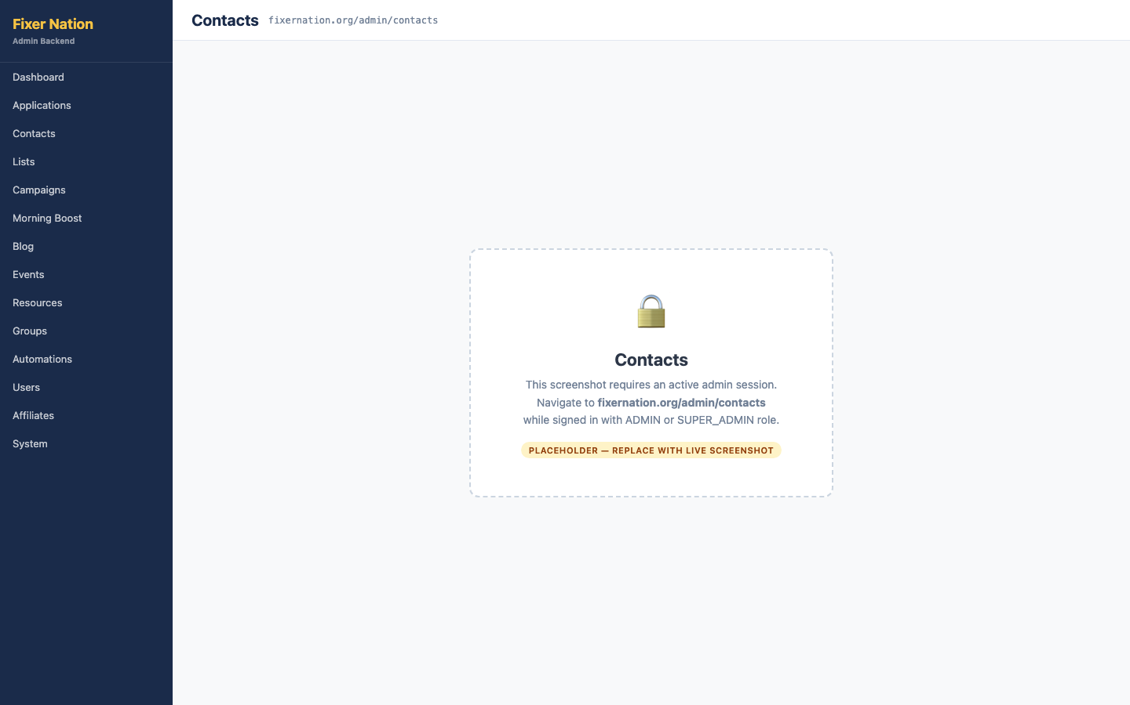
How to get here:
1. Click "Contacts" in the admin left navigation sidebar

What to verify:
1. Table lists all contacts with: name, email, company, tag count, list count, source, and date added
2. Type a name, email, or company in the search input — rows filter in real time
3. Click "+ Add contact" — navigates to /admin/contacts/new
4. Click "Import CSV" — navigates to /admin/contacts/import
5. Click any contact row — navigates to that contact's detail page at /admin/contacts/[id]

3.2 Creating a Contact
URL: fixernation.org/admin/contacts/new
How to get here:
1. From /admin/contacts, click "+ Add contact"

Steps:
1. Enter the contact's email address (the only required field)
2. Optionally fill in: first name, last name, phone, secondary phone, secondary email, and company
3. Click "Create contact" — the contact is created and you are redirected to their detail page
4. Click "Cancel" — returns to the contacts list without creating a record

What to test:
5. Submit with no email — validation error shown
6. Submit with a valid email and optional fields — contact created, detail page opens

3.3 Contact Detail
URL: fixernation.org/admin/contacts/[id]
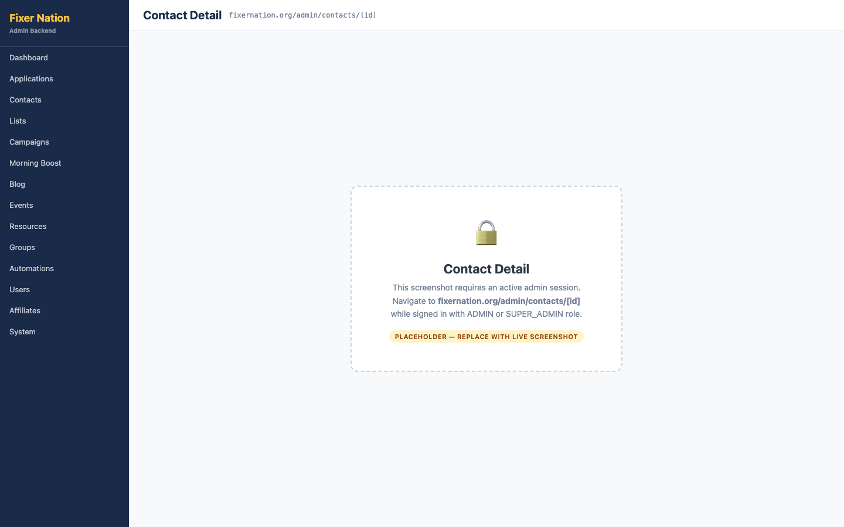
How to get here:
1. From /admin/contacts, click any contact row

Profile section:
1. All fields display: email, secondary email, company, phones, source, added date, last activity, and linked user account status
2. Click "Edit" — an inline form opens for all fields
3. Make a change and click "Save" — reload the page and verify the change persisted
4. Click "Delete contact" — a confirmation dialog appears; confirm to permanently delete the contact and all associated data

Tags:
5. Type a tag name in the tags input and press Enter or click "Add" — a tag badge appears
6. Click the × on any tag badge — that tag is removed from the contact

Notes:
7. Type a note in the notes textarea and click "Save" — note appears with the current timestamp above the textarea
8. Notes are sorted newest first

Email consent:
9. Per-topic consent toggles are shown: Morning Boost, Campaigns, Newsletters, Product Updates
10. Flip any toggle — the change saves immediately and affects future sends to this contact

Lists:
11. Click the "Add to list" dropdown — all available lists are shown
12. Select a list and click "Add" — this contact now appears in that list's member table at /admin/lists/[id]

Addresses:
13. Click "Add address" — a form opens with type, street, city, state, zip, country fields
14. Fill in the address and click "Save" — address appears in the address list with type and primary badges
15. Click "Edit" or "Remove" on an existing address to modify or delete it

Campaign history:
16. All campaigns this contact was included in appear with: campaign name, send status, and sent date

3.4 Importing Contacts from CSV
URL: fixernation.org/admin/contacts/import
How to get here:
1. From /admin/contacts, click "Import CSV"

Steps:
1. Click the file upload area or drag a CSV file onto it — the file is parsed immediately in the browser
2. Column auto-detection shows which fields were recognized (email, first name, last name, etc.)
3. A preview table shows the first 5 rows of data
4. If the CSV has no subscriber status column, consent topic checkboxes appear — check the topics to grant consent to all imported contacts
5. Click "Import N contacts" — import runs and a result summary appears showing: contacts added, duplicates skipped, consents set, and addresses saved
Note: The importer accepts Wix contact exports and generic CSVs. Only the email column is required. Duplicate email addresses are skipped, not overwritten.

Part 4: Contact Lists

4.1 Lists Overview
URL: fixernation.org/admin/lists
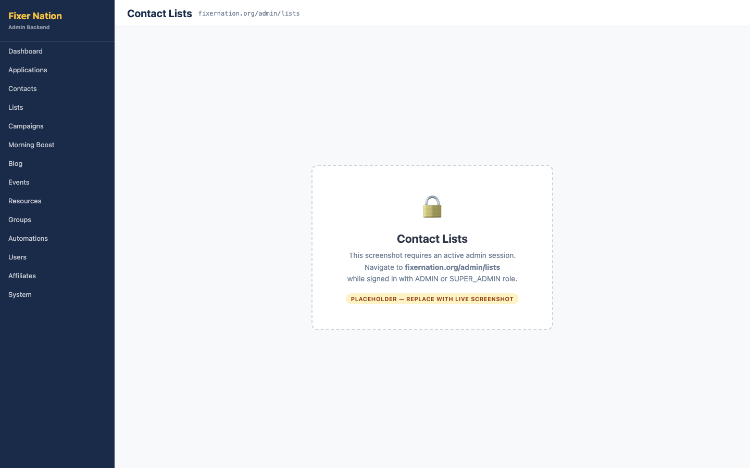
How to get here:
1. Click "Lists" in the admin left navigation

What to verify:
1. Lists appear as cards with: name, owner type badge (FN Admin / Ambassador / Provider), description, and member count
2. Click "+ New list" — an inline form appears with name and description fields
3. Enter a name and click "Create" — the new list card appears in the grid
4. Click any list card — navigates to the list detail page at /admin/lists/[id]

4.2 List Detail
URL: fixernation.org/admin/lists/[id]
How to get here:
1. From /admin/lists, click any list card

What to verify:
1. List name and description appear at the top; click "Edit name" to rename inline
2. Member count shows the current number of contacts in the list
3. Add a contact: type an email address in the add-contact input and click "Add" — contact appears in the member table
4. Remove a contact: click the "Remove" button on any row — contact is removed from the list but not deleted
5. Click "Delete list" (with confirmation dialog) — the list is deleted; contacts in it are not deleted
Important: Ambassador-owned lists (owner type = Ambassador) cannot be selected as the audience for FN Admin campaign sends. The campaign creation form will prevent this selection.

Part 5: Campaigns

5.1 Campaigns List
URL: fixernation.org/admin/campaigns
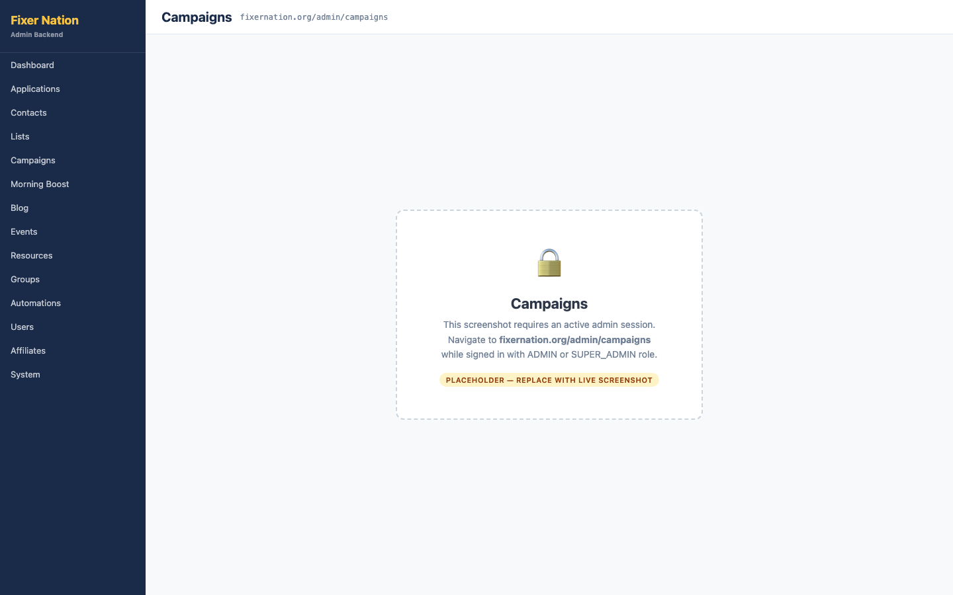
How to get here:
1. Click "Campaigns" in the admin left navigation

What to verify:
1. Table shows all campaigns with: name, subject line, status badge, assigned list, send count, and sent or scheduled date
2. Status badges: Draft (grey), Scheduled (blue), Sending (amber), Sent (green)
3. Click "+ New campaign" — navigates to /admin/campaigns/new
4. Click any campaign row — navigates to that campaign's detail page

5.2 Creating a Campaign
URL: fixernation.org/admin/campaigns/new
How to get here:
1. From /admin/campaigns, click "+ New campaign"

Required fields:
1. Campaign name (for internal reference only)
2. Email subject line (appears in the recipient's inbox)
3. HTML email body

Optional fields:
4. From name and from email address (defaults to the system address if left blank)
5. Send-to list (assigns a contact list as the audience)
6. Plain text fallback body
7. Schedule date and time (if set, the campaign-scheduler cron will send it at or after that time)

Saving the campaign:
8. No schedule date: click "Save as draft" — campaign is saved with Draft status
9. Schedule date set: click "Save and schedule" — campaign is saved with Scheduled status

5.3 Campaign Detail
URL: fixernation.org/admin/campaigns/[id]
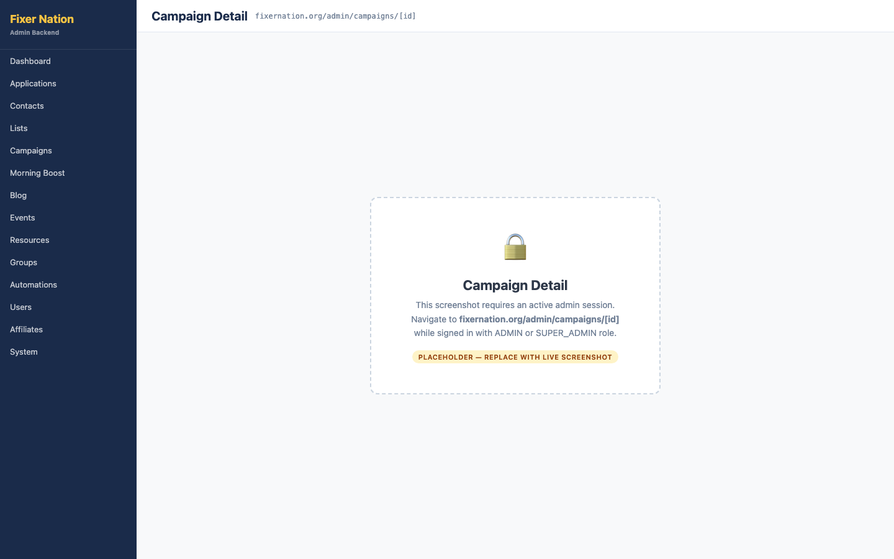
How to get here:
1. From /admin/campaigns, click any campaign row

What to verify:
1. Header shows: campaign name, subject, status badge, from address, assigned list, and timestamps
2. A preview panel shows a sample of the email body HTML
3. Stats sidebar shows send counts by status: Sent, Opened, Bounced, Unsubscribed

Sending:
4. "Send now" button is available for Draft and Scheduled campaigns that have a list assigned
5. Click "Send now" — status changes to Sending; emails go out to all eligible consented contacts; status then changes to Sent

What to verify after sending:
6. Open the received email in a test inbox — {{first_name}} in the subject or body should be replaced with the contact's actual first name
7. Scroll to the bottom of the email — an Unsubscribe footer link is present
8. Click the unsubscribe link — a /unsubscribed confirmation page appears; the contact's campaign consent is set to opted out

Other actions:
9. "Edit" button (only available for Draft and Scheduled status) — opens the edit form at /admin/campaigns/[id]/edit
10. "Delete" button (not available while Sending) — confirmation dialog; campaign is deleted

5.4 CAN-SPAM Compliance — Unsubscribe Flow
End-to-end test:
1. Send a campaign to a list that includes a test contact
2. Open the received email and scroll to the bottom — an "Unsubscribe" link is in the footer
3. Click the Unsubscribe link — browser opens fixernation.org/unsubscribed with a confirmation message
4. Go to /admin/contacts/[id] for that contact — the Email Consent section shows Campaigns as opted out
5. Create another campaign, assign the same list, and send it — the unsubscribed contact is not included in the send
Note: The unsubscribe token is HMAC-SHA256 signed using the AUTH_SECRET environment variable. Tokens are scoped per contact and cannot be reused across contacts.

Part 6: Morning Boost

6.1 Morning Boost List
URL: fixernation.org/admin/morning-boost
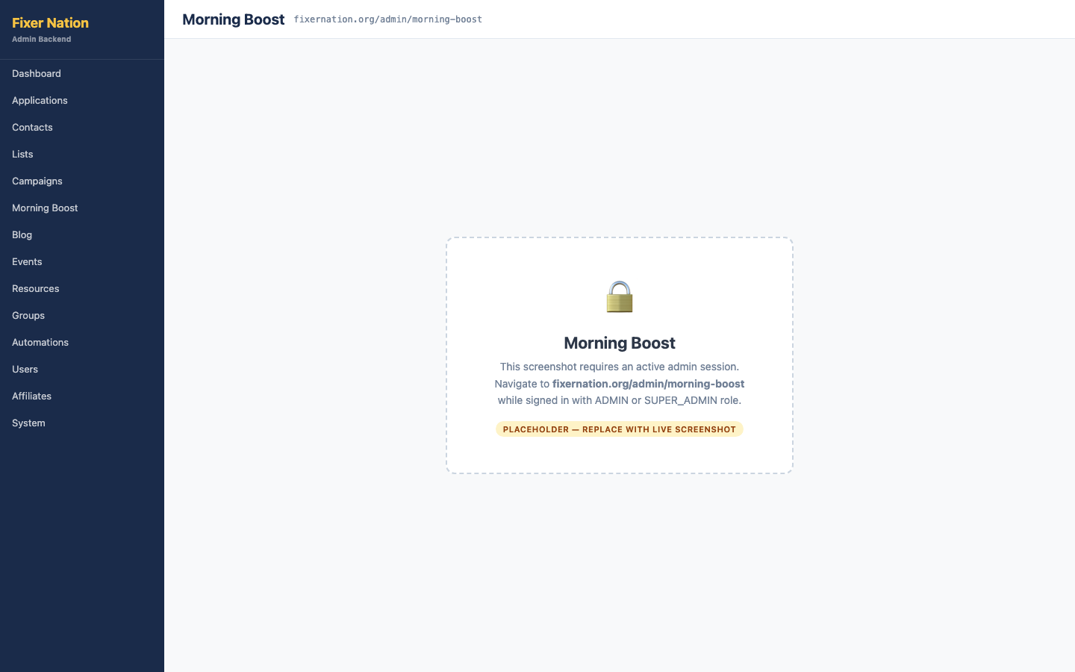
How to get here:
1. Click "Morning Boost" in the admin left navigation

What to verify:
1. All Morning Boost entries are listed with title, publish date, and excerpt
2. Entries with today's date are highlighted as the active boost
3. Click "+ New entry" — navigates to /admin/morning-boost/new
4. Click any entry row — navigates to the edit page

6.2 Creating a Morning Boost Entry
URL: fixernation.org/admin/morning-boost/new
How to get here:
1. From /admin/morning-boost, click "+ New entry"

Steps:
1. Enter a title — the slug field auto-populates from the title
2. Write the body content in the body textarea (required)
3. Optionally add an excerpt and author name
4. Cover image: click "Upload" to select a local image file, or enter an image URL in the URL field
5. Publish date: enter today's date to make this the featured boost; leave blank to save as a draft
6. Click "Create entry" — entry is saved and appears in the Morning Boost list

What to verify:
7. Go to fixernation.org/morning-boost — the entry with today's date appears as the featured card
8. Click "Read Today's Boost" — full entry content is visible
Note: The morning-boost cron job emails all opted-in contacts with today's entry. To test it manually, trigger the cron with: GET /api/cron?job=morning-boost&token=CRON_SECRET

6.3 Editing a Morning Boost Entry
URL: fixernation.org/admin/morning-boost/[id]
What to verify:
1. All fields are pre-filled; make an edit and click "Save changes" — inline success message appears
2. Change the publish date to a future date — entry is no longer the featured boost on the public page
3. Click "Delete" — confirmation dialog appears; confirm to permanently remove the entry

Part 7: Blog

7.1 Blog Post List
URL: fixernation.org/admin/blog
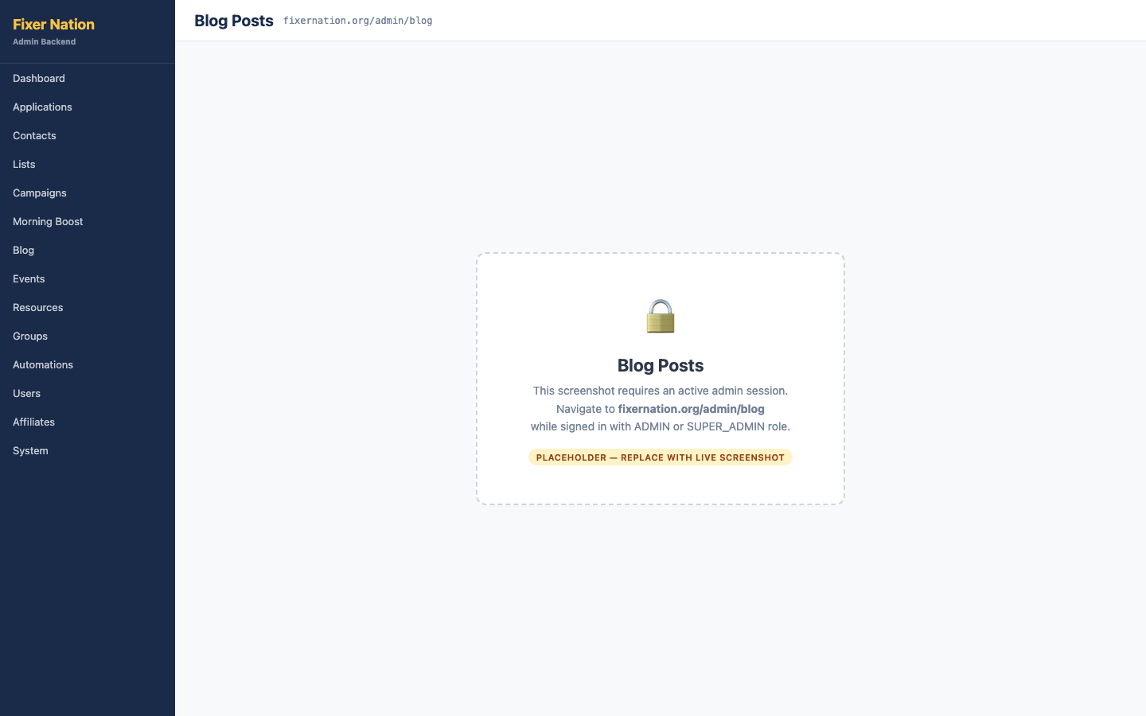
How to get here:
1. Click "Blog" in the admin left navigation

What to verify:
1. All blog posts listed with title, category, status (Published / Draft), and publish date
2. Click "+ New post" — navigates to /admin/blog/new

7.2 Creating a Blog Post
URL: fixernation.org/admin/blog/new
Steps:
1. Enter a title — slug field auto-populates
2. Select a category from the dropdown
3. Write the body content (required)
4. Add an excerpt, cover image (upload or URL), and author name
5. Set a publish date equal to or before today to make it visible on the public blog
6. Leave the publish date blank to save as a draft (not publicly visible)
7. Click "Create post" — post appears in the admin blog list; if published, it appears at fixernation.org/blog/[slug]

7.3 Editing a Blog Post
URL: fixernation.org/admin/blog/[id]
What to verify:
1. Edit any field and click "Save changes" — changes appear on the public blog
2. Change the publish date to a future date — post reverts to draft status and disappears from the public blog
3. Delete button (with confirmation) — post removed from the public blog

Part 8: Events

8.1 Events List
URL: fixernation.org/admin/events
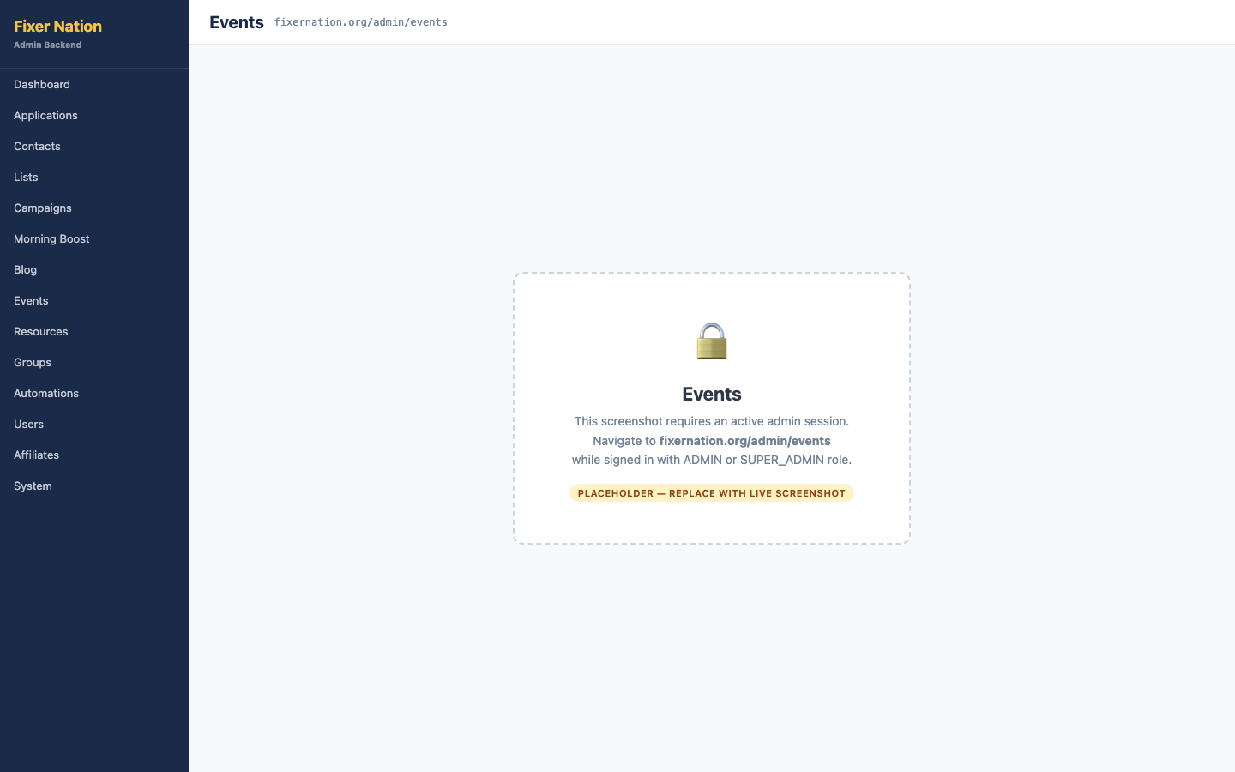
How to get here:
1. Click "Events" in the admin left navigation

8.2 Creating an Event
URL: fixernation.org/admin/events/new
Steps:
1. Enter a title — slug auto-populates
2. Add a description (required)
3. Set start and end date/time (both required)
4. Check "Online event" — location field is hidden; uncheck it to re-show the location field
5. Price: set to 0 for a free event, or enter a dollar amount for a paid event
6. Capacity: enter a maximum RSVP count to enable the waitlist feature
7. Publish: check "Publish immediately" to make the event visible at once, or leave unchecked to save as a draft
8. Click "Create event" — event appears in the admin events list and on fixernation.org/events if published

8.3 Editing an Event
URL: fixernation.org/admin/events/[id]
What to verify:
1. Edit any field and click "Save changes" — changes appear on fixernation.org/events/[slug]
2. "Publish" / "Unpublish" toggle button changes the event's public visibility
3. Attendees sidebar shows all RSVPs grouped by status: Registered, Waitlisted, and Cancelled
4. Delete button removes the event and all RSVP records (with confirmation)

Part 9: Resources

9.1 Resources List
URL: fixernation.org/admin/resources
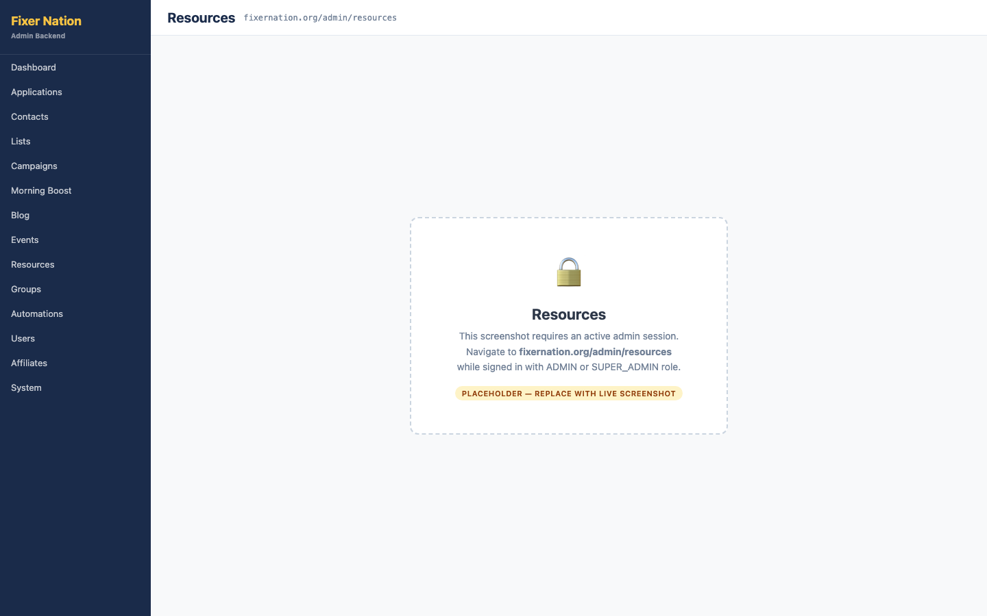
How to get here:
1. Click "Resources" in the admin left navigation

9.2 Creating a Resource
URL: fixernation.org/admin/resources/new
Steps:
1. Enter a title — slug auto-populates
2. Select a type from the dropdown: Guide, Worksheet, Video, Template, or Tool
3. Write the body content (required)
4. Add excerpt, cover image, download file URL, and author name (all optional)
5. Set a publish date to make the resource visible to signed-in members on /resources
6. Leave publish date blank to save as a draft
7. Click "Create resource"

What to verify:
8. Go to fixernation.org/resources (signed in as a member) — the new resource appears in the library
9. If a download URL was set, a "Download" button appears on the resource card

9.3 Editing a Resource
URL: fixernation.org/admin/resources/[id]
What to verify:
1. Edit any field and save — changes appear in the public resources library
2. Removing the download URL — the Download button disappears from the member-facing card
3. Delete with confirmation dialog

Part 10: Groups

10.1 Groups List
URL: fixernation.org/admin/groups
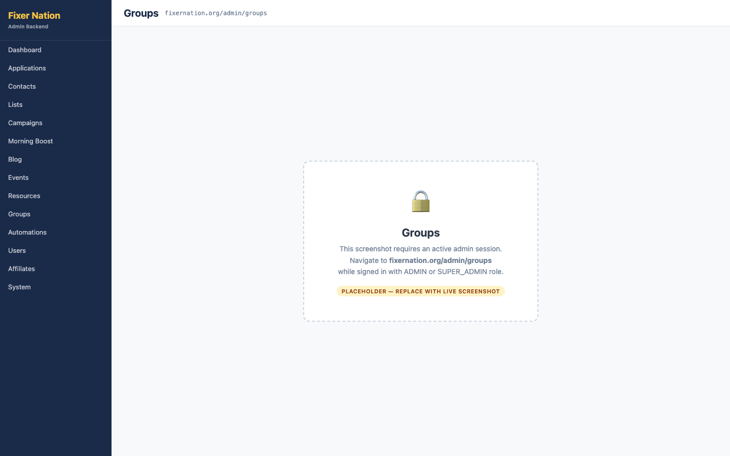
How to get here:
1. Click "Groups" in the admin left navigation

What to verify:
1. Table shows each group with: name, slug, auto-join type labels, visibility, member count, post count, and pending request count
2. "Pending" count for a group is a clickable link — navigates to /admin/groups/[id]/requests
3. "View" link opens the public group page; "Edit" link opens the edit form
4. Click "+ New Group" — navigates to /admin/groups/new

10.2 Creating a Group
URL: fixernation.org/admin/groups/new
Steps:
1. Enter a group name — slug auto-populates
2. Add a description and optional cover image URL
3. Visibility: select Public (visible to everyone at /network/groups) or Private (visible but join-gated)
4. Auto-join: check any roles (Consumers, Brand Ambassadors, Service Providers) — users with those roles are automatically added to the group when they sign up or their role changes
5. Click "Create" — group appears at fixernation.org/network/groups and in /admin/groups

10.3 Editing a Group
URL: fixernation.org/admin/groups/[id]
What to verify:
1. Edit any field and save — changes appear on the public group page
2. Pending join request count badge links to /admin/groups/[id]/requests
3. Changing visibility from Public to Private — non-members now see a gate message on the group page
4. Delete (with confirmation) — group and all posts are removed

10.4 Group Join Requests
URL: fixernation.org/admin/groups/[id]/requests
How to get here:
1. From /admin/groups, click the pending count next to any group

What to verify:
1. Table shows pending requests with: requester name, email, optional message, and request date
2. Click "Approve" — member is added to the group; row disappears from this list
3. Click "Reject" — request is removed; the user is not added to the group
Note: Approved members can immediately post in the group and see it in their sidebar on /network.

Part 11: Automation Journeys

11.1 Automations List
URL: fixernation.org/admin/automations
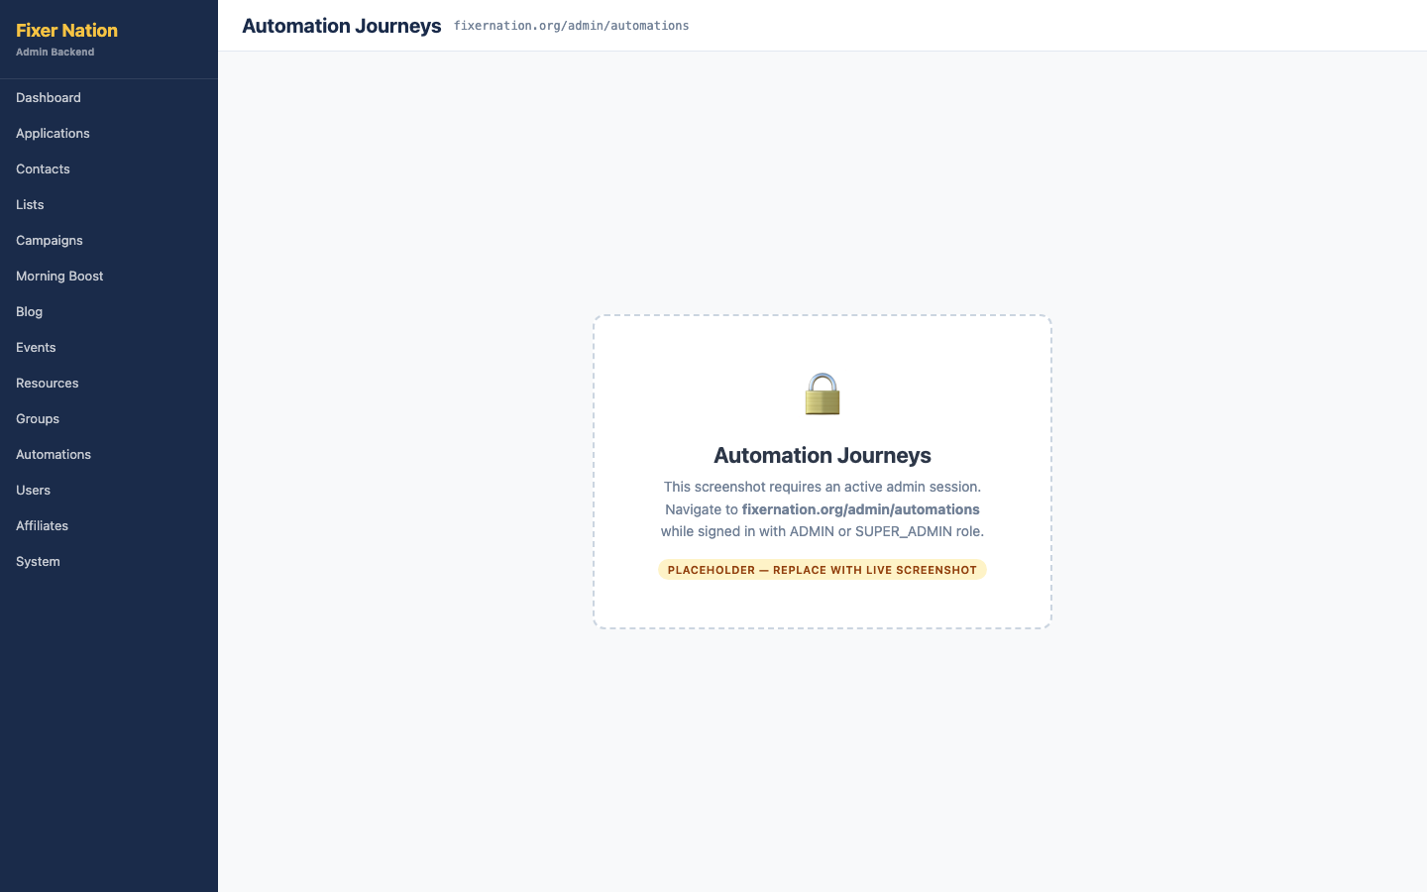
How to get here:
1. Click "Automations" in the admin left navigation

What to verify:
1. Summary stats at the top: total journeys, active journeys, and currently running enrollments
2. "New journey" inline form: enter a name and select a trigger type (Manual, User Signup, Role Change, Tag Added, or Application Accepted)
3. Click "Create" — new journey appears in the table
4. Active/Inactive toggle button on any journey — status changes inline without a page reload
5. Click any journey name — navigates to the journey detail page

11.2 Journey Detail — Steps Tab
URL: fixernation.org/admin/automations/[id]

How to get here:
1. From /admin/automations, click any journey name

Adding steps:
1. Click the "Steps" tab if it is not already active
2. "+ Add step" form at the bottom: select a step type from the dropdown — Wait, Send Email, Add Tag, Remove Tag, Webhook, or Condition
3. Wait step: enter a duration such as 2 hours or 3 days, then click "Add step"
4. Send Email step: enter a subject line, HTML body, and plain text body, then click "Add step"
5. Add Tag step: enter a tag name and click "Add step"

Managing steps:
6. Reorder steps using the up/down arrow buttons — the order updates immediately
7. Remove a step by clicking the Remove button on it — step is deleted from the journey
8. Edit an existing step: click the edit (pencil) icon — config form opens inline

11.3 Journey Detail — Enrollments Tab
What to verify:
1. Click the "Enrollments" tab
2. Active enrollments show: contact email, step progress (e.g., "Step 2 of 4"), and next scheduled run date
3. Click "Cancel" on an active enrollment — status changes to Cancelled and no further steps execute for that contact
Note: The automation-tick cron job advances all active enrollments. It runs daily via Vercel. To advance enrollments immediately during testing: GET /api/cron?job=automation-tick&token=CRON_SECRET

Part 12: Users
URL: fixernation.org/admin/users
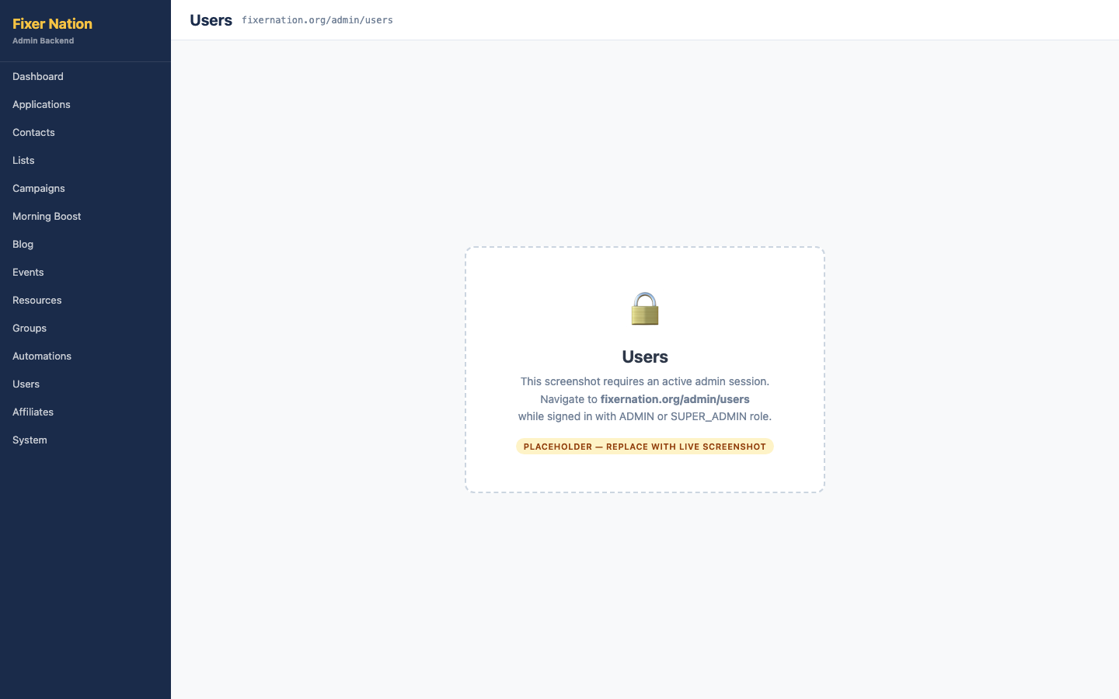
How to get here:
1. Click "Users" in the admin left navigation

What to verify:
1. All registered users are listed with name, email, current role, and join date
2. Change a user's role using the role dropdown on their row — the change saves immediately
3. Go to a different admin page and return — the updated role persists
4. Verify the role change reflects in the user's experience (their dashboard role card should show the new role)
5. The currently signed-in admin account: the role dropdown is disabled — you cannot change your own role
6. A regular ADMIN: the SUPER_ADMIN option is absent from the dropdown — only SUPER_ADMIN can promote users to SUPER_ADMIN
Important: Role changes take effect immediately. A user currently signed in who has their role changed will see the effect on their next page load or sign-in.

Part 13: Affiliates & Commissions

13.1 Affiliates
URL: fixernation.org/admin/affiliates
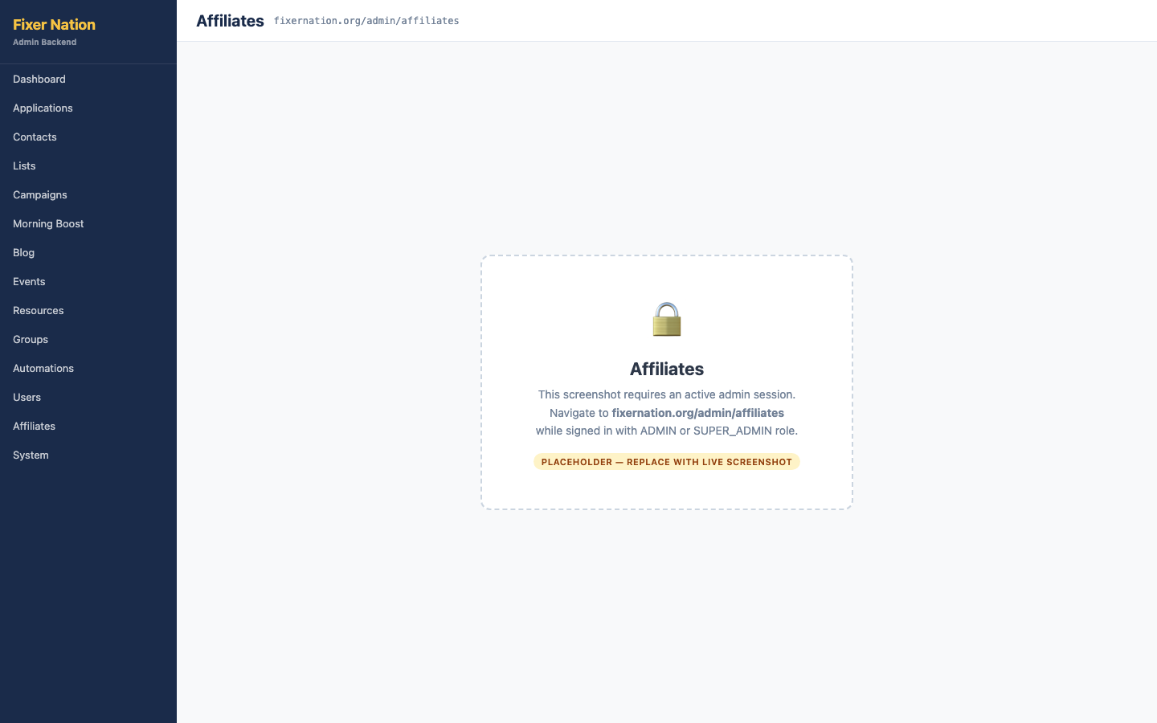
How to get here:
1. Click "Affiliates" in the admin left navigation (may be under a "System" or "Commerce" sub-menu)

What to verify:
1. Summary line shows: total affiliates, active count, and pending-setup count
2. Table lists all provisioned affiliates with: name/email, type (Ambassador), status badge, setup status, promo code count, and commission count
3. Click "Manage" on any affiliate row — navigates to /admin/affiliates/[id]
Note: Affiliate records are created when an admin clicks "Provision affiliate account" on an accepted ambassador application. They do not exist until that step is taken.

13.2 Territories
URL: fixernation.org/admin/territories
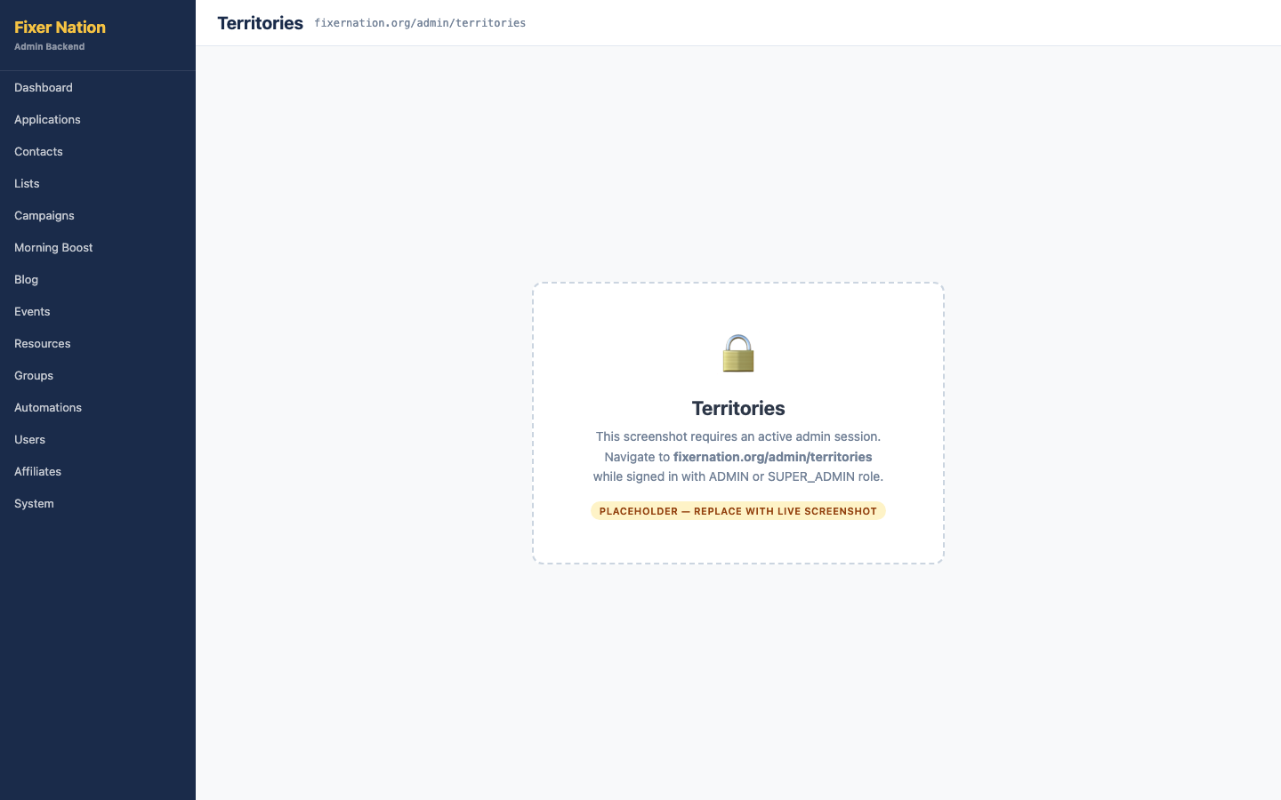
How to get here:
1. Click "Territories" in the admin left navigation

Creating a territory:
1. Click "+ New territory" — an inline form appears
2. Enter a name and select a type: Geographic, Industry, Organization, or Custom
3. Set the scope (County, City, ZIP, State, Region, National, or Custom) and any applicable geographic fields
4. Check "Exclusive" if only one ambassador should hold this territory
5. Click "Create" — territory appears in the table

What to verify:
6. Search and filter by type, status, and state narrow the results
7. Territory now appears in the territory dropdown on application detail pages

13.3 Commission Payout Queue
URL: fixernation.org/admin/commissions
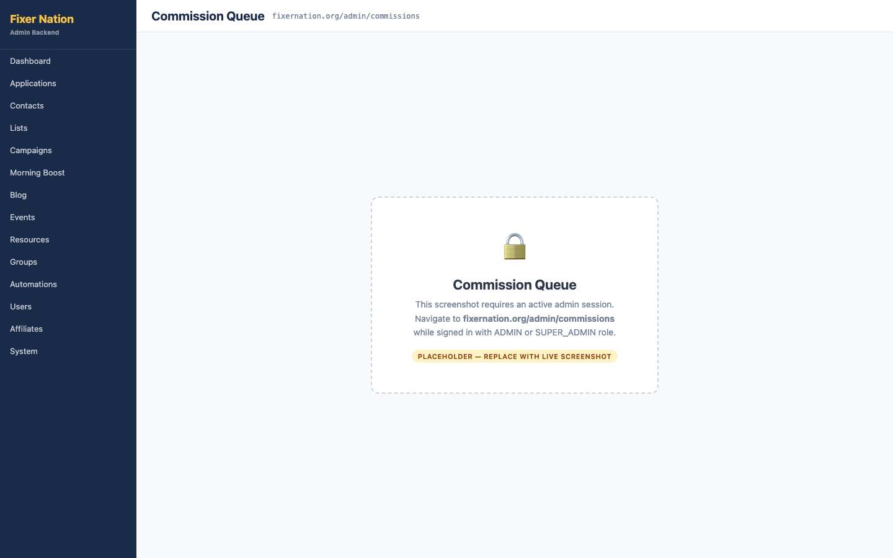
How to get here:
1. Click "Commissions" in the admin left navigation

What to verify:
1. Summary card shows total dollar amount and count of Approved commissions ready to pay out
2. Status summary cards show totals for: Approved, Pending, On Hold, Paid, and Reversed
3. Payout batch ID field (optional): enter a label such as "August 2026 Payroll" — all Mark Paid actions on this page will tag entries with that batch ID
4. Commissions are grouped by affiliate — each group shows the affiliate name, total approved amount, and a "Pay all" button
5. Click "Pay all" on an affiliate group — all Approved entries for that affiliate move to Paid status
6. Click "Mark paid" on a single entry — that entry moves to Paid status
7. Click "Hold" on a single entry — that entry moves to On Hold status

Part 14: System Administration

14.1 Audit Log
URL: fixernation.org/admin/audit
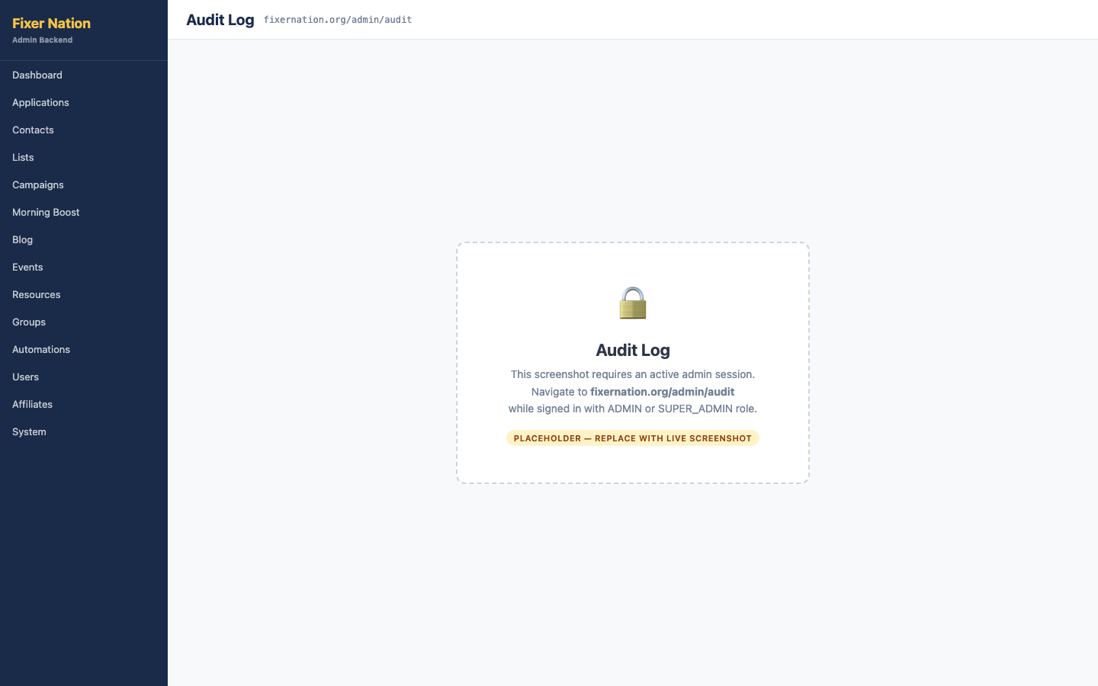
How to get here:
1. Click "System" in the admin left navigation, then "Audit Log"
2. Or navigate directly to fixernation.org/admin/audit

What to verify:
1. Recent audit events are listed with: timestamp, actor email, color-coded action badge, and event details
2. Category filter: All, Applications, Users, Security, Content, Groups — each narrows to relevant events
3. Date range filter: Last 7 days, Last 30 days, Last 90 days, All time
4. Perform an action (e.g., change a user's role in /admin/users) then return to the audit log — a new entry is visible at the top
5. No edit or delete controls exist — audit log entries are immutable

14.2 Blocked Emails
URL: fixernation.org/admin/blocked-emails
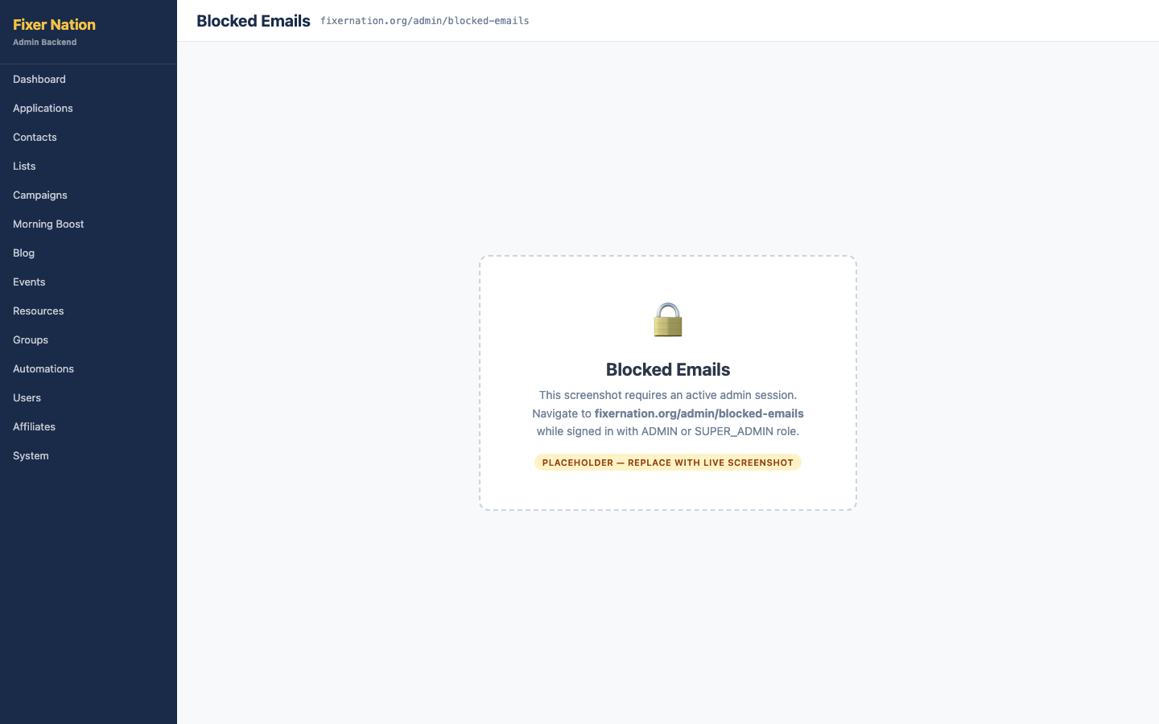
How to get here:
1. Navigate to fixernation.org/admin/blocked-emails

What to verify:
1. Summary shows the current count of blocked addresses
2. Add form: enter an email address and optional reason, click "Block email" — address appears in the blocked list
3. Go to fixernation.org/register and try creating an account with the blocked address — registration fails with an error
4. Click "Unblock" on the address — address is removed; registration with that email is now permitted

14.3 Gift Codes
URL: fixernation.org/admin/gift-codes
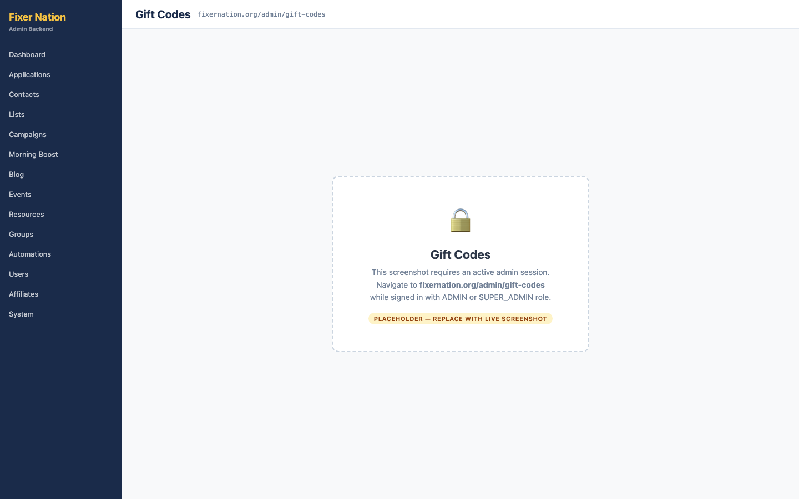
How to get here:
1. Navigate to fixernation.org/admin/gift-codes

Generating codes:
1. Enter a quantity (1–100) in the "Generate" form
2. Select the role the code will grant: Member, Provider, or Ambassador
3. Optionally add a description and an expiry date
4. Click "Generate" — codes appear in the Available table

What to verify:
5. Each code row has a "Copy" button that copies the code to clipboard
6. Redeem one of the generated codes at fixernation.org/redeem using a test account — the code row moves from Available to the Redeemed table
7. Redeemed table shows: code, granted role, redeeming user's name and email, and redemption date
8. Click "Delete" on an Available code — code is removed; redeemed codes cannot be deleted

14.4 Site Settings
URL: fixernation.org/admin/settings
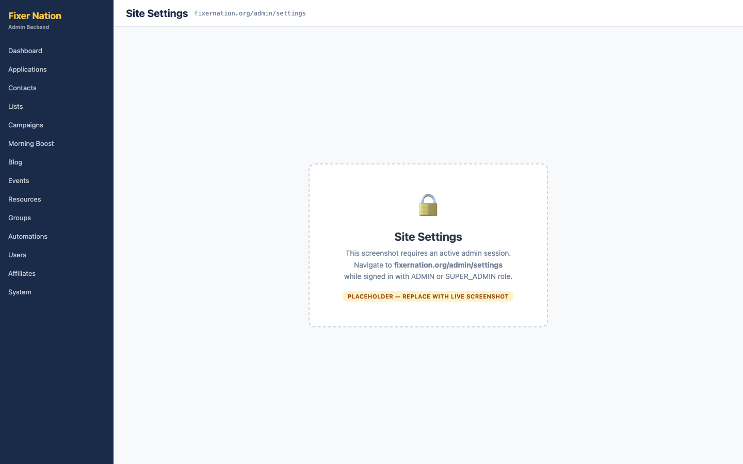
How to get here:
1. Navigate to fixernation.org/admin/settings

What to verify:
1. Existing key-value settings are listed with: key (monospace), value, last updated date, and Save/Delete buttons
2. Add a new setting: enter a key and value in the Add form, click "Add" — new row appears in the list
3. Edit an existing value: change the value in the inline input, click "Save" — updated value persists on reload
4. Click "Delete" on a setting — row is removed
Note: Site settings are runtime configuration key-value pairs. They are not used in page rendering unless specific server-side code explicitly reads them.

14.5 Email Message Templates
URL: fixernation.org/admin/message-templates
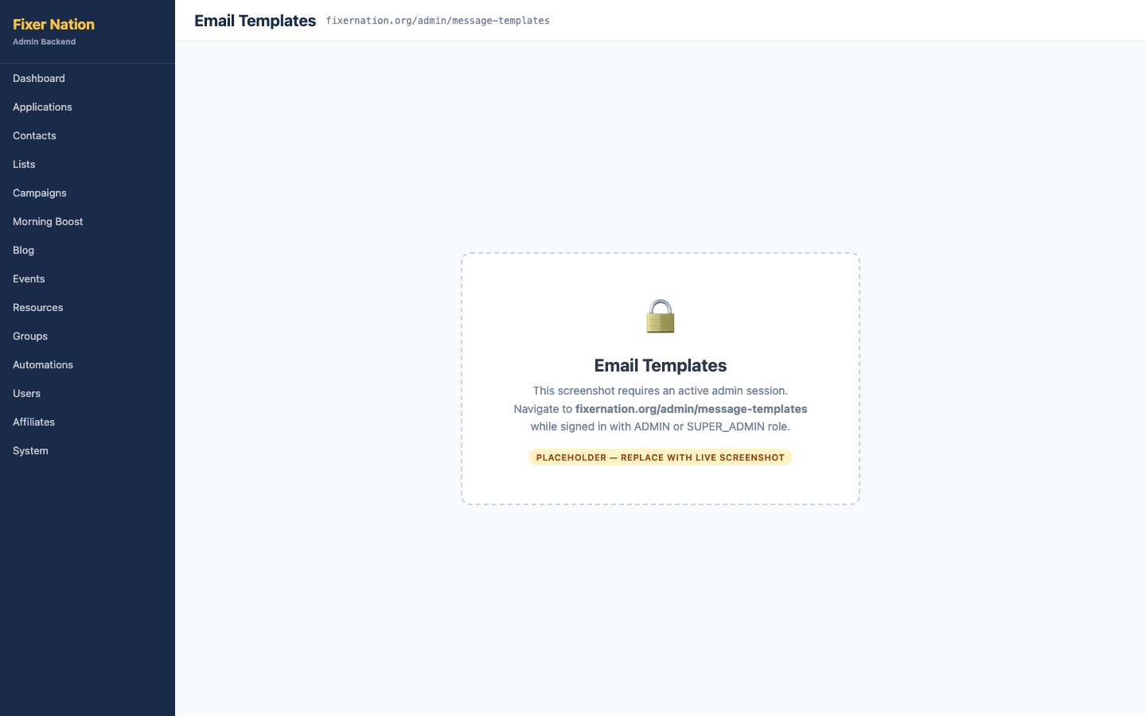
How to get here:
1. Navigate to fixernation.org/admin/message-templates

What to verify:
1. The list shows all transactional email templates with: template key, human-readable name, subject line, last edited date, and editor
2. Click "Edit →" on any template — a full edit page opens with the template's current subject and body
3. The edit page shows the available {{variable}} placeholders for that template (e.g., {{name}}, {{link}})
4. Edit the subject line and click "Save" — trigger the action that sends that template email and verify the updated subject appears
Note: Template variables use {{variable}} syntax. Variables available for each template are listed on its edit page. Using an undefined variable results in a blank substitution, not an error.

Appendix: Triggering Cron Jobs for Testing
The /api/cron endpoint handles all scheduled background jobs. During testing you can trigger any job on demand without waiting for the scheduled run time.

Endpoint format:
GET https://fixernation.org/api/cron?job={job-name}&token={CRON_SECRET}

Replace {CRON_SECRET} with the actual value from the Vercel environment variables panel. You can also pass it as a header:
Authorization: Bearer {CRON_SECRET}

Available jobs:
Job key | What it does
morning-boost | Sends today's Morning Boost entry to all MORNING_BOOST-consented contacts
campaign-scheduler | Finds all Scheduled campaigns past their scheduledAt time and sends them
automation-tick | Advances all active automation journey enrollments one step forward
application-expiration | Marks Accepted/Onboarding applications as Expired if inactive for 30+ days
application-expiration-reminders | Sends 14-day and 7-day reminder emails to applications nearing expiration
account-invitation-reminders | Resends invite emails for accepted applications with no account after 7 days
health-check | Returns 200 OK — use this to verify the cron endpoint and token are working

Example — trigger the campaign scheduler:
GET https://fixernation.org/api/cron?job=campaign-scheduler&token=YOUR_CRON_SECRET

Expected response on success:
{ "ok": true, "job": "campaign-scheduler", "message": "Processed 1 scheduled campaign" }

Distributed locking:
Each cron job uses a distributed lock stored in the CronJob database table. If a job is already running (RUNNING status with a lock timestamp less than 5 minutes old), the endpoint returns a 200 with skipped: true. Stale locks (over 5 minutes old) are overridden and the job runs normally.

Part 15: Loyalty Program

15.1 Admin Loyalty View
URL: fixernation.org/admin/loyalty
How to get here:
1. Click "Loyalty" in the admin left navigation (under the Community group)
What to verify:
1. Header stats show: total members with points, and total points awarded across the platform
2. Search box (name or email) with a "Search" button filters the member table; results paginate 50 per page with "Previous"/"Next"
3. Table lists: member name/email, role badge, total points, and last-earned date (or "Never")
4. Click "Award points" on any member row — an inline form appears (button changes to "Cancel")
5. Enter a Points value (1–1000, required) and a Note (required, max 200 characters), click "Award" — the member's total updates immediately
6. Enter 0 or a number over 1000 in Points — client-side validation blocks submission before the request is sent
Note: There is no dedicated LTV or campaign-ROI reporting dashboard. Lifetime value is shown as a column and summary tiles on /admin/memberships (Estimated MRR, Total LTV, Avg LTV per member — computed as monthly-equivalent price × months active). Per-campaign conversion revenue ("Conversion MRR") appears on each campaign's own detail page under Part 17. There is no single combined report that aggregates both.

Part 16: Campaign Builder — Content, Audience & Templates
This part supersedes the basic campaign creation steps in Part 5.2 with the full block-based composer and audience segmentation builder that ship with the campaign wizard at /admin/campaigns/new and the edit page at /admin/campaigns/[id]/edit.

16.1 Drag-and-Drop Block Composer
URL: fixernation.org/admin/campaigns/new (Content step, Email channel)
Adding and arranging blocks:
1. Under "Add:", click any block button, grouped as Content (Heading, Text, Button, Image), Layout (2 Columns, Divider, Spacer, HTML), Platform (Event, Blog post, Morning Boost, Resource, Product, Membership CTA, Referral CTA), and Utility (Social links, Personalization, Unsubscribe, Legal footer)
2. Clicking a block button appends it to the end of the list and opens it for editing immediately — no drag is required to add a block
3. Hover any block row — a grip icon (drag to reorder), up/down arrow buttons, a duplicate icon, and a delete icon appear
4. Drag the grip icon over another row — the block reorders live
5. Click a block's body (not its icons) — its inline editor opens with type-specific fields (e.g. Heading has level/align/color; Button has label/URL/align/colors/UTM fields; Image has URL/alt/link/width/align and a "Browse" button)
Toolbar controls:
6. "Undo" / "Redo" — up to 50 history states
7. "Desktop preview" / "Mobile preview" — renders the email at 600px or 375px width
8. "Validate" — opens a panel flagging: images missing alt text, buttons missing a URL or label, platform blocks with no content selected, and a campaign-wide check for a missing Unsubscribe block (required for CAN-SPAM). Each issue has a "jump to block" link
9. "Save section" — prompts for a name and saves the current block set for reuse; "Sections" opens a panel to insert a previously saved set
10. "View HTML" — shows the generated HTML in a read-only textarea
Note: The composer autosaves to the browser's localStorage under the key campaign_composer_draft. Refresh the page mid-edit and confirm the draft restores; submit the campaign and confirm the key is cleared.
Important: The Image block's "Browse" button (media picker) is only wired up on the email-template composer (/admin/email-templates/new), not on the campaign composer (/admin/campaigns/new or edit). Verify whether "Browse" appears at all when editing an Image block from a campaign — if it does not, that is expected given the current wiring, not a bug to report on its own.

16.2 Audience Builder
URL: fixernation.org/admin/campaigns/new (Audience step)
The builder is a flat two-bucket structure (Include / Exclude), not a nested AND/OR group tree — there is only one logic level.
Building an audience:
1. "Include contacts who match" section has an ANY/ALL toggle (OR vs. AND) that applies to every include rule together
2. Click "+ Add include rule" — choose a rule Type: On a list, Has role, Has tag, Subscribed to topic, In a group, RSVPd to event, or Custom field (operators: is set / is not set / equals / does not equal / contains)
3. "Exclude contacts who match any of these rules" section is always OR'd — there is no AND option for exclusions
4. Each added rule appears as a labeled chip with a × to remove it
Previewing the audience:
5. Click "Preview audience" (disabled until at least one include rule exists) — shows the matching contact count, a breakdown of suppressed contacts by reason (opted out / bounced / unsubscribed), and a small sample of matching names/emails
6. Build a rule set matching zero contacts — an amber "No contacts match these rules yet" warning appears instead of a count
Important: A separate, lighter-weight "Preview audience size" control also exists on the campaign wizard's Content step — it only shows a count and is distinct from the Audience Builder's own "Preview audience" button on the Audience step. Don't confuse the two when writing test evidence.
Note: Ambassador-owned contact lists cannot be selected as an Include rule's list value for an FN Admin campaign send — confirm the list picker excludes them.

16.3 Email Template & Media Asset Library
URL: fixernation.org/admin/email-templates and fixernation.org/admin/media
Creating and reusing a template:
1. On /admin/email-templates, filter by status (All / Draft / Approved / Retired) or search by name
2. Click "+ New template" — fill in Template name, Default subject line, Category, Tags, and Status (Draft/Approved), then build content with the same block composer as Part 16.1, and click "Create template"
3. On a template card, click "Clone" — a copy is prepended to the list; click "Delete" — disabled (with a tooltip) if the template is used by any campaign
4. On /admin/campaigns/new, Content step, use the "Start from a template" dropdown — selecting a template pre-fills the subject (only if blank) and body content
Media library:
5. On /admin/media, click "+ Upload image" — select a JPG/PNG/GIF/WEBP file; it uploads immediately and appears at the top of the grid
6. Click any thumbnail — a detail panel opens with the full preview, size/dimensions/type, an editable Alt text field, a "Copy URL" button, and "Delete image"
7. On /admin/email-templates/new, click "Browse" on an Image block — a media picker modal opens with its own search box and a "Manage media library" link

Part 17: Campaign Analytics, A/B Testing & Browser Push

17.1 Campaign Dashboard & Delivery Metrics
URL: fixernation.org/admin/campaigns
What to verify:
1. When at least one campaign exists, four summary tiles appear above the table: Total campaigns, Sent, Emails sent, Avg open rate
2. Open any sent campaign's detail page — a "Delivery" card shows Queued, Sent, Delivered, Bounced (if any), Cancelled (if any), plus Attributed contacts, New members (30 days), and Conversion MRR when attribution data exists
3. An "Engagement" card shows Opened, Clicked, Open rate, Click rate, and Bounce rate (if any), with a "Computed <timestamp>" footer
4. Click "Refresh" (visible only once status is Sent) — metrics recompute and the timestamp updates
5. Before any send, the Engagement card reads "No metrics yet — click Refresh above"

17.2 A/B Testing
URL: fixernation.org/admin/campaigns/[id] (Draft or Scheduled email campaign)
Note: The A/B testing section is hidden entirely for browser-notification (Push) campaigns — it only appears for the Email channel.
Setting up a test:
1. On the campaign detail page, find "A/B testing" — with no variants yet, helper text explains Control (A) always uses the campaign's current content
2. Click "+ Add variant" (available until 3 variants exist — max B, C, D) — a form pre-fills from the campaign's current subject/from name/from email/body, plus a Split % field (1–99, default 50)
3. Click "Save variant" — adding the first variant automatically turns on A/B testing for the campaign; Control (A)'s split shows as the remainder (100% minus all variant splits)
4. Click "Edit" on a variant — inline Subject and Split % fields appear with Save/Cancel; click "Remove" — the variant is deleted immediately with no confirmation dialog
5. Try adding a 4th variant — blocked with an error ("Maximum 3 variants (B, C, D) per campaign")
6. Try modifying variants after the campaign has started sending — blocked with an error ("Cannot modify variants of a campaign that is sending or sent")
Important: There is no validation preventing the sum of all variant splits from exceeding 100% — test creating two variants at 90% each and confirm whether this is accepted. If it is, flag it as a data-integrity gap rather than assuming it's already handled.
Viewing results (after send):
7. Once the campaign is Sent and has A/B data, an "A/B test results" card lists each variant's Sent, Opens, Open rate, and Click rate, with the top open-rate variant highlighted green and tagged "Winner"

17.3 Browser Notification (Push) Campaigns
URL: fixernation.org/admin/campaigns/new
Creating a push campaign:
1. On the Details step, select the "Browser notification" channel button instead of "Email" — the From name/From email fields disappear
2. On the Content step, enter Notification title (max 80 characters), Message (max 150 characters), and optionally a Click URL and Icon URL
3. The UTM & Tracking and Test Send steps both show explanatory text that they don't apply to push and are skipped
4. Complete the Audience and Schedule steps exactly as for an email campaign, then submit
5. On the campaign detail page, a violet "Push" badge appears next to the status, and a "Notification preview" card mimics a browser notification instead of an HTML email preview
Important: Delivery and engagement metric cards use the same Open rate / Click rate labels for push as for email — double check with the team whether "click-through" tracking is meaningful for a push notification or whether this is a mislabeling worth flagging.
Member-facing opt-in:
6. Sign in as a member and go to /account — in the "Email preferences" card, a "Browser notifications" toggle appears below the Morning Boost checkbox
7. Click the toggle to enable — the browser's native permission prompt appears; grant it — the toggle turns on and a push subscription is saved
8. Click the toggle to disable — the subscription is removed
9. Deny the browser permission prompt instead — the toggle is disabled and shows "Notifications blocked — reset permissions in your browser settings to enable."
Note: This flow depends on a real browser permission prompt and a registered service worker — test it in an actual browser window, not headless or incognito without a permission grant.

Part 18: Contact Management — Custom Fields, Suppression & Merge
This part supersedes and extends Part 3.3 (Contact Detail) with the full tab set and the additional admin sections that ship alongside it.

18.1 Contact Detail — Full Tab Set
URL: fixernation.org/admin/contacts/[id]
The tab bar on a contact's detail page has 7 tabs, plus an 8th ("Custom fields") that only appears once at least one custom field definition exists:
1. Activity — read-only chronological timeline of actions taken on this contact (notes added, tags changed, consent updated, etc.)
2. Notes — existing notes plus a textarea and "Save note" button to add a new one, newest first
3. Lists — list memberships as links, plus an "Add to list" dropdown and "Add" button
4. Consent — covered in 18.2 below
5. Campaigns — read-only history of every campaign this contact was sent, with status and sent date
6. Addresses — address cards with type/primary badges, Edit/Remove per card, and "+ Add address"
7. Identities — alternate identity records (Email, Phone, or External ID type), each with a value, optional label, and a Primary badge; "+ Add identity" opens a form; each has a Remove link
8. Custom fields (conditional) — covered in 18.3 below
Header area (above the tabs):
9. Tag chips: type a name and click "Add" to add a tag; click × on a chip to remove it
10. Attribution badge: click "Edit" (or "+ Set attribution") to choose Organic / Referral / Import / Manual / Invite / Subscribe Form / Campaign, then Save
11. "Merge" button — covered in 18.4 below

18.2 Suppression List & Implied Consent
URL: fixernation.org/admin/suppression
Managing the suppression list:
1. Table lists suppressed addresses with Type (Bounce, Complaint, Unsubscribe, or Manual), reason, and status; filter by search, Type, or Status (Active only / Lifted only)
2. Click "+ Add suppression" — enter an email address and optional reason, click "Add suppression" — a Manual-type record appears at the top of the table
3. Click "Lift" on an active row — confirm the dialog — the status flips to "Lifted <date>"
4. Only Manual-type suppressions can be created or lifted from this admin UI; Bounce/Complaint/Unsubscribe records are system-generated and shown read-only here
Consent tab on a contact's detail page:
5. A banner at the top reads "Implied consent — has account" (green) if the contact is linked to a platform user account, or "No platform account" (neutral) if not — this is derived automatically from account linkage, not a toggle
6. If the contact's email has an active suppression, a red "🚫 Suppressed — will not receive campaigns" warning appears with type and date; a "Lift" button appears inline only if the suppression type is Manual
7. Below that, per-topic In/Out toggles for Morning Boost, Campaigns, Newsletters, and Product Updates; a topic with neither set shows "No record"

18.3 Custom Fields
URL: fixernation.org/admin/custom-fields
Creating a field:
1. Click "+ New field" — enter a Label, choose a Type (Text, Number, Date, Dropdown, Checkbox, URL, or Long text), and for Dropdown enter comma-separated Options; optionally check "Required field"; click "Create field"
2. Click "Edit" on an existing field — Label, Options (if Dropdown), and Required can be changed inline; the field Type itself cannot be changed after creation
3. Click the Status pill (Active/Inactive) to toggle it — inactive fields render dimmed in the list
4. Click "Delete" on a field with zero recorded values — confirm the dialog — the field is removed
5. Try deleting a field that has at least one contact value set — the Delete control is disabled with a tooltip suggesting deactivation instead
Setting a value on a contact:
6. Open any contact's detail page — a "Custom fields" tab now appears; click "Edit", fill in the type-appropriate input, and click "Save"

18.4 Merging Duplicate Contacts
URL: fixernation.org/admin/contacts/[id]
Merging two contacts:
1. On the contact you want to keep, click "Merge" — a modal opens titled "Merge another contact into this one"
2. Type at least 2 characters of the duplicate contact's name or email — matching results appear; click one to select it as the record to absorb
3. Click "Confirm merge" — confirm the browser dialog — the merge runs
What to verify after merging:
4. Tags, list memberships, per-topic consent, campaign send history, newsletter subscriptions, and custom field values move to the surviving contact; if the survivor already has a value for any of these, the survivor's value wins and the duplicate is discarded
5. Notes, addresses, activity records, and identity records move over from the absorbed contact with no deduplication
6. Attribution moves over only if the surviving contact had none of its own
7. The absorbed contact's own record (email, name, phone, company as stored directly on that contact) is permanently deleted — confirm it no longer appears anywhere in /admin/contacts
Important: A merge cannot be undone. Test this against disposable test contacts, not real production data.

Part 19: Automation Journeys — Visual Canvas
Important: This part corrects Part 11 (Automation Journeys). The step-management UI has since been rebuilt as a visual canvas — the "+Add step" form and up/down reorder buttons described in Part 11.2 no longer reflect the current interface. Use this part as the authoritative walkthrough; Part 11.3 (Enrollments tab) is still accurate as written.

19.1 Creating a Journey
URL: fixernation.org/admin/automations
Two ways to start:
1. Click "New journey" — enter a Name and choose a Trigger (Manual, User signup, Role change, Tag added, Application accepted, Group join, Event RSVP, or Loyalty milestone), then click "Create & edit"
2. Or click "From template" — choose one of 4 pre-built templates: Welcome series (Signup trigger, 5 steps), Loyalty milestone reward (Loyalty milestone trigger, 2 steps), Event follow-up (Event RSVP trigger, 3 steps), or New member onboarding (Application accepted trigger, 5 steps) — the journey is created with all steps pre-filled, ready to review
Important: The "New journey" trigger dropdown lists all 8 trigger types, but only Manual, User signup, Role change, Tag added, and Application accepted are accepted by the create form's validation. Selecting Group join, Event RSVP, or Loyalty milestone here fails with no visible error message on screen — worth a dedicated negative test case. Journeys with those three triggers can only be created via the template panel.

19.2 Building the Canvas
URL: fixernation.org/admin/automations/[id] (Steps tab)
Adding a step:
1. Click the floating "+ Add step" button (bottom-left of the canvas) — choose a Step type: Wait, Send email, Add tag, Remove tag, Webhook, Push notify, Condition, or Exit — click "Add"
2. The new step node appears below the last one automatically — there is no dragging a block from a palette onto the canvas
Connecting and branching:
3. Edges between steps are drawn automatically based on step order — you do not manually draw a connection
4. For a Condition step only: two auto-generated edges appear — a green "Yes" edge to the next step in order, and a red dashed "No" edge to whichever step's order matches the "If false, skip to step #" value set in that step's config panel
Configuring a step:
5. Click any step node (the trigger node itself is not clickable) — a side panel opens with a type-specific form:
• Wait — Days to wait (number)
• Send email — Inline (Subject + HTML body) or Template (dropdown of saved email templates)
• Add tag / Remove tag — a single Tag text field
• Webhook — URL and Method (POST/GET)
• Push notify — Title, Body, Click URL
• Condition — Field (User role / Has tag / Days since signup), Operator, Value, and "If false, skip to step #"
• Exit — no configuration; ends the enrollment immediately
6. Click "Save step", "Cancel", or "Remove step" (confirms before deleting)
Repositioning and activating:
7. Drag a step node to a new position on the canvas — this changes its visual layout only, not execution order
8. Click the "Active"/"Inactive" pill at the top of the page (or on the journey's row in the list) — toggles immediately; new journeys always start Inactive
Important: The engine that actually runs journeys (executeStepAction in src/lib/automation.ts) only implements Send email, Add tag, and Webhook. Remove tag, Push notify, Condition, and Exit are fully configurable in the canvas but currently have no runtime effect — building a journey with these step types and running the automation-tick cron job should be tested explicitly to confirm nothing happens, since that is the current (likely unintended) behavior.
Note: Activating a journey with zero steps is not blocked — an enrolled contact would complete it instantly on the next tick. There is also no delete button anywhere in the current UI for a journey itself; deletion is only reachable via a direct API call, and is blocked server-side if any active enrollments exist.

19.3 Cron Testing Reference
Trigger the automation-tick cron job on demand to advance all active enrollments one step forward, instead of waiting for the scheduled daily run:
GET https://fixernation.org/api/cron?job=automation-tick&token=CRON_SECRET

Appendix B: Admin Dashboard Test Case Tracker (SP-1 – SP-53)
Use this table to track manual execution. Each row is independently repeatable — reset any test data created (contacts, campaigns, journeys) between runs where noted. Pass/Fail and Tester/Date columns are left blank for you to fill in during a test pass.
ID | Area | Preconditions | Steps | Expected Result | Pass/Fail
ADM-001 | Applications list | Signed in as ADMIN | Go to /admin/applications; use tab, type, and search filters | List narrows correctly for each filter combination
ADM-002 | Applications list | ≥1 application exists | Click 'Advanced filters'; set a date range + territory filter | Results match the combined filter criteria
ADM-003 | Applications list | ≥1 application exists | Click 'Export CSV' with a filter applied | Downloaded CSV matches the filtered view, not the full list
ADM-004 | Application review | App in Needs Review status | Open detail page; expand each collapsible section | All submitted data displays correctly per section
ADM-005 | Application review | App in Needs Review | Click 'Mark under review' | Status changes to Under Review; applicant receives an email
ADM-006 | Application review | App in Needs Review | Click 'Conditionally accept' or 'Accept' | Email preview dialog appears; confirming sends the acceptance email using the configured message template
ADM-007 | Application review | App in any status | Click 'Decline' | Decline email is sent; status updates
ADM-008 | Onboarding checklist | Provider application | Open onboarding checklist section | Exactly 12 checklist items shown, each with a status dropdown
ADM-009 | Onboarding checklist | Ambassador application | Open onboarding checklist section | Exactly 14 checklist items shown
ADM-010 | Onboarding checklist | Any application | Change a status dropdown; refresh the page | New status persists without a Save button
ADM-011 | Territory assignment | Application accepted | Select a territory, add notes, click Assign | Territory appears in the assignments list
ADM-012 | Territory assignment | Territory assigned | Click the revoke (×) button | Territory is removed from this application only
ADM-013 | Affiliate provisioning | Accepted ambassador application | Click 'Provision affiliate account' | Affiliate record created and visible at /admin/affiliates; button becomes a management link
ADM-014 | Account invite | Accepted app, no linked account | Click 'Send account invite' | Invite email sent; button becomes 'Resend invite'; 'Revoke invite' appears
ADM-015 | Account invite | Invite sent | Click 'Revoke invite' | Invite link is invalidated
ADM-016 | Directory listing | Active provider application | Enable 'List in provider directory' toggle | Provider's card appears at /providers immediately
ADM-017 | Directory listing | Provider listed | Disable the toggle | Provider's card is removed from /providers immediately
ADM-018 | Applications | Application inactive 30+ days in Accepted/Onboarding | Trigger cron job=application-expiration | Application is marked Expired
ADM-019 | Applications | Application nearing expiration | Trigger cron job=application-expiration-reminders | 14-day and 7-day reminder emails send at the correct thresholds
ADM-020 | Contacts list | ≥1 contact exists | Search by name, email, or company | Rows filter in real time
ADM-021 | Contacts list | Signed in as ADMIN | Click '+ Add contact'; submit with no email | Validation error shown; contact not created
ADM-022 | Contacts list | Signed in as ADMIN | Click '+ Add contact'; submit valid email | Contact created; redirected to detail page
ADM-023 | Contact detail | Contact exists | Edit profile fields, save, reload | Changes persist across reload
ADM-024 | Contact detail — tags | Contact exists | Add a tag, then remove it | Tag appears then disappears correctly
ADM-025 | Contact detail — notes | Contact exists | Add two notes in sequence | Notes are sorted newest first with timestamps
ADM-026 | Contact detail — consent | Contact exists | Flip each of the 4 topic toggles | Each change saves immediately and independently
ADM-027 | Contact detail — lists | ≥1 list exists | Add contact to a list via the dropdown | Contact appears in that list's member table
ADM-028 | Contact detail — addresses | Contact exists | Add an address; edit it; remove it | Each action reflects correctly with type/primary badges
ADM-029 | Contact detail — activity | Contact has recent actions (tag/note/consent change) | Open the Activity tab | Timeline shows the actions in chronological order, read-only
ADM-030 | Contact detail — identities | Contact exists | Add an Email-type identity, mark as primary | Identity appears with Primary badge; Remove works
ADM-031 | Contact detail — custom fields | ≥1 active custom field definition exists | Open the Custom fields tab, set a value, save | Value persists and displays correctly for its field type
ADM-032 | Custom fields admin | Signed in as ADMIN | Create a Dropdown field with 3 comma-separated options | Field created; options render as a select on the contact tab
ADM-033 | Custom fields admin | Field has ≥1 recorded value | Attempt to delete the field | Delete is disabled with a tooltip suggesting deactivation
ADM-034 | Custom fields admin | Field has 0 recorded values | Delete the field | Field is removed after confirmation
ADM-035 | Suppression list | Signed in as ADMIN | Add a Manual suppression by email | Record appears at top of the list, Active status
ADM-036 | Suppression list | Manual suppression exists | Click 'Lift', confirm dialog | Status flips to Lifted with a date
ADM-037 | Suppression + campaign send | Contact is suppressed | Assign contact to a campaign's audience and send | Suppressed contact is excluded from delivery; excluded count matches the audience preview
ADM-038 | Implied consent | Contact is linked to a User account | Open the Consent tab | Banner reads 'Implied consent — has account'
ADM-039 | Implied consent | Contact has no linked account | Open the Consent tab | Banner reads 'No platform account'
ADM-040 | Contact merge | Two duplicate contacts exist | Merge contact B into contact A | Tags/lists/consent/campaign history/custom fields move to A; duplicates on A win; B is deleted
ADM-041 | Contact merge | Both contacts have differing attribution | Merge; check attribution on survivor | Survivor's own attribution is kept; source's is discarded
ADM-042 | CSV import | Wix-exported CSV file ready | Upload the file on /admin/contacts/import | Columns auto-detected; preview table shows first 5 rows correctly
ADM-043 | CSV import | CSV has no subscriber-status column | Check consent topic boxes before importing | All imported contacts receive opt-in consent for checked topics
ADM-044 | CSV import | CSV includes a duplicate email already in the system | Import the file | Duplicate is skipped, not overwritten; skipped count reported
ADM-045 | CSV import | Import completed | Open Import history table | Most recent batch appears with correct row/added/skipped counts
ADM-046 | Contact lists | ≥1 list exists | Add and remove a contact from a list via the list detail page | Membership updates correctly; contact record itself is unaffected by removal
ADM-047 | Contact lists | Ambassador-owned list exists | Attempt to select it as a campaign audience source | List is not selectable for an FN Admin campaign send
ADM-048 | Campaign creation | Signed in as ADMIN | Create a campaign with a name, subject, and body; save as draft | Campaign saved with Draft status
ADM-049 | Campaign creation | Draft campaign | Set a schedule date; save | Status becomes Scheduled
ADM-050 | Campaign block composer | Creating/editing an email campaign | Add a Heading, Text, Button, and Image block; reorder via drag | Blocks render in the new order in the HTML preview
ADM-051 | Campaign block composer | Blocks added, no Unsubscribe block | Click 'Validate' | Validation panel flags the missing Unsubscribe block as a CAN-SPAM requirement
ADM-052 | Campaign block composer | Composer has unsaved blocks | Refresh the browser tab | localStorage draft restores the blocks
ADM-053 | Audience builder | ≥2 contacts, ≥1 matching a rule | Add an include rule (e.g. Has tag), preview audience | Correct matching count and sample contacts shown
ADM-054 | Audience builder | Include + exclude rules set | Preview audience with an exclude rule active | Excluded contacts are not counted in the total
ADM-055 | Audience builder | No include rules set | Attempt to click Preview audience | Button is disabled until at least one include rule exists
ADM-056 | Sending a campaign | Draft campaign with an assigned list | Click 'Send now', confirm | Status becomes Sending, then Sent; emails delivered to eligible consented contacts
ADM-057 | CAN-SPAM compliance | Campaign sent to a test contact | Open received email, click Unsubscribe link | /unsubscribed confirmation page loads; contact's Campaigns consent set to opted out
ADM-058 | CAN-SPAM compliance | Contact unsubscribed via link | Send another campaign to the same list | Unsubscribed contact is excluded from the new send
ADM-059 | Variable substitution | Campaign body contains {{first_name}} | Send and inspect the received email | Placeholder is replaced with the contact's actual first name
ADM-060 | Campaign dashboard | ≥1 campaign exists | Open /admin/campaigns | Summary tiles (Total, Sent, Emails sent, Avg open rate) match the underlying data
ADM-061 | Campaign metrics | Campaign sent | Click 'Refresh' on the detail page | Delivery and Engagement cards update with a new computed timestamp
ADM-062 | A/B testing | Draft email campaign | Add variant B at 40% split, save | Control (A) auto-adjusts to 60%; variant appears in the list
ADM-063 | A/B testing | 3 variants already exist | Attempt to add a 4th | Blocked with a max-variant error
ADM-064 | A/B testing | Campaign status is Sending | Attempt to edit or remove a variant | Blocked with a 'cannot modify' error
ADM-065 | A/B testing | Campaign sent with 2+ variants | Open the campaign detail page | A/B test results table shows per-variant stats; highest open-rate variant is tagged Winner
ADM-066 | Browser push campaign | Signed in as ADMIN | Create a campaign with channel = Browser notification | From name/email fields hidden; UTM and Test Send steps show 'not applicable' messaging
ADM-067 | Browser push campaign | Push campaign created | Open detail page | Violet 'Push' badge shown; Notification preview card renders instead of HTML preview
ADM-068 | Push opt-in (member side) | Signed in as a member, VAPID configured | Toggle 'Browser notifications' on in /account | Browser permission prompt appears; granting turns the toggle on and saves a subscription
ADM-069 | Push opt-in (member side) | Browser notification permission denied | View the toggle | Toggle is disabled with guidance to reset permission in browser settings
ADM-070 | Email templates | Signed in as ADMIN | Create a template, then use it from a new campaign's 'Start from a template' dropdown | Subject (if blank) and body pre-fill from the template
ADM-071 | Email templates | Template used by ≥1 campaign | Attempt to delete it | Delete is disabled with an 'in use' tooltip
ADM-072 | Media library | Signed in as ADMIN | Upload an image, then use 'Browse' from the email-template composer | Image appears in the picker grid and can be inserted into an Image block
ADM-073 | Cron — campaign scheduler | Scheduled campaign with scheduledAt in the past | Trigger cron job=campaign-scheduler | Campaign sends and status becomes Sent
ADM-074 | Journey creation | Signed in as ADMIN | Create a journey with trigger = User signup | Journey created, Inactive by default
ADM-075 | Journey creation | Signed in as ADMIN | Attempt to create a journey via the form with trigger = Group join | Request fails validation with no visible on-screen error — confirm this reproduces as documented
ADM-076 | Journey templates | Signed in as ADMIN | Create a journey from each of the 4 templates | Each creates the correct trigger + step count (Welcome series 5, Loyalty milestone reward 2, Event follow-up 3, New member onboarding 5)
ADM-077 | Journey canvas | Journey exists | Add a Wait, a Send email, and a Condition step | Steps render as connected nodes with auto-generated edges; Condition shows Yes/No branches
ADM-078 | Journey canvas | Condition step configured with a false-branch target | Run automation-tick against a test enrollment that fails the condition | Enrollment should branch per the False path — verify this actually happens given known engine gaps (see ADM-079)
ADM-079 | Journey engine gap | Journey contains a Remove tag, Push notify, Condition, or Exit step | Enroll a contact and run the automation-tick cron | Confirm whether these step types currently execute — engine code only implements Send email, Add tag, and Webhook as of this writing
ADM-080 | Journey activation | Journey has 0 steps | Activate it | Activation is not blocked; an enrolled contact would complete instantly on next tick
ADM-081 | Journey enrollments | Journey has active enrollments | Open the Enrollments tab | Table shows Person, Progress (current/total step), Next run, Status
ADM-082 | Journey enrollments | Active enrollment exists | Click 'Cancel' on an active enrollment | Status becomes Cancelled; no further steps execute
ADM-083 | Journey deletion | Journey has active enrollments | Attempt to delete via the API | Deletion is blocked (409) while active enrollments exist
ADM-084 | Cron — automation tick | Active enrollments due to advance | Trigger cron job=automation-tick | Enrollments advance one step; next run dates update
ADM-085 | Groups | Signed in as ADMIN | Create a group with auto-join roles checked | Users with matching roles are auto-added on signup/role change
ADM-086 | Groups | Group set to Private | View the public group page as a non-member | Gate message appears instead of the feed
ADM-087 | Group join requests | Pending join request exists | Click Approve | Member is added; can post immediately; request disappears from the queue
ADM-088 | Group join requests | Pending join request exists | Click Reject | Request removed; user not added to the group
ADM-089 | Blog admin | Signed in as ADMIN | Create a post with a future publish date | Post does not appear on the public blog until that date
ADM-090 | Events admin | Signed in as ADMIN | Create an event with capacity = 1, then have 2 test accounts RSVP | Second RSVP is placed on the waitlist
ADM-091 | Events admin | Event with RSVPs exists | Delete the event | Event and all RSVP records are removed after confirmation
ADM-092 | Resources admin | Signed in as ADMIN | Create a resource with no download URL, then add one and save | Download button appears on the member-facing card only once a URL is set
ADM-093 | Morning Boost admin | Signed in as ADMIN | Create an entry with today's publish date | Entry becomes the featured boost at /morning-boost
ADM-094 | Cron — morning boost | Today's Morning Boost entry exists | Trigger cron job=morning-boost | Email sent to all MORNING_BOOST-consented contacts
ADM-095 | User role management | Signed in as ADMIN | Change another user's role | Change saves immediately and persists across navigation
ADM-096 | User role management | Signed in as ADMIN (not SUPER_ADMIN) | View the role dropdown for any user | SUPER_ADMIN option is absent
ADM-097 | User role management | Signed in as any admin | View own row's role dropdown | Dropdown is disabled — cannot change own role
ADM-098 | Dual-role system | Signed in as ADMIN with adminRole=ADMIN and role=PROVIDER | Attempt to access an admin-only route | adminRole (not role) governs access; PROVIDER role does not grant admin access on its own
ADM-099 | Audit log | Perform an action (e.g. change a user's role) | Return to /admin/audit | New entry appears at the top with actor, action, and details
ADM-100 | Audit log | Signed in as ADMIN | Search for edit/delete controls on any audit entry | None exist — entries are immutable
ADM-101 | Blocked emails | Signed in as ADMIN | Block an email, then attempt to register with it | Registration fails with an error
ADM-102 | Blocked emails | Address is blocked | Unblock it, then register with it | Registration succeeds
ADM-103 | Gift codes | Signed in as ADMIN | Generate 5 codes granting the Member role | Codes appear in the Available table with working Copy buttons
ADM-104 | Gift codes | Generated code exists | Redeem it at /redeem with a test account | Code moves from Available to Redeemed with the redeeming user's info; role is granted
ADM-105 | Gift codes | Code already redeemed | Attempt to delete it | Delete is unavailable for redeemed codes
ADM-106 | Site settings | Signed in as ADMIN | Add a key-value setting, edit its value, then delete it | Each action persists/reflects correctly on reload
ADM-107 | Message templates | Signed in as ADMIN | Edit a transactional template's subject; trigger the corresponding email | Updated subject appears in the sent email
ADM-108 | Rate limiting / abuse | Repeated rapid registration attempts from one IP | Attempt several registrations quickly | Rate limit engages and blocks further attempts
ADM-109 | Rate limiting / abuse | Form with honeypot field present | Submit with the honeypot field filled (simulating a bot) | Submission is silently rejected or flagged as spam
ADM-110 | Mobile responsiveness | Any admin page with a data table | View at a mobile viewport width | Table scrolls horizontally (overflow-x-auto) rather than breaking layout; sidebar collapses appropriately
ADM-111 | Affiliates list | ≥1 provisioned affiliate | Open /admin/affiliates | Table shows type, status, setup status, promo code count, commission count
ADM-112 | Affiliate detail — status | Affiliate exists | Change status to On Hold with a reason | Status updates; reason recorded
ADM-113 | Affiliate detail — promo codes | Affiliate exists | Create a promo code with a discount %, max uses, and expiry | Code created and usable at checkout
ADM-114 | Affiliate detail — commission rules | Affiliate exists | Add a percentage commission rule, then deactivate it | Rule created, then shown with strikethrough once deactivated
ADM-115 | Affiliate detail — ledger | Affiliate exists | Add a manual ledger entry (Bonus type) | Entry appears in the ledger with Pending status
ADM-116 | Commission state machine | Ledger entry is Pending | Approve it, then attempt to approve it again | First approve succeeds; a second attempt on a non-Pending/On-Hold entry is blocked
ADM-117 | Commission state machine | Ledger entry is Approved | Mark it Paid | Status becomes Paid; entry becomes terminal — no further transitions accepted
ADM-118 | Commission state machine | Ledger entry is Paid | Attempt to Reverse it without a reason | Blocked — reason is required for reversal
ADM-119 | Commission payout queue | Multiple Approved entries for one affiliate | Enter a payout batch ID, click 'Pay all' | All Approved entries for that affiliate move to Paid, tagged with the batch ID
ADM-120 | Territories | Signed in as ADMIN | Create an Exclusive Geographic territory scoped to a State | Territory appears in the application territory-assignment dropdown
ADM-121 | Provider campaigns (admin visibility) | Provider has sent a campaign | Check whether admin has any oversight view of provider campaign sends | Confirm current behavior — no admin-side review UI was found for provider-originated sends; flag if oversight is expected
ADM-122 | Provider open tracking | Provider campaign sent and opened by a recipient | Tamper with the tracking pixel's token query param | Pixel still returns a 1x1 GIF but does not update openedAt
ADM-123 | Memberships / LTV | ≥1 active membership | Open /admin/memberships | Estimated MRR, Total LTV, and Avg LTV per member tiles show plausible values matching the underlying subscriptions

