Fixer Nation
Member & User Guide

Step-by-step guide to every user-facing feature

Fixer Nation Testing Guide

v2.0 — SP-1 through SP-53

August 2026

Introduction
Note: This is a living document — it will be updated with each new sprint release.

Fixer Nation (fixernation.org) is a membership platform for professionals and community-minded individuals. This guide walks you through every page and feature available to visitors, registered members, service providers, and brand ambassadors. Use it to test features, verify flows, and catch regressions after each release.

How to read this guide:
• Each section starts with the page URL and a screenshot of the actual page
• Numbered steps show exactly how to navigate to and use each feature
• "What to verify" items describe what should happen when the feature is working
• Notes in amber boxes call out edge cases, gotchas, or prerequisites
• Screenshots of pages that require sign-in show a placeholder until the Chrome extension is reconnected

Part 1: Public Pages (No Sign-in Required)
These pages are accessible to anyone without an account.

1.1 Home Page
URL: fixernation.org/
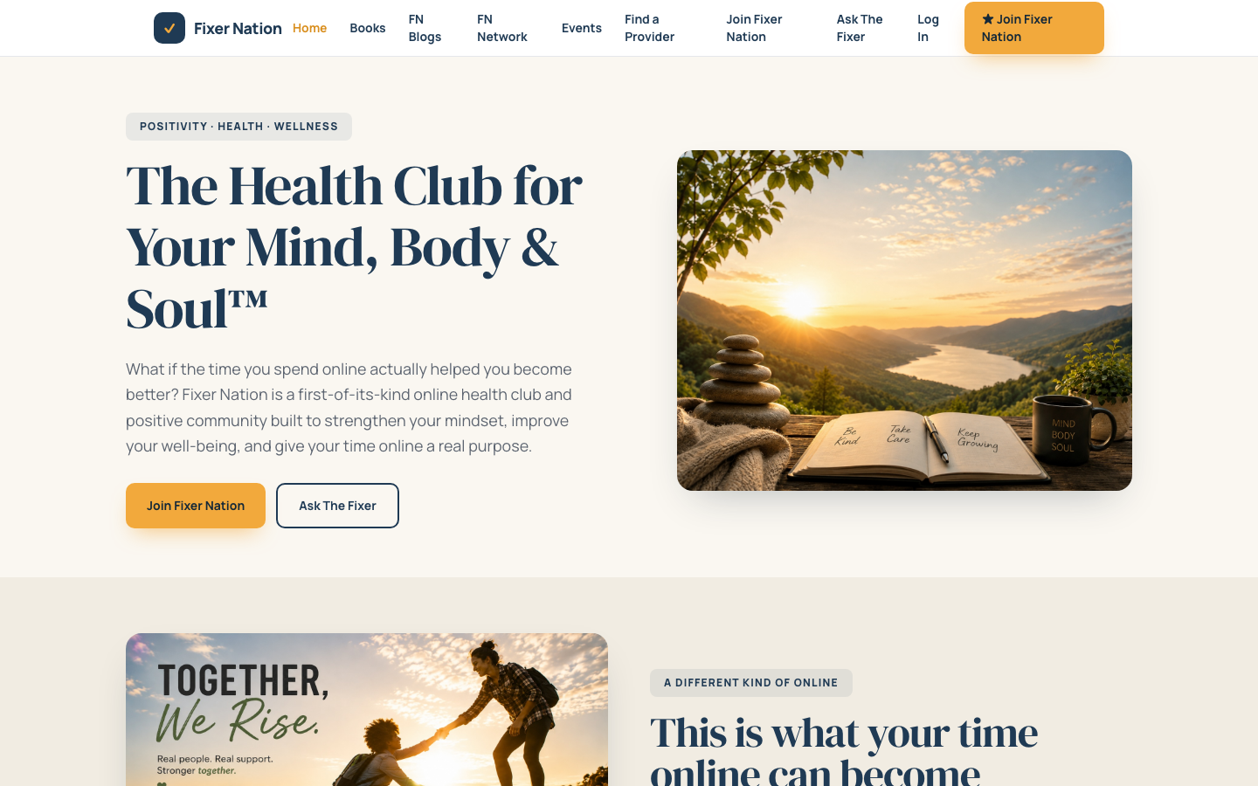
How to get here:
1. Open a browser and go to fixernation.org
2. You land on the home page automatically

What to verify:
1. Hero section loads with the main heading, description, and two buttons: "Join Fixer Nation" and "Ask The Fixer"
2. Top navigation shows: Home, Books, FN Blogs, FN Network, Events, Find a Provider, Ask The Fixer, Log In, and the yellow "Join Fixer Nation" button
3. Click "Join Fixer Nation" in the hero — navigates to /register
4. Click "Ask The Fixer" — navigates to the Ask The Fixer page
5. Scroll down the page — a community section appears followed by platform feature tiles
6. Scroll to the very bottom — newsletter signup form is present; enter a first name and email, click Subscribe, form submits without error
7. Footer links (Privacy Policy, Terms, Cookie Policy) each navigate to their respective pages

1.2 Provider Directory
URL: fixernation.org/providers
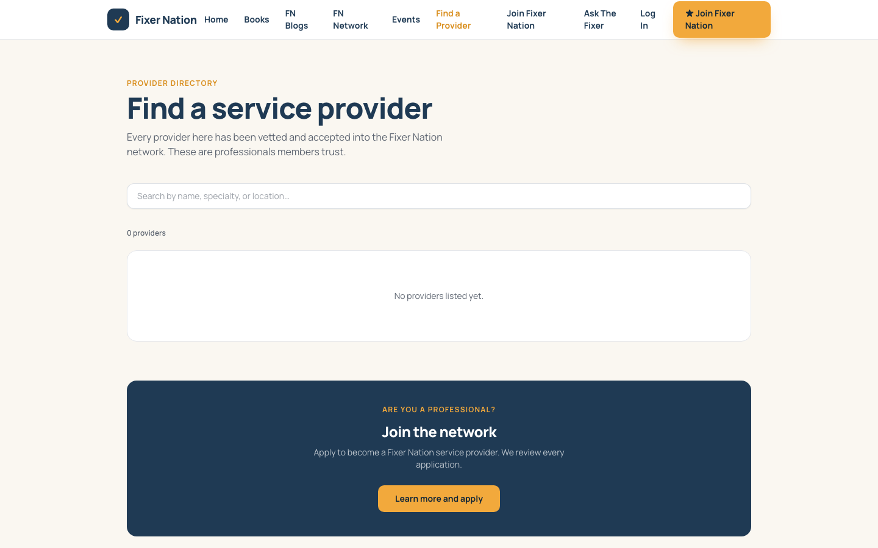
How to get here:
1. Click "Find a Provider" in the top navigation bar
2. Or go directly to fixernation.org/providers

What to verify:
1. Grid of provider cards loads (or an empty state if none are listed yet)
2. Each card shows: avatar or initials, business name, service category badge, headline, location, and service areas served
3. Type a name, business, specialty, or location in the search box — cards filter in real time
4. Select a category from the dropdown — grid narrows to that category only
5. Clear the search and reset the dropdown to "All categories" — all providers reappear
6. Click any provider card — navigates to /profile/[username]
7. Scroll to the bottom — a navy "Are you a professional?" call-to-action section appears with a "Learn more and apply" button that links to /service-provider
Note: Cards only appear here after an admin enables the "List in provider directory" toggle on the provider's application page in the admin backend.

1.3 Events
URL: fixernation.org/events
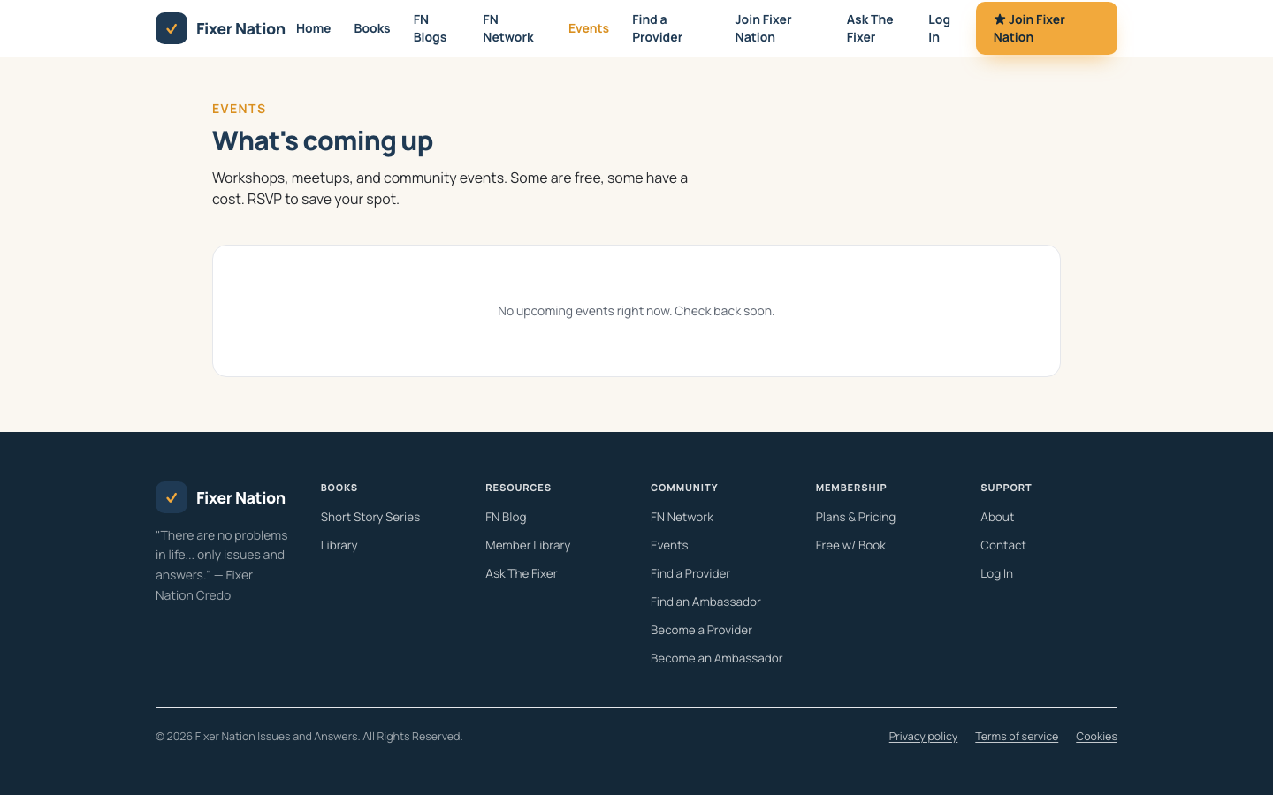
How to get here:
1. Click "Events" in the top navigation bar
2. Or go directly to fixernation.org/events

What to verify:
1. Upcoming events appear as cards with title, date, time, location or "Online" badge, and price badge
2. Past events appear in a separate section below, dimmed or with a "Past" indicator
3. Click an event card — navigates to the event detail page at /events/[slug]

On the event detail page:
4. Full event title, date, time, description, and location or meeting link display correctly
5. Free future event: an "Count me in" RSVP button is visible — clicking it while logged out redirects to /signin
6. Paid event: a "Register ($X.00)" button appears
7. Full event (capacity reached): a "Join waitlist" button appears
8. Past event: a "This event has passed" message replaces the RSVP button

1.4 Morning Boost
URL: fixernation.org/morning-boost
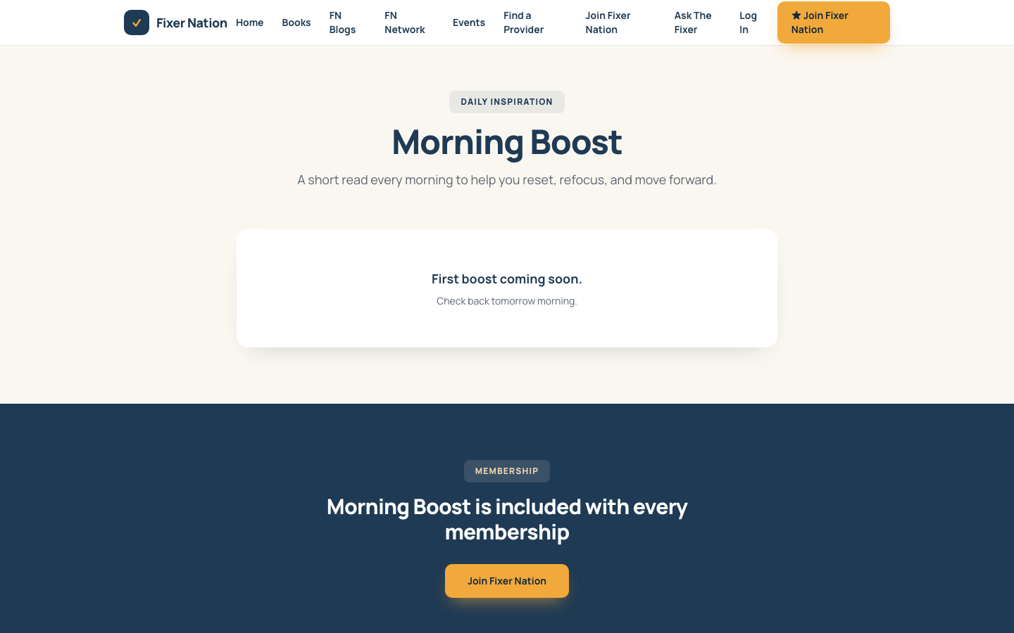
How to get here:
1. Navigate directly to fixernation.org/morning-boost

What to verify:
1. A featured card at the top shows the most recent boost entry with a title, excerpt, and "Read Today's Boost" link
2. Click "Read Today's Boost" — navigates to the full entry at /morning-boost/[slug]; full content is visible without signing in
3. Older boost entries listed below are blurred or hidden behind a "Join Fixer Nation" gate for unauthenticated visitors
4. Sign in as a member, then return to this page — all past entries are readable
Note: The most recent entry with today's publish date appears as the featured boost. Entries with past dates are members-only.

1.5 Blog
URL: fixernation.org/blog
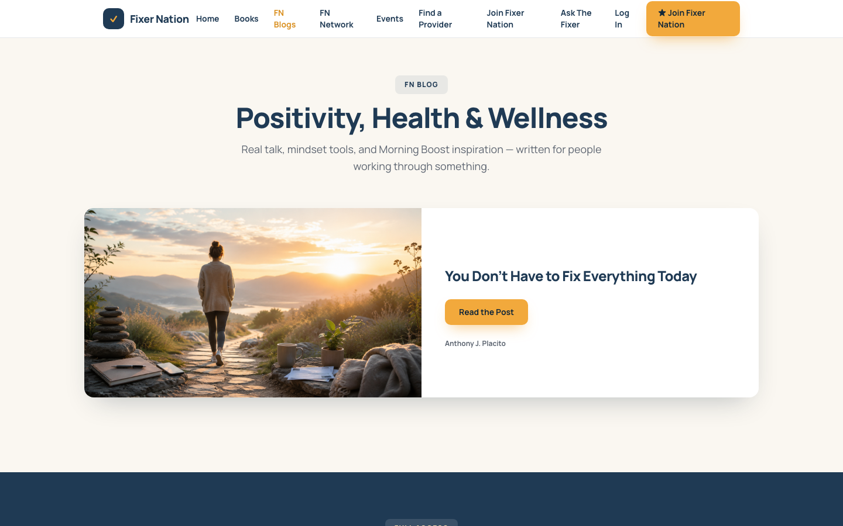
How to get here:
1. Click "FN Blogs" in the top navigation
2. Or go to fixernation.org/blog

What to verify:
1. The most recently published article appears as a featured post with a "Read the Post" link
2. Additional articles appear below as a card grid
3. Category filter chips filter the article grid when clicked
4. Unauthenticated: older article cards show a "Members only" badge and lock icon; clicking them redirects to /signin
5. Click "Read the Post" on the featured article — full article opens at /blog/[slug]
6. Sign in as a member and return to /blog — all published articles are now readable

1.6 Resources Library
URL: fixernation.org/resources
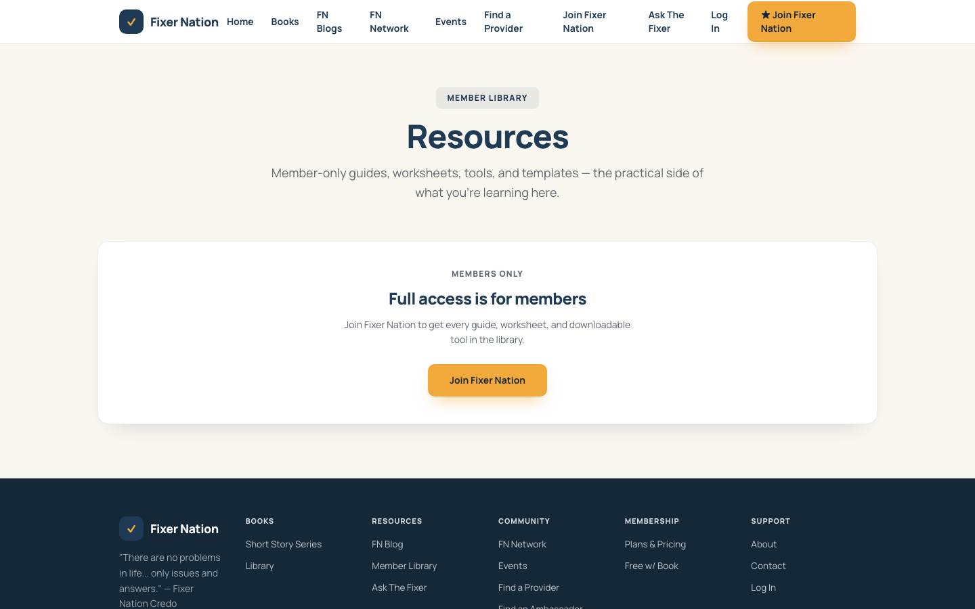
How to get here:
1. Go directly to fixernation.org/resources (members access this from the dashboard)

What to verify:
1. Unauthenticated: 2–3 resource cards are visible; the rest are blurred behind a "Join Fixer Nation" gate
2. Sign in as a member — full library of resource cards is visible
3. Type filter chips (Guide, Worksheet, Video, Template, Tool) filter the grid when clicked
4. Cards with a download URL set show a "Download" button that links to the file

1.7 Books
URL: fixernation.org/books
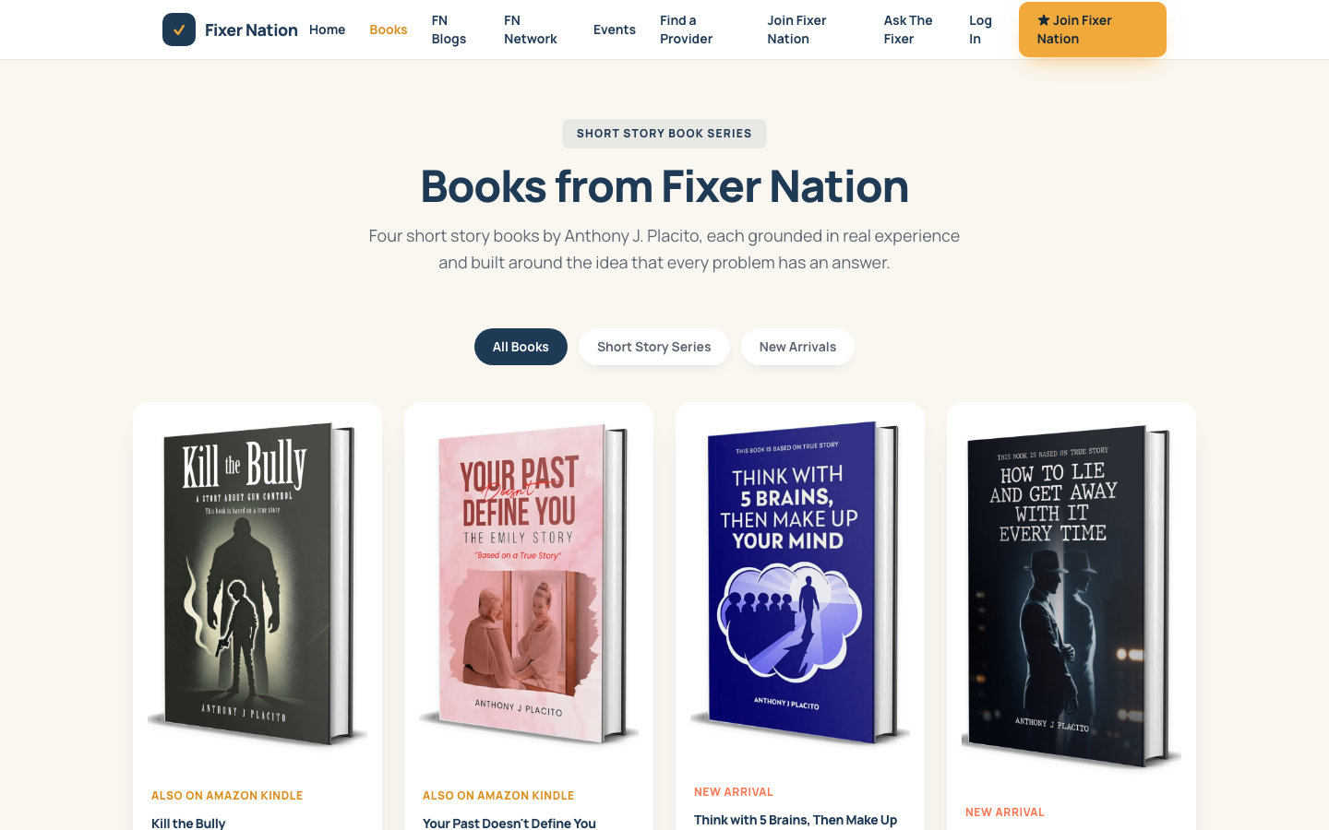
How to get here:
1. Click "Books" in the top navigation bar

What to verify:
1. Filter chips — All, Short Story Series, New Arrivals — filter the grid
2. Book cards show cover image, title, and description
3. "Amazon" button links to the Amazon product page, or shows "Coming Soon" for unpublished books

1.8 Service Provider Landing Page
URL: fixernation.org/service-provider
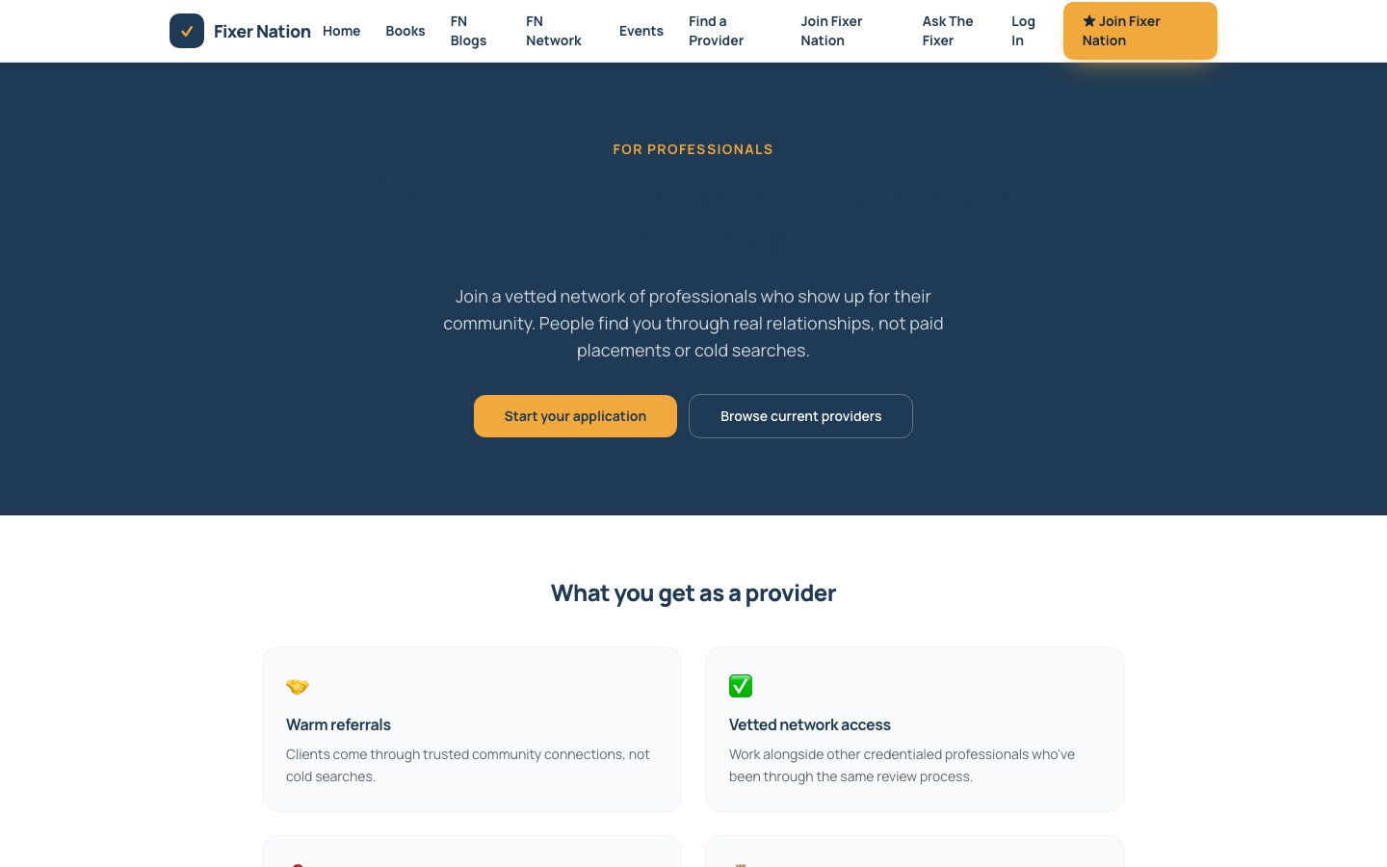
How to get here:
1. Click "Find a Provider" → scroll to the bottom, click "Learn more and apply"
2. Or go directly to fixernation.org/service-provider

What to verify:
1. Page shows hero section, benefits, eligibility requirements, and the 4-step application process
2. "Start your application" CTA links to /become-a-provider

1.9 Brand Ambassador Landing Page
URL: fixernation.org/brand-ambassador
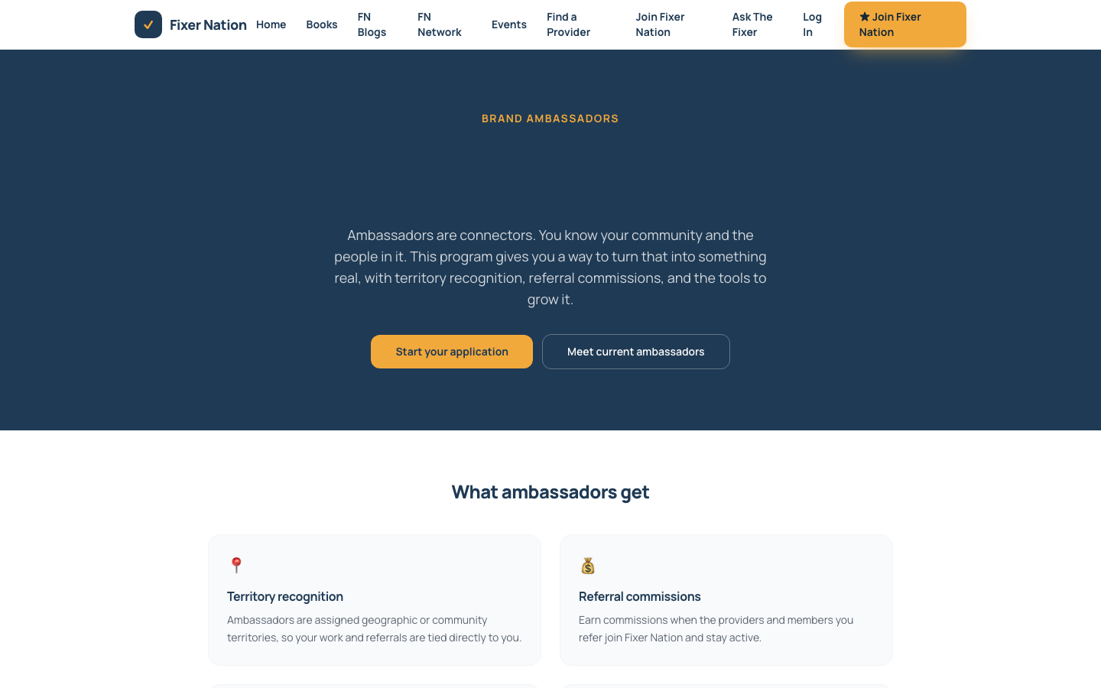
How to get here:
1. Go directly to fixernation.org/brand-ambassador

What to verify:
1. Page loads with program overview, benefits, and eligibility information
2. CTA button navigates to /become-an-ambassador

1.10 About, Contact, and Legal Pages
URL: fixernation.org/about | /contact | /privacy | /terms | /cookie-policy
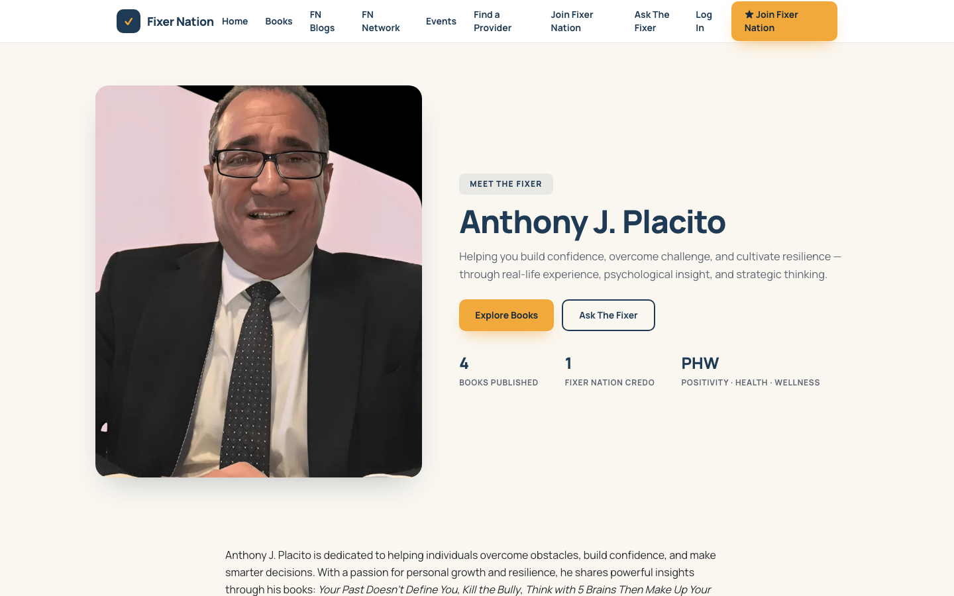
How to get here:
1. Links to these pages appear in the site footer at the bottom of any page

What to verify:
1. Each page loads without a 404 or error
2. Contact page (/contact): fill in name, email, and message fields, then click Submit — success confirmation appears

Part 2: Authentication

2.1 Create an Account
URL: fixernation.org/register
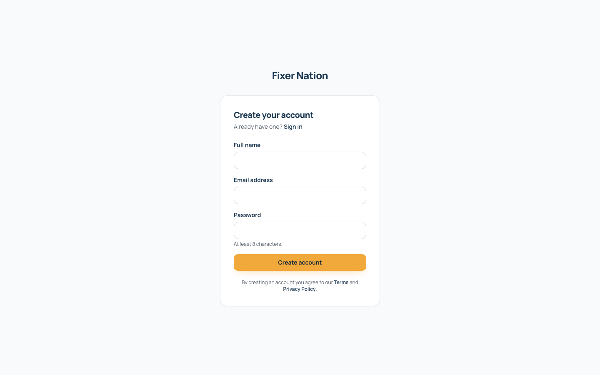
How to get here:
1. Click "Join Fixer Nation" in the top navigation bar
2. Or click "Create an account" link on the sign-in page
3. Or go directly to fixernation.org/register

Registration steps:
1. Enter your full name in the Name field
2. Enter your email address
3. Enter a password (minimum 8 characters)
4. Re-enter the same password to confirm
5. Click "Create account"
6. A message appears saying a verification email was sent to your inbox
7. Open the email and click the verification link — your account is confirmed and you are redirected to the dashboard

What to test:
1. Register with a fresh email address — account created, verification email sent
2. Register with an email already in use — error message shown
3. Enter mismatched passwords — validation error before submission
4. Enter a password under 8 characters — validation error shown
Note: Users who receive a gift code invitation register via /invite/[token] instead, where the invite pre-populates their email and sets their role automatically.

2.2 Sign In
URL: fixernation.org/signin
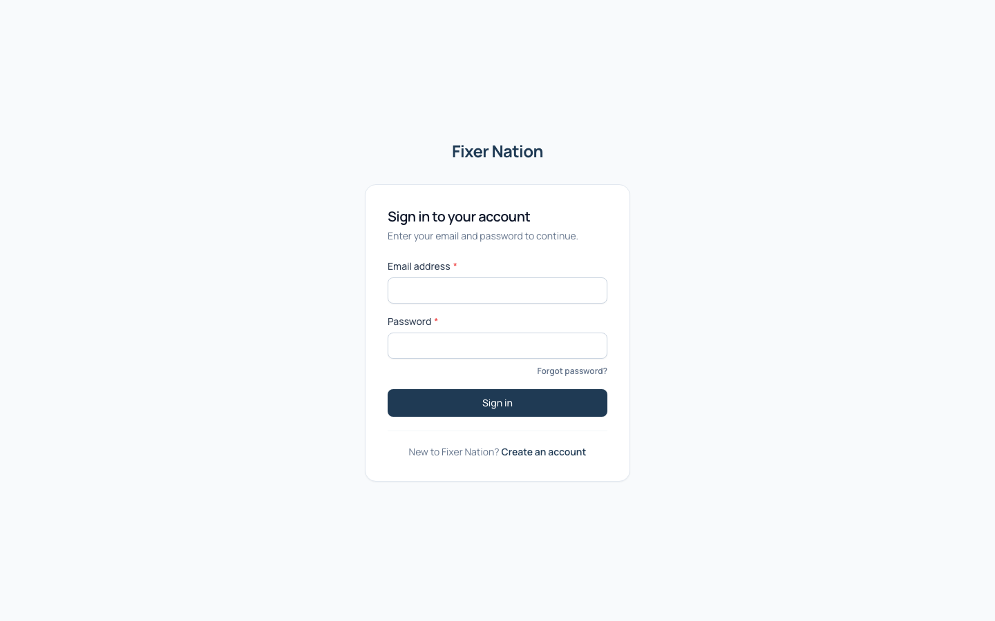
How to get here:
1. Click "Log In" in the top navigation bar
2. Or go to fixernation.org/signin

Sign-in steps:
1. Enter your registered email address
2. Enter your password
3. Click "Sign in"
4. On success, you are redirected to /dashboard

What to test:
1. Valid credentials — redirects to /dashboard
2. Wrong password — error message shown below the form
3. Unverified email — message asking you to verify your email first
4. Click "Forgot password?" — navigates to /forgot-password
5. Click "Create an account" — navigates to /register
6. Account with MFA enabled: after correct password, a 6-digit TOTP entry screen appears — enter the code from your authenticator app to complete sign-in

2.3 Forgot Password
URL: fixernation.org/forgot-password
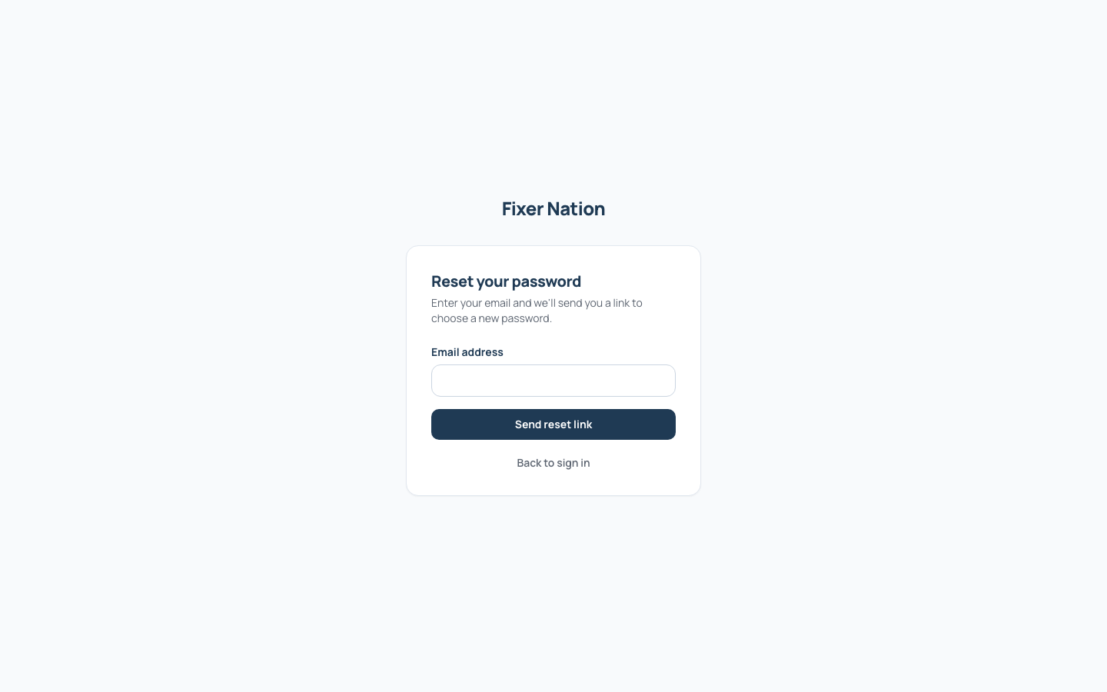
How to get here:
1. Click "Forgot password?" on the sign-in page
2. Or go to fixernation.org/forgot-password

Steps:
1. Enter the email address tied to your account
2. Click "Send reset link"
3. A generic confirmation message appears regardless of whether the email exists (intentional, prevents account enumeration)
4. If the email is registered, a reset link arrives in your inbox
5. Click the link — opens /reset-password?token=... with fields for a new password
6. Enter and confirm a new password, then click "Reset password"
7. Success message appears — sign in with the new password

What to test:
1. Registered email — confirmation shown, reset email sent
2. Unregistered email — same generic confirmation shown, no email sent
3. Expired reset link — error message about the token being invalid or used

Part 3: Member Features
All features in this section require you to be signed in. If you are not signed in, go to fixernation.org/signin first.

3.1 Member Dashboard
URL: fixernation.org/dashboard
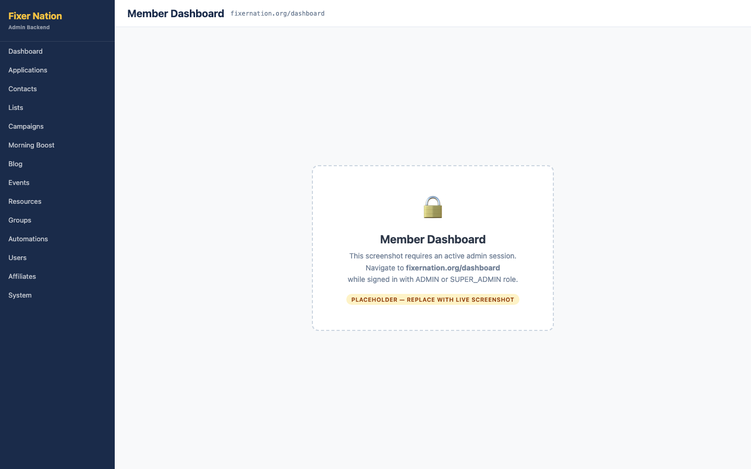
How to get here:
1. Sign in at /signin — you are automatically redirected here after sign-in
2. From any page, click your avatar or name in the top-right corner and select "Dashboard"

What to verify:
1. Welcome banner shows your display name and email address
2. Role card shows your current role: CONSUMER, MEMBER, PROVIDER, or AMBASSADOR
3. ADMIN or SUPER_ADMIN accounts: an "Admin" shortcut link is visible — clicking it navigates to /admin
4. Pending application: if you have submitted an application that is under review, a status notice appears with a "View status" link
5. Loyalty points balance displays in a card
6. Quick-access tiles for Morning Boost, Blog, Resources, and Ask The Fixer all link to their correct pages

3.2 Account Settings
URL: fixernation.org/account
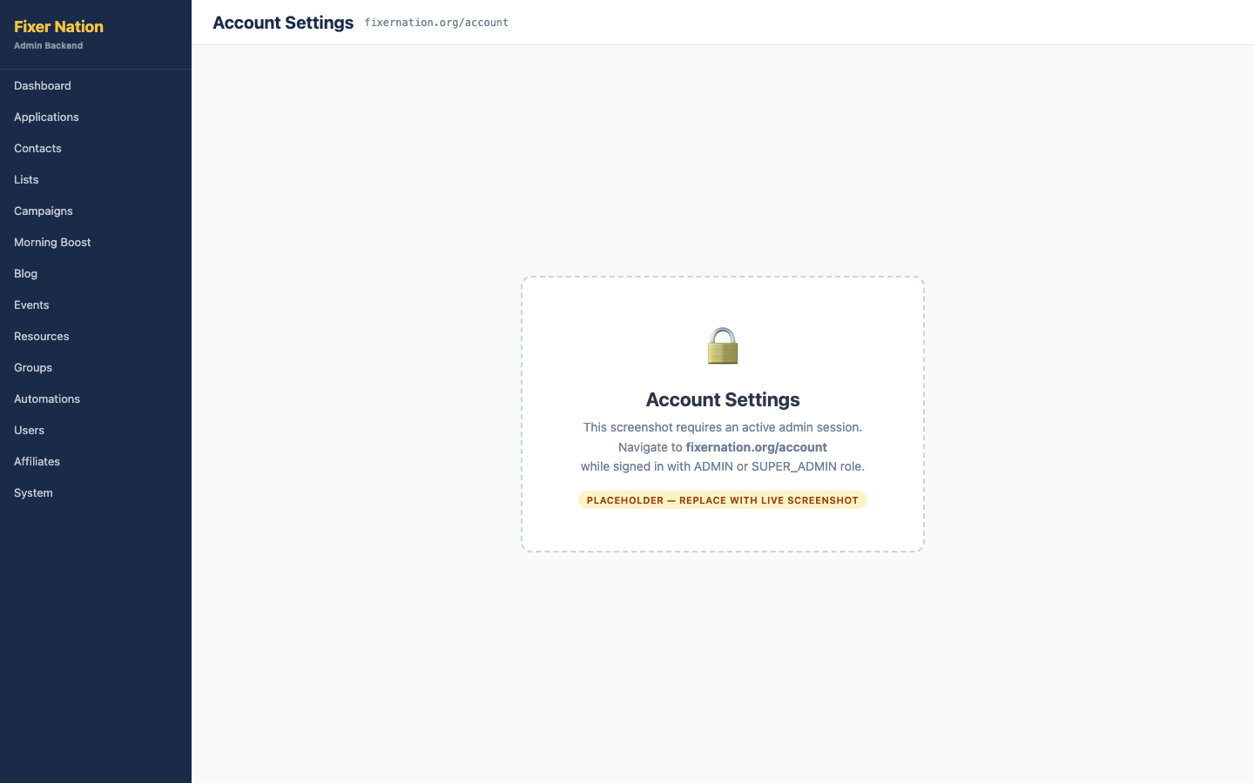
How to get here:
1. Click your avatar or initials in the top-right corner
2. Click "Account settings" in the dropdown
3. Or go directly to fixernation.org/account

Updating your display name:
1. Click the edit icon or pencil icon next to your display name
2. Type a new name
3. Click "Save"
4. Refresh the page — the new name persists

Morning Boost email preference:
5. Find the "Morning Boost emails" toggle and switch it off
6. Click "Save preferences"
7. Sign out and sign back in, then return to /account — the toggle is still off

Changing your password (email/password accounts only):
8. Click "Change password"
9. Enter your current password in the "Current password" field
10. Enter and confirm a new password
11. Click "Update password" — success message appears
12. Try the wrong current password — error message shown without changing anything

3.3 Edit Public Profile
URL: fixernation.org/account/profile
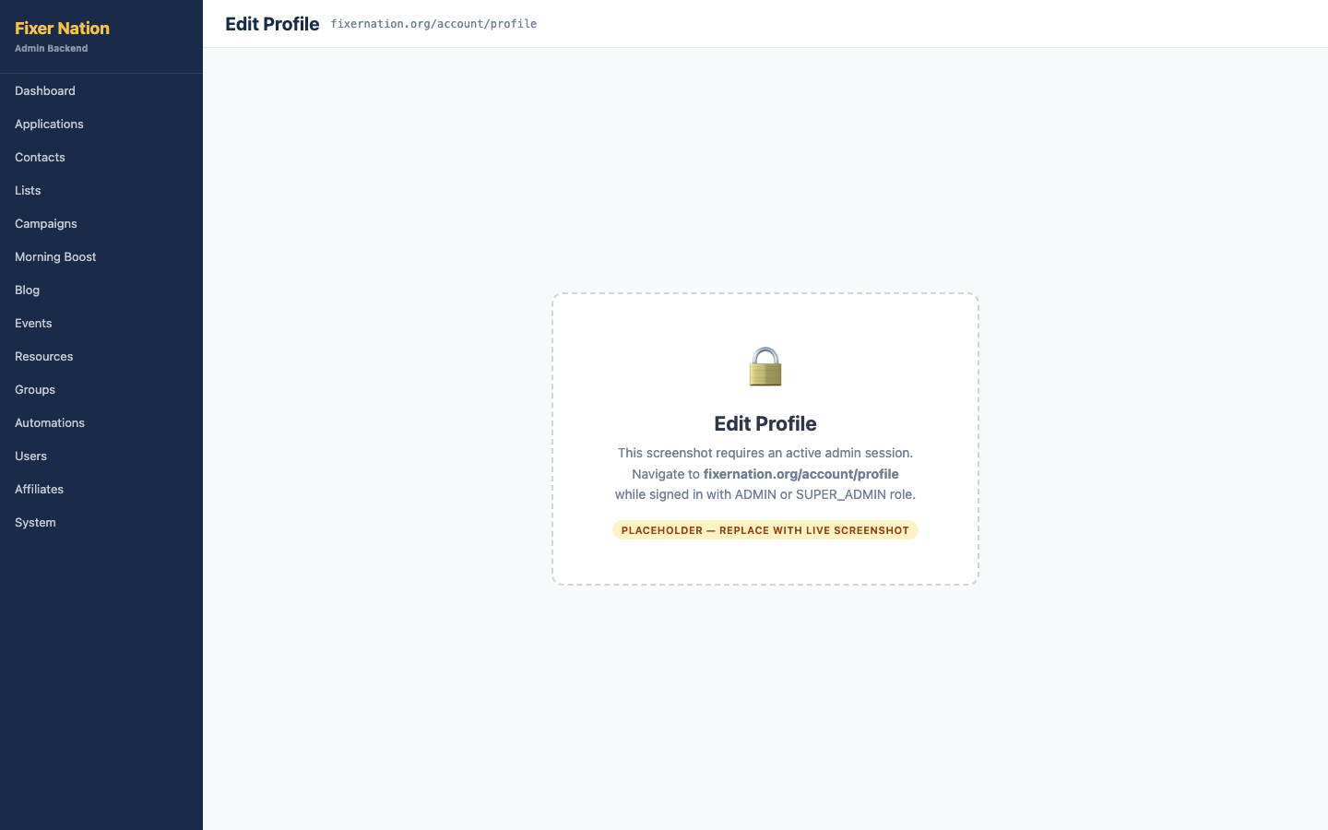
How to get here:
1. Go to fixernation.org/account
2. Click the "Profile" tab in the account navigation

Setting a username:
1. Type a username in the "Username" field (letters, numbers, and hyphens only, no spaces)
2. Click "Save changes"
3. Your public profile is now live at fixernation.org/profile/[your-username]

Uploading a profile photo:
4. Click the avatar circle or "Upload photo" button
5. Select a JPG or PNG file under 5 MB
6. A preview of the photo appears in the avatar circle
7. Click "Save changes" — photo is uploaded and appears on your public profile

Headline and bio:
8. Enter a short headline in the "Headline" field (e.g., "Financial advisor in Chicago")
9. Enter a longer bio in the "About" or "Bio" field
10. Click "Save changes"
11. Click the "View your public profile" link at the top of the page — headline and bio appear on /profile/[username]

3.4 Two-Factor Authentication (2FA)
URL: fixernation.org/account/security
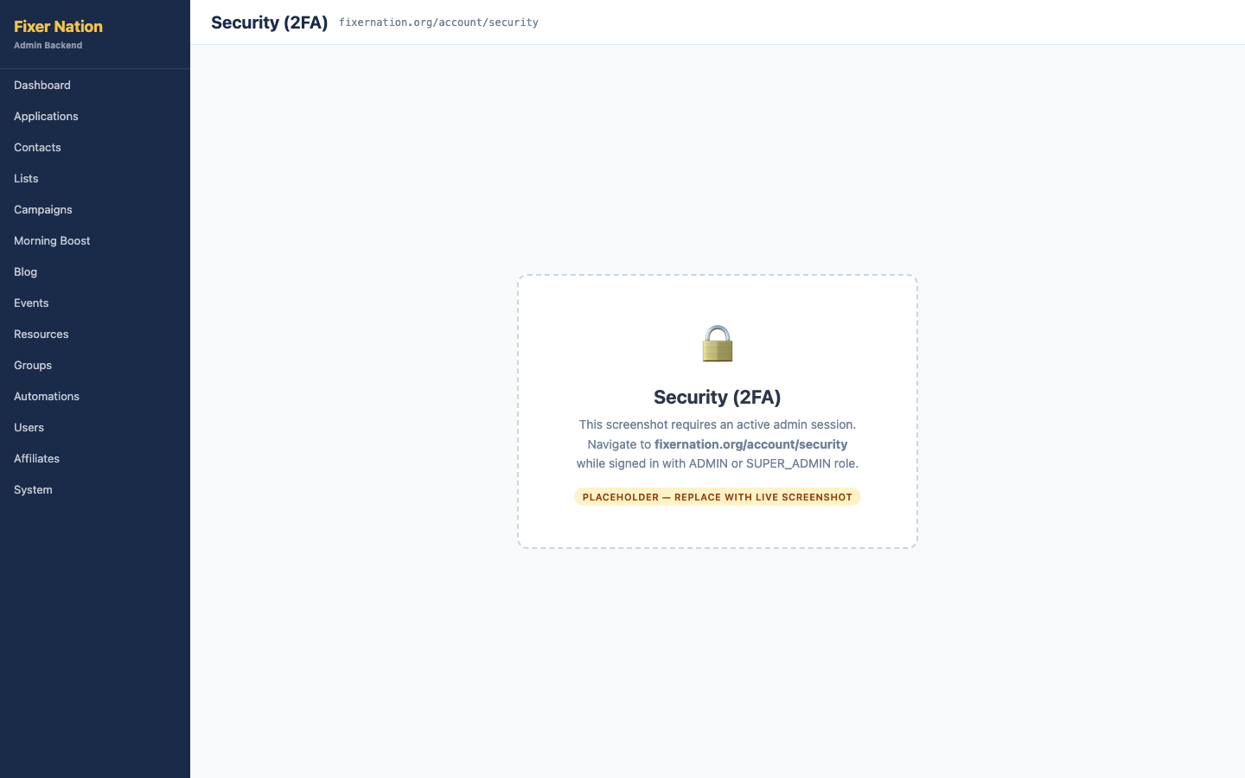
How to get here:
1. Go to fixernation.org/account
2. Click the "Security" tab

Enabling 2FA:
1. Click "Enable two-factor authentication"
2. A QR code and a text-based backup code appear
3. Open Google Authenticator, Authy, 1Password, or any TOTP app on your phone
4. Scan the QR code with the app — a 6-digit rotating code now appears in the app
5. Enter the current 6-digit code from the app into the verification field on this page
6. Click "Verify and enable" — 2FA is active

Testing 2FA at sign-in:
7. Sign out, then go to /signin
8. Enter your email and password — instead of going to the dashboard, a "Enter authentication code" screen appears
9. Enter the current 6-digit code from your app
10. Click "Verify" — you are signed in and redirected to /dashboard

Disabling 2FA:
11. Return to /account/security while signed in
12. Click "Disable two-factor authentication"
13. Enter a valid 6-digit code from your app to confirm the removal
14. Click "Confirm and disable" — 2FA is turned off

3.5 Community Feed
URL: fixernation.org/network
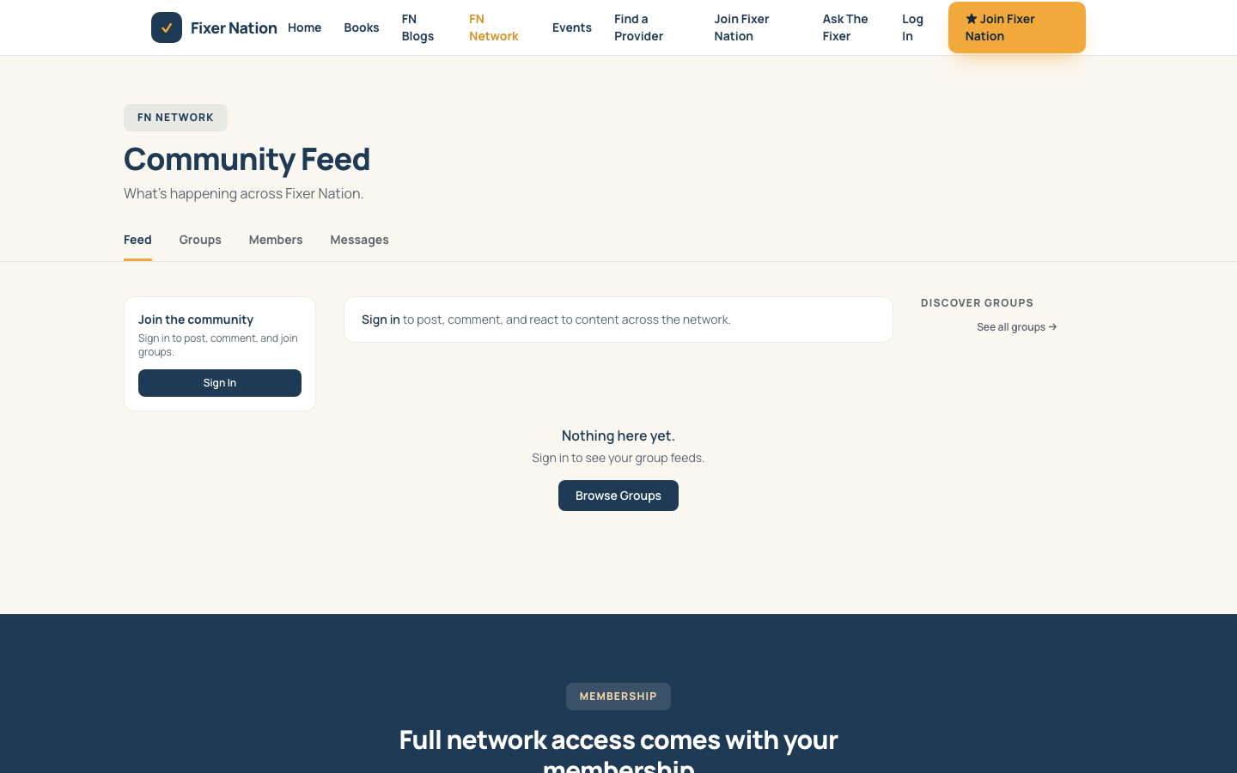
How to get here:
1. Click "FN Network" in the top navigation
2. Or go to fixernation.org/network

What to verify:
1. Signed-in members: left sidebar lists groups you have joined; click a group name to view that group's feed
2. Post cards appear in the center feed in reverse chronological order, each showing author, timestamp, group tag, and content
3. Click "Load more" at the bottom of the feed to fetch older posts
4. Compose box at the top: type a message and click "Post" — the new post appears at the top of the feed
5. Unauthenticated visitors: a "Sign in to join the conversation" prompt appears instead of the compose box

3.6 Groups Directory
URL: fixernation.org/network/groups
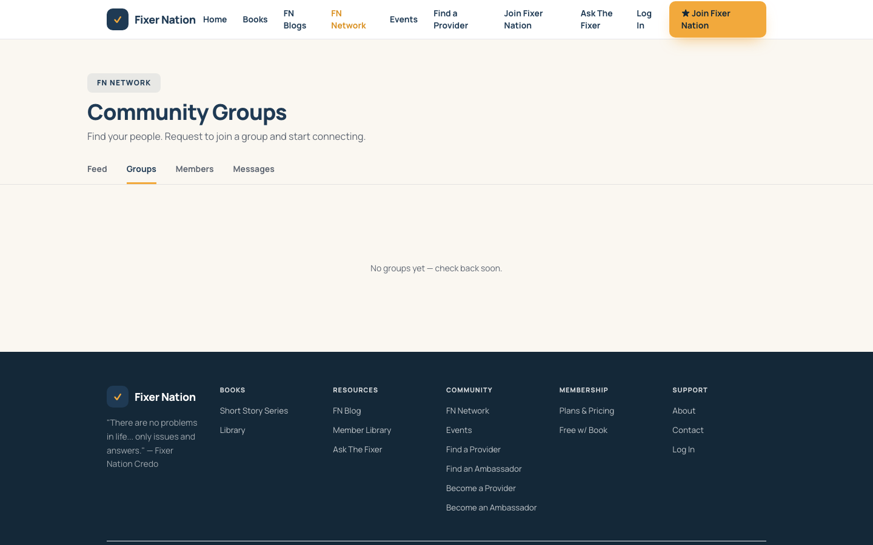
How to get here:
1. From /network, click "Groups" in the left sidebar
2. Or go directly to fixernation.org/network/groups

What to verify:
1. Group cards appear with name, visibility badge (Public / Private), description, and member count
2. Groups you belong to show a "View Group" button; groups you have not joined show "Request to Join"
3. Click "Request to Join" — button changes to "Request Sent"
4. After an admin approves the request (from /admin/groups/[id]/requests), the button changes to "View Group"
5. Click "View Group" — navigates to the group page at /network/groups/[slug]
6. Unauthenticated visitors clicking any join button are redirected to /signin

3.7 Members Directory
URL: fixernation.org/network/members
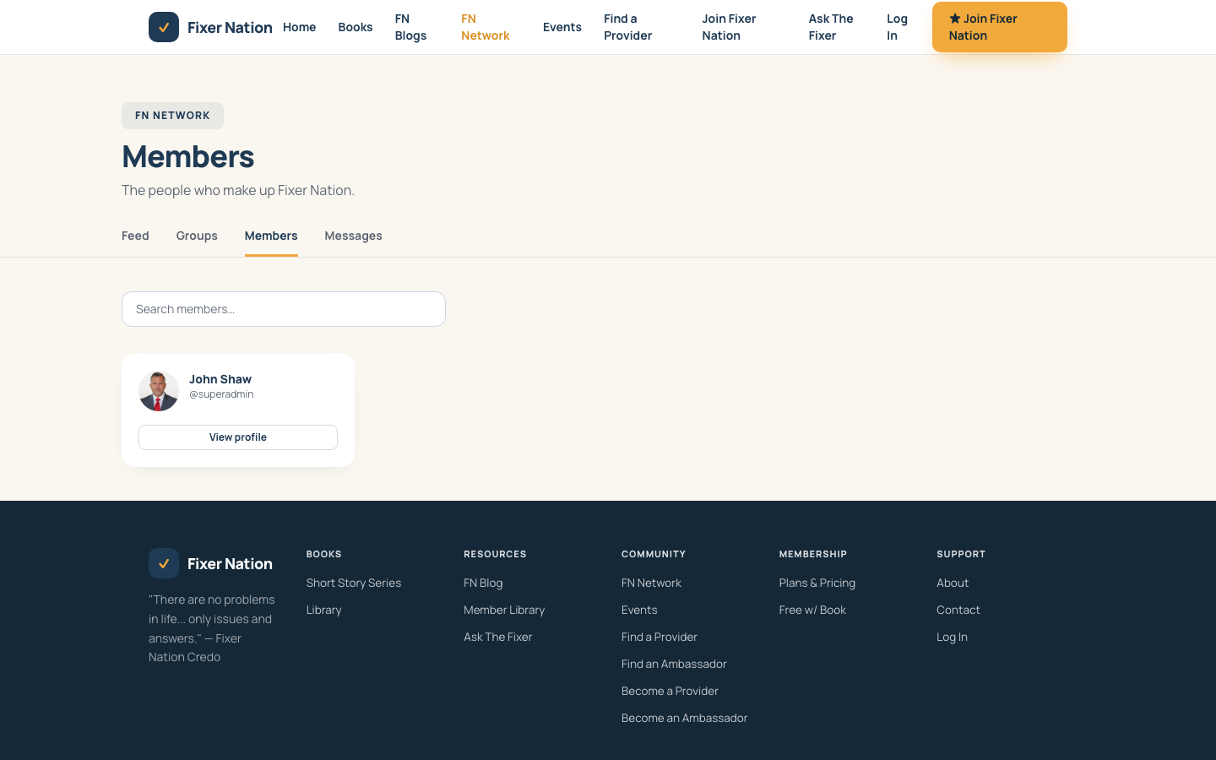
How to get here:
1. From /network, click "Members" in the left sidebar
2. Or go to fixernation.org/network/members
Note: The members directory is only visible to signed-in users.

What to verify:
1. Grid of member cards with avatar, name, username, and headline
2. Search input: type a name, username, or headline — cards filter in real time
3. Click "View profile" — navigates to /profile/[username]
4. Click "Message" — opens a direct message thread at /network/messages/[id]

3.8 Direct Messages
URL: fixernation.org/network/messages
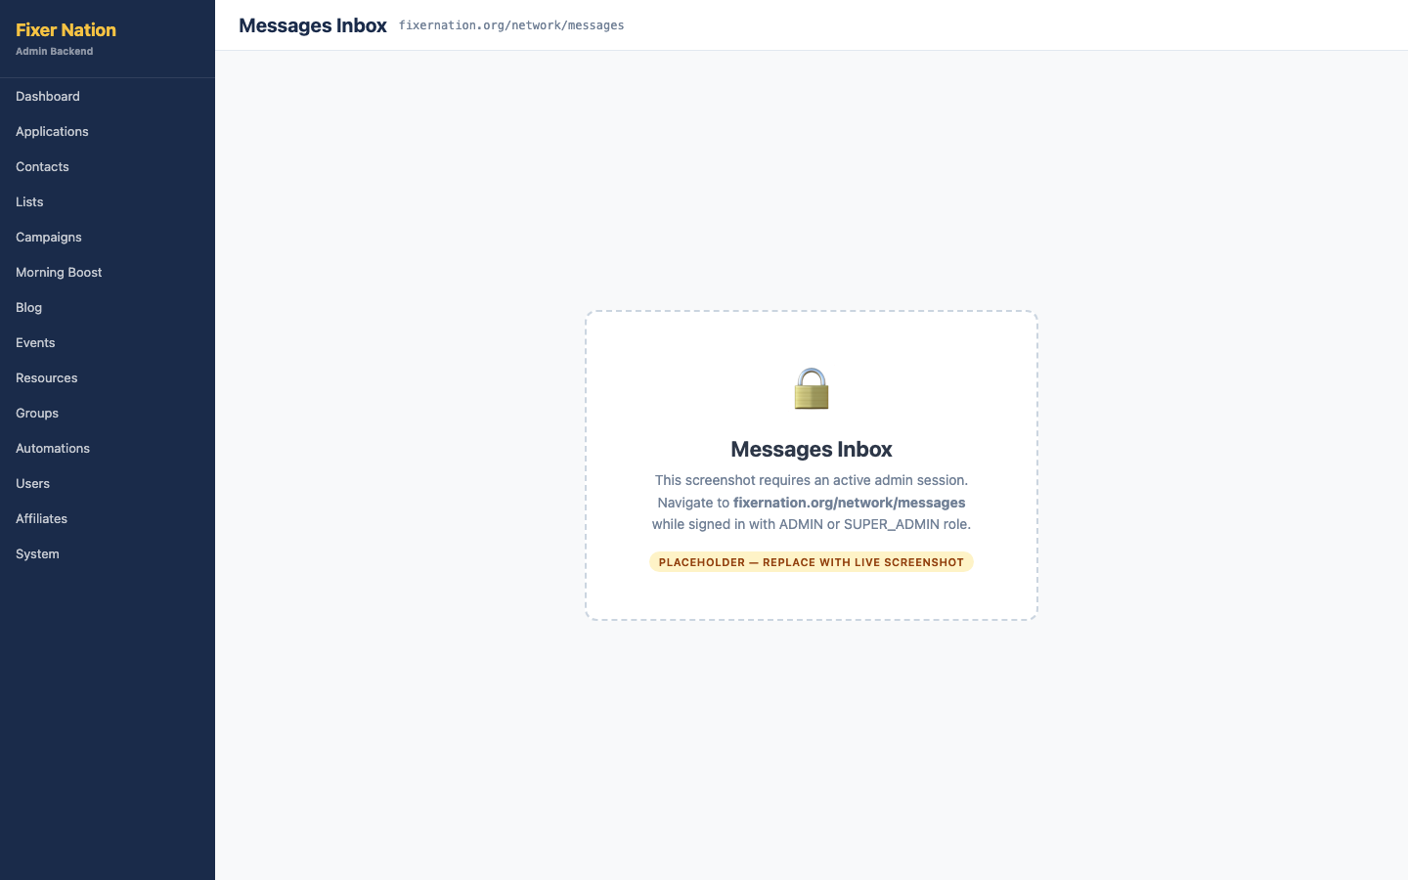
How to get here:
1. Click the messages icon (envelope) in the navigation bar
2. Or go to fixernation.org/network/messages

Starting a new conversation:
1. Click "New Message"
2. A search modal appears — type a member's name or username
3. Click the matching result — a new DM thread opens
4. Type your message in the compose bar at the bottom
5. Press Enter or click "Send" — message appears in the thread

What to verify:
6. Existing conversations are listed on the left with unread count badges
7. Messages in a thread appear in chronological order, grouped by date
8. Shift+Enter inserts a line break without sending

3.9 Public Profile
URL: fixernation.org/profile/[username]
How to get here:
1. Click a member card in /network/members and select "View profile"
2. Click a provider card in /providers
3. Or go directly to fixernation.org/profile/[username]

What to verify:
1. Profile shows avatar, name, username, headline, bio, and location
2. Viewing your own profile: "Edit profile" and "Edit your listing" buttons are visible
3. Viewing another member: a "Message" button appears — clicking opens a DM thread
4. Provider profiles: a services card shows service category and areas served
5. Ambassador profiles: territory and bio information is displayed
6. Public groups the member has joined appear at the bottom of the profile

3.10 Redeem a Gift Code
URL: fixernation.org/redeem
How to get here:
1. Go directly to fixernation.org/redeem (link is typically shared by admins or in a welcome email)

Steps:
1. Sign in first — unauthenticated visitors are prompted to sign in
2. Enter the gift code in the code field
3. Click "Redeem code"
4. Success message shows the role that was granted (e.g., Member, Provider, or Ambassador)
5. Refresh /dashboard — your new role is displayed on the role card

What to test:
1. Valid unused code — success, role updated
2. Already-redeemed code — error message shown
3. Invalid/fake code — error message shown
Note: Gift codes are generated by admins at /admin/gift-codes. Each code grants a specific role and can only be redeemed once.

Part 4: Applying to Join the Network

4.1 Service Provider Application
URL: fixernation.org/become-a-provider
How to get here:
1. Go to fixernation.org/service-provider
2. Click "Start your application"
3. Or go directly to fixernation.org/become-a-provider

The application is a 6-step form. Your progress is auto-saved to the browser's localStorage, so refreshing the page will not lose your data.

Step-by-step:
1. Step 1 — Contact information: enter email, phone, city, and state; click Next
2. Step 2 — Professional background: enter your business name, credentials, license numbers, and experience summary; click Next
3. Step 3 — Services: select your service category from the dropdown; enter the zip codes or cities you serve; click Next
4. Step 4 — About you: write a short bio and describe your approach to working with clients; click Next
5. Step 5 — Online presence: enter your website URL and any social media profiles; click Next
6. Step 6 — Agreements: read the Fixer Nation agreements, check all required agreement checkboxes, type your full legal name as your e-signature
7. Click "Submit application" — a confirmation page appears at /apply/confirmed

What to test:
1. Click Next on Step 1 with required fields empty — validation errors highlight the missing fields
2. Fill Step 1 and advance to Step 2, then click Back — your Step 1 data is preserved
3. Fill several steps, then refresh the page — the form restores from localStorage
4. Complete all 6 steps and submit — confirmation page appears at /apply/confirmed

4.2 Brand Ambassador Application
URL: fixernation.org/become-an-ambassador
How to get here:
1. Go to fixernation.org/brand-ambassador
2. Click the "Apply" or "Become an ambassador" button
3. Or go directly to fixernation.org/become-an-ambassador

The ambassador application follows the same 6-step flow. Key difference: Step 3 asks about your social media presence and estimated audience size rather than service areas.

What to test:
1. Complete all 6 steps and submit — confirmation page at /apply/confirmed
2. Step 3: check multiple platform checkboxes and fill in audience sizes — all inputs save and persist when navigating back

Part 5: Service Provider Features
These features are available to users with the PROVIDER role. Your application must have been accepted and your account activated.

5.1 Provider Public Profile
URL: fixernation.org/profile/[username]
What to verify:
1. Sign in with a PROVIDER account
2. Go to fixernation.org/profile/[your-username]
3. A "Services" card appears below your bio showing service category, description, and areas you serve
4. Click "Edit your listing" on your own profile — navigates to the account settings where you update provider details

5.2 Business Profile Settings
URL: fixernation.org/account (Business tab)
How to get here:
1. Go to fixernation.org/account
2. Click the "Business" tab in the account navigation

What to verify:
1. Fields available: business name, specialty, description, service areas (comma-separated), website URL, and business phone
2. Edit any field and click "Save" — changes appear on your public profile at /profile/[username]
3. Adding service areas: enter them as comma-separated values — each area appears as a separate tag on your public profile and in the /providers directory

5.3 Directory Visibility
Whether your card appears in the public /providers directory is controlled by an admin. When an admin enables your listing (from /admin/applications/[id]), your card appears automatically.

What to verify:
1. Ask an admin to enable your directory listing
2. Go to fixernation.org/providers — your card now appears in the grid
3. Verify the card shows the correct business name, category badge, headline, and location

Part 6: Brand Ambassador Features
These features are available to users with the AMBASSADOR role. You must have an accepted application, a provisioned affiliate account, and an active user account.

6.1 Ambassador Dashboard Panel
URL: fixernation.org/dashboard

What to verify:
1. Sign in with an AMBASSADOR account and go to /dashboard
2. An "Ambassador" section is visible below the main dashboard cards
3. Referral link: click the copy button — your unique referral URL is copied to the clipboard (e.g., fixernation.org/r/[code])
4. Promo codes: each listed code has a copy button — clicking copies the code
5. Stats: "Total referrals" and "Converted" counts are shown
6. Commission totals show three figures: Pending, Approved, and Paid amounts in dollars
7. Onboarding checklist items show status badges set by your admin (Pending, Passed, Failed, N/A)

6.2 Ambassador Account Profile
URL: fixernation.org/account/ambassador
How to get here:
1. Go to fixernation.org/account
2. Click the "Ambassador" tab

What to verify:
1. Fields visible: territory, bio, website, and business phone
2. Edit any field and click "Save" — changes appear on your public profile

6.3 Referral History
URL: fixernation.org/account/referrals
How to get here:
1. Go to fixernation.org/account
2. Click the "Referrals" tab

What to verify:
1. Table shows each referred person's name, email, and registration date
2. Referral totals at the top match the stats shown on your dashboard
Note: Referrals are counted when someone registers using your unique referral link (fixernation.org/r/[code]) or enters your promo code at checkout.

Part 1 Addendum: Ambassador Directory

1.11 Find an Ambassador
URL: fixernation.org/ambassadors
How to get here:
1. Go directly to fixernation.org/ambassadors, or follow the link from the site navigation or home page
What to verify:
1. A grid of ambassador cards loads, or an empty state if none are listed
2. Type a name or area in the search box — the grid filters in real time
3. Click a card — navigates to that ambassador's public profile at /profile/[username]

Part 7: Membership & Billing

7.1 Subscribing to a Membership
URL: fixernation.org/join
How to get here:
1. Go directly to fixernation.org/join, or follow a 'See membership options' link from your account page
Steps:
1. Toggle between Monthly ($10/mo after a 30-day free trial) and Annual ($60/yr, billed as $5/mo)
2. Click 'Start free trial'
3. If you are not signed in, you are redirected to sign in first, then returned to this flow
4. You are redirected to a Stripe-hosted Checkout page — enter payment details and confirm
5. On success, you land back on fixernation.org/account/billing with a confirmation banner
What to test:
1. Attempt to subscribe while already having an active subscription — you are redirected straight to /account/billing instead of a new checkout
2. Complete a real trial signup with a Stripe test card — confirm the trial end date and plan name are correct on /account/billing

7.2 Managing Your Billing
URL: fixernation.org/account/billing
How to get here:
1. Go to fixernation.org/account, then click the 'Billing' tab
What to verify:
1. Your current plan name, price, billing interval, and status (Active, Free trial, Payment past due, or Canceled) are shown
2. Click 'Manage subscription' — opens the Stripe-hosted billing portal in the same tab
3. In the billing portal, update your payment method or view past invoices, then use the portal's back link to return to fixernation.org/account/billing
4. If you have no active membership but have billing history, a 'View past invoices' link still opens the billing portal
5. If you have never subscribed, a 'See membership options' button links to /join
Note: All payment method entry, invoice history, and subscription cancellation happens inside Stripe's own hosted portal — there is no custom UI for these actions on fixernation.org.

Part 8: Service Provider Campaigns
These features require the PROVIDER role and an active account. They extend Part 5 (Service Provider Features).

8.1 Creating and Sending a Campaign
URL: fixernation.org/account/provider/campaigns
How to get here:
1. Sign in with a PROVIDER account, go to /account, click the 'My Campaigns' tab under Business
Creating a campaign:
1. Click '+ New campaign' (or 'Create a campaign' if you have none yet)
2. Enter a Campaign name (internal only), From name, Subject line, and the Email body (HTML). A plain-text version is optional
3. Click 'Save as draft'
Sending:
4. On the campaign's detail page, the Send panel shows 'Send to N contact(s)' — this always targets every contact you have personally added; there is no list or segment picker
5. If you have 0 contacts, the button is disabled with a link to 'Add contacts'
6. Click 'Send to N contact(s)', confirm the dialog — the campaign sends and status becomes Sent
7. Attempt to send the same campaign again — blocked; a sent campaign cannot be resent
Note: Providers can only send to their own contacts (added at /account/provider/contacts). There is no access to the platform-wide contact database or any other provider's contacts.

8.2 Viewing Campaign Open Stats
URL: fixernation.org/account/provider/campaigns/[id]
What to verify:
1. Once a campaign is Sent, a 'Delivery stats' card shows Delivered %, Opened %, and Failed count
2. A Recipients table lists each contact with Status, Sent at, and Opened (date if opened, otherwise —)
3. Open the sent email in a real inbox — the Opened column updates for that recipient after the tracking pixel loads

Part 9: Ambassador Campaign Materials & Earnings
These features require the AMBASSADOR role, an accepted application, and a provisioned affiliate account. They extend Part 6 (Brand Ambassador Features).

9.1 Campaign Materials
URL: fixernation.org/account/ambassador/materials
How to get here:
1. Go to /account, click the 'Campaign Materials' tab under Ambassador
What to verify:
1. Materials shown here are campaigns an admin has specifically flagged for ambassador use and that have already been sent — you will not see every FN campaign
2. Each card shows a channel badge (Email or Push), the send date, name, and subject
3. Click 'Copy subject' — subject line copies to your clipboard
4. Click 'Preview' — card expands to show 'Copy text' and 'Copy HTML' buttons (or 'Copy URL' for a Push material)
Note: There is no downloadable file, ZIP, or PDF export here — 'materials' means copyable text and HTML you paste into your own outreach. Use the copied content for your own channels; do not send on Fixer Nation's behalf using these materials.

9.2 Referrals and Earnings
URL: fixernation.org/account/referrals and fixernation.org/account/commissions
Referrals page — what to verify:
1. Stat tiles show Total referrals, Converted, and Conversion rate
2. A commission balance summary links to /account/commissions with 'View earnings →'
3. Referral history table lists each referred person's name, email, and sign-up date, with conversion date if applicable
Commissions ('My earnings') page — what to verify:
4. Three totals: Pending (in review period), Approved (ready to pay out), and Paid out (all time)
5. A payout-threshold banner shows how much more is needed to reach the next payout, or confirms the threshold is already met
6. Earnings history table lists each entry's description, amount, status (Pending/Approved/Paid/Reversed/On hold/Cancelled), and date
Note: Your ambassador profile page (/account/ambassador) is where you edit your territory, bio, website, and phone, and copy your referral link — it does not show commission totals or promo codes directly. Those live on the two pages above.

Appendix A: Website Test Case Tracker (SP-1 – SP-53)
Use this table to track manual execution across public pages, authentication, member features, applications, provider/ambassador features, and membership billing. Pass/Fail and Tester/Date columns are left blank for you to fill in during a test pass.
ID | Area | Preconditions | Steps | Expected Result | Pass/Fail
WEB-001 | Home page | Unauthenticated visitor | Load fixernation.org | Hero, nav, community section, feature tiles, and footer links all render
WEB-002 | Home page | Unauthenticated visitor | Fill in newsletter form (name + email), click Subscribe | Submits without error; contact created with newsletter consent
WEB-003 | Provider directory | ≥1 provider directory-listed | Search by name, filter by category | Grid narrows correctly for each filter; clearing resets to full list
WEB-004 | Provider directory | Provider not yet listed | Check /providers | Provider does not appear until an admin enables the directory toggle
WEB-005 | Events | ≥1 upcoming, ≥1 past event | Load /events | Upcoming and past events render in separate sections
WEB-006 | Event detail — free | Free future event | Open detail page while signed out | 'Count me in' RSVP button visible; clicking redirects to /signin
WEB-007 | Event detail — paid | Paid future event | Open detail page | 'Register ($X.00)' button visible
WEB-008 | Event detail — full | Event at capacity | Open detail page, attempt to RSVP | 'Join waitlist' button shown instead of direct RSVP
WEB-009 | Event detail — past | Event date has passed | Open detail page | 'This event has passed' message replaces the RSVP control
WEB-010 | Morning Boost | Today's entry published | Load /morning-boost signed out | Today's entry is fully readable; older entries are gated
WEB-011 | Morning Boost | Signed in as member | Load /morning-boost | All past entries are now readable
WEB-012 | Blog | Signed out, multiple posts exist | Load /blog | Most recent post is fully readable; older posts show a Members-only badge and redirect to /signin on click
WEB-013 | Blog | Signed in as member | Load /blog | All published posts are readable
WEB-014 | Resources | Signed out | Load /resources | 2-3 cards visible; rest gated behind a Join prompt
WEB-015 | Resources | Signed in as member | Load /resources, use type filter chips | Full library visible; chips filter correctly
WEB-016 | Books | Any state | Use All / Short Story Series / New Arrivals filter chips | Grid narrows per chip; Amazon button links out or shows Coming Soon
WEB-017 | Ambassador directory | ≥1 ambassador exists | Search by name/area on /ambassadors | Grid filters in real time; card click opens the ambassador's public profile
WEB-018 | Legal/static pages | Any state | Load /about, /contact, /privacy, /terms, /cookie-policy | Each loads without a 404 or error
WEB-019 | Contact form | Any state | Fill in and submit the contact form | Success confirmation appears
WEB-020 | Registration | Fresh email address | Register with a new email and matching passwords ≥8 chars | Account created; verification email sent
WEB-021 | Registration | Email already registered | Register with the same email again | Error message shown; no duplicate account created
WEB-022 | Registration | Any state | Enter mismatched passwords | Validation error before submission
WEB-023 | Registration | Any state | Enter a password under 8 characters | Validation error shown
WEB-024 | Registration via invite | Valid invite token from an accepted application | Open /invite/[token] | Email is pre-populated and role is set automatically on account creation
WEB-025 | Sign in | Verified account | Sign in with valid credentials | Redirects to /dashboard
WEB-026 | Sign in | Verified account | Sign in with wrong password | Error message shown below the form
WEB-027 | Sign in | Unverified account | Attempt to sign in | Message prompts email verification first
WEB-028 | Sign in — MFA | Account with 2FA enabled | Sign in with correct password | 6-digit TOTP entry screen appears; correct code completes sign-in
WEB-029 | Forgot password | Registered email | Request a password reset | Generic confirmation shown; reset email sent
WEB-030 | Forgot password | Unregistered email | Request a password reset | Same generic confirmation shown (no account enumeration)
WEB-031 | Reset password | Expired or already-used reset token | Open the reset link | Error shown about an invalid/used token
WEB-032 | Dashboard | Signed in, pending application exists | Load /dashboard | Status notice with 'View status' link appears
WEB-033 | Dashboard | Signed in as ADMIN/SUPER_ADMIN | Load /dashboard | Admin shortcut link is visible and navigates to /admin
WEB-034 | Account settings | Signed in | Change display name, save, reload | New name persists after reload
WEB-035 | Account settings | Signed in | Toggle Morning Boost emails off, save, sign out and back in | Toggle remains off after re-sign-in
WEB-036 | Account settings — password | Email/password account | Change password with correct current password | Success message; new password works on next sign-in
WEB-037 | Account settings — password | Email/password account | Attempt password change with wrong current password | Error shown; password unchanged
WEB-038 | Public profile | Signed in | Set a username, upload a photo, add headline/bio, save | Public profile at /profile/[username] reflects all changes
WEB-039 | Two-factor auth | Signed in, 2FA not yet enabled | Enable 2FA, scan QR, enter code, verify | 2FA becomes active
WEB-040 | Two-factor auth | 2FA enabled | Sign out, sign in again | TOTP code screen appears before dashboard access
WEB-041 | Two-factor auth | 2FA enabled | Disable 2FA with a valid current code | 2FA turns off; next sign-in skips the code screen
WEB-042 | Community feed | Signed in, member of ≥1 group | Load /network | Joined groups listed in sidebar; compose box present; posting adds to the top of the feed
WEB-043 | Community feed | Signed out | Load /network | Sign-in prompt shown instead of the compose box
WEB-044 | Groups directory | Signed in, not a member of a public group | Click 'Request to Join' | Button changes to 'Request Sent'
WEB-045 | Groups directory | Join request approved by an admin | Reload /network/groups | Button changes to 'View Group'
WEB-046 | Members directory | Signed in | Search by name/username/headline | Cards filter in real time; 'Message' opens a DM thread
WEB-047 | Direct messages | Signed in | Start a new conversation, send a message | Thread opens and message appears immediately
WEB-048 | Direct messages | Signed in, existing thread | Press Shift+Enter in the compose bar | Inserts a line break without sending
WEB-049 | Public profile | Viewing own profile | Load /profile/[own-username] | Edit profile and Edit your listing buttons are visible
WEB-050 | Public profile | Viewing another member's profile | Load /profile/[other-username] | Message button is visible instead of edit controls
WEB-051 | Gift code redemption | Valid unused code, signed in | Redeem the code at /redeem | Success message shows granted role; /dashboard reflects the new role
WEB-052 | Gift code redemption | Already-redeemed code | Attempt to redeem it again | Error message shown
WEB-053 | Gift code redemption | Invalid/fake code | Attempt to redeem it | Error message shown
WEB-054 | Provider application | Not yet a provider | Complete all 6 steps of /become-a-provider and submit | Confirmation page at /apply/confirmed
WEB-055 | Provider application | Partially completed form | Fill several steps, refresh the browser | Form restores from localStorage
WEB-056 | Provider application | On step 2+ | Click Back | Previously entered data on the prior step is preserved
WEB-057 | Ambassador application | Not yet an ambassador | Complete all 6 steps of /become-an-ambassador and submit | Confirmation page at /apply/confirmed
WEB-058 | Ambassador application | On step 3 | Check multiple platform checkboxes, enter audience sizes | All inputs persist when navigating back and forth
WEB-059 | Provider profile | PROVIDER role, accepted application | View own /profile/[username] | Services card shows category, description, and service areas
WEB-060 | Provider business settings | PROVIDER role | Edit business name, specialty, service areas, save | Public profile at /profile/[username] reflects changes; each service area renders as a separate tag
WEB-061 | Provider directory visibility | Admin has enabled directory listing | Load /providers | Provider's card appears with correct business name, category, headline, location
WEB-062 | Provider campaigns | PROVIDER role, ≥1 contact added | Create a draft campaign and send it | Sends only to the provider's own contacts; cannot select any other audience
WEB-063 | Provider campaigns | Campaign already sent | Attempt to send it again | Blocked — a sent campaign cannot be resent
WEB-064 | Provider campaign tracking | Sent campaign, recipient opened the email | Check the campaign detail page | Delivery stats and per-recipient Opened column update correctly
WEB-065 | Ambassador dashboard panel | AMBASSADOR role, provisioned affiliate | Load /dashboard | Referral link and promo codes have working copy buttons; referral and commission stats display
WEB-066 | Ambassador profile | AMBASSADOR role | Edit territory, bio, website, phone, save | Changes appear on the public profile
WEB-067 | Referral history | AMBASSADOR role, ≥1 referral | Load /account/referrals | Table matches the referral totals shown on the dashboard
WEB-068 | Ambassador commissions | AMBASSADOR role, ≥1 commission entry | Load /account/commissions | Pending/Approved/Paid totals and earnings history render correctly
WEB-069 | Ambassador campaign materials | ≥1 campaign flagged for ambassador use and sent | Load /account/ambassador/materials, use Copy subject / Copy text / Copy HTML | Correct content copies to clipboard; no file download exists (copy-only by design)
WEB-070 | Referral conversion | Fresh referral link/code | Register a new account via the referral link, or enter the promo code at checkout | Referral is recorded and counted toward the referring ambassador's totals
WEB-071 | Membership subscribe | Signed in, no active membership | Go to /join, start a free trial with a Stripe test card | Redirects to Stripe Checkout, then back to /account/billing with a success banner
WEB-072 | Membership subscribe | Already has an active subscription | Attempt to subscribe again via /join | Redirected straight to /account/billing instead of a new checkout
WEB-073 | Membership subscribe | Signed out | Click 'Start free trial' | Redirected to sign in first, then returned to the checkout flow
WEB-074 | Billing management | Active membership | Load /account/billing | Plan name, price, interval, and status render correctly
WEB-075 | Billing management | Active membership | Click 'Manage subscription' | Opens the Stripe-hosted billing portal; changes made there are reflected back on /account/billing
WEB-076 | Billing management | No membership, no Stripe customer history | Load /account/billing | 'See membership options' button links to /join

