INSTITUTIONAL TLEP PORTFOLIO – PROGRAMME EXECUTIVE REPORT

1. Compliance Status Distribution
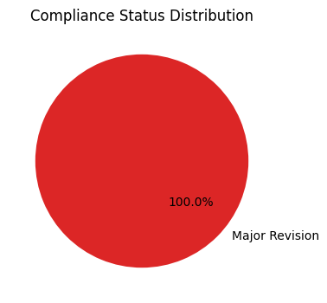

PROGRAMME STATISTICS SUMMARY
Total Courses Audited: 1
Average Compliance Score: 54.1%
Fully Compliant (Ready for BoS): 0
Needs Minor Revision: 0
Requires Major Rework: 1

2. UG vs PG Course Breakdown
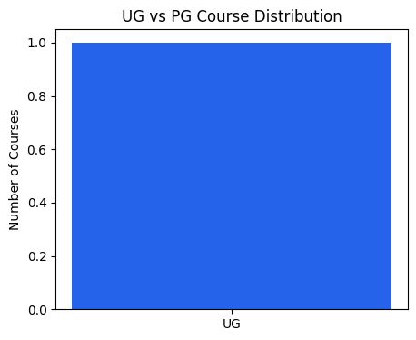
3. Department Performance Leaderboard
