TLEP REVIEW – REMARKS
Sample Review: Unknown Course (Submitted Teaching-Learning & Evaluation Plan – Sports Biomechanics, Bachelor of Sports Science, Course Code 23BSS3C01.)
Programme: None Credits: 3.0 L-T-P-E: Bachelor of Sports Science Credits: 03 L-T-P-E: 2-0-2-0 Contact Hours: 60 Contact Hours: 0

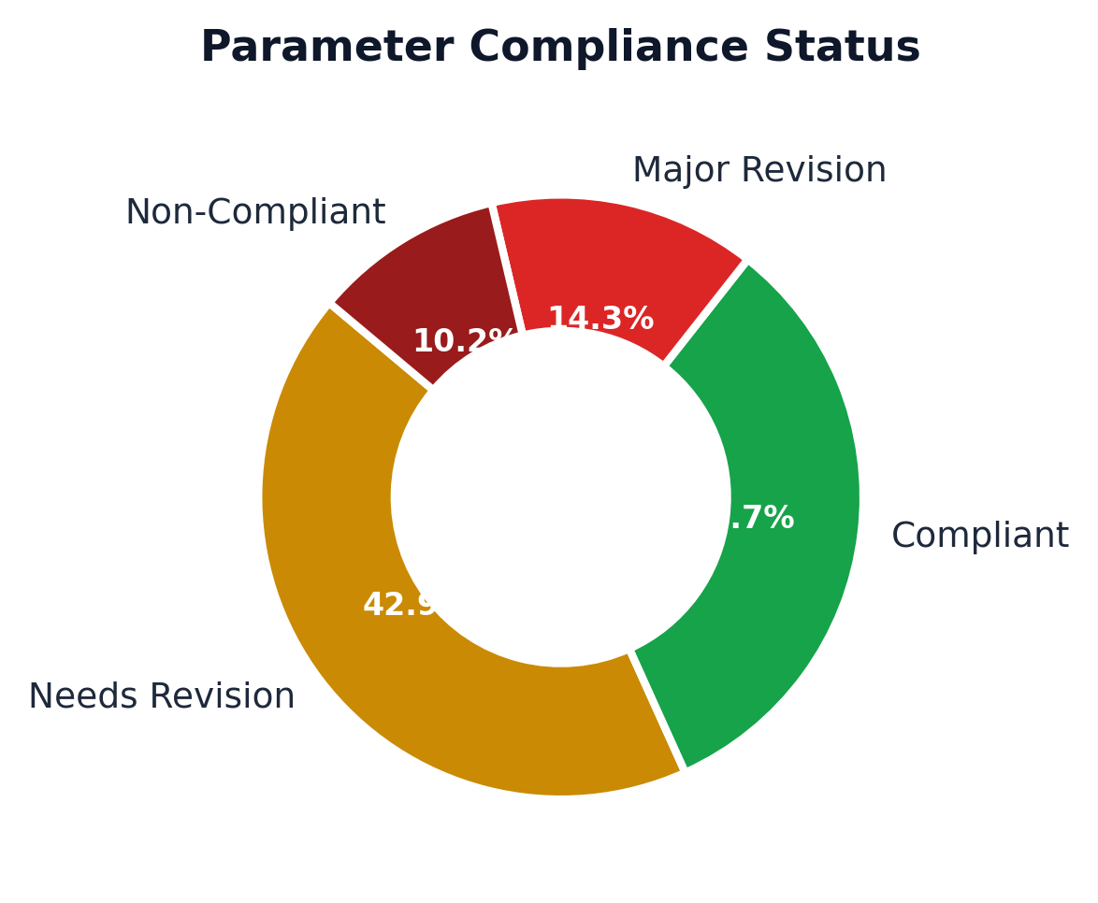

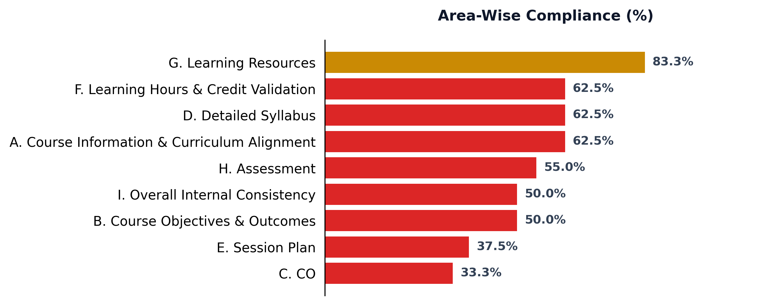

Remarks
1. The TLEP is structured with a 0-hour session-wise plan. Module coverage appears incomplete.
2. Pedagogy is mentioned globally but not detailed session-wise.
3. Some CO statements lack measurable Bloom's taxonomy action verbs.
4. No CO–PO mapping matrix found.
5. Assessments appropriately demarcated into formative/continuous and summative components.
6. The practical and experiential learning components should be explicitly reflected in the teaching-learning plan.
7. Evidence of student feedback analysis and resulting improvements should be incorporated.
8. A formal continuous-improvement record linking previous course review actions is not fully evidenced.
9. Basic/prescribed textbooks are listed and relevant.
10. Overall, the TLEP demonstrates a teaching-learning foundation but requires targeted revision in areas marked for action.

Recommended Action
Return for targeted revision. The course may be considered for final review after the critical OBE mapping inconsistencies, CO-assessment alignment and feedback/continuous-improvement documentation are addressed.

Lead Team Quick View
Source: Submitted Teaching-Learning & Evaluation Plan – Unknown Course, None, Course Code Submitted Teaching-Learning & Evaluation Plan – Sports Biomechanics, Bachelor of Sports Science, Course Code 23BSS3C01..

