LOAD BALANCING USING MOD_JK

1. INTRODUCTION :-
Here first we will install Apache 2.4.7, Tomcat 7, and will implement load balancing between them using mod_jk connector i.e. apache will redirect its hits to all the tomcat servers equally.

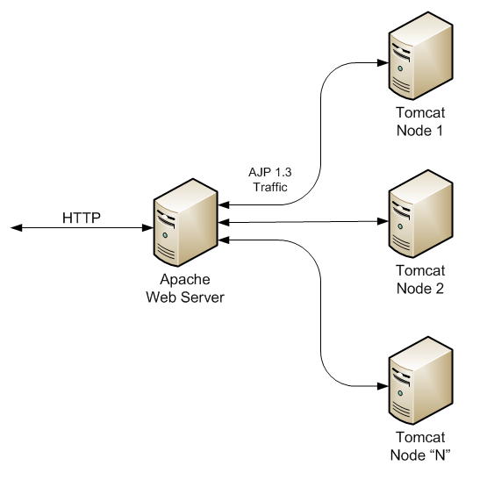
2. REQUIREMENTS :-
- one machine with Apache 2.4.x & mod_jk
- min. two machines with Tomcat 7

3. INSTALLATIONS :-

A) Apache Installation -
Apache is the world's most widely used Web Server Software

* run following commands

Download the package lists from the repositories and update them to get information on the newest version of packages and their dependencies.
# apt-get update

fetch new versions of packages existing on the machine
# apt-get upgrade

install apache
# apt-get install apache2

Restart services of Apache
# service apache2 restart

Now go to firefox and type http://localhost , you must see a default apache page.

B) Tomcat Installation -
Tomcat is an application server that executes Java servlets and enders Web pages that include Java Server Page coding. ***Do same process in all the tomcat machines. Here I have used two tomcat machines.

Download the package lists from the repositories and update them to get information on the newest version of packages and their dependencies.
# apt-get update

fetch new versions of packages existing on the machine
# apt-get upgrade

install tomcat 7 (Binary package) & tomcat7-admin packages (Admin login package)
# apt-get install tomcat7
# apt-get install tomcat7-admin

Now go to /etc/tomcat7/tomcat-user and add username and password for tomcat login page

<role rolename=”manager-gui”/>
<user username=”your_username” password=”your_password” roles=”manager-gui”/>

Restart tomcat services
# service tomcat7 restart

after giving these entries, you can go to firefox and login into tomcat using your username and password using url- http://localhost:8080 ,we can also give our ip address in place of localhost.

Note :- here we can also use a unused port no. (i.e. other than 8080), just define that in connector port in /etc/tomcat7/server.xml

C) mod_jk installation -

mod_jk is an Apache Module used to connect the Apache with multiple Tomcats.
It will be installed on same machine on which Apache is installed by following commands

# apt-get install libapache2-mod-jk
# a2enmod jk

4. CONFIGURATIONS :-

A) Tomcat Configuration -

* go to Tomcat1 server and make these changes

# vim /etc/tomcat 7/server.xml
add this line in there
<connector port=”8009” protocol=”AJP/1.3” redirectport=”8443” />

* now go to Tomcat2 server, do the same but use an unused port no. (other than 8009)

example:-
f

B) Apache Configuration -

go to apache machine

# vim /etc/apache2/apache2.conf
( add this line if you don’t have a fully qualified domain name else add your domain name in /etc/apache2/sites-enab led/000-defaults.conf file)

ServerName apache

# vim /etc/apache2/sites-enabled/000-default.conf
add these two lines in between VirtualHost
JkMount /status status
JkMount /* loadbalancer

*make a file workers.properties in /etc/apache2 with following entries
c
# vim /etc/apache2/workers.properties

worker.list=loadbalancer, status

worker.tomcat1.port=8009
worker.tomcat1.host=( i.p. address of tomcat1 machine )
worker.tomcat1.type=ajp13
worker.tomcat2.port=9009 (port defined for tomcat2 earlier)
worker.tomcat2.host=( i.p. address of tomcat2 machine )
worker.tomcat2.type=ajp13

worker.tomcat1.lbfactor=1
worker.tomcat2.lbfactor=1
worker.loadbalancer.type=lb
worker.loadbalancer.balance_workers=tomcat1,tomcat2

worker.status.type=status

* go to file- /etc/apache2/mods-enabled/jk.conf and edit
Here give the absolute path of worker properties file

JkWorkersFile /etc/apache2/workers.properties

make these changes and allow all to access jk-status and jk-manager files

<Location /jk-status>
JkMount jk-status
Order allow,deny
Allow from all
</Location>
<Location /jk-manager>
JkMount jk-manager
Order allow,deny
Allow from all
</Location>

* allow firewall on all tomcat machines by following command (or simply disable firewall on all machine by # ufw disable)

list the rules
# sudo iptables -L
# sudo iptables -A INPUT -p tcp --dport 8080 -j ACCEPT

* Restart the services on Apache and Tomcats by respective commands
# service apache2 restart
# service tomcat7 restart
* Now hit your apache URL and you will be directed to tomcat machines.

5. TESTING :-

- to test whether it is reaching both the tomcats or not, make a file in both the tomcats at /var/lib/tomcat7/webapps/ with same name but different message content

example:-

# vim /var/lib/tomcat7/webapps/demo

<HTML>
<HEAD>
<TITLE>Hello World</TITLE>
</HEAD>
<BODY>
<Hi> Welcome to Tomcat1/Tomcat2 </Hi>
<Hi>Hello World</Hi>
Today is: <%= new java.util.Date().tostring() %>
</BODY>
</HTML>

* Now restart the Tomcat services on both machines, and apache services on apache machine.

* Hit http://(apache_ip_address)/demo in firefox
you will be directed to your tomcat's demo file, now refresh the page and you will see the message content changing each time from one tomcat to another.

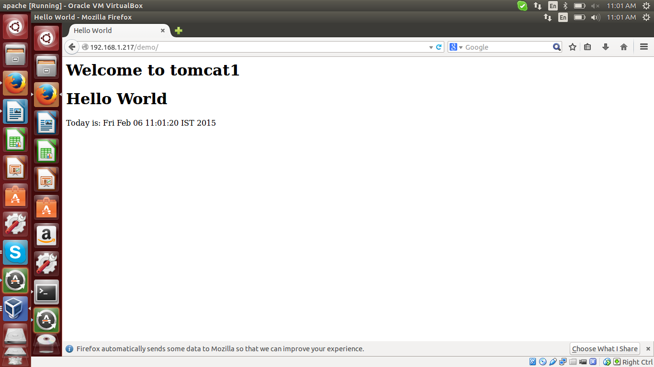

* Refresh this page and now you will see Welcome to tomcat 2 message in place of Tomcat1.

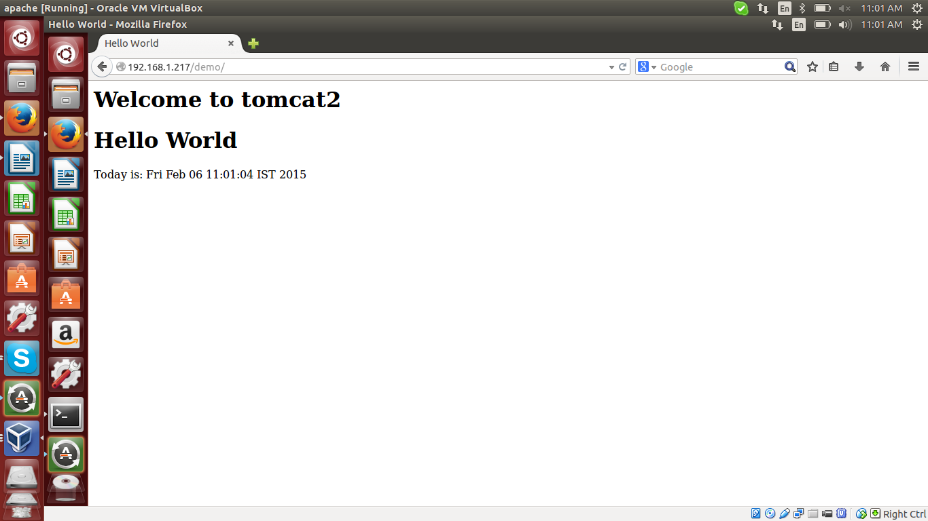

- Another way to test the same is by turning off any one of the tomcat machine by

# service tomcat7 stop

* Now REFRESH the page and automatically Apache will forward the request to only active tomcat each time.

- hit http://(apache_ip_address)/status in firefox

it is jk manager status page, where we can see all of its details.
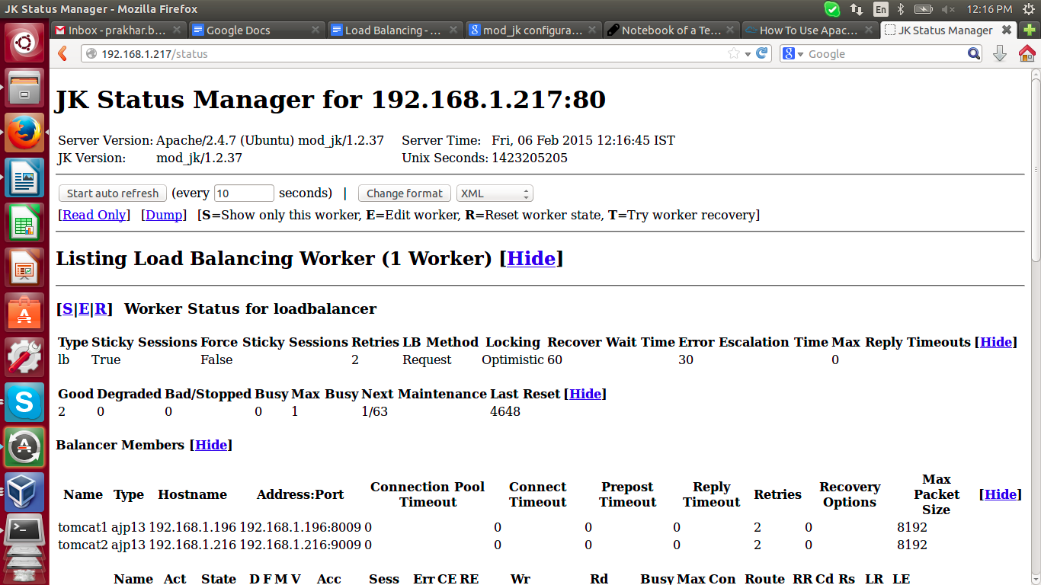
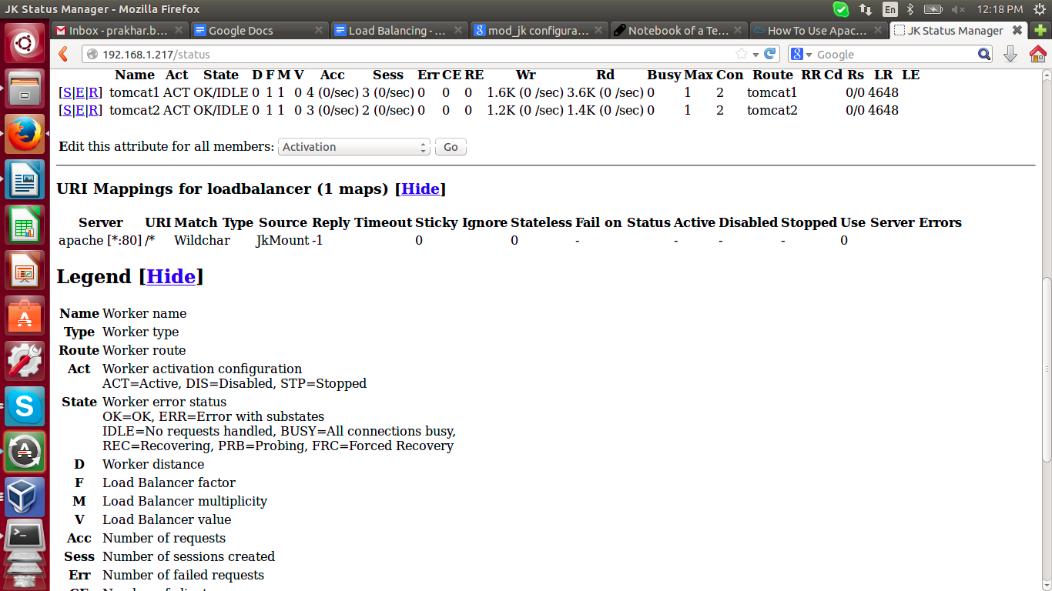

6. CONCLUSION :-
Load balancing is done successfully..

HOW TO ENABLE COMPRESSION ON APACHE

1. INTRODUCTION -
mod_deflate allows Apache2 to compress files and deliver them to clients that can handle compressed content . With mod_deflate, you can compress HTML, text or XML files to approx. 20 - 30% of their original sizes, thus saving your server traffic and making your modem users happier.

2. INSTALLATION & CONFIGURATION -

By default mod_deflate is installed with apache so just enable mod_deflate on ur apache machine now
# a2enmod deflate

Restart apache services
# service apache2 restart

We can enable mod_deflate for your whole Apache2 server, or just for specific virtual sites. Depending on this, either open your Apache’s global server configuration section now or just the vhost configuration section where you want to enable mod_deflate (as i did)

# vim /etc/apache2/sites-enabled/001-www.xyz.com.conf

add the following lines:
1. SetOutputFilter DEFLATE
2. SetEnvIfNoCase Request_URI \.(?:gif|jpe?g|ico|png)$ \ no-gzip dont-vary
3. SetEnvIfNoCase Request_URI \.(?:exe|t?gz|zip|bz2|sit|rar)$ \no-gzip dont-vary
4. SetEnvIfNoCase Request_URI \.pdf$ no-gzip dont-vary
5.
6. BrowserMatch ^Mozilla/4 gzip-only-text/html
7. BrowserMatch ^Mozilla/4\.0[678] no-gzip
8. BrowserMatch \bMSIE !no-gzip !gzip-only-text/html
*Details of above entries
Line 1: Enable gzip compression
Line 2: Do not compress images
Line 3: Do not compress already compressed files
Line 4: Do not compress pdf
Line 6-8: Some exceptions for old browsers

3. TESTING -
In order mod_deflate to keep logs, add the following lines to website configuration file (and restart Apache).
DeflateFilterNote Input instream
DeflateFilterNote Output outstream
DeflateFilterNote Ratio ratio

LogFormat '"%r" %{outstream}n/%{instream}n (%{ratio}n%%)' deflate
CustomLog /var/log/apache2/deflate_log deflate

# service apache2 restart

Now hit your url and check the logs at your defined location or use Suggested online tools
- GIDzip test http://www.gidnetwork.com/tools/gzip-test.php
- DNSqueries.com test http://www.dnsqueries.com/en/check_http_gzip.php
- HTTP Compression Test http://www.whatsmyip.org/http-compression-test/

