

Documentation for Installation and configuration of PfSense.

Introduction to PFSense :-

pfSense is a complete firewall software package that, when used together with suitable hardware, provides all the important features of commercial firewall boxes (including ease of use) at a fraction of the price (free software). pfSense is based on a stripped-down and heavily customized version of FreeBSD, The entire system configuration is stored in one single XML text file to keep things transparent.
pfSense is probably the second UNIX system to have its boot-time configuration done with PHP, rather than the usual shell scripts, and to have the entire system configuration stored in XML format. The pfSense project was based on m0n0wall, which was the first system of this type.
pfSense features a package system, available on traditional and embedded installations (but not LiveCD, that allows the environment to be extended with new features and functions

Features of PFSense :-

pfSense provides many of the features of expensive commercial firewalls, and some that are not found in any commercial firewalls, including:
- Web interface (Uses SSL by default)
- Serial console interface for recovery
  - Set interface IP addresses
  - Reset admin password
  - Restore factory defaults
  - Reboot system
- Wireless support (access point or BSS/IBSS with depending on the card and driver)
- Stateful packet filtering
  - Block/pass rules
  - Logging
  - Scheduled rules
- NAT/PAT (including 1:1)
- DHCP client, PPPoE and PPTP support on the WAN interface
- IPsec VPN tunnels (IKE; with support for hardware crypto cards)
  - NAT+IPsec support for masking Phase 2 tunneled networks
  - Mobile IPsec support using xauth and local, RADIUS, or LDAP backed authentication
- OpenVPN for site-to-site or remote access setup
- PPTP VPN (with RADIUS server support)
- Static routes
- DHCP server or relay
- Caching DNS forwarder

Hardware Requirements :-

The following outlines the minimum hardware requirements for pfSense 2.x.

- PC or System (any) should not be loaded with any Operating System (Must be bare to Install PFSense)
- CPU - Pentium II processor (No less than 100 MHz)
- RAM - 256 MB
- Hard Disk Space - 1GB
- Your target machine must be with at least 2 Ethernet Cards
- PFSense ISO (Image) [Download it from http://files.bgn.pfsense.org/mirror/downloads/pfSense-LiveCD-2.1.5-RELEASE-amd64.iso.gz]

Steps to Install and configure PFSense.

Step 1 :- Boot from pfSense boot device, in this case, we’re booting from a LiveCD Installer. Upon booting from the CD, you should see a screen menu with various boot options to select from. At this point, you should choose 1., that is, Boot pfSense [default].

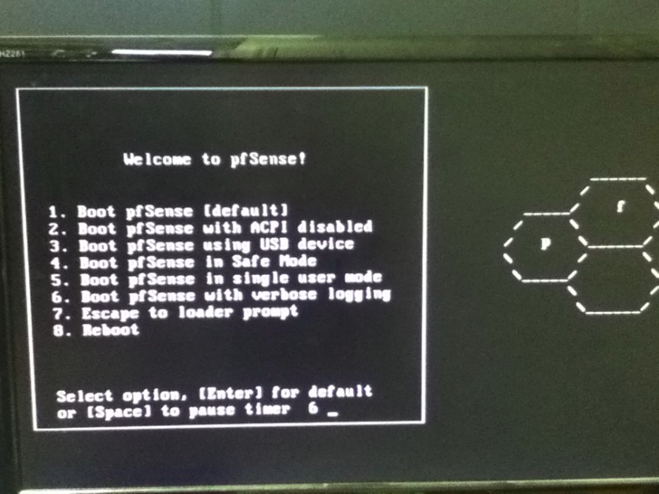
Step 2 :- After selecting the boot option above, you’ll be taken to a screen with a list of options to enter recovery mode, continue with the LiveCD or install pfSense. In our case we wanted to install pfSense, so press the corresponding hot-key to perform the install process.

Press I to install

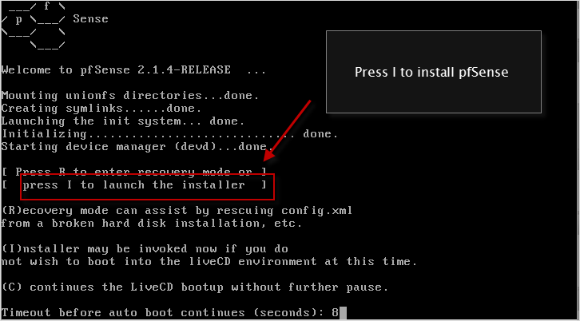

Step 3 :- Now , At this point you will see a blue colour screen reflecting some options as below :

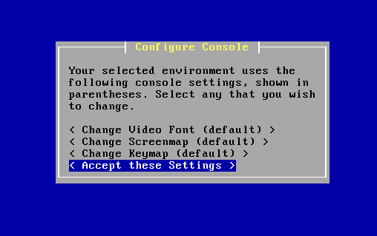
Use Arrow-keys to highlight and scroll down Options and select Accept these Settings and then Press ENTER to move forward.

Step 4 :- Now you will be taken to another Blue Screen with reflecting Options below :-

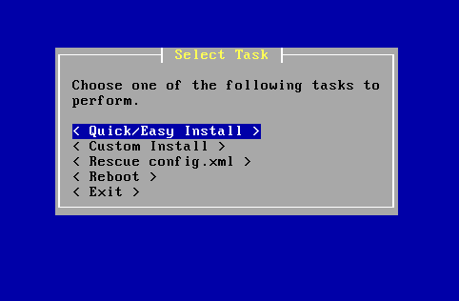

Using Arrow-Keys just Select Quick Easy Install and then press ENTER.

Step-5 :- Now , pfSense is now ready to copy the core files to your hard-drive. and It will come up with the new Blue Screen Like below :-

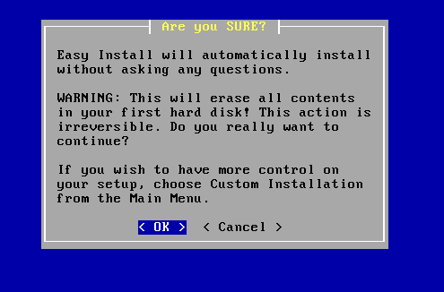
WARNING :- Please Do not Skip this Image without Reading , It will erase all your content (If exists in your Hard Disk).

Select OK and then hit ENTER.

Now , PFSense Installer will start Installing the Process.

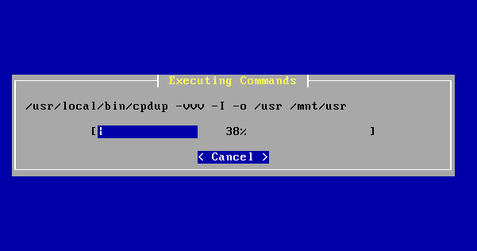

Step 6 :- Now , After the above process gets over , another screen comes over and you will asked to choose one Kernel option out of two . Now , If you are installing PfSense on PC or Desktop , you must choose STANDARD KERNEL , otherwise go for EMBEDDED KERNEL.

NOTE :- Embedded kernel are for those who are installing PFSense on router-boards and Flash storage.

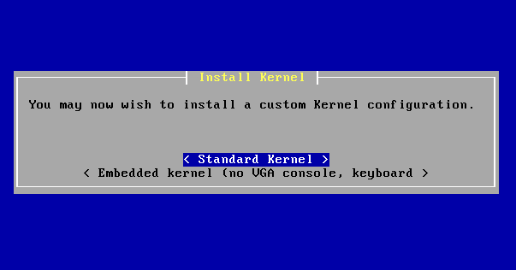
Step 7 :- After setting the kernel from the above step, you’ll be prompted to reboot your machine. So, do so by selecting Reboot menu and hit Enter key. Eject the install media before doing this, or change back your boot device order to system drive.

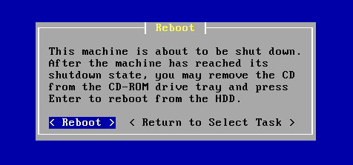

Step :- 8 After Rebooting your machine you will be asked to if you want to set up VLAN.

Do you want to setup VLANs now [y|n] ?

At this point of time , you may skip this option as we are installing basic setup of PFSense and you can Press n and then hit ENTER Key.

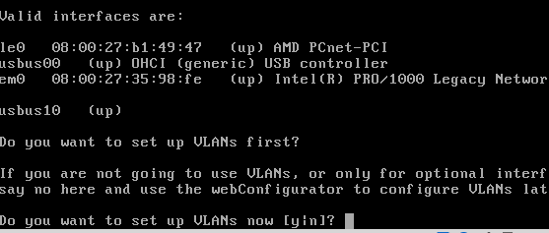

Step :- 9 At this point of the installation, you should know and have already decided what Ethernet port to use with your WAN and LAN connection. So you need to designate a specific device (Ethernet Card) for your Internet and LAN connection.
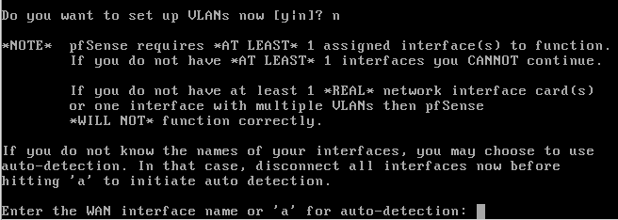

My CASE

You’ll be prompted to enter the WAN interface name, in my case, it is em0. So I should type em0 and then ENTER key.

Next prompt should be asking you to enter your LAN interface name, in my case, it is em1. So I type in em1 and then Enter key.

Another prompt will ask you to enter an Optional interface, you may skip this for now. We only need at least 2 network interfaces for this basic pfSense installation. So just press Enter to continue.

MIGHT BE IN YOUR CASE

If in your machine it shows somewhat identical name of interfaces then you can use the installer’s auto-detection option.

To initiate this option, disconnect all your cables from your Ethernet cards.

Then type a -> Enter key. You’ll be prompted to connect the WAN interface first, make sure the link is up and working when you do this. So plugin your cable to any of your available Ethernet card and wait for it to be detected by the installer.

It should show you the interface name, like so:

em0: link state changed to UP

Now that your interface is detected, press ENTER key to assign it as your WAN interface.

Next, you’ll be prompted again to enter a to auto-detect your LAN interface name. So, connect your cable to your second Ethernet card, wait for a few seconds and it should be detected. In my case, it was detected as em1.

Step 10 :- After setting your network interfaces from the step above, continue with the next step and type in y to commit your network settings.

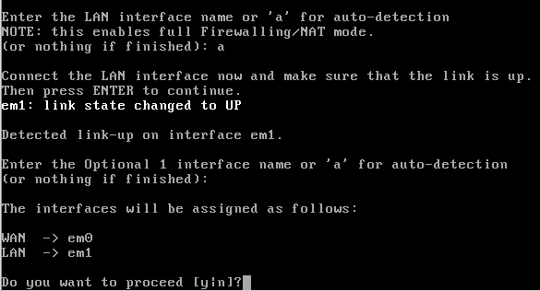

Now , you will be taken to other screen like the image is shown below

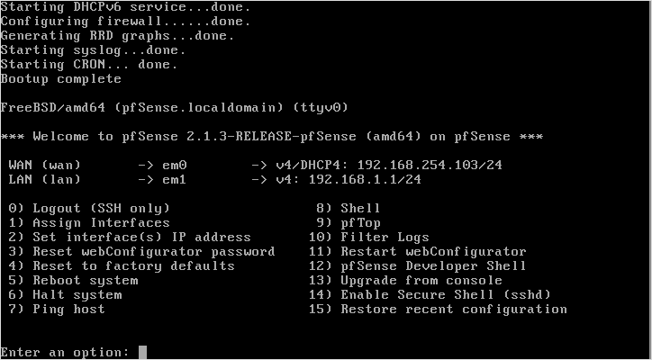

Step 11 :- Before you can use your pfSense instance, you need to configure it further to make it work within your local network. You need to login to its webConfigurator page and set things up from there.
To start with the configuration, login to pfSense’s administration page by accessing the LAN IP(Make sure the IP is free i.e. not being used by any other user within your local network) from any browser you wanted to use. The IP is the default configured, you may also change this if you wish, using the webConfigurator.

Login by accessing LAN IP from a web browser and login when prompted to.

Default Username :- admin
Default password :- pfsense

When you access the Admin page for the first time, a splash page will open with a message saying either .
This Connection is Untrusted or The site's security certificate is not trusted!

Just accept the connection and move on. In Firefox, just click
I Understand The Risk -> Add Exception button, a pop-up window will open, click Confirm Security Exception and you’re good to go. In Chrome, just click Proceed Anyway button.

You will get the PfSense Login page like below :-


Step 12 :- Upon successful login, you should be greeted by a welcome page and an initial configuration wizard page. Just click Next button to start the configuration wizard.

Step 13:- A new screen should open (see image below), and you need to fill up the Hostname and Domain field. In my case, I leaved Hostname field untouched but I’ve filled up the Domain field with local.net. I’ve skipped Primary DNS Server and Secondary Server. Click Next to go to the next page.
Click Next and continue and finally you are come up with the below new page

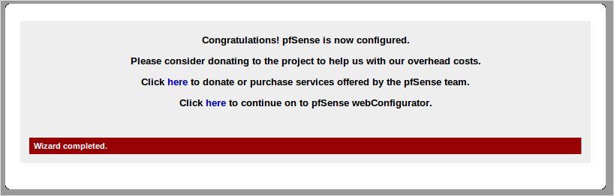

Once you see the confirmation message, you can now click here to continue working with pfSense web Configurator.

You should be now taken to pfSense main dashboard

