**IMAGE COLORIZATION USING GENERATIVE ADVERSARIAL NETWORKS**

**OOHA REDDY BIRRU**

**HO74376**

**Introduction**

The project focuses on revolutionizing the traditional process of image colorization, historically burdened by manual effort and subjective interpretation. Leveraging the power of deep learning, specifically U-Net and Generative Adversarial Networks (GANs), the objective is to create an end-to-end solution capable of autonomously and realistically colorizing black and white images with minimal human intervention. Contrary to the belief that such models demand extensive datasets and prolonged training, the project aims to showcase an efficient strategy, achieving impressive results with a modest dataset and shorter training durations. The integration of U-Net, renowned for its ability to capture both global and local features, with GANs adds a layer of realism and diversity to the colorized outputs. The significance of automating image colorization extends to applications in entertainment, historical restoration, and creative content creation. Addressing challenges such as achieving realism in colorization, training efficiency, and generalization to diverse scenes, the project acknowledges its scope while recognizing potential limitations. Overall, the project seeks to transform image colorization into a streamlined, efficient, and automated process through cutting-edge deep learning methodologies.

**Pytorch framework**

Image colorization using the PyTorch framework involves employing deep learning techniques to automatically add color to grayscale images. The process typically leverages neural network architectures, and PyTorch, being a powerful and flexible deep learning framework, provides a suitable environment for implementing such models. One common approach involves using architectures like U-Net and Generative Adversarial Networks (GANs). In PyTorch, you can design and train a U-Net-based model that takes grayscale images as input and outputs colorized versions. GANs can be incorporated to enhance the realism of colorization by introducing adversarial training, where a generator network attempts to produce realistic colorizations, and a discriminator network learns to distinguish between real and generated color images. The dynamic computational graph in PyTorch facilitates the efficient training of these networks, allowing for experimentation with different architectures, loss functions, and training strategies. Overall, PyTorch enables the implementation of sophisticated image colorization models, providing a versatile platform for researchers and developers in the field of computer vision.

**Training a model for image colorization:**

1.Image Preprocessing:

Resizing: The images are resized to a consistent size, ensuring uniformity in dimensions for the model.

2. Horizontal Flipping (Augmentation):

Horizontal flipping is applied, but only for the training set. This introduces variety during training, improving the model's robustness.

3. Color Space Conversion:

Images are initially read in RGB format, the standard for digital images.

Conversion to the Lab color space is performed. Lab separates the image into three channels: L (luminance/grayscale), a (green to magenta), and b (blue to yellow).

4. Input-Output Pair Formation:

The grayscale channel (L) is used as the input to the model.

The color channels (a and b) are used as the target or ground truth for the model.

This separation allows the model to learn the mapping from grayscale to color.

5. Data Loader Creation:

Data loaders are created to efficiently load and handle the dataset during training.

The processed images are organized into batches, allowing for effective model training.

**Methodology**

1.RGB vs Lab Color Spaces

When working with images, traditional RGB color space is common. However, for colorization tasks, Lab color space is preferred. Lab separates image channels into lightness (L) and color components (*a and *b), making it suitable for colorization.

2.U-Net Architecture

The U-Net architecture is a key component of this project. It consists of a contracting path, a bottleneck, and an expansive path. This architecture is effective for capturing both global and local features in images.

3.Conditional GANs

Conditional Generative Adversarial Networks (GANs) are employed for image colorization. In this context, the generator takes a grayscale image as input and produces colorized outputs (*a and *b channels). The discriminator is trained to distinguish between real and generated colorized images.

4. Loss Functions

Two main loss functions are used: GAN loss and L1 loss. The GAN loss evaluates the realism of colorized images, while L1 loss measures the difference between predicted and actual colors. The combination of these losses ensures both realism and color accuracy.

5. Training Strategy

The training strategy involves a combination of adversarial training and L1 loss optimization. The generator and discriminator are trained iteratively to enhance the colorization process. The strategy aims to achieve good results with a relatively small dataset.

**Model Architecture**:

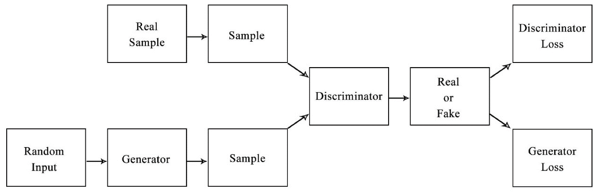

**Code Implementation**:

The code implementation for image colorization using PyTorch follows a structured approach, encompassing data preparation, model architecture design, loss function definition, and training procedures. The process begins with loading image file names, dividing them into training and validation sets, and creating a custom dataset. The dataset undergoes preprocessing steps such as resizing and horizontal flipping, and the images are converted from RGB to the Lab color space. The grayscale (L) channel is isolated, and the color channels (a and b) are combined to form the target for the model. The U-Net architecture is employed as the generator, while a Patch Discriminator serves as the discriminator in the adversarial training setup. Two loss functions are introduced: GAN loss for adversarial training and L1 loss to ensure color accuracy. The training procedure involves optimizing the generator and discriminator alternatively, striking a balance between realistic colorization and minimizing the L1 loss. Notably, a pretraining strategy is introduced, where the generator's backbone is pretrained on a classification task using ResNet18, followed by the entire generator being pretrained on the colorization task using only L1 loss. This dual-stage pretraining enhances the model's performance significantly. The results showcase the effectiveness of the final model on the test set, with an emphasis on improved colorization quality compared to the baseline model. Additionally, a comparison highlights the impact of adversarial training, demonstrating its role in producing more realistic colorizations. The comprehensive implementation, including data loading, model architecture, loss functions, and training strategies, underscores the versatility and effectiveness of PyTorch in developing advanced image colorization models.

**Applications:**

Image colorization has diverse applications, including historical photo restoration, entertainment and media production, medical imaging interpretation, artistic expression, fashion design visualization, advertising, machine learning data augmentation, virtual and augmented reality environments, documentary production, educational content enhancement, and improved image understanding in various domains. Colorization enhances visual appeal, aids interpretation, and contributes to creative and practical uses across industries.

**Results:**

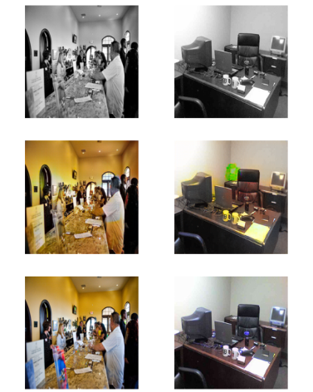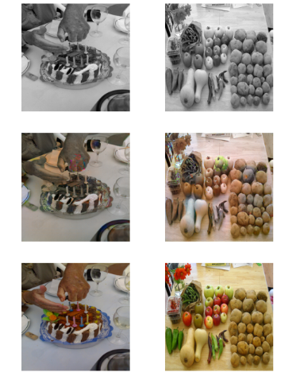

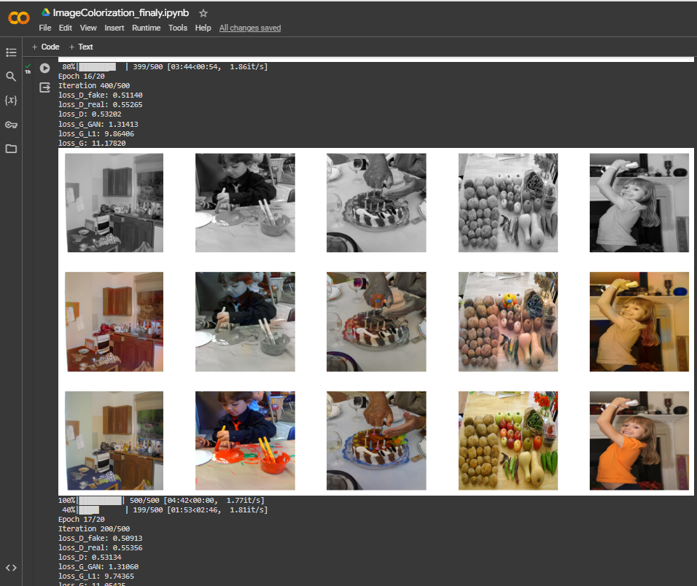

The results of the image colorization project using a combination of U-Net and conditional GAN are highly promising. The approach involved a strategic two-stage pretraining process, where the generator's backbone was pretrained on ImageNet classification, followed by the entire generator being pretrained on the colorization task using L1 loss. The final model, trained through a combination of adversarial and L1 loss, exhibited remarkable improvements over the baseline model.

The colorization results achieved with the final model are visually striking, demonstrating an impressive ability to add realistic and vibrant colors to black and white images.

An interesting finding was the effectiveness of adversarial training, which, despite the absence of dropout layers in the generator, played a crucial role in enhancing the model's creativity and producing more compelling outputs. The model not only successfully colored common scenes but also exhibited a significant improvement in handling challenging cases, such as correctly colorizing specific objects like jackets and buses.

In summary, the results demonstrate the success of the proposed approach in achieving high-quality image colorization, showcasing the power of deep learning techniques, strategic pretraining, and adversarial training in generating visually appealing and accurate colorized images.

**Future Work:**

1.Hyperparameter Tuning: Fine-tune model parameters for optimal performance.

2.Complexity Boost: Consider more complex architectures to capture intricate details.

3.Dataset Expansion: Increase dataset size and diversity for improved generalization.

4.Adversarial Training Strategies: Explore alternative strategies for balancing adversarial and L1 losses.

5.Conditional Inputs: Incorporate additional contextual information for scene-aware colorization.

6.User Interaction: Develop interactive features for user-guided colorization.

**Conclusion:**

In conclusion, the image colorization project employing U-Net and conditional GANs has achieved remarkable success in the task of transforming black and white images into vibrant, realistic color representations.

Looking ahead, potential areas for improvement include fine-tuning hyperparameters, exploring more intricate neural network architectures, expanding the training dataset for greater diversity, and investigating alternative adversarial training strategies. The success of this project suggests promising applications in user-friendly tools, real-time colorization, and domain-specific tailoring. The ability to generate visually appealing and authentic colorizations from grayscale images underscores the potential of advanced machine learning techniques in the realm of computer vision.

**References:**

X. Jin, Z. Li, K. Liu, D. Zou, X. Li, X. Zhu, Z. Zhou, Q. Sun, and Q. Liu, “Focusing on persons: Colorizing old images learning from modern historical movies,” CoRR, vol. abs/2108.06515, 2021. [Online]. Available: <https://arxiv.org/abs/2108.06515>

Jun-Yan Zhu, Taesung Park, Phillip Isola, and Alexei A. Efros. Unpaired image-to-image translation using cycle-consistent adversarial networks. CoRR, abs/1703.10593, 2017. URL   
<https://arxiv.org/abs/1611.07004>

Top of Form