|  |  |
| --- | --- |
| “Business Requirements Document | |
| Project Code: | Project Title / System Name: |
| P. | RAS APP for HCP and Labaratory |

# Requestors

The requestors are representatives and responsible units for below requirements. In case of questions this will help to find the right person and the right answer. If the requestor is a unit, the head of unit will represent it. The requestor can also be a legal or regulatory requirement.

|  |  |  |
| --- | --- | --- |
| Requestor | Abbreviation | Representative Person |
| Oncology Franchise | Onco | Gizem Elbirlik |
|  |  |  |

# Version History

|  |  |  |
| --- | --- | --- |
| **Version** | **Version Date** | **Changes** |
| 1 | 26.04.2017 | Initial Version |
|  |  |  |
|  |  |  |

# Signature

|  |  |  |  |
| --- | --- | --- | --- |
| **Duty** | **Name and Title** | **Date** | **Signature** |
| **Author** | **Ezgi Torun, BT Management Trainee** |  |  |
| **Author** | **Olcay Oztekin, BT Specialist** |  |  |
| **Reviewer** | **Gizem Elbirlik, Junior Product Manager** |  |  |
| **Reviewer** | **Şener Erdal, Regional Digital Marketing Manager** |  |  |
| **Approver** | **Kaan Yuzbasioglu, BT Business Partner of Middle east, Turkey and Egypt** |  |  |
| **Approver** | **Altay Akbulut Compliance Manager** |  |  |
| **Approver** | **Selen Zeydanli, Oncology Director** |  |  |

**CONTENT**

1. Requestors 1

2. Version History 1

3. Signature 1

4. Introduction 3

4.1 Project Triggers 4

4.2 Strategic Business Objectives 4

4.3 Objectives of the Project 4

4.4 Success Criteria for the Project 4

5. Business Design 4

5.1 Business Capabilities 4

6. Requirements 7

6.1 Rating of Requirements 7

6.2 List of Specified Requirements (non-GxP) 8

# Introduction

In Turkey, RAS test and that kind of tests are analyzed by private laboratories. HCP sends the test kits and RAS test request forms to the relevant laboratory via cargo. Then the result of these tests is sent via mail to the Oncologist. The process flow is shown in the Figure-1. Because of the above-mentioned manual process, laboratories and physicians are experiencing difficulties in order to initiate the analyzing of the samples due to the missing data in the forms; like test types, physician contact details and patient names. Therefore, Merck Oncology team wants to have a platform powered over a WEB portal and mobile App. Combination for clear communication between selected laboratory and HCPs.

**Figure 1. Current Process Flow**

## Project Triggers

* The selected laboratory faces many problems about missing information on the RAS test request form.
* Along the treatment schedule, the patient should visit oncologist within 7-10 working days with the test results. However, HCPs are having difficulties to track the result for the individually each and every patient since in most cases the forms were not adequately fulfill.

## Strategic Business Objectives

* Increase the usage of Erbitux with analyzing the sample for accurate result.

## Objectives of the Project

* Increase the number of tested kit
* Provide well-structured end-to-end platform to track result of patients for HCP
* To follow RAS Test result in order to decrease the lost time

## Success Criteria for the Project

* Complete end of May
* Decrease the workload of Istanbul Genetic Lab
* Increase the usage of platform

# Business Design

## Business Capabilities

The business demand is having a web based platform, which is accessible from two different frontends; for Laboratories via WEB interface for HCPs via a mobile application. This platform will be hosted in the cloud. Laboratories will be able to access to the WEB platform. Anonymous access to the Platform will be restricted. Considering Istanbul Genetic Lab demand, they need to have a platform stored the demand forms and contact details of the initiator-HCP, to keep the RAS test list, to prepare reports of analysis, to communicate with HCPs via the platform and to create reports which are used frequently.

A mobile app will be developed for only use of HCPs which is able to run on all mobile devices (android and iOS). HCPs will be able to fill RAS Test Forms and track the test results of patients easily.

In the platform, Merck will not have any authorization to see any information related patient. Merck will take a role as the sponsor of the platform. Merck is responsible only to provide a platform for Istanbul Genetic Lab and verify the HCPs.

Current situation is like that:

* When the patient visits a doctor with his/her sample, the doctor fills the form and sends to the the Istanbul Genetik Lab with courrier.
* After the deliveryl of sample, the Lab assistant enters the form information to the excel and the analysis process starts.
* In max. Seven working days, the result report are prepared and sent to the doctor via e-mail.

The desired flow is shown in the Figure-2 and described

* The application can be downloaded via App Store and/or Google play in the mobile tools
* After downloading, the HCPs need to enter below information in order to sign up
  + Name
  + Surname
  + Hospital Name
  + Phone Number
  + E-mail as username
* After sign-in to system, there will be displayed a consent which highlights that the information used to sign up will be shared with laboratories.

*“Websitemize kaydolurken sunduğunuz ad, soyad, telefon ve e-mail bilgilerinden oluşan kişisel bilgilerinizi sunmakla bu bilgilerin aşağıda yer alan amaçlarla ve kapsamda toplanmasına, depolanmasına, vesair suretle işlenmesine muvafakat ettiğinizi beyan ve kabul etmektesiniz.*

*Kendi rızanız doğrultusunda sunduğunuz bu bilgileri İstanbul Genetik Laboratuvarına ulaştırdığınız test örneklerinin analiz sonuçları ve test ile alakalı soruları için sizinle irtibata geçilmesine yönelik olarak şahsınızla SMS, e-mail ve telefon dâhil her türlü elektronik iletişim aracı vasıtasıyla irtibata geçilmesi amacıyla kullanılmak üzere sunmaktasınız.*

*Sunduğunuz kişisel bilgiler sadece yukarıda muvafakat gösterdiğiniz kapsamda kullanılacak olup, özellikle bu bilgilerin mevzuat gereğince zorunlu olması durumu hariç üçüncü kişilerle paylaşılmayacağını ve tüm mevzuatın öngördüğü şekilde ve özenle saklanacağını belirtmek isteriz.”*

* HCPs can receive confirmation e-mail and then HCPs will enter to system with creating password.
* When the patient visits the doctor with his/her sample, the doctor will fill the form on app and send to Istanbul Genetik Lab with courrier.
* The application will calculate the next visit date and highlights the date on the calendar.
* The filled form will be appeared in the web platform, which the lab user can see the new inquiry. The format of displayed screen are descriebed below. Additionaly if there is a new inquiry, the Istanbul Genetik Lab will receive a notification via mail.
* After delivery of the sample, the Lab assistant will change the status of the inquiry as under analysis, instead of waiting for courrier and the analysis process starts.
* In max. Seven days, the result of analysis will be prepared on the system by using pre-prepared format and sent to doctor through e-mail web portal. That time the satatus will be changed with completed rather than under process.
* At the end, the notification will be accessable via the mobile app.
* The results can be seen in the mail and in the mobile app. under patient records.
* Also this web platform will be used as the repository-database for lab.
* After signing up of HCPs, in the web platform there will be kept under doctors information database.
* The application will cover 4 section
  + New Patient: Blank RAS test request form will be displayed
  + Patient records: The data of patient will be followed here
  + Calender: Doctor shows the patient visit and next visit day on the calender
  + Notification: all updates will be seen here
* The form includes that the name of hospital, name of doctor-mail-phone, name of patient and the type of test (KRAS, BRAF and NRAS). the name of hospital, the name of doctor, doctor’s e-mail and doctor’s phone will be filled automatically. Test type can be selectable multiple.
* It would be nice if there is a choice on the form to add photo for pathology result
* The web platform is only accessible for lab with using a password. There will be 4 segment such as the initial page which displays the inquiries, ınformation for database of the tests, reports section for database and doctor cards for doctors database
* Initial page like in the Picture 1; it will be like a list of inquiries
  + Arrival date of sample: when the status will be changed with under processing
  + Patient name: comes from form
  + Hospital name: comes from form
  + Doctor name: comes from form
  + E-mail: comes from form
  + Phone: comes from form
  + Test type: comes from form
  + Result: there will be color sign to decribe the status. Red for waiting sample, green for completed and yellow for analyzing.
* End of every line there will be three button; one for informing any delay in the analysis, second for communication with doctors via email and the last one for prepare the reports.
* Considering the type of test, there will be three pre-prepared reports. (KRAS, NRAS and BRAF). They can be seen on Appendix1-2-3-4. Some part of report is automatically filled by form. They will indicated on the form with yellow



**Figure 2. Desired Process Flow**

* Information segments like in the Picture 2: the below list should be there
  + Date: same with the arrival date of sample
  + Patient no: enter manually from lab assistant (if the patient already in the system, it will come automatically)
  + Patient Name: comes from form
  + Test: comes from form
  + Test description: manually
  + Quantity: Drop-down (1-100)
  + Type: Drop-down (DNA, LAM or BLOK)
  + Doctor name: comes from form
  + Hospital name: comes from form
* Reports section. Here some reports can be created by clicking one button
* Doctors section: doctors card which covers information of doctors.
* Download via app store-google play
* Sign up with e-mail-name-mobile phone-hospital name- password
* After sign up, there is an approver system to sign up process
* The data will be kept in cloud
* Mobile App and Web platform will be Turkish and English
* After every changes on the form from lab can be informed as a pop-up notification in the app.

# Requirements

## Rating of Requirements

Not all requirements may have the same importance. These ratings help to prioritize them and to decide about the acceptability of the system from a general “project” viewpoint. If GxP relevant requirements exist their rating with regard to GxP regulations will have to be performed in the respective framework.

*Adapt if meaningful, e.g. if you plan implementation in several waves and indicate future-wave requirements as technical guidance.*

|  |  |  |
| --- | --- | --- |
| Rating / Code | | Rating explanation |
| Mandatory | MAND | The system will not go live without having this item being properly addressed and successfully tested: |
| Critical | CRIT | A risk analysis will be performed and an action plan will be written if the future test fails. Issues with items having this severity level will not stop the system to go live, provided that a feasible work-around is defined as part of the action plan |
| Important | IMP | An action plan will be written if the future test fails. Issues with items having this severity level will not stop the system to go live |
| Nice To Have | NTH | The requirement can be postponed to a later version if the future test fails or planned right away for later implementation. Issues with items having this severity level will not stop the system to go live nor to close the project |

## List of Specified Requirements (non-GxP)

| Req # | Requirement Title | Specification | **Rating** |
| --- | --- | --- | --- |
| 1. | Mobile application for iOS and Android | * New patient * Patient record * Calendar * Notification | Mand |
| 2. | Sign in | * Password * Username * Name * Surname * Hospital Name * Phone Number | Mand |
| 3. | Cloud hosting | * AWS | Mand |
| 4. | New patient form | * Hospital * Doctor name * E-mal * Phone * Patient name manually * Test type: selectable more than one * Add photo for pathology result | Mand |
| 5. | Patient record | * All patient data and the results | Mand |
| 6. | Calendar | * Patient visit and calculate next visit | Mand |
| 7. | Notifications | * All notification can be seen * Pop-up massages | Mand |
| 8. | We platform for lab | * Inquiries * Information * Reports * Doctor details | Mand |
| 9. | Pre-prepared reports | * KRAS * NRAS * BRAF * KRAS and NRAS | Mand |
| 10. | Doctor database | * The details of doctor information | Mand |

**APPENDIX 1. KRAS**

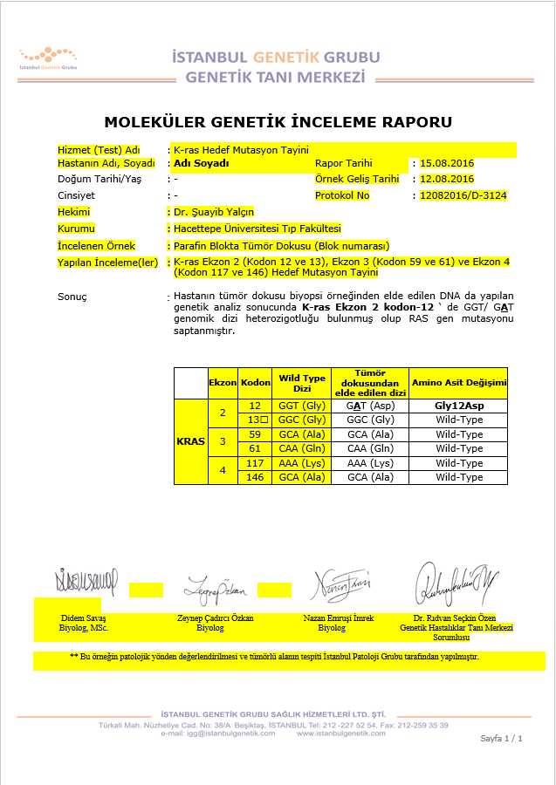

**APPENDIX 2. NRAS**

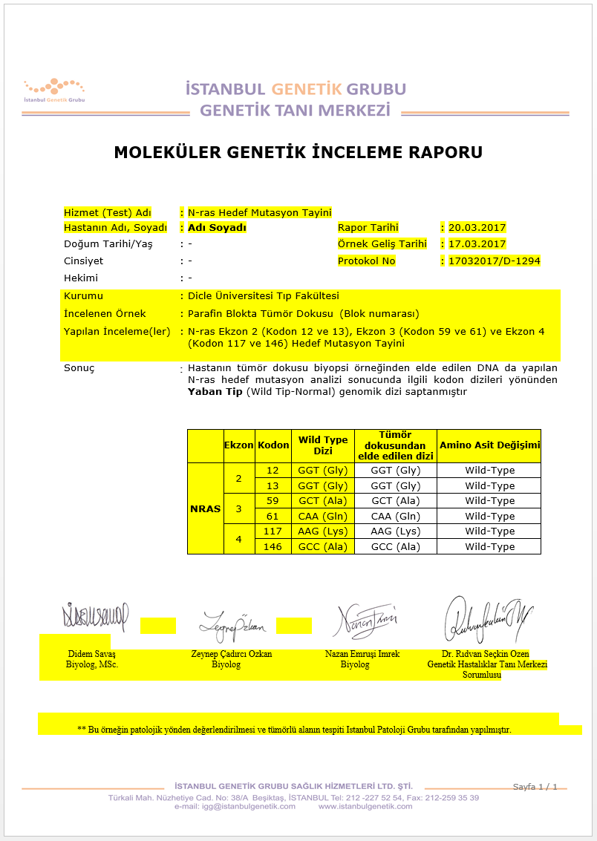

**APPENDIX 3. BRAF**

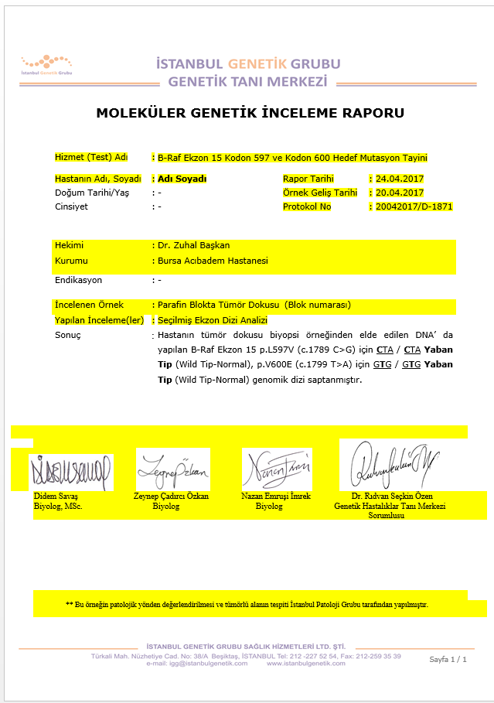

**APPENDIX 4. KRAS and NRAS**

