# LAB2

1. Select * from dept

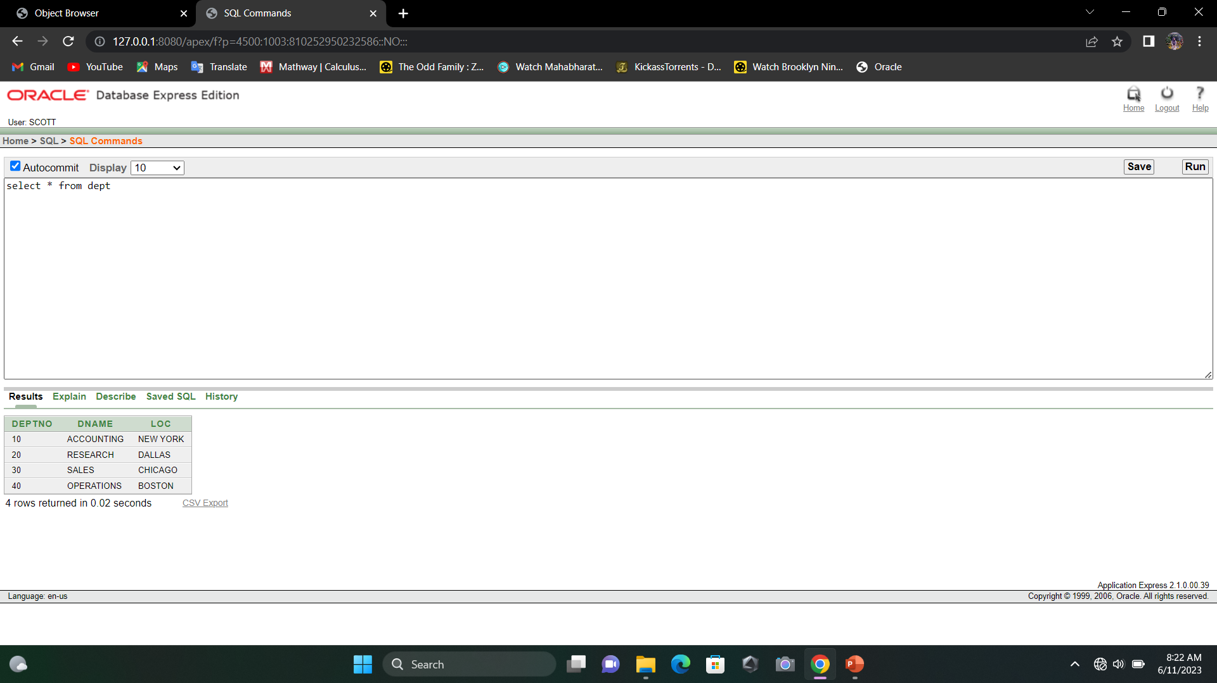

1. Select deptno, loc from dept

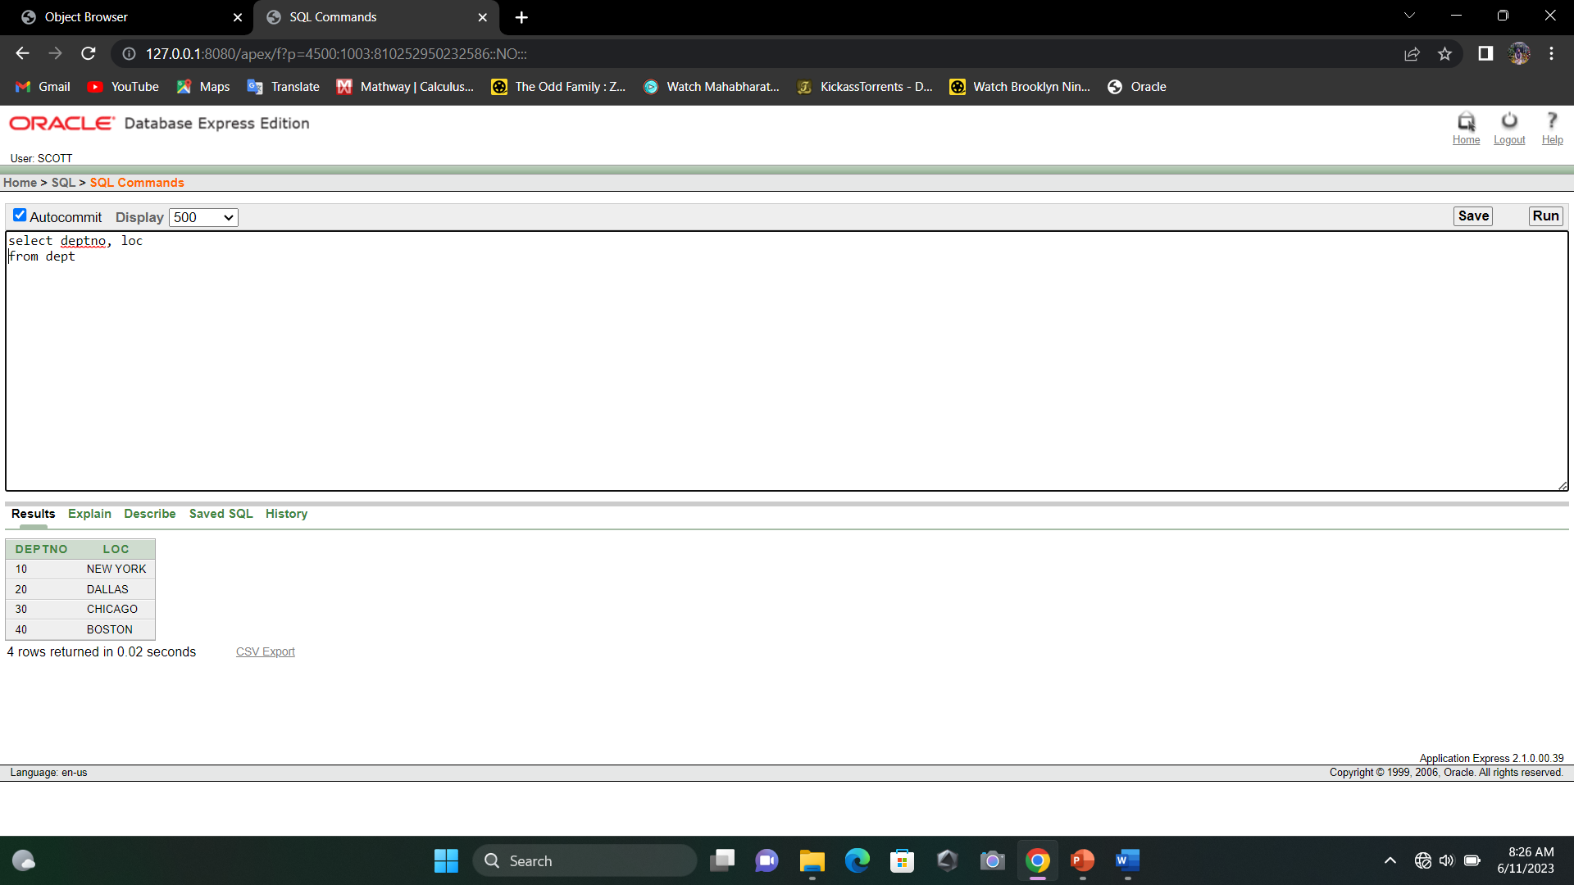

1. Select ename, sal, sal+100 from em0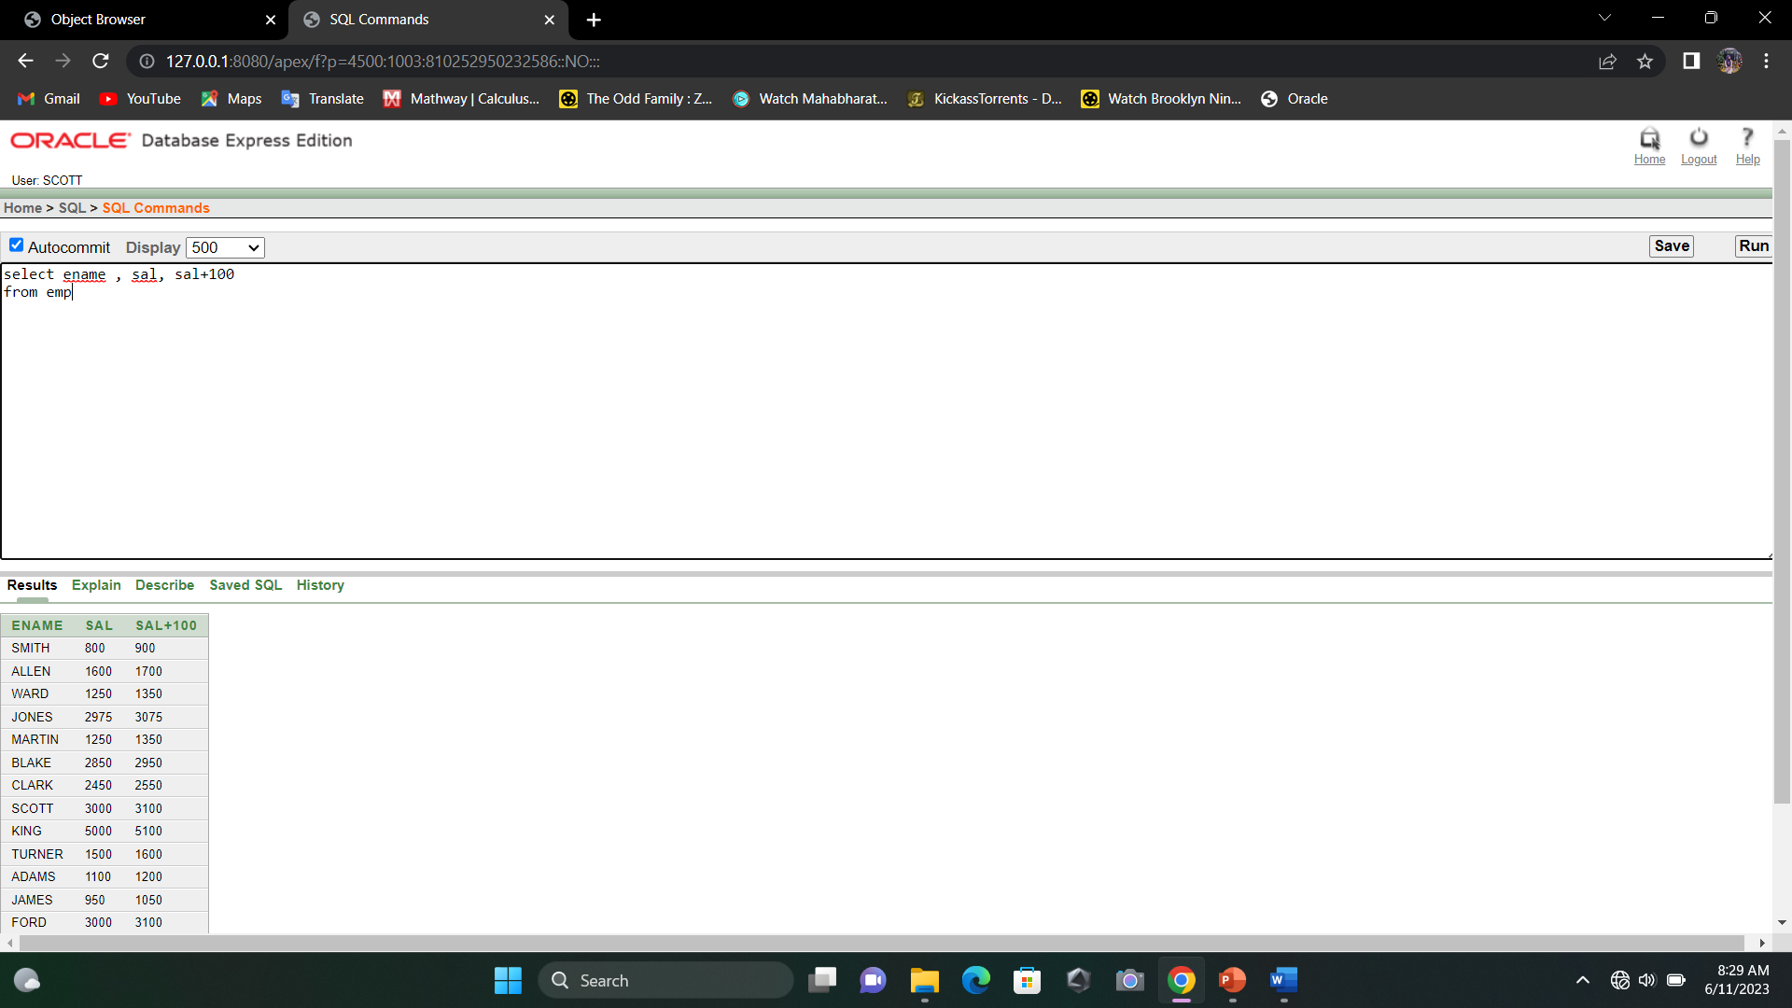
2. Select ename, sal, sal*3+100 from emp

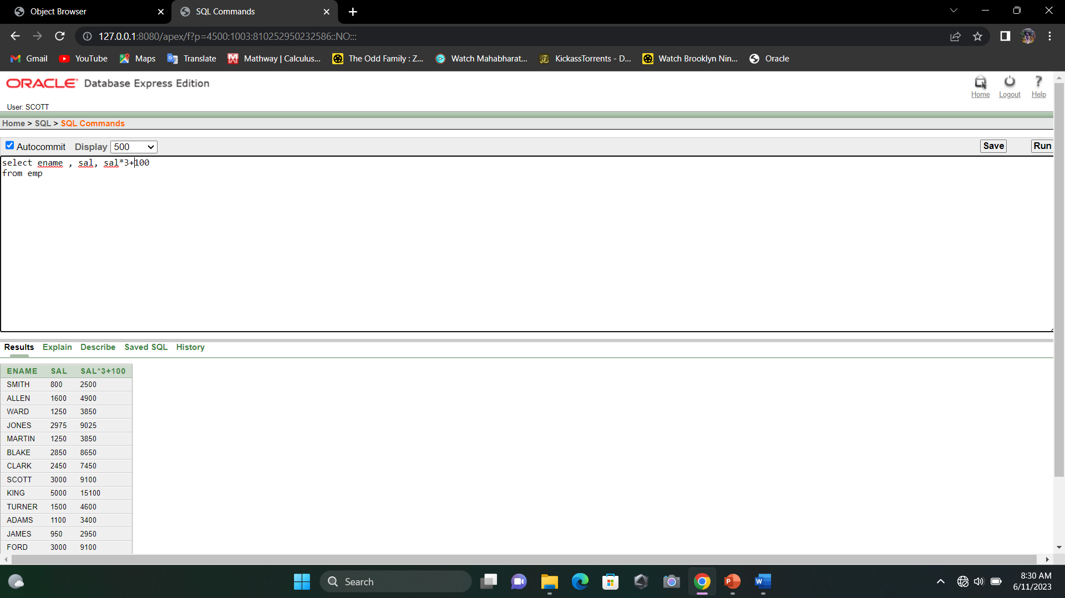

1. Select ename, sal, 3*(sal+100) from emp

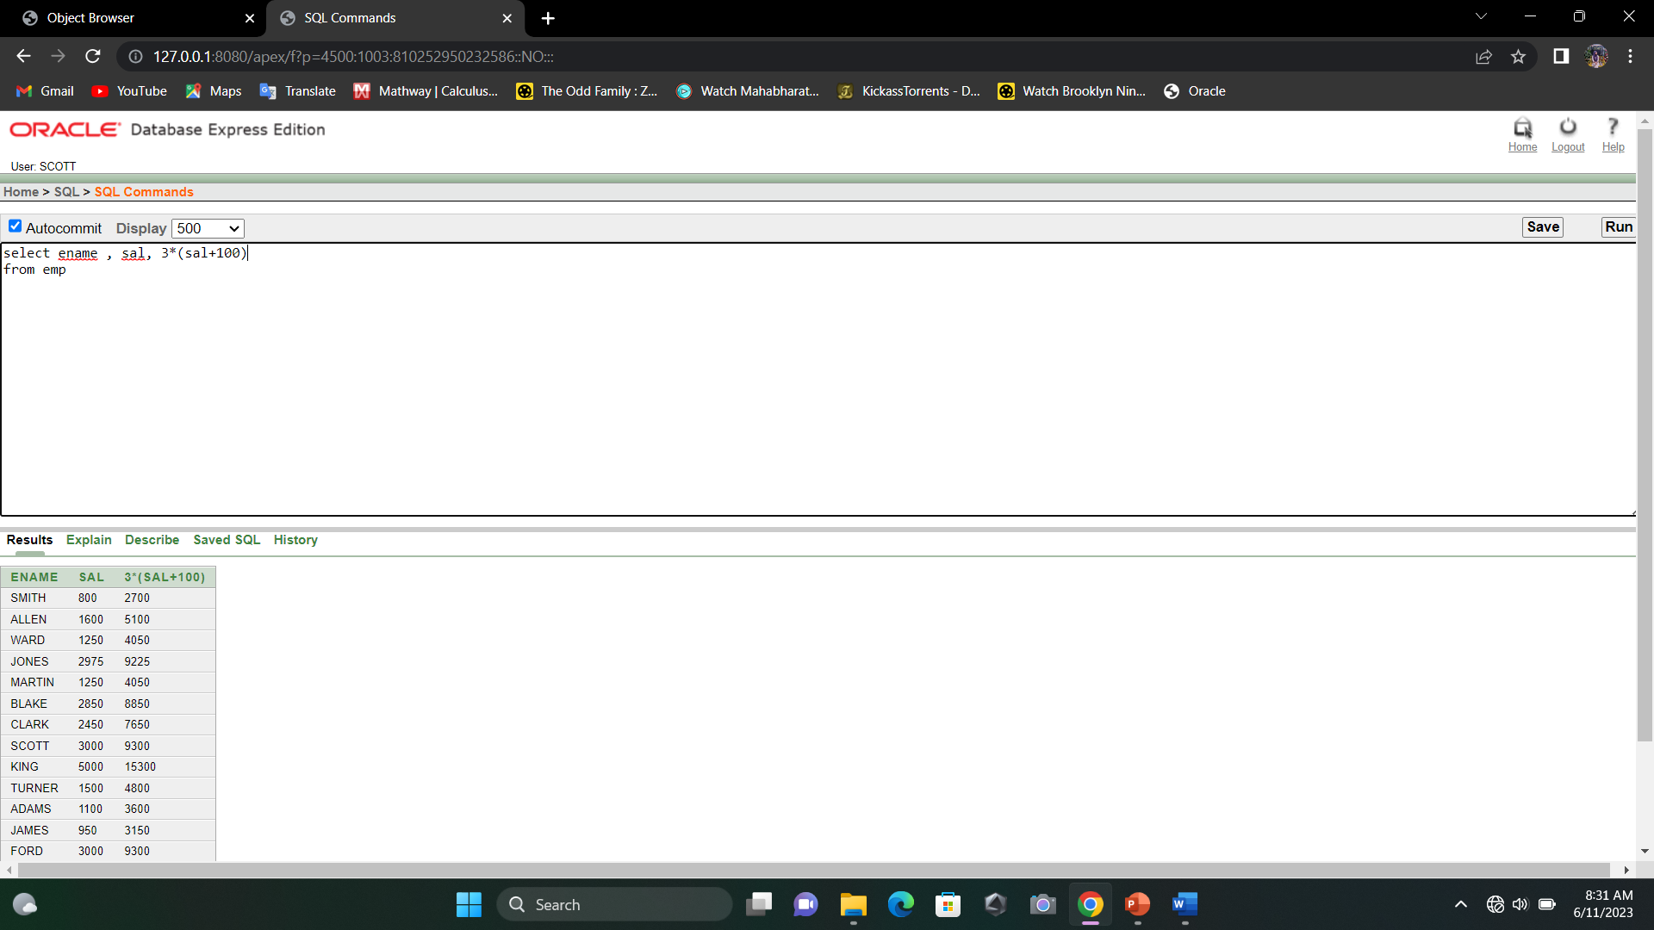

1. Select ename 3*(sal+comm) from emp where ename = ‘BLAKE’

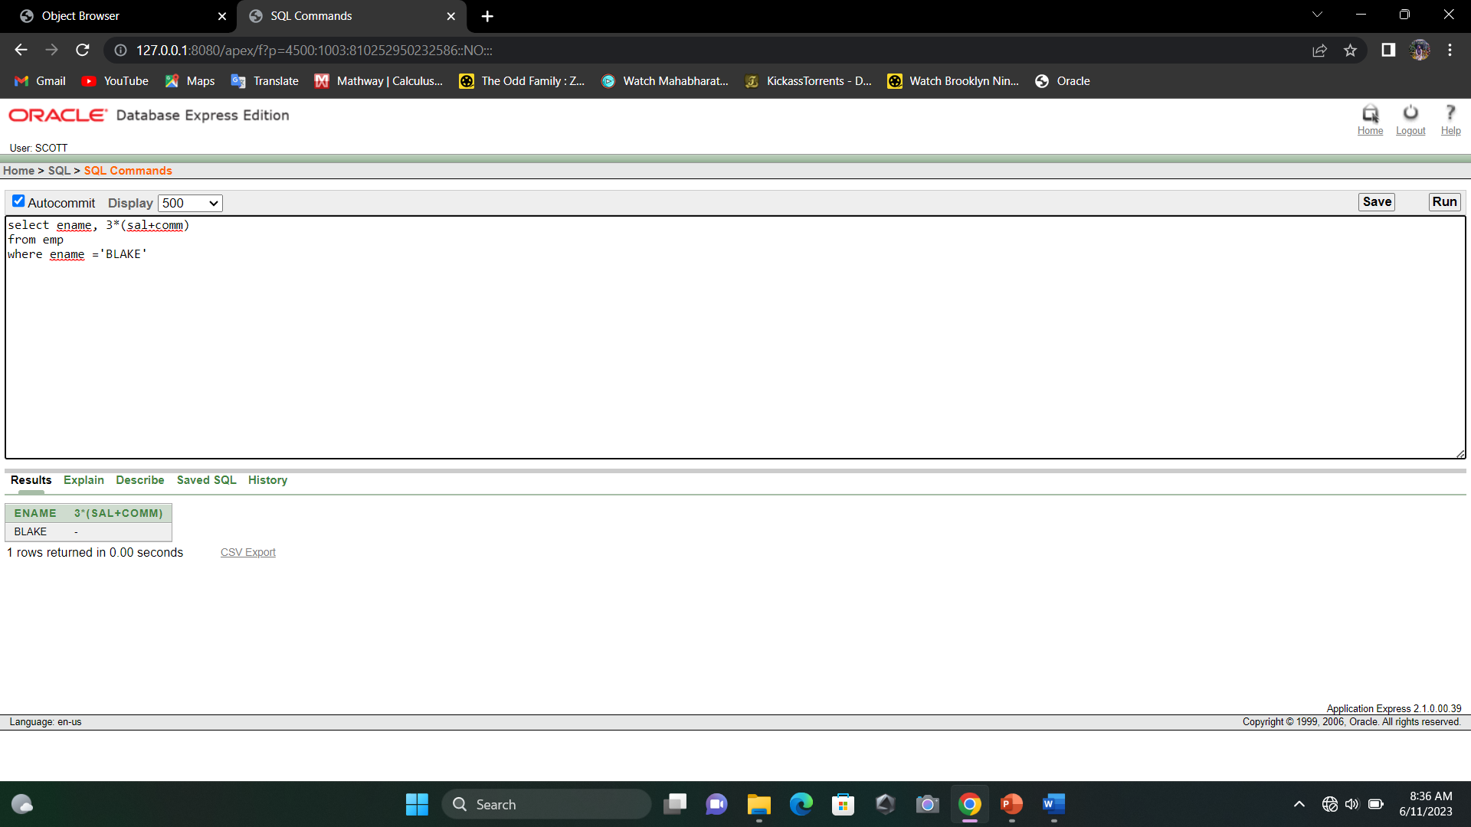

1. Select ename as name, sal salary, comm “Commission” from emp

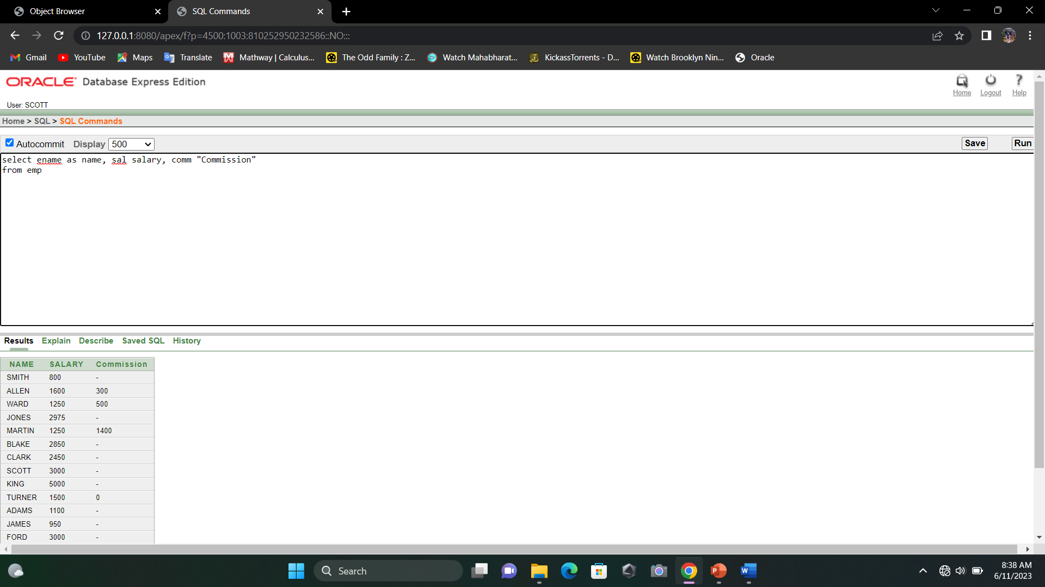

1. select ename || job as employees, ename ||' '||'earns'||' '||sal as salary from emp

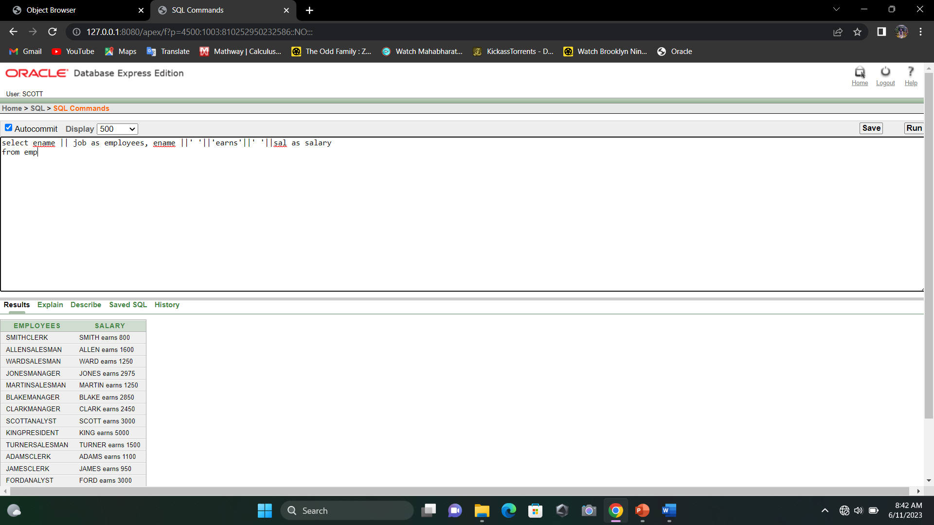

1. select distinct deptno from emp

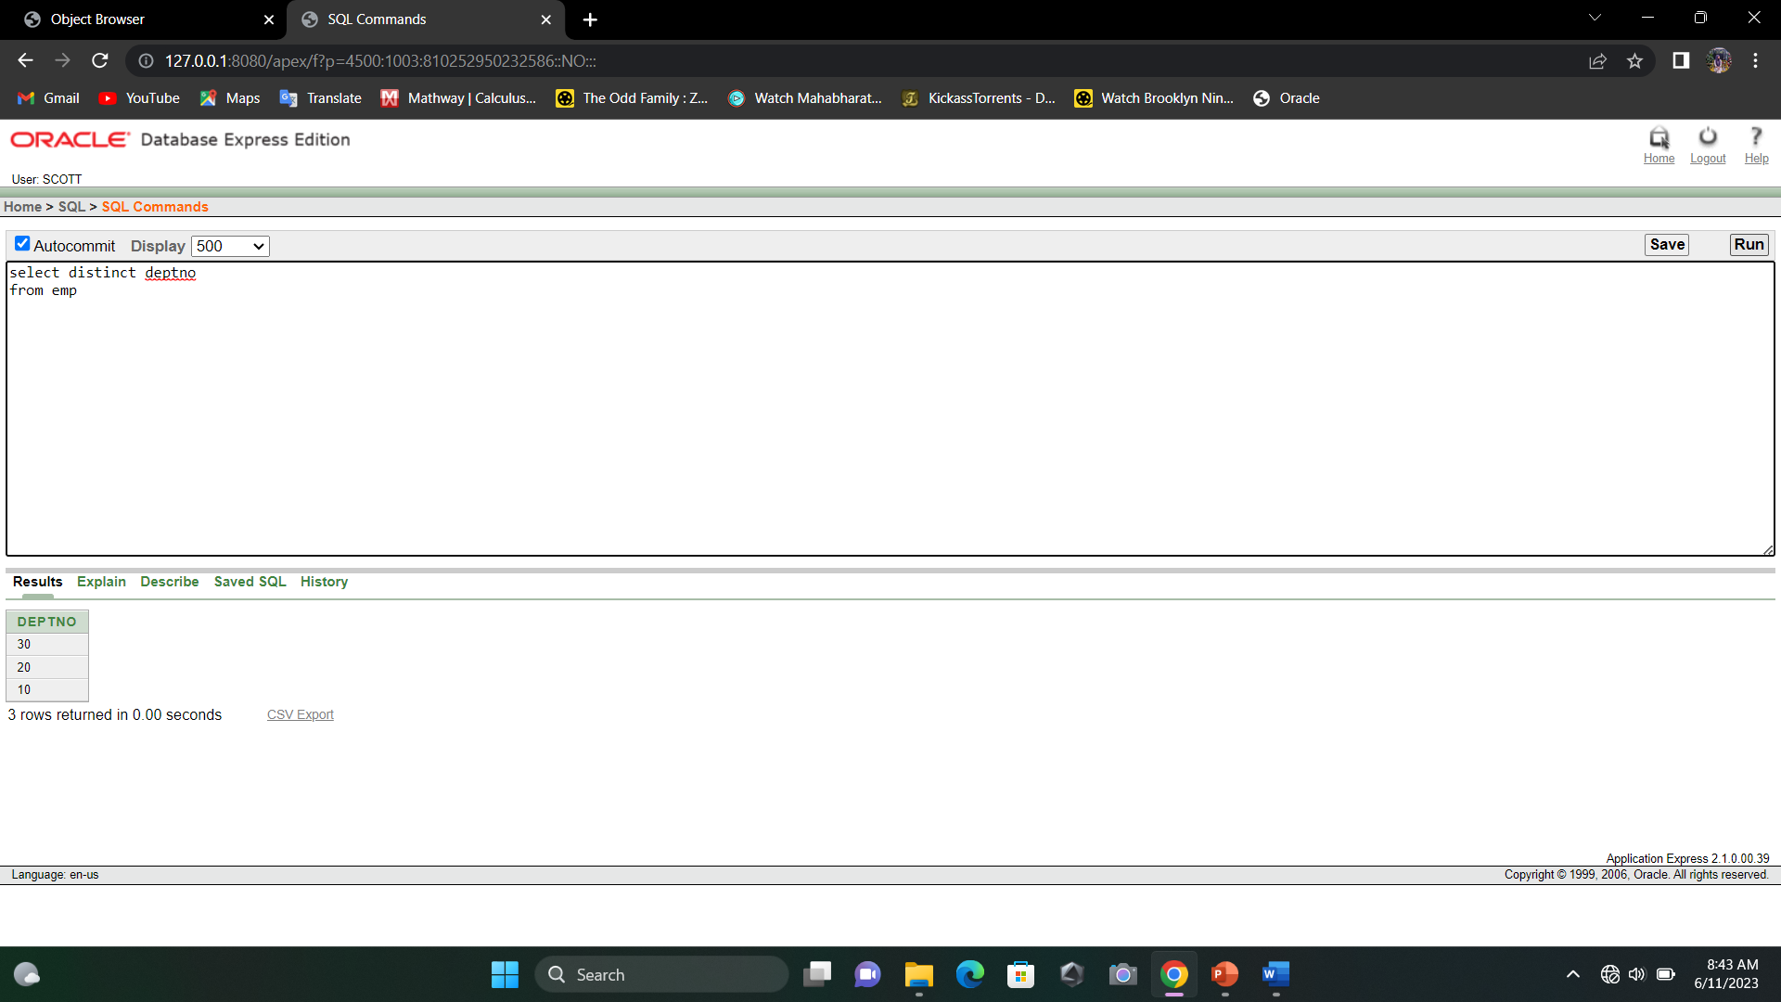

1. describe emp

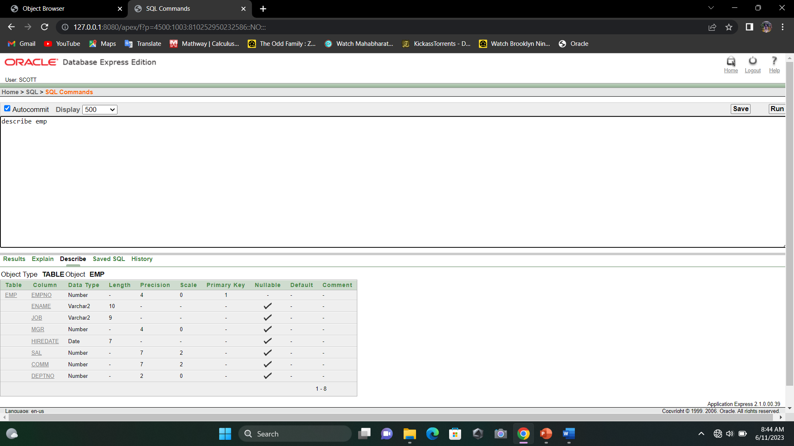

# Lab 01 - Exercise

1. Write a query to display the name, department number for all employees.

Select ename, deptno from emp

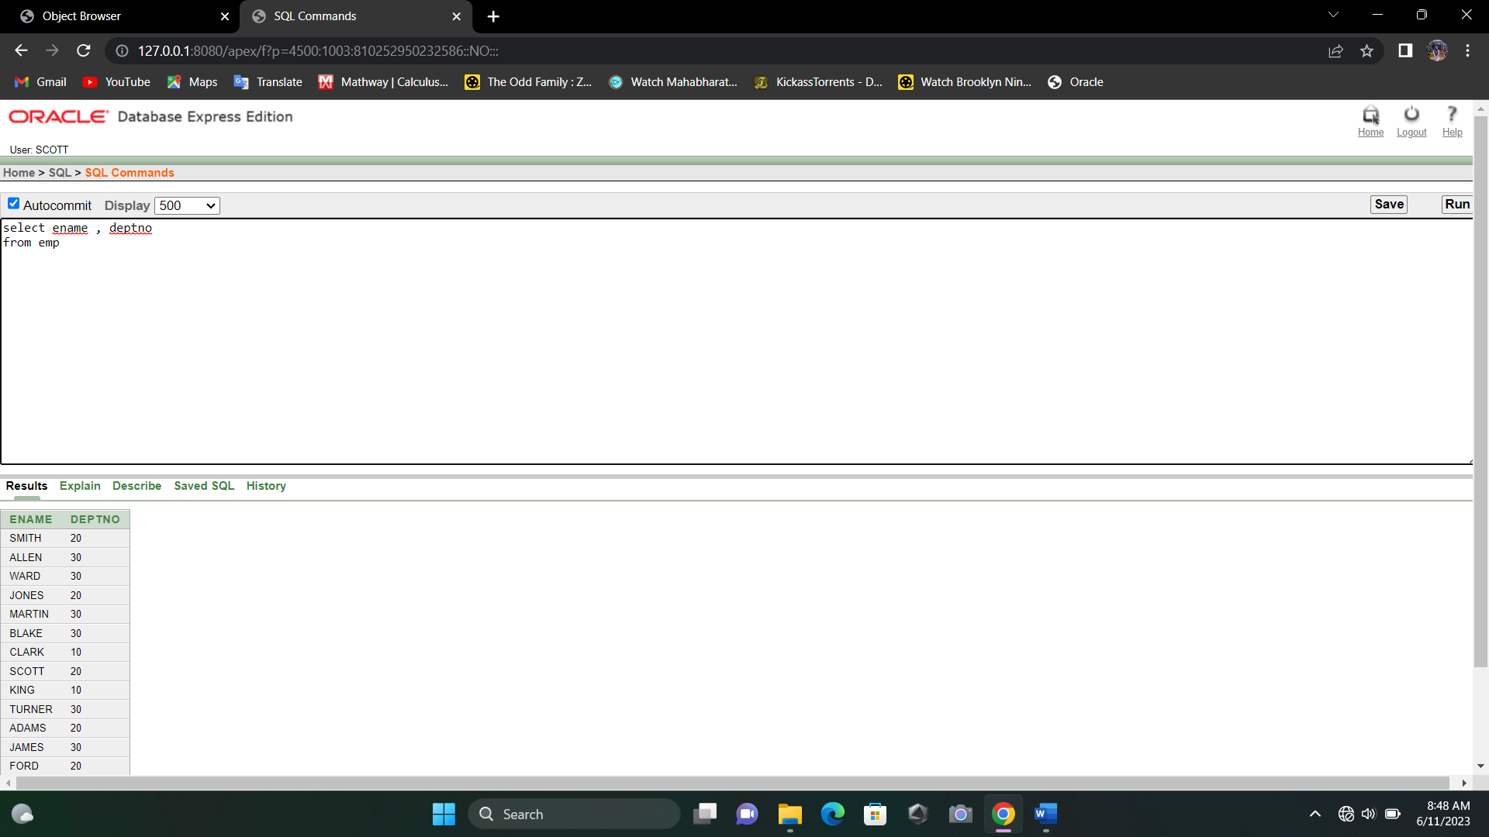

1. Create a unique listing of all jobs that are in department 30.

Select distinct job from emp where deptno=30

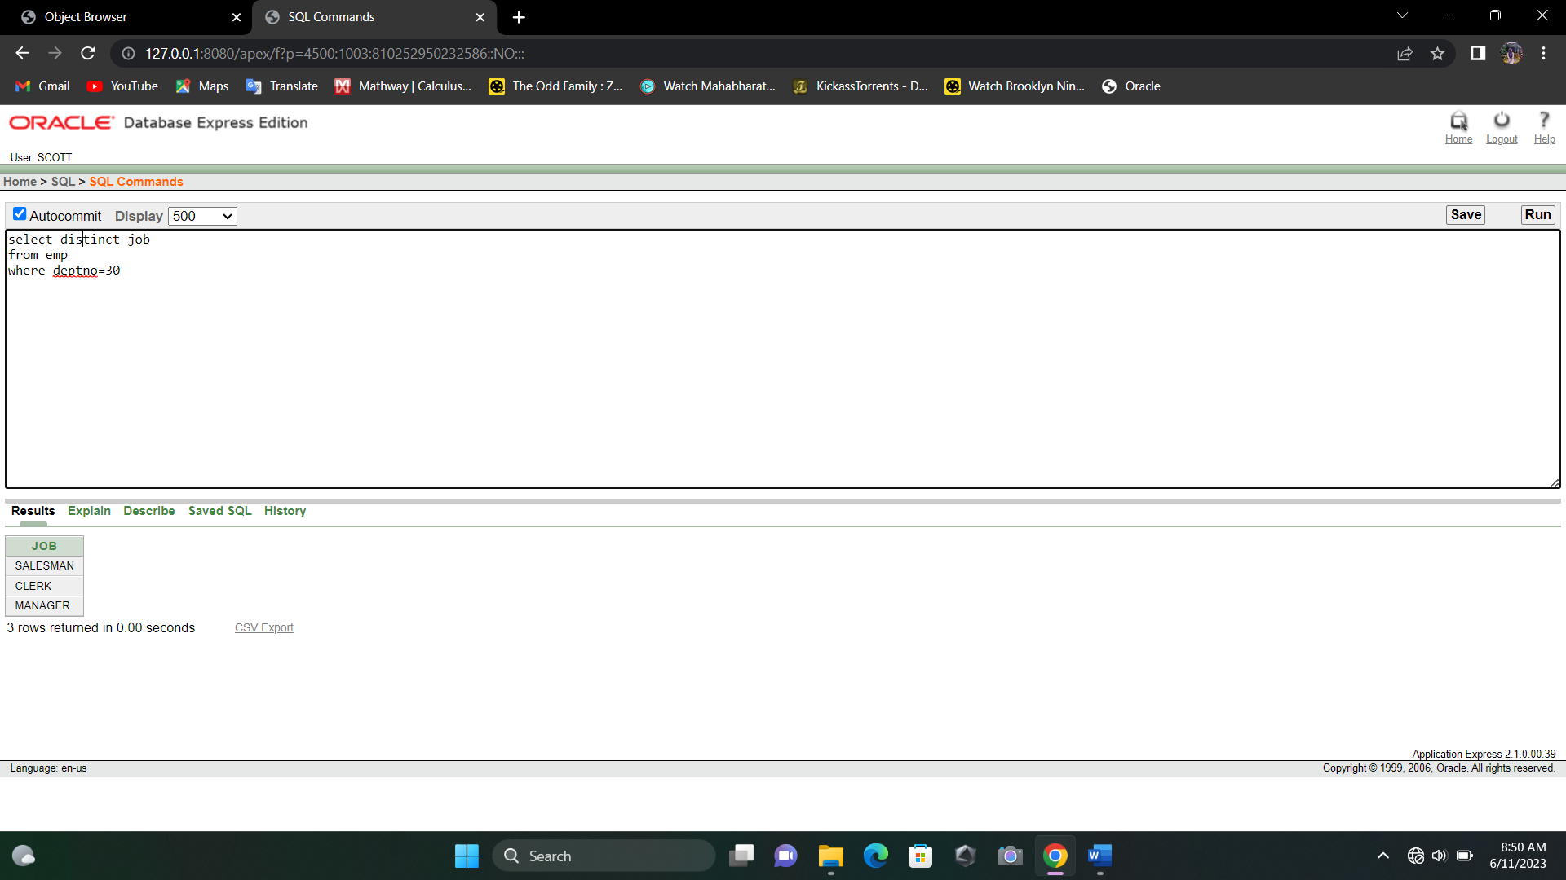

1. Include the location of department 30 in the output.

Select loc from dept where deptno=30

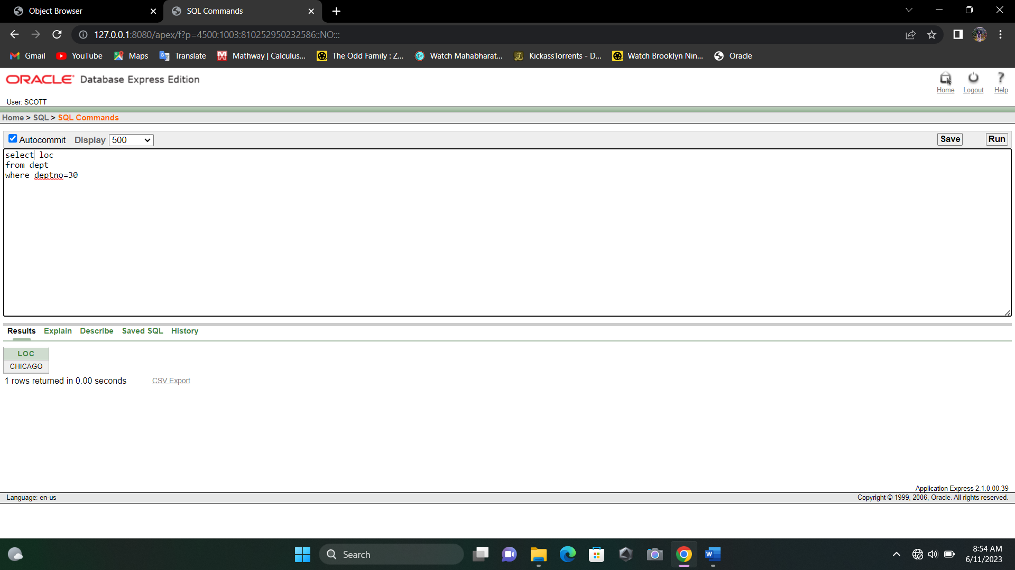

1. Write a query to display the employee name, employee no of all employees who earn a commission.

Select ename, empno from emp where not comm=0

