Practical 1A: A client server based program using TCP to find if the number entered is prime.
Server.java
import java.net.*;
import java.io.*;

public class Server {
public static void main(String[] args) throws Exception {
ServerSocket ss = new ServerSocket(5000);
System.out.print("Server Started...............");
Socket s = ss.accept();
BufferedReader br = new BufferedReader(new InputStreamReader(s.getInputStream()));
PrintWriter pw = new PrintWriter(s.getOutputStream(), true);

int n = Integer.parseInt(br.readLine());
boolean prime = true;

if (n <= 1)
prime = false;
for (int i = 2; i <= n / 2; i++)
if (n % i == 0)
prime = false;

pw.println(prime ? "Prime Number" : "Not Prime");

s.close();
ss.close();
}
}
Client.java
import java.net.*;
import java.io.*;

public class Client {
public static void main(String[] args) throws Exception {
Socket s = new Socket("localhost", 5000);
BufferedReader br = new BufferedReader(new InputStreamReader(System.in));
PrintWriter pw = new PrintWriter(s.getOutputStream(), true);
BufferedReader in = new BufferedReader(new InputStreamReader(s.getInputStream()));

System.out.print("Enter a number: ");
pw.println(br.readLine());

System.out.println("Result: " + in.readLine());

s.close();
}
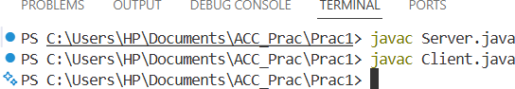
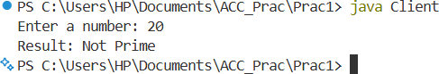
}

Practical 1B: A client server TCP based chatting application.
ChatServer.java:
import java.net.*;
import java.io.*;

public class ChatServer {
public static void main(String[] args) throws Exception {
ServerSocket ss = new ServerSocket(5000);
Socket s = ss.accept();

BufferedReader in = new BufferedReader(new InputStreamReader(s.getInputStream()));
PrintWriter out = new PrintWriter(s.getOutputStream(), true);
BufferedReader kb = new BufferedReader(new InputStreamReader(System.in));

while (true) {
System.out.print("Server: ");
String send = kb.readLine();
out.println(send); // send to client

String recv = in.readLine(); // receive from client
System.out.println("Client: " + recv);

if (send.equals("exit") || recv.equals("exit"))
break;
}

s.close();
ss.close();
}
}

ChatClient.java:
import java.net.*;
import java.io.*;

public class ChatClient {
public static void main(String[] args) throws Exception {
Socket s = new Socket("localhost", 5000);

BufferedReader in = new BufferedReader(new InputStreamReader(s.getInputStream()));
PrintWriter out = new PrintWriter(s.getOutputStream(), true);
BufferedReader kb = new BufferedReader(new InputStreamReader(System.in));

while (true) {
String recv = in.readLine(); // receive from server
System.out.println("Server: " + recv);

System.out.print("Client: ");
String send = kb.readLine();
out.println(send); // send to server

if (send.equals("exit") || recv.equals("exit"))
break;
}

s.close();
}
}

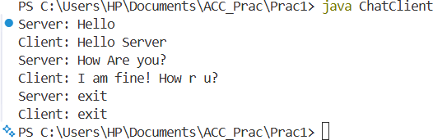
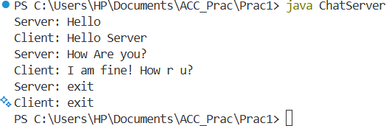

Practical 2A: A client server based program using UDP to find if the number entered is even or odd.
UDPServer.java
import java.net.*;

public class UDPServer {
public static void main(String[] args) throws Exception {
DatagramSocket ds = new DatagramSocket(5000);
byte[] buf = new byte[100];

DatagramPacket dp = new DatagramPacket(buf, buf.length);
ds.receive(dp); // receive number

String numStr = new String(dp.getData()).trim();
int n = Integer.parseInt(numStr);

String result = (n % 2 == 0) ? "Even Number" : "Odd Number";
byte[] sendData = result.getBytes();

DatagramPacket send = new DatagramPacket(
sendData, sendData.length,
dp.getAddress(), dp.getPort());

ds.send(send); // send result
ds.close();
}
}
UDPClient.java

import java.net.*;
import java.io.*;

public class UDPClient {
public static void main(String[] args) throws Exception {
DatagramSocket ds = new DatagramSocket();

BufferedReader br = new BufferedReader(new InputStreamReader(System.in));
System.out.print("Enter a number: ");
String num = br.readLine();

byte[] data = num.getBytes();
InetAddress ip = InetAddress.getByName("localhost");

DatagramPacket dp = new DatagramPacket(data, data.length, ip, 5000);
ds.send(dp); // send number

byte[] buf = new byte[100];
DatagramPacket reply = new DatagramPacket(buf, buf.length);
ds.receive(reply); // receive result

System.out.println("Result: " + new String(reply.getData()).trim());
ds.close();
} }
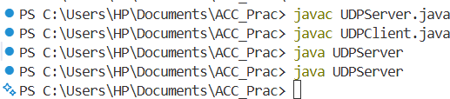

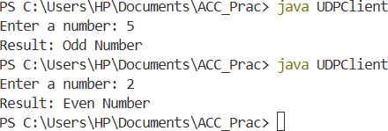
Practical 2B: A client server based program using UDP to find the factorial of the entered number
UDPServer1.java
import java.net.*;

public class UDPServer1 {
public static void main(String[] args) throws Exception {
DatagramSocket ds = new DatagramSocket(5000);
byte[] buf = new byte[100];

DatagramPacket dp = new DatagramPacket(buf, buf.length);
ds.receive(dp); // receive number

String numStr = new String(dp.getData()).trim();
int n = Integer.parseInt(numStr);

// factorial logic (simple)
int fact = 1;
for (int i = 1; i <= n; i++)
fact *= i;

byte[] result = String.valueOf(fact).getBytes();

DatagramPacket reply = new DatagramPacket(
result, result.length,
dp.getAddress(), dp.getPort());

ds.send(reply); // send factorial
ds.close();
}
}
UDPClient1.java
import java.net.*;
import java.io.*;

public class UDPClient1 {
public static void main(String[] args) throws Exception {
DatagramSocket ds = new DatagramSocket();

BufferedReader br = new BufferedReader(new InputStreamReader(System.in));
System.out.print("Enter a number: ");
String num = br.readLine();

byte[] data = num.getBytes();
InetAddress ip = InetAddress.getByName("localhost");

DatagramPacket dp = new DatagramPacket(data, data.length, ip, 5000);
ds.send(dp); // send number

byte[] buf = new byte[100];
DatagramPacket reply = new DatagramPacket(buf, buf.length);
ds.receive(reply); // receive factorial

System.out.println("Factorial = " + new String(reply.getData()).trim());
ds.close();
} }
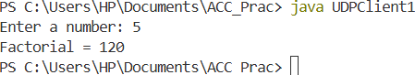
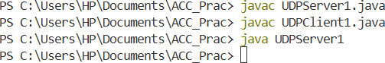

Practical 2C: A program to implement simple calculator operations like addition, subtraction, multiplication and division
CalcServer.java
import java.net.*;

public class CalcServer {
public static void main(String[] args) throws Exception {

DatagramSocket ds = new DatagramSocket(5000);

byte[] buf = new byte[200];
DatagramPacket dp = new DatagramPacket(buf, buf.length);

ds.receive(dp); // receive 2 numbers

String received = new String(dp.getData()).trim();
String[] parts = received.split(" ");

int n1 = Integer.parseInt(parts[0]);
int n2 = Integer.parseInt(parts[1]);

int add = n1 + n2;
int sub = n1 - n2;
int mul = n1 * n2;
String div = (n2 != 0) ? String.valueOf((double) n1 / n2) : "Undefined";

String result = "Add = " + add +
" | Sub = " + sub +
" | Mul = " + mul +
" | Div = " + div;

byte[] sendData = result.getBytes();

DatagramPacket reply = new DatagramPacket(
sendData, sendData.length,
dp.getAddress(), dp.getPort());

ds.send(reply);
ds.close();
}
}
CalcClient.java
import java.net.*;
import java.io.*;

public class CalcClient {
public static void main(String[] args) throws Exception {

DatagramSocket ds = new DatagramSocket();
BufferedReader br = new BufferedReader(new InputStreamReader(System.in));

System.out.print("Enter first number: ");
String n1 = br.readLine();

System.out.print("Enter second number: ");
String n2 = br.readLine();

String message = n1 + " " + n2;
byte[] data = message.getBytes();

InetAddress ip = InetAddress.getByName("localhost");

DatagramPacket dp = new DatagramPacket(data, data.length, ip, 5000);
ds.send(dp); // send two numbers

byte[] buf = new byte[200];
DatagramPacket reply = new DatagramPacket(buf, buf.length);
ds.receive(reply);

System.out.println("\nResults:\n" + new String(reply.getData()).trim());

ds.close();
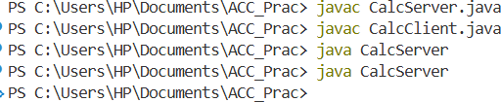
}
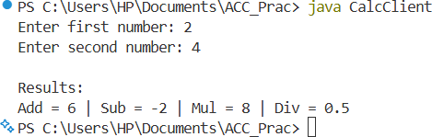
}

Practical 2D: A program that finds the square, square root, cube and cube root of the entered number.
MathServer
import java.net.*;

public class MathServer {
public static void main(String[] args) throws Exception {
DatagramSocket ds = new DatagramSocket(6000);
byte[] buf = new byte[100];

DatagramPacket dp = new DatagramPacket(buf, buf.length);
ds.receive(dp); // receive number

String numStr = new String(dp.getData()).trim();
double n = Double.parseDouble(numStr);

double sq = n * n;
double sqrt = Math.sqrt(n);
double cube = n * n * n;
double cbr = Math.cbrt(n);

String result = "Square=" + sq +
" Sqrt=" + sqrt +
" Cube=" + cube +
" CubeRoot=" + cbr;

byte[] sendData = result.getBytes();

DatagramPacket reply = new DatagramPacket(
sendData, sendData.length,
dp.getAddress(), dp.getPort());

ds.send(reply); // send all results
ds.close();
}
}
MathClient
import java.net.*;
import java.io.*;

public class MathClient {
public static void main(String[] args) throws Exception {
DatagramSocket ds = new DatagramSocket();
BufferedReader br = new BufferedReader(new InputStreamReader(System.in));

System.out.print("Enter a number: ");
String num = br.readLine();

byte[] data = num.getBytes();
InetAddress ip = InetAddress.getByName("localhost");

DatagramPacket dp = new DatagramPacket(data, data.length, ip, 6000);
ds.send(dp); // send number

byte[] buf = new byte[200];
DatagramPacket reply = new DatagramPacket(buf, buf.length);
ds.receive(reply); // receive results

System.out.println("Results: " + new String(reply.getData()).trim());
ds.close();
}
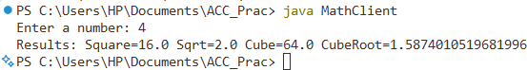
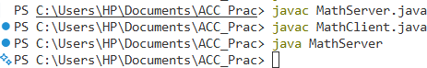
}

PRACTICAL NO. 3
Aim: A multicast Socket example. MulticastServer:
import java.net.*;

public class MulticastServer {
public static void main(String[] args) throws Exception {

DatagramSocket ds = new DatagramSocket();
String msg = "Hello from Multicast Server";

InetAddress group = InetAddress.getByName("224.0.0.5"); // multicast group
byte[] data = msg.getBytes();

DatagramPacket dp = new DatagramPacket(data, data.length, group, 5000);
ds.send(dp);

System.out.println("Message sent to multicast group.");
ds.close();
}
}
MulticastClient:

import java.net.*;

public class MulticastClient {
public static void main(String[] args) throws Exception {

InetAddress group = InetAddress.getByName("224.0.0.5");
NetworkInterface ni = NetworkInterface.getByInetAddress(InetAddress.getLocalHost());

MulticastSocket ms = new MulticastSocket(5000);
ms.joinGroup(new InetSocketAddress(group, 5000), ni);

byte[] buf = new byte[200];
DatagramPacket dp = new DatagramPacket(buf, buf.length);

System.out.println("Waiting for multicast message...");
ms.receive(dp);

System.out.println("Received: " + new String(dp.getData()).trim());

ms.leaveGroup(new InetSocketAddress(group, 5000), ni);
ms.close();
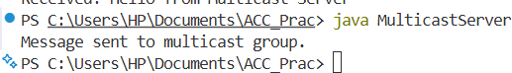
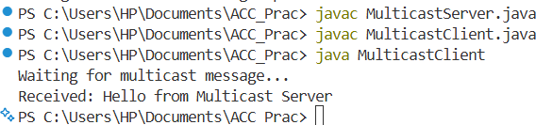
}

Practical 4A: A RMI based application program to display current date and time.
DateTimeInterface.java
import java.rmi.Remote;
import java.rmi.RemoteException;

public interface DateTimeInterface extends Remote {
String getDateTime() throws RemoteException;
}
DateTimeServer.java
import java.rmi.server.UnicastRemoteObject;
import java.rmi.RemoteException;
import java.rmi.Naming;
import java.util.Date;

public class DateTimeServer extends UnicastRemoteObject implements DateTimeInterface {

protected DateTimeServer() throws RemoteException {
super();
}

@Override
public String getDateTime() throws RemoteException {
Date d = new Date();
return d.toString();
}

public static void main(String[] args) {
try {
DateTimeServer obj = new DateTimeServer();
Naming.rebind("rmi://localhost:1099/DateTimeService", obj);
System.out.println("RMI Server is running...");
} catch (Exception e) {
System.out.println("Server Error: " + e.getMessage());
}
}
}
DateTimeClient.java
import java.rmi.Naming;

public class DateTimeClient {
public static void main(String[] args) {
try {
DateTimeInterface obj = (DateTimeInterface) Naming.lookup("rmi://localhost:1099/DateTimeService");
System.out.println("Current Date and Time: " + obj.getDateTime());
} catch (Exception e) {
System.out.println("Client Error: " + e.getMessage());
}
}
}

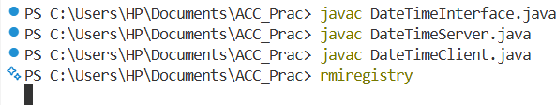

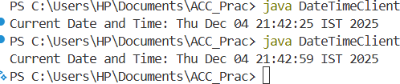
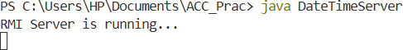

Practical 4B: A RMI based application program that converts digits to words, e.g. 123 will be converted to one two three.
DigitToWordInterface.java
import java.rmi.Remote;
import java.rmi.RemoteException;

public interface DigitToWordInterface extends Remote {
String convertToWords(String number) throws RemoteException;
}
DigitToWordServer.java
import java.rmi.server.UnicastRemoteObject;
import java.rmi.Naming;
import java.rmi.RemoteException;

public class DigitToWordServer extends UnicastRemoteObject implements DigitToWordInterface {

protected DigitToWordServer() throws RemoteException {
super();
}

@Override
public String convertToWords(String number) throws RemoteException {
String[] words = { "zero", "one", "two", "three", "four", "five", "six", "seven", "eight", "nine" };
StringBuilder sb = new StringBuilder();

for (char c : number.toCharArray()) {
if (Character.isDigit(c)) {
sb.append(words[c - '0']).append(" ");
} else {
sb.append("? "); // for any non-digit character
}
}
return sb.toString().trim();
}

public static void main(String[] args) {
try {
DigitToWordServer obj = new DigitToWordServer();
Naming.rebind("rmi://localhost:1099/DigitToWordService", obj);
System.out.println("DigitToWord RMI Server is running...");
} catch (Exception e) {
System.out.println("Server Error: " + e.getMessage());
}
}
}
DigitToWordClient.java

import java.rmi.Naming;
import java.io.BufferedReader;
import java.io.InputStreamReader;

public class DigitToWordClient {
public static void main(String[] args) {
try {
DigitToWordInterface obj = (DigitToWordInterface) Naming.lookup("rmi://localhost:1099/DigitToWordService");
BufferedReader br = new BufferedReader(new InputStreamReader(System.in));

System.out.print("Enter a number: ");
String number = br.readLine();

String result = obj.convertToWords(number);
System.out.println("In Words: " + result);

} catch (Exception e) {
System.out.println("Client Error: " + e.getMessage());
}
}
}
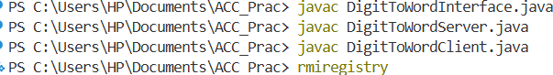

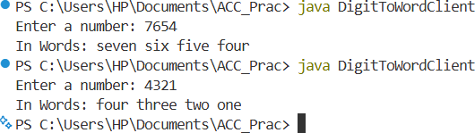
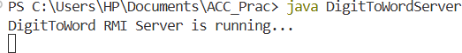

PRACTICAL NO. 5
Hosting Multiple Websites on a Single Apache Server using Virtual Hosts

Aim: To configure and host multiple websites on a single Apache server inside a Virtual Machine using Virtual Hosts, and access them from a host machine by mapping domain names to the VM's IP address.
sudo apt update
sudo apt install apache2 -y
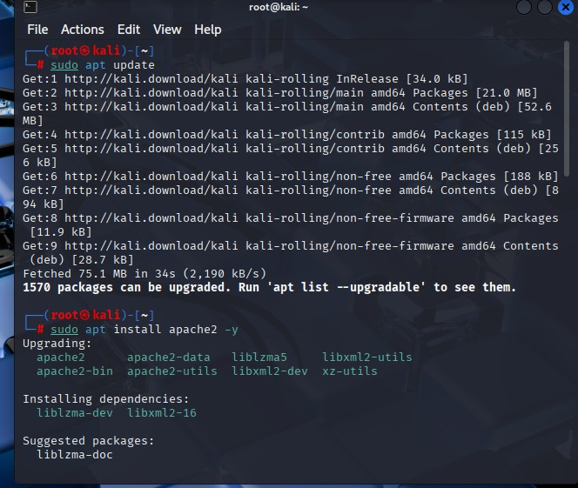

sudo systemctl start apache2 sudo systemctl enable apache2
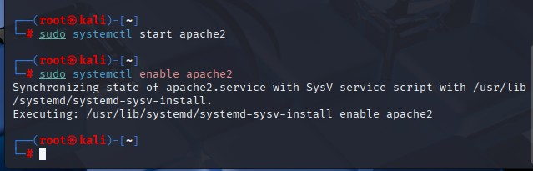

sudo mkdir -p /var/www/example.com sudo mkdir -p /var/www/test.com

Add simple HTML files:

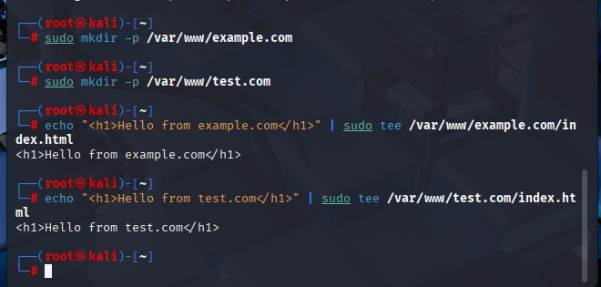
echo "<h1>Hello from example.com</h1>" | sudo tee /var/www/example.com/index.html echo "<h1>Hello from test.com</h1>" | sudo tee /var/www/test.com/index.html

sudo chown -R www-data:www-data /var/www/example.com sudo chown -R www-data:www-data /var/www/test.com sudo chmod -R 755 /var/www

chown = change ownership
-R = apply changes recursively (to all files and folders inside)
www-data:www-data = set the owner and group to Apache's default user (www-data)
/var/www/example.com = the folder you are changing

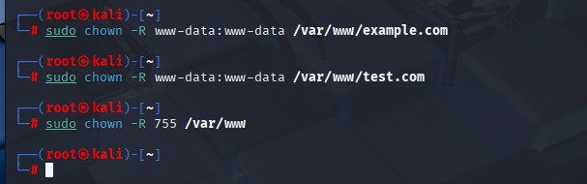

sudo nano /etc/apache2/sites-available/example.com.conf

<VirtualHost *:80>
ServerName example.com DocumentRoot /var/www/example.com

<Directory /var/www/example.com> Options Indexes FollowSymLinks AllowOverride All
Require all granted
</Directory>

ErrorLog ${APACHE_LOG_DIR}/example.com-error.log
CustomLog ${APACHE_LOG_DIR}/example.com-access.log combined
</VirtualHost>

sudo nano /etc/apache2/sites-available/test.com.conf

<VirtualHost *:80>
ServerName test.com DocumentRoot /var/www/test.com

<Directory /var/www/test.com> Options Indexes FollowSymLinks AllowOverride All
Require all granted
</Directory>

ErrorLog ${APACHE_LOG_DIR}/test.com-error.log
CustomLog ${APACHE_LOG_DIR}/test.com-access.log combined
</VirtualHost>

sudo a2ensite example.com.conf sudo a2ensite test.com.conf sudo systemctl reload apache2

Check config:

sudo apache2ctl con figtest
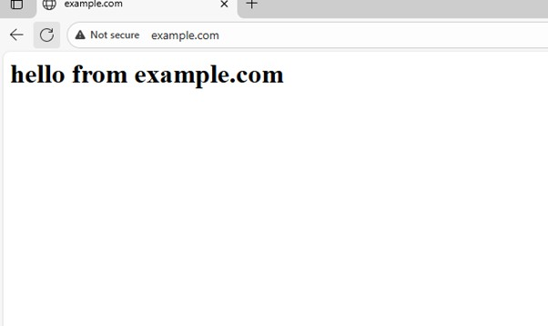
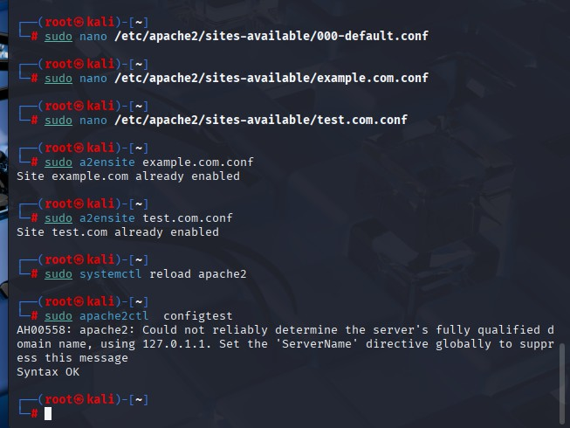

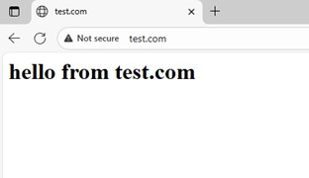

PRACTICAL NO. 6
SSH Key Login
On a cloud server (like AWS EC2), if anyone knows the password, they can login and hack the server.
So we do 3 things:
- Create a new admin user (instead of using root)
- Use SSH Key Login (so no one can hack using passwords)
- Disable Root Login (so no one can target root)

sudo adduser adminuser6
sudo usermod -aG sudo adminuser6
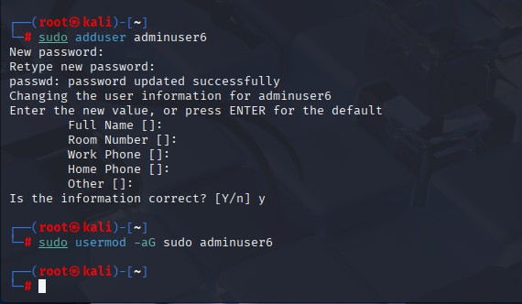

Now in MobaXterm,
ssh adminuser6@192.168.0.106 ssh-keygen

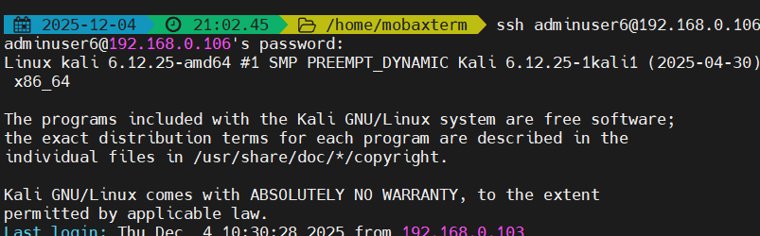

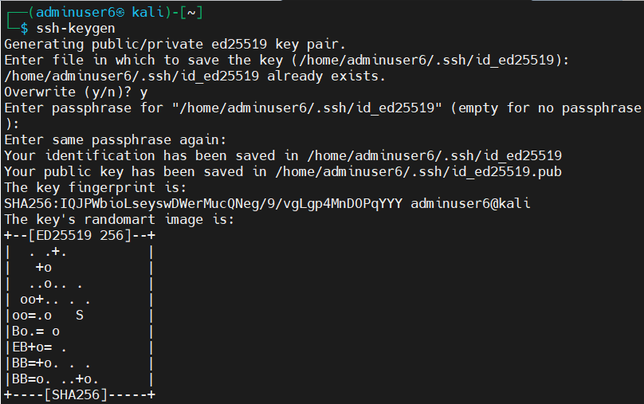

Ssh-copy-id adminuser6@192.168.0.106
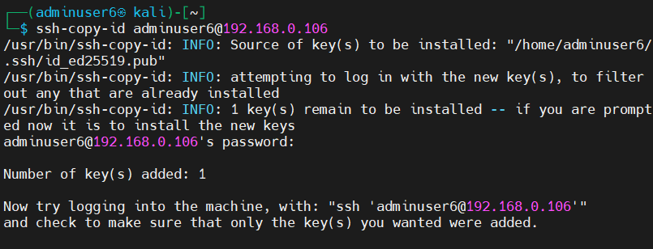

ssh adminuser6@192.168.0.106
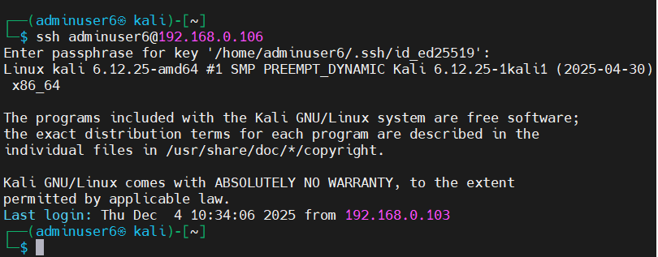

On your server,

open the SSH config:

sudo nano /etc/ssh/sshd_config
Find or add these lines (add if missing): PermitRootLogin no PasswordAuthentication no
Save and exit:
- Press CTRL + O then Enter to save
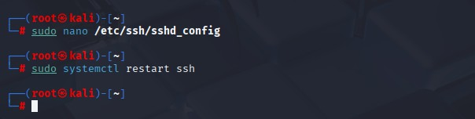
- Press CTRL + X to exit nano Restart SSH service to apply changes: sudo systemctl restart ssh

PRACTICAL NO. 7
Network & Compliance Hardening for a Linux Server PART 1 Firewall Configuration Using UFW
sudo apt install ufw -y
sudo ufw default deny incoming sudo ufw default allow outgoing sudo ufw allow 22/tcp
sudo ufw allow 443/tcp sudo ufw deny 80/tcp
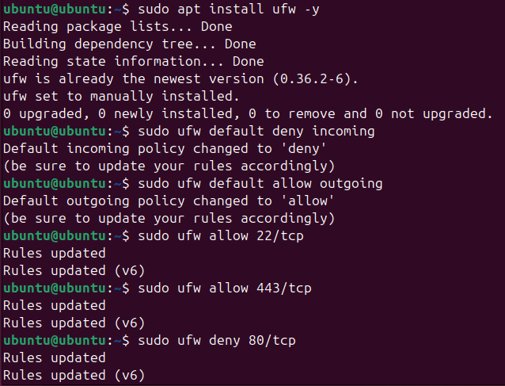

sudo ufw enable sudo ufw status
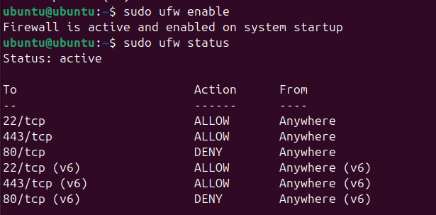

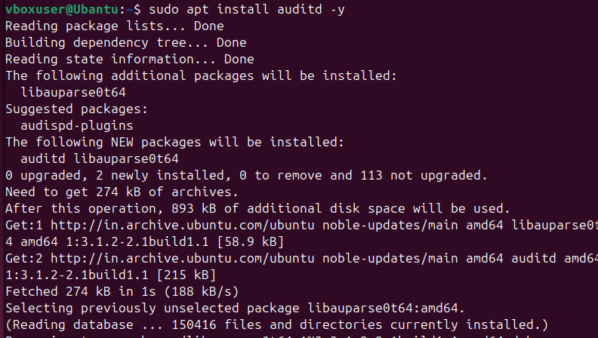
PART 2 Compliance Logging Using auditd sudo apt install auditd -y

sudo systemctl start auditd

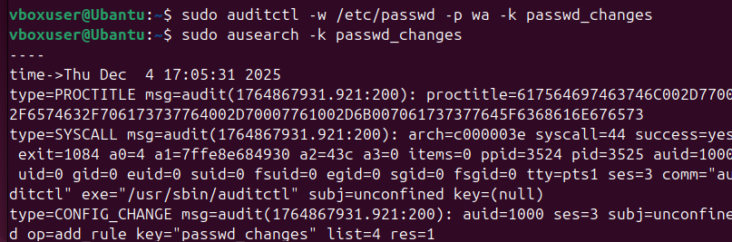

sudo auditctl -w /etc/passwd -p wa -k passwd_changes sudo ausearch -k passwd_changes

sudo adduser testuser3

sudo ausearch -k passwd_changes

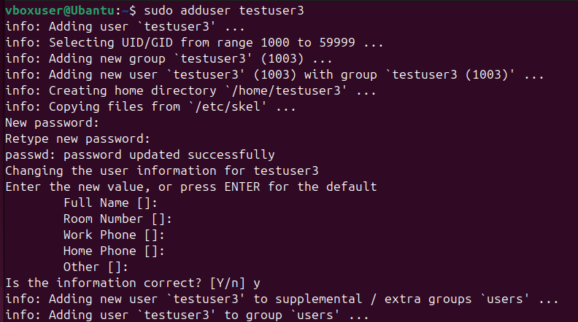
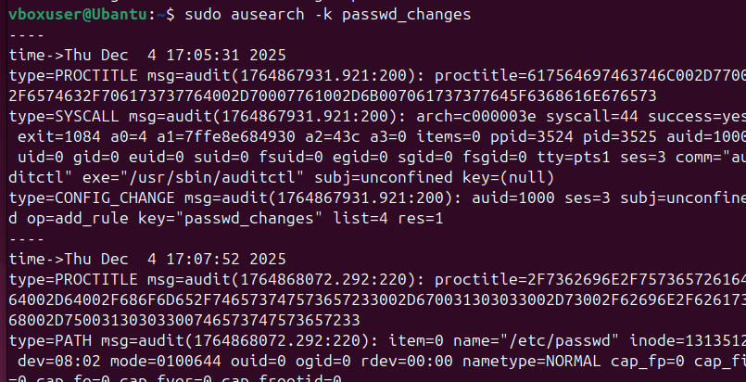

Sudo aureport -f -i
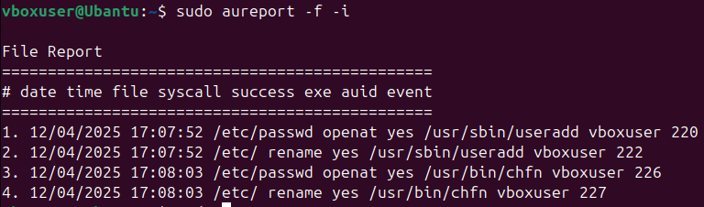

sudo nano /etc/security/limits.conf
Step 2: Add These Lines at Bottom
- hard nproc 200
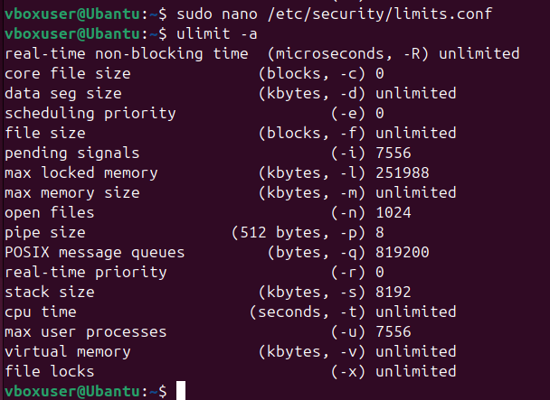
- soft nofile 100 ulimit -a

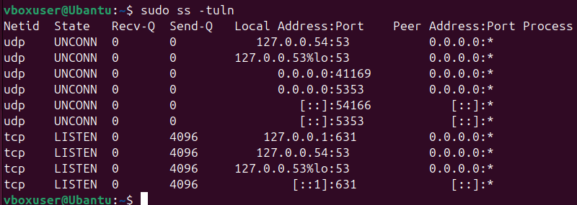
PART 3 Checking Open Network Ports (Monitoring Active Services) sudo ss -tuln

PART 4 Enable Automatic Security Updates sudo apt install unattended-upgrades -y
sudo dpkg-reconfigure unattended-upgrades Select Yes when prompted.
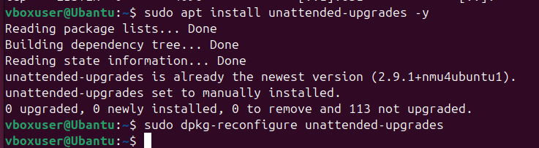

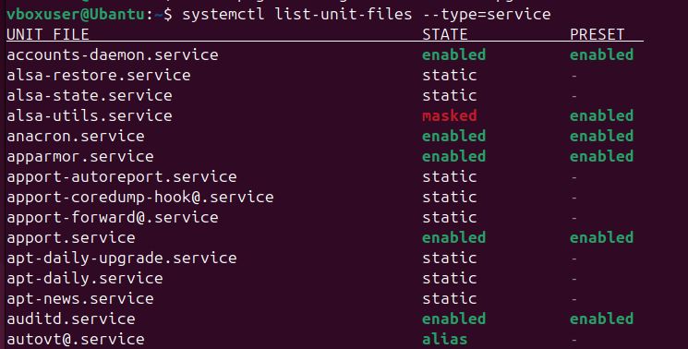
PART 5 Disable Unnecessary Services systemctl list-unit-files --type=service

Step 2: Stop an Unused Service (Example: Bluetooth) sudo systemctl stop Bluetooth
Step 3: Disable the Service Permanently
sudo systemctl disable bluetooth (Service will not start after reboot)

