Capacity Investment and Price Competition in Oligopolistic LLM Infrastructure Markets: A Dynamic Bertrand Approach with Markov Perfect Equilibrium

Abstract
Large Language Model (LLM) inference platforms face volatile demand and sunk, lagged capacity adjustment, and they compete mainly on posted prices rather than on a fixed market share. We recast the capacity-race model as a dynamic Bertrand game: in every period two platforms simultaneously post a per-request price (Bertrand competition with capacity constraints, Kreps and Scheinkman, 1983) and choose a discrete capacity action (Rust, 1987), while demand follows a Markov-modulated Poisson regime. We solve a stationary Markov Perfect Equilibrium (MPE, Ericson and Pakes, 1995; Maskin and Tirole, 1988) with extreme-value shocks, i.e. a logit MPE, by a nested fixed-point algorithm whose inner loop solves each state’s pricing game. In our numerical illustration, price competition does not remove the capacity buildup but it dampens it: relative to the market-share contest of the original specification, Bertrand platforms hold 21% less total capacity, but they earn 46% less industry profit than a joint-profit-maximising cartel and the average transaction price falls from 1.50 to 1.13. Prices are high (the reservation price) when installed capacity is scarce relative to demand and drop sharply once both platforms hold enough capacity to serve the whole market, so capacity acts as a commitment device that softens price competition.

1. Introduction
Cloud providers of LLM inference provision GPU clusters with a provisioning lag and sunk setup costs, so capacity chosen today is operational only next period. The earlier version of this paper allocated demand by capacity share, ω_i = m_i/(m_i+m_{-i}), so that rivals interact only by eroding each other’s share. In practice platforms post prices (per-token or per-request) and customers switch to the cheaper provider as long as it has spare capacity. This is the structure of a Bertrand–Edgeworth game: the lower-priced firm serves demand up to its capacity and the residual demand spills to the rival. Static analysis (Kreps and Scheinkman, 1983) shows that when capacity is chosen first and prices second, the equilibrium is Cournot-like; with dynamics, Maskin and Tirole (1988) show that Markov-perfect price competition can generate price cycles and prices above marginal cost without explicit collusion.
This paper embeds Bertrand price competition in the dynamic capacity model. Three changes relative to the previous version: (i) each platform now chooses a price in addition to the capacity action, (ii) revenue is determined by the Bertrand allocation rule with capacity constraints rather than by a share rule, and (iii) equilibrium is computed as a logit MPE so that mixed pricing behaviour (which pure Bertrand equilibria cannot deliver in capacity-constrained games) is represented. We then ask how price competition changes the “capacity race” of the previous version.

2. Theoretical Foundation and Game Framework

2.1. State space and demand
Two platforms i ∈ {A, B} hold m_i ∈ {0,…,M−1} active GPU nodes; each node serves κ requests per period. The demand regime λ_t ∈ {Low, Med, High} = {10, 25, 45} requests per period follows the Markov chain P_λ (the NHPP phase-shift matrix of the original paper). The state is
S_t = (m_{A,t}, m_{B,t}, λ_t). (1)

2.2. Actions: price and capacity
Both platforms simultaneously choose a ≡ (p_i, k_i) ∈ 𝒫 × {0,1,2}, where p_i ∈ 𝒫 = {0.4, 0.8, 1.2, 1.5} is the posted price per request (the upper value is the customers’ reservation price p̄) and k_i is the capacity action (0 hold, 1 expand, 2 contract). Capacity evolves deterministically with a one-period lag:
m_{i,t+1} = max(0, min(M−1, m_{i,t} + 1[k_i=1] − 1[k_i=2])). (2)

2.3. Capacity-constrained Bertrand payoffs
Customers are homogeneous and inelastic up to p̄. Let K_i = κ·m_i. Directed demand is d_i = λ if p_i < p_{-i}, λ/2 if p_i = p_{-i}, and 0 otherwise. Each firm serves its directed demand up to capacity and the rival’s overflow spills over (efficient rationing):
q_i = min{ K_i , d_i + max(0, d_{-i} − K_{-i}) }. (3)
Per-period profit is
Π_i = (p_i − c)·q_i − ψ·max(0, d_i − K_i) − P_k·m_i − 1[k_i=1]·FC_i − 1[k_i=2]·0.3·FC_i, (4)
with marginal serving cost c = 0.3, SLA/queueing penalty ψ = 0.3 per directed-but-unserved request, node holding cost P_k = 2, and expansion costs FC_A = 12, FC_B = 15 (contraction costs 30% of FC_i, as in the earlier version). Rust’s sunk adjustment friction is therefore preserved, but strategic interaction now operates through prices within the period and through capacity across periods.

3. Markov Perfect Equilibrium
A strategy σ_i(a | S) is Markov if it depends only on S. Adding i.i.d. Type-I extreme-value shocks ε_i(a) with scale ρ to each action’s payoff yields choice probabilities in logit form. With β = 0.95 the integrated value function of firm i solves
V_i(S) = ρ·[ γ + ln Σ_a exp( v_i(a, S)/ρ ) ], (5)
v_i(a, S) = Σ_{a_{-i}} σ_{-i}(a_{-i}|S) · [ Π_i(S, a, a_{-i}) + β Σ_{λ′} P_λ(λ′|λ) V_i(m_i′, m_{-i}′, λ′) ], (6)
σ_i(a | S) = exp( v_i(a, S)/ρ ) / Σ_{a′} exp( v_i(a′, S)/ρ ), (7)
where γ is Euler’s constant. A stationary MPE is a pair (σ_A, σ_B, V_A, V_B) satisfying (5)–(7) in every state simultaneously. The logit shocks guarantee existence of mixed behaviour in the stage game, which matters because capacity-constrained Bertrand games typically have no pure-strategy equilibrium (Edgeworth cycles) in some states; as ρ → 0 the solution approaches an MPE in nearly pure strategies (McKelvey and Palfrey, 1995; Doraszelski and Satterthwaite, 2010).
Algorithm (nested fixed point). The outer loop updates (V_A, V_B); for each outer iteration the inner loop solves the 12 × 12 logit stage game in every one of the 75 states by damped best-response iteration on (σ_A, σ_B) (damping 0.1) until the change is below 1e−10. The outer update is damped (0.3) and iterated until max|ΔV| < 1e−4. Because strategic complementarity can make the stage game and the dynamic game multi-equilibrium, the reported equilibrium is the one reached from the uniform-strategy initialisation; Table 1 should be read as one MPE, not as the unique one.

4. Counterfactual Simulation Results

4.1. Price–capacity interaction
Figure 1 plots the equilibrium expected price by state. Prices equal (or are close to) the reservation price whenever installed capacity is scarce relative to demand: a firm that undercuts cannot serve the market, so it forgoes margin without gaining volume. Once both platforms hold enough nodes to serve the current demand regime alone, undercutting is credible and the expected price falls to about 0.8; with Low demand the price falls for every pair with m_A, m_B ≥ 1. Capacity therefore plays the role of a commitment to compete: the more capacity a rival holds, the lower the price a firm can sustain.
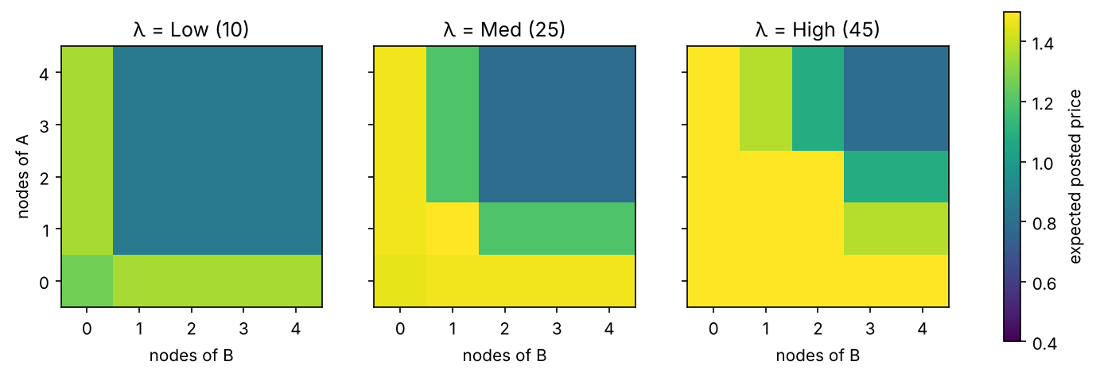
Figure 1. Equilibrium average posted price by state (m_A, m_B) and demand regime.

4.2. Expansion, contraction and the capacity race
Table 1: MPE behaviour at selected states. Capacity entries are probabilities of hold/expand/contract.
State (m_A,m_B,λ) | E[price] A | A: hold/exp/con | E[price] B | B: hold/exp/con | P(both expand)
(1,1,Med) | 1.50 | 1.00/0.00/0.00 | 1.50 | 0.00/1.00/0.00 | 0.00
(1,1,High) | 1.50 | 0.00/1.00/0.00 | 1.50 | 0.73/0.27/0.00 | 0.27
(2,2,Med) | 0.79 | 1.00/0.00/0.00 | 0.79 | 1.00/0.00/0.00 | 0.00
(2,2,High) | 1.50 | 1.00/0.00/0.00 | 1.50 | 1.00/0.00/0.00 | 0.00
(3,3,Med) | 0.79 | 0.05/0.00/0.95 | 0.79 | 0.05/0.00/0.95 | 0.00

In the Medium-demand state (1,1) only one platform expands (a leader–follower outcome; which one is selected depends on the equilibrium chosen), whereas in the High-demand state (1,1) both platforms expand with positive probability (27% that both expand). At (2,2,Med) and (2,2,High) neither expands, and at (3,3,Med) both contract with probability about 0.95 – a shakeout when capacity is redundant. Expansion is thus triggered when capacity is scarce relative to demand, and simultaneous expansion occurs only in the High-demand state; a plausible reading is that in a price game the value of an additional node falls once the rival also holds capacity, since extra capacity then mainly intensifies price competition (we did not test this mechanism separately).

4.3. Benchmarks
Table 2: Stationary averages under the ergodic distribution of each equilibrium.
Model | Avg. price | Industry profit | Consumer surplus | Mean capacity | Excess capacity
Dynamic Bertrand (MPE) | 1.126 | 12.91 | 9.48 | 59.8 | 34.4
Joint-profit cartel | 1.500 | 23.79 | 0.00 | 45.0 | 19.7
Market-share contest (previous version) | 1.500 | 20.38 | 0.00 | 75.2 | 49.9

Excess capacity is E[max(κ(m_A+m_B) − λ, 0)]; consumer surplus is (p̄ − p)·q. Industry profit under Bertrand competition is 54% of the cartel’s, and consumers capture a positive surplus (9.48) that is zero in the other two cases because both charge the reservation price. Bertrand platforms hold more capacity than the cartel (60 vs 45 request-units) but less than platforms competing for market share (75). Compared with the previous version, the capacity race is therefore weakened rather than strengthened by price competition: the market-share rule rewards capacity directly, while under Bertrand pricing extra capacity mainly intensifies price competition.
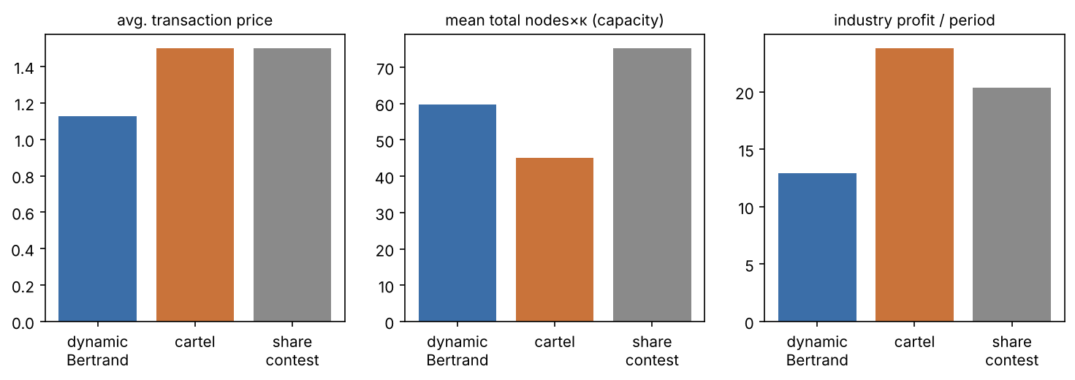
Figure 2. Stationary averages: dynamic Bertrand MPE, joint-profit cartel and the market-share contest.

5. Limitations
- Results come from one illustrative parameterisation (ρ = 1, c = 0.3, four price points); a sensitivity sweep over ρ and c is available in the code (--sweep) but was not run for this draft, so the qualitative claims are not yet shown to be robust.
- The reported MPE is one of possibly several equilibria; the asymmetric expansion at (1,1,Med) and the asymmetric capacity of the share-contest benchmark (about 2.0 vs 3.0 nodes) are equilibrium-selection outcomes.
- Demand is inelastic up to the reservation price and products are homogeneous; differentiated demand (e.g. logit demand by latency) is a natural extension.
- Prices are posted from a discrete grid, and the logit shocks smooth the Bertrand undercutting logic; the minimum price in the grid (0.4) exceeds marginal cost (0.3).
- The appendix code of the previous draft did not converge (see Appendix); its Table 1 should not be relied on.

References
- E. Ericson and A. Pakes, “Markov-Perfect Stochastic Growth in an Industry: A Framework for Empirical Work,” Review of Economic Studies, vol. 62, no. 1, pp. 53–82, 1995.
- J. Rust, “Optimal Replacement of GMC Bus Engines: An Empirical Model of Harold Zurcher,” Econometrica, vol. 55, no. 5, pp. 999–1033, 1987.
- E. Maskin and J. Tirole, “A Theory of Dynamic Oligopoly, II: Price Competition, Kinked Demand Curves, and Edgeworth Cycles,” Econometrica, vol. 56, no. 3, pp. 571–599, 1988.
- D. M. Kreps and J. A. Scheinkman, “Quantity Precommitment and Bertrand Competition Yield Cournot Outcomes,” Bell Journal of Economics, vol. 14, no. 2, pp. 326–337, 1983.
- R. D. McKelvey and T. R. Palfrey, “Quantal Response Equilibria for Normal Form Games,” Games and Economic Behavior, vol. 10, no. 1, pp. 6–38, 1995.
- U. Doraszelski and M. Satterthwaite, “Computable Markov-Perfect Industry Dynamics,” RAND Journal of Economics, vol. 41, no. 2, pp. 215–243, 2010.
- A. K. Dixit and R. S. Pindyck, Investment under Uncertainty, Princeton University Press, 1994.
- M. Armbrust et al., “A View of Cloud Computing,” Communications of the ACM, vol. 53, no. 4, pp. 50–58, 2010.

Appendix: Code and Reproducibility
The simulation is in dynamic_bertrand/bertrand_mpe.py (numpy only; plotting needs matplotlib): python dynamic_bertrand/bertrand_mpe.py. The main solve takes about 6 minutes on a CPU, all three models converged (outer tolerance 1e-4, 5810 / 467 / 1011 outer iterations). Outputs: results/dynamic_bertrand.json and the two figures.
Note on the previous draft’s appendix code. Running the code as printed in the earlier manuscript for its full 300 iterations did not converge (final value changes 7.68 for A and 5.83 for B against a 1e−4 tolerance), and its policy at state (3,3,Medium) is A = Expand, B = Inaction, not Contract/Contract as stated in the earlier Table 1. The present results come from the new solver, in which each firm’s payoff depends on the rival’s price and capacity action and the value update is damped.

