When the Platform Moves Underneath: Maintaining Complementary IT Assets under Endogenous Release Cadence
Target journal: Information Systems Research (anonymized manuscript; no author information)
Keywords: platform evolution; post-adoption maintenance; real options; compatibility; foundation models; release cadence; complementary assets; platform competition

Abstract
Firms increasingly build complementary IT assets, such as fine-tuned adapters, on foundation-model platforms that they do not control, and every platform upgrade destroys some or all of that value. We study this post-adoption maintenance problem as an interaction between the adopter’s real-option decision and the platform owner’s choice of release cadence and compatibility support. At each upgrade a firm can copy its asset, which is free but imperfect, transfer it with a costly compatibility tool that recovers a share $R$ of its value, or retrain it, an irreversible investment that expires at the next upgrade. The retraining threshold rises with the recovery rate as $1/\left(1−R\right)$ and also with upgrade intensity and value volatility. A free copy weakly dominates immediate retraining, and a costly tool is optimal only for assets of intermediate value and only when its cost falls below a bound $Γ$. When the platform owner chooses how often to release, an owner that captures part of enterprise surplus over-releases if and only if the average customer is harmed at the margin by a faster clock. Compatibility tools and release speed are strategic complements for any distribution of asset values, so better tools invite faster release and can leave firms that retrain anyway worse off. Under logit duopoly with a release race, each owner internalizes exactly one-third of the marginal change in customer surplus, and numerical analysis shows that an intermediate race separates owners into a fast, compatible frontier platform and a slow, stable one. Release histories of six open-weight model families imply about two main-line versions per year. Recovery measured on open model pairs of 160M to 3B parameters, on three tasks, falls with the size of the upgrade, and a costly transfer method has room to pay in only two of 24 pair-task combinations. The practical rule that follows is to copy by default, to buy a transfer tool only when its measured cost is below $Γ$, and to read the arrival of owner-provided compatibility tooling as a signal of faster release. Compatibility tooling is thus a governance variable that the platform owner sets jointly with the pace of change.

1. Introduction
Information systems research has long treated platforms as bundles of options for the firms that build on them (Fichman 2004), and it has examined how platform owners govern architecture and the boundary between the platform and its complements (Tiwana et al. 2010, Ghazawneh and Henfridsson 2013). Less attention has gone to what happens after adoption, when the platform is replaced beneath assets that the adopter has already built. Foundation models make the question concrete. A fine-tuned low-rank adapter is cheap to train on a given base model, yet as a weight file it is worthless on the next one, and open-weight families ship roughly two main-line versions a year. The usual engineering response is to retrain every adapter at every upgrade. That response takes the platform’s clock as a fact of nature and the firm’s cost as a sunk operating expense, and both assumptions are questionable. The problem belongs to information systems research because it concerns the maintenance of IT assets that depend on a platform someone else controls.
Retraining is an irreversible investment with an uncertain payoff, and its useful life ends when the platform owner ships again. This is the textbook setting for real options (McDonald and Siegel 1986, Dixit and Pindyck 1994): the right to wait has value. Tools that move an adapter to a new base model without the original training data alter the option. They buy a recovery rate $R$ at a cost $C$ and shift the exercise threshold. A free, naive copy of the adapter weights is itself such a tool, with $C=0$.
The clock, however, is chosen by someone. Platform owners release to win benchmarks, developers, and publicity, and much of the cost of each release falls on enterprise customers. Compatibility tools restore part of the option that a release destroys, and for that very reason they change the owner’s incentive to destroy it. Better compatibility is therefore a mixed blessing for the firms that use it. It invites faster release, and firms that would have retrained anyway then face a higher cadence and can end up worse off.
We ask three questions. First, given an exogenous release intensity, when should a firm copy, transfer, or retrain a complementary asset that expires at the next upgrade? Second, when the platform owner chooses the intensity, and possibly compatibility as well, does it release too often, and how does transfer technology feed back into that choice? Third, if owners compete for enterprise customers and for a general-market prize tied to release speed, how much of the change in customer surplus do they internalize, and can they differentiate on a speed–compatibility bundle?
Summary of results. Table 1 lists the results, the intuition behind each, and what each implies for information systems research and practice.
Result | Intuition | Implication for IS
The retraining threshold is proportional to $1/\left(1−R\right)$ and rises with upgrade intensity and volatility; a free copy weakly dominates immediate retraining (Props. 1–2) | Waiting is valuable when the asset can be partly rescued and may be rescued again | Copy first; do not retrain by default, and triage assets by value relative to retraining cost
A costly tool is optimal only in an intermediate band of values and only if its cost is below $Γ$ (Prop. 2b) | Low-value assets are served by copy and high-value assets are retrained anyway | Default to free copy; buy a compatibility tool only if its measured cost is below $Γ$
A revenue-sharing owner over-releases iff the average customer is harmed at the margin (Prop. 3) | The owner internalizes only share $θ$ of the burden it imposes | Release cadence is a governance variable with welfare consequences
Compatibility and cadence are strategic complements for any distribution of values (Props. 4a, 6) | Easier transfer lowers the marginal burden of a release | Owner-provided migration tools should be read as a signal of faster release
Better transfer helps mid-value transferring firms and hurts firms that retrain anyway (Prop. 4b) | The cadence effect dominates for firms that cannot use the tool | Contractual release caps or long-term-support lines can be worth more than a better converter for high-value assets
Under logit duopoly each owner internalizes exactly one-third of the marginal change in customer surplus (Prop. 5) | A logit price response splits a quality shock one-third to price and one-third to share | Competition does not remove over-release; it caps internalization
A numerical intermediate race yields a fast, compatible frontier owner and a slow, stable one (Numerical Finding 1) | Cadence and compatibility are a bundle along which owners can separate | Segment assets across frontier and stable platforms
Table 1. Summary of results.
The practical message. The model’s central prescription is a default: when free copy recovers most of the value, copy. Retraining is warranted only for assets whose value exceeds a threshold that lies well above the NPV threshold, and a costly transfer tool pays only in a bounded intermediate band and only if its cost is below $Γ$. Our measurements are consistent with this default. In 22 of the 24 pair-task combinations we tested, free copy leaves too little to gain for any costly method with a plausible cost to pay off. The exceptions are large upgrades of a 160M-parameter model on two tasks, where copy recovered 40 and 67 percent of the retraining gain, and a third task is borderline. Where copy recovers little and no tool helps, as with summarization and instruction-tuned targets, the model says to retrain. The default is thus a first step to be checked on a sample, not an unconditional rule. It argues against two habits that look prudent, retraining at every upgrade and buying compatibility tools by default.
Two empirical inputs discipline the model, though neither is a contribution in itself. Public release dates for Llama, Gemma, Phi, Qwen, Mistral, and DeepSeek through 28 September 2026 imply a pooled primary-definition intensity of 1.97 main-line versions per year. Recovery rates measured on open model pairs, on math reasoning, summarization, and text-to-SQL, show that the size of the upgrade and the task, rather than the brand of transfer method, are the first-order determinants of $R$. After small continued-training upgrades of a 160M-parameter model, a naive copy recovered 91 to 97 percent of the retraining gain on all three tasks; after a large upgrade it recovered 35 to 67 percent, depending on the task. In the larger models, copy recovered 79 to 99 percent after the large upgrade on two tasks but only 12 percent on summarization, and a costly transfer method added little beyond copy except on summarization (means over three to five seeds). We use these facts as $\left(R,C,μ\right)$ inputs. The converter we used to measure one $\left(R,C\right)$ pair is described in the online appendix and is not a contribution of the paper.
Contribution. The paper makes three contributions to information systems research. First, it moves the real-options view of IT platforms (Fichman 2004, Taudes et al. 2000, Benaroch and Kauffman 1999) from the adoption decision to the post-adoption maintenance of complementary assets, and it characterizes the resulting policy regions without reference to any named algorithm. Second, it treats the platform owner as the agent that sets the rate at which the adopter’s options are destroyed. Doing so reveals a complementarity between compatibility support and release speed, with a sharp distributional implication: tools that help some customers hurt others through the cadence they induce. This extends research on platform evolution (Tiwana et al. 2010) with an explicit maintenance channel. Third, it shows how much of the change in customer surplus competing owners internalize, and that the speed–compatibility bundle is a dimension along which platforms can separate, which links platform governance to platform competition (Parker and Van Alstyne 2018, Rochet and Tirole 2003). For managers, the paper offers a maintenance policy whose qualitative regions do not depend on any particular algorithm and whose default is free copy.
The paper proceeds as follows. Section 2 places it in the literature, and Section 3 sets up the model and presents two stylized facts. Section 4 solves the firm’s maintenance option. Sections 5 and 6 turn to a monopoly owner and to competing owners, Section 7 reports robustness checks and extensions, Section 8 draws implications for research and practice, and Section 9 concludes.

2. Related Literature and Positioning
Real options and IT investment. McDonald and Siegel (1986) and Dixit and Pindyck (1994) established that the right to delay an irreversible investment has value. The logic fits technology investment well, because implementation costs are partly sunk while standards keep moving (Dos Santos 1991, Grenadier and Weiss 1997, Benaroch and Kauffman 1999, Taudes et al. 2000, Benaroch 2001, Fichman 2004, Kauffman and Li 2005, Santiago and Bifano 2005). The closest models in structure study adoption when a further innovation is anticipated (Rajagopalan 1999) and modular upgradeability as insurance against technological change (Kamrad et al. 2013). More recent work applies the same lens to enterprise AI adoption (Tewari 2026). We shift the question from whether to adopt to how to renew an asset that is already deployed, when the platform underneath it is replaced at a rate the asset owner does not choose, and we make that rate endogenous.
Platform evolution, compatibility, and planned obsolescence. Compatibility choices shape adoption and competition (Katz and Shapiro 1985, Farrell and Saloner 1985). Platform owners trade openness off against control over complements (Parker and Van Alstyne 2018), and platform architecture and governance coevolve with the environment (Tiwana et al. 2010, Ghazawneh and Henfridsson 2013, Yoo et al. 2010). Competing platforms can soften price competition through differentiation (Shaked and Sutton 1982) and compete in two-sided markets (Rochet and Tirole 2003, Armstrong 2006). We add a maintenance channel. The platform’s release cadence destroys options held by complementors, compatibility tools partly restore them, and the restoration in turn feeds back into the cadence. The resulting speed–compatibility bundle is a dimension along which competing platforms can separate.
What the paper changes in IS theory. The model connects to three established IS constructs. Digital options (Sambamurthy et al. 2003, Fichman 2004) are usually treated as assets that the adopter accumulates; here they are assets the platform owner can extinguish, so the life of the option is a choice variable of the owner. Compatibility tools such as migration kits, converters, and long-term-support promises are boundary resources in the sense of Ghazawneh and Henfridsson (2013). The literature treats them as instruments for attracting third-party development, whereas we show that they also change the owner’s incentive to change the platform, so resource provision and platform evolution (Tiwana et al. 2010) cannot be analyzed separately. Finally, generativity (Yoo et al. 2010) refers to a platform’s capacity to be changed by many uncoordinated actors. Our model shows its cost side: a platform that its owner changes often imposes a maintenance burden that falls unevenly on the actors who build on it.
Maintenance of IT and learning systems. Maintenance has long been recognized as a central cost of IT assets (Swanson 1976). Work on when to retrain a machine-learning model attributes the need to data drift and considers two actions, retrain or keep (Mahadevan and Mathioudakis 2023, Regol et al. 2025). We attribute the need to platform replacement and add transfer as an intermediate action.
Adapter transfer. Methods for moving adapters without retraining include distillation, subspace projection, and light remapping (Wang et al. 2024, Farhadzadeh et al. 2025a,b, Li et al. 2025, Xia et al. 2025). Hochlehnert et al. (2026) find that naive copy is a strong baseline between related models. In our model every method is simply a pair $\left(R,C\right)$, which lets us study the economics without taking a position on the algorithm.
 | Adoption timing | Maintenance after adoption | Platform owner endogenous | Competition between owners
Real options in IT (Benaroch and Kauffman 1999, Fichman 2004) | ✓
Anticipated innovation (Rajagopalan 1999, Kamrad et al. 2013) | ✓
Platform evolution and governance (Tiwana et al. 2010, Parker and Van Alstyne 2018) |  |  | ✓ | partly
Model retraining (Mahadevan and Mathioudakis 2023, Regol et al. 2025) |  | ✓
This paper |  | ✓ | ✓ | ✓
Table 2. Positioning.

3. Setting and Stylized Facts

3.1 Complementary assets on a foundation-model platform
The unit of analysis on the demand side is a firm that operates one task-specific adapter on a named base model. An epoch is the interval between two successive upgrades. At the start of an epoch the firm chooses a transfer method, and during the epoch it may retrain. When the next upgrade arrives, the current adapter and any retraining investment lose their value and a new epoch begins.
A transfer method $j$ is summarized by a recovery rate $R_{j}∈\left[0,1\right]$ and a cost $C_{j}≥0$. Running the target model without the adapter is always feasible and corresponds to $R=0$, so a method whose measured recovery is negative is treated as having $R=0$. A naive copy of the adapter weights is $\left(R_{C},0\right)$, and retraining costs $C_{N}$ and restores $R=1$. The value flow $v$ that the adapter yields at the retrained level follows a geometric Brownian motion, $dv=g v dt+σv dW$. After a transfer the firm loses a flow of $v\left(1−R\right)$ until it retrains or the epoch ends. The discount rate is $ρ$, with $ρ+μ>g$, and upgrades arrive as a Poisson process with intensity $μ$ when $μ$ is taken as given. Section 5 endogenizes $μ$.

3.2 Stylized fact 1: release intensity is about two per year and more regular than Poisson
We recorded the date on which the weights of each new main-line version of six open-weight families first became publicly available, from each family’s first release through 28 September 2026. The primary definition counts a new version of the family’s main general-purpose text model; a broad definition adds refreshed checkpoints and reasoning variants. The replication package lists every date. We re-checked selected dates against vendor announcements (Llama 3.3 on 6 December 2024, Gemma 4 on 2 April 2026, and DeepSeek-V4.1-Flash on 10 September 2026); see Appendix D.
Family | $n$ | $T$ (years) | $\hat{μ}$ | 95% CI | Mean gap (months) | CV of gaps
Llama | 6 | 3.59 | 1.67 | [0.61, 3.64] | 7.2 | 0.61
Gemma | 3 | 2.60 | 1.15 | [0.24, 3.37] | 10.4 | 0.50
Phi | 4 | 3.05 | 1.31 | [0.36, 3.36] | 9.1 | 0.18
Qwen | 8 | 3.15 | 2.54 | [1.10, 5.00] | 4.7 | 0.44
Mistral | 8 | 3.00 | 2.66 | [1.15, 5.25] | 4.5 | 0.70
DeepSeek | 7 | 2.83 | 2.47 | [0.99, 5.10] | 4.9 | 0.31
Pooled | 36 | 18.23 | 1.97 | — | 6.1 | 0.46
Table 3. Estimated upgrade intensity, primary definition (window to 28 September 2026).
The pooled rate is 1.97 per year, and a likelihood-ratio test does not reject a common primary rate across families ($χ^{2}\left(5\right)=3.43$, $p=0.63$). The rate was 2.18 before 2025 and 1.82 afterwards ($p=0.62$). Under the broad definition the pooled rate rises to 3.40 and family rates differ ($p=0.04$). Gaps between releases are more regular than an exponential distribution would imply, with a mean coefficient of variation of 0.46. Platforms can also stop releasing: as of the end of the window, Llama had gone 17.8 months without a new open-weight main-line release.
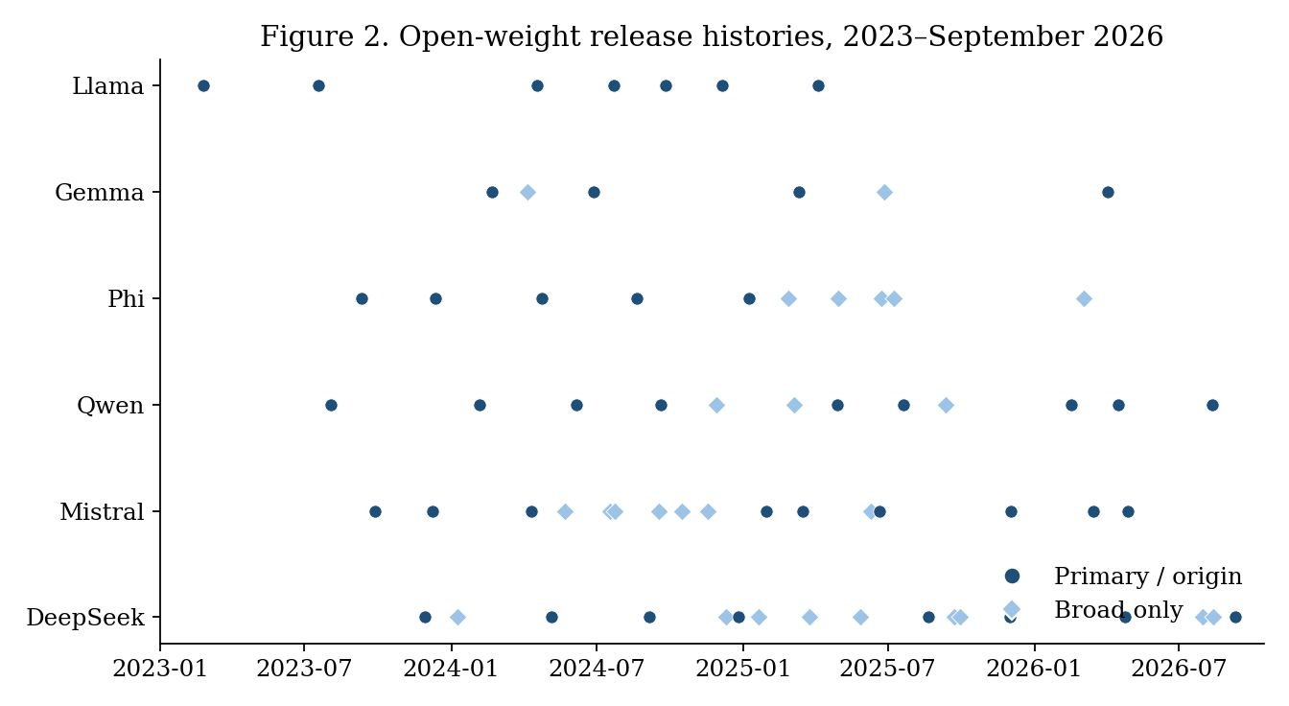
Figure 2. Open-weight release histories, 2023–September 2026. Filled circles are primary or origin releases; diamonds are counted only under the broad definition.

3.3 Stylized fact 2: recovery falls sharply with upgrade size
We measured recovery on five open model pairs that share a tokenizer. For each pair, a rank-8 adapter was trained on the source model, retrained on the target, copied, and transferred with a calibration method that reduces to copy as its regularization diverges (Online Appendix C). Each pair was run with five seeds, which resample the training and calibration rows and the training order. After the two small Pythia continued-training upgrades, copy recovered 0.948 and 0.923 of the retraining gain (means of five seeds, with 95% intervals of [0.93, 0.97] and [0.90, 0.94]). After the large Pythia upgrade, copy recovered 0.404 (95% interval [0.31, 0.50]) and the calibration method 0.725 ([0.64, 0.81]), and the calibration method beat copy in all five seeds. Base-to-instruct upgrades fell in between, with copy at 0.73 to 0.75 and a gain from the calibration method of at most 0.04. The compute-only cost ratios of the calibration method were 0.35 to 0.61 of retraining; they overstate the economic ratio because they leave out data acquisition and revalidation. Small upgrades therefore look like high-$R$ free copy, whereas large upgrades open a gap that a costly method can fill if and only if its cost is below $Γ$.
We repeated the design on five pairs of larger models (1.4B to 3B parameters, with five seeds, or four for the 3B pair; Online Appendix C, Table C.2). Recovery still falls with the size of the upgrade, but much less. Copy recovered 0.987 [0.95, 1.03] after the small Pythia-1.4B upgrade and 0.786 [0.72, 0.85] after the large one, against 0.40 for the 160M model. The calibration method improved on copy by at most 0.03 in the Pythia pairs and by 0.01 for Qwen2.5-1.5B, and it did not improve on copy for Qwen2.5-3B. Base-to-instruct pairs varied widely: copy recovered 0.81 for Qwen2.5-1.5B and 0.65 for Qwen2.5-3B, while for SmolLM2-1.7B copying left the adapter worse than no adapter at all (negative recovery), because the instruct model already scores well without one and the retraining gain is small (0.08 nats). The room for cost savings thus depends on both the size of the upgrade and the scale of the model, and in our sample it is small for the larger models. That is the regime in which the model recommends free copy.
Other tasks. We repeated the design on two further tasks, summarization (DialogSum) and text-to-SQL (Online Appendix C, Table C.3). For the small continued-training upgrades of the 160M model, copy again recovered 91 to 97 percent on both tasks, so the default of copying holds across tasks. After the large upgrade, the recovery of copy varied with the task (0.40 for math reasoning, 0.35 for summarization, and 0.67 for SQL), while the calibration method added a similar 0.28 to 0.32 on each. That gain is large enough for $Γ$ to exceed the reference cost ratio of 0.36 on two of the three tasks (0.45 and 0.82) and is borderline on the third (0.356). In the larger models the picture depends on the task. After the large Pythia-1.4B upgrade, copy recovered 0.99 on SQL and 0.79 on math reasoning but only 0.12 on summarization (three seeds, with an interval that spans zero), where the calibration method reached 0.28. For base-to-instruct pairs on summarization, copy recovered between $−0.06$ and 0.63, and the calibration method never improved on it reliably. These are the cases in which the model recommends retraining, since copy is of little use and no tool helps.

4. Microfoundation: The Firm’s Maintenance Option
Let $k\left(R\right)=\left(1−R\right)/\left(ρ+μ−g\right)$ be the expected present-value multiplier on the flow lost until Poisson expiry. The underlying asset of the retraining option is $k\left(R\right)v$, its strike is $C_{N}$, and it expires at the next upgrade. Let $β>1$ be the positive root of $1/2σ^{2}β\left(β−1\right)+gβ−\left(ρ+μ\right)=0$.
Proposition 1 (Maintenance option). (a) For a firm operating at recovery $R<1$, it is optimal to retrain the first time $v$ reaches
$$v^{*}\left(R\right)=\frac{β}{β−1} \frac{C_{N}}{k\left(R\right)}.$$
For $v<v^{*}$ the option value is $F\left(v\right)=\left(kv^{*}−C_{N}\right){\left(v/v^{*}\right)}^{β}$. (b) $v^{*}\left(R\right)$ is increasing in $R$, in $μ$, and in $σ$, and strictly exceeds the NPV threshold $C_{N}/k\left(R\right)$.
At $ρ=0.10$, $g=0.20$, $σ=0.40$, and $μ=2$, one has $β≈4.43$ and $β/\left(β−1\right)≈1.29$. Write $W_{j}\left(v\right)$ for the expected total cost of transferring with method $j$ and then following the optimal retraining rule. For $v<v_{j}^{*}$, $W_{j}\left(v\right)=C_{j}+k_{j}v−F_{j}\left(v\right)$; otherwise $W_{j}\left(v\right)=C_{j}+C_{N}$.
Proposition 2 (Copy dominance and the costly-transfer band). (a) For all $v$, $W_{C}\left(v\right)≤C_{N}$, with equality only on $v≥v_{C}^{*}$. Immediate retraining is therefore optimal only above the copy threshold. (b) A method $A$ with $R_{A}>R_{C}$ has a nonempty set of $v$ at which it is uniquely optimal only if $C_{A}<Γ\left(R_{A},R_{C}\right)$, the maximum reduction in expected cost that $A$ can deliver relative to copy and to immediate retraining. That set, when it exists, lies strictly between the copy region and the immediate-retraining region.
Family | $\hat{μ}$ | $v^{*}$ copy | $v^{*}$ transfer | Transfer-optimal band | $Γ$
Gemma | 1.15 | 3.50 | 6.90 | 0.25 to 5.66 | 0.38
Phi | 1.31 | 3.91 | 7.72 | 0.29 to 6.37 | 0.39
Llama | 1.67 | 4.84 | 9.55 | 0.37 to 7.95 | 0.40
DeepSeek | 2.47 | 6.87 | 13.55 | 0.56 to 11.49 | 0.42
Qwen | 2.54 | 7.05 | 13.90 | 0.57 to 11.77 | 0.42
Mistral | 2.66 | 7.35 | 14.49 | 0.60 to 12.33 | 0.42
Table 4. Firm policy regions at family-specific $μ$ ($R_{\text{copy}}=0.57$, $R_{\text{transfer}}=0.78$, $C_{A}=0.05 C_{N}$).
The platform a firm has already chosen is itself an input to the maintenance rule. When we feed the measured $\left(R,C\right)$ pairs of the five smaller pairs into the same formulas, an actual transfer-optimal region appears only for the large Pythia upgrade. There the bound is $Γ=0.45$ at the seed-mean recovery rates, above the compute-only cost ratio of 0.36, and the transfer-optimal band is $v∈\left[2.2,4.5\right]$ in units of retraining cost. The ordering is the same in each of the five seeds ($Γ$ between 0.37 and 0.50), but it is sensitive to measurement error: at the least favorable corner of the two 95% intervals, $Γ=0.22$, which is below the cost ratio. For the two small upgrades and the two base-to-instruct pairs, $Γ$ lies between 0 and 0.12 and no costly method has a market. For the larger models, $Γ$ is about 0.07 for Pythia-1.4B after the large upgrade, about 0.04 for Qwen2.5-1.5B, and zero for Qwen2.5-3B and SmolLM2-1.7B; after the small Pythia-1.4B upgrade both methods recover essentially everything and $Γ$ is uninformative. With any plausible cost ratio, such as the 0.36 measured for the 160M models, no costly method pays in the larger models on math reasoning or SQL. Free copy suffices there, as Proposition 2(a) predicts. Across all 24 pair-task combinations, a costly method pays in two (the large upgrade of the 160M model on math reasoning and on SQL), and a third is borderline.

5. A Monopoly Platform Owner Chooses Cadence and Compatibility
To keep the owner’s problem tractable we use the static limit $σ=g=0$ of Section 4, in which the retraining threshold collapses to $\hat{v}=C_{N}\left(ρ+μ\right)/\left(1−R\right)$. Section 7.4 re-optimizes the owner’s problem with the dynamic threshold inside the burden function.
A mass $n$ of firms each operate one adapter. Their values $v$ are constant and distributed with c.d.f. $F$. Each upgrade permanently raises every firm’s flow by $δ$, and we write $b=δ/ρ^{2}$ for the present value of a unit intensity of such gains. A firm retrains if and only if $v≥\hat{v}$. The present value of a cost $w$ incurred at every Poisson upgrade is $\left(μ/ρ\right)w$, so the maintenance burden $m\left(μ,v;R\right)$ is $μC_{N}/ρ$ for retraining firms and $\left(1−R\right)vμ/\left[ρ\left(ρ+μ\right)\right]$ for transferring firms. Net surplus is $s\left(μ,v;R\right)=bμ−m\left(μ,v;R\right)$.
The burden of a transferring firm is concave in $μ$ and saturates at $\left(1−R\right)v/ρ$, whereas the burden of a retraining firm is linear and unbounded. A retraining firm is therefore harmed by more frequent releases whenever $b<C_{N}/ρ$.
The owner earns a direct return $ψμ$ from the general market, bears a development cost $1/2cμ^{2}$, and captures a share $θ∈(0,1]$ of expected enterprise surplus. The planner has the same objective with $θ=1$.
Proposition 3 (Cadence and over-release). (a) The owner’s intensity $μ_{V}$ solves $ψ−cμ+θn \left(b−∂E\left[m\right]/∂μ\right)=0$. Movement of $\hat{v}$ has no first-order effect on $E\left[m\right]$ because the two options have equal burden at $\hat{v}$. Under $v∼U\left[0,\overset{‾}{v}\right]$ with some retraining and $κ\left(ρ+μ\right)≤1$,
$$E\left[m\right]=\frac{μC_{N}}{ρ}\left(1−\frac{κ\left(ρ+μ\right)}{2}\right), κ=\frac{C_{N}}{\left(1−R\right)\overset{‾}{v}},$$
and $μ_{V}=\left(ψ+θX\right)/\left(c−θY\right)$ with $X=n\left[b−\left(C_{N}/ρ\right)\left(1−κρ/2\right)\right]$ and $Y=nC_{N}κ/ρ$, provided $c>θY$. (b) If the planner’s objective is concave, $μ_{V}>μ_{P}$ if and only if $E\left[s_{μ}\left(μ_{V},v\right)\right]<0$, that is, if and only if the average customer is harmed at the margin. Under the uniform specification this is equivalent to $cX+ψY<0$. Because $κ$ rises with $R$, better transfer shrinks the region of over-release.
Proposition 4 (Complementarity and distribution). Suppose $F$ puts positive mass on both sides of $\hat{v}$, so that some firms transfer and some retrain. (a) Strategic complementarity: $dμ_{V}/dR>0$ for any such $F$. If all firms retrain or all transfer, $R$ has no effect on the owner’s problem and $dμ_{V}/dR=0$. (b) Distribution: a small increase in $R$ has a direct effect and a cadence effect. A firm that retrains before and after the change has no direct effect; if $b<C_{N}/ρ$ it is made strictly worse off. A transferring firm with $v→0$ gains from both effects. In the over-release region the cadence effect is negative on average, so mean surplus can fall even as $R$ improves.
Easier transfer lowers the marginal burden of a release. The owner internalizes the share $θ$ of that reduction and therefore releases more often, while the firms that cannot use the tool bear the faster clock.
$R$ | $μ_{V}$ | $μ_{P}$ | Retrain boundary | Over-release?
0.3 | 2.48 | 1.84 | 3.68 | Yes
0.5 | 2.58 | 2.02 | 5.36 | Yes
0.7 | 2.86 | 2.61 | 9.85 | Yes
0.8 | 3.30 | 4.08 | 16.98 | No
Table 5. Monopoly intensity by recovery rate ($ρ=0.10$, $C_{N}=1$, $v∼U\left[0,40\right]$, $b=7$, $ψ=6$, $c=2$, $θ=0.5$).
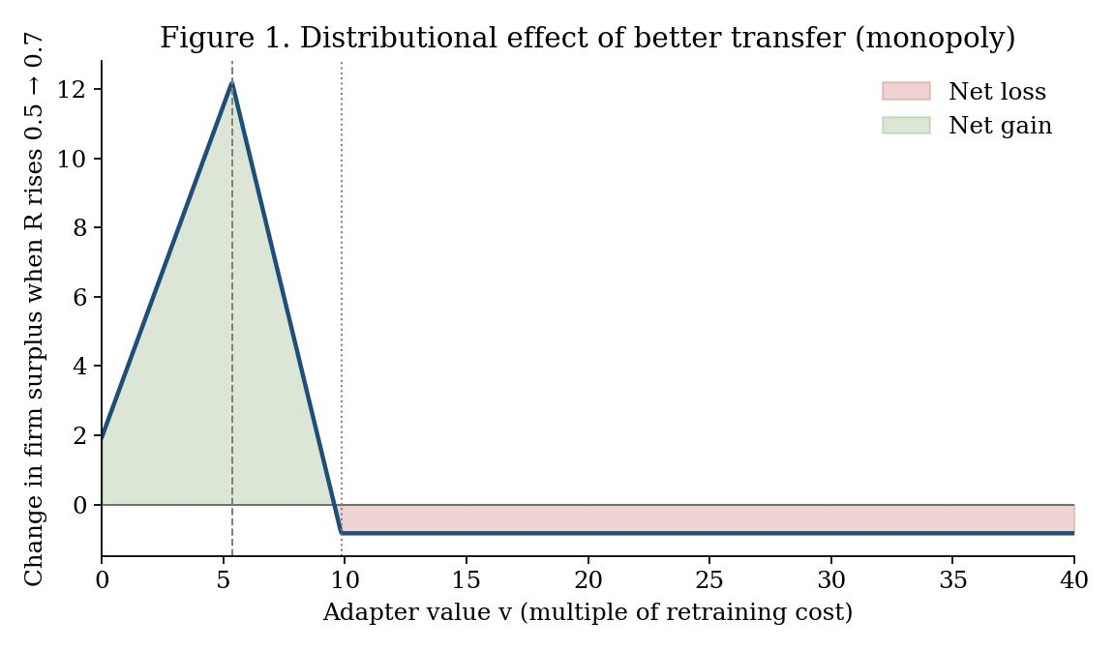
Figure 1. Change in firm surplus when $R$ rises from 0.5 to 0.7 under the monopoly best response. Retraining firms with $v≳9.57$ lose through the cadence effect.
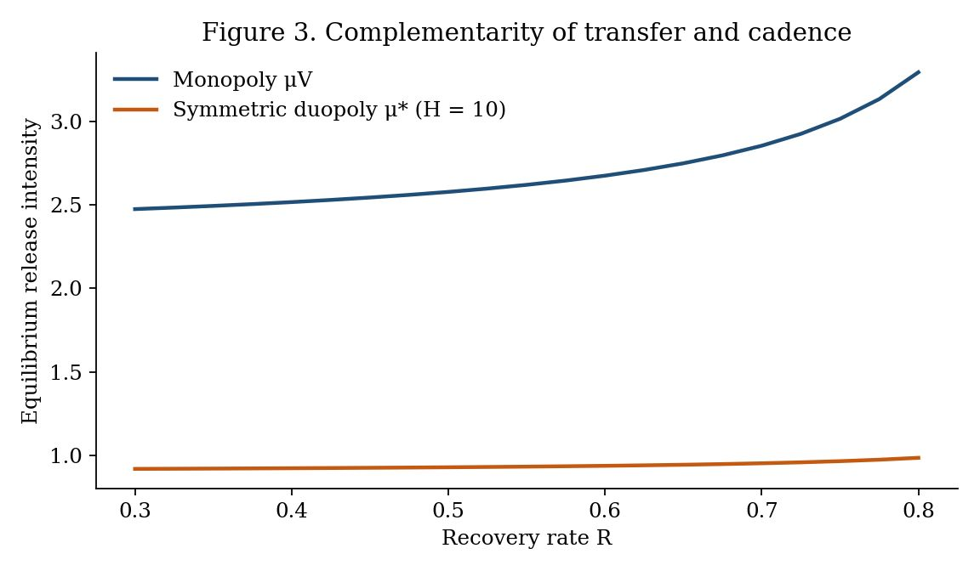
Figure 3. Equilibrium intensity as a function of $R$. Complementarity is positive under both monopoly and symmetric duopoly; the slope is an order of magnitude flatter under competition.

6. Competing Platform Owners and the One-Third Rule
Owners first choose intensities (and, later, compatibilities) simultaneously and then set enterprise prices; firms then choose an owner and stay with it. A firm of value $v$ obtains $s\left(μ_{i},v;R_{i}\right)−p_{i}+ηε_{i}$ from owner $i$, where the $ε_{i}$ are i.i.d. Gumbel. A general-market prize $H$ is split by a Tullock contest (Tullock 1980) in intensities. Let $a≥0$ denote the planner’s marginal valuation of the general-market benefit of intensity.
Proposition 5 (One-third rule and efficiency). Let $R$ be exogenous and common. In a symmetric subgame-perfect equilibrium, (a) prices are $p^{*}=2η$, independent of $μ$ and $R$; (b) $μ^{*}$ satisfies $\frac{H}{4μ^{*}}+\frac{n}{3}E\left[s_{μ}\right]−cμ^{*}=0$; (c) each owner internalizes the marginal change in enterprise surplus with weight exactly one-third, regardless of $η$ and of $F$. (d) If the planner’s objective is concave, the symmetric equilibrium over-releases if and only if $a+\left(n/6\right)E\left[s_{μ}\right]−H/\left(4μ^{*}\right)<0$. Over-release has two sources: rent-seeking in the race and under-internalization of enterprise surplus (weight 1/3 against the planner’s per-owner weight 1/2).
Proposition 6 (Complementarity under competition). Under the condition of Proposition 4, $dμ^{*}/dR>0$ in the symmetric equilibrium. If $b<C_{N}/ρ$, firms that keep retraining lose when $R$ improves. Evaluated at the same $μ$, the rebound $dμ^{*}/dR$ is smaller than the monopoly rebound whenever $θ≥1/3$.
Raising $R$ from 0.5 to 0.7 raises $μ^{*}$ only from 0.928 to 0.952, against 2.58 to 2.86 under monopoly.
Numerical Finding 1 (Differentiation). Suppose each owner also chooses $R_{i}$ at cost $Z\left(R\right)=zR^{2}/\left(1−R\right)$. The symmetric candidate is an equilibrium when the race is weak and fails when it is of intermediate intensity. In the latter case an asymmetric equilibrium appears, with a frontier owner that is fast and compatible and a stable owner that is slow and sparse. Mid-value transferring firms sort to the frontier owner, while the highest-value retraining firms lean toward the stable owner. When the race is very intense, both owners become fast and compatible. This is a grid-search finding at one parameterization rather than a theorem, and multiple equilibria exist at some values of $H$.
With $z=0.1$ and $η=10$, the asymmetric pair at $H=20$ is approximately $\left(μ,R\right)=\left(2.50,0.96\right)$ versus $\left(1.38,0.08\right)$. Prices in this illustration are 26.4 and 17.3, and mean customer value is 18.2 on the frontier platform and 22.8 on the stable platform.
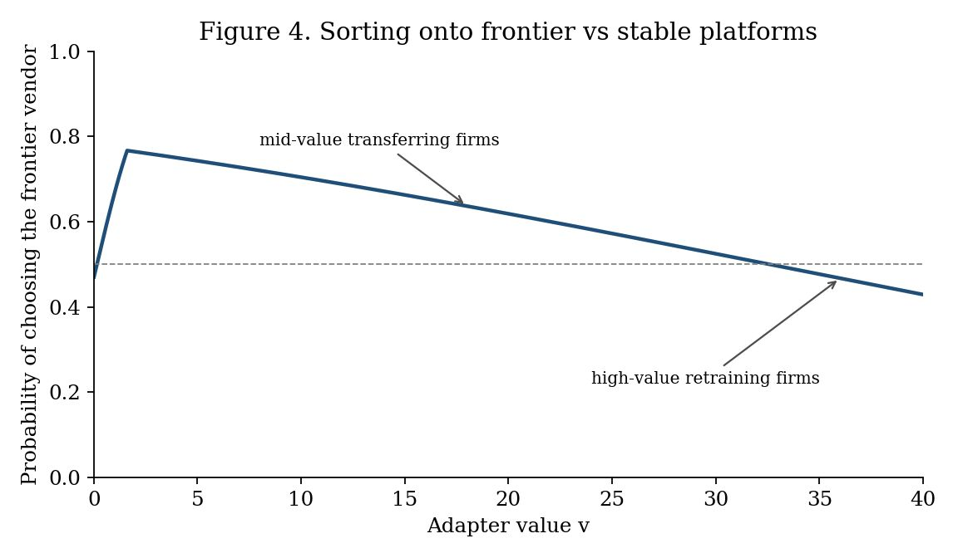
Figure 4. Logit probability of choosing the frontier owner in the $H=20$ asymmetric illustration. Mid-value firms lean frontier; high-value retraining firms lean stable.

7. Robustness and Extensions

7.1 Regular arrivals
Replace the exponential epoch length by a gamma law matched to each family’s mean gap and coefficient of variation, or by a deterministic gap. The loss multiplier $E​\left[\int_{0}^{τ}{e^{−\left(ρ−g\right)t}}dt\right]$ is 1 to 4 percent smaller than under Poisson (gamma-to-Poisson ratios of 0.96 to 0.99), so the average burden barely moves. What regularity changes is timing: with a predictable release, the retraining threshold should rise as the date approaches (Rajagopalan 1999). The time-homogeneous $v^{*}$ should therefore be read as an average over the epoch.
Family | CV | Gamma / Poisson | Deterministic / Poisson
Gemma | 0.50 | 0.965 | 0.954
Phi | 0.18 | 0.961 | 0.960
Llama | 0.61 | 0.980 | 0.969
Qwen | 0.44 | 0.984 | 0.980
Mistral | 0.70 | 0.990 | 0.981
DeepSeek | 0.31 | 0.981 | 0.979
Pooled | 0.46 | 0.979 | 0.974
Table 6. Loss-multiplier ratio versus Poisson ($ρ=0.10$, $g=0.20$).

7.2 Threshold loss
Suppose the adapter creates value only above a quality floor $R_{min}$, so that effective recovery is 0 when $R<R_{min}$ and $R$ otherwise. Then $k$ and $v^{*}$ jump when a method crosses the floor. A large upgrade that drops copy below the floor but leaves a costly method above it widens $Γ$. Linear loss thus understates the value of transfer exactly when the upgrade is large. It does not overturn the weak dominance of copy when copy itself stays above the floor.

7.3 A two-period switching extension
Section 6 assumes that a firm stays with its first owner. Consider a two-period variant in which owners choose $\left(μ_{i},R_{i}\right)$ and prices in period 0 and firms then choose an owner. After the first upgrade, a firm may switch at a cost $ω\left(R_{\text{from}},R_{\text{to}}\right)$, which we interpret as the labor of rebuilding the complementary asset on the rival stack. A transfer technology that is stack-agnostic lowers $ω$.
Write $V_{i}\left(v\right)$ for the period-1 continuation value, including the option to switch. The period-0 choice probability remains logit in $s\left(μ_{i},v;R_{i}\right)−p_{i}+E\left[V_{i}\left(v\right)\right]$. Two first-order effects follow without solving the full game.
Portability intensifies price competition. A lower $ω$ raises the elasticity of period-0 demand with respect to period-1 quality and price, because the period-1 outside option is closer. In the logit model this amounts to a fall in the effective $η$ on the continuation component. Symmetric prices fall below $2η$ once continuation is included, and customers capture more of any quality gain.
Portability reduces the return to compatibility investment. The demand derivative $∂D_{i}/∂R_{i}$ splits into an own-customer maintenance effect (the channel of Section 5) and a switching-in effect. The second is business-stealing: in a symmetric equilibrium it is a transfer and does not enter welfare, but it does enter the owner’s private return to $R$. As $ω→0$, differentiation in $R$ cannot support a price gap, so $Z′\left(R\right)$ becomes harder to recoup. Compatibility investment therefore falls even though the social return to $R$, a lower maintenance burden, remains.
The one-third weight is consequently an upper bound on under-internalization only inside the no-switching game. Treating transfer purely as a maintenance tool and ignoring portability would overstate the case for owner-provided compatibility as a customer-friendly investment. We do not claim a closed-form analogue of Proposition 5 under switching.

7.4 Owner’s first-order condition with the dynamic threshold
Replace $\hat{v}$ by $v^{*}\left(R;μ\right)$ inside the static present-value arithmetic and re-optimize $ψμ−1/2cμ^{2}+θn\left(bμ−E\left[m\right]\right)$. The result is still a proxy, because the firm’s option value is not the full infinite-horizon object, but it lets the owner respond to a threshold that depends on $μ$.
$R$ | $μ_{V}$ static | $μ_{V}$ dynamic proxy | $μ_{P}$ static | $μ_{P}$ dynamic proxy
0.3 | 2.475 | 2.472 | 1.837 | 1.830
0.5 | 2.579 | 2.574 | 2.017 | 2.005
0.7 | 2.855 | 2.846 | 2.607 | 2.582
0.8 | 3.295 | 3.279 | 4.083 | 4.024
Table 7. Owner intensity: static cutoff versus dynamic-threshold proxy.
Intensities move by less than one percent. The slope $dμ_{V}/dR$ from $R=0.3$ to $0.7$ is 0.95 under the static cutoff and 0.93 under the proxy, so complementarity is not an artifact of dropping volatility. Finite-difference estimates of $∂^{2}E\left[m\right]/∂μ ∂R$ at $\left(R,μ\right)=\left(0.5,2\right)$ equal $−2.05$ (static) and $−2.02$ (proxy).

7.5 Logit specificity of one-third
The one-third weight rests on two logit facts: the own-price markup $p=2η$ at the symmetric point, and the way a quality shock splits, one-third into price and one-third into share. Under Hotelling competition the analogous weight differs, and pure-strategy price equilibria fail when $η$ is small relative to value heterogeneity. The rule should be read as follows: competing owners internalize a constant that is strictly less than one-half, and in the standard discrete-choice workhorse that constant is one-third.

7.6 Parameter grid and alternative value distributions
The numerical illustrations use one parameter vector and uniformly distributed values. To check that Propositions 3 and 4 do not depend on these choices, we solved the monopoly problem on a grid of $ρ∈\{0.05,0.10,0.20\}$, $b∈\{2,4,7,10,14\}$, $ψ∈\{0,3,6,9\}$, $c∈\{1,2,4\}$, $θ∈\{0.25,0.5,0.75\}$ and $R∈\{0.1,0.3,0.5,0.7,0.8\}$, under six value distributions with the same mean as $U\left[0,40\right]$ (uniform, exponential, gamma with shape 3, lognormal with $s=0.5$ and $s=1$, and Pareto with tail index 2.5). The code reproduces Tables 5 and 7 (static columns) exactly. Of the 16,200 cells, 6,505 satisfy the hypotheses of the propositions, namely that the owner’s and the planner’s objectives are globally concave on the grid and both have interior maximizers (Appendix F gives the breakdown). Three results follow. First, strategic complementarity (Proposition 4a) holds in all of these cells: $dμ_{V}/dR>0$ in 5,212 cells, equals zero in 392, and is negative in none. In every zero cell essentially no firm transfers (the threshold $\hat{v}$ lies below the support of $F$, or the mass below it is at most $4×{10}^{−8}$), which is the degenerate case excluded in the statement of Proposition 4. Second, the over-release criterion of Proposition 3(b), $E\left[s_{μ}\left(μ_{V}\right)\right]<0$, agrees with the direct comparison of $μ_{V}$ and $μ_{P}$ in all 6,505 cells, including 31 exact ties at $μ_{V}=μ_{P}$. Third, over-release does not depend on one parameter vector. It occurs in 23 to 34 percent of the valid cells, depending on the distribution, and in the uniform case it arises when $b$ is below roughly $C_{N}/ρ$ (Figure 5b), the region in which firms that retrain are harmed at the margin.
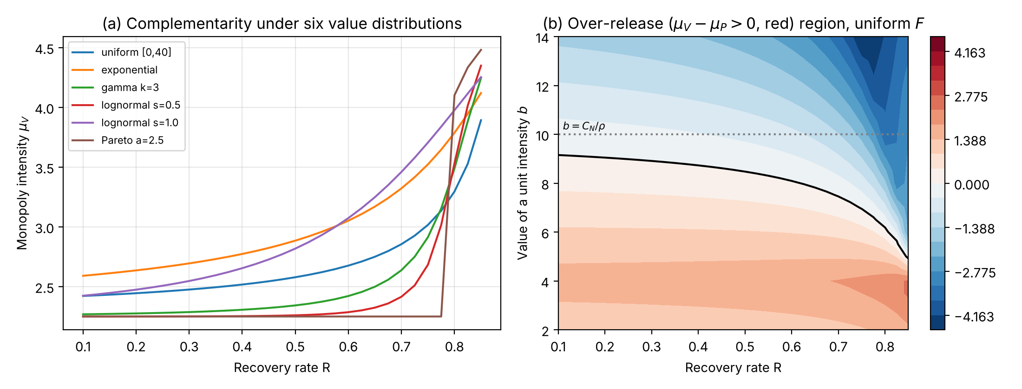
Figure 5. Robustness of the monopoly results. (a) Equilibrium intensity as a function of $R$ under six value distributions with common mean (baseline parameters $ρ=0.10$, $b=7$, $ψ=6$, $c=2$, $θ=0.5$). (b) Difference between owner and planner intensity for uniform $F$; the black line is the over-release boundary.

8. Implications for Research and Practice

8.1 Implications for research
Post-adoption IS value. The real-options view of IT platforms has concentrated on when to adopt. Our results show that the maintenance decision has an option structure of its own: a free partial transfer (copy) rules out blanket retraining, and a costly tool survives only in a bounded intermediate band. Empirical work on the value of IT assets should therefore measure recovery under upgrades and not only the timing of adoption.
Platform governance. Release cadence and compatibility support are governance instruments that the platform owner sets jointly, and the provision of boundary resources (Ghazawneh and Henfridsson 2013) should be modeled as endogenous to platform evolution rather than as a fixed offer. Treating the two separately misses their complementarity and the distributional consequence that follows. One testable implication is that announcements of migration or compatibility tooling should be followed by higher release frequency across platforms, and another is that customers with the highest-value retrained assets should be the most likely to object.
Platform competition. Platforms can separate on the speed–compatibility bundle, and customers sort across them by asset value. Studies of platform choice should therefore consider heterogeneity at the level of the asset as well as at the level of the customer.

8.2 Implications for practice
The model’s main practical prescription is a default: when free copy recovers most of the value, copy. Five implications follow that do not depend on any named transfer algorithm.
- Default to free copy. Reuse the existing adapter on the new base model first. By Proposition 2(a), this weakly dominates immediate retraining for every asset value, because the right to retrain later is kept. In our measurements copy recovered 91 to 99 percent of the retraining gain after small upgrades on all three tasks, which leaves little for any costly method to add. The default is only a first step, however, and copy recovery should be measured on a sample of adapters. After large upgrades it ranged from 12 to 99 percent, depending on the task and the model. The copied adapter should also be compared with running the new model without an adapter: for SmolLM2-1.7B the copy was worse than no adapter, and the right default there is the base model.
- Retrain only above the threshold, and not at every upgrade. Retraining is optimal only for assets whose value exceeds $v^{*}$, which is higher than the NPV threshold and rises with upgrade intensity and volatility (Proposition 1). The portfolio should be triaged by value relative to retraining cost, with the platform’s estimated $μ$ setting the boundaries: copy below a high cutoff and retrain above it.
- Buy transfer tools only against a measured $Γ$. A costly tool can pay only in an intermediate band of values, and only when its measured cost satisfies $C_{A}<Γ\left(R_{A},R_{C}\right)$. That inequality failed in 22 of the 24 pair-task combinations we tested (for the larger pairs against the cost ratio of 0.36 measured on the smaller models, since we did not measure CPU costs at that scale). It held for the large upgrade of a 160M-parameter model on two tasks, where copy recovered 40 and 67 percent. Copy should be tested first on a sample of adapters, and if it already recovers most of the gain, the tool should not be bought. If copy recovers little and the tool does not beat it by more than its cost, the assets above $v^{*}$ should be retrained instead.
- Treat cadence as part of procurement. Owner-provided migration tools should be expected to arrive with faster releases (Proposition 4a). Owners of the highest-value assets, who retrain anyway, can be made worse off by those tools, and for such assets a contractual cap on release frequency or a long-term-support line can be worth more than a better converter.
- Segment and time. If owners separate into frontier and stable platforms, high-value and regulated adapters belong on the stable line and mid-value adapters on the frontier line. When the next dated release is near, retraining of adapters that sit close to $v^{*}$ should be deferred.

8.3 Limitations and future research
We take value to be linear in $R$. The owner’s problem is solved in the static limit, with a dynamic-threshold proxy in Section 7.4; the asymmetric compatibility equilibrium is numerical; the switching game is characterized only to first order; and open lines can be discontinued. The recovery measurements are small in scale (160M to 3B parameters, three tasks, three to five seeds, float32 on one GPU, and only two pairs of larger models on the two added tasks). The first empirical priority is to estimate $\left(g,σ\right)$ from service logs and to compile a historical cost accounting of copy versus retrain-every-time on a real adapter portfolio. A natural field-data test of Proposition 4(a) is whether the introduction of owner-provided migration tooling predicts a subsequent change in release frequency.

9. Conclusion
The practical message of the paper is a default, free copy, and its theoretical claim is not that any particular converter is optimal. The claim is that complementary assets on an evolving platform create a maintenance option; that a free partial transfer already rules out blanket retraining; that a costly converter has a market only in a bounded intermediate band; and that the platform owner, facing that band, will use improvements in the converter to go faster. Competing owners internalize a fixed fraction of the resulting change in customer surplus, which is one-third in the logit workhorse. Platforms are not only bundles of options for adopters (Fichman 2004); they are also the agents that choose how fast those options expire.

References
Armstrong M (2006) Competition in two-sided markets. RAND J. Econom. 37(3):668–691.
Benaroch M (2001) Option-based management of technology investment risk. IEEE Trans. Engrg. Management 48(4):428–444.
Benaroch M, Kauffman RJ (1999) A case for using real options pricing analysis to evaluate information technology project investments. Inform. Systems Res. 10(1):70–86.
Dixit AK, Pindyck RS (1994) Investment Under Uncertainty (Princeton University Press, Princeton, NJ).
Dos Santos BL (1991) Justifying investments in new information technologies. J. Management Inform. Systems 7(4):71–89.
Farhadzadeh F, Das D, Borse S, Porikli F (2025a) LoRA-X: Bridging foundation models with training-free cross-model adaptation. Proc. 13th Internat. Conf. Learn. Representations.
Farhadzadeh F, Das D, Borse S, Porikli F (2025b) Zero-shot adaptation of parameter-efficient fine-tuning in diffusion models. Proc. 42nd Internat. Conf. Machine Learn., PMLR 267:16144–16160.
Farrell J, Saloner G (1985) Standardization, compatibility, and innovation. RAND J. Econom. 16(1):70–83.
Fichman RG (2004) Real options and IT platform adoption: Implications for theory and practice. Inform. Systems Res. 15(2):132–154.
Ghazawneh A, Henfridsson O (2013) Balancing platform control and external contribution in third-party development: The boundary resources model. Inform. Systems J. 23(2):173–192.
Grenadier SR, Weiss AM (1997) Investment in technological innovations: An option pricing approach. J. Financial Econom. 44(3):397–416.
Hochlehnert A, Liu D, Niehues J, Kumar S, Stahlberg F (2026) On the importance of trivial baselines: Re-evaluating LoRA adapter transfer for generative tasks. Proc. 43rd Internat. Conf. Machine Learn.
Kamrad B, Schmidt GM, Ulku S (2013) Analyzing product architecture under technological change: Modular upgradeability tradeoffs. IEEE Trans. Engrg. Management 60(2):289–300.
Katz ML, Shapiro C (1985) Network externalities, competition, and compatibility. Amer. Econom. Rev. 75(3):424–440.
Kauffman RJ, Li X (2005) Technology competition and optimal investment timing: A real options perspective. IEEE Trans. Engrg. Management 52(1):15–29.
Li Y, Meng F, Zhang M, Zhu S, Wang S, Xu M (2025) LoRASuite: Efficient LoRA adaptation across large language model upgrades. Adv. Neural Inform. Processing Systems 38.
Mahadevan A, Mathioudakis M (2023) Cost-effective retraining of machine learning models. Working paper, arXiv:2310.04216.
McDonald R, Siegel D (1986) The value of waiting to invest. Quart. J. Econom. 101(4):707–727.
Milgrom P, Shannon C (1994) Monotone comparative statics. Econometrica 62(1):157–180.
Parker G, Van Alstyne M (2018) Innovation, openness, and platform control. Management Sci. 64(7):3015–3032.
Rajagopalan S (1999) Adoption timing of new equipment with another innovation anticipated. IEEE Trans. Engrg. Management 46(1):14–25.
Regol F, Schwinn L, Sprague K, Coates M, Markovich T (2025) When to retrain a machine learning model. Proc. 42nd Internat. Conf. Machine Learn., PMLR 267.
Rochet J-C, Tirole J (2003) Platform competition in two-sided markets. J. Eur. Econom. Assoc. 1(4):990–1029.
Santiago LP, Bifano TG (2005) Management of R&D projects under uncertainty. IEEE Trans. Engrg. Management 52(2):269–280.
Shaked A, Sutton J (1982) Relaxing price competition through product differentiation. Rev. Econom. Stud. 49(1):3–13.
Swanson EB (1976) The dimensions of maintenance. Proc. 2nd Internat. Conf. Software Engrg. (IEEE Computer Society Press, Los Alamitos, CA), 492–497.
Taudes A, Feurstein M, Mild A (2000) Options analysis of software platform decisions: A case study. MIS Quart. 24(2):227–243.
Tewari G (2026) Pilot early, commit late: A real-options model of enterprise AI adoption under rapid technological progress. Working paper, arXiv:2609.15919.
Tiwana A, Konsynski B, Bush AA (2010) Platform evolution: Coevolution of platform architecture, governance, and environmental dynamics. Inform. Systems Res. 21(4):675–687.
Tullock G (1980) Efficient rent seeking. Buchanan JM, Tollison RD, Tullock G, eds. Toward a Theory of the Rent-Seeking Society (Texas A&M University Press, College Station), 97–112.
Wang R, Ghosh S, Cox D, Antognini D, Oliva A, Feris R, Karlinsky L (2024) Trans-LoRA: Towards data-free transferable parameter efficient finetuning. Adv. Neural Inform. Processing Systems 37.
Xia F, Liao M, Fang Y, Li D, Xie Y, Li W, Li Y, Xia D, Huang J (2025) Cross-LoRA: A data-free LoRA transfer framework across heterogeneous LLMs. Working paper, arXiv:2508.05232.
Yoo Y, Henfridsson O, Lyytinen K (2010) The new organizing logic of digital innovation: An agenda for information systems research. Inform. Systems Res. 21(4):724–735.

Appendix A. Proofs of Propositions 1 to 6
Proof of Proposition 1. (a) In the continuation region the option satisfies the Bellman equation $ρF=gvF′+1/2σ^{2}v^{2}F″+μ\left(0−F\right)$. The Euler equation is $1/2σ^{2}β\left(β−1\right)+gβ−\left(ρ+μ\right)=0$. Of the two roots, the negative root is discarded by $F\left(0\right)=0$. Value matching $F\left(v^{*}\right)=kv^{*}−C_{N}$ and smooth pasting $F′\left(v^{*}\right)=k$ with $F=Av^{β}$ yield
$$A{\left(v^{*}\right)}^{β}=kv^{*}−C_{N}, Aβ{\left(v^{*}\right)}^{β−1}=k,$$
hence $v^{*}=\left[β/\left(β−1\right)\right] C_{N}/k$. The quadratic identity $ρ+μ−g=\left(β−1\right)\left(g+1/2σ^{2}β\right)$ gives the equivalent writing in terms of $ρ+μ−g$.
- Since $v^{*}=h\left(K\right) C_{N}/\left(1−R\right)$ with $K=ρ+μ$ and $h\left(K\right)=\left(K−g\right)β/\left(β−1\right)$: (i) $v^{*}$ is proportional to $1/\left(1−R\right)$, hence increasing in $R$. (ii) By the implicit function theorem $β′\left(K\right)=1/Q′\left(β\right)$ with $Q′\left(β\right)=\left(g+1/2σ^{2}β\right)+1/2σ^{2}\left(β−1\right)>0$. Substituting $K−g=\left(β−1\right)\left(g+1/2σ^{2}β\right)$ shows $h′\left(K\right)>0$, so $v^{*}$ is increasing in $μ$. (iii) At any fixed $β>1$, $Q$ is increasing in $σ$ and $Q′>0$ at the root, so $β$ is decreasing in $σ$. Since $β/\left(β−1\right)$ is decreasing in $β$, the threshold increases in $σ$. (iv) $β/\left(β−1\right)>1$ gives the strict excess over the NPV threshold. $▫$
Proof of Proposition 2. (a) An option is worth at least its immediate exercise value, so $F_{C}\left(v\right)≥k_{C}v−C_{N}$, that is $W_{C}\left(v\right)≤C_{N}$. Equality holds only on $v≥v_{C}^{*}$. (b) Any $v$ at which $A$ is uniquely optimal must satisfy $W_{A}\left(v\right)<min\{W_{C}\left(v\right),C_{N}\}$. Because $W_{A}\left(v\right)=C_{A}+\left(k_{A}v−F_{A}\left(v\right)\right)$, the highest $C_{A}$ that can satisfy the inequality for some $v$ is
$$Γ=\sup_{v}\left(min\{W_{C}\left(v\right),C_{N}\}−\left(k_{A}v−F_{A}\left(v\right)\right)\right).$$
The optimizer cannot lie in $v≥v_{C}^{*}$, where both copy and immediate retraining cost $C_{N}$ and $W_{A}≥C_{A}$, nor at $v=0$, where $W_{A}=C_{A}>W_{C}=0$ whenever $C_{A}>0$. Hence the $A$-region, when nonempty, is intermediate. $▫$
Proof of Proposition 3. (a) The owner’s first-order condition is $ψ−cμ+θn\left(b−∂E\left[m\right]/∂μ\right)=0$. At $\hat{v}$ the two instruments have equal burden, so the Leibniz term from moving $\hat{v}$ vanishes. Under the uniform law with $κ\left(ρ+μ\right)≤1$,
$$E\left[m\right]=\int_{0}^{\hat{v}}{\frac{\left(1−R\right)vμ}{ρ\left(ρ+μ\right)}}\frac{dv}{\overset{‾}{v}}+\int_{\hat{v}}^{\overset{‾}{v}}{\frac{μC_{N}}{ρ}}\frac{dv}{\overset{‾}{v}}=\frac{μC_{N}}{ρ}\left(1−\frac{κ\left(ρ+μ\right)}{2}\right).$$
Then $∂E\left[m\right]/∂μ=\left(C_{N}/ρ\right)\left(1−κρ/2\right)−μC_{N}κ/ρ$, which produces $X$ and $Y$ and the closed form. Concavity requires $c>θY$.
- Substituting the owner’s first-order condition into the planner’s derivative gives $W′\left(μ_{V}\right)=\left(1−θ\right) n E\left[s_{μ}\left(μ_{V}\right)\right]$, which is negative if and only if $μ_{P}<μ_{V}$ when $W$ is concave. For the uniform case write $μ\left(θ\right)=\left(ψ+θX\right)/\left(c−θY\right)$. Then $dμ/dθ$ has the sign of $cX+ψY$, which does not depend on $θ$. Thus $μ\left(θ\right)>μ\left(1\right)$ for $θ<1$ if and only if $cX+ψY<0$. $▫$
Proof of Proposition 4. (a) $dμ_{V}/dR=−Π_{μR}/Π_{μμ}$ with $Π_{μμ}<0$. Differentiating the first-order condition with respect to $R$,
$$Π_{μR}=−θn⋅\frac{∂^{2}E\left[m\right]}{∂μ ∂R}.$$
The first term in that cross-partial, holding $\hat{v}$ fixed, is negative because a higher $R$ lowers the marginal burden of transferring firms. The second term comes from $∂\hat{v}/∂R=C_{N}\left(ρ+μ\right)/{\left(1−R\right)}^{2}>0$. At $\hat{v}$ a transferring firm’s marginal burden $C_{N}/\left(ρ+μ\right)$ lies below a retraining firm’s $C_{N}/ρ$. Raising $\hat{v}$ therefore replaces a high marginal burden with a lower one, which again lowers $∂E\left[m\right]/∂μ$. Both terms vanish if no firm transfers or no firm retrains. Hence $Π_{μR}>0$ and $dμ_{V}/dR>0$ when $F$ puts mass on both sides of $\hat{v}$.
- Differentiate $s\left(μ_{V}\left(R\right),v;R\right)$ and use part (a). A retraining firm has $∂s/∂R|_{μ}=0$ and $s_{μ}=b−C_{N}/ρ$, which is negative under the maintained condition. A transferring firm with $v→0$ has $s_{μ}→b>0$ and a strictly positive direct effect. Average surplus moves with $E\left[s_{μ}\right] dμ_{V}/dR$ plus the average direct effect; the first term is negative in the over-release region. $▫$
Proof of Proposition 5. (a), (b), (c) At the symmetric point every type chooses each owner with probability $φ\left(v\right)=1/2$, so the price first-order condition $p=ηE\left[φ\right]/E\left[φ\left(1−φ\right)\right]$ gives $p=2η$. Raising $μ_{1}$ slightly gives
$$\frac{∂E\left[φ\right]}{∂μ_{1}}=\frac{E\left[s_{μ}\right]}{4η}, \frac{∂E\left[φ\left(1−φ\right)\right]}{∂μ_{1}}=0.$$
To first order the price subgame responds as if every firm received the same quality advantage $dδ=E\left[s_{μ}\right] dμ_{1}$. In a logit duopoly a quality advantage $dδ$ yields $d\left(p_{1}−p_{2}\right)=\left(2/3\right)dδ$, $dp_{1}=dδ/3$ and $dφ_{1}=dδ/\left(12η\right)$. Enterprise profit therefore changes by $φ dp_{1}+p_{1} dφ_{1}=dδ/3$. The race term contributes $H/\left(4μ\right)$ at the symmetric point.
- At the symmetric point the planner’s marginal welfare per owner is $a+\left(n/2\right)E\left[s_{μ}\right]−cμ$. Substituting $cμ^{*}$ from part (b) gives $a+\left(n/6\right)E\left[s_{μ}\right]−H/\left(4μ^{*}\right)$, which is negative if and only if $μ^{*}>μ_{P}$ when the planner’s objective is concave. $▫$
Proof of Proposition 6. Let $Φ\left(μ,R\right)$ be the left-hand side of the duopoly first-order condition. $Φ_{R}=−\left(n/3\right) ∂^{2}E\left[m\right]/∂μ ∂R>0$ by the proof of Proposition 4. Apply the implicit function theorem with $Φ_{μ}<0$. The comparison of slopes follows from $E\left[s_{μμ}\right]>0$ (convexity of $s$ in $μ$ for retraining firms, and the race term). $▫$
Numerical Finding 1 is a grid search, not a proof. The two-period switching extension in Section 7.3 is a first-order characterization, not an equilibrium existence theorem.

Appendix B. Additional Results
Proposition B1 (Endogenous compatibility). If the owner also chooses $R$ at an increasing convex cost $Z\left(R\right)$, the objective is supermodular in $\left(μ,R\right)$ and has increasing differences in $\left(μ,ψ\right)$. The largest and smallest optimizers $\left(μ^{*},R^{*}\right)$ are therefore nondecreasing in $ψ$.
Proof. $Π\left(μ,R;ψ\right)=ψμ−1/2cμ^{2}−Z\left(R\right)+θnE\left[s\left(μ,v;R\right)\right]$ is supermodular in $\left(μ,R\right)$ by Proposition 4(a), has increasing differences in $\left(μ,ψ\right)$, and has zero cross-partial in $\left(R,ψ\right)$. Topkis’s theorem (Milgrom and Shannon 1994) yields monotonicity of the extremal optimizers in $ψ$. Holding $μ$ fixed, $Π_{Rθ}=−n ∂E\left[m\right]/∂R>0$. $▫$

Appendix C. Online Appendix: Calibration Pairs
The tables below report the measurements used to pin $\left(R,C\right)$ in Section 3.3. Tables C.1 and C.2 cover math reasoning (GSM8K), with 160M to 0.5B parameters in Table C.1 and 1.4B to 3B parameters in Table C.2; the other two tasks are described below and reported in Table C.3. All runs use a short training budget (500 training problems and 300 steps). Each pair was run with five seeds (0 to 4) on a single GPU in float32. The seed resamples the training and calibration rows and the training order, and the 200 evaluation rows are fixed. Recovery is $R=\left(L_{0}−L_{m}\right)/\left(L_{0}−L_{\text{retrain}}\right)$ on held-out negative log-likelihood. These are calibration inputs, not production estimates.
Pair | $R_{C}$ mean [95% CI] | $R_{A}$ mean [95% CI] | Seeds with $R_{A}>R_{C}$ | $C_{A}/C_{N}$
Pythia-160M, +10k steps | 0.948 [0.929, 0.967] | 0.944 [0.921, 0.967] | 0 of 5 | 0.377
Pythia-160M, +30k steps | 0.923 [0.902, 0.944] | 0.936 [0.916, 0.956] | 5 of 5 | 0.348
Pythia-160M, +70k steps | 0.404 [0.309, 0.499] | 0.725 [0.643, 0.806] | 5 of 5 | 0.359
SmolLM2-360M, Base → Instruct | 0.734 [0.702, 0.767] | 0.734 [0.694, 0.775] | 1 of 5 | 0.612
Qwen2.5-0.5B, Base → Instruct | 0.745 [0.571, 0.919] | 0.782 [0.613, 0.951] | 5 of 5 | 0.433
Table C.1. Recovery rates over five seeds and compute-only cost ratios on five open model pairs. The cost ratios are wall-clock ratios from CPU runs (seed 0 for the Pythia +10k and +70k pairs, and a single earlier CPU run for the other three). On a GPU the fixed overhead of the calibration method dominates, so the ratio is not informative there. Recovery on CPU with seed 0 is 0.940 and 0.941 for Pythia +10k and 0.242 and 0.584 for Pythia +70k (copy and calibration method), so the recovery estimates do not depend on the device beyond the sampling spread. The large-upgrade copy recovery has the widest spread across seeds (0.31 to 0.51 on GPU).
The calibration method matches, at each layer, the change in hidden activations that the source adapter produces on unlabeled inputs, with a ridge term that anchors the solution to naive copy. As the ridge diverges, the method equals copy. Its cost is forward passes plus per-layer linear algebra. The full protocol uses public checkpoints from EleutherAI/pythia-160m (steps 73000, 113000, and 133000, each upgraded to step 143000), HuggingFaceTB/SmolLM2-360M, and Qwen/Qwen2.5-0.5B, with rank-8 LoRA on every linear layer in the decoder, 500 GSM8K training problems, 300 AdamW steps, and 128 unlabeled calibration prompts.
Tasks and protocol. Math reasoning is GSM8K (prompt “Question: … Answer:”). Summarization is DialogSum (prompt “Summarize the dialogue. … Summary:”, evaluation on the test split, maximum length 512 tokens). Text-to-SQL is sql-create-context (prompt “Schema: … Question: … SQL:”). That dataset has no test split, so a fixed pool of 2,000 rows is held out for evaluation and the training and calibration rows of every seed are drawn from the rest. All other settings are as above. A seed is dropped when its retraining gain (the loss without an adapter minus the loss after retraining) is less than half the median gain of the same pair, because the recovery ratio is meaningless once the retraining upper bound has failed. This rule dropped one seed (Pythia-160M +30k on SQL, with a retraining loss of 1.27 against 0.50 to 0.59 for the other seeds) and none in the other cells.
Larger models. Table C.2 repeats the design with 1.4B to 3B parameters, using the same task, hyperparameters, and float32 precision. Seeds were run on one GPU. The Qwen2.5-3B pair has four seeds because the fifth was cut off by the time limit of the run.
Pair | $R_{C}$ mean [95% CI] | $R_{A}$ mean [95% CI] | Seeds with $R_{A}>R_{C}$ | NLL: none / retrain
Pythia-1.4B, +10k steps | 0.987 [0.947, 1.028] | 0.991 [0.952, 1.030] | 5 of 5 | 2.06 / 0.99 to 1.02
Pythia-1.4B, +70k steps | 0.786 [0.722, 0.850] | 0.809 [0.754, 0.863] | 5 of 5 | 2.06 / 0.97 to 1.03
Qwen2.5-1.5B, Base → Instruct | 0.810 [0.584, 1.036] | 0.822 [0.590, 1.055] | 5 of 5 | 0.87 / 0.58 to 0.64
Qwen2.5-3B, Base → Instruct (4 seeds) | 0.645 [0.396, 0.895] | 0.625 [0.362, 0.888] | 0 of 4 | 1.20 / 0.63 to 0.66
SmolLM2-1.7B, Base → Instruct | −1.316 [−1.787, −0.846] | −1.449 [−1.987, −0.911] | 0 of 5 | 0.68 / 0.59 to 0.61
Table C.2. Recovery rates over five seeds on larger model pairs. Recovery above one is sampling noise around full recovery. For SmolLM2-1.7B the copied adapter has a higher held-out loss (about 0.77) than the target without any adapter (0.677), and the retraining gain is only about 0.08, so the ratio is large and negative; in the model this pair has $R_{C}=R_{A}=0$. We do not report wall-clock cost ratios for these runs, because on a GPU they are dominated by fixed overhead, and we did not run a CPU measurement at this scale.
All tasks. Table C.3 collects every pair-task combination. The cost reference for $Γ$ is the CPU compute-only ratio of the pair for the 160M to 0.5B models and 0.36 for the larger models, and it is the same for each task. $Γ$ is computed from the seed-mean recovery rates, clipped to $[0,1)$, and is set to zero when copy recovers more than 0.95, where it is numerically unstable and copy already recovers essentially everything. The two added tasks use five seeds for the small models and three seeds for the two larger pairs.
Pair | Task | Seeds | $R_{C}$ [95% CI] | $R_{A}$ [95% CI] | $Γ$ | Tool pays
pythia-160m +10k | DialogSum | 5 | 0.96 [0.85, 1.06] | 0.93 [0.84, 1.03] | 0.00 | no
pythia-160m +10k | GSM8K | 5 | 0.95 [0.93, 0.97] | 0.94 [0.92, 0.97] | 0.00 | no
pythia-160m +10k | SQL | 5 | 0.97 [0.78, 1.16] | 0.97 [0.78, 1.16] | 0.00 | no
pythia-160m +30k | DialogSum | 5 | 0.91 [0.81, 1.01] | 0.91 [0.80, 1.02] | 0.03 | no
pythia-160m +30k | GSM8K | 5 | 0.92 [0.90, 0.94] | 0.94 [0.92, 0.96] | 0.12 | no
pythia-160m +30k | SQL | 4 | 0.95 [0.76, 1.14] | 0.96 [0.77, 1.15] | 0.24 | no
pythia-160m +70k | DialogSum | 5 | 0.35 [0.22, 0.48] | 0.64 [0.54, 0.73] | 0.36 | no
pythia-160m +70k | GSM8K | 5 | 0.40 [0.31, 0.50] | 0.72 [0.64, 0.81] | 0.45 | yes
pythia-160m +70k | SQL | 5 | 0.67 [0.54, 0.81] | 0.95 [0.88, 1.03] | 0.82 | yes
smollm2-360m instr | DialogSum | 5 | 0.63 [0.57, 0.68] | 0.60 [0.55, 0.65] | 0.00 | no
smollm2-360m instr | GSM8K | 5 | 0.73 [0.70, 0.77] | 0.73 [0.69, 0.77] | 0.00 | no
smollm2-360m instr | SQL | 5 | 0.89 [0.82, 0.96] | 0.90 [0.84, 0.96] | 0.04 | no
qwen2.5-0.5b instr | DialogSum | 5 | -0.06 [-0.39, 0.27] | -0.04 [-0.33, 0.26] | 0.00 | no
qwen2.5-0.5b instr | GSM8K | 5 | 0.74 [0.57, 0.92] | 0.78 [0.61, 0.95] | 0.10 | no
qwen2.5-0.5b instr | SQL | 5 | 0.76 [0.65, 0.88] | 0.77 [0.65, 0.88] | 0.01 | no
pythia-1.4b +10k | GSM8K | 5 | 0.99 [0.95, 1.03] | 0.99 [0.95, 1.03] | 0.00 | no
pythia-1.4b +70k | DialogSum | 3 | 0.12 [-0.37, 0.62] | 0.28 [-0.16, 0.72] | 0.12 | no
pythia-1.4b +70k | GSM8K | 5 | 0.79 [0.72, 0.85] | 0.81 [0.75, 0.86] | 0.07 | no
pythia-1.4b +70k | SQL | 3 | 0.99 [0.91, 1.08] | 0.99 [0.90, 1.09] | 0.00 | no
qwen2.5-1.5b instr | DialogSum | 3 | 0.22 [-0.47, 0.91] | 0.09 [-0.56, 0.75] | 0.00 | no
qwen2.5-1.5b instr | GSM8K | 5 | 0.81 [0.58, 1.04] | 0.82 [0.59, 1.05] | 0.04 | no
qwen2.5-1.5b instr | SQL | 3 | 0.92 [0.72, 1.12] | 0.92 [0.71, 1.12] | 0.00 | no
smollm2-1.7b instr | GSM8K | 5 | -1.32 [-1.79, -0.85] | -1.45 [-1.99, -0.91] | 0.00 | no
qwen2.5-3b instr | GSM8K | 4 | 0.65 [0.40, 0.89] | 0.62 [0.36, 0.89] | 0.00 | no
Table C.3. Recovery and the bound $Γ$ for 24 pair-task combinations. “Tool pays” means that $Γ$ exceeds the cost reference. The case of Pythia-160M +70k on DialogSum is borderline ($Γ=0.356$ against 0.359).

Appendix D. Date Verification
Window end: 28 September 2026. Primary definition: new version of the family’s main general-purpose text model.
Family | Version | Date | Check
Llama | Llama 3.3 | 2024-12-06 | Confirmed (Meta AI, 6 Dec 2024)
Gemma | Gemma 4 | 2026-04-02 | Confirmed (Google AI / press, 2 Apr 2026)
DeepSeek | V4.1-Flash | 2026-09-10 | Confirmed (DeepSeek API changelog)
Other rows | — | source list | Dates as listed in the replication package
Classification retained: LLaMA 1 research-license weights counted as origin; instruct-only twins and extra sizes excluded from primary; QwQ, DeepSeek-R1, and refreshed checkpoints counted only under the broad definition.

Appendix E. Replication Materials
The replication package reproduces Tables 3 to 7 and the figures that come from the model, the parameter grid of Appendix F, and the summaries of Appendix C. It contains the scripts for the model and the numerical analysis, the multi-seed driver and aggregation scripts for the model-pair experiments, the family-level release counts behind Table 3, the saved numerical output including the per-seed result files, and a script that compares 62 numbers with those printed in the paper. It does not contain model weights or training logs; those can be regenerated from public checkpoints with the supplied scripts. No proprietary or subscription data are used. An anonymized copy of the package will be provided to reviewers on request.

Appendix F. Parameter Grid and Alternative Distributions
The grid is $ρ∈\{0.05,0.10,0.20\}$, $b∈\{2,4,7,10,14\}$, $ψ∈\{0,3,6,9\}$, $c∈\{1,2,4\}$, $θ∈\{0.25,0.5,0.75\}$, and $R∈\{0.1,0.3,0.5,0.7,0.8\}$, with $C_{N}=1$ and $n=1$; all value distributions have mean 20. A cell is valid if the owner’s and the planner’s objectives are concave on the whole intensity grid and both maximizers are interior. Cells that fail concavity violate the hypothesis of Propositions 3(b) and 5(d), and cells with a corner solution are those in which the owner prefers no release at all or the maximizer lies at the upper end of the grid. Slopes are computed between adjacent values of $R$, and “Zero” means an absolute slope below ${10}^{−6}$.
Distribution | Valid cells | $dμ_{V}/dR>0$ | Zero | Negative | Over-release share | Criterion agrees
Uniform [0,40] | 1455 of 2700 | 1203 | 0 | 0 | 0.34 | 1455 of 1455
Exponential | 1300 of 2700 | 1134 | 0 | 0 | 0.30 | 1300 of 1300
Gamma, shape 3 | 1185 of 2700 | 987 | 0 | 0 | 0.28 | 1185 of 1185
Lognormal, $s=0.5$ | 1095 of 2700 | 922 | 38 | 0 | 0.29 | 1095 of 1095
Lognormal, $s=1.0$ | 1098 of 2700 | 948 | 0 | 0 | 0.23 | 1098 of 1098
Pareto, tail index 2.5 | 372 of 2700 | 18 | 354 | 0 | 0.31 | 372 of 372
Table F.1. Monopoly results on the parameter grid. The Pareto row has few valid cells because its heavy tail makes the planner’s objective nonconcave over most of the grid. Its zero cells are those in which $\hat{v}$ lies below the Pareto lower bound, so that every firm retrains.

