Cheap Code, Costly Choices: A Behavioral Decision Model of Technical Debt and Its Governance in AI-Assisted Software Development
Abstract
Large language model (LLM) coding assistants turn a developer’s choice between an expedient and a quality implementation into a decision about whether to accept, inspect, or refactor an artifact that already exists and looks finished. This paper models that decision and the organization’s decision about how to configure and oversee the assistant, to determine what decision support for generated code must do. The model includes present bias, a perception wedge, default acceptance, and loss aversion, and it is solved analytically, including the subgame-perfect equilibria of a game among developers, an organization, and vendors. Aggregate debt cannot separate the behavioral account from a rational-acceleration rival, but the self-admitted share of debt, the effect of possessing an artifact on refactoring, and the lapse of planned refactoring can. More reliable models can increase debt, present bias creates debt traps with hysteresis, central control of configuration lowers debt within limits set by shadow AI, and a temporary inspection mandate can have permanent effects. In an exploratory analysis of 22,176 commits from seven public repositories, LLM-assisted commits carried fewer self-admitted debt markers than other commits by the same developers (incidence rate ratio 0.48, 95% confidence interval 0.24 to 0.96), although the effect varied across repositories. Decision support for generated code should therefore target the acceptance decision itself, through defaults, friction, inspection requirements, and feedback, and not only the accounting of debt after the fact.
Keywords: technical debt; decision support; large language models; behavioral economics; present bias; automation bias; choice architecture

1. Introduction
Software organizations are adopting LLM-based coding assistants faster than almost any earlier development tool: 51 percent of professional developers reported using AI tools daily in 2025, although more respondents distrusted than trusted their accuracy [1]. Early evidence on the resulting code is unsettling. After open-source projects adopted an agentic coding assistant, development velocity rose briefly while static-analysis warnings and code complexity rose persistently [2]. Models tend to favor highly coupled solutions, and neither functional correctness nor more detailed prompting removes the tendency [3]. Industry data, which cannot identify machine-generated code, show that in 2024 copy-pasted code exceeded moved code, the main trace of refactoring, for the first time [4]. The tools that make code cheaper to write seem to be making systems more expensive to maintain.
This pattern puzzles the dominant theory of technical debt (TD). Since Cunningham’s metaphor [5] and its formalization [6,7], TD has been modeled as a rational intertemporal trade-off: an actor knowingly accepts a shortcut for delivery speed and incurs “interest” that future rework must repay, so debt accumulates when quality is expensive relative to the value of speed. LLM assistance lowers the price of quality, so the theory predicts that TD should fall, or at least not rise. The puzzle is also a problem for decision support: debt registers, interest estimates, static-analysis dashboards, and quality gates presuppose that someone has recognized a shortcut as a shortcut and will act when the numbers justify it. If LLM assistance changes how the decision is framed, these tools support a decision that has moved.
The puzzle is not decisive by itself. A rational account can accommodate rising debt if cheaper code raises the value of shipping sooner, and if new code is cheaper to generate than existing code is to find and reuse, so that volume and duplication grow even when each unit is written with care [8,9]. We call this the rational-acceleration account and treat it as the principal rival. Both accounts predict more debt; they differ in its form. Under rational acceleration debt is taken on knowingly, recorded, scrutinized in review, and repaid when repayment pays. Under the behavioral account it is less often recognized, recorded, or reviewed, and planned repayment does not happen.
We argue that LLM assistance changes the decision itself. Without an assistant, a developer chooses between an expedient and a quality implementation before either exists; with one, a working implementation arrives first and the developer decides whether to accept it. We call this conversion of ex ante choice into ex post acceptance the frame shift. The artifact exists before the quality decision is made, looks finished, and is already possessed and pre-selected, and these features activate present bias, the fluency heuristic and automation bias, and default effects, loss aversion, and weak ownership. Incentive conditions that need no bias, such as moral hazard, common-pool dynamics, and metric targeting, determine how far the effects spread through a team.
We ask how the acceptance decision differs from the choice it replaces, what that implies for accumulated debt and for what aggregate debt can reveal, and how an organization should design the decision environment: defaults, friction, inspection requirements, and control over configuration. The paper makes three contributions. First, it offers a behavioral decision model of how developers accept, inspect, and refactor generated code, organized around the frame shift. Second, it derives results that matter for decision-support design: aggregate debt cannot separate the behavioral account from rational acceleration whereas three other statistics can; better models can increase debt; present bias creates debt traps with hysteresis; control of configuration and the ease of bypassing it limit what an organization can prevent; and a temporary inspection mandate can have permanent effects. Third, it turns the results into prescriptions and testable propositions, one of which we check in an exploratory archival analysis of seven public repositories. Section 2 reviews the background, Section 3 develops the theory, Section 4 formalizes it, Section 5 derives empirical implications and reports the archival analysis, Section 6 discusses implications and limitations, and Section 7 concludes. Proofs are in Appendix A.

2. Theoretical background

2.1. Technical debt as a rational trade-off
Cunningham [5] introduced TD to explain why shipping imperfect code can be sensible: like financial debt, it buys time now at the cost of interest later. TD has since been defined as design or implementation constructs that are expedient in the short term but make future change more costly [6], classified as visible or invisible and as deliberate or inadvertent [7], and traced to schedule pressure and insufficient knowledge [10]. Economic models treat TD as an investment with a principal, an interest rate, and a repayment schedule, undertaken by a rational planner who incurs debt when the net present value of speed exceeds the discounted cost of rework [11,12]. Research on self-admitted technical debt (SATD) fits this view: developers write comments such as TODO and HACK because they know a shortcut has been taken and intend to return to it [13,14]. The rational model locates the cause of debt in the price of quality relative to speed and assumes that the actor perceives a shortcut as a shortcut. LLM assistance strains both assumptions.

2.2. LLM-assisted development and its observed consequences
Empirical work documents the quality profile of generated code: exploitable weaknesses in a substantial share of snippets [15], acceptable correctness but recurring maintainability problems [16], and a “volume–quality inverse law” in which more capable models yield more bloated and coupled code [3]. The quasi-experimental estimates of He et al. [2] are the strongest causal evidence, and corpora of agent-authored pull requests make the review of such code observable [17]. A multivocal review finds that LLM assistance amplifies code, design, and documentation debt and adds fast-integration, prompt, and provenance debt [18], and practitioners expect generated code to accelerate TD accumulation [19]. This literature is descriptive. It does not explain why developers, who are not naïve about maintainability, accept such code, nor whether the rise could be a rational response to cheaper code.

2.3. Behavioral constructs and decision support
Four groups of behavioral constructs bear on how developers treat generated code. Present bias, the overweighting of immediate payoffs beyond what a constant discount rate implies, produces repeated deferral of planned investments [20,21], and the planning fallacy compounds it [22]. The fluency heuristic and automation bias describe how readily easily processed output is judged to be of higher quality and how automated aids go under-verified when they are usually right [23–25]. Loss aversion, status quo bias, and default effects imply that what is possessed or pre-selected is retained more often than preference alone predicts [26–28]. Effort-based valuation implies that artifacts acquired without effort attract weaker ownership [29,30]. A fifth group is not behavioral: moral hazard [31], common-pool dynamics [32,33], Goodhart’s law, and the rebound effect [8,9] follow from rational responses to incentives. The decision-support literature adds that reliance on an aid depends on how it is presented and on the effort needed to override it, and that interfaces forcing engagement before the AI’s answer is shown reduce overreliance at some cost in user satisfaction [34]. That result anticipates the conflict between developers and their organization modeled in Section 4.5.

3. Theory development

3.1. From choosing to accepting
We model the introduction of TD as a repeated micro-decision. A developer facing a unit of work chooses between an expedient (E) and a quality (Q) implementation; under the rational model she chooses E when the value of the time saved exceeds the discounted cost of rework. LLM assistance lowers the time cost of Q relative to E, so the rational model predicts more Q. We argue that assistance does something else that outweighs this effect: it turns the decision from a choice into an acceptance. An implementation, often an instance of E, exists as soon as the prompt returns, and the decision becomes whether to accept it or do more work.
The frame shift has three components. Timing: the artifact precedes the quality decision, so Q becomes a deferred investment set against a present reward, which activates present bias and the planning fallacy; developers plan to refactor and then defer (P1, P2). Appearance: the artifact is polished and confidently explained, so E looks like Q to its author and its reviewers, which activates the fluency heuristic and automation bias, converts deliberate debt into inadvertent debt (P3, P4), and weakens code review, whose scrutiny is calibrated to the tool’s perceived reliability rather than to the artifact (P7). Possession: the artifact is already in the working tree and pre-selected, so accepting it is the default (P8), removing it is felt as a loss (P5), and, acquired without effort, it commands little ownership and its defects are fixed more slowly (P6). Three incentive amplifiers need no bias. LLM assistance makes it cheap to change modules one does not own while maintenance falls on others, which is moral hazard (P9); it makes generating code cheaper than finding and reusing it, so a shared codebase is over-extracted (P10); and where individual throughput is rewarded and maintainability is not measured, cheap throughput becomes a target (P11). The theory does not claim that LLM output is intrinsically worse: strong ownership, quality-blind review, active-selection interfaces, deletion-friendly workflows, and rewarded maintainability metrics attenuate the mechanisms.
Table 1 lists the propositions. P1 to P5, P7, and P8 follow from the model of Section 4. P9 to P11 rest on rational incentives and, as Section 3.2 shows, are predicted by both accounts, so formalizing them would not change what the model says about the contest between the accounts; they enter as moderators of how far debt spreads. P6 concerns repair after acceptance, which the dynamic model treats as an exogenous repayment rate, and is an auxiliary prediction.
Table 1. Mechanisms and propositions
P | Statement | Mechanism | Formal basis
P1 | (a) Refactoring per active contributor falls as the LLM-authored share rises. (b) At fixed cost, possessing a working generated artifact raises deferral and the lapse of planned refactoring. | Present bias; planning fallacy | Results 2, 4
P2 | Comments deferring quality work on LLM-authored code are resolved less often and later. | Present bias | Result 2
P3 | At equal measured structural quality, reviewers rate LLM-authored code higher. | Fluency heuristic | Perception wedge
P4 | For a given amount of statically detected debt introduced by a change, LLM-assisted changes carry fewer self-admitted debt markers. | Fluency heuristic | Result 2
P5 | LLM-assisted commits add more relative to what they delete, mainly in duplicated and unreachable code. | Loss aversion | Loss-aversion wedge
P6 | At equal severity, defects in code a developer generated are fixed more slowly than in code she wrote. | Effort-based valuation | Verbal (auxiliary)
P7 | LLM-authored pull requests receive less review time per changed line and fewer substantive comments, increasingly with size. | Automation bias | Results 3, 5
P8 | Acceptance of inline suggestions varies less with suggestion quality than with the interface cost of rejection. | Default effect | Result 3
P9 | Debt introduced by LLM-assisted changes concentrates in modules the author does not maintain. | Moral hazard | Verbal (moderator)
P10 | Duplication rises with LLM adoption, more so in repositories with more contributors and weaker ownership. | Common pool; rebound | Verbal (moderator)
P11 | The link between LLM adoption and debt growth is stronger where throughput is rewarded and maintainability is not measured. | Metric targeting | Verbal (moderator)

3.2. A rival account: rational acceleration
Suppose LLM assistance lowers the time cost of both E and Q but also raises the value of time saved, because a faster team has more features it can profitably ship. A rational developer then chooses E more often, not less, whenever the rise in the value of speed outweighs the fall in the price of quality. Add the rebound effect and moral hazard, and the rational account predicts rising debt without any bias, consistent with the aggregate evidence [2]. The two accounts agree on the direction of aggregate debt and disagree about its form, because the rational account keeps the two features of the rational model identified in Section 2.1: debt is taken on knowingly, and it is repaid when repayment pays. Four implications follow (Table 2). A knowingly incurred shortcut is recorded at the same rate whoever wrote it, so self-admission per unit of detected debt should not differ by authorship (contrast P4). Reviewers who calibrate scrutiny to risk should give LLM-assisted changes at least as much substantive review (contrast P7). Retention should follow usefulness, so a net-addition bias should appear only where rebound operates, in larger teams (contrast P5). Refactoring should follow its net present value, so, with cost held fixed, possession of a working artifact should not change the decision to refactor and planned refactoring should be carried out (contrast P1b and P2). Rebound, moral hazard, and metric targeting operate under both accounts, so P9 to P11 cannot discriminate.
Table 2. Competing predictions of rational acceleration and the behavioral theory
Prediction | Rational acceleration | Behavioral theory | Evidence
Aggregate debt after LLM adoption | Rises | Rises | Study 1; does not discriminate
Self-admitted debt per unit of detected debt (P4) | No difference by authorship | Lower for LLM-assisted changes | Study 1, change level
Substantive review per changed line (P7) | No lower for LLM-assisted changes | Lower for LLM-assisted changes | Study 1 with reviewer effects; Study 2
Net-addition bias in single-contributor code (P5) | Absent | Present | Study 1, low-contributor stratum
Deferral with artifact in hand at equal cost; completion of planned refactoring (P1b, P2) | No possession effect; plans carried out | Possession raises deferral; plans lapse | Study 2; SATD resolution in Study 1
Debt under developer-controlled versus organization-controlled configuration (Result 6) | No difference | Lower under organization control | Study 3

4. A formal model of choosing and accepting
The model is deliberately minimal: one developer, one task at a time, and four behavioral wedges, each corresponding to a component of the frame shift. Present bias expresses timing, a perception wedge expresses appearance, and a default share and loss aversion express possession. Section 4.1 states the developer’s preferences and decision problem in each regime, Sections 4.2 to 4.4 and 4.6 analyze her decisions, and Section 4.5 embeds her in a game with a vendor and an organization and derives its subgame-perfect equilibria by backward induction. Proofs are in Appendix A, and every result was also checked numerically; the illustrative values come from those computations.

4.1. Preferences, regimes, and timing
A task can be implemented expediently (E) or with quality (Q). If E remains, it imposes a rework cost R one period later, drawn from a continuous distribution F with positive density on the positive reals. Developer time is valued at v per unit, so a rise in v is the rational-acceleration channel of Section 3.2. The developer’s flow payoff in period t is u_{t} = −(v × time spent) − (rework cost incurred), and she evaluates the stream by U_{t} = u_{t} + β Σ_{τ≥1} δ^{τ} u_{t+τ} [20,21], where β ≤ 1 measures present bias and δ ≤ 1 is the long-run discount factor. Welfare uses β = 1. She is naive: each period’s self maximizes U_{t} and expects planned actions to be carried out.
In the choice regime (no assistant) she decides at date 0 how the task will be built at date 1. Q requires a more units of time than E, and E leaves rework R at date 2, so her date-0 payoffs from E and Q are −βδ²R and −βδva, and she chooses E if and only if
v a > δ R (1)
Present bias cancels because the extra effort and the rework both lie in the future. A shortcut chosen this way is recognized as one and is self-admitted with probability σ.
In the acceptance regime (with an assistant) an artifact arrives at date 1 and is an instance of E with probability q, the model’s defect rate. Three features distinguish this regime. The artifact exists before the quality decision, so the inspection time k, drawn from a distribution G, and the refactoring time r are spent now while rework comes later (timing). The developer perceives the defect rate as φq with φ ≤ 1, and an uninspected instance of E is noticed with probability ηφ (appearance). A share α of artifacts is accepted by default, and changing a possessed artifact is felt as a loss that scales the perceived cost of refactoring by λ ≥ 1 (possession). Events occur in this order: with probability α the artifact is accepted by default; otherwise the developer decides whether to inspect it, before learning anything about it; if she does not, an instance of E is noticed with probability ηφ. A detected instance of E is refactored at once if and only if
λ v r < β δ R (2)
because refactoring costs λvr immediately whereas leaving E costs the date-2 rework, which the date-1 self weights by βδ. Inspecting costs vk now and is expected to save φq(1 − ηφ) max{0, βδR − λvr}, so she inspects an artifact that is not accepted by default if and only if
v k < φ q (1 − ηφ) max{0, β δ R − λ v r} (3)
Debt remains when the artifact is E and is not both detected and refactored; a detected but unrefactored instance is self-admitted with probability σ and an undetected one with probability σφ. The behavioral wedges are β < 1, φ < 1, α > 0, and λ > 1, and the rational benchmark sets β = φ = λ = 1 and α = 0. We assume η ≤ 1/2, so that a stronger perception wedge never makes inspection more attractive, and that G has a positive density on (0, K̄). With T(R) = βδR − λvr the perceived net gain from refactoring, the probability that a task ends with debt is
D_{A}(v) = q E[h(R)] (4)
where h(R) = 1 if T(R) ≤ 0 and h(R) = (1 − ηφ)[1 − (1 − α) G(φq(1 − ηφ) T(R)/v)] otherwise. In the choice regime it is D_{C}(v) = F(va/δ).

4.2. Why debt can rise when quality gets cheaper, and what aggregate debt cannot reveal
Result 1 (Decomposition). D_{A}(v₁) − D_{C}(v₀) = [D_{A}*(v₀) − D_{C}(v₀)] + [D_{A}*(v₁) − D_{A}*(v₀)] + [D_{A}(v₁) − D_{A}*(v₁)], where D_{A}* is the benchmark value. The first term, the price effect, is non-positive when refactoring is no more costly than building quality (r ≤ a) and inspection is free. The second, the acceleration effect, is non-negative when v₁ ≥ v₀. The third, the behavioral wedge, is non-negative, and strictly positive when any wedge binds on a set of tasks with positive probability.
The rational trade-off view corresponds to the first term alone and predicts that debt falls when quality gets cheaper. Debt can nonetheless rise through either other term, so the anomaly of Section 1 does not by itself favor either account. Take q = 0.8, β = 0.5, φ = 0.6, α = 0.3, λ = 1, η = 0.5, δ = 1, σ = 0.5, r = 0.4a, inspection time uniform on [0, 0.6a], and lognormal rework costs with median va and log-dispersion 0.8. The price effect lowers the probability of debt by 0.24 and the wedge raises it by 0.32 at a constant value of time, so debt rises from 0.50 to 0.58 per task even though quality has become cheaper.
Three statistics can separate the accounts. The self-admitted share is the probability that a unit of debt is self-admitted. The possession effect is the probability of deferring refactoring with an artifact in hand, F(λva/(βδ)), minus the probability of choosing E ex ante, F(va/δ), at equal cost (r = a). The lapse rate is the probability that a detected instance of E is left unrefactored although the developer planned, from the current period, to refactor it in the next. Because β cancels when cost and benefit both lie in the future, the plan holds if and only if λvr < δR, whereas refactoring is carried out only if λvr < βδR, so the lapse rate is F(λvr/(βδ)) − F(λvr/δ).
Result 2 (Observational equivalence and separation). (a) For any wedges with D_{A}(v₀) < q, there is v₁ ≥ v₀ at which the rational benchmark produces the same aggregate debt. (b) In the rational benchmark, for every v, q, and G, the self-admitted share equals σ, the possession effect is zero, and the lapse rate is zero. (c) Under the wedges, the self-admitted share falls below σ if and only if φ < 1 and some debt is undetected; the possession effect is positive if and only if β < 1 or λ > 1; and the lapse rate is positive if and only if β < 1.
Part (a) explains why aggregate debt, including the difference-in-differences estimates that dominate current evidence, cannot adjudicate between the accounts: whatever the wedges do to the level of debt, a faster pace of work can do as well. Parts (b) and (c) identify what can. The self-admitted share isolates the appearance wedge (P4); the possession effect and the lapse rate isolate the timing and possession wedges (P1b, P2); and the lapse rate separates present bias from loss aversion, because a developer who feels refactoring as a loss feels it today and tomorrow alike and so does not plan what she will not do, whereas a present-biased developer plans to refactor tomorrow and defers again. In the illustration above, rational acceleration matches the behavioral level of debt at v₁ = 2.88v₀ while its self-admitted share stays at 0.50 and its possession effect and lapse rate stay at zero. The behavioral configuration yields a self-admitted share of 0.33, a possession effect of 0.31, and a lapse rate of 0.26; with loss aversion alone (λ = 1.8) the possession effect is 0.27 and the lapse rate is zero.

4.3. The reliability paradox
One might expect debt to fall as models become more reliable. Suppose inspection time is uniform on [0, K], and consider tasks with a given rework cost R for which refactoring a detected instance is worthwhile, B ≡ βδR − λvr > 0.
Result 3 (Reliability paradox). Debt per task is D(q) = q(1 − ηφ)[1 − (1 − α) min{1, q/q̂}] with q̂ = vK/[φ(1 − ηφ)B]. If α < 1/2, D is decreasing in q on (q*, q̂), where q* = q̂/[2(1 − α)], so a more reliable model produces more debt there. If α ≥ 1/2, D is increasing in q.
The mechanism is reliance. When models are unreliable developers inspect everything and debt is low; as reliability improves, perceived risk falls and inspection stops before the defect rate has fallen far enough to compensate. The paradox is not in itself behavioral, since a rational developer also relaxes inspection as models improve; the wedges move and widen the interval and turn an efficient response into an inefficient one. Anything that lowers the perceived value of inspection raises q̂ and extends the paradox to less reliable models, and default acceptance removes it only by raising debt at every level of reliability (Fig. 1). The debt consequences of a model upgrade therefore depend on how much inspection it displaces.
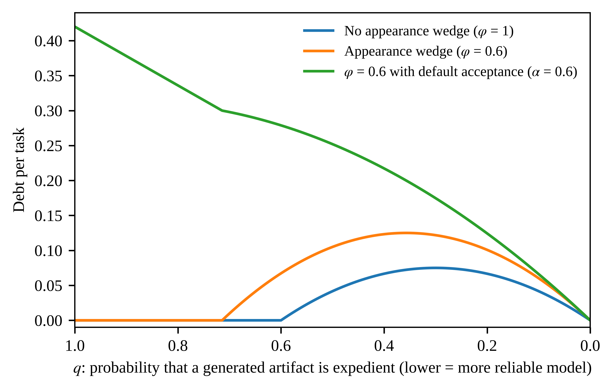
Fig. 1. Debt per task as model reliability improves (K = 0.3, B = 1, η = 0.5, v = 1).

4.4. Debt traps
Let H be the stock of unresolved debt and suppose refactoring becomes harder as it grows, r(H) = r₀(1 + γH), which plays the role of interest. In each period n artifacts arrive and a share p of those not accepted by default is examined, by noticing or inspection, and a defect that is examined is detected; a detected instance is refactored when (2) holds at r(H). The inflow of debt is I(H; β) = A + C·F(λvr₀(1 + γH)/(βδ)), where A = nq[1 − (1 − α)p] and C = nq(1 − α)p. A fraction μ of the stock is repaid each period, so H_{t+1} = (1 − μ)H_{t} + I(H_{t}; β) and steady states solve I(H; β) = μH. Let rework costs be lognormal with median R_{m} and log-dispersion s, and for ε ∈ (0, 1/2) let z = Φ⁻¹(1 − ε). Write H_{ε} = (A + Cε)/μ, H^{ε} = (A + C(1 − ε))/μ, β₁(ε) = λvr₀[1 + γ(A + Cε)/μ]/(δR_{m} exp(−sz)), and β₂(ε) = λvr₀[1 + γ(A + C(1 − ε))/μ]/(δR_{m} exp(sz)).
Result 4 (Debt traps and hysteresis). (a) If β ∈ (β₁(ε), β₂(ε)), the regions [0, H_{ε}] and [H^{ε}, ∞) are both forward invariant; a stable low-debt state lies in (0, H_{ε}), a stable trap in [H^{ε}, (A + C)/μ], and an unstable steady state between them. (b) This interval is non-empty if and only if exp(2sz) < [1 + γ(A + C(1 − ε))/μ]/[1 + γ(A + Cε)/μ]. (c) If β ≥ λvr₀[1 + γ(A + C)/μ]/(δR_{m} exp(−sz)), every steady state lies below H_{ε}; if β ≤ λvr₀/(δR_{m} exp(sz)), every steady state lies above H^{ε}. (d) [0, H_{ε}] is forward invariant for every β ≥ β₁(ε) and [H^{ε}, ∞) for every β ≤ β₂(ε). A codebase pushed into the trap by a value of β at or below λvr₀/(δR_{m} exp(sz)) therefore stays there when β returns to any value below β₂(ε), which is strictly higher; it leaves only if β rises above β₂(ε) or a one-time repayment brings H below H_{ε} while β ≥ β₁(ε).
Because present bias cancels in the choice regime, a team without an assistant behaves as if β = 1 in its refactoring decisions, and adoption replaces 1 with the team’s β. Adoption can therefore tip a codebase from the low-debt state into the trap even though the assistant also lowers r₀. The distribution of debt across codebases should become bimodal after adoption, codebases that enter adoption with more debt should be more likely to tip, and slight nudges to effective β cannot reverse a trap, which requires a large change in the decision environment or a one-time refactoring program. In the illustration in Fig. 2 (v = λ = δ = 1), a numerical computation gives a bistable region β ∈ (0.646, 0.843): codebases tip into the trap when β falls below 0.646 and escape only when it rises above 0.843. The closed-form conditions are sufficient and here nearly sharp, since the union of (β₁(ε), β₂(ε)) over ε reproduces the region to three decimals; the widest single interval, at ε = 0.14, is (0.659, 0.829).
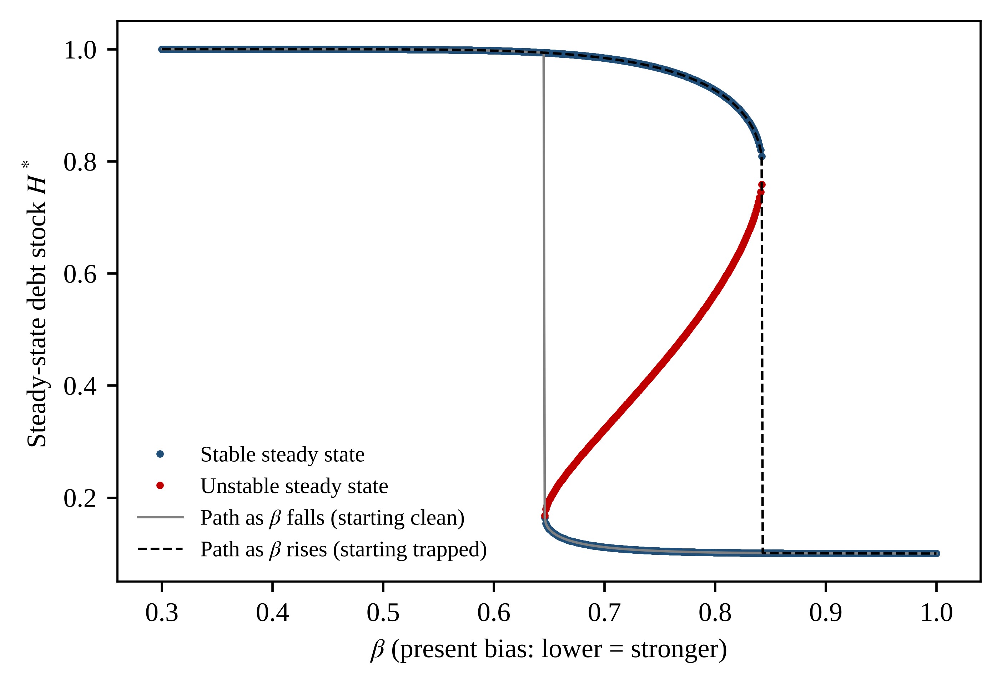
Fig. 2. Steady-state debt and hysteresis in present bias (n = 1, q = 0.5, p = 0.9, α = 0, r₀ = 0.3, γ = 3, μ = 0.5, lognormal rework costs with median 1 and log-dispersion 0.25).

4.5. A game of tool design, adoption governance, and shadow AI
The single-decision model treats the interface as given. In practice a vendor designs it, and whether its settings are chosen by developers or by their organization is a governance decision, so we model a game among the players in Table 3. Friction f ∈ [0, 1] is the effort needed to accept a suggestion without deliberation, as when large suggestions are shown as diffs to be reviewed; it lowers the default share to α(f) = α₀(1 − f) but costs the developer time vcf²/2 per artifact, incurred now. The governance regime, developer-led or organization-led, is given. Vendors then simultaneously post offers (f_{j}, p_{j}), and the adopter, the developer or the organization according to the regime, chooses the offer that maximizes its payoff net of price, or no assistant; where the organization controls the setting it then chooses the configured friction. Each developer then decides whether to use the sanctioned tool or to bypass it for an unsanctioned one, the equilibrium product of the developer-led market, at personal cost ε, which captures the shadow IT documented for earlier technologies [35]. Finally she faces each artifact as in Section 4.1. The equilibrium concept is subgame-perfect Nash equilibrium in pure strategies, with ties broken in favor of the sanctioned tool and the higher-surplus offer, and parameters are common knowledge.
Table 3. Players, actions, and payoffs of the governance game
Player | Actions | Payoff
Vendor j = 1, …, N (N = 1: monopoly; N ≥ 2: Bertrand) | Offers friction f_{j} ∈ [0, 1] at price p_{j} ≥ 0 per developer | p_{j} if adopted, 0 otherwise; zero marginal cost; friction is costless to the vendor
Organization | Under organization-led adoption: chooses a vendor or no assistant and, where it controls the setting, the configured friction | Long-run payoff W_{O}(f) − p with β = φ = λ = 1, given developers’ behavior
Developer (representative) | Under developer-led adoption: chooses a vendor or no assistant. Under organization-led adoption: complies or bypasses at cost ε. For each artifact: inspects, refactors | Perceived payoff W_{D}(f) − p with the wedges and rules (2) and (3)

For tractability rework cost is a constant R̄ with B > 0, inspection time is uniform on [0, K], and Δ ≤ vK. Rules (2) and (3) summarize the inspection problem in two quantities: the perceived value of inspecting, Δ_{p} = φq(1 − ηφ)(βδR̄ − λvr), and its long-run value, Δ = q(1 − ηφ)(δR̄ − vr); the wedges push Δ_{p} below Δ (Appendix A, Lemma 2). The developer’s perceived option value of deliberating is V_{D} = Δ_{p}²/(2vK) and the long-run value this behavior generates is V_{O} = Δ_{p}(2Δ − Δ_{p})/(2vK), so W_{D}(f) = −K_{D} + (1 − α(f))V_{D} − vcf²/2 and W_{O}(f) = −K_{O} + (1 − α(f))V_{O} − vcf²/2, where K_{D} and K_{O} are the perceived and long-run costs of an uninspected artifact, which do not depend on f.
Result 5 (Friction wedge). The friction that maximizes developers’ perceived payoff is f_{D} = α₀Δ_{p}²/(2v²cK), and the friction that maximizes the organization’s long-run payoff, given how developers inspect, is f_{O} = α₀Δ_{p}(2Δ − Δ_{p})/(2v²cK), both capped at 1. At interior values f_{O} − f_{D} = α₀Δ_{p}(Δ − Δ_{p})/(v²cK) ≥ 0, with equality if and only if Δ_{p} = Δ, which holds in the rational benchmark for every v.
Result 6 (Governance, not competition). In every subgame-perfect equilibrium under developer-led adoption the adopted interface has friction f_{D}, whether the vendor is a monopolist, who charges the developer’s entire perceived surplus, or one of N ≥ 2 Bertrand competitors, who charge zero; market structure affects the price, not the design. Under organization-led adoption the equilibrium friction is f_{O}. Adoption governance therefore affects debt if and only if a wedge binds.
Result 7 (Shadow AI constraint). If developers can bypass a sanctioned tool at cost ε, the organization implements f = f_{D} + min{f_{O} − f_{D}, (2ε/(vc))^{1/2}} in equilibrium. The constraint binds, and the organization closes only part of the gap, when f_{O} − f_{D} exceeds (2ε/(vc))^{1/2}.
The vendor’s side follows a familiar logic: when a cost is borne later and perceived dimly, sellers compete on what buyers perceive [36,37], so developers will not pay for friction. On the buyer’s side the remedy is a matter of IT governance rather than market structure, since what matters is who controls the configuration, and the prediction that debt is lower under central control holds only under the behavioral theory (Table 2); it is bounded by shadow IT, so enforcement against unsanctioned tools and choice architecture are complements. The organization’s optimal friction is not monotone in the wedges (Fig. 3): friction moves artifacts from default acceptance into deliberation, but deliberation yields inspection only in proportion to perceived risk, so friction complements debiasing rather than substituting for it. The closed forms assume a quadratic friction cost, a constant rework cost, and uniform inspection time, but the sign result does not: Appendix A shows that f_{O} ≥ f_{D}, with equality at interior optima if and only if no wedge binds, for any convex friction cost, decreasing and convex default share, distribution of inspection time, and heterogeneous rework costs. With β = 0.5, φ = 0.6, and λ = 1.2, developers prefer friction of 0.05 and the organization 0.49, and with ε = 0.005 the organization can implement 0.31. Under rational acceleration the preferences coincide at every value of time: doubling v lowers the friction both prefer from 0.71 to 0.10 but opens no gap.
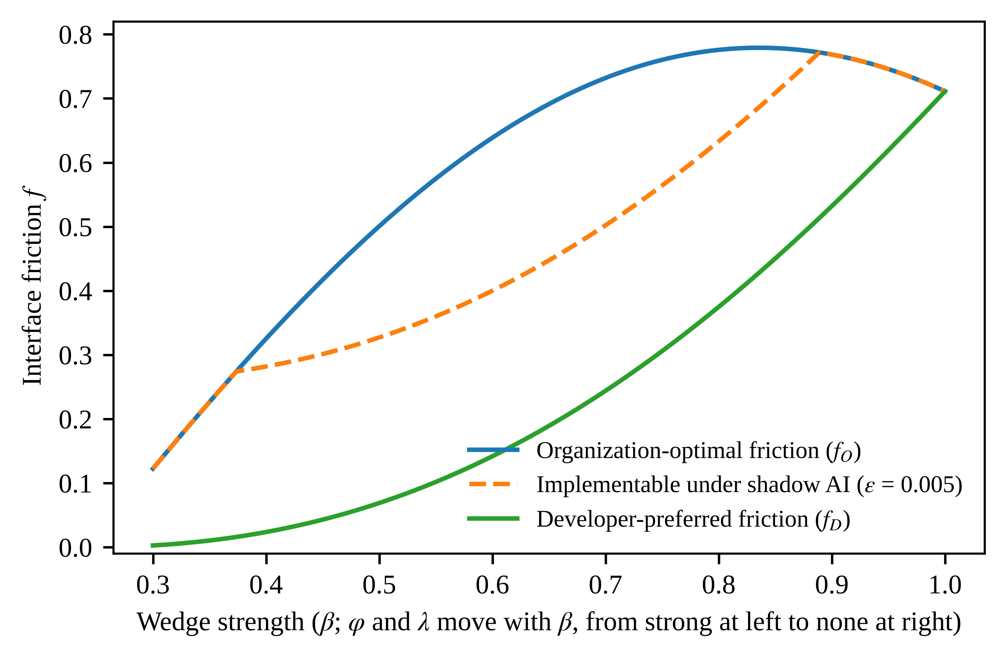
Fig. 3. Developer-preferred, organization-optimal, and implementable friction as the wedges weaken (q = 0.5, R̄ = 2, r = 0.4, K = 0.6, α₀ = 0.8, c = 0.15, ε = 0.005, η = 0.5, δ = v = 1; φ and λ move linearly with β from 0.6 and 1.2 at β = 0.3 to 1 and 1 at β = 1).

4.6. Learning and self-confirming complacency
The perception wedge need not be permanent, because developers can learn the defect rate. Let the perceived rate q̂ = φq evolve while the noticing probability stays fixed, and suppose developers learn from inspected artifacts, an unbiased sample, and from rework they attribute to generated code, which happens with probability θ per instance of undetected debt. Let s(q̂) be the probability that a developer with belief q̂ inspects. With learning speed κ ∈ (0, 1], q̂′ = q̂ + κ[s(q̂) + θ(1 − s(q̂))](q − q̂) and q̂₀ ≤ q. If inspection takes at least k_{min} > 0 units of time, with positive density above it, and Δ_{p}(q̂) = q̂(1 − ηφ)B, then s(q̂) = 0 whenever Δ_{p}(q̂) ≤ vk_{min}, which defines a threshold belief q̂_{c} < q, and s(q̂) > 0 if and only if q̂ > q̂_{c}.
Result 8 (Self-confirming complacency). (a) If θ > 0 or q̂₀ > q̂_{c}, the perceived defect rate converges to q and the perception wedge vanishes. (b) If θ = 0 and q̂₀ ≤ q̂_{c}, the belief is self-confirming: developers do not inspect, observe no evidence, and never revise. (c) In case (b), a mandate that requires inspection for T periods removes the wedge permanently if and only if (1 − κ)^{T}(q − q̂₀) < q − q̂_{c}.
Learning dissolves the perception wedge only if evidence reaches the developer, and evidence arrives mainly through the inspection that the wedge suppresses. Result 8 gives friction and mandates a dynamic value that Result 5 omits: by inducing inspection they produce the evidence that corrects perception, so a temporary intervention can have permanent effects. In Fig. 4 a single period of mandatory inspection moves a developer from a self-confirming belief of 0.05 onto a path toward the true defect rate of 0.5, and attributed rework does the same more slowly. Under a perception wedge the effects of a temporary mandate should persist after it is lifted; under rational acceleration they should end with it.
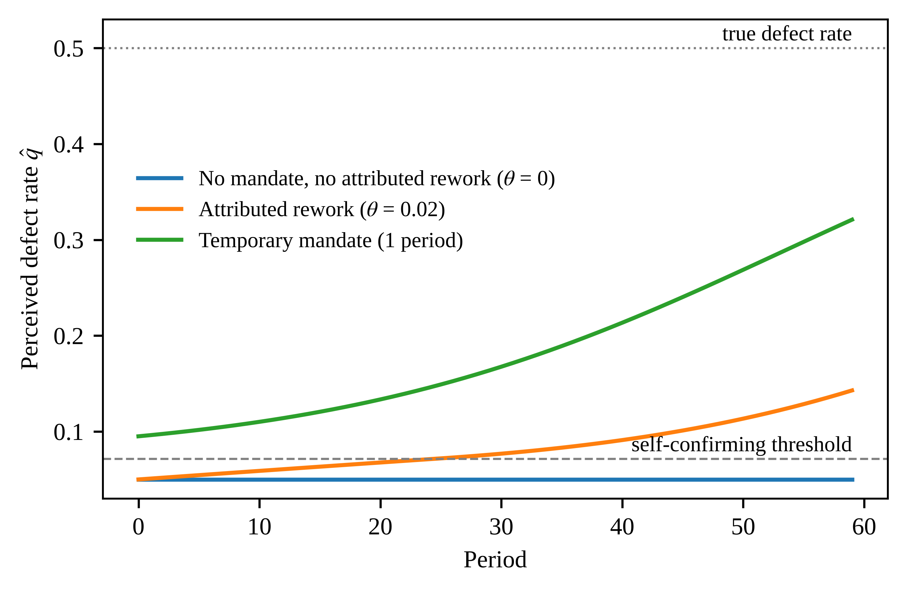
Fig. 4. Learning about the defect rate: self-confirming complacency and a temporary mandate (q = 0.5, κ = 0.1, k_{min} = 0.05, K = 0.6, B = 1, η = 0.5, noticing wedge 0.6).

5. Empirical implications
The contribution is theoretical, but the theory is built to be tested. This section states what evidence would bear on it and what would count against it, and Section 5.1 reports an exploratory archival test of one proposition.

5.1. Archival evidence (Study 1)
Public repositories in which LLM authorship can be identified support difference-in-differences comparisons of adopting and non-adopting repositories and change-level comparisons within repositories and reviewers. The model dictates the measures. Aggregate debt cannot adjudicate between the accounts (Result 2a); the adjudicating statistics are the self-admission rate of a change conditional on the warnings it introduces (P4), the substantive review it receives with reviewer effects (P7), and the net-addition bias in single-contributor modules (P5). Refactoring should be measured as commits per active contributor rather than as a share of changed lines, which rebound would contaminate (P1a). The dynamic results imply that the distribution of debt across repositories becomes bimodal after adoption (Result 4) and that debt per LLM-assisted change need not fall with model reliability (Result 3).
Exploratory test of P4. We tested P4 on seven repositories in which LLM assistance can be identified: Aider-AI/aider, whose tool appends “(aider)” to the author name of the commits it writes, and six repositories (BerriAI/litellm, mlflow/mlflow, pydantic/pydantic-ai, PrefectHQ/fastmcp, simonw/datasette, crewAIInc/crewAI) [38] where commits carry a Claude co-author or “Generated with Claude Code” trailer. The six were chosen from ten candidates as those with at least 100 marked commits since 1 January 2025 (the others had 12 to 49). The analysis is exploratory and was not preregistered. Within each repository we kept authors with at least eight marked and eight unmarked commits that change Python files, so that the comparison is within author, and excluded agent accounts. The window starts on 1 January 2025 (18 June 2024 for Aider, when its tag first appears), and for litellm we analyzed the 12,000 most recent qualifying commits. The sample contains 22,176 commits by 43 authors, of which 4,811 are marked as LLM-assisted; because marking captures disclosed use only, unmarked use biases the estimates toward zero.
Self-admitted debt is the number of added comment lines containing TODO, FIXME, HACK, XXX, KLUDGE, or WORKAROUND (584 events; the strict measure). Because these markers are rare, we also report a broader measure, fixed after seeing the counts, that adds phrases such as “for now,” “temporary,” “quick fix,” “ugly,” and “refactor later” (910 events). Statically detected debt introduced is the increase, summed over the files a commit changes, in the number of warnings from the ruff linter [39] for excess complexity, too many branches, arguments, statements, or returns, magic values, simplifiable code, commented-out code, and likely bugs, computed on the parent and child versions of each file with suppression comments ignored. We estimate Poisson regressions of marker counts on an indicator of LLM assistance, controlling for detected debt introduced, the logarithm of added lines, author fixed effects, and repository-by-quarter fixed effects, with standard errors clustered by author.
Marked commits carry fewer markers (Table 4). The pooled incidence rate ratio is 0.48 (95% confidence interval 0.24 to 0.96) for the strict measure and 0.40 (0.23 to 0.69) for the broad one. The estimates change little when we control for added comment lines, cap added lines at 5,000, or drop test-only commits, and they stay below one when each repository is left out in turn, although the strict estimate then loses significance in several cases. The pattern is not uniform. Five of the six repositories with enough events show ratios below one on both measures, whereas mlflow shows no difference (1.04 and 1.02), and the random-effects average over the six is 0.47 (0.23 to 0.97) on the strict measure and 0.46 (0.29 to 0.72) on the broad one, with substantial heterogeneity (I² of 69 and 57 percent). Without Aider, where the sample relies on trailers alone, the pooled ratios are 0.66 (0.44 to 1.01) and 0.60 (0.43 to 0.84). Marked commits add 0.043 comment lines per added line against 0.030 for other commits, so the gap does not reflect fewer comments, and they are somewhat less likely to raise the warning count (22 against 33 percent), which the regressions take into account.
Table 4. Self-admitted debt markers in LLM-assisted versus other commits (incidence rate ratios)
Repository | Commits | LLM-marked | Strict events | Broad events | Strict IRR [95% CI] | Broad IRR [95% CI]
Aider-AI/aider | 4,773 | 2,768 | 30 | 117 | 0.02 [0.00, 0.12] | 0.27 [0.14, 0.52]
BerriAI/litellm | 11,611 | 811 | 69 | 233 | 0.62 [0.22, 1.73] | 0.31 [0.16, 0.62]
mlflow/mlflow | 1,928 | 674 | 220 | 241 | 1.04 [0.50, 2.16] | 1.02 [0.51, 2.05]
pydantic/pydantic-ai | 1,529 | 160 | 177 | 194 | 0.49 [0.21, 1.12] | 0.50 [0.24, 1.05]
PrefectHQ/fastmcp | 1,573 | 218 | 76 | 103 | 0.56 [0.21, 1.51] | 0.74 [0.35, 1.57]
simonw/datasette | 572 | 91 | 12 | 18 | 0.68 [0.26, 1.78] | 0.28 [0.11, 0.71]
crewAIInc/crewAI | 190 | 89 | 0 | 4 | n/a | n/a
Pooled | 22,176 | 4,811 | 584 | 910 | 0.48 [0.24, 0.96] | 0.40 [0.23, 0.69]
Pooled, excluding Aider | 17,403 | 2,043 | 554 | 793 | 0.66 [0.44, 1.01] | 0.60 [0.43, 0.84]
Random-effects average, six repositories |  |  |  |  | 0.47 [0.23, 0.97] | 0.46 [0.29, 0.72]
Note. Poisson regressions controlling for detected debt introduced and the logarithm of added lines. Repository rows include author and quarter fixed effects and standard errors clustered by month; pooled rows include author and repository-by-quarter fixed effects and standard errors clustered by author. Values below 1 mean fewer markers in LLM-assisted commits. crewAIInc/crewAI has too few events to estimate and is left out of the averages.
The direction matches P4 and contradicts the rational-acceleration prediction that self-admission per unit of detected debt does not depend on authorship (Table 2), but the evidence is far from conclusive. The effect is concentrated in some repositories, absent in one, and weaker where it is identified by trailers alone; team conventions or the tool’s own instructions, which we did not examine, may discourage TODO comments, so the gap may reflect configuration rather than the fluency mechanism; assistance is not randomly assigned; and the comparison relies on a static-analysis proxy for debt and on disclosed use. We read the result as a consistency check that motivates the full design of Study 1, with preregistered measures, more repositories, and other languages. P7 requires review data from the platform’s interface and was not tested.

5.2. Experimental evidence (Study 2)
Two statistics of Result 2 cannot be observed in archives because the cost of refactoring is not recorded. A preregistered within-subjects experiment with professional developers can measure them: each participant makes eight decisions in a 2 × 2 design crossing possession (a working generated artifact in hand versus a choice before any code exists) with the stated cost of refactoring, and may commit to refactor in a second session a week later. The possession effect at equal cost identifies β < 1 or λ > 1, and the lapse of commitments identifies β < 1 alone. A simulation-based power analysis indicates that 160 participants give power of 0.94 to detect a 10-percentage-point possession effect. A review module that crosses an authorship label with actual authorship and seeded defects separates the appearance wedge from label-driven automation bias (P3, P7), and varying the keystroke cost of rejecting suggestions tests the default effect (P8).

5.3. Field and governance evidence (Study 3)
A multi-site field study of engineering organizations that differ in how they measure developers (P11), assign module ownership (P6, P9), control assistant configuration, and tolerate unsanctioned tools would test Results 6 and 7: debt should be lower under central configuration only if the wedges operate, and the difference should shrink where bypass is easy. Organizations that introduce and later lift inspection mandates test Result 8.

5.4. What would count against the theory
The theory can be falsified in its distinctive claims, though not in its aggregate prediction. If debt rises after adoption while the self-admitted share, the possession effect, and the lapse of planned refactoring match their benchmark values, rational acceleration explains the evidence. If debt is no lower under central configuration, Result 6 fails; if the effects of temporary mandates end with them, Result 8 fails; and if review of LLM-assisted changes proves more intensive once task type and size are held constant, P7 fails while P4 may still hold.

6. Discussion

6.1. Theoretical contributions
The paper explains an anomaly without assuming it away. A rational account can recover rising debt through the value of speed and the rebound effect; what it cannot produce is the form the debt takes under our theory: unrecorded, under-reviewed, retained, and unrepaid despite plans. The model makes the distinction precise by showing that aggregate debt is observationally equivalent across the accounts and by identifying the statistics that are not. It also reclassifies much LLM-era debt from deliberate to inadvertent: prior taxonomies attribute inadvertent debt to ignorance, whereas the fluency mechanism locates it in judgment that the artifact’s surface suppressed, which calls for different remedies. The paper also connects the software engineering literature on TD to research on human–automation interaction [24,34,40]: TD is a durable, measurable trace of thousands of human–AI micro-decisions that can be studied with an archival precision that survey measures of over-reliance cannot match. The game adds a link to IT governance and shadow IT [35].

6.2. Implications for decision-support design
Debt registers, interest estimates, and repayment sprints assume that the debt is visible and will be repaid when the numbers justify it; decision support built on these assumptions will underperform, because the debt is not recorded (P4) and repayment is deferred (P1, P2). Support for generated code should instead target the acceptance decision. Against appearance, review defaults can set a floor on review time per changed line, require reviewers to name reusable code (P7, P10), and show debt signals independently of authorship. Against timing, deferred refactoring can be recorded as a commitment with an owner, a date, and reserved capacity. Against possession, interfaces can present large suggestions as diffs, require active selection, report net rather than added lines, and surface unreferenced functions (P5, P8). Owner sign-off on cross-boundary changes, defects routed to the authors of the changes, and throughput metrics paired with maintainability metrics restore ownership and address metric targeting (P6, P9, P11). Three design points follow from the results: friction is a decision variable with a cost and works only with feedback that corrects perceived risk (Results 5 and 8); control of configuration and enforcement against unsanctioned tools are part of the design, because developers and the organization prefer different friction whenever a wedge binds (Results 6 and 7); and because better models can increase debt (Result 3), a model upgrade should come with an explicit decision about how much inspection it may displace.

6.3. Limitations
Apart from the exploratory archival test in Section 5.1, the theory is developed rather than tested. The model is deliberately minimal: tasks are independent, inspection detects defects perfectly, the debt-trap result relies on a particular form of interest on debt, and the game has a representative developer and complete information, so the results concern mechanisms rather than calibrated magnitudes; the closed forms also assume a constant rework cost and uniform inspection time. The ownership and incentive mechanisms (P6, P9 to P11) are stated verbally rather than derived, and extending the model to teams is left for future work. The archival test relies on disclosed AI use, a static-analysis proxy for debt, and a marker list partly defined after the fact. Finally, the theory is silent on model capability: a sufficiently capable model might produce code whose surface fluency is matched by its structure, and the fluency mechanism would then become harmless, although the evidence to date, which finds structural degradation increasing with capability, suggests that this point has not been reached.

6.4. Future research
Three extensions suggest themselves: other generative-AI artifacts, such as documentation, infrastructure configuration, and analytics notebooks; individual developers over time, to see whether biases attenuate with experience or intensify as trust accumulates; and field experiments on the decision-support designs of Section 6.2, which would test the mechanisms and give direct evidence on remedies.

7. Conclusion
LLM coding assistants have made code cheap to produce, and the first evidence suggests that they have made systems more expensive to maintain. We have argued that the explanation lies in how LLM assistance restructures the decision: it places a working artifact in the developer’s hand before the quality decision is made, dresses shortcuts as finished work, makes acceptance the default and deletion a loss, and weakens the ownership that effort would confer. A rational response to cheaper code can also produce more debt, but the debt our account predicts is unrecorded, under-reviewed, and unrepaid, and the statistics derived here can tell the two apart. The model warns designers of decision support that better models do not guarantee less debt, that a codebase that has tipped into a high-debt state will not be rescued by the nudges that would have prevented it, and that the reach of any organizational remedy is limited by who controls the configuration. Decision support for generated code should therefore target the acceptance decision itself, through choice architecture, inspection requirements, and feedback, and not only the accounting of debt after the fact.

Appendix A. Proofs
The standing assumptions are those of Section 4.1. Let T*(R) = δR − vr and let h* and D_{A}* be the benchmark (β = φ = λ = 1, α = 0) counterparts of h and D_{A}.

A.1. Lemmas
Lemma 1. (i) T ≤ T* and φ(1 − ηφ) ≤ 1 − η ≤ 1 − ηφ. (ii) h ≥ h*, strictly on a set of positive probability if any wedge binds. (iii) h*(R; v) is nondecreasing in v, and D_{A}* is continuous and nondecreasing in v with limit q as v → ∞.
Proof. (i) β ≤ 1 and λ ≥ 1 give T ≤ T*; the map φ ↦ φ(1 − ηφ) has derivative 1 − 2ηφ ≥ 0 because η ≤ 1/2. (ii) If T ≤ 0 then h = 1 ≥ h*. If T > 0 then T* > 0 and x_{w} = φq(1 − ηφ)T/v ≤ x* = q(1 − η)T*/v by (i), so 1 − (1 − α)G(x_{w}) ≥ 1 − G(x*) and 1 − ηφ ≥ 1 − η, whence h ≥ h*. For strictness, h* < 1 whenever T* > 0 because G(x*) > 0. If α > 0, then, where T* > 0, either T ≤ 0 and h = 1 > h*, or G(x_{w}) > 0 and h > h*. If α = 0 and β < 1 or λ > 1, then h = 1 > h* on (vr/δ, λvr/(βδ)]. If only φ < 1, then x_{w} < x* strictly and G(x_{w}) < G(x*) for small T* by the positive density of G. (iii) As v rises, the set where T* ≤ 0 and h* = 1 expands, and on T* > 0 the argument q(1 − η)(δR/v − r) of G falls, so h* rises. For each v₀, h*(R; v) → h*(R; v₀) except at R = v₀r/δ, a null set, so D_{A}* is continuous by dominated convergence; and F(vr/δ) → 1 gives the limit.
Lemma 2. Let B = βδR − λvr > 0, Δ_{p} = φq(1 − ηφ)B, and Δ = q(1 − ηφ)(δR − vr). Then δR − vr > 0 and Δ ≥ Δ_{p}, with equality if and only if β = φ = λ = 1.
Proof. δR > λvr/β ≥ vr. Also (Δ − Δ_{p})/[q(1 − ηφ)] = X ≡ δR(1 − φβ) − vr(1 − φλ). If φβ < 1, then X > (λvr/β)(1 − φβ) − vr(1 − φλ) = vr(λ/β − 1) ≥ 0. If φβ = 1, then β = φ = 1 and X = vr(λ − 1) ≥ 0, with equality if and only if λ = 1.

A.2. Proofs of Results 1 and 2
Result 1. The decomposition is an identity. If inspection is free then G(x) = 1 for x > 0, so D_{A}*(v₀) = qF(v₀r/δ) ≤ F(v₀a/δ) = D_{C}(v₀) because q ≤ 1 and r ≤ a. The second term is non-negative by Lemma 1(iii), and the third equals qE[h − h*], which is non-negative and, when a wedge binds, strictly positive by Lemma 1(ii).
Result 2. (a) By Result 1, D_{A}*(v₀) ≤ D_{A}(v₀) < q; Lemma 1(iii) and the intermediate value theorem give v₁ ≥ v₀ with D_{A}*(v₁) = D_{A}(v₀). (b) With φ = 1 every unit of debt, detected or not, is self-admitted with probability σ, and in the choice regime all debt is, so the share is σ. The possession effect is F(va/δ) − F(va/δ) = 0 and the lapse rate is F(vr/δ) − F(vr/δ) = 0. (c) Debt is either detected but unrefactored, which arises only when T ≤ 0, or undetected. If u is the undetected share, the self-admitted share is σ[1 − (1 − φ)u], below σ if and only if φ < 1 and u > 0. Since F is strictly increasing, F(λva/(βδ)) > F(va/δ) if and only if λ/β > 1, and F(λvr/(βδ)) > F(λvr/δ) if and only if β < 1.

A.3. Proof of Result 3
With T(R) = B the noticed branch carries no debt. For G(x) = min{1, x/K}, G(φq(1 − ηφ)B/v) = min{1, q/q̂}, and (4) gives D(q) = q(1 − ηφ)[1 − (1 − α)min{1, q/q̂}]. For q ≥ q̂ this is α(1 − ηφ)q, increasing in q. For q < q̂ its derivative (1 − ηφ)[1 − 2(1 − α)q/q̂] is positive if and only if q < q*. If α < 1/2 then q* < q̂, so D is increasing on (0, q*), decreasing on (q*, q̂), and increasing beyond q̂; if α ≥ 1/2 then q* ≥ q̂ and D is increasing everywhere.

A.4. Proof of Result 4
Let f_{β}(H) = (1 − μ)H + I(H; β) and Φ_{β}(H) = I(H; β) − μH. Because I is continuous, increasing in H, and valued in [A, A + C], f_{β} is continuous and increasing, so orbits are monotone and converge to zeros of Φ_{β}, all in [A/μ, (A + C)/μ]; a zero where Φ_{β} changes sign from positive to negative is stable and one where it changes from negative to positive is unstable (non-generic tangencies are ignored). Also F(x) < ε if and only if x < R_{m} exp(−sz), and F(x) > 1 − ε if and only if x > R_{m} exp(sz). (a) β > β₁(ε) means λvr₀(1 + γH_{ε})/(βδ) < R_{m} exp(−sz), so I(H_{ε}) < A + Cε = μH_{ε} and f_{β}(H_{ε}) < H_{ε}; with f_{β}(0) > 0 and monotonicity, [0, H_{ε}] is invariant, and Φ_{β}(0) > 0 > Φ_{β}(H_{ε}) gives a stable state in (0, H_{ε}). Likewise β < β₂(ε) gives I(H^{ε}) > μH^{ε}, so f_{β}(H) ≥ f_{β}(H^{ε}) > H^{ε} on [H^{ε}, ∞), which is invariant, and Φ_{β}(H^{ε}) > 0 ≥ Φ_{β}((A + C)/μ) gives the stable trap. Since Φ_{β}(H_{ε}) < 0 < Φ_{β}(H^{ε}), an upward crossing, the unstable state, lies between. (b) β₁ < β₂ rearranges to the stated condition. (c) If β meets the first bound, I(H) ≤ A + Cε on [0, (A + C)/μ], so every steady state is at most H_{ε}; if β ≤ λvr₀/(δR_{m} exp(sz)), then I(H) > A + C(1 − ε) for H > 0, so every steady state exceeds H^{ε}. (d) Invariance used only the stated inequalities. Below the lower bound, (c) sends every orbit into [H^{ε}, ∞), which stays invariant up to β₂(ε), strictly above the lower bound by the factor 1 + γ(A + C(1 − ε))/μ.

A.5. Derivation of the equilibrium and proofs of Results 5 to 7
Stage 5. With constant R̄ and B > 0, a detected instance is always refactored and the developer inspects if and only if vk < Δ_{p}, which has probability Δ_{p}/(vK) because Δ_{p} ≤ Δ ≤ vK (Lemma 2). An uninspected artifact costs the developer, in perceived terms, K_{D} = φq[ηφλvr + (1 − ηφ)βδR̄] and the organization K_{O} = q[ηφvr + (1 − ηφ)δR̄]; inspecting when vk < Δ_{p} saves Δ_{p} perceived and Δ long-run units at time cost vk. Taking expectations over k and over α(f) = α₀(1 − f) and subtracting vcf²/2 gives W_{D}(f) = −K_{D} + (1 − α(f))V_{D} − vcf²/2 with V_{D} = E[(Δ_{p} − vk)⁺] = Δ_{p}²/(2vK) and W_{O}(f) = −K_{O} + (1 − α(f))V_{O} − vcf²/2 with V_{O} = E[(Δ − vk)1{vk < Δ_{p}}] = Δ_{p}(2Δ − Δ_{p})/(2vK), both strictly concave in f.
Result 5. Setting ∂W_{D}/∂f = α₀Δ_{p}²/(2vK) − vcf and ∂W_{O}/∂f = α₀Δ_{p}(2Δ − Δ_{p})/(2vK) − vcf to zero gives f_{D} and f_{O}, capped at 1. Their difference is α₀Δ_{p}(Δ − Δ_{p})/(v²cK), non-negative and zero if and only if Δ_{p} = Δ, that is, if and only if β = φ = λ = 1 (Lemma 2). Result 6. Under developer-led adoption the developer takes the offer maximizing W_{D}(f_{j}) − p_{j}; let S_{D}(f) = W_{D}(f) − W_{D}⁰ with W_{D}⁰ her payoff without the assistant, assumed positive at f_{D}. A monopolist earns at most S_{D}(f) ≤ S_{D}(f_{D}), with equality only at f = f_{D} and p = S_{D}(f_{D}). With N ≥ 2, suppose a winning offer has f* ≠ f_{D} and price p*; a rival can offer (f_{D}, p′) with p′ = p* + [W_{D}(f_{D}) − W_{D}(f*)]/2 > p*, which beats it and earns p′ > 0, so every winning offer has f_{D}, and undercutting drives the price to zero. Under organization-led adoption the same arguments with W_{O} give f_{O}. Since debt per task is q(1 − ηφ)[1 − (1 − α(f))Δ_{p}/(vK)] by Result 3, which is strictly decreasing in f when Δ_{p} > 0, debt differs across regimes if and only if f_{O} > f_{D}, that is, if and only if a wedge binds. Result 7. W_{D} is quadratic with leading coefficient −vc/2 and maximum at f_{D}, so W_{D}(f_{D}) − W_{D}(f) = (vc/2)(f − f_{D})², and developers comply if and only if |f − f_{D}| ≤ (2ε/(vc))^{1/2}. The organization maximizes the concave W_{O}, peaked at f_{O} ≥ f_{D}, over this interval, which contains f_{D} itself, so it does at least as well as under bypass and chooses f_{D} + min{f_{O} − f_{D}, (2ε/(vc))^{1/2}}.
Proposition A1. Let the friction cost κ(f) be increasing and convex, α(f) decreasing and convex, inspection time have any distribution, and rework costs be heterogeneous. Then f_{O} ≥ f_{D}, and f_{O} > f_{D} if some wedge binds, f_{D} < 1, α′(f_{D}) < 0, and inspection occurs with positive probability.
Proof. Define Δ_{p}(R) and Δ(R) as in Lemma 2 where T(R) > 0 and Δ_{p}(R) = 0 elsewhere, and V_{D} = E[(Δ_{p}(R) − vk)⁺] and V_{O} = E[(Δ(R) − vk)1{vk < Δ_{p}(R)}]. By Lemma 2, V_{O} − V_{D} = E[(Δ − Δ_{p})1{vk < Δ_{p}}] ≥ 0. The payoffs are U(f; V) = (1 − α(f))V − κ(f) up to constants, with ∂U/∂f = −α′(f)V − κ′(f) increasing in V, so by Topkis’s monotone comparative statics theorem the maximizers are nondecreasing in V and f_{O} ≥ f_{D}. For strictness, U is concave in f and ∂U(f_{D}; V_{O})/∂f = −α′(f_{D})(V_{O} − V_{D}) > 0 when α′(f_{D}) < 0 and V_{O} > V_{D}, which Lemma 2 delivers when a wedge binds and inspection occurs; concavity then places the maximizer above f_{D}.

A.6. Proof of Result 8
Let e_{t} = q − q̂_{t} ≥ 0 and w_{t} = s(q̂_{t}) + θ(1 − s(q̂_{t})) ∈ [0, 1], so e_{t+1} = (1 − κw_{t})e_{t}; the belief never decreases and never exceeds q. (a) If θ > 0, w_{t} ≥ θ and e_{t} ≤ (1 − κθ)^{t}e₀ → 0. If θ = 0 and q̂₀ > q̂_{c}, then s(q̂₀) > 0 and, s being nondecreasing, w_{t} ≥ s(q̂₀) for all t, so e_{t} → 0. (b) If θ = 0 and q̂₀ ≤ q̂_{c}, then w₀ = 0 and q̂₁ = q̂₀, and by induction the belief never changes. (c) During a mandate s = 1 and e_{t+1} = (1 − κ)e_{t}, so after T periods q̂ = q − (1 − κ)^{T}(q − q̂₀). By (a) the belief then converges to q if and only if this exceeds q̂_{c}, that is, if and only if (1 − κ)^{T}(q − q̂₀) < q − q̂_{c}; otherwise (b) applies and the belief stays below q.

References
[1] Stack Overflow, 2025 Developer Survey. https://survey.stackoverflow.co/2025/, 2025 (accessed 27 September 2026).
[2] H. He, C. Miller, S. Agarwal, C. Kästner, B. Vasilescu, Speed at the cost of quality: how Cursor AI increases short-term velocity and long-term complexity in open-source projects, in: Proc. 23rd Int. Conf. Mining Software Repositories, ACM, New York, 2026 (preprint arXiv:2511.04427).
[3] Y. Zhu, N. Tsantalis, P.C. Rigby, AI-generated smells: an analysis of code and architecture in LLM and agent-driven development, arXiv preprint arXiv:2605.02741 (2026).
[4] GitClear, AI copilot code quality: 2025 data suggests 4x growth in code clones [report]. https://www.gitclear.com/ai_assistant_code_quality_2025_research, 2025 (accessed [date to be added]).
[5] W. Cunningham, The WyCash portfolio management system, in: Addendum to the Proc. Object-Oriented Programming Systems, Languages, and Applications, ACM, New York, 1992, pp. 29–30.
[6] P. Avgeriou, P. Kruchten, I. Ozkaya, C. Seaman, Managing technical debt in software engineering (Dagstuhl Seminar 16162), Dagstuhl Rep. 6 (2016) 110–138.
[7] P. Kruchten, R.L. Nord, I. Ozkaya, Technical debt: from metaphor to theory and practice, IEEE Softw. 29 (2012) 18–21.
[8] W.S. Jevons, The Coal Question, Macmillan, London, 1865.
[9] S. Sorrell, Jevons’ paradox revisited: the evidence for backfire from improved energy efficiency, Energy Policy 37 (2009) 1456–1469.
[10] E. Tom, A. Aurum, R. Vidgen, An exploration of technical debt, J. Syst. Softw. 86 (2013) 1498–1516.
[11] F. Buschmann, To pay or not to pay technical debt, IEEE Softw. 28 (2011) 29–31.
[12] C. Seaman, Y. Guo, Measuring and monitoring technical debt, Adv. Comput. 82 (2011) 25–46.
[13] A. Potdar, E. Shihab, An exploratory study on self-admitted technical debt, in: Proc. 2014 IEEE Int. Conf. Software Maintenance and Evolution, IEEE, Piscataway, 2014, pp. 91–100.
[14] G. Bavota, B. Russo, A large-scale empirical study on self-admitted technical debt, in: Proc. 13th Int. Conf. Mining Software Repositories, ACM, New York, 2016, pp. 315–326.
[15] Y. Fu, P. Liang, A. Tahir, Z. Li, M. Shahin, J. Yu, J. Chen, Security weaknesses of Copilot-generated code in GitHub projects: an empirical study, ACM Trans. Softw. Eng. Methodol. 34 (2025) 1–34.
[16] B. Yetiştiren, I. Özsoy, M. Ayerdem, E. Tüzün, Evaluating the code quality of AI-assisted code generation tools: an empirical study on GitHub Copilot, Amazon CodeWhisperer, and ChatGPT, arXiv preprint arXiv:2304.10778 (2023).
[17] H. Li, H. Zhang, A.E. Hassan, AIDev: studying AI coding agents on GitHub, in: Proc. 23rd Int. Conf. Mining Software Repositories, ACM, New York, 2026. https://doi.org/10.1145/3793302.3797249.
[18] R. Ehsani, S. Rawal, Y. Cai, P. Chatterjee, Faster code, deeper debt? A multivocal literature review on technical debt and its early signs in LLM-assisted software development, ACM Trans. Softw. Eng. Methodol. (2026). https://doi.org/10.1145/3820165.
[19] X. Sun, D. Ståhl, K. Sandahl, C. Kessler, Quality assurance of LLM-generated code: addressing non-functional quality characteristics, J. Syst. Softw. 238 (2026) 112885.
[20] D. Laibson, Golden eggs and hyperbolic discounting, Q. J. Econ. 112 (1997) 443–478.
[21] T. O’Donoghue, M. Rabin, Doing it now or later, Am. Econ. Rev. 89 (1999) 103–124.
[22] R. Buehler, D. Griffin, M. Ross, Exploring the “planning fallacy”: why people underestimate their task completion times, J. Pers. Soc. Psychol. 67 (1994) 366–381.
[23] A.L. Alter, D.M. Oppenheimer, Uniting the tribes of fluency to form a metacognitive nation, Pers. Soc. Psychol. Rev. 13 (2009) 219–235.
[24] K. Goddard, A. Roudsari, J.C. Wyatt, Automation bias: a systematic review of frequency, effect mediators, and mitigators, J. Am. Med. Inform. Assoc. 19 (2012) 121–127.
[25] R. Parasuraman, D.H. Manzey, Complacency and bias in human use of automation: an attentional integration, Hum. Factors 52 (2010) 381–410.
[26] D. Kahneman, A. Tversky, Prospect theory: an analysis of decision under risk, Econometrica 47 (1979) 263–291.
[27] E.J. Johnson, D. Goldstein, Do defaults save lives?, Science 302 (2003) 1338–1339.
[28] R.H. Thaler, C.R. Sunstein, Nudge: Improving Decisions About Health, Wealth, and Happiness, Yale University Press, New Haven, 2008.
[29] M.I. Norton, D. Mochon, D. Ariely, The IKEA effect: when labor leads to love, J. Consum. Psychol. 22 (2012) 453–460.
[30] J.L. Pierce, T. Kostova, K.T. Dirks, Toward a theory of psychological ownership in organizations, Acad. Manag. Rev. 26 (2001) 298–310.
[31] K.J. Arrow, Uncertainty and the welfare economics of medical care, Am. Econ. Rev. 53 (1963) 941–973.
[32] G. Hardin, The tragedy of the commons, Science 162 (1968) 1243–1248.
[33] E. Ostrom, Governing the Commons: The Evolution of Institutions for Collective Action, Cambridge University Press, Cambridge, 1990.
[34] Z. Buçinca, M.B. Malaya, K.Z. Gajos, To trust or to think: cognitive forcing functions can reduce overreliance on AI in AI-assisted decision-making, Proc. ACM Hum.-Comput. Interact. 5 (2021) Article 188. https://doi.org/10.1145/3449287.
[35] S. Haag, A. Eckhardt, Shadow IT, Bus. Inf. Syst. Eng. 59 (2017) 469–473.
[36] S. DellaVigna, U. Malmendier, Contract design and self-control: theory and evidence, Q. J. Econ. 119 (2004) 353–402.
[37] X. Gabaix, D. Laibson, Shrouded attributes, consumer myopia, and information suppression in competitive markets, Q. J. Econ. 121 (2006) 505–540.
[38] Aider-AI/aider, BerriAI/litellm, mlflow/mlflow, pydantic/pydantic-ai, PrefectHQ/fastmcp, simonw/datasette, crewAIInc/crewAI [software], GitHub. https://github.com/<owner>/<repository>, 2026 (accessed 10 October 2026).
[39] Astral, Ruff [software], GitHub. https://github.com/astral-sh/ruff, 2026 (accessed 10 October 2026).
[40] B.J. Dietvorst, J.P. Simmons, C. Massey, Algorithm aversion: people erroneously avoid algorithms after seeing them err, J. Exp. Psychol. Gen. 144 (2015) 114–126.

