Detecting machine-written scholarly text depends on the generator and on what authors know
[Authors, affiliations and corresponding author to be completed]
Abstract
Organizations that screen documents for machine authorship must decide how much to spend, yet detection research reports accuracy for one generator at a time, without base rates, costs or adaptive authors. We study cascaded screening: a free screen built from counts of small linguistic events decides which documents reach a costly language-model judge. Using 474 human papers and papers from GPT-4o, Claude and Llama, we find that screens detect well only within a generator, that a strong judge almost misses one generator, and that a cascade keeps most detection at lower cost when machine papers are rare. A feature-aware edit cuts the screen's detection from 53% to 8% and weakens the cascade, whereas a generic rewrite does not evade it, and neither fools the judge. A decision model explains these patterns and identifies features that are costly to edit as the basis of robust screens.

Fluent, well-organized prose has long signalled effort in scholarly publishing. Large language models make that signal cheap: a model can draft an abstract, a methods section or a plausible set of results in a minute, and the output is often good enough to survive a quick read. For publishers, preprint servers and research-integrity offices the question is therefore no longer whether machine-written papers exist but how much to spend on finding them, given that every check costs money, every flag costs an investigation and every miss carries a loss.
The detection literature mostly asks a different question: how accurately a classifier separates machine from human text. Detectors based on a language model's own probabilities^{1,2} and judge-style evaluation by a second model³ are usually reported for one generator at a time, without a base rate, without the cost of a false alarm or a miss, and without asking whether authors will adapt once they know how they are screened. A detector with an excellent hit rate can still be a poor investment if machine papers are rare and its false alarms swamp its detections, and a detector that works today may stop working as soon as its method is published.
We study the screening decision directly, with three questions. How should an organization combine a free screen with a costly judge, as a function of the base rate, the costs and the detection rates? How well do a cheap count-based screen and language-model judges detect machine-written papers, and how well do they transfer across generators? And how much of the screen's value survives when authors adapt? We formulate the problem as a two-stage cascade, extend it to strategic authors, and calibrate both with data from three generators and two judges. The free screen is built from counts of seven small linguistic events in English scientific papers, such as parentheses, semicolons and passive clauses, which we model as a count process whose rate varies along the document. This keeps every quantity traceable to a countable feature.
Results
Machine and human text differ in clustering and in rates, but not in a common direction
We cut each document into four consecutive windows of 500 tokens and counted seven events in each (Methods). Human text is not Poisson: 49% of documents reject a Poisson null for square brackets, 42% for parentheses and 36% for semicolons, and only discourse markers behave as a Poisson process (median dispersion index 1.00, 6% rejection). A single distance from Poisson therefore has almost no discriminating power (AUC 0.54 for GPT-4o, 0.51 for Claude and 0.53 for Llama). Machine text departs from human text in both directions (Fig. 1). Nominalizations are less dispersed in all three generators (median dispersion 0.76, 1.10 and 1.27 against 1.67 in human text), and passive constructions and quotation marks are more dispersed in all three (passives 2.51, 1.79 and 2.02 against 1.20). Event rates differ even in sign across generators: Claude uses more semicolons than human authors (3.54 per 500 tokens against 1.95), whereas GPT-4o uses far fewer (0.51), so no rule based on average frequency describes machine text in general.
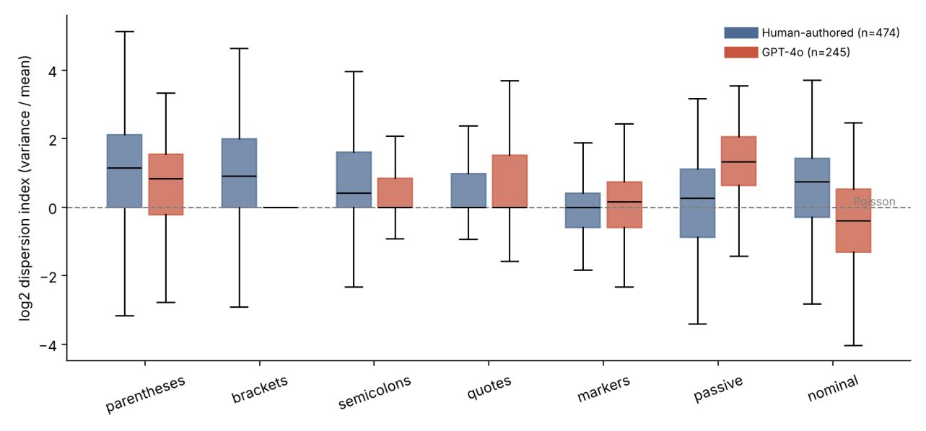
Fig. 1 | Dispersion of linguistic events. Distribution of log₂ dispersion indices (variance divided by mean) by event for human-authored (n = 474) and GPT-4o (n = 245) papers. The dashed line marks a Poisson process (index of 1). Square brackets for GPT-4o are degenerate because most machine papers contain none.
Screens detect well within a generator and poorly across generators
A logistic regression on the fourteen rate and dispersion features reaches an AUC of 0.987 for GPT-4o, 0.913 for Claude and 0.962 for Llama when trained and tested on human papers plus one generator. Performance falls sharply when the screen meets a generator it was not trained on (Table 1): a GPT-4o-trained screen reaches 0.73 on Claude papers (95% interval 0.69 to 0.78) and a Claude-trained screen 0.81 on GPT-4o papers. Rates transfer worst (0.66 and 0.73), and dispersion transfers better (0.70 and 0.81). A screen trained on human papers alone performs near chance (AUCs of 0.45 to 0.66 across three anomaly-detection methods; Supplementary Table 1). A screen is therefore only as good as the examples it has seen.
Table 1 | Detection within and across generators. AUC (95% bootstrap interval) by training and test generator and feature family; folds are grouped by source paper.
Train → test | Rates | Dispersion | Both
GPT-4o → GPT-4o | 0.971 [0.96, 0.98] | 0.856 [0.83, 0.88] | 0.987 [0.98, 0.99]
Claude → Claude | 0.904 [0.88, 0.93] | 0.751 [0.71, 0.80] | 0.913 [0.89, 0.94]
GPT-4o → Claude | 0.659 [0.62, 0.70] | 0.704 [0.65, 0.75] | 0.730 [0.69, 0.78]
Claude → GPT-4o | 0.728 [0.69, 0.76] | 0.808 [0.77, 0.84] | 0.810 [0.78, 0.84]

We then added scale-dependent clustering features: a doubly stochastic Poisson (Cox) process, in which events arrive as a Poisson process whose rate varies along the document, implies that the Fano factor grows with window size when rate fluctuations are correlated over long ranges. The model was developed on GPT-4o and Claude papers, and tested on Llama, which played no part in its development, in an analysis specified beforehand. Trained on human papers plus GPT-4o and Claude, the baseline features detect Llama papers with an AUC of 0.886 (95% interval 0.86 to 0.91) and the clustering features reach 0.932 (0.91 to 0.95), a difference of +0.046 (0.030 to 0.063). The improvement also appears when training on either generator alone (+0.041 and +0.058) and does not rescue detection from human papers alone.
A strong judge is blind to one generator, and a cascade keeps most of its power at lower cost
We asked two language models, GPT-4o and Gemini 2.5 Pro, to estimate zero-shot the probability that an excerpt was machine-written (Table 2). GPT-4o as judge is a modest detector of GPT-4o papers (AUC 0.76) and Llama papers (0.85) and worse than chance on Claude papers (0.45). Gemini 2.5 Pro is far stronger on two generators (AUC 0.97 for both GPT-4o and Llama), and flags only 2% of human papers, but reaches 0.66 on Claude papers, flagging 1% of them against 2% of human papers. The screen, trained without the target generator, is weaker than Gemini on two generators and stronger on the third (Claude, 0.775 against 0.656) at a cost of 4 to 6 milliseconds per document, against US$0.0174 and 23 seconds per excerpt for Gemini. A rank average of the screen and Gemini does better than either alone (Table 2); at a 5% false-positive rate it detects 98% of GPT-4o papers, 96% of Llama papers and 39% of Claude papers.
Table 2 | Screen, judges and their fusion. AUC (95% bootstrap interval) and share of machine papers detected at a 5% false-positive rate (set on the same documents; descriptive). The screen is trained on human papers plus the other two generators.
Target generator | GPT-4o judge | Gemini 2.5 Pro judge | Screen (clustering) | Fusion (AUC; detected at 5% FPR)
GPT-4o (n = 196 / 92) | 0.760 [0.70, 0.81] | 0.972 [0.95, 0.99] | 0.946 [0.92, 0.97] | 0.994; 0.98
Claude (n = 196 / 94) | 0.450 [0.39, 0.51] | 0.656 [0.59, 0.72] | 0.775 [0.72, 0.83] | 0.790; 0.39
Llama (n = 196 / 95) | 0.846 [0.80, 0.89] | 0.974 [0.95, 0.99] | 0.933 [0.90, 0.96] | 0.989; 0.96
Sample sizes are human / machine documents. Scoring unreadable Gemini answers as 50 changes the Gemini AUCs to 0.970, 0.653 and 0.973.
A decision model explains when the screen pays
In the cascade model (Methods), a document with posterior probability p of being machine-written is worth sending to the judge if and only if p exceeds a threshold τ that depends on the judge's price, the cost of investigating a flag and the loss from a missed paper. Four implications follow. The depth of the cascade is nondecreasing in the base rate. A judge that cannot detect a generator lowers its value for the whole stream, because the relevant detection rate is the weighted mean across generators. The judge is never worth calling if its detection rate falls below a bound set by its price and the stakes. And the screen's main economic contribution is to raise the base rate the judge sees, which raises the precision of its flags: with a 1% base rate and a 2% false-alarm rate, only about 23% of the papers an unscreened judge flags are machine-written (77% at 10%, 93% at 30%).
We calibrated the model with the measured judge price (US$0.0174 per document), false-alarm rate (2%) and detection rates, and with illustrative values for the cost of investigating a flagged paper (US$20), the loss per missed paper (US$100 or US$500) and the base rate, which our data cannot measure. Table 3 and Fig. 2 show the results. The optimal share of documents judged rises from 14% at a 1% base rate to 41% at 10% and 67% at 30%. The judge's price is a minor part of total cost, while its false alarms are not: for the equal-weight mixture at a 1% base rate, judging everything costs US$17 in judge calls but US$522 in investigations per 1,000 documents, and the cascade cuts investigations to US$102. Savings against judging everything are largest where machine papers are rare and the judge is expensive (71% at a 1% base rate with a judge 100 times pricier) and small at high base rates (1% to 5% at 30%). These values are structural illustrations and not estimates for any organization.
Table 3 | Expected cost per 1,000 documents (US$) for the equal-weight mixture of generators, with review at US$20 per flagged paper (assumed). q* is the share of all documents sent to the judge at the cascade optimum.
Loss per miss | Judge price | Base rate | Best q* | No screening | Screen only | Judge on all | Cascade | Saving vs judge-all
US$100 | ×1 | 1% | 14% | 1,000 | 973 | 948 | 594 | 37%
US$100 | ×1 | 10% | 41% | 10,000 | 6,225 | 5,652 | 5,420 | 4%
US$100 | ×1 | 30% | 67% | 30,000 | 12,647 | 16,104 | 15,955 | 1%
US$100 | ×100 | 1% | 5% | 1,000 | 973 | 2,671 | 767 | 71%
US$100 | ×100 | 10% | 24% | 10,000 | 6,225 | 7,374 | 6,051 | 18%
US$500 | ×1 | 1% | 36% | 5,000 | 3,465 | 2,582 | 2,284 | 12%
Selected rows; the full table is Supplementary Table 3.
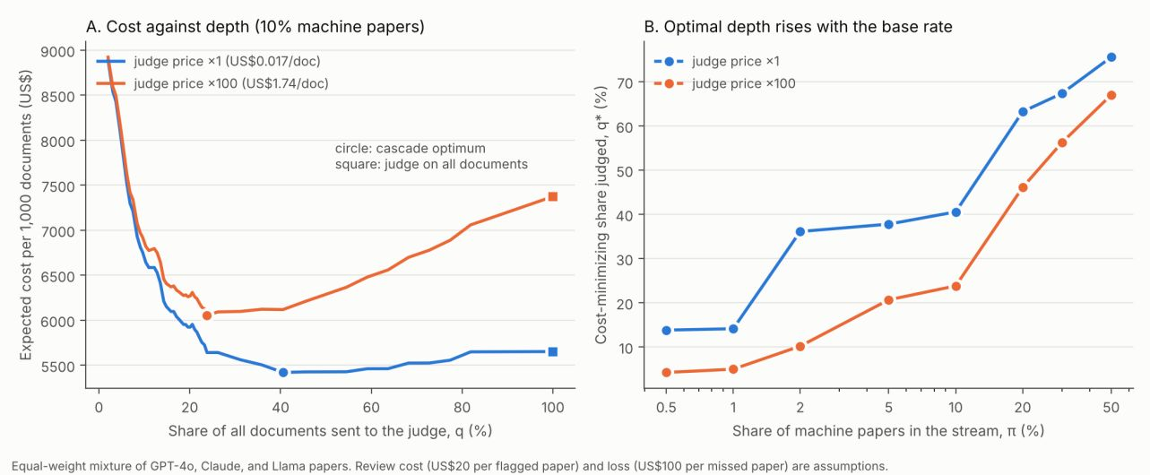
Fig. 2 | Cost and depth of the cascade. a, Expected cost per 1,000 documents against the share of documents sent to the judge, with 10% machine papers, a loss of US$100 per missed paper and review at US$20 per flagged paper. b, Cost-minimizing share judged against the base rate. Both panels use the equal-weight mixture of generators.
A feature-aware edit defeats the screen but not the judge, and a generic rewrite does neither
A machine-using author in the model chooses an evasion effort e that lowers the probability of detection d(e) at a cost. Equilibrium effort rises with the stakes, and a screen that is very effective against non-adaptive authors can provoke enough evasion to detect less than a weaker screen (a detectability paradox). We tested this with a white-box attack on the five events that are easy to edit. For each machine paper, the attack moves a share e of the way from the paper's own count to the human mean count for each event, and places the edits in two of the four windows. The screen degrades quickly (Table 4): averaged over generators, the AUC falls from 0.889 to 0.664 and the share detected at a 5% false-positive rate from 53% to 8% under full attack, with half of the loss at e = 0.25. For Claude papers the AUC falls below 0.5, so edited Claude papers look more human than real human papers. A screen built only on the two unedited events (passives and nominalizations) is unaffected (mixture AUC 0.780 before and 0.779 after), whereas a screen built on the five edited events falls to chance (0.849 to 0.491). The robust features are weaker without an attack (0.780 against 0.889 for all seven).
Table 4 | Detection of machine papers under a feature-aware edit. AUC / share detected at a 5% false-positive rate, by evasion effort e.
Target | e = 0 | e = 0.25 | e = 0.5 | e = 0.75 | e = 1
GPT-4o | 0.959 / 0.73 | 0.888 / 0.33 | 0.849 / 0.24 | 0.824 / 0.12 | 0.800 / 0.10
Claude | 0.777 / 0.18 | 0.634 / 0.05 | 0.539 / 0.02 | 0.473 / 0.01 | 0.471 / 0.01
Llama | 0.932 / 0.69 | 0.852 / 0.37 | 0.799 / 0.20 | 0.763 / 0.17 | 0.721 / 0.12
Mixture | 0.889 / 0.53 | 0.791 / 0.25 | 0.729 / 0.15 | 0.687 / 0.10 | 0.664 / 0.08

A generic attack that needs no knowledge of the features did not work. Llama 3.3 70B rewrote 300 machine papers to read as if written by an experienced human researcher, at about US$0.003 per paper. Averaged over generators, the AUC rose from 0.885 to 0.914 (0.837 to 0.884 when Llama is excluded from training, because the attacker is itself a generator), and for Claude papers detection became clearly easier (AUC 0.750 to 0.905). The rewrite moved counts further from the human mean, not toward it: it removed parentheses, bracketed citations, semicolons and passives. A hybrid of rewrite followed by edit was no stronger than the edit alone (mixture AUC 0.688 against 0.675 with Llama excluded). What matters for evasion is therefore knowledge of the screen's features, not rewriting power as such.
The judge was not fooled by either attack. For GPT-4o and Llama papers its AUC did not fall (paired differences from +0.004 to +0.014 for the hybrid attack and the edit alone), and for Claude papers both attacks made detection easier (+0.167 and +0.080, share detected at 5% false positives rising from 0.01 to 0.35 and 0.05). Because a rank average includes a screen the attack has made uninformative, fusion did worse under attack than the judge alone (0.937 against 0.985 for Llama papers). The cascade, which uses the screen as a gate, suffers the same way, because attacked papers fall out of the top-scoring share and never reach the judge: with 10% machine papers and 30% of documents sent to the judge, detection of Llama papers fell from 88% to 54%. Judging every document was unaffected (0.96 to 0.94). The saving of a cascade is therefore bought with a dependence on a screen that an informed author can defeat.
Discussion
Detection accuracy is the wrong quantity to optimize in isolation. The value of a screen depends on the base rate, on the costs of false alarms and misses, and on whether authors respond, and each of these shifts the answer in ways that headline accuracy hides. Three results stand out. First, accuracy does not transfer across generators, and a screen that needs no examples of machine text does not work in our setting, so maintenance is the dominant cost of any screen. Second, a strong judge can have an almost complete blind spot, and since an organization cannot know which generator it faces, a single blind spot drags down the relevant detection rate. Third, a screen whose features are known is fragile, and publishing the features, as research does, supplies that knowledge. This is the logic of costly signals^{4,5} applied to a detector's inputs: a feature is informative only to the extent that it is costly to fake. In our data, passives and nominalizations played that role. Because we publish our method, the relevant benchmark for any deployed version is the equilibrium detection rate, not the headline accuracy reported here.
The evidence has clear limits. It rests on three generators, one genre (English-language scientific papers) and two judges. Samples are modest, and the Claude sample (152) is smaller than the GPT-4o (245) and Llama (202) samples because we capped generation to limit cost; bootstrap intervals for cross-generator AUCs are about ±0.05, and the judged subset of 500 documents is small enough that the cascade and fusion results are indicative. The clustering model was designed after we had seen baseline results, and its confirmatory test uses one held-out generator. Papers were generated in four requests, which may introduce structural artifacts such as inflated passive dispersion, and human papers come from two extraction pipelines. Costs of review and of a missed paper, and the base rate, are assumed. The attackers are not the strongest conceivable: none edits passives and nominalizations or optimizes against the detector's weights, the hard-to-edit feature set was chosen because our attack left it untouched, and the generic rewrite used one attacker and one prompt. We did not compare against other detectors², did not run embedding-based comparisons^{6,7}, did not test light human editing of machine text, and did not test whether explainable evidence improves human decisions. A stronger adversary, measured cost parameters, more and newer generators, and a randomized experiment with expert reviewers would turn this pilot into a fuller test.
Methods
Documents
Human papers were sampled at random from 2015–2019, before large language models were widely used for scientific writing: 300 from the open-access subset of PubMed Central (article XML body paragraphs) and 200 from arXiv (PDFs converted to text, reference lists removed, broken lines rejoined). We excluded documents shorter than 1,500 words and required at least four 500-token windows, leaving 474 human papers. For each sampled paper a generator wrote a paper on the same topic from the original title and abstract, with one of three prompts of increasing detail. We used GPT-4o, Claude Sonnet 5.5 and Llama 3.3 70B Instruct (open weight) through a commercial API gateway. A single request produced only about 800 words from GPT-4o, so each paper was written in four requests (introduction, methods, results, discussion with conclusion) and concatenated. GPT-4o produced 245 unique papers (median about 2,750 words), Claude 152 (4,566 words; capped to limit cost) and Llama 202 (about 2,970 words). Llama was added last, after the clustering model had been developed, and serves as the confirmatory test. Every document was truncated to the same length.
Screens
Each document was cut into consecutive windows of 500 whitespace-delimited tokens, and only the first four windows (2,000 tokens) were kept for every document. In each window we counted seven events: parentheses, square brackets, semicolons, paired quotation marks, fourteen discourse markers (for example however, therefore, moreover), passive constructions (a form of be plus a participle, by pattern matching) and nominalizations (words ending in -tion, -ment or -ity). The patterns for passives and nominalizations are approximate. For each document and event we computed the mean count per window (rate) and the dispersion index (variance over mean), and the baseline screen is a logistic regression on these fourteen quantities. For the clustering model, events are treated as a doubly stochastic Poisson process, for which the Fano factor in a window of w tokens is F(w) = 1 + Var(Λ_{w})/E(Λ_{w}), with Λ_{w} the rate integrated over the window. We estimated F(w) for each event at window sizes of 50, 100, 200 and 400 tokens by moment matching, clipped to [0.05, 20] and set to one when an event does not occur, and summarized each event by its rate, the mean log Fano factor across scales and the slope of log F(w) on log w, giving 21 features.
Judges and evaluation
GPT-4o and Gemini 2.5 Pro were asked, zero-shot at temperature 0 with one fixed prompt, to estimate the probability (0 to 100) that an excerpt was written by an AI language model. They saw a random sample of 500 excerpts (200 human papers and 100 from each generator), in random order with opaque identifiers, with markdown symbols and bare section titles removed. Gemini 2.5 Pro was allowed up to 8,000 output tokens; 12 of 500 answers were unreadable. A document was excluded for every method if either judge's answer was unreadable, leaving 196 human papers and 92 to 95 papers per generator. GPT-4o is also a generator, so its verdicts on GPT-4o papers involve self-recognition; Gemini is not a generator. Detection was evaluated by five-fold cross-validation in which all material from one source paper stays in one fold; we report the AUC with 95% bootstrap intervals over documents and, where noted, the share of machine papers detected when 5% of human papers are flagged. For transfer, a screen was trained on human papers and the other generators and tested on a generator it never saw. Three analyses were specified before they were run: the test of the clustering model on Llama, the comparison of screens with judges and rank-average fusion, and the cascade calibration.
Decision model
A share π of documents are machine-written. The screen assigns a score s with likelihood ratio ℓ(s) = f_{M}(s)/f_{H}(s), nondecreasing in s, so the posterior probability of machine authorship is p = πℓ/(πℓ + 1 − π). A judged document is flagged with probability J if machine-written and a if human. Costs are c_{J} per judge call, c_{R} per flagged paper investigated (assumed to settle its status) and L per unflagged machine paper. Proposition 1: sending a document with posterior p to the judge reduces expected cost by V(p) = p[(L − c_{R})J + c_{R}a] − (c_{J} + c_{R}a), which is linear and increasing in p, so the document is worth sending if and only if p ≥ τ = (c_{J} + c_{R}a)/((L − c_{R})J + c_{R}a); if (L − c_{R})J ≤ c_{J}, the judge is never worth calling. Proposition 2: the set of documents worth judging expands as the likelihood-ratio threshold falls, which it does as π rises, so the cost-minimizing depth is nondecreasing in π, in J and in L, and nonincreasing in c_{J} and c_{R}. Proposition 3: τ rises as J falls; for a stream mixing generators with weights w_{g}, the relevant rate is J̄ = Σw_{g}J_{g}. Proposition 4: among documents an unscreened judge flags, the machine share is πJ/(πJ + (1 − π)a). For strategic authors, the author chooses effort e ∈ [0, 1] at cost (κ/2)e² to minimize m·d(e) + e²/2, with m = (B + P)/κ the ratio of stakes (gain B if the paper passes, loss P if detected) to the cost of effort. Proposition 5: if d is decreasing and convex, effort is nondecreasing in m and equilibrium detection falls as stakes rise. Proposition 6: if d(e) = d₀(1 − e), then e* = min(1, md₀) and equilibrium detection d₀(1 − md₀) is maximized at d₀ = 1/(2m), so a more effective screen can detect less. Proposition 7: a screen built on features that cannot be edited cheaply (flat d_{B}) has higher equilibrium detection than a screen with d_{A}(0) > d_{B}(0) and steep d_{A} for every m above a threshold. Proofs are in the Supplementary Information.
Attacks
The feature-aware attack moves a share e of the way from a paper's own count to the human mean count for parentheses, square brackets, semicolons, quotation marks and discourse markers, placing the edits in two of the four windows, as human text clusters. It knows the features but not the detector's weights, and the detector was trained on clean text and only scores attacked texts. The generic attack asked Llama 3.3 70B Instruct to rewrite each of the 300 machine papers in the judge sample (100 per generator) so that it read as if written by an experienced human researcher, in chunks of 1,000 tokens with the target length stated. Because the attacker is itself a generator, we report both the standard protocol and one that excludes Llama from training. The hybrid attack applies the edit to the rewritten text. The Gemini judge was given the hybrid-attacked and edit-only papers (first 2,000 tokens; US$11.27 in judge calls).
Reporting
No human participants were involved. All analyses used published papers and machine-generated text. [Confirm with the authors' institution whether any approval is needed.]
Data availability
The human papers were drawn from the open-access subset of PubMed Central and from arXiv. The prompts, the generated papers and the script that re-collects the human papers will be made available in a public repository. [Authors: deposit before submission and give the DOI here.]
Code availability
The analysis code will be made available in a public repository. [Authors: deposit before submission and give the DOI here.]
Author contributions
[To be completed.]
Competing interests
[To be completed. Describe any use of generative AI tools in preparing the manuscript, code or analysis, as the journal's policy requires.]

References
1. Gehrmann, S., Strobelt, H. & Rush, A. M. GLTR: statistical detection and visualization of generated text. In Proc. 57th Annu. Meet. Assoc. Computational Linguistics: System Demonstrations 111–116 (ACL, 2019).
2. Mitchell, E., Lee, Y., Khazatsky, A., Manning, C. D. & Finn, C. DetectGPT: zero-shot machine-generated text detection using probability curvature. In Proc. 40th Int. Conf. Machine Learning (PMLR, 2023).
3. Zheng, L. et al. Judging LLM-as-a-judge with MT-Bench and Chatbot Arena. In Adv. Neural Inf. Process. Syst. 36 (Datasets and Benchmarks Track, 2023).
4. Spence, M. Job market signaling. Q. J. Econ. 87, 355–374 (1973).
5. Connelly, B. L., Certo, S. T., Ireland, R. D. & Reutzel, C. R. Signaling theory: a review and assessment. J. Manage. 37, 39–67 (2011).
6. Pillutla, K. et al. MAUVE: measuring the gap between neural text and human text using divergence frontiers. In Adv. Neural Inf. Process. Syst. 34 (2021).
7. Zhang, T., Kishore, V., Wu, F., Weinberger, K. Q. & Artzi, Y. BERTScore: evaluating text generation with BERT. In Proc. Int. Conf. Learning Representations (2020).

