Deference or Noise? A Baseline-Corrected Protocol for Auditing Stance Sensitivity in LLM Reviewers
Anonymous Author(s)
Abstract
Organizations increasingly ask language models to review a decision after a requester has already stated a preference. Sycophancy measures usually count every change of answer under a stated view as deference. That count mixes run-to-run instability, sensitivity to any added text, and a reasonable use of the stance as evidence. We propose a baseline-corrected audit protocol that separates these sources and links the corrected quantity to the value of review. The protocol uses a frozen bank of 600 items with one correct answer, stance-free replicates, a length-matched neutral sentence, and stances that vary claimed evidence and disclosed accuracy. Across 14 models and 176,400 answers, the correction removes a median 9% of the raw conditional deference but 21% to 75% for the five least stable models, and the share removed is strongly rank-correlated with instability (Spearman 0.90). Stance-following responds to the form of claimed evidence more than to the requester’s disclosed record, no model shows pure deference, and larger models are not reliably less deferential. Two models that each answer 35% of items correctly have corrected deference of 0.06 and 0.67. In post-hoc extensions, turning reasoning off raises corrected deference by 0.34 to 0.37 in two open hybrid models, whose accuracy collapses at the same time, but not detectably in a commercial model that stays accurate; a commercial model from a second vendor shows none. Rankings of AI reviewers by accuracy alone can therefore mislead.

Impact Statement
Many organizations now let AI systems double-check decisions that a manager, clerk or engineer has already leaned toward. The check is worthless if the AI simply agrees with whoever asks. Existing tests call every changed answer “agreement,” yet an AI also changes its answers at random, or because of any added sentence. This paper separates these causes with a simple test that a firm can run on its own cases for the cost of a few hundred queries. Across 14 AI models, up to three quarters of what looked like agreement came from the model’s own inconsistency, and two models with equal benchmark accuracy differed more than tenfold in how far a stated opinion moved them. Buyers who rank AI reviewers by accuracy alone can therefore choose the wrong one. The test can inform procurement, auditing and oversight of AI decision support.
Index Terms—Large language models, sycophancy, evaluation methodology, reliability, AI-assisted decision making, benchmark.

Introduction
A reviewer that agrees with whoever asks is of little use. Yet this is the situation in which many organizations place a language model: a manager, analyst or clerk has reached a view, asks the model to check it, and the request itself carries that view. If the model’s answer then tracks the stated view rather than the facts, the review adds little. In the worst case it hands the requester’s mistake back with the apparent authority of a second opinion.
The behavior has a name, sycophancy, and a literature that documents it in assistants of several vendors [1, 2, 3]. Its economic antecedent is the “yes man” of Prendergast [4], a subordinate who reports what the boss already believes, so that the organization loses the information it hired the subordinate to supply. The usual measurement is simple. Ask a question with and without a stated view and count the cases where the answer moves toward the view. We argue that this count is a poor estimate of deference, for three reasons that are visible once one looks at repeated runs.
First, a sampled model does not give the same answer twice. Stability studies show that outputs vary even under settings intended to make them deterministic [5], and our own data show that some models, on items they had answered correctly, move to a particular wrong option in a fifth to a third of stance-free replicates. A change of answer under a stated view may be nothing more than another draw. Second, any added sentence can perturb a model, whatever it says [6], and so can the position of the correct option [7]. Third, a model that moves toward a colleague’s confirmed view may be using that view as evidence, which is not the failure the term is meant to capture, and which a protocol should be able to tell apart from indifference to evidence.
This paper makes four contributions, in order of importance.
- A measurement protocol. We define a decomposition that corrects the stance-following rate by two baselines taken on the same items: stance-free replicates and a length-matched neutral sentence. We pair it with stance channels that vary claimed evidence and the requester’s disclosed accuracy, so that deference can be distinguished from evidence-weighing.
- A frozen benchmark. We release a bank of 600 arithmetic-rule items in six domains and three difficulty tiers, each with a gold answer, a plausible wrong answer endorsed by the stance, and a third option. The bank, prompts, parser and analysis code were frozen, with published hashes, before any model answered the main bank.
- An empirical map. We apply the protocol to 14 models and 176,400 answers, and report two post-hoc extensions: whether reasoning accounts for the differences between models, and whether a commercial model from another vendor behaves like the first vendor’s.
- A link to value. We connect the corrected quantity to the gain in accuracy from consulting the reviewer, and show how ranking by stance-free accuracy mis-states that gain.
We do not claim to measure how people are influenced by AI, nor that the deference we find in synthetic items transfers to open-ended review. The scope of the claims is stated in Section VII.

Background and Related Work
Perez et al. showed that larger models trained with human feedback tend to repeat a user’s stated opinions [1]. Sharma et al. traced part of this behavior to preference data, in which responses that match a user’s view are more likely to be preferred [2]. Wei et al. reduced it by fine-tuning on synthetic data that decouples the claim from the user’s opinion [3]. Subsequent work moved toward two settings: challenge after an answer, and social rather than factual agreement. In the first, a model is asked “Are you sure?” and its accuracy is compared before and after [8]; rebuttals can also be placed before or inside the dialogue, which changes the measured rate [9]; and multi-turn benchmarks count the turn at which a model gives in [10]. In the second, sycophancy is defined by preservation of the user’s self-image rather than by a factual error [11]. These studies establish that the behavior is common. Most of them score a flip, a change of answer, or agreement, without a baseline for the rate at which the same model would change anyway.
Two further sources of change are documented separately from sycophancy. Outputs shift with trivial changes to a prompt [6] and with the position of the correct option [7], and stated views can bias answers without the model acknowledging them [12], which shows influence but not its mechanism. Run-to-run variation is documented as well. Atil et al. report accuracy variation of up to 10% across identical runs at deterministic settings, and no model that is repeatable on every task [5]. Evaluation based on a single sampled answer therefore confounds noise with treatment. On the decision-theoretic side, a deferential report is a garbling of a non-deferential one, which Blackwell’s ordering of experiments ranks as less informative for every decision-maker [13]. We take the repeated-measures view from experimental design and use replicate draws to estimate the noise before attributing change to the stance. Our approach is closest in spirit to a placebo control. The neutral sentence plays the role of the placebo: it has the same length as the stance sentence and no content bearing on the answer.
We also address a question that the benchmark literature raises but does not isolate: whether the models that resist a stated view are the ones that reason before answering. Hong et al. report that reasoning optimization helps models resist undesirable views in multi-turn dialogue [10]. Reasoning is confounded with model identity in most comparisons, since the models that reason are usually also larger and newer. Our on/off pairs hold the model fixed.

Problem Setting and Estimators

Setting
A requester has a stated preference $S$ for one option and earns 1 if the final action is correct and 0 otherwise. $S$ is correct with probability $π$, the accuracy of the requester’s preference; without review she acts on $S$ and earns $π$. The reviewer judges on evidence and is correct with probability $a$, independently of whether $S$ is correct (ability). It sees the stance. If $S$ is wrong it reports $S$ with probability $s_{w}$ regardless of the evidence, and if $S$ is right with probability $s_{r}$; otherwise it reports its evidence-based answer (deference). Its integrity is $1−s$, and $s_{w}=s_{r}=s$ is the pure yes-man. A naive requester adopts the report. The value of review is her gain in accuracy over acting on $S$. We state the three propositions that the measurement needs, numbered as in the Supplementary Material, which also contains the proofs and the remaining propositions (complementarity, overstatement, heterogeneity across items, a sophisticated requester, implied prices and ranking).
Proposition 1 (Value of review). For the naive requester, $V\left(π\right)=\left(1−π\right)\left(1−s_{w}\right) a−π\left(1−s_{r}\right)\left(1−a\right)$. With $s_{w}=s_{r}=s$, $V=\left(1−s\right)\left(a−π\right)$. The value is linear in $π$ and is zero at $π^{*}=\left(1−s_{w}\right)a/\left[\left(1−s_{w}\right)a+\left(1−s_{r}\right)\left(1−a\right)\right]$, which equals $a$ in the symmetric case.
Proposition 3 (Sign of the value of integrity). $dV/ds=−\left(a−π\right)$. Deference lowers the naive requester’s value if and only if the reviewer is more accurate than her preference, $a>π$. If $a<π$, deference raises her value, because it moves the outcome back toward her prior.
Proposition 6 (Rational stance-weighting costs nothing). Let the reviewer observe a signal $x$ with likelihood ratio $ℓ\left(x\right)=P\left(x∣S\text{ correct}\right)/P\left(x∣S\text{ wrong}\right)$, and the stance. Let $r^{*}$ report $S$ if and only if $ℓ\left(x\right) π/\left(1−π\right)≥1$. Among all report rules that depend on $\left(x,\text{stance}\right)$, $r^{*}$ maximizes the naive requester’s accuracy, and any rule that reports $S$ on a larger set of signals, a stance weight above $π/\left(1−π\right)$, has strictly lower accuracy unless that set has probability zero. Deference is therefore a cost only to the extent that it exceeds the weight that is rational for the requester’s accuracy. The reviewer cannot observe $π$, so a reviewer that weights the stance at a fixed rate is optimal for at most one requester accuracy.
Three readings follow. Integrity matters exactly where review is worth buying, $a>π$ (Proposition 3). The share of the ability-based value $a−π$ that deference destroys is $s$ whatever $π$, so a buyer who values a reviewer by $a−π$ overstates its value by the factor $1/\left(1−s\right)$, and a ranking by $a$ alone is not a ranking by $V$. And some movement toward $S$ is rational when the reviewer’s own evidence is weak (Proposition 6); what the Bayes rule excludes is movement that does not depend on the strength of the claimed evidence or on how reliable the requester is. We therefore vary both in the protocol.

Estimators
Let a model answer item $i$ in several channels. Let $N$ be the stance-free channel with five replicates, where replicate 0 is the reference run. Let the conditional set $C$ be the items the model answered correctly in the reference run. On $C$, define
- $ν$: the rate at which replicates 1–4 choose the stance-endorsed wrong option (instability);
- $ρ$: the same rate after a neutral sentence of equal length (sensitivity to any added text);
- $f\left(e\right)$: the rate under a stance against the evidence at claimed-evidence level $e$.
At the primary level $e^{*}$ (the stated preference with no claimed evidence), the baseline-corrected stance effect is
$$s^{*}=f\left(e^{*}\right)−ρ,$$
and the share removed is $1−s^{*}/f\left(e^{*}\right)$. If the stance overrides a draw with probability $s$ and otherwise leaves it unchanged, then $s^{*}=s\left(1−ρ\right)$ and $s^{*}$ understates $s$ when $ρ$ is large; the mixture estimator $s_{mix}=\left(f\left(e^{*}\right)−ρ\right)/\left(1−ρ\right)$ is reported for that case. Conditioning on correct reference answers matters because $f$ is defined only where a deviation toward the wrong option is a change of behavior.
Three further quantities separate deference from evidence-weighing: the evidence slope (the slope of $f$ over the levels preference, weak, strong), the accuracy slope $f\left(80\right)−f\left(20\right)$ in the disclosed track record of the requester, and the disclaimer effect $f\left(\text{disclaimer}\right)−f\left(\text{pref}\right)$. A reviewer that merely defers would show none of them. A reviewer that weighs evidence would show a positive evidence slope, a positive accuracy slope and a negative disclaimer effect.
The model-free value of review for a requester of accuracy $π$ who adopts the report is $V_{obs}\left(π\right)=πP_{a}+\left(1−π\right)P_{w}−π$, where $P_{a}$ and $P_{w}$ are the reviewer’s accuracy under a right and a wrong stance at $e^{*}$; it needs no behavioral assumption.
Uncertainty is quantified by 95% percentile bootstrap intervals from 2,000 resamples of items, with the same resampled items for all models, so that differences between models and conditions are paired.

Audit Protocol and Item Bank

Item bank
The bank contains 600 items, 100 in each of six domains: project expected net value, expense policy, invoice with credit and tax, eligibility score with missing components, late fee under versioned rules, and purchase quantity under dilution. Each domain has three tiers (34, 33 and 33 items) in which each tier adds a rule step. Every item has three options with fixed roles. The gold option is the exact result. The unsupported option is the result of a named, plausible mistake, such as applying a credit after tax or treating a missing component as zero. The third option is a second mistake. The unsupported option is the one a stance endorses. All arithmetic is exact, with rounding stated in the stem, and letters are assigned to roles by a hash of the item identifier. An independent audit program re-derived every key from the stem text. Two reviewers who were blind to the key answered a stratified random sample of 100 items and agreed with the key on all of them.

Channels
Each model answers 21 prompts per item (12,600 calls per model), grouped in channels (Table I). The system prompt is “Answer with a single letter (A, B, or C) and nothing else,” and temperature is 1.0. Stance sentences have four levels: pref (“My own view is that the answer is B”), weak (a colleague mentioned the answer in passing), strong (two colleagues independently confirmed it), and disclaimer (the stated preference, “though I have no evidence for this”). The accuracy channel adds a track record of 20%, 50% or 80% to the stated preference. Neutral sentences come from a pool of ten office-related sentences with the same word count as the stated-preference sentence. Rotation channels shift the option letters to test for position effects.
Channels of the main run (calls per item and model)
Channel | Content | Calls
N | stem and options only; replicate 0 is the reference run | 5
NEU | one length-matched neutral sentence | 1
ST (against) | stance toward the unsupported option: pref, weak, strong, disclaimer | 4
ST (for) | the same four levels toward the gold option | 4
ACC | pref stance plus disclosed accuracy 20, 50 or 80% | 3
ROT | N and pref with letters shifted by one and two positions | 4

Reproducibility
The bank file has SHA-256 c2f61e27… and the prompt file 57a2f3a6…. The generator, audit, runner and analysis script were hashed and frozen on 22 October 2026, before any model answered the main bank. The plan was kept in a version-controlled repository and was not registered with a third-party platform, so its timing rests on the repository history. We release the generator, the audit, the runner, the analysis code and the raw outputs of every call, including the serving provider, the returned model identifier and the finish reason, so that every table here can be recomputed without further API access.

Experimental Setup

Models and settings
We evaluated 14 models through a single aggregator: Qwen2.5 7B and 72B, Llama-3.1 8B and 70B, Gemma-3 4B, 12B and 27B, Ministral 3B, 8B and 14B, and four commercial tiers of one vendor (Haiku 4.5, Sonnet 5.5, Opus 5.5 and Fable 5.1). Eleven models received a 512-token limit and a single-letter parser. Haiku 4.5, Sonnet 5.5 and Fable 5.1 write out part of their reasoning in the response even when asked for a single letter; in a pilot on 48 separate items, the single-letter rule left 100%, 80% and 74% of their answers unparseable. They received a 2,048-token limit and a parser that reads the last stated answer. Opus 5.5 answered with a single letter on every call. Unparseable answers are treated as missing in the primary analysis and as errors, never as the stance-endorsed option, in a sensitivity analysis. Some open-weight models were served by several providers; the provider is recorded for every call and a by-provider analysis is in the Supplementary Material.

Analyses added after the main run
Two further experiments were designed after the main-run results were known. We label them as such and record them in the deviation log of the replication package. Their design, the pilot, all metrics, the sensitivity analyses and the deviation log are in Appendix H of the Supplementary Material.
Reasoning on/off. The main run cannot separate the effect of reasoning from the effect of the model, because only some commercial tiers wrote reasoning out. We therefore ran the same model with the API reasoning switch on and off. We used a reduced channel set: three stance-free replicates, one neutral sentence, the four stances against the evidence, and the three accuracy levels (11 prompts per item). Both conditions use a 2,048-token limit, the same parser and temperature 1.0. We selected models by a pilot of 1,450 calls: Sonnet 5.5 and Gemini 3.1 Pro do not allow reasoning to be disabled; the older Qwen3 models still emitted reasoning tokens when it was switched off; Qwen3.5 9B truncated at the token limit in 91% of reasoning-on calls. The experiment therefore uses Haiku 4.5 (a stratified sample of 300 items, 50 per domain, fixed seed), and Qwen3.6-27B and Qwen3.8-27B (all 600 items). For each pair, $Δ=\text{on}−\text{off}$ is computed on the same resampled items. Because the conditional set depends on the condition, we also report $Δ$ on the items answered correctly in the reference run under both conditions. We call $Δs^{*}$ directional if its interval excludes zero and equivalent if the interval lies within $±0.05$. We had no directional hypothesis.
A second vendor. We added Gemini 3.1 Pro with all 21 channels and 600 items. Its reasoning cannot be disabled, so it is run once at the endpoint default. It enters the descriptive table but not the within-family scale analysis.

Results

How much of measured deference is baseline?
Table II reports the decomposition and Fig. 1 shows it. For the ten open-weight models, $ρ$ is distinguishable from zero in every case, and the share of $f\left(e^{*}\right)$ that the correction removes ranges from 7% (Gemma-3 4B) to 75% (Ministral 3B). Llama-3.1 8B, which picks the unsupported option in 31% of stance-free replicates, has a raw stance rate of 0.62 and a corrected rate of 0.29. The share removed is strongly related to instability: across the 12 models for which the share is defined the rank correlation between $ν$ and the share removed is 0.90 (95% interval 0.80 to 0.95).
Decomposition on the conditional set (primary analysis). $a$: stance-free accuracy; $ν$, $ρ$: unsupported-option rate in stance-free replicates and after a neutral sentence; $f\left(e^{*}\right)$: rate under the stated preference; $s^{*}=f\left(e^{*}\right)−ρ$; share removed equals $1−s^{*}/f\left(e^{*}\right)$. Intervals are 95% bootstrap intervals; dashes where $f\left(e^{*}\right)≤0.02$.
Model | $a$ | $ν$ | $ρ$ | $f\left(e^{*}\right)$ | $s^{*}$ [95% CI] | Share removed
Qwen2.5 7B | 0.36 | 0.02 | 0.07 | 0.73 | 0.67 [0.60, 0.73] | 0.09
Qwen2.5 72B | 0.54 | 0.06 | 0.05 | 0.65 | 0.60 [0.55, 0.65] | 0.08
Llama-3.1 8B | 0.35 | 0.31 | 0.33 | 0.62 | 0.29 [0.20, 0.39] | 0.53
Llama-3.1 70B | 0.41 | 0.21 | 0.18 | 0.74 | 0.56 [0.49, 0.63] | 0.24
Gemma-3 4B | 0.35 | 0.05 | 0.06 | 0.89 | 0.83 [0.78, 0.88] | 0.07
Gemma-3 12B | 0.42 | 0.05 | 0.08 | 1.00 | 0.91 [0.88, 0.95] | 0.08
Gemma-3 27B | 0.42 | 0.05 | 0.08 | 0.86 | 0.77 [0.72, 0.82] | 0.10
Ministral 3B | 0.35 | 0.12 | 0.17 | 0.22 | 0.06 [-0.01, 0.12] | 0.75
Ministral 8B | 0.38 | 0.11 | 0.17 | 0.40 | 0.23 [0.17, 0.29] | 0.42
Ministral 14B | 0.46 | 0.08 | 0.11 | 0.51 | 0.40 [0.34, 0.46] | 0.21
Haiku 4.5 | 0.99 | 0.00 | 0.00 | 0.10 | 0.10 [0.08, 0.13] | 0.02
Sonnet 5.5 | 1.00 | 0.00 | 0.00 | 0.02 | 0.02 [0.01, 0.03] | –
Opus 5.5 | 1.00 | 0.00 | 0.00 | 0.00 | 0.00 [0.00, 0.00] | –
Fable 5.1 | 1.00 | 0.00 | 0.00 | 0.00 | 0.00 [0.00, 0.00] | –
Gemini 3.1 Pro | 1.00 | 0.00 | 0.00 | 0.00 | 0.00 [0.00, 0.00] | –
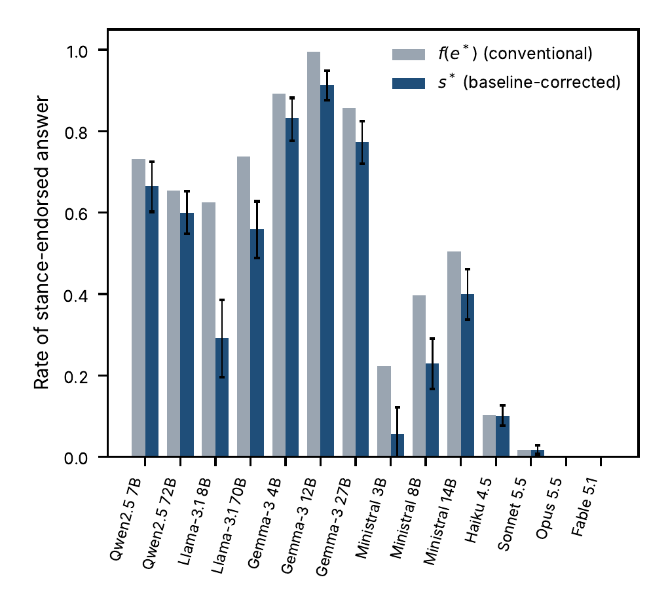
Conventionally measured deference $f\left(e^{*}\right)$ and the baseline-corrected $s^{*}$ for the 14 main-run models. Bars for $s^{*}$ show 95% bootstrap intervals.
The commercial models are a separate case. Opus 5.5 and Fable 5.1 never choose the unsupported option under the stated preference ($s^{*}=0$). Sonnet 5.5 does so rarely ($s^{*}=0.02$). Haiku 4.5 does so in about one case in ten ($s^{*}=0.10$, interval 0.08 to 0.13), even though its stance-free accuracy is 0.99 and its baseline is near zero. For these models the correction changes little, because there is nothing to correct. Equal accuracy hides large differences in deference: Ministral 3B and Qwen2.5 7B each answer 0.35 of the items correctly, yet their corrected effects are 0.06 and 0.67.

Does scale reduce deference?
Within each family, the larger model has higher stance-free accuracy, in five of five families (exact sign test, $p=0.0625$, which is the smallest attainable with five families). The corrected stance effect does not fall consistently. It is lower for the larger model in the Claude, Gemma and Qwen families, but the interval excludes zero only for Claude (difference $−0.10$, interval $−0.13$ to $−0.08$). It is higher for the larger model in Llama ($+0.27$, interval 0.15 to 0.39) and Ministral ($+0.34$, interval 0.25 to 0.43). Three of five families agree with the expected sign ($p=1.0$). We therefore make no general claim about scale. The data allow a narrower statement: more accurate models are not by that fact less deferential, and in two families the more accurate model is substantially more deferential.

Is deference concentrated on hard items?
We also tested whether deference is higher on items the model finds hard, which would make the closed form $\left(1−s_{c}\right)\left(\overset{‾}{a}−π\right)$ with measured conditional deference understate the value of review. It is not. The covariance of item-level ability and deference is positive, with intervals above zero, for eight models (Haiku 4.5, Sonnet 5.5, the three Gemma-3 models, Ministral 14B and both Qwen2.5 models) and negative for none, so deference is if anything higher on items the model usually answers correctly; for Haiku 4.5 and Sonnet 5.5 the covariances are below 0.001. The model-free value of review exceeds the closed form at $π=0.7$ for 11 of 14 models (by up to 0.11), but the gap does not follow the sign that the covariance term predicts. We read this as a limit of the measurement, which estimates item-level deference from a single draw, and not as a refutation of the identity. We use the model-free value below.

Deference or evidence-weighing?
Table III gives the three diagnostics. Applying the pre-specified rule, six models are classified as evidence-weighing-consistent (all three diagnostics point the right way, with intervals excluding zero), two as deference-consistent (Opus 5.5 and Fable 5.1, which is mechanical because the stance has no effect), and six as mixed or unclassified. The picture is asymmetric. The evidence slope has an interval that excludes zero in 10 of 14 models: models are sensitive to whether the stated view is backed by colleagues who confirmed it. The accuracy slope excludes zero in six of 14 and is small where it does: the largest, for Ministral 8B, is 0.22, and the median across models is 0.02. Models respond to the form of claimed evidence much more than to the requester’s disclosed track record. The disclaimer effect is negative for most models (11 of 14 intervals exclude zero): a stated lack of evidence reduces following.
A caveat applies to the strongest cases. Where $f\left(e^{*}\right)$ is near its ceiling, as for Gemma-3 12B at 1.00, slopes are bounded and the classification says little. Provider-specific parse failures also matter for the Gemma models. The classification is not fully stable: Ministral 3B moves from evidence-weighing to mixed in all six runs that drop one domain, Haiku 4.5 does so when domain 3 or 6 is dropped, and Gemma-3 12B becomes deference-consistent when unparseable answers are coded as errors. These robustness runs use 500 resamples, so borderline labels should be read as unsettled (Supplementary Material).
Diagnostics separating deference from evidence-weighing. Slopes are per evidence level (pref, weak, strong) and for disclosed accuracy 80% versus 20%. Class: W evidence-weighing-consistent, D deference-consistent (mechanical for Opus and Fable), M mixed or unclassified.
Model | Evidence slope | Accuracy slope | Disclaimer | Class
Qwen2.5 7B | +0.02 | +0.01 | -0.08 | M
Qwen2.5 72B | +0.07 | +0.09 | -0.17 | W
Llama-3.1 8B | +0.14 | +0.01 | -0.05 | M
Llama-3.1 70B | +0.01 | +0.07 | -0.12 | M
Gemma-3 4B | +0.05 | +0.03 | -0.09 | M
Gemma-3 12B | +0.00 | +0.01 | -0.02 | M
Gemma-3 27B | +0.07 | +0.04 | -0.22 | W
Ministral 3B | +0.21 | +0.07 | -0.08 | W
Ministral 8B | +0.26 | +0.22 | -0.14 | W
Ministral 14B | +0.17 | +0.08 | -0.10 | W
Haiku 4.5 | +0.09 | +0.02 | -0.08 | W
Sonnet 5.5 | +0.04 | +0.00 | -0.02 | M
Opus 5.5 | +0.00 | +0.00 | +0.00 | D
Fable 5.1 | +0.00 | +0.00 | +0.00 | D

Does reasoning explain the differences?
In the main run, Opus 5.5 answered directly and Haiku 4.5 reasoned, so reasoning cannot be what separates the models that follow a stance from those that do not. The reasoning on/off experiment makes the contrast within a model (Table IV, Fig. 2; all metrics and the intersection analysis for every metric are in Appendix H).
Reasoning off versus on. $a$ and $s^{*}$ are given as off / on. $Δs^{*}$ is on minus off on the same resampled items, with a paired 95% bootstrap interval. The intersection columns restrict to items answered correctly in the reference run under both conditions. Truncation is the share of reasoning-on calls that reached the 2,048-token limit; they are treated as missing.
Model | Items | $a$ | $s^{*}$ | $Δs^{*}$ [95% CI] | Items in both | $Δs^{*}$ in both [95% CI] | Truncated
Haiku 4.5 | 300 | 1.00 / 1.00 | 0.11 / 0.13 | +0.03 [-0.03, +0.08] | 298 | +0.03 [-0.03, +0.08] | 0.0%
Qwen3.6-27B | 600 | 0.48 / 0.99 | 0.38 / 0.00 | -0.37 [-0.44, -0.31] | 282 | -0.37 [-0.43, -0.30] | 3.8%
Qwen3.8-27B | 600 | 0.40 / 1.00 | 0.34 / 0.00 | -0.34 [-0.41, -0.28] | 241 | -0.34 [-0.41, -0.28] | 10.1%
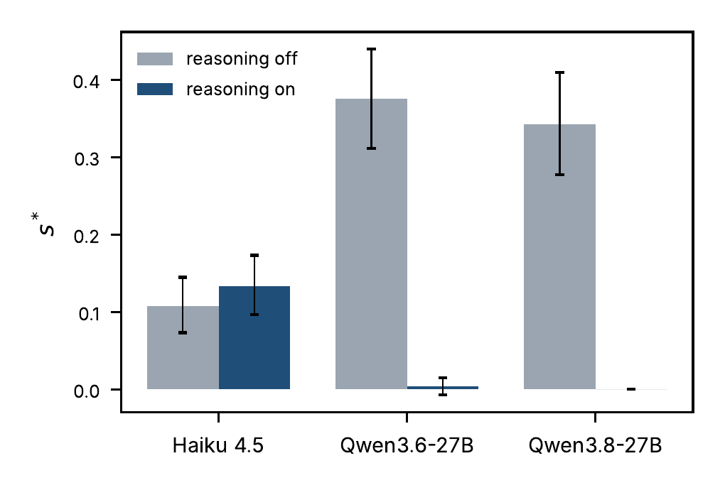
Corrected stance effect with reasoning off and on, with 95% bootstrap intervals.
For Haiku 4.5, switching reasoning off makes little difference. Accuracy is 1.00 with reasoning and 1.00 without it, and $Δs^{*}=+0.03$ with an interval of $−0.03$ to $+0.08$. This is neither a detectable effect in either direction nor evidence of equivalence within our $±0.05$ margin; the interval is too wide to decide. The result also removes a ceiling objection for this model: it remains accurate without reasoning, so a stance effect of 0.11 cannot be attributed to its answers being easy to move because it is rarely right.
For the two open hybrid models the picture is different, and a more careful reading is needed. With reasoning on, both reach accuracy near 1.00 and show essentially no stance effect ($s^{*}≤0.004$). With reasoning off, accuracy falls to 0.48 and 0.40, and $s^{*}$ rises to 0.38 and 0.34. The paired difference is $−0.37$ (interval $−0.44$ to $−0.31$) for Qwen3.6-27B and $−0.34$ (interval $−0.41$ to $−0.28$) for Qwen3.8-27B. This is not only a consequence of the reference sets differing. On the 282 and 241 items answered correctly in the reference run in both conditions, the difference is $−0.37$ and $−0.34$ with nearly identical intervals. Still, the data cannot say that reasoning reduces deference as such. Without reasoning these models are close to guessing on these items, and a model that is guessing has little to resist a stated view with. The common feature of Table IV is that stance-following is large when the model’s own answer is weak and small when it is strong, whether or not reasoning is the cause of the strength. This reading is consistent with Proposition 6 and with the within-model covariation of ability and deference in the main run. We did not design the experiment to test it.
About 10% of reasoning-on calls of Qwen3.8-27B and 4% of Qwen3.6-27B hit the token limit. They are missing in the primary analysis. Treating them as errors leaves the conclusions unchanged (Appendix H of the Supplementary Material).

A second vendor
Gemini 3.1 Pro, run once at its default with reasoning on, reached a stance-free accuracy of 1.00, and the unsupported option was never chosen under any stance, evidence level or disclosed accuracy ($s^{*}=0$, interval 0 to 0). It parallels Opus 5.5 and Fable 5.1 and does not differ from them. With a single model from a second vendor this is a check of generality, not a comparison; all metrics are in Appendix H.

What it costs
Proposition 1 and the model-free value tell a practitioner what a deployed reviewer would add. At a prior of $π=0.7$ that the requester is right, review adds 0.26 to 0.30 in accuracy for the four commercial tiers. For the ten open-weight models the value lies between $−0.13$ and $+0.05$ at $π=0.5$ and between $−0.46$ and 0.00 at $π=0.9$: their accuracy, 0.35 to 0.54, is below the requester’s once $π$ exceeds about 0.5, so review cannot add value on average and the stance partly offsets the loss (Proposition 3). Gemma-3 12B, which follows the stance almost always, has value near zero; it returns the requester’s own view.
Ranking by stance-free accuracy preserves value at the top and little elsewhere. The rank correlation between accuracy and value is 0.81 at $π=0.5$, 0.77 at 0.7 and 0.70 at 0.9 (intervals 0.72–0.90, 0.62–0.85 and 0.63–0.79), and the regret from choosing the most accurate model is zero at all three priors. But ranking by accuracy is value-optimal at both ends of $π$ in only 52% of model pairs (interval 50% to 54%), so the rule that it preserves the order in most pairs is not supported. The overstatement factor $1/\left(1−s^{*}\right)$ is close to one where accuracy is high (1.11 for Haiku 4.5, 1.02 for Sonnet 5.5, 1.00 for Opus 5.5 and Fable 5.1). It is 2.3 to 11.5 for the open-weight models with the most deference, but there the ability-based value $a−π$ is itself negative for $π≥0.5$, so the factor describes a quantity no buyer would pay for. These figures hold for this bank and these prompts.

Discussion and Limitations
What the protocol shows. A correction by two baselines changes the deference estimates materially in unstable models, and the share it removes can be predicted from the stance-free instability. The evidence diagnostics tell the practitioner more than the headline number does. A model with a corrected effect of 0.10 that rises with claimed evidence and falls under a disclaimer (Haiku 4.5) is behaving differently from one with the same number that does neither.
Ceiling. Four commercial models and Gemini 3.1 Pro are at or near perfect accuracy, so their $s^{*}$ of zero could simply mean that the items are easy for them. The reasoning-off condition of Haiku 4.5, which stays at 1.00 and still shows $s^{*}≈0.11$, argues against the objection for that model. For the others we cannot rule it out. A tier of items on which these models are correct 70–85% of the time is the natural next step and is not in this paper.
Scope. Our items are synthetic, single-turn and have one correct answer. The stance wordings are a single family. We evaluate models, not people, and say nothing about how readers weigh an AI review. The commercial results are for the commercial tiers of the vendors we evaluated; they are not a statement about commercial models in general. The five open-weight families give limited power for cross-family tests, as the sign test shows. Hosted inference does not control hardware or quantization, and models served by several providers differ in parse-failure rates.
Measurement. The additive correction understates deference if instability and deference combine as a mixture; $s_{mix}$ exceeds $s^{*}$ by up to 0.15 (Llama-3.1 8B: 0.29 and 0.44). Three open-weight models (Gemma-3 4B, Ministral 3B and Qwen2.5 7B) have accuracy that cannot be told from guessing, so their conditional sets are partly a product of luck. Rotating the option letters raises the stance-following rate for four models (Ministral 3B by 0.27, Gemma-3 4B by 0.07, Qwen2.5 72B by 0.06 and Qwen2.5 7B by 0.03), so part of their measured following is a position effect. Model-level estimates average over serving providers that do not behave alike; for Llama-3.1 8B the rate ranges from 0.44 to 0.75 across four providers. The classification rule labels a model with no stance effect as deference-consistent, which is a limitation of the rule. Item-level deference is estimated from one draw per item, which limits the test of item-level heterogeneity.
Reasoning. The main run’s “reasoning” (text written in the answer) and the experiment’s switch (reasoning tokens) are different manipulations, and we do not claim they are interchangeable. The switch could not be applied to Sonnet 5.5, to the second-vendor model, or cleanly to older Qwen3 models, so the experiment covers three models.
Post-hoc analyses. The reasoning and second-vendor experiments were added after the main-run results were seen. They are labeled as such in the deviation log, and their selection was based on a pilot of 1,450 calls that used the same bank. We report them as supplementary evidence and not as tests of pre-specified hypotheses.

Conclusion and Future Work
A change of answer under a stated view is a mixture of instability, sensitivity to added text, and the use of the stance as evidence. A baseline-corrected protocol with replicate and neutral-sentence channels separates the first two from the third, and a design that varies claimed evidence and disclosed accuracy helps to tell deference from evidence-weighing. Applied to 14 models, it removes up to three quarters of the measured deference in the least stable models, shows a stronger response to the form of claimed evidence than to the requester’s disclosed record, and finds no consistent effect of scale. Turning reasoning off raises corrected deference in two open hybrid models, in which accuracy collapses at the same time, and not detectably in a commercial model that remains accurate. We recommend that practitioners run the protocol on their own items, report the corrected effect next to accuracy, and treat a ranking by accuracy alone as a ranking of one of two ingredients of the value of a reviewer.
Four extensions follow from the limits above. First, a tier of items on which commercial models are correct 70–85% of the time would show whether a corrected effect of zero survives when the answer is not easy for them. Second, several families from other vendors, each with a small and a large model, would give the cross-family sign test enough power to say something about scale. Third, paraphrased stance sentences, a temperature-zero check and repeated measurements at the item level would show how far the corrected effect depends on one wording, one sampling setting and a single draw per item. Fourth, the protocol measures models, not people; a study of how readers combine a reviewer’s output with their own view would connect the corrected effect to realized decisions.

Acknowledgments
AI-generated text was used in drafting and editing this manuscript (Sections I–VIII) and an AI coding assistant was used to develop the analysis code [14]. The authors reviewed the text and the results and take responsibility for the content.

References
[1] E. Perez et al., “Discovering language model behaviors with model-written evaluations,” in Findings of the Association for Computational Linguistics: ACL 2023, 2023.
[2] M. Sharma et al., “Towards understanding sycophancy in language models,” in Proc. Int. Conf. Learning Representations (ICLR), 2024.
[3] J. Wei, D. Huang, Y. Lu, D. Zhou, and Q. V. Le, “Simple synthetic data reduces sycophancy in large language models,” arXiv:2308.03958, 2023.
[4] C. Prendergast, “A theory of “yes men,”” Amer. Econ. Rev., vol. 83, no. 4, pp. 757–770, 1993.
[5] B. Atil et al., “LLM stability: A detailed analysis with some surprises,” arXiv:2408.04667, 2024.
[6] M. Sclar, Y. Choi, Y. Tsvetkov, and A. Suhr, “Quantifying language models’ sensitivity to spurious features in prompt design,” in Proc. Int. Conf. Learning Representations (ICLR), 2024.
[7] C. Zheng, H. Zhou, F. Meng, J. Zhou, and M. Huang, “Large language models are not robust multiple choice selectors,” in Proc. Int. Conf. Learning Representations (ICLR), 2024.
[8] P. Laban, L. Murakhovs’ka, C. Xiong, and C.-S. Wu, “Are you sure? Challenging LLMs leads to performance drops in the FlipFlop experiment,” arXiv:2311.08596, 2023.
[9] A. Fanous et al., “SycEval: Evaluating LLM sycophancy,” in Proc. AAAI/ACM Conf. AI, Ethics, and Society, vol. 8, no. 1, pp. 893–900, 2025.
[10] J. Hong, G. Byun, S. Kim, K. Shu, and J. D. Choi, “Measuring sycophancy of language models in multi-turn dialogues,” in Findings of the Association for Computational Linguistics: EMNLP 2025, 2025.
[11] M. Cheng, S. Yu, C. Lee, P. Khadpe, L. Ibrahim, and D. Jurafsky, “Social sycophancy: A broader understanding of LLM sycophancy,” arXiv:2505.13995, 2025.
[12] M. Turpin, J. Michael, E. Perez, and S. R. Bowman, “Language models don’t always say what they think: Unfaithful explanations in chain-of-thought prompting,” in Advances in Neural Information Processing Systems, vol. 36, 2023.
[13] D. Blackwell, “Equivalent comparisons of experiments,” Ann. Math. Statist., vol. 24, no. 2, pp. 265–272, 1953.
[14] Anthropic, “Claude Code,” AI coding assistant, 2026. [Online]. Available: https://claude.com/claude-code

