Reach Before Price: When AI Testing Services Get Adopted, and Why Vendors Invest in Reach in Discrete Jumps
Manuscript submitted to Information Systems Research (anonymized for review)
Abstract
Vendors of AI-assisted software testing sell two things that buyers tend to run together: speed, meaning how fast a tool finds faults, and reach, meaning how large a share of the faults that a competent human team could eventually find the tool can find at all. We build a model that separates the two. A firm with heterogeneous stakes chooses a testing budget under a Goel–Okumoto fault-discovery process, and a monopolist sets a usage price and, in a second step, chooses how much to invest in reach. Adoption is a single interval of stakes. When the tool's reach falls short of the human baseline, the interval is bounded, and the highest-stakes firms stay with human testing under every pricing scheme in which the net transfer to the firm is bounded. When reach matches the baseline, the bound disappears. The vendor's profit is continuous in reach but has a kink at parity, and as a result the optimal investment jumps from none to parity at a cost threshold and then stays at parity over an interval of costs. A planner's threshold lies strictly above the vendor's, so a subsidy of limited size changes nothing for vendors in an intermediate cost range. All results are proved except where we say otherwise; the quantitative illustrations use uncalibrated parameters. Public data on coding agents and open-source defect reports are consistent with the model's building blocks but do not test it.
Keywords: AI-assisted testing; software reliability; nonhomogeneous Poisson process; technology adoption; vendor pricing; reach investment; economics of information systems
History: [to be completed by the editorial office]

1. Introduction
Software teams now buy testing capacity from vendors of large-language-model (LLM) tools. A typical sales pitch stresses speed: the tool generates tests, runs them, and triages failures far faster than a human tester. A buyer's question is less obvious. If the tool is fast but cannot find some of the faults a human team would eventually catch, should the firm use it, and does the answer depend on what an undetected fault would cost? A vendor faces the mirror-image question. Making a tool cheaper or faster is a matter of engineering effort and pricing; extending the set of faults it can find at all is a different kind of investment, and its payoff may be very uneven.
This paper builds a model in which speed and reach are separate attributes of an AI testing service and asks how each shapes adoption, vendor pricing, and the vendor's investment. The model has three layers. In the first, a firm chooses a testing budget under a nonhomogeneous Poisson process (NHPP) for fault discovery, the workhorse of the software-reliability literature (Goel and Okumoto 1979; Okumoto and Goel 1980). Testing is carried out either by a human team with a fault pool of size a and discovery rate b, or by an AI tool that reaches a fraction A of that pool, at B times the speed and a different unit cost. In the second layer, a vendor sells the tool at a usage price to firms whose stakes, the cost of a fault that escapes to production, differ. In the third layer, the vendor chooses A itself at a convex cost.
Four results follow, and each can be stated without reference to the numerical parameters.
First, with a linear usage price, the set of firms that adopt is a single interval of stakes (Proposition 2). The upper end of the interval is finite exactly when reach is below the human baseline (A < 1). Above the baseline the interval becomes a half-line. The reason is simple: when stakes are very high, the firm tests for a long time, nearly all reachable faults get found, and what matters is the share of the pool the tool can reach; speed and price become irrelevant.
Second, the exclusion of high-stakes firms is not a pricing problem (Proposition 3). For any contract under which the net transfer from vendor to firm is bounded above by some constant, there is a stakes level beyond which the firm prefers human testing. Menus, two-part tariffs, success fees, and fixed-damages warranties all fall in this class. Only transfers that grow with the firm's own stakes, which a vendor cannot sustain, could reverse the result.
Third, the vendor's profit as a function of reach is continuous but has a kink at parity, with a finite right derivative and an infinite left derivative (Proposition 7). Together with a market-entry threshold in reach, this gives a discrete investment rule: below a cost threshold the vendor invests up to parity and stops there, over a whole interval of costs, and above the threshold it does not invest at all (Propositions 6 and 8).
Fourth, the social planner's threshold lies strictly above the vendor's (Proposition 9). There is therefore a window of investment costs in which the vendor does not invest although investment would raise welfare, and a proportional subsidy closes the window only if it is at least a specific fraction of cost, below which it does nothing for the marginal vendor.
The contribution is mostly conceptual and structural. We do not claim that the particular numbers are realistic. The illustrations use parameters chosen to display the mechanisms, and we say so wherever numbers appear. Section 7 shows what public data can and cannot say. Coding-agent benchmarks show a steep fall in resolution rates as the human fix time of a task rises, and open-source defect histories are well described by a saturating NHPP, which is consistent with the building blocks. We do not have firm-level data on stakes or adoption, and the paper does not test its predictions on them.
We view the model as relevant to three groups of readers. For managers deciding whether to adopt, the result says that the stakes at which an AI tool pays off are bounded above unless reach is at parity, so risk managers should ask about reach, not only about price and speed. For vendors, it says that reach investment is lumpy and that the payoff concentrates at parity. For policy makers, it says that instruments aimed at price, or at the vendor's liability, do not remove the exclusion, while an instrument aimed at the cost of extending reach can, provided it is large enough.
The rest of the paper proceeds as follows. Section 2 positions the paper relative to the literature. Section 3 sets up the model. Section 4 derives the adoption structure. Section 5 turns to the vendor's investment. Section 6 gives a numerical illustration. Section 7 reports the public-data evidence. Section 8 discusses implications and limits, and Section 9 concludes. Proofs are collected in the Online Appendix, which also contains extensions: private information about reach, competition, learning from usage, and a mixed market in task complexity.
2. Related Literature
Software reliability and optimal testing. The NHPP approach models the cumulative number of faults found by time t as a Poisson process with a mean value function m(t). The exponential form of Goel and Okumoto (1979) and the logarithmic form of Musa and Okumoto (1984) are the two classic specifications, and Okumoto and Goel (1980) derived the cost-minimizing release time. Information systems research has used this machinery to study how long to test and when to release (Chiang and Mookerjee 2004; Ji, Mookerjee, and Sethi 2005). Our firm-side problem is a stripped-down version of this literature. What is new here is the distinction between the fault pool a technology can reach and the rate at which it works through that pool, and the use of that distinction to ask who adopts an externally supplied technology.
Pricing and contracting for AI services. Bergemann, Bonatti, and Smolin (2026) show that the revenue-maximizing mechanism for selling LLM capacity to users with private task values is a menu of committed-spend contracts. We take their result seriously: a linear usage price is a restricted instrument, and we report a committed-spend menu as an upper bound on what richer pricing can achieve in our setting. Our exclusion result is of a different kind. It does not depend on which pricing instrument is used. Bauer (2026) studies how generative AI erodes competence signals and shows that fixed-damages warranties can separate sellers of different ability; Bakshi, Kim, and Savva (2015) show that performance-based contracts can signal product reliability. Our treatment of private information about reach in the Online Appendix applies this logic to a setting with an outside human option, and we do not claim novelty for the basic separating mechanism. Sreenivas and Larson (2026) study moral hazard in the choice of model and token budget by a delegated agent, a problem that is related to but distinct from the buyer's problem here.
Technology adoption and task fit. Koren, Bárány, and Wohak (2026) model workers combining human skill with AI tools and obtain an adoption region that widens with AI capability, with partial use between an entry and a full-adoption threshold. The structure is superficially close to our adoption interval, but the objects differ: their agents are workers in a production team, with no vendor, no price, and no cost of failure that varies across adopters. In our model the interesting object is the upper end of the adoption set, which arises because the human option dominates at high stakes when reach is incomplete.
Investment, thresholds, and kinks. Our investment results use standard tools: monotone comparative statics in the sense of Topkis (1998) and Milgrom and Shannon (1994), and a comparison of profit per unit of investment cost. The substantive result is not the tool but the shape of the profit function. We show that the profit is continuous, has a kink at the point where the tool's reach equals the human baseline, and that the kink is steep from the left. That shape implies bunching at parity. To our knowledge this is not a feature of existing models of quality investment, though we have not searched the literature exhaustively, and we flag the novelty claims in Section 8 as provisional.
3. Model
3.1 Fault discovery and the firm's testing problem
A firm is about to release software containing a pool of faults. Each undetected fault that escapes to production costs the firm f > 0. The firm chooses a testing technology and a testing time T ≥ 0. Under human testing, cumulative discoveries follow an NHPP with mean value function
m_{H}(T) = a(1 − e^{−*bT*}), (1)
where a is the number of faults a human team can find in the limit, b is the discovery rate, and testing costs c_{H} per unit of time. We normalize c_{H} = 1. Under AI testing the mean value function is
m_{L}(T) = Aa(1 − e^{−*BbT*}), (2)
with unit cost c_{L} = c₀ + p, where c₀ is the firm's own cost of running the tool (compute, integration, review of results) and p is the vendor's usage price. The parameter A > 0 is the tool's relative reach: the share of the human-reachable fault pool that the tool can find at all. The parameter B > 0 is its relative speed. We write A < 1 for a tool that cannot find some faults a human team eventually would, and A ≥ 1 for a tool that can reach at least as many. The firm is risk neutral. Let N be the total number of faults in the code, so that doing no testing costs fN. Because N enters the no-testing cost and the net saving from testing only through the faults that testing removes, it cancels in comparisons across technologies. Define the net saving from a technology as the reduction in expected cost relative to no testing. For human testing with budget T, it is f m_{H}(T) − T.
3.2 The value of testing
Let κ ≡ abf be the firm's stakes index, the product of the fault pool, the discovery rate, and the cost per fault. Define
h(x) = 1 − (1 + ln x)/x for x > 1, and h(x) = 0 for x ≤ 1. (3)
Lemma 1 (value of testing). The human net saving, maximized over T, is S_{H}(f) = fa h(κ), attained at T*_{H} = ln κ/b. The AI net saving is S_{L}(f) = fAa h(ρκ), attained at T*_{L} = ln(ρκ)/(Bb), where ρ ≡ AB/(c₀ + p) is the AI's effectiveness index relative to the human technology. Both are zero when the argument of h is at most 1.
Proof. The human problem is max_{*T*} fa(1 − e^{−*bT*}) − T. The first-order condition fab e^{−*bT*} = 1 gives T* = ln κ/b when κ > 1, and the objective evaluated there equals fa(1 − 1/κ) − ln κ/b. Since 1/b = fa/κ, this is fa h(κ). The AI problem is the same with fa replaced by fAa, b by Bb, and unit cost 1 by c_{L}, so κ is replaced by fAaBb/c_{L} = ρκ. The objective is concave in T, so the first-order condition is sufficient. ∎
Two features deserve emphasis. The function h rises from 0 to 1, so the human net saving is bounded by fa, the full cost of the reachable faults. And in the AI saving, reach A appears as a multiplicative scale on the whole function, while speed and price enter only through ρ inside h. This is the formal sense in which reach and speed are different attributes. Speed and price shift how soon the firm gets close to the ceiling. Reach moves the ceiling.
3.3 Adoption
A firm adopts the AI service if and only if its net saving from AI exceeds that from human testing, V(f) ≡ S_{L}(f) − S_{H}(f) > 0. Dividing by fa,
V(f)/(fa) = Φ(κ) ≡ A h(ρκ) − h(κ). (4)
The firm's own stakes enter only through κ. Stakes are distributed across firms with a continuous density.
3.4 The vendor
A monopoly vendor serves a unit mass of firms. It has marginal cost k per unit of testing time (compute). It first chooses reach A ∈ [A₀, Ā] at cost θc(A), with c(A) = (A − A₀)²/2 and θ > 0, where A₀ is the reach the vendor starts with. It then sets the usage price p. Given p and A, firms choose as in Section 3.3. The vendor's profit is (p − k) times the expected testing time of adopting firms. We write π(p, A) for the second-stage profit, Π*(A) = max_{*p*} π(p, A), and J(A; θ) = Π*(A) − θc(A) for the first-stage payoff. The vendor chooses the price with full information about stakes. We discuss the restrictions implicit in these assumptions in Section 8.
4. Who Adopts: The Structure of Adoption
4.1 A single interval, bounded if and only if reach is below parity
Our first proposition characterizes the set of adopters. Let R(κ) ≡ h(κ)/h(ρκ) for κ > 1.
Lemma 2 (single crossing). Let ρ > 1. Then R is strictly increasing on (1, ∞) with limits 0 as κ ↓ 1 and 1 as κ → ∞. For every κ > 1, ∂ ln R/∂ ln ρ < 0.
Proposition 2 (adoption set). Let ρ > 1. If A < 1, the set of adopting firms is {κ: 1/ρ < κ < κ*}, where κ* is the unique solution of A h(ρκ) = h(κ). If A ≥ 1, the adopting set is {κ > 1/ρ}, a half-line. The upper bound κ* is increasing in A, B, and ρ, decreasing in the usage price p, and diverges as A ↑ 1.
A short proof is given here; details are in Online Appendix A. On κ ≤ 1 the human saving is zero, so any firm with κ > 1/ρ weakly prefers AI. On κ > 1, adoption means A > R(κ). Write g(x) ≡ xh′(x)/h(x) = ln x/(x − 1 − ln x). Setting u = ln x, g = 1/φ(u) with φ(u) = (e^{*u*} − 1 − u)/u, and φ′(u) > 0 for all u ≠ 0 because (ue^{*u*} − e^{*u*} + 1) is positive for u ≠ 0. So g is strictly decreasing on (1, ∞), and d ln R/d ln κ = g(κ) − g(ρκ) > 0. The limits follow from h(x) → 1 and h(x) → 0 as x → 1. The comparative statics follow from the implicit function theorem and the sign of ∂ ln R/∂ ln ρ = −g(ρκ)/ρ < 0.
Figure 1 plots Φ for four values of A. For A = 0.8 and 0.9 the curve crosses zero from above at a finite stakes index, and for A = 1.0 and 1.1 it stays positive. The right limit of Φ is A − 1, so the sign of A − 1 decides what happens at the top. This is the sense in which parity is a boundary: it governs the behavior at the highest stakes, not at moderate ones, where a fast cheap tool with A < 1 may well be adopted.
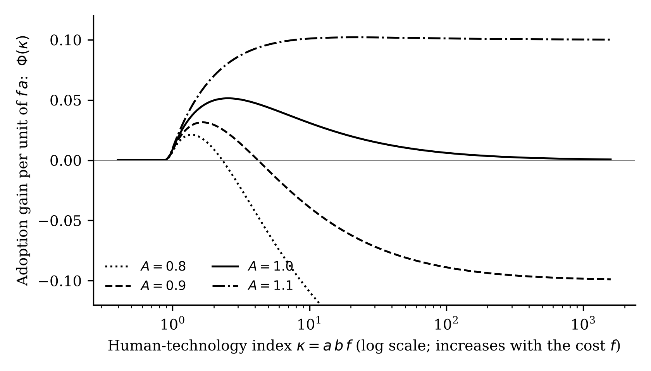
Figure 1. Adoption payoff Φ(κ) = A h(ρκ) − h(κ) for four levels of relative reach (ρ = 1.15). A firm adopts where the curve is above zero. For A < 1 it crosses zero at a finite stakes index; for A ≥ 1 it does not. The curves approach A − 1 as κ grows.
4.2 Exclusion of high-stakes firms is price-independent
Proposition 2 holds for a linear usage price. One may object that a better pricing instrument could keep high-stakes firms in the market, for instance by giving them a discount, a rebate on failures, or a warranty. The next result shows that this cannot happen when the vendor's payments to the firm are bounded.
Proposition 3 (general exclusion). Let 0 < A < 1. Consider any contract in which the net transfer from the vendor to the firm never exceeds a constant τ ≥ 0. Then every firm with stakes f satisfying (1 − A)af − (1 + ln(abf))/b > τ strictly prefers human testing. In particular, for the usage price, V(f)/(fa) → A − 1 < 0 as f → ∞ for every price with c₀ + p > 0, including a zero price.
Proof. Under AI testing the firm's gross benefit is at most fAa, the cost of all faults the tool can reach, and its costs are nonnegative. Adding a transfer of at most τ, the firm's net payoff is at most fAa + τ. Under human testing the firm gets S_{H} = fa − (1 + ln κ)/b from Lemma 1, for κ > 1. The human option is strictly better if fa − (1 + ln κ)/b > fAa + τ, which is the stated inequality. Its left side is eventually increasing and diverges because (1 − A)a > 0. ∎
The class covered includes menus, two-part tariffs, success fees (which are transfers from the firm to the vendor and so make the bound easy to satisfy), and fixed-damages warranties. Table 1 reports the stakes level beyond which the theorem guarantees human testing, for the illustrative fault pool and discovery rate. The threshold is a guaranteed bound, not the actual exclusion boundary. In the illustrations of Section 6 the actual boundary under the vendor's optimal price is much lower. For A = 0.9 the guarantee starts at f = 20.4, whereas the optimal linear price already excludes firms with stakes of about 2.8. The guarantee rises sharply as A approaches 1 and shows that for A very close to parity the exclusion moves out into the far tail of the stakes distribution.
Table 1. Stakes level above which human testing is guaranteed, for bounded net transfers up to τ
Relative reach A | τ = 0 | τ = 10 | τ = 50 | τ = 200
0.50 | 2.2 | 3.6 | 8.3 | 24.2
0.80 | 8.3 | 11.5 | 22.9 | 62.5
0.90 | 20.4 | 26.5 | 49.0 | 128.0
0.95 | 47.9 | 59.7 | 104.4 | 262.0
0.99 | 318.3 | 375.1 | 594.3 | 1,379.4
Notes. Solution of (1 − A)af − (1 + ln(abf))/b = τ for the largest root, with a = 20 and b = 0.12. Units of f are those of the cost of one unit of human testing time. Illustrative parameters.
A remark on interpretation. Proposition 3 does not say that high-stakes firms never use AI tools. It says that a tool with reach below parity cannot win them away from human testing through any bounded transfer. A firm could still use AI as a complement to human testing; the model treats the two as alternatives and Section 8 returns to this limitation.
4.3 How the adopting share responds to a rise in stakes
Suppose all firms' stakes are scaled up by a factor λ > 0, for example because liability for software failures becomes more demanding. The share of firms that adopt at a given price is then the share with λκ in the adoption set. Let ln κ be normally distributed with mean m, and let l = −ln ρ and u = ln κ* be the log endpoints of the adoption set.
Proposition 4 (scaling of stakes). If A ≥ 1, the adopting share is nondecreasing in λ. If A < 1 it is single-peaked in ln λ and attains its maximum at λ* = √(κ*/ρ)/med(κ), where med(κ) = e^{*m*} is the median stakes index.
Proof. The share is Φ_{*N*}((u − x)/σ) − Φ_{*N*}((l − x)/σ) with x = ln λ + m, where Φ_{*N*} is the standard normal cdf. Its derivative in x has the sign of ϕ((l − x)/σ) − ϕ((u − x)/σ), where ϕ is the standard normal density. This is positive if and only if x < (l + u)/2, since ϕ is symmetric and unimodal. For A ≥ 1 the upper endpoint is infinite and the share equals 1 − Φ_{*N*}((l − x)/σ), which is increasing. ∎
Figure 4 in Section 6 illustrates. The result matters for evaluating policies that raise the private cost of software failure. With tools below parity, such a policy first raises and then lowers adoption, and its sign depends on where the market sits relative to λ*. With tools at or above parity it can only raise adoption. We emphasize this because a common intuition, that higher stakes uniformly push firms toward either more or less automation, is not supported by the model for tools below parity.
4.4 Complexity
Tasks differ in complexity. Public benchmark data (Section 7) suggest that the reach of an AI tool falls with the human effort a task requires. In the model, complexity is a shifter of A at a given human stakes index. By Proposition 2, κ* is increasing in A, so at a given κ the adoption set shrinks as complexity rises. For complex tasks the adoption interval is narrower and its upper end is lower, and a mixed market of simple and complex tasks has a lower adoption share and a larger excluded high-stakes segment than a market of simple tasks alone. Online Appendix D works out the mixed-market case for the vendor's pricing problem.
5. The Vendor's Investment in Reach
5.1 Market entry in reach
The vendor's second-stage profit is π(p, A) = ((p − k)/(Bb)) · E[ln(ρκ); κ ∈ adoption set], with ρ = AB/(c₀ + p), because each adopter tests for ln(ρκ)/(Bb) units of time. The vendor earns a positive profit only at p > k, which implies ρ < AB/(c₀ + k).
Proposition 5 (entry threshold). Let A_{e} ≡ (c₀ + k)/B. If A ≤ A_{e} and A_{e} < 1, then Π*(A) = 0.
Proof. At any price with p > k, ρ < AB/(c₀ + k) ≤ 1. With ρ ≤ 1 and A < 1, Φ(κ) ≤ 0 for all κ: if ρκ ≤ 1 the AI saving is zero, and otherwise h(ρκ) ≤ h(κ) because h is increasing above 1 and A < 1. So no firm adopts and the profit is zero. ∎
In words, a tool whose reach is below (c₀ + k)/B is never adopted at any price that covers the vendor's cost, because its speed advantage per dollar is too small to compensate for the faults it cannot find. The threshold is 0.5625 in our illustration. If the starting reach A₀ is below A_{e}, there is no market at the starting point, and any investment must carry the vendor across a stretch where profit is zero.
5.2 The investment threshold and the jump
Proposition 6 (investment jump). Suppose Π* is continuous and A₀ < A_{e}. Define θ̂ ≡ max_{*A*>*A*_{0}} Π*(A)/c(A), attained at some A_{t} > A_{e}. (i) The vendor's optimal reach is nonincreasing in θ. (ii) For θ > θ̂ the unique optimum is A₀. (iii) For θ < θ̂ every optimum is at least A_{t}. Hence the optimal reach jumps by at least A_{t} − A₀ at θ = θ̂.
Proof. (i) The cross-partial of J in (A, θ) is −c′(A) ≤ 0, so Topkis' theorem applies. (ii) For θ > θ̂, Π*(A) ≤ θ̂c(A) < θc(A) for all A > A₀, so J(A) < 0 = J(A₀). (iii) At A_{t}, J(A_{t}) = (θ̂ − θ)c(A_{t}) > 0. For A in (A₀, A_{t}), J(A) ≤ (θ̂ − θ)c(A) < J(A_{t}) because c is increasing. ∎
The proposition does not require convexity of Π* or a second-order condition. The jump comes from the entry threshold alone: profit is zero for low reach, so the ratio of profit to cost has an interior maximum, and the vendor invests only if its cost parameter is below that maximum. The threshold θ̂ is the highest cost-efficiency of investment that the market offers.
5.3 The kink at parity and bunching
Where is A_{t}? For our illustration it is at parity. To show why, we derive the shape of Π* near A = 1. Let P ≡ B − c₀ − k, let M ≡ E[ln κ; κ > 1]/(Bb), and let s ≡ Pr(κ > 1). We maintain two conditions: (Q) C_{*ε*} ≡ BM − Ps/(Bb) > 0, which says that E[ln κ | κ > 1] exceeds 1 − (c₀ + k)/B; and (Q′) B(1 + A₀) > 2(c₀ + k). Both are checked numerically in the illustration and hold there with wide margins; we have not verified them away from the illustrative parameters or for non-lognormal stakes.
Proposition 7 (kink at parity). Under (Q) and lognormal stakes: (i) Π*(1) = PM; the optimal price at A = 1 lies just below the adoption cliff ρ = 1. (ii) The right derivative is Π*′(1⁺) = BM = E[ln κ; κ > 1]/b. (iii) The left derivative is Π*′(1⁻) = +∞.
The logic of the proof is as follows; the full argument is in Online Appendix A. At exact parity, a tool with ρ ≤ 1 is never adopted, so the vendor sets its price to leave ρ just above 1, and all firms with κ > 1 adopt. This gives (i). Above parity, raising A slightly lets the vendor raise its price one-for-one with B·(A − 1) while keeping the cliff just reached, which gives (ii), and any attempt to raise the price further loses more demand than it gains by a term of order (A − 1)². Below parity, a small shortfall δ forces the vendor either to cut its price at a rate that is first order in δ, which costs BM per unit of δ, or to exclude firms at the top. The exclusion boundary κ̄(δ) is where g(κ̄) = δ/ε for the price discount ε. We show by contradiction that if the loss were at most K δ for some constant K, then δ/ε would stay bounded away from zero along a sequence, which would make the excluded demand bounded below and contradict the assumption. The loss therefore exceeds any multiple of δ, so the left derivative is infinite. The rate of divergence is slower than any polynomial in 1/δ but faster than any power of the logarithm; we do not claim a sharp constant, and the closed-form approximation of the divergence that we derive overstates the loss by a factor of about two at the smallest δ we compute.
Proposition 8 (bunching at parity). Under (Q) and (Q′), the cost-efficiency ratio Π*(A)/c(A) is locally maximized at A = 1 and θ̂ = 2PM/(1 − A₀)². The optimal reach equals one exactly for all θ in [θ_{low}, θ̂], where θ_{low} = sup_{*A*>1}[Π*(A) − Π*(1)]/[c(A) − c(1)] ≥ BM/(1 − A₀). The global maximum of the ratio at A = 1 and the value of θ_{low} are verified numerically, not proved.
Figure 2 shows the kink in profit, and the left panel of Figure 3 plots the vendor's cost-efficiency ratio (solid line), which rises steeply to a peak at A = 1 and declines afterwards. In our illustration Π*(1) = 5.77, the right derivative is 13.2, θ̂ = 46.18, and θ_{low} = 27.58. For any cost parameter in the interval from 27.6 to 46.2, the vendor chooses to invest exactly up to parity and stops, even though the vendor could invest further. Outside this interval the vendor invests nothing (above 46.2) or goes past parity (below 27.6, as the stepped line in the right panel of Figure 3 shows).
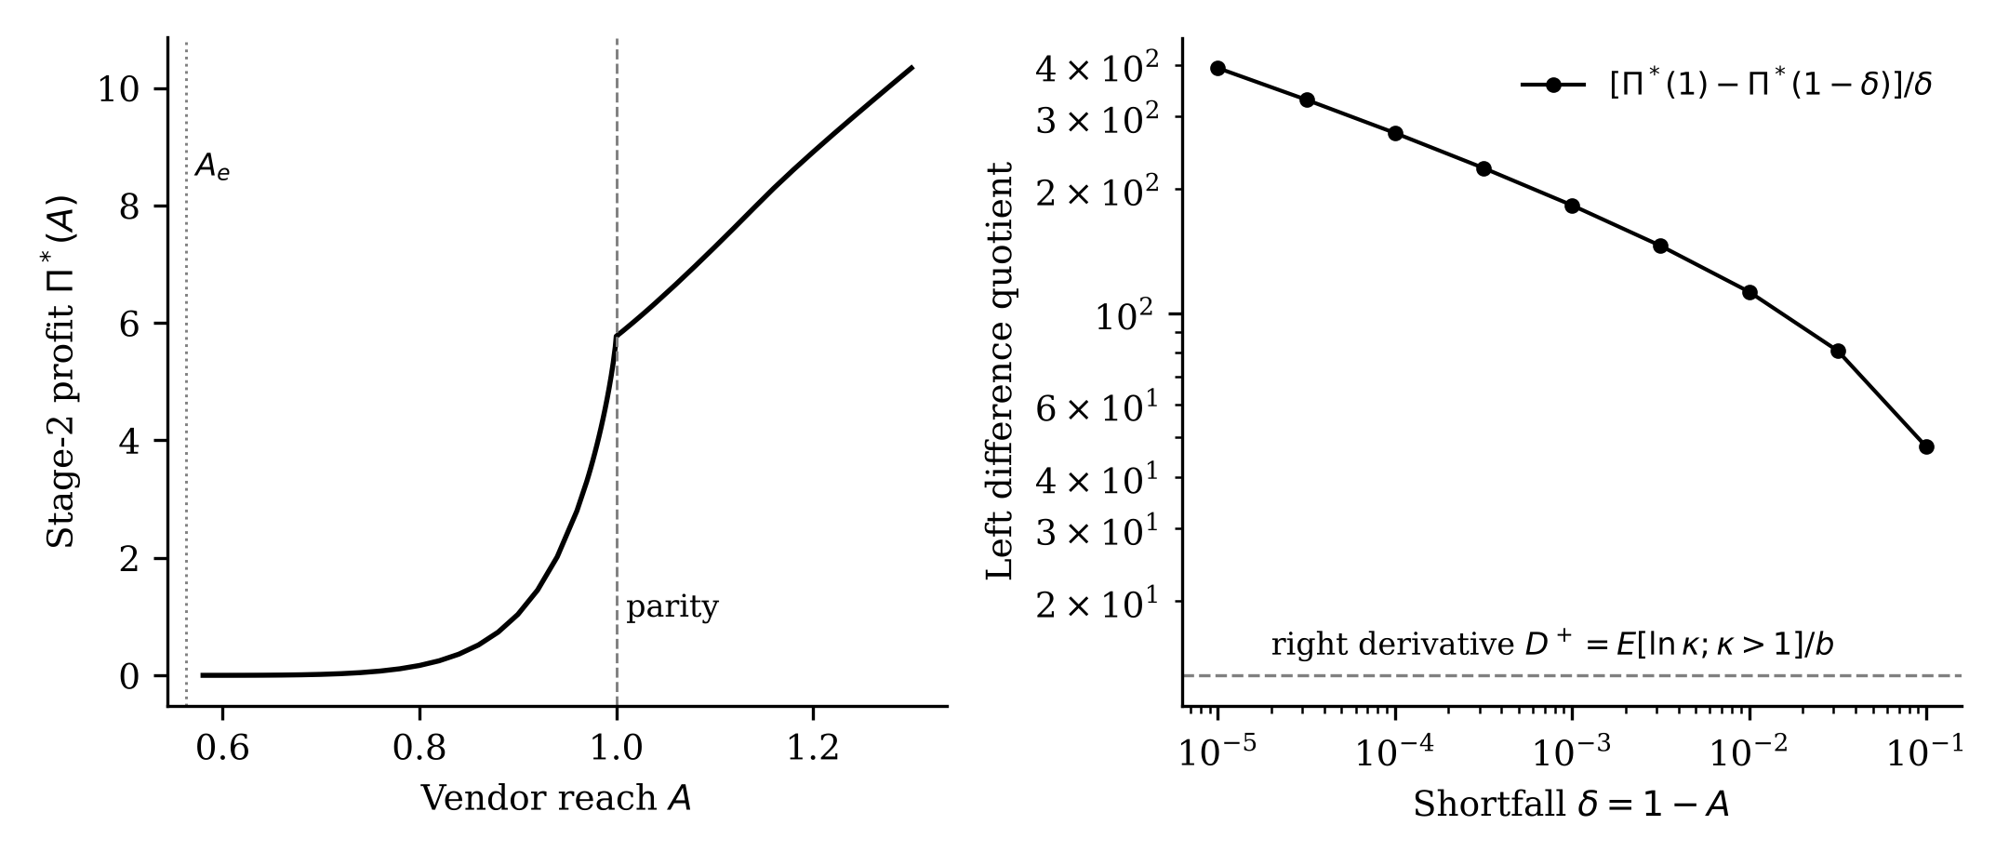
Figure 2. The vendor's maximized second-stage profit Π*(A) in the continuous-stakes model. Profit is zero below the entry threshold, rises steeply, and has a kink at parity (A = 1), steep from the left and with a finite slope from the right.
5.4 Social value and the gap with the vendor
Define welfare as W(A) = Π*(A) + CS(A), where CS is the sum of adopters' net savings relative to human testing, and let θ_{s} = sup_{*A*} W(A)/c(A).
Proposition 9 (under-investment and subsidies). (i) θ_{s} ≥ θ̂, strictly if CS(A_{t}) > 0. For θ in (θ̂, θ_{s}] the planner prefers some A > A₀ but the vendor does not invest. (ii) A proportional subsidy s of investment cost raises the vendor's threshold to θ̂/(1 − s). The subsidy rate that closes the window is s* = 1 − θ̂/θ_{s}. (iii) For s < s*, vendors with θ between θ̂/(1 − s) and θ_{s} still do not invest.
In the illustration (Figure 3, left), θ_{s} = 65.1 when the planner is limited to reach of at most 1.3, so s* is about 29 percent. We stress that θ_{s} depends on the arbitrary reach cap and on how we count consumer surplus, which excludes the benefit to the firms' own customers. The qualitative result, that there is a window and that subsidies are threshold-like, does not depend on the cap. The size of the closing subsidy does.
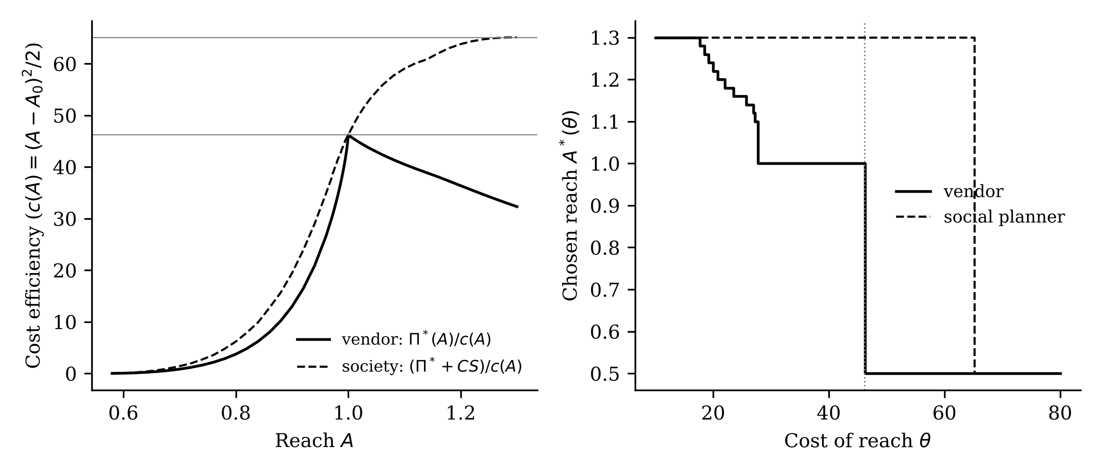
Figure 3. Left: cost efficiency of reach for the vendor (profit divided by investment cost, solid) and for society (profit plus consumer surplus divided by investment cost, dashed). Horizontal lines mark the maximum of each. Right: chosen reach as a function of the cost parameter θ for the vendor and the planner (reach capped at 1.3). The vendor's choice stays at parity over an interval and then drops to the starting reach of 0.5.
5.5 Competition in reach
With two vendors, price competition after reach is chosen dissipates the profit of a vendor whose tool is no better than its rival's. Two results follow (Online Appendix C). First, a duopolist's profit is at most the monopoly profit at the same reach, so if θ > θ̂, no vendor invests in any pure-strategy equilibrium. Second, there is no symmetric equilibrium in which both vendors invest the same positive amount, because Bertrand competition at equal reach drives price to marginal cost, and a vendor could save the investment cost by staying at the starting reach. A preemption outcome, in which one vendor invests and the other does not, is an equilibrium under a sufficient condition on θ. We do not prove that preemption is the only equilibrium. The implication is that in markets with reach as the strategic variable, competition does not raise investment in reach as it tends to lower prices. Competition policy aimed at prices would not move the investment threshold.
6. Numerical Illustration
We illustrate the results with a single illustrative parameter set (Table 2). The parameters are chosen to display the mechanisms and are not calibrated to any market. The stakes index is lognormal with median 4.8 and log standard deviation 0.9, equivalent to a median per-fault cost of 2 in units of the cost of one hour of human testing.
Table 2. Illustrative parameters
Parameter | Symbol | Value
Faults a human team can find | a | 20
Human discovery rate | b | 0.12
Human cost per unit time | c_{H} | 1 (normalization)
AI relative speed | B | 1.6
Firm's own cost of using the tool | c₀ | 0.8
Vendor's marginal cost | k | 0.1
Vendor's starting reach | A₀ | 0.5
Stakes index | ln κ | Normal(ln 4.8, 0.9²)
Investment cost | c(A) | (A − A₀)²/2, scaled by θ
Notes. Parameters are for illustration. They were not estimated from data.
Adoption and pricing. At A = 0.9 and the monopoly linear price, the vendor serves firms in a bounded interval whose upper end is at stakes of about 2.8; about 62 percent of firms adopt, and the top decile of stakes does not. Raising reach to parity raises the vendor's profit from about 1.0 to 5.7, a factor of about 5.5, and the optimal price rises from about 0.33 to 0.80, nearly the entire speed advantage. The profit gain comes from two sources: the vendor can serve high-stakes firms, who test for long, and it can charge more. Replacing the linear price by an optimal committed-spend menu raises profit by an amount that is largest below parity (Online Appendix B), but leaves the highest-stakes decile excluded for A < 1, as Proposition 3 requires.
Scaling. Figure 4 shows the adopting share as stakes scale up by λ with price held fixed. For A = 0.9 the share peaks at 77 percent at λ* = 0.49 and falls toward zero as λ grows; for A = 1 it rises monotonically toward one.
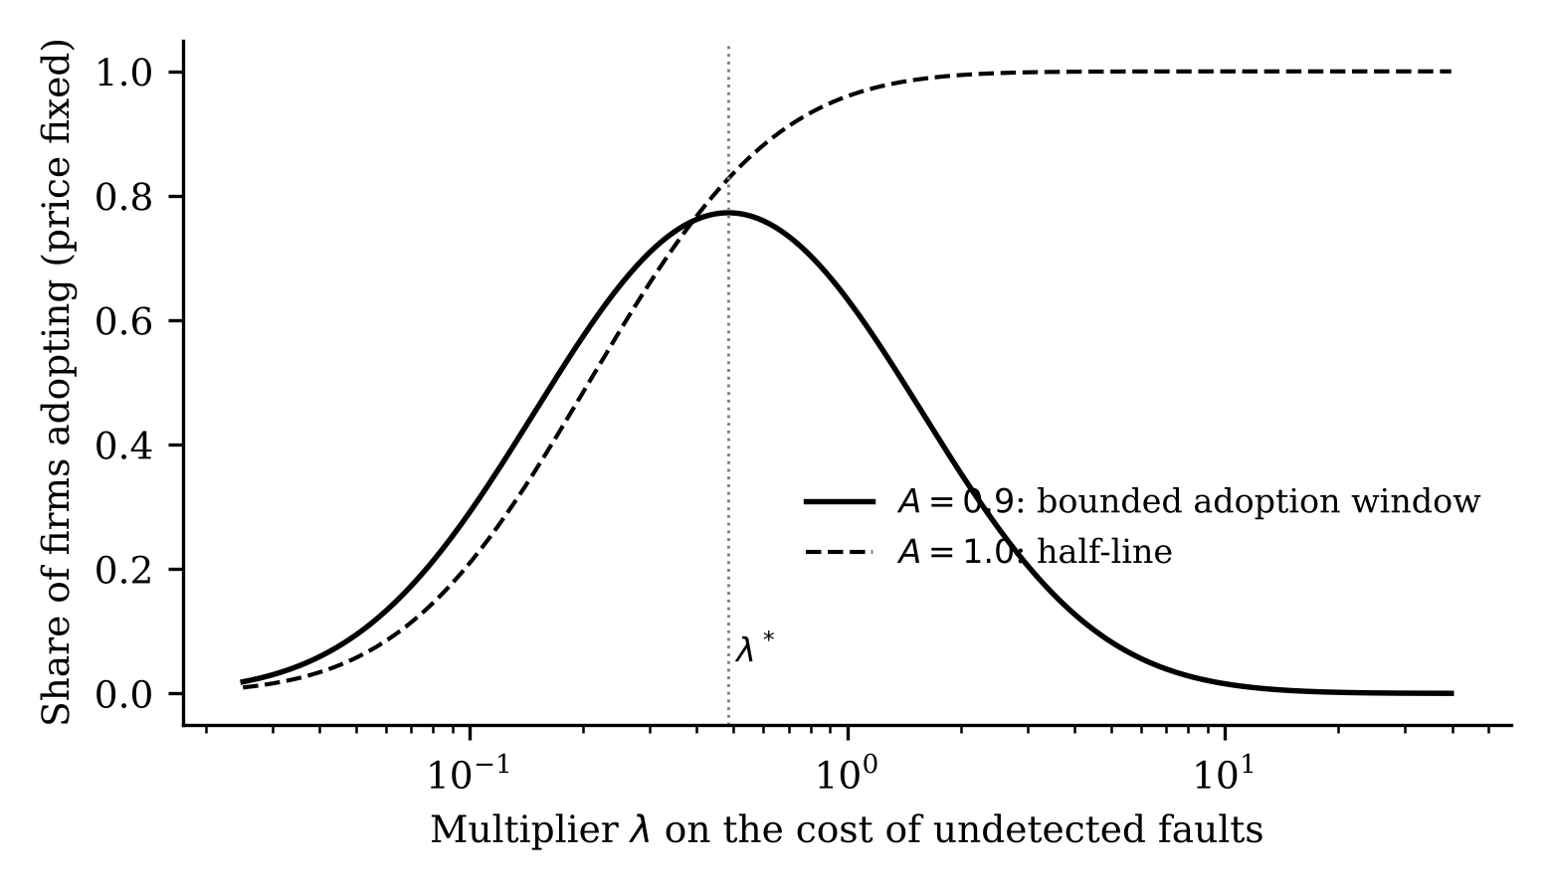
Figure 4. Share of firms adopting at a fixed price as stakes are scaled by λ. With reach below parity (solid) the share is single-peaked; at parity (dashed) it is nondecreasing.
Investment. With the vendor's cost parameter θ between 27.6 and 46.2, the vendor invests up to parity and no further. Above 46.2 it does not invest. Below 27.6 it goes past parity. The social threshold, computed for reach up to 1.3, is 65.1. Table 3 collects the results of the paper and their status.
Table 3. Summary of results and their status
Result | Statement | Status
Lemma 1 | Closed form for net saving and optimal budget | Proved
Proposition 2 | Adoption set: bounded interval iff A < 1 | Proved (ρ > 1)
Proposition 3 | Exclusion of high stakes under bounded transfers | Proved
Proposition 4 | Stakes scaling: single-peaked iff A < 1 | Proved (lognormal)
Proposition 5 | Entry threshold in reach | Proved
Proposition 6 | Investment jump at θ̂ | Proved
Proposition 7 | Kink at parity | Proved under (Q); divergence rate approximate
Proposition 8 | Bunching at parity | Proved locally; global maximum numerical
Proposition 9 | Under-investment window; subsidy threshold | Proved; magnitudes illustrative
Duopoly | No investment above θ̂; no symmetric investment | Proved; uniqueness of preemption not proved
Notes. All quantitative values rely on illustrative parameters.
7. Public-Data Evidence
We do not have firm-level data on stakes, tool reach, or adoption decisions, and we do not claim to test the model. We use public data to check that three building blocks are not contradicted: that reach declines with task complexity, that reach depends on the testing budget, and that human fault discovery saturates. Table 4 and Figure 5 summarize. Details and the code are in Online Appendix F and the replication package.
Reach and task complexity. SWE-bench Verified (Jimenez et al. 2024; the human-validated subset released by Chowdhury et al. 2024) labels each of 500 tasks with the time a human engineer would need to fix it. Combining the labels with a published run of a reasoning model on 495 of these tasks, the agent resolved 39.9 percent of the tasks labeled under 15 minutes (n = 193), 25.2 percent of those labeled 15 minutes to one hour (n = 258), 4.9 percent of the one-to-four-hour tasks (n = 41), and none of three tasks above four hours. Resolving an issue is not the same as finding a fault, so this is a proxy at best. The sign, however, matters for the model: reach falls with complexity, which by Section 4.4 narrows the adoption interval.
Reach depends on budget. In a public set of 80,036 agent trajectories on 3,591 task instances (Nebius), the share of instances solved at least once rises from 12.5 percent with one attempt to 27.4 percent with twelve attempts. A logarithmic NHPP fits better than an exponential one (sum of squared errors 0.00023 versus 0.00104), and 68 percent of instances are never solved in the first twelve attempts. A heterogeneous model in which a share of instances are unsolvable implies an asymptotic reach of about 0.55 with a wide interval (0.43 to 0.75) for the 70-billion-parameter open-weight model, which has the most instances, while a model without unsolvable instances implies eventual reach of 1. The two models agree within two percentage points on solve rates at one hundred attempts. We conclude that reach is identified as a function of budget, A(K), not as a limit, and that a model that treats A as a fixed share is a simplification.
Human fault discovery saturates. We fit the Goel–Okumoto, Musa–Okumoto, and constant-rate models to 3,333 software releases from seven public Jira trackers, with 876,957 bug reports in total, of which 43 percent could be assigned to a dated affected release. The Goel–Okumoto model has the lowest AIC in 80 percent of releases. The median discovery half-life is about 1.3 months, and the median release receives 38 percent of its observed bug reports in its first 30 days. These are field reports, however, not outcomes of structured testing, and some of the apparent saturation reflects users moving to newer versions.
Table 4. Public-data checks of the model's building blocks
Building block | Source | Finding
Reach falls with complexity | SWE-bench Verified with a published o1 run, n = 495 | Resolution rate: 39.9%, 25.2%, 4.9%, 0% across four difficulty classes
Reach depends on budget | 80,036 agent trajectories, 3,591 instances | Cumulative solve rate 12.5% (1 attempt) to 27.4% (12 attempts); logarithmic fit beats exponential
Human discovery saturates | Seven public Jira trackers, 3,333 releases | GO model best in 80% of releases; median half-life about 1.3 months
Notes. These checks are indicative. None identifies the model's parameters or tests its adoption predictions.
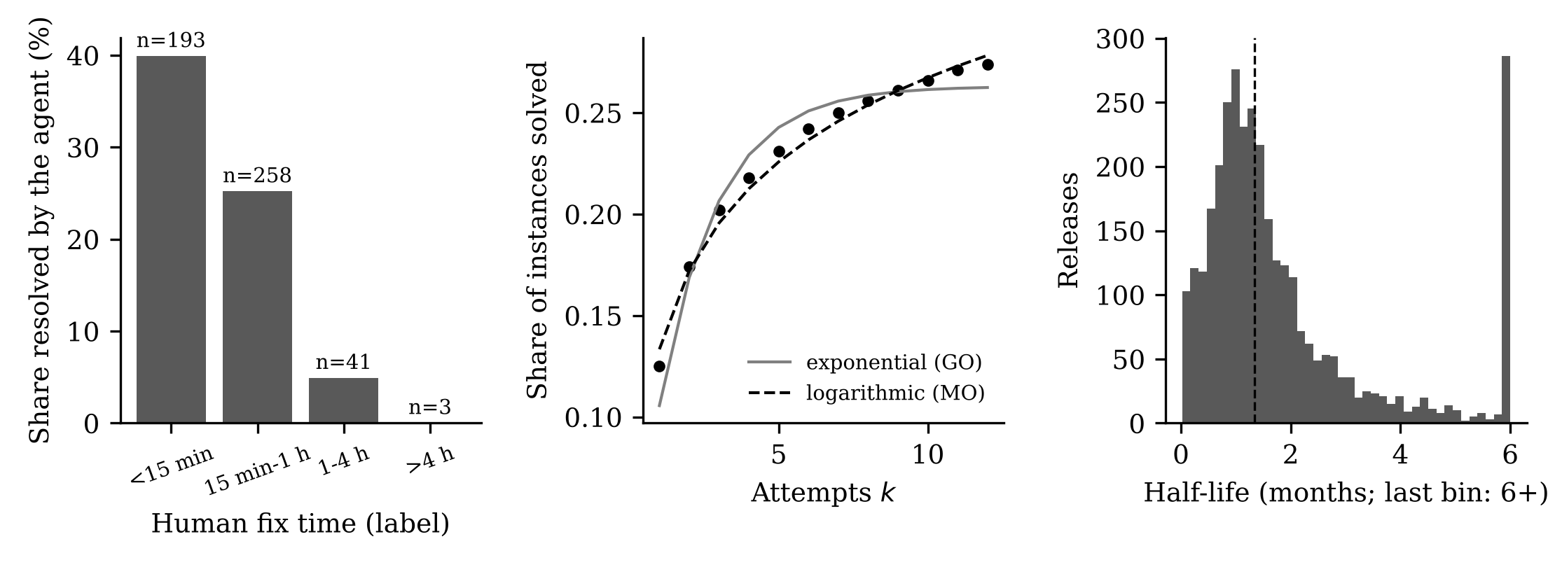
Figure 5. Public-data checks. Left: agent resolution rate by human fix-time class (SWE-bench Verified). Middle: cumulative share of task instances solved by number of attempts, with exponential and logarithmic NHPP fits (Nebius trajectories). Right: distribution of the estimated discovery half-life across 3,333 releases in public Jira trackers.
We also tried a crude test of the adoption-interval prediction on a public replication package of repositories that adopted an AI coding assistant. Using the number of GitHub stars as a stand-in for stakes, adoption intensity was U-shaped, not single-peaked. We do not take this as evidence against the model. Stars measure popularity, not the cost of a fault; the control sample was not documented in a way that lets us interpret the ratios as probabilities; and the sample combines individual projects with firms. The test is uninformative, and a proper test would need a better proxy for stakes, such as the number of dependent packages or production use, and contributor-level adoption.
8. Discussion
8.1 Implications
For adopting firms. The model implies that an AI testing tool's value to a firm should be assessed against the firm's own stakes. A tool that is attractive at moderate stakes may lose to human testing as stakes rise, and the cutoff is determined by reach, not by price. A procurement question that follows is to ask the vendor what share of the faults that human testers eventually find the tool can find, as a function of budget, and to compare that with the firm's loss from the faults it cannot find.
For vendors. Investment in reach is lumpy. If a vendor's cost of reach lies in the interval identified in Proposition 8, it should invest up to the human baseline and stop, because the kink makes parity the efficient stopping point. Investment beyond parity has a lower return per unit cost. This can be read as a rationale for benchmark-driven development that targets human parity, though we do not claim that firms behave this way.
For policy. Because exclusion is price-independent (Proposition 3), policies that regulate or subsidize the price of AI testing services do not reach high-stakes firms. Policies that reduce the cost of extending reach, such as shared benchmarks, public datasets of faults, or R&D support, might. Proposition 9 says such support has a threshold effect: below a minimum rate, it changes nothing for vendors whose costs are in the intermediate range. This is a feature of the model's lumpiness, and it needs empirical support before guiding policy. Finally, policies that raise the stakes of failure, for instance product liability for software, have an ambiguous effect on adoption of tools below parity (Proposition 4).
8.2 Limitations
The model is static. It has a monopoly vendor with full information, risk-neutral firms, two technologies that are alternatives rather than complements, a quadratic cost of investing in reach, and a binary notion of reach. The firm's stakes are assumed independent of its fault pool and discovery rate, which public Jira data are at least consistent with. The welfare measure excludes the benefit to end users. Parameters are illustrative. The kink results (Propositions 7 and 8) are proved under conditions (Q) and (Q′) and for lognormal stakes; the global maximum in Proposition 8 and the value of θ_{low} rest on numerical computation, and we have not checked robustness to other stakes distributions or cost functions beyond the lognormal and quadratic cases. The extensions in the Online Appendix are more tentative than the main results; several rest on numerical solutions on a coarse grid.
A deeper issue is what A means empirically. We defined reach as the share of the human-reachable fault pool the tool can eventually find. Public agent benchmarks measure issue resolution at a given budget, not fault detection in a production system, and the public evidence in Section 7 is evidence about the sign of dependencies, not about the level of A. A study with firm-level data on stakes, tool use, and escaped faults would be required to test the model's adoption and exclusion predictions. A difference-in-differences design on the introduction of a tool is a natural approach (see the Online Appendix), but it requires data on stakes that public sources do not provide.
The paper's claims of novelty are restricted to the literature we reviewed, which consisted of a small set of recent working papers on AI pricing, signaling, and adoption, and of the software-reliability and information-systems literature on testing economics. We have not conducted a systematic search of the published literature and so cannot rule out overlap with existing work, particularly for the signaling extension in the Online Appendix, which we regard as an application of known mechanisms.
9. Conclusion
We separated the speed and reach of an AI testing service and showed that the two matter in different places. Speed and price decide who adopts at moderate stakes. Reach decides what happens at the top: when reach is below the human baseline, no bounded-transfer contract keeps the highest-stakes firms in the market, and when reach reaches the baseline, the exclusion disappears. Because the vendor's profit has a kink at the baseline, its investment in reach comes in jumps and bunches at parity, and a planner would invest over a wider range of costs than the vendor does. The results are structural, and the next step is empirical: measuring reach, stakes, and adoption in firm data to see whether the interval, the exclusion, and the bunching appear where the model says they should.

References
Bakshi N, Kim S-H, Savva N (2015) Signaling new product reliability with after-sales service contracts. Management Sci. 61(8):1812–1829.
Bauer [first initial] (2026) The last costly signal: How generative AI collapses competence signaling and why liability sustains markets for expert services. Games 17(5):49. [Authors' given name and final bibliographic details to be verified.]
Bergemann D, Bonatti A, Smolin A (2026) Menu pricing of large language models. Working paper, arXiv:2502.07736. [Version and publication status to be verified.]
Callaway B, Sant'Anna PHC (2021) Difference-in-differences with multiple time periods. J. Econometrics 225(2):200–230.
Chiang IR, Mookerjee VS (2004) A fault threshold policy to manage software development projects. Inform. Systems Res. 15(1):3–21. [Details to be verified.]
Chowdhury NJ, et al. (2024) Introducing SWE-bench Verified. Technical report, OpenAI. [Details to be verified.]
Goel AL, Okumoto K (1979) Time-dependent error-detection rate model for software reliability and other performance measures. IEEE Trans. Reliability R-28(3):206–211.
He H, et al. (2026) Cursor adoption and software development outcomes: Evidence from open-source repositories. Working paper, arXiv:2511.04427. [Title and author list to be verified.]
Ji Y, Mookerjee VS, Sethi SP (2005) Optimal software development: A control theoretic approach. Inform. Systems Res. 16(3):292–306.
Jimenez CE, Yang J, Wettig A, Yao S, Pei K, Press O, Narasimhan K (2024) SWE-bench: Can language models resolve real-world GitHub issues? Proc. Internat. Conf. Learn. Representations (ICLR 2024).
Koren M, Bárány Z, Wohak [initials] (2026) [Title to be verified.] Working paper, arXiv:2602.12958.
Milgrom P, Shannon C (1994) Monotone comparative statics. Econometrica 62(1):157–180.
Montgomery L, Lüders C, Maalej W (2022) An alternative issue tracking dataset of public Jira repositories. Proc. 19th Internat. Conf. Mining Software Repositories (MSR 2022).
Musa JD, Okumoto K (1984) A logarithmic Poisson execution time model for software reliability measurement. Proc. 7th Internat. Conf. Software Engrg., 230–238.
Okumoto K, Goel AL (1980) Optimum release time for software systems based on reliability and cost criteria. J. Systems Software 1:315–318.
Sreenivas [initials], Larson [initials] (2026) Contracting for LLM delegation: Moral hazard in technology and effort choice. Working paper, arXiv:2608.18232.
Topkis DM (1998) Supermodularity and Complementarity (Princeton University Press, Princeton, NJ).

