Autonomous Action Timing for LLM-Based Agents: An Inhomogeneous Poisson Process Artifact for Simulating Opinion Diffusion on Social Media
[Author names and affiliations withheld for review]
Manuscript prepared in the format of MIS Quarterly (research article, design science)

ABSTRACT
Agent-based simulations that use large language models (LLMs) as synthetic users typically decide when an agent acts through fixed-interval polling, a convention that imposes artificial synchrony and ignores the circadian and reactive structure of human online activity. We propose and evaluate an artifact, Poisson-SNS, in which each agent’s next action time is drawn from an inhomogeneous Poisson process whose conditional intensity is the sum of a persona-specific, time-of-day baseline and exponentially decaying stimuli generated by content exposure and social feedback. The stimulus magnitude is obtained from an “intensity oracle,” a prompt that asks an LLM to rate, on a 0–5 scale, an agent’s urge to post or comment given its state. Following a design science approach, we evaluate the artifact in three studies. First, compared with homogeneous Poisson and fixed-period polling baselines, the proposed scheduler reproduces a stylized diurnal activity profile much more closely (Pearson r = 0.78 vs. −0.20 and 0.12), although it does not match an assumed heavy-tailed reply-delay distribution. Second, in a seeding experiment on a synthetic scale-free network with equal exposure budgets, concentrating a campaign on three high-degree influencers yielded roughly 24% more adopters than seeding several hundred ordinary users (p = .001), but reached the 50% adoption milestone about 0.3 hours later, and its outcomes were more variable. Third, replacing the rule-based oracle with LLM-assigned intensities left these conclusions unchanged. Because no empirical platform data were available, the behavioral comparison relies on a parametric reference, and we outline the data needed for a confirmatory test. The study contributes a reusable specification for event-driven LLM agent simulation and evidence on how seeding objectives trade off scale against speed.
Keywords: LLM agents, agent-based simulation, inhomogeneous Poisson process, Hawkes process, social media, information diffusion, seeding strategy, design science

1. INTRODUCTION
Social media platforms have become a primary site where opinions form and spread, and firms, public agencies, and platform operators all face decisions that can be tested only imperfectly in the field. Whether to place a message with a handful of prominent accounts or to spread it thinly across many ordinary users is a representative case. Field experiments on such questions are expensive, can disturb the communities under study, and are difficult to replicate. Simulation therefore remains attractive, and the recent availability of large language models (LLMs) has renewed interest in it. Agents driven by LLMs can be given personas and can read, write, and react to natural-language content, which promises behavioral richness that rule-based agents lack (Park et al. 2023; Gao et al. 2023; Törnberg et al. 2023).
A less discussed weakness of this emerging literature is how simulated agents are scheduled. In most implementations the simulator advances in discrete rounds, and every agent is queried once per round about whether and how to act. This design is convenient, but it embeds a strong and rarely examined assumption: that the timing of human action is regular and synchronous. Empirical work on human dynamics points the other way. Online activity follows pronounced daily cycles, arrives in bursts, and responds to external triggers such as a notification or an interesting post (Barabási 2005; Malmgren et al. 2008; Crane and Sornette 2008). A simulator that polls on a clock cannot produce these properties as emergent outcomes, and any conclusion about the speed or reach of diffusion inherits the artifact.
This paper addresses the problem by treating action timing as a stochastic point process rather than as a clock. We design and evaluate Poisson-SNS, an artifact in which each LLM agent acts at the event times of an inhomogeneous Poisson process (IPP). The intensity of the process combines a persona-specific baseline that follows a circadian rhythm with stimuli that arise when an agent is exposed to relevant content or receives feedback on its own posts. Importantly, the LLM is used where it is most defensible, to judge how strongly a situation would move a particular persona to speak, and not to decide the clock time of the next action. The resulting system is event-driven, so computation is spent only when something happens, and it allows self-exciting cascades of the kind described by Hawkes (1971).
We pursue three research questions. RQ1: Does an IPP scheduler reproduce the temporal regularities of online activity better than homogeneous Poisson and fixed-period polling schedulers? RQ2: Given an equal exposure budget, which seeding strategy, concentrating on a few influencers or distributing across many ordinary users, produces faster and broader diffusion in the simulated network? RQ3: Are the conclusions of RQ1 and RQ2 sensitive to whether the intensity oracle is a rule-based function or an LLM?
The contribution is mainly one of design. Following the guidelines for design science in information systems (Hevner et al. 2004; Gregor and Hevner 2013), we offer a precise specification of the artifact, evaluate it against alternative designs, and report where it succeeds and where it does not. We also add a substantive finding about seeding that is not simply a restatement of the influencer literature: in our simulations the better strategy depends on whether the objective is final scale or speed, and the concentrated strategy carries a higher variance. We are explicit throughout about what the evidence can and cannot support. In particular, we did not have access to platform trace data, and the behavioral validation is therefore conducted against an assumed reference profile. We treat this as a limitation of the present evidence rather than of the design and describe how the artifact can be re-evaluated against real traces.
The remainder of the paper is organized as follows. Section 2 reviews the relevant literature. Section 3 describes the artifact. Section 4 reports the three evaluation studies. Section 5 discusses contributions, implications, and limitations, and Section 6 concludes.

2. THEORETICAL BACKGROUND

2.1 Agent-Based Simulation and LLM Agents
Agent-based modeling studies system-level outcomes that emerge from the interaction of heterogeneous, autonomous actors (Bonabeau 2002; Gilbert 2008), and it has a long record in marketing and diffusion research, where its credibility rests on careful specification and validation (Rand and Rust 2011). Traditional agents follow hand-coded rules. LLM-based agents replace those rules with a generative model conditioned on a persona and the agent’s observations. Park et al. (2023) showed that such agents can sustain believable individual and collective behavior in a small sandbox. Subsequent work has built social-network simulators on the same idea, including S3 (Gao et al. 2023), and has used LLM agents to compare news-feed algorithms (Törnberg et al. 2023).
These systems generally leave the question of timing to the simulation loop. Calls to the model are expensive, which encourages coarse, uniform rounds. Yet if the loop is the source of timing, then temporal outcomes such as the volume of activity per hour, response delays, and the speed of cascades are partly determined by a modeling convention rather than by agent behavior. We take this to be a validity concern, and the artifact we propose is a response to it.

2.2 Temporal Point Processes and Human Activity
A temporal point process describes events through a conditional intensity function λ(t), the instantaneous event rate given the history. A homogeneous Poisson process fixes λ(t) to a constant and produces memoryless, evenly spread events. Human communication departs from this in two ways. First, it is non-stationary, with strong daily and weekly cycles. Second, it is bursty, with heavy-tailed inter-event times that Barabási (2005) attributed to priority-based task queues, whereas Malmgren et al. (2008) showed that a cascading, non-homogeneous Poisson mechanism with circadian modulation can account for much of the same heavy tail. The latter account is the one most relevant here, because it suggests that a time-varying intensity, rather than an exotic waiting-time law, may be sufficient to generate realistic timing.
Self-exciting processes add feedback. In a Hawkes process each event temporarily raises the intensity of future events (Hawkes 1971). The mean number of direct descendants of an event, the branching ratio, indicates whether cascades die out (below one) or grow without bound (above one). Self-exciting models have been used successfully to describe and forecast the popularity of online content (Crane and Sornette 2008; Zhao et al. 2015). In our artifact, self-excitation is not imposed as a parametric kernel. It emerges from the interaction of exposure, stimulus, and action, and we estimate the branching ratio after the fact as a summary of the simulated cascades.
Non-homogeneous Poisson processes can be simulated exactly by thinning, in which candidate events are drawn from a dominating homogeneous process and accepted with probability λ(t)/λ_{max} (Lewis and Shedler 1979; Ogata 1981). Thinning is the scheduling primitive we use.

2.3 Influence, Seeding, and Diffusion
The question of whom to target has a substantial literature. The influence-maximization problem asks for the set of initial adopters that maximizes expected spread and has been shown to be computationally hard, with greedy approximations that have performance guarantees (Kempe et al. 2003). The “influentials” hypothesis holds that a small group of highly connected individuals drives diffusion, but Watts and Dodds (2007) argued, using a threshold model, that large cascades are driven at least as often by many easily influenced ordinary users. Empirically, Bakshy et al. (2011) found that the most influential Twitter users were those who had been influential before and had many followers, yet that targeting ordinary users could be cost-effective once costs are considered. Aral and Walker (2012) used a randomized field experiment to identify influential and susceptible members of a network, showing that the two roles can be distinguished.
This body of work frames the comparison in the present study. We hold the exposure budget constant, so that differences cannot be attributed simply to the larger audience of an influencer, and we examine both the final scale and the speed of diffusion, because the literature’s verdicts differ partly by the outcome measured. The influence-maximization and threshold literatures typically evaluate final cascade size. Practitioners, in contrast, often care about how quickly a message gains traction, since attention decays.

3. ARTIFACT DESIGN
We follow a design science approach in which the artifact is specified, instantiated, and evaluated against alternatives (Hevner et al. 2004). The design objective is stated as follows: an LLM-agent simulator should generate action times endogenously, so that circadian rhythm, reactivity, and cascade dynamics emerge from agent state instead of from the simulation clock. Figure 1 shows the architecture, and the subsections below describe each component.
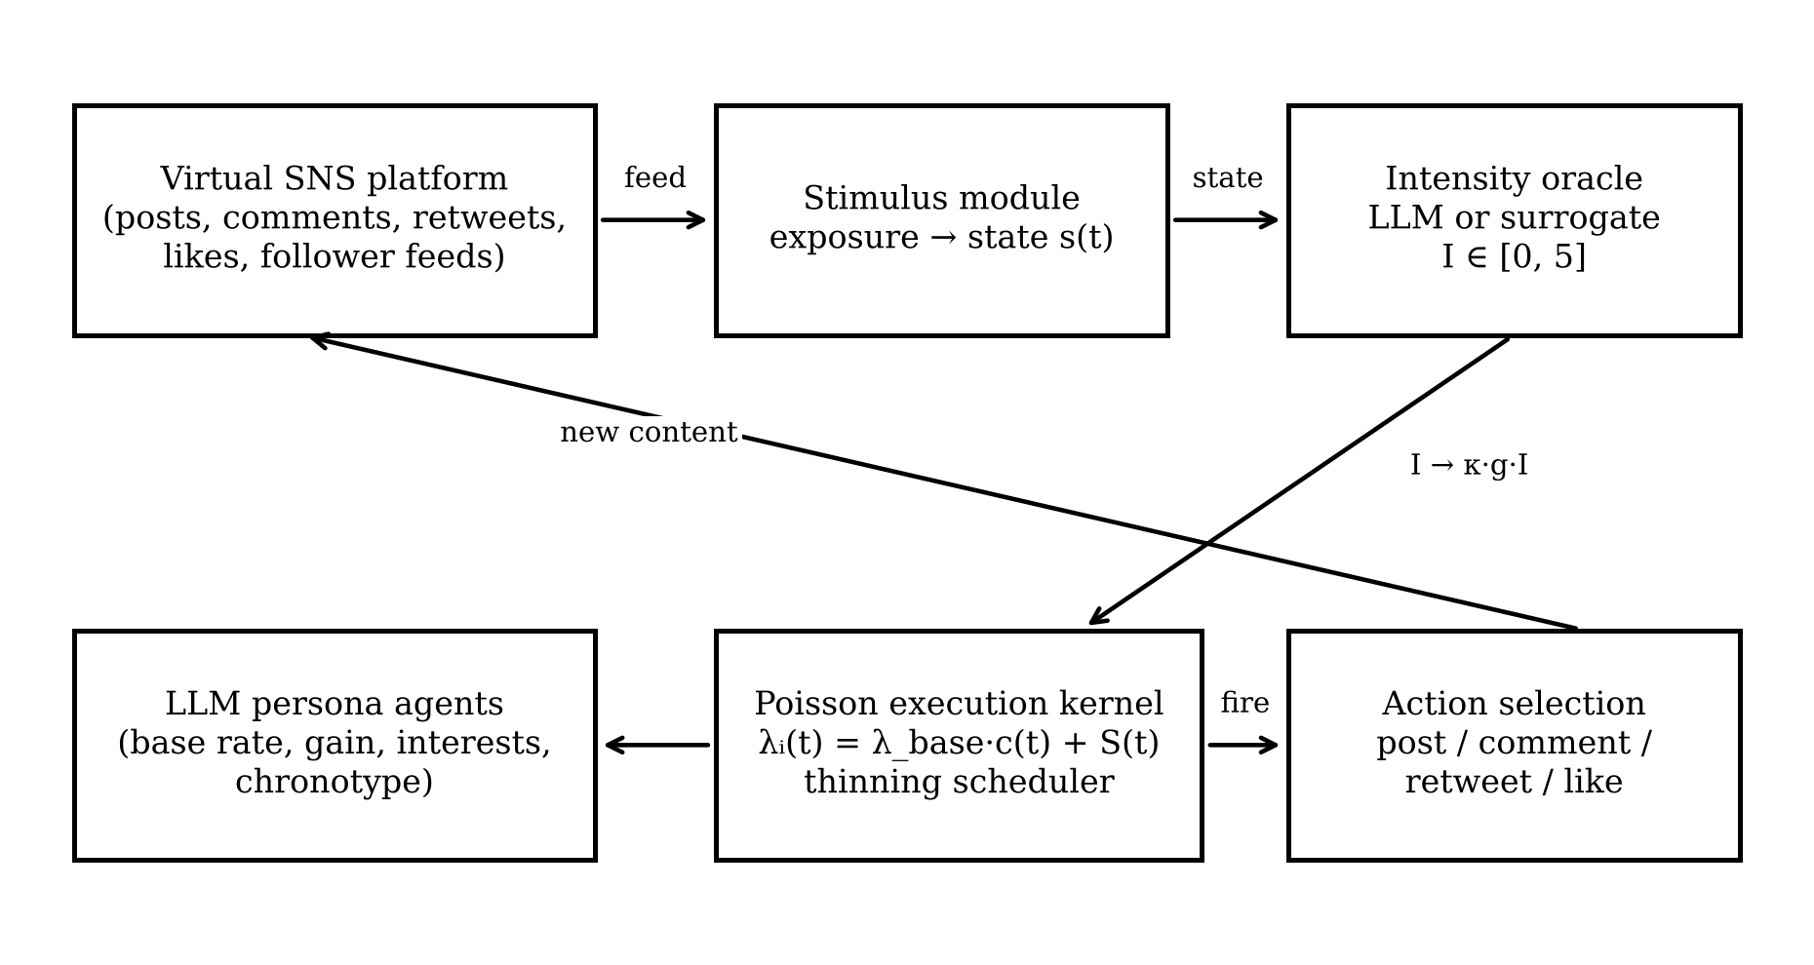
Figure 1. Architecture of the Poisson-SNS artifact

3.1 Platform Environment
The environment is a text-based virtual platform. It maintains a directed follower graph, a store of items (original posts, comments, and retweets), and a bounded feed for each agent that holds the 40 most recent items shown to that agent. When an agent publishes content, each follower is exposed to it with probability p_{view} = 0.5, and comments are displayed with an additional visibility factor of 0.4 because replies are less prominent than original posts. Agents may also receive a notification when another agent comments on or retweets their content. Likes are recorded but do not propagate. The follower graph is generated by preferential attachment on in-degree, which yields a heavy-tailed follower distribution (Barabási and Albert 1999).

3.2 Persona Agents
Each agent is assigned one of five personas (Table 1) that determine its baseline rate, its sensitivity to stimuli, its chronotype, and its propensity for each action type. Individual baseline rates are multiplied by a log-normal factor (σ = 0.4) and chronotype is perturbed by a normal term (σ = 1.5 hours) to produce heterogeneity within personas. Each agent also has an interest vector over five topics drawn from a symmetric Dirichlet distribution with concentration 0.4, which makes interests concentrated rather than uniform.
Table 1. Persona parameters
Persona | Share | Base rate λ⁰ (h⁻¹) | Gain g | Peak hour | P(post / comment / retweet / like)
Early adopter | 15% | 0.45 | 1.3 | 22 | .30/.20/.25/.25
Cynic | 15% | 0.30 | 0.8 | 23 | .20/.45/.05/.30
Trend follower | 25% | 0.40 | 1.2 | 21 | .15/.15/.40/.30
Lurker | 30% | 0.12 | 0.6 | 21 | .05/.10/.10/.75
News junkie | 15% | 0.70 | 1.0 | 20 | .40/.20/.20/.20
Note: Action probabilities are listed in the order post, comment, retweet, like. When an agent selects an action that requires a feed item and none is eligible, it posts instead.

3.3 Intensity Model and Scheduler
Let c_{i}(t) denote a mean-one daily activity profile for agent i with an evening peak, a smaller midday peak, and a night trough. The conditional intensity of agent i at time t is
λᵢ(t) = λ⁰ᵢ · cᵢ(t) + Sᵢ(t), (1)
where S_{i}(t) aggregates the stimuli received before t:
Sᵢ(t) = min{ S_{max} , Σⱼ κ · gᵢ · Iᵢⱼ · rᵢⱼ · exp(−(t − tⱼ)/τ) }. (2)
Here t_{j} is the time of the j-th stimulating event (an exposure to relevant content or a notification), I_{ij} ∈ [0, 5] is the intensity rating returned by the oracle for the agent’s state at that moment, r_{ij} ∈ {0.25, 0.50, 0.75} encodes the relevance of the item to the agent’s interests, g_{i} is the persona gain, κ is a global scale (0.16), and τ is the decay time (1 hour). Feedback on an agent’s own content (a comment or retweet) enters as a stimulus with a fixed relevance. The cap S_{max} = 3 bounds the excitation. This additive form is the formulation proposed in the original research plan, namely a baseline propensity plus the sum of external stimuli.
Next event times are drawn by thinning. For agent i at time t, the dominating rate is λ_{max} = λ⁰ᵢ · max c + S_{i}(t), which is valid until the next stimulus arrives because the stimulus term decays. Candidate times are generated from a homogeneous process at rate λ_{max} and accepted with probability λᵢ(s)/λ_{max}. Whenever a new stimulus raises S_{i}, the agent’s pending event is invalidated and redrawn, which is exact because the Poisson process is memoryless. The simulator is thus fully event driven, and no agent is queried on a schedule.

3.4 The Intensity Oracle
The oracle maps an agent’s situation to an urge rating I ∈ [0, 5]. In the LLM instantiation, the model receives a system instruction to act as a behavior controller for a given user, together with the current time, emotional state, the number of relevant items recently shown in the feed, the topical relevance of the latest item, and notification status, and it must return the rating together with a short reason (Appendix A). The model is not asked when the agent will act. Clock time is determined entirely by the process in Section 3.3, which makes the number of model calls independent of the simulated time span and allows ratings for recurring states to be cached.
We implement two oracles. The surrogate oracle is a deterministic function that is increasing in leisure time, relevant feed volume and relevance, notifications, and a positive emotional state, and it is used for the main experiments and for development. The LLM oracle is described in Section 4.4. Both are accessed through the same interface, so the rest of the system is unchanged when one is substituted for the other.

3.5 Design Iterations
Two iterations are worth reporting because they bear on the stability of the artifact. First, with an uncapped additive stimulus and κ ≥ 0.25, the system became supercritical in evening hours: a six-hour run produced several times the baseline volume, and longer runs did not terminate in practical time. Capping the stimulus at S_{max} and reducing κ to 0.16 produced a stable system with a clear diurnal pattern. Second, an initial unimodal circadian curve produced too little midday activity relative to the reference profile used in Study 1, and a midday component was added. We note that this second change tunes the artifact toward the reference and discuss its implication in Section 5.3.

4. EVALUATION

4.1 General Setup
Unless stated otherwise, simulations used the parameters in Table 1 and Section 3, with the time unit set to hours. Study 1 used 800 agents for 72 simulated hours with 5 replications per scheduler. Studies 2 and 3 used a 2,000-agent network (three new links per node) simulated for 48 hours with the campaign starting at 18:00, with replications paired by network and random seed across strategies. The code and results are available in the project repository.

4.2 Study 1: Behavioral Plausibility of the Scheduler (RQ1)

Design
We compared three schedulers that share every other component: (a) the proposed IPP; (b) a homogeneous Poisson process (HPP) at each agent’s mean base rate, which has no circadian or reactive structure; and (c) fixed-period polling, in which each agent acts every 1/λ⁰ hours with a random phase. Outcomes were the hourly distribution of posting events (posts, comments, and retweets) pooled over days and the distribution of reply delays, the time between an item’s creation and a comment on it. The reference for the first was a stylized bimodal daily profile with a midday and an evening peak, and for the second a log-normal delay distribution with a median of 0.5 hours and heavy right tail truncated at 48 hours. These references are assumptions, not empirical measurements. They encode qualitative regularities commonly reported for online activity, and they were chosen with functional forms different from those of the simulator, but they are not data.
We report the Pearson correlation and total variation (TV) distance between the simulated and reference hour-of-day distributions, the Pearson χ² statistic (23 degrees of freedom), and the two-sample Kolmogorov–Smirnov statistic D for delays. Because simulated samples contain tens of thousands of events, χ² and KS tests reject at any conventional level for any imperfect model, so we interpret effect-size measures (r, TV, D) and treat significance tests as uninformative.

Results
Table 2. Scheduler comparison (means over 5 replications)
Scheduler | Pearson r | TV distance | χ² (crit. 35.2) | KS D (delay) | Median delay (h)
IPP (proposed) | 0.78 | 0.13 | 2,845 | 0.29 | 1.53
HPP | −0.20 | 0.22 | 8,127 | 0.40 | 2.34
Fixed-period polling | 0.12 | 0.21 | 7,838 | 0.37 | 1.79
Reference | — | — | — | — | 0.50
Note: Reference distributions are assumed (see text). All χ² statistics exceed the critical value at α = .05, as do all KS tests (p < .001).
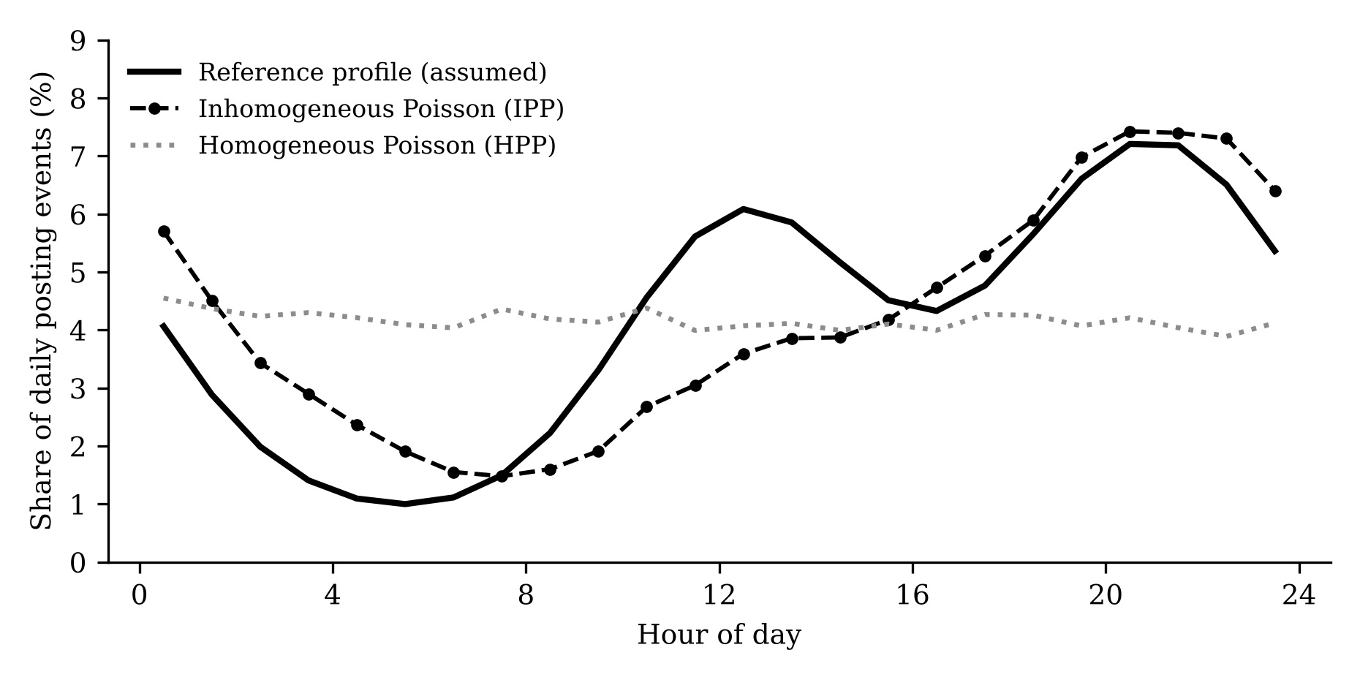
Figure 2. Hourly distribution of posting events: reference profile and two simulated schedulers (3 runs of 72 hours)
Table 2 and Figure 2 show that the IPP scheduler tracks the daily profile far better than either baseline. Neither HPP nor polling can produce a diurnal pattern, because neither contains a time-varying component, and the small positive correlation for polling reflects chance. IPP also lies closer to the reference on the reply-delay distribution (D = 0.29 vs. 0.40 and 0.37). The fit is nevertheless imperfect, and the discrepancies are systematic. The following figures come from a single representative 72-hour replication. Activity between midnight and 5 a.m. is overestimated by about 1.5 percentage points per hour, and the midday peak is underestimated by two to three points. Reply delays are too long: the median is about 1.5 hours against 0.5 hours in the reference, only 4.7% of replies occur within five minutes against 12.7% in the reference, and the tail beyond 24 hours is thinner (0.1% vs. 0.7%). The pooled hourly counts are also strongly overdispersed (variance-to-mean ratio of 73.5, against 1.5 under HPP), which reflects the clustering produced by cascades. We cannot say from these data whether that degree of clustering is realistic.
We therefore conclude that the IPP scheduler is a clear improvement over the two baselines in reproducing the temporal structure of the assumed reference, but we do not claim statistical equivalence with it, and we do not claim a match to any real platform.

4.3 Study 2: Seeding Strategies and Cascade Dynamics (RQ2)

Design
A campaign message on one topic was injected at 18:00 under four conditions. In the concentrated condition, the three accounts with the most followers posted the message. In the distributed condition, randomly chosen non-influencer accounts posted it, with accounts added until their combined follower count matched that of the concentrated condition (on average 370 accounts, with seed reach of about 980 vs. 955 follower links in the distributed and concentrated conditions, respectively). A random-three condition with three random ordinary accounts served as a size-matched control, and a no-seed condition confirmed that organic activity does not generate campaign adoption. Adoption was defined as a retweet or comment on campaign content. We recorded the number of adopters, the number of agents exposed, the times at which 10% and 50% of eventual adopters had adopted (t₁₀ and t₅₀), and the branching ratio from a maximum-likelihood fit of a Hawkes process with a constant background and exponential kernel to the campaign event times. We ran 40 paired replications and compared the concentrated and distributed conditions with Wilcoxon signed-rank tests and bootstrap confidence intervals for the mean paired difference.

Results
Table 3. Seeding outcomes (40 paired replications; surrogate oracle)
Outcome | Concentrated | Distributed | Difference [95% CI] | Wilcoxon p
Adopters | 283.3 | 229.3 | +54.0 [24.2, 84.6] | .001
Agents exposed | 864.6 | 905.2 | −40.6 [−107.3, 26.8] | .17
t₅₀ (hours) | 1.81 | 1.50 | +0.31 [0.13, 0.49] | < .001
t₁₀ (hours) | 0.26 | 0.21 | +0.05 [0.01, 0.09] | .007
Hawkes branching ratio | 0.954 | 0.944 | +0.010 [0.003, 0.019] | .027
Adopters per unit seed reach | 0.296 | 0.237 | — | —
Note: The random-three control yielded 2.1 adopters and reached 8.4 agents on average; the no-seed condition produced no campaign adoption.
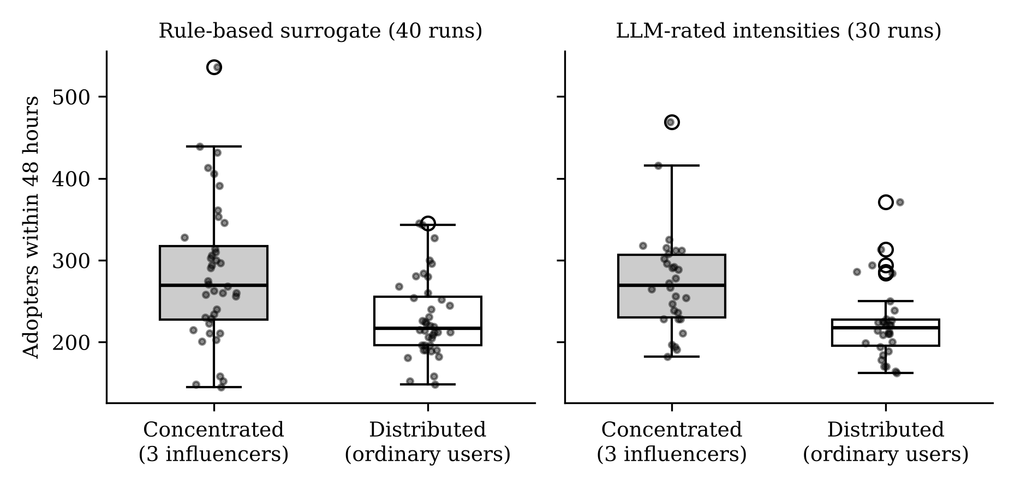
Figure 3. Adopters within 48 hours by seeding strategy, under the surrogate oracle (left) and the LLM oracle (right). Points are individual replications.
Concentrating the campaign on three influencers produced about 24% more adopters than the distributed condition, and the concentrated condition had the larger outcome in 75% of the paired replications (paired effect size d_{z} = 0.55). The two conditions did not differ detectably in the number of agents reached. The concentrated strategy therefore converted exposure into engagement more effectively (0.30 vs. 0.24 adopters per unit of seed reach). We did not test the mechanism. Plausible explanations include less overlap between the audiences of the high-degree accounts and a larger contribution from second-wave sharing by well-connected adopters, but we have not separated them.
The distributed condition was nevertheless faster. It reached half of its eventual adopters about 0.3 hours earlier, consistent with hundreds of simultaneous points of exposure compared with three. The concentrated condition was also more variable (standard deviation of adopters of 86 vs. 49), and its outcomes ranged from 145 to 536, whereas those of the distributed condition ranged from 148 to 345. Its worst replications resembled the distributed condition’s average, while its best replications greatly exceeded the distributed condition’s best. Thus the two strategies differ in the expected scale, the speed, and the spread of outcomes, and no single strategy dominates. The random-three control confirms that the advantage is not due to the number of seeds: three ordinary accounts produced essentially no cascade, because the process is close to critical and total cascade size scales with initial exposure.
The estimated branching ratios were close to one in both conditions (0.954 and 0.944). The difference of 0.010, although statistically detectable, is too small to interpret as evidence that concentrated seeding is more “viral.” The fitted kernel decay rate (about 4.6 per hour, or a mean memory of roughly 13 minutes) is also faster than the one-hour stimulus decay built into the simulator, which indicates that a constant-background exponential Hawkes model is a misspecified summary of these non-stationary cascades. We therefore use the branching ratio only as a coarse index of criticality.

4.4 Study 3: Rule-Based vs. LLM-Rated Intensity (RQ3)

Design
No API access was available in our environment, so we obtained LLM ratings through ten independent instances of an LLM-based assistant (Claude Sonnet) operating as raters. Because the number of distinct agent states visited in a simulation is large (about 9,000 in a single run), we coarsened the state space to 1,600 states defined by four time-of-day periods, five personas, four emotions, ten combinations of recent relevant feed volume (0 to 3 or more) and item relevance, and the presence of a notification. Each rater received 160 randomly ordered states and the instruction in Appendix A, was told not to write code or formulas to compute scores, and was not given access to the repository. The resulting 1,600 ratings form a lookup table used by the simulator. To separate the effect of the oracle from the effect of coarsening, we ran the surrogate oracle on the same coarse states as a control.
The LLM ratings (mean 2.36, SD 1.01, range 0.1–4.6) correlated moderately with the surrogate (Spearman ρ = 0.61), which indicates independent rather than imitative judgments. Ratings were lowest for lurkers (mean 0.92 vs. 2.49–2.91 for other personas), increased with the volume of relevant feed items (1.31, 2.15, 2.48, and 2.78 for 0, 1, 2, and 3 or more items), with topical relevance (1.96, 2.44, and 2.80), and with the presence of a notification (2.64 vs. 2.08), and varied little by time of day (2.20 to 2.48). Indifferent emotion lowered the rating (1.94 vs. 2.42 to 2.65).

Results
Table 4. Sensitivity of results to the intensity oracle
Oracle (replications) | Concentrated adopters | Distributed adopters | Difference (p) | Concentrated larger | t₅₀ difference (h)
Surrogate, original (40) | 283 | 229 | +54 (.001) | 75% | +0.31
Surrogate, coarse states (30) | 312 | 230 | +82 (< .001) | 80% | +0.36
LLM-rated, coarse states (30) | 274 | 223 | +51 (< .001) | 80% | +0.40
Note: Differences are concentrated minus distributed; p-values are from Wilcoxon signed-rank tests. For the behavioral comparison under IPP, the LLM oracle yielded r = 0.81, TV = 0.117, and D = 0.287, against r = 0.80, TV = 0.122, and D = 0.295 for the surrogate on the same coarse states (5 replications each).
The substantive conclusions were the same under all three oracles: the concentrated strategy produced more adopters and the distributed strategy was faster. The LLM oracle gave a somewhat smaller concentrated advantage (+51) and lower variability (SD 62 vs. 113 for the coarse surrogate), which may reflect its larger differentiation between personas, although we did not test this explanation. In terms of behavioral plausibility, the LLM oracle was statistically indistinguishable in practice from the surrogate, and it did not repair the reply-delay shortfall (median 1.48 hours). In short, the results of Studies 1 and 2 appear robust to the oracle, but the LLM oracle did not by itself improve fidelity.

5. DISCUSSION

5.1 Contributions to Research
The artifact makes three contributions. First, it separates two roles that LLM-agent simulators usually merge. The LLM is used for a judgment it is plausibly able to make, namely how strongly a situation motivates a persona to speak, whereas timing is handled by a point process whose properties are well understood. This separation yields an explicit link between a language-model output and a rate parameter, and it makes the temporal assumptions inspectable and testable, which is not possible when timing is implicit in the simulation loop.
Second, the design shows that endogenous timing matters for conclusions. Because action times emerge from agent state, the simulator reproduces a daily cycle that polling and homogeneous schedules cannot, and it generates reactive cascades without a prescribed excitation kernel. The finding that a stimulus cap was necessary for stability is itself informative, since it indicates that unbounded reactivity in an additive model quickly produces unrealistic explosion and that simulation designers need an explicit saturation assumption.
Third, the seeding results qualify the influencer debate. Under an equal exposure budget, concentration on influencers produced more engagement in expectation, which is consistent with the view that high-degree accounts matter (Bakshy et al. 2011), yet distribution produced faster and less variable diffusion, which is in the spirit of the argument that many ordinary users can do the work (Watts and Dodds 2007). The simulation suggests that the two positions need not conflict once one separates the objective (scale vs. speed) and the risk preference (mean vs. variance).

5.2 Implications for Practice
For platform operators and marketers who use simulation to pre-test campaigns, the results suggest framing the decision around the objective. If the goal is the largest expected engagement and the campaign can tolerate the risk of a weak outcome, concentrating on prominent accounts is favored. If the campaign is time sensitive, as in a product launch with a short attention window or a public-safety announcement, or if a poor outcome is costly, broad distribution is favored. Because these conclusions come from a synthetic network and assumed parameters, they should be treated as hypotheses for field testing and not as prescriptions. For simulation builders, the artifact offers a specification that is simple to implement and cheap to run: ratings for recurring states can be cached, so the cost of the LLM is largely independent of the length of the simulated period.

5.3 Limitations and Future Research
Several limitations bound the conclusions. The most important is the absence of empirical reference data. The behavioral comparison in Study 1 uses a parametric reference that we specified, so the results show that the scheduler is closer to the assumed regularities than the alternatives are, not that it is close to any real platform. In addition, the circadian profile of the simulator was adjusted after inspecting its fit to that same reference (Section 3.5), which makes the reported fit optimistic as a test of out-of-sample validity. A confirmatory evaluation should calibrate on one part of a real trace and test on a held-out part, for example using the timestamps of public posts and the reply delays of a public discussion platform. The artifact accepts such data without modification.
Second, several parameters, namely the stimulus scale, exposure probabilities, and saturation cap, were set manually to avoid unstable dynamics, and we did not conduct a sensitivity analysis. The direction of the seeding result may depend on them, in particular because the system operates close to criticality. Third, the network is synthetic, and real networks have community structure, homophily, and different degree distributions that could change the relative merit of the strategies. Fourth, the LLM ratings came from a single pass of batched evaluation on a coarsened state space. Batching may induce anchoring across items, we did not test the reproducibility of repeated ratings, and the model never saw the full context of any individual agent. Finally, the mean reply delay is too long and the tail too light, which indicates that a single exponential stimulus decay is too restrictive. A mixture of short and long decay components is a natural extension.
Future work can proceed in three directions: confirmatory validation against real traces, a systematic sensitivity and robustness analysis including alternative network models, and richer oracles that supply the full agent context to the model on each call, together with studies of repeatability across models and prompts.

6. CONCLUSION
This study asked whether the timing of LLM agents on a simulated social platform should be determined by a polling clock or by a stochastic process driven by agent state. We specified and evaluated an inhomogeneous Poisson process artifact in which an LLM supplies the strength of an agent’s stimulus and the process supplies the timing. The artifact reproduces a stylized daily profile much better than homogeneous or periodic scheduling, supports an equal-budget comparison of seeding strategies in which concentration raises expected scale and distribution raises speed and stability, and yields conclusions that are robust to whether intensity is rule-based or LLM-assigned. The evidence is limited by the lack of real trace data and by manual parameterization. We offer the artifact and the evaluation protocol so that these gaps can be closed in subsequent work.

REFERENCES
Aral, S., and Walker, D. 2012. “Identifying Influential and Susceptible Members of Social Networks,” Science (337:6092), pp. 337–341.
Bakshy, E., Hofman, J. M., Mason, W. A., and Watts, D. J. 2011. “Everyone’s an Influencer: Quantifying Influence on Twitter,” in Proceedings of the Fourth ACM International Conference on Web Search and Data Mining, New York: ACM, pp. 65–74.
Barabási, A.-L. 2005. “The Origin of Bursts and Heavy Tails in Human Dynamics,” Nature (435:7039), pp. 207–211.
Barabási, A.-L., and Albert, R. 1999. “Emergence of Scaling in Random Networks,” Science (286:5439), pp. 509–512.
Bonabeau, E. 2002. “Agent-Based Modeling: Methods and Techniques for Simulating Human Systems,” Proceedings of the National Academy of Sciences (99:suppl. 3), pp. 7280–7287.
Crane, R., and Sornette, D. 2008. “Robust Dynamic Classes Revealed by Measuring the Response Function of a Social System,” Proceedings of the National Academy of Sciences (105:41), pp. 15649–15653.
Gao, C., Lan, X., Lu, Z., Mao, J., Piao, J., Wang, H., Jin, D., and Li, Y. 2023. “S3: Social-Network Simulation System with Large Language Model-Empowered Agents,” arXiv:2307.14984.
Gilbert, N. 2008. Agent-Based Models, Thousand Oaks, CA: Sage Publications.
Gregor, S., and Hevner, A. R. 2013. “Positioning and Presenting Design Science Research for Maximum Impact,” MIS Quarterly (37:2), pp. 337–355.
Hawkes, A. G. 1971. “Spectra of Some Self-Exciting and Mutually Exciting Point Processes,” Biometrika (58:1), pp. 83–90.
Hevner, A. R., March, S. T., Park, J., and Ram, S. 2004. “Design Science in Information Systems Research,” MIS Quarterly (28:1), pp. 75–105.
Kempe, D., Kleinberg, J., and Tardos, É. 2003. “Maximizing the Spread of Influence through a Social Network,” in Proceedings of the Ninth ACM SIGKDD International Conference on Knowledge Discovery and Data Mining, New York: ACM, pp. 137–146.
Lewis, P. A. W., and Shedler, G. S. 1979. “Simulation of Nonhomogeneous Poisson Processes by Thinning,” Naval Research Logistics Quarterly (26:3), pp. 403–413.
Malmgren, R. D., Stouffer, D. B., Motter, A. E., and Amaral, L. A. N. 2008. “A Poissonian Explanation for Heavy Tails in E-mail Communication,” Proceedings of the National Academy of Sciences (105:47), pp. 18153–18158.
Ogata, Y. 1981. “On Lewis’ Simulation Method for Point Processes,” IEEE Transactions on Information Theory (27:1), pp. 23–31.
Park, J. S., O’Brien, J. C., Cai, C. J., Morris, M. R., Liang, P., and Bernstein, M. S. 2023. “Generative Agents: Interactive Simulacra of Human Behavior,” in Proceedings of the 36th Annual ACM Symposium on User Interface Software and Technology, New York: ACM.
Rand, W., and Rust, R. T. 2011. “Agent-Based Modeling in Marketing: Guidelines for Rigor,” International Journal of Research in Marketing (28:3), pp. 181–193.
Törnberg, P., Valeeva, D., Uitermark, J., and Bail, C. 2023. “Simulating Social Media Using Large Language Models to Evaluate Alternative News Feed Algorithms,” arXiv:2310.05984.
Watts, D. J., and Dodds, P. S. 2007. “Influentials, Networks, and Public Opinion Formation,” Journal of Consumer Research (34:4), pp. 441–458.
Zhao, Q., Erdogdu, M. A., He, H. Y., Rajaraman, A., and Leskovec, J. 2015. “SEISMIC: A Self-Exciting Point Process Model for Predicting Tweet Popularity,” in Proceedings of the 21st ACM SIGKDD International Conference on Knowledge Discovery and Data Mining, New York: ACM, pp. 1513–1522.

APPENDIX A. INTENSITY ORACLE PROMPT
The instruction below is the English rendering of the Korean prompt used in the study; the state fields in brackets were filled in programmatically.
[System] You are the behavior controller of a virtual SNS user (persona description). Given the user’s current state and surroundings, rate on a real-valued scale from 0.0 to 5.0 the urge (Intensity) this user feels, within the next hour, to write a new post or leave a comment on the SNS.
[Current situation] Time of day: [period]. Current emotion: [emotion]. Timeline update: [n] posts on topics of interest appeared in the feed within the last hour (the latest concerns a topic of [low / medium / high] interest). Notifications: [none / present].
[Output format] Respond only in the following JSON format. {"intensity": (float between 0.0 and 5.0), "reason": "short reason"}

APPENDIX B. SIMULATION SETTINGS
Table B1. Global simulation parameters
Parameter | Value | Remarks
Stimulus scale κ | 0.16 | Set manually; see Section 3.5
Stimulus decay τ | 1 hour | Single exponential component
Stimulus cap S_{max} | 3.0 | Bounds excitation
Exposure probability p_{view} | 0.5 | Posts and retweets
Comment visibility factor | 0.4 | Multiplies p_{view}
Feed capacity | 40 items | Most recent items
Network (Study 1) | 800 agents, m = 5 | Preferential attachment
Network (Studies 2–3) | 2,000 agents, m = 3 | Preferential attachment
Horizon | 72 h (Study 1); 48 h (Studies 2–3) | Campaign starts at 18:00
Replications | 5 (Study 1); 40 / 30 / 30 (Studies 2–3) | Paired by network and seed

