Reach, not speed, limits who benefits from AI testing tools and where vendors invest
Ook Lee
Department of Information System, Hanyang University, Seoul, Korea. e-mail: ooklee@hanyang.ac.kr
Abstract
AI testing tools are marketed on speed, but they differ from human testers in reach: the share of the faults a competent human team would eventually find that the tool can find at all. We build a model that separates the two. Firms with heterogeneous costs of undetected faults choose testing budgets, and a monopoly vendor chooses a price and an investment in reach. Below the human baseline, adoption is confined to a bounded range of stakes, and the highest-stakes firms stay with human testing under any contract with bounded transfers; at parity the bound disappears. Vendor profit has a kink at parity, so optimal investment jumps from none to parity at a cost threshold and then stays at parity over a range of costs, and the planner invests more widely than the vendor. Public benchmark and defect data are consistent with the model's building blocks; firm-level predictions remain untested.

Software teams now buy testing capacity from vendors of AI tools. Procurement discussions and benchmark leaderboards emphasize how quickly a tool produces tests, patches or verdicts, and how often it passes a fixed set of tasks. A buyer deciding whether to rely on such a tool needs to know something else: whether the tool can find the faults that matter. A fast tool that cannot find a class of faults may be a good purchase for a team whose undetected faults are cheap and a poor one for a team whose undetected faults are expensive. The vendor faces the mirror-image problem. Making a tool cheaper or faster is mostly engineering and pricing, whereas extending the set of faults it can find is a different kind of investment whose payoff may be very uneven.
We study this distinction with a model that has three layers. In the first, a firm chooses how long to test under a nonhomogeneous Poisson process (NHPP) for fault discovery, the standard workhorse of software reliability^{1,2,3}. Testing is done either by a human team, which can find a pool of a faults at rate b, or by an AI tool that reaches a fraction A of that pool at B times the speed and a different unit cost. In the second layer, a vendor sells the tool at a usage price to firms whose stakes, the cost of a fault that escapes to production, differ. In the third, the vendor first chooses reach A at a convex cost. The approach extends the economics of testing and release studied in information systems and operations research^{4,5} by making reach a separate attribute of a vendor-supplied technology, and it complements recent theoretical work on pricing and contracting for large language models^{6,7,8}.
Four results follow. We state them here and give the derivations in Methods and the Supplementary Information. First, with a usage price, the set of adopting firms is a single interval of stakes, and the interval is bounded exactly when reach is below the human baseline. Second, no contract with bounded net transfers to the firm can keep the highest-stakes firms in the market when reach is below baseline. Third, the vendor's profit is continuous in reach but has a kink at the baseline, so that optimal investment jumps and bunches at parity. Fourth, the planner would invest over a wider range of costs than the vendor, so a subsidy of limited size changes nothing for vendors in an intermediate range of costs. Throughout, numerical values use an illustrative parameter set that we did not calibrate; they show mechanisms, not magnitudes.
Results
Reach sets the ceiling; speed and price set how soon it is reached
Let a firm's stakes index be κ = abf, where f is the cost of one undetected fault. With testing budget T and unit cost c, a technology that can reach a′ faults at rate b′ yields a net saving relative to no testing of fa′(1 − e^{−*b*′*T*}) − cT. Maximizing over T gives a closed form (Methods, equation 1): the human saving is fa h(κ) and the AI saving is fAa h(ρκ), where h(x) = 1 − (1 + ln x)/x rises from 0 to 1 and ρ = AB/(c₀ + p) is the AI's effectiveness index, with c₀ the firm's own cost of running the tool and p the vendor's usage price. Reach A scales the whole saving, whereas speed and price enter only through ρ inside h. In this sense they act in different places: speed and price determine how soon testing approaches the ceiling set by what the tool can reach, and reach moves the ceiling itself.
A firm adopts if the AI saving exceeds the human saving, that is, if Φ(κ) = A h(ρκ) − h(κ) > 0. Fig. 1 plots Φ. For A < 1 it crosses zero from above at a finite κ*, and for A ≥ 1 it never does. The limit of Φ as stakes grow is A − 1, so the sign of A − 1 decides what happens at the top of the stakes distribution. Because Φ crosses zero at most once (Methods, Proposition 2), the adopting set is a single interval: {1/ρ < κ < κ*} if A < 1 and the half-line {κ > 1/ρ} if A ≥ 1. The upper end κ* rises with speed and reach and falls with price, and diverges as A approaches 1. Parity is therefore a boundary for high-stakes behaviour, not for moderate stakes, where a fast, cheap tool with A < 1 may well be adopted. The structure is related to adoption regions that widen with AI capability in models of worker–tool teams⁹, but those models have no vendor, price, or stakes that vary across adopters.
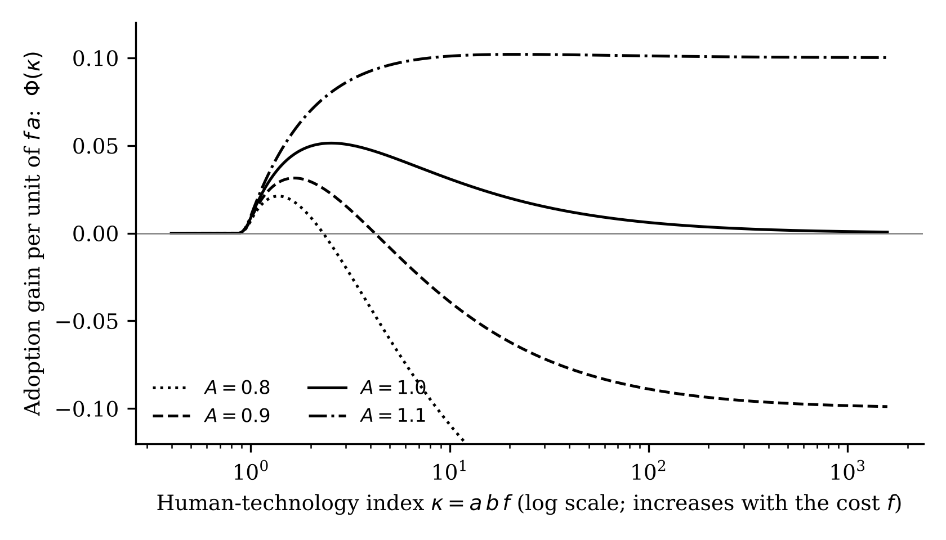
Fig. 1 | Who adopts. Adoption payoff Φ(κ) = A h(ρκ) − h(κ) for four levels of relative reach A (ρ = 1.15). A firm adopts where the curve is above zero. For A < 1 the curve crosses zero at a finite stakes index; for A ≥ 1 it does not. All curves approach A − 1 as κ grows. Illustrative parameters.
Price cannot remove the exclusion of high-stakes firms
One might expect richer pricing to keep high-stakes firms in the market, for example through a discount, a rebate on failures or a warranty. It cannot, as long as payments from the vendor to the firm are bounded. For any contract in which the net transfer to the firm never exceeds a constant τ, every firm with (1 − A)af − (1 + ln(abf))/b > τ prefers human testing (Methods, Proposition 3). The argument is short: under AI the firm's gross benefit cannot exceed fAa, the cost of all faults the tool can reach, whereas human testing yields fa − (1 + ln κ)/b, so the human option wins once (1 − A)af outgrows a logarithmic term. The class of contracts covered includes menus, two-part tariffs and fixed-damages warranties. Table 1 gives the guaranteed thresholds. The guarantee is a bound, not the actual exclusion boundary: at A = 0.9 the bound is at f = 20.4, while the optimal linear price already excludes firms with f above about 2.8. For A close to parity, however, the guarantee rises steeply (318 at A = 0.99), which means exclusion moves into the far tail of the stakes distribution.
Table 1 | Stakes above which human testing is guaranteed under bounded transfers τ
Relative reach A | τ = 0 | τ = 10 | τ = 50 | τ = 200
0.50 | 2.2 | 3.6 | 8.3 | 24.2
0.80 | 8.3 | 11.5 | 22.9 | 62.5
0.90 | 20.4 | 26.5 | 49.0 | 128.0
0.95 | 47.9 | 59.7 | 104.4 | 262.0
0.99 | 318.3 | 375.1 | 594.3 | 1,379.4
Largest root of (1 − A)af − (1 + ln(abf))/b = τ, with a = 20 and b = 0.12; units of f are the cost of one unit of human testing time.
The result does not say that high-stakes firms never use AI. A tool with reach below parity cannot win them from human testing through any bounded transfer; a firm could still use it as a complement, which the model does not capture. Committed-spend menus, which are the revenue-maximizing instrument for selling language-model capacity to users with private values⁶, raise the vendor's profit in our setting by about 60% below parity and 3% at parity, but leave the top decile of firms excluded for A < 1 (Supplementary Information, section B). Two further results sharpen the point. Scaling all stakes by a factor λ, as when liability for software failures tightens, makes the adopting share nondecreasing in λ if A ≥ 1 but single-peaked if A < 1 (Fig. 2). And with several tools all below parity, the top segment is excluded whatever the number of vendors or the intensity of price competition.
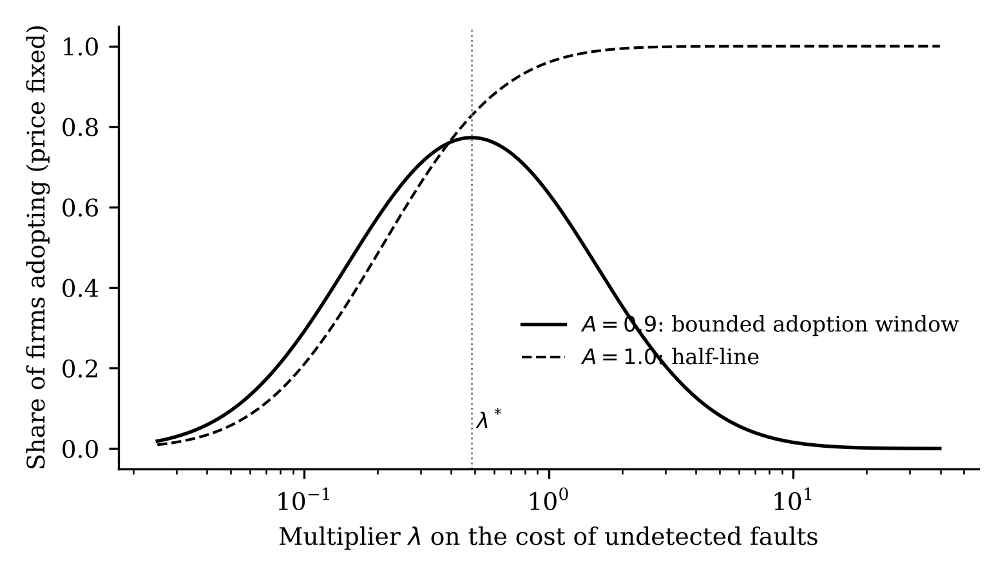
Fig. 2 | Stakes scaling. Share of firms adopting at a fixed price as stakes are scaled by λ. With reach below parity (solid) the share is single-peaked, with its maximum at λ* = 0.49 in this illustration; at parity (dashed) it is nondecreasing.
Vendor profit has a kink at parity, so investment jumps and bunches
We now let the vendor choose reach at cost θ(A − A₀)²/2, where A₀ is its starting reach. Two features of the second-stage profit Π*(A) matter. A tool whose reach is below (c₀ + k)/B, with k the vendor's marginal cost, is never adopted at a price that covers cost, so profit is zero below an entry threshold (0.5625 in our illustration). This alone implies a jump: the ratio of profit to investment cost has an interior maximum θ̂, and the vendor invests only if θ < θ̂, in which case it invests at least up to the maximizing reach (Methods, Proposition 6). No convexity or second-order condition is needed.
The second feature is where the maximizing reach lies. At exactly parity, the vendor sets its price just below the cliff at which the tool would be rejected, and all firms with κ > 1 adopt. Its profit is Π*(1) = (B − c₀ − k)E[ln κ; κ > 1]/(Bb). Above parity, profit rises with a finite slope BM, where M = E[ln κ; κ > 1]/(Bb); below parity, profit falls off with a slope that diverges as reach approaches 1 (Methods, Proposition 7). The vendor's profit is continuous but has a kink, steep from the left. Under two conditions that hold with wide margins in our illustration, this gives bunching: for θ between θ_low and θ̂ = 2PM/(1 − A₀)², where P = B − c₀ − k, the optimal reach is exactly 1 (Fig. 3). In the illustration θ̂ = 46.2 and θ_low = 27.6. Between these values the vendor invests up to the human baseline and no further.
The social planner's threshold, computed with profit plus the net saving of adopting firms, is higher (65.1 when reach is capped at 1.3), so for θ between the two thresholds the planner would invest and the vendor does not. A proportional subsidy raises the vendor's threshold to θ̂/(1 − s); it closes the window only at s = 1 − θ̂/θ_s, about 29% here, and below that rate has no effect on vendors in the intermediate range. The magnitude depends on the reach cap and on the welfare measure, which excludes the benefit to the firms' own customers, whereas the existence of the window does not. With two vendors, price competition after reach is chosen dissipates the profit of a vendor whose tool is no better than its rival's. No vendor then invests when θ > θ̂, and no symmetric investing equilibrium exists (Supplementary Information, section A.8).
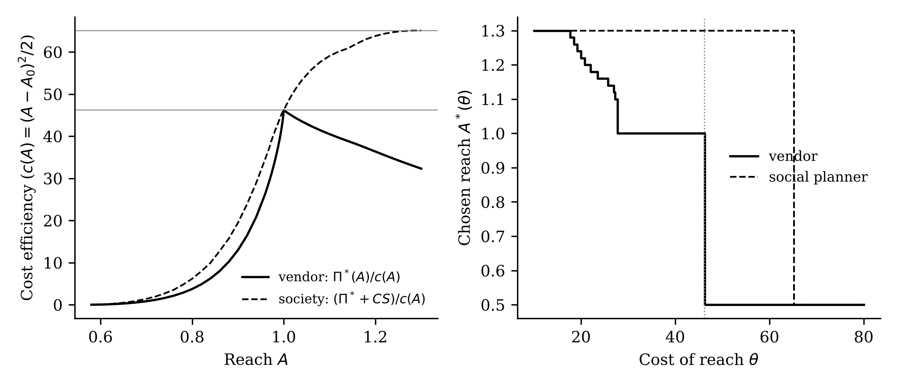
Fig. 3 | Reach investment. Left: cost efficiency of reach for the vendor (profit divided by investment cost, solid) and for society (profit plus consumer surplus divided by investment cost, dashed); horizontal lines mark the maximum of each. Right: chosen reach as a function of the cost parameter θ for the vendor and the planner (reach capped at 1.3). The vendor's choice stays at parity over an interval and then drops to the starting reach of 0.5. Illustrative parameters.
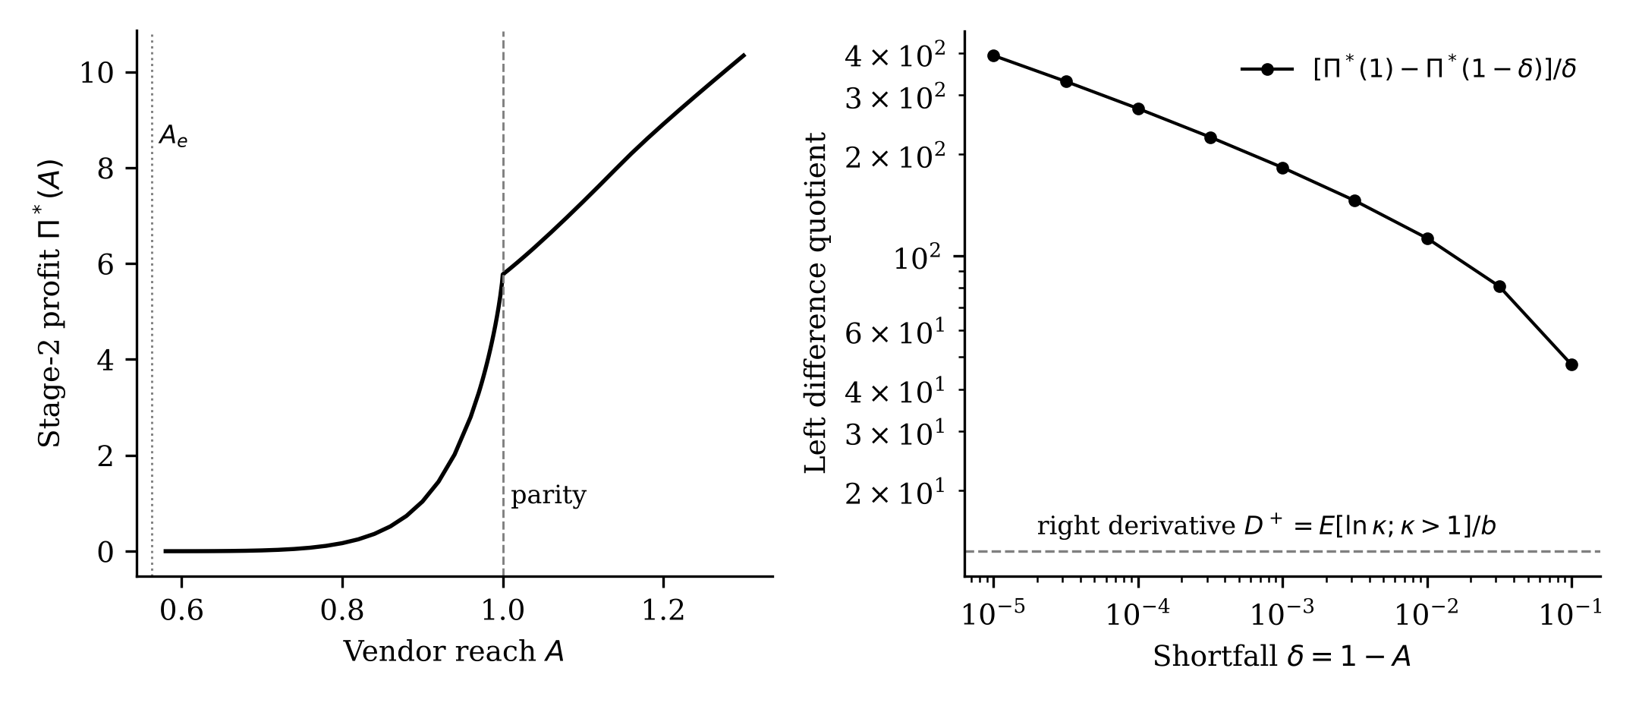
Fig. 4 | The kink. The vendor's maximized second-stage profit Π*(A) in the continuous-stakes model. Profit is zero below the entry threshold, rises steeply, and has a kink at parity (A = 1), steep from the left and with a finite slope from the right.
Public data are consistent with the building blocks but do not test the model
We have no firm-level data on stakes, tool reach or adoption, and we do not test the model's predictions. We use public data to check that three building blocks are not contradicted (Fig. 5). First, reach should fall with task complexity. On SWE-bench Verified^{10,11}, where each task carries a human fix-time label, a published run of a reasoning model resolved 39.9% of tasks labelled under 15 minutes (n = 193), 25.2% of those between 15 minutes and one hour (n = 258), 4.9% of the one-to-four-hour tasks (n = 41) and none of three longer tasks. Resolving an issue is not finding a fault, so this is a proxy; the sign is what the model uses. Second, reach should depend on budget. Across 80,036 public agent trajectories on 3,591 task instances, the share of instances solved at least once rose from 12.5% with one attempt to 27.4% with twelve, a logarithmic NHPP fitted better than an exponential (squared error 0.00023 versus 0.00104), and 68% of instances were never solved. The asymptotic reach is model-dependent, so we treat reach as a function of budget. Third, human fault discovery should saturate. In 3,333 releases from seven public Jira trackers¹², with 876,957 bug reports in total, the exponential Goel–Okumoto model had the lowest AIC in 80% of releases and the median half-life was about 1.3 months. Field reports reflect user exposure as well as testing, and some of the apparent saturation reflects users moving to newer versions.
A crude test of the adoption-interval prediction on a public study of repositories that adopted an AI coding assistant¹³, with GitHub stars as a stand-in for stakes, gave a U-shaped adoption intensity and therefore did not support a single peak. We do not read this as evidence against the model, because stars measure popularity, not the cost of a fault, and the control sample is not documented well enough to read the ratios as probabilities. A proper test needs a better proxy for stakes and contributor-level adoption data.
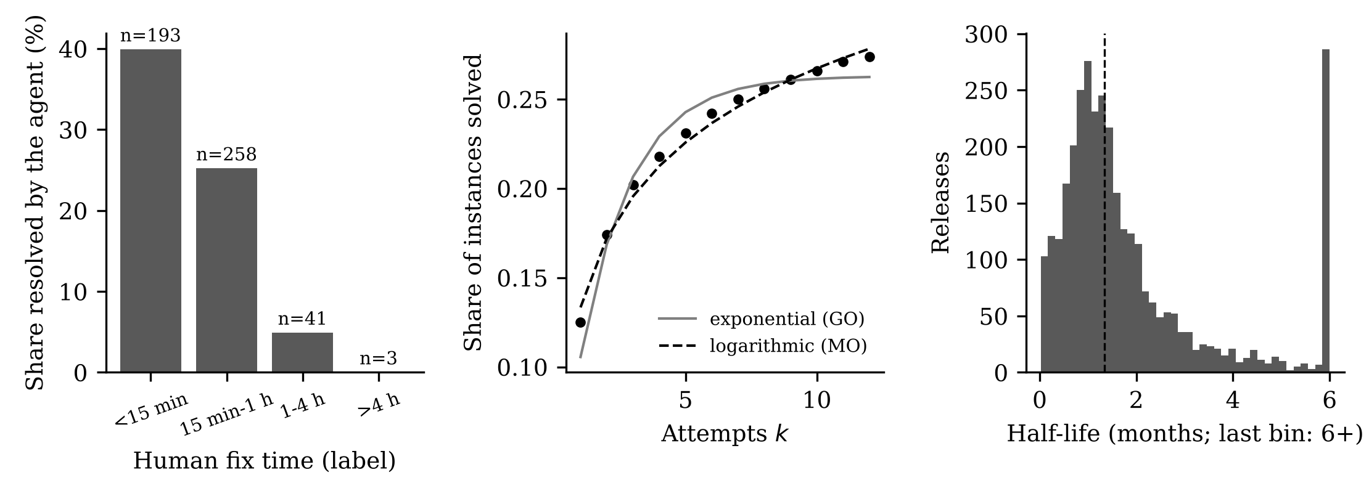
Fig. 5 | Public-data checks. Left: agent resolution rate by human fix-time class (SWE-bench Verified). Middle: cumulative share of task instances solved by number of attempts, with exponential and logarithmic NHPP fits (public agent trajectories). Right: distribution of the estimated discovery half-life across 3,333 releases in public Jira trackers.
Discussion
The model suggests three practical readings. For firms deciding whether to rely on an AI testing tool, the relevant question is not only how fast or cheap it is but what share of the faults a competent human team would find it can find, as a function of budget, and how that compares with the firm's own cost of the faults it misses. For developers of such tools and for those who evaluate them, benchmark results measure something close to speed and pass rates at a budget, and the model says that the payoff to extending reach is concentrated at the human baseline. A development programme aimed at parity is therefore rational, though we do not claim that firms behave this way, and benchmark over-fitting is a risk outside the model. For policy, price regulation and vendor liability do not remove the exclusion of high-stakes firms, while an instrument that lowers the cost of extending reach, such as shared fault datasets or research support, could, provided it is large enough to move vendors across the threshold.
The model is static and has a monopoly vendor with full information, risk-neutral firms, two technologies that are alternatives and not complements, a quadratic investment cost and a single notion of reach. Parameters are illustrative. The kink results are proved under stated conditions and for lognormal stakes; the global maximum behind bunching and the value of θ_low are numerical, and uniqueness of a pre-emption equilibrium with two vendors is not shown. Extensions on private information about reach, learning from usage and mixed-complexity markets are in the Supplementary Information and are more tentative than the main results; the signalling extension applies known mechanisms^{14,7} and we do not claim novelty for them. A deeper limit is what reach means empirically. Public agent benchmarks measure issue resolution at a given budget, not fault detection in production systems, and the evidence in Fig. 5 concerns the sign of dependencies, not the level of reach. Testing the adoption and exclusion predictions requires firm-level data on stakes, tool use and escaped faults, ideally from staggered introduction of a tool analysed with heterogeneity-robust difference-in-differences estimators.
Methods
Model
A firm bears cost f for each undetected fault. Human testing for time T at unit cost c_{H} = 1 yields NHPP mean value function m_{H}(T) = a(1 − e^{−*bT*})¹; AI testing yields m_{L}(T) = Aa(1 − e^{−*BbT*}) at unit cost c_{L} = c₀ + p. The firm is risk neutral. The total fault count cancels in comparisons across technologies, because it enters the cost of no testing and the saving from testing only through the faults that testing removes. The vendor has marginal cost k per unit of testing time, serves a unit mass of firms with continuously distributed stakes, chooses reach A ∈ [A₀, Ā] at cost θc(A) with c(A) = (A − A₀)²/2, and then chooses p with full information about stakes. We write π(p, A) for second-stage profit, Π*(A) = max over p of π, and J(A; θ) = Π*(A) − θc(A).
Results and proof outlines
Lemma 1 (value of testing). For κ = abf > 1, the human net saving maximized over T is fa h(κ) at T* = ln κ/b. The AI saving is fAa h(ρκ) at T* = ln(ρκ)/(Bb), with ρ = AB/(c₀ + p). Both are zero when the argument of h is at most 1. Outline: the first-order condition fab e^{−*bT*} = 1 gives T*; substituting and using 1/b = fa/κ gives fa h(κ). The AI problem is identical with κ replaced by ρκ and fa by fAa. (1)
Proposition 2 (adoption set). Let ρ > 1. If A < 1, firms adopt exactly for 1/ρ < κ < κ*, where κ* solves A h(ρκ*) = h(κ*); if A ≥ 1, exactly for κ > 1/ρ. κ* increases in A and B, decreases in p, and diverges as A ↑ 1. Outline: with g(x) = xh′(x)/h(x) = ln x/(x − 1 − ln x), g is strictly decreasing, so R(κ) = h(κ)/h(ρκ) has d ln R/d ln κ = g(κ) − g(ρκ) > 0 and increases from 0 to 1. Adoption is A > R(κ).
Proposition 3 (general exclusion). For 0 < A < 1 and any contract with net transfer to the firm at most τ, firms with (1 − A)af − (1 + ln(abf))/b > τ choose human testing. For the usage price, V/(fa) → A − 1 as f → ∞ at every price with c₀ + p > 0. Proof: AI gross benefit is at most fAa, so the AI payoff is at most fAa + τ, while human payoff is fa − (1 + ln κ)/b.
Proposition 4 (stakes scaling). With lognormal stakes, the adopting share is nondecreasing in the stakes multiplier λ if A ≥ 1 and single-peaked in ln λ if A < 1, with maximum at λ* = √(κ*/ρ)/med(κ). Proof: the share is a normal probability of an interval whose position shifts with ln λ; its derivative changes sign when the interval is centred on the mean.
Proposition 5 (entry). If A ≤ (c₀ + k)/B < 1, then Π*(A) = 0. Proposition 6 (investment jump). If Π* is continuous and A₀ lies below the entry threshold, θ̂, the maximum over A > A₀ of Π*(A)/c(A), is attained at some A_{t}; the optimal reach is nonincreasing in θ, equals A₀ for θ > θ̂, and is at least A_{t} for θ < θ̂. Proof: monotone comparative statics^{15,16} and the inequality Π*(A) ≤ θ̂c(A).
Proposition 7 (kink at parity). For lognormal stakes and C_{ε} = BM − Ps/(Bb) > 0 (s = Pr(κ > 1)): Π*(1) = PM, Π*′(1⁺) = BM, and Π*′(1⁻) = +∞. Proposition 8 (bunching). If also B(1 + A₀) > 2(c₀ + k), the profit-to-cost ratio has a strict local maximum at A = 1 with value 2PM/(1 − A₀)²; if this is the global maximum (verified numerically, not proved), the optimal reach is exactly 1 for θ ∈ [θ_low, θ̂]. The right slope is obtained by bounding the gain from pricing above the adoption cliff by a term of order (A − 1)²; the infinite left slope follows by contradiction from a lower bound on the excluded tail. We did not trace the uniformity of the constants in the O(ε²) terms, and the rate of divergence is approximate. Proposition 9. With welfare W = Π* + consumer surplus, θ_s = sup W/c ≥ θ̂, strictly if consumer surplus is positive at A_{t}; a subsidy s shifts the vendor's threshold to θ̂/(1 − s). Full proofs are in the Supplementary Information.
Illustrative parameters
a = 20, b = 0.12, c_{H} = 1, B = 1.6, c₀ = 0.8, k = 0.1, A₀ = 0.5, and ln κ ~ Normal(ln 4.8, 0.9²), equivalent to a median per-fault cost of 2. These were chosen to display the mechanisms and were not estimated. At A = 0.9 and the monopoly linear price, about 62% of firms adopt and the top decile of stakes does not; raising reach to parity raises profit from about 1.0 to 5.7 and the optimal price from about 0.33 to 0.80. Computations use grid quadrature (vendor model) or a continuous lognormal calculation (kink); the closed forms Π*(1) = 5.7729 and θ̂ = 46.18 agree with the continuous numerical optimum.
Public data
SWE-bench Verified^{10,11} difficulty labels were combined with a published single run of a reasoning model on 495 of the 500 tasks. Agent trajectories (80,036 on 3,591 instances) were analysed with a logarithmic and an exponential NHPP and with beta-binomial models with and without unsolvable instances. The Public Jira Dataset¹² was streamed (about 56 GB); 876,957 bug reports across seven trackers were attributed to the latest dated affected release preceding creation (43% could be attributed) and constant-rate, Goel–Okumoto and Musa–Okumoto models were fitted by Poisson maximum likelihood to 3,333 releases with at least 25 reports. Issue-label data for repositories from a public adoption study¹³ were collected through the GitHub API (114,362 issues from 191 repositories); this sample was too small for a controlled design and is not used for any claim in the main text.
Reporting
No human participants, animals or personal data were involved. The completed Reporting Summary is provided with the submission.
Data availability
Derived data tables are included in the replication package. The raw public data are available from their original sources, listed in the package README: the Public Jira Dataset (Zenodo, DOI 10.5281/zenodo.5882881), SWE-bench Verified and agent trajectories (Hugging Face), and the replication package of the AI-coding-assistant adoption study (Zenodo, record 18368661).
Code availability
All code for the model, figures and public-data analyses is provided in the replication package, with a script that reproduces the key numbers in the text. [Authors: deposit the package in a public repository with a DOI before submission and cite it here.]
Acknowledgements
[To be completed.]
Author contributions
O.L. conceived the study, developed the model and analyses, and wrote the manuscript. [Authors to confirm.]
Competing interests
The author declares no competing interests. [To be confirmed.] [Describe any use of generative AI tools in preparing the manuscript, code or analysis, in line with the journal's policy.]
Additional information
Supplementary information The online version contains supplementary material. Correspondence and requests for materials should be addressed to O.L.

References
1. Goel, A. L. & Okumoto, K. Time-dependent error-detection rate model for software reliability and other performance measures. IEEE Trans. Reliab. R-28, 206–211 (1979).
2. Okumoto, K. & Goel, A. L. Optimum release time for software systems based on reliability and cost criteria. J. Syst. Softw. 1, 315–318 (1980).
3. Musa, J. D. & Okumoto, K. A logarithmic Poisson execution time model for software reliability measurement. In Proc. 7th Int. Conf. Software Engineering 230–238 (IEEE, 1984).
4. Ji, Y., Mookerjee, V. S. & Sethi, S. P. Optimal software development: a control theoretic approach. Inf. Syst. Res. 16, 292–306 (2005).
5. Chiang, I. R. & Mookerjee, V. S. A fault threshold policy to manage software development projects. Inf. Syst. Res. 15, 3–21 (2004).
6. Bergemann, D., Bonatti, A. & Smolin, A. Menu pricing of large language models. Preprint at https://arxiv.org/abs/2502.07736 (2026).
7. Bauer, A. The last costly signal: how generative AI collapses competence signaling and why liability sustains markets for expert services. Preprint at https://arxiv.org/abs/2607.26327 (2026).
8. Sreenivas, N. K. & Larson, K. Contracting for LLM delegation: moral hazard in technology and effort choice. Preprint at https://arxiv.org/abs/2608.18232 (2026).
9. Koren, M., Bárány, Z. & Wohak, U. The directions of technical change. Preprint at https://arxiv.org/abs/2602.12958 (2026).
10. Jimenez, C. E. et al. SWE-bench: can language models resolve real-world GitHub issues? In Proc. Int. Conf. Learning Representations (ICLR, 2024).
11. OpenAI. Introducing SWE-bench Verified. https://openai.com/index/introducing-swe-bench-verified/ (2024).
12. Montgomery, L., Lüders, C. & Maalej, W. An alternative issue tracking dataset of public Jira repositories. In Proc. 19th Int. Conf. Mining Software Repositories (ACM, 2022).
13. He, H., Miller, C., Agarwal, S., Kästner, C. & Vasilescu, B. Speed at the cost of quality: how Cursor AI increases short-term velocity and long-term complexity in open-source projects. In Proc. 23rd Int. Conf. Mining Software Repositories (ACM, 2026).
14. Bakshi, N., Kim, S.-H. & Savva, N. Signaling new product reliability with after-sales service contracts. Manage. Sci. 61, 1812–1829 (2015).
15. Milgrom, P. & Shannon, C. Monotone comparative statics. Econometrica 62, 157–180 (1994).
16. Topkis, D. M. Supermodularity and Complementarity (Princeton Univ. Press, 1998).

