LLM Maintenance as a Portfolio of Real Options: Theory and Illustrative Evidence

Abstract
Organizations that deploy large language models face a recurring investment decision: how to reallocate training resources across content domains or languages at each model update. We theorize this decision as the exercise of a portfolio of real options embedded in the firm’s foundation-model asset. Drawing on the information technology investment literature, we distinguish growth, insurance, switching, and compound options, and derive propositions predicting which option dominates reallocation under which conditions. The central claim is that growth-option value depends on remaining, capacity-conditioned upside—an analogue of option moneyness—rather than on raw domain difficulty, so the same option can point to opposite targets at different model scales. Secondary reanalyses, a computational illustration, and a three-organization panel are directionally consistent with this account. Implications for information technology investment theory and for maintenance budgeting are discussed.
Keywords: real options; information technology investment; large language models; foundation-model maintenance; resource allocation; option moneyness; continual learning

1. Introduction
Large language models have become capital-intensive information technology assets. Like other major information technology investments, they are not acquired once. They are maintained through repeated reinvestment: continual pretraining on new content, onboarding of new languages or capabilities, and periodic retraining to limit capability decay [1, 2]. Each maintenance event requires a resource-allocation decision—how much of a fixed update budget to assign to each candidate domain or language. That decision is structurally analogous to decisions long studied in the information systems real-options literature: sequential, uncertain investments in which the firm holds the right, but not the obligation, to expand, protect, redeploy, or abandon components of an information technology platform [3, 4, 5, 6].
We ask whether established real-options constructs can explain, and not merely redescribe, observed patterns in how organizations reallocate foundation-model training resources. The question matters for information systems theory because foundation-model maintenance is a new empirical setting in which the classic tension in real-options research—invest now under a certainty-equivalent heuristic, or preserve flexibility under uncertainty—recurs at a novel cadence and granularity. Prior information technology investment research has examined infrastructure timing [4], platform adoption [7], and staged systems development [8]. It has not examined weekly-to-monthly retraining cycles in which the decision variable is a vector of domain or language budget shares.
The paper proceeds as follows. Section 2 reviews the real-options constructs on which we build. Section 3 maps foundation-model maintenance onto those constructs and states four propositions. Section 4 evaluates the propositions against secondary machine-learning evidence, an original computational illustration, and a cross-organization panel of published maintenance decisions. Sections 5 through 7 discuss contributions, boundary conditions, and the evidence required for a confirmatory test.

2. Theoretical Background
Real options theory extends financial option-pricing logic to nonfinancial investment decisions under uncertainty, in which an early commitment creates the right to make further investments contingent on how uncertainty resolves [9, 10]. The information systems literature has applied this lens to information technology investment [3, 4, 5, 7], typically distinguishing option types by the contingent decision they represent.
Growth, or expansion, options are the right to scale an investment if early returns are favorable [11, 12]. Their value increases with the volatility of the underlying payoff and with the time remaining before the opportunity to expand closes. Insurance and abandonment options are the right to limit downside loss, either by abandoning a failing initiative or by pre-investing against a low-probability, high-severity failure [3, 13]. Their value increases with the severity of the downside being insured, largely independent of upside volatility. Switching options are the right to redeploy an asset from one use to another as relative conditions change [14]. Kogut and Kulatilaka’s canonical result—that a multinational network’s option value depends on relatedness among plants rather than on any single plant’s isolated volatility—is the closest structural analogue to a multi-market reallocation problem. Compound options are options whose value depends on other options [12, 15]. Valuing them requires interaction terms among constituent payoffs, and those terms are highly sensitive to misspecification when the number of underlying components is small and historical data for estimating correlations are limited [12].
We next map foundation-model maintenance decisions onto these four constructs. The mapping is the paper’s theoretical object. The computational and secondary-data material in Section 4 is an illustration of that object, not a confirmatory test.

3. Maintenance as a Portfolio of Real Options

3.1 Growth options and capacity-conditioned upside
When the objective is to improve average capability across an existing set of domains—the objective implicitly optimized by weighted-average loss-minimization methods [16, 17]—the reallocation is a growth-option exercise. The firm invests additional tokens or compute in the domain whose marginal capability payoff is largest. Classic option-pricing intuition holds that an option’s value is not determined by the underlying’s volatility alone. It is determined by time value: how much upside remains unresolved given current moneyness, that is, how close the underlying already is to its achievable ceiling. Applied here:
Proposition 1 (growth-option value is governed by remaining, capacity-conditioned upside). The marginal growth-option value of allocating resources to domain i is proportional to the gap between i’s current loss and its capacity-constrained achievable floor, not to i’s raw intrinsic difficulty, and is therefore a function of both task difficulty and current model scale.
V_G(i, s) = L_i − F_i(s) (1)
L_i is domain i’s current loss and F_i(s) is its capacity-constrained achievable floor at model scale s. Because F_i(s) falls as s grows, growth-option value is scale-dependent. For a domain that has already neared its floor at small scale, value collapses quickly as scale increases. A domain far from its floor retains growth-option value well beyond that point, producing the crossover in Figure 1.
[Insert Figure 1 about here]
Proposition 1 resolves an apparent contradiction between two results reported in Section 4. A small-model illustration favors the easiest domain, because a capacity-constrained model has already exhausted the harder domain’s near-term option value. A large-model secondary-data finding favors the hardest domains, because at that scale their option value remains largely unexploited [16]. Both are instances of the same construct evaluated at different points on the capacity axis, analogous to comparing a near-expiration option with a long-dated option on the same underlying.

3.2 Insurance options and downside exposure
When the objective shifts to preventing regression on a specific capability—the objective implicitly optimized by worst-case or group-distributionally robust methods [18]—the reallocation is an insurance-option exercise. The firm allocates resources to whichever domain currently sits closest to an unacceptable performance floor, independent of that domain’s growth potential.
Proposition 2 (insurance-option value is governed by current downside exposure). The marginal insurance-option value of allocating resources to domain i is proportional to i’s current shortfall below an acceptable performance floor. This value driver is largely orthogonal to, and can point in the opposite direction from, i’s growth-option value under Proposition 1.
V_I(i) = max(0, T_i − S_i) (2)
T_i is the acceptable performance threshold for domain i and S_i is its current score. Because Propositions 1 and 2 identify different value drivers, they predict that organizations optimizing different objectives will reallocate the same domains in opposite directions—not because either organization is wrong, but because each is exercising a different option in the same portfolio.
Classical option pricing also permits insurance value to saturate once the protected position is no longer near the money. We do not elevate that nonlinearity to a proposition. The production-scale pattern consistent with saturation, reported in Section 4.2, was measured on a small evaluation set and is not statistically distinguishable from sampling noise. We treat saturation as a conjecture for confirmatory work rather than as a claim of this paper.

3.3 Switching options across heterogeneous markets
Growth and insurance logic both presume that reallocation occurs within a relatively homogeneous market, for example topical subdomains of a single language. When the decision spans structurally distinct markets, most clearly different languages, a third construct becomes dominant: switching-option value created by operational relatedness across markets [14]. Capability in a linguistically proximate, already well-resourced language is partially redeployable to a related, under-resourced language. That embedded optionality is invisible to a difficulty-only or scarcity-only metric.
Proposition 3 (cross-market reallocation is governed by switching-option value). When maintenance spans heterogeneous markets, the dominant value driver shifts from within-market growth or insurance logic to switching-option value, proxied by operational relatedness between the target market and the firm’s existing capability portfolio.
V_S(i, j) = ρ_ij × V_G(j) (3)
ρ_ij is operational relatedness between markets i and j, bounded between 0 and 1. A market’s switching-option value is its neighbor’s growth-option value discounted by relatedness.

3.4 Compound options and small portfolios
A real maintenance decision typically reallocates across a small number of domains or languages, rarely more than a dozen. The overall decision is therefore a compound option over few underlying assets. Classical theory shows that compound-option valuations are highly sensitive to interaction terms, and that those terms are difficult to estimate reliably from limited historical data [12, 15].
Proposition 4 (small option portfolios punish joint interaction estimation). When the number of domains or markets is small, models that jointly estimate cross-domain interaction effects will exhibit higher out-of-sample valuation error than parsimonious single-driver approximations of the dominant option type, because the historical data available to estimate interaction terms are insufficient relative to the number of free parameters.
V_C(i, j) = V(i) + V(j) + θ_ij, Var(θ̂_ij) ∝ σ² / n (4)
θ_ij is the interaction between options i and j. Its estimation variance scales inversely with sample size n. For typical maintenance panels n is small, so the estimated interaction adds more error than it corrects. A related conjecture—that negative interactions concentrate in narrowly targeted insurance options rather than in diffuse growth options—is discussed in Section 4.2 as a directional observation, not as a fifth proposition. The score difference on which it rests is not statistically distinguishable from sampling noise.

4. Illustrative Evidence
Consistent with prior real-options research that pairs formal propositions with numerical illustration rather than with firm-level data collection alone [3], we illustrate Propositions 1 through 4 with reanalyses of published domain-weight tables and with an original, self-contained gradient-trained toy model. Specification details are in the Appendix. These analyses are illustrations of functional form and direction. They are not a probability sample of organizational investment decisions.

4.1 Secondary reanalyses and a computational illustration
Insurance logic. Reanalyzing published domain weights from a worst-case reweighting study [18] against a baseline-difficulty measure derived from a published perplexity table [16], current downside exposure predicts the direction of reweighting with five-of-six held-out accuracy (Spearman ρ = 0.93, p = .003). The pattern is consistent with an insurance-option mechanism that protects whichever domain currently exhibits the largest shortfall.
Growth logic and the moneyness resolution. An average-loss reweighting of the same domains at production scale moves them in the same direction as the worst-case method [16], which appears to contradict a naive growth-option prediction that average-loss objectives should favor easier domains. Our toy experiment—three synthetic Markov-chain domains of known entropy, a small gradient-trained neural language model, and an exhaustive 66-point grid over the resource simplex—reproduces the tension. Under a capacity-constrained model, the allocation that maximizes marginal loss reduction favors the easiest domain (0.55 bits from low to high allocation, versus 0.37 bits for the hard domain). Proposition 1’s moneyness framing treats the small-model and large-model results as the same growth option evaluated at different capacity scales.
Switching logic. The difficulty-based predictor that succeeds inside a monolingual corpus fails at chance (three of six; ρ = −.37, not significant) on a six-language reweighting [19]. Replacing difficulty with summed pairwise lexical similarity to the other five languages, a proxy for switching-option value, restores accuracy to five of six. The contrast is consistent with Proposition 3’s claim that within-market drivers do not transfer across markets.
Compound-option estimation. In both the monolingual and multilingual settings, augmenting the single successful predictor with a second, theoretically motivated interaction term degraded held-out accuracy (five of six to four of six in each setting). The degradation is consistent with Proposition 4.

4.2 A within-project maintenance panel
A qualitatively different illustration comes from a within-project experimental panel in a fully open production development effort [20]. Unlike the cross-sectional weight tables above, the project ran controlled dose-response experiments, varying allocation to a stated target capability while holding other conditions fixed. After initial pretraining, a mid-training stage was explicitly intended, in the authors’ words, “to patch deficiencies in capabilities”—an insurance-option framing stated independently of our theorizing. The patched capability was mathematical reasoning, which showed a severe shortfall after Stage-1 pretraining (28.5 points on a 200-example development subset, versus 59.8 on a general-knowledge benchmark).
[Insert Table 1 about here]
[Insert Figure 2 about here]
The repetition series rises from 1× to 2× and then reverses by one point at 4×. The direction is what an insurance option’s saturation past a moneyness ceiling would produce, and what a linear shortfall heuristic would not anticipate. We do not treat the reversal as established. Treated as a binomial proportion on the disclosed 200-example subset, a Monte Carlo and analytic two-proportion test (200,000 replications; Appendix) indicates that the one-point reversal is not distinguishable from sampling noise (p = .833). The underlying patch effect itself is highly significant (p < .001). Saturation remains a theoretically motivated conjecture.
The same project reports the result of combining two independently motivated patches, a math patch and an instruction-formatting patch, versus each patch alone. On three diffuse, growth-type metrics the combined mixture performs at or above both single-patch mixtures. On the narrowly targeted math metric, the combined mixture underperforms the better single patch by 5.5 points. A negative interaction of this kind is what compound-option theory warns is difficult to anticipate from constituent values in isolation [12]. The 5.5-point gap is likewise not distinguishable from sampling noise on the 200-example subset (p = .271). We therefore report the contrast as a directional observation about where interaction risk may concentrate—in narrowly targeted options rather than diffuse ones—and not as a confirmed proposition.

4.3 A three-organization panel
We extend the single-project illustration to a cross-project panel spanning three independent organizations: the Allen Institute for AI [20], Meta [21], and OpenLLM France [22]. Each ran and publicly reported a structurally similar maintenance intervention—annealing a pretrained model’s learning rate toward zero while up-sampling a targeted capability’s data—and reported before-and-after benchmark scores. Table 2 summarizes the panel.
[Insert Table 2 about here]
The Meta comparison is the most theoretically informative cell. The same intervention, on the same capability, is applied at two points on the capacity axis: the authors report large gains at 8 billion parameters and a negligible effect at 405 billion [21]. That is the ceteris-paribus contrast Proposition 1 requires, and it is the organization’s own finding rather than a reinterpretation assembled for another purpose. The OpenLLM France record independently replicates both the risk that ordinary maintenance can erode an unprotected capability and the recovery that follows a subsequent targeted reallocation [22].
The panel does not establish generality across engineering paradigms. All three organizations converge on learning-rate annealing with data up-sampling, a technique popularized by one of them and cited by the other two. The propositions are illustrated inside the dominant current maintenance paradigm. They are silent on continual learning without annealing, parameter-efficient adapters, or mixture-of-experts routing. We treat that silence as a boundary condition, not as evidence against the propositions.

4.4 Anecdotal evidence from practitioner interviews
As a further plausibility check we draw on a published interview study conducted for an unrelated purpose: semi-structured interviews with 18 machine-learning engineers, aimed at documenting MLOps practice rather than at testing a real-options account [23]. One manager described hard-coded rules that reserved serving resources for designated mission-critical customers, citing hospital clients at the onset of the COVID-19 pandemic, independent of those customers’ segment growth potential. That is an insurance-option exercise in the sense of Proposition 2, described in the practitioner’s own words. A second interviewee reported that productivity rose after committing to the single most promising idea within each project’s frontier, rather than diversifying across several. That maps onto Proposition 1: under a binding capacity constraint, concentrating the bet on the highest-moneyness option outperforms spreading it.
The same study reports that engineers often identify which experimental change worked before constructing an explanation of why it worked, a pattern the authors label retrofitting an explanation. We treat that finding as a methodological caution. Theoretical refinement after an observed result can be indistinguishable, from the outside, from post hoc storytelling. The interviews concerned serving-time protection and experiment prioritization, not training-mixture reallocation, and they cannot substitute for firm-level data collected on maintenance decisions.

5. Discussion

5.1 Contribution to information systems theory
This paper extends real-options reasoning to a new class of information technology asset—foundation models under continual maintenance—and surfaces a nuance that has not been salient in the information technology investment literature. The same nominal option can rationally point toward opposite targets depending on the scale at which the capacity constraint binds (Proposition 1). Prior information systems work has generally treated volatility, not scale-dependent moneyness, as the primary driver of option value [3, 7]. The moneyness elaboration is the paper’s theoretical contribution. It is distinct from a claim that any particular published reweighting was optimal.
Two further patterns emerged from the maintenance panel rather than from a priori derivation: a possible saturation point in insurance-option value, and a possible concentration of negative compound-option interactions in narrowly targeted capabilities. Both rest on score differences that are not statistically distinguishable from the sampling noise of a 200-example evaluation set. We report them as conjectures that specify what a confirmatory design should test, not as established refinements.

5.2 Contribution to practice
Propositions 1 through 4 jointly yield a budgeting heuristic. First, identify whether the maintenance objective invokes a growth option or an insurance option. Second, if growth, proxy remaining option value with an early marginal-return probe rather than with raw difficulty, and expect the profitable target to shift toward harder domains as model scale increases. Third, if the decision spans languages rather than within-language domains, switch to a relatedness-based proxy. Fourth, resist elaborating the rule with interaction terms when the number of domains or markets is small, and be skeptical of fine-grained dose-response claims computed on evaluation sets of a few hundred examples.

6. Boundary Conditions
The propositions are scoped to maintenance decisions with a small number of reallocation targets, consistent with most deployments, and to a training process in which marginal returns to additional data are measurable within the firm’s compute budget. We do not theorize the case of models at the very largest scales, where the capacity constraint in Proposition 1 may bind so loosely that growth-option value becomes effectively monotonic in raw difficulty across all economically feasible allocations. That is an empirical question we flag and cannot resolve with the evidence here. We also do not theorize maintenance architectures that do not reallocate a shared data budget—adapter-based updates and expert routing among them.

7. Limitations and the Path to Confirmatory Evidence
This paper is a theory-building contribution. It offers illustrative evidence for Propositions 1 through 4 and cross-project corroboration for Propositions 1 and 2. Four limits bound that claim.
First, the dose-response and interaction contrasts in Section 4.2 were evaluated on a 200-example development subset. The specific numeric patterns that motivate the saturation and interaction conjectures are not distinguishable from sampling noise (p = .833 and p = .271), even though the underlying patch effects are highly significant. Second, the quantitative illustrations are reanalyses of published tables or a synthetic computation, and the cross-project panel is a small, nonrandom set of organizations that published technical reports, not a firm-level probability sample. Third, the panel is confined to one engineering paradigm, annealing with targeted up-sampling. Fourth, a dose-response test of Proposition 3 has not been assembled; the switching-option evidence remains a single cross-sectional reanalysis. Meta’s scale comparison supports the moneyness resolution at two points, not along a continuous capacity axis, so the functional form of the decay in Proposition 1 remains untested.
A confirmatory study would collect firm- or project-level panel data on actual maintenance allocations, with an evaluation set large enough to separate saturation and interaction from sampling noise, and with at least one organization using a maintenance architecture other than annealing. Until that evidence exists, the propositions should be read as a theoretical account that organizes existing patterns, not as a validated decision model.

8. Conclusion
Reframing foundation-model maintenance as the exercise of a portfolio of real options organizes otherwise puzzling patterns—an objective-dependent reversal of reweighting direction, a failure of within-market predictors to transfer across markets, and degraded accuracy from added interaction terms—under a small number of established information systems constructs. In doing so it surfaces a scale-dependent elaboration of option moneyness: the same growth option can rationally point to opposite targets at different points on the capacity axis. The path from this theory-building contribution to a confirmatory test runs through firm- or project-level panel data on actual maintenance decisions.

References
[1] A. Ibrahim, B. Thérien, K. Gupta, M.L. Richter, Q. Anthony, T. Lesort, E. Belilovsky, I. Rish, Simple and scalable strategies to continually pre-train large language models, Transactions on Machine Learning Research (2024) 1–36.
[2] J. Kirkpatrick, R. Pascanu, N. Rabinowitz, J. Veness, G. Desjardins, A.A. Rusu, K. Milan, J. Quan, T. Ramalho, A. Grabska-Barwinska, D. Hassabis, C. Clopath, D. Kumaran, R. Hadsell, Overcoming catastrophic forgetting in neural networks, Proceedings of the National Academy of Sciences 114 (13) (2017) 3521–3526.
[3] M. Benaroch, Managing information technology investment risk: A real options perspective, Journal of Management Information Systems 19 (2) (2002) 43–84.
[4] M. Benaroch, R.J. Kauffman, A case for using real options pricing analysis to evaluate information technology project investments, Information Systems Research 10 (1) (1999) 70–86.
[5] B.L. Dos Santos, Justifying investments in new information technologies, Journal of Management Information Systems 7 (4) (1991) 71–90.
[6] A. Kambil, J.C. Henderson, H. Mohsenzadeh, Strategic management of information technology investments: An options perspective, in: R.D. Banker, R.J. Kauffman, M.A. Mahmood (Eds.), Strategic Information Technology Management, Idea Group, Harrisburg, PA, 1993, pp. 161–178.
[7] R.G. Fichman, Real options and IT platform adoption: Implications for theory and practice, Information Systems Research 15 (2) (2004) 132–154.
[8] R.L. Kumar, A note on project risk and option values of investments in information technologies, Journal of Management Information Systems 13 (1) (1996) 187–193.
[9] S.C. Myers, Determinants of corporate borrowing, Journal of Financial Economics 5 (2) (1977) 147–175.
[10] L. Trigeorgis, Real Options: Managerial Flexibility and Strategy in Resource Allocation, MIT Press, Cambridge, MA, 1996.
[11] W.C. Kester, Today’s options for tomorrow’s growth, Harvard Business Review 62 (2) (1984) 153–160.
[12] L. Trigeorgis, The nature of option interactions and the valuation of investments with multiple real options, Journal of Financial and Quantitative Analysis 28 (1) (1993) 1–20.
[13] R.G. McGrath, A real options logic for initiating technology positioning investments, Academy of Management Review 22 (4) (1997) 974–996.
[14] B. Kogut, N. Kulatilaka, Operating flexibility, global manufacturing, and the option value of a multinational network, Management Science 40 (1) (1994) 123–139.
[15] R. Geske, The valuation of compound options, Journal of Financial Economics 7 (1) (1979) 63–81.
[16] S. Fan, M. Pagliardini, M. Jaggi, DoGE: Domain reweighting with generalization estimation, in: Proceedings of the 41st International Conference on Machine Learning, PMLR, Vienna, 2024.
[17] J. Ye, P. Liu, T. Sun, Y. Zhou, J. Zhan, X. Qiu, Data mixing laws: Optimizing data mixtures by predicting language modeling performance, arXiv preprint arXiv:2403.16952 (2024).
[18] S.M. Xie, H. Pham, X. Dong, N. Du, H. Liu, Y. Lu, P. Liang, Q.V. Le, T. Ma, A.W. Yu, DoReMi: Optimizing data mixtures speeds up language model pretraining, in: Advances in Neural Information Processing Systems 36, NeurIPS, New Orleans, 2023.
[19] I. Lacunza, J.J. Saiz, A. Shvets, A. Gonzalez-Agirre, M. Villegas, XDoGE: Multilingual data reweighting to enhance language inclusivity in LLMs, in: Proceedings of the LLMs4All Workshop, IEEE International Conference on Big Data, IEEE, Washington, DC, 2025.
[20] Team OLMo, P. Walsh, L. Soldaini, D. Groeneveld, K. Lo, S. Arora, A. Bhagia, Y. Gu, S. Huang, M. Jordan, N. Lambert, D. Schwenk, O. Tafjord, T. Anderson, D. Atkinson, F. Brahman, C. Clark, P. Dasigi, N. Dziri, H. Hajishirzi, 2 OLMo 2 furious, arXiv preprint arXiv:2501.00656 (2025).
[21] Llama Team, AI at Meta, The Llama 3 herd of models, arXiv preprint arXiv:2407.21783 (2024).
[22] OpenLLM France, The Lucie-7B LLM and the Lucie training dataset: Open resources for multilingual language generation, arXiv preprint arXiv:2503.12294 (2025).
[23] S. Shankar, R. Garcia, J.M. Hellerstein, A.G. Parameswaran, Operationalizing machine learning: An interview study, arXiv preprint arXiv:2209.09125 (2022).

Tables
Table 1. Dose-response ablations in a production mid-training stage (adapted from Team OLMo et al. [20], Table 12).
Manipulation | Allocation | GSM* score | Marginal return
Math/web ratio | 10% math | 61.0 | —
Math/web ratio | 35% math (3.5×) | 63.5 | +2.5 points for 3.5× the allocation
Repetition of math data | 1× | 61.0 | —
Repetition of math data | 2× | 66.0 | +5.0 points
Repetition of math data | 4× | 65.0 | −1.0 point (reversal; within noise)
Note. GSM* is a 200-example development subset. The 4× reversal is not statistically distinguishable from sampling noise (p = .833; Appendix). Scores are as reported by the source project.
Table 2. Cross-project panel of maintenance interventions.
Project | Target | Manipulation | Reported outcome | Illustration
OLMo 2 [20] | Math (GSM*) | Repetition 1× / 2× / 4× | 61.0 to 66.0 to 65.0 | P2 direction; reversal not significant
OLMo 2 [20] | Math + format | Two patches vs. either alone | Combined 46.5 vs. math-alone 52.0 | Interaction conjecture; not significant
Llama 3 [21] | Math/code | Same anneal at 8B and 405B | 8B: +24.0% GSM8K; 405B: negligible | P1: scale-dependent option value
Lucie-7B [22] | Math (GSM8K) | Unprotected extension, then anneal | 8.4% to 6.7%, then to 23.5% | P2: regression and recovery
Note. All figures are taken from the cited technical reports. No additional experiments were run on these systems.

Figures
Figure 1. Conceptual illustration of Proposition 1. Growth-option value for an easy domain and a hard domain as a function of model scale. At small scale the easy domain’s option value dominates; past the crossover, the hard domain’s value dominates. Curves are schematic, not estimated.
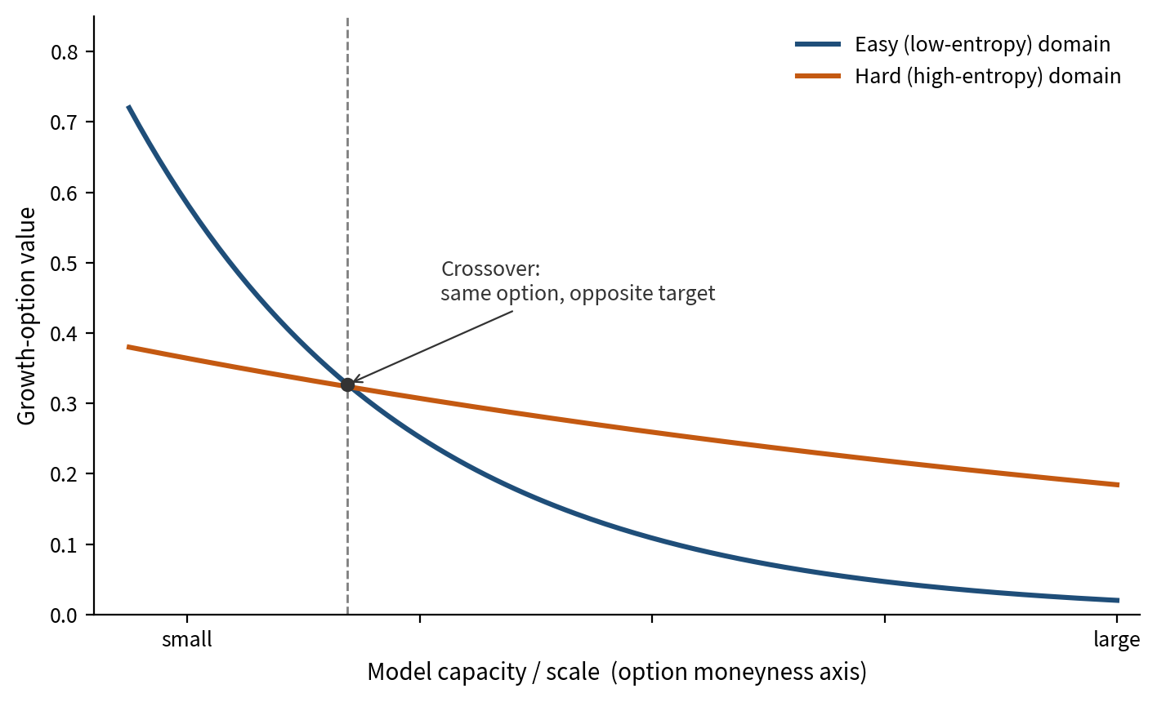
Figure 2. Dose-response curves corresponding to Table 1. The repetition series rises from 1× to 2× and reverses at 4×. The reversal is within the sampling noise of the 200-example evaluation set and is not a confirmed saturation effect.
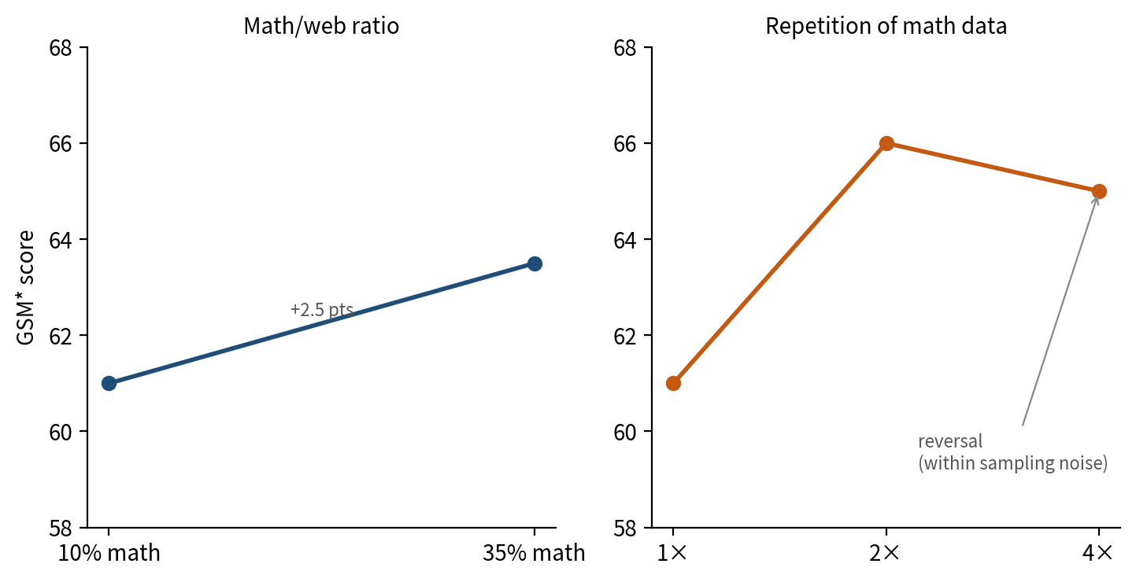

Appendix

A. Toy computational illustration
To isolate the capacity dependence predicted by Proposition 1, three synthetic text domains were generated from Markov chains of differing order and transition-probability concentration, calibrated so that one domain has substantially lower per-token entropy than the other. A small gradient-trained Transformer language model was trained under an exhaustive grid of resource allocations across the two-domain simplex, sampled at a fixed step size to yield 66 mixtures. For each mixture, held-out cross-entropy loss was recorded on each domain. Marginal loss reduction from shifting allocation from low to high is the quantity interpreted as growth-option value.

B. Held-out accuracy
For each proposition tested against published weights, a binary predictor of reweighting direction (upweighted versus downweighted relative to a uniform baseline) was built from the theorized value driver—baseline shortfall for Proposition 2, relatedness for Proposition 3—and evaluated with leave-one-out cross-validation. The compound-option check added a second predictor and re-evaluated held-out accuracy under the same procedure.

C. Monte Carlo check
Each reported percentage in Section 4.2 was treated as an observed proportion out of n = 200. For each comparison, 200,000 replications resampled both arms as Binomial(n, p) / n under a pooled null of equal true rates. The reported p-value is the fraction of replications producing a gap at least as large as observed. Results were cross-checked against an analytic two-proportion z-test; the two methods agreed to within 0.03. Code and a fixed random seed are available from the authors on request. This appendix is part of the review manuscript; a longer online appendix can be supplied as a separate file if requested.

