Cheap Code, Costly Choices: A Behavioral Economics Theory of Technical Debt Accumulation in LLM-Assisted Software Development

Abstract
Large language model (LLM) coding assistants have sharply lowered the cost of producing working code, yet maintainability signals are deteriorating. The rational trade-off view of technical debt predicts less debt when clean code becomes cheaper, although a rational account can recover rising debt if cheaper code raises the value of speed. We develop a behavioral theory whose core construct is a frame shift: LLM assistance converts an ex ante choice between an expedient and a quality implementation into an ex post decision about whether to accept an artifact that already exists, works, and looks finished. We formalize the frame shift with present-bias, perception, default, and loss-aversion wedges. The wedges can make debt rise as quality becomes cheaper, and rational acceleration can match any aggregate debt level they produce but not three statistics: the self-admitted share of debt, the effect of possessing an artifact on refactoring, and the lapse of planned refactoring. More reliable models can increase debt, and present bias creates debt traps with hysteresis. In a game among vendors, organizations, and developers, developer-led adoption yields low-friction interfaces under any market structure; organizations can correct this only by controlling configuration, within limits set by developers' option to bypass sanctioned tools; and because complacency suppresses the evidence that would correct it, a temporary inspection mandate can have permanent effects. None of these distortions arises under rational acceleration. We derive testable propositions and reframe technical debt as a choice-architecture problem.
Keywords: technical debt; large language models; AI-assisted software development; behavioral economics; present bias; automation bias; choice architecture; formal model; software maintainability

1. Introduction
Software organizations are adopting LLM-based coding assistants at a pace with few precedents in the history of development tooling. In the largest annual developer survey, 51 percent of professional developers reported using AI tools daily in 2025, even though more respondents distrusted the accuracy of those tools than trusted it (Stack Overflow 2025). The earliest evidence on what happens to the code afterward is unsettling. In a difference-in-differences study of open-source projects, adopting an agentic coding assistant produced a large but transient increase in development velocity and a persistent increase in static-analysis warnings and code complexity (He et al. 2026). Controlled comparisons of human- and LLM-authored implementations find that models systematically favor high-coupling solutions—long methods in small tasks, unstable inter-module dependencies in larger ones—and that neither functional correctness nor more detailed prompting removes this tendency (Zhu et al. 2026). Industry-wide trends point the same way, although they do not identify which code was generated: across hundreds of millions of changed lines in commercial and open-source repositories, 2024 was the first year in which copied-and-pasted code exceeded moved code, the main trace of refactoring, and the share of commits containing duplicated blocks rose several-fold over two years (GitClear 2025, 2026). In short, the tools that make code cheaper to write appear to be making systems more expensive to maintain.
This pattern is a puzzle for the dominant theory of technical debt (TD). Since Cunningham's (1992) original metaphor, and in its subsequent formalization (Avgeriou et al. 2016; Kruchten et al. 2012), TD has been modeled as a rational intertemporal trade-off: an actor knowingly accepts a shortcut today in exchange for delivery speed, incurring "interest" that must be repaid through future rework. On this account, debt should accumulate when the price of doing things properly is high relative to the value of speed. LLM assistance lowers the price of doing things properly—generating a well-structured, documented, tested module costs little more than generating a sloppy one. The rational-trade-off theory therefore predicts that TD should fall, or at least not rise, as LLM adoption spreads. The evidence points the other way.
The puzzle is not decisive on its own. A rational account can accommodate rising debt if cheaper code changes more than the price of quality. When features can be built faster, the value of shipping them sooner rises, so a rational developer may accept more expedient implementations; and when new code is cheaper to generate than existing code is to find and reuse, total volume and duplication grow even if each unit is written with care (Jevons 1865; Sorrell 2009). We call this the rational-acceleration account and treat it as the principal rival to our theory. Both accounts predict more debt. They differ in the form the debt takes. Under rational acceleration, debt is taken on knowingly, recorded, scrutinized in review, and repaid when repayment pays. Under the behavioral account, it is less often recognized, recorded, or reviewed, and repayment that was planned does not happen.
We argue that the distinctive change LLM assistance brings is a change in the decision itself. Without an assistant, a developer chooses between an expedient and a quality implementation before either exists; with one, a working implementation arrives first, and the developer decides whether to accept it. We call this conversion of ex ante choice into ex post acceptance the frame shift. The artifact exists before the quality decision is made, looks finished, and is already possessed and pre-selected, and these three features activate present bias, fluency and automation bias, and default effects, loss aversion, and weak ownership. Incentive conditions that require no bias, such as moral hazard, common-pool dynamics, and metric targeting, determine how far the frame effects spread through a team.
We ask: Through which mechanisms does LLM-assisted development accelerate the accumulation of technical debt, what distinguishes those mechanisms from a rational response to cheaper code, and what do they imply for how debt evolves and how it should be governed?
The paper makes three contributions. First, it offers a theory of technical debt accumulation organized around a single construct, the frame shift from choosing to accepting. Second, it formalizes the frame shift and derives results that the verbal argument cannot establish: when debt rises as quality becomes cheaper; that aggregate debt cannot separate the behavioral theory from rational acceleration, although three other statistics can; that better models can increase debt; that present bias creates debt traps with hysteresis; and that the governance of tool adoption, and the ease of bypassing it, determine how much of this debt an organization can prevent. Third, it translates these results into testable propositions and prescriptions grounded in choice architecture. The paper is written for IS researchers who study the value, risks, and governance of AI tools in organizations, and for managers who decide how those tools are configured and overseen.
Section 2 reviews the background. Section 3 develops the theory and its rational rival, Section 4 formalizes it, Section 5 states its empirical implications, Section 6 discusses contributions and limits, and Section 7 concludes. The Online Appendix contains the proofs, an agent-based extension to teams, and two additional results.

2. Theoretical Background

2.1 Technical Debt as a Rational Trade-off
Cunningham (1992) introduced technical debt to explain to non-technical stakeholders why shipping imperfect code can be sensible: like financial debt, it buys time now at the cost of interest later. Subsequent work formalized the construct. Avgeriou et al. (2016) define TD as design or implementation constructs that are expedient in the short term but create a technical context that makes future change more costly. Kruchten et al. (2012) distinguish debt that is visible (known shortcuts) from debt that is invisible, and deliberate from inadvertent. Tom et al. (2013) catalog its dimensions—code, design, architecture, test, documentation—and its causes, which they locate in schedule pressure, insufficient knowledge, and inattention.
The economic framing has been made explicit in models that treat TD as an investment decision with a principal, an interest rate, and a repayment schedule (Seaman and Guo 2011; Buschmann 2011). In these models the actor is a rational planner: she incurs debt when the net present value of speed exceeds the discounted cost of rework, and she repays when the reverse holds. Self-admitted technical debt (SATD) research (Potdar and Shihab 2014; Bavota and Russo 2016) is consistent with this view; developers leave comments such as TODO and HACK precisely because they know a shortcut has been taken and intend to return to it.
The rational model has two features that matter here. First, it locates the cause of debt in the price of quality relative to speed. Second, it assumes the actor perceives the shortcut as a shortcut. Both features are strained by LLM assistance. The price of quality falls, yet debt rises; and much LLM-introduced debt is not perceived at the moment of introduction, because the code that carries it looks finished.

2.2 LLM-Assisted Development and Its Observed Consequences
A growing empirical literature documents the quality profile of LLM-generated code. Early security studies found that a substantial share of assistant-generated snippets contained exploitable weaknesses (Pearce et al. 2022; Fu et al. 2025). Comparative evaluations of Copilot, CodeWhisperer, and ChatGPT found acceptable validity and correctness but recurring maintainability issues (Yetiştiren et al. 2023). More recent work has moved from snippets to systems. A pilot study of microservices generated under hexagonal-architecture constraints found that one open-weights model violated the prescribed dependency boundaries in most runs, although the proprietary models it tested conformed (Slater 2025). An audit of code and architectures generated by LLMs and coding agents finds that code volume is a near-perfect predictor of structural degradation, which the authors term a "volume–quality inverse law," and that more capable models produce more bloated and coupled code (Zhu et al. 2026). The quasi-experimental estimates of He et al. (2026), described in Section 1, are the strongest causal evidence to date, and public corpora of agent-authored pull requests now make the review of such code directly observable (Li et al. 2026). A multivocal review of 104 academic and practitioner sources concludes that LLM assistance amplifies code, design, and documentation debt and introduces new forms, notably fast-integration debt, in which rapidly generated code is integrated ahead of quality, along with prompt and provenance debt (Ehsani et al. 2026). In industry workshops, practitioners prioritized the maintainability and readability of generated code and warned that it may accelerate the accumulation of technical debt (Sun et al. 2026).
This literature is descriptive rather than explanatory. It establishes that debt is rising and characterizes its form, but it does not offer a theory of why developers, who are not naïve about maintainability, accept it. Nor does it ask whether the rise could be a rational response to cheaper code, a possibility we take up in Section 3.3. That is the gap this paper addresses.

2.3 Behavioral Economics: Relevant Constructs
Behavioral economics studies systematic departures from the rational-actor model, and four groups of its constructs bear on how developers treat generated code. Present bias, the tendency to overweight immediate payoffs relative to delayed ones beyond what any constant discount rate implies, produces preference reversals in which planned investments are repeatedly deferred (Laibson 1997; O'Donoghue and Rabin 1999), and the planning fallacy compounds it (Buehler et al. 1994). The fluency heuristic and automation bias describe how easily processed output is judged to be of higher quality and how automated aids are under-verified when they are usually right (Alter and Oppenheimer 2009; Parasuraman and Manzey 2010; Goddard et al. 2012). Reference dependence covers loss aversion, status quo bias, and default effects, under which what is already possessed or pre-selected is retained far more often than preference alone would predict (Kahneman and Tversky 1979; Samuelson and Zeckhauser 1988; Johnson and Goldstein 2003; Thaler and Sunstein 2008). Effort-based valuation, the IKEA effect, implies that artifacts acquired without effort command less care and weaker psychological ownership (Pierce et al. 2001; Norton et al. 2012).
A fifth group is not behavioral at all. Moral hazard (Arrow 1963), common-pool dynamics (Hardin 1968; Ostrom 1990), Goodhart's law, and the rebound effect (Jevons 1865; Sorrell 2009) follow from rational responses to incentives. We build the theory from the first four groups and treat the fifth as incentive conditions that amplify it; on their own, those conditions form the core of the rational account we develop as a rival in Section 3.3. Section 3.2 applies each construct to LLM-assisted development.

3. Theory Development

3.1 The Core Argument: From Choosing to Accepting
We model the introduction of technical debt as the outcome of a repeated micro-decision: a developer, facing a unit of work, chooses between an expedient implementation (E) and a quality implementation (Q). Under the rational model, she chooses E when the value of the time saved, V(E), exceeds the discounted cost of future rework, δ·C(E). LLM assistance reduces the time cost of Q relative to E, so V(E) shrinks and the rational model predicts more Q.
Our theory holds that LLM assistance does something else that dominates this effect: it turns the decision from a choice into an acceptance. Before LLM assistance, E and Q are compared before either exists, and both lie in the future. With LLM assistance, an implementation—often an instance of E—exists as soon as the prompt returns, and the developer's decision becomes whether to accept it or to do more work. We call this the frame shift. It has three components, each of which activates a distinct set of mechanisms. Timing: the artifact precedes the quality decision, so Q becomes a deferred investment set against a present reward, activating present bias and the planning fallacy. Appearance: the artifact is syntactically polished and confidently explained, so E looks like Q to its author and to its reviewers, activating the fluency heuristic and automation bias. Possession: the artifact is already in the working tree and pre-selected by the interface, so accepting it is the default, removing it is experienced as a loss, and, because it was acquired without effort, it commands little ownership. The joint result is that developers choose E more often even though Q has become cheaper, and that E is more often not recognized as E, which converts deliberate debt into inadvertent debt. Incentive conditions—moral hazard, common-pool dynamics, the rebound effect, and metric targeting—do not depend on the frame shift, but they determine how far its consequences spread beyond the individual decision.
The incentive amplifiers are not biases but rational responses to incentives. We include them because they govern how the frame effects propagate through a team and because, on their own, they generate the rival account developed in Section 3.3, so the theory must say where its predictions differ from theirs. Table 1 in Section 3.2 lists the mechanisms by component together with the propositions they imply.

3.2 Mechanisms and Propositions
Timing. Before LLM assistance, E and Q were compared before any code existed. With assistance, E exists as soon as the prompt returns, and Q requires further effort after a working artifact is already in hand. That is the configuration in which present bias is strongest (Laibson 1997; O'Donoghue and Rabin 1999), and the planning fallacy leads developers to underestimate the rework they defer (Buehler et al. 1994). Developers therefore plan to refactor and then defer (P1, P2).
Appearance. LLM output is syntactically regular, idiomatically named, and accompanied by fluent explanation, which are the surface features that trigger fluency-based judgments of quality (Alter and Oppenheimer 2009). A human shortcut typically looks like a shortcut and is often self-admitted; a generated one looks finished, which converts deliberate debt into inadvertent debt (P3, P4). Code review, the institutional check on individual judgment, is weakened by automation bias when reviewers calibrate scrutiny to the perceived reliability of the tool rather than to the artifact (Parasuraman and Manzey 2010), and more so as generated changes grow larger (P7).
Possession. A generated artifact is already in the working tree and pre-selected by the interface. Accepting it is the default (Johnson and Goldstein 2003), so acceptance is insensitive to suggestion quality (P8). Deleting it is experienced as a loss (Kahneman and Tversky 1979), so LLM-assisted changes add more and delete less (P5). And because it cost little effort, it commands little ownership (Norton et al. 2012), so its defects are fixed more slowly (P6).
Incentive amplifiers. Three further mechanisms require no departure from rationality. LLM assistance makes it cheap to change modules one does not own while their maintenance falls on others, which is moral hazard (Arrow 1963; P9). It makes generating new code cheaper than finding and reusing existing code, so a shared codebase is over-extracted, more so with more contributors (Ostrom 1990; Sorrell 2009; P10). And where individual throughput is rewarded and maintainability is not measured, cheap throughput becomes a target (P11). These mechanisms determine whether the frame effects stay local or spread through a team; on their own, they constitute the rival account of Section 3.3.
Table 1 lists the mechanisms and the eleven propositions they imply. The propositions are the empirical hypotheses of the verbal theory; Section 4 formalizes the timing, appearance, and possession mechanisms at the level of a single decision, and Online Appendix A carries the ownership and incentive mechanisms to teams.
Table 1. Mechanisms and Propositions
P | Statement | Mechanism | Component
P1 | (a) Refactoring per active contributor declines as the share of LLM-authored code rises. (b) Holding the cost of refactoring fixed, possessing a working generated artifact increases deferral and the lapse of planned refactoring. | Present bias; planning fallacy | Timing
P2 | Comments deferring quality work on LLM-authored code are resolved less often and later than comparable comments on human-authored code. | Present bias | Timing
P3 | At equal measured structural quality, reviewers rate LLM-authored code higher. | Fluency heuristic | Appearance
P4 | For a given amount of statically detected debt introduced by a change, LLM-assisted changes carry fewer self-admitted debt markers. | Fluency heuristic | Appearance
P5 | LLM-assisted commits add more relative to what they delete, and the surplus is concentrated in duplicated and unreachable code. | Loss aversion | Possession
P6 | At equal severity and complexity, defects in code a developer generated are fixed more slowly than defects in code she wrote. | Effort-based valuation | Possession
P7 | LLM-authored pull requests receive less review time per changed line and fewer substantive comments, with a gap that widens with size. | Automation bias | Appearance
P8 | Acceptance of inline suggestions varies less with suggestion quality than with the interface cost of rejection. | Default effect | Possession
P9 | Debt introduced by LLM-assisted changes concentrates in modules the author does not maintain. | Moral hazard | Incentive amplifier
P10 | Duplication rises with LLM adoption, more so in repositories with more contributors and weaker ownership. | Common pool; rebound | Incentive amplifier
P11 | The association between LLM adoption and debt growth is stronger where individual throughput is rewarded and maintainability is not measured. | Metric targeting | Incentive amplifier

3.3 A Rival Account: Rational Acceleration
The rational trade-off view is not exhausted by the prediction that cheaper quality means less debt. Suppose LLM assistance lowers the time cost of both E and Q but also raises the value of time saved, because a team that can build faster has more features it can profitably ship. A rational developer then chooses E more often, not less, whenever the rise in the value of speed outweighs the fall in the price of quality. Add the rebound effect, under which cheaper code means more code and more duplication, and moral hazard, under which cross-boundary edits become cheaper to make while their maintenance cost falls on others, and the rational account predicts rising debt without any bias. We call this the rational-acceleration account. It is consistent with the aggregate evidence reviewed in Section 2.2, including a transient rise in velocity accompanied by a persistent rise in static-analysis warnings (He et al. 2026).
Rational acceleration and the behavioral theory therefore agree on the direction of aggregate debt. They disagree about its form, because the rational account keeps the two features of the rational model identified in Section 2.1: debt is taken on knowingly, and it is repaid when repayment pays. Four implications follow. First, a knowingly incurred shortcut is recorded at the same rate whoever wrote it, so self-admission per unit of detected debt should not differ between LLM-assisted and hand-written changes (contrast P4). Second, reviewers who calibrate scrutiny to risk rather than to authorship should give LLM-assisted changes of a given size at least as much substantive review as others (contrast P7). Third, retention should follow usefulness rather than provenance, so a net-addition bias in LLM-assisted commits should appear only where rebound operates, in larger teams, and not in single-contributor code (contrast P5). Fourth, refactoring should follow its net present value, so, holding its cost fixed, possession of a working artifact should not change the decision to refactor, and refactoring that was planned should be carried out (contrast P1b and P2). Table 2 summarizes the contrast.
The comparison also marks the limits of the discrimination. Rebound, moral hazard, and metric targeting operate under both accounts, so Propositions 9 to 11 cannot distinguish them; their role in the design is to measure how far debt spreads, not to adjudicate between accounts. The adjudicating evidence comes from P1b, P2, P4, P5 in single-contributor code, and P7, and from the governance comparison of Result 6 in Section 4.6.
Table 2. Competing Predictions of Rational Acceleration and the Behavioral Theory
Prediction | Rational acceleration | Behavioral theory | Evidence
Aggregate debt after LLM adoption | Rises | Rises | Study 1; does not discriminate
Self-admitted debt per unit of detected debt introduced (P4) | No difference by authorship | Lower for LLM-assisted changes | Study 1, change level
Substantive review per changed line (P7) | No lower for LLM-assisted changes | Lower for LLM-assisted changes | Study 1 with reviewer fixed effects; Study 2
Net-addition bias in single-contributor code (P5) | Absent | Present | Study 1, low-contributor stratum
Deferral with artifact in hand at equal cost; completion of planned refactoring (P1b, P2) | No possession effect; plans carried out | Possession raises deferral; plans lapse | Study 2; SATD resolution in Study 1
Debt under developer-controlled versus organization-controlled configuration of the assistant (Result 6) | No difference | Lower under organization control | Study 3; procurement and configuration records
Duplication rising with team size; debt in non-owned modules; stronger effects under throughput metrics (P9 to P11) | Yes | Yes | Studies 1 and 3; does not discriminate

3.4 Boundary Conditions
The theory is not a claim that LLM output is intrinsically worse than human output. Several conditions attenuate the mechanisms. Strong module ownership limits moral hazard (P9). Mandatory, quality-blind review protocols limit automation bias (P7). Interfaces that require active selection rather than passive acceptance limit default effects (P8). Deletion-friendly workflows and explicit "net lines" reporting counteract loss aversion (P5). And maintainability metrics, when measured and rewarded, reverse the Goodhart dynamic (P11). These conditions are also the theory's prescriptions, and they differ from those of the rational model, which would recommend better cost accounting and debt registers—interventions that assume the actor already perceives the debt.

4. A Formal Model of Choosing and Accepting
This section formalizes the frame shift. The model is deliberately minimal: one developer, one task at a time, and four behavioral wedges, each corresponding to a component of the frame shift in Section 3. Present bias expresses timing, a perception wedge expresses appearance, and a default share and loss aversion express possession. The model's purpose is to establish results that the verbal theory suggests but cannot establish: when debt rises as quality becomes cheaper, what can and cannot separate the behavioral theory from rational acceleration, how debt responds to better models, and how it evolves over time. Section 4.6 then embeds the developer in a game with a tool vendor and her organization. Proofs are in Online Appendix B. Every result was also verified numerically, and the illustrative values below come from those computations.

4.1 Primitives and Timing
A task can be implemented expediently (E) or with quality (Q). If E remains in the code, it imposes a rework cost R one period later, where R is drawn from a continuous distribution F with positive density on the positive reals. Developer time is valued at v per unit, so an increase in v represents the rational-acceleration channel of Section 3.3: time saved is worth more when more features can be shipped. The developer discounts with quasi-hyperbolic weights 1, βδ, βδ², and so on (Laibson 1997; O'Donoghue and Rabin 1999), where β ≤ 1 measures present bias and δ ≤ 1 is the long-run discount factor. Welfare is evaluated with β = 1.
In the choice regime, which describes development without an assistant, the developer decides at date 0 how the task will be built at date 1, and Q requires a units of time more than E. Both the extra effort and the rework lie in the future at the moment of decision, so the developer chooses E if and only if
$va>δR.$ (1)
Present bias cancels from (1) because it scales both sides equally. A shortcut chosen in this way is recognized as a shortcut and is self-admitted with probability σ.
In the acceptance regime, which describes development with an assistant, an artifact arrives at date 1 and is an instance of E with probability q, the model's maintainability-defect rate. Three features distinguish this regime. The artifact exists before the quality decision, so the time needed to inspect it, k, drawn from a distribution G, and the time needed to refactor it into Q, r, are spent now while rework comes later (timing). The developer perceives the defect rate as φq with φ ≤ 1, and an instance of E is noticed without inspection with probability ηφ, so polished output is both trusted and overlooked (appearance). A share α of artifacts is accepted by default without deliberation, and changing a possessed artifact is felt as a loss, which scales the perceived cost of refactoring by λ ≥ 1 (possession). A detected instance of E is refactored now if and only if
$λvr<βδR,$ (2)
and an artifact that is not accepted by default is inspected if and only if
$vk<φq\left(1−ηφ\right)\max\left\{0, βδR−λvr\right\}.$ (3)
Debt remains when the artifact is E and is not both detected and refactored. A developer who detects E but does not refactor it self-admits it with probability σ; an undetected instance is self-admitted with probability σφ, in proportion to the risk the developer perceives. We call β < 1, φ < 1, α > 0, and λ > 1 the behavioral wedges; the rational benchmark sets β = φ = λ = 1 and α = 0. We assume η ≤ 1/2, so that noticing a defect without inspection is less likely than missing it; this ensures that a stronger perception wedge never makes inspection more attractive.

4.2 Why Debt Can Rise When Quality Gets Cheaper
Let D_C(v) and D_A(v) denote the probabilities that a task ends with debt in the choice and acceptance regimes, and let D_A*(v) denote D_A(v) in the rational benchmark.
Result 1 (Decomposition). D_A(v₁) − D_C(v₀) = [D_A*(v₀) − D_C(v₀)] + [D_A*(v₁) − D_A*(v₀)] + [D_A(v₁) − D_A*(v₁)]. The first term, the price effect, is non-positive when refactoring is no more costly than building quality in (r ≤ a) and inspection is free (k = 0). The second term, the acceleration effect, is non-negative when v₁ ≥ v₀. The third term, the behavioral wedge, is non-negative, and strictly positive when any wedge binds on a set of tasks with positive probability.
The rational trade-off view of Section 2.1 is the first term alone; it predicts that debt falls when quality becomes cheaper. Debt can nonetheless rise through either of the other two terms, which is why the anomaly described in Section 1 does not by itself favor either account. With illustrative values (q = 0.8, β = 0.5, φ = 0.6, α = 0.3, r = 0.4a, inspection time uniform on [0, 0.6a], and lognormal rework costs whose median equals va), the price effect lowers the probability of debt by 0.24 and the wedge raises it by 0.32 at a constant value of time, so debt rises from 0.50 to 0.59 per task even though quality has become cheaper.

4.3 What Aggregate Debt Cannot Reveal
Define three statistics. The self-admitted share is the probability that a unit of debt is self-admitted. The possession effect is the probability of deferring refactoring with an artifact in hand minus the probability of choosing E ex ante, at equal cost (r = a). The lapse rate is the probability that a detected instance of E is left unrefactored although the developer planned, from the vantage of the current period, to refactor it in the next.
Result 2 (Observational equivalence and separation). (a) For any configuration of wedges with D_A(v₀) < q, there is a value of time v₁ ≥ v₀ at which the rational benchmark produces the same aggregate debt, D_A*(v₁) = D_A(v₀). (b) In the rational benchmark, for every v, q, and G, the self-admitted share equals σ, the possession effect is zero, and the lapse rate is zero. (c) Under the wedges, the self-admitted share falls below σ if and only if φ < 1 and some debt is undetected; the possession effect is positive if β < 1 or λ > 1; and the lapse rate is positive if and only if β < 1.
Part (a) formalizes why aggregate debt, including the difference-in-differences estimates that dominate the current evidence, cannot adjudicate between the accounts: whatever the wedges do to the level of debt, a faster pace of work can do as well. Parts (b) and (c) identify what can. The self-admitted share isolates the appearance wedge (P4). The possession effect and the lapse rate isolate the timing and possession wedges (P1b and P2), and the lapse rate separates present bias from loss aversion. A developer who feels refactoring a generated artifact as a loss feels it today and tomorrow alike, so she does not plan what she will not do; a present-biased developer plans to refactor tomorrow and, tomorrow, defers again. In the illustration of Section 4.2, rational acceleration matches the behavioral level of debt at v₁ = 2.9v₀, while its self-admitted share stays at σ = 0.50 and its possession effect and lapse rate stay at zero. The behavioral configuration yields a self-admitted share of 0.33, a possession effect of 0.31, and a lapse rate of 0.21. With loss aversion alone (λ = 1.8), the possession effect is 0.27 and the lapse rate is zero. Table 2 in Section 3.3 is the empirical counterpart of this result.

4.4 The Reliability Paradox
A natural expectation is that debt falls as models become more reliable. The model shows that it need not. Suppose inspection time is uniform on [0, K], and consider tasks on which refactoring a detected instance of E is worthwhile, B ≡ βδR − λvr > 0.
Result 3 (Reliability paradox). Debt per task is D(q) = q(1 − ηφ)[1 − (1 − α)·min{1, q/q̂}], where q̂ = vK / [φ(1 − ηφ)B]. If α < 1/2, D is decreasing in q, so that a more reliable model produces more debt, on the interval (q*, q̂), where q* = q̂ / [2(1 − α)]. If α ≥ 1/2, D is increasing in q.
The mechanism is reliance. When models are unreliable, developers inspect everything and debt is low. As reliability improves, perceived risk falls and inspection stops before the defect rate has fallen far enough to compensate, so the share of defects reaching the codebase rises faster than the defect rate falls. The paradox is not in itself behavioral: a rational developer also relaxes inspection as models improve, and her debt also rises, efficiently, over an interval. What the wedges do is move and widen that interval and turn an efficient response into an inefficient one. Anything that lowers the perceived value of inspection, whether an appearance wedge, a present-biased view of rework, or a higher value of time, raises q̂ and extends the paradox to less reliable models. Default acceptance removes the paradox only by raising debt at every level of reliability. Figure 1 illustrates. The result implies that improvements in model quality should not be expected to reduce debt monotonically, and that the debt consequences of a model upgrade depend on how much inspection it displaces.
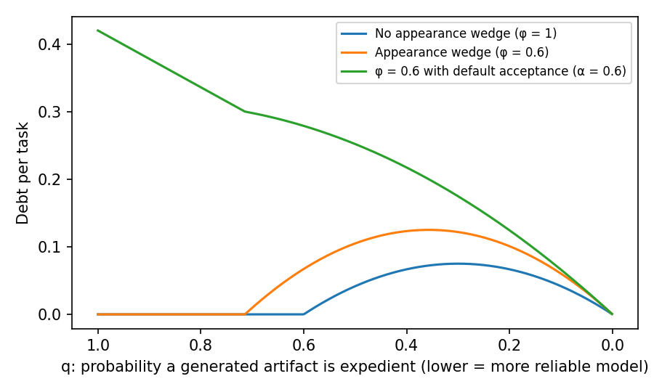
Figure 1. Debt per Task as Model Reliability Improves (K = 0.3, B = 1, η = 0.5, v = 1)

4.5 Debt Traps
Debt accumulates. Let H be the stock of unresolved debt in a codebase, and suppose refactoring becomes harder as the stock grows, r(H) = r₀(1 + γH), which is the interest in the debt metaphor. Each period n artifacts arrive; a share p of those not accepted by default is inspected, and a detected instance of E is refactored when (2) holds at r(H). The inflow of debt is I(H; β) = A + C·F(λvr₀(1 + γH)/(βδ)), where A = nq[1 − (1 − α)p] is the inflow when every detected defect is refactored and A + C, with C = nq(1 − α)p, is the inflow when none is. A fraction μ of the stock is repaid each period, and steady states solve I(H; β) = μH. Let rework costs be lognormal with median R_m and log-dispersion s, and for ε ∈ (0, 1/2) let z = Φ⁻¹(1 − ε), where Φ is the standard normal distribution function.
Result 4 (Debt traps and hysteresis). A low-debt state and a debt trap, both stable and separated by an unstable steady state, coexist whenever β lies in (β₁(ε), β₂(ε)) for some ε, where β₁(ε) = λvr₀[1 + γ(A + Cε)/μ] / (δR_m e^(−sz)) and β₂(ε) = λvr₀[1 + γ(A + C(1 − ε))/μ] / (δR_m e^(sz)). The interval is non-empty when rework costs are concentrated relative to the interest on debt, e^(2sz) < [1 + γ(A + C(1 − ε))/μ] / [1 + γ(A + Cε)/μ]. Only the trap exists if β ≤ λvr₀/(δR_m e^(sz)), and only the low-debt state exists if β ≥ λvr₀[1 + γ(A + C)/μ]/(δR_m e^(−sz)). A codebase that enters the trap as β falls does not leave it when β returns to the level at which it tipped, but only when β rises past the upper edge of the bistable region or when a one-time repayment lowers H below the unstable steady state. Here the low-debt state lies below (A + Cε)/μ and the trap above (A + C(1 − ε))/μ.
Because present bias cancels in the choice regime, a team without an assistant behaves as if β = 1 in its refactoring decisions. Adoption replaces 1 with the team's β. Adoption can therefore tip a codebase from the low-debt state into the trap even though the assistant also lowers r₀. Three implications follow. The distribution of debt across codebases should become bimodal after adoption. Codebases that enter adoption with more debt are more likely to tip, because a shock to H can carry a codebase in the bistable region across the unstable steady state. And interventions that would have prevented the trap, such as nudges that raise effective β slightly, cannot reverse it; escape requires a large change in the decision environment or a one-time refactoring program. In the illustration in Figure 2, the bistable region is β ∈ (0.646, 0.843): codebases tip into the trap when β falls below 0.646 and escape only when it rises above 0.843. The closed-form conditions are sufficient, but here they are also sharp: taking the union of (β₁(ε), β₂(ε)) over ε recovers the region to three decimal places, and the widest single interval, at ε = 0.14, is (0.659, 0.829).
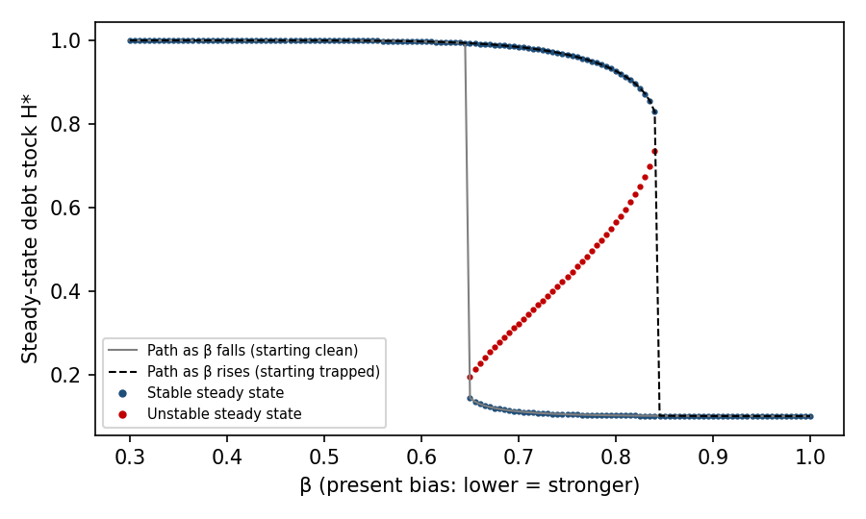
Figure 2. Steady-State Debt and Hysteresis in Present Bias (n = 1, q = 0.5, p = 0.9, α = 0, r₀ = 0.3, γ = 3, μ = 0.5, lognormal rework costs with median 1 and log-dispersion 0.25)

4.6 Strategic Extension: Tool Design, Adoption Governance, and Shadow AI
The single-decision model treats the interface as given. In practice, the interface is designed by a tool vendor, and whether its settings are chosen by developers or by their organization is a governance decision. We therefore embed the developer in a sequential game. A vendor designs the interface friction f ∈ [0, 1], the effort required to accept a suggestion without deliberation, as when large suggestions are presented as diffs to be reviewed rather than text to be accepted. Friction lowers the default share to α(f) = α₀(1 − f) but costs developer time vcf²/2 per artifact, incurred now. The party that controls the setting then chooses the tool, and developers use it as in Section 4.1. When adoption is developer-led, developers choose by perceived cost. When it is organization-led, the organization chooses by long-run cost, but developers can bypass a sanctioned tool for an unsanctioned one at a personal cost ε, which captures the shadow IT that IS research has documented for earlier technologies (Haag and Eckhardt 2017). For tractability, rework cost is a constant R̄ with B > 0, and inspection time is uniform on [0, K].
Two quantities summarize the developer's inspection problem: the perceived value of inspecting an artifact, Δ_p = φq(1 − ηφ)(βδR̄ − λvr), and its long-run value, Δ = q(1 − ηφ)(δR̄ − vr). The wedges push Δ_p below Δ.
Result 5 (Friction wedge). The friction that minimizes developers' perceived cost is f_D = α₀Δ_p² / (2v²cK), and the friction that minimizes the organization's long-run cost, given how developers inspect, is f_O = α₀Δ_p(2Δ − Δ_p) / (2v²cK), both capped at 1. At interior values, f_O − f_D = α₀Δ_p(Δ − Δ_p) / (v²cK) ≥ 0, with equality if and only if Δ_p = Δ, which holds in the rational benchmark for every value of time v.
Result 6 (Governance, not competition). Under developer-led adoption, the equilibrium interface has friction f_D whether the vendor is a monopolist or faces Bertrand competition; market structure affects the price, not the design. Under organization-led adoption with control of the setting, the equilibrium friction is f_O. Adoption governance therefore affects debt if and only if a wedge binds.
Result 7 (Shadow AI constraint). If developers can bypass a sanctioned tool at cost ε, the organization implements f = f_D + min{f_O − f_D, (2ε/(vc))^½}. The constraint binds, and the organization closes only part of the gap, when f_O − f_D exceeds (2ε/(vc))^½.
The vendor's side of the game follows a familiar logic. When a cost is borne later and perceived dimly, sellers compete on what buyers perceive, as in the shrouded-attribute and self-control results of behavioral industrial organization (DellaVigna and Malmendier 2004; Gabaix and Laibson 2006), so developers will not pay for friction and a vendor that offered more of it would lose them. What the extension adds lies on the buyer's side. First, the remedy is a matter of IT governance rather than market structure: what matters is not who pays for the tool but who controls its configuration, and the prediction that debt is lower where configuration is centrally controlled holds only under the behavioral theory, which adds a row to Table 2. Second, the remedy is bounded by shadow IT: an organization can move friction toward f_O only as far as developers are willing to comply, so enforcement against unsanctioned tools and choice architecture are complements. Third, as Figure 3 shows, the organization's optimal friction is not monotone in the wedges. The closed forms rely on a quadratic friction cost and a constant rework cost, but the sign results do not: Online Appendix B shows that f_O ≥ f_D, with equality if and only if no wedge binds, for any convex friction cost, any decreasing and convex default share, any distribution of inspection time, and heterogeneous rework costs.
Friction pays by moving artifacts from default acceptance into deliberation, but deliberation yields inspection only in proportion to perceived risk; when the wedges are strong, developers who deliberate still inspect little, and friction buys little. Friction is therefore a complement to debiasing rather than a substitute for it, and the conflict between developers and their organization is sharpest at intermediate wedges. With β = 0.5, φ = 0.6, and λ = 1.2, developers prefer friction of 0.05 and the organization 0.49; with a bypass cost of ε = 0.005, the organization can implement 0.31. Under rational acceleration the two preferences coincide at every value of time: doubling v lowers the friction both parties prefer from 0.71 to 0.10 but opens no gap.
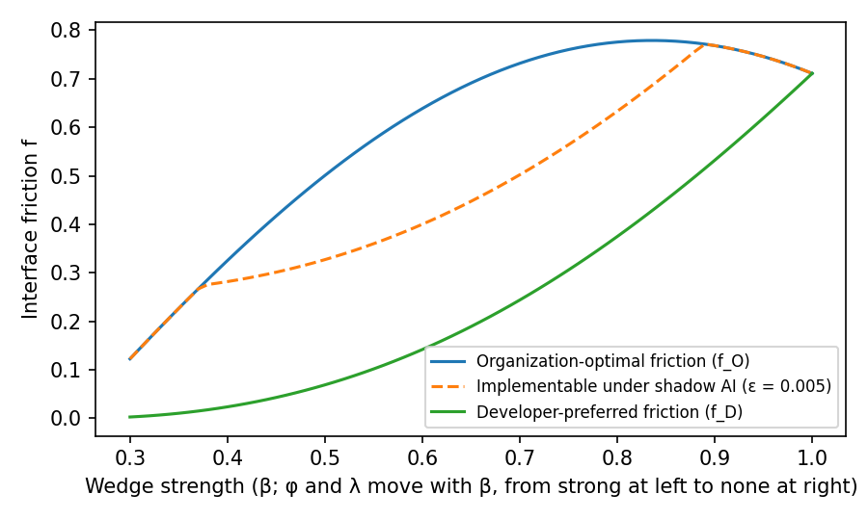
Figure 3. Developer-Preferred, Organization-Optimal, and Implementable Friction as the Wedges Weaken (q = 0.5, R̄ = 2, r = 0.4, K = 0.6, α₀ = 0.8, c = 0.15, ε = 0.005; φ and λ move linearly with β from 0.6 and 1.2 at β = 0.3 to 1 and 1 at β = 1)

4.7 Learning and Self-Confirming Complacency
The perception wedge need not be permanent, because developers can learn the defect rate. Let the perceived defect rate q̂ = φq evolve while the noticing probability stays fixed, and suppose developers learn from inspected artifacts, which are an unbiased sample, and from rework they attribute to generated code, which happens with probability θ per instance of undetected debt. With learning speed κ, q̂′ = q̂ + κ[s(q̂) + θ(1 − s(q̂))](q − q̂). Suppose inspection takes at least k_min > 0 units of time, so that s(q̂) = 0 whenever Δ_p(q̂) ≤ vk_min, which defines a threshold belief q̂_c < q.
Result 8 (Self-confirming complacency). (a) If θ > 0 or q̂₀ > q̂_c, the perceived defect rate converges to q and the perception wedge vanishes. (b) If θ = 0 and q̂₀ ≤ q̂_c, the belief is self-confirming: developers do not inspect, observe no evidence, and never revise. (c) In case (b), a mandate that requires inspection for T periods removes the wedge permanently if and only if (1 − κ)^T(q − q̂₀) < q − q̂_c.
Learning dissolves the perception wedge only if evidence reaches the developer, and evidence arrives mainly through the inspection that the wedge suppresses. Attribution of rework to generated code, which weak ownership of generated code makes less likely, is the other channel. Result 8 gives friction and mandates a dynamic value that Result 5 omits: by inducing inspection, they produce the evidence that corrects perception, so a temporary intervention can have permanent effects. In Figure 4, a single period of mandatory inspection moves a developer from a self-confirming belief of 0.05 onto a path toward the true defect rate of 0.5; attributed rework does the same more slowly. The result also yields a test. Under a perception wedge, the effects of a temporary inspection mandate should persist after it is lifted; under rational acceleration, they should end with it.
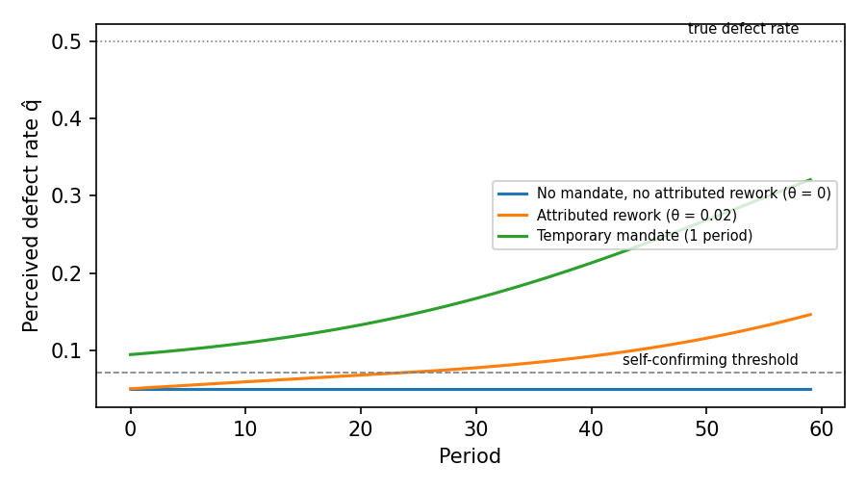
Figure 4. Learning About the Defect Rate: Self-Confirming Complacency and a Temporary Mandate (q = 0.5, κ = 0.1, k_min = 0.05, K = 0.6, B = 1, η = 0.5, noticing wedge 0.6)

4.8 From the Model to the Propositions
The model formalizes the frame shift at the level of a single decision: present bias generates P1 and P2, the perception wedge generates P3, P4, and P7, the default share generates P8, and loss aversion generates the retention component of P5. Results 1 and 2 ground the contrast with rational acceleration in Table 2, and Results 3 to 8 add predictions that the verbal theory does not make. Online Appendix C reports two further results: the sign of a mandate's effect on maintenance cost is diagnostic of the wedges (Result S1), and acceptance-linked vendor revenue lowers friction equally under both governance modes, which leaves the test of Result 6 intact (Result S2). Online Appendix A extends the model to teams, where ownership, moral hazard, rebound, and metric targeting operate.

5. Empirical Implications
The contribution of this paper is theoretical, but the theory and the model are built to be tested. This section states what evidence would bear on them and what would count against them. Online Appendix A shows by simulation that the proposed archival measures can separate the mechanisms and the two accounts.

5.1 Archival Evidence (Study 1)
Public repositories in which LLM authorship can be identified, through co-author trailers, agent-opened pull requests, or assistant configuration files, support a staggered difference-in-differences comparison of adopting and non-adopting repositories and change-level comparisons within repositories and reviewers. The model dictates the measures. Aggregate debt is reported but cannot adjudicate between the accounts (Result 2a). The adjudicating statistics are the self-admission rate of a change conditional on the static-analysis warnings it introduces (P4), the substantive review a change receives with reviewer fixed effects (P7), and the net-addition bias in single-contributor modules (P5). Refactoring is measured as commits per active contributor rather than as a share of changed lines, which rebound would contaminate (P1a), and duplication that grows with contributor count identifies rebound rather than loss aversion (P10). The same data test the dynamic results: after adoption, the cross-repository distribution of debt should become bimodal, and repositories that enter adoption with more debt should be more likely to tip (Result 4). Within repositories that switch model generations, debt per LLM-assisted change should not fall monotonically with model reliability (Result 3).

5.2 Experimental Evidence (Study 2)
Two statistics of Result 2 cannot be observed in archives because the cost of refactoring is not recorded there. A preregistered within-subjects experiment with professional developers can measure them. In a refactoring module, each participant makes eight decisions in a 2 × 2 design that crosses possession (a working generated artifact already in hand versus a choice made before any code exists) with the stated cost of refactoring, and may commit to refactor in a second session one week later. The possession effect at equal cost identifies β < 1 or λ > 1, and the lapse of first-session commitments identifies β < 1 alone (P1b, Result 2). A simulation-based power analysis indicates that 160 participants provide power of 0.94 to detect a 10-percentage-point possession effect. In a review module, crossing an authorship label with actual authorship and seeded maintainability defects separates the appearance wedge from label-driven automation bias (P3, P7), and varying the keystroke cost of rejecting inline suggestions tests the default effect (P8). The review module uses an authorship cover story and ends with a debriefing.

5.3 Field and Governance Evidence (Study 3)
The organizational results require variation across firms. A multi-site field study of engineering organizations that differ in how they measure developers (P11), how strongly they assign module ownership (P6, P9), whether they control the configuration of AI assistants centrally, and how easily developers can use unsanctioned tools would test Results 6 and 7: debt should be lower under central configuration only if the wedges operate, and the difference should shrink where bypass is easy. Organizations that introduce and later lift inspection mandates provide a test of Result 8: under a perception wedge, a temporary mandate should have effects that persist after it ends.

5.4 What Would Count Against the Theory
The theory can be falsified in its distinctive claims, not in its aggregate prediction. If debt rises after adoption while the self-admitted share of debt, the possession effect, and the lapse of planned refactoring are all indistinguishable from their rational-benchmark values, rational acceleration explains the evidence and the frame shift is not needed. If debt is no lower where configuration is centrally controlled, Result 6 fails, and if the effects of temporary mandates end with them, Result 8 fails. Early descriptive evidence on review points both ways: in popular repositories, pull requests authored by coding agents are merged less often than human ones, yet those from one agent are accepted roughly ten times faster, which the authors read as a possible sign of shallow review (Li et al. 2025). If review of LLM-assisted changes proves more rather than less intensive once task type and size are held constant, the appearance wedge operates, if at all, through authors rather than reviewers, and P7 fails while P4 may still hold.

6. Discussion

6.1 Theoretical Contributions
The paper's first contribution is to explain an anomaly without assuming it away. A rational account can recover rising debt through the value of speed and the rebound effect, and we take it seriously as a rival; what it cannot produce is the form the debt takes under our theory: unrecorded, under-reviewed, retained, and unrepaid despite plans. The formal model makes the distinction precise by showing that aggregate debt is observationally equivalent across the two accounts and by identifying the statistics that are not. The theory also reclassifies much LLM-era debt from deliberate to inadvertent. Prior taxonomies attribute inadvertent debt to ignorance, whereas the fluency mechanism locates it in judgment that the artifact's surface suppressed, which calls for different remedies.
Second, the paper connects the software engineering literature on technical debt to IS research on human–automation interaction, including automation bias (Goddard et al. 2012) and algorithm aversion and appreciation (Dietvorst et al. 2015; Logg et al. 2019). Technical debt is a durable, measurable trace of thousands of human–AI micro-decisions and can be studied with an archival precision that survey measures of over-reliance cannot match. The strategic extension adds a link to research on IT governance and shadow IT (Haag and Eckhardt 2017): the debt consequences of generative AI depend on who controls the configuration of the tools, and the reach of any organizational remedy is bounded by how easily developers can bypass it.

6.2 Implications for Practice
The rational model's prescriptions, such as debt registers, interest estimates, and repayment sprints, assume that the debt is visible and will be repaid when the numbers justify it. Our mechanisms suggest they will underperform, because the debt is not recorded (P4) and repayment is deferred (P1, P2). Choice-architecture interventions target the mechanisms directly. Review defaults that set a floor on review time per changed line and require reviewers to name reusable code counter automation bias and duplication (P7, P10). Reporting net rather than added lines and surfacing unreferenced functions make retention the active choice (P5). Owner sign-off on cross-boundary changes and routing defects to change authors restore ownership and internalize moral hazard (P6, P9). Interfaces that present large suggestions as diffs to be reviewed counter default acceptance (P8), and pairing throughput metrics with maintainability metrics at the team level addresses metric targeting (P11). The model adds two prescriptions: organizations should control assistant configuration centrally and enforce it against unsanctioned tools (Results 6 and 7), and where developers perceive little risk in generated code, a temporary inspection mandate can have lasting effects (Result 8). Each intervention is cheap relative to a refactoring program and testable as a moderator in Study 3.

6.3 Limitations
The theory and model are developed rather than tested here; the propositions and results await the evidence the design in Section 5 would produce. The formal model is deliberately minimal: tasks are independent, inspection detects defects perfectly, and the debt-trap result relies on a particular form of interest on debt, so its results are statements about mechanisms rather than calibrated magnitudes. The strategic extensions abstract from competition among the organizations that use the tools, and they model learning only about the defect rate, not about the heuristic component of fluency, which may resist statistical evidence. The simulation in Online Appendix A shows that the design can separate the mechanisms and the two accounts if they operate as theorized; because every effect in it is assumed, it is not evidence that they do. Several measurement challenges are unresolved. AI-authorship labels are noisy and likely to understate usage, which biases Study 1 estimates toward zero. Static-analysis measures of debt are proxies that may not track the debt developers experience. The experiment's cover story may not fully reproduce field conditions in which reviewers know the tools their colleagues use. And the theory is silent on model capability: it is possible that a sufficiently capable model produces code whose surface fluency is matched by its structure, in which case the fluency mechanism becomes harmless. The evidence to date, which finds structural degradation increasing with model capability, suggests this point has not been reached, but the theory should be understood as conditional on the current gap between apparent and actual quality.

6.4 Future Research
Three extensions are natural. First, the theory could be applied to other generative-AI artifacts—documentation, infrastructure configuration, analytics notebooks—where the same mechanisms plausibly operate but the debt has not been named. Second, the propositions could be tested at the level of the individual developer over time, asking whether biases attenuate with experience or, as some automation-bias research suggests, intensify as trust accumulates. Third, the choice-architecture interventions in Section 6.2 could be studied as field experiments, which would provide both a test of the mechanisms and direct evidence on remedies; as Result S1 in Online Appendix C shows, the sign of such an intervention's effect on maintenance cost is itself a test of the wedges.

7. Conclusion
LLM coding assistants have made code cheap to produce, and the first evidence suggests that they have made systems more expensive to maintain. We have argued that the explanation lies in how LLM assistance restructures the decision: it places a working artifact in the developer's hand before the quality decision is made, dresses shortcuts as finished work, makes acceptance the default and deletion a loss, and weakens the ownership that effort would confer. A rational response to cheaper code can also produce more debt; what distinguishes our account is that the debt it predicts is unrecorded, under-reviewed, and unrepaid, and the statistics derived here can tell the two apart. The model adds two warnings: better models do not guarantee less debt, and a codebase that has tipped into a high-debt state will not be rescued by the nudges that would have prevented it. If the theory is correct, the remedy is not better accounting but better choice architecture.

References
Alter AL, Oppenheimer DM (2009) Uniting the tribes of fluency to form a metacognitive nation. Personality Soc. Psych. Rev. 13(3):219–235.
Arrow KJ (1963) Uncertainty and the welfare economics of medical care. Amer. Econom. Rev. 53(5):941–973.
Avgeriou P, Kruchten P, Ozkaya I, Seaman C (2016) Managing technical debt in software engineering (Dagstuhl Seminar 16162). Dagstuhl Rep. 6(4):110–138.
Bavota G, Russo B (2016) A large-scale empirical study on self-admitted technical debt. Proc. 13th Internat. Conf. Mining Software Repositories (ACM, New York), 315–326.
Buehler R, Griffin D, Ross M (1994) Exploring the “planning fallacy”: Why people underestimate their task completion times. J. Personality Soc. Psych. 67(3):366–381.
Buschmann F (2011) To pay or not to pay technical debt. IEEE Software 28(6):29–31.
Cunningham W (1992) The WyCash portfolio management system. Addendum to the Proc. Object-Oriented Programming Systems, Languages, and Applications (ACM, New York), 29–30.
DellaVigna S, Malmendier U (2004) Contract design and self-control: Theory and evidence. Quart. J. Econom. 119(2):353–402.
Dietvorst BJ, Simmons JP, Massey C (2015) Algorithm aversion: People erroneously avoid algorithms after seeing them err. J. Experiment. Psych. General 144(1):114–126.
Ehsani R, Rawal S, Cai Y, Chatterjee P (2026) Faster code, deeper debt? A multivocal literature review on technical debt and its early signs in LLM-assisted software development. ACM Trans. Software Engrg. Methodology, ePub ahead of print, https://doi.org/10.1145/3820165.
Fu Y, Liang P, Tahir A, Li Z, Shahin M, Yu J, Chen J (2025) Security weaknesses of Copilot-generated code in GitHub projects: An empirical study. ACM Trans. Software Engrg. Methodology 34(8):1–34.
Gabaix X, Laibson D (2006) Shrouded attributes, consumer myopia, and information suppression in competitive markets. Quart. J. Econom. 121(2):505–540.
GitClear (2025) AI Copilot code quality: 2025 data suggests 4x growth in code clones. Report, GitClear, https://www.gitclear.com/ai_assistant_code_quality_2025_research.
GitClear (2026) The maintainability gap: 2026 AI code quality research. Report, GitClear, https://www.gitclear.com/the_ai_code_quality_maintainability_gap.
Goddard K, Roudsari A, Wyatt JC (2012) Automation bias: A systematic review of frequency, effect mediators, and mitigators. J. Amer. Medical Informatics Assoc. 19(1):121–127.
Haag S, Eckhardt A (2017) Shadow IT. Bus. Inform. Systems Engrg. 59(6):469–473.
Hardin G (1968) The tragedy of the commons. Science 162(3859):1243–1248.
He H, Miller C, Agarwal S, Kästner C, Vasilescu B (2026) Speed at the cost of quality: How Cursor AI increases short-term velocity and long-term complexity in open-source projects. Proc. 23rd Internat. Conf. Mining Software Repositories (ACM, New York). Preprint, arXiv:2511.04427.
Jevons WS (1865) The Coal Question (Macmillan, London).
Johnson EJ, Goldstein D (2003) Do defaults save lives? Science 302(5649):1338–1339.
Kahneman D, Tversky A (1979) Prospect theory: An analysis of decision under risk. Econometrica 47(2):263–291.
Kruchten P, Nord RL, Ozkaya I (2012) Technical debt: From metaphor to theory and practice. IEEE Software 29(6):18–21.
Laibson D (1997) Golden eggs and hyperbolic discounting. Quart. J. Econom. 112(2):443–478.
Li H, Zhang H, Hassan AE (2025) The rise of AI teammates in software engineering (SE) 3.0: How autonomous coding agents are reshaping software engineering. Working paper, arXiv:2507.15003.
Li H, Zhang H, Hassan AE (2026) AIDev: Studying AI coding agents on GitHub. Proc. 23rd Internat. Conf. Mining Software Repositories (ACM, New York), https://doi.org/10.1145/3793302.3797249.
Logg JM, Minson JA, Moore DA (2019) Algorithm appreciation: People prefer algorithmic to human judgment. Organ. Behav. Human Decision Processes 151:90–103.
Norton MI, Mochon D, Ariely D (2012) The IKEA effect: When labor leads to love. J. Consumer Psych. 22(3):453–460.
O’Donoghue T, Rabin M (1999) Doing it now or later. Amer. Econom. Rev. 89(1):103–124.
Ostrom E (1990) Governing the Commons: The Evolution of Institutions for Collective Action (Cambridge University Press, Cambridge, UK).
Parasuraman R, Manzey DH (2010) Complacency and bias in human use of automation: An attentional integration. Human Factors 52(3):381–410.
Pearce H, Ahmad B, Tan B, Dolan-Gavitt B, Karri R (2022) Asleep at the keyboard? Assessing the security of GitHub Copilot’s code contributions. Proc. 2022 IEEE Sympos. Security Privacy (IEEE, Piscataway, NJ), 754–768.
Pierce JL, Kostova T, Dirks KT (2001) Toward a theory of psychological ownership in organizations. Acad. Management Rev. 26(2):298–310.
Potdar A, Shihab E (2014) An exploratory study on self-admitted technical debt. Proc. 2014 IEEE Internat. Conf. Software Maintenance Evolution (IEEE, Piscataway, NJ), 91–100.
Samuelson W, Zeckhauser R (1988) Status quo bias in decision making. J. Risk Uncertainty 1(1):7–59.
Seaman C, Guo Y (2011) Measuring and monitoring technical debt. Adv. Comput. 82:25–46.
Slater T (2025) Quantitative analysis of technical debt and pattern violation in large language model architectures. Working paper, arXiv:2512.04273.
Sorrell S (2009) Jevons’ paradox revisited: The evidence for backfire from improved energy efficiency. Energy Policy 37(4):1456–1469.
Stack Overflow (2025) 2025 Developer Survey. Accessed September 27, 2026, https://survey.stackoverflow.co/2025/.
Sun X, Ståhl D, Sandahl K, Kessler C (2026) Quality assurance of LLM-generated code: Addressing non-functional quality characteristics. J. Systems Software 238:112885.
Thaler RH, Sunstein CR (2008) Nudge: Improving Decisions About Health, Wealth, and Happiness (Yale University Press, New Haven, CT).
Tom E, Aurum A, Vidgen R (2013) An exploration of technical debt. J. Systems Software 86(6):1498–1516.
Yetiştiren B, Özsoy I, Ayerdem M, Tüzün E (2023) Evaluating the code quality of AI-assisted code generation tools: An empirical study on GitHub Copilot, Amazon CodeWhisperer, and ChatGPT. Working paper, arXiv:2304.10778.
Zhu Y, Tsantalis N, Rigby PC (2026) AI-generated smells: An analysis of code and architecture in LLM and agent-driven development. Working paper, arXiv:2605.02741.

