Online Appendix
Fewer Clicks, Not Fewer Searches: Generative AI and the Monetization of Search

Appendix A. Proofs
Let k ≡ γ/(2t), so x̂ = 1/2 + k(a_E − a_I). The AI profits are π_I = s·x̂·(m_I a_I − c) and π_E = s·(1 − x̂)·(m_E a_E − c).
Proof of Proposition 1. For the incumbent,
$$\frac{∂π_{I}}{∂a_{I}}=s\left[m_{I}\hat{x}−k \left(m_{I}a_{I}−c\right)\right], \frac{∂^{2}π_{I}}{∂a_{I}^{2}}=−2skm_{I}<0$$
At a_I = 0, profit is −s·x̂·c < 0 and the derivative is s(m_I x̂ + kc) > 0. A small increase in a_I therefore strictly raises profit, so a_I = 0 is not a best response. The argument for E is symmetric. ∎
Proof of Proposition 2. Strict concavity implies that best responses are given by the first-order conditions:
$$a_{I}=\frac{1}{4k}+\frac{a_{E}}{2}+\frac{c}{2m_{I}}, a_{E}=\frac{1}{4k}+\frac{a_{I}}{2}+\frac{c}{2m_{E}}$$
Each best response has slope 1/2, so the best-response map is a contraction and the equilibrium is unique. Substituting the second condition into the first gives (3/4)a_I = 3/(8k) + c/(2m_I) + c/(4m_E). Using 1/(2k) = t/γ yields the stated a_I^e; a_E^e follows by symmetry. Then a_E^e − a_I^e = (c/3)(1/m_E − 1/m_I), which gives x̂^e.
From the incumbent’s first-order condition, m_I a_I − c = m_I x̂/k = 2t·m_I·x̂/γ. Hence π_I = s·x̂·(2t·m_I·x̂/γ) = s·(2t·m_I/γ)·x̂².
- With m_I = m_E = m, a^e = t/γ + c/m; the comparative statics are immediate. (b) The margin is m·a^e − c = m·t/γ and x̂^e = 1/2, so profit is s·m·t/(2γ), independent of c; and ∂(m·a^e)/∂c = 1. (c) If m_I > m_E, then a_I^e − a_E^e = (c/3)(1/m_I − 1/m_E) < 0 and x̂^e > 1/2. Interiority requires (γc/(6t))·|1/m_E − 1/m_I| < 1/2. ∎
Proof of Proposition 3. With a_E = 0 and m_I = m, the incumbent’s best response is a_I = 1/(4k) + c/(2m) = t/(2γ) + c/(2m). Then x̂ = 1/2 − k·a_I = 1/4 − γc/(4tm), which is positive if and only if m·t > γ·c. The margin is m·a_I − c = (m·t − γ·c)/(2γ), and x̂ = (m·t − γ·c)/(4tm). Multiplying gives π_I = s(m t − γ c)²/(8γ m t). Dividing by the symmetric-equilibrium profit s·m·t/(2γ) gives (1/4)(1 − γc/(mt))² ≤ 1/4. The entrant’s profit is −s(1 − x̂)c < 0. ∎
Proof of Proposition 4. Equilibrium ad intensities do not depend on s, because s multiplies both AI profit functions. Write π_I^AI = s·φ, where φ is the incumbent’s equilibrium AI profit per AI-amenable query. Then Π_I = (1 − s)R + sφ and dΠ_I/ds = φ − R. (i) With a_I = 0, φ = −x̂c < 0, so dΠ_I/ds < −R < 0 and Π_I → −x̂c < 0 as s → 1. (ii) In the symmetric equilibrium φ = m·t/(2γ), so dΠ_I/ds ≥ 0 if and only if m ≥ 2γR/t. ∎
Proof of Proposition 5. Each platform takes m as given, so the first-order conditions of Proposition 2 apply with m_I = m_E = m. In the symmetric equilibrium, a = t/γ + c/m and x̂ = 1/2, so A = (1 − s)ā + s(t/γ + c/m). Substituting into m = μ − ηA and multiplying by m gives m² − Bm + ηsc = 0. Real roots exist if B² ≥ 4ηsc. The larger root is the stable one: there, 2m − B = √(B² − 4ηsc) > 0, which is equivalent to 1 − ηsc/m² > 0. Differentiating the quadratic in c gives (2m − B)·dm/dc = −ηs, hence dm/dc = −ηs/√(B² − 4ηsc) < 0. Incumbent AI profit s·m·t/(2γ) and legacy revenue (1 − s)mā are increasing in m and therefore decrease in c. ∎
Proof of Proposition 6. Holding a_I fixed, differentiate Π_I with respect to a_E. Through x̂, the AI term changes by s·k·(m a_I − c). Through m, the legacy and AI terms change by [(1 − s)ā + s x̂ a_I]·∂m/∂a_E = V_I·∂m/∂a_E, where ∂m/∂a_E = −η·∂A/∂a_E = −ηs[(1 − x̂) + k(a_I − a_E)]. The incumbent’s first-order condition (with m given) is k(m a_I − c) = m x̂. Substituting yields the stated expression. At the symmetric equilibrium, x̂ = 1/2 and a_I = a_E, so ∂Π_I/∂a_E = (s/2)(m − ηV_I). This is positive if and only if ηV_I/m < 1. Writing ηV_I/m = (ηA/m)(V_I/A) = εw_I gives the condition. ∎
Proof of Proposition 7. In the symmetric equilibrium, the incumbent’s AI margin is m·a − c = m·t/γ and its share is 1/2, so Π_I = (1 − s)mā + s·m·t/(2γ) = mΛ. Then dΠ_I/ds = m·Λ’(s) + Λ·m’(s), with Λ’(s) = t/(2γ) − ā. Differentiating m = μ − η[(1 − s)ā + s(t/γ + c/m)] with respect to s gives m’ = η(ā − a) + ηsc·m’/m², so m’ = η(ā − a)/(1 − ηsc/m²). The denominator is positive at the stable root (Proposition 5), so m’ has the sign of ā − a. With η = 0, the condition dΠ_I/ds ≥ 0 reduces to t/(2γ) ≥ ā, that is, m·t/(2γ) ≥ mā = R, as in Proposition 4. ∎
Proof of the Lemma in Section 4.6. With the incumbent’s format fixed, x̂ = 1/2 + (γa_E − g)/(2t), and the entrant maximizes s(1 − x̂)(m a_E − c), which is strictly concave in a_E. The first-order condition is m(1 − x̂) = k(m a_E − c) with k = γ/(2t). Substituting 1 − x̂ = 1/2 − k a_E + g/(2t) gives a_E = (t + g)/(2γ) + c/(2m). Then γa_E = (t + g)/2 + γc/(2m), and x̂ = 1/2 + [(t + g)/2 + γc/(2m) − g]/(2t) = (3t − g)/(4t) + γc/(4tm). The incumbent earns r on each of its x̂ queries. ∎
Proof of Proposition 8. (i) Summaries dominate links if (R − c_O)x̂(Δ − Δ_O) > R·x̂(Δ). Multiplying by 4t and rearranging gives RΔ_O > c_O(3t − Δ + Δ_O + γc/m). (ii) Full answers dominate summaries if m·t/(2γ) ≥ (R − c_O)·[(3t − Δ_H)/(4t) + γc/(4tm)]. Multiplying by 4t/(R − c_O) gives 2mt²/(γ(R − c_O)) ≥ 3t − Δ_H + γc/m, which rearranges to Δ_H ≥ Δ_H*. (iii) ∂Δ_H*/∂R = 2mt²/(γ(R − c_O)²) > 0; ∂Δ_H*/∂c = γ/m > 0; ∂Δ_H*/∂m = −γc/m² − 2t²/(γ(R − c_O)) < 0; ∂Δ_H*/∂c_O = −2mt²/(γ(R − c_O)²) < 0. The corollary follows because Δ_H* is finite while m·t/(2γ) < R is a separate restriction on parameters; both can hold at once (for example, t = γ = 1, m = 2, c = 0.3, R = 1.4, c_O = 0.05 gives Δ_H* ≈ 0.19 and m·t/(2γ) = 1 < R). ∎
Proof of Proposition 9. Fix a date d and let h(σ, d) = σ[π_A − (R_0 − c_O)x̂_H(d)] − R_1x̂_H(d)σ². Since R_1x̂_H(d) > 0, h is strictly concave in σ, so the set S(d) = {σ : h(σ, d) ≥ K} is an interval, possibly empty. Moreover ∂h/∂d = −x̂_H’(d)[(R_0 − c_O)σ + R_1σ²] > 0 for σ > 0, because x̂_H’ < 0 and R_0 > c_O; hence S(d) ⊆ S(d’) for d < d’. The lower contour sets of the switching date, {σ : D(σ, K) ≤ d} = S(d), are therefore nested intervals, which is the definition of quasi-convexity of D in σ and gives part (i). For part (ii), a higher K shrinks S(d) at every d, so D weakly rises. Part (iii) follows because an engine outside every S(d) never satisfies the switching condition, and a fall in K enlarges every S(d). ∎
Proof of Proposition 10. G is continuous and decreasing in θ, and T is continuous and decreasing in ω, so Φ = T ∘ G is continuous and increasing. Since ω ∈ [0, 1], Φ maps [q, θ̄] into itself, where θ̄ = 1 − (1 − q)ζ, and by Brouwer’s theorem (or Tarski’s, since Φ is increasing) a fixed point exists. (i) At a fixed point, θ = 1 − (1 − q)[ζ + (1 − ζ)ω], so θ − q = (1 − q)(1 − ζ)(1 − ω) ≥ 0, decreasing in ω. (ii) At the lower end of the interval Φ(q) ≥ q, and at the upper end Φ(θ̄) ≤ θ̄. If Φ crosses the 45-degree line from below at an interior fixed point θ₂, continuity implies at least one fixed point in [q, θ₂) where Φ crosses from above and one in (θ₂, θ̄]. Under the adjustment θ_{n+1} = Φ(θ_n), fixed points where Φ crosses from above are stable and θ₂ is unstable; the lowest has the most clicks (vigilant) and the highest the fewest (complacent). (iii) If e/(1 − q) exceeds the upper bound of the support of F, then G(θ) = 0 for all θ ≥ q, so Φ is constant at θ̄, its unique fixed point. (iv) Φ is decreasing in ζ at every θ. For ζ large enough, Φ lies below the 45-degree line on (θ₂, θ̄], so the monotone sequence θ_n falls below θ₂ in finite time. When ζ returns to its original value, θ_n lies in the basin of the vigilant equilibrium and converges to it. ∎

Appendix B. Data and Replication Package
All analyses use publicly available data. The replication package (replication_package.zip) contains the data-collection scripts, the analysis scripts that produce each table and figure, the numerical examples for Propositions 8–10, small hand-coded datasets (event dates, rollout dates by edition and country, launch dates and revenue for 17 search engines), and the processed data for the trust-shock analysis. Its README maps every script to the corresponding table or figure and lists data sources, access dates, run order, and software requirements.
Raw data that third parties do not permit us to redistribute (for example, Google Trends extracts and Wikimedia hourly dump files) are re-downloaded by the collection scripts. Google Trends is rate-limited and returns sampled indices, so re-downloaded series can differ slightly from ours.
Data sources. Wikimedia hourly projectviews dumps (dumps.wikimedia.org); Google Trends (via pytrends); Eurostat datasets isoc_ai_iaiu and isoc_ci_ifp_fu; World Bank World Development Indicators (NY.GDP.PCAP.CD, IT.NET.USER.ZS, SP.POP.TOTL); StatCounter Global Stats; Alphabet, Meta, and Microsoft filings on SEC EDGAR (Forms 8-K, 10-Q, XBRL); daily stock prices for the event study; and launch dates from company announcements, archived help pages, and trade press as cited in the text. All sources were accessed in October 2026.
Figure data. The values plotted in Figures A1–A5 below are provided in figures/figure_data/ together with the plotting script (make_figures.py).

Appendix C. Additional Literature and Published Evidence
This appendix collects two tables that were moved out of the manuscript to meet the length limit: the empirical studies closest to ours (Table A1, from Section 2) and the published evidence on AI and search behavior (Table A3, from Section 5.1).

C.1 Empirical Studies of Generative AI and Search
Table A1. Empirical studies of generative AI and search, 2023–2026.
Study | Data and design | Main finding | Relation to this paper
Agarwal and Sen (2026) | Field experiment; browser extension hides AI Overviews; 1,065 U.S. desktop users | Organic clicks per search 0.37 with vs. 0.62 without AI Overviews; sponsored clicks unchanged | AI summaries cut clicks, but not ad clicks
Khosravi and Yoganarasimhan (2026) | Difference-in-differences; staggered AI Overviews rollout; English vs. German and French Wikipedia articles | About 5% fewer search referrals to English Wikipedia | Same design family as our Test C
Padilla, Lam, Lambrecht, and Hollenbeck (2026) | Comscore desktop panel, 2022–2023; staggered adoption of chatbots | Adopters’ traditional searches fall more than 20%; search-ad exposure unchanged; small sites lose most | Individual-level evidence of substitution
Grossman et al. (2026) | 11,500 real queries run on Google Search, AI Overviews, and Gemini | AI Overviews on 51.5% of queries; sources differ sharply from organic results | Describes the treatment
Kaiser and Schulze (2026) | 973 e-commerce sites, Aug. 2024–July 2025 | Compares ChatGPT referrals with search and other channels | Value of AI-referred traffic
Chapekis (2025), Pew | Browsing data of 900 U.S. adults, March 2025 | Click on a result in 8% of visits with an AI summary vs. 15% without | Clicks per search
Lyu et al. (2025) | Difference-in-differences across Wikipedia articles by similarity to ChatGPT | Declines concentrated in articles ChatGPT can substitute for | Substitution is query-specific
Reeves, Yin, and Simperl (2024) | 12 Wikipedia language editions | No aggregate decline in engagement in the first year | Aggregate null
del Rio-Chanona et al. (2024); Burtch, Lee, and Chen (2024) | Stack Overflow vs. control platforms | Activity down about 25%, most where ChatGPT performs well | Substitution of AI for web Q&A
Xu, Feng, and Chen (2023); Melumad and Yun (2025) | Controlled experiments | Similar accuracy, less time; shallower learning with LLM summaries | Quality of AI answers vs. links

C.2 Extended Discussion of Related Literature
Generative AI and information search. Early experiments found that chatbots complete many search tasks about as accurately as a search engine and in less time, although users check facts less carefully (Xu, Feng, and Chen 2023) and learn less deeply from what they read (Melumad and Yun 2025). Whether chatbots actually replace search in the field depends a good deal on the level at which one looks. At the individual level the answer appears to be yes: in a Comscore panel, users who adopted a chatbot ran more than 20% fewer traditional searches after roughly five months, a decline concentrated in question-type queries, while navigational searches and exposure to search ads held steady (Padilla, Lam, Lambrecht, and Hollenbeck 2026). Destination sites tell a similar story where AI can stand in for their content. Stack Overflow lost about a quarter of its activity (del Rio-Chanona, Laurentsyeva, and Wachs 2024; Burtch, Lee, and Chen 2024), and Wikipedia articles that overlap with ChatGPT’s knowledge lost views and edits (Lyu et al. 2025). In the aggregate, however, Wikipedia engagement did not fall during ChatGPT’s first year (Reeves, Yin, and Simperl 2024).
The clearest effects come from AI summaries placed inside the search page itself. In a field experiment that hid Google’s AI Overviews from participants, outbound organic clicks per search rose from 0.37 to 0.62, but sponsored clicks were unaffected (Agarwal and Sen 2026). Using the staggered international rollout of the same feature, Khosravi and Yoganarasimhan (2026) estimate a reduction of about 5% in search referrals to English Wikipedia. AI Overviews now appear on roughly half of all queries and tend to cite different sources, Google-owned ones more often, than the organic results beneath them (Grossman et al. 2026). Finally, the traffic that chatbots do send onward behaves differently from search traffic once it reaches retail sites (Kaiser and Schulze 2026).
Sponsored search. Most of what we know about the economics of search advertising comes from the study of position auctions. Edelman et al. (2007) and Varian (2007) characterize equilibrium in the generalized second-price auction, and a large body of IS and marketing research shows how rank, relevance, and query intent shape click-through and conversion (Ghose and Yang 2009, Agarwal et al. 2011). All of this work takes the ranked results page for granted. An answer engine replaces that page with generated text, so the platform no longer chooses only which ads to rank; it chooses how much commercial content to weave into the answer. We set the auction aside and model that choice of ad intensity directly.
Advertising inside generated content. A fast-growing literature in computer science and economics asks how ads could be sold within LLM output. Feizi et al. (2023) lay out the opportunities and the risks. Duetting et al. (2024) propose token-level auctions in which advertisers’ own language models steer the generated text; Dubey et al. (2024) auction the prominence of ads within a summary; Hajiaghayi et al. (2024) allocate ads across discourse segments in retrieval-augmented generation; and Balseiro et al. (2025) extend the position auction to sponsored content blended into answers. On the publisher side, Aggarwal et al. (2024) show that content creators can raise their visibility in generative answers by as much as 40% through what they call generative engine optimization. These studies are concerned with mechanism design and take as given that the platform will sell ads. Our question comes one step earlier: whether ads should appear in AI answers at all, in what quantity, and under which competitive conditions.
Two-sided platforms. Rochet and Tirole (2003), Parker and Van Alstyne (2005), and Armstrong (2006) show that platforms set prices to balance participation on each side, often subsidizing the side whose presence is worth more to the other. Anderson and Coate (2005) treat advertising as a nuisance that viewers pay for with attention rather than money. We adopt their view of ads as a nuisance and add one feature that sets generative AI apart from earlier media: serving each user interaction carries a meaningful marginal cost.
Ad-funded versus paid competition. Prasad et al. (2003) ask when a media firm should combine subscription fees with advertising, and Casadesus-Masanell and Zhu (2010) study how an incumbent should respond to an ad-sponsored entrant. Two recent papers bring these questions to generative engines. Zhang, Jiao, Li, and Xiong (2026) derive a dynamic cutoff rule under which an ad is shown only when its immediate payoff exceeds the long-run value of keeping the answer clean, and they show that competition moves the cutoff toward ad-free answers. Wang et al. (2025) analyze the choice of revenue model between two AI platforms. Our setting is in a sense the mirror image of Casadesus-Masanell and Zhu (2010): the incumbent has a legacy search business, and it is the entrant that may stay ad-free. What distinguishes our model from these is the combination of a per-answer inference cost and an explicit advertiser side. Together they determine who ends up paying for AI answers, and they explain why a rival’s decision to carry ads need not help the incumbent.
IT-enabled disruption and cannibalization. Christensen (1997) describes how incumbents underinvest in technologies that would cannibalize a profitable core business. Search offers an unusually clean version of this dilemma: the incumbent must offer AI answers to keep its users, yet every AI answer replaces a query that was already well monetized. We derive the condition under which advertising in AI answers resolves the dilemma, and we then test the prediction, implicit in Christensen’s account, that firms with more to lose should move later. That prediction turns out not to hold.
Position of this paper. We see four differences from prior work. First, existing empirical studies measure either user behavior (searches and clicks) or outcomes at destination sites (Wikipedia, Stack Overflow, publishers). We follow these effects through to the search platform’s own revenue, using stock-market reactions and Alphabet’s reported paid clicks and cost per click. Second, the finding that AI Overviews reduce organic but not sponsored clicks (Agarwal and Sen 2026; Padilla et al. 2026) sharpens the question our model addresses. Revenue per search is at risk less from summaries that sit above the results than from answers that replace the results page altogether, as in AI Mode and stand-alone chatbots. Third, our rollout analysis extends Khosravi and Yoganarasimhan (2026) to 25 Wikipedia language editions and several launch cohorts, separates desktop from mobile traffic, and adds a test of whether trust or effort drives the loss of clicks. Fourth, on the theory side, no existing model of generative engines combines a legacy search business, inference cost, and an advertiser side. This combination produces our results on cost pass-through, on the effect of a rival’s ads, and on the scarcity dividend, and it yields predictions about the timing of AI rollouts that we take to data on 17 search engines and on Google’s launches in 47 countries.

C.3 Published Evidence on AI and Search Behavior
Table A2. Published evidence on AI and search behavior.
Source | Data | Finding | What it measures
Chapekis (2025), Pew Research Center | Browsing data of 900 U.S. adults, March 2025; 68,879 Google searches | A traditional result was clicked on 8% of visits to pages with an AI summary vs. 15% without; sessions ended on 26% vs. 16% | Clicks per search
del Rio-Chanona et al. (2024) | Stack Overflow vs. Russian and Chinese Q&A sites and math forums | Activity fell 25% within six months of ChatGPT’s release, relative to controls | Substitution of AI for web Q&A
Apple testimony (Fortune 2025) | Safari search volume | Fell in April 2025 for the first time in about 22 years; Google disputes the claim | Search volume, one channel
Wikimedia Foundation (TechCrunch 2025) | Wikipedia human pageviews | −8% year over year in 2025, after a bot-detection update; attributed to AI summaries and social video | Visits referred by search
Alphabet (MarketBeat 2026) | Google search queries | Year-over-year query growth highest in five years (Q3 2026) | Search volume, Google
The evidence divides by what is measured. Measures of clicks and of visits to destinations that search used to supply all decline. Measures of search volume are mixed: one channel (Safari) declined and individual chatbot adopters search less (Padilla et al. 2026), but Google’s total queries are growing. Table A1 lists further studies.

Appendix D. Model Extensions: Additional Details

D.1 Formats Available to the Incumbent (Section 4.6)
The entrant always serves full AI answers. The incumbent chooses among three formats f for AI-amenable queries (Table A2). Here Δ > 0 is how much users prefer a full answer to a list of links, Δ_O ∈ (0, Δ) is the part of that gap a summary closes, and c_O < R is the inference cost of a summary. In formats L and H, the incumbent keeps its results-page ads, so its margin is R or R − c_O, consistent with sponsored clicks being unaffected by summaries.
Table A3. Formats available to the incumbent for AI-amenable queries.
Format | Example | Quality gap to a full answer, g_f | Incumbent’s margin per query served
L: links only | Classic results page | Δ | R
H: summary above links | AI Overviews | Δ_H = Δ − Δ_O | R − c_O
A: full AI answer | AI Mode | 0 | m a_I − c (chosen ad intensity)

D.2 Numerical Example for Proposition 9 (Section 4.7)
In a numerical example (π_A = 1, R_0 = 0.6, R_1 = 1.2, c_O = 0.05, K = 0.04, x̂_H(d) = 0.3 + 0.9e^(−0.05d)), the first engine to switch has a share of 0.18; engines with shares of 0.10, 0.30, 0.60, and 0.90 switch after 8.3, 6.4, 14.6, and 22.9 periods; and an engine with a share of 0.02 never switches.

D.3 Numerical Example for Proposition 10 (Section 4.8)
In a numerical example with stakes drawn from a log-normal distribution (median 0.35, dispersion parameter 0.2), e = 0.05 and ζ = 0.02, an AI with accuracy q = 0.6 supports three equilibria: users verify every answer (θ = 0.60), verify 31% of them (θ = 0.87, unstable), or verify almost none (θ = 0.99, overtrust of 39 points). With q = 0.9, only the complacent equilibrium remains, with overtrust of 10 points. Raising ζ to 0.5 for a period moves users from the complacent to the vigilant equilibrium, where they stay after ζ returns to 0.02.

D.4 Trust and Advertising (Section 4.8)
Trust and advertising. The trust model also gives a foundation for ad nuisance γ in Section 3. If users discount the accuracy of answers that carry ads, trust falls to T(ω) − κa for ad intensity a, with κ > 0, so more users verify and the answer is worth less to them. Ads in answers therefore raise outbound clicks, which benefits publishers, and lower the value of the answer, which is the cost γ captures. A platform that prefers users to stay on its answer page also prefers the complacent equilibrium, which raises a consumer-protection concern: complacent users overtrust most. Clear labeling of ads and visible sourcing, by raising ζ, push users toward calibrated trust.

D.5 Defensive Answering (Section 4.6)
Corollary (Defensive answering). The incumbent may switch to full answers even when doing so leaves its profit below the pre-AI level, that is, when Δ_H ≥ Δ_H* but m·t/(2γ) < R. In that region, answering is not a way to restore profit but to limit its loss: under summaries, the entrant’s better answers would take a growing share of users.
The corollary separates two questions that the base model combined. Proposition 4 asks whether AI answers restore the pre-AI profit; Proposition 8 asks whether they beat the alternative formats available today. An incumbent can rationally launch full AI answers that lower its profit, and the market can rationally reprice it when it does, as the events of 2026 illustrate. The extension also locates the costs. Under summaries, publishers bear the loss of organic clicks while the incumbent’s ad revenue is protected; under full answers, the incumbent’s own monetization falls as well.

Appendix E. Additional Empirical Results
This appendix reports the tables, figures, and tests moved out of Section 5 of the manuscript. Table and figure numbers prefixed with A refer to this appendix; unprefixed numbers refer to the manuscript.

E.1 AI Use and Search Activity: Details and Full Results (Section 5.1)
Test A. We collected monthly Google Trends series for 51 states (including the District of Columbia), January 2019 to September 2026. The outcome is the log share of question-type queries that AI can answer (“how to,” “what is”) relative to queries it cannot easily replace (“weather,” “near me”). Treatment is a state’s search intensity for ChatGPT in 2023–2026, standardized, interacted with a post-December 2022 indicator. We include state and month fixed effects and cluster standard errors by state. If AI substitutes for informational search, high-adoption states should show a relative decline in question-type queries.
Test B sample and robustness. Most Wikipedia visits arrive from search engines, so pageviews proxy for clicks out of search. We measure AI adoption with Eurostat’s 2025 survey of ICT use by individuals: the share of people aged 16–74 who used generative AI tools in the last three months (Eurostat 2026; table isoc_ai_iaiu). Rates range from 17% in Türkiye and 18% in Romania to 48% in Denmark and 56% in Norway. We match 24 Wikipedia editions whose readers are concentrated in one Eurostat country (for example, Danish to Denmark, Hungarian to Hungary); we exclude the Spanish, Portuguese, and English editions because most of their readers are outside Europe. Pageviews come from Wikimedia’s hourly project-level dumps (four sampled hours per month, January 2019 to September 2026). We include edition and month fixed effects, cluster by edition, and in one specification control for each country’s 2022 share of daily internet users (Eurostat isoc_ci_ifp_fu) interacted with the post period, because AI adoption tracks general digitalization. Eurostat’s measure is official and survey-based, which addresses the main weakness of search-interest indices, but it is available only for 2025, so treatment intensity is cross-sectional. As a robustness check, we repeat the analysis for 22 editions worldwide using Google Trends interest in the ChatGPT topic.
Test C cohorts. We assign each of 25 Wikipedia editions the first full month in which AI Overviews served its language in its main market: English (June 2024); Japanese, Indonesian, Portuguese, Spanish, and Hindi (September 2024); German, Italian, and Polish (April 2025); French (August 2026). Editions in languages added only in May 2025 (Korean, Dutch, Swedish, Czech, Turkish, Vietnamese, Thai, Hebrew, Arabic, Chinese, Ukrainian, Russian, Malay, Bengali) serve as not-yet-treated controls through April 2025; Persian is never treated. We estimate group-time effects with the Callaway and Sant’Anna (2021) estimator, using not-yet-treated editions as controls and bootstrapping over editions (499 draws). We focus on the August 2024 cohort, the only one with a large control group (19 editions) throughout its window.
Table A4. AI adoption and search-related activity. Coefficient on adoption × post (standard error clustered by state or edition; p-value).
Test | Specification | Estimate | Reading
A. U.S. states (N = 4,743) | Question-type vs. other queries | +0.024 (0.004; p < 0.01) | Wrong sign; driven by “near me” and “weather” falling in high-adoption states
A | “how to” only | −0.004 (p = 0.08) | Negligible
A | “what is” only | −0.001 (p = 0.69) | None
B. 24 European editions, Eurostat AI use (N = 2,232) | Difference-in-differences, all platforms | −0.063 (0.041; p = 0.13) | Not significant
B | Adding daily internet use × post (N = 2,139) | −0.036 (0.066; p = 0.59) | Disappears
B | Desktop only | −0.033 (0.027; p = 0.23) | Not significant
B | Sample before bot reclassification (to April 2025) | −0.085 (0.042; p = 0.04) | Significant only in this window
B | By year, relative to 2022 | 2023: −0.044 (p < 0.01); 2024: −0.015 (p = 0.15); 2025: +0.011 (p = 0.52); 2026: +0.043 (p = 0.04) | Short-lived dip in 2023, then reversal
B | Long difference, 2021–22 to 2025–26 (N = 24) | +0.30 pp per point of AI use (p = 0.09) | Wrong sign: high-adoption countries lost slightly less traffic
B | Long difference with daily internet use | +0.25 (p = 0.37) | None
B (robustness). 22 editions worldwide, Google Trends index | Difference-in-differences | −0.090 (0.034; p < 0.01) | Supportive at face value
B (robustness) | Pre-ChatGPT trend gap (per month) | −0.0071 (0.0021; p < 0.01) | Driven by a trend that predates ChatGPT
B (robustness) | With edition-specific trends | +0.090 (0.037; p = 0.01) | Wrong sign
C. AI Overviews launch, Aug. 2024 cohort (25 editions) | All platforms, months 0 to +6 | +0.022 (0.046; 95% CI −0.072 to 0.109) | No effect on total views
C | Desktop | −0.089 (0.046; 95% CI −0.177 to −0.000) | About 9% fewer desktop views; pre-period average −0.012
C | Mobile web | +0.062 (0.058) | None; pre-period average +0.111 indicates a pre-trend
C | Desktop, excluding Portuguese | −0.061 (0.040; 95% CI −0.142 to 0.018) | Same sign, not significant
C | Desktop, excluding Hindi | −0.090 (0.054; 95% CI −0.193 to 0.010) | Same sign, not significant
C | Desktop, all cohorts pooled | −0.047 (0.046) | Same sign, not significant
Figure A1. Effect of the AI Overviews launch on Wikipedia pageviews, August 2024 cohort.
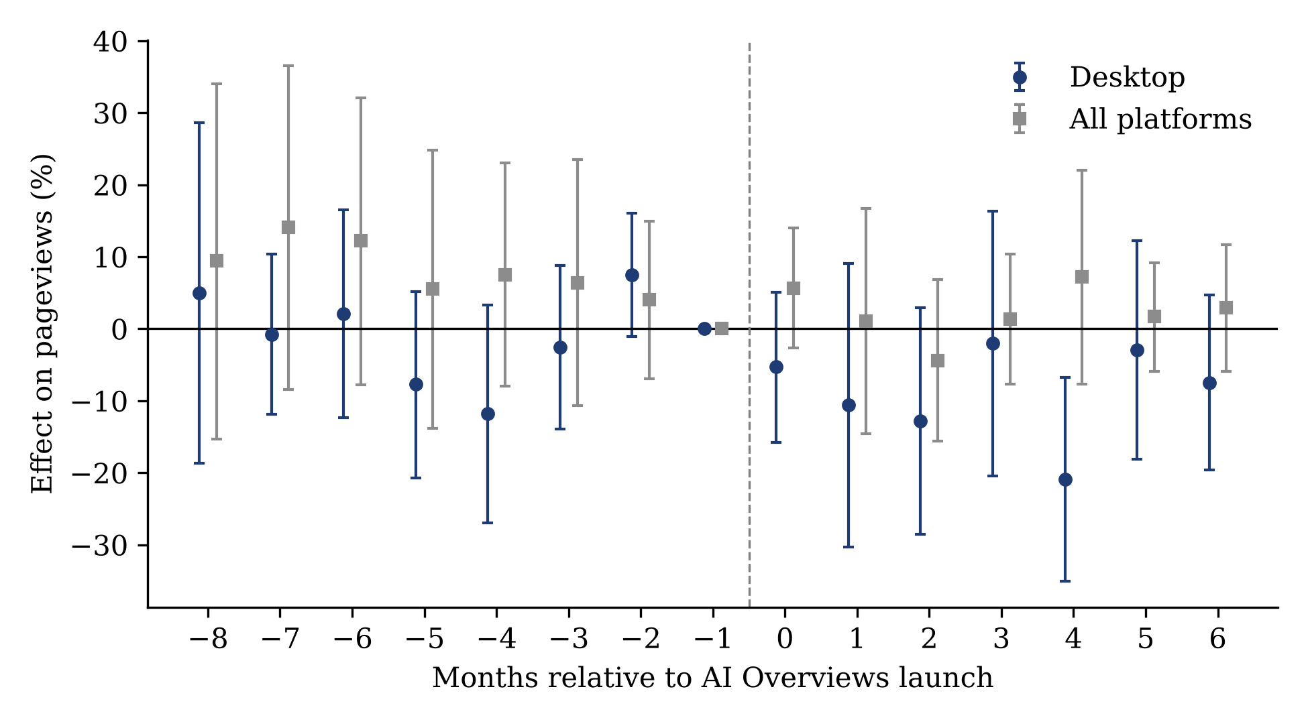
Note. Effect on pageviews in percent (log points × 100) by months since launch, relative to not-yet-treated editions; month −1 is the reference. Bars are 95% bootstrap intervals (499 draws, resampling editions). Source. Wikimedia hourly projectviews dumps (four sampled hours per month); launch dates from Google and trade press; Callaway–Sant’Anna estimator with not-yet-treated controls.
Figure A1 shows the event study for the August 2024 cohort. Desktop estimates fluctuate around zero before launch and are negative in all seven months after it, although most individual intervals include zero. Total views, which are dominated by mobile, show no change.
Limitations of Tests A and B. Google Trends measures shares of searches, not volumes, so Test A cannot detect a fall in total search. Adoption is measured cross-sectionally: Eurostat asked about generative AI for the first time in 2025, and search-interest measures correlate with urbanization and income. Test B has 24 clusters, and its pre-2025 data include bots later reclassified. A direct test of the broad claim requires user-level panel data linking AI use to search sessions, which is not publicly available.

E.2 Quarterly Revenue and Advertiser-Side Evidence (Sections 5.3 and 5.4)
Figure A2. Year-over-year revenue growth of Google Search & other and of Meta, 2019Q4–2026Q3.
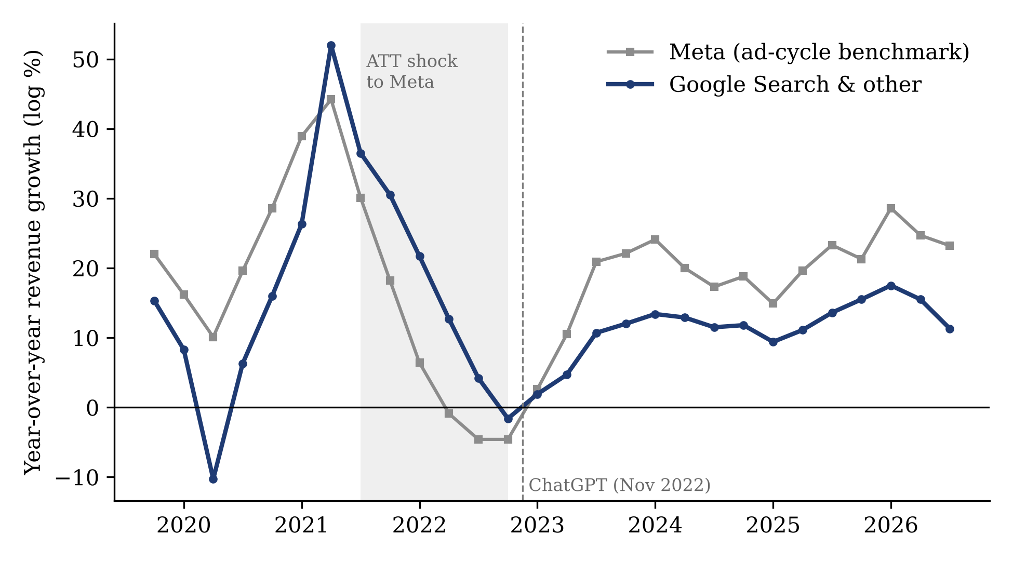
Note. Growth = 100 × log difference over four quarters. Shaded area: Apple’s App Tracking Transparency shock to Meta. Placebo breaks before ChatGPT fit as well (Table A5). Source. Alphabet and Meta 8-K earnings releases and XBRL filings (SEC EDGAR), 2018Q4–2026Q3; growth = 100 × log difference over four quarters.
Placebo tests do not support a causal reading. We re-estimate both specifications with break dates from 2021Q1 to 2024Q3.
Table A5. Placebo break dates. Coefficient (p-value).
Break date | Trend k, spec. (2) | g^M × Post, spec. (3) | AIC, spec. (3)
2021Q1 (placebo) | −0.510 (<0.01) | −0.366 (0.07) | 176.3
2021Q3 (placebo) |  | −0.748 (<0.01) | 163.0
2022Q1 (placebo) | −0.646 (0.04) | −0.749 (<0.01) | 166.9
2023Q1 (ChatGPT) | −0.452 (0.04) | −0.681 (<0.01) | 169.5
2023Q3 | −0.127 (0.54) | −0.695 (<0.01) | 173.5
2024Q1 | −0.370 (0.11) | −0.659 (<0.01) | 176.1
Figure A3. Paid-click and cost-per-click growth, Google Search & other, 2023–2026.
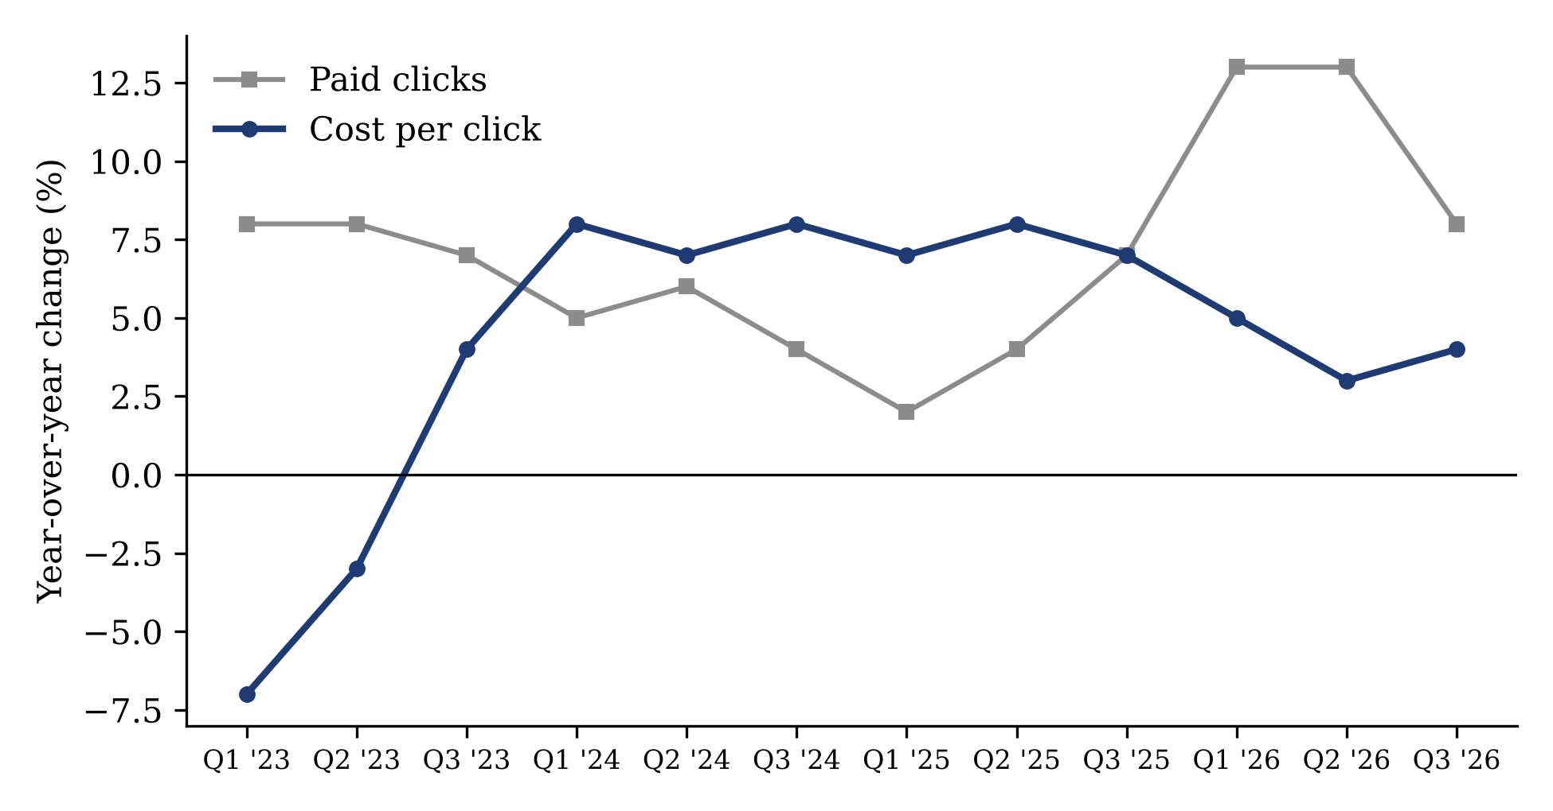
Note. Year-over-year change in percent for the first three quarters of each year (Q4 is not reported separately). Source. Alphabet Forms 10-Q, “Monetization Metrics,” three months ended March, June, and September, 2023–2026 (SEC EDGAR).

E.3 Bing (Section 5.5)
Proposition 8 implies that a search engine with little legacy search profit has a low threshold for full AI answers and should adopt them early, without the summary step. Relative to Google, Bing is such a firm, although its absolute legacy revenue is large (Table A10). In January–March 2026, Microsoft’s search advertising revenue was $3.8 billion (Microsoft 2026), against $60.4 billion for Google Search & other (Alphabet 2026c), about one-sixteenth. We test three implications.
Order of formats. Microsoft announced a chat-based Bing with full AI answers on February 7, 2023, and announced ads inside chat answers on March 29, 2023 (Engadget 2023). Google launched AI summaries in the United States in May 2024 and full AI answers (AI Mode) in May 2025. As Proposition 8 predicts for a firm whose legacy profit was small relative to its rival’s, Bing went straight to full answers, 15 months before the incumbent’s summaries and 27 months before its full answers; the incumbent took the summary step first.
Market share. In the model, a rival’s full answers draw users away from an incumbent that offers only links, and the incumbent’s summaries close part of that gap. Bing’s share should therefore rise faster after February 2023 and stop rising once Google adds summaries. We estimate a segmented trend model of Bing’s monthly share from StatCounter, January 2019 to August 2026 (N = 92), with breaks at Bing Chat (February 2023), AI Overviews (June 2024), and AI Mode (June 2025), and Newey–West standard errors. Figure A4 plots both series.
Figure A4. Bing’s share of search referrals, January 2019–August 2026.
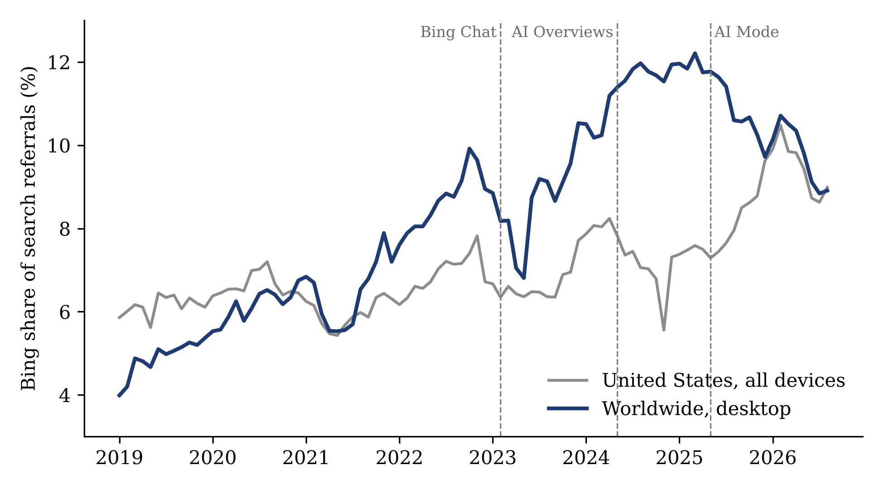
Note. Worldwide desktop trend in percentage points per month: +0.10 before Bing Chat, +0.26 after, +0.02 after AI Overviews, −0.16 after AI Mode. Source. StatCounter Global Stats, search engine market share, January 2019–August 2026; September 2026 excluded as an outlier (worldwide desktop 14.65%).
Table A6. Bing’s share trend, percentage points per month, by period.
Period | Worldwide desktop | United States, all devices
Before Bing Chat (2019–Jan. 2023) | +0.10 | +0.02
After Bing Chat, before AI Overviews | +0.26 (change +0.16, p < 0.01) | +0.14 (change +0.12, p < 0.01)
After AI Overviews, before AI Mode | +0.02 (change −0.24, p < 0.01) | +0.03 (change −0.11, p < 0.01); level −1.27 (p < 0.01)
After AI Mode | −0.16 (change −0.18, p < 0.01) | +0.11 (change +0.08, p = 0.21)
The worldwide desktop pattern matches the prediction: Bing’s gains accelerated after it alone offered full answers, stopped once Google added summaries, and reversed after Google launched full answers. In the United States, Bing’s share also rose faster after Bing Chat and fell when AI Overviews launched, but it rose again after AI Mode, which the model does not predict.
Revenue and market value. Two further tests are uninformative. Microsoft’s search advertising revenue growth (excluding traffic acquisition costs) exceeded Google’s search growth by 2.9 points on average before 2023 and by 1.3 points after, a difference that is not significant (p = 0.71, 15 quarters). Abnormal returns around Microsoft’s announcements are confounded: Google announced Bard on February 6, 2023 and stumbled in its demonstration on February 8, and neither firm’s abnormal return on the ads-in-chat announcement (March 29) was significant (Alphabet −1.5%, t = −1.01; Microsoft +0.1%, t = 0.06).
Caveats. StatCounter measures shares of page views referred by search engines on sites carrying its tracking code, not searches. Bing’s share also depends on Windows and Edge defaults, which Microsoft changed over the same period, notably when it rebranded Bing Chat as Copilot in late 2023. A segmented trend with three breaks fits a single firm’s history and cannot exclude other explanations. The Bing evidence is therefore consistent with Proposition 8 but is not a causal test, and the cross-firm test below does not support its broader prediction.

E.4 Cross-Firm Tests (Section 5.5)
Cross-firm test. Bing is one case. Proposition 8 makes a cross-sectional prediction: the larger a search engine’s legacy business, the later it should move to full AI answers, and the more likely it is to add summaries first. We coded the first public launch of each format for 17 search engines from company announcements and trade press, and measured legacy strength by each engine’s average 2022 share of its home market (StatCounter, all devices). Timing is measured in months from ChatGPT’s release (December 2022); Daum, which had not launched full answers by October 2026, is coded at 46 months.
Table A7. AI search formats by search engine, ordered by legacy market share.
Search engine | Home market | 2022 share (%) | Summary above links (H) | Full AI answer (A) | Order
Google | U.S. | 87.2 | May 2024 | May 2025 | H then A
Baidu | China | 72.1 | By Aug. 2023 | Aug. 2023 (AI Partner) | Same month
Yandex | Russia | 49.2 | Feb. 2024 | Apr. 2024 (Neuro) | H then A
Naver | Korea | 24.0 | Mar. 2025 | June 2026 (AI Tab) | H then A
Yahoo! JAPAN | Japan | 15.9 | Oct. 2024 | Oct. 2024 | Same day
Seznam | Czechia | 12.2 | Jan. 2025 | May 2026 | H then A
Sogou | China | 7.6 | Oct. 2026 | Oct. 2026 | Same month
Bing | U.S. | 6.9 | — | Feb. 2023 | A first
360 Search | China | 3.4 | Sept. 2023 (placement unclear) | Jan. 2024 | H then A
Yahoo | U.S. | 3.1 | Not found | Jan. 2026 (beta) | A only
DuckDuckGo | U.S. | 2.4 | Mar. 2023 | June 2024 | H then A
Daum | Korea | 1.6 | July 2026 (beta) | Not launched | H only
Ecosia | Germany | 1.0 | Dec. 2025 | Dec. 2025 (beta) | Same day
Qwant | France | 0.8 | Not found | Jan. 2026 | A only
Brave | Global | <0.1 | Mar. 2023 | Nov. 2024 | H then A
Perplexity | AI-native | 0 | — | Dec. 2022 | A only
You.com | AI-native | 0 | — | Dec. 2022 | A only
Table A8. Rank correlation between 2022 legacy share and months until full AI answers (positive = larger firms later, as predicted).
Sample | N | Spearman ρ | p
All search engines | 17 | +0.17 | 0.51
Excluding AI-natives | 15 | −0.21 | 0.46
Excluding AI-natives and China | 12 | −0.16 | 0.62
Engines with in-house frontier models (Google, Baidu, Yandex, Naver, Seznam, Bing, 360) | 7 | +0.21 | 0.65
Same, coding Baidu’s full answer at its July 2025 search overhaul | 7 | +0.39 | 0.38
Engines without in-house models | 10 | +0.50 | 0.14
Results. The cross-firm prediction is not supported. Legacy share and the timing of full answers are not significantly related in any sample, and the sign depends on whether AI-native services are included. Two patterns stand out. First, the summary step is common among large engines: three of the four engines with more than 20% home share (Google, Yandex, Naver) added summaries before full answers, against four of nine engines below 5%. Second, the smallest legacy engines were not early. Seznam, Sogou, Daum, Qwant, Ecosia, and Yahoo all reached full answers late or not at all, even though they had little to lose.
Interpretation and a test of Proposition 9. Proposition 8 treats the ability to offer full answers as given. The small engines’ delays suggest that scale and capability also govern timing, which Proposition 9 formalizes: adoption should be fastest at intermediate shares and faster for engines with in-house models. We regress months until full answers on legacy share, its square, and an indicator for an in-house frontier model, excluding the two AI-native entrants (N = 15; heteroskedasticity-robust standard errors).
Table A9. Months until full AI answers, 15 legacy search engines.
Specification | Share | Share squared | In-house model | R²
(1) In-house model only |  |  | −11.6 (p = 0.11) | 0.18
(2) Share and share squared | −29.2 (p = 0.52) | +19.0 (p = 0.73) |  | 0.08
(3) All three | +11.7 (p = 0.85) | −15.6 (p = 0.82) | −11.8 (p = 0.31) | 0.18
(4) As (3), Baidu coded at its July 2025 search overhaul | +31.4 (p = 0.63) | −24.8 (p = 0.72) | −12.9 (p = 0.27)
(5) As (3), excluding China (N = 12) | −7.8 (p = 0.93) | +9.5 (p = 0.90) | −4.8 (p = 0.80)
Engines with in-house frontier models reached full answers about 12 months earlier on average (21.6 vs. 33.1 months), in line with part (ii), but the difference is not statistically significant. The data show no inverted-U relation with share: the share terms are small relative to their standard errors and change sign across specifications. The cross-firm evidence therefore neither confirms nor rejects Proposition 9; with 15 engines, month-level dates, and share as a proxy for scale and legacy profit, it cannot separate the two forces. A sharper test would use engine-level search revenue and model-licensing contracts, or the timing of features within a firm across markets of different size. China’s engines add a further constraint: Baidu and 360 released their public products in the same period that regulators first approved generative AI services.
Legacy revenue instead of share. Market share measures position, not what an engine stands to lose. We therefore collected each engine’s 2022 search advertising revenue, or the closest reported line, from annual reports and filings, converted at 2022 average exchange rates (IRS).
Table A10. Legacy search advertising revenue, 2022, and months until full AI answers.
Search engine | Reported line | Revenue (US$ millions) | Months until full answers
Google | Google Search & other, sum of 2022 quarters from Alphabet’s earnings releases | 162,450 | 29
Bing | Microsoft search and news advertising, calendar 2022, gross of TAC | 12,022 | 2
Baidu | Baidu Core online marketing services, includes feed ads | 10,330 | 8
Yandex | Search and Portal segment, includes portal and ad network | 3,214 | 16
Naver | Search Platform segment, includes display | 2,762 | 42
Yahoo! JAPAN | Search ads, fiscal year to March 2023 | 1,481 | 22
Sogou | Search and search-related revenue, 2020 (last reported) | 837 | 46
360 Search | Internet advertising and services, all ads | 700 | 13
Daum | Kakao Portal Biz, sum of quarters | 328 | 46 (not launched)
Seznam | Total revenue | 254 | 41
DuckDuckGo | Company statement, “more than $100 million” | 100 | 18
Ecosia | Total income, monthly reports | 36 | 36
Brave | Analyst estimate of total revenue | 20 | 23
The revenue lines are not like-for-like: several are gross of traffic acquisition costs or include non-search advertising, and the smallest are estimates. Revenue for Qwant and Yahoo (U.S.) was not available.
With revenue in place of share, the relation runs, if anything, against the cannibalization prediction. Engines with more legacy revenue reached full answers somewhat earlier (Spearman ρ = −0.35, p = 0.24, N = 13; ρ = −0.25, p = 0.49 excluding China). In regressions on log revenue, its square, and the in-house model indicator, no coefficient is close to significant (all p > 0.45). The ordering at the top is the most informative. Bing, with the second-largest legacy revenue in the sample ($12.0 billion, gross of traffic acquisition costs), moved first; Baidu and Yandex followed within 16 months; Google, the largest, took 29 months; and Naver took 42. Bing was therefore not a firm with little to lose in absolute terms, only relative to Google, and its early move is better explained by its privileged access to OpenAI’s models and by Microsoft’s other gains from AI (cloud and Windows) than by a small legacy business. Across the available evidence, scale and capability appear to govern timing more than the size of the legacy business, which supports the fixed-cost channel of Proposition 9 and offers no support for the cannibalization channel of Propositions 8 and 9 in cross-firm data.

E.5 Google across Countries (Section 5.5)
Within-firm test: Google across countries. Cross-firm comparisons confound legacy profit with capability. Holding the firm fixed removes that confound: Google’s capability is the same everywhere, while the value of its legacy search business, the size of its markets, and regulation differ across countries. We dated the first month in which AI Overviews and AI Mode were available in each of 49 countries, from Google’s announcements and archived copies of Google’s help pages that list supported countries and languages (AI Overviews, AI Mode). AI Mode reached the United States in May 2025 (Google 2025b), India and the United Kingdom in July, about 180 more countries in English in August (Google 2025c), local languages from September, the EU/EEA, Switzerland, and Australia in October (Google 2025d), Türkiye in February 2026, and France in July 2026. We regress months until availability on log GDP per capita, a proxy for the value of a query to advertisers and hence for legacy profit per query; log internet users, a proxy for scale; and indicators for the EU/EEA, English-speaking markets, and the two markets held back by regulatory disputes (France and Türkiye). Covariates are from the World Bank; Taiwan and Pakistan lack data, leaving N = 47.
Table A11. Months until Google AI Mode by country (N = 47; heteroskedasticity-robust p-values in parentheses).
Variable | AI Mode, any language | AI Mode, local language | AI Mode, any language, outside EU and regulated markets (N = 30) | Months from AI Overviews to AI Mode
Log GDP per capita | −0.07 (0.67) | −1.15 (<0.01) | −0.18 (0.29) | +0.09 (0.79)
Log internet users | −0.26 (0.10) | −0.72 (<0.01) | −0.34 (0.04) | +1.12 (<0.01)
EU/EEA | +1.92 (<0.01) | +1.33 (<0.01) |  | −0.91 (0.26)
English-speaking | −0.25 (0.35) | +0.67 (0.30) | −0.19 (0.47) | +2.25 (<0.01)
France and Türkiye | +7.68 (<0.01) | +7.36 (<0.01) |  | −8.18 (<0.01)
R² | 0.90 | 0.64 |  | 0.59
Results. Three findings stand out. First, regulation dominates: the EU/EEA received AI Mode about two months later than comparable markets, and France and Türkiye seven to eight months later still. Second, scale speeds adoption: larger markets received AI Mode earlier, in any language outside the EU (p = 0.04) and in the local language (p < 0.01), as the fixed-cost channel of Proposition 9 predicts. Third, there is no sign of a cannibalization delay. Markets where a query is worth more to advertisers did not receive full answers later; in their local languages they received them earlier (p < 0.01). Larger and English-speaking markets kept summaries longer before full answers arrived, but this reflects their early access to AI Overviews rather than a later switch.
Interpretation. GDP per capita raises both the legacy profit per query R and the ad productivity of AI answers m, so it acts mainly as a measure of market value, which favors early entry when entry has a fixed cost per market (for example, localization). The prediction of Proposition 8 depends on the ratio of m to R, which income alone cannot isolate. The within-firm evidence therefore supports the fixed-cost and scale channel and is inconsistent with a cannibalization delay large enough to show up in Google’s rollout across countries. Rollouts in waves leave little independent variation, so these estimates describe Google’s sequencing rather than causal effects.

E.6 The Trust Shock of May 2024 (Section 5.6)
Section 4.8 separates two reasons why users stop clicking: trust in AI answers and the effort that reading results requires. The widely publicized AI Overviews errors of late May 2024 lowered trust without changing that effort, so they allow a test. If trust drives clicking, clicks out of search should rise after the errors (Proposition 10(iv)); if effort drives it, clicks should change little. We use daily pageviews of English Wikipedia, the edition most exposed to AI Overviews in the United States, then the only market with AI Overviews. We compare English with the ten other largest editions in a triple difference: English minus other editions, 2024 minus the same weekdays of 2023, by period relative to the four weeks before the launch on May 14 (Table A12). Inference uses Newey–West standard errors on the daily series and a placebo comparison in which each other large edition is treated in turn. Figure A5 plots the daily gap.
Figure A5. English Wikipedia desktop views relative to 10 large editions around the AI Overviews errors of May 2024.
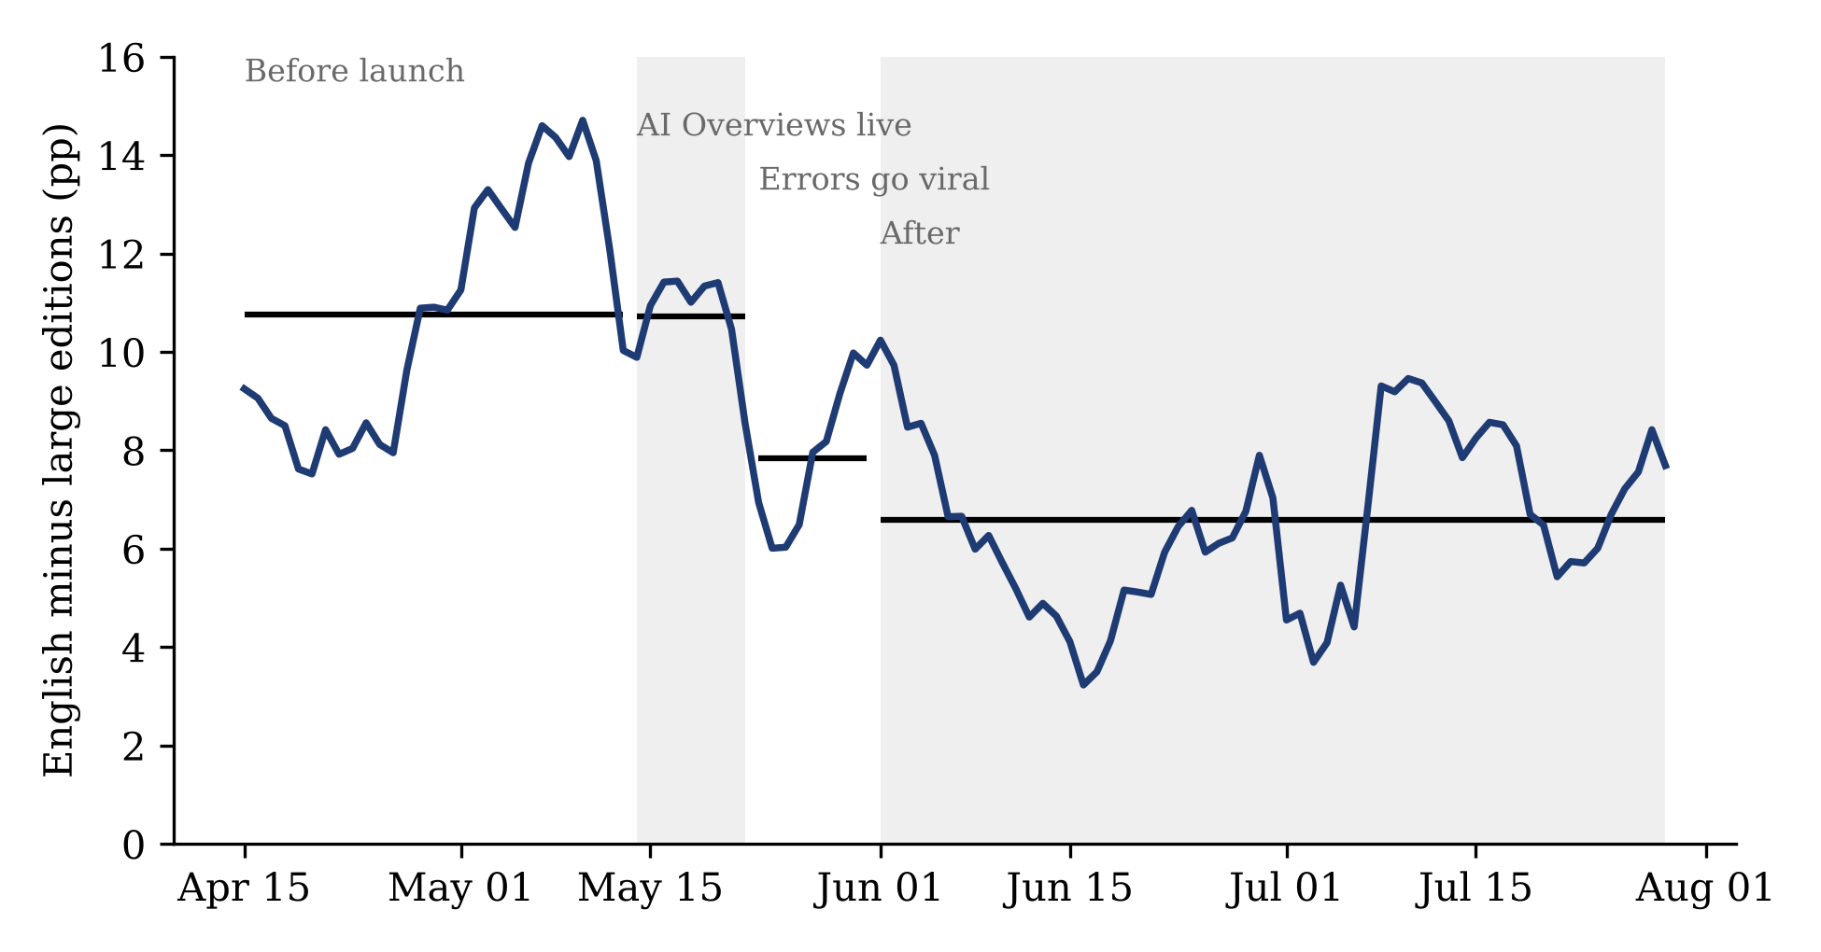
Note. Year-over-year growth of English minus 10 large editions, percentage points, 7-day centered average. Horizontal lines are period means. Source. Wikimedia hourly projectviews dumps, four sampled U.S.-daytime hours per day, April–July 2023 and 2024; 2023 dates shifted 364 days to align weekdays and Memorial Day.
Table A12. Change in English Wikipedia views relative to large editions, year over year, by period (versus April 15–May 13, 2024).
Period | Desktop | Mobile web | All
AI Overviews live (May 14–22) | −0.8% (p = 0.74) | −0.7% (p = 0.71) | −0.4% (p = 0.78)
Errors go viral (May 23–31) | −3.4% (p = 0.15) | −1.6% (p = 0.31) | −1.8% (p = 0.07)
June 2024 | −4.9% (p < 0.01) | −2.5% (p = 0.12) | −3.3% (p < 0.01)
July 2024 | −3.9% (p = 0.03) | −3.0% (p = 0.02) | −3.6% (p < 0.01)
Placebo p-value, June | 0.40 | 0.70 | 0.60
Clicks out of search did not rise after the trust shock. English Wikipedia views did not change in the week after AI Overviews launched, and after the errors went viral they fell further relative to other editions, by about 4% through June and July. This happened even though Google cut back AI Overviews at the same time, from about 11% to 7% of queries by the end of June (Search Engine Land 2024), which on its own should have raised clicks. The result is the opposite of what the trust account predicts and is consistent with effort as the main driver. The evidence is weak in two respects. The June and July declines are significant in the daily time series but not relative to the variation among other large editions (placebo p = 0.40 to 0.70), and English Wikipedia is an imperfect measure of U.S. clicks, since much of its traffic comes from outside the United States. With these caveats, the trust shock moved clicks in the wrong direction for the trust account, which supports the view that the convenience of AI answers, more than trust in them, keeps users from reading search results.

E.7 Remaining Tests (Section 5.7)
Three designs could identify the AI effect more cleanly than firm-level time series.
- Staggered rollout. AI Overviews and AI Mode launched in different countries at different dates. A difference-in-differences design using country-level search ad spend (for example, from advertiser panels) would identify the effect of AI answers on search monetization.
- Query categories. Commercial categories with high legacy profit R (travel, finance, retail) should lose more revenue when AI answers appear than informational categories, unless AI ad productivity is correspondingly higher (Proposition 4).
- Answer-level ad load. A panel of AI answers, coding sponsored content per answer across platforms and model generations, would test whether ad load tracks inference cost (Proposition 2).

References Cited Only in the Online Appendix
- Google (2025b) AI Mode in Google Search: U.S. launch update. The Keyword (Google blog), May.
- Google (2025c) AI Mode: Agentic and personalized features and English expansion. The Keyword (Google blog), August.
- Google (2025d) AI Mode expands to more languages and locations. The Keyword (Google blog), October.
- Grossman R, Liu S, Chen MK, Smith M, Borcea C, Chen Y (2026) How generative AI disrupts search: An empirical study of Google Search, Gemini, and AI Overviews. Proc. ACM SIGIR 2026.
- Internal Revenue Service (2026) Yearly average currency exchange rates. Accessed October 2026.
- Kaiser M, Schulze C (2026) Frontiers: ChatGPT referrals to e-commerce websites: How do LLMs compare against traditional channels? Marketing Sci., forthcoming.
- Reeves N, Yin W, Simperl E (2024) Exploring the impact of ChatGPT on Wikipedia engagement. Working paper, arXiv:2405.10205.

