Who Takes Office? Decision Rights, Office Rents, and the Limits of Power Concentration in LLM Agent Economies

Abstract
Organizations are beginning to let networks of large language model (LLM) agents allocate scarce resources among themselves, yet little is known about how the governance rules built into such systems shape who ends up in control. Drawing on IT governance and cumulative-advantage theory, we ask when agents seek and keep allocation authority, and whether holding it concentrates access. We report a controlled simulation of 168 agent worlds in which binding allocation authority, the rewards attached to office, the election rule, and the model composition of the population were varied, and in which every outcome is computed from logged events rather than agent discourse. Office rents sharply increased candidacy and competition, but not inequality of access. Binding authority made allocation more equal than chance, because holders favored agents with fewer tasks and less energy and gave themselves less, not more. Election rules made no detectable difference. Model family and capability predicted who stood for office. Power concentration was weak; competition for it was not.
Keywords: agentic information systems; IT governance; decision rights; large language model agents; multi-agent simulation; office rents

1. Introduction
Firms increasingly deploy LLM-based agents that negotiate, schedule, and allocate on behalf of human principals. As these agents begin to deal with each other and not only with people, the information system becomes a setting in which allocation outcomes are produced through agent-to-agent exchange. Research on AI in organizations has concentrated on the human–AI interface, such as trust, adoption, and augmentation. A prior question for the designers of such systems has received less attention. When agents share scarce resources and some of them hold governance rights over those resources, who comes to control them, and does that control entrench itself?
The question matters because agentic systems inherit their governance from their designers. Voting interfaces, allocation privileges, and the rewards attached to holding office are design choices made before any agent acts. The IT governance literature has long treated the assignment of decision rights as a central lever for shaping behavior (Sambamurthy and Zmud 1999; Weill and Ross 2004). That literature assumes human actors whose interests, norms, and hesitations moderate how formal rights are used. Whether the same moderation operates when the rights holders are LLM agents is an open empirical matter.
Recent evidence suggests it cannot be taken for granted. Zhang and Shang (2026) report that LLM agents placed in a minimal executable world, with scarce tasks and basic mechanisms for transfer, election, and allocation, form economic relations without being instructed to, including exchanges of votes for future access. Their setting is small and short, and it was built to show that such relations can emerge, not to ask whether they harden into durable control. Work on LLM-based economic simulation has largely asked a different question, namely whether a governance procedure converges on a socially desirable outcome (Karten et al. 2025). We ask the complementary one: under what design conditions do agents seek office, and does holding office translate into control over who gets access?
Our evidence is a controlled simulation in which four design features were varied across 168 worlds. We report three main findings. First, rewards attached to office determine whether agents compete for it at all; without them most elections drew no candidate. Second, binding allocation authority did not concentrate access. It made allocation more even than a lottery would. Third, which agents took office depended strongly on model family and, within a family, on capability, but mostly through the decision to stand and much less through winning once standing.
These findings qualify a natural expectation, that agents given allocation power and scarce resources will tend to capture them. We contribute in three ways. We specify office rents and authority binding as design-level constructs and derive propositions about their effects. We provide a design that identifies governance effects from behavioral traces, with a placebo comparison for vote-for-access claims. And we document where concentration did and did not appear, which is information designers need before deploying such systems.

2. Theoretical Background and Propositions

2.1 Decision rights as a governance design variable
IT governance research defines governance as the specification of decision rights and accountability structures that encourage desirable behavior in the use of IT (Weill and Ross 2004). Arrangements for who decides produce systematic differences in how organizations use technology (Sambamurthy and Zmud 1999), and in platform ecosystems, governance mechanisms shape participant behavior and platform evolution (Tiwana et al. 2010). A shared assumption is that a right and its exercise are separable: holding a decision right is one thing, and what the holder does with it depends on incentives and social context. In agentic systems that separation may be thinner, because agents act on the mechanisms as specified and carry few loyalties beyond those the system records.

2.2 Delegation among agents
Agency theory frames delegation as a problem of aligning an agent’s actions with a principal’s interests under information asymmetry (Jensen and Meckling 1976; Eisenhardt 1989). Multi-agent settings add a layer. When one agent controls allocation, the others are in effect subject to its authority, and the question becomes the distribution of control among agents. Research on machine behavior argues that such collective outcomes need to be studied in their own right (Rahwan et al. 2019), and LLMs have begun to be used as simulated economic agents, subject to the usual caveats about validity (Horton 2023).

2.3 Cumulative advantage, office rents, and entrenchment
Cumulative-advantage accounts show how early positional gains can feed on themselves (Merton 1968) and how small early differences can lock in outcomes under increasing returns (Arthur 1989). Institutional accounts add that when the holders of political power can steer economic opportunity toward their supporters, and economic advantage helps them retain power, institutions become self-perpetuating (Acemoglu and Robinson 2012). Ostrom (1990) documents rule configurations under which shared resources are governed without capture.
These accounts share a premise: holding office is worth something. We call the value attached to holding a position office rents. Whether anyone competes for office, and whether holding it reinforces itself, depends on whether such rents exist. A second design feature is authority binding, the degree to which an officeholder’s allocation decision is executed without further approval. Where authority is not binding, office carries symbolic status but no control.
A cumulative-advantage account also bears on who stands. Agents that already hold resources or office bear a lower cost from a failed bid and gain a platform from a successful one, so resources and incumbency should raise the willingness to stand (Merton 1968; Arthur 1989). We examine this as an additional test in Section 4.4 and do not state it as a separate proposition.

2.4 Propositions
P1 (Office rents and candidacy). Office rents increase candidacy and electoral competition. Without them, agents have little reason to bear the costs of standing.
P2 (Authority binding and access). Binding authority increases the officeholder’s ability to concentrate access, so inequality of access is greater under binding than under advisory authority. We state this as the expectation from the cumulative-advantage and capture literatures and treat it as a test that could fail.
P3 (Interaction). The effect of binding authority on inequality of access is larger when office rents are present, because rents give holders a reason to use authority for their own advantage.
P4 (Election rules). Rules that raise the cost of assembling a decisive majority (ranked-choice, relative to plurality) reduce the persistence of control.
P5 (Capability and selection). More capable agents are more likely to hold office, whether through greater willingness to stand or through greater success when standing.
Figure 1 summarizes the model. The design features on the left are the manipulated factors: office rents, authority binding, the election rule, and the capability or family of the model that drives each agent. The central construct is candidacy and electoral competition, which we expect office rents to raise (P1) and which we expect in turn to lengthen the persistence of control over the office. Authority binding is expected to raise inequality of access to tasks (P2), and the dotted arrow indicates that office rents are expected to strengthen that relationship (P3), because rents give holders a reason to use authority to their own advantage. The election rule is expected to shorten the persistence of control (P4). Agent capability and model family are expected to affect which agents hold office (P5). The model is deliberately parsimonious: it contains no mediating variables beyond candidacy, and it treats the three outcomes (persistence, inequality, and identity of the holder) as separate.
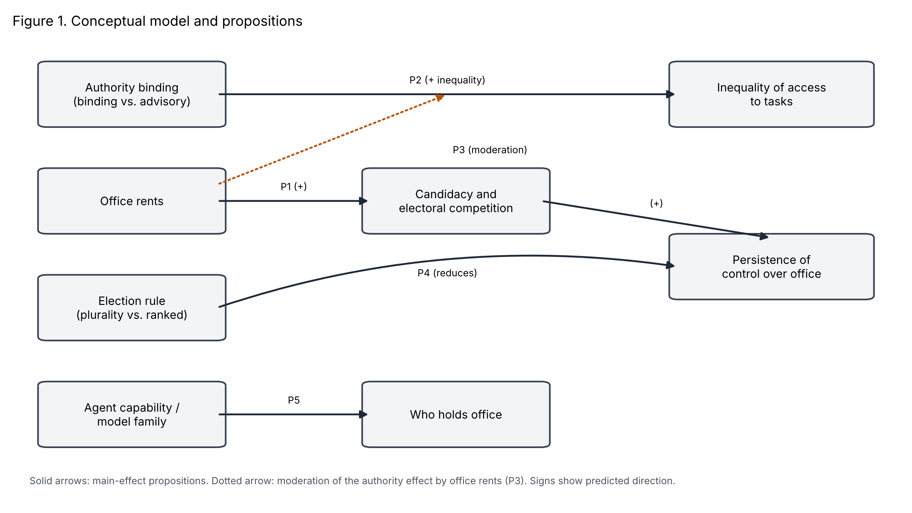
Figure 1. Conceptual model and propositions. Solid arrows are main-effect propositions; the dotted arrow is the moderation of the authority effect by office rents (P3). Signs show the predicted direction.
We also examine rights convertibility, the extent to which a vote can be exchanged for access, as a within-world phenomenon and not a manipulated factor. Section 4.5 reports a placebo test of whether voters favor candidates who have given them promises or transfers.

2.5 An account of how rights are exercised among agents (post hoc)
The propositions above follow from accounts written for human actors. The results in Section 4 led us to a more specific account, which we state here so that it can be tested outside the data that suggested it. It was developed after the main results were examined and should be read as a hypothesis and not as a finding.
In the human governance literature the gap between holding a decision right and using it is filled by norms, reputation, and the holder’s own interests. Among LLM agents the gap appears to be filled by two other things: the incentives that the system specification states explicitly, and the dispositions that the underlying model brings to the task. Four statements follow. First, incentive responsiveness: whether agents stand for office depends on whether the specification attaches a reward to it. Second, an equity default: when nothing in the prompt directs the holder to pursue its own gain, a holder with binding authority applies simple fairness heuristics, favoring agents who have received less and have less, and does not favor itself. Third, dispositional selection: who stands depends on the model’s disposition to take on roles, which varies with model family and capability, more than on the model’s success in the vote. Fourth, limited strategic depth: election rules and vote-for-access exchange matter only to the extent that agents reason about coalitions, and the agents in our setting, which answered directly without hidden reasoning, did so little.
Each statement can fail. The first fails if rewards for office do not raise candidacy across model families. The second fails if holders favor themselves or past benefactors once the prompt makes their own interest salient. The third fails if differences between models appear mainly in success among candidates. The fourth fails if enabling reasoning makes election rules or vote-for-access exchange matter. Section 5.1 reports how far Study 1 supports each statement.

3. Method

3.1 Environment
We built an executable world in the spirit of Zhang and Shang (2026). Each world contains six agents and runs for 50 simulated days. Each day two scarce tasks become available, and an agent can receive at most one. A task yields three units of energy; every agent pays one unit per day. Agents can send public messages, transfer energy, make promises of future access, stand for election, and vote. An election is held every five days, and the winner holds office until the next election. A holder submits an allocation of the day’s tasks. Where authority is binding, that allocation is executed; where it is advisory, tasks are drawn at random from all agents and the holder’s proposal is recorded but ignored. The interface is identical in the two conditions. If nobody stands in an election, the office is vacant until the next one and tasks are drawn at random.
All economic relations are identified from logged, state-changing events (transfers, promises, votes, allocations). Agent messages are logged but not used to measure outcomes.

3.2 Design
The main design crosses four factors: authority (binding or advisory), election rule (plurality or ranked-choice), population (all Claude Haiku 5.5; all DeepSeek V4 Pro; or three of each), and office rent (zero or two extra energy per day in office). This gives 24 cells, each run with six seeds, for 144 worlds. A second, capability-contrast design places DeepSeek V4 Flash and V4 Pro agents together in the same world, crossing authority with office rent over six seeds (24 worlds). The within-family contrast separates capability from model family. Models were accessed through OpenRouter at a sampling temperature of 1.0, with hidden reasoning disabled so that responses are direct actions.

3.3 Measures
Competition. The share of elections with no candidate, and the share with at least two. Persistence. The longest uninterrupted spell of one holder, the share of office days held by the most frequent holder, and the re-election rate. Inequality of access. The Gini coefficient of cumulative tasks received and the longest spell without a task. Exchange. The number of voters who backed the winner after receiving a promise or transfer from the winner since the previous election, and the gifted-vote share, the proportion of a candidate’s votes that came from voters who had received a gift from that candidate. The last is computed separately for winners and non-winners, which provides a placebo benchmark. Reliability. The fraction of access promises later honored.

3.4 Analysis
We compare levels of each factor with two-sided permutation tests (10,000 permutations) using the world as the unit of analysis. The design is balanced, so these marginal comparisons are valid, although they do not adjust for the other factors and so lose power. We ran about thirty such tests and applied no multiplicity correction. Results with p-values between 0.02 and 0.05 should be read as exploratory. As a check on the marginal tests, and to adjust for the other factors, we also fitted full-factorial models in which authority, rent, and population interact pairwise and the election rule enters as a main effect, with sum-to-zero coding so that each main-effect term is an average over the balanced design. Continuous outcomes used least squares with HC3 standard errors; shares of elections used quasi-binomial models and counts used quasi-Poisson models, both with robust standard errors. The five tests that correspond directly to propositions (rent on the share of elections with no candidate and on contested elections, authority on the Gini and on transfers, and election rule on re-election) are adjusted with the Holm method, and all other terms with the Benjamini–Hochberg method. Candidacy was modeled with a logit estimated by generalized estimating equations clustered on world. Success among candidates was modeled with a conditional logit within election, and the receipt of tasks with a conditional logit within day (Table 2). Intervals for these models come from bootstrap resampling of worlds (200 draws, 300 for the capability contrast, 100 for each rent column of Table 2, and 40 for its placebo column, whose interval is therefore rough). The interaction of authority with population was tested with a joint Wald test. As a benchmark for inequality, we simulated 2,000 worlds in which two of six agents are drawn at random each day; the expected Gini was 0.103 and the expected longest spell without a task was 12.0 days.

3.5 Research transparency
The design evolved over three stages. An initial 24-world pilot revealed that a task-request step in the advisory condition produced an artifact: agents adopted informal rotation rules, tasks went unfilled, and inequality in that condition reflected lost tasks and not governance. The request step was removed. A second 24-world pilot, run with the corrected design, showed that most elections had no candidate and that incumbents therefore persisted by default. We changed the rule so that an empty election vacates the office, and added the office-rent factor and the placebo gifted-vote measure. The pilots informed the final design and are not pooled with the main results. The main design was first run with three seeds per cell; three further seeds were added after an initial look at those results, because several differences were borderline, and all 144 worlds are analyzed together. The stopping decision was therefore not fixed in advance, and readers should treat borderline p-values accordingly. The design, models, and all analysis code are retained in a repository, and per-call costs are logged. The factorial models, the analyses of candidacy, winning, and allocation rules (Sections 4.2 and 4.4), the interaction of authority with population (Section 4.1), and the account in Section 2.5 were developed after the main results were examined and are exploratory.

4. Results

4.1 Competition for office
Office rents changed the nature of the elections (Table 1). Without rents, 55 percent of elections drew no candidate; with them, 34 percent did (p < 0.001). The share of contested elections rose from 25 to 40 percent (p < 0.001), and the longest spell of a single holder rose from 8.1 to 12.4 days (p < 0.001). Model family mattered at least as much as any design feature: in Claude-only worlds, 71 percent of elections had no candidate, against 28 percent in DeepSeek-only worlds and 35 percent in mixed worlds. The five tests tied to the propositions keep their conclusions in the factorial models after adjustment (rent, no candidate and contested elections: adjusted p < 0.0001; authority, Gini: p = 0.0007; authority, transfers: p < 0.0001; election rule, re-election: p = 0.29). One result was not anticipated and is exploratory. Binding authority moved candidacy in opposite directions depending on the population: the share of elections with no candidate fell from 35 to 20 percent in DeepSeek-only worlds, rose from 66 to 75 percent in Claude-only worlds, and was unchanged in mixed worlds (34 and 36 percent; joint test of the authority by composition interaction, χ²(2) = 17.2, p = 0.0002).
Table 1. Main effects (144 worlds; means by level; two-sided permutation p-values)
Outcome | Rent 0 | Rent 2 | p | Advisory | Binding | p | Plurality | Ranked | p
Elections with no candidate | 0.55 | 0.34 | <0.001 | 0.45 | 0.44 | 0.79 | 0.44 | 0.45 | 0.69
Contested elections | 0.25 | 0.40 | <0.001 | 0.32 | 0.33 | 0.91 | 0.32 | 0.33 | 0.79
Longest holder spell (days) | 8.1 | 12.4 | <0.001 | 10.1 | 10.4 | 0.80 | 9.9 | 10.6 | 0.53
Re-election rate | 0.33 | 0.36 | 0.54 | 0.30 | 0.40 | 0.09 | 0.32 | 0.38 | 0.31
Gini of tasks | 0.091 | 0.098 | 0.34 | 0.108 | 0.082 | <0.001 | 0.094 | 0.096 | 0.77
Longest spell without a task (days) | 11.0 | 12.3 | 0.07 | 12.0 | 11.2 | 0.28 | 11.6 | 11.7 | 0.87
Winner-backing exchanges | 5.8 | 11.5 | <0.001 | 9.7 | 7.6 | 0.13 | 8.9 | 8.4 | 0.72
Transfers | 100 | 122 | 0.27 | 153 | 68 | <0.001 | 117 | 104 | 0.54
Promises honored | 0.12 | 0.19 | 0.008 | 0.12 | 0.20 | 0.002 | 0.16 | 0.16 | 0.81

4.2 Authority and access
Binding authority did not concentrate access. Under advisory authority, which is effectively a lottery, the Gini coefficient of tasks (0.108) and the longest spell without a task (12.0 days) matched the random benchmark (0.103 and 12.0). Under binding authority the Gini was lower (0.082, p < 0.001; Holm-adjusted p = 0.0007 in the factorial model): holders distributed tasks more evenly than chance would. The longest spell without a task was also shorter (11.2 days) but this difference is not distinguishable from noise (p = 0.28). The effect on the Gini is probably understated, because in roughly 45 percent of election cycles the office was vacant and allocation reverted to a lottery even in the binding condition. In the earlier pilot, in which offices persisted by default, the same comparison showed far larger equalization (a Gini of 0.026 against 0.086). Authority binding did not alter the persistence of control: the longest holder spell was 10.1 days under advisory and 10.4 under binding authority, and the re-election rate rose from 0.30 to 0.40 (p = 0.09), a small difference that we do not interpret. Binding authority also halved the number of transfers (68 against 153, p < 0.001), reduced the number of access promises (43 against 64, p = 0.009), and raised the share of promises honored (0.20 against 0.12, p = 0.002).
The proposed interaction between authority and rents (P3) received only weak support. For the Gini of tasks the interaction was negligible (difference in differences of 0.008; permutation p = 0.60; bootstrap interval from −0.017 to 0.033). For the longest spell without a task, binding authority shortened exclusion by about two days when office carried no rents (9.9 against 12.0 days) but not at all when it did (12.5 against 12.0 days). The difference in differences is 2.6 days (permutation p = 0.055, bootstrap interval from −0.1 to 5.3). We read this as suggestive and not as established.
Why was allocation under binding authority more equal than a lottery? Table 2 models which agents received tasks on the 2,025 days, in 70 worlds, on which the office was filled and authority was binding. Holders favored agents who had received fewer tasks so far (coefficient −0.18, 95% interval −0.26 to −0.12) and agents with less energy (−0.11, −0.17 to −0.07). They also gave themselves less, not more: the coefficient for the holder is −0.50 (−0.67 to −0.33), and it is larger when office carried rents (−0.88, −1.15 to −0.60) than when it did not (−0.25, −0.43 to −0.09). Agents who had earlier transferred energy to the holder were not favored in a way we can distinguish from zero (0.04, −0.00 to 0.07). On days when allocation was a random draw, which serves as a placebo, the coefficients for tasks and energy were close to zero and the coefficient for the holder was −0.08 (−0.18 to −0.02), which we take as the noise level of the method. The equalization under binding authority thus reflects the heuristics holders applied, rotation and need, and not self-dealing or the repayment of favors.
Table 2. Rules used when allocating tasks (conditional logit coefficients; 95% bootstrap intervals from resampling worlds in brackets)
Predictor | Binding, office filled | Rent 0 | Rent 2 | Random draw (placebo)
Tasks received so far (rotation) | −0.18 [−0.26, −0.12] | −0.21 [−0.39, −0.10] | −0.15 [−0.24, −0.10] | 0.01 [−0.00, 0.02]
Energy at allocation (need) | −0.11 [−0.17, −0.07] | −0.28 [−0.41, −0.14] | −0.06 [−0.10, −0.03] | 0.00 [−0.00, 0.01]
Agent is the holder (self-allocation) | −0.50 [−0.67, −0.33] | −0.25 [−0.43, −0.09] | −0.88 [−1.15, −0.60] | −0.08 [−0.18, −0.02]
Energy given to the holder earlier (reciprocity) | 0.04 [−0.00, 0.07] | 0.03 [−0.03, 0.08] | 0.02 [−0.01, 0.07] | −0.00 [−0.02, 0.01]
Note. Each day’s task recipients are modeled as a choice among the six agents. Negative coefficients for tasks received and for energy mean that agents with fewer tasks and less energy were favored. The first three columns use days with a filled office and binding authority (70 worlds); the last uses days on which tasks were drawn at random (advisory authority or a vacant office; 139 worlds).
These estimates rest on a subset of the data. Office is filled only when someone stands, which is itself an outcome of the design, and splitting by rent leaves 34 and 36 worlds. We treat the pattern as exploratory.

4.3 Election rules
Plurality and ranked-choice produced indistinguishable outcomes on every measure we examined (all p ≥ 0.22; Table 1). The largest gap was in re-election (0.32 under plurality, 0.38 under ranked-choice), in the direction opposite to P4, and it is not distinguishable from noise at this sample size.

4.4 Who takes office
Model composition shaped which agents stood and which won. In the 48 mixed Claude/DeepSeek worlds, agents powered by Claude stood in 105 elections and won 44, while DeepSeek agents stood 462 times and won 269. DeepSeek therefore held 86 percent of the terms filled, against its 82 percent share of candidacies. The raw win rate per candidacy was 58 percent for DeepSeek and 42 percent for Claude, but that gap mostly reflects who stood in which elections: in an election with only Claude candidates or only DeepSeek candidates, model family cannot matter. The informative comparison is the 62 contested elections in which both families stood. There Claude candidates won 26, against 25.6 expected if the winner were drawn uniformly from the candidates (conditional logit coefficient for Claude 0.03, 95% bootstrap interval −0.68 to 0.58, resampling worlds). The family difference is therefore one of candidacy and not of success once standing.
The capability contrast within one model family points the same way for candidacy and, more modestly, for success. The stronger DeepSeek V4 Pro stood 246 times and won 121; the weaker V4 Flash stood 161 times and won 56. In the 73 contested elections in which both stood, Pro won 47, against 38.4 expected under a uniform draw among candidates. The conditional logit coefficient for Pro is 0.59 (95% bootstrap interval 0.12 to 1.16, resampling worlds), which allows for dependence among the elections of a world more carefully than a normal approximation would. In a candidacy model clustered on world, Pro had 1.7 times the odds of standing (coefficient 0.54, p < 0.001). P5 is thus supported as regards selection into candidacy and, more modestly, as regards success once standing.
Beyond model family, candidacy followed the pattern that cumulative-advantage accounts imply (full design, logit clustered on world; all p < 0.001). Agents who held office at the previous election had 2.9 times the odds of standing again (coefficient 1.06, 95% interval 0.87 to 1.25), and agents with more energy than their peers were more likely to stand: each step down the energy ranking lowered the odds of standing by about 7 percent (coefficient −0.07, interval −0.11 to −0.04). Rents raised the odds of standing by a factor of 1.7 (coefficient 0.54, interval 0.35 to 0.74), and Claude agents had about a quarter of the odds of DeepSeek agents (coefficient −1.44, interval −1.64 to −1.25). Resources and incumbency therefore feed candidacy, although, as Section 4.2 shows, holding office did not translate into capture of access.

4.5 Vote-for-access exchange
Office rents raised the count of voters who backed a winner after receiving a gift from that winner (5.8 against 11.5, p < 0.001), which could be taken as evidence of vote buying. The placebo comparison does not support that reading. In the 110 worlds with votes for both a winner and a non-winner, gifted-vote shares were higher for the winner in 58 worlds and for the non-winner in 50 (two ties), with a mean difference of −0.013. The exchange counts correlate with the volume of transfers in a world (r = 0.67) but not with the number of promises (r = −0.07). Agents who exchange resources freely will often have given something to those who later vote for them, whether or not votes were the object. The count is therefore a poor indicator of an exchange of votes for access, and in our data we cannot distinguish the two.

5. Discussion

5.1 What the results say
The data do not support the expectation that scarce resources and allocation authority lead LLM agents to capture access. Where authority was binding, the distribution of tasks was more equal than chance. The pattern of competition was driven by the rewards attached to office: when office was worth nothing, most agents did not stand, and when it paid, competition and the volume of exchange rose, but inequality of access did not. Where holders had binding authority, they used it, on the evidence in Table 2, as a rotation device that favored agents with fewer tasks and less energy and gave themselves less, not more. For designers, the result locates the lever. The rents attached to a position, and not the authority attached to it, determine whether it becomes contested. Whether contest turns into capture is a separate question that, in this environment, the agents answered mostly in the negative.
The observation that agents often held office for stretches of ten days or more is easily over-read. A considerable part of that persistence in the pilot reflected incumbents continuing by default when nobody stood. After correcting for this, the longest holder spells (8.1 to 12.4 days, against terms of five days) correspond to two or three consecutive terms, which is moderate.
Section 2.5 stated four hypotheses, and Study 1 bears on each. Incentive responsiveness is supported: rents lowered the share of elections with no candidate from 55 to 34 percent and raised the odds of standing by a factor of 1.7. The equity default is supported: under binding authority, holders favored agents with fewer tasks and less energy and gave themselves less (Table 2). The self-allocation result runs against the expectation that rents tempt holders, since holders gave themselves less when office paid, and we note the direction without interpreting the difference between rent conditions further. Dispositional selection is supported for model family, where Claude agents stood far less often but won about as often as their share of contested elections implied, and modestly supported for capability, where V4 Pro both stood more often and won more often than V4 Flash. Limited strategic depth is consistent with the null results for election rules and for vote-for-access exchange, but Study 1 did not vary reasoning, so it cannot show that depth is the explanation. All four statements were formed after the data were seen and remain to be tested on new data.
Figure 2 maps the results onto the same structure. Of the five propositions, P1 is supported, P5 is supported with respect to who stands and only weakly with respect to who wins, and P4 is not supported. P2 is contradicted: binding authority reduced inequality of access measured by the Gini coefficient and did not affect the persistence of control. P3 receives only suggestive support, in the form of a loss of the exclusion benefit under rents. We did not test mediation through candidacy, so the path from rents through competition to persistence is inferred from the main effects and not estimated.
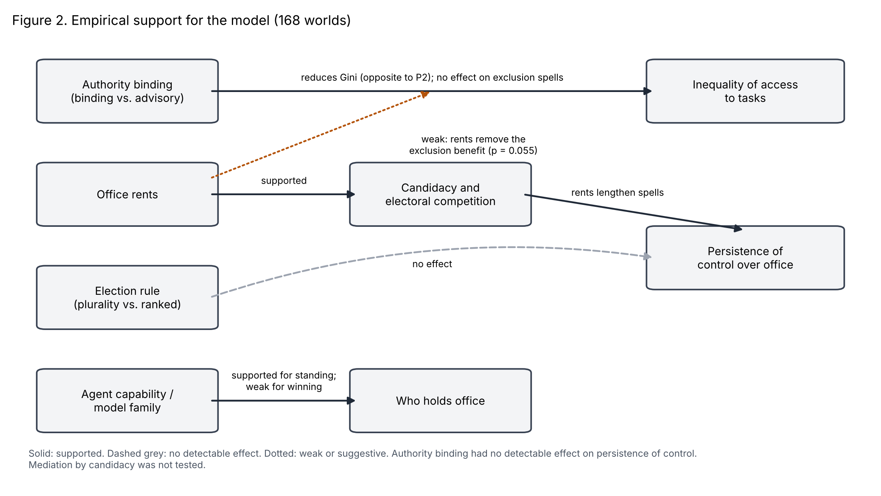
Figure 2. Empirical support for the model (168 worlds). Solid arrows indicate supported effects, dashed grey arrows no detectable effect, and the dotted arrow a weak or suggestive moderation. Authority binding had no detectable effect on persistence of control. Mediation by candidacy was not tested.

5.2 Implications for governance design
Three implications follow, with the caution that they derive from a single simulated environment. First, designers who wish to limit contention over control of an agent system should look at the incentives attached to the role before the powers attached to it. Second, binding authority was not harmful here, and may have been protective, in the sense that holders distributed access more evenly than a lottery would. The mechanism evidence suggests that this protection came from the fairness heuristics the holders applied and not from authority as such, so it may not survive prompts or models that make a holder’s own interest salient. It should not be generalized to settings where holders have private interests that conflict with those of the agents they allocate to. Third, measures of exchange based on co-occurrence, such as a gift followed by a vote, require a benchmark. Without our placebo comparison we would have reported evidence of vote buying where the data show only a high base rate of giving.

5.3 Limitations
The environment is small: six agents, 50 days, two tasks per day, and a single prompt framing. The agents had no heterogeneous interests beyond energy and no means of coercion or exclusion beyond the allocation itself. Public reputation records, which the platform supports, were not varied. Outcomes depend on the specific models and on a sampling temperature of 1.0; both are snapshots, and different versions may behave differently. The permutation tests in Table 1 are marginal and uncorrected for multiple comparisons. The factorial models with Holm and Benjamini–Hochberg adjustment address this for the tests tied to the propositions, but with six seeds per cell the design can detect an authority-by-rent interaction in the Gini only if it exceeds about 0.04. We did not vary initial endowments, so the part of the capability proposition concerning initial resources is untested. The allocation analysis in Section 4.2 uses only the 70 worlds and 2,025 days in which the office was filled under binding authority, the filling of office is itself an outcome of candidacy, and the placebo coefficient for self-allocation was not exactly zero, so we read the self-allocation result as a difference of degree against a noise floor. The account in Section 2.5 and the analyses of candidacy, winning, and allocation rules were developed after the main results and have not been tested on new data. A preregistered replication with larger populations, varied prompt framing, and reasoning enabled is the necessary next step. Finally, the findings come from simulated agents, and no claim is made that human actors, or agents embedded in organizations, would behave in the same way. A human benchmark in the same environment would be the most informative extension.

5.4 Future research
Several extensions follow from these limits: larger populations and tighter scarcity, where competition for access is harder to resolve by rotation; heterogeneous endowments and interests; accountability mechanisms such as public records; and comparison with human participants in the same game. Studying how agents formed the informal rotation norms we observed in early pilots is a further direction, since such norms may be an important and under-studied form of self-governance among agents.

6. Conclusion
We asked when LLM agents sharing scarce resources seek and keep control over allocation, and whether control becomes capture. In a controlled simulation of 168 worlds, the rewards attached to office determined whether agents competed for it, binding authority led to a more equal distribution of tasks than chance, election rules made no detectable difference, and stronger models were more active in seeking office. Where concentration appeared, it was concentration of office, not of access. For the designers of agentic systems, the primary design lever is the value attached to a role, and the evidence for capture by authority is, so far, weak.

References
Acemoglu, D., and Robinson, J. A. 2012. Why Nations Fail: The Origins of Power, Prosperity, and Poverty. New York: Crown.
Arthur, W. B. 1989. “Competing Technologies, Increasing Returns, and Lock-In by Historical Events,” The Economic Journal (99:394), pp. 116-131.
Eisenhardt, K. M. 1989. “Agency Theory: An Assessment and Review,” Academy of Management Review (14:1), pp. 57-74.
Horton, J. J. 2023. “Large Language Models as Simulated Economic Agents: What Can We Learn from Homo Silicus?” NBER Working Paper.
Jensen, M. C., and Meckling, W. H. 1976. “Theory of the Firm: Managerial Behavior, Agency Costs and Ownership Structure,” Journal of Financial Economics (3:4), pp. 305-360.
Karten, S., Li, W., Ding, Z., Kleiner, S., Bai, Y., and Jin, C. 2025. “LLM Economist: Large Population Models and Mechanism Design in Multi-Agent Generative Simulacra,” arXiv:2507.15815.
Merton, R. K. 1968. “The Matthew Effect in Science,” Science (159:3810), pp. 56-63.
Ostrom, E. 1990. Governing the Commons. Cambridge: Cambridge University Press.
Rahwan, I., et al. 2019. “Machine Behaviour,” Nature (568), pp. 477-486.
Sambamurthy, V., and Zmud, R. W. 1999. “Arrangements for Information Technology Governance: A Theory of Multiple Contingencies,” MIS Quarterly (23:2), pp. 261-290.
Tiwana, A., Konsynski, B., and Bush, A. A. 2010. “Platform Evolution: Coevolution of Platform Architecture, Governance, and Environmental Dynamics,” Information Systems Research (21:4), pp. 675-687.
Weill, P., and Ross, J. W. 2004. IT Governance: How Top Performers Manage IT Decision Rights for Superior Results. Boston: Harvard Business School Press.
Zhang, L., and Shang, S. 2026. “AI Agent Economics: Can Autonomous Economic Behavior Emerge among AI Agents under Minimal External Conditions?” arXiv:2608.03076.

