Flat Prices for Shared Generative AI Capacity: Batching, Demand Phases, and Posted Schedules
Blinded manuscript for double-anonymous review. Author names, affiliations and acknowledgments are provided separately in ScholarOne. Article type: Research Article.

Abstract
Generative artificial intelligence (AI) is increasingly delivered from shared clusters of accelerators, whether by providers that sell metered access or by organizations that run internal AI platforms and charge business units for their use. Because capacity is shared, every request imposes delay on others, a cost that users bear as latency and that no invoice records, yet the dominant practice is a price that does not vary over time. We ask when a time-invariant price is a poor way to govern such capacity, how much welfare it forgoes, and how much a short posted schedule of prices can recover. Building on the congestion-pricing theory of computing services, we develop a model in which demand switches among phases and requests are served in batches, so that each admitted request slows the requests already in service. Four results follow. First, batched serving creates a slowdown externality that dedicated-server models lack; it arises at loads far below those at which queues form, so efficient prices are positive even in quiet periods. Second, the congestion toll equals the excess of the variance of the number of requests in the system over its mean, per unit arrival rate, and it rises strictly with load whenever throughput shows diminishing returns to concurrency and completion time per request rises at a nondecreasing rate. Third, whether a flat price is costly depends on a ratio of time scales: when demand phases switch quickly relative to the queue, the loss of the best flat price vanishes quadratically in the dwell time, and when they switch slowly the system behaves as a sequence of steady states. Fourth, optimal schedules with few price levels group phases contiguously by demand and can be computed by dynamic programming. Calibrated on public Microsoft Azure and BurstGPT traces and on measured decode times, the model shows that a flat price forgoes 4% to 13% of the welfare attainable with hourly prices on a trace with a pronounced daily cycle, that a two-level peak/off-peak schedule removes 74% to 84% of that loss, and that capacity sized under a Poisson assumption falls short of a delay target by 7% on a conversation trace and by 81% on a code trace.
Keywords: generative AI services; pricing of IT services; congestion pricing; batching; cloud computing; capacity planning; analytical modeling; queueing

1. Introduction
Organizations are rebuilding the shared computer center. Enterprises now route employees’ and applications’ requests to large language models (LLMs) through internal AI platforms that run on a common pool of accelerators, and they must decide how to charge business units for that capacity. Externally, providers sell the same kind of shared capacity through metered application programming interfaces (APIs). In both settings, every request lengthens the wait of others, a cost that no invoice records. The information systems (IS) literature resolved this problem four decades ago for centralized computing: the efficient charge equals the delay a job imposes on others (Mendelson 1985, Dewan and Mendelson 1990). That resolution, however, rested on two features of the computer center that generative AI does not share.
The first is stationary demand. The public workload traces analyzed in this paper (Patel et al. 2024, Stojkovic et al. 2025, Wang et al. 2025) show clear daily cycles and, on shorter time scales, pronounced bursts, yet the dominant commercial arrangement is a posted price per token that does not change with the time of day or the state of the cluster. A price that is right on average is then too high when the cluster is idle and too low when it is saturated. The second is the technology of service. In the classic models, a job occupies a server of its own once it starts, so it delays only the jobs that wait behind it. LLM inference is instead served in batches: a serving engine generates tokens for many requests at once, and each additional request in the batch lengthens the time every other request needs to produce its next token (Yu et al. 2022, Kwon et al. 2023). An admitted request therefore slows the requests already in service even when no request waits.
Some providers have begun to depart from flat prices. DeepSeek charges twice as much during weekday working hours in China as at other times, and OpenAI offers a delay-tolerant tier at half the standard rate alongside low-latency tiers priced at two to six times that rate (Section 6.6). These arrangements raise questions that matter to anyone who designs, runs or buys AI services. Is it worth departing from a single price? If so, how many price levels are needed, and when should they apply? And does the batched technology of AI serving change the answers? This paper addresses two research questions.
RQ1. When does a time-invariant price fail to govern shared AI inference capacity efficiently, and how large is the resulting welfare loss?
RQ2. How much of that loss can a short posted schedule of prices recover, and what structure does the best such schedule have?
Along the way, we quantify how much capacity planning based on Poisson arrivals understates the capacity that observed LLM workloads require, because the same burstiness that makes flat prices costly also defeats capacity formulas that ignore it.
To answer these questions, we extend the congestion-pricing model of Mendelson (1985) and Dewan and Mendelson (1990) in two directions. Demand moves among phases, such as hours of the day or bursts, according to a Markov process. And service is batched: the cluster serves up to a fixed number of requests at once, and the speed at which each request progresses falls as the batch grows. The classic dedicated-server queue is the special case in which speed does not depend on the batch size. In each phase, users observe the posted price and the phase and decide whether to submit a request, anticipating the expected delay; they do not observe the queue itself. This information structure matches how API customers and internal users interact with a cluster: they know the price and roughly when the service is busy, but they cannot see the backlog. The model is simple enough to yield exact statements, and we calibrate it on public traces from Microsoft Azure and BurstGPT and on decode times measured on an open-weight model.
The central result is a time-scale condition. Whether a flat price is costly depends not on the amount of demand variation alone but on how long demand phases last relative to the time the queue needs to adjust. When phases alternate quickly, all phases experience nearly the same delay, and the loss of the best flat price vanishes at a rate quadratic in the dwell time. When phases alternate slowly, the exact model converges to a sequence of steady states, in which a flat price is efficient only if all phases are alike and its welfare loss has an exact integral form. Between these limits, the loss peaks when bursts last a few service times. The condition tells a provider or a platform team which fluctuations a price schedule can usefully address and which ones the queue absorbs on its own (Sections 4.3 and 6.4).
Batching adds a second externality to the one the classic theory prices. The congestion toll splits into a waiting component and a slowdown component, both nonnegative, and the slowdown component dominates at low load, because batches are large and slowdown begins long before queues form (Section 4.1). Efficient prices are therefore positive even in quiet hours, and efficient schedules are flatter than a dedicated-server model would suggest. Batching also opens a channel through which fast fluctuations matter: a request that arrives in a busy phase anticipates more arrivals during its own service, and under batching those arrivals slow it down. The analysis rests on a representation of the toll as the excess of the variance of the number of requests in the system over its mean, per unit arrival rate, and on a result that guarantees that this toll rises with load whenever throughput shows diminishing returns to concurrency and completion time per request rises at a nondecreasing rate. Both conditions hold for batch servers whose step time grows linearly in the batch size and for the dedicated-server queue, for which the result recovers the known convexity of the Erlang C delay.
When few price levels are allowed, the optimal schedule groups phases contiguously in order of demand, and the residual loss falls roughly as the inverse square of the number of levels; contiguity reduces the search for the best schedule to a dynamic program over ordered partitions (Section 4.4). In the calibration, two levels recover 81% of the flat-price loss and four levels 95%, Poisson-based capacity planning understates the required capacity by 7% on the conversation trace and by 81% on the code trace, and the two-to-one peak/off-peak ratio posted by one provider is consistent with a serving cost of 2% to 14% of the marginal user’s value (Section 6).
The paper contributes to IS research in three ways. First, it adds a boundary condition to the IS theory of computing-service prices (Mendelson 1985, Dewan and Mendelson 1990, Dewan 1996): the assumption of stationary demand is harmless in some regimes and misleading in others, and the dividing line is a ratio of time scales rather than the size of demand fluctuations. Second, it identifies the externality that batched AI serving adds to the one that theory prices, characterizes when the resulting toll is well behaved, and recovers the classic dedicated-server results as a special case. Third, it speaks to the literature on pricing digital and cloud services (e.g., Sundararajan 2004, Hosanagar et al. 2008, Dierks and Seuken 2022) by showing that, for latency-sensitive AI services, the temporal structure of a price, not only its level or its menu, is a design variable with measurable welfare consequences, and it offers a replicable procedure that platform teams, providers and enterprise buyers can apply to their own request logs and serving engines. For practice, the results support short posted schedules over either a single price or fully dynamic pricing, they caution that the ratio between peak and off-peak prices must be chosen with care, and they show that sizing a cluster from mean utilization or from waiting time alone can understate the required capacity by a wide margin.
We use welfare as the objective. It fits an internal platform that charges business units in order to allocate capacity efficiently, and it separates the inefficiency of a time-invariant price from the question of who captures the surplus. We do not model competition among providers, and the sharpest analytical results hold only in the limits of slow and fast switching; Section 8 discusses these limitations. Section 2 positions the study in the literature. Section 3 presents the model and Section 4 the analytical results; proofs are collected in Online Appendix A and numerical verifications in Online Appendix B. Section 5 describes the data, the measurement of serving parameters and the computational procedures, Section 6 reports the results, Section 7 discusses implications for research and practice, and Section 8 concludes.

2. Related Literature
The study draws on three streams: the IS literature on pricing computing and digital services, the economics of congestion and time-varying prices in queues, and recent work on the economics and operations of LLM serving.

2.1 Pricing Computing and Digital Services
The IS literature has long treated the price of a shared computing resource as an instrument of governance rather than merely a means of cost recovery. Mendelson (1985) showed that users of a computer center, each considering only their own delay, overuse the facility, and that an internal price equal to the delay externality restores efficiency. Dewan and Mendelson (1990) incorporated heterogeneous user delay costs and derived the joint optimum of price and capacity, and Mendelson and Whang (1990) designed incentive-compatible priority prices when delay costs are private. Dewan (1996) compared alternative control structures for computing services and traced how changing technology alters the relative merits of pricing and capacity. Gupta et al. (1997) carried the same logic to Internet pricing, where users decide on the basis of expected rather than realized congestion. All of these models assume that demand is stationary, and all assume that a job in service does not slow other jobs in service. Our point of departure is to relax both assumptions, which are the defining features of the workloads and the serving technology that AI providers now face.
A second line of IS research studies how digital goods and IT services should be priced when marginal costs are low and usage is metered. Bakos and Brynjolfsson (1999) and Sundararajan (2004) analyze bundling and nonlinear pricing of information goods, Choudhary (2007) compares perpetual licensing with software as a service, and Hosanagar et al. (2008) study pricing and adoption of content delivery services in which performance depends on load. In cloud computing, Dierks and Seuken (2022) combine queueing and game theory to show when a provider gains from selling idle capacity on a preemptible spot market next to a fixed-price market. These studies focus on the menu of contracts and the level of prices. We focus on a different design dimension, the temporal structure of a posted price, and ask how many price levels a provider needs and over which hours each should apply.

2.2 Congestion, Peak-Load and Dynamic Pricing in Queues
Our model belongs to the economics of congestion in queues initiated by Naor (1969), who showed that self-interested customers join a queue more often than is socially optimal and that a toll restores efficiency; Hassin and Haviv (2003) survey the equilibrium analysis that followed, and Afèche and Mendelson (2004) extend priority pricing to general delay cost structures. Time variation in demand is the central concern of the peak-load pricing literature (Steiner 1957, Boiteux 1960), but there capacity is fixed and demand deterministic, so queueing delay plays no role.
Within queueing theory, a body of work asks how much is gained by conditioning the price on the state of the system. Paschalidis and Tsitsiklis (2000) and Ata and Shneorson (2006) analyze congestion-dependent prices, Kim and Randhawa (2018) quantify the value of dynamic over static pricing in large queueing systems, and Bergquist and Elmachtoub (2026) provide performance guarantees for static pricing. In our setting, prices depend on an exogenous demand phase that the provider observes, which is precisely the situation in which time-of-day schedules are used. Our finding that a few price levels capture most of the gain is related in spirit to that work. The mechanism differs, however, because the price responds to the phase rather than to the queue length, and we do not claim a formal equivalence. Markov-modulated Poisson processes, which we use to represent bursty demand, are a standard tool in traffic modeling (Heffes and Lucantoni 1986, Fischer and Meier-Hellstern 1993), and our analysis of fast switching uses the perturbation theory of Markov chains (Schweitzer 1968, Avrachenkov et al. 2013).

2.3 Economics and Operations of LLM Serving
A fast-growing literature examines how LLM services are priced and run. Bergemann et al. (2026) study menu pricing for LLMs. McDougall and Sankaralingam (2026) design latency-aware mechanisms for inference when users hold private information about willingness to pay, task volume and time preference, and show that optimal per-task prices do not depend on volume. Their model abstracts from queueing, and they note that stochastic demand would connect their framework to congestion externalities. The two results concern different objects: theirs concerns linearity in volume, ours constancy over time. On the systems side, continuous batching, which admits new requests into a running batch at each generation step, is the standard way to serve LLMs (Yu et al. 2022), and memory management for the key–value cache determines how many requests a batch can hold (Kwon et al. 2023). Recent papers derive scheduling and control policies for contention between the prefill and decode stages of inference (Dai et al. 2025, Lin et al. 2026). We do not study scheduling; instead we abstract the serving engine into a rate at which the cluster completes requests as a function of how many are present, which captures the effect of batch size on the speed of each request. The public traces released alongside systems studies (Patel et al. 2024, Stojkovic et al. 2025, Wang et al. 2025) motivate our demand model and supply our calibration data.
We are not aware of prior work that combines Markov-modulated demand, a batched service technology, welfare-optimal pricing under equilibrium user behavior and a calibration on LLM workload traces. By joining these elements, the paper connects the classic IS theory of computing-service prices to the design questions that AI providers, platform teams and enterprise customers face today.

3. Model
We consider a provider or platform that operates a cluster for LLM inference and posts a price per request. Users decide whether to submit requests after observing the price and the current demand phase. The model keeps the structure of Mendelson (1985) and Dewan and Mendelson (1990), namely a delay externality priced through a toll, and adds phase-varying demand and a batched service technology. Figure 1 summarizes the structure.
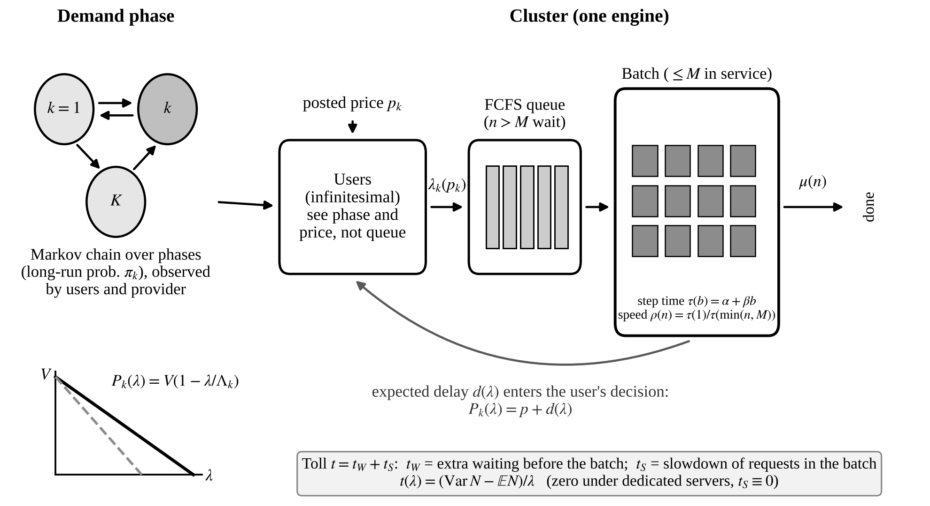
Figure 1. Model Structure: Demand Phases, Price- and Delay-Sensitive Users, and a Batched Serving Cluster

3.1 Phases and Demand
The system moves among K phases, indexed by k = 1, …, K, with long-run probabilities π_{k} > 0. Both the provider and the users observe the current phase. In phase k, inverse demand is linear,
P_{k}(λ) = V(1 − λ/Λ_{k}), 0 ≤ λ ≤ Λ_{k}, (1)
where λ is the request rate, V > 1 is the willingness to pay of the highest-value user, and Λ_{k} > 0 is the demand potential of the phase. We measure values, prices and delay costs in units of the cost of waiting one isolated service time, the mean time a request needs when it is served alone. Phases differ only in Λ_{k}, so a busy hour is one in which more users would like to submit requests at any given price. The gross user value in phase k is B_{k}(λ), the integral of P_{k} from 0 to λ.

3.2 Serving Technology and Delay
The cluster serves requests in batches. When n requests are in the system, at most M of them are in service, and the cluster completes requests at rate μ(n), with μ(0) = 0. We write μ(n) = min(n, M)·ρ(n), where ρ(n) ∈ (0, 1] is the speed at which each request in service progresses, normalized so that a request served alone takes one time unit on average (ρ(1) = 1), and ρ(n) = ρ(M) for n > M. Requests in excess of M wait in a first-come-first-served queue. Request sizes are exponentially distributed, and requests in service share the batch equally, so the number of requests in the system is a birth–death process.
Two cases illustrate the specification. If ρ ≡ 1, the cluster is the M/M/M queue of the classic analyses, and admitting a request never slows those already in service. Under linear batching, a serving engine that holds b requests needs time τ(b) = α + βb per generation step, so each request progresses at speed ρ(n) = τ(1)/τ(min(n, M)) = (α + β)/(α + β·min(n, M)), and M is the largest batch that the key–value cache admits. A cluster of several engines to which requests are routed at random behaves, engine by engine, like a single engine facing a proportional share of the demand, so the analysis applies to each engine. Balanced routing across engines is discussed in Section 5.4 and Online Appendix B.
Let r_{n} = n/μ(n) denote the mean completion time per request when n requests are present. We maintain the following assumption.
Assumption S. (S1) μ is nondecreasing and concave on {0, 1, 2, …}, and μ̄ = lim_{n→∞} μ(n) < ∞. (S2) r_{n} is convex in n ≥ 1.
Both conditions have a direct engineering reading: throughput shows diminishing returns to concurrency, and completion time per request rises at a nondecreasing rate as requests accumulate. Both hold under dedicated servers, where r_{n} = max(1, n/M), and under linear batching, where r_{n} rises at slope β/(α + β) until the batch is full and at the larger slope 1/μ̄ = α/(M(α + β)) + β/(α + β) afterwards. Section 5.2 checks them on measured decode times. Concavity of μ with μ(0) = 0 implies that r_{n} is nondecreasing.
At request rate λ < μ̄, let N denote the stationary number of requests in the system. The mean sojourn time of a request is d(λ) = E[N]/λ by Little’s law. It splits into the mean wait before a request enters the batch, w(λ) = E[(N − M)⁺]/λ, and the mean time in the batch, s(λ) = d(λ) − w(λ). The total waiting cost rate is D(λ) = λd(λ). We define the toll function
t(λ) = λd′(λ) = D′(λ) − d(λ), (2)
which measures the additional delay that one more request imposes on all other requests, and we write t = t_{W} + t_{S} with t_{W} = λw′ and t_{S} = λs′ for its waiting and slowdown components.
Lemma 1 (Representation). For 0 < λ < μ̄, (a) d(λ) = E[r_{N+1}], w(λ) = E[(N + 1 − M)⁺/μ(N + 1)] and s(λ) = E[1/ρ(N + 1)]; (b) t(λ) = (Var N − E N)/λ.
Part (a) states that a request is delayed, on average, as if it completed at the per-request pace of the state that its own arrival creates. Part (b) gives the toll an interpretation that does not depend on the details of the serving technology. Without congestion, as in a system with unlimited servers, the number of requests in the system is Poisson, its variance equals its mean, and the toll is zero. Congestion makes occupancy overdispersed, and the toll measures that overdispersion per unit arrival rate.

3.3 Quasi-Static Queue and User Equilibrium
In the baseline analysis, the queue is assumed to be in steady state at the arrival rate of the current phase. This approximation is accurate when phases last long relative to the relaxation time of the queue; Sections 4.3 and 6.4 relax it. A posted price p_{k} applies in phase k. Users are infinitesimal and submit a request as long as the value of the marginal request covers the price plus the expected delay. The equilibrium rate λ_{k}(p) therefore solves P_{k}(λ) = p + d(λ) whenever p < V − 1, and equals zero otherwise.
The assumption that users see the phase and the price but not the queue deserves a brief comment. API customers and internal users can learn from experience, published status pages or the provider’s own tier descriptions when the service tends to be slow, but they cannot observe the instantaneous backlog of the cluster. Their decision therefore rests on expected rather than realized delay, as in Gupta et al. (1997).

3.4 Welfare and Serving Cost
Welfare in phase k at price p is W_{k}(p) = B_{k}(λ_{k}(p)) − D(λ_{k}(p)), and expected welfare under a schedule (p₁, …, p_{K}) is the sum over k of π_{k}W_{k}(p_{k}). A flat price sets p_{k} = p for all k. If the provider also incurs a marginal serving cost c₀ per request, for example the energy and amortized hardware cost of generating tokens, welfare is reduced by c₀λ. This is equivalent to replacing V with V − c₀, with the price paid equal to c₀ plus the toll. We set c₀ = 0 in Sections 3 to 5 and reintroduce it in Section 6.6.
We adopt welfare as the objective for two reasons. It is the benchmark that the congestion-pricing literature in IS uses to judge chargeback and pricing rules, and it is the natural objective of an internal platform that charges business units in order to allocate shared capacity. It also separates the inefficiency caused by the time-invariance of a price from the distributional question of who captures the surplus. Section 8 notes that, with competing providers, phase-dependent prices can raise profits without raising welfare.

4. Analysis
This section answers RQ1 and RQ2 analytically. Section 4.1 establishes the properties of delay and toll under batching, Section 4.2 characterizes first-best prices and the loss of a flat price in the quasi-static model, Section 4.3 examines how that loss depends on the speed at which phases switch, and Section 4.4 studies schedules with a small number of price levels. Proofs are in Online Appendix A.

4.1 Delay and Toll under Batching
Proposition 1 (Delay and Toll). Under (S1), d is real-analytic on [0, μ̄), d(0) = 1, d is strictly increasing, and d(λ) → ∞ as λ ↑ μ̄. Under (S1) and (S2), d is also convex; consequently, the toll t is strictly increasing and the total delay D is strictly convex.
Proposition 1 supplies the properties that the classic analysis takes from the Erlang C formula, and in the dedicated-server case it recovers the known convexity of the M/M/c sojourn time (Grassmann 1983, Lee and Cohen 1983). The proof writes G(λ)[d(λ) − ℓ(λ)], where G is the normalizing constant of the stationary distribution and ℓ an arbitrary line, as a power series whose coefficients form a convex sequence under Assumption S, and applies Descartes’ rule of signs. Neither condition can be dropped. Online Appendix B gives an example in which μ is not concave and the toll falls with load over a wide range, and it shows that balanced routing across many engines, under which r_{n} is locally concave, produces local violations.
Proposition 2 (Toll Decomposition). (a) Under (S1), t_{W} ≥ 0 and t_{S} ≥ 0. (b) t_{S} ≡ 0 if and only if ρ ≡ 1, that is, under dedicated servers. (c) Let n_{S} = min{n : ρ(n) < 1} and m = n_{S} − 1. As λ → 0, t_{S}(λ) = Θ(λ^{m}) and t_{W}(λ) = Θ(λ^{M}).
The classic models price only one externality: a request that finds all servers busy delays those behind it. Batched serving adds a second. A request admitted into a batch slows every request already being served, even when no one waits. Under linear batching n_{S} = 2, so the slowdown toll grows linearly from zero, whereas the waiting toll is of order λ^{M} with M in the tens or hundreds. The externality in quiet hours therefore consists almost entirely of slowdown, the efficient price is positive even when the cluster is lightly loaded, and the efficient schedule is flatter than a queueing model with dedicated servers would suggest. A stylized calibration in Online Appendix B (Table B5) illustrates the size of the effect: holding capacity fixed, raising β/α from 0 to 0.06 lifts the toll of the lower-quartile hour from essentially zero to 0.25 and shifts about three quarters of that toll to slowdown.

4.2 First-Best Prices, Flat Prices and the Exact Loss
Let λ*_{k} maximize w_{k}(λ) = B_{k}(λ) − D(λ). Since B_{k} is concave and D is strictly convex by Proposition 1, w_{k} is strictly concave, and λ*_{k} > 0 solves P_{k}(λ) = D′(λ). This rate is implemented by the price p*_{k} = t(λ*_{k}). In words, the first-best price in a phase is the congestion toll evaluated at the first-best rate. We denote by
κ_{k}(p) = −λ_{k}′(p) = 1/[V/Λ_{k} + d′(λ_{k}(p))] > 0 (3)
the sensitivity of the equilibrium rate to the price.
Proposition 3 (Tolls Rise with Demand). If Λ_{j} > Λ_{k}, then λ*_{j} > λ*_{k} and p*_{j} > p*_{k}.
Proposition 4 (Flat Pricing). (a) W_{k}′(p) = −κ_{k}(p)[p − t(λ_{k}(p))], and W_{k} is strictly increasing for p < p*_{k} and strictly decreasing for p > p*_{k}. (b) If the Λ_{k} are not all equal, no flat price attains the first best. Every maximizer p^{f} of expected welfare satisfies min_{k} p*_{k} < p^{f} < max_{k} p*_{k} and solves
Σ_{k} π_{k} κ_{k}(p^{f}) [p^{f} − t(λ_{k}(p^{f}))] = 0. (4)
If all Λ_{k} are equal, the common price p* is first best.
Proposition 5 (Exact Loss). For any flat price p,
W^{FB} − W(p) = Σ_{k} π_{k} ∫ from p*_{k} to p of κ_{k}(s)[s − t(λ_{k}(s))] ds ≥ 0, (5)
where each integral is nonnegative.
Proposition 3 is the formal basis for time-of-day pricing of AI capacity: busier phases warrant higher prices, not because the provider can extract more from users, but because each request does more damage to others when the cluster is loaded. It relies on the toll rising with load, which Proposition 1 guarantees under Assumption S. Proposition 4 shows that the best flat price is a compromise. It overprices quiet phases, deterring requests that would have cost others little, and it underprices busy ones, admitting requests whose delay externality exceeds their value. Proposition 5 measures the cost of this compromise exactly.
When the dispersion of the Λ_{k} is small, a second-order expansion yields a simpler expression. Defining ω_{k} = κ_{k}(1 + κ_{k}t′(λ*_{k})), one has W_{k}″(p*_{k}) = −ω_{k}, and the loss of the best flat price is approximately
½ Σ_{k} π_{k} ω_{k} (p*_{k} − p̄)², (6)
where p̄ is the πω-weighted mean of the p*_{k} (Proposition 6 in Online Appendix A). The loss thus grows with the weighted variance of first-best tolls across phases. Under batching, Proposition 2 implies that the tolls of quiet phases are no longer negligible, so the dispersion of tolls, and with it the loss in (6), is smaller than a dedicated-server model would predict for the same demand profile. The numerical check in Section 6.3 confirms that the approximation is accurate for small spreads and overstates the loss for large ones. The direction of the error deserves comment. Setting the price at the level appropriate for average demand does not systematically underprice. Whether that price lies above or below the best flat price depends on the curvature of the map Λ ↦ p*(Λ), and both cases occur in our data.

4.3 Switching Speed
The quasi-static model ignores the time the queue needs to adjust when the phase changes. To study this adjustment, let the phase process have generator θG₀, where G₀ is irreducible with stationary distribution π. The parameter θ is the switching speed, and the mean dwell time in phase k equals 1/(θ|G₀(k,k)|). Throughout this subsection the buffer is finite, of size N, as in all Markov chain computations reported below. The state space is S = {0, …, N} × {1, …, K}, and the generator is θQ₀ + Q₁, where Q₀ = I ⊗ G₀ changes only the phase and Q₁ contains the queue transitions: arrivals at rate λ_{k} in phase k (blocked at level N) and completions at rate μ(n). We write μ_{θ} for its stationary distribution.
We parameterize plans by the rate vector λ = (λ₁, …, λ_{K}) in a compact set R. Since any rate vector is implemented by the prices p_{k} = P_{k}(λ_{k}) − d_{k}^{θ}(λ), nothing is lost, and uniqueness of equilibrium for given prices is not needed. Under dedicated servers and first-come-first-served service, the delay of a request depends only on the number of requests it finds on arrival. Under batching this is no longer so: requests that arrive later join the batch and slow the requests already in it, so the delay of a request depends on the future path of phases. We therefore follow a tagged request. Its state (a, b, k) records the number of requests ahead of it, the number behind it and the phase. Arrivals, phase changes and completions occur as in the original chain, and once a < M the tagged request completes at rate μ(n)/min(n, M), where n = a + b + 1. Let T_{θ}(a, b, k) denote its expected remaining sojourn time. The mean sojourn time of an admitted request arriving in phase k is
d_{k}^{θ}(λ) = Σ_{n<N} μ_{θ}(n | k) T_{θ}(n, 0, k) / [1 − μ_{θ}(N | k)]. (7)
Under dedicated servers, T_{θ}(n, 0, k) = 1 + (n − M + 1)⁺/M for every θ and k, and (7) reduces to the familiar expression in which only the state found on arrival matters. By Little’s law, Σ_{k} π_{k} λ̃_{k} d_{k}^{θ}(λ) = E_{μθ}[N], where λ̃_{k} = λ_{k}[1 − μ_{θ}(N | k)] is the admitted rate in phase k. Online Appendix B confirms both properties numerically and shows that the shortcut of freezing the phase at the arrival time overstates the difference in delay between phases by up to 12% under fast switching, so that it would wrongly predict a loss that does not vanish in the limit.
Expected welfare is W_{θ}(λ) = Σ_{k} π_{k}[1 − μ_{θ}(N | k)]B_{k}(λ_{k}) − E_{μθ}[N], where blocked requests are drawn at random from those submitted. The results below hold for any welfare function of the form Φ(λ, μ_{θ}) with Φ twice continuously differentiable. Let d_{N}(x) denote the mean sojourn time of admitted requests in the stationary single-phase queue with arrival rate x and buffer N, and let λ̄ = Σ_{k} π_{k}λ_{k}. Two benchmark welfare functions play a role:
W^{qs}(λ) = Σ_{k} π_{k}[B_{k}(λ_{k}) − λ_{k}d_{N}(λ_{k})], W∞(λ) = Σ_{k} π_{k}B_{k}(λ_{k}) − λ̄ d_{N}(λ̄). (8)
The loss L(θ) is the difference between the largest welfare attainable with phase-dependent prices and the largest welfare attainable with a single price, both computed in the exact chain. We use two assumptions. (A1) d_{N} is twice continuously differentiable and nondecreasing; Lemma A.2 shows that (A1) holds under (S1). (A2) W∞ has a unique maximizer λ∞ in the interior of R, and its Hessian there is negative definite. Assumption (A2) holds whenever x ↦ x d_{N}(x) is convex near λ̄∞, which is the case for large N because d_{N} then approaches d, which is convex by Proposition 1.
Theorem 7 (Switching-Speed Limits). (a) Fast switching, limit. For fixed rates, μ_{θ} → ν ⊗ π as θ → ∞, where ν is the stationary distribution of the single-phase queue with rate λ̄, and d_{k}^{θ}(λ) → d_{N}(λ̄) for every k. Hence every phase faces the delay d_{N}(λ̄), the limiting first-best rates satisfy P_{k}(λ_{k}) = D_{N}′(λ̄) for all k with D_{N}(x) = x d_{N}(x), a flat price implements them, and L(θ) → 0.
(b) Fast switching, rate. Under (A1) and (A2), μ_{θ} and d_{k}^{θ} are real-analytic in 1/θ at 1/θ = 0, and
L(θ) ≤ κ/θ² + O(θ⁻³), κ = ½[gᵀ(−H)⁻¹g − (1ᵀg)²/(1ᵀ(−H)1)] ≥ 0, (9)
where H and g are the Hessian with respect to prices and the mixed derivative with respect to 1/θ and prices of equilibrium welfare, evaluated at the limiting flat price. If the best flat price lies on the equilibrium branch through the limiting optimum, the bound holds with equality. The loss therefore vanishes quadratically in the dwell time, and κ = 0 only in the nongeneric case in which g is proportional to H1.
(c) Slow switching. Under (A1), as θ → 0, μ_{θ} converges to the distribution that puts mass π_{k}ν_{k}(n) on state (n, k), where ν_{k} is the stationary distribution of the single-phase queue with rate λ_{k}. Moreover, d_{k}^{θ}(λ) = d_{N}(λ_{k}) + O(θ) uniformly on R, and L(θ) = L_{N}^{qs} + O(θ), where L_{N}^{qs} is the flat-price loss of the quasi-static model of Section 4.2 with d replaced by d_{N}.
The intuition for parts (a) and (b) is as follows. A queue subject to rapid switching cannot tell the phases apart, so the externality of a request hardly depends on the phase in which it arrives. For large θ, phase-conditional delays differ from d_{N}(λ̄) by terms of order 1/θ, so first-best prices differ across phases by the same order. Because welfare is flat to first order at its maximum, imposing a common price costs only the square of that difference. Part (c) is the mirror image: under slow switching, the queue settles into the steady state of each phase before the phase changes, and the quasi-static analysis of Section 4.2 becomes exact up to an error proportional to θ.
Under batching, the first-order term of the phase-conditional delays has two parts (Lemma A.5). The first reflects the state that a request finds on arrival, as under dedicated servers. The second is new: d_{k}^{θ} contains the term (1/θ) Σ_{j} D₀(k, j)(λ_{j} − λ̄) E_{ν}[τ₀(N, 1) − τ₀(N, 0)], where D₀ is the deviation matrix of G₀ and τ₀(a, 1) − τ₀(a, 0) is the extra delay that one later arrival causes a request that finds a requests ahead of it when arrivals occur at the average rate. A request that arrives in a busy phase expects more arrivals during its own service, and under batching those arrivals slow it down. The term vanishes under dedicated servers, so this future-arrival channel is the dynamic counterpart of the slowdown externality of Proposition 2.
Two remarks qualify these statements. First, the expansion behind part (b) is in ε‖Q₁D₀‖, where ε = 1/θ (Online Appendix A). This quantity scales with the dwell time multiplied by the largest arrival rate, not with the dwell time alone, so the quadratic regime may require very short bursts when burst arrival rates are high. In a two-phase example in Online Appendix B (Table B3), the local log–log slope of the loss rises from 1.71 to 1.98 as the dwell time falls from 0.25 to 0.016 service times, with and without slowdown, and the quadratic regime is reached once the dwell time multiplied by the largest arrival rate is below about 0.1. Second, the quasi-static results of Section 4.2 use the delay d of the infinite-buffer queue. For x ≤ μ̄ − δ with δ > 0, the stationary distribution with buffer N converges geometrically fast to the infinite-buffer one as N → ∞, together with its derivatives in x, so d_{N} → d in C¹ on [0, μ̄ − δ]. Consequently L_{N}^{qs} → L^{qs} whenever the quasi-static optimal rates lie below μ̄ − δ, which holds because d(λ) → ∞ as λ ↑ μ̄.
For an IS audience, the managerial content of Theorem 7 is a simple test. A price schedule can only address fluctuations that last long enough for the queue to register them. Bursts much shorter than a few service times are smoothed by the queue itself, and charging for them would add complexity without benefit. Daily cycles, by contrast, last thousands of service times and fall squarely in the regime where the quasi-static analysis applies.

4.4 How Many Price Levels?
A schedule with G levels partitions the phases into G groups and posts a single price for each group. We order the phases by x_{k} = p*_{k}, which by Proposition 3 coincides with the order of the Λ_{k}.
Proposition 8 (Quadratic Regime). Approximate each W_{k} by its second-order expansion around p*_{k} and let w_{k} = π_{k}ω_{k}. (i) For a given partition with optimally chosen prices, the loss equals one half of the weighted within-group sum of squares of the x_{k}, and the optimal price of each group is the weighted group mean. (ii) Some optimal partition is contiguous in the order of the x_{k}. (iii) The share of the flat-price loss recovered by the best G-level schedule equals the between-group share of the weighted variance of the x_{k}.
Part (ii) has a direct computational consequence. Because an optimal partition can be sought among contiguous groups only, the best G-level schedule over K ordered phases can be found by dynamic programming in O(GK²) operations instead of by enumerating all set partitions. Section 6.3 uses the same recursion with the exact welfare curves. Part (ii) also has a practical reading: in the quadratic regime, a good schedule never assigns the same price to two hours unless every hour of intermediate demand also receives that price. Peak and off-peak blocks should follow the demand ranking, not the clock.
Corollary 9 (Bounds). Let q_{k} ∝ w_{k}, and denote by μ_{x}, MAD and σ the mean, the mean absolute deviation and the standard deviation of the x_{k} under q. (a) Two levels recover at least a share (MAD/σ)² of the flat-price loss. (b) If all x_{k} lie in [a, b], G levels recover at least a share 1 − (b − a)²/(4G²σ²).
Corollary 9(a) yields 3/4 for uniformly spread tolls and 2/π ≈ 0.64 for approximately Gaussian spreads. Both bounds are exact only in the quadratic model. A guarantee for the true welfare curves can be obtained from curvature bounds (Online Appendix A). In our calibration, however, the local curvatures range from about 1 to about 200, which makes that guarantee vacuous, and we therefore do not rely on it.

5. Data, Calibration and Computational Procedures

5.1 Workload Traces
We use four public data sets of LLM inference requests that record arrival times and token counts. The Azure LLM inference traces for 2023 contain 19,366 conversation requests over 3,502 seconds and 8,819 code requests over 3,436 seconds (Microsoft Azure 2023). The Azure 2024 code trace contains 16,803,695 requests collected over seven days (Microsoft Azure 2024). The BurstGPT file we use contains 1,429,737 requests over 61 days (Wang et al. 2025). All four data sets are released for research use by their owners, and we use them in accordance with the stated terms. None of the traces records prices or service times.
The traces differ in what they can reveal. The two 2023 traces span about an hour each and are informative about burstiness at the scale of seconds and minutes. The 2024 trace spans a week and reveals the daily cycle. The BurstGPT trace spans two months and is dominated by swings across days. We use each trace for the questions it can answer and say so where the evidence is thin.

5.2 Serving Technology
The traces record token counts but not service times, so we measure the serving technology directly. We serve an open-weight model with vLLM on one NVIDIA B300 GPU with Qwen2.5-7B-Instruct in bfloat16 (tensor-parallel size 1, vLLM 0.31.0 with the Triton attention backend) and measure the decode step time τ(b) for batch sizes b ∈ {1, 2, 4, …, 256, 512, 1024}. For each b, we submit b requests with random prompts of P tokens at once, force exactly O output tokens, and set τ(b) = [T_{O}(b) − T₁(b)]/(O − 1), where T₁ and T_{O} are the completion times with one and with O output tokens; the difference removes the prefill stage. Prefix caching is disabled so that no request reuses another’s cache. A least-squares fit gives α = 3.64 ms and β = 0.0321 ms (β/α = 0.0088, R² = 0.998), and the key–value cache admits at most M = 2,189 concurrent requests of the median trace length (1,930 prompt and 8 generated tokens; the key–value cache holds 4.24 million tokens). We use the largest measured batch, M = 1,024, as the batch cap, which is also the configured maximum number of sequences. The measured τ is approximately linear in b: it deviates from the fitted line by at most 6% for batches of 64 or more and by up to 17% for smaller batches, where the step time is flat and noisy, so strict convexity of τ and concavity of b/τ(b) fail at the smallest batch sizes. The fitted linear specification satisfies Assumption S exactly, and Section 6.5 shows that replacing it with the measured step-time curve changes the results little. Figure 2 shows the fitted step-time line. Prefill costs 16 µs per prompt token.
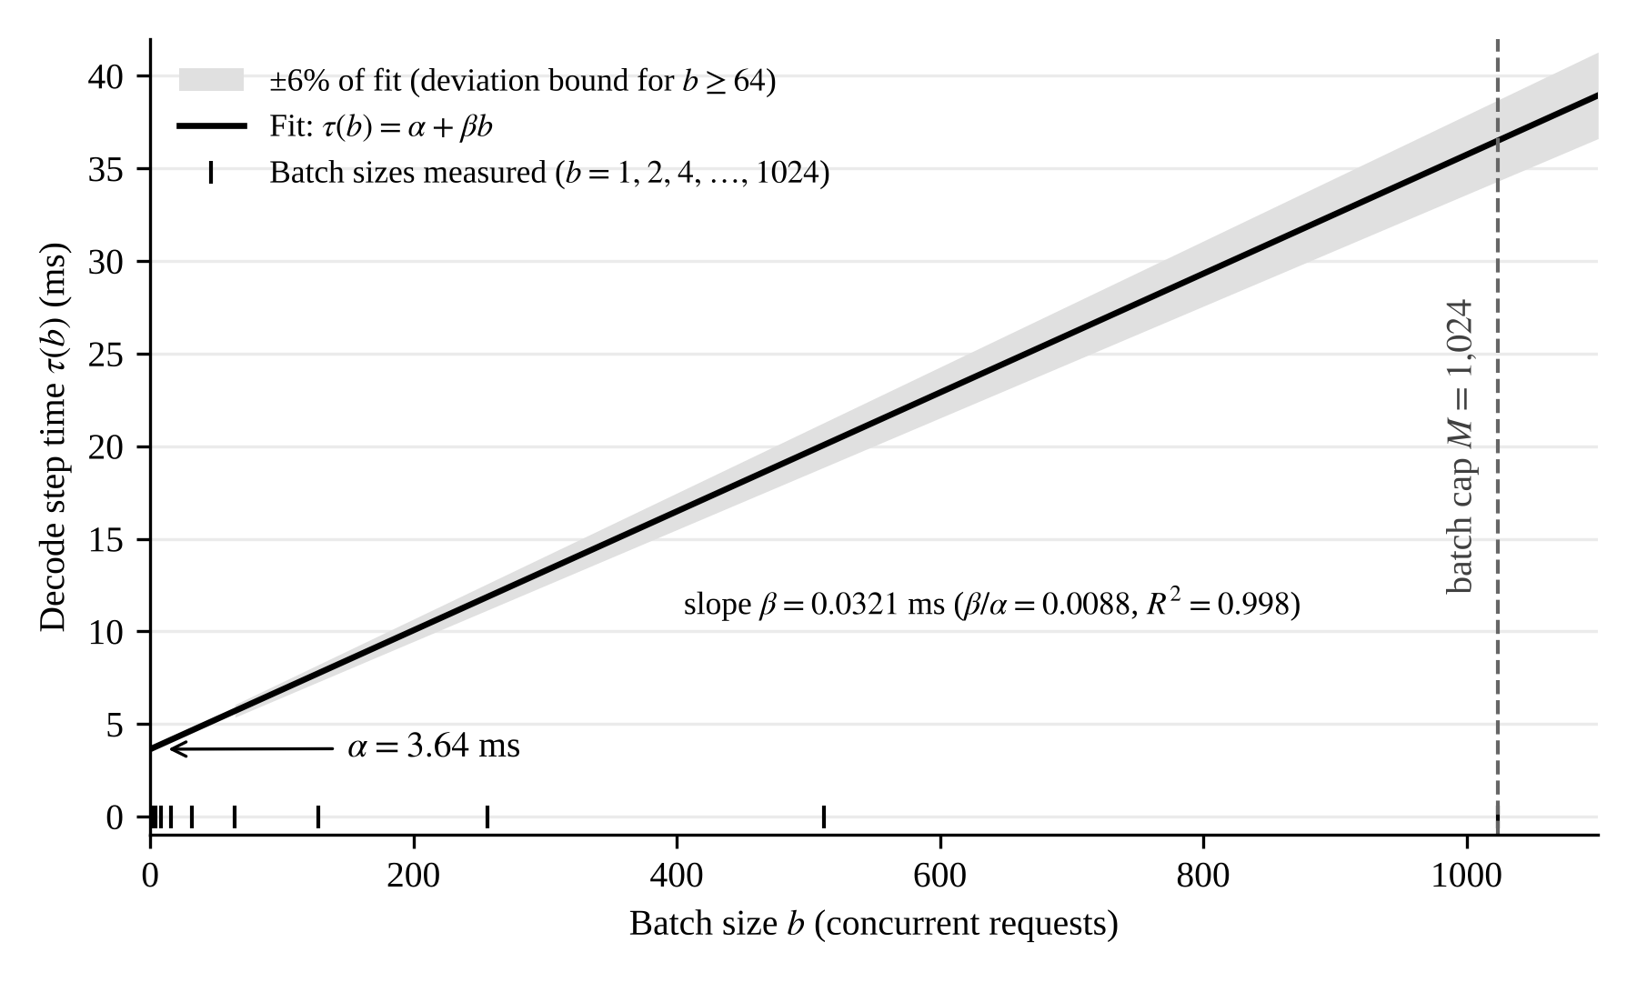
Figure 2. Decode Step Time under Linear Batching: Fitted Line (Qwen2.5-7B-Instruct, vLLM, One NVIDIA B300 GPU)
The service requirement of a request is its number of generated tokens plus its prompt tokens converted to decode-step equivalents. With these parameters, the mean isolated service time is 0.79 seconds on the 2023 conversation trace, 0.14 seconds on the 2023 code trace and 0.12 seconds on the 2024 code trace. Because delays and prices are expressed in units of the mean isolated service time, only the shape of the service-time distribution, the offered load and the slowdown profile ρ enter the analysis. As a benchmark, we report throughout the dedicated-server case β = 0 with service times constructed as 0.5 ms per prompt token plus 30 ms per generated token, which gives mean service times of 6.9, 1.9 and 1.9 seconds and offered loads of 38, 4.8 and 54 servers on the three traces.

5.3 Arrival Models and Demand Parameters
For the two one-hour traces, we compare the actual arrival sequence with four alternatives: a Poisson process with the same rate; a two-state Markov-modulated Poisson process (MMPP) fitted to the index of dispersion for counts (IDC); a five-state Markov chain on the 30-second arrival rate; and a block bootstrap of the observed arrivals. For the longer traces, we estimate an hour-of-day rate profile.
Two demand parameters are not observed: the choke value V and the ratio of unpriced demand to capacity. We adopt V = 20 and a ratio of 1.4 as the baseline and vary both in Section 6.5. A ratio above one means that, at a zero price, users would request more than the cluster can serve in the busiest phases, which is the situation in which pricing has work to do. We also vary the slowdown parameter β/α over {0, half the measured value, the measured value, twice the measured value}.

5.4 Computational Procedures
Four computational tools are used in Section 6.
Trace-driven capacity sizing. For each arrival model, we replay the trace through a simulator of c serving engines, each holding at most M requests in its batch, with step time τ(b) and either random or balanced (join-the-shortest-queue) routing. Each engine keeps a virtual clock that advances at rate 1/τ(b), so each event costs O(log M) and the 2024 trace can be replayed in minutes. Against the birth–death model with Poisson arrivals and exponential work, the simulator reproduces the mean sojourn time within sampling error (Online Appendix B, Table B4). We search over c for the smallest number of engines that meets the delay target.
Quasi-static welfare optimization. For each phase, the equilibrium rate λ_{k}(p) is obtained as the unique root of P_{k}(λ) − p − d(λ), which is strictly decreasing in λ by Proposition 1, so a bracketing root finder converges reliably. First-best tolls, the best flat price and the exact loss of Proposition 5 are then computed by one-dimensional optimization and quadrature.
Optimal G-level schedules. Using the contiguity property of Proposition 8(ii), we compute the best G-level schedule by dynamic programming over contiguous groups of phases ordered by p*_{k}. The same recursion is applied to the quadratic approximation and to the exact welfare curves; in the latter case, the cost of each candidate group is evaluated by a one-dimensional maximization over its common price.
Exact Markov chain with finite buffer. For the switching-speed experiments, we solve for the stationary distribution of the (queue length, phase) chain with buffer N and for the tagged-request times T_{θ} in (7), and we iterate on the phase-dependent arrival rates until they satisfy the equilibrium condition under the delay that each phase actually experiences. Because the number of requests ahead of the tagged request never increases, the tagged system is solved level by level in a, and each level is block tridiagonal in b.
Under balanced routing across many engines, Assumption S can fail locally (Online Appendix B). Whenever we use balanced routing, we therefore verify numerically, at the calibrated parameters, that the toll is strictly increasing on the relevant range. In the capacity-sizing experiments, service requirements are taken from the trace in the replay and block-bootstrap rows and are drawn from an exponential distribution with the trace mean in the Poisson, rate-chain and MMPP rows. The block bootstrap resamples blocks of 200 consecutive requests; blocks of 1,000 requests change the requirement on the conversation trace by at most one server. The two-state MMPP is fitted by least squares to the logarithm of the index of dispersion for counts at window lengths between 1 and 300 seconds, with a lower bound on the switching rates that guarantees that both regimes occur during the observation span, and each model-based entry is the median of ten replications. Code, random seeds and result tables are provided to the review team as supplementary material and will be released in a public repository upon publication.

6. Results

6.1 Capacity Planning under Poisson and Bursty Arrivals
The two 2023 traces behave very differently. Interarrival times on the conversation trace are close to exponential, with a squared coefficient of variation of 1.20, whereas the code trace is extremely bursty, with a squared coefficient of variation of 173. Table 1 reports the capacity required to meet a delay target. Under batching, waiting is rare at moderate load and slowdown dominates delay, so a target defined on waiting alone would understate the required capacity. For the batched model we therefore report the largest multiple of the observed demand that one engine can sustain while P(stretch > 2) ≤ 5%, where the stretch of a request is its sojourn time divided by its own isolated service time. Required capacity is proportional to the inverse of this multiple. Table 1 reports it for batched serving, alongside the number of servers required under the waiting-based target used for dedicated servers, P(wait > one mean service time) ≤ 5%.
Table 1. Capacity Required to Meet the Delay Target
Arrival model | Conversation, dedicated (servers) | Code, dedicated (servers) | Conversation, batched (max demand multiple) | Code, batched (max demand multiple)
Real trace replay (one path) | 43 | 38 | 11.1 | 22.0
Block bootstrap of real arrivals | 53 | 42 | 10.9 | 28.5
Poisson, same rate | 41 | 7 | 11.8 | 151.8
Five-state rate chain | 52 | 16 | 9.2 | 56.8
Two-state MMPP fitted to IDC | 72 | 45 | 9.5 | 12.8

Taking the bootstrap as the benchmark, Poisson-based planning understates the requirement under dedicated servers by about 23% on the conversation trace and by more than 80% on the code trace; under batching it understates it by 7% and 81%. Two caveats apply. First, the single observed path of the conversation trace requires less capacity than the bootstrap, and one hour of data cannot reveal whether that path is typical. Second, the two-state MMPP reproduces the IDC but considerably overstates delay on the conversation trace. The IDC of that trace grows almost linearly with the window length, which points to slow drift rather than to a two-regime structure. Matching second moments does not pin down the tail of the rate distribution, and it is this tail that drives queueing. The five-state chain, which matches the rate distribution, comes closest on the conversation trace, but it misses short bursts and therefore fails on the code trace.
On the seven-day Azure 2024 trace, the arrival rate peaks at 2.15 times its mean between 14:00 and 21:00 UTC and falls to 0.24 times the mean around 08:00–10:00 UTC. Under dedicated servers at a mean utilization of 0.5 (108 servers), the mean wait under the real arrivals is roughly 2,000 seconds. An inhomogeneous Poisson process with the same daily profile yields 86 seconds, and a homogeneous Poisson process yields practically zero. The daily cycle thus accounts for much, but not all, of the observed delay. Under batching, one engine (M = 1,024) carrying the same load as the 108-server cluster, which is a mean utilization of 0.5 of its throughput, has a mean sojourn time of about 935 mean isolated service times under the real arrivals, 50 under an inhomogeneous Poisson process with the same daily profile and 1.8 under a homogeneous Poisson process, where the delay is slowdown alone. The daily cycle again accounts for much, but not all, of the delay.

6.2 Flat versus Time-Varying Prices
We treat the hour-of-day profile of the 2024 trace as 24 equally likely phases, with V = 20 and unpriced demand equal to 1.4 times capacity. Under dedicated servers with c = 77, a flat price loses 14.7% of welfare relative to hour-by-hour first-best prices. The best two-level schedule loses 4.6%, with 14 off-peak hours at a toll of about 2.1 and 10 peak hours at about 10.6. Charging no price at all loses 44.1%. The two-level schedule therefore eliminates about 69% of the flat-price loss. Under batching at the measured β/α, a flat price loses 6.6% of welfare relative to hour-by-hour first-best prices. The best two-level schedule loses 1.3%, with 14 off-peak hours at a toll of about 3.4 and 10 peak hours at about 9.6, and charging no price loses 36.7%. The two-level schedule therefore eliminates about 81% of the flat-price loss. The profile is shown in Figure 3.
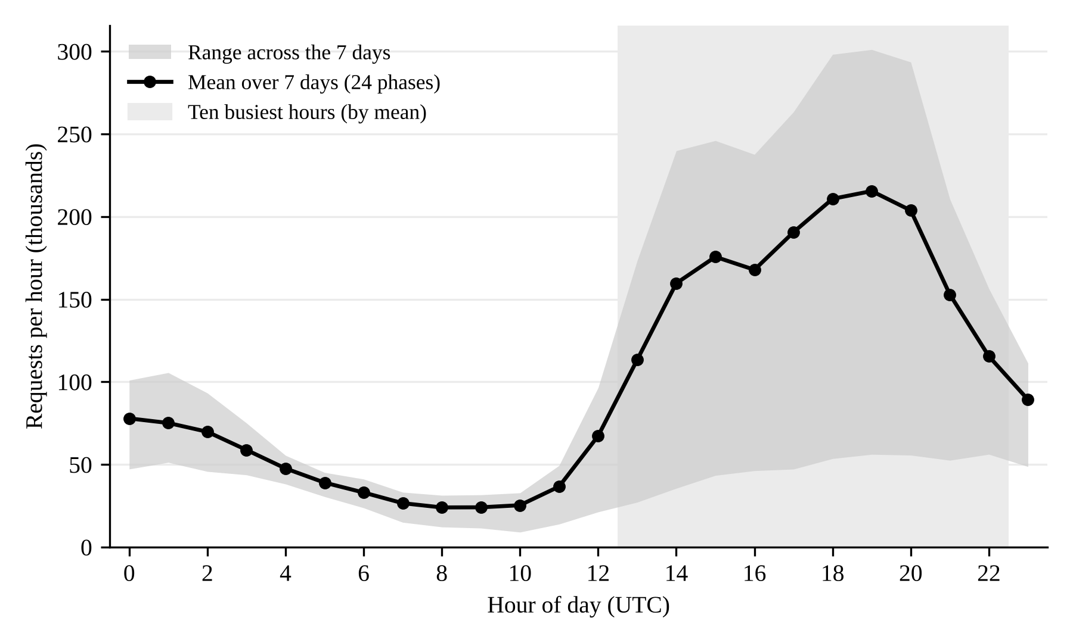
Figure 3. Hour-of-Day Request Profile, Azure 2024 Code Trace (Mean and Range over Seven Days, UTC)
Decomposing the first-best toll of each hour into its waiting and slowdown components shows that, at the measured parameters, slowdown accounts for essentially the whole first-best toll in every hour: the batch cap is large enough that requests practically never wait to enter the batch at first-best rates. With a smaller cap this no longer holds: at M = 256 the slowdown share of the peak-hour toll falls to 54%. The toll of the lowest quartile of hours rises from practically zero under dedicated servers to 1.2, and the peak toll falls from 12.3 to 10.7, so the ratio of peak to off-peak tolls is compressed from several orders of magnitude to about nine. Proposition 2 predicts that slowdown accounts for most of the toll in quiet hours and that the ratio of peak to off-peak tolls is smaller than under dedicated servers; the stylized calibration in Online Appendix B (Table B5) points in this direction, and it also shows that the smaller dispersion of tolls reduces the loss of a flat price.
The comparison with the no-price benchmark puts the flat-price loss in perspective. A single well-chosen price already captures most of what congestion pricing can achieve. Under dedicated servers, the remaining loss is large enough that a provider operating a cluster of this size would forgo about one seventh of attainable welfare by refusing to vary its price over the day. Under batching the corresponding loss is 6.6%, about one fifteenth of attainable welfare.

6.3 The Number of Price Levels
Table 2 compares the prediction of Proposition 8 with the exact recovery obtained from the full welfare curves by dynamic programming over contiguous groups.
Table 2. Share of the Flat-Price Loss Recovered by a G-Level Schedule (Quadratic Prediction / Exact Value)
Service; V, unpriced demand, c₀/V | Bound of Cor. 9(a) | G = 2 | G = 3 | G = 4 | G = 6
Dedicated; 20, 1.4, 0 | 0.47 | 0.76 / 0.69 | 0.89 / 0.85 | 0.97 / 0.94 | 0.99 / 0.98
Dedicated; 20, 1.4, 0.15 | 0.47 | 0.76 / 0.69 | 0.89 / 0.85 | 0.97 / 0.94 | 0.99 / 0.98
Dedicated; 10, 1.2, 0 | 0.48 | 0.77 / 0.72 | 0.90 / 0.84 | 0.97 / 0.96 | 0.99 / 0.99
Dedicated; 40, 2.0, 0 | 0.61 | 0.78 / 0.65 | 0.91 / 0.79 | 0.94 / 0.87 | 0.98 / 0.95
Batched; 20, 1.4, 0 | 0.69 | 0.82 / 0.81 | 0.91 / 0.91 | 0.96 / 0.95 | 0.99 / 0.99
Batched; 20, 1.4, 0.15 | 0.69 | 0.82 / 0.81 | 0.91 / 0.91 | 0.96 / 0.95 | 0.99 / 0.99

The first two dedicated-server rows of Table 2 coincide to two decimals. A serving cost c0 only shifts the effective choke value from V to V − c0, and the recovery shares are nearly invariant to this shift; they differ only in the third decimal.
Under dedicated servers, the bound of Corollary 9(a) holds in all four configurations, although it is loose. The quadratic prediction overstates the exact recovery by 4 to 13 percentage points at G = 2 and by less at larger G, and it reproduces the pattern of diminishing returns (Figure 4). Two levels recover roughly two thirds of the loss, three levels about 80% to 85%, four levels 87% to 96% and six levels 95% to 99%. Under batching at the measured parameters, the bound of Corollary 9(a) holds as well, the quadratic prediction overstates the exact recovery by less than one percentage point, and two levels recover about 81% of the loss, three levels 91%, four levels 95% to 96% and six levels 99%.
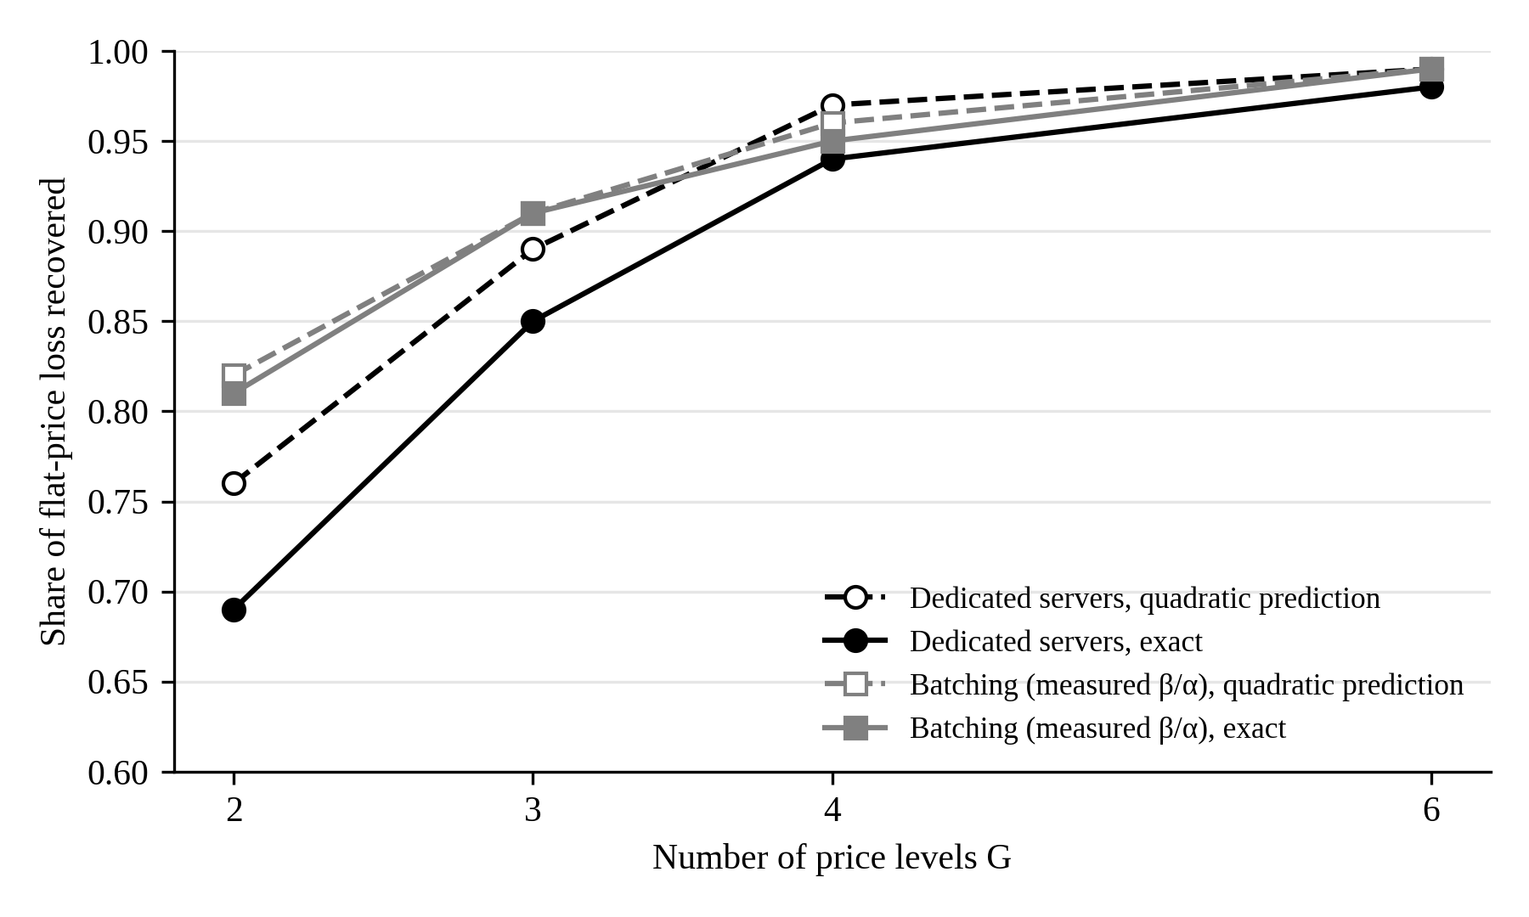
Figure 4. Share of the Flat-Price Loss Recovered by a G-Level Schedule: Quadratic Prediction and Exact Value (Azure 2024 Profile, V = 20, Unpriced Demand 1.4 Times Capacity)

6.4 Switching Speed
We scale the dwell times of the code-trace MMPP by a factor f and compute the loss of the best flat price relative to the best phase-dependent plan, using the exact Markov chain with equilibrium demand and the tagged-request delays (7), a buffer of N = 500 for the 7 dedicated servers and N = 2,000 for the batched engine (M = 1,024, measured β/α), V = 20 and unpriced demand 1.4 times capacity as in Section 6.2 (Table 3 and Figure 5).
Table 3. Loss of the Best Flat Price as a Function of Switching Speed (Code-Trace MMPP, %)
Mean burst length (service times) | 0.02 | 0.08 | 0.4 | 2.1 | 4.1 | 8.2 | 21
Dedicated servers | 0.3 | 2.3 | 10.1 | 17.8 | 17.3 | 15.0 | 11.0
Batched, measured β/α | 0.05 | 0.6 | 3.7 | 7.1 | 7.1 | 6.3 | 5.0

Under dedicated servers, the loss is close to zero under very fast switching, as Theorem 7(a) predicts, reaches a maximum of about 18% for bursts lasting two to four service times, and then declines as bursts lengthen, to 11% at 21 service times and 5.3% at 202 service times. Raising the buffer from N = 400 to N = 600 changes these losses by at most 0.1 percentage points; the buffer must be large relative to the number of servers times V for the result to be meaningful, and with N = 200 the losses are up to one point lower. Theorem 7(b) implies that the loss vanishes quadratically in burst length, whereas the local log–log slopes of the absolute loss over the three fastest settings in Table 3 are 1.4 and 0.9. The two observations need not conflict. The expansion behind Theorem 7(b) is in the burst length multiplied by the arrival rate during bursts, and the code-trace MMPP is extremely bursty, so even bursts of 0.02 service times may lie outside the asymptotic regime. In a less bursty two-phase example in which this product falls below 0.1, the slope approaches 2 (Online Appendix B, Table B3). Under batching, the loss is smaller at every burst length: 0.05% at 0.02 service times, 0.6% at 0.08, 3.7% at 0.4, about 7% for bursts of two to four service times, 6.3% at 8, 5.0% at 21 and 3.5% at 202 service times. The local log–log slope of the absolute loss is 1.7 and 1.1 over the three fastest settings. We have not separated the contribution of the future-arrival channel from the compression of tolls documented in Section 6.2.
By Theorem 7(c), the exact-chain loss should converge, as bursts lengthen, to the quasi-static loss computed with the same buffer N and the same normalization. For this trace, the infinite-buffer quasi-static loss under the same normalization is 4.2% of first-best welfare under dedicated servers and 3.3% under batching. The exact-chain losses at 202 service times (5.3% and 3.5% of the welfare of the best phase-dependent plan) are close to these limits but still falling (local slope about −0.3 under dedicated servers), so the limit has not been reached at that burst length. Quasi-static results should be regarded as conservative when bursts are short compared with the time the queue needs to build up.
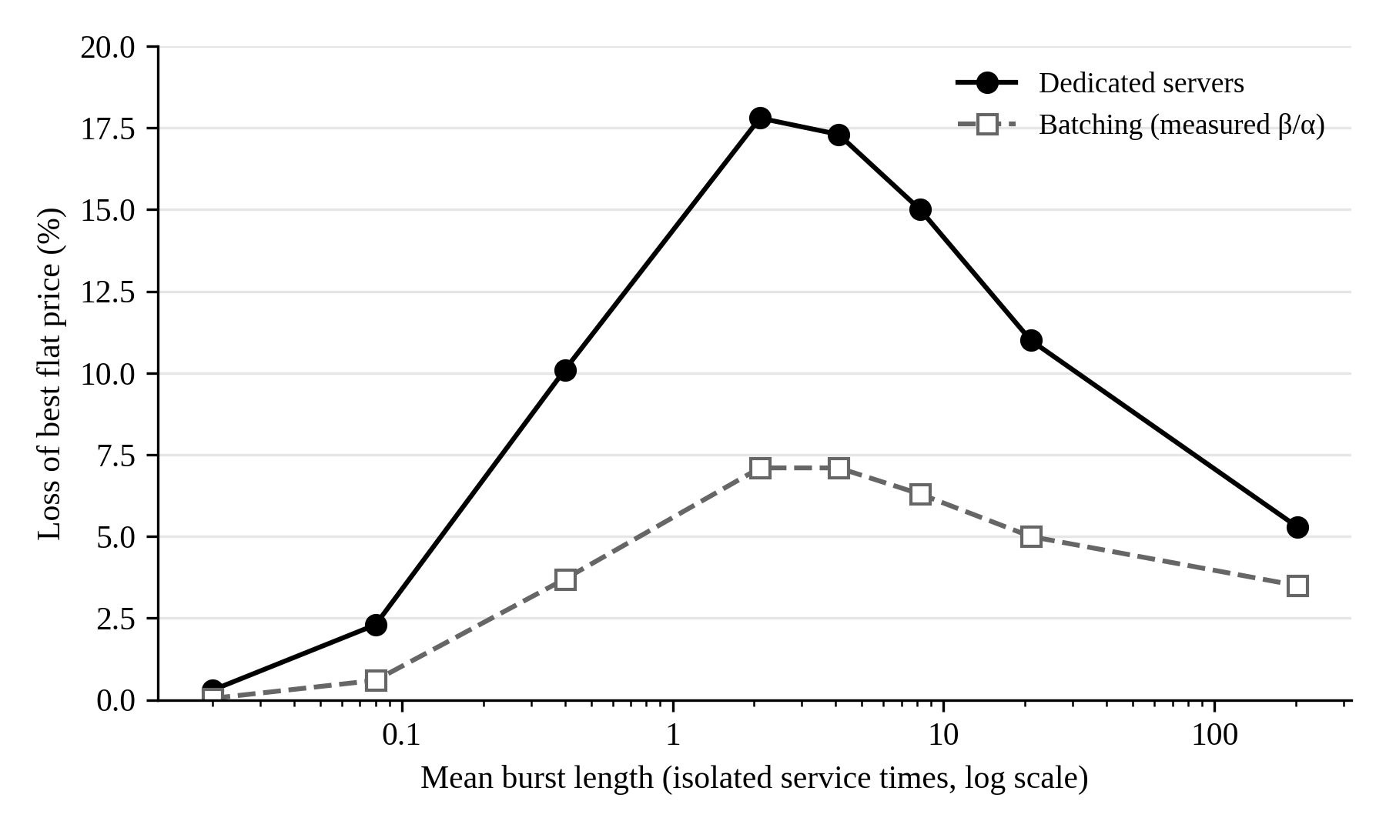
Figure 5. Welfare Loss of the Best Flat Price against Mean Burst Length, Code-Trace MMPP (Exact Markov Chain), Dedicated Servers and Batching

6.5 Robustness
We consider combinations of V ∈ {10, 20, 40}, unpriced demand ∈ {1.2, 1.4, 2.0} times capacity, serving-cost share c₀/V ∈ {0, 0.15} and β/α ∈ {0, half the measured value, the measured value, twice the measured value}. Under dedicated servers, the best flat price loses between 11.0% and 18.6% of first-best welfare, charging no price loses 37% to 57%, and the best two-level schedule removes between 65% and 73% of the flat-price loss. Under batching, with M = 1,024 and β/α equal to half, one and two times the measured value, the best flat price loses between 4.0% and 12.8%, charging no price loses 27% to 53%, and the best two-level schedule removes between 74% and 84% of the flat-price loss. The ranking of no price, flat price and two-level schedule is preserved in all 72 configurations. The batch cap matters: in the baseline configuration the best flat price loses 9.2% at M = 256 and 6.4% at M = 512, against 6.6% at M = 1,024, and replacing the linear specification with the measured step-time curve gives 7.5% at M = 1,024.

6.6 List Prices and the Serving Cost
All pricing pages cited in this subsection were accessed on 9 October 2026. DeepSeek charges half the peak price during off-peak hours; peak hours are 01:00–04:00 and 06:00–10:00 UTC on weekdays, excluding Chinese public holidays (DeepSeek 2026). In China Standard Time these are working hours without the lunch break. OpenAI lists a delay-tolerant tier at half the standard price, a “Fast” tier at twice the standard price and, for some models, an “Ultrafast” tier at six times the standard price (OpenAI 2026). Amazon Bedrock offers reserved, priority, standard and flex tiers (Amazon Web Services 2026).
Two observations link these price structures to the model. First, a posted ratio of two is optimal in the model only if the serving cost is a substantial share of the marginal user’s value. Under dedicated servers with the 2024 daily profile, a peak-to-off-peak ratio of two in the optimal two-level schedule implies c₀/V between 0.08 and 0.25, depending mainly on how far unpriced demand exceeds capacity (0.25 at a ratio of 1.4, and 0.10 and 0.08 at ratios of 1.2 and 2.0). Because batching raises off-peak tolls (Proposition 2), it compresses the toll ratio and lowers the serving cost required to rationalize a ratio of two; at the measured parameters the implied c₀/V is 0.14, 0.12 and 0.02 at unpriced-demand ratios of 1.2, 1.4 and 2.0. Since a single ratio identifies only a single parameter, this is a consistency check rather than a test. Second, imposing a ratio of two can be harmful when it is steeper than optimal. Under dedicated servers at c₀/V = 0.4, the best two-level schedule constrained to a ratio of two loses 19.0% of welfare, more than the best flat price (14.0%), whereas at c₀/V between 0 and 0.2 it loses 4.6% to 5.2%. A schedule with the length and ratio posted by DeepSeek (seven peak hours, ratio of two) also underperforms the best unconstrained schedule in the model, losing 6.3% to 7.1% at low serving cost. Under batching, the schedule constrained to a ratio of two loses 15.5% at c0/V = 0.4, again more than the best flat price (5.5%), and 1.5% to 1.6% at c0/V between 0 and 0.2. Fixing the number of peak hours at seven, as DeepSeek does, raises this loss under batching to 2.4% to 4.1%. Note that the demand profile used here comes from an Azure code workload, not from DeepSeek.
Not every trace supports a daily schedule. In the BurstGPT file, the daily request count ranges from about 1,600 to about 150,000, so swings across days dominate. When each clock hour of the trace is treated as a phase, a flat price under dedicated servers loses 14.5% of the welfare attained by real-time hourly prices, an hour-of-day schedule loses 14.2%, and charging no price loses 48.3%. The predictable component of demand is therefore small. Observed list prices offer no instrument that responds to such swings, apart from quantity limits and error codes.

7. Implications for Research and Practice

7.1 Implications for Research
The classic IS theory of computing-service prices treats congestion as a stationary phenomenon and service as dedicated (Mendelson 1985, Dewan and Mendelson 1990). Our results show that the first simplification is harmless in some regimes and misleading in others, and that the dividing line is a ratio of time scales: the duration of a demand phase relative to the time the queue needs to adjust. This suggests that research on pricing AI services, and IT services more broadly, should report not only the level and dispersion of demand but also its temporal granularity. Two services with identical daily volumes and identical variance of demand can call for very different price structures if one fluctuates in bursts of seconds and the other in cycles of hours.
The second simplification matters because the externality that a theory prices must match the technology of service. Batched serving creates an externality that the dedicated-server model does not contain, and it changes both the level and the shape of efficient prices: quiet hours are no longer free, and schedules become flatter. The representation of the toll as overdispersion of occupancy, and the conditions under which it rises with load, carry over to any service technology that can be summarized by a completion rate that depends on the number of requests present, which makes them a portable tool for analytical IS research on shared digital infrastructure.
The results also bear on the IS literature that studies the menu and form of digital-service contracts. Much of that work asks which tiers or plans a provider should offer. Our analysis indicates that, for latency-sensitive services, a well-designed temporal schedule within a single tier can recover most of the welfare that hour-by-hour prices would deliver. Low-latency tiers, which providers serve with smaller batches, are a natural object for extending the model, since the slowdown externality is precisely what such tiers sell relief from.
Finally, the calibration illustrates a methodological point for analytical IS research. The choice of arrival model is not a technical detail. A Poisson model, an MMPP matched to second moments and a rate chain matched to the rate distribution can produce capacity requirements that differ by a factor of six on the same trace (Table 1). Analytical studies of AI services that rely on Poisson demand or on dedicated-server queues should, at a minimum, test their conclusions against trace replay on a model of the actual serving engine.

7.2 Implications for Practice
Capacity planning. Mean utilization is not a sufficient statistic for sizing a cluster. Providers and platform teams should measure both the daily profile of their demand and the burstiness that remains once that profile is removed, using their own request logs, and they should measure how the step time of their serving engine grows with the batch size. The number of engines should then be validated by replaying those logs through a model of the engine rather than computed from an Erlang formula alone, and the delay target should cover the time requests spend in the batch, not only the time they wait to enter it. In our traces, the Poisson formula was too optimistic by between 23% and more than 80% under dedicated servers and by 7% to 81% under batching.
Design of price schedules. When demand follows a predictable daily cycle, a posted schedule with two to four price levels captures most of the attainable gain. The schedule should follow the ranking of expected demand; in the quadratic model, contiguous blocks of demand-ranked hours are optimal, and the best blocks can be computed by a simple dynamic program. The ratio between price levels needs care. Under batching, quiet hours carry a real externality, so the efficient off-peak price is not zero and the efficient ratio between peak and off-peak prices is smaller than a dedicated-server calculation would suggest. A ratio steeper than optimal can leave a schedule worse than a flat price.
When time-varying prices do not pay. Fast fluctuations, that is, bursts shorter than a few service times, are smoothed out by the queue, and a flat price then loses little. When fluctuations consist mainly of unpredictable multi-day swings, as in the BurstGPT file, an hour-of-day schedule offers little benefit. In that case, quantity limits or real-time pricing are the relevant instruments.
Internal platforms and enterprise buyers. Organizations that run internal AI platforms face the chargeback problem of the computer center in a new form, and the results translate directly into chargeback rules: a short schedule of internal rates, set by demand rank and reviewed against the platform’s own logs, allocates capacity better than a single rate. Organizations that buy AI services can act on the same logic. Where a provider posts off-peak or delay-tolerant prices, workloads that can be deferred, such as batch summarization, evaluation runs or document processing, are a direct source of savings. Because the welfare gain from a schedule comes precisely from moving such requests out of busy hours, buyers who route deferrable work accordingly capture part of that gain while improving latency for interactive users.

8. Limitations and Conclusion
Several limitations qualify the findings. The switching-speed results of Theorem 7 are proved for a finite buffer, and the passage to the infinite-buffer model relies on the limit N → ∞ discussed after the theorem. Demand is linear throughout. The quadratic rate in Theorem 7(b) is asymptotic, and its constant grows with the burst arrival rate, so it says little about moderate burst lengths. The quadratic results on schedules are likewise local. The service model assumes exponentially distributed work, equal sharing within a batch and no interference between the prefill and decode stages; we do not relax any of these assumptions. Assumption S holds for a single engine with linear step time and for random routing across engines, but it can fail locally under balanced routing across many engines, where we rely on numerical checks.
On the empirical side, the serving parameters are measured on one model and one hardware configuration, and both the choke value and the ratio of unpriced demand to capacity are assumed. These assumptions affect the size of the losses but, within our robustness grid, not their ranking (the ranking of no price, flat price and two-level schedule holds in all 72 configurations of the grid, including the batched ones). The traces span one hour (2023), seven days (2024) and 61 days (BurstGPT); the last is dominated by multi-day swings that none of our models describes. The serving cost is identified only through a single posted price ratio.
We model neither competition among providers, nor strategic behavior beyond the equilibrium of infinitesimal users, nor quantity limits as an alternative to pricing. Preliminary computations with two competing providers suggest that phase-dependent prices can raise profits without raising welfare. This possibility deserves a full treatment, because it bears on whether the time-of-day schedules now appearing in the market serve users or mainly providers. Future research could also examine how users learn the delay of each phase, how temporal schedules interact with latency tiers served with smaller batches, and how enterprise buyers reorganize their AI workloads in response to posted schedules.
This paper asked when a flat per-token price is the wrong decision rule for shared generative AI capacity. In our model, a flat price is suboptimal whenever demand differs across phases, its loss has a simple exact form, and that loss vanishes when phases switch fast relative to the queue. Batched serving adds a slowdown externality that makes quiet hours costly and schedules flatter, and the toll that prices both externalities equals the overdispersion of occupancy per unit arrival rate. In calibrations on public traces and measured decode times, a flat price forgoes 6.6% of the welfare attainable with hourly prices at the measured serving parameters, against 14.7% under dedicated servers, and a two-level schedule recovers 81% of that loss; slowdown, not waiting, accounts for the whole toll. The practical message for providers and platform teams is threefold: measure the daily profile and the burstiness of their own demand and the slowdown profile of their own serving engine, size capacity by trace replay, and consider a short posted schedule whose price ratio is chosen with care. More broadly, the results suggest that the old IS question of how to price a shared computer has a new answer when the computer serves generative AI: the right price depends not only on how busy the system is, but on how long it stays busy and on how much each request slows the others.

References
Afèche P, Mendelson H (2004) Pricing and priority auctions in queueing systems with a generalized delay cost structure. Management Sci. 50(7):869–882.
Amazon Web Services (2026) Service tiers for optimizing performance and cost. Amazon Bedrock User Guide. Accessed October 9, 2026, https://docs.aws.amazon.com/bedrock/latest/userguide/service-tiers-inference.html.
Ata B, Shneorson S (2006) Dynamic control of an M/M/1 service system with adjustable arrival and service rates. Management Sci. 52(11):1778–1791.
Avrachenkov KE, Filar JA, Howlett PG (2013) Analytic Perturbation Theory and Its Applications (SIAM, Philadelphia).
Bakos Y, Brynjolfsson E (1999) Bundling information goods: Pricing, profits, and efficiency. Management Sci. 45(12):1613–1630.
Bergemann D, Bonatti A, Smolin A (2026) Menu pricing of large language models. Preprint, arXiv:2502.07736 (first version 2025).
Bergquist J, Elmachtoub AN (2026) Static pricing guarantees for queueing systems. Stochastic Systems 16(1):1–21.
Boiteux M (1960) Peak-load pricing. J. Bus. 33(2):157–179.
Choudhary V (2007) Comparison of software quality under perpetual licensing and software as a service. J. Management Inform. Systems 24(2):141–165.
Dai JG, Deng T, Li Y, Peng T (2025) Throughput-optimal scheduling algorithms for LLM inference and AI agents. Preprint, arXiv:2504.07347.
DeepSeek (2026) Models & pricing. Accessed October 9, 2026, https://api-docs.deepseek.com/quick_start/pricing.
Dewan S (1996) Pricing computer services under alternative control structures: Tradeoffs and trends. Inform. Systems Res. 7(3):301–307.
Dewan S, Mendelson H (1990) User delay costs and internal pricing for a service facility. Management Sci. 36(12):1502–1517.
Dierks L, Seuken S (2022) Cloud pricing: The spot market strikes back. Management Sci. 68(1):105–122.
Fischer W, Meier-Hellstern K (1993) The Markov-modulated Poisson process (MMPP) cookbook. Performance Evaluation 18(2):149–171.
Grassmann W (1983) The convexity of the mean queue size of the M/M/c queue with respect to the traffic intensity. J. Appl. Probab. 20(4):916–919.
Gupta A, Stahl DO, Whinston AB (1997) A stochastic equilibrium model of Internet pricing. J. Econom. Dynam. Control 21(4–5):697–722.
Hassin R, Haviv M (2003) To Queue or Not to Queue: Equilibrium Behavior in Queueing Systems (Springer, Boston).
Heffes H, Lucantoni DM (1986) A Markov modulated characterization of packetized voice and data traffic and related statistical multiplexer performance. IEEE J. Selected Areas Comm. 4(6):856–868.
Hosanagar K, Chuang J, Krishnan R, Smith MD (2008) Service adoption and pricing of content delivery network (CDN) services. Management Sci. 54(9):1579–1593.
Kim J, Randhawa RS (2018) The value of dynamic pricing in large queueing systems. Oper. Res. 66(2):409–425.
Kwon W, Li Z, Zhuang S, Sheng Y, Zheng L, Yu CH, Gonzalez JE, Zhang H, Stoica I (2023) Efficient memory management for large language model serving with PagedAttention. Proc. 29th Sympos. Oper. Systems Principles (SOSP) (ACM, New York), 611–626.
Lee HL, Cohen MA (1983) A note on the convexity of performance measures of M/M/c queueing systems. J. Appl. Probab. 20(4):920–923.
Lin R, Ding Z, Han Z, Zhang J (2026) Large-scale LLM inference with heterogeneous workloads: Prefill-decode contention and asymptotically optimal control. Preprint, arXiv:2602.02987.
McDougall I, Sankaralingam K (2026) Pricing time, not just tokens: Latency-aware mechanism design for LLM inference. Proc. 27th ACM Conf. Econom. Comput. (EC ’26). arXiv:2609.40098.
Mendelson H (1985) Pricing computer services: Queueing effects. Comm. ACM 28(3):312–321.
Mendelson H, Whang S (1990) Optimal incentive-compatible priority pricing for the M/M/1 queue. Oper. Res. 38(5):870–883.
Microsoft Azure (2023) Azure public dataset: Azure LLM inference trace 2023. Accessed October 9, 2026, https://github.com/Azure/AzurePublicDataset.
Microsoft Azure (2024) Azure public dataset: Azure LLM inference trace 2024. Accessed October 9, 2026, https://github.com/Azure/AzurePublicDataset.
Naor P (1969) The regulation of queue size by levying tolls. Econometrica 37(1):15–24.
OpenAI (2026) API pricing. Accessed October 9, 2026, https://developers.openai.com/api/docs/pricing.
Paschalidis IC, Tsitsiklis JN (2000) Congestion-dependent pricing of network services. IEEE/ACM Trans. Networking 8(2):171–184.
Patel P, Choukse E, Zhang C, Shah A, Goiri Í, Maleki S, Bianchini R (2024) Splitwise: Efficient generative LLM inference using phase splitting. Proc. 51st ACM/IEEE Annual Internat. Sympos. Comput. Architecture (ISCA) (IEEE, Piscataway, NJ), 118–132.
Schweitzer PJ (1968) Perturbation theory and finite Markov chains. J. Appl. Probab. 5(2):401–413.
Steiner PO (1957) Peak loads and efficient pricing. Quart. J. Econom. 71(4):585–610.
Stojkovic J, Zhang C, Goiri Í, Torrellas J, Choukse E (2025) DynamoLLM: Designing LLM inference clusters for performance and energy efficiency. Proc. 2025 IEEE Internat. Sympos. High Performance Comput. Architecture (HPCA) (IEEE, Piscataway, NJ), 1348–1362.
Sundararajan A (2004) Nonlinear pricing of information goods. Management Sci. 50(12):1660–1673.
Wang Y, Chen Y, Li Z, Kang X, Fang Y, Zhou Y, Zheng Y, Tang Z, He X, Guo R, Wang X, Wang Q, Zhou AC, Chu X (2025) BurstGPT: A real-world workload dataset to optimize LLM serving systems. Proc. 31st ACM SIGKDD Conf. Knowledge Discovery Data Mining V.2 (ACM, New York), 5831–5841.
Yu GI, Jeong JS, Kim GW, Kim S, Chun BG (2022) Orca: A distributed serving system for transformer-based generative models. Proc. 16th USENIX Sympos. Oper. Systems Design Implementation (OSDI) (USENIX, Berkeley, CA), 521–538.

