Do the Purchase/Visit Count Distributions of LLM Synthetic Customers Reproduce Real Poisson/Negative Binomial Distributions?
Research Proposal and Preliminary Analysis Results
October 2026
Summary
LLM-based synthetic customers have been proposed as a means of pre-simulating marketing experiments. Prior studies mainly evaluated how well responses such as ratings, choices, and willingness to pay are reproduced, and have rarely verified the distributional shape of within-period purchase counts (count data), to the extent confirmed within the search scope. This study evaluates whether the purchase count distribution of synthetic customers reproduces the real Poisson/negative binomial distribution, and proposes a calibration based on how heterogeneity is injected.
In the preliminary analysis, on both public datasets (UCI Online Retail II and CDNOW), the Poisson was rejected in almost all intervals and the negative binomial was best by AIC. The real 4-week purchase count had a mean of about 0.5, a zero proportion of about 0.7, and a negative binomial overdispersion α of about 3. A simulation implemented with a fake LLM (MockLLM) shows that the evaluation pipeline detects the failure patterns reported in the literature, but it is not a conclusion about real LLMs.
1. Background and Motivation
A variance collapse (mode collapse), in which the response variance of synthetic customers (silicon samples) becomes narrower than the real one, has been repeatedly reported. Because count distributions are inputs to CLV, repeat-purchase prediction, and budget allocation, a wrong distributional shape leads to errors in downstream decisions.
Strand | Key content
LLM-agent marketing simulation | Agents choose restaurants in a virtual town to test discount strategies (arXiv 2510.18155). Age bias is a limitation.
Reproducing purchase-intent surveys | When text responses are mapped, correlation with human responses is about 90% (based on a news summary; original needs checking).
Variance collapse | Independent LLM agents cluster on the modal response and the effective sample size is small. Correction sometimes overshoots into overdispersion (preprint).
Describing vs. sampling a distribution | Instruction-tuned models can describe a distribution but cannot sample from it (preprint).
Preferences and willingness to pay | Familiar attributes are reproduced, but response variance is too narrow (Horton; Brand et al.).
2. Research Questions and Hypotheses
Research questions
- RQ1. Does the per-period purchase count distribution of synthetic customers match the real one in mean, variance, zero proportion, and tail?
- RQ2. Does variance collapse appear in count data as a low variance-to-mean ratio (underdispersion) and a distorted zero proportion?
- RQ3. Do prompt and sampling designs change the fidelity of reproduction?
- RQ4. Does the promotion effect (IRR) estimated with synthetic customers agree with real experiments in direction and magnitude?
Hypotheses
- H1: Naive persona simulation has a smaller variance-to-mean ratio than the real one and a distorted zero proportion.
- H2: Real data are dominated by the negative binomial (overdispersion), whereas LLM data are close to Poisson or narrower.
- H3: A hybrid that injects customer-level λ from an external gamma distribution reproduces the data better than a pure-LLM approach.
- H4: The direction of the treatment effect is reproduced, but its magnitude is over- (or under-) estimated.
- H5 (new): The lower the mean purchase count of the setting, the more the direct-response method rounds responses to 0/1/2, producing underdispersion and overestimating the effect.
3. Research Design
3.1 Synthetic customer conditions
Condition | Method | Expected failure/strength
A Direct response | Ask the persona “How many purchases in 4 weeks?” | Clustering on round numbers, zero proportion too low
B Daily simulation | Decide purchase or not for each of 28 days, then sum | Independent Bernoulli → Poisson-like, no heterogeneity
C Describe then sample | Model describes the distribution; draws are made with an external random number generator | Described variance is smaller than the real one
D Hybrid | Inject λᵢ from an external gamma (pilot moment estimation); the LLM supplies the contextual mean | Expected to reproduce the distributional shape; needs a pilot
We plan 2–3 models × 3 temperature levels × 5 repetitions per condition.
3.2 Evaluation metrics and statistical analysis
- Summaries: mean, variance, variance-to-mean ratio, zero proportion, top-10% share of purchases
- Distances: Wasserstein, KS, Jensen–Shannon
- Goodness of fit: AIC for Poisson/NB/ZIP, Cameron–Trivedi overdispersion test
- Effects: comparison of IRRs from a Poisson GLM (robust SE), bootstrap CIs
- Decompose model, prompt, and temperature effects with mixed-effects models and correct for multiple comparisons
3.3 Threats to validity
- Data leakage: public data may be included in pretraining, so non-public/recent data are used in parallel.
- Double counting: because persona means already carry between-segment variance, heterogeneity must be estimated from within-segment moments (confirmed in simulation).
- Cost: start with a pilot of 1,000 customers.
4. Real Data Profile
We aggregated per-customer 4-week purchase counts (unique invoices/purchase dates, cancellations excluded, zeros included). Retail II covers 1,714 customers whose first purchase fell in the first 3 months; CDNOW covers the 2,357 customers in the cohort whose first purchase was in Q1 1997.
Data | 4-week mean | Zero proportion | Variance/mean | NB α | Best model
Retail II (7 intervals) | 0.42–0.51 | 0.68–0.73 | 2.1–4.2 | 2.3–7.3 | Negative binomial
CDNOW 4-week (7 intervals) | 0.09–0.14 | 0.89–0.93 | 1.3–1.5 | 3.0–5.9 | Negative binomial
CDNOW 39-week | 1.00 | 0.64 | 5.1 | 4.1 | Negative binomial
- The Poisson was not rejected in only one interval (the last Retail II interval, p=0.053), so overdispersion appears consistently.
- Variance/mean varies with the mean (= 1 + α·mean). Comparisons across datasets should use α = (variance − mean)/mean².
- The top-10% share degenerates when the zero proportion is high (1.0 for CDNOW 4-week). Interpret it only in intervals where the mean is sufficiently large.
- The initial simulation defaults (mean 1.85, zero 0.45, α 2.4) diverged from reality, so we recalibrated to the Retail II reference (mean 0.49, zero 0.73, α 3.05).
5. Preliminary Simulation Results (MockLLM)
Caution: MockLLM implements failure patterns from the literature (round-number clustering, independent daily decisions, under-described variance) as assumptions. The results below validate the evaluation pipeline and are not conclusions about real LLMs.
5.1 Initial setting (real variance/mean 5.77, zero 0.45)
Condition | Variance/mean | Zero proportion | Top-10% share | Wasserstein | JS
Real | 5.77 | 0.45 | 0.51 | – | –
A Direct | 1.60 | 0.00 | 0.31 | 0.96 | 0.47
B Daily | 2.51 | 0.25 | 0.35 | 0.73 | 0.18
C Describe→sample | 3.16 | 0.28 | 0.38 | 0.59 | 0.15
D Hybrid | 6.60 | 0.40 | 0.50 | 0.34 | 0.06
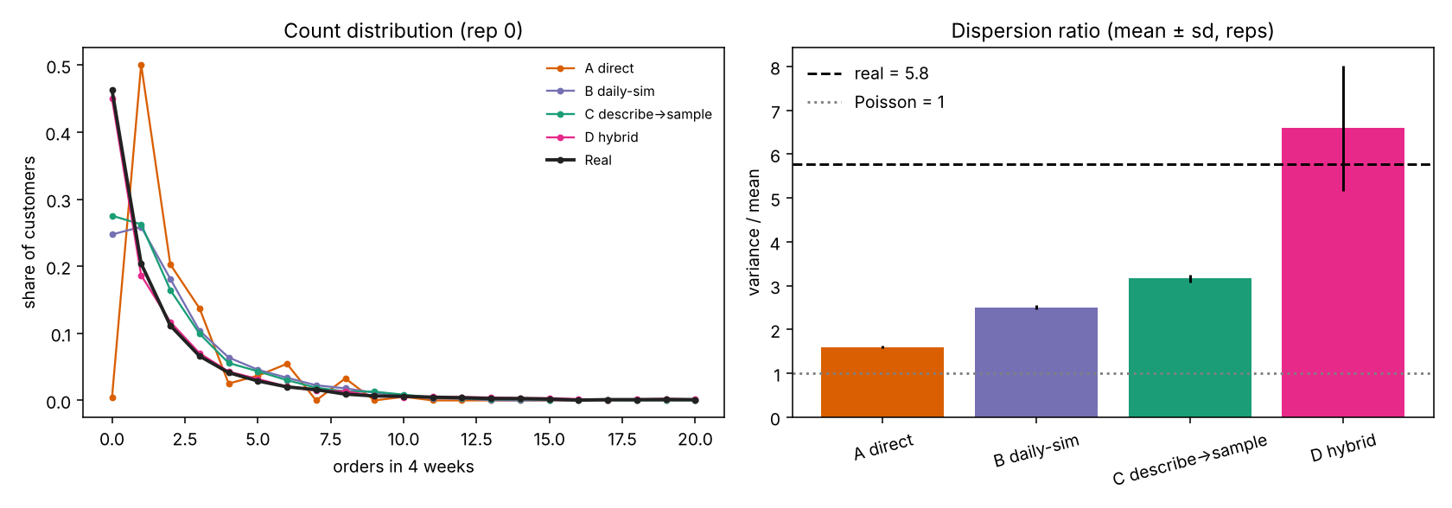
Figure 1. Purchase count distributions and variance-to-mean ratio (initial setting)
The first implementation of D used the full pilot variance, giving an overstated variance ratio of 12 (segment double counting). After correcting to within-segment estimation, it became 6.6.
5.2 Retail II recalibration (real variance/mean 2.54, zero 0.73)
Condition | Variance/mean | Zero proportion | JS | Poisson rejection rate | IRR ratio
A Direct | 0.84 | 0.59 | 0.18 | 0% | 1.43
B Daily | 1.38 | 0.63 | 0.10 | 100% | 1.12
C Describe→sample | 1.53 | 0.64 | 0.09 | 100% | 1.12
D Hybrid | 2.84 | 0.71 | 0.04 | 100% | 1.13
In a realistic setting with a low mean, A rounds responses to 0/1/2, becomes underdispersed, fails even to reject the Poisson, and greatly overestimates the promotion effect (IRR ratio 1.43). This result is the basis for H5 and needs confirmation with real LLMs.
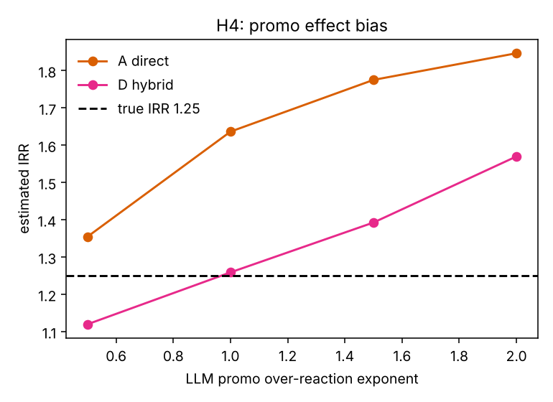
Figure 2. IRR estimation bias by degree of LLM exaggeration of promotion response (Retail II setting)
6. Limitations
- Neither dataset has a promotion treatment variable, so RQ4 cannot be verified with real data.
- Retail II mixes in wholesale customers, and CDNOW (1997–98) may have pretraining leakage.
- Values may change with the cohort definition and interval selection.
- The prior-work summaries are based on search results and need checking against the originals before citation.
7. Schedule
Period | Content
2 weeks | Literature review, data selection, prompt design
3 weeks | Pilot (conditions A–D, 1,000 customers), metric validation
4 weeks | Main experiment and analysis
3 weeks | Treatment effect (RQ4) and paper writing
References
- Horton (2023). Large Language Models as Simulated Economic Agents. arXiv:2301.07543.
- Brand, Israeli, Ngwe. Can LLMs Capture Human Preferences? arXiv:2305.02531.
- LLM-Based Multi-Agent System for Simulating and Analyzing Marketing and Consumer Behavior. arXiv:2510.18155.
- Random Silicon Sampling. arXiv:2402.18144.
- Distribution-First Population Simulation (preprint). alphaxiv.org/abs/2607.18310.
- Instruction-Tuned Language Models Cannot Sample from Distributions They Can Describe (preprint). arXiv:2607.25292.
- When Can You Trust Your Synthetic Users? (preprint). arXiv:2609.13148.
- Fader & Hardie (2001). Forecasting Repeat Sales at CDNOW. Interfaces 31(3), S94–S107.

