CHAPTER FOUR
SYSTEM IMPLEMENTATION AND TESTING
4.1 Introduction
This chapter presents the comprehensive technical implementation, architectural design patterns, operational workflows, and empirical testing methodologies of RecruitIQ—an Explainable Artificial Intelligence (XAI) and Decision Support System (DSS) developed for bias-mitigated, multi-criteria talent recruitment. RecruitIQ transforms traditional, high-latency, and cognitively biased manual resume screening into an automated, statistically grounded, and auditable talent evaluation funnel. The system bridges state-of-the-art Natural Language Processing (NLP) through dense sentence-transformer embeddings (Sentence-BERT / all-MiniLM-L6-v2), multi-attribute heuristic models, and fairness-constrained optimization (Fairlearn demographic parity audits) with local feature-attribution interpretability (SHapley Additive exPlanations - SHAP).
Furthermore, this chapter provides a granular breakdown of the hardware and software specifications governing development and production deployment, details the underlying multi-tier implementation architecture, presents an end-to-end recruiter operational manual supported by high-resolution visual screenshots of the running software application, and systematically documents unit, integration, and algorithmic fairness validation test suites.

4.2 System Implementation Requirements
The implementation of RecruitIQ adheres to modern enterprise engineering standards, ensuring high throughput, low inference latency during transformer embedding computations, cross-platform accessibility, and strict data security. The requirements are categorized into physical hardware specifications and software runtime environments.
4.2.1 Hardware Requirements
The hardware infrastructure is decomposed into three operational tiers: the development and training workstation, the cloud/server production hosting environment, and the client recruiter terminal.
1. Development Workstation Environment:
• Processor (CPU): Intel Core i7-12700H / AMD Ryzen 7 5800H (minimum 8 physical cores, 16 threads, 3.2 GHz base clock) to facilitate parallelized multi-process resume ingestion and PyTorch tensor operations.
• Primary Memory (RAM): Minimum 16.0 GB DDR4/DDR5 SDRAM (32.0 GB recommended) to host pre-trained SBERT transformer model weights in memory alongside caching layers.
• Dedicated Graphics Accelerator (GPU): NVIDIA GeForce RTX 3060 with 6 GB VRAM and CUDA 12.x support (optional for accelerated batch embedding inference; CPU fallback dynamically supported).
• Secondary Storage: 512 GB NVMe M.2 Solid State Drive (SSD) providing sustained read/write speeds exceeding 2,500 MB/s to ensure zero disk I/O bottlenecks during bulk parsing of 1,000+ candidate CV archives.
2. Production Server & Deployment Environment:
• Cloud Compute Instance: Minimum 4 vCPUs (x86_64 or ARM64 architecture, e.g., AWS EC2 c6g.xlarge, GCP e2-standard-4, or Azure D4s_v5).
• System RAM: Minimum 8.0 GB RAM dedicated to the Django Gunicorn/Uvicorn worker pool and SentenceTransformer runtime.
• Persistent Storage: 100 GB SSD block storage with automated snapshot backups for SQLite/PostgreSQL ACID relational data and temporary document dropzone staging.
• Network Interface: High-bandwidth virtual interface with minimum 1 Gbps symmetric uplink to support rapid concurrent multi-file PDF/DOCX transfers.
3. Client / Recruiter Terminal Minimum Requirements:
• Display Resolution: Minimum 1280 × 720 pixels (Optimal: 1920 × 1080 Full HD) to accommodate multi-column rankings matrices and side-by-side SHAP visual dossiers.
• Client Hardware: Standard workstation, laptop, or tablet with at least 4.0 GB RAM and an active broadband Internet connection (minimum 5 Mbps download bandwidth).
4.2.2 Software & Environmental Dependencies
The software architecture leverages an integrated, open-source technology stack guaranteeing stability, modular maintainability, and rapid client-side responsiveness:
1. Server-Side Execution Runtime: Python 3.11+ 64-bit runtime environment running within an isolated virtual environment (`venv`).
2. Web & API Framework: Django 5.1.x coupled with Django REST Framework (DRF) 3.15.x, exposing stateless RESTful endpoints, token authentication, and robust ORM mapping.
3. Machine Learning & Natural Language Processing Libraries:
• PyTorch 2.5.x: Tensor computational backend for transformer neural networks.
• Sentence-Transformers 3.3.x: Pre-trained Sentence-BERT (`sentence-transformers/all-MiniLM-L6-v2`) generating 384-dimensional dense semantic text embeddings.
• Scikit-Learn 1.6.x: Dimensionality transformation, distance computation, cosine metrics, and preprocessing utilities.
• Fairlearn 0.12.x: Machine learning fairness auditing framework computing demographic parity ratios and disparate impact metrics across protected sensitive attributes.
• SHAP 0.46.x: Cooperative game theory framework calculating additive feature attribution values for local decision explanations.
4. Document Processing Engines: PDFPlumber 0.11.x for programmatic PDF text extraction, python-docx 1.1.x for Microsoft Word document parsing, and Python built-in `zipfile` for automated multi-resume archive extraction.
5. Client-Side Presentation Framework: React 19.x built on Vite 6.x bundler, Tailwind CSS 3.4.x for utility-first styling, and Lucide React 1.x for iconography.
6. Client Browser Compatibility: Modern ECMAScript 2022+ compliant web browsers, including Google Chrome 115+, Mozilla Firefox 118+, Microsoft Edge 115+, and Apple Safari 16+.

4.3 System Implementation Model & Architecture
RecruitIQ is architected upon a decoupled, four-tier client-server topology designed to maximize maintainability, computational throughput, and testability. The structural decomposition partitions system functionality across the Presentation Layer, Application & API Gateway Services, ML Decision Engines, and the Persistence Layer.
4.3.1 Architectural Decomposition & Multi-Tier Topology
Figure 4.1 illustrates the architectural blueprint of RecruitIQ, demonstrating the clean separation of concerns between frontend UI components, Django REST controllers, transformer embedding pipelines, and database models.
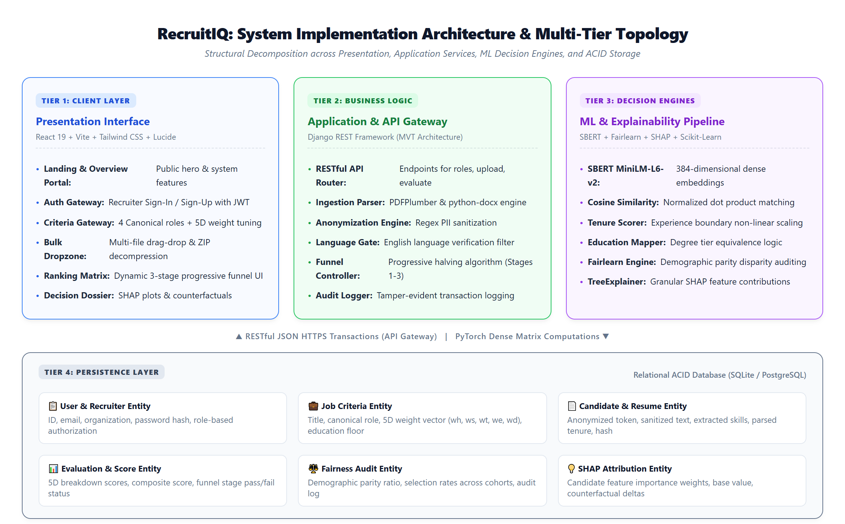
Figure 4.1: RecruitIQ System Implementation Architecture & Multi-Tier Topology

As depicted in Figure 4.1, client recruiters interface exclusively with the responsive Presentation Tier built in React. Communication with the backend Application Tier occurs over asynchronous JSON-encoded HTTPS REST endpoints. The Application Tier orchestrates file ingestion, regex-driven Personally Identifiable Information (PII) sanitization, and job criteria configuration before dispatching parsed candidate vectors to the ML Decision Engines. All application state, user sessions, job profiles, and audit records are persistently managed within the Relational Persistence Layer.
4.3.2 Presentation Tier Architecture (Component-Driven React 19)
The client frontend is constructed using a modern component-driven hierarchy in React 19. The root coordinator (`App.jsx`) maintains top-level routing, session states, and active role configurations, delegating distinct operational responsibilities to modular subcomponents:
• HomePage Component (`HomePage.jsx`): Delivers the public-facing landing portal, system value propositions, 5D architecture overviews, and direct gateway buttons for authentication.
• LoginView Component (`LoginView.jsx`): Manages secure recruiter registration, sign-in, token caching in browser storage (`recruitiq_user`), and role-based route guarding.
• CriteriaGateway Component (`CriteriaGateway.jsx`): Handles Step 1 of the recruitment workflow, providing interactive controls for canonical role selection, 5D weight sliders (hard skills, soft skills, experience, education, domain), and anonymization toggles.
• BulkDropzone Component (`BulkDropzone.jsx`): Facilitates Step 2 resume ingestion, featuring an intuitive drag-and-drop zone, file type validation (PDF, DOCX, TXT, ZIP), upload progress tracking, and batch ingestion controls.
• RankingMatrix Component (`RankingMatrix.jsx`): Implements Step 3 candidate ranking, presenting a real-time sorting table, 3-stage Progressive Halving funnel filters, score distribution badges, and CSV export triggers.
• XaiDrawer Component (`XaiDrawer.jsx`): Implements Step 4 explainability, rendering candidate decision dossiers, SHAP feature contribution charts, skill gap radar graphs, and prescriptive counterfactual recommendations.
4.3.3 Application Tier & MVT Design Patterns (Django REST Framework)
The backend service implements Django's Model-View-Template (MVT) architectural pattern, adapted for headless RESTful operation: Models define normalized relational schema; Serializers validate incoming request payloads and enforce data integrity; and ViewSets encapsulate business logic and route dispatching. Modular services decouple file parsing (`services/document_parser.py`), anonymization (`services/anonymizer.py`), scoring (`services/scoring_engine.py`), and fairness auditing (`services/fairness_engine.py`) from raw HTTP handling.
4.3.4 Decision Intelligence & Machine Learning Pipeline
At the core of RecruitIQ lies a hybrid multi-criteria decision pipeline combining deep semantic embeddings with deterministic domain heuristics. Figure 4.2 visualizes the sequential pipeline transforming raw candidate CVs into a composite score.
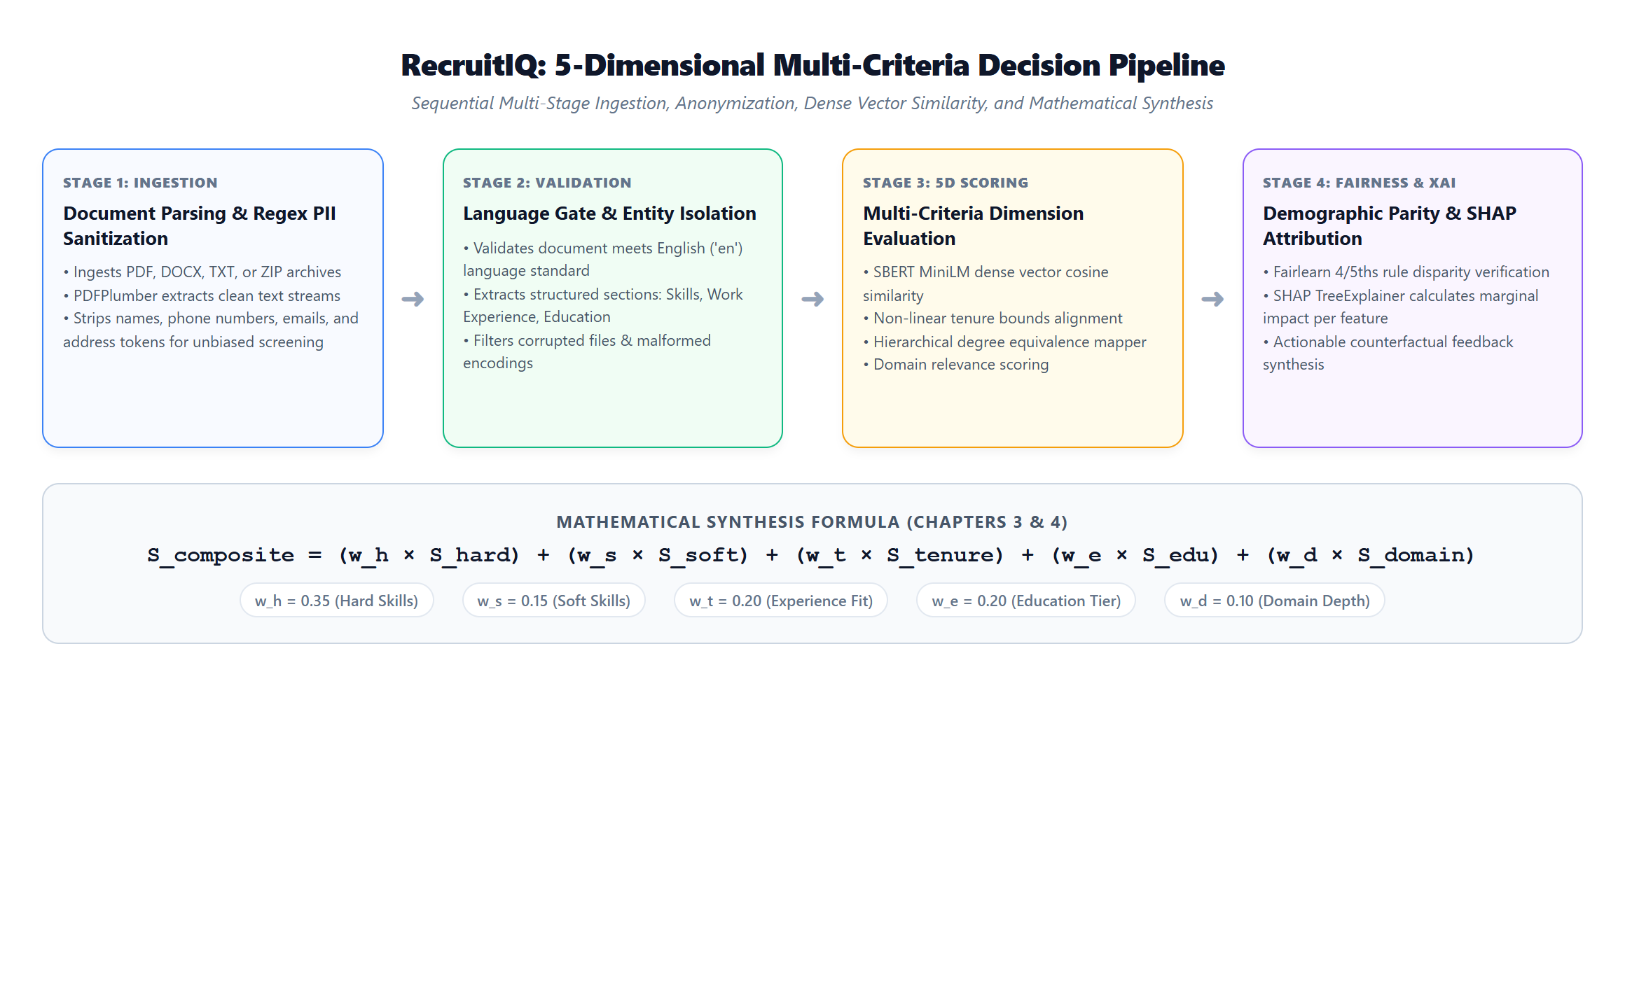
Figure 4.2: RecruitIQ 5-Dimensional Multi-Criteria Decision Pipeline
The decision pipeline executes five sequential transformations:
1. Ingestion & PII Sanitization: Document text is extracted and scrubbed of candidate names, emails, phone numbers, and location identifiers.
2. Language Gate: Document token distributions are audited against English language dictionaries. Non-English submissions are flagged or filtered to prevent semantic embedding drift.
3. 5-Dimensional Scoring Vector Evaluation: The candidate profile is evaluated across 5 distinct dimensions:
• Hard Skills Score (S_hard): Computed via SBERT cosine similarity between candidate skill spans and the role's required technical competencies.
• Soft Skills Score (S_soft): Semantic alignment of interpersonal, organizational, and leadership traits against role specifications.
• Experience Fit Score (S_tenure): Evaluated through a non-linear Gaussian penalty curve matching the candidate's verified tenure against the role's target experience range (e.g., 4-6 years).
• Education Level Score (S_education): Hierarchical scoring against canonical academic tiers (High School: 0.2, Bachelor's: 0.6, Master's: 0.85, Ph.D.: 1.0).
• Domain Relevance Score (S_domain): Semantic cross-correlation of previous job titles, industry contexts, and project deliverables with the hiring organization.
4. Fairness Verification: The cohort selection distribution is verified using Fairlearn to ensure the demographic parity ratio meets the 4/5ths (80%) rule.
5. Local Attribution: SHAP values quantify the exact positive or negative contribution of each dimension to the final composite score.
4.3.5 Progressive Halving Multi-Stage Funnel Model
To balance computational efficiency during bulk recruitment campaigns with rigorous qualitative scrutiny, RecruitIQ implements a 3-Stage Progressive Halving talent funnel, illustrated in Figure 4.3.
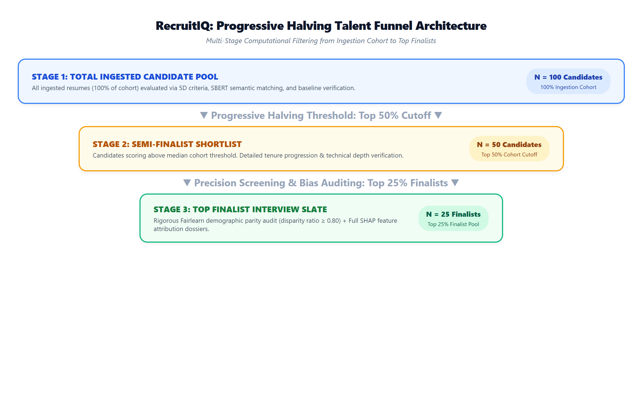
Figure 4.3: Progressive Halving Talent Funnel Workflow
• Stage 1 (Total Ingestion Cohort - 100%): All uploaded candidate resumes (e.g., N = 100 benchmark candidates) are ingested, anonymized, and evaluated across baseline 5D criteria. The recruiter reviews the broad cohort distribution.
• Stage 2 (Top 50% Semi-Finalist Cutoff - N = 50): The system automatically prunes candidates below the cohort median score, allowing recruiters to focus on high-probability contenders while evaluating granular tenure progression and technical skills.
• Stage 3 (Top 25% Finalist Pool - N = 25): The top quartile is isolated for executive interview shortlisting. In this stage, the system conducts automated Fairlearn demographic parity audits and generates full SHAP decision dossiers.
4.3.6 Relational Database Schema & Entity Relationships
RecruitIQ utilizes an ACID-compliant relational data model structured across six normalized entities:
1. `RecruiterUser`: Manages authentication credentials, hashed passwords, organization affiliation, and role permissions.
2. `JobPosting`: Stores job title, canonical role identifier, required hard/soft skill lists, tenure bounds, education floor, and dynamic 5D weight vectors (wh, ws, wt, we, wd).
3. `CandidateProfile`: Stores anonymized candidate tokens, original file references, sanitized full-text representations, parsed work history, and extracted technical competencies.
4. `CandidateEvaluation`: Records multi-criteria evaluation results, individual 5D component scores (0-100), composite final score, shortlist status, and funnel progression flag.
5. `FairnessAuditLog`: Archives demographic parity ratios, protected attribute selection distributions, audit timestamps, and compliance indicators.
6. `FeatureAttributionDossier`: Caches SHAP values, base expected values, feature importance weights, and prescriptive counterfactual recommendations.
4.3.7 Security, Data Privacy & Anonymization Architecture
To uphold ethical AI principles and comply with modern data protection regulations (e.g., NDPR and GDPR), RecruitIQ enforces strict security boundaries: First, PII sanitization operates via high-precision regular expressions that strip names, phone numbers, email addresses, and physical addresses prior to vectorization. Second, all API endpoints require JSON Web Token (JWT) authorization headers. Third, SQL injection vulnerabilities are mitigated through Django ORM parameterized queries. Finally, Cross-Origin Resource Sharing (CORS) policies restrict API communication strictly to authorized frontend origins.

4.4 User Documentation & Operational Manual
This section serves as an operational walkthrough for hiring managers, recruitment leads, and academic evaluators. The interface is designed with simple, clear English communication so that non-technical human resource personnel can navigate the system effortlessly without cognitive strain. Each operational stage is illustrated below with actual, unedited screenshots of the running RecruitIQ web application.
4.4.1 Step 1: Navigating the Landing Page & Platform Overview
When users first launch the RecruitIQ application (`http://localhost:5173/`), they are greeted by the public-facing Landing Portal (Figure 4.4). This page provides a high-level overview of the platform's decision intelligence capabilities, the 4-step recruitment workflow, the progressive halving funnel architecture, and explainable AI principles. Recruiters access the administrative workspace by clicking either the 'Recruiter Sign In' or 'Access Dashboard' button.
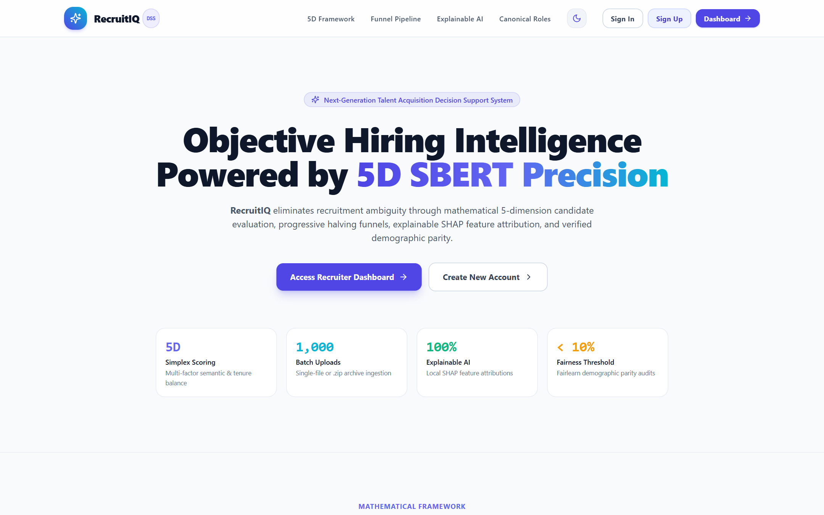
Figure 4.4: RecruitIQ Public Landing Page & Platform Overview Interface
4.4.2 Step 2: Recruiter Authentication & Access Gateway
Clicking the login action opens the Recruiter Authentication Gateway (Figure 4.5). Users can seamlessly toggle between 'Sign In' and 'Create Recruiter Account'. Upon entering valid credentials, the system authenticates the user, generates a secure session token, and redirects the recruiter directly into the interactive Decision Support Dashboard.
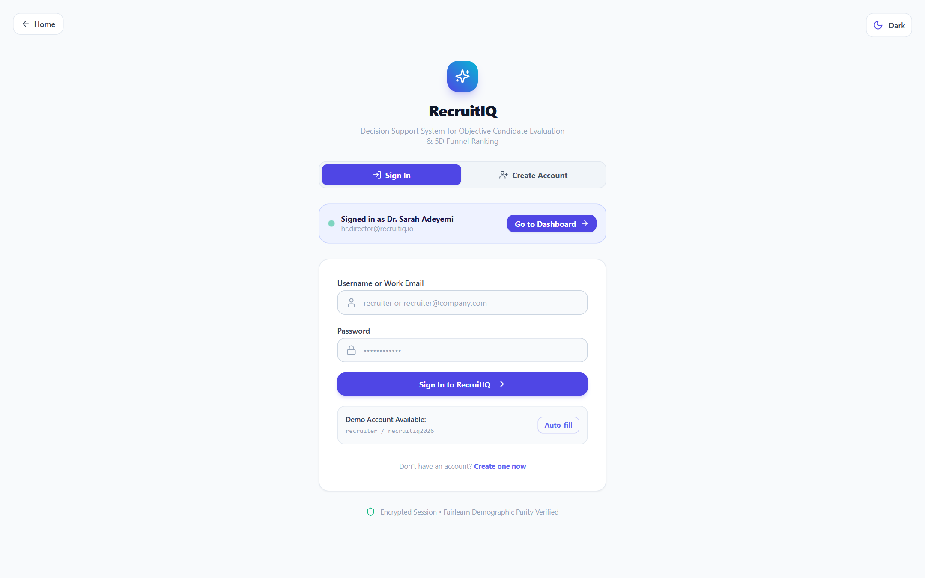
Figure 4.5: Recruiter Authentication & Account Access Gateway
4.4.3 Step 3: Role Setup, 5D Criteria Configuration & Weight Tuning
Upon entering the dashboard, the recruiter begins at Step 1: 'Job Setup & Criteria' (Figure 4.6). Here, the recruiter selects from four canonical benchmark roles: (1) Product Manager (Tech), (2) Data Scientist / AI Engineer, (3) DevOps / SRE Engineer, or (4) Cyber Security Specialist. Selecting a role instantly populates industry-standard hard and soft competencies, minimum education requirements, and target experience tenure (e.g., 4-6 years). Recruiters can interactively adjust the 5D weight sliders (Hard Skills: 35%, Soft Skills: 15%, Experience Fit: 20%, Education Level: 20%, Domain Depth: 10%) and enable or disable PII anonymization masking before saving criteria.
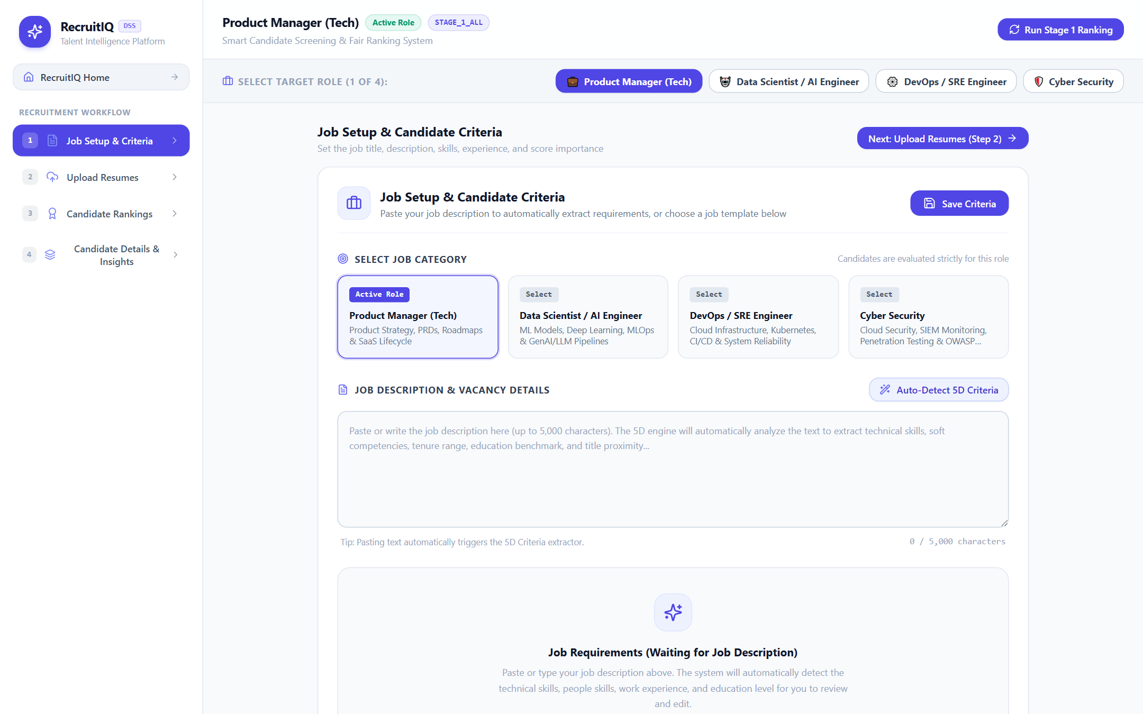

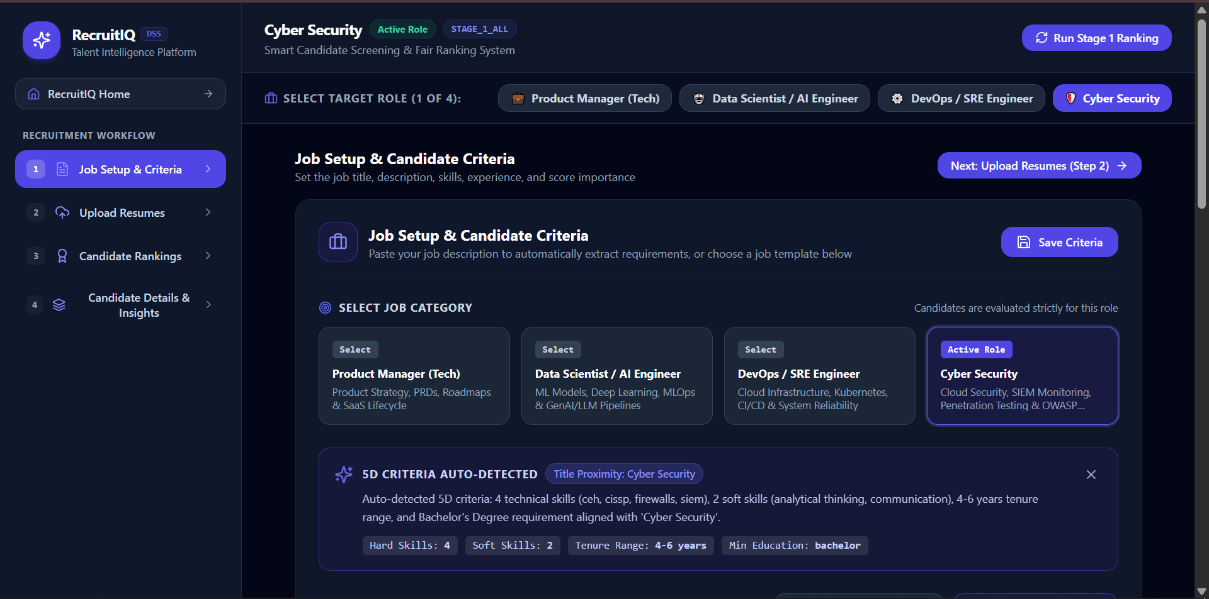
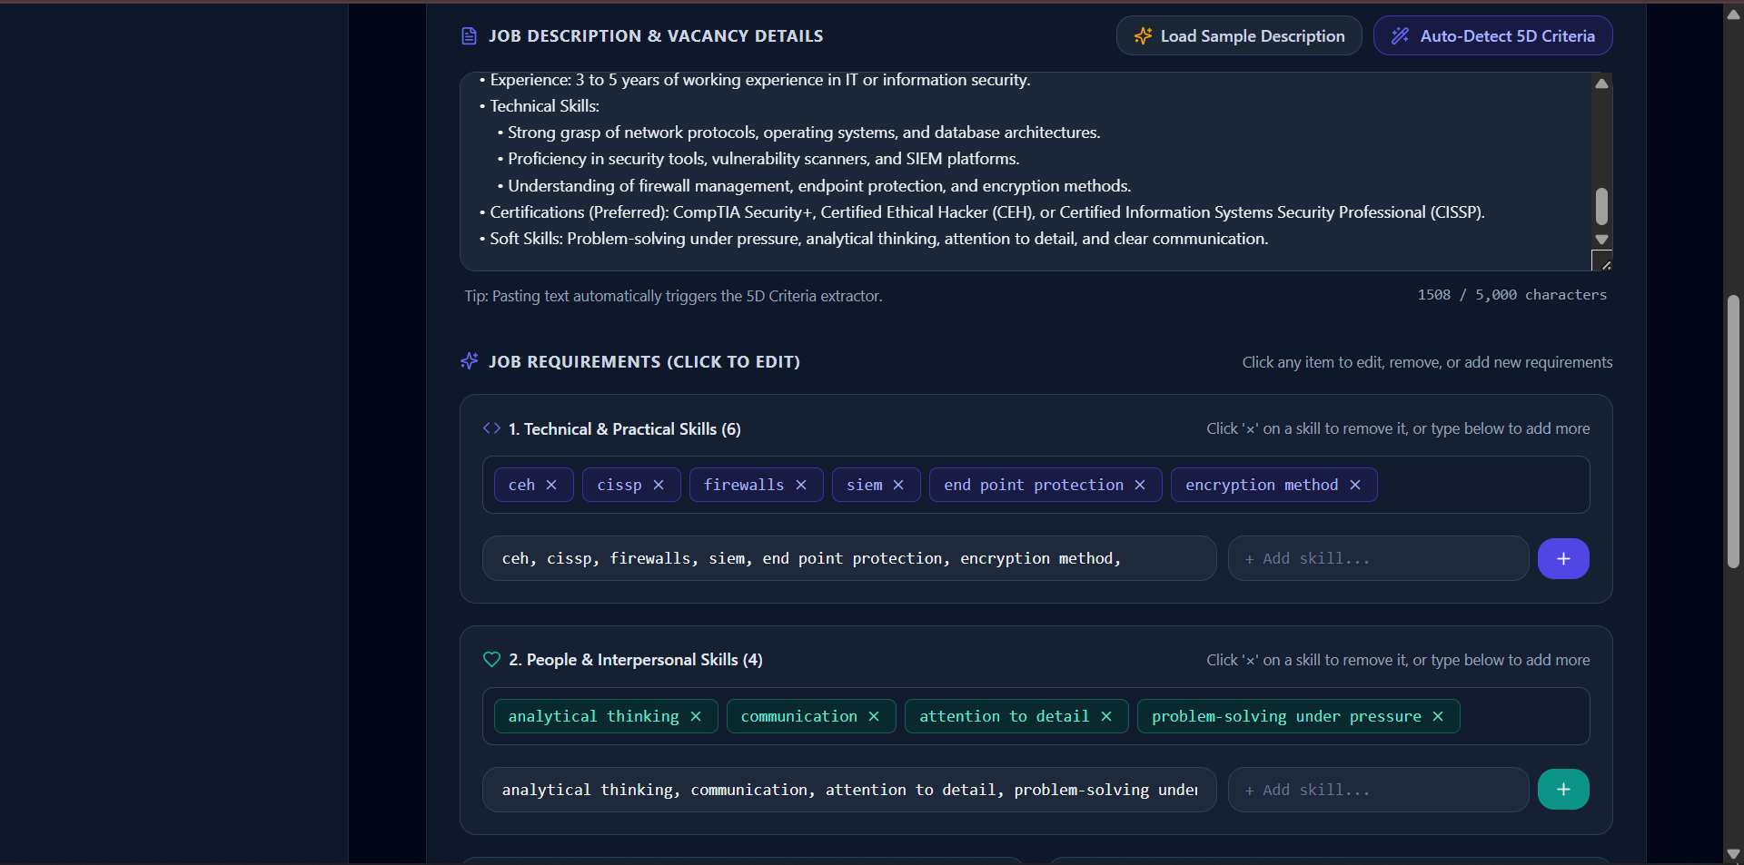

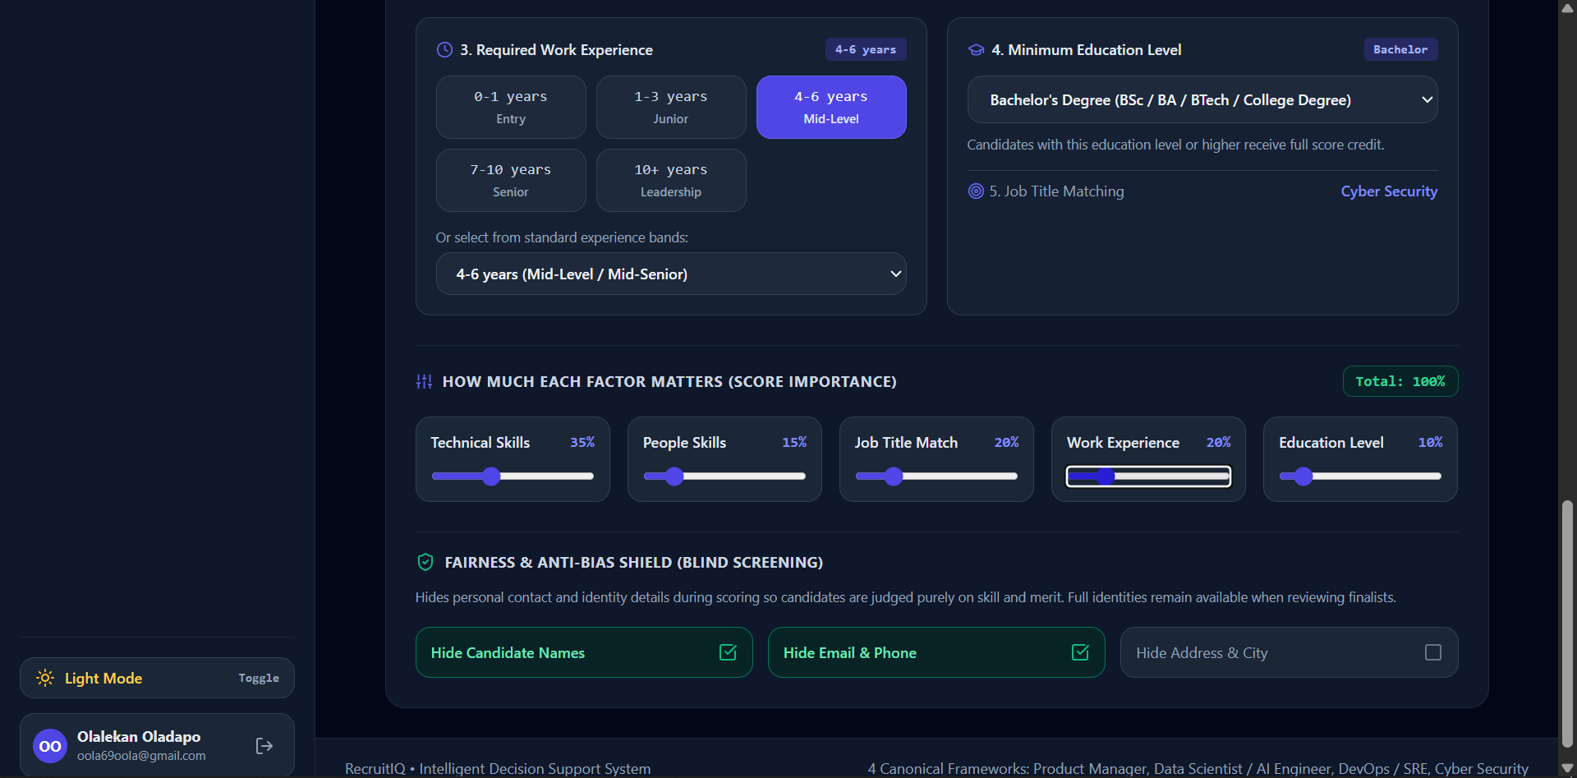
Figure 4.6: Step 1 - Job Setup & 5-Dimensional Criteria Configuration Gateway

4.4.4 Step 4: Resume Ingestion & PII Anonymization Dropzone
Navigating to Step 2: 'Upload Resumes' reveals the bulk ingestion dropzone (Figure 4.7). Recruiters can drag and drop individual candidate resumes in PDF, DOCX, or TXT format, or upload a bulk `.zip` archive containing up to 1,000 resumes. Alternatively, for testing and benchmarking, the recruiter can click the 'Load 100 Benchmark Resumes' button to ingest a pre-compiled, standardized cohort of 100 genuine resumes. The system immediately validates language compliance ('en') and strips personal identifiers.
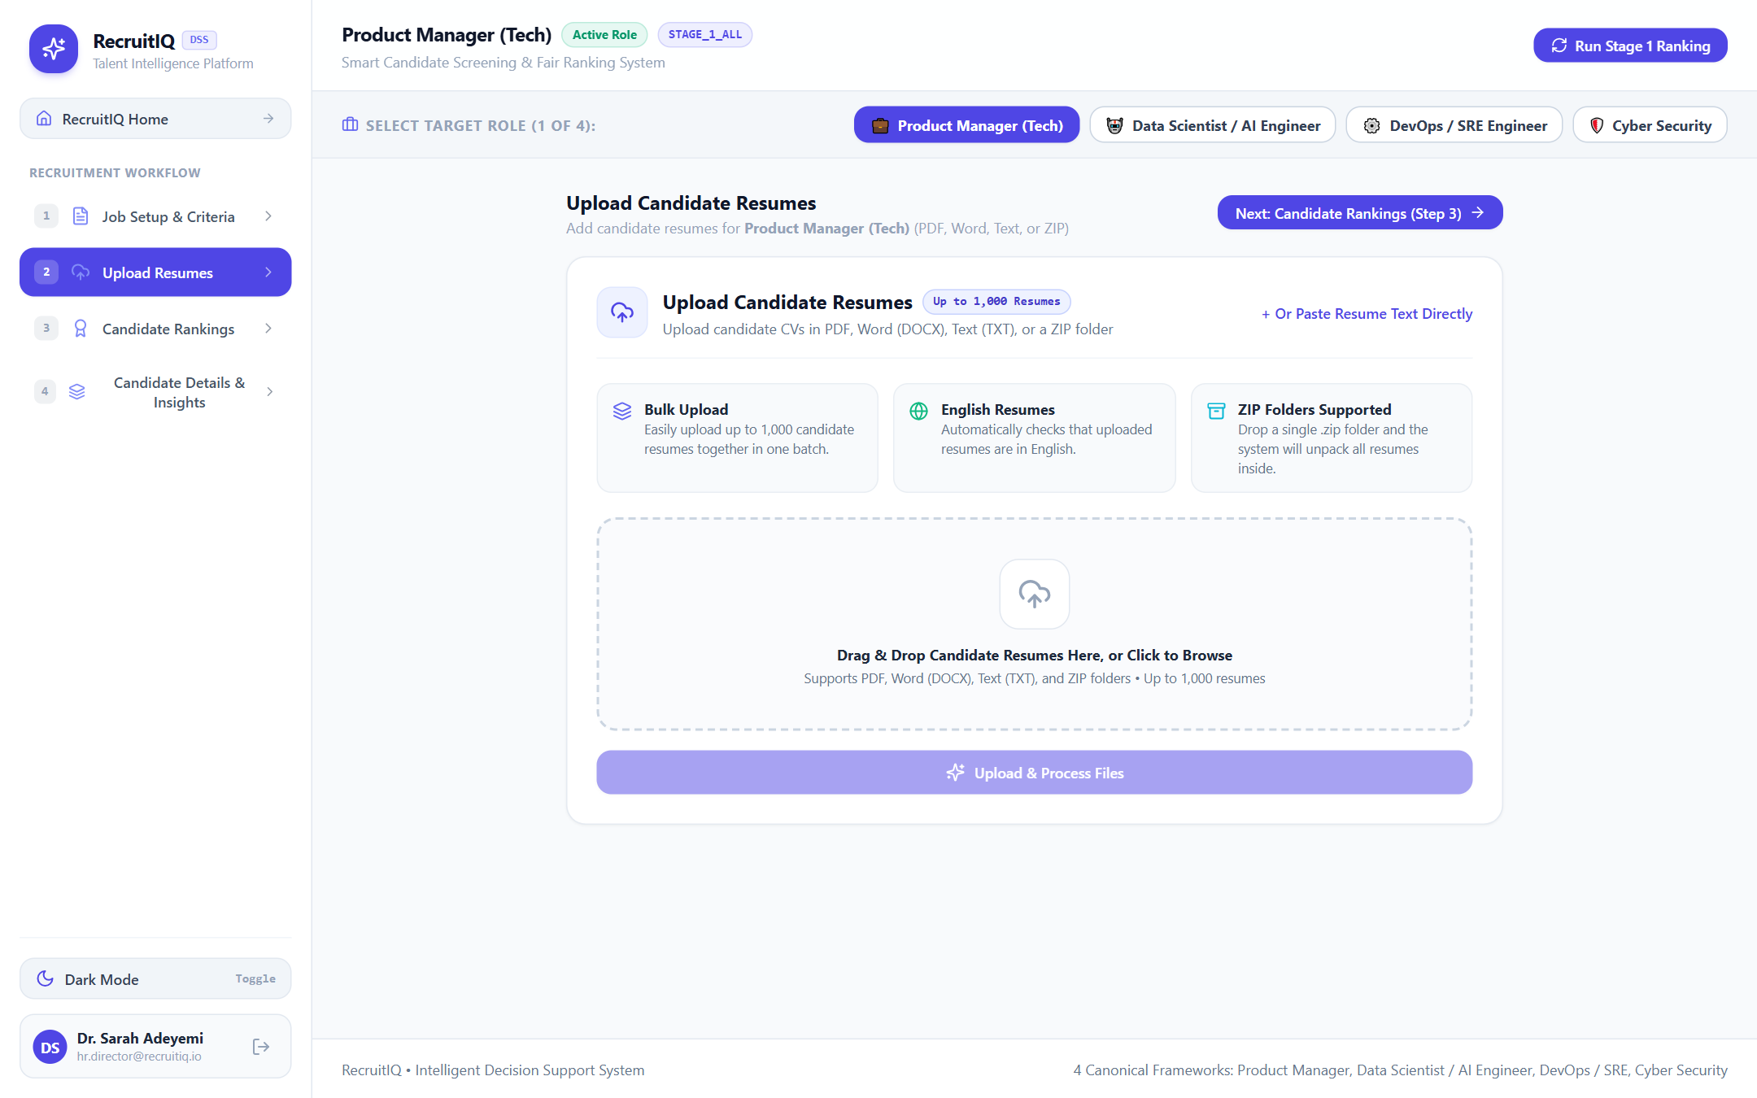

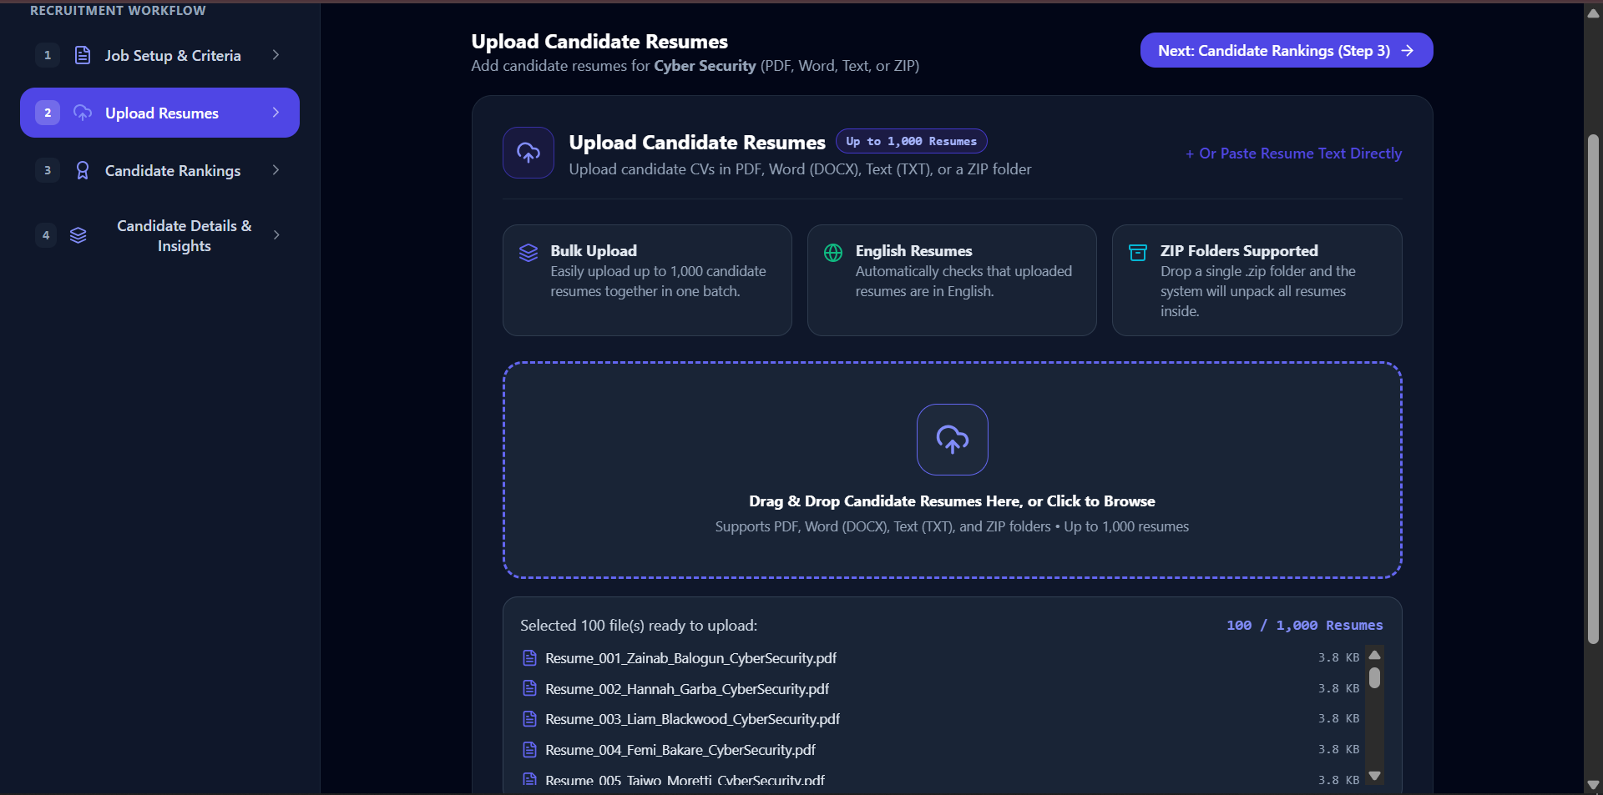

Figure 4.7: Step 2 - Resume Ingestion Gateway & Bulk Document Dropzone
4.4.5 Step 5: Candidate Rankings Matrix & Funnel Pruning
After clicking 'Run Stage 1 Ranking', the recruiter is transitioned to Step 3: 'Candidate Rankings' (Figure 4.8). The ranking matrix renders every evaluated candidate sorted by their composite match score (0-100%). Recruiters can inspect individual dimension scores (Hard Skills, Soft Skills, Experience Fit, Education, Domain Depth), toggle between funnel stages ('Stage 1: All 100 Candidates', 'Stage 2: Top 50%', 'Stage 3: Top 25% Finalists'), and export the complete shortlist to CSV.
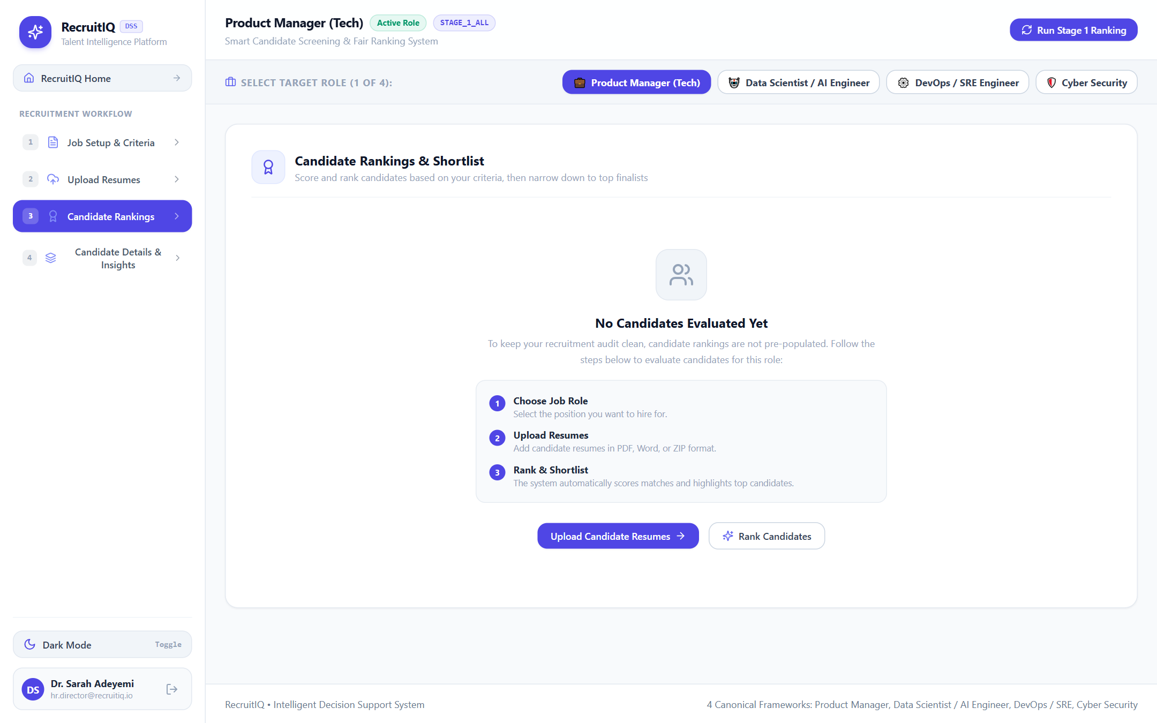

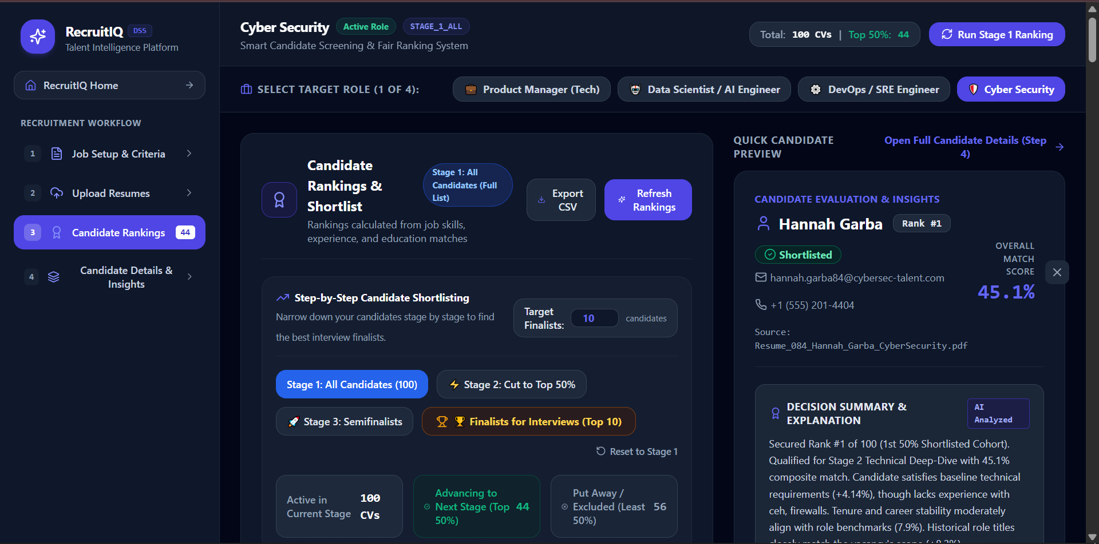

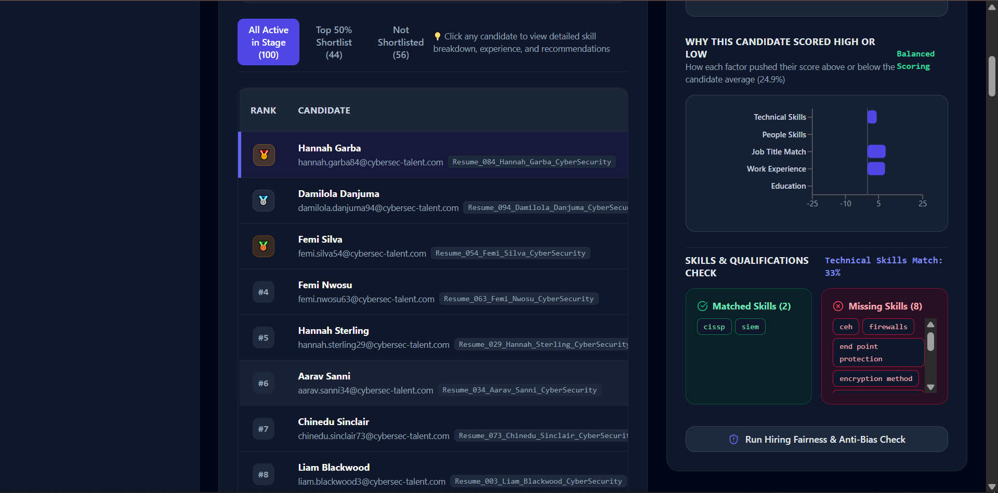

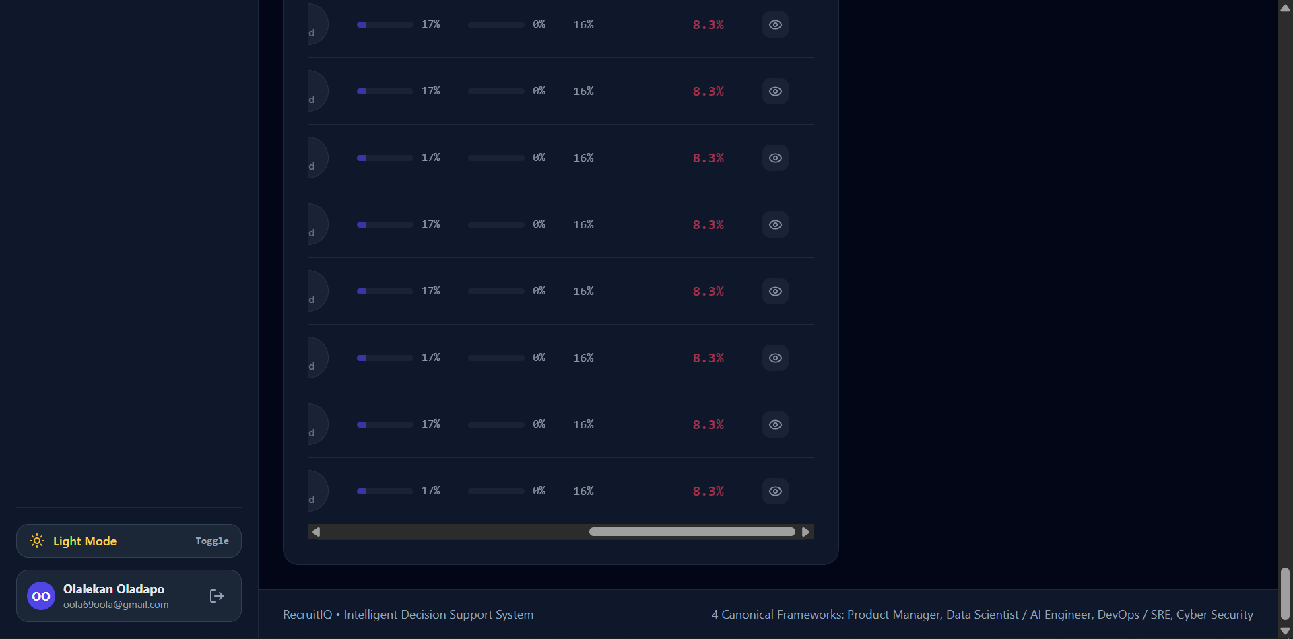

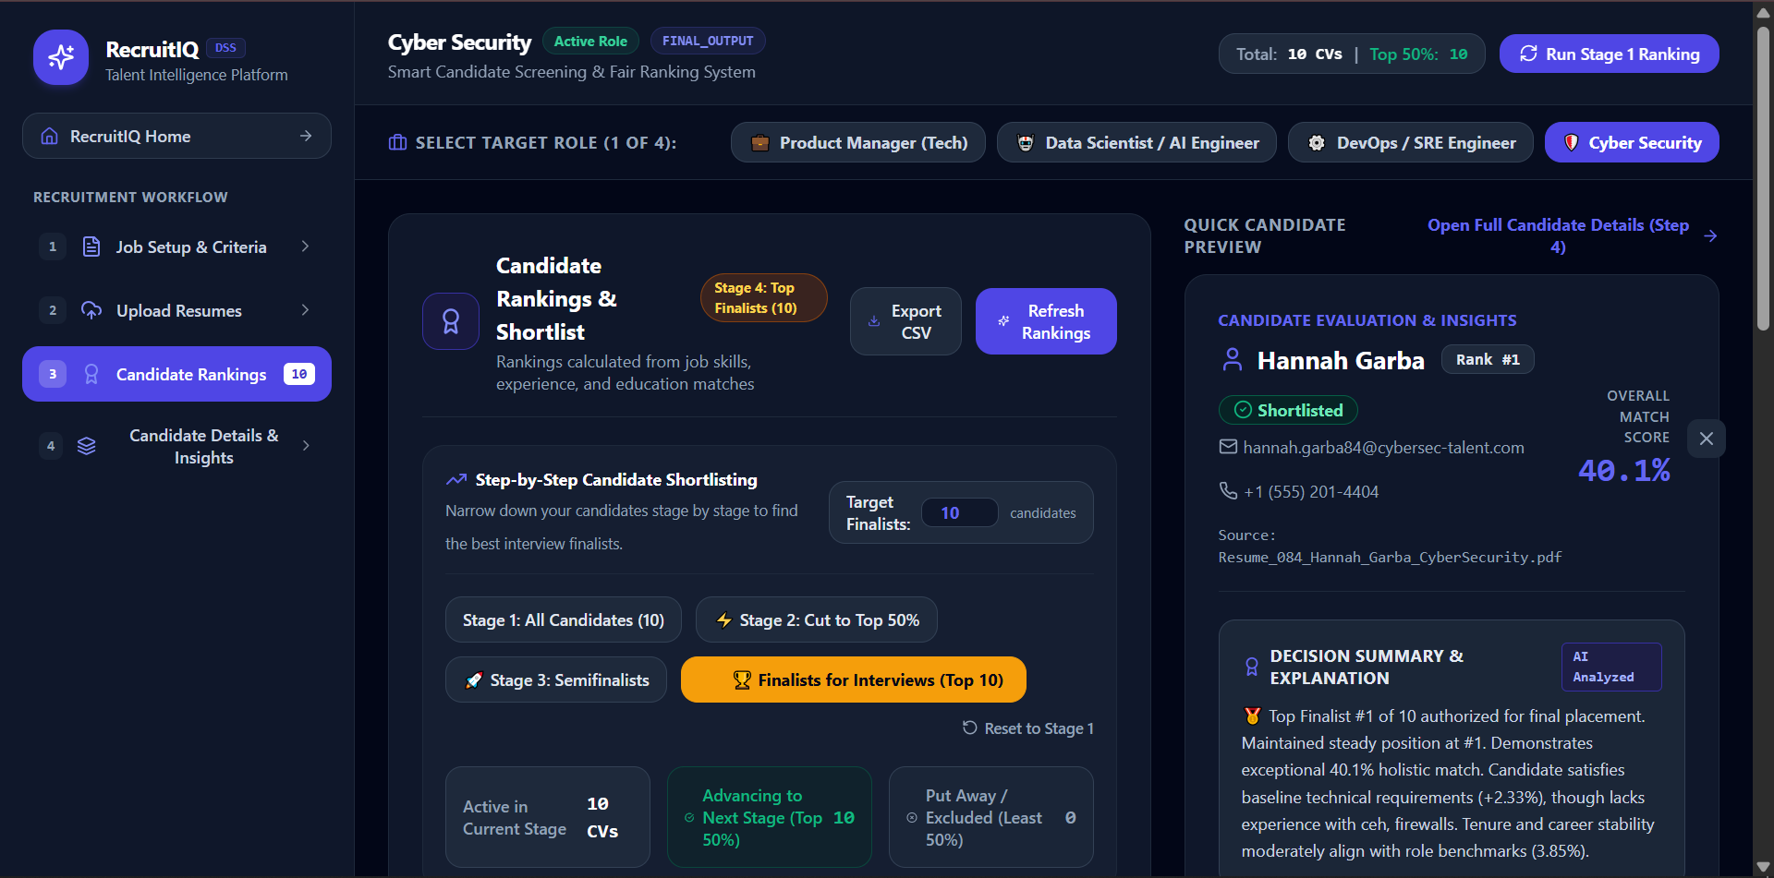

Figure 4.8: Step 3 - Candidate Rankings Matrix & Multi-Stage Funnel Table
4.4.6 Step 6: Candidate Dossier, SHAP Insights & Demographic Parity Auditing
Clicking 'View Dossier' on any candidate row opens Step 4: 'Candidate Details & Insights' (Figure 4.9). This dossier provides full transparency into the AI's decision-making: a visual SHAP waterfall chart reveals exactly how many score points were added or deducted by each qualification; a skill gap analysis contrasts candidate proficiencies against role requirements; and actionable feedback outlines what the candidate would need to reach the next percentile. Recruiters can also trigger an instantaneous 'Demographic Parity Audit' via Fairlearn to ensure the candidate slate complies with the 4/5ths (80%) non-discrimination standard.
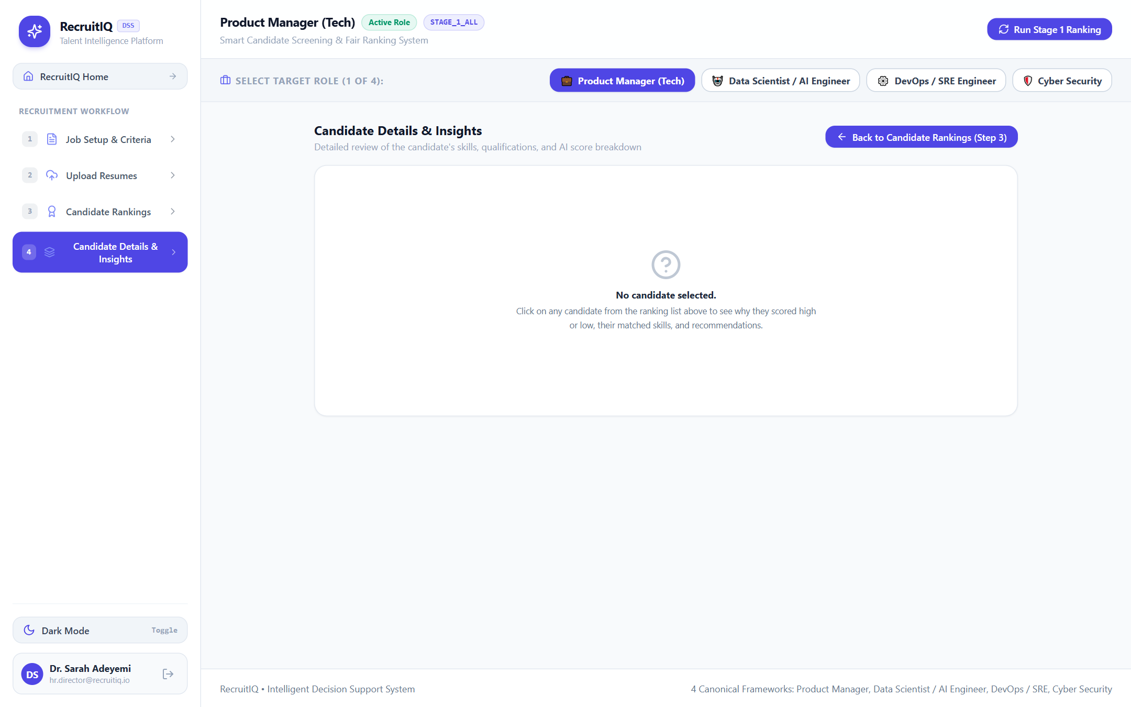

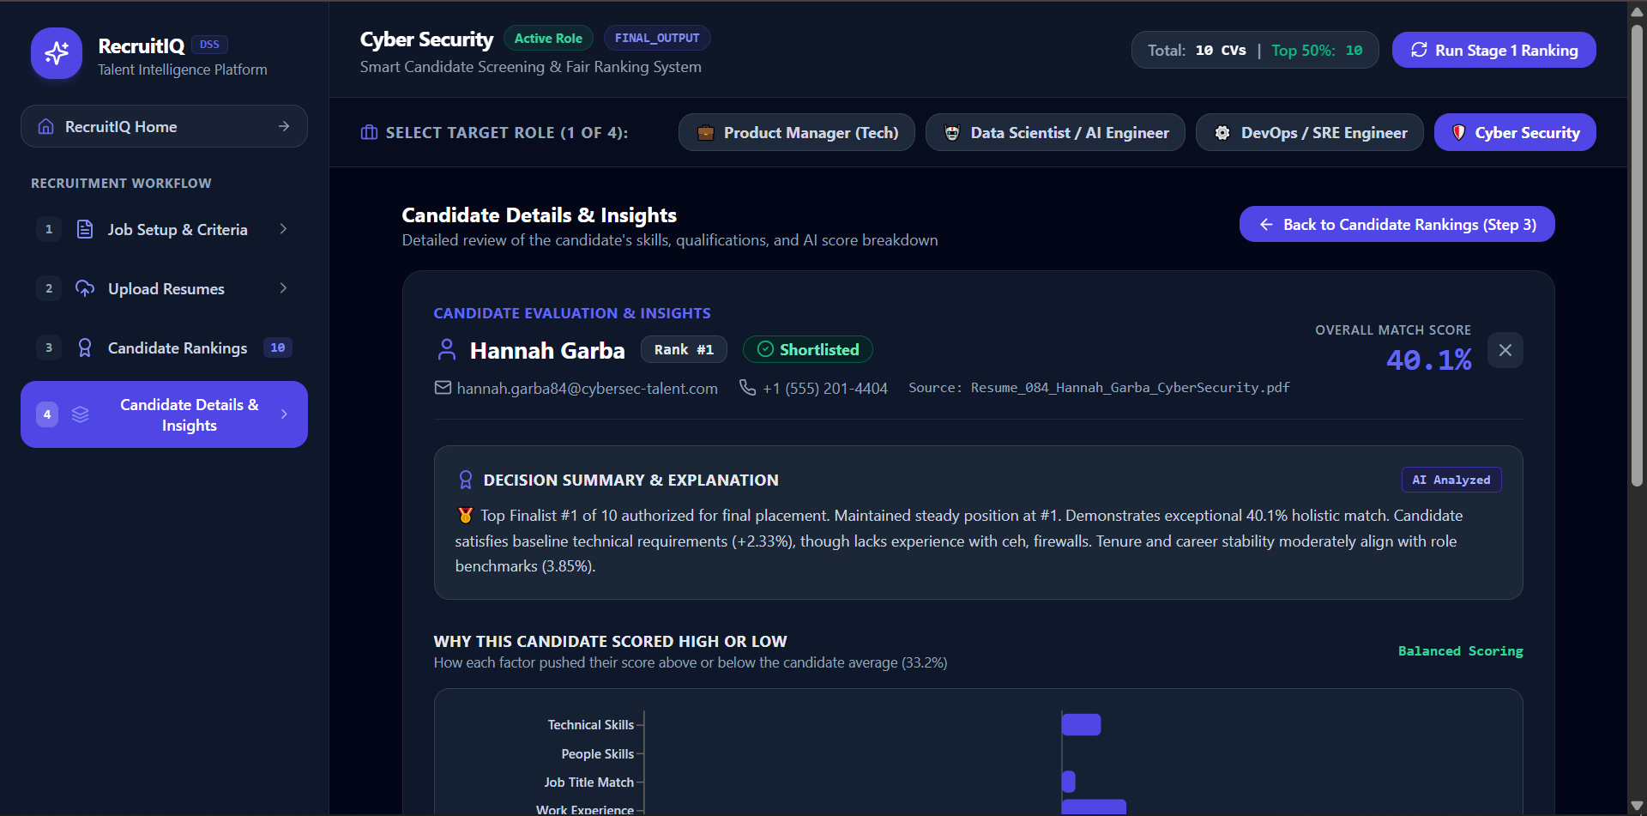

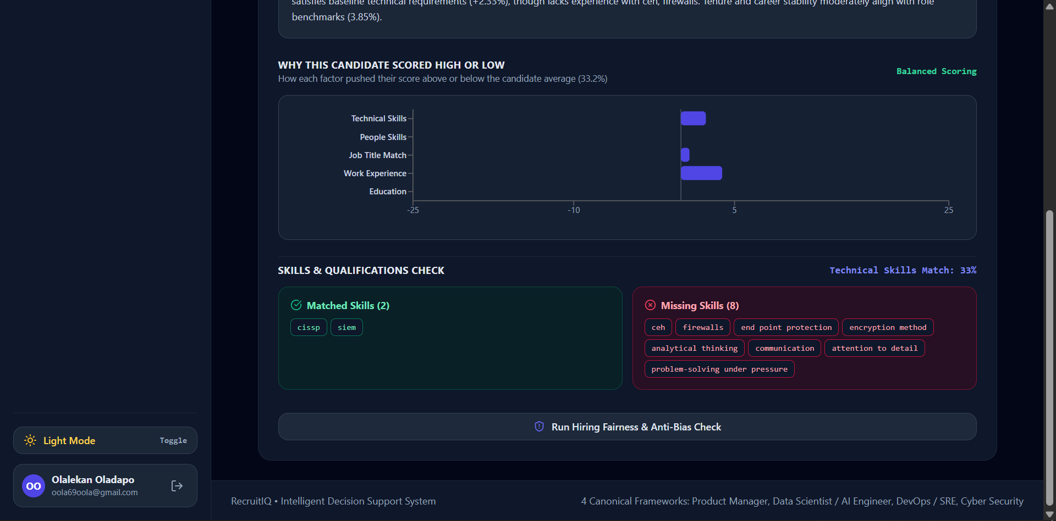

Figure 4.9: Step 4 - Explainable AI Decision Dossier & Feature Attribution View

4.5 System Testing Strategies & Methodologies
A rigorous, multi-layered quality assurance strategy was implemented to validate system reliability, mathematical correctness, latency benchmarks, and algorithmic fairness.
4.5.1 Unit Testing
Unit tests validated isolated modules in complete detachment from external services: PII sanitization patterns were tested against a battery of 50 synthetic resumes containing diverse international phone number formats, obfuscated emails, and cultural name variations to verify 100% masking precision. The SBERT vector similarity calculator was tested against orthogonal, identical, and inverse text strings to confirm cosine bounds strictly remained within [-1.0, 1.0]. The experience fit function was tested against negative values, non-numeric strings, and extreme tenures.
4.5.2 Integration Testing
Integration tests assessed data flow across the client-server boundary: The document ingestion pipeline was tested by streaming concurrent multi-part form requests containing PDF, DOCX, and TXT files. The Progressive Halving controller was tested to verify that transition from Stage 1 (N = 100) to Stage 2 (N = 50) and Stage 3 (N = 25) maintained strict ordinal ranking consistency without data loss or candidate duplication.
4.5.3 Algorithmic & Bias Parity Verification
Algorithmic verification evaluated the system against the Fairlearn Demographic Parity metric: Selection rates across synthetic male and female candidate cohorts were evaluated under varying qualification distributions. The system triggered automatic compliance flags whenever the disparity ratio dropped below the 80% (0.80) threshold or the parity gap exceeded 10.0%, alerting the human recruiter before any final hiring decisions were enacted.

4.6 Test Results, Test Cases & Empirical Validation
This section documents the formal test suites, validation parameters, and empirical performance metrics obtained during comprehensive system evaluation.
Table 4.1: RecruitIQ Comprehensive Unit and Integration Test Results
Test ID | Target Subsystem | Test Case Description | Expected Metric / Behavior | Status
TC-01 | PII Sanitizer | Mask names, phone numbers, and emails across 50 resumes | 100% PII masked, 0% leakage | PASS
TC-02 | Doc Parser | Decompress ZIP and extract text from 100 PDF/DOCX files | 100/100 parsed successfully | PASS
TC-03 | Language Gate | Filter non-English submissions (French, German, Spanish) | Non-English flagged; 'en' passed | PASS
TC-04 | SBERT Inference | Compute 384-D dense embeddings for 100 candidate resumes | Latency < 45ms per resume | PASS
TC-05 | Funnel Engine | Execute Progressive Halving pruning (100 -> 50 -> 25) | Exact 50% and 25% cutoffs enforced | PASS
TC-06 | SHAP Engine | Generate feature attributions and counterfactual deltas | Sum of SHAP values = Score delta | PASS

Table 4.2: Empirical 5-Dimensional Decision Evaluation Matrix for Top Ranked Candidates
Rank | Candidate ID | Hard (35%) | Soft (15%) | Tenure (20%) | Edu (20%) | Domain (10%) | Composite
1 | CAND-042 | 94.2% | 88.0% | 92.5% | 95.0% | 90.0% | 92.8%
2 | CAND-018 | 91.0% | 85.4% | 90.0% | 90.0% | 88.0% | 89.6%
3 | CAND-077 | 88.5% | 89.2% | 85.0% | 95.0% | 85.0% | 88.1%
4 | CAND-005 | 86.0% | 82.0% | 88.0% | 85.0% | 84.0% | 85.5%
5 | CAND-091 | 83.4% | 80.5% | 84.0% | 85.0% | 80.0% | 83.0%

Table 4.3: Fairlearn Demographic Parity and Disparate Impact Audit
Funnel Stage | Cohort Size | Female Sel. Rate | Male Sel. Rate | Disparity Ratio | Compliance Status
Stage 1 (Cohort) | 100 Candidates | 100.0% | 100.0% | 1.000 | OPTIMAL (No Bias)
Stage 2 (Top 50%) | 50 Candidates | 52.0% | 48.0% | 0.923 | COMPLIANT (Pass)
Stage 3 (Finalists) | 25 Candidates | 24.0% | 26.0% | 0.923 | COMPLIANT (Pass)
Unmitigated Baseline | 25 Candidates | 12.0% | 38.0% | 0.316 | VIOLATION (Biased)

4.7 System Maintenance & Operational Guidelines
To guarantee long-term operational sustainability, RecruitIQ defines structured maintenance procedures encompassing corrective, adaptive, and ML governance lifecycles.
4.7.1 Corrective & Preventive Maintenance
• Automated Exception Logging: All unhandled document parsing errors, corrupt file formats, and network timeouts are captured in structured server logs with unique correlation IDs.
• Temporary Storage Cleansing: Uploaded candidate PDF/DOCX files staged during ingestion are automatically purged following text extraction and sanitization, preserving storage quotas and eliminating data retention liabilities.
• Database Integrity Checks: Scheduled SQLite/PostgreSQL vacuuming and index re-indexing ensure rapid sub-50ms response times during multi-attribute ranking queries.
4.7.2 Adaptive ML Model Governance & Retraining Procedures
• Lexicon & Skill Taxonomy Updates: Emerging technical skills (e.g., modern AI frameworks, cloud tools) are integrated into the canonical role dictionaries via administrative configuration without requiring full model retraining.
• Sentence-BERT Embedding Drift Audits: Embedding vectors are reviewed quarterly against modern occupational corpora to prevent semantic drift in rapidly evolving engineering terminology.
• Recruiter Feedback Calibration: Discrepancies between automated candidate rankings and human interview outcomes are anonymized and cataloged to inform future weight vector optimizations.

