**Name :**

**B.N:**

**Date :**

**Topic:**

**Github link :**

**Github page :**

**Application brief :**

In computer engineering, computer architecture is the conceptual design and fundamental operational structure of a computer system. It is the technical drawings and functional description of all design requirements (especially speeds and interconnections), it is how to design and implement various parts of a computer — focusing largely on the way by which the central processing unit (CPU) operates internally and how it accesses addresses in memory.

It can be defined as the science and art of selecting and interconnecting hardware components to create computers that meet functional, performance and cost goals.

Computer architecture includes at least three main subcategories

1)Instruction set architecture, or ISA, is the abstract model of a computing system that is seen by a machine language (or assembly language) programmer, including the instruction set, memory address modes, processor registers, and address and data formats.

2)Microarchitecture, also known as Computer organization is a lower level, a detailed description of the system that is sufficient for completely describing the operation of all parts of the computing system, and how they are inter-connected and inter-operate in order to implement the ISA. The size of a computer's cache for instance, is an organizational issue that generally has nothing to do with the ISA.

3)System Design which includes all of the other hardware components within a computing system such as:

* System interconnects such as computer buses and switches.
* Memory controllers and hierarchies.
* CPU off-load mechanisms such as direct memory access.
* Issues like multi-processing**.**

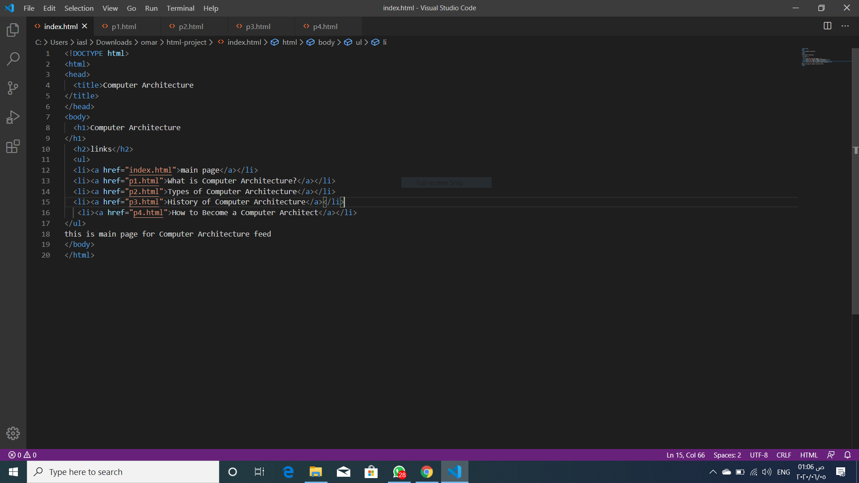**Screeshots :**

