绝密★启封前

**2016普通高等学校招生全国统一考试（浙江卷）**

**英 语**

选择题部分（共80分）

第一部分：英语知识运用（共两节，满分30分）

第一节：单项填空（共20小题；每小题0.5分，满分10分）

从A、B、C和D四个选项中，选出可以填入空白处的最佳选项，并在答题纸上将该选项标号涂黑。

1. --Are you sure you're ready for the best?

--_________. I'm well prepared for it.

A. I'm afraid not B. No problem C. Hard to say D. Not really

2.______prize for the winner of the competition is ______two-week holiday in Paris.

A. The ; 不填 B. A ; 不填 C. A ; the D. The ; a

3. In many ways , the education system in the US is not very different from ____in the UK.

A. that B. this C. one D. it

4. It is important to pay your electricity bill on time , as late payments may affect your ______.

A. condition B. income C. credit D. status

5._______online shopping has changed our life , not all of its effects have been positive.

A. Since B. After C. While D. Unless

6.That young man is honest , cooperative , always there when you need his help .______, he's reliable.

A. Or else B. In short C. By the way D. For one thing

7. The study suggests that the cultures we grow up _______influence the basic processes by which we see world around us.

A. on B. in C. at D. about

8. We can achieve a lot when we learn to let our differences unite , rather than _______ us.

A. divide B. reject C. control D. abandon

9. Silk ______ one of the primary goods traded along the Silk Road by about 100 BC.

A. had become B. reject C. control D. abandon

10.To return to the problem of water pollution , I'd like you to look at a study _______ in Australia in 2012.

A. having conducted B. to be conducted C. conducting D. conducted

11. Scientists have advanced many theories about why human beings cry tears , none of ______ has been proved.

A. whom B. which C. what D. that

12.When their children lived far away from them , these old people felt ______from the world.

A. carried away B. broken down C. cut off D. brought up

13. A sudden stop can be a very frightening experience , ______ if you are travelling at high speed.

A. eventually B. strangely C. merely D. especially

14. When the time came to make the final decision for a course , I decided to apply for the one that ______my interest.

A. limited B. reserved C. reflected D. spoiled

15. Had the governments and scientists not worked together , AIDS-related deaths _______ since their highest in 2005.

A. had not fallen B. would not fall C. did not fall D. would not have fallen

16. In this article , you need to back up general statements with ________ examples.

A. specific B. permanent C. abstract D. universal

17. George _________ too far . His coffee is still warm .

A. must have gone B. might have gone C. can't have gone D. needn't have gone

18. I have always enjoyed all the events you organized and I hope to attend in the coming years

A. little more B. no more C.much more D.many more

19. I had as much fun sailing the seas as I now do with students.

A. working B. work C. to work D. worked

20.—The movie starts at 8:30,and we can have a quick bite before we go

-- .See you at 8:10

A. So long B. Sounds great C. Good luck D.Have a good time

第二节：完形填空（共20小题；每小题1分，满分20分0）

阅读下面短文，掌握其大意，然后从21—40各题所给的四个选项（A、B、C和D）中，选出最佳选项，并在答题纸上将该选项标号涂黑。

During the war,my husband was stationed at an army camp in a desert in California.I went to live there in order to be 21 him. I hated the place .I had never 22 been so unhappy . My husband was ordered out on a long-term duty,and I was left in a tiny shack(棚屋) alone. The heat was 23 -almost 125 0F even in the shade of a cactus(仙人掌)。 24 a soul to talk to . The wind blew non-stop ,and all the food I ate ,and the evry air I breathed,were 25 with sand , sand , sand !

I was so sorry for myself that I wrote to my parents. I told them I was 26 and coming back home.I said I couldn’t stand it one minute longer. I 27 be in prison! My father answered my 28 with just two lines-two lines that will always sing in my 29 - two lines that completely changed my life :

Two men looked out from prison bars

One saw the mud ,the other saw the stars

I read those two lines 30 I was ashamed of myself. I made up my mind I would find out what was good in my present 31 ; I would look for the stars

I made friends with the natives,and their 32 amazed me. They gave me presents of their favorite artworks which they had 33 to sell to toueists . I studied the delightful forms of the cactus .I watched for the desert sunsets,and 34 for seashells that had been left there millions of years ago when the desert had been an ocean 35

What brought about this 36 change in me ? The desert hadn’t changed , 37 I had .I had changed my 38 And by doing so ,I changed an unhappy experience into the most amazing 39 of my life . I was excited by this new world that I had discovered. I had looked out of my self-created prison and 40 the stars

A. B. C. D.

21. A. off B. behind C. near D. beyond

22. A. before B. already C. then D. still

23. A. inflexible B. incomprehensible C. uncontrollable D.unbearable

24. A. Only B. Not C. Many D.Such

25. A. covered B. filled C. buried D. charhed

26. A. catching up B. keeping up C. giving up D.getting up

27. A. ought to B. might well C. would rather D.had better

28. A.request B. call C. question D.letter

29. A. comparison B. imagination C. consideration D. memory

30. A. over and over B. by and by C. up and down D.noe and then

31. A. company B. occupation C. situation D.relationship

32. A. movement B. reaction C. guidance D.purpose

33. A. refused B. failed C. managed D.happened

34. A. asked B. hunted C. waited D.headed

35. A. floor B. surface C. rock D.level

36. A. shocking B. challenging C. puzzling D.astonishing

37. A. as B. but C. for D.or

38. A. attitude B. principle C. identity D.standard

39. A. vacation B. operation C. affair D. adventure

40. A. sought B. counted C. found D.reached

**第二部分：阅读理解（第一节20小题，第二节5小题；每小题2分，满分50分）**

第一节：阅读下列材料，从每题所给的四个选项（A、B、C、D）中，选出最佳选项，并在答题纸上将该选项标号涂黑。

**A**

“Did you hear what happened to Adam Last Friday?”Lindsey whispers to Tori.

With her eyes shining,tori brags，“You bet I did,Sean told me two days ago.”

Who are Lindsey and Tori talking about?It just happened to be yours truly,Adam Freedmam,I can tell you that what that what they are saying is (a) not nice and (b) not even true.Still,Lindsey and Tori aren’t very different from most students here at Linton High School,including me.Many of our conversations are gossip(闲话)。I have noticed three effects of gossip:it can hurt people,it can give gossipers a strange kind of satisfaction,and it can cause social pressures in a group.

An important negative effect of gossip is that it can hurt the person being talked about.Usually,gossip spreads information about a topic-breakups,trouble at home,even dropping out-that a person would rather keep secret.The more embarrassing or shameful the secret is,the juicier the gossip it makes.Probably the worst type of gossip is the absolute lie.People often think of gossipers as harmless,but cruel lies can cause pain.

If we know that gossip can be harmful,then why do so many of us do it? The answer lies in another effect of gossip:the satisfaction it gives us.Sharing the latest rumor(传言)can make a person feel important because he or she knows something that others don’t.Similarly,hearing the latest rumor can make a person feel like part of the “in group.”In other words,gossip is satisfying because it gives people a sense of belonging or even superiority(优越感).

Gossip also can have a third effect:it strengthens unwritten,unspoken rules about how people should act.Professor David Wilson explains that gossip is important in policing behaviors in a group.Translated into high school terms, this means that if everybody you hang around with is laughing at what John wore or what Jane said,then you can bet that wearing or saying something similar will get you the same kind of negative attention.The do’s and don’ts conveyed through gossip will never show up in any student handbook.

The effects of gossip vary depending on the situation.The next time you feel the urge to spread the latest news,thing about why you want to gossip and what effects your “juicy story”might have.

41.The author uses a conversation at the beginning of the passage to .

A.introduce a topic

B.present an argument

C.describe the characters

D.clarify his writing purpose

42.An important negative effects of gossip is that it .

A.breaks up relationships

B.embarrasses the listener

C.spreads information around

D.causes unpleasant experiences

43.In the author’s opinion,many people like to gossip because it .

A.gives them a feeling of pleasure

B.helps them to make more friends

C.makes them better at telling stories

D.enables them to meet important people

44.Professor David Wilson think that gossip can .

A.provide students with written rules

B.help people watch their own behaviors

C.force school to improve student handbooks

D.attract the police’s attention to group behaviors

45.What advice does the author give in the passage?

A.Never become a gossiper

B.Stay away from gossipers

C.Don’t let gossip turn into lies

D.Think twice before you gossip.

**B**

**Below are search record from a university library’s database**

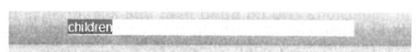

**Quick Search l Category l Full Text l Advanced**

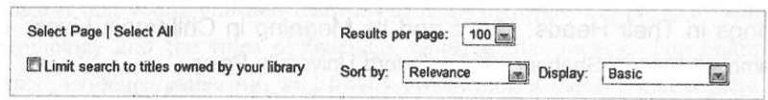

**Refine Your Search**

**Remove all them**

Year Published

**2016( 9 )**

**2015( 90 )**

**2014( 290 )**

**2013( 118 )**

**2012(62 )**

**Show more……**

**Language**

English(637 )

German(2)

**Category**

Education(639)

Social Science(27)

Medicine (15)

Psychology(11)

Language/Linguistics  
(10)

**Show more…..**

Search full text books for children

Displaying 1 to 100 of 639 titles for children where Category is Education



|  |
| --- |
| Build it ,Make it ,Play it ! Guides for Children and Teens Bomhold Catharine ;Elder Terri,2004 l ABC-CLIO  Series: Children’s and Young Adult Literature Reference  Available  For busy librarians and educators ,finding instructions for projects ,activities ,sports ,and games that children and teens will find interesting is a constant challenge, This guide is a time-saving,one-stop….  Read this book l View details l Add to Collection |
| Circle Time for Young Children  Mosley Jenny,2014 l Taylor and Francis  Series: Essential Guides for Early Years Practitioners  Available  Jenny Mosley’s quality circle time model involves setting up an on-going, timetable process  Of circle-meeting for adults and children ,As a basis for teaching relationship skills, building up self-esteem…..  Read this book l View details l Add to Collection |
| Connecting Animals and children in Early Childhood  Selly Patty Born,2014 l Redleaf Press  Available  Understand the value of connecting animals and children .From family pets and wild animals to toys ,stuffed animal ,and media images ,animals are a central part of every child’s world .This book examines….  Read this book l View details l Add to Collection |
| Education and Disadvantaged Children and Young People  Matsumoto Mitsuko; Brock Colin,2013 l Bloomsbury Publishing  Series: Education as a Humanitarian Response  Available  Do street children go ti school ,and if not ,why not? What kind of education can be ‘meaningful’ to young people affected by conflict? The contributors explore groups of children and young people who have….  Read this book l View details l Add to Collection |

Children with School problems:A Physician’s Manual

|  |
| --- |
| The Canadian paediatric Society; Andrews Debra;Mahoney WilliamJ, 2012 I wiley  Available  C:\Documents and Settings\Administrator\桌面\图片2.pngThe physician’s guide to diagnosing and treating learning disabilities in children.1 to 10 Canadians have a learning disability,and doctors must be able to identify,diagnose,treat,and manage children…  Read this book I view details I Add to Collection |
| Songs in Their Heads:Music and Its Meaning In Children’s Lives  Campbell Patricia Shehan,1989 I Oxford University Press  Available  This book explores the interest and needs of children in their expressed thoughts and actual “musicking”behaviors, This text examines the songs they sing,the rhythms…  Read this book I view details I Add to Collection C:\Documents and Settings\Administrator\桌面\图片三.png |
| C:\Documents and Settings\Administrator\桌面\图片四.pngYoung Children as Artists:Art and Design in the Early Years and Kay Stage 1  Tutchell Suzy 2014 I Taylor Francis  Available  From the moment a child is born,they interact with the world,looking at colours ,feeding texrures;constructing mental and physical images of what they see and experience.Within all early years…  Read this book I view details I Add to Collection |
| Big Ideas for Little Kids:Teaching Philosophy Through Children’s Literature  Wartenberg Thomas E.2014 I Rowman & Littlefield Publishers  Available  Big Ideas for Little Kids includes everything a teacher,or a college student needs to teach philosophy to elementary school children from picture books.Written in a clear and accessible style…  C:\Documents and Settings\Administrator\桌面\图片5.pngRead this book I view details I Add to Collection |

46.Suppose you are doing research on children’s relationship skills,you may want to read .

A.*Circle Time for Young Children*

B. *Children with School Problems:A*  Physician’s *Manual*

C.*Education and Disadvantaged Children and Young People*

D.*Build It,Make It,Do It,Play It!Guides for Children and Teens*

47.Which book would you recommend to someone interested inchildren’s mental images?

A.*Connecting Animals and Children in Early Childhood.*

B.*Songs in Their Heads:Music and Its Meaning in children’s Lives.*

C.*Big Ideas for Little Kids: Teaching Philosophy Through children’s Literature.*

D.*Young Children as Artists:Art and Design in the Early Years and Key Stage 1.*48.How many books published in 2015 are found in this search?

A. 9. B.90. C.118. D.290.

49. *Children with School Problems:A*  Physician’s *Manual is most likely intended for* .

A. educators B. librarians C. doctors D.artists

C

A scientist working at her lab bench and a six-old baby playing with his food might seem to have little in common.After all,the scientist is engaged in serious research to uncover the very nature of the physical world,and the baby is,well, just playing…right?Perhaps,but some developmental psychologists()have argued that this“play”is more like a scientific investigation than one might think.

Take a closer look at the baby playing at the table.Each time the bowl of rice is pushed over the table edge,it

falls in the ground---and, in the process, it belongs out important evidence about how physical objects interact ; bowls of rice do not flood in mid-sit, but require support to remain stable. It is likely that babies are not born knowing the basic fact of the universe; nor are they ever clearly taught it. Instead, babies may form an understanding of object support through repeated experiments and then build on this knowledge to learn even more about how objects interact. Though their ranges and tools differ, the baby’s investigation and the scientist’s experiment appear to share the same aim(to learn about the natural world ), overall approach (gathering direct evidence from the world), and logic (are my observations what I expected?).

Some psychologists suggest that young children learn about more than just the physical world in this way---that they investigate human psychology and the rules of language using similar means. For example, it may only be through repeated experiments, evidence gathering, and finally overturning a theory, that a baby will come to accept the idea that other people can have different views and desires from what he or she has, for example, unlike the child , Mommy actually doesn’t like Dove chocolate.

Viewing childhood development as a scientific investigation throws on how children learn ,but it also offers an inspiring look at science and scientists. Why do young children and scientists seem to be so much alike? Psychologists have suggested that science as an effort ---the desire to explore, explain, and understand our world---is simply something that comes from our babyhood. Perhaps evolution provided human babies with curiosity and a natural drive to explain their worlds, and adult scientists simply make use of the same drive that served them as children. The same cognitive systems that make young children feel good about feel good about figuring something out may have been adopted by adult scientists. As some psychologists put it, ”It is not that children are little scientists but that scientists are big children.”

50. According to some developmental psychologists,

A. a baby’s play is nothing more than a game.

B. scientific research into babies; games is possible

C. the nature of babies’ play has been thoroughly investigated

D. a baby’s play is somehow similar to a scientist’s experiment

51.We learn from Paragraph 2 that

A. scientists and babies seem to observe the world differently

B. scientists and babies often interact with each other

C. babies are born with the knowledge of object support

D. babies seem to collect evidence just as scientists do

52. Children may learn the rules of language by

A. exploring the physical world B. investigating human psychology

C. repeating their own experiments D. observing their parents’ behaviors

53. What is themain idea of the last paragraph?

A. The world may be more clearly explained through children’s play.

B. Studying babies’ play may lead to a better understanding of science.

C. Children may have greater ability to figure out things than scientists.

D. One’s drive for scientific research may become stronger as he grows.

54. What is the author’s tone when he discusses the connection between scientists’ research and babies’ play?

A. Convincing. B. Confused. C. Confidence. D. Cautious.

D

Two things changed my life: my mother and a white plastic bike basket. I have thought long and hard about it and it’s true. I would be a different person if my mom hadn’t turned a silly bicycle accessory into a life lesson I carry with me today.

My mother and father were united in their way of raising children, but it mostly fell to my mother to actually carry it out. Looking back, I honestly don’t know how she did it. Managing the family budget must have been a very hard task., but she made it look effortless. If we complained about not having what another kid did, we’d hear something like, “I don’t care what so –and –so got for his birthday, you are not getting a TV in your room a car for your birthday a lavish sweet 16 party.” We had to earn our allowance by doing chores around the house. I can still l remember how long it took to polish the legs of our coffee table.My brothers can no doubt remember hours spent cleaning the house .Like the two little girls growing up at the White House,we made our own beds (no one left the house until that was done)and picked up after ourselves.We had to keep track of our belongings ,and if something was lost ,it was not replaced.

It was summer and ,one day ,my mother drove me to the bike shop to get a tire fixed---and there it was in the window, White, shiny, plastic and decorated with flowers ,the basket winked at me and I knew ----I *knew---*I had to have it.

“It’s beautiful,” my mother said when I pointed it out to her,”What a neat basket.”

I tried to hold off at first ,I played it cool for a short while.But then I guess I couldn’t stand it any longer:“Mon, please can I please ,please get it? I ‘ll do extra chores for as long as you say, I’ll do anything ,but I need that basket,I love that basket.Please ,Mom .Please?”

I was desperate.

“You know,” she said ,gently rubbing my back while we both stared at what I believes was the coolest thing ever,”If you save up you could buy this yourself.”

“By the time I make enough it’ll bu gone!”

“Maybe Roger here could hold it for you,” she smiled at Roger ,the bike guy.

“He can’t hold it for that long ,Mom .Someone else will buy it .Please,Mom,Please?”

“There might be another way,”she said.

And so our paying plan unfolded.My mother bought the beautiful basket and put it safely in some hiding place I couldn’t find.Each week I eagerly counted my growing saving increased by extra work here and there (washing the car ,helping my mother make dinner, delivering or collecting things on my bike that already looked **naked** without the basket in front).And then ,weeks later ,I counted ,re-counted and jumped for joy. Oh ,happy day ! I made it! I finally had the exact amount we’d agreed upon….

Days later the unthinkable happened. A neighborhood girl I’d played with millions of times appeared with the exact same basket fixed to her shiny ,new bike that already had all the bells and whistles. I rode hard and fast home to tell my mother about this disaster.This horrible turn of events.

And then came the lesson . I’ve taken with me through my life:”Honey, Your basket is extra-special,” Mom said, gently wiping away my hot tears.”Your basket is special because you paid for it yourself.”

55.What can we learn from the first two paragraphs?

A. The children enjoyed doing housework.

B.The author came from s well-off family

C. The mother raised her children in an unusual way

D.The children were fond of the US president’s daughters.

56.When the author saw the basket in the window,she .

A. fell in love with it B. stared at her mother

C. recognized it at once D.went up to the bike guy

57.Why did the author say many “please” to her mother?

A. She longed to do extra work. B. She was eager to have the basket.

C.She felt tired after standing too long. D.She wanted to be polite to her mother.

58.By using“naked” (Paragraph 12),the author seems to stress that the basket was

A..something she could afford B.something important to her

C.something impossible to get D.something she could do without

59.To the author, it seemed to be a horrible turn of events that

A. something spoiled her paying plan

B. the basket cost more than she had saved

C.a neighborhood girl had bought a new bike

D.someone else had got a basket of the same kind

60.What is the life lesson the author learned from her mother?

A. Save money for a rainy day B. Good advice is beyond all price.

C. Earn your bread with your sweat D. God helps those who help themselves

第二节：下面文章中有5处（第61-65题）需要添加小标题。请从以下选项（ABCDE和F）中选出符合各段意思的小题，并在答题纸上将相应选项的标号涂黑。选项中有一项是多余选项。

A. Get involved in student activities

B. Your voice is actually super important

C. There is a significant increase of opportunities

D. Stay in active communication with your friends

E. Get smart about the people who you spend your time with

F. Your major does not matter as much in your first of college

Five Things Nobody Told Me about College

As I type this , I am in my university dorm room. A year ago, when I was awaiting to hear the results of my college applications, I often went to websites for some type of insider look on what college would be like. However, there’s only so much that prep books, websites, and older friends can teach. Here are the top 5things nobody told me about college:

61

Nobody entering a university knows exactly what they want to study. If they tell you otherwise, they’re lying and will probably change what they want to purse within the first quarter of attendance . During my first quarter at University of California, Riverside (UCR),I thought that I wanted to study Political Science with its focus on International Affairs, so that’s what I applied for. However, once I worked with statewide and local government, I realized that a better fit for me would be Public Policy, and now I am in the process of changing my area.

62

In college, there are so many good chances for you to meet your expectations. However, there is a very important difference between wanting to do something and applying for something. In order for you to take advantage of the conferences, research, internships ,and fellowships that your university offers, apply! Step into your academic advisor’s office, introduce yourself, and begin making the valuable connections that are necessary to help during the rest of your college career. Great things happen when you step out of your comfort zone, and you would be surprised on how many chances exist if you just ask.

63

College is where you meet your birdesmaids, neighbors, and potential bosses. The relationships you develop now will probably be linked to the ones you value later, so he wise about the people who you invest yourself in . You are only one person, and you do not have time to waste on people who would rather cause drama or mess up with your purpose. Surround yourself with uplifting individuals who challenge you to be better while loving you for who you are, and be patient to the people who are the complete opposite of that description.

64

As a first-year, I was afraid to make any noise towards campus issues that I noticed. It was not until I became involved in student government that I gained the confidence to handle projects that I created with the help of ASUCR Office of the President. During my first quarter, I spoke directly to the Chancellor, asking him for support towards my initiatives, met with the Vice Chancellors, and cooperated with my teaching assistants to begin my undergraduate research protect. Nothing good will happen when you are silent.

65

At my high school,there were about only four active club and organizations that students could be a part of.Imagine my surprise when I stepped foot onto UCR’s campus,where over 400 organizations exist,ranging from political organizations to karate club.You are not paying all or your tuition(学费)to merely go to class,study,pass tests and graduate.Make something worthy out of your experience.Create that you will want to tell your grandchildren one day.It all begins here,by signing up to join an organization.

**非选择题部分**（共40分）

第三部分：写作（共两节，满分40分）

第一节：短文改错（共10小题；每小题1分，满分10分）

下面短文中有10处语言错误。请在有错误的地方增加、删减或修改某个单词。

增加：在缺词处加一个漏字符号（∧），并在其下面写上该加的词。

删除：把多余的词用斜线（/）划掉。

修改：在错的词下划一横线，并在该词下面写上修改后的词。

注意：1.每处错误及其修改均仅限一词；

2.只允许修改10处，多着（从第11处起）不计分。

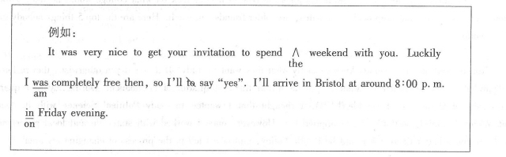

When I was a very young children,my father created a regular practice I remember well years late.Every time he arrived home at end of the day ,we’d greet het at the door.He would ask who we was and pretend not to knowing us,Then he and my mother would have had a drink while she prepared dinner and they would talk about his day and hers.While they chat,my father would lift my sister and me up to sit in the top of the fridge.It was both excited and frightening to be up there！

My sister and I thought he was so cool for putting us there.

第二节：书面表达（满分30分）

“Planning is good ,but doing is better”是一句英国名言。请以此为题目用英语写一篇100-120词的短文。

要求如下：

1.简述你对这句名言的理解；

2.用一个具体事例加以说明；

3.给出恰当的结尾。

注意：1.文章的标题已给出（不计词数）：

2.文中不得以任何形式透露地区、学校、老师或同学姓名等真实信息，否则按作弊行为认定。

**Planning Is Good ,But Doing Is Better**

**英语试题参考答案**

第一部分：英语知识运用（共两节，30分）

第一节：单项填空（10分，每小题0.5分）

1.B 2. D 3.A 4.C 5.C

6.B 7.B 8.A 9.A 10.D

11.B 12.C 13.D 14.C 15.D

16.A 17.C 18.D 19.A 20.B

第二节：完形填空（20分，每小题1分）

21.C 22.A 23.D 24.B 25.B

26.C 27.C 28.D 29.D 30.A

31.C 32.B 33.A 34.B 35.A

36.D 37.B 38.A 39.D 40.C

第二部分：阅读理解（50分，每小题2分）

41.A 42.D 43.A 44.B 45.D

46.A 47.D 48.B 49.C 50.D

51.D 52.C 53.B 54.D 55.C

56.A 57.B 58.B 59.D 60.C

61.F 62.C 63.E 64.B 65.A

第三部分：写作（共两节，40分）

第一节：短文改错（10分，每小题1分）

When I was a very young children,my father created a regular practice I r

child

emember well years late.Every time he arrived home at ∧end of the day ,

later the

we’d greet herat the door.He would ask who we was and pretend not to knowing

him were know

us,Then he and my mother would have had a drink while she prepared dinner and they would talk about his day and hers.While they chat,my father would lift my sister and

chatted

me up to sit in the top of the fridge.It was both excited and frightening to be up there！

on exciting

My sister and I thought he was so cool for putting us there.

第二节：书面表达（30分）

***One possible student version***

**Planning Is Good ,But Doing Is Better**

Planning is good as it decides in detail how we do.However,a plan can bear no fruit without being actually carried out.

My experience in the English speech contest last October is a case in point.A month before the event,I Spent hours working out a schedule outlining my goals and practical steps.After that,I set out to read widely for an inspiring topic,wrote a speech,and practiced its delivery in beautiful prounnciation with good public speech skills.I finally came out of the contest as the first prize winner.

I know how I achieved my success. It came from good planning and better doing combined.

**选择题部分（共80分）**

**第一部分：英语知识运用（共两节，满分30分）**

第一节：单项填空（共20小题；每小题0.5分，满分10分）

从A、B、C和D四个选项中，选出可以填入空白处的最佳选项，并在答题纸上将该选项标号涂黑。

1. --Are you sure you're ready for the best?

--_________. I'm well prepared for it.

A. I'm afraid not B. No problem C. Hard to say D. Not really

【答案】B

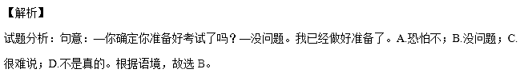

考点：考查交际用语。

【名师点睛】交际英语注重运用，首先平时要多积累常用的交际用语，解题时要在上下文中进行，特别要注意与语境语义的联系。还有要注意中英文之间的差异，千万不要用汉语的思维，还要注意礼貌用语。这个题目是一个对话，上下文语境非常关键。I'm afraid not应该是委婉地拒绝；Hard to say表示说话人没有把握；Not really是一种否定回答。

2.______prize for the winner of the competition is ______two-week holiday in Paris.

A. The ; 不填 B. A ; 不填 C. A ; the D. The ; a

【答案】D

【解析】

试题分析：句意：这个比赛获胜者的奖品是一个巴黎的两个星期的假期。第一空填the，是特指“获胜者的奖

品”，用定冠词，第二空是泛指“一个两周的假期”，用不定冠词a。故选A。

考点：考查冠词。

【名师点睛】本题着重理解定冠词和不定冠词的区别，定冠词the表示特指，不定冠词a/an表示泛指；对于冠词特指和泛指的考查是历年来高考的必考点，平时的学习要多进行积累，仔细分析特指还是泛指。同时，更为重要的是要多去积累习惯表达，特殊表达，这也是近几年高考习惯考的地方。总而言之，多解题、多理解、多积累才是关键。做冠词的题目语感非常重要，平时阅读的时候，注意出现冠词的地方，体会是特指还是泛指。

3. In many ways , the education system in the US is not very different from ____in the UK.

A. that B. this C. one D. it

【答案】A

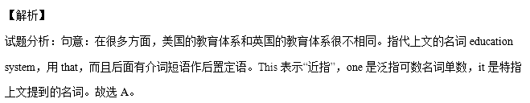

考点：考查代词。

【名师点睛】本题着重考查指示代词：用来指示或标识人或事物的代词。它们主要有：this这个；that那个；these这些；those那些；it 它。指示代词所指的对象取决于谈话双方都熟悉的语境。指示代词在句中可用做主语、宾语、表语、定语和状语。that指代上文的可数或不可数名词，后面有后置定语；those指代上文的可数名词复数，后面有后置定语；one是泛指上文的可数名词单数；it指同类同物。

4. It is important to pay your electricity bill on time , as late payments may affect your ______.

A. condition B. income C. credit D. status

【答案】C

【解析】

试题分析：句意：准时付电费很重要，因为付晚了会影响你的信用。Condition条件；income收入；credit

学分，信用（卡）。根据句意故选C。

考点：考查名词辨析。

【名师点睛】名词最常考的命题形式是名词词义辨析，对于同义词辨析，我们一定要平时注意积累。由做题经验可知，同义词辨析大多是在具体语境中，由关键固定短语来判断的。真正的词义辨析题很少。常考的名词词义辨析词有: custom风俗习惯；habit个人习惯；tradition传统；scene场景；scenery自然风景（总称）；view特定位置的景观；sight人文或历史景观；skill技能；ability能力；talent才华；strength优势，长处 等等。这题中的credit属于一词多义，有时也会考查熟词生义。

5._______online shopping has changed our life , not all of its effects have been positive.

A. Since B. After C. While D. Unless

【答案】C

【解析】

试题分析：句意：尽管网上购物已经改变了我们的生活，单数不是所有的影响都是积极的。While引导让步

状语从句，意为“尽管，虽然”；since既然，自从；after在……之后；unless除非。故选C。

考点：考查连词。

【名师点睛】这几个词都是连词，要分清每个连词短语的含义和用法，做题时关键看上下文和句意的逻辑关系做题。since引导原因/时间状语从句；after引导时间状语从句，while引导让步/时间状语从句；unless引导的是条件状语从句；while的用法比较多，不仅仅在选择题中经常出现，学生在做阅读完型的时候，遇到while一定要判断它的准确含义，以便于正确理解这句话的意思。

6.That young man is honest , cooperative , always there when you need his help .______, he's reliable.

A. Or else B. In short C. By the way D. For one thing

【答案】B

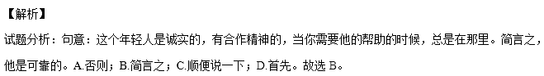

考点：考查介词短语。

【名师点睛】介词短语的考查通常是一些易混的相似的介词短语，这题的介词短语都是out of+名词搭配，但是意思都是大相径庭，学生在平时要注意积累这些相似短语的搭配和含义，做题时结合具体的语境代入各个选项确定答案。这句话很明显，前后两句话意思一样，就是后面简短写，可以确定是“简言之”。

7. The study suggests that the cultures we grow up _______influence the basic processes by which we see world around us.

A. on B. in C. at D. about

【答案】B

【解析】

试题分析：句意：研究表明我们成长的文化影响我们看周围世界的基本过程。The cultures后面是定语从句，

省略that，定语从句中cultures作宾语，那么还缺少一个介词，和cultures搭配用介词in，故选B。

考点：考查介词。

【名师点睛】这道题与其说是考查介词，还不如说是考查定语从句，因为介词in不是和后面的influence搭配，而是通过分析发现这是定语从句，和前面的先行词culture搭配需要什么介词。

8. We can achieve a lot when we learn to let our differences unite , rather than _______ us.

A. divide B. reject C. control D. abandon

【答案】A

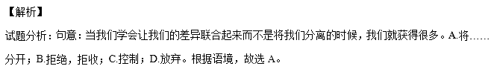

考点：考查动词辨析。

【名师点睛】词义辨析题在高考中有所涉及，每年的趋势不尽相同。对于词义辨析题目，首先可以从句意着手，看懂句意是解答此类题目的关键，其次四个选项的意思也要了如指掌。这对于平时学生的学习仔细度提出了要求，学生在平时的学习中要勤积累，多记忆，多查字典，以便在考试时能够迅速准确的答出。动词是非常重要的词性，在句中起着至关重要的作用，掌握好动词非常关键，这也是经常考查动词的原因。这题要找准关键词unite，和divide是反义词。

9. Silk ______ one of the primary goods traded along the Silk Road by about 100 BC.

A. had become B. reject C. control D. abandon

【答案】A

【解析】

试题分析：句意：到公元前100年为止，丝绸已经成为丝绸之路上交易的主要商品之一。时间状语是by+

过去时间，谓语用过去完成时。故选A。

考点：考查动词时态。

【名师点睛】动词的时态、语态是选择题中必考内容之一，动词的各种时态形式都可能考到，不过最常考的是一般现在时态，一般过去时态，现在进行时态，以及一般将来时态，现在完成时态，同时还常与非谓语动词一起考查，做语法填空题时，首先要判断括号中所给动词是谓语动词还是非谓语动词，如本小题第一个空就是考查谓语动词；若是谓语动词，就要考虑时态、语态、语气(陈述语气还是虚拟语气)、主谓一致四个方面，本小题考查过去完成时，从三个方面来进行判断：

1. 看句子中的时间状语或时间状语从句，本小题时间状语是by about 100 BC，故判断是过去完成时。

2. 在没有时间状语或时间状语从句时，要看上下文的谓语动词的形式。

3. 看是否是特殊句型等。如：It was+the first time+that从句中用过去完成时。

10.To return to the problem of water pollution , I'd like you to look at a study _______ in Australia in 2012.

A. having conducted B. to be conducted C. conducting D. conducted

【答案】D

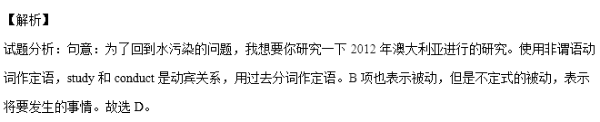

考点：考查非谓语动词。

【名师点睛】判断非谓语动词的形式的第一步是分析句子成分，看是用谓语动词还是非谓语动词，确定了是非谓语动词，还要判断非谓语动词的成分，和这个动词和逻辑主语的关系。这道题考查非谓语动词作定语的用法，看carry out和修饰的study之间的关系可知用过去分词。

11. Scientists have advanced many theories about why human beings cry tears , none of ______ has been proved.

A. whom B. which C. what D. that

【答案】B

【解析】

试题分析：句意：关于人类为什么哭的时候会流泪，科学家已经提出了很多理论，没有一个被证明了。使

用定语从句，先行词是theories，指物，定语从句中用代词+介词+关系代词which引导。故选B。

考点：考查定语从句。

【名师点睛】定语从句的考查主要就是考查关系词的辨析，关系代词that, which, whose, whom, as， who在句中做主语，宾语，表语或者定语；where, why, when在句中做地点，原因和时间状语。要分析定语从句的成分，看缺少什么成分，就选用相应的关系词。如果是代词+of+关系代词，注意先行词是人用whom，先行词是物用which。

12.When their children lived far away from them , these old people felt ______from the world.

A. carried away B. broken down C. cut off D. brought up

【答案】C

【解析】

试题分析：句意：当孩子远离他们生活的时候，这些老人感觉和世界隔绝了。Carry away带走，夺走；break

down崩溃，破坏，抛锚，分解；cut off切断；bring up养育，培养。故选C。

考点：考查动词短语。

【名师点睛】动词短语是高考常考内容。可以按照以下方法学习：1.在每个部分找出自己最熟悉或者最理解的短语，并根据该短语助记总体意思；2.熟记动词本身所具有的全部意思；3.重点根据小品词在该项中的总体意思结合动词本身的意思，理解自己最不理解和不熟悉的短语4.脱离汉语，只看英语动词短语，并放到具体句子和场景中认识动词短语5.注意有些短语意义很接近, 这要结合例句和上下文掌握它们的用法。

13. A sudden stop can be a very frightening experience , ______ if you are travelling at high speed.

A. eventually B. strangely C. merely D. especially

【答案】D

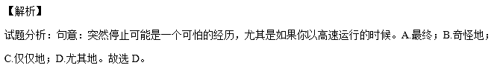

考点：考查副词辨析。

【名师点睛】副词辨析是试卷中经常出现的题型，所以平时一定要把词汇放在句中进行记忆。在复习词汇的时候，要依据语言的横向组合和纵向聚合，按照点-线-面顺序，构建知识网络环境，对知识内容进行巩固、深化和提升，这样才能提高复习知识点的效率。这样，再做单项填空题时，就会觉得游刃有余。对于英语中的词汇用法，平时要多归纳总结，词汇用法的特殊语法规则更要特别记忆。最好把词汇放在句子中，连同句子一起记忆，这样能够加强记忆。

14. When the time came to make the final decision for a course , I decided to apply for the one that ______my interest.

A. limited B. reserved C. reflected D. spoiled

【答案】C

【解析】

试题分析：句意：当最后决定课程的时候到了，我决定申请能反映我兴趣的课程。A.限制；B.保留；C.反映，

反射；D.宠坏。故选C。

考点：考查动词辨析。

【名师点睛】对于动词词义辨析题目，首先可以从句意着手，看懂句意是解答此类题目的关键，其次四个选项的意思也要了如指掌。这对于平时学生的学习仔细度提出了要求，学生在平时的学习中要勤积累，多记忆，多查字典，以便在考试时能够迅速准确的答出，还有的是一些固定搭配，需要了如指掌。Reflect意思较多，有：反射，反照; 表达; 显示; 折转。平时记忆要准确，全面。

15. Had the governments and scientists not worked together , AIDS-related deaths _______ since their highest in 2005.

A. had not fallen B. would not fall C. did not fall D. would not have fallen

【答案】D

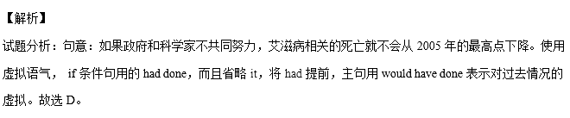

考点：考查虚拟语气。

【名师点睛】if的虚拟语气非常重要，首先要熟悉基本用法：1、表示与现在事实相反的情况，从句：If主语+过去时(be动词用were)；主句：主语+should/would/could/might+do：　2、表示与过去事实相反的情况，从句：If主语+had+done；主句：主语+should/would/could/might+have done　3、表示对将来情况的主观推测，从句：①if+主语+were to do②if+主语+should+do ③if+主语+did（动词过去式）/were ；主句：主语+should/would/could/might+do，另外要注意从句也可以省略if，把had，were，should提前。这句话的虚拟语气比较明显，if条件句省略了if，将had提前，说明使用了过去完成进行时和过去相反，学生看出这点就容易做题了。

16. In this article , you need to back up general statements with ________ examples.

A. specific B. permanent C. abstract D. universal

【答案】A

【解析】

试题分析：句意：在文章中，你需要用具体的例子来支持总的观点。A.具体，明确的；B.永久的；C.抽象的；

D.全球的，共通的。故选A。

考点：考查形容词辨析。

【名师点睛】把相似、相近的词语或结构放在一起作为干扰选项，若我们基础知识掌握不牢就难于区分。解答这类题目，关键是理解题干意思以及各选项副词的意思，可以像数学中的代入法一样，依次把各个选项意思放入句子中进行比较，不难选出正确答案。还有抓住句中的关键词general和specific对应。

17. George _________ too far . His coffee is still warm .

A. must have gone B. might have gone C. can't have gone D. needn't have gone

【答案】C

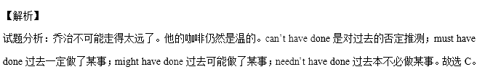考点：考查情态动词+have done。

【名师点睛】熟练掌握情态动词的用法，对准确理解语法填空、完形填空、阅读理解、听力理解中含有情态动词的句子是很有益处的，并且在写作中也可能会用到情态动词。因此，我们应当学好情态动词，尤其要掌握好常用情态动词的用法。情态动词+have done的用法：情态动词无论是表达“推测和可能性”，还是表达“虚拟”这一概念，只要是对过去已经发生的事情进行描述，一律用“情态动词+have done”这一结构；对现在或将来的事情进行描述，用“情态动词+动词或系动词原形”。注意不同的情态动词和have done搭配的含义。表示推测的can have done一般用于疑问和否定句中。

18. I have always enjoyed all the events you organized and I hope to attend in the coming years

A. little more B. no more C.much more D.many more

【答案】D

【解析】

试题分析：句意：我一直很喜欢你组织的所有的活动并且希望在未来的几年里参加更多的活动。A.没有这

个搭配；B.不再；C.多得多（修饰不可数名词）；D. many more更多（修饰可数名词）。这里修饰的是上文的

activities。故选D。

考点：考查短语辨析。

【名师点睛】这题考查的是形容词比较级搭配的短语，AB项意思相近，CD项意思相近，根据语境可知用CD里面的一个，注意much more和many more的区别。much more修饰不可数名词；many more修饰可数名词，还有根据上下文可知修饰的是上文的activities，所以用many more。

19. I had as much fun sailing the seas as I now dowith students.

A. working B. work C. to work D. worked

【答案】A

【解析】

试题分析：句意：我在海上航行和现在和学生一起一样快乐。使用非谓语动词作状语，I和work是主谓关

系，用现在分词作时间状语。故选A。

考点：考查非谓语动词。

【名师点睛】判断非谓语动词的形式的第一步是分析句子成分，看是用谓语动词还是非谓语动词，确定了是非谓语动词，还要判断非谓语动词的成分，和这个动词和逻辑主语的关系。这道题考查非谓语动词作状语的用法，看I和work的逻辑关系可以看出是现在分词。

20.—The movie starta at 8:30,and wo can have a quick bite before wo go

--.See you at 8:10

A. So long B. Sounds great C. Good luck D.Have a good time

【答案】B

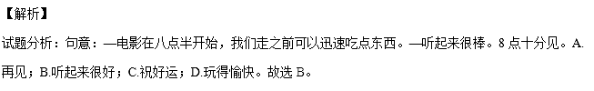

考点：考查交际用语。

【名师点睛】情景交际的考查关键在于理解上下文语境，同时要注意辨析选项的意思，平时多熟记交际用语，尤其是一些与汉语相差较大的表达。做这类试题，要求同学们按照所给的情景，选择最佳问句或答句，完成题目。要想做好这类题目，关键是平时要养成讲英语的良好习惯，努力提高口语水平，熟练掌握日常会话项目中常用的问答语。这题的sound great实际上是省略句，完整的句子是The idea sounds great.和上文提出的建议吻合。

第二节：完形填空（共20小题；每小题1分，满分20分0）

【语篇解读】这是一篇记叙文。作者讲述自己为了离丈夫近一些，住在他所在的沙漠的军营里，寂寞的生活和艰苦的生活条件让作者难以忍受，她写信告诉父母要回家。父亲给他的信中就两行字，就是这两行字使作者改变了自己对人生的态度。

21.【答案】C

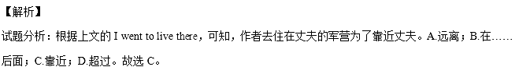

考点：考查介词辨析。

22.【答案】A

【解析】

试题分析：根据下文I was left in a tiny shack(棚屋) alone.可知，作者以前从没有感觉这么不开心。A.以前；

B.已经；C.然后；D.仍然。故选A。

考点：考查副词辨析。

23.【答案】D

【解析】

试题分析：根据almost 125F，可知炎热让人无法忍受。 A.不灵活的；B.无法理解的；C.不能控制的；D.不

能忍受的。故选D。

考点：考查形容词辨析。

24.【答案】B

【解析】

试题分析：根据上文a desert和alone，可知，没有一个人可以交谈。A.仅仅；B. 没有；C.很多；D.这样。

故选B。

考点：考查副词辨析。

25.【答案】B

【解析】

试题分析：根据上文a desert可知，作者吃的食物，呼吸的空气都充满了沙子。A.覆盖；B.填满；C.埋葬；

D.负责，要价。故选B。

考点：考查动词辨析。

26.【答案】C

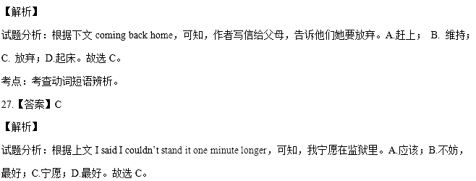

考点：考查短语辨析。

28.【答案】D

【解析】

试题分析：根据上文I wrote to my parents，可知，作者的爸爸回复了作者的信，只有两行字。A.请求；B.

电话；C.问题；D.信。故选D。

考点：考查名词辨析。

29.【答案】D

【解析】

试题分析：根据句意：这两行字将永远在我记忆里唱响—这是永远改变我的生活的两行字。A.对比； B.想

象；C.考虑；D.记忆。故选D。

考点：考查名词辨析。

30.【答案】A

【解析】

试题分析：根据下文I was ashamed of myself.可知，作者一遍又一遍地读这两行字。A.一遍又一遍；B.不久；

C. 上上下下； D. 不时。故选A。

考点：考查短语辨析。

31.【答案】C

【解析】

试题分析：根据上文I would look for the stars，可知，作者决定要发现现在的环境中好的东西。A.公司，陪

伴；B.占据，职业；C.环境；D. 关系。故选C。

考点：考查名词辨析。

32.【答案】B

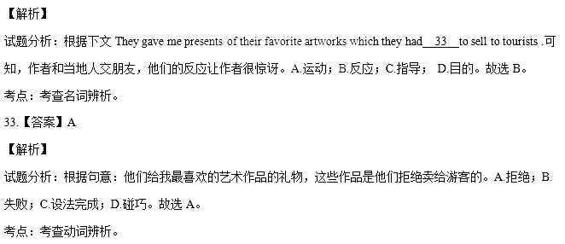

34.【答案】B

【解析】

试题分析：根据下文for seashells that had been left there millions of years ago可知，作者寻找几百万前留下的

贝壳。A.问；B.打猎；C.等待；D.前往。hunt for寻找。故选B。

考点：考查动词辨析和短语搭配。

35.【答案】A

【解析】

试题分析：根据上文millions of years ago可知，几百万年前，沙漠曾经是海床。A.地板；B.表面；C.岩石；

D.水平。故选A。

考点：考查名词辨析。

36.【答案】D

【解析】

试题分析：根据上文two lines that completely changed my life :，可知，这里是：什么造成我这样令人惊讶的

改变？A.令人震惊的；B.有挑战的；C.令人困惑的；D.令人惊讶的。故选D。

考点：考查形容词辨析。

37.【答案】B

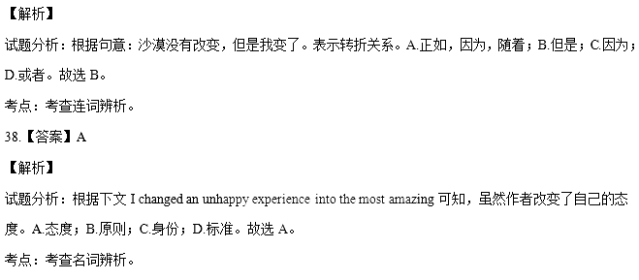

39.【答案】D

【解析】

试题分析：根据上一段内容可知，作者将不愉快的经历变成最令人惊叹的人生冒险。A.假期；B.手术；C.

事务；D.冒险。故选D。

考点：考查名词辨析。

40.【答案】C

【解析】

试题分析：根据上文I would look for the stars.可知，作者从自己创造的监狱向外看，发现了星星。A.寻找；

B.数数，重要；C.发现；D.到达。故选C。

考点：考查动词辨析。

【名师点睛】这篇文章是记叙文，难度适中，这类文章首先要通读抓住故事发生的情节和作者想传达的中心思想。围绕主旨解答更有把握。故事内容体现了作者从父亲的简单的两行字中领悟到做人的道理。学生要抓住这个主题，而且这个主题贯穿整个文章。这个文章一个明显的特点是上下文之间的联系非常紧密。做题时要牢记上下文的关联对解题会很有帮助。

做题时要结合完形填空的特点，完形填空题有的考查词语同现、词语复现，有的则是要运用逻辑推理能力，领会和掌握解题策略对提高完形填空的解题速度和准确率大有裨益。

1. 上下文串联和语境暗示。

这篇完型填空里面出现词语同现的很少，但是词语复现不少，就是指某一个词以原词、同根词、同义词、反义词等方式重复出现在语篇中，语篇中的句子通过这种复现关系达到相互衔接。像这篇完型的23题用unbearable，因为下文明显出现了almost 125F，还有28题，上文的I wrote to my parents暗示这里是letter。40题是和上文的look for信息词对应的，都是属于这种类型。

2. 逻辑推理。

逻辑推理是通过对句子间和上下文之间逻辑关系的理解从而推断出正确答案。其中逻辑关系主要包括因果关系、转折关系、对比关系、并列关系等。逻辑推理题需要考生对上下文的理解全面把握，难度较大，考生不能将句子独立开，要注意一个句群，一个段落的整体理解。这篇文章逻辑推理的题较多。如24题，根据上文a desert和alone，可知这里用not合适；37题主要是上下文的逻辑关系，上文hadn’t changed和下文changed是转折关系。

3.固定搭配。

有的题目单单从四个选项不能看出差别，需要和横线的前后搭配，形成固定短语才能判断，如34题使用hunt for这个词组。

**第二部分：阅读理解（第一节20小题，第二节5小题；每小题2分，满分50分）**

第一节：阅读下列材料，从每题所给的四个选项（A、B、C、D）中，选出最佳选项，并在答题纸上将该选项标号涂黑。

**A**

【语篇解读】本文是一篇议论文。文章讨论了传言的危害和人们为什么喜欢传闲话。

41. 【答案】A

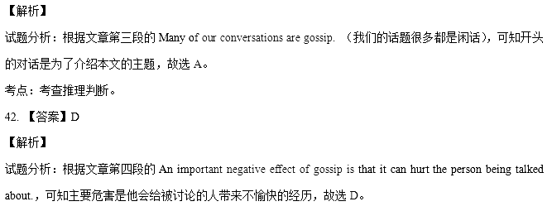考点：考查细节理解。

43. 【答案】A

【解析】

试题分析：根据文章第五段的The answer lies in another effect of gossip: the satisfaction it gives us,可知人们散播传言是因为它会带来满足感，故选A。

考点：考查细节理解。

44. 【答案】B

【解析】

试题分析：根据文章第六段的Professor David Wilson explains that gossip is important in policing behaviours in a group.可知，他认为传言能帮助人们观察自身的行为，故选B。

考点：考查细节理解。

45. 【答案】D

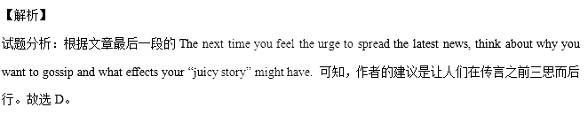

考点：考查细节理解。

【方法点拨】

这是一篇议论文，题目设置以细节理解题为主。学生可以带着题目回到原文，能够在短文中画出解题依据是正确解题的关键，各位考生要谨记，在做阅读理解时要做到“不见依据不做题”。理由充分，依据凿实，这是不仅“知其然”，而且“知其所以然”的超高境界，是阅读水平提高的最大见证。那么如何能快速准确回到原文找到依据呢?

1. 关键词定位法。

这里说的关键词并不一定是中心词，而是在理解题干所问之后，在题干中能帮助你迅速回到原文的“特征词”。如43题的信息句是The answer lies in another effect of gossip: the satisfaction it gives us,可知人们散播传言是因为它会带来满足感，和选项A里面的a feeling of pleasure对应。还有44题，题干中的Professor David Wilson可以定位到第六段的Professor David Wilson explains that gossip is important in policing behaviours in a group.可知，他认为传言能帮助人们观察自身的行为，所以答案是B。

2. 自然段定位法。

即命题者往往按照信息点在文中出现的先后来依次命制各个小题，也就是说，各题的答案信息常常在短文中依次出现，排在后面的小题，文中对应的信息点也在后面。例如，第1题往往位于一、二自然段，第2题会在第1题的答案信息之后且与第一题的位置最接近，第3题会在第2题的答案信息之后，往往在文中较为中间的地方，而第4题则位于文中较后的位置。最后一题(偶尔可能是第一题)一般是主旨题(包括给文章加标题、归纳写作目的)，这时，可能涉及全文内容。如41题，题目问文章的开头的作用，自然定位到第一段的内容，结合下文可以快速解答。

**B**

【语篇解读】本文是一篇应用文，文章提供了图书馆网页上一些书本的信息。

46. 【答案】A

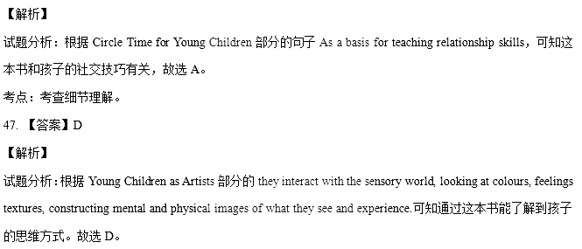

考点：考查推理判断。

48. 【答案】B

【解析】

试题分析：根据侧边栏的Year Published下的2015（90），可知有90本书是2015年出版的。故选B。

考点：考查细节理解。

49. 【答案】C

【解析】

试题分析：根据Children with School Problems部分的The physician’s guide to diagnosing and treating learning disabilities in children.可知这本书介绍了如何诊断治疗孩子的病症，是给医生读的资料，故选C。

考点：考查细节理解。

【名师点睛】阅读中的细节理解可以细化为：（1）一一对应型。答案与题目在表达形式和意义上直接吻合，一一对应，一目了然。属于浅层次的阅读试题，分数比例较少。（2）语言转述型。这是一类间接事实细节题，答案与题目在意义上从分运用了词义之间的转述关系，即正确选项是原文有关词语和句子的另类表达。属于中档难度题，分数比例较大。（3）语意理解型。这是一类深层事实细节理解题，答案与题目之间存在着一定的逻辑联系，这种联系需要建立在事实的基础上通过上、下文来进行判断、分析、归纳和整合，才能得出正确答案。属于较高难度的事实细节题。（4）是非辨别型。这是一类综合事实细节题，出题形式常常是“三正一误”(三项正确，只有一项不符合原文内容)或“三误一正”（三项错误，只有一项符合原文内容)。（5）事实排序型。这是一类运用多项事实进行排序的事实细节题，要求根据动作发生的先后顺序、时间顺序或者句子之间的逻辑关系，找出时间发生，发展的正确顺序。

细节理解题主要的答题策略有：

（1）细心审题，直接就题找答案。解答此类试题时，不必通篇细看原文，而应采取“带着问题找答案”的方法，先从问题中抓住关键性词语（题眼），然后以此为线索，运用略读及查读的技巧快速在文章中寻找与此问题相关的：段落、语句，仔细品味，对照比较，确定答案。本题中的48小题就是一一对应型，解题时不需要通读全文，带着48题题干的关键词in 2015找到文章中的相应内容2015（90），即可找到正确答案B。（2）多点归纳，综合事实找答案。细节理解题有时考查的并不是单一的信息，而是多处信息的整合。解答此类“综合”信息细节题时，一定要全面捕捉相关信息，进行综合分析、归纳，切忌根据“一面之词”草率地作出结论。本题中的47题，首先根据题干的mental images定位到they interact with the sensory world, looking at colours, feelings textures, constructing mental and physical images of what they see and experience.这句话，再追溯到这本书的名字Young Children as Artists可以得出答案D。

考点：考查广告应用文阅读

C

【语篇解读】本文是一篇说明文。文章主要介绍了孩子的玩耍和科学家的研究有共同之处。

50. 【答案】D

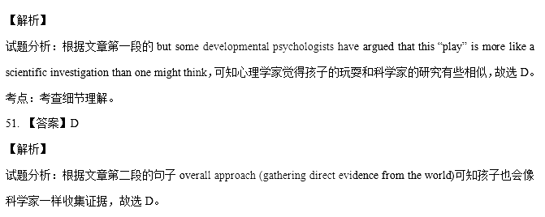考点：考查细节理解。

52. 【答案】C

【解析】

试题分析：根据文章第三段的句子For example, it may only be through repeated experiments, evidence gathering and finally overturning a theory可知孩子可以通过重复自己的实验来学习语言的规律，故选C。

考点：考查细节理解。

53. 【答案】B

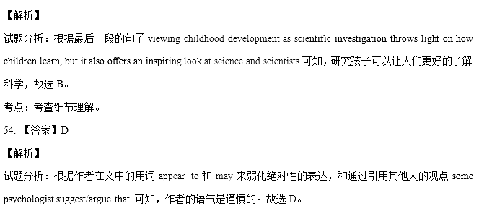

考点：考查推理判断。

【名师点睛】

阅读理解有时理解文章的长难句是关键，理解不了这些句子很难理解文章的大意。下面我们分析一下这篇文章中的长句。

句子1：It is likely that babies are not born knowing the basic fact of the universe; nor are they ever clearly taught it.

这句话使用分号连接两个并列分句，前面的分句使用It is likely that这个句型，还有knowing…作伴随状语，后面的分句是nor+倒装句的结构。

句意：可能孩子不是天生就知道宇宙的基本事实，他们也没有被清楚的教过。

句子2：For example, it may only be through repeated experiments, evidence gathering, and finally overturning a theory, that a baby will come to accept the idea that other people can have different views and desires from what he or she has.

这句话使用强调句，强调的是through repeated experiments, evidence gathering, and finally overturning a theory,这部分比较长，考生可能没有注意这个句式。主干部分中idea后面是同位语从句，from后面还有宾语从句。

句意：例如，它可能只是通过反复实验，收集证据，并最终推翻一个理论，一个婴儿会接受其他人可以和他/她有不同的意见和愿望的想法。

考点：考查说明类短文阅读

D

【语篇解读】本文为一篇记叙文。作者回忆自己母亲对孩子不寻常的教育方法。通过一个自行车篮子的事情，母亲教会作者什么事情都要自力更生，通过自己努力得到的东西才是珍贵的。

55. 【答案】C

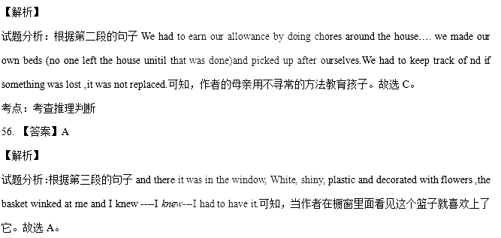考点：考查细节理解

57. 【答案】B

【解析】

试题分析：根据第五段的句子I tried to hold off at first ,I played it cool for a short while. But then I guess I couldn’t at and it any longer:可知，作者说了很多“pleases”，因为她渴望拥有这个篮子。故选B。

考点：考查推理判断

58. 【答案】B

【解析】

试题分析：根据第十二段的句子(washing the car ,helping my mother make dinner, delivering or collecting things on my bike that already looked **naked** without the basket in front可知作者觉得没有这个篮子，自行车看起来光秃秃的，使用“naked”这个词，说明这个篮子对她是重要的东西。故选B。

考点：考查推理判断

59. 【答案】D

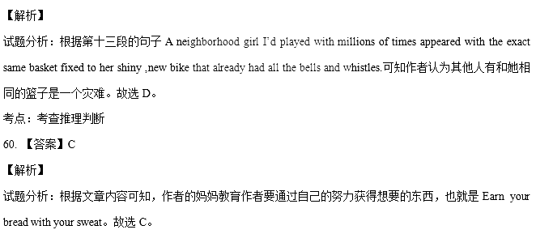

考点：考查主旨大意

【名师点睛】这是一篇故事类短文，题目设置都以推理判断题为主，推理判断题不是通过题干的某个单词定位到文中能直接看出答案来的，要通过故事中人物的语言，动作去揣摩他们的真正意图。做题时不能流于表面。可以适当运用一些解题技巧。

做推理判断题要善于抓住某一段话中的关键信息，即某些关键词或短语去分析、推理、判断，利用逆向思维或正面推理，从而推断出这句话所隐含的深层含义。比如这篇阅读理解的55题，问：我们可以从前两段得出什么？第二段的句子We had to earn our allowance by doing chores around the house…. we made our own beds (no one left the house unitil that was done)and picked up after ourselves.We had to keep track of nd if something was lost ,it was not replaced.告诉我们作者的母亲教育孩子时使用的不寻常的方法。所以答案是C。再如59题，题目问：对作者什么是可怕的事情？文章没有直接表明，而是通过第十三段的句子A neighborhood girl I’d played with millions of times appeared with the exact same basket fixed to her shiny ,new bike that already had all the bells and whistles.可知作者认为其他人有和她相同的篮子是一个灾难。所以答案是D。

第二节：下面文章中有5处（第61-65题）需要添加小标题。请从以下选项（ABCDE和F）中选出符合各段意思的小题，并在答题纸上将相应选项的标号涂黑。选项中有一项是多余选项。

61. 【答案】F

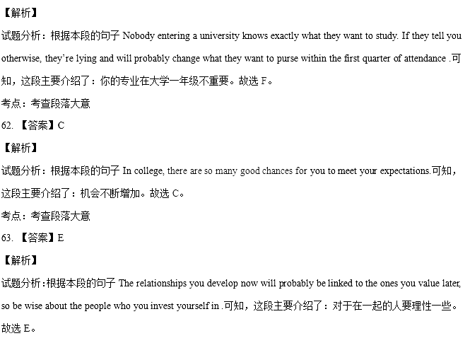

考点：考查段落大意

64. 【答案】B

【解析】

试题分析：根据本段的句子Nothing good will happen when you are silent.可知，这段主要介绍了：你说的话实际上非常重要。故选B。

考点：考查段落大意

65. 【答案】A

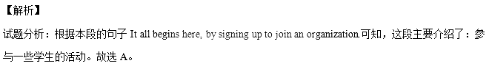

考点：考查段落大意

【名师点睛】任务型阅读出题模式与往年相同，给段落添加首句，考查学生对信息的提取和把握能力。由于关键词汇不易混淆，所以难度略有下降。如61题，段落中的what you want to study和选项F中的major 匹配；62.题，段落中的chances和选项C的opportunities是同义词；63题段落中的wise和选项E的smart是近义词；64题段落中的silent和选项B的voice是关联词；65题段落中的organization 和A项的activities也有联系。

**非选择题部分**（共40分）

第三部分：写作（共两节，满分40分）

第一节：短文改错（共10小题；每小题1分，满分10分）

66.【答案】children改成child

【解析】

试题分析：因为前面有不定冠词a，所以这里用单数。故children改成child。

考点：考查名词单复数

67.【答案】late改成later

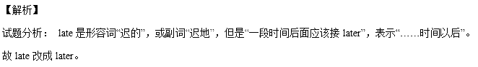

考点：考查副词

68.【答案】at后面加the

【解析】

试题分析： at the end of为固定搭配，意为“在……结束的时候”。故at后面加the。

考点：考查冠词

69.【答案】her改成him

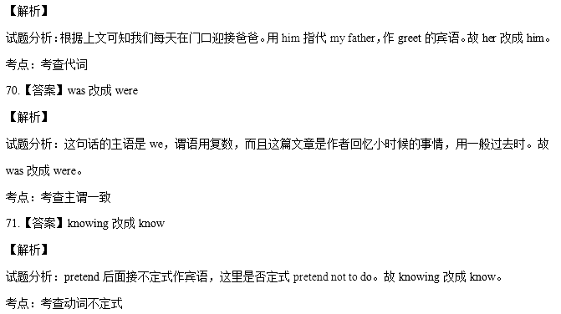

72.【答案】去掉had

【解析】

试题分析：句意：他和我妈妈会喝些东西。这里不是虚拟语气，不能用would have done，用would do表示“过去常常做”。故去掉had。

考点：考查动词形式

73.【答案】chat改成chatted

【解析】

试题分析：根据主句内容my father would lift my sister 可知while引导的时间状语从句用一般过去时。故chat改成chatted。

考点：考查动词时态

74.【答案】in改成on

【解析】

试题分析：on the top of…为固定搭配，意为“在……顶部”。故in改成on。

考点：考查介词

75.【答案】excited改成exciting

第二节：书面表达（满分30分）

【答案】***One possible student version***

**Planning Is Good ,But Doing Is Better**

Planning is good as it decides in detail how we do.However,a plan can bear no fruit without being actually carried out.

My experience in the English speech contest last October is a case in point.A month before the event,I spent hours working out a schedule outlining my goals and practical steps.After that,I set out to read widely for an inspiring topic,wrote a speech,and practiced its delivery in beautiful pronunciation with good public speech skills.I finally came out of the contest as the first prize winner.

I know how I achieved my success. It came from good planning and better doing combined.

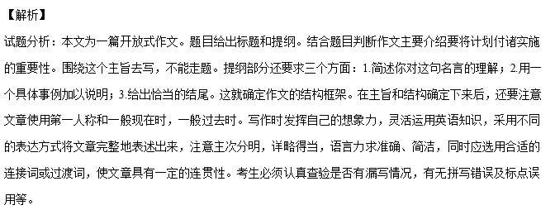【名师点睛】本篇范文短小精悍，结构合理，语言简练，时态人称准确，很好的完成了写作任务。在文章开头作者紧扣题目，提出自己对plan的理解，同时引出下文，然后用自己的亲身经历表明要将计划付诸实施这点非常重要。在文中作者用到了短语in detail , bear no fruit ,carry out, set out to等短语，避免了文章句式的单一。此外，还用到了宾语从句how we do , It came from good planning and better doing combined.等，这些都给朴素的语言带来了亮点。

考点：考查开放式作文